

University of Wales Trinity Saint David
School of Engineering

Physical Science for Materials Coursework
Physical Science for Materials ACMA4001

Philip Craig Bartle
1808882
23/01/2024
Contents
1 Task 1 iii
1.1 Making Pig Iron using a blast furnce iii
1.2 Using pig iron to make steel (BOS) iv
2 Task 2 v
3 Task 3 vi
4 Task 4 vii
5 Task 5 viii
6 References x

Task 1

Making Pig Iron Using a Blast Furnace
The production of pig iron, figure 1.1 (IIMA, 2021), using a blast furnace is a critical step in the steelmaking process, involving complex reactions at high temperatures. This process begins with the raw materials: iron ore, coke, and limestone.
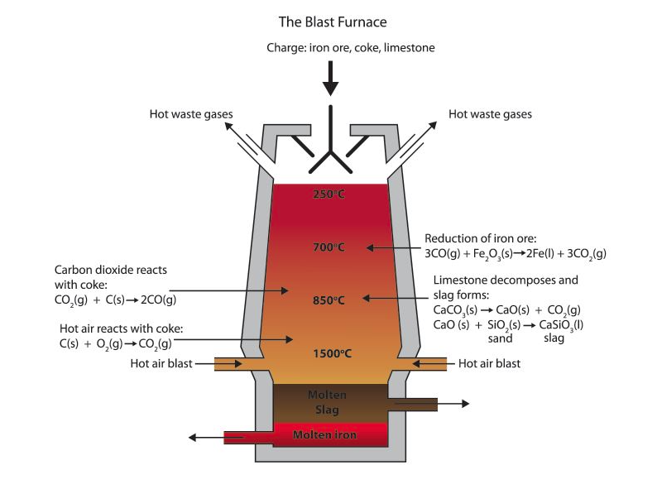
Figure 1.1 Pig Iron Production – Blast furnace Route Diagram (IIMA, 2021)
Iron ore in the form of hematite (Fe₂O₃) or magnetite (Fe₃O₄), is crushed into smaller pieces and along with coke and limestone, are charged into the top of the blast furnace. As the raw materials enter the furnace, they encounter a series of intense heat zones. At the bottom of the furnace, preheated air, also known as blast, is blown in through tuyeres. The blast, typically heated to around 1200°C, reacts with the coke, initiating combustion and generating temperatures exceeding 2000°C.
The primary reactions in the blast furnace include the combustion of coke to produce carbon monoxide (CO), which serves as the reducing agent in the subsequent reduction of iron ore. The iron ore, upon contact with the hot CO, undergoes reduction, leading to the formation of molten iron (Fe) and carbon dioxide (CO₂). This molten iron, along with impurities known as slag, collects at the bottom of the furnace, forming a layer of pig iron. Limestone acts as a fluxing agent and undergoes decomposition in the furnace, producing calcium oxide (CaO). The CaO reacts with impurities such as silica (SiO₂) to form calcium silicate (CaSiO₃), which constitutes the slag. The slag floats on top and is tapped off separately. The production of pig iron within a blast furnace involves several chemical reactions. However, these reactions can be simplified using the following chemical equation:
Fe₂ ​O₃ ​+ 3CO → 2Fe + 3CO₂​
This equation represents the reduction of iron ore (Fe₂O₃) with carbon monoxide (CO) to produce iron (Fe) and carbon dioxide (CO₂). This reaction is a fundamental step in the blast furnace process for producing pig iron.

Using Pig Iron to Produce Steel in the Basic Oxygen Route (BOS)
The pig iron from the blast furnace is used as the primary raw material for steel production in the Basic Oxygen Route (BOS), figure 1.2, (StudyMeta, 2020).
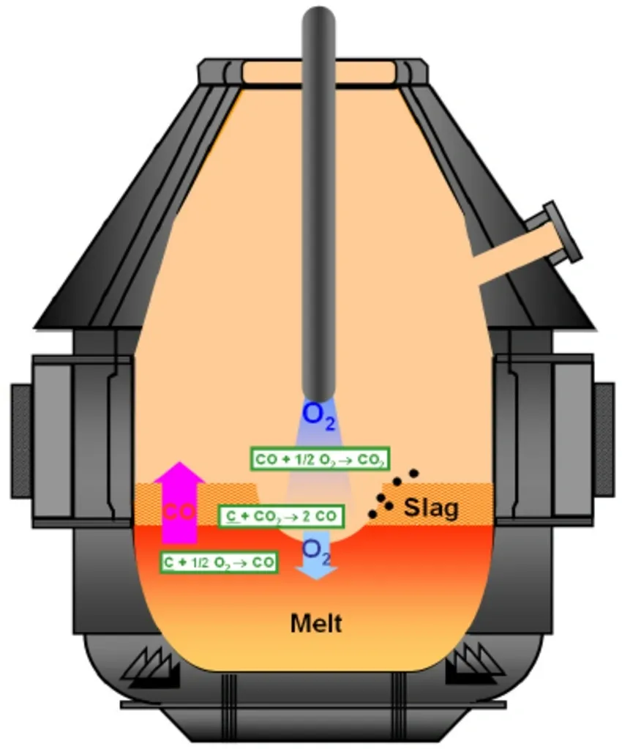
Figure 1.2 - Basic Oxygen Furnace diagram (StudyMeta, 2020).
In the BOS plant, molten pig iron is transferred from the blast furnace to a basic oxygen converter. The converter is then charged with the pig iron and a high-pressure stream of oxygen is injected through a lance from the top. As the oxygen reacts with the impurities present in the pig iron, such as carbon (C), silicon (Si), and manganese (Mn), exothermic oxidation reactions occur. The carbon oxidizes to form carbon monoxide (CO), while silicon and manganese form their respective oxides (SiO₂ and MnO). The oxidation of these impurities results in their removal from the molten metal, forming a slag layer that floats on top of the steel. The slag, composed mainly of oxides, absorbs any remaining impurities, and is subsequently removed. The result of the BOS process is high-quality steel with accurate control over its chemical composition and mechanical properties.
The chemical reaction that occurs during production of steel using the Basic Oxygen Route (BOS) can be simplified and illustrated using the following chemical equation:
Fe + C + Mn + Si + O₂​ → Steel + CO + MnO + SiO₂​
The above equation illustrates the oxidation of impurities such as carbon (C), manganese (Mn), and silicon (Si) present in pig iron using oxygen (O2) in the basic oxygen converter. The result is the production of steel along with the formation of carbon monoxide (CO), manganese oxide (MnO), and silicon dioxide (SiO₂) as slag.

Task 2
Carbon is a fundamental element in the creation of steel due to its atomic structure and its ability to influence desirable mechanical properties. The use of carbon in steelmaking is essential for several reasons.
- Alloying: Carbon readily forms alloys with iron. This alloying process alters the properties of iron. Carbon's ability to form alloys with iron is critical for enhancing the properties of the resulting steel. Alloying allows us to alter the thermal and electrical conductivity through the metallic bonding of atoms. It also allows us to easily shape the material through processes such as forging and rolling.

- Influencing Mechanical properties: The presence of carbon in steel increases its strength and hardness, and corrosion resistance. Carbon forms solid solutions with iron, allowing for the formation of various microstructures such as pearlite, ferrite, and martensite, which contribute to different mechanical properties. Carbon atoms are smaller than Iron atoms and can fit into gaps in the lattice. When interstitially aligned within the iron lattice, Carbon atoms disrupt the regular arrangement of iron atoms, preventing them from sliding (slip planes) past each other easily. This interference strengthens the steel and makes it more resistant to deformation and wear from plastic deformation and dislocations.

- Controlling Carbon: Precise control over the carbon content in the final product can easily be achieved. By adjusting the amount of carbon, manufacturers can tailor the mechanical properties of the steel to suit specific applications. Low-carbon steels are more ductile and easily formed and machined, while high-carbon steels are harder and more suitable for cutting tools and structural components.

- Availability and Cost: Carbon is abundant and relatively inexpensive, making it the ideal choice for steel production on an industrial scale. Other element such as Boron and Cobalt can have similar results on mechanical properties when alloying steel. However, they are less readily available and more difficult to produce, making them more expensive than Carbon. The versatility of Carbon allows production of a wide range of steel grades with varying carbon content to meet diverse industrial applications.

Atomically, the structure of Carbon is small. This allows Carbon to fit interstitially within the iron lattice without significantly distorting its structure, figure 2.1 (LFF Group, 2017).
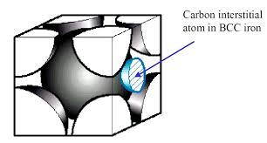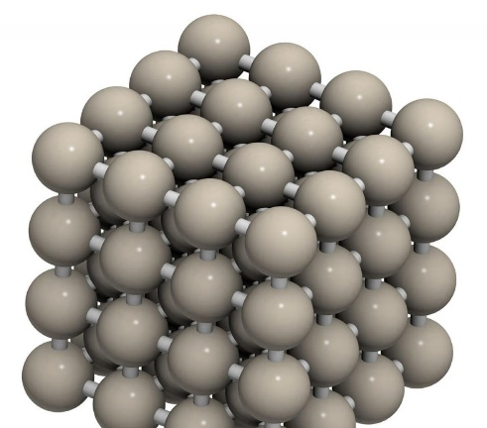
Figure 2.1 - Illustrating Cabon atoms sitting interstitially in the Iron matrix (LFF Group, 2017).

Task 3
Ferrous metals typically have lower electrical and thermal conductivity compared to non-ferrous metals like copper and aluminium. However, they still conduct electricity and heat to some extent. A useful application for ferrous metals' moderate conductivity is in electrical wiring where their strength and durability are required, albeit at a slightly higher resistance compared to non-ferrous metals.
Non-ferrous metals like copper and aluminium exhibit high electrical and thermal conductivity. They are extensively used in electrical wiring due to their ability to efficiently conduct electricity, reducing energy loss and heat buildup. In thermal applications, non-ferrous metals are utilized in heat exchangers and cooking utensils for their superior heat transfer properties.
Semiconductors, such as silicon, have conductivity between that of metals and insulators. They are crucial in electronics for their ability to control and manipulate electrical currents. A common application is in semiconductor diodes and transistors, which are fundamental components in electronic circuits, including computer processors and solar cells.
Insulators, like rubber and glass, have very low electrical and thermal conductivity, effectively preventing the flow of electricity or heat. They are indispensable in electrical insulation, providing safety by isolating conductive components from external currents. Insulating materials are extensively used in electrical cables, insulating jackets, and building materials to prevent electrical shocks and heat loss.

Task 4
Table 4.1 shows a simple material selection table for plain carbon steels (Low carbon steel, medium carbon steel and high carbon steel) highlighting the basic mechanical (Young’s modulus, Yield strength and Ultimate tensile strength ¹) and physical properties (Thermal conductivity, specific heat capacity, density etc.) of these metals. All figures were sourced from ¹(Engineering Toolbox, 2024).
Tabe 4.1 – Material selection table.
Property | Low Carbon Steel | Medium Carbon Steel | High Carbon Steel
Chemical Composition | 0.05%-0.30% C < 0.30% Mn | 0.30%-0.60% C < 0.60% Mn | 0.60%-1.00% C < 0.60% Mn
Young’s Modulus (GPa) ¹ | 200-210 | 200-210 | 200-210
Yield Strength (MPa) ¹ | 250-350 | 350-500 | 500-800
Ultimate Tensile Strength (MPa) ¹ | 400-600 | 550-750 | 700-1000
Thermal Conductivity (W/m·K) ¹ | 45-55 | 45-55 | 45-55
Specific Heat Capacity (J/kg·K) ¹ | 450-490 | 450-490 | 450-490
Density (g/cm³) | 7.85 | 7.85 | 7.85
Hardness (Brinell) | 120-170 | 170-230 | 230-270
Electrical Conductivity (10^6 siemens/m) ¹ | 5.9 | 5.9 | 5.9
Electrical Resistivity (10^-8 ohms/m) ¹ | 9-10 | 9-10 | 9-10

Task 5
Steel is arguably one of the most versatile and indispensable materials in engineering. Its uses range across countless applications, from buildings and infrastructure to surgical instruments. In this answer, we will assess the some of the reasons behind steel's usefulness, diverseness and discuss the future potential of steel.
Firstly, what makes steel so valuable to industry? What are the properties of steel that render it so invaluable. Steel is renowned for its exceptional strength, durability, and versatility. Its strength-to-weight ratio surpasses that of many other materials, making it ideal for structures that demand resilience without excessive bulk. In addition, steel exhibits good durability, a level of corrosion resistance along with resistance to wear and degradation over extended periods. This longevity ensures the reliability of steel components in a multitude of environments, from harsh industrial settings to the home of the average person.
Steel's versatility stems from its ability to be produced to meet specific requirements through alloying, heat treatment, cold working, and coating. By varying the composition of elements such as carbon, manganese, and chromium, engineers can engineer steel with specifically designed mechanical properties suited to diverse applications. For instance, high-carbon steel exhibits enhanced hardness and wear resistance, making it suitable for cutting tools and machinery components, while stainless steel, with addition of chromium, resists corrosion, making it a staple in chemical environments and medical equipment.
The applications of steel are as diverse and extensive. Within the construction industry, steel is unrivalled as the ‘go to’ material as the backbone of concrete reinforcement (Figure 6.1) (Leclere, 2021), bridges (figure 6.2) (HISTORY.COM EDITORS, 2023), and infrastructure such as HS2 due to its strength, flexibility, and cost-effectiveness. The automotive industry relies heavily on steel for its lightweight yet sturdy chassis and safety components, enhancing vehicle performance whilst safeguarding the passengers. Furthermore, ferritic steel's magnetic properties render it indispensable in electrical transformers and motors, facilitating the efficient transmission of power across vast distances.
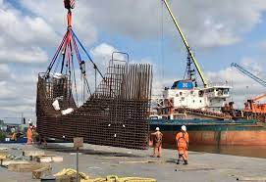
Fig 6.1-Rebar tunnel section (Leclere, 2021) Fig 6.2-Golden Gate bridge (HISTORY.COM EDITORS, 2023)
However, despite its prevalence, steel continues to evolve. Ongoing research and innovation are unlocking new potential applications. One such area of exploration lies in advanced steel alloys engineered to withstand extreme conditions, such as high temperatures, pressure, or corrosive environments. One such alloy is 253 MA®(NeoNickel, 2023). 253 MA® is an advanced micro alloyed austenitic stainless steel with the addition of Cerium. The alloy has superior strength to other austenitic stainless grades. It has twice the strength of 309/309S and 310S stainless above 870°C and excellent oxidation resistance up to 1094°C.These superalloys hold promise for aerospace, energy, and defence applications, where traditional materials falter in the face of formidable challenges.
Moreover, emerging manufacturing techniques, such as additive manufacturing or 3D printing, offer new avenues for steel fabrication, enabling the creation of complex geometries and customized components with precision. These new techniques allow designers and engineers access to innovation and applications previously deemed practicable, from intricately structured architectural designs to intricately personalized medical implants that accurately replace the bone/limb being replaced.
Furthermore, steel's sustainability and recyclability position it highly within the circular economy, where resources are to be conserved, and waste minimized through continuous reuse and regeneration. The steel industry's commitment to reducing its environmental footprint, through initiatives such as energy-efficient production processes and scrap recycling, such as electric arc furnaces, reinforces its status as a sustainable material of choice for a greener future.
In conclusion, steel's future relevance stems from its cost effectiveness and exceptional properties, versatility, and adaptability to diverse applications. While it has undoubtedly made a huge mark on human civilization, the use of steel is far from over. As research and innovation continue to push the boundaries of material science, new possibilities emerge, offering glimpses into a future where steel's potential can grow further.

References
Engineering Toolbox, 2024. Young's Modulus, Tensile Strength and Yield Strength Values for some Materials. [Online]
Available at: https://www.engineeringtoolbox.com/young-modulus-d_417.html
[Accessed 28 04 2024].
HISTORY.COM EDITORS, 2023. Golden Gate Bridge. [Online]
Available at: https://www.history.com/topics/landmarks/golden-gate-bridge
[Accessed 17 03 2024].
IIMA, 2021. Pig Iron Production - Blastt Furnace Route. [Online]
Available at: https://www.metallics.org/pig-iron-bf.html
[Accessed 16 03 2024].
Leclere, M., 2021. HS2 contract for Kent business ArcelorMittal Kent Wire leads to new jobs despite redevelopment fears at Chatham Docks base. [Online]
Available at: https://www.kentonline.co.uk/medway/news/firm-under-threat-by-development-plans-set-to-create-50-new-253760/
[Accessed 16 03 2024].
LFF Group, 2017. Fundamentals of Carbon Steel Part 1 - Phases and Microstructures. [Online]
Available at: https://www.lffgroup.com/posts/carbon-steel-fundamentals-part-1
[Accessed 17 03 2024].
NeoNickel, 2023. Heat Resistant Alloys. [Online]
Available at: https://www.neonickel.com/heat-resistant-alloys/#:~:text=235%C2%B0C-,253%20MA%C2%AE,up%20to%201094%C2%B0C.
[Accessed 17 03 2024].
StudyMeta, 2020. StudyMeta-Basic Oxygen Furnace (SteelMaking). [Online]
Available at: https://studymeta.com/blogs/f/basic-oxygen-furnace-steelmaking?blogcategory=Steelmaking+Process
[Accessed 16 03 2024].

