An Exploration of How the Culture within the 1960’s Influenced the Art at the Time

Lola Preston
2102958
Independent project ADAA6000
Fine Art: Studio, Site and Context
Sue Williams
Submitted in partial fulfilment of the requirements for the degree of BA (Hons) Fine Art, University of Wales Trinity Saint David, Swansea
(submitted: 15th December, 2023)

Contents:

- Introduction – pg.3

- Chapter 1: Andy Warhol and the Rise of Consumerism – pg.5

- Chapter 2: Music, Time and Space – pg.11

- Chapter 3: The Rise of LSD and Psychedelic Art – pg.14

- Conclusion – pg.19

Introduction
The 1960’s was a decade of change; ‘change in identity family unit, sexuality, dress and the arts’(Bousalis, 2021, pg.1), it was a time in which the flaws within society’s construct were highlighted and groups of people (mainly the younger generations) began to reject and actively protest against societal norms that had been forced upon them by older generations, causing a ‘generational dichotomy’ (Roszak,1969,pg.2). Following on from the Beatnik generation of the 50’s; a rise in ‘counterculture’ (Roszak, 1969) meant that the youth at the time were conducting an ‘increasingly radicalised version of reality’ (Averyt, 1971, pg.18) that was worlds apart from the conservative nature of the 1950’s, making ‘the end of that decade so different from the beginning.’ (Averyt, 1971, pg.18). Members of the counterculture were known for their sexual liberation, drug experimentation, and anti-war campaigning, particularly in relation to the Vietnam war, which became ever more prominent as the fast developments in technology at the time meant that ‘by the 1960’s, 75% of British homes had a television’ (Goodhart, 2020), allowing for images of the devastation caused overseas to be made more accessible to the majority of the population. Music also became a strong form of protest, with many artists creating songs in direct response to the conflict happening around them; for example, Buffalo Springfield’s 1966 song ‘For What it’s Worth’. Inspired by the Sunset Strip curfew riots of 1966, lyrics from the song reference the resistance enforced by the police against the counterculture youth, the lyrics reading:
“Young people speaking their minds
Getting so much resistance from behind” (Buffalo Springfield, 1966), the lyric “a man with a gun over there” is also in reference to the Vietnam War. ‘For What it’s Worth’ peaked ‘at number seven in the spring of 1967’(Browne, 2016) highlighting the reach that music could gain in society at the time, and even after, as ‘its references to police, guns and paranoia remaining continually relevant’ (Browne, 2016).
The 1960’s also saw a change in the way people understood the human psyche, prior to this, Sigmund Freud’s theory of repression and the unconscious, suggested that one must repress any feelings that lie outside the norm, stating that ‘there is a primal repression, a first phase of repression, which consists in the physical (ideational) representative of the instinct being denied entrance into the conscious’ (Freud, 1915, pg.148).
However, as these norms began to breakdown and people began to become more expressive with their thoughts and aggressions, members of the counterculture began to disregard Freud’s notion that impulses should be supressed as it was seen that ‘the disciplining of these two urges, sex and aggression, accounts for mans unhappiness in a civilised state’ (Averyt, 1971, pg.21). Therefore leading to a rise in humanistic psychology, which emphasises the importance of the self and gaining self- actualisation, with Abraham Maslow, the founder of the humanistic approach, stating that ‘improving individual health is one approach to making a better world’ (Maslow, 1968, pg.6). This new outlook on human psychology emerging from a decade of extreme change suggests that ‘when religion, science and morality are shaken… and when the outer supports threaten to fall, man turns his gaze from externals in on to himself’ (Kandinsky, 1912, pg.13), allowing for people to freely express themselves for the first time.
This dissertation will go on to explore how culture in the 1960’s and radical changes in people’s perspectives, impacted art.

Andy Warhol and the Rise of Consumerism

In his book “The Work of Art in the Age of Mechanical Reproduction” (1935), Walter Benjamin states that ‘Even the most perfect reproduction of a work of art is lacking in one element: its presence in time and space, its unique existence at the place where it happens to be’ (Benjamin, 1935, pg.II), but what if it is the act of reproduction that sets its place within history?
Pop art is a movement that began in 1950’s America as the post war period led to great advances in technology, allowing for an influx of visual media to spread across the west. Artists of this movement used symbols of popular culture almost as ‘readymade’s’ (Duchamp, n.d.), going on to adjust the context in which these images are seen, changing the narrative of the image in order to comment on society at the time. The Pop Art movement is said to be heavily influenced by Marcel Duchamp who invented the concept of the readymade, which is the process of taking an object that already exists and changing its context, in order for it to be viewed as art, an example of this can be seen in figure.1.

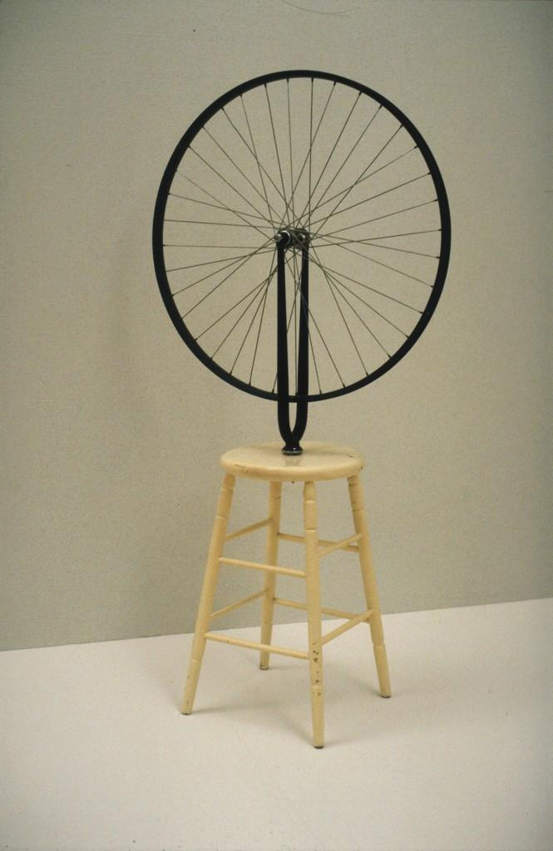
Figure.1 – Duchamp, 1913, Bicycle Wheel

This was seen as a completely radical concept in the art world at the time as it was very focused on traditional processes such as painting and drawing, so by taking pre-existing objects, Duchamp almost undermines other art that was produced in the early 1900’s. ‘Duchamp and the readymade represented the epitome of privileged aestheticism’ (Considine, 2019, pg.4) paving the way for other artists, in this case those of the Pop Art movement, to not have to justify their reasoning and methods but ‘to choose what might constitute art simply through the act of naming it as such’ (Considine, 2019,pg.4).
Andy Warhol was born in Pittsburgh in 1928, as the third son of working-class immigrants that had emigrated from Slovakia. He began his artistic career as an illustrator, moving to New York City to pursue this endeavour, exposing him to a completely new culture than what he was used to. 1960’S America was an ever-evolving society, in which an increase in factory production had led an abundance of money, more so than the previous decades and during the war, which caused developments in ‘the means of mass transportation and communication, the commodities of lodging, food and clothing, the irresistible output of the entertainment and information industry’ (Marcusse, 1991, pg.14), allowing more people to become open to consumerist culture. However, ‘rather than seeing these developments as beneficial to the individual’ (Marcuse and Kellner, 1991, pg.xii), many people, including the philosopher Herbert Marcuse, saw this ‘as a threat to human freedom and individuality in a totally administered society’ (Marcuse and Kellner, 1991, pg.xii, xiii). Andy Warhol saw this shift and utilised this aspect of society within his work, highlighting the consumerism within American culture at the time that was fuelled by the new age of mass production and forcing the viewers to confront and question how they engage with this aspect of society.
In 1962, Warhol created his piece ‘Marilyn Monroe Diptych’ (see figure.2), in direct response to Marilyn Monroe’s death by overdose.

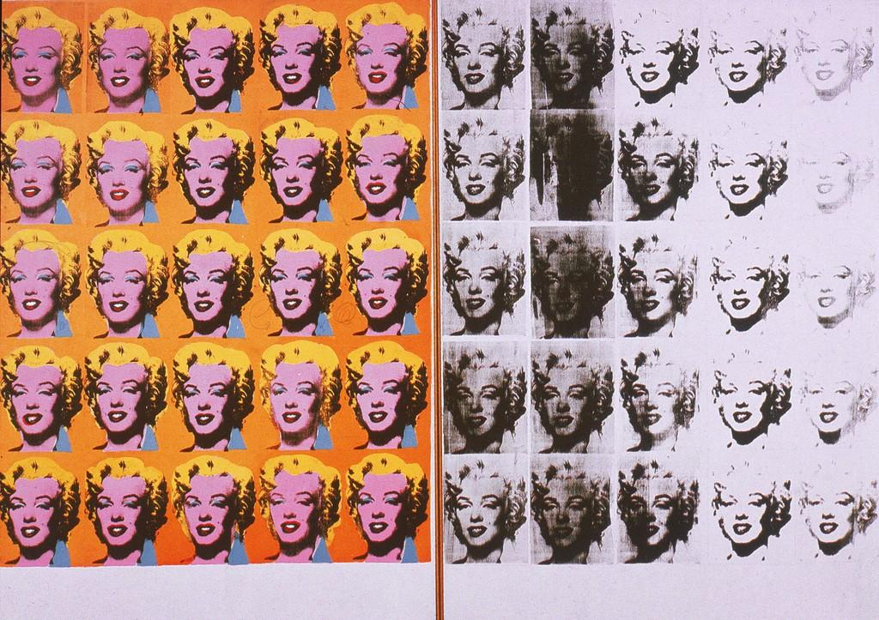
Figure.2 – Andy Warhol, 1962, Marilyn Monroe Diptych

Warhol used images of Marilyn Monroe taken by Gene Kornman in 1953, that were originally created to use as advertisement for the film ‘Niagra’ (1953) in which Monroe was starring and began creating screen prints of this imagery. On the left side of the diptych Monroe is presented using garish colours, creating unnatural representations of her image, bright blues and reds display almost ‘a parody of makeup’ (Madoff, 1997, pg.xiii). This creates a greatly artificial depiction of the film star, mirroring the glamourised images that had been churned out endlessly by the media throughout her career, the bright orange background creating the sense that Monroe lived in an unnatural environment that was greatly detached from reality. The right side presents Monroe in a much less perfected way, using a monotone palette to create an instant visual contrast between the two sides. Warhol seems to have applied the ink in a much more hap hazard way, creating smudges and spots of ink that in some cases fully distort the face beyond the point of recognition, suggesting how despite her glamourous presentation in the media, Monroe’s actual reality was far from this, ‘emphasising the artificiality of the celebrity’s image and possibly suggesting that this was a crude commercialization of an image that could lead to her decline’ (Klanovicz and Parode, 2014, 35). Allowing the viewer to question the reality of mainstream media at the time and also the way in which they interact with it.
Warhol utilised the technique of silk screen printing as a way of mirroring the rise of mass production at the time, stating that ‘The reason I’m painting this way is that I want to be a machine’ (Smith, 1986, pg.110), his studio even being referred to as ‘The Factory’ (Lancaster, 1989, pg.198). This comment on mass production can be seen in his piece ‘Green Coca-Cola Bottles’ (see figure.3), which was one of his first explorations of the screen-printing technique.

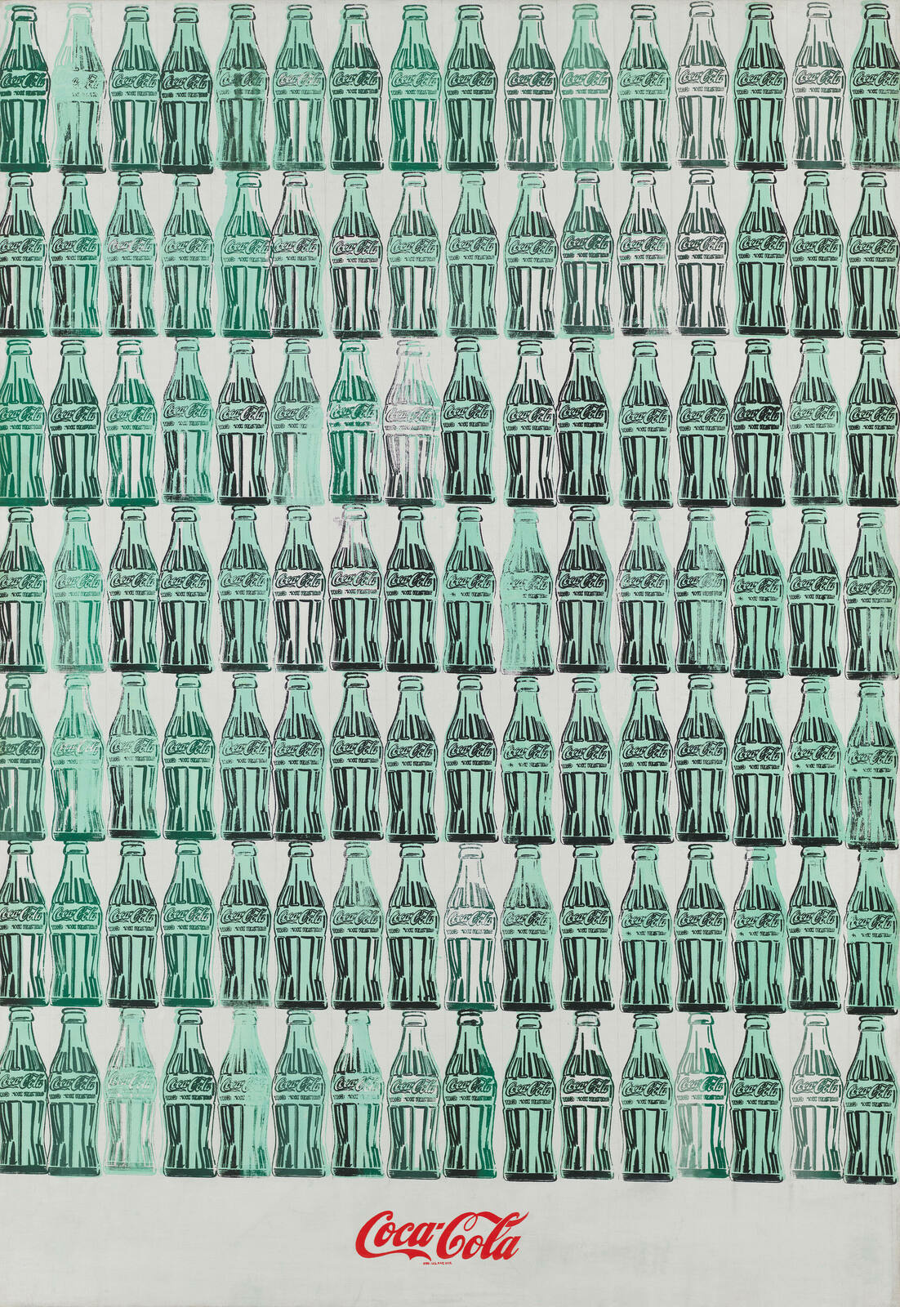
Figure.3- Warhol, 1962, Green Coca-Cola Bottles

Coca-Cola was a product that was created and advertised in a way that it was accessible to everyone within society, ‘A Coke is a Coke and no amount of money can get you a better Coke than the one the bum on the corner is drinking. All the Cokes are the same and all the Cokes are good.’ (Warhol, 1975, pg.111). By repeatedly screen printing the Coke bottles and turning them into an art piece, Warhol is mirroring both the mass production and the accessibility of the product itself. Highlighting how Warhol created work in direct response to the culture that surrounded him during the 1960’s.

Music, Time, and Space

‘A work of art is an object, but also an encounter with time’ (Malraux, 1935)

Up until the early 1900’s, space and time have been viewed as separate forms that do not interact with one another, however it has since been discovered that ‘the world in which we live is a four-dimensional space-time continuum’ (Einstein, 2012, pg.40) and that there is thought to be an ‘interdependence of space and time’ (Bértola, 1972, pg.27) where ‘there is no absolute time that is independent of space.’ (Bértola, 1972, pg.27). Similarly, music and art have always acted closely beside one another but never been thought to merge completely, however this new viewpoint on the relationship between space and time has altered the way people view many aspects of our world, including music and art. It has been said that time is the medium upon which music is created and that ‘music’s temporality is the very aspect through which it actually congeals into something that survives independently’ (Adorno, 1995, pg.66); in contrast to art, specifically painting in this case, which is said to be seen ‘as a reworking of space’ (Adorno, 1995, pg.67), therefore almost transcending time. However, these two mediums are not linear as art is seen as spatial and music temporal, so they must interact in a similar manner to time and space which ‘function together, in that they are both necessary before anything is perceived’ (Bértola, 1972, pg.27). Adorno states that ‘the established boundaries that set the spatial and temporal art in opposition to each other derive from the need to classify, to order’ (pg.75), so as society has evolved and people are becoming less constricted within their practise, particularly with the rise of counterculture, the distance between music and painting lessens greatly as the need for literal communication with the viewer or listener lessens, allowing for a new ‘non subjective language’ (pg.72) to arise. An art piece that cultivates both time and space simultaneously, is Yoko Ono’s ‘Cut Piece’ (see figure.4), a profound piece of performance art that highlights the physical effects of time upon a certain space.
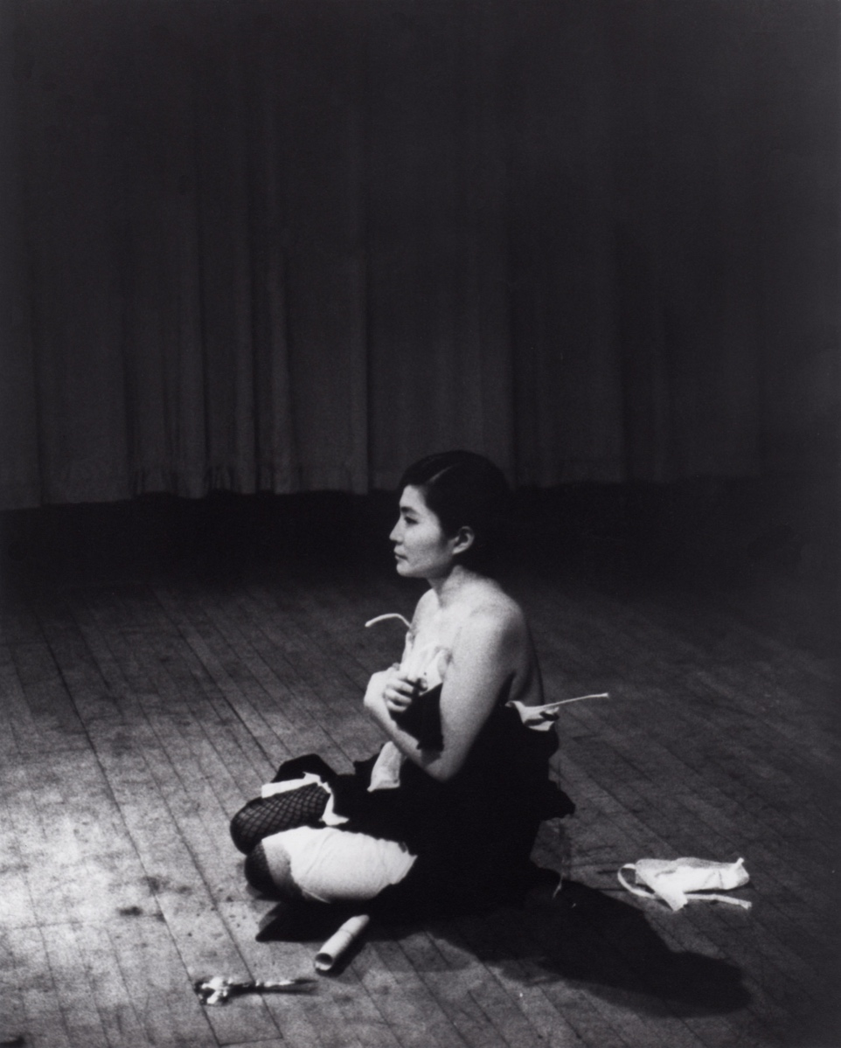
Figure.4 – Ono, 1964, Cut Piece
In ‘Cut Piece’, Ono sits onstage in her best suit in front of an audience with a pair of scissors placed in front of her, the audience are instructed that they can go up to Ono and use the scissors to cut away her clothing, which they could then take to keep as a souvenir. Ono remains completely silent throughout, giving the audience complete freedom to be as bold or as reserved with their cuts as possible. Despite her silence, Ono manages to orchestrate a sense of music within the piece, with repeating sounds of the scissors and murmurs of the audience, along with footsteps and other sounds that capture the moment she is holding; Ono stating that ‘There was a long silence between one person coming up and the next person coming up. And I said it’s a fantastic, beautiful music, you know? Ba-ba-ba, cut! Ba-ba-ba, cut! Beautiful poetry actually’ (MoMA, Ono, n.d.). Cut piece highlights the objectification and exploitation of the female body as the audience take part in stripping Ono, until she is at her most vulnerable, while each member takes a piece of clothing, suggesting almost a submissive sense of generosity, ‘this dualism of aggression and generosity has complex implications for the audiences of this work’ (Bryan-Wilson, 2003, pg.103).
Music in the 1960’s was one of the most influential pieces of media at the time, as musicians began to write music that was relevant to the culture and people’s lives ‘Suddenly, popular music began to deal with civil rights demonstrations and drug experiences, with interracial dating and war and explicit sexual encounters, with, in short, the real world in which people live’ (Rosenstone, 1969, pg.133). Music was also used as a method of protesting, with many artists expressing their views through their lyrics in order to shed light upon issues within society and allow the public to be aware of these. One of the most influential protest musicians of the time being Bob Dylan, releasing songs such as “Times they Are A-Changin’” (1964) and “Masters of War” (1963). Within “Masters of War”, lyrics such as:
‘You play with my world
Like it’s your little toy’
And,
‘Come you masters of war
You that build the big guns
You that build the death planes
You that build the big bombs
You that hide behind walls
You that hide behind desks’
Directly criticise and question the leaders in America at the time who are spending money to build weapons and orchestrated the war and yet watch the atrocities unfold from the comfort of their office.
As well as, exposing the public to the negative aspects of society, music was a way of making art accessible to the masses, through the use of album covers and posters for gigs, allowing for a merge between the two creative outlets to occur.

The Rise of LSD and Psychedelic art
‘The urge to transcend self-conscious selfhood is, as I have said, a principle appetite of the soul’ (Huxley, 1954, pg.42)
One of the most notable changes in the 1960’s was the widespread use of LSD, after its affects were first discovered by Albert Hofmann in 1943. Hofmann made notes of how he was feeling after a self-experiment, stating that his ‘condition began to assume threatening forms’(Hofmann, 1980, pg.13) and going onto say that his ‘surroundings had now transformed themselves in terrifying ways’(Hofmann, 1980, pg13). Despite the negative start to his first trip, after a while Hoffman began to experience the more positive side to the drug stating that ‘The horror softened and gave way to a feeling of good fortune and gratitude the more normal perceptions and thoughts returned, and I became more confident that the danger of insanity was conclusively past. Now, little by little I could begin to enjoy the unprecedented colors and plays of shapes that persisted behind my closed eyes.’ (Hofmann, 1980, pg.13-14). Although there were positive aspects to Hofmanns trip, the negative aspects caused people to become weary of the drug and highly reluctant to trying it. However, in order to change the narrative of the drug, Aldous Huxley, ‘alongside Canadian psychiatrist Humphry Osmond, coined the term “psychedelic” at a conference in 1956, and they declared that the effects of LSD were not a model psychosis, but rather a psychedelic experience.’ (Stanger, 2021, pg.2). This led to people beginning to utilise the drug for different things, such as a substitute for therapy, allowing more word to get out about the drug itself. One of the most influential and controversial LSD researchers at the time was Timothy leary, who started off his career as a lecturer at Harvard University, where he began researching the effects of psychedelics alongside fellow lecturer Richard Alpert, both of who were fired shortly after research began due to supplying students with drugs. After this, Leary, along with some fellow researchers released ‘The Psychedelic Experience’ (Leary, Metzner and Alpert, 1964), which is a guide to unlocking new potential realms of consciousness when taking psychedelics, based off of the ‘Tibetan Book of the Dead’, or the ‘Bardo Thodol’ which is a text used in Tibetan Buddhism that speaks about the different states one will go through when they die and provides instructions for those individuals to follow in order to make the most out of the stages and reach rebirth. Leary used this concept to create his own guide using the same principles and stages but as a guide for taking psychedelics in order to get the most out of the drug and ‘journey to new realms of consciousness’ (Leary, Metzner and Alpert, 1964, pg.1). The in depth guide produced by leary, allowed LSD to seem less daunting to the average person, inspiring millions of people to experiment with drugs and psychedelics, including John Lennon, who followed the guide for his first ever LSD trip, in turn inspiring the closing track on the Beatles 1966 album ‘Revolver’: ‘Tomorrow Never Knows’, the opening line being directly taken from a passage in the book that states, ‘Whenever in doubt, turn off your mind, relax, float downstream’. Leading on from this, the rise of psychedelic music and artwork in the 1960’s began, evident in the music posters that were lining the streets during the mid 1960’s. One of the best-known designers of the time being Wes Wilson, who designed posters for many psychedelic and rock bands at the time, for example he created a poster in 1967 for The Doors (see figure. 5)
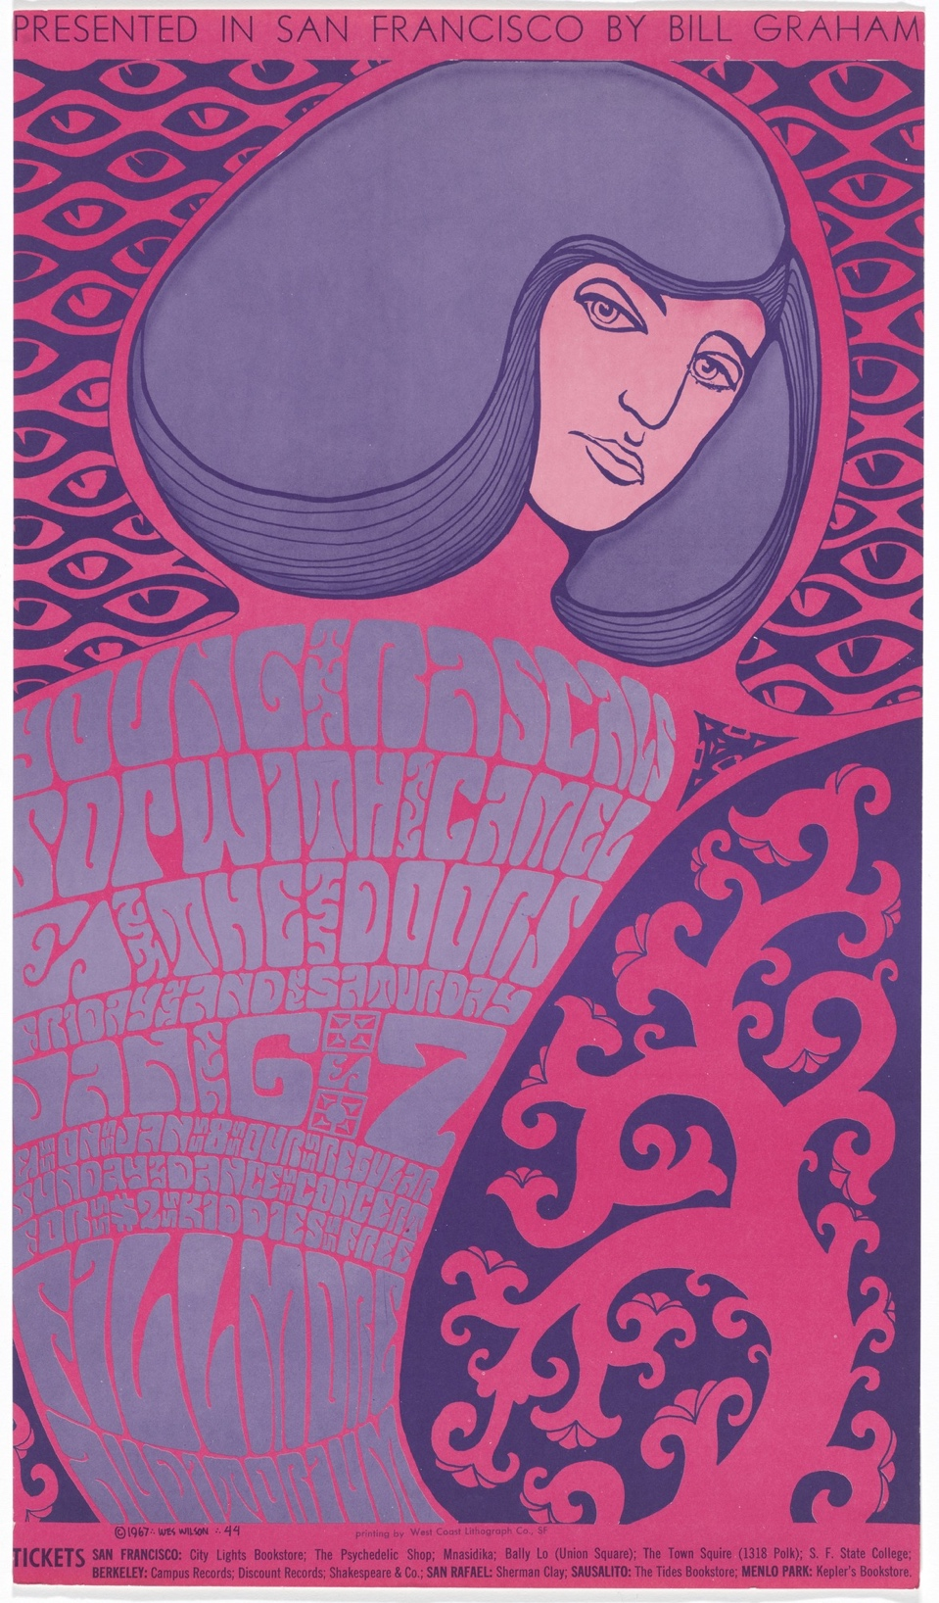
Figure.5- Wilson, 1967, The Doors

Bright pink and purple span the page of this poster, synonymous of colours one is said to experience when under the influence of LSD, the two colours being relatively similar creates a greatly unnatural feel but also a sense of intrigue as they aren’t usually seen beside one another. Curved lines sweep across the poster, giving a slightly warped sense of perspective, again using the visuals seen when taking psychedelics as inspiration giving a ‘distorted’ feel ‘as if seen in a curved mirror’ (Hofmann, 1980, pg.13). ‘One of the most iconic features of psychedelic rock posters of the era, particularly in terms of separating counterculture from straight culture, was the fonts used’ (Grimes, 2022, pg.3) which is evident in figure.5 as the font switches from being elongated to exceptionally squashed, with only small amounts of space between the letters. This style of font was created on purpose in order to force viewers to have to spend time looking at the poster and deciphering it to be able to gather the information embedded within, which was done to counteract the fast paced nature of society at the time and be seen as ‘a direct act of rebellion against the advertisements of the 1950s and early 1960s, which were designed to be read instantaneously, often from the window of a moving vehicle’ (Grimes, 2022, pg.3). Although the psychedelic posters of the 1960’s may seem to be mainly influenced by the colours and visions experienced when taking LSD, this is not entirely the case, as when you strip back the bold colours and take away the font, you are left with an image that is entirely reminiscent of an art nouveau piece. The art nouveau movement emerged in the late 1800’s, around the time where there were great technological advancements happening across Europe after the end of the Industrial Revolution in 1840. Recognised by highly decorative floral motifs and female figures, both of which are prominent in the posters of the 1960’s, highlighting the influence, not only of culture from the 1960’s, but culture in general on art.

Conclusion
The shift from the start of the 1960’s to the end was monumental in more ways than one, it was solely a decade for change and liberation amongst the younger generations, ‘the alienated young are giving shape to something that looks like the saving vision our endangered civilisation requires’ (Roszak, 1969, pg.1). Pushing for much needed change in culture allowed people to question how their society had been constructed for the past few decades, leading to criticisms within the media, psychology, the government and treatment of minority groups, all things that led to art being created in order to move away from these views. Causing the 60’s to not only be a decade of change within society, but a decade in which the art world advanced greatly, where new ideas and visuals were being put forwards that had deeper meanings than just their visual worth, showing how the 1960’s had a significant affect within the art world.

Bibliography
Rosenstone, R.A. (1969). ‘The Times They Are A-Changin’’: The Music of Protest. The Annals of the American Academy of Political and Social Science, [online] 382, pp.131–144. Available at: https://www.jstor.org/stable/1037121?searchText=music+and+art+in+the+1960%27s&searchUri=%2Faction%2FdoBasicSearch%3FQuery%3Dmusic%2Band%2Bart%2Bin%2Bthe%2B1960%2527s&ab_segments=0%2Fbasic_search_gsv2%2Fcontrol&refreqid=fastly-default%3A4e80c2125dbb05c5af0f18c031d38165&seq=1 [Accessed 2 Dec. 2023].

‌ P, S. (2016). 1960s Art and the Age of Pop | Widewalls. [online] www.widewalls.ch. Available at: https://www.widewalls.ch/magazine/1960s-art.

Cohen, A. (2018). When Timothy Leary Got Artists to Take LSD. [online] Artsy. Available at: https://www.artsy.net/article/artsy-editorial-timothy-leary-artists-lsd.
‌
de Bertola, E. (1972). On Space and Time in Music and the Visual Arts. Leonardo, 5(1), p.27. doi:https://doi.org/10.2307/1572468.

‌ Averyt, W.F. (1971). The Philosophy of the Counterculture. Naval War College Review, [online] 23(7), pp.17–25. Available at: https://www.jstor.org/stable/44641214 [Accessed 15 Nov. 2023].

Alperson, P. (1980). ‘Musical Time’ and Music as an ‘Art of Time’. The Journal of Aesthetics and Art Criticism, 38(4), p.407. doi:https://doi.org/10.2307/430322.

‌ Thompson, B. (1978). Andre Malraux and the Artist’s Quest. Twentieth Century Literature, 24(3), p.408. doi :https://doi.org/10.2307/441281.

Frank, J. (1961). Andre Malraux: The Image of Man. The Hudson Review, 14(1), p.50. doi:https://doi.org/10.2307/3848665.
‌Lancaster, M. (1989). Andy Warhol Remembered. The Burlington Magazine, [online] 131(1032), pp.198–202. Available at: https://www.jstor.org/stable/883667.
Duchamp, M., French, 1887-1968 (n.d.). Bicycle Wheel. JSTOR. [online] Available at: https://www.jstor.org/stable/community.18118623 [Accessed 9 Dec. 2023].

Maizels, M. and Warhol, A. (2014). Doing It Yourself: Machines, Masturbation, and Andy Warhol. Art Journal, [online] 73(3), pp.5–17. Available at: https://www.jstor.org/stable/43188652 [Accessed 15 Dec. 2023].
‌Haskins, C. (1989). Kant and the Autonomy of Art. The Journal of Aesthetics and Art Criticism, 47(1), p.43. doi:https://doi.org/10.2307/431992.
‌ Pape, G.J. (1985). Marcel Duchamp. American Imago, [online] 42(3), pp.255–267. Available at: https://www.jstor.org/stable/26304017 [Accessed 10 Dec. 2023].

Warhol, A., 1928- (n.d.). Marilyn Monroe Diptych. JSTOR. [online] Available at: https://www.jstor.org/stable/community.13705744 [Accessed 15 Dec. 2023].
‌Adorno, T.W. and Gillespie, S. (1995). On Some Relationships between Music and Painting. The Musical Quarterly, [online] 79(1), pp.66–79. Available at: https://www.jstor.org/stable/742517.
‌ Garrett, A. (1972). On Space and Time in Art. Leonardo, 5(4), p.329. doi:https://doi.org/10.2307/1572588.
‌Bryan-Wilson, J. (2003). Remembering Yoko Ono’s ‘Cut Piece’. Oxford Art Journal, [online] 26(1), pp.99–123. Available at: https://www.jstor.org/stable/3600448.
‌ BRIGGS, J. (2012). Sex and the Girl’s Single: French Popular Music and the Long Sexual Revolution of the 1960s. Journal of the History of Sexuality, [online] 21(3), pp.523–547. Available at: https://www.jstor.org/stable/23322013.
‌Ashmore, J. (1977). Sound in Kandinsky’s Painting. The Journal of Aesthetics and Art Criticism, 35(3), p.329. doi:https://doi.org/10.2307/430292.
Pye, M. (1971). Syncretism and Ambiguity. Numen, [online] 18(2), pp.83–93. doi:https://doi.org/10.2307/3269648.
‌Alperson, P. (1992). The Arts of Music. The Journal of Aesthetics and Art Criticism, 50(3), p.217. doi:https://doi.org/10.2307/431230.
‌ Averyt, W.F. (1971). The Philosophy of the Counterculture. Naval War College Review, [online] 23(7), pp.17–25. Available at: https://www.jstor.org/stable/44641214.

‌ Artsy. (n.d.). Jonas Mekas - Biography, Shows, Articles & More. [online] Available at: https://www.artsy.net/artist/jonas-mekas?sort=-partner_updated_at [Accessed 15 Dec. 2023].

Bousalis, R. (2021). The Councilor: A Journal of the Social Studies The Councilor: A Journal of the Social Studies Misunderstood Misunderstood. Journal of the Social Studies, [online] 82(2). Available at: https://thekeep.eiu.edu/cgi/viewcontent.cgi?article=1186&context=the_councilor.
‌
VOX (2019). Where the 1960s ‘psychedelic’ look came from. YouTube. Available at: https://www.youtube.com/watch?v=9vuqI2v2IRs.
‌
www.youtube.com. (n.d.). Hippies, protests and music: The brief history of 1960s Counterculture. [online] Available at: https://www.youtube.com/watch?v=HRLPRMxFBw4.

‌ MoMA (2015). Robert Rauschenberg. [online] The Museum of Modern Art. Available at: https://www.moma.org/artists/4823.

americanhistory.si.edu. (n.d.). Lisa Law: The Counterculture. [online] Available at: https://americanhistory.si.edu/lisalaw/4.htm#:~:text=It%20%5Bthe%20counterculture%5D%20was%20an [Accessed 1 Dec. 2023].

‌ Widewalls (n.d.). The Counterculture Movement in Society and Art | Widewalls. [online] www.widewalls.ch. Available at: https://www.widewalls.ch/magazine/counterculture.

‌ Hoggard, L. (2016). The revolutionary artists of the 60s’ colourful counterculture. The Observer. [online] 4 Sep. Available at: https://www.theguardian.com/artanddesign/2016/sep/04/revolutionary-artists-60s-counterculture-v-and-a-you-say-you-want-a-revolution#:~:text=Along%20with%20Hapshash%20%26%20the%20Coloured [Accessed 1 Dec. 2023].

Allan, D. (2017). L’Art, le temps et la metamorphose: Un aspect revolutionnaire de la theorie de l’art d’Andre Malraux (Art, Time and Metamorphosis: A Revolutionary Aspect of Andre Malraux’s Theory of Art). Frankofoni. [online] Available at: https://openresearch-repository.anu.edu.au/handle/1885/170640 [Accessed 15 Dec. 2023].
‌
Popova, M. (2014). Kandinsky on the Spiritual Element in Art and the Three Responsibilities of Artists. [online] The Marginalian. Available at: https://www.themarginalian.org/2014/06/02/kandinsky-concerning-the-spiritual-in-art/.
‌
www.youtube.com. (n.d.). Thief to a Minister: Adventures of an Art Theorist Andre Malraux p1. [online] Available at: https://www.youtube.com/watch?v=GqZqxWkmb5k [Accessed 15 Dec. 2023].

‌ THE MAKING OF A COUNTER CULTURE. (n.d.). Available at: https://monoskop.org/images/b/b4/Roszak_Theodore_The_Making_of_a_Counter_Culture.pdf.

‌ Maslow, A.H. (1964). Toward a Psychology of Being. Philosophy and Phenomenological Research, 25(2), p.288. doi:https://doi.org/10.2307/2105414.

‌ www.bbc.co.uk. (n.d.). Andy Warhol’s America - Series 1: 1. Living the Dream. [online] Available at: https://www.bbc.co.uk/iplayer/episode/p0b5mq8s/andy-warhols-america-series-1-1-living-the-dream.

‌ Bousalis, R. (2021). The Councilor: A Journal of the Social Studies The Councilor: A Journal of the Social Studies Misunderstood Misunderstood. Journal of the Social Studies, [online] 82(2). Available at: https://thekeep.eiu.edu/cgi/viewcontent.cgi?article=1186&context=the_councilor.

‌ Lounging in the 60s. (n.d.). Lounging in the 60s: Technology and Consumerism in the 1960s. [online] Available at: https://scalar.usc.edu/works/mission-66/1960s-technology--consumerism [Accessed 15 Dec. 2023].
‌
Goodhart, C. (2020). A visual history of the television in England | Museum of the Home. [online] www.museumofthehome.org.uk. Available at: https://www.museumofthehome.org.uk/explore/stories-of-home/television-through-the-ages/.
‌
Browne, D. (2016). ‘For What It’s Worth’: Inside Buffalo Springfield Classic – Rolling Stone. [online] Rollingstone.com. Available at: https://www.rollingstone.com/music/music-features/for-what-its-worth-inside-buffalo-springfields-classic-protest-song-106435/.
‌
Houghton, C. (2023). Meaning Behind Buffalo Springfield’s Protest Anthem ‘For What It’s Worth’. [online] American Songwriter. Available at: https://americansongwriter.com/meaning-behind-buffalo-springfields-protest-anthem-for-what-its-worth/.
‌
www.youtube.com. (n.d.). Andy Warhol Explained: Cambell’s Soup Cans (1962). [online] Available at: https://www.youtube.com/watch?v=HqvELc2FSfE.
‌
Naumann, F.M. (2020). Marcel Duchamp’s ‘Bicycle Wheel’ Changed My Life. [online] Artsy. Available at: https://www.artsy.net/article/artsy-editorial-artwork-changed-life-marcel-duchamps-bicycle-wheel.
‌
Marcuse, H. (1964). One-dimensional man : studies in the ideology of advanced industrial society. London: Routledge.
‌
Tate (2018). What Was Andy Warhol Thinking? – Look Closer | Tate. [online] Tate. Available at: https://www.tate.org.uk/art/artists/andy-warhol-2121/what-was-andy-warhol-thinking.

‌ Stanger, A. (2021). ‘Moral Panic’ in the Sixties: The Rise and Rapid Declination of LSD ‘Moral Panic’ in the Sixties: The Rise and Rapid Declination of LSD in American Society in American Society. [online] Available at: https://ir.library.louisville.edu/cgi/viewcontent.cgi?article=1072&context=tce.

Lounging in the 60s. (n.d.). Lounging in the 60s: Technology and Consumerism in the 1960s. [online] Available at: https://scalar.usc.edu/works/mission-66/1960s-technology--consumerism.

‌

‌

‌

‌

‌

‌

‌

‌

‌

‌

‌

