Consulting Report for Holiday Inn Express London – Stratford


Delivered on: 6th December, 2022
Name:
Mohammed Mamunur Rashid
Student ID: 2012546
Module Name & Code:
Organisational Consultancy (BMIH6005)
Tutor: Laurence Blake
Delivered to: General Manager

Submission Date: 9th December, 2022


Table of Contents
Executive Summary 3
Introduction 7
Scope and analysis 8
PESTEL analysis 9
SWOT analysis 11
Main Body 13
Analyzing issues 13
Initiatives to be taken 15
Strategic Analysis 18
Findings and results 20
Action plan 24
Recommendations 26
Conclusion 27
References 28

Executive Summary
The Holiday Inn Express London-Stratford is one of the popular choice among travelers looking for a comfortable, convenient, and modern hotel in the heart of Stratford. It has a convenient location, close to both Stratford Station and the Olympic Park, and excellent amenities for guests. Despite the impacts of COVID-19, this hotel has been doing pretty well due to its affiliation with the Intercontinental Hotels Group (IHG), which operates a broad portfolio of hotels and resorts catering to the middle-scale, upmarket, and luxury segments of the hospitality industry (Spanaki et al., 2021). According to Booking.com, travelers gave the hotel an average rating of 8.4, with a rating of 9 for the staff and a rating of 8.5 for the location.
The hotel has hired Boston Consulting Group to conduct an in-depth analysis of its current state and make recommendations for improvement. Problems with the room, bathroom, bar, parking, service at the front desk, refunds, and breakfast are among the first to surface in consumer evaluations posted on various hotel booking websites. Therefore, exterior and internal environmental evaluations have been carried out prior to the actual issues being investigated by attending the hotel (López-Andreu et al. 2019). The external context has been proven to have an effect on the hotel through a PESTEL analysis. Multiple shifts in the hospitality industry have been traced back to COVID-19 and Brexit. There has been a decrease in the number of available workers as a result of recent reforms to occupational health and safety regulations, immigration policy, minimum wage laws, and other related policies (Kirby, 2020). Uncertainty about one's future employment prospects in the hotel industry has grown. There was a global furlough affecting 15% of Holiday's staff. Holiday Inn Express London-Stratford, as a service-based business, relies on a dedicated staff that pulls together to achieve its objectives (Collins and Perret, 2015.). This report has analyzed any potential problems with inspiring employees because their happiness has a direct impact on customer satisfaction.
A SWOT analysis was also done on the hotel to figure out what its weaknesses and strengths are, as well as what its threats and opportunities are (Lin, 2016). Brand values, a well-established hotel, a convenient location, a friendly atmosphere, reasonable pricing, environmental sustainability, improved services, and new technologies are some of the strengths and opportunities for the hotel. The hotel can utilize the facts to attain the targeted goal for them. On the other hand, lower publicity, lower customer engagement, less differentiation of services, post-COVID effects, intense competition, and political factors are some of the weaknesses and threats for the hotel that need to be tackled to have customer satisfaction and to retain the existing customers (Seyitoğlu and Ivanov, 2020).
The issues were prioritized in accordance with the relative importance of the duties. The hotel's goals, plans, actions, and controls have all been laid out using the SOSTAC model, a tactical management solution, before they were ranked. The relative rankings of the various endeavors are shown below (Tufail, 2021):
- The hotel should fix the issues first that are related with the direct service of the customers like room related issues.
- Then the issues regarding the bathrooms should be fixed making sure that all the fittings have no flaws.
- Staff training in areas such as providing quick room service, regular housekeeping, and engaging customers at the front desk should be ensured.
- The hotel should schedule in-depth interviews with workers, managers, and executives to learn what drives them.
- The infrastructural developments in parking area and breakfast area should be completed in planned time so that customers get their expected service.
- The internal issues regarding the services, breakfast, refund and parking should be looked at next.
- In terms of excellent service to the guests, it is necessary to hire smart, hardworking, and personable staff members.
- Lastly, the issues regarding the bar set up should be fixed making the bar an attractive place for the visitors.
After analyzing feedback from previous guests and conducting an internal audit of the hotel, each individual step has been pinpointed. Individual conversations with staff members have also been useful in revealing hotel problems. COVID-19 has been proven to be the cause of a severe labor shortage since many qualified workers have quit their jobs. As a result, staff morale is low, and service to customers is poor (Goibibo.com, 2022). Improvements and adjustments to the building's infrastructure are also required, including to the guest rooms, bathrooms, parking, dining, and lounge areas. Beyond that, the front desk, refund policy, and some of the staff members' methods of service need to be improved and modernized.
Eight separate action plans were developed after the issues were identified, and they will all be carried out as scheduled (García-Gómez et al., 2021). Here's an overview of the action plan of the problems with projected costs:
No. | Problem | Solution | Time Scale | Completion  Date | Planned  Budget
01 | Cold and wet rooms, small bed, hard pillow and bed, window problem. | Determining which areas of the residence require repair and stocking them with the required supplies. | 3 months | 25/02/2023
  £15,0000
02 | Water extraction problem, problematic shower equipment, door issue at bathrooms. | Locating and fixing malfunctioning bathroom fixtures and supplies. | 1 month | 25/12/2022 | £20,000
03 | Old lounge area | Updating renovating the lounge area with contemporary facilities. | 1 month | 25/12/2022 | £10,000
04. | Limited parking area with excessive charge | Expanding the parking area and revising the charge. | 3 months | 25/02/2023 | £100,000
05 | Breakfast | Expanding the area of serving, updating the menu and use of no plastics. | 2 months | 25/01/2023 | £50,000
06. | Bar set-up | Updating the menu with more attractive drinks and expansion of serving time. | 1 month | 25/12/2022 | £10,000
07. | Employee Shortage and management | Bringing in, training, and fostering new personnel. | 2 months | 20/02/2023 | £55,000
08. | Refund | Ensuring smooth cancellation and refund procedures (within 3 working days). | 1 month | 25/12/2022 | £5,000

This is a plan for the next three months, and its timelines will vary from job to job. The impending Abba event in 2023 serves as the primary motivation for this timetable, which aims to resolve all outstanding maintenance and repair issues. Therefore, it would be simpler to fulfill organizational objectives of attracting and maintaining visitors at the Hotel Holiday Inn Express London-Stratford and turning them into devoted clients if the strategy is followed correctly while ensuring staff involvement and motivation (Ozil and Arun, 2022).

Introduction
The Holiday Inn Express London Stratford is well located, just few minutes' walk from Stratford Railway Station. This contemporary hotel has a wide range of amenities, including meeting rooms, easy check-in and check-out, and a 24-hour front desk (Booking.com, 2022). The trendy hotel has a safe, a currency exchange, and a place to store your bags. Staff members who speak multiple languages are also available to help. This contemporary 3-star hotel features rooms with flat-screen TVs and on-demand movies. Room amenities include fax machines, sitting areas, and suite bathrooms with showers. A variety of restaurants may be found in the neighbourhood as well. Since the Holiday Inn Express London Stratford is located so close to the Stratford High Street DLR Station, visitors will have an easy time getting around the city and its surrounding areas (Tripadviosr, 2022). The motel is conveniently located near the Olympic Stadium. Despite making a full recovery from COVID-19's impacts, the hotel is still having trouble staffing and servicing its guests (Siddiqui, 2020). The main purpose of this study is to examine the problems that arise at the hotel and lead to dissatisfied guests, identify their sources, detail the various factors that contribute to those sources, and provide an analysis of the solutions that are most likely to be successful. The hotel's strengths have been evaluated alongside its weaknesses in order to find new ways to better meet the needs of its guests and leave a pleasant impression on them (Jayapalan, 2001). To assure client happiness and loyalty, the hotel has hired Boston Consulting Group as a consultant to analyse guest and employee feedback and pinpoint the hotel's most pressing problems. This study will use PESTEL analysis to determine the issue and provide an outside perspective on the conditions under which the hotel functions (Gregoric, 2014). Moreover, SWOT analysis will be used to further examine the hotel's advantages, disadvantages, threats, and chances. External and internal research will build off of these two analyses, providing a more complete picture of the situation at hand and the potential for growth in the future (Enz, 2012). In addition to the business strategy cascade, the SOSTAC model, a scenario toolbox, will be used to determine the nature of the problem and the best course of action. In order for the hotel to attract and retain a greater number of satisfied clients, who are more likely to stay at the establishment on subsequent visits and who are more likely to provide constructive criticism, these models and techniques will be helpful (Ham and Han, 2013).

Scope and analysis
The Holiday Inn Express London-Stratford is situated in the east of the capital of the United Kingdom, close to the Olympic Park, and it has been awarded three stars. The atmosphere at this hotel is bright and contemporary, and it stands out in a modern setting. In addition, this hotel is in an excellent location with respect to Westfield Stratford, the O2 Arena, and the ExCel Conference Center. It is one of the hotels owned and operated by the Intercontinental Hotels Group (IHG). Every year number of guests visit the hotel to attend Abba concert in London (IHG, 2022).
The hotel was built in 2002 and was renovated in 2010. Thus, the hotel is serving for almost 20 years. The Holiday Inn Express London-Stratford is a 6-story, family-friendly hotel with more than 153 modern rooms. In addition to a flat-screen TV, other amenities in the accommodation include a telephone, a guest bedroom, a desk, and Wi-Fi. In the private bathroom, visitors will find a shower and free toiletries. Cribs are available on request, and the space may be made more adaptable with the use of daylighting, temperature control, and blackout shades. Up to 80 persons may be accommodated in the hotel's five adaptable, air-conditioned conference rooms (Hotelscombined.com, 2022).
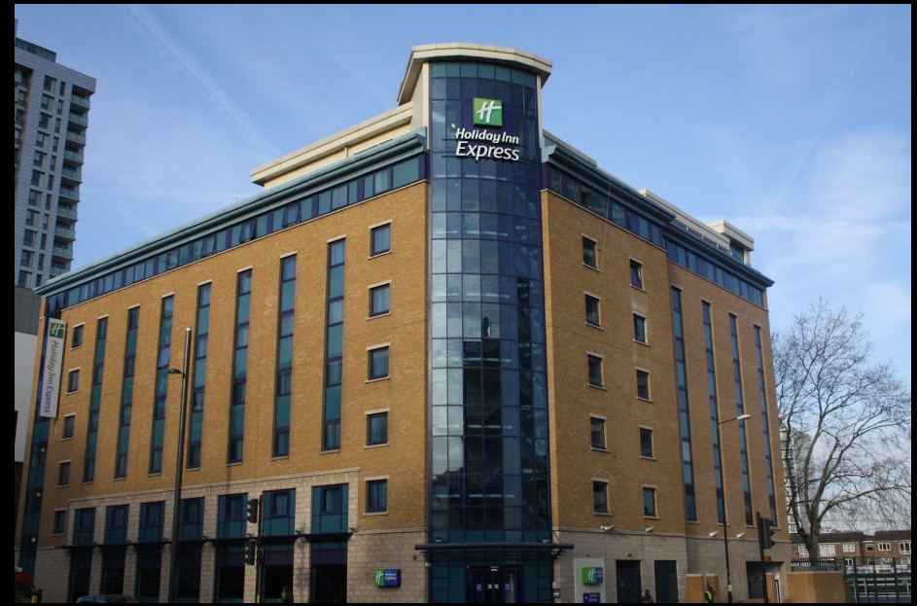
Figure-01: Hotel Holiday Inn Express (IHG, 2022)
The hotel is well reputed for its modern rooms and friendly atmosphere. According to the reviews of the customers on online platforms (such as tripadvisor.com and booking.com), sometimes the customers are facing difficulties regarding food, bar-related issues, internet access, noise issues, narrow beds, etc. The hotel is also facing difficulties regarding marketing and revenue issues (Booking.com, 2022).

PESTEL analysis
Name of the factors | Particulars
Political | Brexit issue, recent Russia-Ukraine war, COVID-19 restrictions, , new immigration policies etc.
Economical | COVID-19 effect, global economic crisis, impact of Russia-Ukraine war, increase of inflation and unemployment rate etc.
Socio-cultural | Highly competitive, new players of market etc.
Technological | Modern facilities, new technologies, social-media engagement etc.
Environmental | Local considerations, CO2 emissions, eco-friendly activities, sustainability etc.
Legal | Innkeeper laws, truth-in-menu laws and Digital Economy Act (2010) etc.
Figure-02: PESTEL analysis of Hotel Holiday Inn Express London-Stratford (Author)
PESTEL Summary
Political factors: Since political events may have unforeseen and far-reaching consequences, businesses should regularly assess the political situation. The Brexit crisis has a negative effect on Holiday Inn Express London by reducing client volume. Because of COVID-19 in 2020, the UK government has imposed restrictions on hotels (Matovic, 2020). As a result, the hotel saw a precipitous drop in income that year. The UK government's new rules on immigration and the ongoing war between Russia and Ukraine have also had an effect on the hotel.
Economic factors: The post-impact outcomes of COVID-19 and the conflict between Russia and Ukraine in Europe had a detrimental effect on the economy of Europe as a whole. Because of these factors, the rate of inflation as well as the rate of unemployment have grown, which has finally caused a crisis on a worldwide scale (Rosenthal et al. The hotel is not immune to the effects that are being caused by such problems. Therefore, as a result of such shifts, it has had a detrimental influence.
Socio-cultural factors: In the hospitality business, there is a lot of cutthroat rivalry (Keogh-Brown et al., 2020). New market participants are entering the market and delivering services at prices that are competitive with those of their peers. As a socio-economic aspect, the hotel is also influenced by the expectations of the visitors as well as the lifestyles that they lead.
Technological factors: The hotel offers contemporary amenities in the guest rooms, including access to the internet and a contemporary aesthetic, among other such features (Yan, 2021). In addition to that, it makes use of various forms of digital software, such as Frontdesk and StayNTouch Cloud PMS. The newest technology in the hotel business are being used in order to participate in social media activities.
Environmental factors: The Holiday Inn Express Hotel has a great deal of worry for the realities of the environment. It is taking into account the environment in the immediate area and working toward reducing its carbon emissions to the greatest extent practicable by the year 2030 (Nicola et al., 2020). The hotel takes environmental concerns very seriously. It conducts its operations using methods that are environmentally friendly.
Legal factors: The Digital Economy Act of 2010 has an effect on almost all aspects of the hotel industry. The hospitality industry in the UK is one that the government works hard to encourage and advance. The Holiday Inn Express London is quite familiar with the legislation governing innkeepers as well as the laws governing the disclosure of ingredients on menus (Tanford et al., 2012).

SWOT analysis
The SWOT matrix for the Holiday Inn Express London-Stratford is as follows (Aldehayyat, 2011):
Strengths  - Brand Value  - Well-established  - Convenient location  - Reasonable pricing  - Having experience  - Friendly atmosphere  - Versatile facilities | Opportunities  - Environment sustainability  - Online booking  - Flexible pricing  - Improved service  - Use of new technologies
Weaknesses  - Lower publicity  - Lower customer engagement  - Lack of online response  - Less diversification of services  - Poor catering review  - Outdated website | Threats  - Political factors  - Post-COVID effects  - Intense competition  - Global economic crisis
Figure-03: SWOT analysis of Hotel Holiday Inn Express London-Stratford (Author)
SWOT Summary
Strengths: The Holiday Inn Express London-Stratford first opened its doors in 2002 and has garnered a positive reputation since then. It is a member of the Intercontinental Hotels Group (IHG), which is a hotel chain that enjoys a significant reputation and brand value in the industry. The hotel is also well-known for its affordable rates and the fact that it has a convenient location. The hotel features a variety of convenient amenities. At the Holiday Inn Express London-Stratford, the hotel's boardrooms as well as its training rooms are equipped with high-speed access to the Intercontinental Hotels Group (IHG), which is a hotel chain that enjoys a significant reputation and brand value in the industry. The hotel is also well-known for its affordable rates and the fact that it has a convenient location. The hotel features a variety of convenient amenities (Rosenthal et al., 2020. At the Holiday Inn Express London-Stratford, the hotel's boardrooms as well as its training rooms are equipped with high-speed access to the Internet. Comfortable public rooms equipped with air conditioning may serve as venues for the facilitation of currency exchange. After a long day of sight-seeing, hotel guests can unwind with a drink in the hotel's cocktail lounge or a meal in the Great Room restaurant. All of these are qualities that make the hotel stand out.
Weaknesses: There are also some problems occurring on the property's internal level. It receives a lower amount of publicity both online and offline compared to its rivals (Aldehayyat, 2011). The hotel does not have a strong reputation for providing prompt online responses and engaging with customers, both of which are necessary to maintain a loyal customer base. Inadequate catering and a website that has seen better days are two more of the hotel's flaws.
Opportunities: The hotel is making efforts toward environmental sustainability, which presents a potential opportunity for the establishment to draw in new guests (Vaughan and Daverio, 2016). Other opportunities for the hotel to bring in new customers and keep the ones it already has, such as online booking, a flexible pricing structure, and improved services, can come in the form of improvements to the hotel's offerings. The hotel's adoption of cutting-edge technology may also represent a significant step forward for the establishment.
Threats: There are also some dangers that come from outside that could affect the hotel. The most recent political unrest in Europe, the global economic crisis as a result of post COVID's impacts, and the ongoing war between Russia and Ukraine are the three most significant dangers for the hotel. Those are the serious and potential factors to decrease the number of guests staying at the hotel, which could have a detrimental effect on the establishment (Avdimiotis et al., 2009). The other danger is the cutthroat competition that exists within the sector. There are already quite a few hotels open for business in east London, and additional competitors are also beginning to enter the industry. It demonstrates the breadth of the competition in that industry.

Main Body

Analyzing issues
Even though the Holiday Inn Express London-Stratford is widely known for its convenient location, friendly atmosphere, contemporary amenities, and so on, there are certain negative concerns that can be identified based on the feedbacks from customers who have been at the hotel. Both positive and negative issues regarding the hotel have been addressed below (Hotelscombined.com, 2022):
Room issues: Many visitors remarked on how nice the rooms looked and how well equipped they were. The beds and cushions are quite relaxing for the guests. It appears that adequate lighting has satisfied their needs as well. However, there were negative issues with a few of the hotel's rooms. Guests had issues with the window (not functioning properly), the bed (too hard), the size of the room (too small), and the pillows (too hard). In the absence of these, the rooms' amenities appear to be excellent (Tripadvisor, 2022).
Bathroom issues: According to the reviews of the guests, the bathrooms of the hotel are well-spaced. The bathrooms were found neat and clean as well. But in some of the cases, there were water extraction problems, door problems, and some issues regarding the shower. Other than that, the bathrooms were quite good for the visitors (Batten, 2022).
Lounge issues: The lounge area of the hotel has a quite modern look. However, some visitors have suggested that the lounge area be updated to provide more natural light and amenities.
Parking issues: The parking lot is well-disciplined. But there are some constraints regarding the parking area. Some visitors criticized it for having insufficient parking in comparison to the size of the hotel and charging exorbitant parking fees.
Front desk issues: It appears that the service at the front desk is decent. The hosts provided a welcoming and inviting environment for the visitors. Some visitors, however, felt that the check-in process was cumbersome and time-consuming. Some guests claimed that the room assignments were made without sufficient communication (Johann, 2022).
Staff issues: The hotel's crew has earned a strong reputation for their impeccable behavior. They have good manners and are quite welcoming to the guests. However, in certain instances, there was a paucity of staff as well as a lack of professional gesture among those who were working there.
Breakfast issues: There is a lot of appreciation for the complimentary breakfast that is provided to the guests. However, it has received a lot of negative feedback from visitors due to the fact that it has a little space, a busy atmosphere, few varieties of items, and uses plastic cutlery.
Bar issues: The hotel's guests favored it over competing accommodations due to the hotel's well-kept and organized bar. In the bar, customers are greeted and served in a very friendly manner. On the other hand, a few of the visitors were dissatisfied with the limited drink menu and the fact that the bar was closed so early (Zamyatina and Solntseva, 2019).
Refund issues: The hotel's refund process runs smoothly, on the whole, in general. Within the allotted amount of time specified in the refund policy, the consumers are given their money back. Some of the guests had to wait longer than expected to receive their refunds, while others had trouble canceling their reservations and getting their money back.
Therefore, the Holiday Inn Express London-Stratford has both positive and negative aspects to their services as well as their infrastructures. In order to run the hotel in a more efficient manner and to achieve the happiness of the hotel's customers, the things that are working well simply need to be maintained, while the things that are not working well need to be altered (Cromarty and Barton, 2018). All the issues are not problematic. The problematic infrastructures and services should be changed and renovated. The infrastructures and services which need to be altered are summarized as follows:

Categories | Issues need to be altered
Room issues | Cold and wet, small bed, hard pillow and bed, window problem.
Bathroom issues | Water extraction problem, problematic shower equipment, door issue.
Lounge issue | Need of renovation.
Parking issues | Limited parking, expensive.
Front Desk issues | Late in check ins, lack of internal coordination.
Staff issues | Shortage of employees, unprofessional gesture
Breakfast issues | Small area, cramped and busy, less and dry items on menu and use of plastic cutlery.
Bar issues | Poor drink selection, lack of verities on menu and early closing.
Refund issues | Difficulties in cancellation of reservations, taking longer time in providing fund.
Figure-04: Summary of the issues (Author)

Initiatives to be taken
Room issues
During the time that guests are staying at the hotel, the temperature in some of the rooms does not get adjusted. All of the rooms need to have their heating checked to ensure that they are comfortable even when the temperature outside is low. It would be better to use larger beds in place of the smaller ones. The beds and pillows in the guest rooms should provide a better level of comfort for the guests. It must be ensured that all the windows in the rooms are functioning properly (Burley et al., 2022).
Bathroom issues
To begin, it is essential to check that all of the doors in the washrooms are operating as they should. It is necessary to make the necessary adjustments to the problematic shower, fittings, and other equipment. Last but not least, it is essential to ensure that water is extracted properly so that the spaces are not left damp.
Lounge issue
The lounge area should be renovated as soon as possible. Increases in the number of contemporary facilities ought to be made in that area.
Parking issues
There are only about 10 parking spaces at the hotel. It would be beneficial to expand the parking area. It is required that the rates for the parking lot be reevaluated so that guests do not consider them to be too expensive.
Front-Desk issues
It is necessary for the front-desk services to be provided in a timelier and responsive manner. In some situations, some guests arrived and found that it was too late to check in. The personnel need to be more coordinated with one another in order to provide the customers with the service they anticipate in the allotted amount of time.
Breakfast issues
The majority of the hotel's visitors expressed concern about the condition, and as a result, the breakfast area needs significant revision. It is necessary to increase the size of the breakfast area to ensure that guests have a pleasant time eating breakfast. Additionally, the number of people working in that division ought to increase. The menu absolutely must be updated to provide more suitable options for food. When food is being served, absolutely no plastic or other similar materials should be used in any way (Piso, 2022).
Bar issues
The menu was the primary source of criticism directed toward the bar. Taking into consideration the preferences of the guests, the menu needs to be updated. The menu ought to be expanded with other categories. For better accommodate the needs of the patrons, the bar's closing time may need to be extended.
Refund issues
When customers try to cancel reservations, they shouldn't have to deal with any kind of difficulty. The process ought to go more rapidly and effortlessly. The process of issuing refunds ought to be sped up so that guests do not experience any inconvenience while having their money returned to them.
Staff issues and development
Employees and customers' answers indicated a need for more workers in some service areas. Twenty-seven people make up the cleaning crew, for instance. There are 11 staff for corridors and the remaining are for bedrooms and bathrooms. There is not enough cleaning and maintenance employees to meet demand. Many of the present cleaning personnel were hired after January,2022 and have no relevant experience, thus they also lack the required training. Consequently, fresh faces are required to ensure the smooth operation of the hotel (Musavengane, 2019).
The front desk staff and various departments are famous for their helpful attitude. However, there was an occasional lack of a professional approach on the part of some personnel. These measures can be implemented to ensure that personnel are adequately developed.
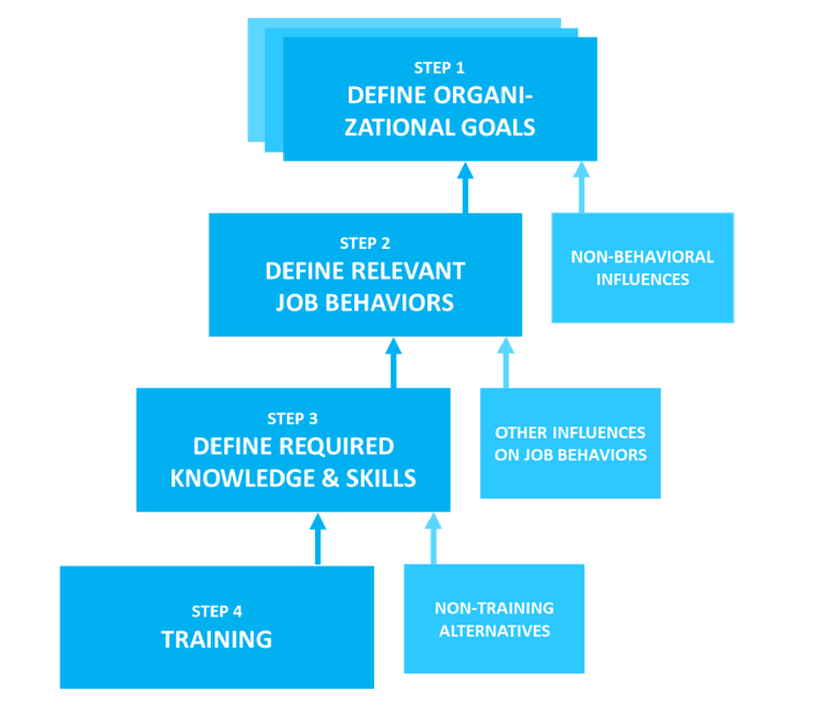
Figure-05: Staff development procedure for Holiday Inn Express London (Hooper, 2022)
So, in order to achieve the desired results from its employees, Holiday Inn Express London-Stratford must invest more in training and development. For an organization to effectively serve its clients, its management must establish clear objectives. After that, employees need to learn the appropriate abilities and attitudes to demonstrate on the job. Staff members should attend training programs to ensure they are equipped to provide excellent service.

Strategic Analysis
The SOSTAC model provides assistance in determining the primary issues at hand and in recognizing the goals that constitute the organization's active and realizable missions. Plans for strategies, plans, and actions are devised on the basis of the objectives in order to bring the circumstance under control and to solve the problems that have been identified. The SOSTAC model is broken down as follows:
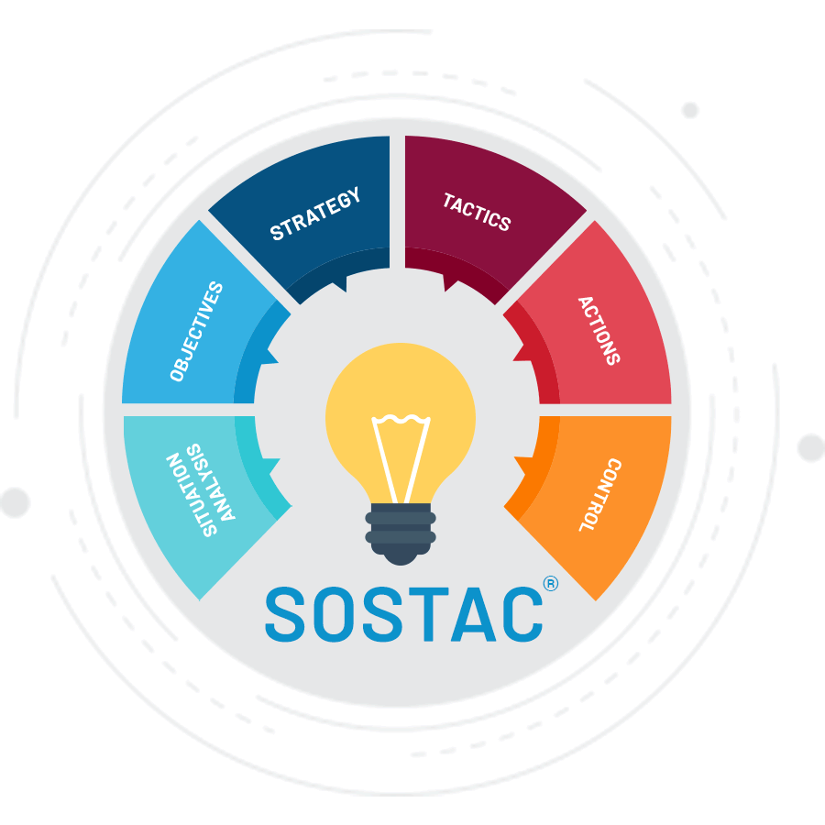
Figure-06: SOSTAC model (SlideBazar, 2022)
Situation Analysis
There are a lot of excellent reviews for this hotel, but there are also some complaints about the hotel's lack of employees, the quality of the breakfast, the price of parking, and other concerns with the rooms, the bathrooms, and the fittings. These problems have been addressed, and it is anticipated that they will be resolved within the next four months.

Objectives
To find solutions to the problems within the next four months so that Holiday Inn Express can earn the loyalty of 93% of its guests (Guix et al., 2019).
Strategy
The problems that were experienced with the rooms, the staff, the restrooms, the bar, the parking, and the lounge area have all been addressed and will be resolved using the appropriate tactics and procedures. The problems will be fixed using the strategies that have been chosen to make sure that customer satisfaction goes up.
Tactics
Setting together a plan of action, dividing up resources, allocating resources, and responding to detailed feedback from staff.
Actions
Delegating tasks to the appropriate workers, such as managers, who will respond quickly to the first survey. The next step is to organize how new staff members will be hired and brought on board. Lastly, make sure that all of the necessary stages have been strictly followed in order to achieve the best possible results (Mitchell et al., 2015).
Control
Keeping an eye on everything, laying down the rules (both procedural and service-related), and checking in on how well things are doing. Getting this done will take at least 7-8 months.

Findings and results
The scope of the study details the many strengths of the Holiday Inn Express London-Stratford Hotel, which have contributed to the establishment of a solid reputation among travelers. Guest reviews often praise the hotel's helpful front desk staff, complimentary breakfast, cozy vibe, convenient location, and comfortable, up-to-date accommodations. The most important outcomes and discoveries are summarized by topic below (Penner, 2013).
Room issues
Immediately taking punitive measures to repair any broken fixtures or untidy rooms is a top priority. Those guest rooms that are not causing any problems for the visitors during their stay will not have any changes or improvements made to them. However, rooms that have been complained about by the guests will be prioritized for maintenance (Bresciani et al., 2015).
Particulars | Findings
Room issues | - It may take up to 2 months to finish the task, during which time rooms with lower heating levels will maintain a temperature that is comfortable.  - New beds need be replaced with the more spaced ones which can be done within 3 months.  - More comfortable bed system and pillow must be provided while changing them.  - Windows need to be checked and renovated within 1 month.

Bathroom and fittings
The functionality of each and every restroom will be evaluated before the inspection is complete. The difficult problems will be resolved in accordance with the activities that have been done. The results of the investigation are provided in the table that may be found below.

Particulars | Findings
Bathroom and fittings | - Water extraction problem of some bathrooms must be solved urgently.  - New fittings can be set up within 1 month for the replacement of the problematic ones,  - Problematic doors need to be replaced within 1 month.

Lounge issue
The lounge room gives the impression of being in good shape, despite the fact that it need updating to include more contemporary amenities.
Particulars | Findings
Lounge issue | - Lounge needs to be renovated considering the demands of the guests within 3 months.  - Lounge can be facilitated with modern equipment within 3 months.

Parking issues
The findings of the issues regarding the parking are as follows:
Particulars | Findings
Parking issue | - Needs to increase the parking space as early as possible.  - Needs to provide at least 10 more parking slots.  - The parking fees should be revised within 1 month so that guests do find it expensive.

Front-Desk issues
This hotel's front desk has a stellar reputation for its friendly service among guests. However, there is a problem with the number of personnel and the level of their internal communication. The following is what was discovered:
Particulars | Findings
Front-desk issues | - Needs one additional staff for serving the guests.  - Internal coordination must be increased within one month.  - Needs to be more active while serving the guests.

Staff issues and management
Brexit and the COVID-19 outbreak have created an uncertain time for the UK hotel industry. After Brexit, changes were made to UK immigration rules, which contributed to a rise in the country's unemployment rate. There was a scarcity of qualified workers in the hospitality industry during COVID-19 because 335,000 people quit their jobs and went back home (Napierała et al., 2020). Holiday Inn Express employees share the concerns of the general public about recent compensation cuts, job insecurity, and frequent legislative changes. In order to provide enough amenities for their staff, the hotel's management must first understand their point of view. Issues with the hotel staff that have been identified are as follows:
Particulars | Findings
Staff issues and management | - There needs to be a better emphasis on and dissemination of retention programs, vacation policies, and performance reviews.  - Need to provide workers the monetary and non-monetary support they require.  - Need to hire new employees.  - Need of arranging workshops and training sessions during the changing period.

Breakfast issues
Based on the issues that have been discovered earlier, the breakfast findings are as follows:

Particulars | Findings
Breakfast issues | - Need to expand the serving area so that 20 more guests can have their breakfast together.  - Need to add five to ten more items.  - Use of plastics can be abandoned within one month.  - The chef of cooking can be changed for better test.

Bar issues
The summary of the findings of the bar issue is as follows:
Particulars | Findings
Bar issues | - Need to have variant drinks in the menu.  - Customer demands must be acknowledged while choosing items.  - Bar can be opened till 1 am to night.

Refund issues
The followings can be found regarding the refund issues of the hotel:
Particulars | Findings
Refund issues | - Need to smooth the cancellation of the reservations.  - The guests should get their fund within 3 working days.

In sum, it's important to develop a comprehensive strategy for securing the involvement of all relevant staff members. Many guests' complaints have to do with the quality of the hotel's services, which can be improved if workers have a strong sense of belonging and security there. The new plan of action should be proposed after an in-depth discussion of the employees' thoughts on the current leadership model, management structure, etc. The entire hiring, onboarding, and training process can be wrapped up in three months if this one-month goal is met (Weed, 2007). Better customer service and brand loyalty are both outcomes that can be secured by encouraging and rewarding employee participation.

Action plan
The following table details the issues, the proposed remedies, and the required time period for completing the work. Furthermore, the predicted costs for each activity are displayed (the numbers represent hypothetically calculated estimates) (Górska-Warsewicz and Kulykovets, 2020):
No. | Problem | Solution | Desired Outcome | Time Scale | Completion  Date | Planned  Budget
01 | Cold and wet rooms, small bed, hard pillow and bed, window problem. | Determining which areas of the residence require repair and stocking them with the required supplies. | Leaving a good impression with visitors and encouraging brand loyalty. | 3 months | 25/02/2023
  £15,0000
02 | Water extraction problem, problematic shower equipment, door issue at bathrooms. | Locating and fixing malfunctioning bathroom fixtures and supplies. | Facilitation of the customer experience and favourable feedback. | 1 month | 25/12/2022 | £20,000
03 | Old lounge area | Updating renovating the lounge area with contemporary facilities. | Guaranteeing customers that their comments and suggestions have been carefully considered. | 1 month | 25/12/2022 | £10,000
04. | Limited parking area with excessive charge | Expanding the parking area and revising the charge. | Facilitate the experience for visitors. | 3 months | 25/02/2023 | £100,000
05 | Breakfast | Expanding the area of serving, updating the menu and use of no plastics. | Customer appreciation through treating them like they're the most important part of the business. | 2 months | 25/01/2023 | £50,000
06. | Bar set-up | Updating the menu with more attractive drinks and expansion of serving time. | To ensure the best service for the bar customers. | 1 month | 25/12/2022 | £10,000
07. | Employee Shortage and management | Bringing in, training, and fostering new personnel. | Enhancing existing customer service. | 2 months | 20/02/2023 | £55,000
08. | Refund | Ensuring smooth cancellation and refund procedures (within 3 working days). | To increase customer satisfaction so that they reserve in future. | 1 month | 25/12/2022 | £5,000

Recommendations
Many problems and their remedies have been identified based on previous analysis. Though not every problem is equally pressing, some are more critical than others. Therefore, it's crucial to set priorities and order tasks in terms of priority. The hotel must take the following steps to win back loyal patrons by solving their problems (briggs et al., 2019):
- The hotel should fix the issues first that are related with the direct service of the customers like room related issues.
- Then the issues regarding the bathrooms should be fixed making sure that all the fittings have no flaws.
- Staff training in areas such as providing quick room service, regular housekeeping, and engaging customers at the front desk should be ensured.
- The hotel should schedule in-depth interviews with workers, managers, and executives to learn what drives them.
- The infrastructural developments in parking area and breakfast area should be completed in planned time so that customers get their expected service.
- The internal issues regarding the services, breakfast, refund and parking should be looked at next.
- In order to ensure excellent service to the guests, it is necessary to hire smart, hardworking, and personable staff members.
- Lastly, the issues regarding the bar set up should be fixed making the bar an attractive place for the visitors.

Conclusion
This consulting study was made for the Holiday Inn Express London-Stratford, which has an excellent reputation due to its location, the courteous behavior of its staff, the complimentary breakfast service, and the room facilities it provides. Our Boston Consultancy Group was given the opportunity to be nominated as the consulting business to handle the existing and potential difficulties of this hotel, and as a result, we have identified a significant number of problems that need to be resolved (Camilleri, 2018). The hotel's strategic location makes it the ideal base from which to go on foot or two-wheeled adventures throughout the city of London. In addition, it is advantageous to go to the Abba concert every single year. According to the reviews left by previous customers, this establishment deserves praise for its high-quality customer support and front-desk control system. On the other hand, this hotel is experiencing some difficulties due to a lack of employees, room service, bathrooms, parking, breakfast, a bar, and a policy for refunds (Benstead et al., 2021).
This paper describes the renovation and service development strategy in anticipation of the 2023 Abba concert, allowing management to prioritize tasks accordingly. Because fixing the equipment and fixtures may be done ahead of time and will make a favorable impression in the hearts of the visitors, these need to be attended to first. The problem of keeping the rooms clean is therefore resolved by establishing a routine. Housekeeping staff should be quick and helpful so that they may be summoned whenever needed (Anagblah, 2019). Hiring a team with the right mix of experience, outlook, and energy may help with any HR problem. Employee retention is crucial, so conducting one-on-one interviews to gauge employee enthusiasm is a smart move. Additional infrastructure improvements need to be finished on schedule. Employees will be more driven to provide excellent service to guests if they are regularly evaluated, rewarded for their efforts, and encouraged to take ownership of the company's goals through employee engagement programs (Cromarty and Barton, 2018).

References
Aldehayyat, J.S., 2011. Organisational characteristics and the practice of strategic planning in Jordanian hotels. International Journal of Hospitality Management, 30(1), pp.192-199.
Aldehayyat, J.S., Al Khattab, A.A. and Anchor, J.R., 2011. The use of strategic planning tools and techniques by hotels in Jordan. Management Research Review.
Anagblah, D.A., 2019. Strategic marketing plan for Hill View Guest Centre, Abokobi.
Avdimiotis, S., Bonarou, C., Dermetzopoulos, A., Karamanidis, I., Mavrodontis, T., Kelessidis, V. and Kalonaki, E., 2009. Global SWOT Analysis. Technical University of Crete, p.48.
Batten, M., 2022. London's Transport and the Olympics: Preparation, Delivery and Legacy. Amberley Publishing Limited.
Benstead, A.V., Hendry, L.C. and Stevenson, M., 2021. Detecting and remediating modern slavery in supply chains: a targeted audit approach. Production Planning & Control, 32(13), pp.1136-1157.
Booking.com (2022). ★★★ holiday inn express London Stratford, an IHG Hotel, London, UK Available at:https://www.booking.com/hotel/gb/hiexpress.engb.html? aid=356980&amp; label=gog235jc1FCA0oUEIJaGlleHByZXNzSDNYA2gUiAEBmAEJuAEXyAEM2AEB6AEB-AEMiAIBqAIDuALpw_abBsACAdICJDExNWQ0N2M2LWFmNGMtNGI4Yy05YmFhLTFhMjhiZjBhNmM0MtgCBuACAQ&amp;sid=7335c8790a06ace3324fffb2d6e8e8fa(Accessed: November 25, 2022).
Bresciani, S., Thrassou, A. and Vrontis, D., 2015. Determinants of performance in the hotel industry. An empirical analysis of Italy.
Briggs, V., Davies, S. and Wilkie, M., 2019. International variations in peritoneal dialysis utilization and implications for practice. American Journal of Kidney Diseases, 74(1), pp.101-110.
Burley, J., Samir, N., Price, A., Parker, A., Zhu, A., Eapen, V., Contreras-Suarez, D., Schreurs, N., Lawson, K., Lingam, R. and Grace, R., 2022. Connecting Healthcare with Income Maximisation Services: A Systematic Review on the Health, Wellbeing and Financial Impacts for Families with Young Children. International Journal of Environmental Research and Public Health, 19(11), p.6425.
Camilleri, M.A., 2018. Strategic planning and the marketing effectiveness audit. In Travel marketing, tourism economics and the airline product (pp. 117-135). Springer, Cham.
Collier, P. and Gregory, A., 1995. Strategic management accounting: a UK hotel sector case study. International Journal of Contemporary Hospitality Management.
Collins, S. and Perret, S., 2015. Decisions, decisions... Which hotel operating model is right for you?. HVS consulting report.
Council, F.R., 2019. Developments in audit 2019. London, UK: FRC.
Cromarty, H. and Barton, C., 2018. The growth in the short-term lettings (England).
Enz, C.A., 2012. Competing successfully with other hotels: The role of strategy. The Cornell School of Hotel Administration on hospitality: Cutting edge thinking and practice, pp.207-226.
Enz, C.A., 2012. Competing successfully with other hotels: The role of strategy. The Cornell School of Hotel Administration on hospitality: Cutting edge thinking and practice, pp.207-226.
García-Gómez, C.D., Demir, E., Díez-Esteban, J.M. and Bilan, Y., 2021. The impact of COVID-19 outbreak on hotels’ value compared to previous diseases: the role of ALFO strategy. Heliyon, 7(8), p.e07836.
García-Gómez, C.D., Demir, E., Díez-Esteban, J.M. and Bilan, Y., 2021. The impact of COVID-19 outbreak on hotels’ value compared to previous diseases: the role of ALFO strategy. Heliyon, 7(8), p.e07836.
Gardetti, M.A. and Torres, A.L. eds., 2017. Sustainability in Hospitality: How innovative hotels are transforming the industry. Routledge.
Goibibo.com (2022) Hotel London at ₹ 7002 - Reviews, Photos & Offer. Available at: https://www.goibibo.com/hotels-international/holiday-inn-express-london-stratford-hotel-in-london-4586442817996587075/ (Accessed: November 20, 2022).
Górska-Warsewicz, H. and Kulykovets, O., 2020. Hotel brand loyalty—A systematic literature review. Sustainability, 12(12), p.4810.
Gregoric, M., 2014. PESTEL analysis of tourism destinations in the perspective of business tourism (MICE). In Faculty of Tourism and Hospitality Management in Opatija. Biennial International Congress. Tourism & Hospitality Industry (p. 551). University of Rijeka, Faculty of Tourism & Hospitality Management.
Guix, M., Font, X. and Bonilla-Priego, M.J., 2019. Materiality: stakeholder accountability choices in hotels’ sustainability reports. International Journal of Contemporary Hospitality Management.
Ham, S. and Han, H., 2013. Role of perceived fit with hotels’ green practices in the formation of customer loyalty: Impact of environmental concerns. Asia Pacific Journal of Tourism Research, 18(7), pp.731-748.
Han, H., Yu, J. and Kim, W., 2019. Environmental corporate social responsibility and the strategy to boost the airline’s image and customer loyalty intentions. Journal of Travel & Tourism Marketing, 36(3), pp.371-383.
Hemsley-Brown, J. and Alnawas, I., 2016. Service quality and brand loyalty: the mediation effect of brand passion, brand affection and self-brand connection. International Journal of Contemporary Hospitality Management.
Hooper, A.L. (2022) Create an effective training and development program in 2022, Venngage. Available at: https://venngage.com/blog/employee-training-and-development/ (Accessed: November 25, 2022).
Hotelscombined.com (2022). Holiday Inn Express london - Stratford, London Available at: https://www.hotelscombined.com/Hotel/Holiday_Inn_Express_London_Stratford.htm (Accessed: November 25, 2022).
IHG (2022). Stratford Hotels near Olympic Park: Holiday Inn Express London – Stratford. Available at https://www.ihg.com/holidayinnexpress/hotels/us/en/london/lonst/hoteldetail (Accessed: November 22, 2022).
Jayapalan, N., 2001. Introduction to tourism. Atlantic Publishers & Dist.
Johann, M., 2022. CSR Strategy in Tourism during the COVID-19 Pandemic. Sustainability, 14(7), p.3773.
Keogh-Brown, M.R., Jensen, H.T., Edmunds, W.J. and Smith, R.D., 2020. The impact of Covid-19, associated behaviours and policies on the UK economy: A computable general equilibrium model. SSM-population health, 12, p.100651.
Kirby, T., 2020. Efforts escalate to protect homeless people from COVID-19 in UK. The Lancet Respiratory Medicine, 8(5), pp.447-449.
Köseoglu, M.A., Ross, G. and Okumus, F., 2016. Competitive intelligence practices in hotels. International Journal of Hospitality Management, 53, pp.161-172.
Lin, X., 2016. Strategy analysis of a boutique and lifestyle hotel: a SWOT analysis.
López-Andreu, M., Papadopolous, O. and Jamalian, M., 2019. How has the UK hotels sector been affected by the fissuring of the worker–employer relationship in the last 10 years?.
Matovic, I.M., 2020. PESTEL analysis of external environment as a success factor of startup business. ConScienS, p.96.
Mitchell, J., Font, X. and Li, S., 2015. What is the impact of hotels on local economic development? Applying value chain analysis to individual businesses. Anatolia, 26(3), pp.347-358.
Moise, M.S., Gil-Saura, I., Šerić, M. and Ruiz Molina, M.E., 2019. Influence of environmental practices on brand equity, satisfaction and word of mouth. Journal of Brand Management, 26(6), pp.646-657.
Musavengane, R., 2019. Small hotels and responsible tourism practice: Hoteliers’ perspectives. Journal of cleaner production, 220, pp.786-799.
Napierała, T., Leśniewska-Napierała, K. and Burski, R., 2020. Impact of geographic distribution of COVID-19 cases on hotels’ performances: Case of Polish cities. Sustainability, 12(11), p.4697.
Nicola, M., Alsafi, Z., Sohrabi, C., Kerwan, A., Al-Jabir, A., Iosifidis, C., Agha, M. and Agha, R., 2020. The socio-economic implications of the coronavirus pandemic (COVID-19): A review. International journal of surgery, 78, pp.185-193.
Ozili, P.K. and Arun, T., 2022. Spillover of COVID-19: impact on the Global Economy. In Managing Inflation and Supply Chain Disruptions in the Global Economy (pp. 41-61). IGI
Pan, W., Chen, L. and Zhan, W., 2019. PESTEL analysis of construction productivity enhancement strategies: A case study of three economies. Journal of Management in Engineering, 35(1), p.05018013.
Penner, R.H., Adams, L. and Rutes, W., 2013. Hotel design: Planning and development. Routledge.
Piso, A., 2022. Controlling the clock: Working hours in the UK hotel sector. Research in Hospitality Management, 12(1), pp.1-11.
Potapova, M., 2017. Digital Marketing Strategy with the Help of Web Analytics: Case study: Best Western Plus Hotel Haaga.
Rosenthal, D.M., Ucci, M., Heys, M., Hayward, A. and Lakhanpaul, M., 2020. Impacts of COVID-19 on vulnerable children in temporary accommodation in the UK. The Lancet Public Health, 5(5), pp.e241-e242.
Seyitoğlu, F. and Ivanov, S., 2020. A conceptual framework of the service delivery system design for hospitality firms in the (post-) viral world: The role of service robots. International Journal of Hospitality Management, 91, p.102661.
Siddiqui, K.A.L.I.M., 2020. The Impact of COVID-19 on the Global economy. World.
Sostac Marketing Model PowerPoint Template (2022) SlideBazaar. Available at: https://slidebazaar.com/items/sostac-marketing-model-powerpoint-template/ (Accessed: November 25, 2022).
Spanaki, M.Z., Papatheodorou, A. and Pappas, N., 2021. Tourism in the post COVID-19 era: evidence from hotels in the North East of England. Worldwide Hospitality and Tourism Themes, 13(3), pp.357-368.
Styles, D., Schoenberger, H. and Galvez-Martos, J.L., 2015. Water management in the European hospitality sector: Best practice, performance benchmarks and improvement potential. Tourism Management, 46, pp.187-202.
Tanford, S., Raab, C. and Kim, Y.S., 2012. Determinants of customer loyalty and purchasing behavior for full-service and limited-service hotels. International Journal of Hospitality Management, 31(2), pp.319-328.
Techthug99 (2021) 5 step of Training Process & Systematic Approach, Geektonight. Available at: https://www.geektonight.com/training-process/ (Accessed: November 25, 2022).
Tripadvisor (2022) Holiday Inn Express london - stratford, an IHG Hotel $73 ($̶9̶6̶) - updated 2022 prices & reviews - Stratford City, England. Available at: https://www.tripadvisor.com/Hotel_Review-g11963623-d275570-Reviews-or20-Holiday_Inn_Express_London_Stratford_an_IHG_Hotel-Stratford_City_Greater_London_.html (Accessed: November 25, 2022).
Tufail, S., 2021. Digital Marketing Plan: Case Indian Masala Kebabish.
Vaughan, R. and Daverio, R., 2016. Assessing the size and presence of the collaborative economy in Europe. Luxembourg: Publications Office of the European Union.
Weed, M., 2007. Olympic tourism. Routledge.
Williams, C., 2003. Service quality in leisure and tourism. CABI is a trading name of CAB International.
Yan, Z.R., SWOT Analysis of a Boutique and Lifestyle Hotel-Uncle Ming Retreat.
Zamyatina, N.A. and Solntseva, O.G., 2019, December. Hotel tech ecosystem: adaptations to online distribution. In Institute of Scientific Communications Conference (pp. 194-204). Springer, Cham.

