


Independent Project ACCA6020
Testing the Security of a Home Network (HN)

Supervisor: Dr Kapilan Radhakrishnan

Project submitted as part of the requirements for the award of BSc (Hons) Computer Networks

Submission date

Declaration of Originality

I, ............................................(FULL NAME)………………………………… declare that I am the sole author of this Project; that all references cited have been consulted; that I have conducted all work of which this is a record, and that the finished work lies within the prescribed word limits.

This work has not previously been accepted as part of any other degree submission.

Signed : .............................................

Date : ...............................................

FORM OF CONSENT

I ............................................(FULL NAME)………………………………… hereby consent that my Project, submitted in candidature for the B.Sc.(Hons) Computer Networks degree, if successful, may be made available for inter-library loan or photocopying (subject to the law of copyright), and that the title and abstract may be made available to outside organisations.

Signed : .............................................

Date : ...............................................

Copyright Acknowledgement

I acknowledge that the copyright of this project report, and any product developed as part of the project, belong to University of Wales Trinity Saint David, Swansea.

ABSTRACT/SYNPOSIS
This project is all about trying to hack into a home network, the objective is to hack into one gaining access to the network and maintaining the access. What will happen in this project is carry out a study by hacking into a WAP (wireless access point), a laptop/computer and a smart device which will be a Smart Phone aka Android. All three scenarios (WAP, Laptop/computer and Smart device) will be done virtually using “Oracle VM VirtualBox”.
All scenarios will be done using a virtual network set up on Oracle VirtualBox, this will be done using the operating system Kali Linux, the reason for this operating system being chosen is because it comes with pre-installed hacking tools which will be used to hack into all three scenarios.
The reason this project has been chosen is because there is a constant increase in smart homes being developed and smart devices being installed into readymade homes. It is becoming a trend for people to do this because it makes everyday life a lot easier. However, because of this happening there is also a rise into hacking, where normal families are being targeted by the hackers and they are not sure what to do to prevent this. The point of this of this project is to show people how easy or hard it is for a normal hacker to be able to hack into a normal home using easy vulnerabilities to exploit the network.
Scenario one was done within a Oracle virtual machine using kali Linux operating system, the Wap was set up and the hack was done using a hacking tool called” Fern Wifi cracker. Scenario two was done the same way just using a windows computer and the hacking tool Metasploit was used for this hack as well as the third hack, but the target was a smart phone which was using android.

Contents
2 List of Figures 6
3 Acknowledgements 9
4 Introduction 10
4.1 Project Background 10
4.2 Aim 11
4.3 Objectives 11
4.4 Structure Of the Project 11
5 RESEARCH & REVIEW OF LITERATURE 13
5.1 Home router/ Wireless Access Point 13
5.2 DPI Attack 14
5.3 IOT Attacks 14
5.4 Social Engineering Attacks 14
5.5 Laptop/Computer 15
5.6 Smart Devices/ Smart Phone 17
6 RESEARCH METHODOLOGY 21
6.1 Research Onion 23
6.2 Methodology 25
6.2.1 Research Process – 25
6.2.2 Research Philosophy 26
6.2.3 Research Methodology 26
6.2.4 Philosophies 27
6.2.5 Approach 27
6.2.6 Strategies 27
6.2.7 Choices 27
6.2.8 Time Horizons 27
6.2.9 Techniques and Procedures 27
6.3 Overview of tools 28
7 Design & Implementation 29
7.1 Design 29
7.2 Virtual network 30
7.3 Hardware 30
7.4 Implementation 31
8 Testing and Evaluation 32
8.1 Router Hack 32
8.1.1 Result of the Hack 53
8.2 Laptop/Computer Hack 54
8.2.1 Result of the Hack 73
8.3 Smart Device Hack (Alexa) 74
8.3.1 Result of the Hack 93
9 Conclusions & Recommendations 94
10 Reflections 95
11 Appendices 96
12 Project Management 96
13 Ethics Form 96
14 Bibliography 97

List of Figures
Figure 1 - Example of infiltration of home system [20] 18
Figure 2 - Network Map [21] 18
Figure 3 - Hacking Methodology [25] 21
Figure 4 - Research Onion Diagram [29] 23
Figure 5 - Inductive v Deductive [30] 24
Figure 6 - Diagram of Virtual network 28
Figure 7 - Diagram of another Virtual Network for the Smart Phone Scenario 28
Figure 8 - TP Link Wireless Access-Point 31
Figure 9 - Changing Default Password 32
Figure 10 - Oracle VM VirtualBox 33
Figure 11 - VirtualBox after installation 33
Figure 12 - Kali Linux Machine Installed 34
Figure 13 - Linux Machine Start-Up 35
Figure 14 - Start-Up Process 36
Figure 15 - Continued Start-Up Process 37
Figure 16 - Setting up a Password 38
Figure 17 - Installation Complete 39
Figure 18 - Set-Up Complete 40
Figure 19 - USB Adaptor for Kali 41
Figure 20 - When Connected 42
Figure 21 - Opening Fern Wi-Fi Cracker 43
Figure 22 - Selecting All Channels 44
Figure 23 - 22 devices were detected 44
Figure 24 - Results of the Scan 45
Figure 25 - Attack Option 45
Figure 26 - Selecting a Wordlist 46
Figure 27 - rockyou.txt 46
Figure 28 - Attack begun/De-authentication has Started 47
Figure 29 - Before Attack 48
Figure 30 - During Attack 48
Figure 31 - Handshake complete 48
Figure 32 - Attack Successful 49
Figure 33 - Password in Full 50
Figure 34 - Saved Key 51
Figure 35 - Start of Hack 2 53
Figure 36 - Retrieving Windows 10 ISO 54
Figure 37 - Set up Target 55
Figure 38 - Set-Up Process in Windows 56
Figure 39 - Finishing up Process 57
Figure 40 - Set-Up Process Complete 58
Figure 41 - Start of Hacking 59
Figure 42 - Accessing Terminal 59
Figure 43 - msfvenom command 60
Figure 44 - msfvenom --list payloads 61
Figure 45 - Setting up the Attack 62
Figure 46 - Activating Metasploit 63
Figure 47 - Metasploit Activated 63
Figure 48 - Command executed 64
Figure 49 - Finding the Payload File 65
Figure 50 - Execute Command 65
Figure 51 - Target Laptop 66
Figure 52 - The Payload 66
Figure 53 - Run Payload 66
Figure 54 - Executing Payload 67
Figure 55 - Prompt Message are you sure? 67
Figure 56 - Confirmed Target has run Payload 68
Figure 57 - System Info Command 68
Figure 58 - Help Command 68
Figure 59 - List of Remote Commands 69
Figure 60 - More Commands 70
Figure 61 - Execute Screenshot Command 71
Figure 62 - Screenshot Command Result 71
Figure 63 - Finding Android ISO 73
Figure 64 - Downloading Android ISO File 74
Figure 65 - Need to Create Android VM 74
Figure 66 - Android VM Created 75
Figure 67 - Running Android VM 76
Figure 68 - Going Through Set-Up Process 77
Figure 69 - Android VM Set-Up 78
Figure 70 - Next Start up Kali Linux 79
Figure 71 - Starting up the Terminal 80
Figure 72 - msfvenom -help Command 81
Figure 73 - msfvenom Android command 81
Figure 74 - Running MetaSploit 82
Figure 75 - Setting the Payload 82
Figure 76 - Checking LHOST and LPORT / Engaged Payload 82
Figure 77 - Response from MetaSploit 83
Figure 78 - Accessing the internet with Android VM 83
Figure 79 - Entering IP/ File Downloads 84
Figure 80 - Download Complete 85
Figure 81 - Android Prompt to Install apk file 86
Figure 82 - Installation Complete 86
Figure 83 - Command to Show Who Installed 87
Figure 84 - Command sessions -I 1 87
Figure 85 - Entering Help Command 87
Figure 86 - Commands that can be Used 88
Figure 87 - Commands that can be Used 88
Figure 88 - More Commands that can be Used 89
Figure 89 - Useful Commands 89
Figure 90 - App List command executed 90
Figure 91 - Result of Command 90
Figure 92 - Trying Another Command 90
Figure 93 - Webcam Command 91

Introduction

Title
Testing the Security of a Home Network (HN)

Project Background
My project is all about testing the security of a Home Network. This project will show others how easy or hard it is for a hacker to be able to gain access to their home network. This project will have 3 scenarios/targets which are a Wireless access point, Laptop, and a smart device. This project will cover vulnerabilities within a people’s network and how to address the situation and fix them. The way the project is going to happen is by setting up a virtual network using “Oracle VM Virtual machine” setting up a virtual network and using Kali Linux to target the router and laptop scenarios, but with the smart device attack this is yet to be decided to be done virtually or physically.
The motive for this project and hackers targeting households is because there is a continuing rise in numbers of households adopting smart devices into their home network, in 2021 there was a “41.9%” rise of US households will use a smart home device. by 2025 it will rise to “48.4%” it is projected that new smart home households will slow but existing households will continue to adopt new smart devices slowly converting. [1]
Statistically speaking 57% of Britain’s homes which is 66.44 million has a smart device in 2018, apparently 8% of percentage owns 2 or more smart devices. There is an estimation of 2.22 million smart homes in the UK. Smart homes consist of a smart hub which is connected to 2 devices or more which can be bulbs, smart plugs, and others. [2]
Because of the rise in smart devices being implemented in homes and smart homes being built, there has been s significant rise in hacking as well. The problem lies with IoT devices, if a homeowner was to implement any IoT devices into their home network then they are creating a potential point of entry into their network, and this can be taken advantage of by a cybercriminal/hacker. A recent study was done by setting up a smart home with various smart devices around the network. This study found that with a normal smart home set-up there were various cyber-attacks attempts (12,000) per week. [3]
The main aim for this project is to discover how easy/hard is it for a hacker to manipulate a homeowner’s network and maintain that access to the network. It will be done by showing common vulnerabilities to people and how to stop these from being exploited by the hackers. The reason why this project has been chosen is because smart homes are or have become the common trend to date, people are not going to stop, if anything it is going to continue to be a trend (Smart Homes/Smart Devices) and people need to be aware of the common issues and threats that are to come.

Aim
The aim of this research is to attempt to hack a HN to test the security features of the system and devices in order to find and exploit vulnerabilities and offer recommendations for securing HNs.

Objectives
The main objectives are as followed: -
Perform a review of existing research on HN, Smart devices, the security features which are involved, and hacking tools and software which are used in hacking such networks.
Create a hybrid virtual/physical network with connected physical HN devices.
Attempt to find and exploit vulnerabilities within the home network using the chosen tools and methods and report the results.
Offer recommendations for securing HN based on findings.

Structure Of the Project
Section One – Is a complete overview of the project that is being conducted. This includes the title of the project which is “Testing the Security of a Home Network (HN)”. A Project Background, which identifies the issues at hand, and the reasoning for the project being selected and why it is worth doing. Finally, this section covers Aims for example what is the aim for this project, and Objectives, which gives an insight on what needs to be done to get this project done, how will it be conducted/competed.

Section Two – Consist of Research and Literature Review, this section is all about gathering the necessary research which is relevant to this project. The main aim is to gather a good amount of research, gain a better understanding of the topic, which will help later with having that better understanding of how things work. Also widen the knowledge of tools which are used in a day-to-day life of hacker, knowing which tools are used and where to use them. Another key point of doing this is knowing where each vulnerability lies, in which when the project is being done, I will know where to look.

Section Three – Is all about the Research Methodology, and this is where the research onion comes into play. The reason for using research onion is because it breaks down to the way to the project would be down and gives the reader a clearer path to how this project has been conducted.

Section Four – The Design & Implementation phase covers the design of the network; a diagram has been created to show a map of the virtual network. The Implementation part goes through how the project will be done physically, going through step by step and how the project would be a success or failure.

Section Five – Covers Testing & Evaluation phase. This is where the project is conducted, and the results are evaluated. Was it a success or was it a failure? This section will possess screenshots of the project being done, showing how it was done, what tools were used and so on.

Section Six – Is the Conclusion & Recommendation phase, this is where the conclusion is made about the whole project, things are explained afterwards in a clearer sight, and recommendations are made on how to make your network safer or the devices within them

Section Seven – A Reflection is where the writer can input their thoughts on the whole project, for example what they think about the project, how it went and any ideas on improvements, which it could have made it better or more of a success.

RESEARCH & REVIEW OF LITERATURE

Wireless Access Point
WAP’s are one of the most common devices out there, because it is an essential device for a household to receive a functioning network connection. One of the most common issues is that a lot of Households have UPnP “Universal Plug and Play” WAP installed in their household. The reason for UPnP being so popular is because the network connectivity will allow different types of devices for example wireless devices, as well as applications. The UPnP is simple in terms of setting up, all the user has to do is connect the devices wirelessly or via ethernet cable and it will be ready to use, the user does not have to go through the hassle of manually configuring both devices. The reason for UPnP existing is to make it easier for users to add devices to their network, but his comes with an issue, it also adds a security vulnerability, the device does not implement authentication or authorization, even though there have been many concerns of this before. [4]
In today’s world WAP are one of the first encounter an attacker would face in the attack, the attack would start externally and would aim an attack at someone in particular or a business, there is always a reason for this attack something that would motivate this would be ransom. As previously stated, the attack would begin with the WAP, the very first device they would come across to gain access to the network. Even though the wireless access point is the first line of defence, the device has its vulnerabilities which fall under software, hardware and even configuration errors exploited by attackers. [5]
Most Home Wi-Fi access points would provide a web application, in which the admin would have the ability to configure them. The issue with this is the web application would be subject to an SQL injection attack or buffer overflow [6]. Unfortunately, these attacks are not avoidable with the simplicity of changing your default password of the device, but these attacks can be more difficult to implement, because the manufacturer do launch newer versions of firmware on their websites, these are launched with the intent of fixing bugs and other vulnerabilities. If the device is not secured or protected like it should be, then the router itself can be compromised easily by the attacker, and the attacker would have the ability to leak confidential information about the user or their business, then the attacker can turn this attack into a ransomware attack. Another step the attacker can consider is using the router to be a part of botnet to perform a Distributed Denial-of-Service (DDoS) attack. The attacker could perform an attack by intercepting the data being sent and received, this data could be sensitive especially if it being sent in terms of business. Something else the attacker can do is use the internet connecting and hijack bandwidth. [7]
One of the major security features that hackers face is a firewall, it is clearly stated that network security solutions are getting more and more sophisticated every day, in which protection is getting better and better, and all of this happening in an affordable solution too.

DPI Attack
One common attack is the “Encrypted Injection Attack” people who have older firewalls or those who do not use a feature called “Deep packet inspection” (DPI), are at risk from this attack because their firewall will monitor incoming and outgoing packets which contain malicious code, malware and other threats to the network, however encrypted injection attacks are usually delivered via email. The email will trick the user into clicking a link within the email, and that will inject encrypted code onto their machine, this can be typical malware, fileless malware or even some kind of access backdoor allowing them to come and go when they please, but also the phishing link may also ask the user for some kind of login credentials as well as delivering the encrypted payload for a cybercrime. [8]
Another attack would come under “Neighbour WI-FI Access Points” attack. However, it does not resemble the same scenario because it would determine a co-worker to unconnected from the business internet and connect to another business where the hacker would have the ability to attack that device, then that co-worker would then be the carrier of the attack, because when they reconnect to the business network the hacker has access to the whole network. In my project the scenario would be the homeowner would go out somewhere connect to a coffee shop’s WI-FI, this would give the hacker the ability to launch an attack on the homeowner’s device. Then they would go back home and connect to their network. That is where the hacker has access to the whole network and would have the option to leave a backdoor where the hacker can come and go as they please.

IOT Attacks
The problem with IOT devices is that devices are “Internet-Enabled”, because of this feature anyone can connect to this device via the internet including hackers, but the best thing about this is the security feature and that the device is connected to the network as well. The IoT device is basically a safe passage into the network. [8]

Social Engineering Attacks
Social engineering is a term used for a range of malicious activities which done through human interactions, it would be done by manipulation and tricking the user into making security mistakes or even giving away sensitive information to the attacker. They would use techniques such as request vanity, offer expertise advice [9]. The usual social engineering attack techniques are as followed –

Baiting – implies baiting attacks with false promises with the intention to pique the victim’s greed/curiosity. The attacker lures the victims into a trap and then steals their personal information or inflicts their systems with malware.

Scareware – involves victims being ambushed with false alarm and fictitious threats. The user is then deceived into thinking their system in infected with malware, this would then cause the victim to install software which has no benefit to them or is malware itself [10].

Pretexting – is when the attacker obtains information from the victim through likes and gaining their trust by acting as the police, bankers tax officials even. The attacker would gain their trust, then gaining the information necessary/ needed to carry on with further attacks.

Phishing – phishing attacks are used with the intention to steal users’ sensitive information, this can be usernames, passwords, bank details, credit card details [11]. Phishing attacks are very commonly used by hackers because the attack can be useful and successful. Phishing attacks are commonly found in emails disguised as trustworthy sources like your bank or social media, and trustworthy connections such as friends or colleagues.

Spear Phishing – is a more tailored attack, the attacker would have its target and tailor it to make it more characterised towards the victim [12], making it more perceivable, increasing the likelihood that the victim will fall for the spear phishing attack.

Laptop/Computer
Laptops are another common device which is vastly used across the world, for many uses personal, business and so on. As laptops are commonly used for many purposes and contain a lot of data about the user, this is enough to motivate a hacker to try and compromise the device for their own self greed. Data is getting generated in different ways by various end points for example laptops, computers and IoT devices. There is always a high chance that the threats will exploit the vulnerabilities within the devices. There are steps which can be taken to avoid certain attacks but not all. Some hackers would attempt to intercept people’s network, in which they would gain access to data steal the sensitive information and would carry out malicious activity. Any devices that are connected to the internet are vulnerable to cyber-attacks, this could lead to security breaches, credentials being stolen, malware attacks, DDoS attacks, man-in-the-middle attacks, and common ransomware as well [13]. The only way for someone to prevent this is to have proper security controls in place and even with them in place, it is still possible to bypass them.
When the individual person has a laptop, it is one of two things its either used for personal use, and the laptop can contain personal and sensitive information about the individual themselves which is enough motive for the hacker to target this person, or the laptop can be used for business purposes which again can contain very important information about the business its self and about the businesses clients/customers, and again that is more than enough of a reason for hacker too attempt to hack and compromise your device. When the laptop is used at a household on their own network, the laptop is at its most vulnerable because they are not at the office and the business have security protocols at place, but when at home those protocols are not in place and are ideal targets for hackers. The ideal attack would be the trojan horse style [14]. A trojan horse attack is designed to attack the system causing absolute chaos while being undetected, the attack would read passwords, record activity by the user, and opening paths for more malware to attack the device, taking the entire computer hostage [15]. Looking at the attack in more detail, the damage it does is deleting data, blocking data modifying data copying it and the attack would disrupt computer performance and slow down network speeds making the computer hard to work with. However, there are different Trojan attacks, one being the “Backdoor Trojan” is a malware type which gains remote access to resources within the system, the hackers then can remotely issue system commands and update malware [16]. Another is a “Trojan Exploit”, this attack is typically injected into the system via phishing emails or a harmful software application [17]. As soon as the trojan exploit attack has been injected into the system, it will either cipher the information on the computer or will prevent the system from working as it should. The attack will then demand ransom money to the user, and once paid will then give a guide to the user on how to decrypt the data within the computer system. There are many more trojan attack types which do so much more they are as follow: -
Rootkit
Banking Trojans
DDoS Trojans
Fake Antivirus Trojan
Trojan-IM
Trojan- Ransom
Trojan SPY

Smart Devices/ Smart Phone
It is very easy to attack Home Network “HN”, simply because their vulnerabilities within the system. Even though it sounds like a great idea to add smart devices to your network, it also comes with invitations for people to try and attack it. Unfortunately, some people may enjoy the challenge of trying to hack into a system, some people would do it as it is a hobby for them, but also would do it as a malicious way for their own personal gain. These people are called “Hackers”. [18]
One common issue that people do when they receive their Router is not changing the username or password. This is an issue because devices such as routers which still use factory default usernames and password are easy to manipulate. If this can happen to big companies such as “botnet of “hacked home Internet routers” was used to disturb the gaming networks of Sony and Microsoft in the end of 2014” [19]. When adding new devices to the home system, it is always recommended to change the username and password to something unique to yourself as the user, thus way it is harder for people to gain access to this device, the first thing the intruder will do is by trying the defaults to gain access, so by doing this gives the device a slimmer chance to getting hacked. [19]
Some Smart devices will always have their vulnerabilities. For example, a smart phones will always be targeted because they hold so much sensitive data about their users, another example is a toilet within a water system would only have a default Bluetooth password, which can be accessed by anyone who has a smartphone, they would have the ability to control this device, but only if they have the free app [19].
The issues that Hackers encounter these days is that smart devices which are part of the IoT (Internet of Things) are that they are always trying to improve the security features, especially smart phones they are becoming harder and harder to hack because the big companies like “Samsung and Apple” are implementing better security protocols, always improving the security aspect of their devices every year. The reason for this is because the market for Smart devices/IoT is only growing more and more. “Connected devices around the world will dramatically increase from 20.35 billion in 2017 to 75.44 billion in 2025” [20]. However, with the growth of Smart devices and IoT, comes a more serious problem and that is the growth in cyberattacks. Cyber-attacks are going to improve, becoming a serious threat to companies as well as individuals in their homes. [20]
There are many ways that hackers can manipulate devices within the home-network, they may not even have to manipulate the devices, they could essentially use the homeowner as a way into their home this is known as “Social Engineering. Another way that this can be done is by infecting their mobile device that way when the phone connects to network there is a passage to the network. However, the home system is the more common way to gain access to the house. For example, in a Smart home, a hacker could potentially turn off a smart plug and that maybe their route into the house: this would turn off the air-con in which the temperature of the house would then rise, which would trigger the house thermometer to go past its threshold in which would then trigger the windows to open automatically, this would give the hacker the safe passage into the house (see figure 1) [20].
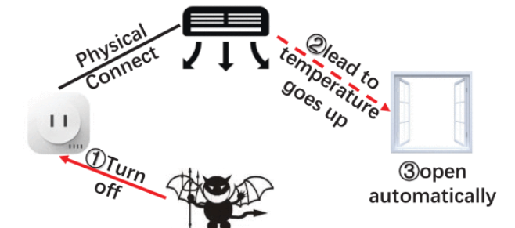
Figure 1 - Example of infiltration of home system [20]
This is an example of how easy it can for hackers to gain access to a house where a vulnerability is present. However, the hackers would most likely take a different way. Some Black Hat hackers are more likely to compromise the network and gain access to the CCTV, in which then the hackers would monitor the house through the CCTV and get an idea of the homeowner’s schedule, in which they will know when the best/worst time is to break into the homeowner house and not get caught. [20]
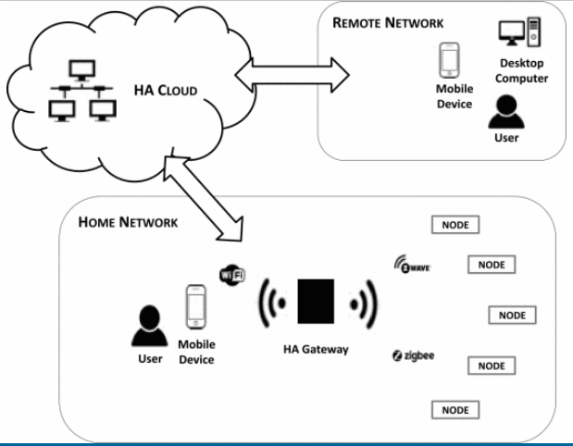
The reason for this happening is because everyone is following the latest trend, and that is making your home smart. The reason for this happening is because it is affordable and makes everyone’s lives a lot easier, but to do this and have a smart home means having devices throughout your house such as smart lights, “HVAC” (Heating, Ventilation, Air Conditioning), Cameras and doorbells in which is connected to a central device something like Amazon Alexa, Google Home or Microsoft Cortana, and that is where the problem lies, the central device is connected to the internet, it acts as the gateway to the network of devices throughout your house. The Home system gateway is in control of all the devices using the local network and is always communicating with the devices within the network, that way the user is then able to use the home system to control the devices within the network using the mobile application associated [21]. Simply because the gateway device is connected to the WIFI and has direct access to the internet, this is where the hackers are going to focus their energy on, the reason for this is because if they get through there are a few possibilities and options, they can take advantage of, for example the HVAC, Cameras, Ring Doorbell and so on. [21]
Figure 2 - Network Map [21]

One of the most popular devices around these days are smart phones, they are pretty much a bank for data because a smart phone will hold large amounts of data about their user. A normal person smart phone would hold their email, phonebook (which could contain their address), social media, photo’s, banking app and much more, these alone are huge motivational reasons for a hacker to want to hack your personal smart phone, they could steal your data and use it for their own ort sell the data on making profit from it. Over the years with smart phones becoming more and more improved upon there are concerns for their security. Smart phone operating systems is the most important core component of the smart phone, the reason for this is because it provides third party application programming interface, which is based on the smart mobile. There are many important characteristics about the smart phone such as “Flexible operations, multitasking and real-time response” [22]. Smart phones are the latest multipurpose gadget in which people are becoming addicted with, a survey which was taken and showed that android is dominating the smart phone market with shares of up to 82.8% back in 2015 [23]. The android phone is open source based on “Linux kernel” and because of this it gives the developers opportunities to develop and improve the platform. It is said that security developers would use different types of SDK tools which like Android SK manager, AVD manager and many more using Java programming language because it is well suited to this application. The android architecture as we know are split into 5 major parts, these are “Linux Kernel, System Libraries, Android Runtime, Application Framework as well as Application Layer.
Unfortunately, in today’s cyber world there are many cyber-attacks undergone against major businesses as well as individuals and families, hence for this project being done to show people how easy it is to attack a home network. Smart phones are improving every year with capabilities as well as security, however it is still going to have security vulnerabilities because they will constantly be targeted by the hackers. Back in 2016 there was an android version 6.0 which was known as “Marshmallow which was released to the market and this version again running on Linux kernel version, and the good thing about this is that version would handle security management for the androids operating system, once again improving the security aspect of that smart phone.
One of the most important security aspects of the smart phones which are androids is their security architecture, it represents the security issues which is associated with android’s applications, the main aim is to isolate any app data and codes which come from outside apps which are downloaded by the users. The way the developers did this was by giving each app a unique user ID, and this concept is known as a privilege separation in hindsight that would not give the application any permission to access any other application within the smart phone device. [23]
The architecture helps the developers to develop various android applications, and in this case android and the developers can create any android application and place them within the market, but then these applications are self-signed and have no reviews, in which cannot verify the safety on the application, because the user can be trapped into downloads malware which is a major safety concern for the smart device [24]. This is hacking tools can manipulate users by having them download payload which can be generated by MSF-venom and Metasploit, which would result the users in download malware and tr hackers would have control of their targets device, which in this case would be their smart phone android

RESEARCH METHODOLOGY
The hacking methodology that has been selected for this project is the Penetration methodology. This methodology is used by most penetration testing professionals because it works efficiently. There are 6 stages to this methodology, and all are very important stages. These stages are: -
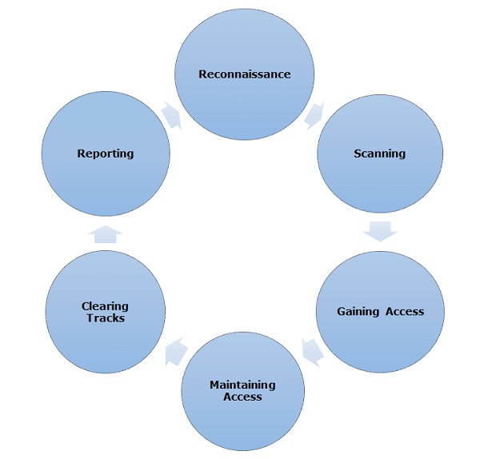
Figure 3 - Hacking Methodology [25]

- Reconnaissance – The first very step in a penetration methodology is “Reconnaissance”, before performing anything penetration testing this step must be taken, the hackers would footprint the system gathering as much information they can about their targets. Reconnaissance is considered the preparatory phase which is when the hackers would document valuable information about their targets such as configuration details, login information, probing the network and so on. [26]

- Scanning – In this stage the hackers would begin to by testing the network and the devices on that network such as laptops and smart devices, the hackers would do this to identify the potential breaches they could exploit, this can be done by using scanning tools such as “Nmap”, the main goal is to map out the network, to discover network topologies, the host machine information, discover what router and switches are used within the network and what firewalls are in place. Another important part of this phase is the port scanning, hackers would use essential tools to find vulnerable ports which are left open to being exploited. Finally in this phase is the vulnerability-*- scan, what hackers do is use automated tools to scan and detect weaknesses which are capable of being exploited by their attacks. [26]

- Gaining Access – This is the third step in the methodology and is all about gaining access to the targets network. The aim for the hackers is to expose and exploit the administrative access, and now they intend to send a malicious payload to the target’s devices through the network. The hackers would typically use a various amount of hacking tools as well as techniques to attack the target, of course this would be unauthorised access, but they would use things such as Buffer Overflows, phishing attacks, Injection attacks and many others. If the hackers are successful, then they will have full control of the network, they will also have the option to simulate further attacks such as data breaches and DDoS attacks. [26]

- Maintaining Access – The fourth stage of this methodology is to do with maintaining access to the network. Once you have gained access you want to maintain it, ensuring your able to come and go as you please, pre planning for future uses. In which gives them to ability to exploit the system for further vulnerabilities and escalate things further, seeing how much they can push their luck, this can be done using trojans and Rootkits or other malicious files. [27]

- Clearing Tracks - This phase is the most Important, the reason for this being the vital stage is because you do not want to get caught, so this phase involves clearing all evidence of there being an intrusion in the first place, which means modifying files corruption them or deleting them, modifying the logs and registry to show you weren’t there, as well as removing the application used, which removing them from the files so they aren’t found in the future. [27]

Research Onion
Research onion is a research method, which was initially designed to help students to create a better and more organised methodology. By following research onion, it would illustrate and explain the different ways and different elements which should be covered in a dissertation. As you can see from the diagram below there are various elements within the “Research Onion” which needs to be explained within the dissertation. [28]


These elements will be covered within the following: -
Figure 4 - Research Onion Diagram [29]

Methodology

Research Process –
The research process has two scenarios which are “Inductive process and Deductive process”. This research would have to cover the project, which is being done in this report, in which the quantitative would be the best solution for this situation.
Inductive – The inductive process goes in stages which are (Observation, Pattern, Hypothesis and Theory). It starts from research driven questions and then the data is collected and then it generates the results, which then brings them to hypothesis and theory.

Deductive – The deductive process goes in stages which are (Theory, Hypothesis, Observation and Confirmation/rejection). The deductive research starts off with research, and then moves onto theory, then hypothesis, and then data is collected and then comes the analysis results.

The quantitative research method is a lot more beneficial for this project as the method is normally used for projects. The process that is much better for this project is the Deductive process as the stages are more aligned with the project and is better suited, going forward the “Deductive Process” will be chosen for this project.
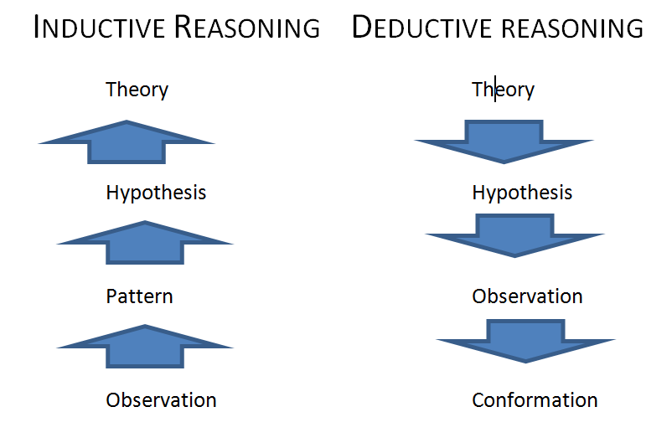

Figure 5 - Inductive v Deductive [30]
The inductive Process begins with observation, the person undergoing this project will observe the work being done recording the results of the attack was it a success or failure. Next stage would be pattern, if it did not work why, how did it work and record the result, if it failed again record the patter find out why it failed, fix the issue and go again until it works. Next there is an explanation based off the theory with limited evidence to prove this study or support it, and then a starting point to further support this theory. [31]

Research Philosophy
Research Philosophy is the first stage you encounter in the research onion process and contains four different Scenarios which are very important. They are “Positivism, Realism, Interpretivism and Pragmatism”.
Positivism – is directly related to the objective, under this the researcher is only interested in the general information gained from the project to get to the main goal and gaining success. [32]

Research Methodology
Quantitative Research is the process which is taking to collecting results and analysing them accordingly. This process can be used to find patterns, make predictions and testing, which will generally give you results which you may or may not expect. [33]
Quantitative research is widely known and used in the natural and social sciences as well as many other fields.

Philosophies
Positivism is again related to the objective at hand. The person undergoing this project will only be interested in data gained from the project, which will result in a success or failure to this project.

Approach
The inductive process goes in stages which are (Observation, Pattern, Hypothesis and Theory). It starts from research driven questions and then the data is collected and then it generates the results, which then brings them to hypothesis and theory. This method is better approach as it aligns nicely with my project in terms of stages to be taken.

Strategies
The strategy chosen for this project will be experiment. The reason or this strategy being chosen is because it is the only one which seems reasonable to go alongside with my project.

Choices
The choices being chosen within this project will be multi-method. The reason for this is because there will be many different methods taken to hack the chosen targets. There will be 3 chosen targets which are the “Router, Laptop/computer and smart device”, and there will be different hacking methods used to complete the project.

Time Horizons
Cross Sectional has been chosen for this section because it relates to the work that is being done for example the study takes place at a single point in time, and because it is an observational study which goes along nicely to what the person must do within the project at certain times. [34]

Techniques and Procedures
Techniques used to complete this task would be using a suitable operating system which is kali Linux, and because of this it comes with hundreds of pre-installed hacking tools. One tool that is going to be used is “Fern WIFI cracker for the wireless access-point another one which will chosen to use is MSF-Venom and Metasploit-Framework, if that doesn’t work then possibly John the ripper to crack a password for example laptop, but also again MSF-Venom and Metasploit would also be used for the Smart device which is a smart phone android. Expected results will be three successful hacks, but two would be a good result as well.

Overview of tools
The project will mainly be done using “Oracle VM VirtualBox using Kali Linux, the best thing about using Kali Linux is that come with many pre-installed tools. Kali Linux is a Linux based open-source operating system which allows users to use tools for penetration testing and Ethical hacking. The tools are as followed: -

- Fern Wi-Fi Cracker - is a WIFI hacking tool which is pre-installed on kali Linux, this tool is highly used by hacker as well as security professionals. The program has the ability to crack and recover WEP/WPA and WPS keys, giving the user the password instantly, as well as saves any previous jobs so if you need to go back and gain a key/password it will be there. This program also can be run on other networks-based attacks, wireless or even ethernet based networks. [35]
- Armitage - which is a collaboration tool which works with Metasploit and discovers targets finds and recommends exploits/weaknesses and will expose them. [36]
- Nmap - Nmap stands for Network Mapper, this tool is commonly used within the ethical hacking industry, and most likely used by Hackers as well. Nmap is a utility tool, in a sense it is an active reconnaissance in which it will find holes/vulnerabilities within the network, which the hacker can then use. The tool supports Ping scanning finding which hosts are up which is part of port scanning techniques. [37]
- Metasploit-Framework - Is another common tool used today by Security Professionals, ethical hackers, and hackers in general. Metasploit framework is aa powerful tool which finds vulnerabilities on the network and exposes them. Metasploit Framework is an open-source platform and can be used in creating security tools as well which can be beneficial. [38]
- BlueSnarfer – Is another commonly used hacking tool, this hacking tool is used to exploit Bluetooth connections, and the tool snatches the data from a wireless device which has Bluetooth enabled.
- John the Ripper- Another popular tool used within the Security industry. Ethical hackers like to use this tool because it detects weak passwords that could be at risk. The tool is designed to help find weak points in the system, one of these can be weak passwords, the tool will try and guess or will crack it using brute force, a very exiting tool which is used commonly. [39]
- Wireshark – A popular tool used again by ethical hackers and penetration testers. The tool Wireshark is a network sniffer, and is designed to analyse the packets it finds, these packets contain data like where they came from where they are going (IP) and the protocols that have been used. The packets usually contain extensions such as “.pcap”, and this can be read/exploited using the Wireshark tool. [40]

Design & Implementation

Design
This project is being done with scenarios, the goal is to hack 3 different targets which are “WAP, Laptop/Computer and a smart device/Smart phone”. All three of these devices are going to be done using a virtual network. As you can see from below there have been two diagrams supplied, one showing the virtual network and the other is the physical aspect.
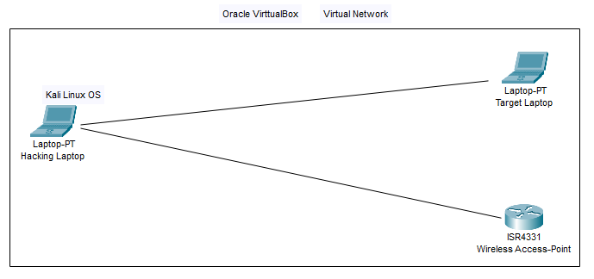
Figure 6 - Diagram of Virtual network

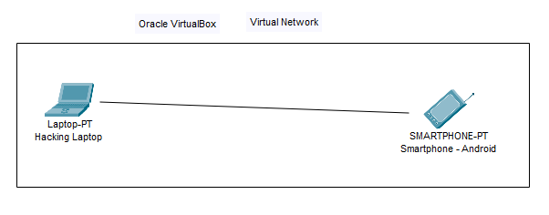
Figure 7 - Diagram of another Virtual Network for the Smart Phone Scenario

Virtual network
With regards to virtualisation in this project, as previously stated all three of the scenarios will be done virtually using “Oracle VM VirtualBox” I will be using this software to set a virtual network adding a couple of computers/laptops, and one of them will be using “Kali-Linux” as the designated hacking system, the hacker will use this system to hack the other devices “Laptops and Computers”. Also, a “USB Wi-Fi adapter” has been purchased, this will be used while using the virtual network to discover a WAP and hack it. To do this all-ISO files will need to be downloaded and implemented into oracle VM VirtualBox, for example The kali Linux ISO file will be downloaded in order to create a Kali Linux VM system, the same goes for Windows and android ISO Files.

Hardware
Hardware needed to complete this project would things like a laptop or PC to be able to download “Oracle VM VirtualBox” a USB Wi-Fi adaptor to discover other WAP devices. Another piece of hardware needed is the Wireless access point device to discover as one of the scenarios.

Implementation
With regards to implementation there is going to be 3 scenarios to complete. The first one being the WAP hack, then the laptop/computer hack and finally the smart device hack which is going to be a smart phone Android. The first part of the project which will be tackled is the WAP hack, first things first is downloading the latest Oracle updates and creating a machine with Kali Linux OS on it. Again, the reason for choosing this operating system is because it is recommended for hacking and because it comes with pre-installed hacking tools which are perfect for these scenarios. Once the VM machine is set up with everything, the next step is to set up the wireless access-point somewhere physically within my work area and once that is done, it is time to connect the USB Wi-Fi adaptor, when that is plugged in to the laptop there will be a pop message asking the user to connect it to the laptop or to the VM machine, of course it will be the VM machine, in which the user is all good to go to start the hack with Scenario 1 “Hacking a WAP” . The tools chosen to be used to try and hack the wap will be first “Fern WIFI Cracker” if that is not successful then I will turn to the next tools which are “Aircrack, Wireshark and Wifite”, all of these tools are highly recommended and are used on a daily basis by professionals like “Penetration Testers” as well as hackers in general. Next is scenario two which is hacking a laptop or computer, this will also be done within “Oracle VM VirtualBox” and luckily it has been installed with the appropriate machine done and operating system in place, again luckily Kali Linux comes with pre-installed hacking tools, the first thing to do is set up other virtual machines within the virtual network. Once everything is set up appropriately, next is to begin the hack, and the tools which will be used are “Metasploit, Nmap, John the Ripper and Aircrack”. The third and final scenario is the smart device hack which going to be done to a Smart phone device, first things first is setting up the virtual network again, the ISO file will need to be downloaded once more but luckily the kali Linux will be set up ready to be used. Once everything is set up on Oracle the hack can begin, again the pre-installed tool which is going to be selected for this scenario is again “Metasploit/MSF-Venom” this tool is used regularly in the cyberspace as well as by security professionals and there are plenty of guides on how to use the tool. If that does not work, there are other hacking such as “BlueSnarfer” and so on.

Testing and Evaluation
Results of hacking

WAP Hack
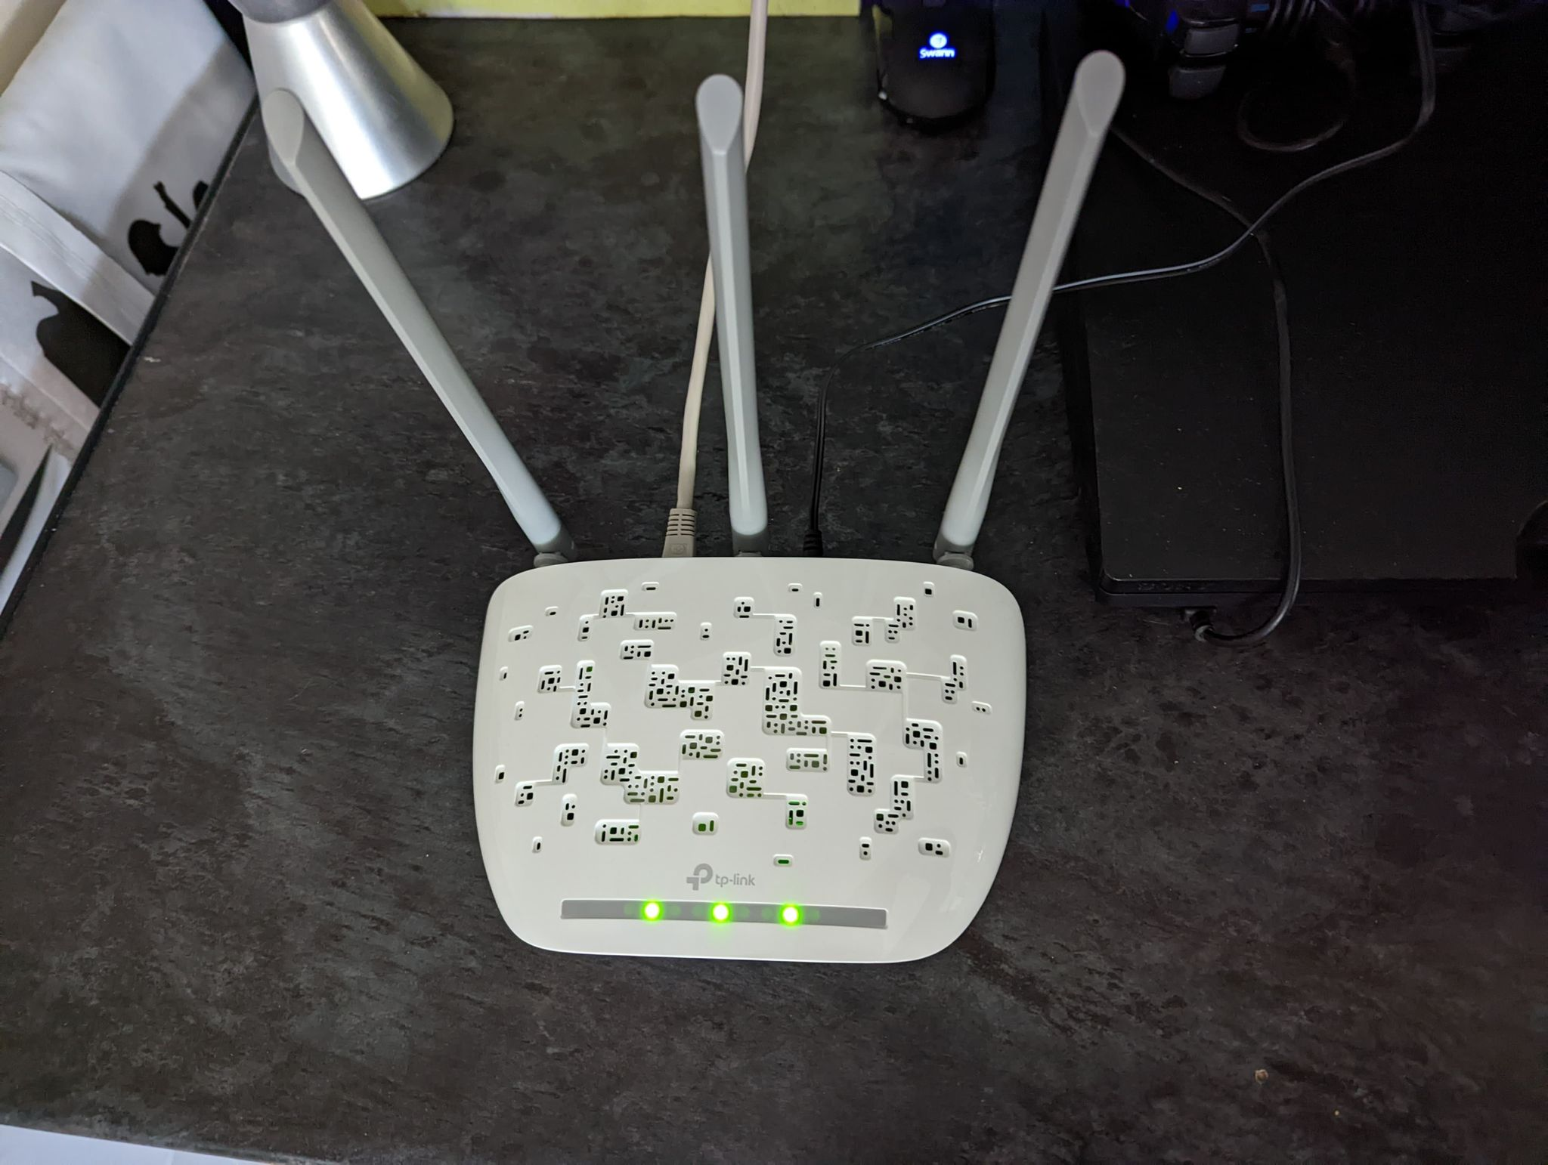
First things first, is setting up the target, which involves ordering the product and once it arrives. The setting up, powering it on and establishing a connection which is suitable, which is a simple patch cable from the switch to the WAP. The wireless Access Point was ordered in place for this project. The WAP (Wireless Access-Point) is more than suitable for this project and the attack can be done the same as accordingly because both devices work with Wi-Fi. So, the device chosen for this device is a TP Link – wireless access-point which was ordered from Amazon and is fully functioning and is set up ready for this attack. The device is set up in the same room as the attacking laptop is in ordering to achieve a full connection when available and any problems can be fixed physically if needed.
Figure 8 - TP Link Wireless Access-Point

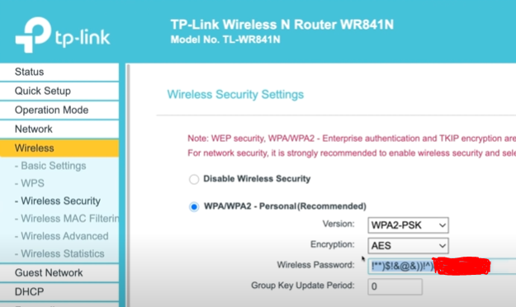
Figure 9 - Changing Default Password
After setting up the TP-Link, I went to the password page and changed the password from the default password to something more a lot more complex. I have covered part of the password because I want to show you how too get the full password using a password cracking tool named “Fern WIFI Cracker”.


The next step is to set up the laptop, which involves downloading the latest version of “Oracle VM VirtualBox”. The reason for this is because Oracle VirtualBox is one of the most popular virtual machines software’s out there today and is constantly being used.

Figure 10 - Oracle VM VirtualBox

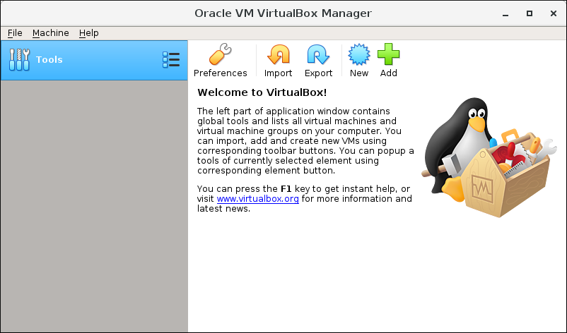
Figure 11 - VirtualBox after installation
Once the program is installed, it comes bare with no machines installed. That is where I would have to go on and download the Kali Linux ISO file from their website. Once that is done, I would have to implement that into the VirtualBox program and make the necessary changes needed, for example giving it more RAM and so on. Once the Kali Linux machine has been set up, that machine is one to be used to do the hacking.

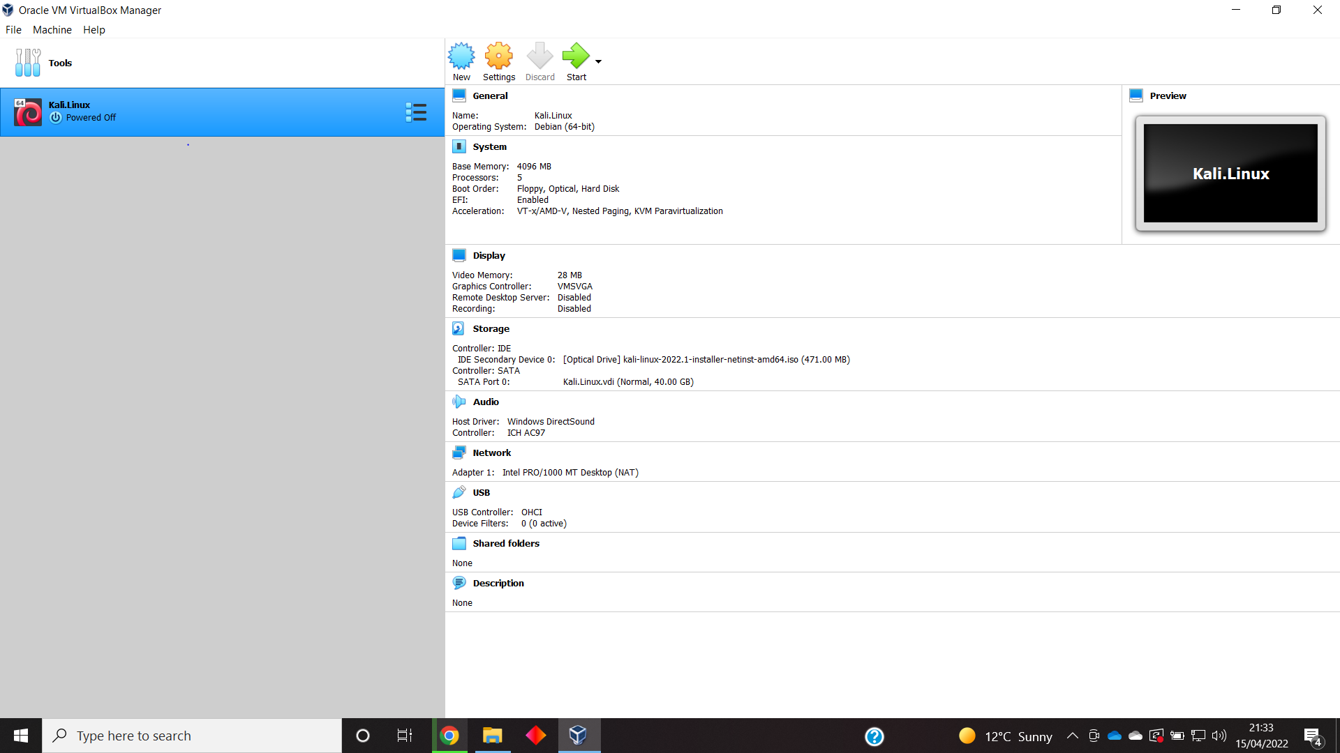
Figure 12 - Kali Linux Machine Installed
As previously stated, had to download the appropriate Kali Linux ISO file directly from Kali Linux’s website, once downloaded, then I could create a new virtual machine with the ISO file and make the appropriate changes within settings such as increasing the RAM storage and other necessary changes.
Next up is to start the machine to ensure it works accordingly.

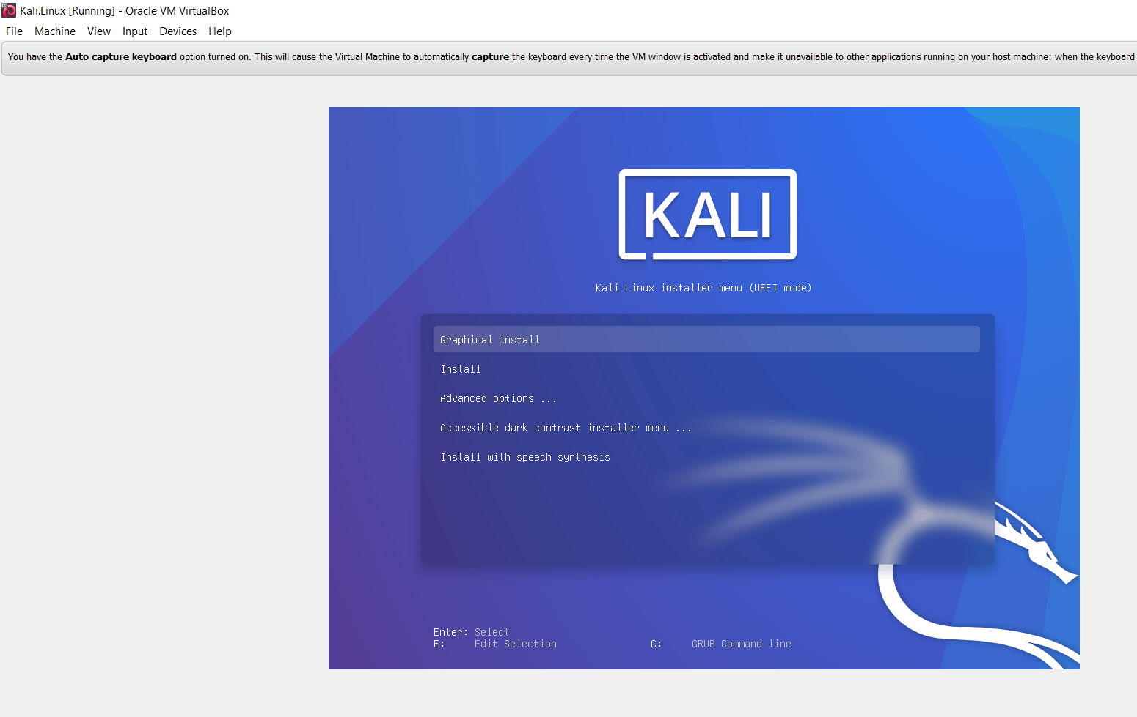
In which it did nicely, next steps is to go through the set up process which you can see on the next screenshot.
Figure 13 - Linux Machine Start-Up

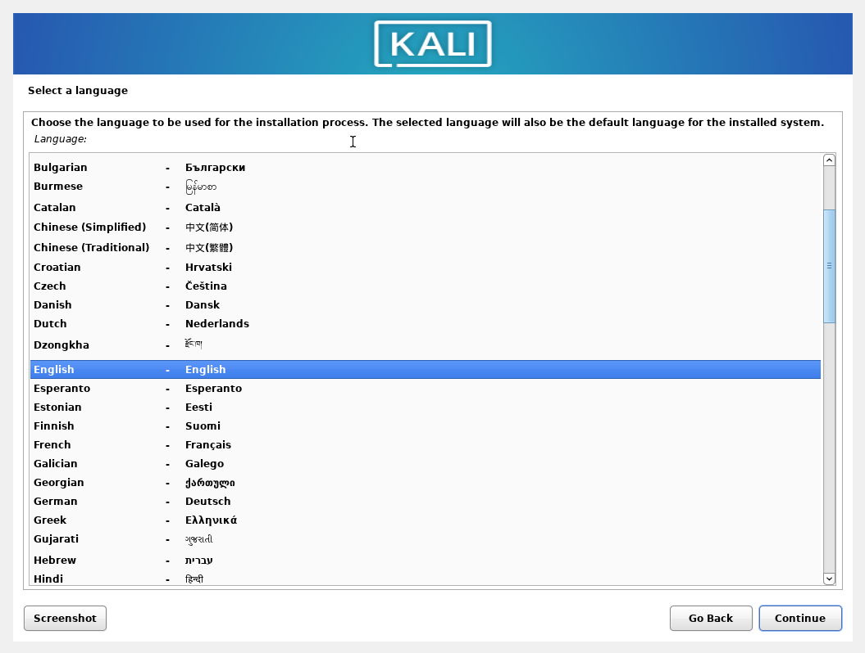
Figure 14 - Start-Up Process
Just going through the start-up process, stating the language as English, stating the keyboard configuration as English again, then some installs are done via the machine.

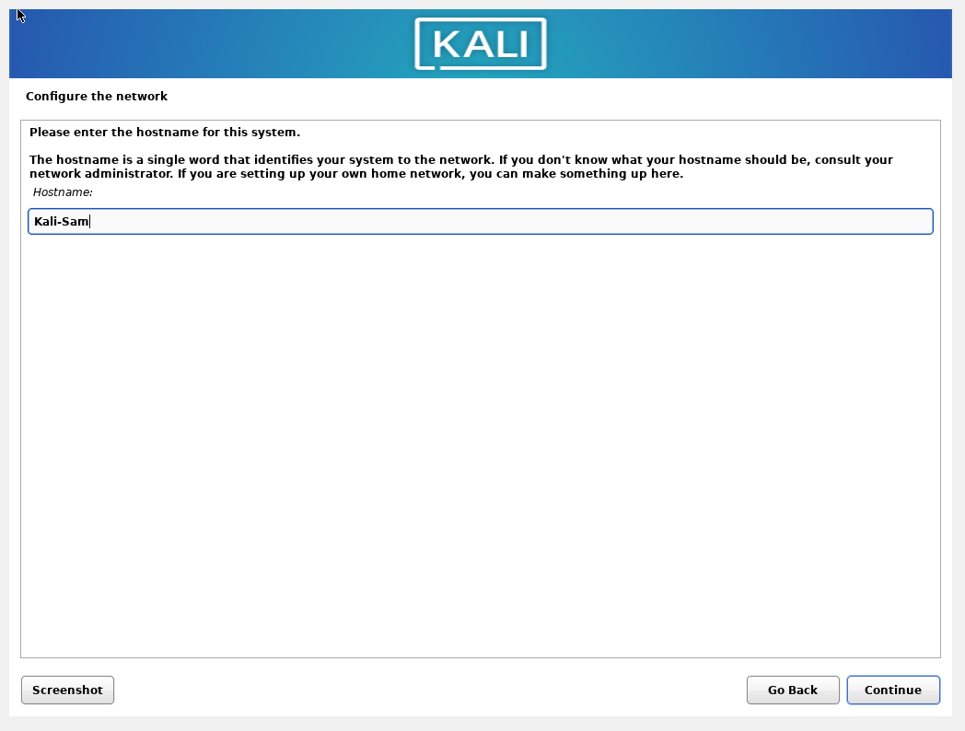
Figure 15 - Continued Start-Up Process
Next in the start-up process it asked for a hostname in which the name “Kali” was entered. It was changed afterwards, later it asked for user’s name which I entered as kali@kali

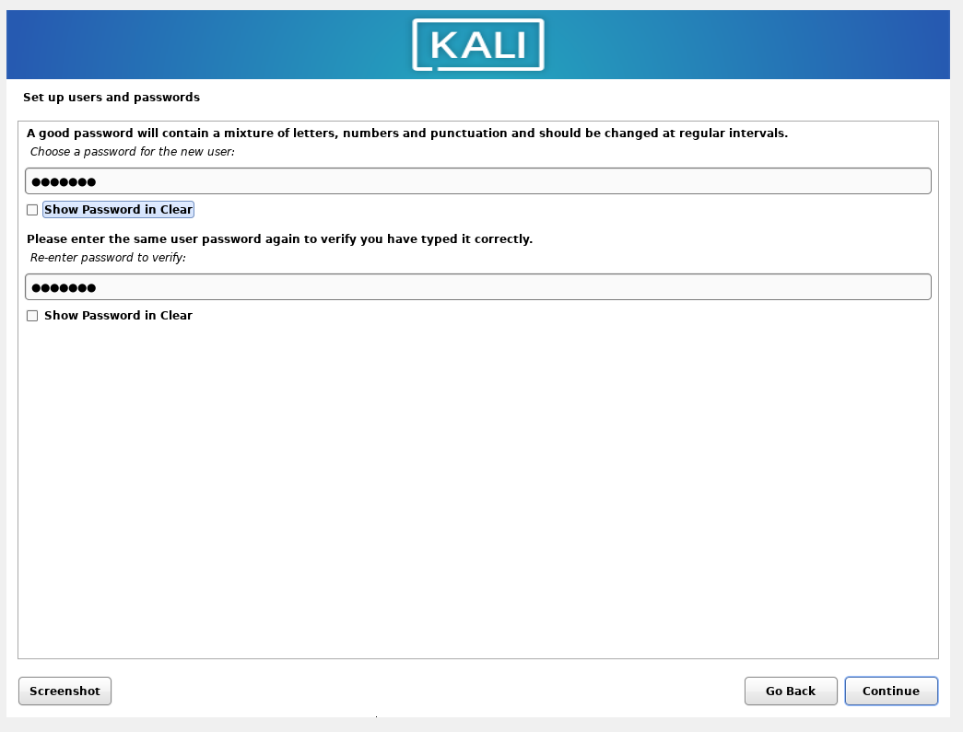
Figure 16 - Setting up a Password
Making my way through the start up process, now setting up the Password.

Kali123

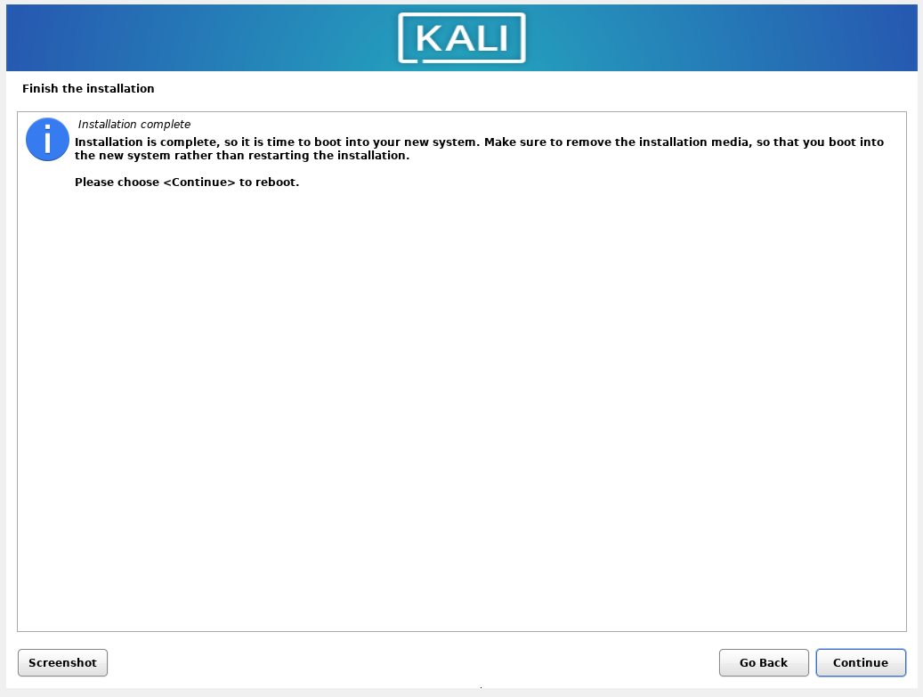
Figure 17 - Installation Complete

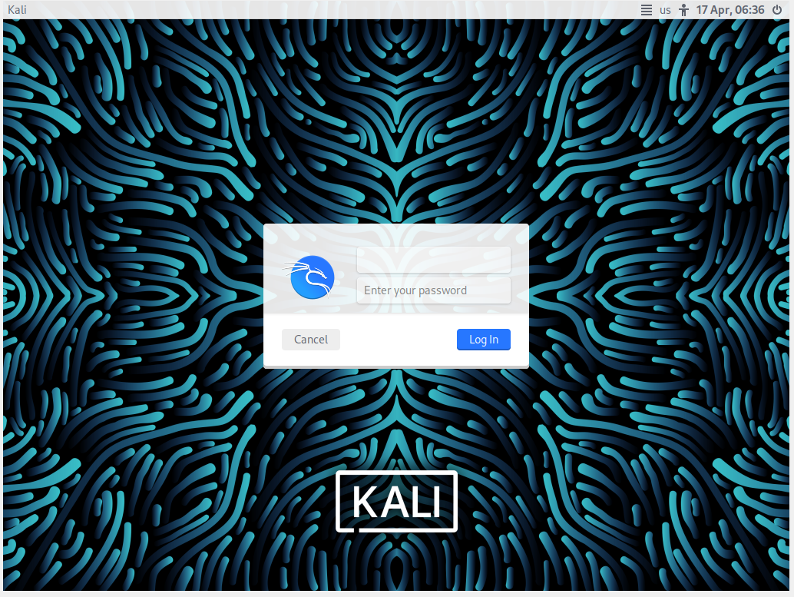
Figure 18 - Set-Up Complete
The set-up process has been complete next is to logging and confirm everything is working accordingly.
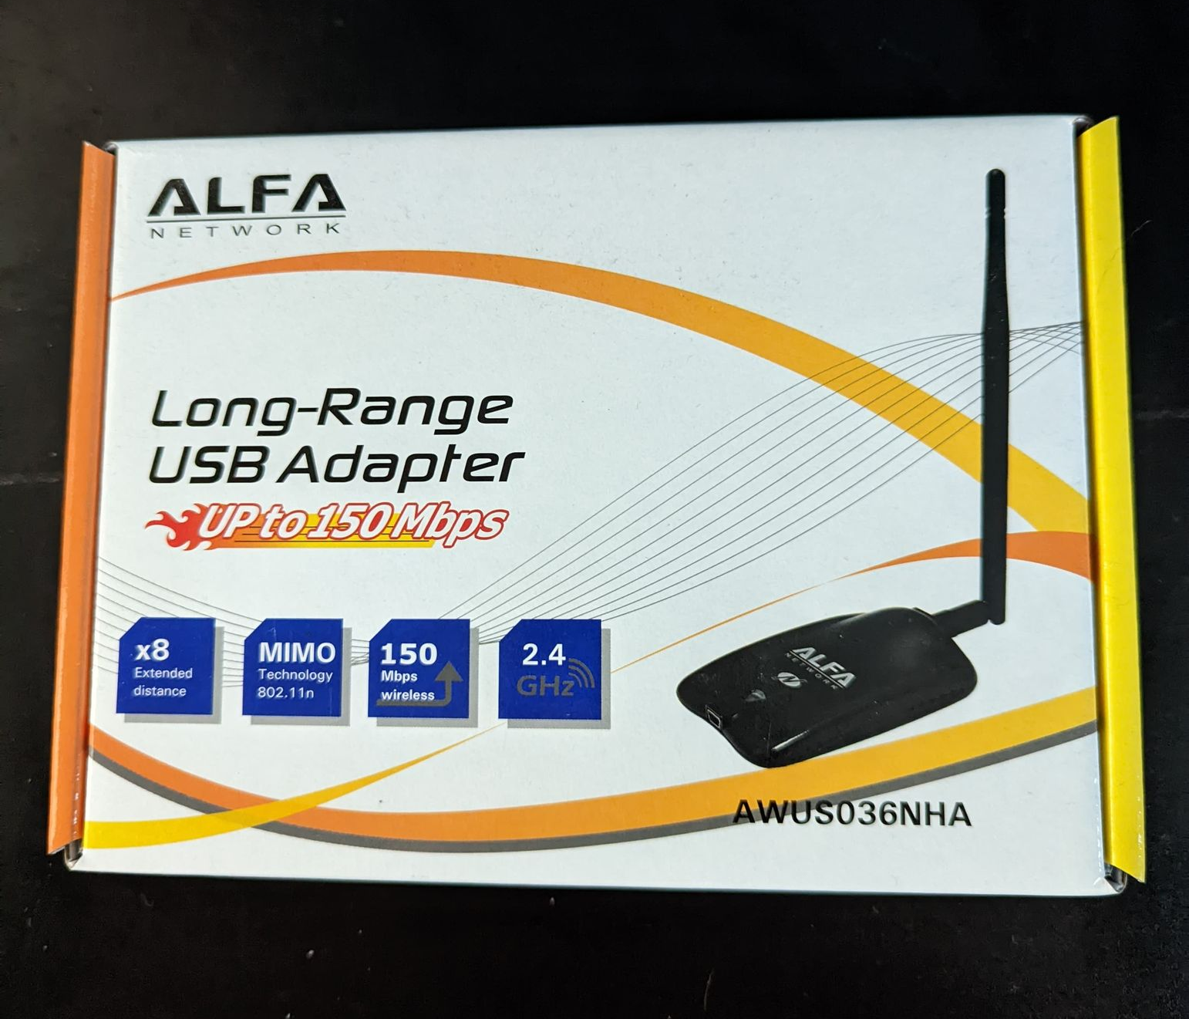
The reason for buying this device is because it supports monitor mode and packet injection
Figure 19 - USB Adaptor for Kali

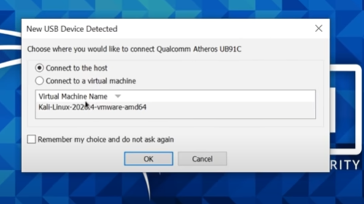
Figure 20 - When Connected
Once the Alfa was connected a prompt message appeared asking if I wanted to connect the device to the real laptop or the virtual machine.

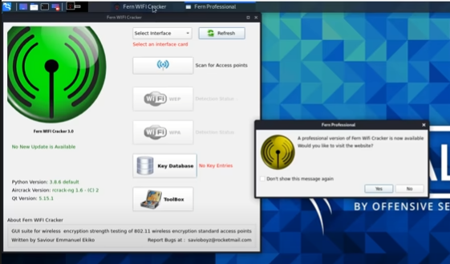
Figure 21 - Opening Fern Wi-Fi Cracker
Once everything was all done and ready for the hack, the first thing to do was go through a couple of hacking tools such as “Fern Wifi cracker”.

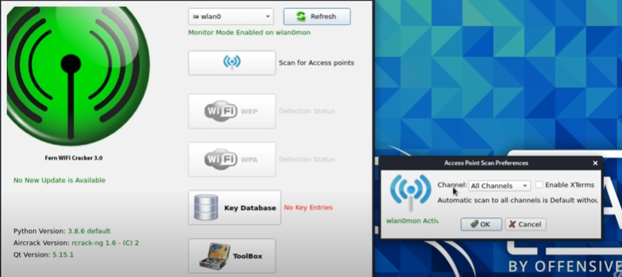
Figure 22 - Selecting All Channels
I instructed the tool to scan all channels around, to detect any devices around which can be cracked.

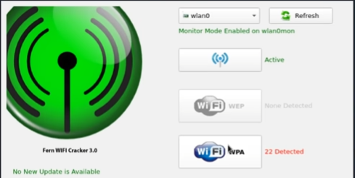

Figure 23 - 22 devices were detected

After the scan the tool detected 22 devices around the area.

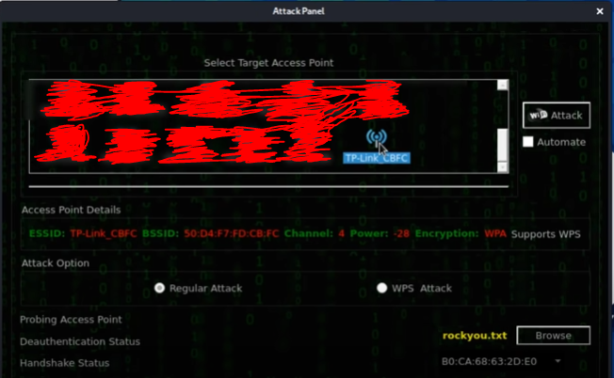
Figure 24 - Results of the Scan
After the scan was complete, I had to go through the results and find the device selected for this project. In the end it was found under the name of “TP-Link CBFC”.
All the other devices were crossed out of the screenshot simply because this is being done for educational purposes and did not want to reveal their devices, the other devices will be left untouched.

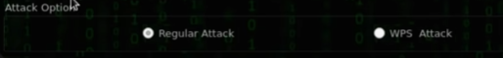
Figure 25 - Attack Option
There are two attack option with this hacking tool, and the regular attack will be implemented again the device.

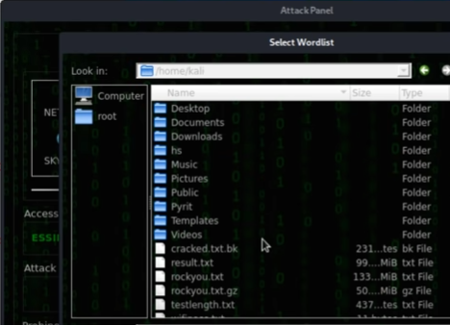
A wordlist attack is being performed for this device, in which the “rockyou.txt” file was chosen
Figure 26 - Selecting a Wordlist

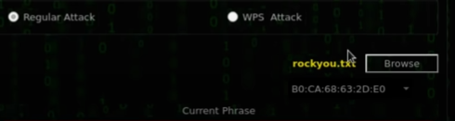
Figure 27 - rockyou.txt
The wordlist file being selected for this attack. Next now is to implement the attack.

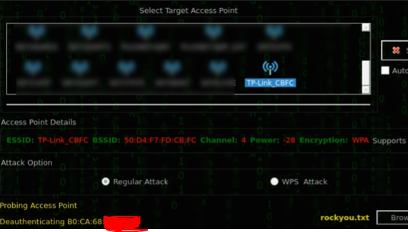
Figure 28 - Attack begun/De-authentication has Started
The attack has begun on the TP Link, which means the attack implement the De-authentication attack which is a form of dos attack (denial of service), essentially making the device unusable by the user, meaning the user will not be able to connect to the device

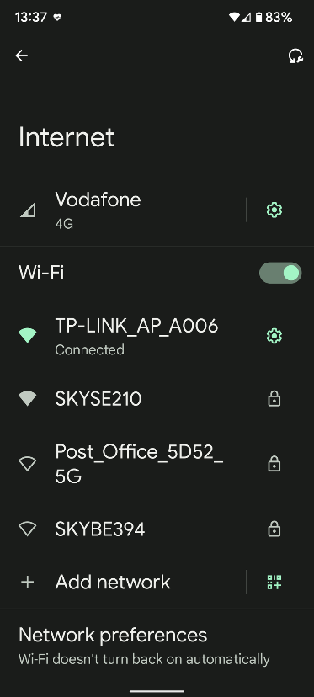
Figure 29 - Before Attack
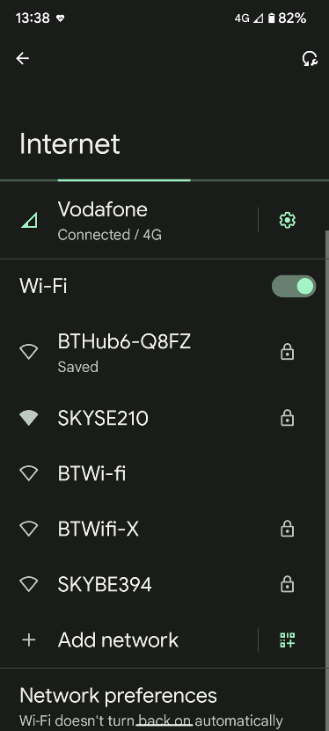
Figure 30 - During Attack
Before the attack I connected my phone to the TP Link and was working as it should.
During the attack the TP Link officially vanished as was not available to be used. This is because the dos attack took it offline.

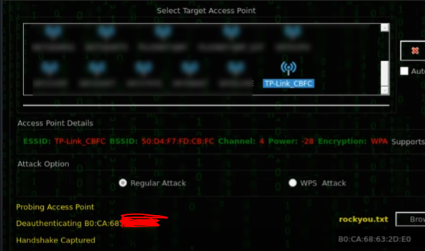
The handshake has been captured.
Figure 31 - Handshake complete

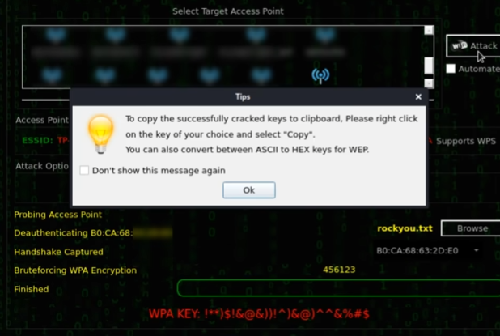
Figure 32 - Attack Successful
The brute force has been done and the WPA Password has been cracked and provided at the bottom of the page.

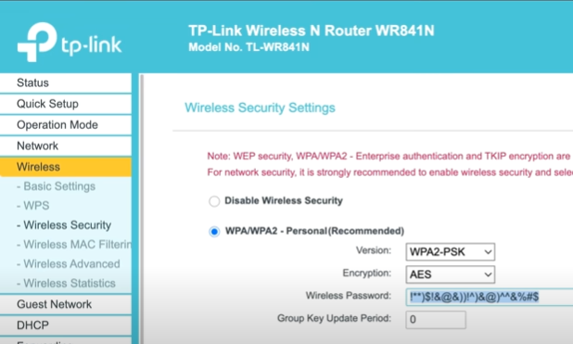
Figure 33 - Password in Full
This is the full password from earlier when I changed the password from default to something more complex and it matches the password cracked from the hacking tool, it’s a full match and this demonstrates how it can be done using Kali Linux pre-installed hacking tools.

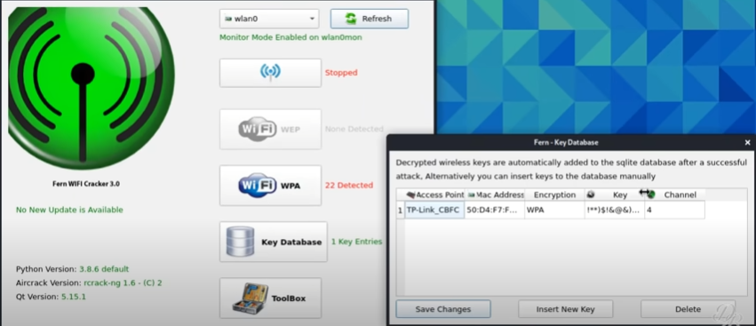
Figure 34 - Saved Key
After the hack the tool application saves any password keys done previously, so if you need the WPA password again it is saved by the application hacking tool.

Result of the Hack
The result of this hack has been successful overall, the main aim of this is to show how easy or hard it is to hack someone’s wireless access point. The result is that it is very simple for someone to do this, all they need is a USB Wi-Fi adaptor and they can easily detect your router, next they need to do is run a simplistic hacking tool like “Fern Wi-Fi Cracker” and they can have your password in the matter of minutes.

Laptop/Computer Hack
Figure 35 - Start of Hack 2
This is the start of hacking target 2 which is a standard Laptop or computer, again this will be done on “Oracle VirtualBox”. The first step is to add another Virtual Machine to the network.
The kali Linux machine is already installed from the previous hack which will be used for this scenario.


Figure 36 - Retrieving Windows 10 ISO
The ISO file is needed to create a Windows 10 virtual machine which we will be attempting to hack.
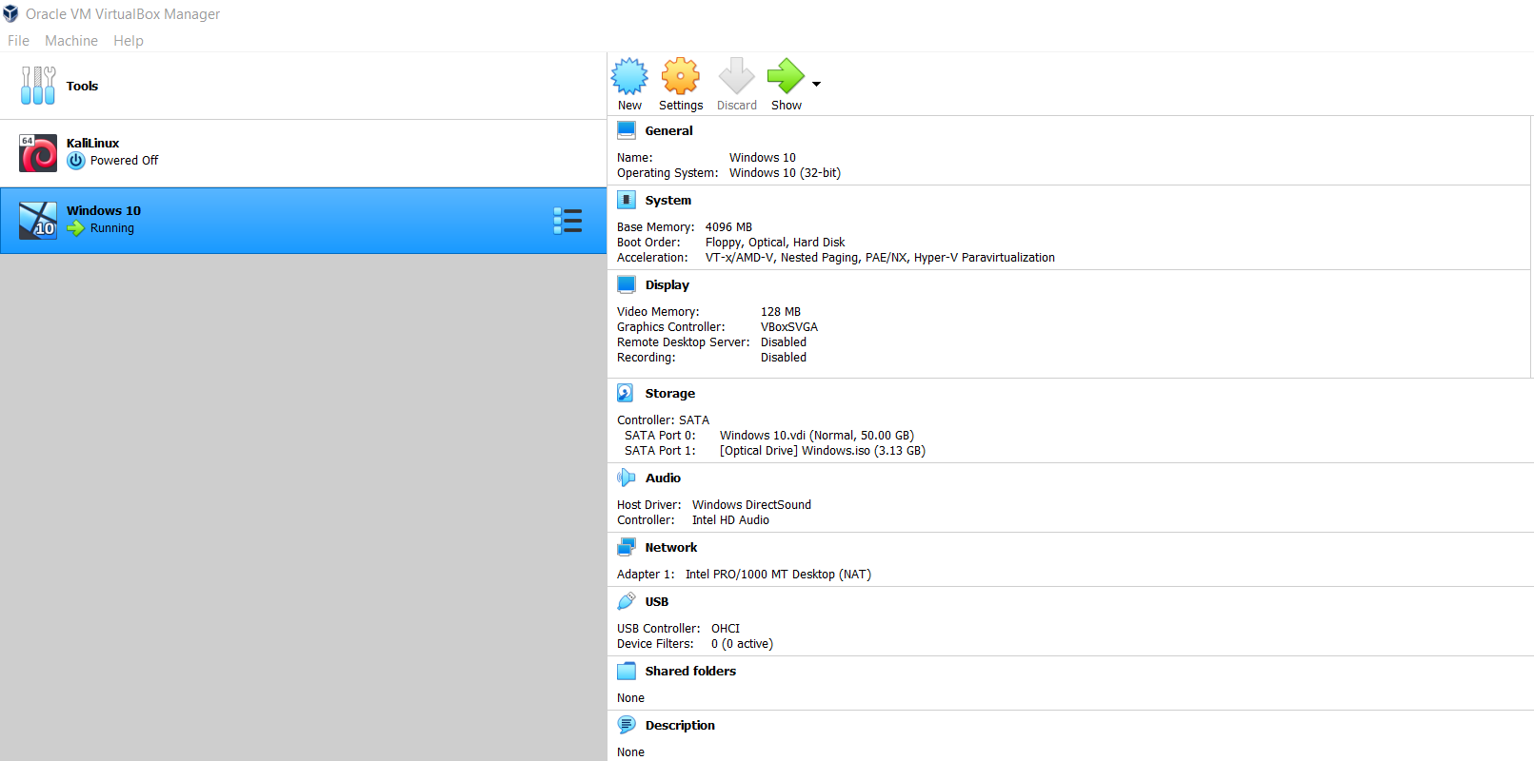
Figure 37 - Set up Target
After downloading the correct ISO files, the next step was to set up the target virtual machine, essential the start of the virtual network for scenario 2. This step had to be done correctly because the settings had to be configured changing the RAM storage as well as the correct number of processors to be given to this VM.

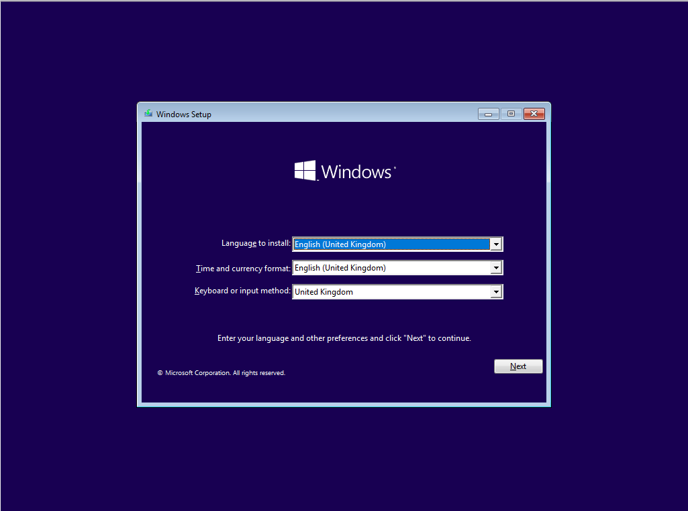
Figure 38 - Set-Up Process in Windows

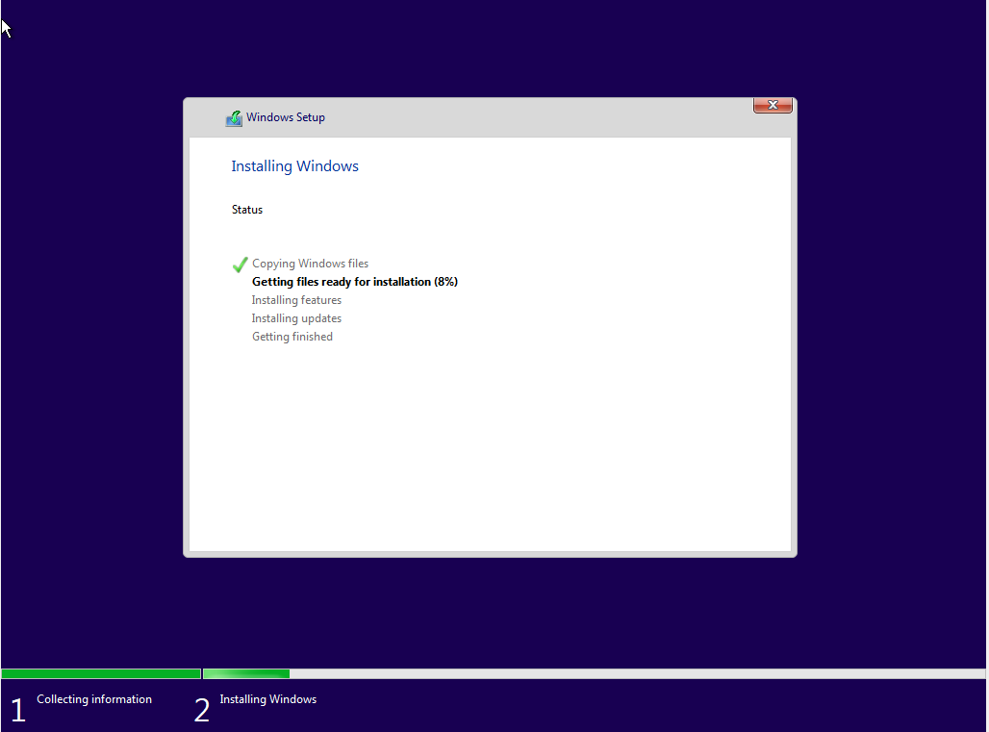
Figure 39 - Finishing up Process
Finishing up windows 10 download for the Virtual machine.

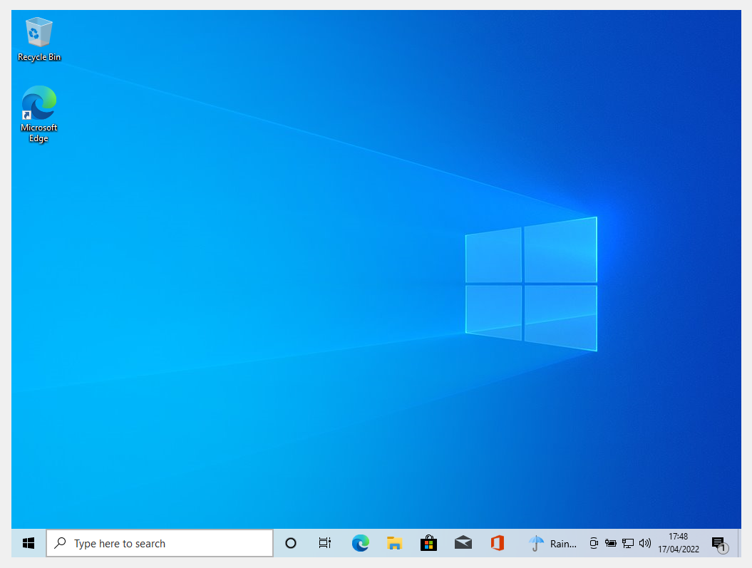
Figure 40 - Set-Up Process Complete
Set up process is all complete. Going through the steps and setting up username and passwords as well. The password set is very simplistic which contains letter and numbers.

Next is to complete the hacking of this virtual machine.
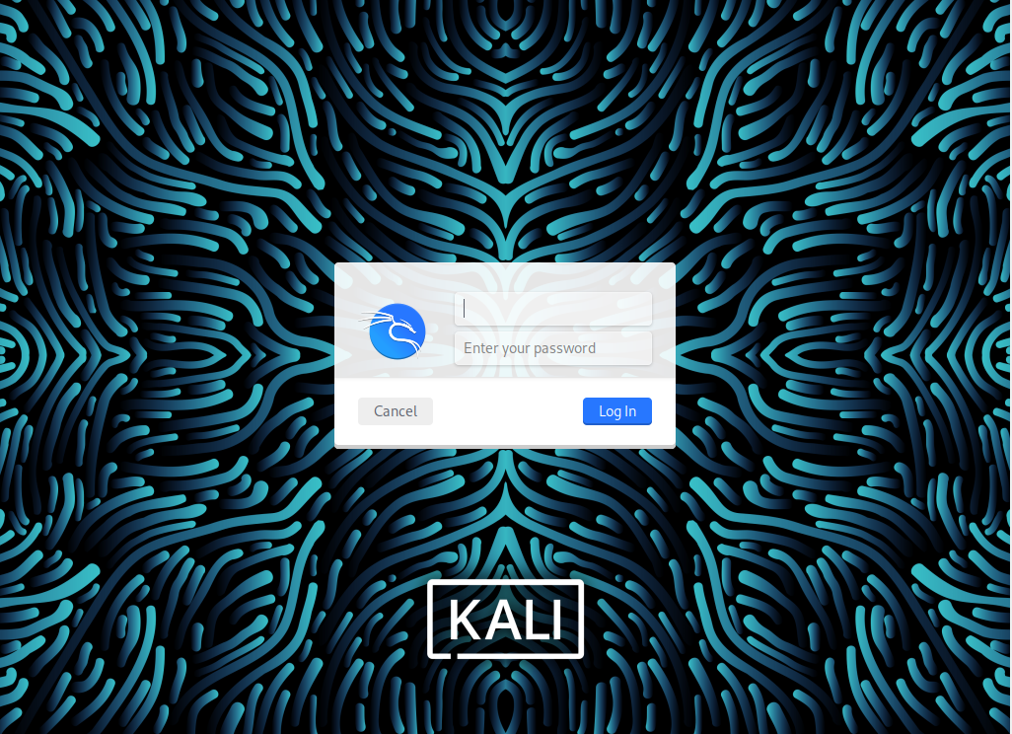
Figure 41 - Start of Hacking
First things first is log on to the hacking vm, And open up the terminal
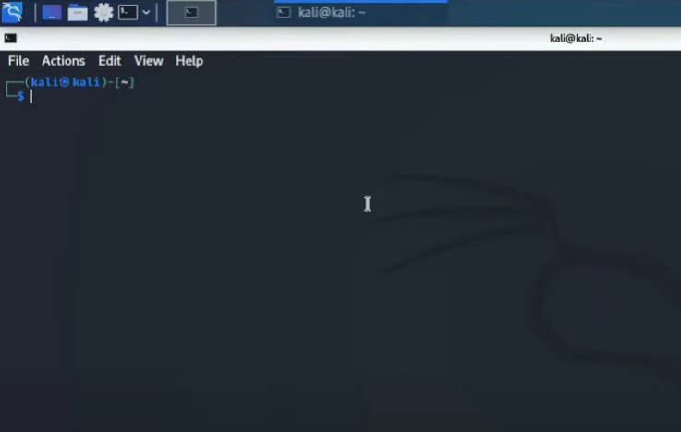
The first line inputted into the terminal is “msfvenom –help” which gave me a list of options which can be executed but also gives detailed explanations to these executions.
Figure 42 - Accessing Terminal
Figure 43 - msfvenom command
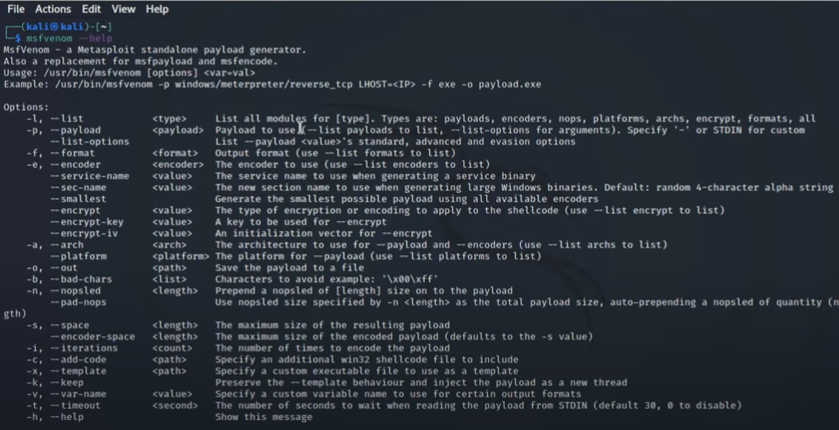
This command would give you a list of options which can be executed but also gives detailed explanations to these executions. The next command that will executed is “mfsvenom –list payloads”

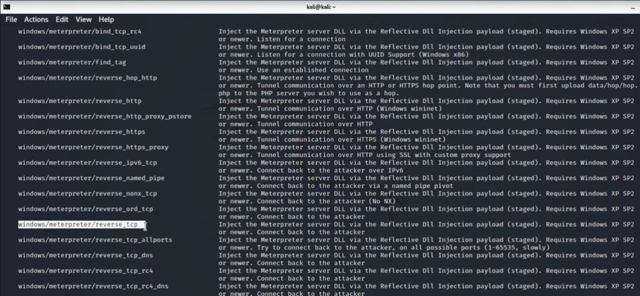
Figure 44 - msfvenom --list payloads
This command gives you endless amount of options to attack which can be done via payloads, the one that I will be using is a “windows/meterpreter/reverse_tcp” the reason for this is because it’s a smart hack, in terms of I won’t be connecting to the target, it will be connecting to my device, thus fixies the issue with getting past a firewall because a firewall monitors incoming traffic, but thew firewall will not stop the user form connecting to me.

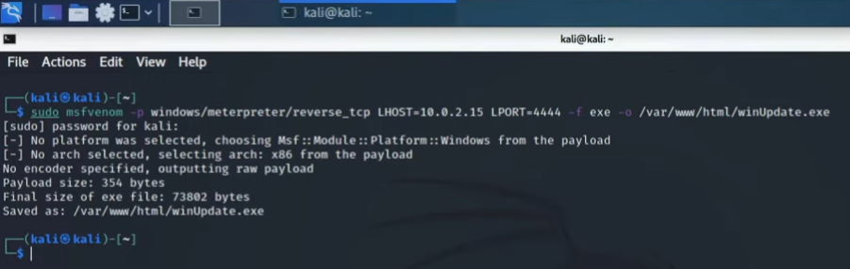
This is where the attack was getting set up, inputting an exploit into a file. After entering the command, the application asked to input the password, which was done, and this command was executed. Afterwards the terminal specified the payload size and that it was saved to a specific location within the files.
Figure 45 - Setting up the Attack

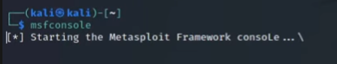
Figure 46 - Activating Metasploit

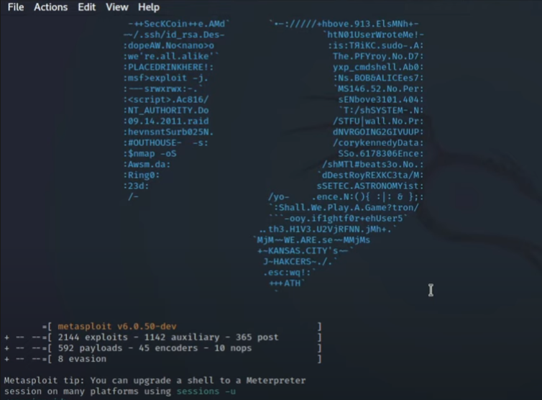
Figure 47 - Metasploit Activated
This stage would involve starting up Metasploit hacking tool, the reason for this is to execute the commands in full, and when they are set up the hack would begin with the target laptop.

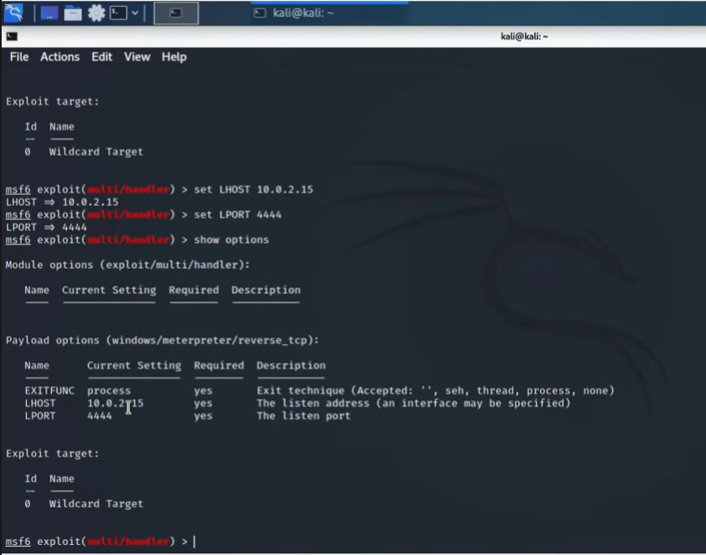
Figure 48 - Command executed

Fixing any issues with LHOST OR LPORT, if these are not set correctly the whole payload will not be executed as accordingly and the hack will be rendered a failure. The next command to input is exploit and this will execute the payload.

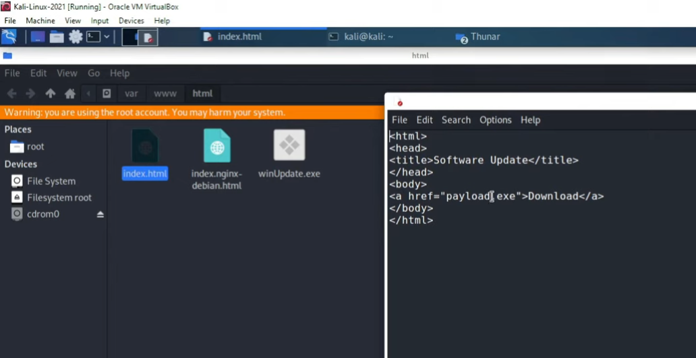
Figure 49 - Finding the Payload File
Before executing the payload, I wanted to make sure the file was there with the payload inside and that is named correctly before sending the payload off.

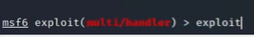
Figure 50 - Execute Command
Now that I know everything is correct as it should be I will execute the command “Exploit” which will run the attack.

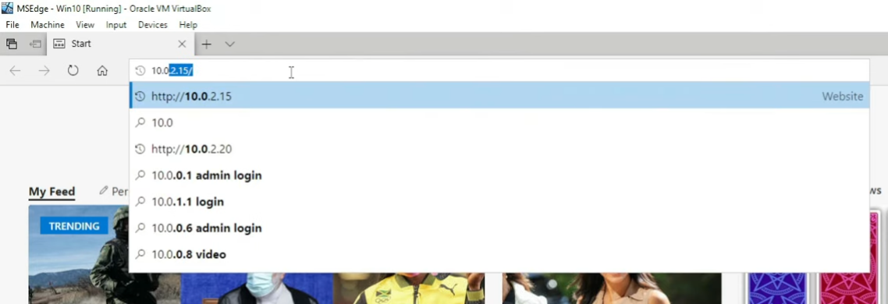
Figure 51 - Target Laptop
Now with the target laptop, the user would go to the IP address where the payload is.

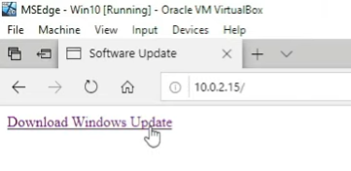
This is where the danger is and the user could easily click the download link, which is where the payload is.

Figure 52 - The Payload

Figure 53 - Run Payload
This is where the user has downloaded the payload onto their Laptop/Computer, without them knowing what it is.

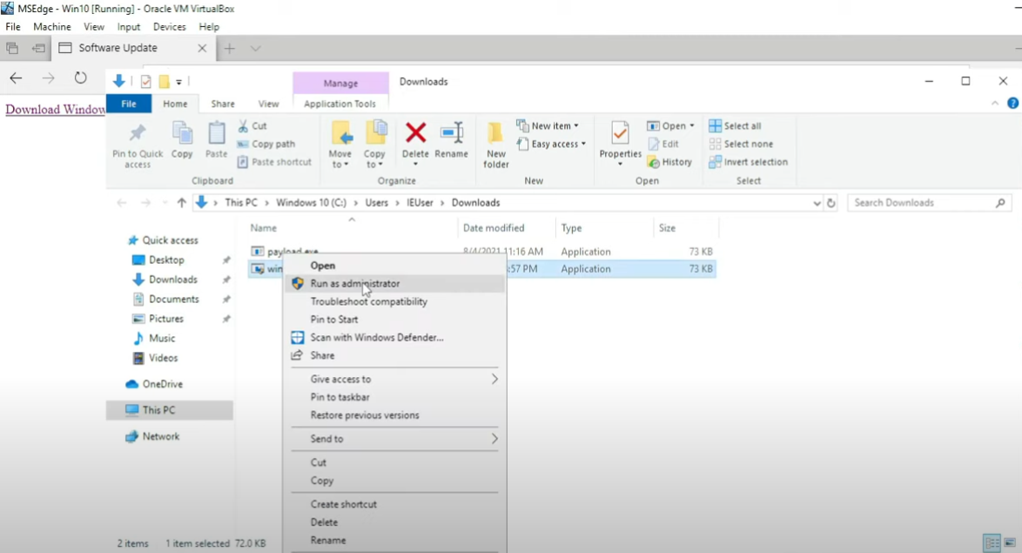
Figure 54 - Executing Payload
This is where the user would execute the payload from their Laptop/Computer. At this point the hacker has executed the payload meaning it is active so once the user runs this payload, the hacker would have full access to their Laptop/Computer.

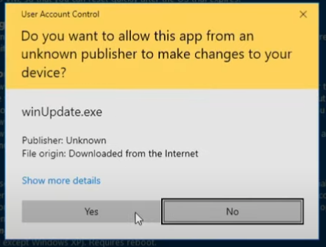
The user has clicked “Yes”. The payload has been executed by the user. The hacker has full access to their device.

Figure 55 - Prompt Message are you sure?

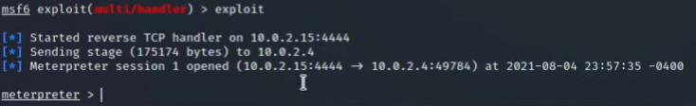
Figure 56 - Confirmed Target has run Payload
This shows on the hackers end that the target has run the payload. Next is to run the “system info command”

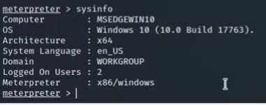
Figure 57 - System Info Command
Hacker getting information about targets system.
Next command to input is “help”

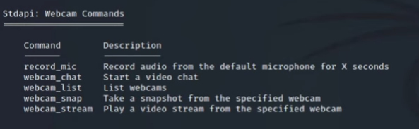
Figure 58 - Help Command

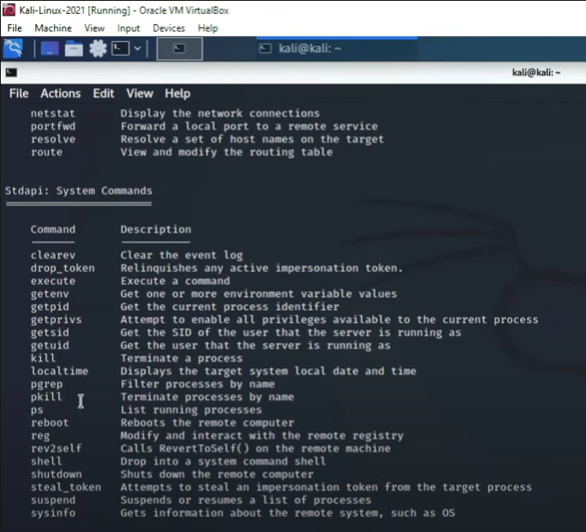
under the “Help” command this is showing aa list of commands which can be executed by the hacker against the target’s device, you can even execute the “Reboot” command which will reboot their whole device, and a lot more.
Figure 59 - List of Remote Commands

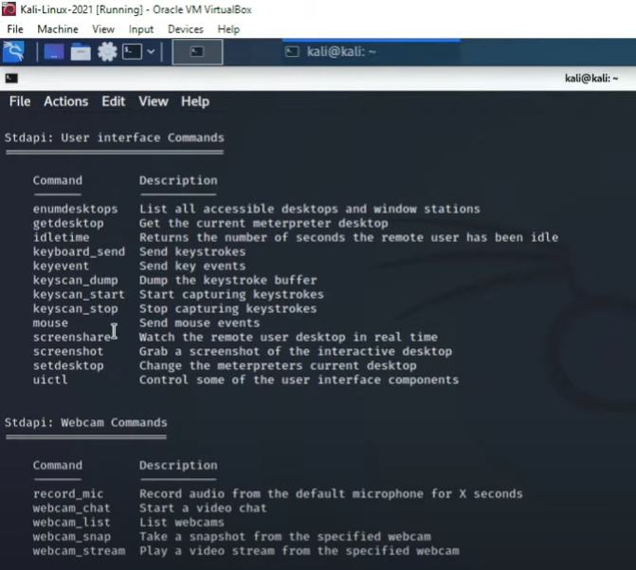
This is a screenshot oof more commands which can be executed against the target, for example a screenshot can be executed against the user, for example if they were on social media, you can take a screen grab of what the user can see. If the user has a webcam, you can record them or take a picture of them.
Figure 60 - More Commands

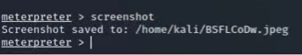

Figure 61 - Execute Screenshot Command

The screenshot command has been executed and screenshot has been saved to the hacker’s device.
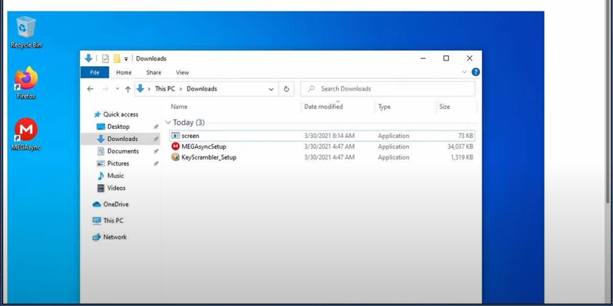
This is the result of the “Screenshot Command”, this was captured from the targets POV, and any command would work once executed.
Figure 62 - Screenshot Command Result

Result of the Hack
The Hack went well overall, the main aim was to hack the targets device which was their computer and that was done. There were a few issues along the way like learning the commands and entering the wrong commands, also learning about payloads and other strategies to how it could have been done, but the payload was the best solution for this project, and overall, it was done, and I was able to successfully deliver the payload and it was implemented against the target. Which resulted the hacker in being able to control their device, for example the screenshot being taken to show this.

Smart Device Hack (Smart phone Android)
Luckily Oracle is already downloaded from the previous hacks. However, I had to reinstall Kali Linux. Firstly, we need to download an android for this hack because were going to be hacking a smart device and luckily a smart phone is considered as one of those.
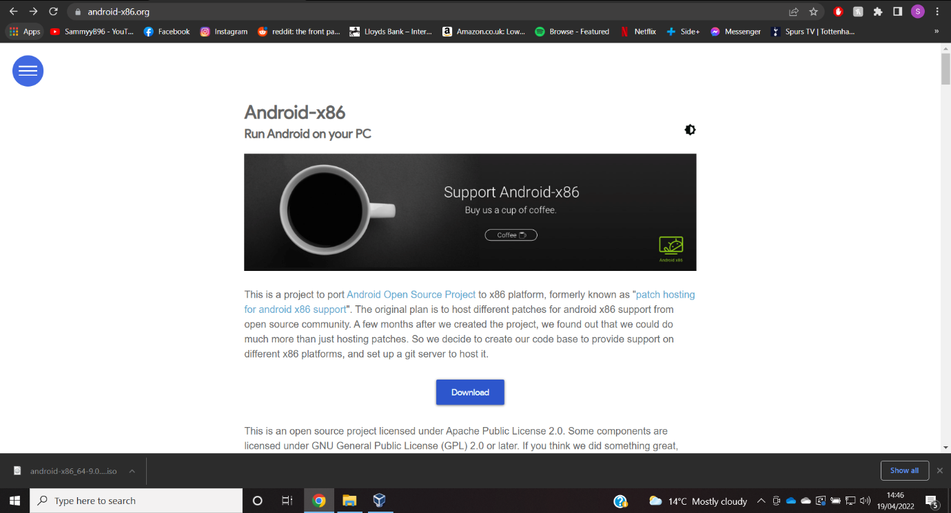
Hack number three is going to be hacking aa smart device which will be the smart phone, and you can implement a smart phone device into VirtualBox. First things first is to find an android ISO File.
Figure 63 - Finding Android ISO

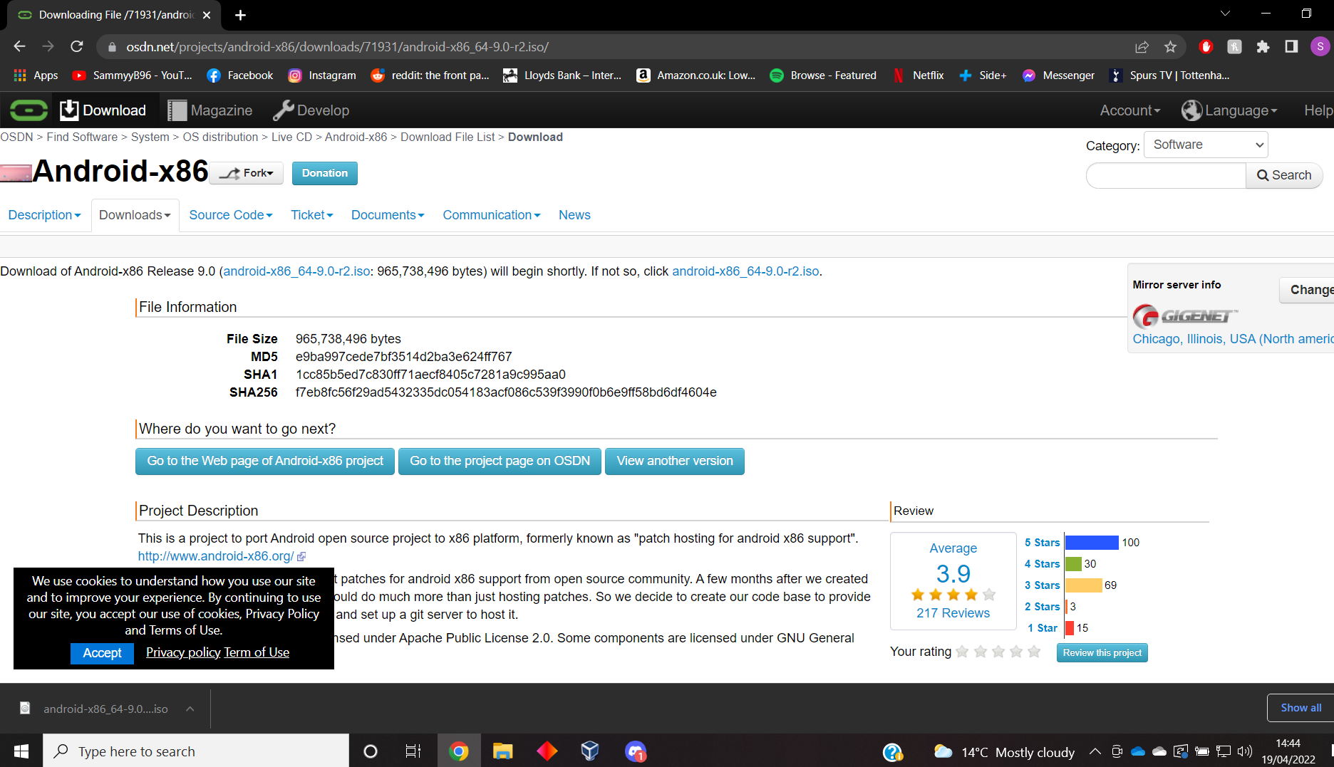
Download the Android ISO file from the reliable website, android themselves.
Figure 64 - Downloading Android ISO File
Figure 65 - Need to Create Android VM

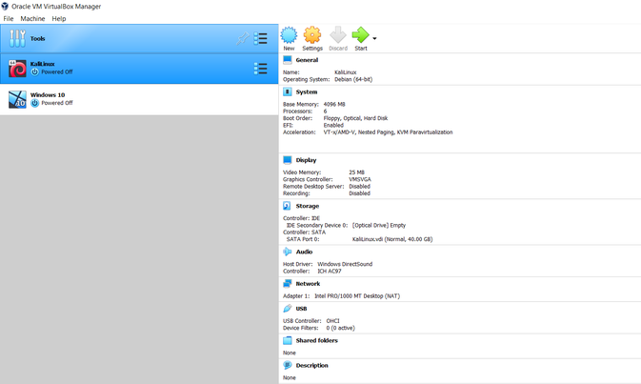
Now I have to create an android Virtual machine within Oracle VirtualBox, luckily, I can re-use Kali Linux VM from the previous hacks.
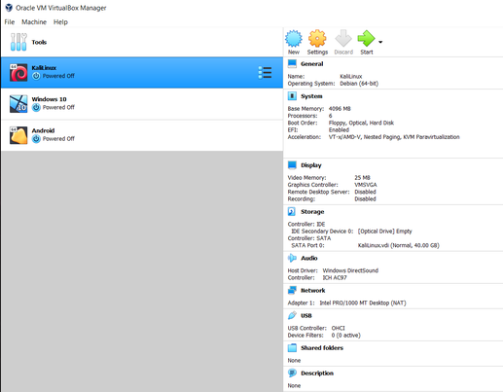
Figure 66 - Android VM Created
The Android VM has been created, straightforward and had to alter some setting like the video setting maxing it out as well as given it some extra processors.

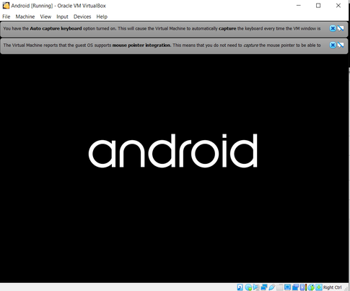
Running the Android VM to ensure it is working accordingly.
Figure 67 - Running Android VM

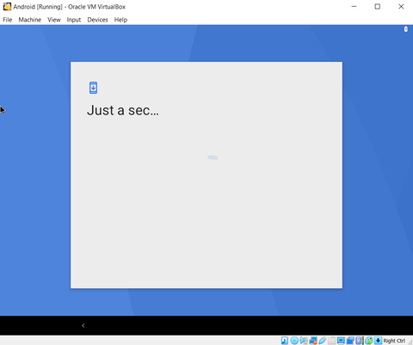
Going through the set-up process as it provides.
Figure 68 - Going Through Set-Up Process
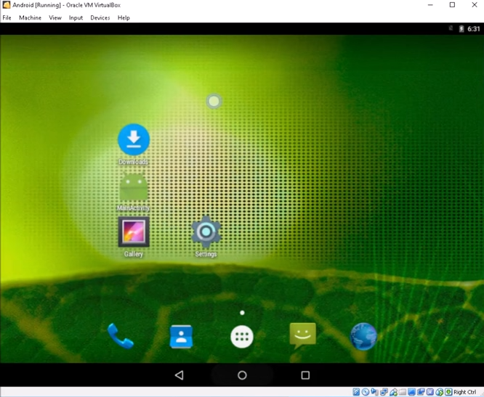
Figure 69 - Android VM Set-Up
After the set-up process is complete, making sure the VM is working and ready to bed hacked.
Next it to boot up the Hacking VM kali Linux and begin the Haack on the android.
Figure 70 - Next Start up Kali Linux
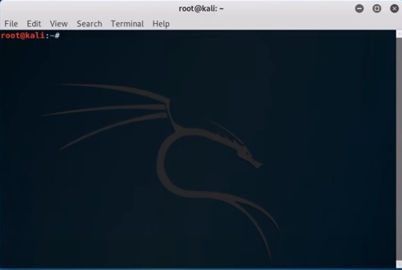
Figure 71 - Starting up the Terminal

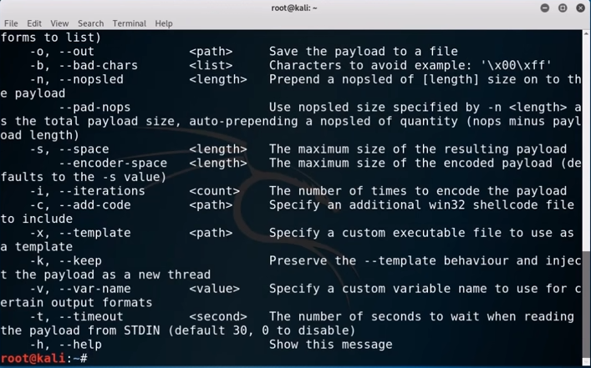
This command gives you a list of other commands which can be used for this attack that is going to happen, I went with the payload option again because it is best suited to this attack
Figure 72 - msfvenom -help Command

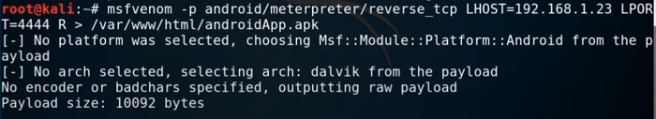
Figure 73 - msfvenom Android command
Again, a reverse tcp attack is going to be chosen for this attack, because it’s a great way to get past any security protocols because the target is going to be connecting to you, bypassing any security which would get in the way. The command would generate the payload ready for use, and as you can see if tells the user the what the payload size is.

Figure 74 - Running MetaSploit
Starting up MetaSploit ready to start engaging the payload.

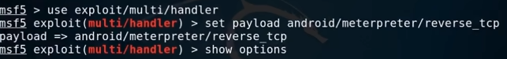
This is the command used to start up the payload, using meterpreter selecting the reverse tcp option earlier from the help command.
Figure 75 - Setting the Payload
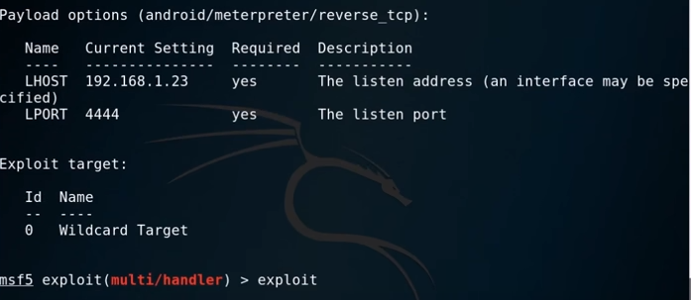
Figure 76 - Checking LHOST and LPORT / Engaged Payload
This is where I made sure the LHOST and LPORT are correct, this is vital otherwise the hack would not work. Afterwards the “Exploit” command was used to start the payload and the application came back stating the payload has been done.

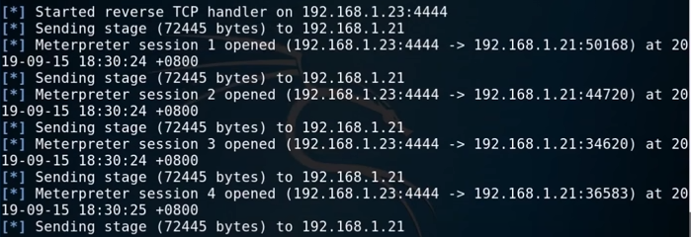
This is what the application came back wit, stating that tcp handler has done what it was supposed to do. Metasploit has engaged the payload to the right IP, in which it has been sent and set up ready for the target to engage with.
Figure 77 - Response from MetaSploit
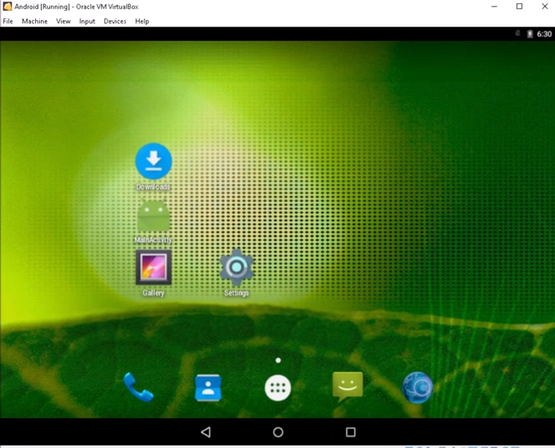
Figure 78 - Accessing the internet with Android VM
Now with the Android VM, we would access the internet through the VM, and type in the correct IP address as a user would, and the apk should start downloading.

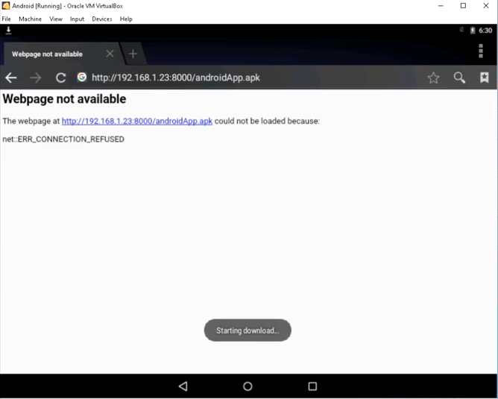
After accessing the internet and running the IP the download does begin to download to the user’s smart phone.
Figure 79 - Entering IP/ File Downloads

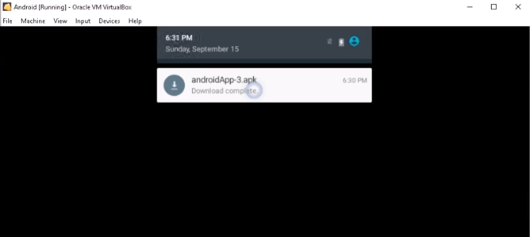
Figure 80 - Download Complete
Download is complete, and the user will receive the notification to show.

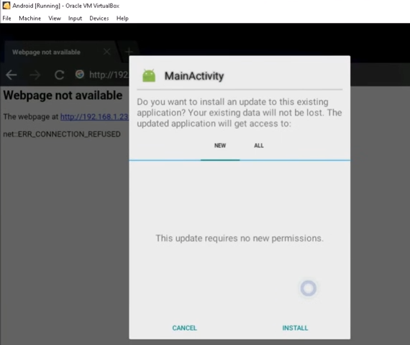
Figure 81 - Android Prompt to Install apk file
Once the user clicks the notification message, the device will prompt the user to install the file to their device.



Figure 82 - Installation Complete

Little message to show the user that the install is complete, click the done button. Now that the payload has been downloaded onto their phone the hacker has access to their device when ever they want.

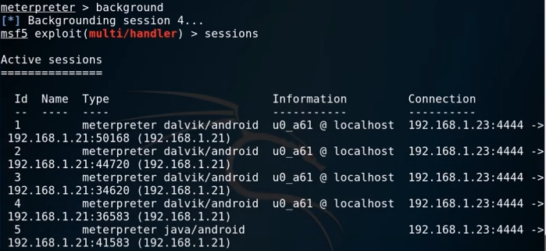
Next, I run two commands the first one was “background” which retrieved session four and then I run the command “sessions” which then came back people who have installed the apk file/ which is the payload and then who actually did install the payload onto their smart phone.
Figure 83 - Command to Show Who Installed

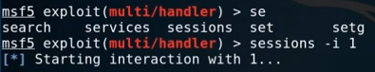

Figure 84 - Command sessions -I 1

Selecting the target you want, in order to access their device.

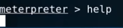

Figure 85 - Entering Help Command

The Help command will show you the commands which can be implemented against the targets device for example webcam shot, will take a photo of the user without them knowing.

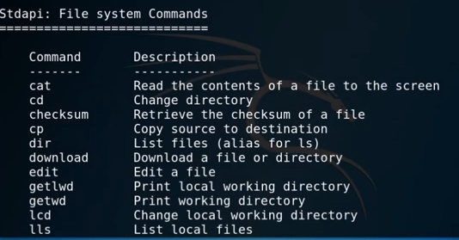

Figure 86 - Commands that can be Used

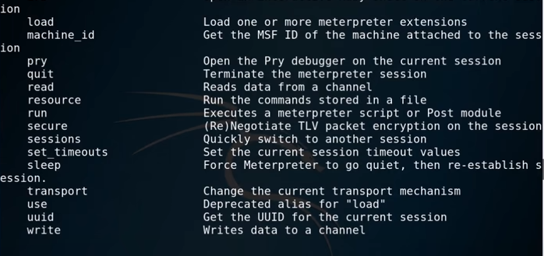
Some commands which can be used against the user, one command will allow the hacker to edit files and so on.
Figure 87 - Commands that can be Used
Some more commands which can come in use to the hacker, for example “sessions” will allow the hacker to switch targets if they wish. The “load” command will allow the hacker to add more meterpreters to the target’s device allowing them to maintain access to the target if they wish.

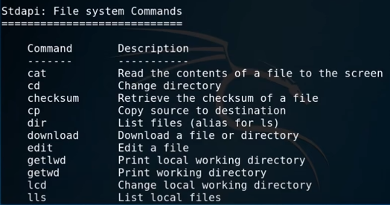
Figure 88 - More Commands that can be Used
These commands are very handy if you want to get data such as sensitive information about the target, these commands will allow you to download them for you own personal gain.

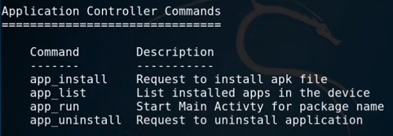
Figure 89 - Useful Commands

Figure 90 - App List command executed

Decided to run one of the commands to see what it comes up with.

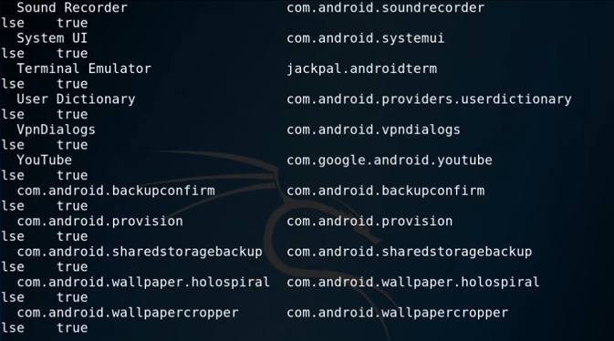
Figure 91 - Result of Command
The command worked and showed the applications which are downloaded on the user’s device, as you can see from figure 93 the user has YouTube download, as well as more
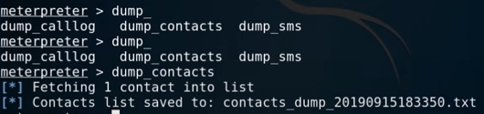

Figure 92 - Trying Another Command

Next, I tried the dump contacts command which as you can see downloaded the files which allows the hacker to download more files.

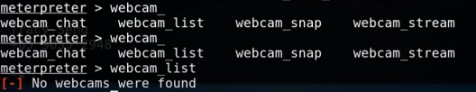

Figure 93 - Webcam Command

Next, I executed the webcam command, of course it was never going to work because I am using aa Virtual Android device, but if this was done in the real world the command would work.

Result of the Hack
Overall, the hack was a success, the objective was done which was hack a smart device, in which a smart phone was selected for this hack. The aim was to hack the device in which that was done. The hack was done using MSF venom and Metasploit, the hacking tool was great to use at times there were a few errors along the way, for example learning the commands different varieties of payloads which could be used, but overall, the result was a success.

Conclusions & Recommendations
In conclusion hacking is easily achievable to learn over a period if you are dedicated to learning new ways of doing things. In this report the main aim was to hack into three devices which are part of a network them being a Wireless Access-point, a computer/laptop and a smart device which could easily be a personas smart phone, and all three hacks were successful. The reason for this project being conducted is because Hacking is becoming a serious issue in the present day, people would think their network is secure enough to withstand a hack but, but it may not be. The reason for these devices being chosen is because they are being used on a day-to-day basis, and some are easier to crack than others but all three is achievable in the long run. All three hacks were done by using a Virtual network supplied by “Oracle VM VirtualBox”. When the virtual network was set up, the appropriate ISO files were downloaded to create the virtual machines themselves for example the hacking machine was using Kali Linux operating system in which the ISO file was download directly from Kali themselves. Once all the virtual machines were set up the hack could then begin. Appropriate research was conducted to know which tools would suit each hack an example of this was “Fern Wi-Fi Cracker” would be best suited to hacking the Wireless Access-Point, in which it was used for that, and the hacking tool did a wonderful job because it gave the hacker the key/Password to the device. The password was changed to a more difficult one, this included special characters and was around twenty to thirty characters long to make it harder to crack, but the tool retrieved the whole password, and the hack was rendered successful. The other two scenarios/hack were successful as well which was, he computer/laptop and smart device-smart phone. The other tool which was used for these hacks were MSF-Venom and Metasploit this tool is great to use because it generates payloads which exploit the targets devices in which the hacker can then control their device and do whatever they want with it. The Literature Review really helped with this project because it allowed me to conduct in depth research on the devices which were being hacked in this project, this allowed me to understand where the weaknesses were with the devices as well as vulnerabilities which are being targeted by hackers. If there were more that could be done to improve this project, it would be that only pre-installed tools were used for this project, there are more out there which can be used but must be downloaded to use within Kali Linux, those tools would be a recommendation because there are always better ones which can be implemented within this project.

Reflections
When conducting this project, I was shocked by how fast you can teach yourself about hacking, this includes the different types of hacking tools that come pre-installed with kali Linux but also others which can be downloaded and used with that operating system as well.
The project went well overall, and there are screenshots to show as evidence that the project was a success overall. The main aim of this project was to show to others how easy it is to hack yourself into a person home network and gaining access/control over those devices. However, there are tools out there which doesn’t not come pre-installed with Kali Linux which could have been more effective if used within this project. Bu also they could have been used in different scenarios if there were other devices for there to be hacked.
The strength about this project is that it shows other how easy it is to teach yourself hacking and how it can be implemented against devices within your own environment, this project was done on an educational basis and was used ethically and to do any illegal behaviour. Another strength about hacking is there is plenty of help on the internet as well as guides to show you how to do things.
A weakness of this project is the research onion, it was confusing at times on how to decide which area this project comes under the research onion diagram. Another one would be that none pre-installed tools were used in this project, it would have been good to show the difference between as well as the effectiveness of them and how they are better against pre-installed tools.
Future changes which would have conducted if there were more time for this project, one would have been using more tools for different scenarios, explain the advantages verses the disadvantages, as well as discussing the effectiveness of each tool.
Issues that came during the project would be not knowing how to use certain hacking tools and commands, for example MSF-Venom/Metasploit, sometimes I was using the incorrect commands to do things. A command which I learned during the process was the “help” command which displays to user the different commands which can be used as well as different payloads which can be generated during the process.

Bibliography

[1] | J. Lis, “Smart Home Forecast 2021,” Insider Intelligence, 21 12 2021. [Online]. Available: https://www.emarketer.com/content/smart-home-forecast-2021. [Accessed 10 03 2022].
[2] | J. Jackmann, “Smart Home Statistics,” theecoexperts, 29 10 2021. [Online]. Available: https://www.theecoexperts.co.uk/smart-homes/statistics. [Accessed 11 03 2022].
[3] | Angoka, “Smart Homes incredibly liable to cyberattacks,” Angoka, 8 07 2021. [Online]. Available: https://angoka.io/smart-homes-incredibly-liable-to-cyberattacks/. [Accessed 11 03 2022].
[4] | S. Esnaashari, I. Welsh and P. Komisarczuk, “Determining Home Users' Vulnerability to Universal Plug and Play (UPnP) Attacks,” IEEE, 26 03 2013. [Online]. Available: https://ieeexplore-ieee-org.ezproxy.uwtsd.ac.uk/document/6550482/authors#authors. [Accessed 18 02 2022].
[5] | K. Ecir Ugur, Y. Mehmet Ali and G. Samet, “Developing a Penetration Test Methodology in Ensuring, Router Security and Testing it in a Virtual Laboratory,” ACM Digital Library, 08 09 2015. [Online]. Available: https://dl-acm-org.ezproxy.uwtsd.ac.uk/doi/10.1145/2799979.2799989. [Accessed 18 02 2022].
[6] | V. Vasaka, J. Pongnapat, P. Natthamon and K. Pongjarun, “Firmaster: Analysis Tool for Home Router Firmware,” IEEE, 12 07 2018. [Online]. Available: https://ieeexplore-ieee-org.ezproxy.uwtsd.ac.uk/document/8457340/authors#authors. [Accessed 18 02 2022].
[7] | M. Nitesh, “Wireless attacks and mitigation,” INFOSEC, 02 02 2021. [Online]. Available: https://resources.infosecinstitute.com/topic/wireless-attacks-and-mitigation/. [Accessed 18 02 2022].
[8] | JustFirewalls, “HOW HACKERS GET THROUGH FIREWALLS – 6 TACTICS CYBER CRIMINALS USE TO BREACH ENTERPRISE-LEVEL BUSINESSES,” JustFirewalls, [Online]. Available: https://www.justfirewalls.com/how-hackers-get-around-firewalls/. [Accessed 18 02 2022].
[9] | S. Gupta, Isha, A. Bhattacharya and H. Gupta, “Analysis of Social Engineering Attack on Cryptographic Algorithm,” IEEE, 03 09 2021. [Online]. Available: https://ieeexplore-ieee-org.ezproxy.uwtsd.ac.uk/document/9596568/authors#authors. [Accessed 18 02 2022].
[10] | Imperva, “Social Engineering,” Imperva, [Online]. Available: https://www.imperva.com/learn/application-security/social-engineering-attack/. [Accessed 18 02 2022].
[11] | T. Nathezhtha, D. Sangeetha and V. Vaidehi, “WC-PAD: Web Crawling based Phishing Attack Detection,” IEEE, 2 10 2019. [Online]. Available: https://ieeexplore-ieee-org.ezproxy.uwtsd.ac.uk/document/8888416/authors#authors. [Accessed 18 02 2022].
[12] | V. Shakela and H. Jazri, “Assessment of Spear Phishing User Experience and Awareness: An Evaluation Framework Model of Spear Phishing Exposure Level (SPEL) in the Namibian Financial Industry,” IEEE, 5 08 2019. [Online]. Available: https://ieeexplore-ieee-org.ezproxy.uwtsd.ac.uk/document/8851058/authors#authors. [Accessed 18 02 2022].
[13] | D. P, M. Kumar S, C. Raghavendra, K. Prasad SJ, K. H and D. SS, “Cyber Security Threats Detection Analysis and Remediation,” IEEE, 24 10 2021. [Online]. Available: https://ieeexplore-ieee-org.ezproxy.uwtsd.ac.uk/document/9641621/authors#authors. [Accessed 18 02 2022].
[14] | Bridwell, “Why Laptops Are One of Your Business’s Biggest Security Risks,” Bridwell Consulting, [Online]. Available: https://www.bridewellconsulting.com/why-laptops-are-one-of-your-businesss-biggest-security-risks. [Accessed 25 02 2022].
[15] | Kaspersky, “What is a Trojan horse and what damage can it do?,” Kaspersky, [Online]. Available: https://www.kaspersky.co.uk/resource-center/threats/trojans. [Accessed 25 02 2022].
[16] | Imperva, “Backdoor Attack,” Imperva, [Online]. Available: https://www.imperva.com/learn/application-security/backdoor-shell-attack/. [Accessed 25 02 2022].
[17] | R. Bailey, “Trojan.Exploit,” Howtofix, [Online]. Available: https://howtofix.guide/trojan-exploit/. [Accessed 25 02 2022].
[18] | “Black hat, White hat, and Gray hat hackers – Definition and Explanation,” Kaspersky, [Online]. Available: https://www.kaspersky.com/resource-center/definitions/hacker-hat-types. [Accessed 07 12 2021].
[19] | M. Schiefer, “Smart Home Definition and Security Threats,” IEEE, 17 08 2015. [Online]. Available: https://ieeexplore-ieee-org.ezproxy.uwtsd.ac.uk/document/7195812/authors#authors. [Accessed 28 11 2021].
[20] | W. Zhou, Y. Jia, A. Peng and Y. Z. Peng , “The Effect of IoT New Features on Security and Privacy: New Threats, Existing Solutions, and Challenges Yet to Be Solved,” IEEE, 15 06 2018. [Online]. Available: https://ieeexplore-ieee-org.ezproxy.uwtsd.ac.uk/document/8386824/authors#authors. [Accessed 07 12 2021].
[21] | S. Ivanović, S. Milivojša, T. Erić and M. Vidaković, “Collection and Analysis of System Usage Data in Smart Home Automation Systems,” IEEE, 18 12 2017. [Online]. Available: https://ieeexplore-ieee-org.ezproxy.uwtsd.ac.uk/document/8210592/authors#authors. [Accessed 07 12 2021].
[22] | S. Jun and H. Daxiang, “Protection Profile for the Smart Phone Operating System,” IEEE, 10 09 2013. [Online]. Available: https://ieeexplore-ieee-org.ezproxy.uwtsd.ac.uk/document/6631585. [Accessed 13 04 2022].
[23] | J. Joshi and C. Parekh, “Android smartphone vulnerabilities: A survey,” IEEE, 08 04 2016. [Online]. Available: https://ieeexplore-ieee-org.ezproxy.uwtsd.ac.uk/document/7578857. [Accessed 13 04 2022].
[24] | A. Khandelwal and A. K. Mohapatra, “An insight into the security issues and their solutions for android phones,” IEEE, 12 03 2015. [Online]. Available: https://ieeexplore-ieee-org.ezproxy.uwtsd.ac.uk/document/7100230. [Accessed 13 04 2022].
[25] | S. Sengupta, “WHAT ARE THE FIVE STEPS OF ETHICAL HACKING?,” Crashtest Security, 22 10 2021. [Online]. Available: https://crashtest-security.com/five-steps-of-ethical-hacking/. [Accessed 28 03 2022].
[26] | S. Sengupta, “WHAT ARE THE FIVE STEPS OF ETHICAL HACKING?,” Crashtest Security, 22 10 2021. [Online]. Available: https://crashtest-security.com/five-steps-of-ethical-hacking/. [Accessed 11 03 2022].
[27] | GreyCampus, “Phases of Hacking,” Grey Campus, [Online]. Available: https://www.greycampus.com/opencampus/ethical-hacking/phases-of-hacking. [Accessed 06 04 2022].
[28] | 15Writers, “Understanding the Research Onion,” 15 Writers, [Online]. Available: https://15writers.com/research-onion/#:~:text=The%20research%20onion%20suggests%20that%20strategies%20can%20include%20action%20research,the%20purpose%20of%20the%20study.. [Accessed 24 03 2022].
[29] | M. A. Al Rahman, “Research philosophy Research philosophy,” ResearchGate, 01 07 2017. [Online]. Available: https://www.researchgate.net/figure/Research-philosophy-Research-philosophy-consists-of-four-main-types-of-researches-these_fig5_326573068. [Accessed 28 03 2022].
[30] | N. James, “Definition of a Scientific Experiment,” Study.com, [Online]. Available: https://study.com/academy/lesson/scientific-experiment-definition-examples-quiz.html. [Accessed 28 03 2022].
[31] | S. GuhaThakurta and P. Chetty, “Understanding research philosophy,” Project Guru, 25 06 2015. [Online]. Available: https://www.projectguru.in/research-philosophy/]. [Accessed 28 03 2022].
[32] | P. Žukauskas, J. Vveinhardt and R. Andriukaitienė, “Philosophy and Paradigm of Scientific Research,” Intechopen, 18 04 2018. [Online]. Available: https://www.intechopen.com/chapters/58890. [Accessed 28 03 2022].
[33] | P. Bhandari, “What Is Quantitative Research? | Definition & Methods,” Scribbr, 04 04 2022. [Online]. Available: https://www.scribbr.co.uk/research-methods/introduction-to-quantitative-research/. [Accessed 05 04 2022].
[34] | K. Cherry, “How Does the Cross-Sectional Research Method Work?,” Verywellmind, 10 10 2019. [Online]. Available: https://www.verywellmind.com/what-is-a-cross-sectional-study-2794978#:~:text=Think%20of%20a%20cross%2Dsectional,happening%20at%20the%20present%20moment.. [Accessed 28 03 2022].
[35] | Kali.org, “Fern-Wifi-Cracker,” Kali , [Online]. Available: https://www.kali.org/tools/fern-wifi-cracker/. [Accessed 13 04 2022].
[36] | Kali.org, “Armitage,” Kali.org, [Online]. Available: https://www.kali.org/tools/armitage/. [Accessed 13 03 2022].
[37] | Kali.org, “Nmap,” Kali.org. [Online]. [Accessed 11 03 2022].
[38] | Kali.org, “Metasploit-Framework,” Kali.org, [Online]. Available: https://www.kali.org/tools/metasploit-framework/. [Accessed 11 03 2022].
[39] | Kali.org, “John,” Kali.org, [Online]. Available: https://www.kali.org/tools/john/#:~:text=John%20the%20Ripper%20is%20a,it%2C%20if%20it%20is%20desired.. [Accessed 11 03 2022].
[40] | Kali.org, “Wireshark,” Kali.org, [Online]. Available: https://www.kali.org/tools/wireshark/. [Accessed 13 03 2022].
[41] | Rubin and B. Fox, “Amazon sees Alexa devices more than double in just one year,” cnet, 6 01 2020. [Online]. Available: https://www.cnet.com/home/smart-home/amazon-sees-alexa-devices-more-than-double-in-just-one-year/. [Accessed 07 12 2021].
[42] | Y. Lit, S. Kim and E. Sy, “A Survey on Amazon Alexa Attack Surfaces,” IEEE, 09 01 2021. [Online]. Available: https://ieeexplore-ieee-org.ezproxy.uwtsd.ac.uk/document/9369553/authors#authors. [Accessed 07 12 2021].
[43] | F. W. Sarjana, T. Y. Arif, R. Adriman and R. Munadi, “Simple Prevention of Advanced Stealth Man-in-The-Middle Attack in WPA2 Wi-Fi Networks,” IEEE, 2 10 2019. [Online]. Available: https://ieeexplore-ieee-org.ezproxy.uwtsd.ac.uk/document/8984491/authors#authors. [Accessed 07 12 2021].
[44] | C. Cimpanu, “Voice Squatting Attacks Impact Amazon Alexa and Google Home Assistants,” BleepingComputer, 17 05 2018. [Online]. Available: https://www.bleepingcomputer.com/news/security/voice-squatting-attacks-impact-amazon-alexa-and-google-home-assistants/. [Accessed 07 12 2021].
[45] | Hasa, “Difference Between Positivism and Realism,” Pediaa, 31 10 2019. [Online]. Available: https://pediaa.com/difference-between-positivism-and-realism/. [Accessed 28 03 2022].
[46] | V. Kaushik, “Pragmatism as a Research Paradigm and Its Implications for Social Work Research,” MDPI, 6 09 2019. [Online]. Available: https://www.mdpi.com/2076-0760/8/9/255/htm. [Accessed 28 03 2022].
[47] | P. Bhandari, “What Is Quantitative Research? | Definition & Methods,” Scribbr, [Online]. Available: https://www.scribbr.co.uk/research-methods/introduction-to-quantitative-research/. [Accessed 28 03 2022].

Appendices

Appendix A - Project Management
Original Gantt Chart
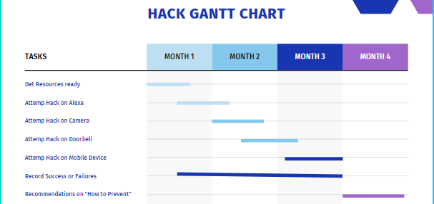

Updated Gantt chart
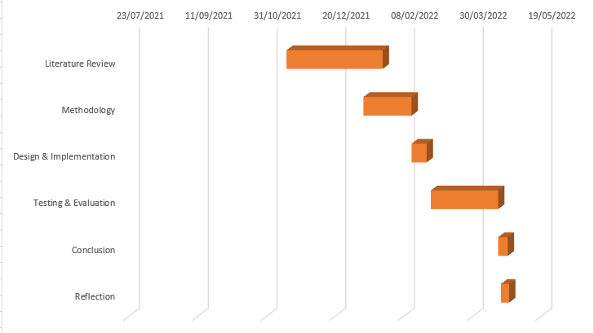

Appendix B - Ethics Form

APPLICATION FOR ETHICAL APPROVAL

In order for research to result in benefit and minimise risk of harm, it must be conducted ethically.

The University follows the OECD Frascati manual definition of research activity: “creative work undertaken on a systematic basis in order to increase the stock of knowledge, including knowledge of man, culture and society, and the use of this stock of knowledge to devise new applications”. As such this covers activities undertaken by members of staff, postgraduate research students, and both taught postgraduate and undergraduate students working on dissertations/projects.

The individual undertaking the research activity is known as the “principal researcher”.

This form must be completed and approved prior to undertaking any research activity.

SECTION A: About You (Principal Researcher)
1 | Full Name: | Samuel Richards
2 | Student Number: | 1901717
3 | Email address: | 1901717@student.uwtsd.ac.uk
4 | Programme of Study: | Computing Networking & Cyber Security
5 | Director of Studies/Supervisor: | Kapilan Radhakrishnan

SECTION B: Internal and External Ethical Guidance Materials
 | Please list the core ethical guidance documents that have been referred to during the completion of this form (including any discipline-specific codes of research ethics, location-specific codes of research ethics, and also any specific ethical guidance relating to the proposed methodology). Please tick to confirm that your research proposal adheres to these codes and guidelines. You may add rows to this table if needed.
1 | UWTSD Research Ethics & Integrity Code of Practice | ☒
2 | UWTSD Research Data Management Policy | ☒
3 |  | ☐

SECTION C: External Collaborative Research Activity
If there are no external collaborators then leave this section blank and continue to section D
1 | Does the research activity involve collaborators outside of the University? |  | YES | ☐ | NO | ☒
 | If Yes, please provide the name of the external organisation and name and contact details for the main contact person and confirmation this person has consented to their personal data being shared.as part of this collaboration.
2 | Institution
3 | Contact person name
4 | Contact person e-mail address
5 | Has this individual consented to sharing their details on this form? |  | YES | ☐ | NO |  | ☒
6 | Has permission to undertake the research has been provided by the partner organisation? | (If YES attach copy)  If NO the application cannot continue | YES | ☐ | NO |  | ☐
7 | Does this organisation have its own ethics approval system that applies to this research? |  | YES | ☐ | NO |  | ☒
 | If Yes, please attach a copy of any final approval (or interim approval) from the organisation (this may be a copy of an email confirming any such approval).

SECTION D: Details of Research Activity
1 | Indicative title: | Testing the Security of a Home Network (HN)
2 | Proposed start date: | 20/09/2021 | Proposed end date: | 13/05/2022
Introduction to the Research (maximum 300 words in each section)
Ensure that you write for a Non-Specialist Audience when outlining your response to the three points below:
- Purpose of Research Activity
- Proposed Research Question
- Aims of Research Activity
- Objectives of Research Activity
Demonstrate, briefly, how Existing Research has informed the proposed activity and explain
- What the research activity will add to the body of knowledge
- How it addresses an area of importance.
3 | Purpose of Research Activity  This project is all about trying to hack into a home network, the objective is to hack into one gaining access to the network and maintaining the access. The reason for this is because hacking is becoming very common now a days.  (this box should expand as you type)
4 | Research Question  Is it possible to hack a HN to test the security features of the system and devices in order to find and exploit vulnerabilities in order to offer recommendations for securing HNs.  (this box should expand as you type)
5 | Aims of Research Activity  The aim of this research is to attempt to hack a HN to test the security features of the system and devices in order to find and exploit vulnerabilities and offer recommendations for securing HNs.  (this box should expand as you type)
6 | Objectives of Research Activity  Perform a review of existing research on HN, Smart devices, the security features which are involved, and hacking tools and software which are used in hacking such networks.  Create a hybrid virtual/physical network with connected physical HN devices.  Attempt to find and exploit vulnerabilities within the home network using the chosen tools and methods and report the results.  Offer recommendations for securing HN based on findings.  (this box should expand as you type)
Proposed data collection methods (maximum 600 words)
Provide a brief summary of all the methods that may be used in the research activity to collect data, making it clear what specific techniques may be used. If methods other than those listed in this section are deemed appropriate later, additional ethical approval for those methods will be needed. You do not need to justify the methods here, but should instead describe how you intend to collect the data necessary for you to complete your project.
7 | Oracle VM VirtualBox  Kali Linux hacking tools “Fern Wifi Cracker”, “Metasploit”  Kali Linux ISO File  Windows ISO File  Android ISO File  (this box should expand as you type)

SECTION E: Scope of Research Activity
 | Will the research activity include: | YES | NO
1 | Use of a questionnaire or similar research instrument? | ☐ | ☒
2 | Use of interviews? | ☐ | ☒
3 | Use of focus groups? | ☐ | ☒
4 | Use of participant diaries? | ☐ | ☒
5 | Use of video or audio recording? | ☐ | ☒
6 | Use of computer-generated log files? | ☐ | ☒
7 | Participant observation with their knowledge? | ☐ | ☒
8 | Participant observation without their knowledge? | ☐ | ☒
9 | Access to personal or confidential information without the participants’ specific consent? | ☐ | ☒
10 | Administration of any questions, test stimuli, presentation that may be experienced as physically, mentally or emotionally harmful / offensive? | ☐ | ☒
11 | Performance of any acts which may cause embarrassment or affect self-esteem? | ☐ | ☒
12 | Investigation of participants involved in illegal activities? | ☐ | ☒
13 | Use of procedures that involve deception? | ☐ | ☒
14 | Administration of any substance, agent or placebo? | ☐ | ☒
15 | Working with live vertebrate animals? | ☐ | ☒
16 | Procedures that may have a negative impact on the environment? | ☐ | ☒
17 | Other primary data collection methods. Please indicate the type of data collection method(s) below. | ☐ | ☒
 | Details of any other primary data collection method:  (this box should expand as you type) | ☐ | ☒

If you have ticked NO to every question then the research activity is (ethically) low risk and you may skip section F and continue to section G.

If you have ticked YES to any question, then no research activity should be undertaken until full ethical approval has been obtained. You should continue to section F.

SECTION F: Intended Participants
 | Who are the intended participants: | YES | NO
1 | Students or staff at the University? | ☐ | ☒
2 | Adults (over the age of 18 and competent to give consent)? | ☐ | ☒
3 | Vulnerable adults? | ☐ | ☒
4 | Children and Young People under the age of 18? (Consent from Parent, Carer or Guardian will be required) | ☐ | ☒
5 | Prisoners? | ☐ | ☒
6 | Young offenders? | ☐ | ☒
7 | Those who could be considered to have a particularly dependent relationship with the investigator or a gatekeeper? | ☐ | ☒
8 | People engaged in illegal activities? | ☐ | ☒
9 | Others. Please indicate the participants below, and specifically any group who may be unable to give consent. | ☐ | ☒
 | Details of any other participant groups:  Complete this only if your participants cannot give consent. This includes animals.  (this box should expand as you type) | ☐ | ☒

Participant numbers and source
Provide an estimate of the expected number of participants. How will you identify participants and how will they be recruited?
10 | How many participants are expected? | 0
11 | Who will the participants be? | 0  (this box should expand as you type)
12 | How will you identify the participants? | 0  (this box should expand as you type)

 | Information for participants: | YES | NO | N/A
13 | Will you describe the main research procedures to participants in advance, so that they are informed about what to expect? | ☐ | ☐ | ☒
14 | Will you tell participants that their participation is voluntary? | ☐ | ☐ | ☒
15 | Will you obtain written consent for participation? | ☐ | ☐ | ☒
16 | Will you explain to participants that refusal to participate in the research will not affect their treatment or education (if relevant)? | ☐ | ☐ | ☒
17 | If the research is observational, will you ask participants for their consent to being observed? | ☐ | ☐ | ☒
18 | Will you tell participants that they may withdraw from the research at any time and for any reason? | ☐ | ☐ | ☒
19 | With questionnaires, will you give participants the option of omitting questions they do not want to answer? | ☐ | ☐ | ☒
20 | Will you tell participants that their data will be treated with full confidentiality and that, if published, it will not be identifiable as theirs? | ☐ | ☐ | ☒
21 | Will you debrief participants at the end of their participation, in a way appropriate to the type of research undertaken? | ☐ | ☐ | ☒
22 | If NO to any of above questions, please give an explanation
You should be able to tick YES or N/A for all of these questions. If not, then explain why not in this box.

(this box should expand as you type)

 | Information for participants: | YES | NO | N/A
24 | Will participants be paid? | ☐ | ☐ | ☒
25 | Is specialist electrical or other equipment to be used with participants? | ☐ | ☐ | ☒
26 | Are there any financial or other interests to the investigator or University arising from this study? | ☐ | ☐ | ☒
27 | Will the research activity involve deliberately misleading participants in any way, or the partial or full concealment of the specific study aims? | ☐ | ☐ | ☒
28 | If YES to any question, please provide full details
You should be able to tick NO or N/A for most of these questions. For any cases that you have ticked YES then provide details in this box. If you are using cameras/voice recorders to record interviews then please state that in this box.

(this box should expand as you type)

SECTION G: Anticipated Risks

 | Outline any anticipated risks that may adversely affect any of the participants, the researchers and/or the University, and the steps that will be taken to address them.
1 | Risks to participants  For example: sector-specific health & safety, emotional distress, financial disclosure, physical harm, transfer of personal data, sensitive organisational information. If you have identified in section D that there are no participants then enter N/A and go skip to question 3.
 | Risk to participants:  None  (this box should expand as you type) | How you will mitigate the risk to participants:  (this box should expand as you type)
2 | If research activity may include sensitive, embarrassing or upsetting topics (e.g. sexual activity, drug use) or issues likely to disclose information requiring further action (e.g. criminal activity), give details of the procedures to deal with these issues, including any support/advice (e.g. helpline numbers) to be offered to participants. Note that where applicable, consent procedures should make it clear that if something potentially or actually illegal is discovered in the course of a project, it may need to be disclosed to the proper authorities
 | (this box should expand as you type)
3 | Risks to the investigator  For example: personal health & safety, physical harm, emotional distress, risk of accusation of harm/impropriety, conflict of interest
 | Risk to the investigator:  None, everything is being conducted in a virtual network, which will result to no risks.  (this box should expand as you type) | How you will mitigate the risk to the investigator:  (this box should expand as you type)
4 | University/institutional risks  For example: adverse publicity, financial loss, data protection
 | Risk to the University:  There are always risks. Do not write N/A.  (this box should expand as you type) | How you will mitigate the risk to the University:  (this box should expand as you type)
5 | Environmental risks  For example: accidental spillage of pollutants, damage to local ecosystems
 | Risk to the environment:  (this box should expand as you type) | How you will mitigate the risk to environment:  (this box should expand as you type)

SECTION H: Feedback, Consent and Confidentiality

If you have identified in section E that there are no participants then skip this section and continue to section I.

1 | Feedback  What de-briefing and feedback will be provided to participants, how will this be done and when?
You don’t need to email your participants with your final report. A good alternative is to set up an email address that they will be able to contact for further details or results.

(this box should expand as you type)
2 | Informed consent  Describe the arrangements to inform potential participants, before providing consent, of what is involved in participating. Describe the arrangements for participants to provide full consent before data collection begins. If gaining consent in this way is inappropriate, explain how consent will be obtained and recorded in accordance with prevailing data protection legislation.
If you are using a paper questionnaire then you should have the participants sign an appropriate consent form. These forms will count as personal data and should be noted as such in section J.
If you are using an online questionnaire, then you should have a screen before the questions start that acts as a consent form, informing participants that by clicking on the NEXT button they are providing consent.

(this box should expand as you type)
3 | Confidentiality / Anonymity  Set out how anonymity of participants and confidentiality will be ensured in any outputs. If anonymity is not being offered, explain why this is the case.
Do not collect names unless you really need them. Do not name participants or organisations in any research publications (including the thesis) without their explicit permission.

(this box should expand as you type)

SECTION I: Data Protection and Storage

 | Does the research activity involve personal data (as defined by the General Data Protection Regulation 2016 “GDPR” and the Data Protection Act 2018 “DPA”)? | YES | NO
1 | “Personal data” means any information relating to an identified or identifiable natural person (‘data subject’). An identifiable natural person is one who can be identified, directly or indirectly, in particular by reference to an identifier such as a name, an identification number, location data, an online identifier or to one or more factors specific to the physical, physiological, genetic, mental, economic, cultural or social identity of that natural person. Any video or audio recordings of participants is considered to be personal data. | ☐ | ☒
 | If YES, provide a description of the data and explain why this data needs to be collected:
2 | This includes audio/video data of participants, but can also include IP addresses and usernames. Names, addresses and emails also count, as do consent forms.  (this box should expand as you type)
 | Does it involve special category data (as defined by the GDPR)? | YES | NO
3 | “Special category data” means sensitive personal data consisting of information as to the data subjects’ –  (a) racial or ethnic origin,  (b) political opinions,  (c ) religious beliefs or other beliefs of a similar nature,  (d) membership of a trade union (within the meaning of the Trade Union and Labour Relations (Consolidation) Act 1992),  (e) physical or mental health or condition,  (f) sexual life,  (g) genetics,  (h) biometric data (as used for ID purposes), | ☐ | ☒
 | If YES, provide a description of the special category data and explain why this data needs to be collected:
4 | What counts as ‘sensitive’ will differ between cultures. Any information on behaviour that is not in accordance with cultural norms would count as sensitive personal data.  (this box should expand as you type)

 | Will data from the research activity (collected data, drafts of the thesis, or materials for publication) be stored in any of the following ways? | YES | NO
5 | Manual files (i.e. in paper form)? | ☐ | ☒
6 | University computers? | ☐ | ☒
7 | Private company computers? | ☐ | ☒
8 | Home or other personal computers? | ☒ | ☐
9 | Laptop computers/ CDs/ Portable disk-drives/ memory sticks? | ☒ | ☐
10 | “Cloud” storage or websites? | ☐ | ☒
11 | Other – specify: | ☐ | ☒
12 | For all stored data, explain the measures in place to ensure the security of the data collected, data confidentiality, including details of backup procedures, password protection, encryption, anonymisation and pseudonymisation:
If possible, save your data on computers that are secure and regularly backed up. Many cloud services only provide GDPR-compliant storage for business customers. An example of suitable text is given below.

All data will be kept in password protected cloud storage on the University Office 365 system which
will not be shared. Audio/visual data will be transcribed and would be shown to participants to
check accuracy of reporting. Any USB sticks used to store or transfer data will be password protected. All participants will be given a unique identifier to ensure confidentiality and this list will be kept securely in the password protected folder.

(this box should expand as you type)

 | Data Protection
 | Will the research activity involve any of the following activities: | YES | NO
13 | Electronic transfer of data in any form? | ☒ | ☐
14 | Sharing of data with others at the University outside of the immediate research team? | ☐ | ☒
15 | Sharing of data with other organisations? | ☐ | ☒
16 | Export of data outside the UK or importing of data from outside the UK? | ☐ | ☒
17 | Use of personal addresses, postcodes, faxes, emails or telephone numbers? | ☐ | ☒
18 | Publication of data that might allow identification of individuals? | ☐ | ☒
19 | If YES to any question, please provide full details, explaining how this will be conducted in accordance with the GDPR and Data Protection Act (2018) (and/or any international equivalent):
This includes data such as drafts of your thesis as well as experimental or survey data. An example of suitable text is given below.

All data will be encrypted and kept in password protected cloud storage on the University Office 365 system which will not be shared. Any USB sticks used to store or transfer data will be password protected. All data transfers will be encrypted and password protected. All participants will be given a unique identifier to ensure confidentiality and this list will be kept securely in the password protected folder. The data will be stored until the completion of the project and then deleted. In accordance with the DPA2018, participants will have the right to ask to see what data is held relating to them, and this data will be deleted immediately if the participant requests this, in which case the data will not be used in the project.

(this box should expand as you type)
20 | List all who will have access to the data generated by the research activity:
Normally the principal researcher, possibly also the supervisor and, if the project has an industrial partner, a representative of that partner. Possibly also external examiner or second marker?

(this box should expand as you type)
21 | List who will have control of, and act as custodian(s) for, data generated by the research activity:
Usually the principal researcher.

(this box should expand as you type)
22 | Give details of data storage arrangements, including security measures in place to protect the data, where data will be stored, how long for, and in what form.
This includes data such as drafts of your thesis as well as experimental or survey data. An example of suitable text is given below.

All data will be encrypted and kept in password protected cloud storage on the University Office 365 system which will not be shared. Any USB sticks used to store or transfer data will be password protected, and will be reformatted at the end of the project in order to destroy the data. The data will be stored until the completion of the project and then deleted.

(this box should expand as you type)
22 | Confirm that you have read the UWTSD guidance on data management (see https://www.uwtsd.ac.uk/library/research-data-management/) | ☒
23 | Confirm that you are aware that you need to keep all data until after your research has completed or the end of your funding | ☒

SECTION J: Declaration
The information which I have provided is correct and complete to the best of my knowledge. I have attempted to identify any risks and issues related to the research activity and acknowledge my obligations and the rights of the participants.

In submitting this application I hereby confirm that I undertake to ensure that the above named research activity will meet the University’s Research Ethics and Integrity Code of Practice which is published on the website: https://www.uwtsd.ac.uk/research/research-ethics/
 | 1 | Signature of applicant: | S.Richards | Date: 29/04/2022
2 |  | Director of Studies/Supervisor: |  |  | Date:
3 |  | Signature: |  |  | Date:

FOR INTERNAL USE ONLY:
 | Ethical approval given
1 | Signature of assessor: |  | Date:
2 | Name:
3 | Role:

