12/15/2025
Gabriel Pegoraro De Souza
2410657
Analyzing and Solving Problems
Wales University London – ACCA4019

Contents
1. Deconstruction of the Problem 2
1.1 Breaking Down the Problem 2
1.2 Main Constraints and Variables 3
1.3 MoSCoW Requirements Analysis 3
2. Proposed Solution and Explanation 4
2.1 Overview of the Proposed Solution 4
2.2 Flowchart Logic 5
2.3 Detailed Explanation of Each Stage 6
2.3.1 Data Preparation 7
2.3.2 Initial Route Construction 7
2.3.3 Route Optimisation 7
2.3.4 Time Validation and Adjustment 7
2.4 How the Solution Meets the Objectives 8
3. Reflection and Justification 8
3.1 Problem-Solving Techniques Used 8
3.2 Justification of the Approach 9
3.3 Limitations and Assumptions 9
References 10

1. Deconstruction of the Problem
GrocerQuick is an online grocery delivery service that faces problems in efficiently managing its delivery routes. The company wants to reduce fuel consumption, improve delivery times, and ensure that no customer receives their order more than 30 minutes late. This situation represents a real-world logistical problem, in which multiple deliveries need to be planned to use a limited number of vehicles, under time and capacity constraints.
At its core, this problem can be classified as a route optimization problem, more specifically a time-constrained vehicle routing problem. This type of problem is common in delivery services, where the challenge is to decide which orders will be delivered on which routes, in what order, and using how many vehicles, while still meeting customer expectations. [1]

1.1 Breaking Down the Problem
To understand the problem clearly, it is helpful to break it down into smaller components. From a systems perspective, GrocerQuick's delivery process can be seen as a system made up of inputs, processes, and outputs. [2]
Inputs include:
- Customer orders (delivery address, order size, and delivery time requested)
- Available delivery vehicles
- Vehicle capacity limits
- Distance and travel time between locations

The processes include:
- Assigning Orders to Delivery Vehicles
- Creating delivery routes
- Calculation of delivery times and distances
- Checking for delays in deliveries or overloaded vehicles
Outputs include:
- A set of delivery routes
- Estimated delivery times for each customer

Total distance travelled by all vehicles (used as a fuel consumption indicator)
This structured view makes it easier to manage the problem and highlights how different parts of the system affect each other. For example, adding more orders to a single route can reduce the number of vehicles needed, but it can also increase delivery times and the risk of delays.

1.2 Main Constraints and Variables
Several constraints must be respected when designing a solution:
- Each order must be delivered exactly once.
- Vehicles may not exceed their maximum load capacity.
- All deliveries must arrive within the stipulated time, with a maximum allowed delay of 30 minutes.
- Vehicles start and end their routes at a depot.

The main variables involved in the problem include:
- Number of orders.
- Distance and travel time between locations.
- Order size or weight.
- Vehicle capacity.
- Delivery times.
- Actual arrival time for each customer.

These variables directly influence route planning decisions and determine whether a solution is viable.

1.3 MoSCoW Requirements Analysis
To clearly prioritize requirements, the MoSCoW technique is used.
Must Have
- All orders are assigned to a delivery route
- Vehicle capacity limits are never exceeded
- Delivery routes minimize the total distance travelled
- No delivery is more than 30 minutes late

Should Have
- Orders are grouped by geographic location
- Routes use realistic travel times
- drivers' working hours are respected

Could Have
- Real-time route adjustments due to traffic
- Priority treatment for urgent or perishable items

Won’t Have
- Fully real-time AI optimization
- Dynamic pricing for the customer based on route difficulty

Using MoSCoW ensures that the solution focuses on the essentials while keeping the system realistic and feasible within the scope of this project. [3]

2. Proposed Solution and Explanation

2.1 Overview of the Proposed Solution
To address GrocerQuick’s delivery issues, a structured and logical approach is proposed. The solution focuses on planning delivery routes in a way that reduces total travel distance, assigns orders efficiently, and ensures deliveries are completed on time. Instead of trying to calculate a perfect solution, which is unrealistic for large delivery operations, the approach uses heuristics. These are practical problem-solving methods that produce good, efficient solutions in a reasonable amount of time. [1]
The proposed solution is divided into three main stages:
- Preparing and organising the delivery data
- Creating and improving delivery routes
- Validating delivery times and adjusting where needed
This structure makes the solution easy to understand, implement, and adapt if new constraints are added in the future.

2.2 Flowchart Logic
The flowchart represents the logical steps followed to optimise the delivery routes. It starts with collecting the required data and ends with generating final routes that can be used by drivers.
The process begins by loading input data, which includes customer orders, vehicle information, and distance or travel-time data between locations. Each order contains a delivery address, order size, and a delivery time window. Each vehicle has a maximum capacity and starts its route from a central depot.
Next, the system pre-processes the orders by validating addresses and ensuring all required data is available. Orders with missing or incorrect information are flagged for manual review to prevent errors during route planning.
After this, orders are grouped geographically. Grouping nearby customers together reduces unnecessary travel and helps lower fuel consumption. This can be done using postcode areas or simple clustering techniques based on customer location.
Once orders are grouped, the system begins initial route construction. A vehicle is selected, and orders from the same geographic group are added to the route one by one. At each step, the system checks whether:
- The order fits within the remaining vehicle capacity
- The estimated delivery time does not exceed the allowed lateness limit
If an order meets both conditions, it is added to the route. This process continues until no more suitable orders can be added. The route is then closed, and the system moves on to the next vehicle or group of orders.
After initial routes are created, the system applies route improvement techniques. These techniques reorder the delivery stops within a route to reduce total distance while keeping time constraints intact. This step helps remove inefficient travel patterns, such as unnecessary backtracking.
The system then simulates each route by calculating expected arrival times at each delivery point. If a vehicle arrives early, it waits until the delivery window opens. If any order is delivered more than 30 minutes late or if a vehicle exceeds capacity, the system identifies the issue.
If problems are detected, adjustments are made. Orders may be reassigned to different routes, or new routes may be created. The system then rechecks the affected routes. This loop continues until all routes meet capacity and time requirements.
Once all conditions are satisfied, the final routes are produced as output and sent for dispatch.
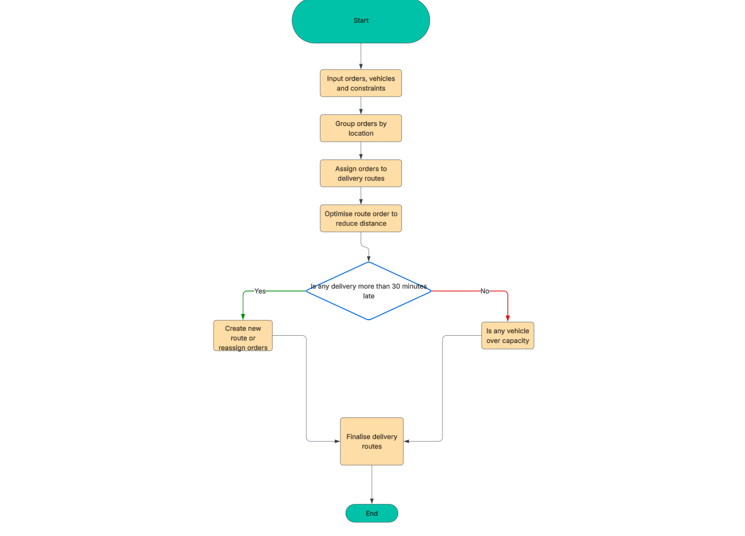
Figure 1: Flowchart illustrating the delivery route optimisation process for GrocerQuick

2.3 Detailed Explanation of Each Stage
The flowchart in Figure 1 illustrates the logical steps taken to optimize GrocerQuick's delivery routes. The process begins with collecting incoming data, including customer orders, available vehicles, and delivery restrictions. Orders are then grouped by geographic location to reduce unnecessary travel and improve fuel efficiency.
Once grouped, orders are assigned to delivery routes and the sequence of deliveries is optimized to minimize the total distance travelled. Delivery times are calculated for each route to ensure that the customer's time requirements are met.
Decision points are included to check if any delivery exceeds the 30-minute delay limit or if any vehicles are operating over capacity. If any of these conditions are violated, the routes are adjusted and the orders are reassigned. This iterative process continues until all constraints are met. The process ends with the completion of the delivery routes, ready for dispatch.

2.3.1 Data Preparation
Accurate data is essential for effective route planning. All customer addresses are converted into geographic coordinates, and travel distances and times are calculated using realistic road data. This ensures that route decisions are based on real-world conditions rather than straight-line distances.
Cleaning and validating data at this stage reduces errors later in the process and improves overall reliability.

2.3.2 Initial Route Construction
Initial routes are built using a greedy approach. Starting from the depot, the system always selects the closest unassigned order that can be delivered without breaking capacity or time constraints. This approach is simple, fast, and effective for large numbers of daily orders.
Although this method does not guarantee the shortest possible route, it provides a strong starting point that can be improved later.

2.3.3 Route Optimisation
Once initial routes are formed, local optimisation techniques are applied. One example is swapping the order of delivery stops to reduce unnecessary travel distance. Any change is only accepted if it does not cause late deliveries or capacity issues.
Reducing total distance directly contributes to lower fuel consumption, making this step important for meeting GrocerQuick’s efficiency goals.

2.3.4 Time Validation and Adjustment
Each route is then checked by simulating the delivery schedule from start to finish. Arrival times are calculated for every order, and any lateness is measured.
If any delivery is more than 30 minutes late, the system attempts to fix the issue by:
- Moving the order to a different route
- Creating an additional route if needed
This ensures that customer service requirements are met without sacrificing overall efficiency.

2.4 How the Solution Meets the Objectives
Efficient order allocation is achieved by grouping nearby customers and systematically assigning orders to routes.
Fuel consumption is reduced by minimising total travel distance and avoiding inefficient routing patterns.
Timely delivery is ensured by continuously checking delivery times and enforcing the 30-minute lateness limit throughout the process.
Overall, the solution provides a balanced and practical approach that addresses all of GrocerQuick’s core requirements.

3. Reflection and Justification
This assignment required analysing a real-world delivery problem and developing a structured solution using problem-solving and abstract thinking techniques. To achieve this, the problem was broken down into smaller parts, key requirements were identified, and a logical process was designed to meet the company’s objectives. The techniques used helped turn a complex logistics issue into a clear and manageable solution.

3.1 Problem-Solving Techniques Used
One of the main techniques used was problem decomposition. Instead of treating the delivery system as one large problem, it was divided into smaller stages such as inputting data, grouping orders, assigning routes, optimising routes, and checking constraints. This made the problem easier to understand and allowed each part of the solution to be designed logically.
Abstraction was also used throughout the task. In a real delivery operation, there are many unpredictable factors such as traffic, road closures, and driver behaviour. To keep the solution practical and suitable for an academic assignment, these real-world factors were simplified into fixed travel times, vehicle capacities, and delivery time windows. This allowed the focus to stay on route optimisation rather than unnecessary detail.
Another important approach was systems thinking. The delivery process was treated as a system where all elements are connected. For example, assigning more orders to one vehicle may reduce the number of routes needed, but it can also increase delivery time and cause late deliveries. Understanding these relationships helped ensure that efficiency and customer service were balanced in the proposed solution. [4]

3.2 Justification of the Approach
The proposed solution is appropriate because it reflects how delivery routing problems are commonly handled in real businesses. Instead of aiming for a perfect solution, which would be difficult and time-consuming, the approach uses heuristic methods that provide efficient and realistic results within a short time frame.
Grouping orders by location helps reduce unnecessary travel, which directly lowers fuel consumption. Optimising the order of deliveries further improves efficiency without affecting delivery deadlines. The use of decision points in the flowchart ensures that vehicle capacity limits and delivery time constraints are always checked and corrected if necessary.
The MoSCoW technique was also effective in keeping the solution focused. By clearly identifying the most important requirements, such as ensuring deliveries are not more than 30 minutes late, the solution stays aligned with GrocerQuick’s main goals. Less important features were intentionally excluded to keep the scope realistic. [2]

3.3 Limitations and Assumptions
Although the solution is effective, it has some limitations. It assumes that all delivery orders are known before route planning begins. In real life, orders may arrive during the day, which would require continuous route updates. The solution also assumes that travel times are accurate and do not change, which may not always be the case due to traffic conditions.
Additionally, because the solution uses heuristics, it does not guarantee the most optimal route in every situation. However, this trade-off is acceptable because the approach prioritises practicality, simplicity, and clarity.
Overall, the solution provides a clear, structured, and realistic approach to solving GrocerQuick’s delivery routing problem while demonstrating effective problem-solving and abstract thinking skills.

References

[1] | D. V. Paolo Toth, Vehicle Routing: Problems, Methods, and Application, Philadelphia, PA: Society for Industrial and Applied Mathematics (SIAM), 2014.
[2] | G. O. f. Science, “Systems Thinking: An Introductory Toolkit,” UK Government, London, 2022.
[3] | A. B. Consortium, “MoSCoW Prioritisation,” Agile Business Consortium, London, UK, 2024.
[4] | J. M. Wing, “Computational Thinking,” Communications of the ACM, vol. 49, no. 3, p. 33–35, 2006.

