Name: IONELA CRISTINA POPESCU
Student Number: 1813115
Module Title: Introducing the Modern Workplace
Assignment Title: Structure and Culture HSBC
Lecturer’s name: Dr Kenny Tang

TABLE OF CONTENTS

Introduction……………………………………………………………….…...3
Organizational structure of HSBS PLC……………………………………….3
Fig.1 Structure of HSBS PLC in UK………………………………………….4
Fig.2 Organizational structure of HSBS Bank…………………………………5
Culture of HSBC UK and factors which affect the organizational culture……5
Leadership Style………………………………………………………………8
Conclusion…………………………………………………………………….9
References…………………………………………………………………….10

Introduction
Different organisations frame and formulate different structure for the internal management to maintain the work efficiency and carry on the business functions. Organisational structure means how the tasks and jobs are formally divided, grouped and coordinated. There is a series of tasks which are to be done in order to complete the organisational structure of any organisation. HSBC is one such organisation which is amongst the largest and leading financial service providing organisation in the world. Hence the following assessment is presented in respect of HSBC Bank and contains discussion regarding the structure of the organisation and the culture which is prevailing currently in the organisation. The following presentation provides for various organisational models and theories reflecting the cultural design of the chosen organisation.

Organisational structure of HSBC PLC
HSBC in United Kingdom was first opened in the year 1990 in England which has its present head office in London since 1993. The headquarter was initially in Hong Kong before 1992 but then it was forced to move due to an acquisition. In the year 2002 the bank came up with a campaign named “The World Local Bank.”
The organisational structure of HSBC Bank is not a complex one and thus the organisation has succeeded in framing a simple structure without any complexities. HSBC PLC has around 1000 branch all over United Kingdom and also has its presence in Ireland and Wales. Further, HSBC is the first bank in United Kingdom to allow the providing of assistance regarding the Islamic sharia law according to which the bank is not allowed to charge any interest on its customers under the Muslim law (Seekingalpha, 2019). Thus, during the implementation of this policy the managers of the organisations must face a lot of challenges in these operations and functions of the organisation’s management. The following chart describes the structure of HSBC PLC in United Kingdom:
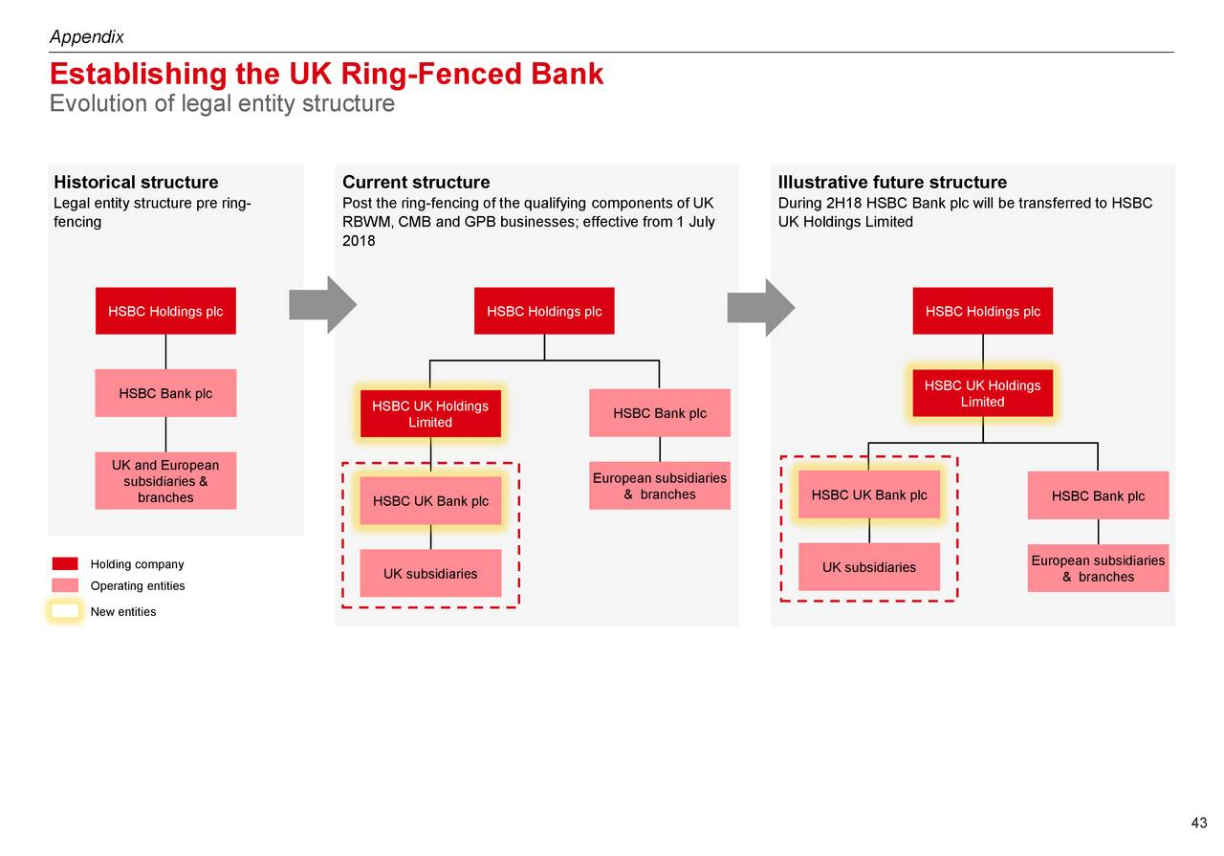

Fig. 1 Structure of HSBC PLC in UK.
(Source: Seekingalpha, 2019)
Organizational structure can be defined as the system that states the outline of the business activities. All these activities are related with the achievement of the organizational objectives of the business. Organizational structure of a business defines the path in which the information flows between all the stakeholders of the business. The different levels of the business are depicted in the organizational structure of the business. The organizational structure can also be referred to as the system in which determined the superior and subordinate relationship in the business.

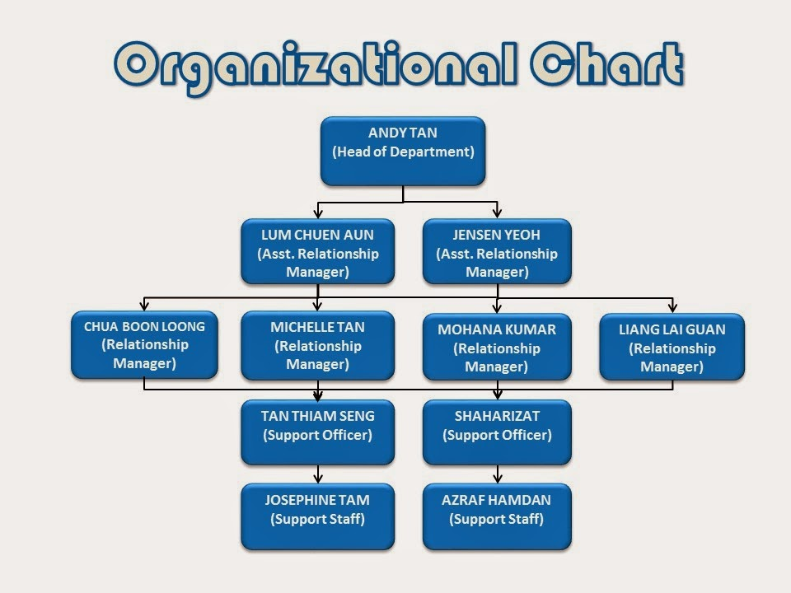

Fig 2: Organizational structure of HSBC bank
(Source: keywords basket, 2019)
Culture of HSBC UK and factors which affect the organisational culture
The organisation is heading with the mission of achieving diversity and inclusion at workplace. The bank is of the vision that diversity and inclusion are essential to achieve out motives and objectives for HSBC UK. The bank is of the view of giving commitment in order to attract, develop and retain a diverse workplace environment. The bank is further of the aim of achieving diverse culture across a variety of areas which includes gender, place of birth, ethnicity, disability and LGBT community (Rice, 2015). The bank has focussed to take a number of actions in order to fulfil this goal and mission.
There has been a diverse culture witnessed in the working environment of HSBC Group in United Kingdom which has also proved to be a positive effect on the working and performance of the organisation. Hence there are two main factors which are responsible for the organisation’s performance. These factors are the internal factor and the external factor.
Among the internal factors the inclusions are the leaders, team members, employees and the organisational culture in the office. There are specific factors which affect the functioning of the organisation HSBC PLC in UK which includes the corporate policies, structure and ethics prevailing in the working environment. As a part of corporate culture, the HSBC PLC wants the best commitment of the employees. The organisation wants to retain its best employees and treat them like a family member. The culture is in support of understanding the employees and give them opportunity to grow in their desired field. The leaders and management of the organisation that the policies are so framed that it completely becomes a symbol of the organisation’s culture. The organisation has made sure that their policies are transparent and designing of the products are done in such a way that it is completely fair for the customers to understand. Further the leaders take an ethical way of controlling the employees and stabilizing the values and beliefs of the bank (Ferdman and Deane, 2014). The leadership style is ethical, and everyone feels free to express their ideas and thoughts. The bank is of the belief of achieving brainstorming in order to get a varied of opinions for better results which shall bring efficiency as well as enhance the personality of the employees. Furthermore, the structure of HSBC PLC is hierarchal under which the leaders and managers are the decision makers regarding the allocation of functions and responsibilities within the organisation. they are also empowered to delegate their responsibility of decision making on others in case it is required in the interest of the organisation.
As an example, the UK Employee Resource Group can be taken into consideration which is an initiative taken by HSBC PLC which promotes diversity and make sure that every employee feels a sense of inclusion in the organisation. there are 12 active networks of HSBC PLC which focus on equality on gender, ethnicity, faith, disability and much more. The Employees network includes a strong external network like Military network, Flex network, Hellenic network, etc. (About. HSBC, 2019).
As an organisational culture HSBC group in UK have been recognised for Times top 50 employer for women in 2015, 2016 and 2017. HSBC has also formulated a global policy for the inclusion of diversity within the organisation. Further in the year 2016 HSBC UK was the first signing organisation to the HM Treasury Women in the Charter of Finance (About.hsbc, 2019). Hence all these examples from the internal as well as external management of HSBC UK are an evidential prove that the organisation has a mission of achieving organisational cultural diversity among its workplace.
Along with the internal factors there are also external factors which are responsible for influencing and affecting the structure and culture of HSBC PLC in UK. These external factors include the advancement in technology, growing political influence, the economy of the country at present and the growing competition among the financial services. In this organisation technology is the main stream to have a connection with the customers so that the bank can provide them with better services (Thomas, 2012). The leaders are sure that they remain updated with the latest technology in their field. The access of the customers to internet banking using password protected files and data is an excellent example of technology being used in HSBC PLC UK.
HSBC PLC has grown tremendously in the past few years and the reason behind the successful running of the organisation is the abidance of the organisation with the current legal system of United Kingdom. There are a number of laws which are made applicable on the organisations functioning in UK. All the regulations to which the financial service organisations are subjected to are governed by the Financial Service Authority (FSA). Thus, HSBC has successfully abided by the legal structure drawn by the FSA in form of regulatory framework and this framework has influenced the structure and culture of the organisation (Torelli, et. al., 2014). For example, due to this regulatory framework the bank has structured an internal committee in order to review the activities being carried on as organisations functions. This formation is to avoid illegality and mis functioning within the organisation.
The current economy of United Kingdom has also influenced the organisation as the growing inflation has adversely affected organisation worldwide. The interest rates are also affected by the economy of UK and hence there is effect on the overall and the final outcome of the organisation. in presence of all these factors and influences, HSBC PLC has also to face the growing competition in the finance sector and banking industry in order to produce good deals and manage overall performance (Rock and Grant, 2016). One of the most trending examples of effect of economy is the uncertainties of the Brexit which shall have potential impact on the banking industry in UK. The withdrawal of United Kingdom form European Union shall have great effect on the economy of United Kingdom which shall in turn affect various sectors including banking and financial services.
There are various types of organizational structures that can be followed by a business. HSBC is the company that follows the Hierarchal structure of the organization. In the hierarchal structure of the organization each employee in the business has a supervisor to look after his work. The hierarchal organizational structure is based on certain factors. The major factors that determined the hierarchy of the organization are the functions of the business. Based upon the functions of the business, employees are divided into various departments like finance, sales, technical and marketing. The next factor is geography as HSBC is a big bank having operations in various countries. All the countries are divided into regions. When the countries are divided into regions, the operations of the business are carried out smoothly. This is called the geographical factor. One more factor is the product factor. The company is organized into various categories as per the multiple products offered by the company. HSBC is divided on the basis of all the three factors of hierarchal organizational structure.

Leadership style
Leadership is the ability of a person to make others work and attain the organizational objectives in the stipulated time and at the stipulated cost. Leaders are very important pillars of any organization. Without the effective guidance and management of the leaders, it is not possible for any company to achieve its objectives. Leadership is the skill that can be either learned by observation and it is also inborn in some people. There are various theories related with the leadership. Talking about the styles of leadership, a leader can make use of various types of leadership styles to guide the employees in a business (Yahaya & Ebrahim, 2016).
Leaders in HSBC are competent enough to manage the employees and the organizational operations effectively so that the overall targets of the business can be achieved. The leadership style that is adopted by HSBC is democratic and transactional leadership. In the democratic leadership, the leaders also consider the opinions and views of the employees while taking any business decision. In transactional leadership, the leaders create criteria to provide rewards and punishment for the efforts of the employees. Employees feel motivated when they get rewards and recognition for their good and hard work.

Conclusion
Thus, from the above findings it can be analysed that the management of HSBC UK and the leadership element is the most important and strongest connection that is holding the organisation. HSBC group has moved all over the world and is holding a competitive stand in the world among the best financial service providers. The hierarchal structure of the bank has also proved to be satisfactory and thus gaining the confidence of the employees as well as customers. The analysis of the organisational culture of HSBC UK has also proved that the organisation has proved to achieve diversity in culture within its workplace. The organisation has further initiated to remove all sorts of inequality by various measures at internal as well as external level. HSBC PLC has also recognised the efforts of the employees by means of awards and thus the organisation is awarded with various recognitions worldwide.
References
- About.hsbc, 2019. Diversity and Inclusion [Online]. www.about.hsbc.co.uk. Available at: https://www.about.hsbc.co.uk/hsbc-uk/diversity-and-inclusion. (Accessed on 23rd July 2019).
- Ferdman, B.M. and Deane, B., 2014. Diversity at work: The practice of inclusion.
- Keywords Basket, (2019). HSBC bank organizational structure. [Online]. Keywords Basket. Retrieved from: http://www.keywordbasket.com/aHNiYyBiYW5rIG9yZ2FuaXphdGlvbmFsIHN0cnVjdHVyZQ/ on 23 July 2019.
- Rice, M.F., 2015. Diversity and public administration. ME Sharpe.
- Rock, D. and Grant, H., 2016. Why diverse teams are smarter. Harvard Business Review, 4(4), pp.2-5.
- Seekingalpha, 2019. HSBC Holdings PLC 2018 Q2 - Results - Earnings Call Slides [Online]. www.seekingalpha.com. Available at: https://seekingalpha.com/article/4195408-hsbc-holdings-plc-2018-q2-results-earnings-call-slides. (Accessed on 23rd July 2019).
- Thomas, K.M. ed., 2012. Diversity resistance in organizations. Psychology Press.
- Torelli, C.J., Leslie, L.M., Stoner, J.L. and Puente, R., 2014. Cultural determinants of status: Implications for workplace evaluations and behaviours. Organizational Behaviour and Human Decision Processes, 123(1), pp.34-48.
- Yahaya, R., & Ebrahim, F. (2016). Leadership styles and organizational commitment: literature review. Journal of Management Development, 35(2), 190-216.

