
Assessment 1

Community Engagement
“Heathrow Airport expansion”
Module Coordinator/ Lecturer:
Rula Alousi

VALENTIN DAN
Student: 1922006

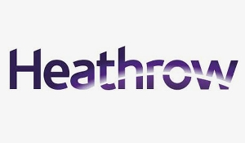

Table of Contents

Introduction 3
Heathrow Airport and community aspects 3
Heathrow expansion motivation 4
Preventing Heathrow expansion 6
Practices of community engagement 6
Heathrow commitment to the community 8
Conclusion and recommendations 9
Bibliography 10
Appendices 11

Introduction
Starting from a general approach, community engagement describes how individuals engage in their community to achieve a positive and pleasant impact from their day-to-day activities inside their neighbourhood. The success of civic engagement activities depends on people's tendency to consider themselves an integral part of society and therefore considers that the problems faced by society are the ones with their parity (Temitope, 2008, pp. 18-33). Such people recognize the moral and civic impact of the problems they face, and they are focused to discover solutions to correct them. This report aims to investigate the problem scale of Heathrow Airport Expansion for the community in North -West London, the challenges that community and industry confronted and recommend corrections in their actions if needed. The report will begin with the literature overview regarding community issues faced in regard to the expansion of Heathrow company and their implications, proved with newspaper articles, flyers distributed in the community, documents attached as an appendix to this report, followed by the challenges and how this was resolved. The final part of the report will present an evaluative management report, that will underline the positive and negative aspects, the sustainability of the project and finalizing with a conclusion and recommendations so that both parties to fulfil their needs.

Heathrow Airport and community aspects
Heathrow Airport, being one of the busiest and most important airports in the world, has been using over the time only two long runways, since 1990 to serve all its terminals and cargo operations. Heathrow Airport Holdings, the mother multinational organisation, to increase the operating capacity of this international airport, prepared and presented to the Transport Department, their expansion plans for the third runway and a new passenger terminal starting from 2006 (Limited, 2021). Certain political parties from British government were an important supporter of this idea, which was also public sustained at the same time by commercial organizations that deal with the aviation industry. On the other hand, there were also public political parties that did not agree with this development and that developed negative campaigns. The project regarding this enlargement of London’s busiest airport was cancelled in 2010, as being illegal and again resumed by the UK government in 2016.

The parties of the British government that were sustained this project of enlarging Heathrow Airport with another runway that deserves as a new passage terminal, as well as developing a hub for public and private transport. Through its actions, part of the Government encouraged the airport operator, British Airways (BA), to request and actively participate in the construction project and the development and planning of the development (Edgington, 2020). The expansion strategy that predicts a new terminal development, requires the compulsory acquisition of the area and also involves the demolition of about 700 homes (Publications, 2009), for which the developer would compensate the owners with 125% of the market value as compensation for the family affected by this enlargement.

At the same time, this project for the third runway supported political and subject to funding by the government, parliamentary approved, also assume the development of an extra-London rail law with the Great Western, in other words, a new national high-speed rail project (Watson, 2007). Over time, the developer and the initiator of the expansion, Heathrow Airport Holdings, joined different approaches. This project was debated many times in the House of Commons and in middle of 2018 the developer received green line of the majority, which represent that the extra runway of Heathrow Airport can start. Following this approval, some important communities, such as Wandsworth, Richmond, Hillingdon, and Hammersmith & Fulham, that were directly involved and affected, have requested a judicial review of the decision. In order to sustain their cause, Greenpeace and Mayor Sadiq Khan, contributed to this decision. To obtain their approval, the project is regularly reviewed by Heathrow Airport Holdings and the latest relative public approach is a different runway tactic, with 300 metres shorter, which would reduce costs from GBP 16.8 billion to GBP 14.3 billion in terms of the demolition of homes. This perspective, however, does not change at the level of the M25 motorway which must continue to divert a tunnel under the runway (Limited, 2021).

Heathrow expansion motivation
The main argument that the initiator has argued in favour of expanding Heathrow with another terminal was that will increase the UK's economic growth. The map below will offer a general facet of the expansion. The green area represents the third runway which will be constructed if this project will get full approval, and the orange area represent the actual Heathrow Airport. Starting from idea that Heathrow is an important connection node for international destination, with this expansion the airport can enlarge the activity by fascinating a wide range of travellers and plenty direct flight (Publications, 2009). Another aspect that is important for the British economy, is that this development will help the GDP of the country to increase (Limited, 2021). As is presented in the following plan, the expansion is connected to the current airport and the orange area which represent the actual airport, operate at full capacity in present and a extension (the green area) is important to avoid the increased delays and risks competing with the destinations of European airports (Temitope, 2008).
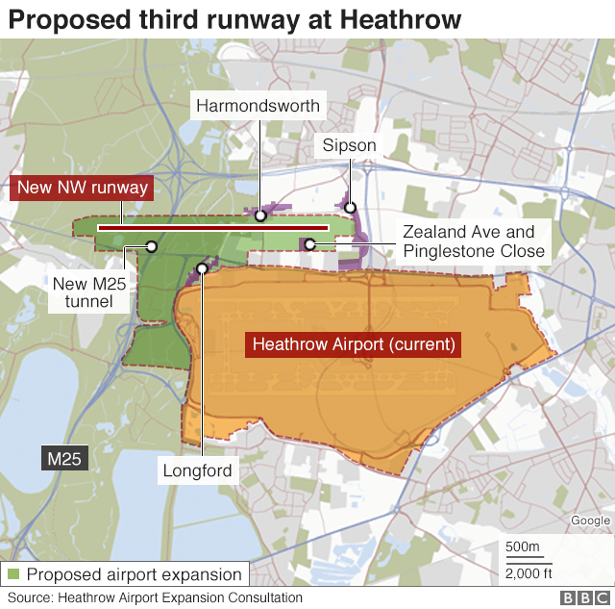

Appendix 1. Heathrow Airport expansion Plan (Edgington, 2020)

Additional aspect of this expansion, foreseen by the initiator through the third runway, are the short flights connections that can be retaken with different area in UK. To maximize their profit, in time Heathrow cancelled or reallocated the majority of flight that made connections with Scotland and Wales. Regarding the reduction of the emissions, the expansion will help reducing them because aircrafts will not flyover the runway waiting to land. Further, economically and socially speaking, the construction and opening new terminal will offer the community an impressive number of jobs. (Publications, 2009).

Preventing Heathrow expansion
Greenhouse gas emissions
The disadvantages that push communities and other part involve to react though protest are plenty. One aspect is the carbon dioxide (CO2) emissions from additional flights , that according to environmental studies (WOOLLEY, 2021) which reveals the increased quantities that will affect the global warming. Even though, balancing costs, the amount spent to minimize the CO2 emission will be over the amount gained through increasing GDP. In other words, the government will spend more money to reduce the emissions, that will earn from collection of the taxes.

Community destruction
About 700 dwellings, a religious place and an impressive number of buildings used by the community affected by this expansion should be erased, in order to fulfil this plan. The main street in Harmonised worth divided, a cemetery moved and the entire Sipson district could disappear. These issues have profoundly affected the entire community in this area, which has asked for support from competent authorities and is actively trying to find solutions to defend their rights (Hugh Knowles, 2021).

Noise and air pollution
Another aspect that the community in the area is affected and is trying to underline in their complaints is that this construction of the third runway at Heathrow would expose an impressive number of residents in London and Berkshire to an extreme and unacceptable level of noise and pollution coming from more aircraft which will be the result of this expansion project.

Practices of community engagement
The actions of the communities involved in this project of development and expansion of Heathrow airport have highlighted during the start of the whole process several indicators and practice specific to the community involvement.
- Involvement – all participating parties have identified themselves through their actions and have shown interest in this.
- Support- during any activity the involved parties were supported and provided real support both financially and at the level of information exchange.
- Preparation of the plan- all the necessary information was gathered using existing resources.
- Methodology- how to approach the situation has been established by common agreement.
- The task distribution work team has been carefully established and supervised.
- Outside support- searched for supporters, distributed by various methods the details of their campaign.
- Feed Back- they seek to organise sessions with the whole commune to share opinions about the state of the project and ideas of approach (Temitope, 2008).

Community Actions against Heathrow expansion
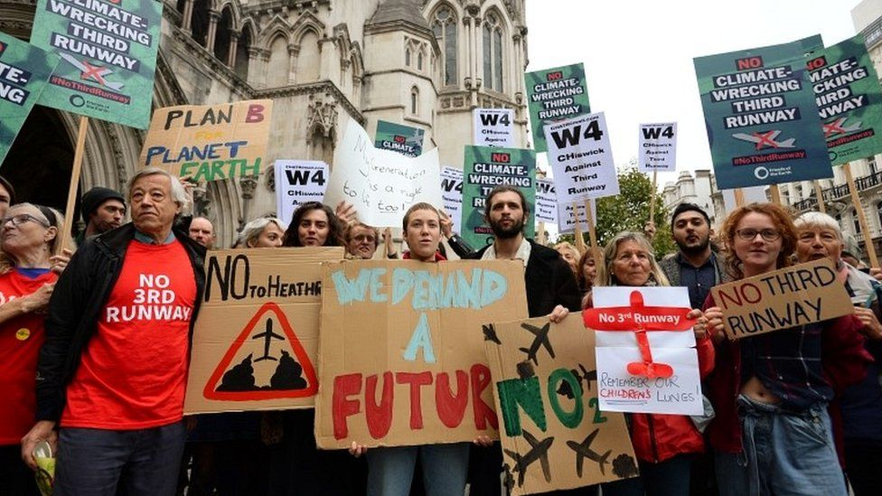
The community was not affected just with the constructions of this expansion. The Terminal 5 project of Heathrow Airport was also debated between the two parties. Furthermore the opening day of this terminal was celebrated by hundreds of protesters descended in red T-shirts. As is presented in the image below, opening day of Terminal 5 (WOOLLEY, 2021). The following image is from the protest on the third runway but since then various methods have been proposed and adopted to stop the expansion.

Fig 1. Anti-expansion protest (Edgington, 2020)

Green Peace and North-West London Community
The local community has been supported through the entire process by the Green Peace organisation. Through their activity, Green Peace reviewed numerous judicial decisions, informed, and presented to the public and locals all the stadiums of their campaign, through leaflets sent by post to the homes in the incident and through repeated publications in local newspapers and television appearances which are attached as Appendix 2.

Community from Wales, England and North Ireland “Friends of the Earth”
Along with the North West London community fighting to prevent expansion, the international organisation Friends of The Earth has joined. This community is dedicated to the protection environment and all the people on earth. Through organised projects and campaigns, try to find real solutions to environmental challenges.
In February 2020, this organisation along with the local community and Green Peace organisation, in front of the Court of Appeal obtained that the third flight strip of Heathrow Airport is illegitimate.
The plea in court was supported by the fact that the government cannot guarantee that the runway will help the economy, that public transport and rail need urgent investments and that the legal level of noise will be exceeded. This decision was again changed in December 2020 and the Supreme Courte agreed that Heathrow expansion could start and that is not an illegal act for the community.

Heathrow commitment to the community
The local community uses a website through which locals and other parties interested, can ask questions and requests, regarding anything related to Heathrow Airport and its expansion. This site is updated with up-to-date information from both parties and the stages of the airport development project. Also, through this platform, the airport management responds to citizens and provides information on airport activities. The following image represent a flyer that was send through post for all the members of the community and contain information’s about the sages of the project.
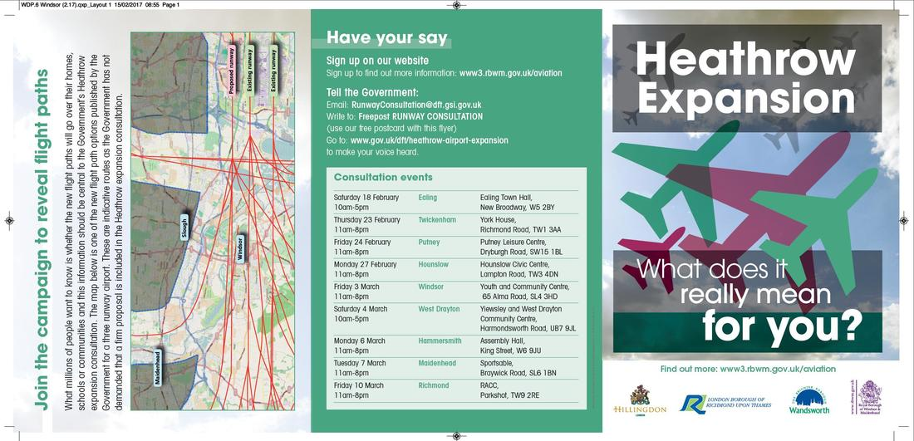

Fig.3 Heathrow Airport engagement with the community Appendix 3

Heathrow organisation was projected in progress for the local community around the airport, donating yearly an important amount of money to Heathrow Community Funds and local community projects, through charitable proposals. One of the projects that this organisation sustain for a better environment is called “Fly quiet and green”.

Conclusion and recommendations
Despite the longevity of this project, regardless of the final resolution that will be criticized anyway, this project has positive and negative parts. Both the local community, the defenders of the environment, the government and the developer have strong arguments to support their cause. After a thorough investigation of this polemic, I can conclude and recommend:
- Public debate between all the parties involved and their attempt to propose changes to the project in order to adopt an optimal and reasonable solution.
- The reanalysis of the project-objective, which was not based on a SMART goal, taking in consideration that after more than 12 years this project is still non-realistic, and non-achievable and time consuming.
- Taking in consideration the theories of the community engagement, this principle were respected such as appreciating their culture, history, norms and values, establish relationships, communicate with individuals, support activities and partnering with the community, but developer did not offer a flexible intervention to individuals that were most impacted about this expansion.

Bibliography
- Anonim, 2021. Heathrow community engagement bord. [Online]
Available at: https://www.hceb.org.uk/
[Accessed 20 March 2021].
- Edgington, T., 2020. Heathrow expansion: What is the third runway plan?. [Online]
Available at: https://www.bbc.co.uk/news/explainers-51646562
[Accessed 20 March 2021].
- Holland-Kaye, J., 2016. Heathrow. [Online]
Available at: https://www.heathrow.com/content/dam/heathrow/web/common/documents/company/heathrow-2-0-sustainability/a-great-place-to-live/Heathrow2.02.pdf
[Accessed 27 April 2021].
- Hugh Knowles, M. T., 2021. Friends of the Earth Limited. [Online]
Available at: https://friendsoftheearth.uk/about-us
[Accessed 03 April 2021].
- Limited, H. A., 2021. Heathrow Airport Limited. [Online]
Available at: https://www.heathrow.com/contact-us
[Accessed 25 March 2021].
- Publications, D., 2009. Britain’s Transport Infrastructure , London: Department for Transport.
- Temitope, O., 2008. The Rules of Engagement - Seven Keys For Effective Community Engagement. First ed. United States Of America: Latin Front.
- Watson, D., 2007. Managing Civic And Community Engagement. First ed. Berkshire England: Open University Press.
- WOOLLEY, J., 2021. Greenpeace UK. [Online]
Available at: https://www.greenpeace.org.uk/about-greenpeace/
[Accessed 02 April 2021].

Appendices

Appendix 1: Fig.1 Heathrow Airport expansion Plan (Edgington, 2020)

Appendix 2

Fig 2. Community engagement initiative against Heathrow expansion
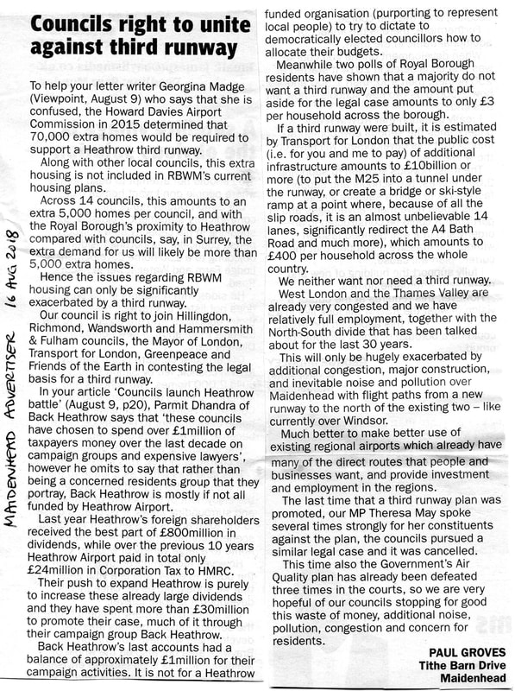

Appendix 2
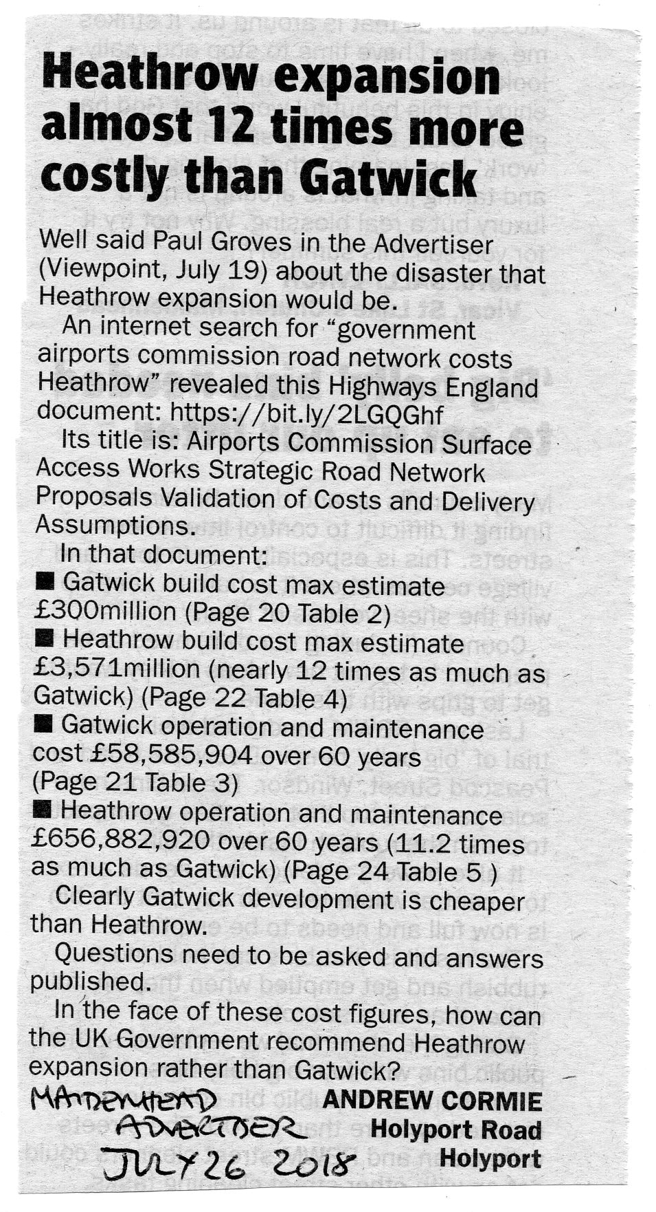

Appendix 3:
Fig.4 Heathrow Airport Holding engagement with affected community.


