

Programme: MSc Public Health and Social Care in Practice
Module: Quality Assurance and Service Improvements
Module code: LCHS7006
Assignment Title: Component 2 Service Improvement Report
Name: Smitkumar Bharatbhai Kachhadiya
ID Number:2520164
Table of Contents
1. Introduction 3
2. Main Body 4
2.1 Nature of the Quality Problem 4
2.2 Root Cause Analysis (Fishbone Diagram and 5 Whys) 5
2.3 Donabedian Model 6
2.4 SWOT Analysis 8
2.5 Critical Evaluation of Frameworks 9
3. Recommendations 10
3.1 Recommendation 1: Strengthen Clinical Governance 10
3.2 Recommendation 2: Improving Leadership and Workforce Well-being 11
3.3 Recommendation 3: Enhance Patient Safety Learning System 12
3.4 Implementation Strategy 12
4. Conclusion 14
References 15

1. Introduction
Patient safety is one of the primary goals of the National Health Service (NHS) since it refers to one of the measures of healthcare quality. Patient safety consists of avoiding any preventable harm during provision of medical care and constant improvements in care systems through proper governance, leadership and organisational learning (Ahmed et al., 2024). Despite extensive policy changes during the last ten years, patient safety remains an important problem for the NHS due to growing demands on services, staff shortages, organisational factors, and variability in the quality of care provided by healthcare organisations (Care Quality Commission (CQC), 2025).

Figure 1. Mid Staffordshire NHS Foundation Trust
(Francis, 2013)

The Mid Staffordshire NHS Foundation Trust continues to be one of the most prominent cases of failure in patient safety within the NHS. According to the Francis Report, during the period between 2005 and 2008, patients had been receiving terrible care with their unnecessary suffering and preventable harm being caused due to the fact that organisational goals were oriented towards financial targets and acquiring the Foundation Trust status rather than providing safe and caring patient care. It has been noted by the Francis Inquiry that ineffective leadership, poor clinical governance, communication and organisational culture tolerant of inappropriate standards have all led to the patient care failure in the case discussed (Francis, 2013).
Despite the numerous changes implemented following the Mid Staffordshire scandal within the NHS, recent data suggests that some of these issues still persist. According to the CQC (2025), there are still problems concerning patient safety, workforce, leadership, governance, and quality of care in NHS organisations.
This report will undertake a critical evaluation of the quality problem of patient safety incidents caused by poor governance, leadership, workforce and organisational safety culture problems at the Mid Staffordshire NHS Foundation Trust. The Fishbone Diagram, 5 Whys, and the Donabedian Model will be used to evaluate the root cause of the problem, while the SWOT analysis will be utilised for strategic planning of the services. Finally, recommendations are made based on evidence-based quality improvement methods like PDSA, PDCA, Lean, and Six Sigma.

2. Main Body

2.1 Nature of the Quality Problem
Patient safety is defined as preventing any unnecessary harm to patients in healthcare provision and a major determinant of the quality of health services (Donabedian, 1988). Effective governance, sufficient staffing, learning organisation culture, and organisational learning are among the determinants of high-quality health service delivery apart from clinical competencies (Bhati et al., 2023). Therefore, patient safety problems do not often occur due to individual mistakes within the process of treatment but are a result of more extensive organisational weaknesses (Ahmed et al., 2024).
Incompetent governance and the poor organisational culture contribute to poor patient safety, as can be illustrated by the case of Mid Staffordshire NHS Foundation Trust. (Sengupta, 2020). The Francis Inquiry found out that poor Board oversight, weak organisational and clinical leadership, insufficient staffing, poor accountability, and the organisational culture oriented towards achievement of organisational targets but not patient care led to poor standards of care and patient harm (Francis, 2013).
Care Quality Commission (2025) keeps on finding issues around patient safety, shortage of staff, and governance as well as variations in the quality of care, especially within maternity services. NHS Staff Survey 2025 indicated that work-related stress has risen from 41.65% to 42.3%, nearly one-third of the staff suffer from burnout, and willingness to recommend NHS as an organisation for employment dropped from 60.79% to 58.05% (NHS Employers, 2026). It shows that workforce issues continue to persist that may impact the safety of patients and organisational performance (Hardy, 2025). This indicates that improving governance, leadership, and culture is necessary for maintaining high quality care for patients (Lee et al., 2023).

2.2 Root Cause Analysis (Fishbone Diagram and 5 Whys)
Root Cause Analysis (RCA) is a technique that helps in identifying the root causes of adverse incidents without pointing fingers at anyone (Singh et al., 2024). Through the determination of contributory factors, RCA helps healthcare organisations make sustainable changes that improve quality and avoid the repetition of similar patient safety incidents (Agency for Healthcare Research and Quality, 2024). For this report, the Fishbone Diagram and the 5 Whys tools have been selected as they can be used together to uncover both the direct and contributory causes of patient safety failures that took place in Mid Staffordshire.
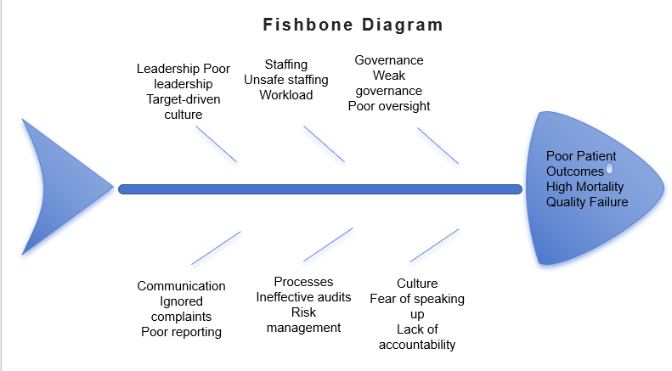
Figure 2. Fishbone Diagram
(Source: Self-Developed)
The Fishbone Diagram classifies contributory factors according to different organisational domains in order to understand complex quality issues (Kumah et al., 2024). There were clear leadership failures due to the inability to make decisions and take responsibility and to foster a patient-focused culture. Governance processes failed in monitoring quality of care and the lack of oversight on the part of the Board was noticeable. A lack of staff caused the organisation to be unable to offer good and compassionate care, hence creating heavy workloads that affected the performance of clinical processes. The inability to communicate led to staff and patient problems not being appropriately reported to the right persons in the organisation. Insufficient resources, lack of proper staff training, and organisational support contributed to the poor delivery of service. The organisational culture did not value safety issues but preferred good performance of the organisation and the Foundation Trust status (Kelly et al., 2023).
Application of the '5 Whys' method also shows the relationship between the above failures. Patients were harmed due to poor quality of care offered. Poor quality of care was due to staffing and clinical process failure. Problems with staffing continued because the governance systems did not manage to recognise any risks within the organisation’s workforce. The lack of governance could be attributed to the fact that organisational leadership concentrated on meeting financial goals rather than patient safety (Kumah et al., 2024). The decisions made by the leaders further developed a poor organisational culture where everything went unheeded, no one was responsible, and poor-quality care became acceptable. From the provided analysis, it could be stated that the primary root cause of the failures in Mid Staffordshire was not the mistakes of the clinicians but the lack of governance and patient safety culture.

2.3 Donabedian Model
The Donabedian Model provides a structured method of assessing the quality of healthcare through three interrelated elements which are structure, process and outcome (Donabedian, 1988). The use of this model to analyse the Mid Staffordshire scandal is justified because it highlights the effects of poor organisation and governance on unsafe clinical practice and poor patient outcomes. This model is still applicable to modern-day NHS patient safety interventions that focus on learning, governance and quality improvement processes (Lee et al., 2024).
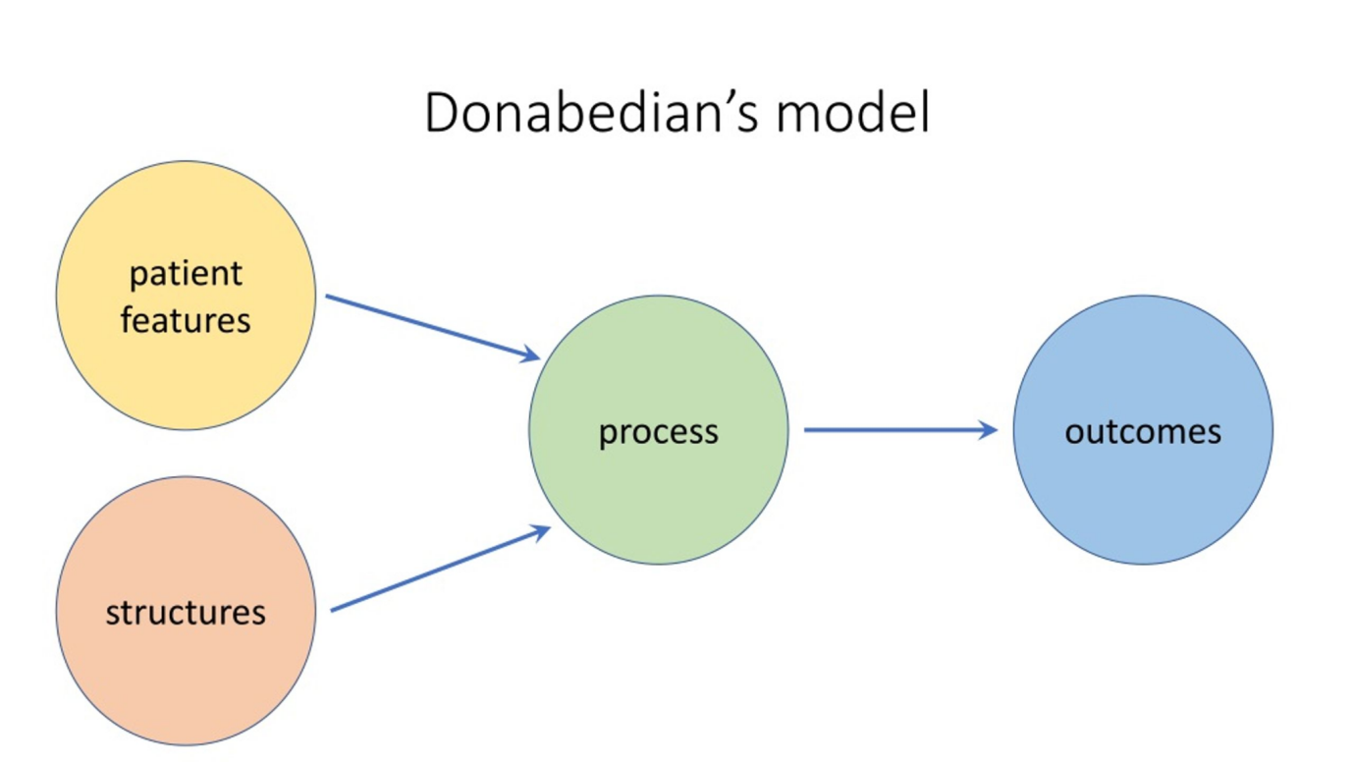
Figure 3. Donabedian’s Model
(Source: Bhati et al., 2023)
Structure is defined by the factors within the organisation that help provide safe care which includes leadership, staffing, governance, education and resources. The failure of governance, insufficient staffing and target culture were among the issues at Mid Staffordshire which undermined the safety structure (Francis, 2013).
In the NHS Staff Survey 2025, rising levels of work-related stress (42.3%) were revealed alongside poor wellbeing of staff and almost a third of the employees suffering from burnout, suggesting that pressure on the workforce continues to pose threats to patient safety. As a solution, the Patient Safety Incident Response Framework (PSIRF) focuses more on governance, patient safety specialists, training of staff, system learning and organisational responsibility and not blaming individuals (NHS England, 2025).
The process factor looks at how care is provided and considers such areas as communication, incident reporting, escalation and organisational learning. The Francis report of 2013 revealed repeated failure to listen to the patients, respond to the complaints and escalate the issues concerning safety, which led to continued provision of poor care. By addressing such issues, PSIRF promotes compassionate engagement with patients and their families, system based investigation, learning in proportion to the incident and continuous improvement of organisation and not punishing investigations (NHS England, 2025).
Lastly, outcomes reflect the impacts of health care delivery including mortality rates, incidents, complaints and loss of public trust. Mid Staffordshire was responsible for unnecessary patient harm as well as loss of public trust (Francis, 2013). In addition, NHS Resolution (2025) found out that the NHS was faced with costs amounting to about £4.9 billion each year on compensation relating to avoidable patient harm. Despite the effectiveness of the Donabedian framework in linking organisational structure and outcome, its weakness is that it assumes linear relationship and neglects the influence of cultural and behavioral factors on patient safety (Draganović et al., 2023).

2.4 SWOT Analysis
Table 1. SWOT Analysis of Patient Safety Improvement Following Mid Staffordshire

Strengths | Weaknesses
• Introduction of PSIRF promoting system learning and continuous improvement.• Strong national patient safety strategies and governance reforms.• National patient safety specialists and learning systems.• NHS Resolution shares claims data to improve organisational learning (Kumah et al., 2024). | • Persistent workforce shortages and burnout affecting quality of care.• Leadership and governance inconsistencies across NHS organisations.• Communication failures and limited psychological safety for speaking up.• High levels of work-related stress reducing staff engagement (Ahmed et al., 2024).
Opportunities | Threats
• Artificial intelligence and digital incident reporting systems (Moralee et al., 2025).• Leadership development and patient safety training.• Strengthening compassionate and just organisational cultures.• Improved use of patient safety data for continuous improvement (Barrow and Annamaraju,2022). | • Increasing patient demand and financial constraints.• Ongoing workforce shortages and retention difficulties.• Resistance to organisational and cultural change (Kelly et al., 2023).• Continuing variation in quality and maternity safety across providers (Harrison et al., 2021).

It can be seen from the SWOT analysis that while there have been major reforms in the area of patient safety following the Francis Inquiry, there are still some organisational issues that need to be addressed. PSIRF has been introduced as an important strength because it provides a systematic approach to learning, compassion, engagement, governance and improvement of the process rather than conducting only reactionary investigations (NHS England, 2025).
At the same time, there is a major weakness in terms of workforce issues. According to the NHS Staff Survey 2025, there has been an increase in stress, burnout and lack of confidence in raising concerns, with 39.71% of staff members saying that they do not feel safe raising concerns in their organisations (Patient Safety Learning, 2026).
Opportunities that will face the future include the increased adoption of AI, digital reporting, leadership development and organisational learning. However, threats facing the future will include the continued increase in demand for services, financial pressures, workforce shortage and the continued disparity in terms of safety performance especially in maternity services (NHS Resolution, 2025).

2.5 Critical Evaluation of Frameworks
Fishbone Diagram, Donabedian model and SWOT analysis frameworks are complementary in the sense that they offer different views on how to analyse patient safety failures at Mid Staffordshire NHS Foundation Trust. The Fishbone diagram can be considered useful since it provides an opportunity for analysing many different contributory factors such as leadership failures, workforce pressures, communication and organisational cultural problems. This framework is particularly useful in taking a non-blame approach when dealing with adverse events since such events are caused by many different faults of the system and not the actions of individuals (Kumah et al., 2024). However, the Fishbone analysis tool only offers possible causes of the problem and not relationships among them.
The Donabedian Model contributes to this analysis by considering the impact that structural deficits such as weak governance and under-staffing have on the care process and finally on patient outcomes (Donabedian, 1988). This framework may be a simplification of the healthcare system since it describes the concept of quality improvement in a linear way and does not consider cultural or behavioral factors (Toulany and Shojania, 2025).
On the other hand, the SWOT Analysis tool is a strategy for evaluating the broader environment of an organisation by analysing the strengths and weaknesses inside the organisation as well as the opportunities and threats from outside the organisation. However, the SWOT Analysis tool can be quite subjective and lacks specific operational solutions (Moralee et al., 2025).

3. Recommendations

3.1 Recommendation 1: Strengthen Clinical Governance
Clinical governance needs to be improved to avoid any repeat of the type of failings seen at Mid Staffordshire. According to the findings of the Francis Report, poor governance, lack of Board oversight, and lack of prioritisation of patient safety were the underlying factors for delivering poor quality services (Francis, 2013). In this regard, the NHS needs to enhance its governance by implementing the Patient Safety Incident Response Framework (PSIRF). The PSIRF encourages learning through incidents rather than placing blame on them. Under PSIRF, the NHS organisation has to conduct proportionate investigations, involve patients and families, and implement improvement measures based on risks.
The healthcare boards need to have regular patient safety meetings using safety dashboards with indicators such as medication errors, falls, complaints, staffing, and incidence trends. They will also need to adopt executive safety walk rounds where the leaders get an opportunity to interact with frontline staff members to identify any risks. Research shows that for effective patient safety governance, there needs to be visible leadership, accountability, and learning from failures and success.
A clear learning culture needs to be developed in order to promote staff reporting and reduce fear of being blamed. Through the integration of governance improvements, NHS organisations will shift from reactionary to risk management and quality improvement (Jalilvand et al., 2024).

3.2 Recommendation 2: Improving Leadership and Workforce Well-being
Workplace pressure and poor leadership continue to pose serious risks to patient safety. The NHS Staff Survey 2025 showed that 42.3% of the staff were subjected to work-related stress; additionally, the problem of burnout continues to impact workforce well-being and engagement (NHS Employers, 2026). Thus, NHS organisations should consider introducing staff development initiatives related to transformational and servant leadership.
The transformational leadership will enhance patient safety through creation of a shared vision, promoting innovation and motivation of staff to reach quality improvement objectives (Ystaas et al., 2023). Servant leadership involves compassion, employee support and ethics of decision-making, and all of these are important for rebuilding trust after organisational failure (Demeke et al., 2024). Leadership training programs should involve compassionate, ethical and communicative leadership skills.
Moreover, organisations should implement such measures as learning time protection, wellbeing activities among the workforce and retention methods to reduce burnout. There is scientific evidence indicating that insufficient staffing levels contribute to reduced quality outcomes and additional pressure on healthcare specialists (Drennan et al., 2024). Improved wellbeing of workers will result in better engagement and retention rates.

3.3 Recommendation 3: Enhance Patient Safety Learning System
It is necessary to have an improved patient safety learning system to make sure that any incident results in organisation improvement. Previously, the approaches to addressing patient safety were based on personal responsibility, but nowadays, patient safety approaches focus on analysis of system failures and human factors (Kelly et al., 2023). Therefore, NHS organisations need to improve electronic reporting systems to identify incidents and support decision-making using the data.
Multidisciplinary learning meetings where incidents are discussed, Root Cause Analysis findings are analysed, and improvement measures are developed should be regularly conducted. Feedback mechanisms are needed because employees will feel encouraged to report concerns if there is evidence that the report results in changes. According to the Agency for Healthcare Research and Quality (2024), effective RCA requires identifying system weakness rather than just fixing human behaviour.
AI will be another factor that will enhance the learning systems through identification of patterns in the incident data and risk prediction for early intervention. The application of the interventions needs appropriate governance, staff training, and ethical issues (Hassan et al., 2024). Integration of electronic reporting, human factors principles, and continuous learning will contribute to a safer working environment (Agbar et al., 2023).

3.4 Implementation Strategy
Intervention recommendations should be implemented based on the Plan-Do-Study-Act (PDSA) model, which provides an opportunity for testing of the improvements in a limited setting prior to their wide-spread implementation. In the Plan phase, it is necessary to gather data on patient safety incidents, medication errors, falls, pressure ulcers, complaints, and safety culture among the staff. KPIs should be set up next.
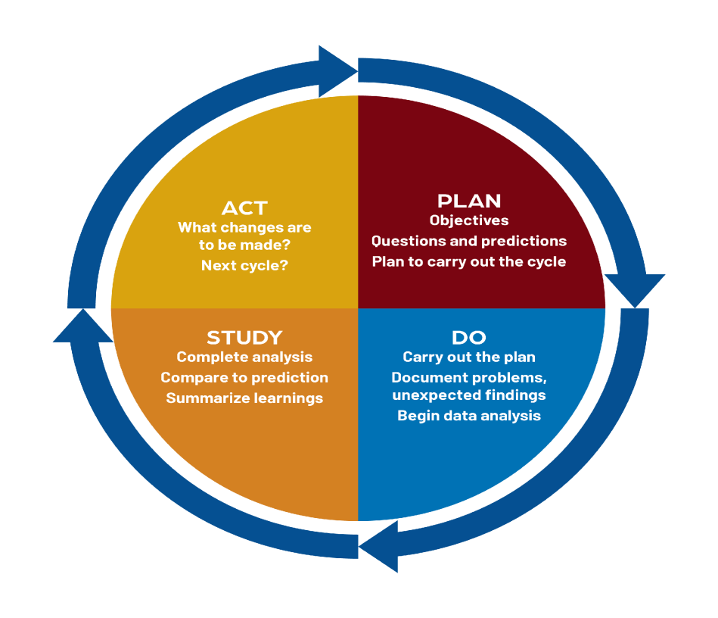
Figure 4. PDSA Cycle
(Source: Western Regional Educator Network, 2024).

At the Do stage, interventions such as better reporting systems, leadership walk rounds, and safety briefings need to be tested on one medical ward first. It is important to gather the feedback from employees to discover what barriers exist and how to address them (Hibbert et al., 2023).
At the Study stage, performance needs to be measured based on comparison between pre-and post-implementation of changes in safety metrics. These changes need to be in reduction of adverse events, improvement in reporting practices, and increased employee confidence in speaking up about issues (Olden and Erwin, 2023).
At the Act stage, successful interventions need to be implemented throughout the NHS Trust organisation on an ongoing basis. Lean can help achieve this aim by cutting down waste and increasing efficiency, while Six Sigma is going to reduce variation and ensure reliability of healthcare processes (Barr and Brannan, 2024).

4. Conclusion
NHS patient safety still poses one of the most important issues concerning quality in the health service, as seen from the failure cases at Mid Staffordshire NHS Foundation Trust. It was established that poor governance, workforce related issues, bad leadership and organisational culture contributed to patient harm. Fishbone Diagram and 5 Whys helped identify the root causes of failure, while the Donabedian Model indicated how structural and process deficiencies led to poor patient outcomes. SWOT analysis has shown that even though many reforms, including PSIRF, have made great improvements in the area of patient safety, there are still challenges left.
The suggestions put forward deal with improving clinical governance, bettering leadership and workforce wellbeing and creating patient safety learning systems. PDSA implementation, along with Lean and Six Sigma techniques, would allow making those changes sustainable. In order to prevent future failure cases in NHS organisations, it is necessary to keep their patient-centric culture built upon transparency, accountability and continuous organisational learning.

References
Agbar, F., Zhang, S., Wu, Y. and Mustafa, M. (2023) ‘Effect of patient safety education interventions on patient safety culture of health care professionals: Systematic review and meta-analysis’, Nurse Education in Practice, 67, p.103565.
Agency for Healthcare Research and Quality (AHRQ) (2024) Root Cause Analysis. Patient Safety Network. Available at: https://psnet.ahrq.gov/primer/root-cause-analysis (Accessed: 7 August 2026).
Ahmed, Z., Ellahham, S., Soomro, M., Shams, S. and Latif, K. (2024) ‘Exploring the impact of compassion and leadership on patient safety and quality in healthcare systems: A narrative review’, BMJ Open Quality, 13(Suppl. 2).
Barr, E. and Brannan, G.D. (2024) ‘Quality improvement methods (Lean, PDSA, Six Sigma)’, in StatPearls [Internet]. Treasure Island, FL: StatPearls Publishing. Available at: https://www.ncbi.nlm.nih.gov/books/NBK599556/
Barrow, J.M. and Annamaraju, P. (2022) ‘Change management in health care’, in StatPearls [Internet]. Treasure Island, FL: StatPearls Publishing. Available at: https://www.ncbi.nlm.nih.gov/books/NBK459380/
Bhati, D., Deogade, M.S. and Kanyal, D. (2023) ‘Improving patient outcomes through effective hospital administration: A comprehensive review’, Cureus, 15(10).
Braithwaite, J. (2018) ‘Changing how we think about healthcare improvement’, BMJ, 361.
Care Quality Commission (CQC) (2025) The State of Health Care and Adult Social Care in England 2024/25: Focus on Maternity. Newcastle upon Tyne: Care Quality Commission. Available at: https://www.cqc.org.uk/publications/state-care/state-health-care-and-adult-social-care-england-2024-25 (Accessed: 7 August 2026).
Demeke, G.W., van Engen, M.L. and Markos, S. (2024) ‘Servant leadership in the healthcare literature: A systematic review’, Journal of Healthcare Leadership, pp.1–14. Available at: https://www.tandfonline.com/doi/pdf/10.2147/JHL.S440160
Donabedian, A. (1988) ‘The quality of care: How can it be assessed?’, JAMA, 260(12), pp.1743–1748.
Drennan, J., Murphy, A., McCarthy, V.J., Ball, J., Duffield, C., Crouch, R., Kelly, G., Loughnane, C., Murphy, A., Hegarty, J. and Brady, N. (2024) ‘The association between nurse staffing and quality of care in emergency departments: A systematic review’, International Journal of Nursing Studies, 153, p.104706.
Draganović, Š. and Offermanns, G. (2022) ‘Patient safety culture in Austria and recommendations of evidence-based instruments for improving patient safety’, PLOS ONE, 17(10), p.e0274805.
Francis, R. (2013) The Mid Staffordshire NHS Foundation Trust Public Inquiry Report of the Mid Staffordshire NHS Foundation Trust Public Inquiry Executive Summary HC 947. London: The Stationery Office. Available at: https://assets.publishing.service.gov.uk/government/uploads/system/uploads/attachment_data/file/279124/0947.pdf (Accessed: 7 August 2026).
Harrison, R., Fischer, S., Walpola, R.L., Chauhan, A., Babalola, T., Mears, S. and Le-Dao, H. (2021) ‘Where do models for change management, improvement and implementation meet? A systematic review of the applications of change management models in healthcare’, Journal of Healthcare Leadership, pp.85–108.
Hassan, M., Kushniruk, A. and Borycki, E. (2024) ‘Barriers to and facilitators of artificial intelligence adoption in health care: Scoping review’, JMIR Human Factors, 11, e48633.
Hardy, S. (ed.) (2025) Workplace Well-being for Nurses, Health and Care Professionals. London: Taylor & Francis.
Hibbert, P.D., Stewart, S., Wiles, L.K., Braithwaite, J., Runciman, W.B. and Thomas, M.J. (2023) ‘Improving patient safety governance and systems through learning from successes and failures: Qualitative surveys and interviews with international experts’, International Journal for Quality in Health Care, 35(4). Available at: https://pmc.ncbi.nlm.nih.gov/articles/PMC10656601/
Jalilvand, M.A., Raeisi, A.R. and Shaarbafchizadeh, N. (2024) ‘Hospital governance accountability structure: A scoping review’, BMC Health Services Research, 24(1), p.47.
Kelly, F.E., Frerk, C., Bailey, C.R., Cook, T.M., Ferguson, K., Flin, R., Fong, K., Groom, P., John, C., Lang, A.R. and Meek, T. (2023) ‘Human factors in anaesthesia: A narrative review’, Anaesthesia, 78(4), pp.479–490.
Kumah, A., Nwogu, C.N., Issah, A.R., Obot, E., Kanamitie, D.T., Sifa, J.S. and Aidoo, L.A. (2024) ‘Cause-and-effect (fishbone) diagram: A tool for generating and organizing quality improvement ideas’, Global Journal on Quality and Safety in Healthcare, 7(2), pp.85–87.
Lee, S.E., Dahinten, V.S. and Lee, J.H. (2023) ‘Testing the association between the enabling and enacting factors of patient safety culture and patient safety: Structural equation modelling’, BMC Nursing, 22(1), p.32.
Moralee, S., Sidhu, M., Smith, J. and Walshe, K. (2025) Healthcare Management. 4th edn. London: McGraw-Hill Education.
NHS England (2024) National Healthcare Inequalities Improvement Programme. Available at: https://www.england.nhs.uk/about/equality/equality-hub/national-healthcare-inequalities-improvement-programme/ (Accessed: 7 August 2026).
NHS England (2024) Patient Safety Incident Response Framework and Supporting Guidance. Available at: https://www.england.nhs.uk/publication/patient-safety-incident-response-framework-and-supporting-guidance/ (Accessed: 7 August 2026).
NHS Resolution (2025) Annual Report and Accounts 2024/25. London: NHS Resolution.
Olden, P.C. and Erwin, C.O. (2023) Management of Healthcare Organizations: An Introduction. Chicago: ACHE Learn.
Patient Safety Learning (2026) Patient Safety Learning’s Response to the NHS Staff Survey Results 2025. London: Patient Safety Learning.
Powell, T. (2013) The Francis Report (Report of the Mid Staffordshire NHS Foundation Trust Public Inquiry) and the Government’s Response. London: House of Commons Library.
Sengupta, S. (2020) Transformational Leadership. Available at: https://managementweekly.org/transformational-leader/ (Accessed: 7 August 2026).
Singh, G., Patel, R.H., Vaqar, S. and Boster, J. (2024) ‘Root cause analysis and medical error prevention’, in StatPearls [Internet]. Treasure Island, FL: StatPearls Publishing.
Toulany, A. and Shojania, K.G. (2025) Measurement for Improvement. Cambridge: Cambridge University Press.
Western Regional Educator Network (2024) The PDSA Cycle. Available at: https://www.westernregionalnetwork.org/post/the-pdsa-cycle (Accessed: 7 August 2026).
Ystaas, L.M.K., Nikitara, M., Ghobrial, S., Latzourakis, E., Polychronis, G. and Constantinou, C.S. (2023) ‘The impact of transformational leadership in the nursing work environment and patients’ outcomes: A systematic review’, Nursing Reports, 13(3), pp.1271–1290.

