

LEVEL 7 ASSESSMENT SPECIFICATION
APPENDIX GA36d

Student name: | Bala Jaya Chandra.Pichikala | Student ID number: | 2219819
Programme: | MSc Programme
Module: | Ethical Hacking
Module code: | ACCA7033 | Contribution to Overall Module Assessment (%): | 100%
Lecturer: | Assoc. Professor Carlene Campbell | Internal Verifier: | Munyaradzi N Murira
Assignment Title: | Research into cyber security attacks and Penetration testing for a virtualise simulated company Website | Word count (or equivalent): | 5,000
Submission deadline: | Jan 8th 2024 | Return date of provisional marks & written feedback:
Submission method: | All written assessments, where practical and possible, must be submitted via Turnitin unless otherwise instructed by the Lecturer. (Please DO NOT put this assessment specification into Turnitin or it will match many similarities with other students’ submissions.)  Alternative submission method (if applicable):  Late submission of the assessment will result in a late penalty mark. Penalties for late submission: Up to one week late, maximum mark of 50%. Over one week late, 0%. Only the Extenuating Circumstances Panel may approve a change to submission dates.
Academic honesty / referencing: | Academic honesty is required. In the main body of your submission you must give credit to authors on whose research and ideas your work is based. Append to your submission a reference list that indicates the books, articles, etc. that you have used, cited or quoted in order to complete this assessment.

Ethical Hacking

Table of Content

Assignment Title 1
Table of Content 2
List of Figures 3
List of Tables 4
Task - 1 5
Task - 2 8
1 Introduction 8
2 Detailed contingency policy put in place before Pentest
2.1 Choice of Penetration testing framework 9
2.2 Choice of Penetration testing tools 10
3 Types of attacks simulated with diagrams 11
3.1 List of vulnerabilities targeted 12
3.2 Attack tools used 13
3.3 Protocols involved in the attack 14
3.4 How the attack was launched 15
3.5 Why you recorded success or failure 23
4 Recommended solutions for the threats discovered on the environment 23
4.1 The configuration changes that could be made to the systems 23
4.2 New software and hardware that might be bought 23
4.3 Defence strategy to avoid this type of attack succeeding in the future 24
5 Cost of Solution 24
5.1 Cost of implementing 24
6 Timetable for execution 25
References 26

List of Figures

Figure 1.SolarWinds Supply Chain 6
Figure 2. Basic architecture 7
Figure 3. CPC Network topology 8
Figure 4. Phases of a pen-testing based on OSSTMM [7] 9
Figure 5. Program for verifying Eternalblue vulnerability 11
Figure 6. Scanning of ports filtered by a firewall 11
Figure 7. Additional configuration for Metasploitable 2 12
Figure 8. Summary of the configuration for Metasploitable 2 13
Figure 9. Laboratory topology 13
Figure 10. Scanning open ports with Nmap - scenario 2 14
Figure 11. Search for the EternalBlue module to execute the attack 14
Figure 10. Exploit details smb_ms17_010_eternalblue 15
Figure 13. Search for appropriate payloads for the EternalBlue attack 15
Figure 14. Smb_ms17_010_eternalblue exploit configuration 16
Figure 15. Information about PHP module 5.2.4 16
Figure 16. Directory information on the web server 17
Figure 17. Vulnerability 1 – Defacement 17
Figure 18. Default web server page 18
Figure 19. Access to the PhpMyAdmin module 18
Figure 20. Running the Metasploit framework 19
Figure 21. Searching for the CGI module to execute the attack 19
Figure 22. Detailed information on the php_cgi_arg_injection exploit 19
Figure 23. Search for appropriate payloads for the CGI attack 20
Figure 24. Configuration of the php_cgi_arg_injection exploit 20
Figure 25. Execution of the php_cgi_arg_injection exploit 21
Figure 26. Function search for Meterpreter 21
Figure 27. Packet capture when performing CGI attack 22
Figure 28. Execution of remote commands on the vulnerable server 23
Figure 29. Searching for the CGI module to execute the attack 23
Figure 30. Modification of the index.php file 24
Figure 31. Downloading the original source code of the page 24
Figure 32. Upload fully modified web page 25
Figure 33. Creating a Mysql database user 25
Figure 34. PhpMyAdmin module login 26
Figure 35. Execution of the exploit smb_ms17_010_eternalblue 26
Figure 36. Function search for Meterpreter 26
Figure 37. smb_ms17_010_eternalblue exploit configuration 27
Figure 38. Capturing the login password 27
Figure 39. Process identification explorer.exe 28

List of Tables
Table 1. Resources required for the controlled laboratory
Table 2. Financial investment of each security project in GBP
Table 3. Timeline of security execution

TASK - 1
- Twitter
Twitter experienced one of the largest hacks in its history in July 2020. Numerous well-known accounts, including those of Bill Gates, Elon Musk, Uber, Apple, Barack Obama, Joe Biden, and Jeff Bezos, were compromised by the hackers. A "coordinated social engineering attack" was launched against Twitter by workers, who provided the attackers with access to the company's internal resources. All of the accounts were simultaneously compromised by the attackers, who then exploited them to spread Bitcoin fraud. To get more payouts, they wrote messages on the compromised accounts advising their followers to transfer funds to a certain Bitcoin wallet address. "It's time for me to give back to everyone who has asked me to," a tweet from Bill Gates said. "I'll return $2,000. You send $1,000." Through this fraudulent technique, the threat actors were able to steal from the gullible followers of the hacked accounts around $120,000 worth of bitcoin (the attackers had collected about 12.86 bitcoins in their wallet). Initially, hackers gained access to accounts focusing on cryptocurrencies, including Ripple, Bitcoin, Gemini, Coinbase, Binance, and Bitcoin. These accounts displayed the tweet, "We have partnered with CryptoForHealth and are giving back 5000 BTC to the community." There was a link to a phishing website in the message. Subsequently, hackers gained access to Elon Musk, Apple, Uber, and Mike Bloomberg's Twitter accounts, urging their followers to send them Bitcoin. Twitter removed the phony tweets from the hacked accounts and locked out the perpetrators as soon as the attack was detected. Two weeks later, Graham Ivan Clark, a 17-year-old from Tampa, Florida, was identified as the subject of an arrest by US officials. It is believed that Clark was the mastermind behind the Twitter breach. The FBI, IRS, and Secret Service worked together to organize the operation that led to the arrest. Clark was charged by Hillsborough State Attorney Andrew Warren for being the "mastermind" of the hack that compromised 130 accounts.

- Attack on the SolarWinds Supply Chain

A sophisticated supply chain attack that targeted network management tool provider SolarWinds was discovered in December 2020. Malicious actors used vulnerabilities in SolarWinds' Orion software updates to spread malware that goes by the name "SUNBURST." This attack impacted numerous commercial sector businesses as well as important U.S. government institutions.

Analysis: The attackers gained access to SolarWinds' software development environment and inserted malicious code into updates that were supposed to be genuine. The ingenuity and persistence of the attackers made this breach noteworthy. The software development and update processes, which lacked sufficient security checks, were the main sources of vulnerabilities.
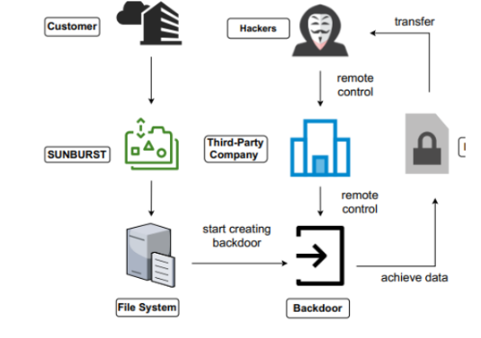
Figure 1: SolarWinds Supply Chain

Preventive Measures: Organizations must secure their supply chains and conduct regular security audits. Implementing a zero-trust security model, practicing least privilege access, and monitoring network traffic for anomalies can significantly reduce such risks[4].

- Equifax Data Breach:

In 2017, Equifax, one of the largest credit bureaus in the U.S., suffered a massive data breach exposing the personal information of about 147 million people.

Analysis: The breach occurred because the vulnerability remained unpatched for months after a fix was available. This oversight allowed attackers to exploit the flaw to access sensitive data. The incident highlighted the need for timely vulnerability management and robust incident response planning.

Preventive Actions: Timely patching and routine vulnerability scanning are crucial. To promptly handle possible breaches, organizations should also prioritize end-to-end encryption of critical data and develop a thorough incident response plan[5].

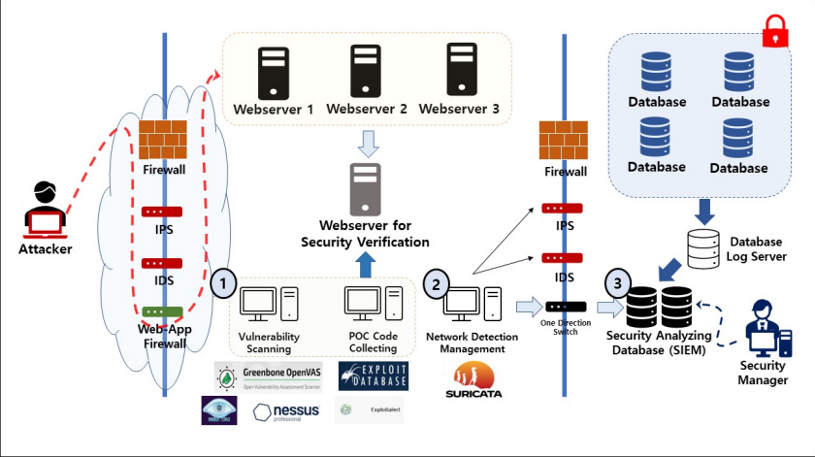
Figure 2: basic architecture

TASK - 2

Introduction
On December 9, 2018 a computer attack occurred at the headquarters of CPC, geographically, the attack sought to carry out sabotage and consisted of altering the presentation of its web portal (Defacement), taking advantage of a CGI (Common Gateway Interface) vulnerability on the server side. This meant that the availability, confidentiality and integrity of the information stored on the web portal were affected. According to the scenario, it was possible to identify that the Apache web server had a phpMyAdmin module. In addition, it was possible to determine that the computer attack at the headquarters of the CPC was caused by a deficient packet filtering in the perimeter security device and a fairly limited security scheme; Figure 3 illustrates the topology of the headquarters.
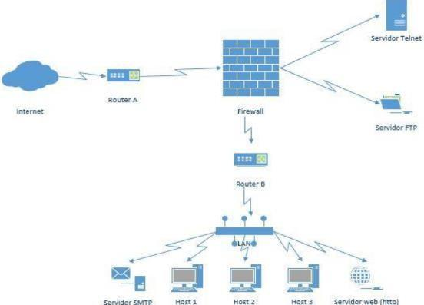

Figure 3. CPC Network topology

After the materialisation of the first attack, another security event occurred. On this occasion, the server was compromised by an EternalBlue attack and the cybercriminals extracted sensitive information from repositories and databases owned by the organisation, thus managing to compromise private information and personal data. According to the scenario, it was identified that the affected computer had a Windows 7 operating system installed and port 445 SMB (Server Message Block) was open and allowing connections. This port is associated with the "Wannacry" ransomware attack. In addition, the attacked computer did not have the MS17-010 update which fixes the SMB vulnerability in Microsoft operating systems.

2 Detailed contingency policy put in place before Pentest

Choice of Penetration testing framework
Infrastructure, personnel and applications have interactions that must be analysed and controlled to reduce downtime and the loss of confidentiality, integrity and availability. An IT security audit helps to identify gaps at the configuration level in IT systems and to detect operational, administrative or technological failures. For a cyber-security conscious organisation, ethical hacking testing is a necessary activity that should be carried out routinely, allowing it to assess the effectiveness of controls and the level of preparedness to deal with a cyber-security incident. The OSSTMM methodology has been chosen for the case study, because it is a comprehensive framework with a lot of documentation in different domains in which security testing is performed. This methodology evaluates security in different aspects (physical, social and communications); this translates into a deep understanding of the organisation's processes and how each of its components are interconnected.
OSSTMM stands out for its analysis phase and the way it answers STAR (Security Test Audit Report) questions [6]. OSSTMM takes a global security concept applied to vulnerability testing, auditing, risk assessment, scanning, and ethical hacking. Across the board it defines the procedure and activities necessary to test security requirements; Figure 4 shows the flow and interaction of the phases of OSSTMM-based pentesting [7]
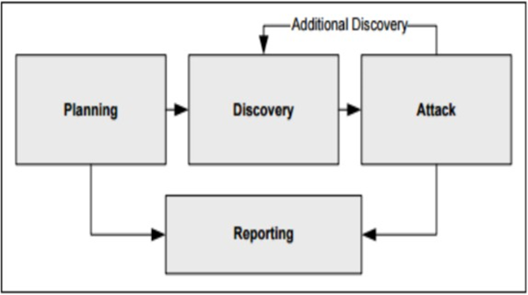

Figure 4. Phases of a pen-testing based on OSSTMM [7]
Planning phase. Preliminary stage where the scope of ethical hacking is established, defining the confidentiality agreement on the information collected, as well as requesting formal authorisation from the owner or administrator of the system to carry out the tests. The activities to be carried out are defined and legal restrictions are identified, such as rules and regulations in force, and operational restrictions; schedules and times for the execution of the tests [8].
Discovery phase. This stage is designed to collect information on the system to be audited and is divided into the following activities:
- Footprinting: A non-intrusive task that seeks to obtain as much information as possible from the context, systems and computer components. This is done using techniques such as social engineering, advanced internet searches, or identifying user profiles on social networks.
- Scanning and numbering: Identification of available systems, listening ports and services offered. Based on the information collected, a list of all findings will be made. It is common at this stage to use tools such as Nmap and OpenVAS.
- Vulnerability scanning: Testing and vulnerability assessment based on configuration errors and security gaps in terms of exposed settings or services. Usually a comparison is made between the system to be assessed and public vulnerability lists such as CVE, NVT or CWE, so that matches are compared and technical issues are ruled out [8].

Attack phase. Central stage of ethical hacking, which consists of the materialisation of the information collected, i.e., based on the information obtained in previous stages, full knowledge of the weaknesses of the target system is obtained and the attacks that will be efficient and with the highest percentage of success are determined [9].
Reporting phase. Concluding stage of ethical hacking in which all the findings are recorded and formal documentation is made, establishing a record of each of the steps carried out in previous stages. In addition, recommendations are made to prevent attacks and suggestions are made for technological controls that help to protect the system from real attacks.

Choice of Penetration testing tools

Table 1. Resources required for the controlled laboratory
Element | Description | Function
Desktop equipment | Core i7 7700 3.6 GHz Processor, 16 GB DDR4 RAM, 1 TB Disk  Hard, Windows 10. | Hardware element to perform virtualisation and collect evidence.
Internet connection | 3 Mbps bandwidth, ADSL type. | Required to download the necessary software and perform the update of the O.S.
Executable from Virtual Box | Version 5.2.22, weight 108  MB, | Software for virtualising machines.
Kali Linux .iso image | Kali Linux 2018.3 version, weight 812 MB | Operating system installation disk to run the pentesting.
Tails .iso image | Version Tails 3.11, weight 1.2 GB, | Disc from installation disk of the Deep web tool.
Metasploitable .zip image | .vbox and vdi file. | Virtual machine for testing the server at the CPC Website.
Windows 7 .iso image | Professional Version, SP1 | Installation disk of the CPC server operating system.

Types of attacks simulated with diagrams

List of vulnerabilities targeted
Vulnerability 1 – Defacement (Wannacry): This simulate a defacement attack on the main web page of CPC the attack is executed by exploiting a vulnerability on the CGI (Common Gateway Interface) component of the Apache web server side that executes the PHP language. The attack vector used is code injection, which consists of sending data not expected by the interpreter and thus gaining access via a command line console to the operating system kernel; after gaining access, the structure of the website is edited for the convenience of the attacker. Using the Kali Linux distribution, different pen-testing tools are run to identify and exploit vulnerabilities on the target server. This operating system was developed by Offensive Security60 and is designed specifically for computer security auditing. It has an arsenal of more than 600 applications, is based on Debian GNU/Linux and its predecessor was BackTrack.
Vulnerability 2 – Eternalblue: It is necessary to validate if the Windows 7 machine is vulnerable to the Eternalblue attack; for this, a CVE 2017-0144 verification tool, developed by the renowned security company ESET64, is used [6]. The executable file is downloaded and a command console is opened directly, showing if he executable file is downloaded and a command console is opened directly showing whether the operating system is exposed to the SMB protocol vulnerability. Figure 5 shows that the test machine is vulnerable to CVE 2017-0144 [11].
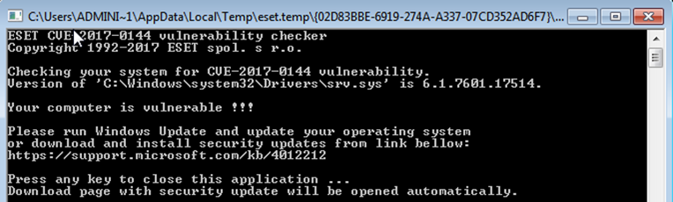

Figure 5. Program for verifying Eternalblue vulnerability

Attack tools used
ZenMap: To run the vulnerability scanning script, type the command nmap -f -sS -sV --script vuln 192.168.0.4 [12].
NMAP: To scan vulnerabilities: Information is gathered to carry out vulnerability exploitation and identify some type of security control. Figure 6 shows the execution of the command nmap - T4 -A -v 192.168.0.4, the output shows the versions of the open ports and that there is no firewall involved [13].
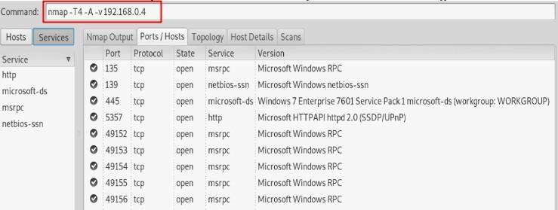

Figure 6. Scanning of ports filtered by a firewall
Nmap has an advanced function that allows a deep scan to be performed in an automated manner through the use of scripts. From a terminal, type the command nmap -f -sS -sV –script-auth 192.168.0.3, which is an automated script to validate authentication in the published services [13].
Wireshark protocol analyser: To document the interaction and flow of connections from the attacking machine in the vulnerable website server [14].
Meterpreter command interpreter: Meterpreter offers different functions and tools to compromise the victim machine [15].

Protocols involved in the attack
Once the Kali Linux operating system is installed, it is necessary to update the repositories and packages. Then we proceed to run the ethical hacking tools and perform the respective analysis of the results obtained. In VirtualBox, a virtual machine is created, assigning it a mnemonic name, memory, CPU and network resources in accordance with a standard Linux machine; these configurations cannot exceed the hardware characteristics of the host system. It is important to note that the system must be compatible to virtualise under X64-based architectures, i.e. processors with 644 bits. In the Hard Disk item, choose the Use an existing virtual hard disk file option to import the Metasploitable.vmdk file [16]. This file is a virtual hard disk container that has all the configuration of the Metasploitable 2 machine. Figure 31 shows the configuration of the scenario 1 virtual machine.
At the end of the configuration wizard, you can see that the virtual machine has been created and is available in the side menu. To modify any of the established settings, select the virtual machine and choose the configuration option, this allows you to observe the machine's settings and modify them. For the laboratory, Figure 7 shows that the network adapter is in bridge mode allowing to establish a connection between virtual machines, the host and the internet.
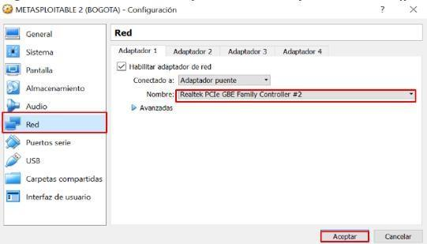

Figure 7. Additional configuration for Metasploitable 2

VirtualBox offers a complete summary of the configurations of each of the virtual machines created, this option can be seen from the side panel where the central box is presented. Figure 8 shows the complete configuration of the virtual machine Metasploitable 2.
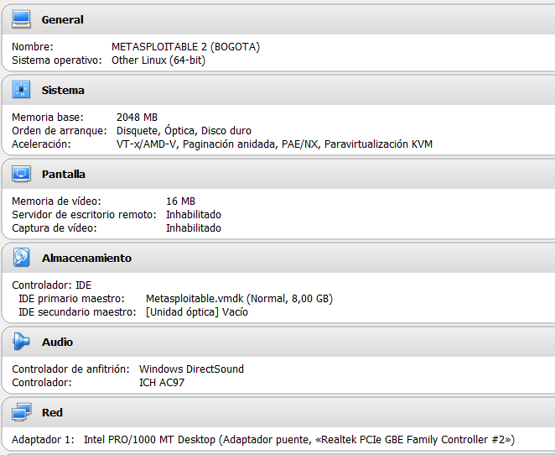

Figure 8. Summary of the configuration for Metasploitable 2

With all the configurations made, the virtual machine created is selected and the start action is executed to start the operating system; the start-up sequence is observed, validating services and pre-established configurations. It is worth noting that this virtual machine has been developed to be vulnerable, showing in plain text the user and password to log in, which in this case is msfadmin. Figure 9 shows the topology suggested for the development of the controlled laboratory. It is possible to appreciate in this image the addressing and the role that each machine will play during the controlled laboratory tests.
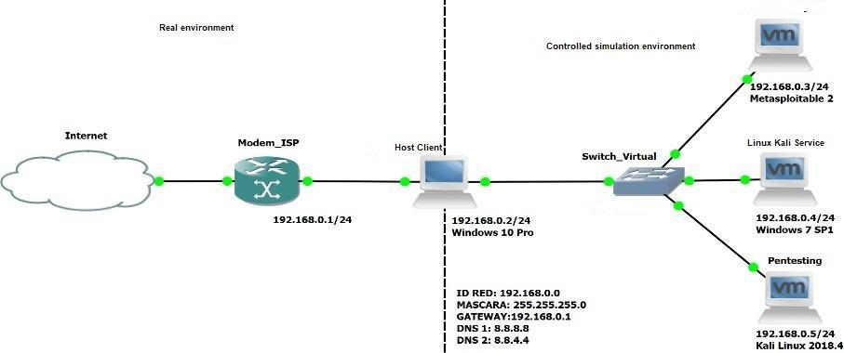

Figure 9. Laboratory topology
Vulnerability 1 – Defacement (Wannacry)
Continuing with the recognition of the vulnerable machine, it is necessary to identify the open ports and the type of operating system. Figure 10 shows the execution of the command nmap -O 192.168.0.4; this identifies that TCP port 445 is open and the operating system of the victim machine is Microsoft Windows.
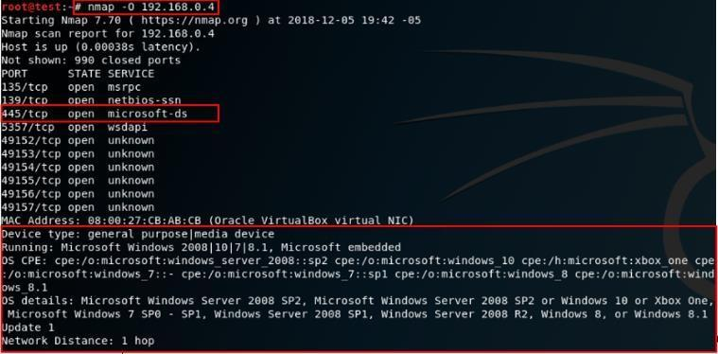

Figure 10. Scanning open ports with Nmap - scenario 2
From a command console, type nmap -f -sS -sV --script auth 192.168.0.4, this script performs a scan to validate the authentication of the available services. Figure 10 shows the name of the Windows machine, TEST-PC, as a result of this command.
Vulnerability 2 – Eternalblue attack
Based on previously collected information, a vulnerability has been identified in the SMB (Server Message Block) protocol that allows code to be executed remotely in different versions of Microsoft Windows. Such vulnerability is related to the code CVE-2017-0143: Eternalblue, this exploit takes advantage of a flaw in version 1 of the SMB protocol to send specific packets that allow code execution remotely on a victim host [17].
Before starting to exploit the SMB protocol vulnerability on the Windows 7 machine, it is necessary to validate that the Windows firewall is disabled. Go to Control Panel, System and Security and temporarily disable the Windows firewall. It is necessary to verify if there are exploits to execute the EternalBlue attack [17]. Therefore, in Figure 11 the search command is executed together with a parameter to perform the search, in this case ms17_010_eternalblue was specified to make the query more efficient.
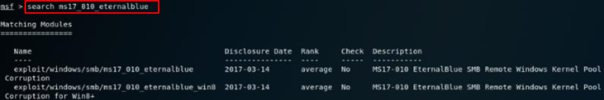

Figure 11. Search for the EternalBlue module to execute the attack
Figure 12 shows detailed information about the exploit via the command info exploit/windows/smb_ms17_010_eternalblue. The exploit was released on 14/03/2019 and is used on versions of Windows 7 and server 2008 R2 that are vulnerable to SMB Buffer Overflow Version 1. On some systems it can cause instability and sometimes a blue screen with an error or unscheduled reboots.

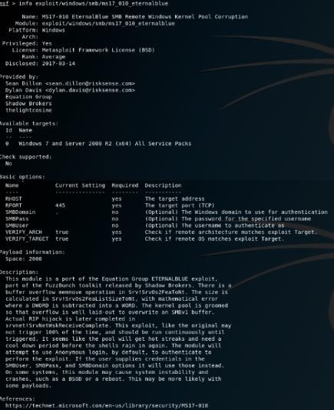

Figure 12. Exploit details smb_ms17_010_eternalblue
Figure 13 displays the command use exploit/windows/smb_ms17_010_eternalblue to select the appropriate exploit, then use the show payloads option to choose the reverse TCP connection payload, windows/x64/meterpreter/reverse_tcp. This attack compromises the affected machine allowing remote access to the webcam and keystroke capture.
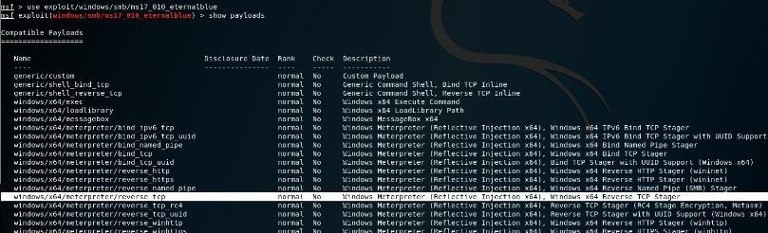

Figure 13. Search for appropriate payloads for the EternalBlue attack
In Figure 14 the Metasploit tool is configured with the information of the vulnerable remote host (RHOST), local host that is going to execute the exploit (LHOST), payload selected (windows/x64/meterpreter/reverse_tcp) and finally the options of the attack configuration are shown using the show options command.
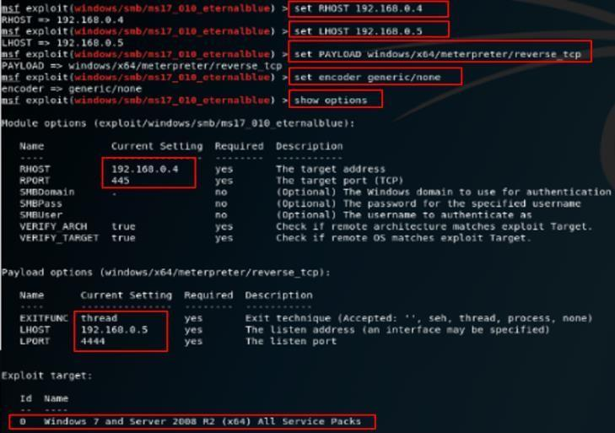

Figure 14. Smb_ms17_010_eternalblue exploit configuration

How the attack was launched
Vulnerability 1 – Defacement
With the vulnerability script, the URL (Uniform Resource Locator) was identified, which links directly to information on the different modules and documentation related to the web server. Figure 15 shows the information of the PHP module, version 5.2.4.

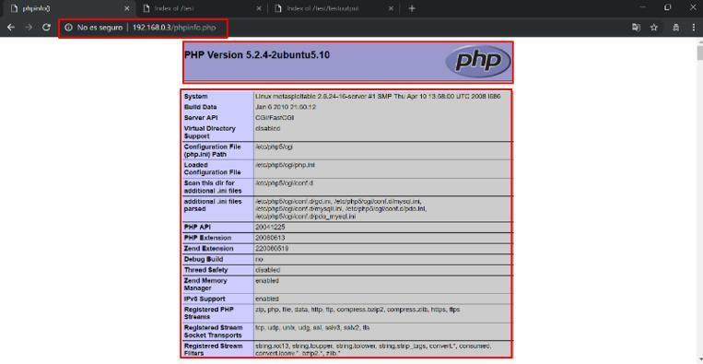

Figure 15. Information about PHP module 5.2.4

Another important finding was finding the path that allows the viewing of directories and documentation of the configuration set up on the web server. Figure 16 shows the /doc directory, which contains a number of exposed repositories and compromised confidential information.
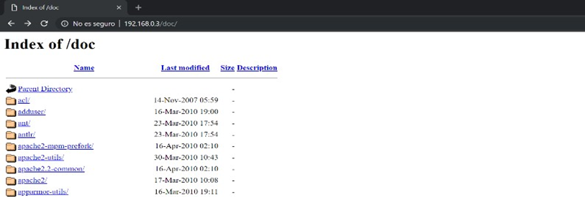

Figure 16. Directory information on the web server

Based on the information gathered in the previous phase, a vulnerability has been identified that allows executing CGI (Common Gateway Interface) code on the web server side in Apache version 2.2.8 and PHP 5.2.4; this vulnerability is related to the code CVE-2012-1823: PHP CGI, according to CVE. Figure 17 illustrates the topology for the development of this scenario, where there is a local area network (LAN) environment through the interconnection of a virtual switch, without a firewall.

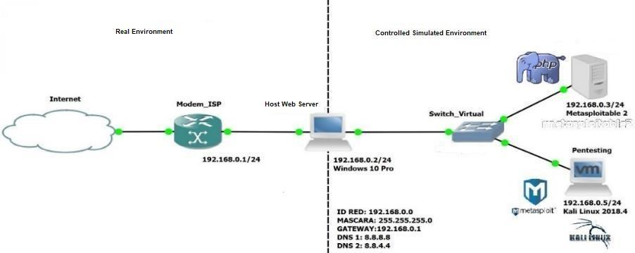

Figure 17. Vulnerability 1 – Defacement

Before starting the exploitation of the vulnerability on the web page provided by default by the web server of the Metasploitable machine, it is necessary to use a web browser from the host host to verify that the page is available. Figure 18 shows that the web page presents a set of options and a welcome message similar to the login message. On the main Metasploitable 2 website it is possible to interact with other types of training applications such as DVWA (Damn Vulnerable Web Application), WebDAV, TWiki and Mutillidae. These vulnerable websites have been developed to perform penetration tests under a controlled environment; exposing the main vulnerabilities on web applications according to the OWASP framework.

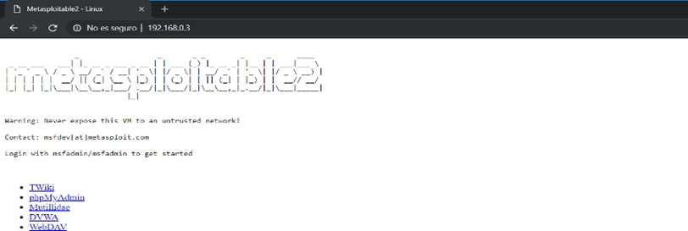

Figure 18. Default web server page
The Metasploitable machine brings by default a main web page with a rather limited design, therefore, a copy of the HTML (HyperText Markup Language) code of the main portal is made and a replica is loaded on the web server, but with PHP (Personal Hypertext Processor) extension. Figure 3 shows the replica web page of CPC. Figure 19 shows the access page to the phpMyAdmin web module, which is disclosed without any control and allows the management of the databases stored on the scenario 1 server.

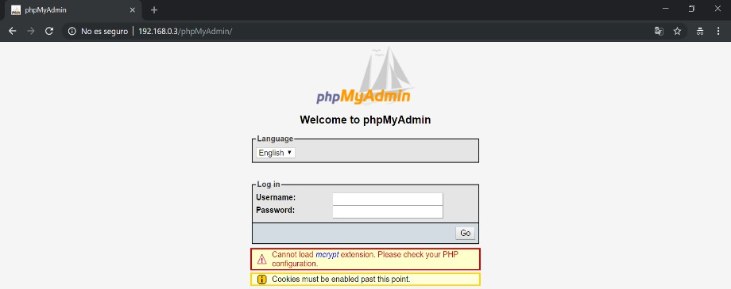

Figure 19. Access to the PhpMyAdmin module

Figure 20 shows the start of the attack when the Metasploit tool, "msfconsole", is run as super-user, root; then the required services are initialised by means of the postgresql (service postgresql start), ports (ss -ant) and framework database (msfdb init) commands.
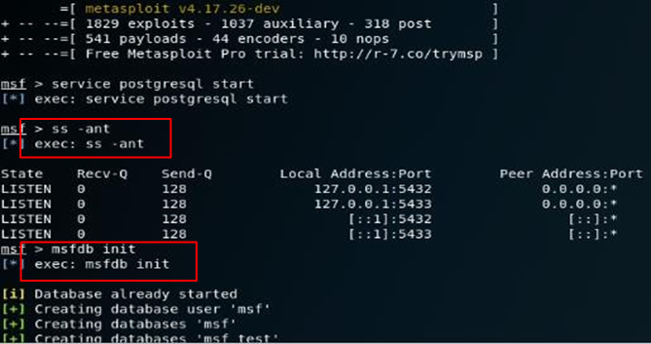

Figure 20. Running the Metasploit framework

It is necessary to verify if there are exploits to execute the CGI attack, therefore, the search command is executed with a parameter to perform the search, in this case, in Figure 21, php_cgi_arg_injection was specified to make the query more efficient.
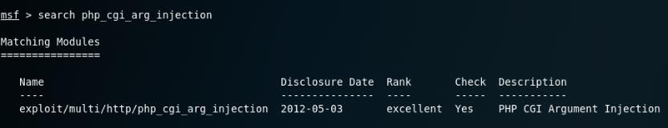

Figure 21. Searching for the CGI module to execute the attack
Once the exploit to be used has been identified, detailed information about the exploit must be looked up via the command info exploit/multi/http/php_cgi_arg_injection. The detailed exploit information is shown in Figure 22.
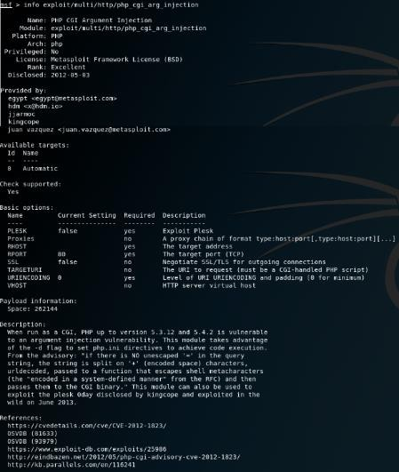

Figure 22. Detailed information on the php_cgi_arg_injection exploit

The exploit exploit/multi/http/php_cgi_arg_injection was released on 03/05/2012 and is used in PHP versions below 5.3.12 and 5.4.2 that are vulnerable to argument injection in the -d flag by setting code execution in php.ini directives. In Figure 23, the command use multi/http/php_cgi_arg_injection is typed to select the exploit and its complement, which in this case is a payload that allows executing specific functions and compromising the victim machine, generating an undesired behaviour such as the defacement of the main web page. By means of the show payloads option, the set of payloads available for the CGI code injection exploit can be observed. In addition, it can be seen that the payload that fits the attack is php/meterpreter/reverse_tcp.

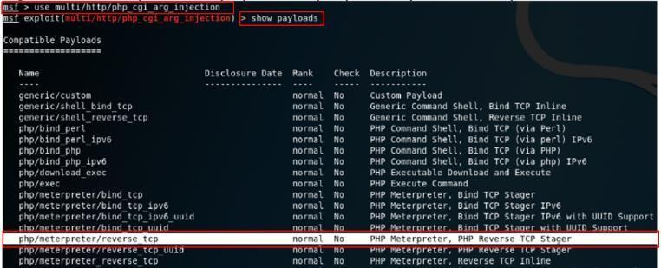

Figure 23. Search for appropriate payloads for the CGI attack

Up to this point in the lab, the necessary data is available to execute the attack, therefore, the Metasploit tool is configured with the information of the vulnerable remote host (RHOST), the local host that will execute the exploit (LHOST), the payload, better known as the payload selected (php/meterpreter/reverse_tcp), and finally the configuration options are shown with the show options command. Several monitoring tools relate port 4444 to malware and Ethicak Hacking framework, however, an attacker can modify this parameter to avoid detection of a SIEM (System Information Event Management). Figure 24 shows the configuration of the php_cgi_arg_injection exploit.

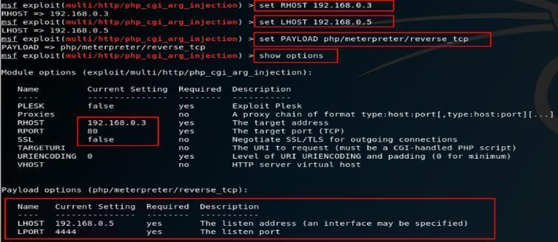

Figure 24. Configuration of the php_cgi_arg_injection exploit

Figure 25 shows the execution of the exploit command, immediately the reverse TCP connection is initiated and if all goes well, the session is established with the Meterpreter command interpreter.

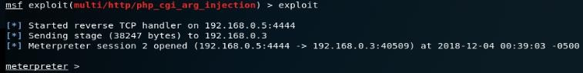

Figure 25. Execution of the php_cgi_arg_injection exploit

Figure 26 shows the list of available commands; to obtain this help, you must ask with the "?" sign, alone or accompanied by a keyword.

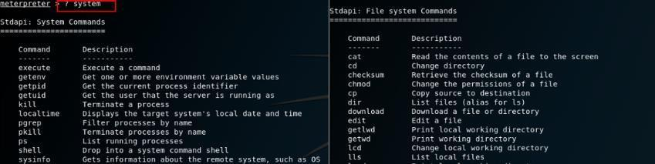

Figure 26. Function search for Meterpreter

During the execution of the attack, packets are captured using the Wireshark protocol analyser; the interaction and flow of connections from the attacking machine to the vulnerable machine can be clearly observed. Figure 27 shows that the attack starts with a request to port 80 where the CGI code is injected and the parameters for the reverse TCP connection are configured; then the execution of the Payload is started and a Meterpreter session is established remotely.
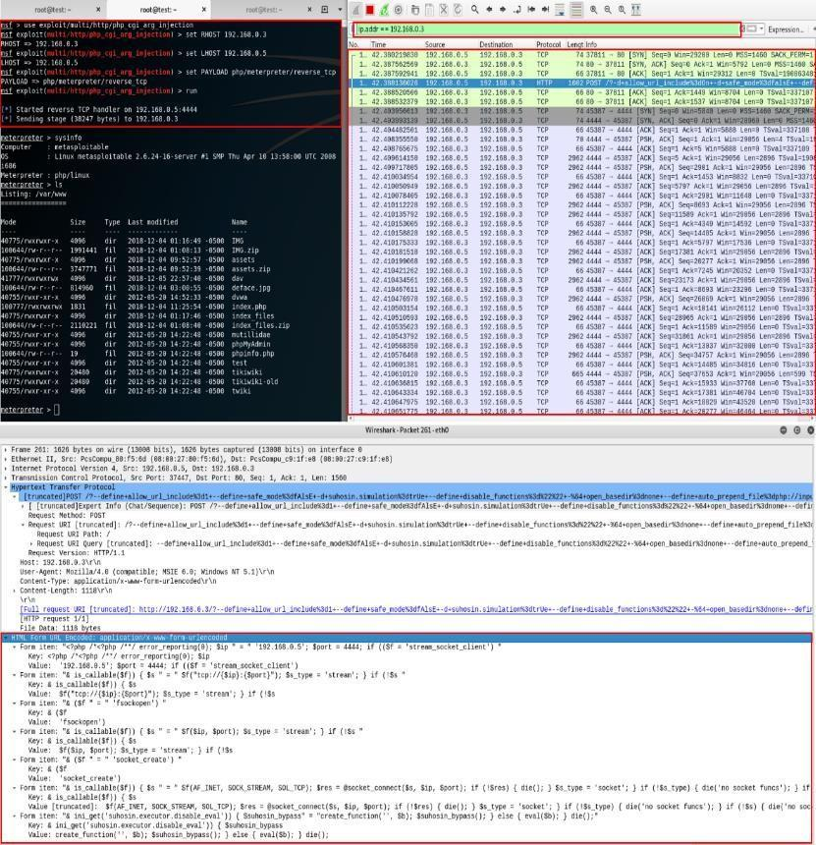

Figure 27. Packet capture when performing CGI attack
After compromising the server machine, meterpreter commands such as sysinfo are used to find out system information, localtime to find out the date and time settings, pwd to find out what directory it is located in and ls to list the contents of the current directory. Figure 28 shows control over the metasploitable machine with the permissions of the user www-data in the /var/www directory. This finding is extremely important because it exposes the path where the server's websites and their corresponding configuration files are stored.

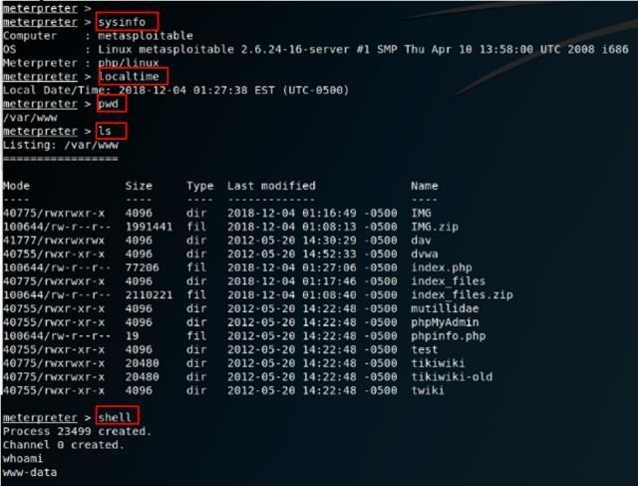

Figure 28. Execution of remote commands on the vulnerable server

Initially Defacement consists of modifying only a part of the main page, therefore, it has been identified that the static content is in the index.php file, however, the user www-data does not have sufficient permissions to edit it. In Linux it is possible to establish levels of privileges to access a file or directory according to the owner, members of a group or the rest of the users of the system; this adds a layer of security by means of access control, non-repudiation and traceability of the actions carried out by a given user. In Figure 29 we proceed to grant administrative read, write and execute permissions through the command chmod 777 index.php.

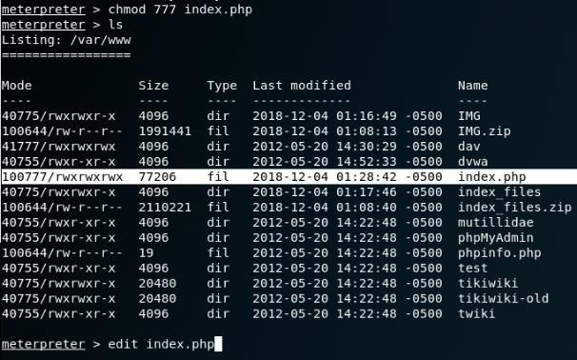

Figure 29. Searching for the CGI module to execute the attack

With the assigned permissions, the edit index.php command is executed and the banner information is changed to the auditor's personal data. This is possible thanks to the access obtained to the /var/www directory, the path where all the web content is stored. Figure 30 shows a fragment of the code of the main page that has been intentionally modified to observe the partial defacement.

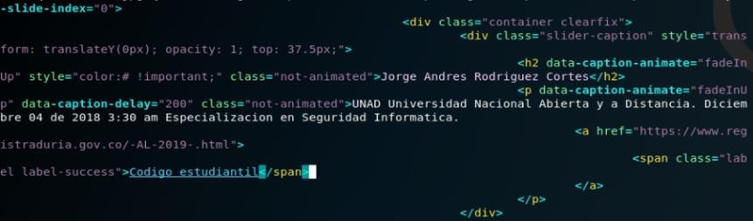

Figure 30. Modification of the index.php file

On consulting the main page again, it can be seen that its structure remains, however, the welcome banner shows the auditor's information and the unauthorised modification of the content. Up to this point, there is a significant change in the Ramdom S.A. website, but in a way, its design prevails. This modality can be used by an attacker to subtly alter the content of a website and embed malicious code that infects visitors with malware or redirects them to phishing sites. To perform a full defacement, a backup copy of the original page is saved in the first instance using the meterpreter command download index.php; it is good practice to take evidence of the configuration and security backup before carrying out any kind of penetration testing. Figure 31 shows that the downloaded file is stored in the home folder of the Kali Linux machine.

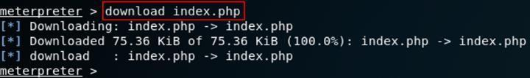

Figure 31. Downloading the original source code of the page
A fully modified web page was previously configured with its corresponding complementary files such as stylesheets and images. Figure 32 uses the command upload index.php and upload-assets.zip to upload and overwrite the local files that are stored on the web server. You can see that the main file of the web page, index.php, has been overwritten, in order for the supplanted page to be displayed correctly, you must unzip the assets.zip file which has the additional files such as style sheets and images.

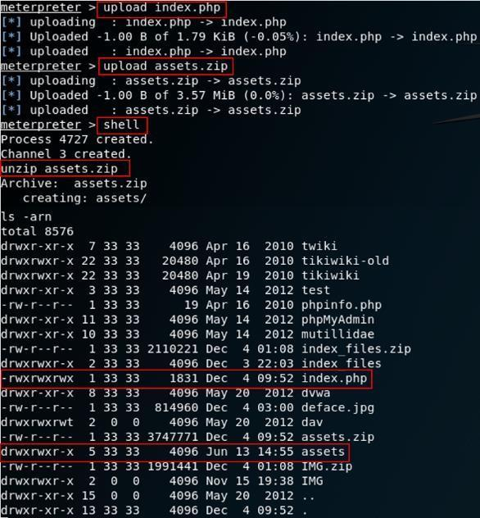

Figure 32. Upload fully modified web page
The purpose of a defacement is to affect the integrity and availability of the information published in a web application; this type of attack is economically, politically, activist or personally motivated. A defacement has a serious impact on the image and brand of a company, causing considerable damage to its reputation. On re-visiting the homepage, the visual structure has been completely modified, showing the auditor's information and a different graphical interface. Another interesting action that can be performed with this attack is to raise a command shell through Meterpreter and take advantage of the fact that the Mysql root user does not have a password, in order to authenticate and create a user with administrator privileges in the phpMyAdmin module. Figure 33 shows the creation of the test user with elevated permissions to access the database module.

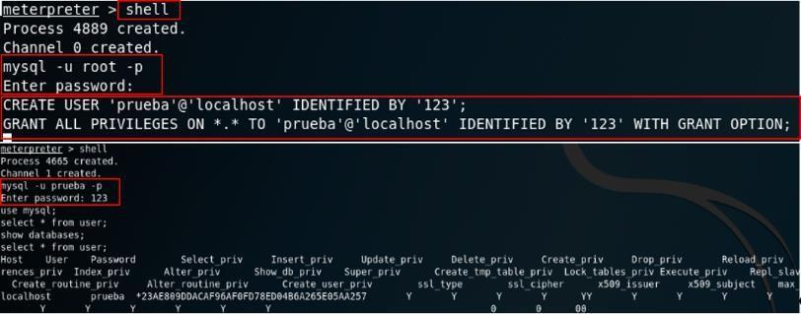

Figure 33. Creating a Mysql database user
Figure 34 shows the login to the phpMyAdmin module via the web interface; authentication is performed with the user created in an unauthorised manner and with the credentials defined in the previous step.
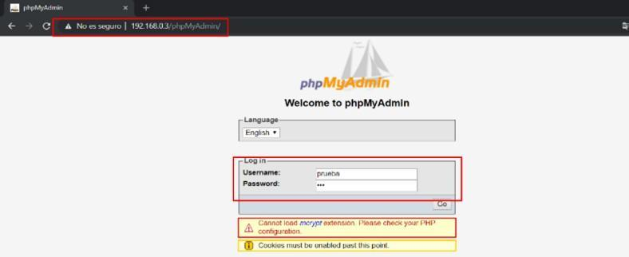
Figure 34. PhpMyAdmin module login
Eternalblue
Figure 35 shows the automated execution of the attack by means of the run command. The console shows the progress of the reverse TCP connection and the establishment of Meterpreter; this command interpreter allows remote execution of instructions and interaction with the victim.

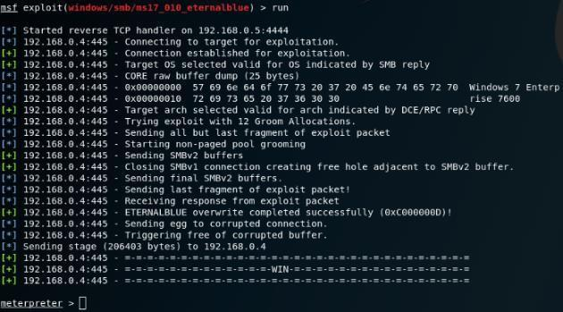

Figure 35. Execution of the exploit smb_ms17_010_eternalblue
Meterpreter offers different functions and tools to compromise the compromised machine. To find out the set of commands, you must ask with the ? sign, alone or accompanied by a keyword. Figure 36 lists some of Meterpreter's tools.
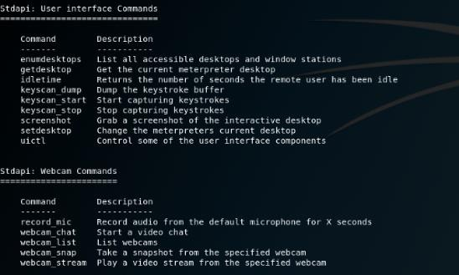

Figure 36. Function search for Meterpreter

After compromising the Windows 7 machine and establishing the session with Meterpreter, commands are used: sysinfo to find out system information, localtime to find out the time configuration, pwd to find out in which directory it is located and ls to list the contents of the current directory. Figure 37 shows control over the machine, as well as the current location and contents of the C:\windows\system32 directory.

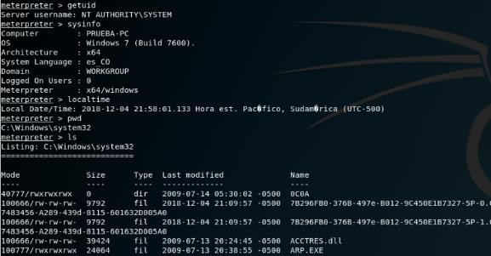

Figure 37. smb_ms17_010_eternalblue exploit configuration

For Keylogger and webcam access, the ps command is typed to list the active processes and the PID (Process Identifier) of the winlogon.exe application is identified. With this value, the migrate 500 command is typed to migrate the login process to the metainterpreter. Figure 37 shows the capture of keystrokes using the keyscan_start command and to see the captured characters, type the keyscan_dump command.

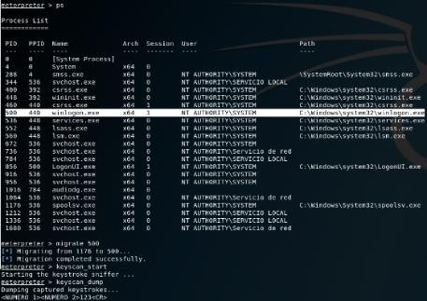

Figure 38. Capturing the login password

With the session enabled, Figure 39 identifies the PID of the explore.exe process through the ps command which on this occasion is 1996, however, this changes dynamically with each login. This system process will be used to capture keystrokes in applications running in the foreground of the operating system.

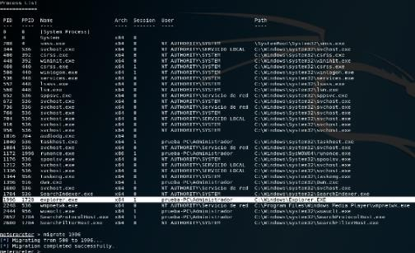

Figure 39. Process identification explorer.exe

With the configuration set up to capture keystrokes, the keystroke capture is started using the command migrate 1996, this allows to migrate the process from the Windows explorer to the metainterpreter, then keyscan_start is typed, which starts the keystroke capture

Why you recorded success or failure
At the end of this simulation on virtualisation of operating systems, use of ethical hacking tools to carry out computer attacks under a controlled environment and strategic planning of cybersecurity, it can be concluded that its development has contributed to assessing the state of information security at CPC. After performing the vulnerability assessment on the organisation's servers, gaps and weaknesses were identified in the configuration established for both servers. According to what was previously said, this document reflects the detailed step-by-step of how to generate a computer attack based on the vulnerabilities found. It also establishes the relevant procedures, policies and controls to prevent this type of intrusions, generating an improvement in the current state of the security of the assets compromised by the computer attack.

Recommended solutions for the threats discovered on the environment
After carrying out the corresponding tests on the compromised servers of CPC, it was possible to identify that the main vulnerability was related to failures in the configuration and obsolete versions at the level of applications and operating system. In accordance with this, a series of recommendations given below;

The configuration changes that could be made to the systems
Establish a policy to periodically back up files and configurations so that they can be restored in the event of an incident on the machine. This activity is performed weekly for the organisation's critical assets and on demand upon a user's prior request. In addition, it is recommended to purge unnecessary files such as temporary files, error reports and any other irrelevant information that takes up space on the machine's hard disk.

New software and hardware that might be bought
- The design and implementation of any security software that involves improving information security for an organisation requires a prior phase of analysis and theoretical knowledge about techniques, best practices and strategies to carry out an in-depth security approach.
- Implement an information security management system (ISMS), which serves as support to guarantee the pillars of information security for all processes that use the organisation's critical data. Protect information from different threats, vulnerabilities and risks associated with information assets. Activities: In the continuous improvement cycle, the following stages of implementing an ISMS are proposed:

- Plan: Establish the scope of the ISMS, define security policies, indicate the statement of applicability and perform the risk analysis.
- Do: Implement controls, define the risk treatment plan, and define cybersecurity metrics and contract security monitoring services.
- Verify: Evaluate the effectiveness of the ISMS, verify controls and security plans, as well as conduct related audits.
- Act: Make identified improvements, raise awareness among operational staff and continue the cycle of continuous improvement.

Defence strategy to avoid this type of attack succeeding in the future
- For equipment that is going to act as a server on the network, it is necessary to install a version of the operating system in accordance with the role that the machine is going to play on the network, and it is also suggested that all services and protocols that are not going to be used be deactivated, including the blocking of their corresponding ports from the perimeter equipment. On the servers, the firewall integrated in each of the machines should be configured and kept activated for private and public networks.

- To mitigate the impact generated by cyber-threats, it is necessary to know what they mean and how they work, and it is also evident that there are currently different types of attack vectors that need to be fully detected and identified for their subsequent management and/or treatment. Based on this, it is necessary to establish a periodic plan to carry out a vulnerability analysis and validate the current state of the configuration of the servers.

Cost of Solution

Cost of implementing

Table 2. Financial investment of each security project in GBP
Security project | Phase I 2024 | Phase II 2024 | Phase III 2025 | Total
ISMS | 500 | 600 | 1000 | 2100
Access to the information | 100 | 500 | - | 600
Secure transfer of information | 400 | 600 | - | 1000
Perimeter security | 500 | 350 | - | 850
Event monitoring security | 300 | 300 | 550 | 1150
DLP (Data Loss Protection) | 700 | 500 | 400 | 1600
Vulnerabilities | 900 | 900 | 900 | 2700
Continuity of the business | 1200 | 1000 | 900 | 3100
Awareness-raising | 1400 | 750 | 650 | 2800
Ethical hacking | 900 | 900 | 900 | 2700
Data protection personal | 5000 | 5000 | 3000 | 13000
Total | 11900 | 11400 | 8300 | 31600

Timetable for execution
The definition of the project implementation schedule is proposed for the next 3 years, for instance, 2024 - 2025, and is recorded in Table 3.

Table 3. Timeline of security execution
Project for security | 2024 | 2025 | 2026
ISMS | Design and implement the ISMS at the  organisation | ISMS audit process. | Certification of the ISMS.
Access to the  information | Assignment of permits and privileges. | Management of identities. | -
Secure transfer of information | Implement encryption techniques. | VPN implementation. | -
Perimeter security | Creation of rules. Acquisition from licensing. | Documentation of rules. | -
Security event monitoring | Acquire SOC services for security operations. | Modelling of use cases. | Renewing services of SOC operations in security.
DLP (Data Loss Protection) | Acquire a module of  DLP on the antivirus solution. | Notifications on ex-data breach. | Profiles from  DLP security in the UTM.
Vulnerability management | Acquire services management from vulnerabilities. Perform scan of vulnerabilities. | Perform vulnerability scanning and remediation. | Perform vulnerability scanning and remediation.
Continuity of the  business | Elaboration and design of the BIA and PRA. | Implementation of the DRP | Audit of the DRP.
Awareness-raising | Design the training plan.  Conduct awareness-raising campaigns and cybersecurity courses. | Conduct awareness-raising campaigns and training courses at cybersecurity. | Carrying out awareness-raising and training at  Cybersecurity.
Ethical hacking | Acquire services from Pen testing. Carry out safety tests every 6 months. | Perform safety tests every 6 months | Perform safety tests every 6 months
Protection of personal data | Design the personal data protection policy. | Implement relevant data management measures personal. | Evaluate the end handling of personal data.

References
[1]“Address: bc1qxy2kgdygjrsqtzq2n0yrf2493p83kkfjhx0wlh,” www.blockchain.com. https://www.blockchain.com/explorer/addresses/btc/bc1qxy2kgdygjrsqtzq2n0yrf2493p83kkfjhx0wlh (accessed Jan. 07, 2024).
[2]P. Paganini, “Four individuals charged for the recent Twitter Hack,” Security Affairs, Aug. 01, 2020. https://securityaffairs.com/106617/cyber-crime/twitter-hack-suspects.html (accessed Jan. 07, 2024).
[3]P. Paganini, “Twitter revealed that hackers accessed DM Inboxes in July attack,” Security Affairs, Jul. 24, 2020. https://securityaffairs.com/106285/social-networks/twitter-hackers-dm-inboxes.html (accessed Jan. 07, 2024).
[4]https://www.researchgate.net/publication/373262598_A_review_of_SolarWinds_attack_on_Orion_platform_using_persistent_threat_agents_anf_techniques_for_gaining_unauthorized_access
[5]https://cs.ucf.edu/~mohaisen/doc/teaching/cap5150/fall2022/cap5150-proj2.pdf
[6] Albrecht, M.R. and Jensen, R.B., 2020. The Vacuity of the Open Source Security Testing Methodology Manual. In Security Standardisation Research: 6th International Conference, SSR 2020, London, UK, November 30–December 1, 2020, Proceedings 6 (pp. 114-147). Springer International Publishing.

[7] Costa, R. and Serrão, C., 2015. Cloud Security Assessment: Practical Method for Organization’s Assets Migration to the Cloud. In Knowledge Discovery, Knowledge Engineering and Knowledge Management: 5th International Joint Conference, IC3K 2013, Vilamoura, Portugal, September 19-22, 2013. Revised Selected Papers 5 (pp. 411-423). Springer Berlin Heidelberg.

[8] Al Shebli, H.M.Z. and Beheshti, B.D., 2018, May. A study on penetration testing process and tools. In 2018 IEEE Long Island Systems, Applications and Technology Conference (LISAT) (pp. 1-7). IEEE.

[9] Shravan, K., Neha, B. and Pawan, B., 2014. Penetration Testing: A Review. Compusoft, 3(4), p.752.

[10] Galata, L. and Korniyenko, B., 2018, December. Research of the training ground for the protection of critical information resources by iRisk method. In International Conference of Students, PhD Students and Young Scientists" Engineer of the XXI Century" (pp. 227-237). Cham: Springer International Publishing.

[11] Fujimoto, M., Matsuda, W. and Mitsunaga, T., 2019, November. Detecting attacks leveraging vulnerabilities fixed in MS17-010 from Event Log. In 2019 IEEE Conference on Application, Information and Network Security (AINS) (pp. 42-47). IEEE.

[12] Chhillar, K. and Shrivastava, S., 2021. Vulnerability Scanning of University Computer Network Using Zenmap. Indian Journal of Computer Science, 6(6), pp.8-18.

[13] Tundis, A., Mazurczyk, W. and Mühlhäuser, M., 2018, August. A review of network vulnerabilities scanning tools: types, capabilities and functioning. In Proceedings of the 13th international conference on availability, reliability and security (pp. 1-10).

[14] Ndatinya, V., Xiao, Z., Manepalli, V.R., Meng, K. and Xiao, Y., 2015. Network forensics analysis using Wireshark. International Journal of Security and Networks, 10(2), pp.91-106.

[15] Messier, R. and Messier, R., 2016. Exploitation. Penetration Testing Basics: A Quick-Start Guide to Breaking into Systems, pp.55-78.

[16] Shi, H., Mirkovic, J. and Alwabel, A., 2017. Handling anti-virtual machine techniques in malicious software. ACM Transactions on Privacy and Security (TOPS), 21(1), pp.1-31.

[17] Visoottiviseth, V. and Moonkhaen, V., 2023, March. A Centralized System for Detecting Attacks from Windows Event Logs. In 2023 International Electrical Engineering Congress (iEECON) (pp. 367-371). IEEE.

