

Human Capital Management

Student Name: Vijaysinh Shaktisinh Zala
Student ID: 2330740
Module Code: LCMB7023
Module: Human Capital Management
Lecturer: Nishi Ramsurrun

Executive Summary
Human resource management is one of the most useful aspects that are beneficial for the improvement of the healthcare industry in the UK. The main focus of this report is to develop understanding about the current issues in the UK healthcare industry related to the NHS. The National Health Service (NHS) sector in the UK has been renowned as one of the largest healthcare service providers across the globe by providing their immense quality services to the patients. The report has structured the main issues of the NHS UK such as the labour shortage and poor employee motivation in the organisation along with lack of funding by shareholders.
Table of Contents
Component 1: Report 3
1. Introduction 3
2. Heading 1: Current Challenges in the NHS 3
3. Heading 2: Key issues in estimating internal and external supply of human resources 5
4. Position Analysis for Doctors in NHS 9
5. Conclusion 13
Reference List 14

Component 1: Report

1. Introduction
Human resource capital is one of the most concerned issues that are beneficial for increasing organisational capabilities. The report has significantly focused on the internal and external HRM issues of the NHS UK including the negative effects of Covid-19 on its patient care and employee shortage. A position analysis for doctors has also been evaluated in this report that is beneficial for mitigating the identified issues successfully. Accordingly, the purpose of this report is to focus on organisational enhancement in the NHS UK based on mitigating the current challenges of the organisation.

2. Heading 1: Current Challenges in the NHS
Lack of Funding
Lack of funding in the healthcare services from the private investors and the governmental sectors as well can decrease the service quality and patient care opportunities as well. As per Figure 1, the funding in the NHS UK has been consecutively decreased since the year 2020 which has reached at the amount of 186 billion British pounds in the year 2024 (Statista, 2023). Hence, it can be determined that the organisational mangers are needed to focus on the investment aspects to provide better quality care to the patients.
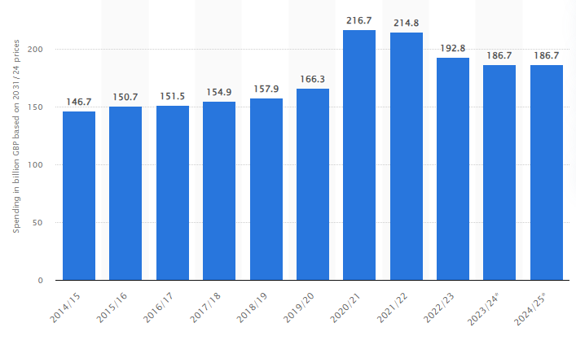
Figure 1: Funding in NHS UK by Private Investors and UK Government
(Source: Statista, 2023)
Shortage of Staff
The pandemic has affected the employee count and employee engagement rate of the NHS UK negatively due to the heavy work pressure. As per Figure 2, it has been seen that the employee count of the NHS UK has been decreased in the count of 32000 in the year 2020 which is lesser than the count of 34000 in the previous year (Statista, 2024). The figure has also shown that the public healthcare sector of the UK has been facing issues regarding their labour shortage simultaneously within the consistent 10 years. Hence, it can be determined that the poor HR practices and lack of ability to retain the employees is one of the significant and consistent challenge of NHS UK.
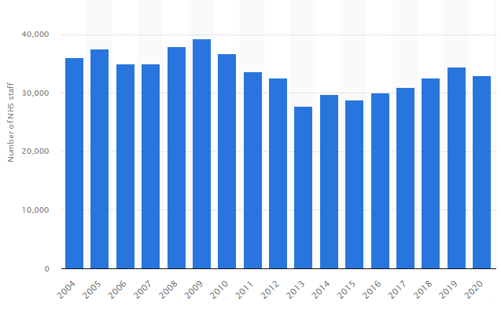
Figure 2: Annual number of National Health Service Senior Managers and Managing Staff in England
(Source: Statista, 2024)
Staff Burnout due to High Volume of Work
Employee motivation is a great deal for the human resource managers that can bring business success and higher service quality for the patients in healthcare sectors. Since the year 2020, the employee motivation of the NHS UK has been simultaneously decreased and reached in the rate of 66.9% in the year 2022 (Statista, 2024). In this regard, Figure 3 suggests that the emergence of employee motivation is consecutively getting low for the NHS UK since the pandemic year of 2020.
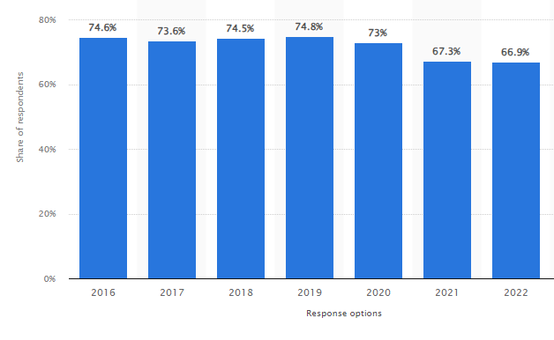
Figure 3: Levels of Enthusiasm at Work among NHS Staff in the UK
(Source: Statista, 2024)

3. Heading 2: Key issues in estimating internal and external supply of human resources
3.1 Key internal issues
Long working hours
Healthcare professionals face exhaustion from too much working pressure which is mainly related to long working hour schemes. Apart from allotted time of working these healthcare professionals have to work in additional shifts and do not have proper shifting hours. Sometimes it becomes too difficult for doctors and nurses to manage a balance between professional and personal life. As per the regards of the British Medical Association, NHS staff hiring stands at a critical situation owing to insufficient investment in training new staff, inadequate workforce planning, and inconsistency in government support. The study also shows England situated at a most vulnerable situation owing to 3.5 doctors per 1000 inhabitants (Bma, 2021). Long working hours, lack of additional support from the government as rewards are significant reasons for the large number of resignations of the health care professionals.
Poor pay scheme
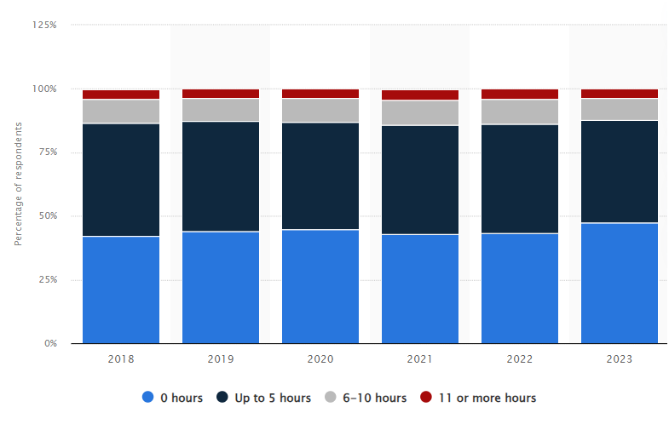
Figure 4: Average weekly unpaid overtime worked by healthcare professionals of NHS England Staff
(Source: Statista, 2024)
Payment scheme of NHS is not sufficient as per the working hours is one of the most significant reasons for resignation of healthcare practitioners in NHS England. The report of Statista on an average 40% of the NHS staff have to work additional 5 hours every week for which they do not get paid (Statista, 2024). Other than this, 8.71% of the NHS staff has to work 6 to 10 hours and 3.46% of the staff work more than 11 hours every week for which they won't get paid. Long time working schedule, poor payment schemes along with unpaid working hours every week causes working exhaustion for the doctor. Therefore, the government has to update the payment matrix of doctors and allot sufficient charges according to dint of effort in order to ensure retention of healthcare practitioners in the NHS to mitigate lack of funding issue.
Lack of motivation towards staff
Employee motivation is the key for every successful practice which ensures long term retention. The job role of a healthcare professional becomes too serious as it is associated with a life. Due to lack of sufficient motivation from higher up authority’s resignation rate of employees gets increased. The healthcare practitioners do not get praised for their serious contribution and often get subjected to vulnerable situations for non-intentional mistakes (Aini and Dzakiyullah, 2024). Due to lack of motivation from higher up authorities, insufficient appraisal, limited career growth opportunities, increasing job burn outs the rate of termination for healthcare professionals has increased in the NHS.
3.2 Key external issues
The current issues of staff shortage in the NHS and staff burnout are affecting the external work environment of the organisation along with the internal work process. Poor recruitment and selection procedures are one of the main reasons for staff shortage and employee burnout. In the 1st quarter of 2023/2024 NHS had the vacancy of 43,339 nurses and 71,378 vacancies for other staff (Statista, 2024). Regarding this, the organisation is facing issues in its talent management process and ensuring to provide a better service to the people. The number of vacancies in the NHS is increasing over the years which are causing staff shortage in the organisation. Talent pool in the organisational background is the collection of a database of professionals which outline the available expertise and available candidates for the job (Abioro et al., 2020). In the external recruitment process of the NHS the talent pool management system can provide a clear insight to the company to identify the available expertise and the number it requires recruiting.
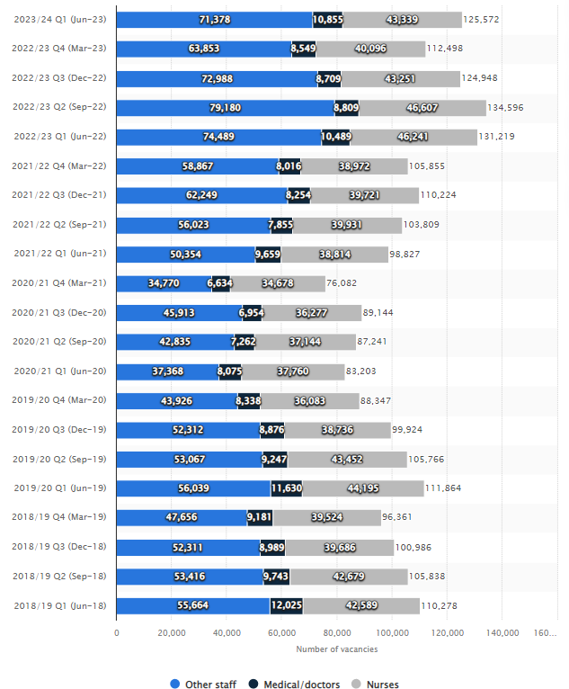
Figure 5: Number of vacancies in the NHS workforce in England
(Source: Statista, 2024)
The financing issues of the NHS after the COVID-19 due to limited findings and increased budget-cost are affecting the external work facilities. England’s health spending has faced a cut of 1.2% which is worth £2 billion in the new financial year (Theguardian, 2024). Due to this, the NHS health budget has been limited to £166.2 billion in 2024-2025 from the amount of £168.2 billion in the previous financial year. Regarding this, the NHS has faced issues in its talent pool management and maintaining technical advancement to support the work-life balance. Lack of funding in the skill development of employees and providing them the required facilities is causing employee burnout with the increasing workload.
External recruitment in the NHS can allow individual expertise and increase diversity in the team. Political restrictions and influences in the NHS operate the policies or strategies of hospital services (NHS, 2024). The involvement of political power in the NHS creates difficulties for the healthcare professionals to work independently and represent the values of the NHS. External recruitment processes in the organisation provide benefits to manage the talent pool, increase diversity and promote inclusivity in the workforce (Morfaki and Morfaki, 2022). As staff shortage and lack of job satisfaction in the NHS have become a prior issue to control the staff shortage, external recruitment in the NHS can meet the vacancy gap. The organisation can take action to hire employees from distant locations of England to enrich its talent pool and improve the work standards.
Corporate social responsibility is also a main concern in external recruitment as it promotes diversity and inclusivity in the workplace. The practice of external recruitment provides scope to hire employees from different locations and demographics based on their skills and experiences in promoting diversity (Rosales et al., 2023). In developing a diversified workplace and managing the talent pool, hiring employees from diversified areas, NHS can get the opportunity of including experienced members. The staff shortage issue in the NHS creates difficulties for the organisation to manage the increasing workload and provide quality of services to the people. Hence, promoting external recruitment the organisation can take active action to employ experienced members in the team to support its increasing workload and provide better care to the patients.

4. Position Analysis for Doctors in NHS
Skills
The major skills within the doctors in NHS UK are needed as the teamwork capability and communication along with adaptability of digitalisation. Teamwork among the doctors has also been beneficial in the UK NHS due to better communication among the staff and the patients. In the view of Anderson et al. (2021) an annual growth of 2.4% in the workforce has been evidenced in the UK that has been useful for developing the current situation of doctors in the organisation. Apart from this, rewarding the staff for medical achievements has been useful for the organisation to develop human capital management in the organisation. On the contrary, Aiken et al. (2021) have mentioned that 85% of professional nurses and midwives have started to work for the betterment of healthcare infrastructure in the NHS. Due to this, the healthcare organisation has been facing better growth along with active participation from the healthcare professionals.
Understanding of the issues of the patients in the UK healthcare field can be possible by the initiation of better communication with the patients. In the current situation, patient experience in the UK shows that “Patients, public and people with lived experience (PPPLE)” have increased to a great extent along with developing patient safety methods (North Tees and Hartlepool NHS Foundation Trust, 2023). Due to this, active participation in the UK healthcare industry is expected to be enhanced along with interacting with the patients.
Pay and Working Condition
Currently, the NHS doctors have been focusing on promoting better health care programmes for patients due to the issue of “Chronic staff shortage”. As depicted by the senior NHS doctors, the cancer unit of the NHS have been working on developing treatment for patients as the number of the care seekers have been increasing (NHS struggling to provide safe cancer care, say senior doctors, 2023). Considering the factors, implementation of advice from the senior doctors is required for the NHS. The basic salary of a specified doctor or surgeon in NHS UK has been shown to be £59,175 to £95,400 in recent years (NHS, 2024). The doctors in the NHS can try to communicate with the hierarchy such as the UK government to provide more beds and modern digital equipment for cancer treatment. Considering this, doctor’s positioning in the NHS UK might be developed in healthcare governance.
Job Description
Different job descriptions of NHS doctors in the UK include diagnosing, managing, and preventing disease with utmost care. It is seen in the NHS that emergency medical care units in the NHS often work for “Accident & Emergency (A&E)” patients through communication and execution is also based on the communication process (NHS, 2020). Considering this, it is assessed that doctors in the NHS are currently focusing on interacting with the patients based on individual issues. The role of doctors in maintaining public health in the NHS also includes the usage of “NHS Commissioning Board”, communicating with local and regional authorities outside the NHS (Steele, 2024). This process is expected to be useful for doctors in the NHS in securing the position of healthcare practitioners.
Shared value is one of the core capabilities that have been adopted by the NHS doctors in order to make development in the UK healthcare industry. For example, the aim of “Make every contact count” built by the NHS include regular communication with care seekers as doctors in the NHS see more than 800,000 patients every day (Steele, 2024). The core values of NHS doctors include “Working together for patients, showing respect to patients, Commitment for care, compassion, and improving lives” (NHS England, 2024). Concerning the identified values, the position for doctors can be defined as guides for case seekers in the UK.
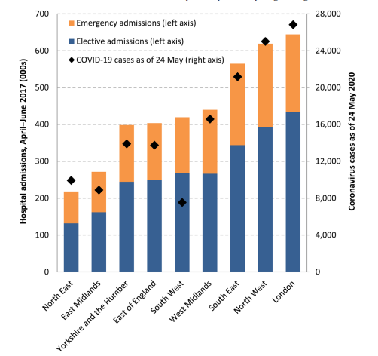
Figure 6: Disruption in the NHS due to significant enhancement of the Global Pandemic
(Source: Propper, Stoye and Zaranko, 2020)
The implication of “5A’s behaviour change model” in healthcare can be considered useful for enhancing position competencies for doctors in the UK. Position of the doctors can also be enhanced due to active participation in assisting and advising the patients. As mentioned by Propper, Stoye and Zaranko (2020) after the global pandemic, the human capital at the NHS have faced issues such as delays and disrupted treatments. The above mentioned figure shows that the disruption in required treatment for care seekers have increased due to lack of beds and poor healthcare infrastructure. Keeping this in concern, “Advice” from the doctors and “Assistance” from healthcare professionals are expected to be required. Consequently, the positioning factor of the NHS doctors can also be increased due to active participation of them in the hospital infrastructure.
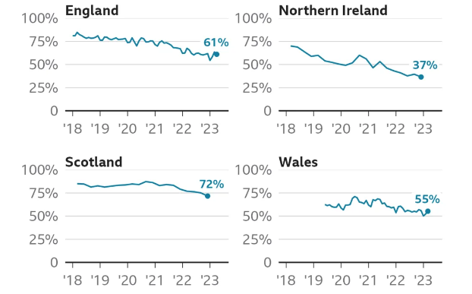
Figure 7: Poor Treatment of Patients in the NHS
(Source: NHS struggling to provide safe cancer care, say senior doctors, 2023)
Person Specification
Assistance of doctors in order to positively influence the doctors is also an influential factor for securing the specification of the caregivers in the UK healthcare industry using person specification factor. It is seen in the UK that NHS doctors have been able to promote new ways to work in primary care for care seekers. The new primary care processes include “Klinik workflow system” that relates to the creation of an online triage named “PrioryCARE” (NHS, 2024). This application includes identification of the most appropriate clinical for every individual patient based on his or her health condition. Regarding this, advice from the NHS doctors for patients is expected to be enhanced in the long run. For example, “Technology Integrated Health Management (TIHM)” has been included in the NHS infrastructure with the active participation of the HRM department (Term, 2023). This technological advancement has been helpful for the organisation to monitor the health of people diagnosed with dementia in home. Showing an in-depth concern for the patients has been expected to be useful for developing the position of the doctors.

5. Conclusion
Lack of employee motivation and staff burnout in the NHS UK has been one of the main issues in poor organisation development and lack of human capital management. Some of the current issues faced by the organisation include poor enthusiasm among employees and lack of funding in the NHS UK. Apart from this, the implication of position analysis for the NHS doctors has also been depicted in this report that has been useful for analysing the current situation of the doctors. In conclusion, regular communication with the medical staff and enhancing the wellbeing factor of the workers are beneficial for increasing the human capital management process for employees.

Reference List
Abioro, M.A., Olabisi, J., Onigbinde, I.O. and Adedeji, A.M., (2020). Skill mapping, talent pool management and organisational development: Evidence from professional bodies in Nigeria. Economics and Business, [online] 34(1), pp.46-59. Available at: https://doi.org/10.2478/eb-2020-0004.
Aiken, L.H., Sloane, D.M., Ball, J., Bruyneel, L., Rafferty, A.M. and Griffiths, P. (2021). Patient Satisfaction with Hospital Care and Nurses in England: an Observational Study. BMJ Open, [online] 8(1). Available at: doi:https://doi.org/10.1136/bmjopen-2017-019189.
Aini, Q. and Dzakiyullah, N.R., (2024). Leadership Styles in healthcare settings for Hospital Management and Employee Engagement. Journal of Angiotherapy, [online] 8(5), pp.1-7. https://publishing.emanresearch.org/CurrentIssuePDF/EmanPublisher_1_5445angiotherapy-859697.pdf
Anderson, M., O’Neill, C., Macleod Clark, J., Street, A., Woods, M., Johnston-Webber, C., Charlesworth, A., Whyte, M., Foster, M., Majeed, A., Pitchforth, E., Mossialos, E., Asaria, M. and McGuire, A. (2021). Securing a sustainable and fit-for-purpose UK health and care workforce.The Lancet, [online] 397(10288), pp.1992–2011. Available at: doi:https://doi.org/10.1016/s0140-6736(21)00231-2.
Bma. (2021). NHS medical staffing data analysis. [online] Available at: https://www.bma.org.uk/advice-and-support/nhs-delivery-and-workforce/workforce/nhs-medical-staffing-data-analysis
Morfaki, C. and Morfaki, A., (2022). Managing Workforce Diversity and Inclusion: A Critical Review and Future Directions. International Journal of Organizational Leadership, [online] 11(4). Available at: http://journals.cikd.ca/article_60656_946d1a0c293a68d54552ca1f3732e1bb.pdf.
NHS (2020).Roles for Doctors. [online] Available at: https://www.healthcareers.nhs.uk/explore-roles/doctors/roles-doctors.
NHS (2024) Pay for doctors, Health Careers. [online] Available at: https://www.healthcareers.nhs.uk/explore-roles/doctors/pay-doctors.
NHS england (2024). NHS England and NHS Improvement North West» Our Values. [online] Available at: https://www.england.nhs.uk/north-west/north-west-coast-strategic-clinical-networks/about-us/our-values/.
NHS struggling to provide safe cancer care, say senior doctors. (2023). [online] 8 Jun. Available at: https://www.bbc.com/news/health-65764755.
NHS, (2024). Pre-election guidance for NHS organisations – General Election 2024. [online] Available at: https://www.england.nhs.uk/long-read/pre-election-guidance-for-nhs-organisations-general-election-2024/.
NHS. (2024).NHS England» How new ways of working in primary care are boosting patient experiences in York. [online] Available at: https://www.england.nhs.uk/gp/case-studies/how-new-ways-of-working-in-primary-care-are-boosting-patient-experiences-in-york/.
North Tees and Hartlepool NHS Foundation Trust.(2023). Patient experience and involvement report 2022 - 2023. [online] Available at: https://www.nth.nhs.uk/resources/patient-experience-and-involvement-report-2022-2023/.
Propper, C., Stoye, G. and Zaranko, B. (2020).The Wider Impacts of the Coronavirus Pandemic on the NHS *.Fiscal Studies, [online] 41(2). Available at:
Rosales, R., León, I.A. and León-Fuentes, A.L., (2023). Recommendations for recruitment and retention of a diverse workforce: A report from the field. Behavior Analysis in Practice, [online] 16(1), pp.346-361. Available at: https://doi.org/10.1007/s40617-022-00747-z.
Statista, (2023).NHS England resource spending in real terms in 2014/15 and forecast to 2024/25, based on 2023/24 prices. [online] Available at: https://www.statista.com/statistics/632289/nhs-england-health-spending-in-real-terms/
Statista, (2024). Average weekly unpaid overtime worked by NHS England staff 2018-2023. Available at: https://www.statista.com/statistics/883433/nhs-england-staff-working-extra-unpaid-hours/
Statista, (2024).Annual number of National Health Service senior managers and managing staff in England from 2004 to 2022. [online] Available at: https://www.statista.com/statistics/488819/england-nhs-qualified-managing-staff/
Statista. (2024). Number of vacancies in the NHS workforce in England from Q1 2018/19 to Q1 2023/24, by staff group. [online] Available at: https://www.statista.com/statistics/1269306/nhs-england-workforce-vacancies-by-staff-group/.
Statista.(2024). Enthusiasm at work of NHS staff England 2020. [online] Available at: https://www.statista.com/statistics/883005/enthusiasm-at-work-nhs-england/.
Steele, J. (2024). The NHS’s role in the public’s health A report from the NHS Future Forum Workstream members. [online] Available at: https://assets.publishing.service.gov.uk/media/5a7c9c8aed915d12ab4bbf41/dh_132114.pdf.
Term, L. (2023).Technology helps clinicians monitor the health of dementia patients in their homes. [online] Available at: https://www.longtermplan.nhs.uk/case-studies/technology-integrated-health-management/.
Theguardian, (2024). NHS funding faces biggest real-terms cuts since 1970s, warns IFS. [online] Available at: https://www.theguardian.com/uk-news/2024/mar/04/nhs-funding-faces-biggest-real-terms-cuts-since-1970s-warns-ifs.

