
APPENDIX GA36c

LEVEL 6 ASSESSMENT SPECIFICATION

Student name: | Ffion Fox | Student ID number: | 1502844
Programme: | Secondary PGCE Art & Design
Module: | Curriculum Development and Enhancement
Module code: | ECSP6004 | Contribution to Overall Module Assessment (%): | 100%
Lecturer: | Helen Denny | Internal Verifier:
Assignment Title: | Research Study including Ethics Form | Word count (or equivalent): | 10.000 words in total including an Ethics form (to be given in on January 11th 2019)
Submission deadline: | May 13th 2019 | Return date of provisional marks & written feedback: | June 10th 2019
Submission method: | All written assessments, where practical and possible, must be submitted via Turnitin unless otherwise instructed by the Lecturer. (Please DO NOT put this assessment specification into Turnitin or it will match many similarities with other students’ submissions.)  Alternative submission method (if applicable):  Late submission of the assessment will result in a late penalty mark. Penalties for late submission: Up to one week late, maximum mark of 40%. Over one week late, 0%. Only the Extenuating Circumstances Panel may approve a change to submission dates.
Academic honesty / referencing: | Academic honesty is required. In the main body of your submission you must give credit to authors on whose research and ideas your work is based. Append to your submission a reference list that indicates the books, articles, etc. that you have used, cited or quoted in order to complete this assessment.

Context Page
Introduction 3
Literature Review 4 - 9
School Policy and Practice 10 - 11
Methodology & Ethics 12 - 15
Evaluation 16 - 19
Conclusion 20 - 21
Limitations and Future Development 22 - 23
Appendices
Bibliography

Introduction
School X is an 11 – 16 English medium, co-educational community secondary school that is maintained by the local authority. The school is located within two catchment areas which are target areas of ‘community first’ disadvantaged areas as well as contrasting prosperous areas. From the latest ESTYN report in 2017, there were 464 pupils within School X, a 120 decrease from the ESTYN inspection in 2010. Regarding statistical data, approximately 29% of pupils in School X are eligible for free school meals.
The purpose of the research being conducted was to investigate if there is a link between music enhancing creativity and focus within art. This was to be focused within a mixed ability year 8 class, whom are studying portraiture, their task is to produce a realistic and abstract portrait of themselves. The study will not have a pre-test, intervention and post-test but will be split into three sections. The first part of the study will be a standard normal classes with no changes to what they are used to, this is to have a base background of the pupil of how they would normally act within the art lessons. This gives a comparable result to rely back to after the rest of the study has been conducted to see pupil’s development. The second part of the study is the second lesson where the lesson will have classical and baroque music playing. The third and final parts of the study pupils have the choice of their own music to be played in the class. During the lesson of the study, when the music is being played it will only be displayed whilst pupils are completing their main task. To know if pupils have achieved a level of creativity and focus they will be marked on a scale from 1-5; 1 being the lowest creativity and focus and 5 being the highest. The results will be recorded after every lesson in the exact same process; these then will be able to be compared with each other to provide a concluded result.

Literature Review
Creativity is a language in its own right, which can be identified by anyone, anywhere (Treffinger et al, 2002). The idea of creativity flows throughout everyone’s everyday life, it journeys from school to work and at home. Lubart and Sternberg (1999) suggested that creativity is the competence and ability to create work that is both original and appropriate. Creativity can be seen through an individual development such as everyday life skills such as problem solving, or at a wider communicative level where creativity is essential for a development in the future society such as a new art movement, new inventions and scientific findings (Sternberg, 1999). It is apparent that creativity is an economical importance, as it is required for future business, developments and ideas to move our technology and sense of living to be developed further.
It is suggested that there is a clear connection between creativity and learning, both ingest imagination and imitation, it is apparent that from the beginning of when individuals begin to talk and walk, imagination is needed to engage with the real world. As it suggested by Anna Craft (2005) that as the sense of creativity and learning are closely connected. Like Sternberg (1999) suggests, Craft also supports the idea of creativity being defined as originality and novelty and within that every day or democratic creativity, thing such as an idea or an action can be defined as creative in relation to an individual. As creativity could be enhanced through a way of expanding of what an individual already knows, understands and can do, which can be deemed as an aspect of learning (Craft, 2005).
At any age, when we learn we make the connection between an idea and breaking it down to make sense of it. We must use our imagination to construct these ideas and to map it out, this can be considered as creativity. It is suggested that the process of imagination is the most engaged mind-set and space we could be in (Craft, 2005).
Early 20th century psychologist, Lev S. Vygotsky proposed that culture is the fundamental factor that affects the nature of cognitive process, therefore in his constructivism theory it’s stated that knowledge should then lead onto further cognitive development. The societal arrangement of insight expresses that the individual development could not be understood without sign to the societal and social setting where the previously mentioned advancement is settled at the top of the priority list improvement is constant. Regarding Vygotsky constructive theory, he focused upon the actual mechanism of development; he disregards obvious stages of development as proposed theories. His constructive theory suggested that there couldn’t be just one factor or characteristic that will explain the cognitive development but a collection of data. As in discussion of constructivism, Piaget argued that knowledge is the psychological outcome of a conscious mind reasoning of social activity. In the mid-late 20th century, Jean Piaget expresses that there are 4 core operational stage and formal operational stage.
He suggests that in the first stage –
The sensorimotor stage which the period from birth until 2 years old, within this time infants see the world through movements and sensations. Their knowledge begins with learning about the world through basic actions and key development skills such as sucking, grasping, looking and listening. They begin to identify existence of objects and the stability of specific objects; this leads on to being able to categorise the difference between objects and human beings. Towards the end of the sensorimotor stage, they recognise that their movements can cause something to happen; they begin to have an idea of their own existence by starting to attach names and words to objects and to people.
Piaget suggests that in the second stage –
From the age of 2 to 7 years old, children enter the preoperational stage. This stage allows them to think symbolically, learn to connect words and pictures to represent an object yet struggle to visual things from others perspective as they tend to become egocentric. During the second stage they start to better their language and thinking but their thinking about things in a concrete styled way. At this point, children still learn though play but can often struggle with logic and constancy.
He suggests that in the third stage –
The concrete operational stage is from ages 7 to 11 years old, during this time, children tend to begin to logically think about concrete events, understand concept of how a conversation works and perception improves. As developing to become more organised and logical, they also continue to be very concrete and literal in their thought process. During the concrete operational stage, although their thinking and logical develops further it can still be rigid and find it difficult to think in an abstract way or discuss hypothetical situations. From the previous stage of preoperational where they often become egocentric, during this new development stage that characteristic begins to disappear and start to develop empathy and judge a situation from another’s perspective, leading on from children recognising that their thoughts are their own and not everyone shares the same views and feelings.
Piaget suggests that in the fourth stage –
The fourth stage which is from the age 12 and up which is called the formal operational stage, is where the adolescent beings to expand their knowledge and can have an abstract thought trail and be involved in hypothetical concepts. As they become teenagers, they being to question by thinking about; morals and developing their own, philosophy and the world around us, ethics, social and political issues which enhances their abstract and hypothetical reasoning as well as knowledge. During this stage, they often become interested in a specific principle that they tend to investigate and start making decisions for themselves for the future.
Piaget expresses that children’s intellectual develop is not a quantitative process, suggesting that they do not add more information to their existing knowledge through their life, instead he suggests that there is a change in how they start to think as they get older. He believes that there is a gradual cognitive change that is seen through the 4 key stages. He believes that a child at 7 doesn’t have more information about the world as they did when they were 2, it is a change in the way they think about the world which is the fundamental change.
The same concept as Piaget’s theory can be questioned through is creativity born with us or is does it get developed through our lives as we get older. The everlasting argument of whether we are who we are through nature or nurture, the subject of are we born with creativity or do we develop our creative thinking has been in discussion for many years. In an article from The Guardian (David Cox, 2013), it suggests that every single person can learn how to be creative to some extent, although new research conducted indicates that the idea of creativity is born with us and is inheritable. In 2011 a neuroscientist Kenneth Heilman and his colleagues at the Department of Neurology and Neuroscience at Cornell University uncovered that ‘the brains of artistically creative individuals have a particular characteristic that may enhance creativity’. In biological terms the brain has two sections which is conjoined by a a group of fibres called the corpus callosum, research into the brains of creative influences professions such as writers, artists and musicians, here it was seen that the brains of those who are in the creative industry tend have a smaller corpus callosum. This suggests that biological those who have jobs seen as creative have the creativity embedded within them, suggested that the nature pathway is determined. On the other hand, In a talk in 2014, Ken Robinson suggest that creativity itself is not something that can be learnt, but the process of it can be learnt therefore creativity can be developed and in some way be learnt.
In addition to music enhancing creativity and attaining focus, it is a well-known tale that music can helps memory whilst studying. To support this idea of this, The Florida National University provided students with an article in 2013 regarding the benefits of studying whilst listening to music, this article encouraged their students to listen to music whilst they revise for an exam or in need of completing work. The studies that they have conducted suggest that music can produce positive effects on the human’s brain; this has proven to ease stress, reduce anxiety and improve performance. In a 2007 Stanford study, it was discovered that rather than music being a distraction to students, it gets the brain moving and encourages the brain to switch on and pay attention. To measure their research, Stanford University researchers used music which was composed from the 1800’s in their study, from this they found that the classical music helped college students to pay more attention and attain it as well as enhancing their memory (Baker, 2007). It is believed by listening to their preferred music choice was more influential on the brain and work was completed to a higher standard (Baker, 2007). The concept of particular music encourages the brain to work in different ways is interesting as every person has their own taste of music and how that affects others who may not like that style.
In a pilot study conducted by The Department of Occupational Theory in the College of Medicine, Taiwan in 2009 to investigate whether there is a link between work concentration levels and background music. In this study their pre-test was an attention test which would then we revisited it after the experiment, this then was to gain an understanding of the possible influences of music being played in the background to influence participant’s concentration and focus whilst completing work. There were 32 college students divided into three controlled groups which all completed the pre-test which was complete to give an indication regarding their attention levels. The reasoning behind grouping was to be able to compare different working environments to see what the outcome would be regarding their attention. Group 1 were to complete a test for 10 minutes whilst having music on in the background, Group 2 had no background music whatsoever whilst completing their 10-minute test, and Group 3 listened to background music prior to their 10-minute test then the test environment was noise free. From this the mean was calculated from each study group, it was concluded that in comparison with group 2 who listened to no music whatsoever, and with those listened to prior to the test in group 3 had a higher score in regards to attentiveness, suggesting that it was an effect from the music. Whereas those in group 1 who listened to music throughout their test proved to a range of different scores. They propose that background music has have effects on participants work performances on different levels.
From my reading I have investigated different methods I could use in my study, I propose that instead of having a pre-test, intervention and a post-test, I will effectively have two trails which will compare the work completed over three lessons. The first lesson is to conduct like a normal lesson with no music to have an idea of what standard they would usually be working at. During the second lesson, the classroom will have classical and baroque music played in the background, which has no words just instrumental music so no words can influence them, as well from other studies such as the Baker study have proven that classical music enhances brain movement and performance. For the last lesson, pupils will have free range of what music gets played within the classroom. They will all have an opportunity to play whatever style of music they would like; therefore in the lesson there would be a range of music being played within that lesson due to personal preference. I will be measuring the pupil's creativity; do they think of any original ideas? Do they have fluency in their work? Is there flexibility within their work? Can they elaboration their work? Within this study their attention and how attentive they are.
Within the scheme of work the theme is portraiture, the main task, which will be spread over 6-8 weeks of lessons, is to create an abstract portrait of them. One influential artist they have been investigating is Lucy Jane whom is a new Welsh contemporary artist who creates female portraits in an abstract style using bright colours and collage works. The other artist they have been getting inspiration from is Henri Matisse who uses the mixture of realistic and abstract portraits. Pupils would take inspiration of these artists and apply techniques to their work, to create an abstract self-portrait.

School Policy and Practice
Within School X, their policy throughout the whole school is that pupils should not have a phone nor should be used within lessons. This results in pupils not being able to listen to music through headphones or earphones when independent learning/working. It is understandable that during lessons that whilst the lesson is being taught the policy is put in place for that reason. Consequently, the use phones can be a disruption within lessons and school life as they may be spending too long on their phone and unnecessarily off task. From observational visits to the school, pupils did have phones on them throughout the lessons and on breaks; they also listened to music with earphones and air-pods. Pupils know and understand the rules and if caught using the phone by teachers they get a warning, and possibly a detention. If a senior member of staff catches pupils usually, they would have their phone taken off them and they would need to get their parents to come and collect it from the office. As a result of pupils not being allowed to listen to music, does this mean that similarly in the 2009 Taiwan study, the group where they listened to no music performed worse in their test and paid less attention. If this is the case for all then would this mean that pupils within school X may not be achieve to their full potential. If not all aspects of learning and techniques are explored, are we failing the education system and pupil’s potential to have full access to their education?
From my readings and research, many case studies indicate that there is a clear link between music and focus and suggested that there is a link between music and creativity. Similarly like the Taiwan study, my study will have 2 of the 3 classroom environments; no music and with classical and baroque music, but the third lesson will allow the pupils to choose their own music. The order of the lessons will begin with a silent environment as there will be no music played within the classroom, meaning this is a normal condition classroom for the pupils. The second lesson will involve classical and baroque music from Beethoven, Mozart and Handel to be played in the background whilst pupils complete their work, pupils will complete their starter activity without music as well having their instructions for their task without any music, as soon as pupils have their set task music will be played. The third and final lesson will be completed in the same style of lesson 2 but instead of classical and baroque music to be played, pupils will have a choice of what they would like to listen to. In lesson three, as pupils have their own free choice of music, this could result in a range of different genres to be played and listened to. The interesting factor of, if a range of different genre of music is being played; does this then effect their progress or subject of work? Does it change their mood? If changing their mood, would their work dynamic differ? Does their sub consciousness play a part in this?

Methodology & Ethics
In light of my literature of creativity and focus I have been able to outline the methods that will be used within my study in order to answer my proposed questions and research. Due to researching into case studies conducted by the Florida National University, Stanford University and College of Medicine, Taiwan have allowed me to establish a clear link and plan for my research.
From investigating into these I have been able to determine the methods of my study, the first lesson will be a standard lesson in which the subject is portraiture, more specifically self-portraits in an abstract light, in this lesson pupils will have no music played and will be taught in normal learning conditions. By having the first lesson with no music is allows myself to compare, as when I change something within the lesson, I will be able to see how pupils may act differently or how their work may be affected. Within the second lesson pupils will begin to listen to classical and baroque music as it has been suggested in 2007 Stanford University study that by listening to classical music whilst pupils complete work it has an impact on their focus and attainment.
It has also been suggested that it can improve their creativity, which has been proposed, by Simone Ritter and Sam Ferguson that explores the idea that music is a source of creativity. It has been shown that music improves cognition and can enhance the way of learning and better memory in other studies, this study by Ritter and Ferguson attempt to make sense of a link that music can have an impact on creativity thinking as well. Through this study, the participants had creative activities which were to measure the divergent or convergent thinking whilst completing their task five different environments; in the controlled room, which was silent, or with classical music which represented four core emotional states; happy, sad, calm or and anxious. In deliberation of the experiment whilst comparing the performance of the participants, researchers discovered that those who listened to happy music whilst completing their activities had a considerably higher score on divergent thinking than those within the silent working conditions. It is shown that in the room playing happy music, the participants level of divergent thinking was much more advanced than those working quietly, it was seen that the ideas of the participants were more creative and innovative; the other styles of music did not have the same impact as this. The authors – Ritter and Ferguson suggest that the results indicate that when listening to positive music will enhance the level of divergent thinking. From this study, they question whether the participants enjoyed the music that they listened to links to a the performance of the work, they concluded with that it had no impact whether they liked the music or not, their level of creativity and innovation was enhanced by the music even though they may not have enjoyed that style of music. In view of convergent thinking and getting the correct answer to closed questioning, from all five groups none had an impact on their thinking. The authors’ write;
“The increase in divergent but not convergent thinking after listening to happy music may be explained by the fact that convergent task rely less on fluency and flexibility, but on finding one correct answer.”
As happiness is categorised as a positive and optimistic emotion it can realise endorphins which then broadens our mind-set and enhances our development of our desire of exploration and play, according Barbara Fredrickson. Researcher, Fredrickson suggests the link between positive mood and creativity, indicating that the underlying benefits of listening to happy and has a mass of effects on performance, creativity and focus.
The reasoning behind investigating these methods of case studies is due to the similarity between those studies and the one that will be conducted for this assignment. Understanding what other studies have done and how they have used the study to suggest a link between music and creativity as well as music and attentiveness. To have an original study that has not been conducted in the past, putting research into these case studies is vital to ensure the same study is not repeated nor too similar.
The benefits of the study are to promote an effective, contemporary method of creative thinking, learning and attaining focus. For the participants it should be an exciting time for them where they are able to listen to music whilst they complete work instead of constantly being in quiet working conditions. In the second lesson of the study, where participants who are the pupils, will be listening to classical and baroque music; this modern-day society, the dominant audience for classical and baroque music is the age range of 50+, more of the older generation. The issue could be that the pupils get bored or irritated with the music therefore get distracted from their work in a negative form. Classical music has been proven to enhance studying and performances within schools and colleges, this is a main factor why this study will use classical and baroque music within the lesson. As participants are able to choose their own music in the final part of the study, the limitations could be their choice of music, this can be seen as an advantage as they get their enjoyment out of it, although it can also be seen as a disadvantage as not everyone by like the music and create a fuss or may be a distraction for some participants.
Regarding the ethics for this study, The UWTSD Code of Ethics allows us to have a guideline of how to go about it properly. For the procedure for this study to go ahead ethically, the research should be honest, rigour, transparent and open to communication, has care and respect for all participants. Principles for the study is to be; beneficial therefore is positive and does well, not malfeasance and causes no harm. The study must protect the participants with their interests and rights, following this all risks or potential harm to participants and researcher needs to be avoided, having health and safety put in place can prevent. Whilst the study is being completed the consideration of the impact on others that the study could have, and the need of protecting if necessary.
To conduct the study as part of UWTSD, the participants which in this case is the pupils, need to be informed of the aims and procedures of the study and research, leading on to their permission to be involved in the study based on that honest information. As the participants are under the age of 16, the research would require parental consent, as part of a UWTSD partnership school parents are already informed that research may/will be conducted throughout the school year. It is vital that participants know their right to withdraw from the investigation and research at any stage- before, during or at the end of the study. To obey the Code of Ethics with UWTSD, this study must be fully confidential to all other than the researcher, and this information cannot be disclosed. In terms of requirements for the Data Protection Act, the study is kept in a secure form, and it shall be archived in an accessible yet secured manner for future audit purposes.
In recent publications, BERA: Ethical Guidelines for Educational Research, fourth edition (2018) also suggest that when guiding researchers on their studies, that participants taking part in the research could be the main focus of the study or could be involved passively in processes that are observational, experimental, auto/biographically reflected, survey or test. The study could be about the teacher’s way of teaching which would be the main focus of the study, other than the pupils response but the pupil’s response may be the only results.
BERA also outline that researchers have the responsibility to reflect on the most appropriate way of informing participants about the conclusions of the study that they were in involved in. It should be carefully planned out whether or how to discuss with the participants at the end of the research regarding the findings of the study. The researcher can offer participants a copy of any publications, which involves the study they were part of.

Evaluation
The study involved a year 8 mixed ability class of 26 but only 23 were a part of the study due to absences. The theme that the participants were working on was portraiture, more specifically self-portraiture in an abstract form; for this they were to take inspiration from two main focussed artists – Lucy Jane and Henri Matisse. From the linking artists, within pupil's work, similarity styles should be seen and being able to combine their ideas with the artist’s work to create a link between them. This theme was on-going for 6-8 weeks; therefore, the study was fully within the portraiture sector of the scheme of work.
The first lesson was conducted like any other lesson they have had; no music played in the lesson and they completed tasks in normal their working conditions. The starter activity was for them to start their thinking of features and different styles. The starter activity was 10 minutes; in this time they were to complete three worksheets with as many different styles of eyes, nose and lips. This activity was given to pupils for them to start a trial and error process of different techniques compared to what they are used to. The time limit is so that they do not think about it too much and overthink what they are drawing. The starter activity is quick to get the pupils brains alert and gets them ready for the main task. In research led by neuroscientists, indications that the human brain cannot multi-task when it comes to thinking meaning the brain can only think about one idea or thing at a time. When asking somebody a question, this forces his or her brains to focus only that question (Medina, 2014). Whilst the starter activity was being conducted question were read out and ideas were suggested to ensure pupils were considering other ways of completing their starter activity, this was done as Medina states the human mind cannot multi-task, therefore the questions were relevant to the task sheet that they were on for the reason of them focusing on that feature in more depth and with greater consideration. The main task for the lesson was to start an abstract self-portrait, for this the pupils were given plain A3 paper to start planning out their project, many pupils also required a pencil which was then provided by the researcher. Whilst the task was being completed, there were two resource sheets which featured images of the key artists the pupils have been looking – Lucy Jane and Henri Matisse. At the end of the lesson the researcher assessed the pupils on creativity and focus the scale from 1 to 5, 1 being the lowest and 5 being the highest. This lesson provided an initial analysis based on the pupils' level of creativity and focus, as this was a lesson like any other lesson. In the study, 17% of pupils achieved a level 1, 17% of pupils achieved a level 2, 30% of pupils achieved a level 3, 22% achieved a level 4 and finally 13% of pupils achieved a level 5. The majority of pupils achieved a level 3 in the result, making this the average score. [See Appendix]
In the second lesson, the starter activity was conducted as normal – with no music. For the starter, pupils had to work in pairs to complete a continuous line drawing portrait of each other. This activity was proposed to allow pupils to think about a new technique that they could consider using, also lets them think about proportion of features. Another reason for pupils to complete an activity of continuous line drawing was to allow them to think that it does not have necessarily look realistic, and that they would use this technique for their abstract portrait. After the instruction were given to the pupils of their main task; continue with your abstract self-portrait project, the researcher put a playlist on YouTube which featured famous pieces of music from classical and baroque composers; Beethoven, Mozart and Handel [See Appendix]. The music was played at a mid-level sound which allowed the pupils to still be louder if they wanted to be in their discussions. There was approximately 30 minutes for the pupils to complete the main task of continuing to process with their abstract portrait. At the beginning of the main task when the music was being played, most of the pupils in the class were complaining regarding the music for the reasons of not being their choice or style of music, or they found it boring and tiring. When the music was first displayed, pupils focused so much on a negative point about the music being played; it affected their process of work. This could be as it was different to what they are used to in terms of style of music but as well as it wasn’t like a normal lesson so the change of structure could have thrown them off. After a couple of minutes into the classical and baroque music, the room was suddenly silent as the majority started to complete their work and were focusing on what they were doing like they were in a world of their own. Throughout the lesson there were a few remarks regarding the music but overall the room was rather calm. There were few individuals who were completing very little or no works as well as are attempting to disrupt others from working. Within the main task many pupils started to think outside of the box and were thinking of new and original ideas. In relation to their creativity and focus, there was a shift within the levels from the initial analysation. The levels moved from 4 to 2 in level 1, from 4 to 7 in level 2, staying the same with 7 in level 3, from 5 to 4 in level 4 and staying the same with 3 in level 5. This has shown a better result in terms of less pupils in level 1 from initially recorded, which indicates that there has been an improvement with the classical and baroque musical being played whilst work is being completed. Although the level 4 and level 5 have decreased by 1, the level of work throughout the class over all improved and the atmosphere within the class appeared to be calmer and the overall standard was slightly raised [See Appendix].
Within the third and last lesson of this study for the starter activity there were three different A3 sheets of a variety portraits, the sheets were differentiated but the pupils needed to choose which sheet they wanted unaware that they were 3 different levels. The starter was completed in silence, and they had 10 minutes to write down and describe the portraits, whilst they were writing the researcher read out different questions to allow pupils to consider. During the main task, pupils were asked what music they would like on whilst they completed their abstract portrait. This allowed pupils to have freedom of what they listened to which could have gone two ways; one pupil find comfort in their chosen music and are relaxed therefore get on with their work, or distract the pupils meaning hyperactivity resulting in little or no work being completed. For the pupil's choice of music, the general choice was pop / chart music, this is modern music very different to the classical and baroque music they listened to previously in the second lesson. The music that was chosen to be played from artists such as Ed Sheeran, Ariana Grande, Post Malone as well as many other famous artists, as there was a variety of artists the songs are similar within the genre and style [See Appendix]. Within the classroom, there was hardly any talking although some pupils were quietly singing along but it did not seem to be a distraction to other pupils. As an overall observation, pupils were adding creativity streaks to their work, focusing hard on getting their work finished and to a high standard. There were a small handful of pupils were refusing to do work or when asked to complete the task they were off topic; these pupils would also attempt to be distracting and disruptive but luckily the majority of the class carried on working with their portraits. In comparison to the results of the level of creativity and focus from the classical and baroque music within level 1 they remained the same with 2, decreased from 7 to 2 in level 2, a slight increase from 7 to 9 in level 3, increasing from 4 to 5 in level 4 and from 3 to 5 in level 5. Overall in comparison from classical and baroque music to their chosen music, the mass majority of pupils worked much better in an environment with their own chosen music being played. Comparing their results from the initial analysation, the results show that; there has been a decrease from 4 to 2 in level 1, from 4 to 2 in level 2, an increase from 7 to 9 in level 3, remaining the same at 5 in level 4, and increased from 3 to 5 in level 5 [See Appendix]
Within this study, there is a definite link between music enhancing creativity and focus. There have been improvements from the initial analysation in both the classical and baroque music lesson as well as free choice lesson which can suggest that music does influence and effect environments. From the comparable results from the lesson with no music, indicates that this is not the most effective learning condition for pupils to learn in, and there are other techniques which can enhance the way of learning and that they need to be seriously considered such as listening to music whilst they learn.

Conclusion
In conclusion, there have been some clear indications that link music to enhancing creativity and attaining focus. The first part of the study showed poor results of creativity and focus, where pupils had a standard lesson with no music. This is the traditional way of teaching, which was evident through my observations of other subjects. Usually there is no music or even flexibility within the lesson to allow this technique. From my research, it was clear that many teachers believe that if the lesson is conducted in silences when the pupils must be getting on with their work and are achieving their full potential. Pupils need to have discussion within education to develop peer assessment and peer help, this will also aid their social skills. When pupils complete work in silence, teachers cannot assess their process and understanding of the task. From the study, it indicates that this traditional teaching technique is not the most effective or the most manageable. From the second lesson within the study there were slight improvements based on creativity skills. This was demonstrated through the student’s original ideas, artistic techniques and focus on the task. The results suggest that having classical or baroque music playing within lessons can enhance their focus and could work as a relaxation method. In general, the class were calmer than usual and the majority completed their work to a higher standard than normal. This proposes that classical or baroque music can have a positive effect on pupils’ progression with their work and their level of creativity and focus. It also supports the idea from the 2007 Stanford study which theorised that regardless whether participants enjoyed classical and baroque music or not, it still has a wealthy effect on their performance. Within the third part of the study, there was a great deal of improvement in creativity; this was seen through the originality of the pupil's ideas and the focus and determination of finishing the work. It was also noticed that it was easier to get their attention more effectively during the lesson when the music was paused. This could be down to an unspoken respect agreement where students are able to listen to music that they have chosen; they listen more attentively when spoken to. Based on the study, it could be suggested that music should be played within all lessons not just the arts to enable pupils to achieve their full potential.
As educators we must appreciate that all students learn in different ways, and different techniques help student reach their full potential. Education is continuously improving its teaching techniques along with technology developments and social enhancements.

Limitations and Future Development
From this study many thinks have been suggested, such as music enhancing creativity and focus more specifically personal choice music has worked ever so slightly better than classical and baroque music being played. If the study was to be conducted again, the amount of lesson that it could be covered over would be more, instead of 3 lessons, 6-8 lessons would be more affected to have more a comparison and reliable results. If a reconducting study was to be completed then having more of a variation of music to be played could reveal in a better style of music enhancing creativity and attaining focus which then will better learning as well as allowing pupil’s achieve their full potential which is the main goal. The timetable of which the class of the study is conducted with was based on a two-week timetable; the times of the which the lessons were displayed were not best or most useful. The first week which the studies took place in the study were first lesson on a Monday morning which is interrupted by extended registration which uses time of first lesson by 15 minutes. This can be seen as a disruption for the pupils as there is not much time left within the lesson and things usually need to be rushed which is not an effective lesson. In the second week of their timetable the pupils were seen after lunch on a Wednesday, which is also their last lesson of the day. The most common behaviour for classes after lunch or break is usually on the hyperactive side, pupils are most commonly very chatty and restless to do work. The study could benefit from having a variety of lessons to see if there was a common theme, having more lessons and lessons at different times could see a more accurate scheme of results, which could be very similar to the ones from this study or possibly have a difference. Hence seeing at the study was a positive and can suggest that music enhances creativity and attain focus, having a variation of lesson times could provide better and more developed results, indicating that the level of learning could be much higher. Also using the same study with different year groups within the secondary sector to see the results and if they are similar to the study with a year 8 class. Subsequently, conducting a study within the primary sector to see if there is the same effect as the secondary sector, as primary is a very differently structured layout of the school day would it better or distracts their education. Also the study would have to be adapted, as they may not know what songs or genres they like at a certain age.
If this study was to be reconducted with the same factors, but there was more time, it would be conducted over the duration over 6-8 weeks. In this time period, over the 6-8 lessons, there would be a variety of genres of music played such as rock, reggae, jazz, techno, drum and bass, as well as the original classical and baroque and their choice which is most likely to be chart music, the genre of pop.
In the opinion of the researcher, the study that was set out and was conducted was achieved very well and was a success. Within the study there were clear links indicating that music can have a positive influence in education and can highly possibly enhance creativity and attain focus. From what the researcher proposed in the initial ethics form as been very true to its study. The possible chance of developing this study further should be deeply considered as in such short time the results have shown themselves as linking music to enhancing creativity as well as attaining focus. Therefore if this study has indicated that music can most definitely enhance the education of young people, hopefully in the future this can be put into place within the education system to ensure pupils achieve their full potential. As a future study considering the change of many factors such as the style of music for the lessons may have different outcomes to this study, also considering different year groups and different subjects. Although the study can be seen as a success, repeating the study will help provide evidence that this could be a new contemporary teaching technique to use within the classroom. The researcher believes that pupils need to be creativity within all subjects and not just the creative arts, therefore conducted in other subjects could be beneficial to enhance and develop creativity more.

Appendix
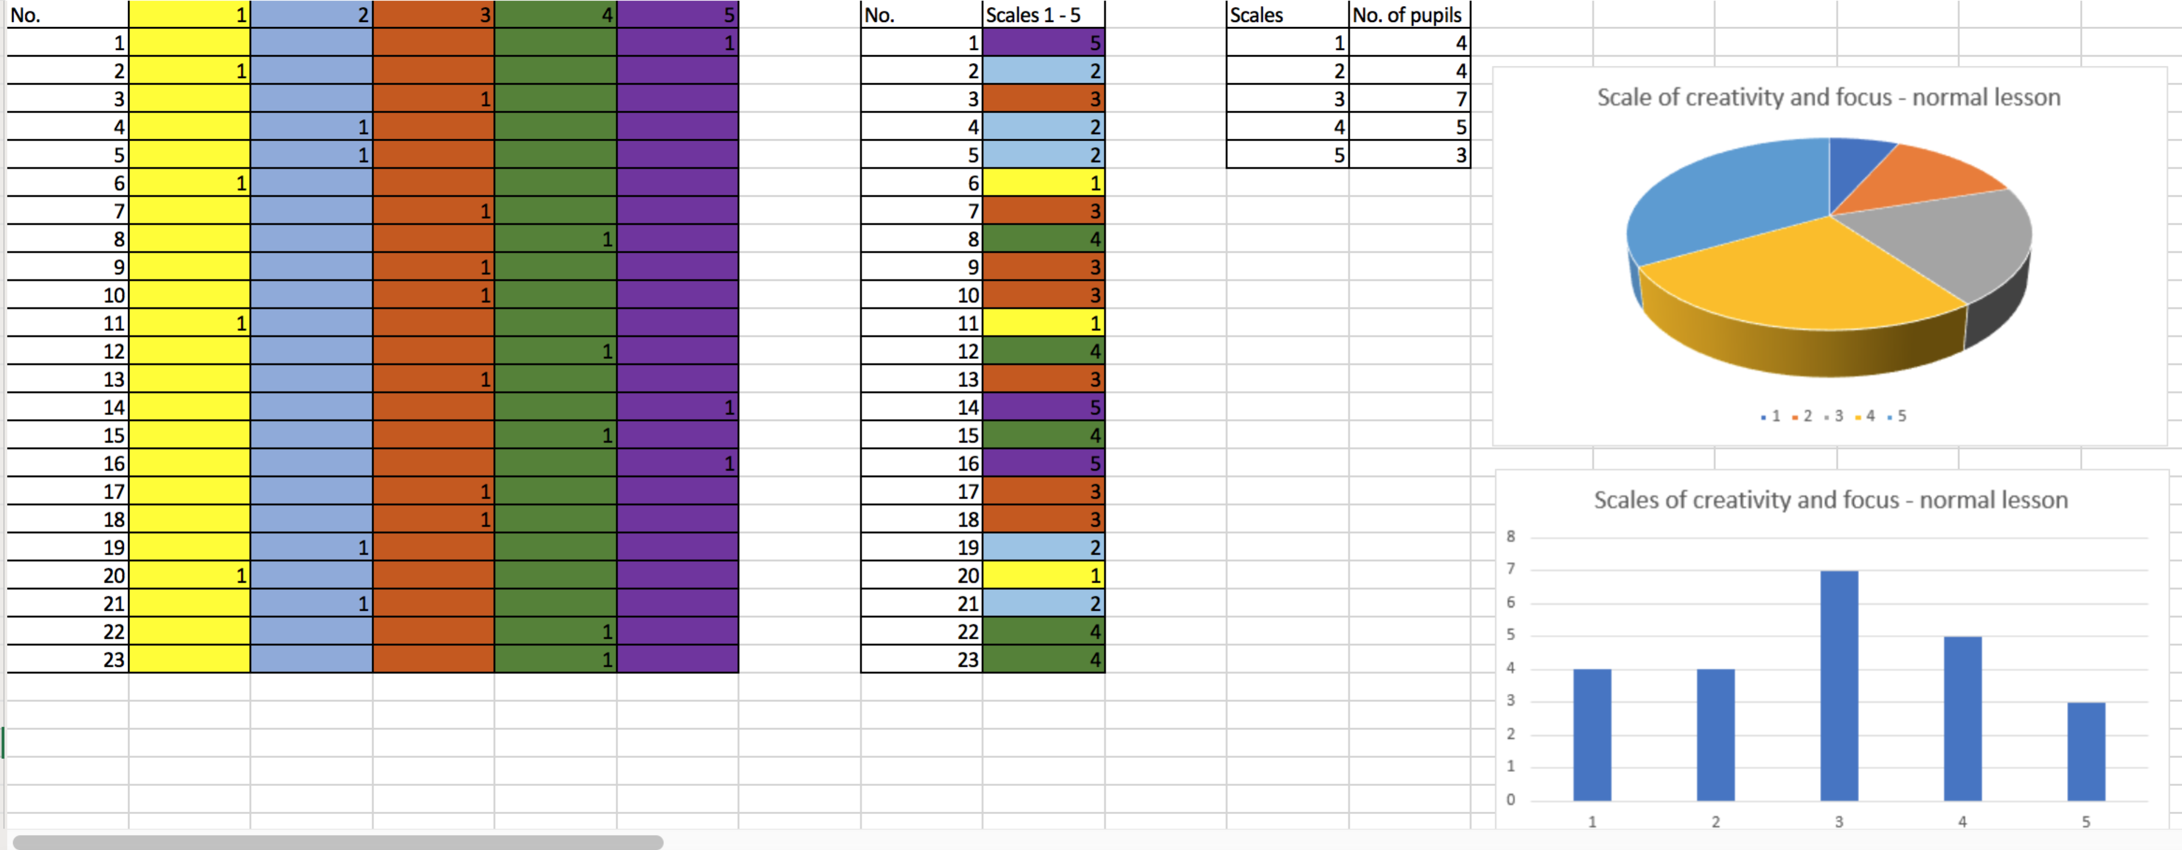
Appendix 1 - Results – Normal Lesson – Lesson 1

Appendix 2 – Results – Classical and Baroque Music – Lesson 2
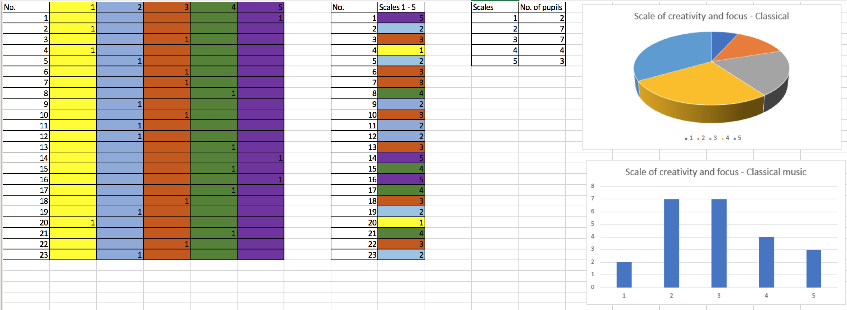

Appendix 3 – Results – Free Choice Music – Lesson 3
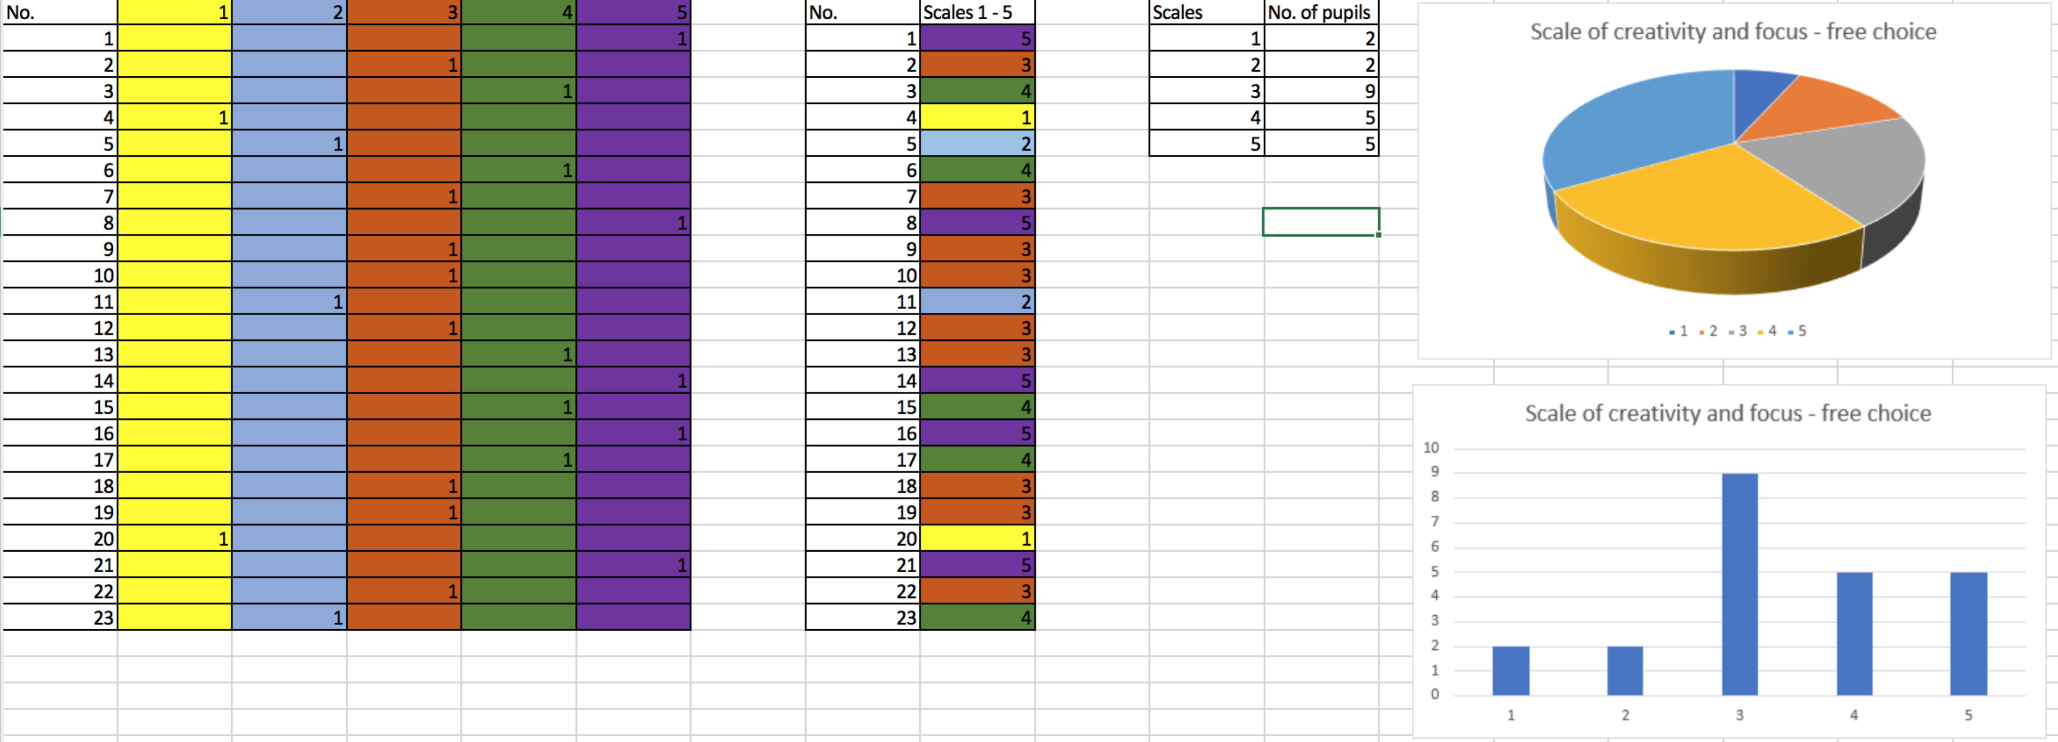
Appendix 4 – Classical and Baroque Music Playlist on YouTube
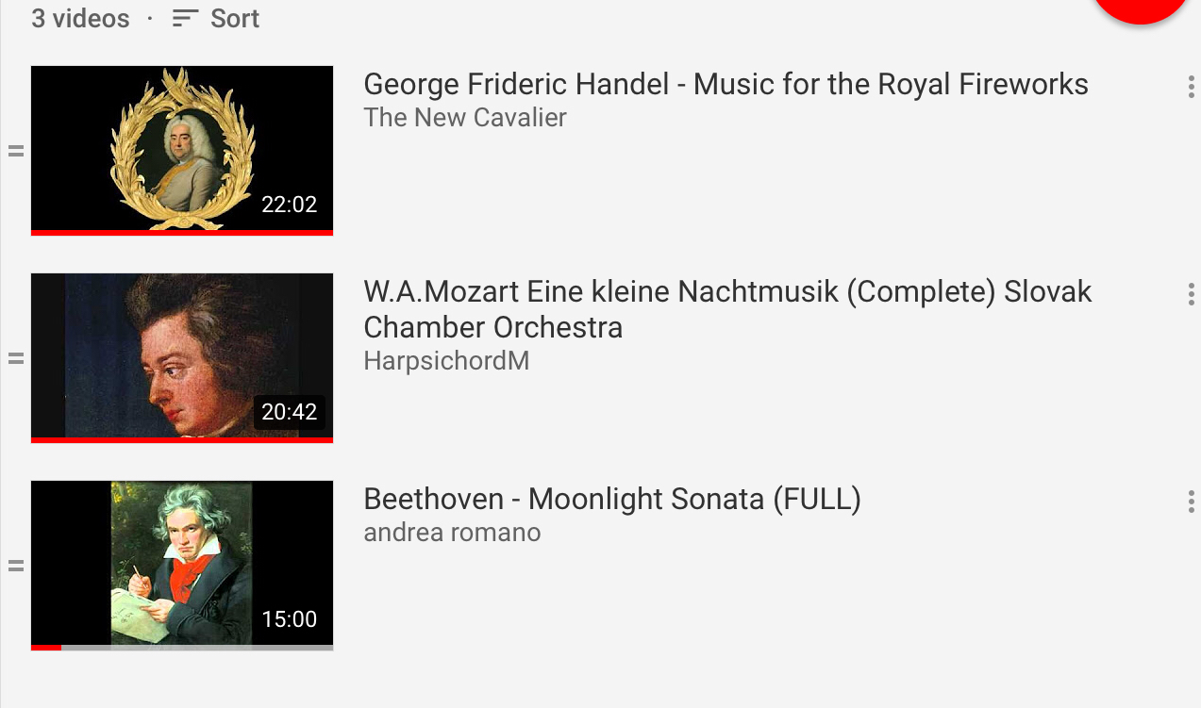

Appendix 5 – Free Choice Music Playlist on YouTube






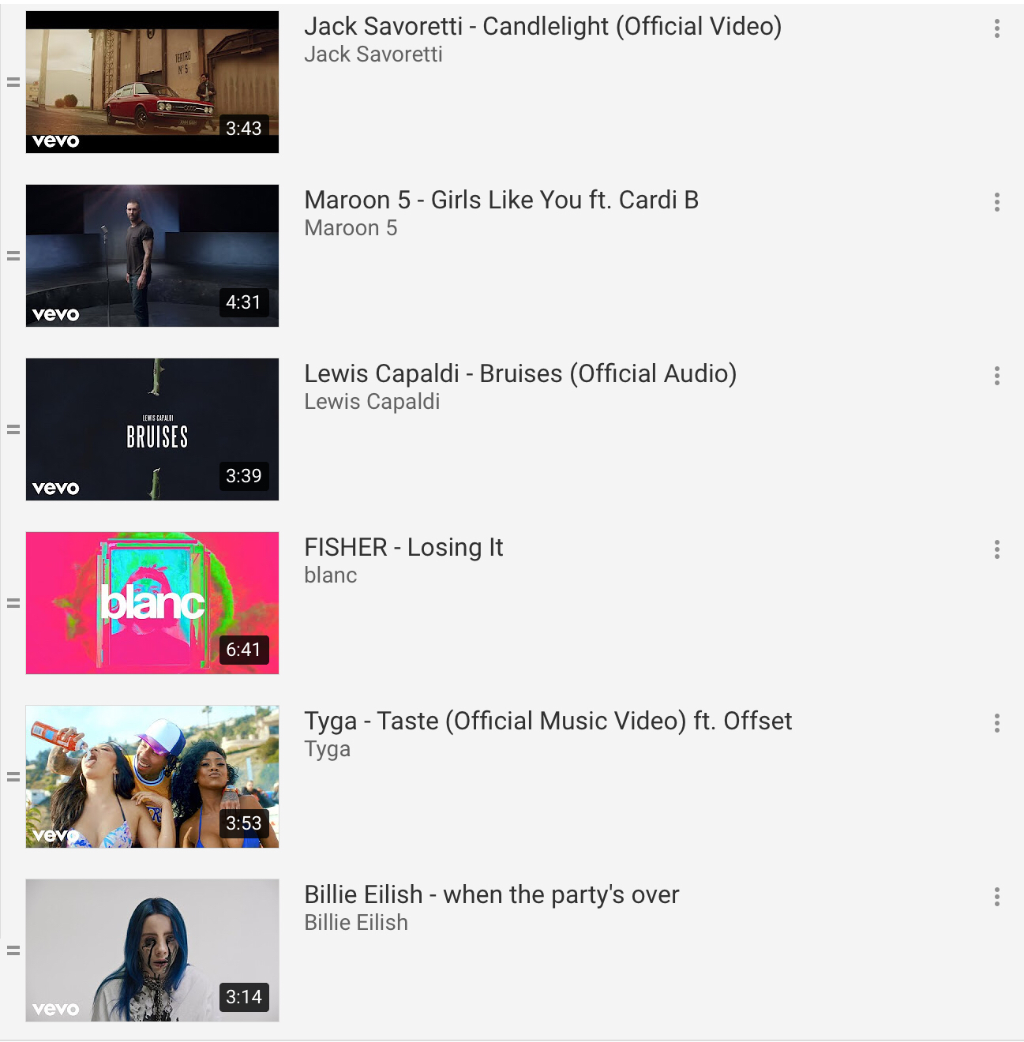


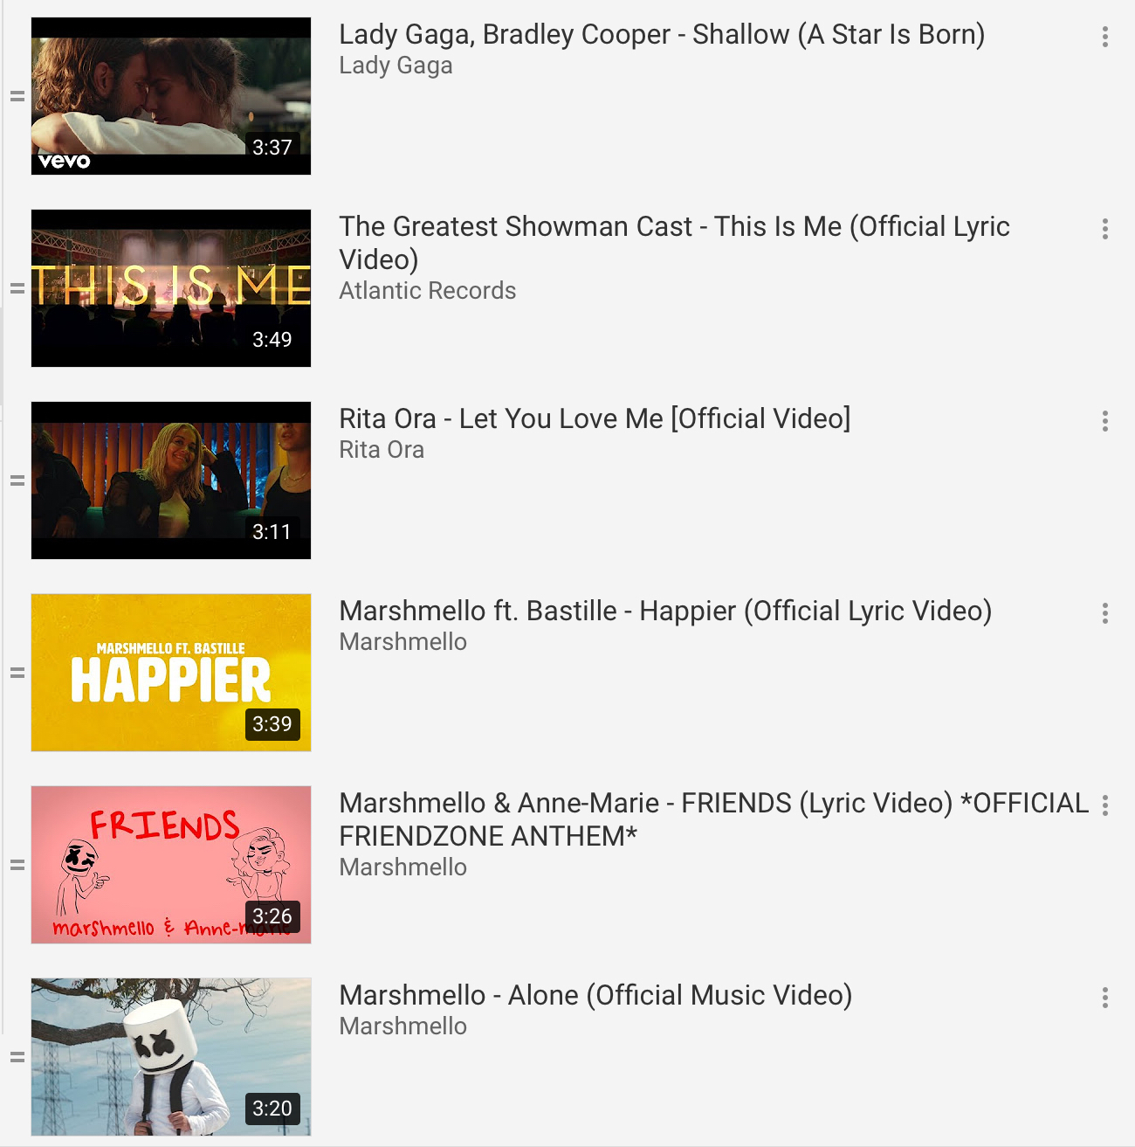

Bibliography

Anon., n.d. Teachnology. [Online]
Available at: http://www.teach-nology.com/currenttrends/constructivism/vygotsky/
[Accessed 16 April 2019].
Baker, M., 2007. Music Moves Brain to Pay Attention.. Stanford : Stanford School of Medicine.
BERA, 2018. Ethically Guidelines for Educational Research , s.l.: s.n.
BL., F., 2004. The broaden-and-build theory of positive emotions.. [Online]
Available at: http://doi:10.1098/rstb.2004.1512
[Accessed 09 May 2019].
Boice, R., 1991. Quick Starters: New Faculty Who Succeed. [Online]
Available at: https://onlinelibrary.wiley.com/doi/abs/10.1002/tl.37219914810
[Accessed 09 05 2019].
Cherry, K., 2019. The 4 Stages of Cognivitive Development. [Online]
Available at: https://www.verywellmind.com/piagets-stages-of-cognitive-development-2795457
[Accessed 16 April 2019].
Cox, D., 2013. Are some people born creative?. [Online]
Available at: https://www.theguardian.com/science/blog/2013/sep/19/born-creative-study-brain-hemingway
[Accessed 16 April 2019].
Craft, A., 2005. Creativity in Schools – Tensions and Dilemmas. Abingdon, Oxon: Routledge.
Hoffeld, D., 2016. Want to Know what your brain does when it hears a question?. [Online]
Available at: https://www.fastcompany.com/3068341/want-to-know-what-your-brain-does-when-it-hears-a-question
[Accessed 10 May 2019].
Medina, J., 2014. Brain Rules: 12 Principles for Surviving and Thriving at Work, Home, and School. s.l.:Pear Press.
Ritter SM, F. S., 2017. Happy Creativity: Listening to happy music facilitates divergent thinking. [Online]
Available at: https://doi.org/10.1371/journal.pone.0182210
[Accessed 08 May 2019].
Robinson, K., 2014. Can Creativty be taught? [Interview] 2014.
Suttie, J., 2017. How Music Helps Us Be More Creative. [Online]
Available at: https://greatergood.berkeley.edu/article/item/how_music_helps_us_be_more_creative
[Accessed 5 May 2019].
Treffinger, D., 2002. Assessing Creativity: A guide for Educators. Connecticut: The National Research Centre on the Gifted and Talented.
UWTSD, n.d. UWTSD Code of Ethics, Wales: UWTSD.

