Hotel Handbook for Intercultural Competence

Module: Cultural Awareness
Module Code: BMIH5003

Name: Mohsina Khanam Mitu
ID: 2012555

Lecturer: Mike Davies

Executive Summary

The tourism and hospitality industry contributes a lot to the global economy. A major portion of global income is contributed to this tourism and hospitality industry. This industry is completely people oriented as both the customer and the server requires continuous interaction between them. This assignment will explore the country Brazil and Indonesia. Belonging from the region, make them highly different from each other in terms of culture, behaviour, expression and so on. While serving people from Brazil as well people from Indonesia, the hotel staffs need to keep in mind the differences for serving them effectively and maximum consumer satisfaction.

Table of Contents
Executive Summary 2
Introduction 4
Country A (Hotel Location) 5
Country B (Guests cultural background) 7
Country Analysis 9
Hotel handbook 10
Conclusion 13
References 14

Table of Figures
Figure 1 Six Dimension Value of Brazil (Country Comparison - Hofstede Insights, 2021) 5
Figure 2 Six Dimension Value of Indonesia (Country Comparison - Hofstede Insights, 2021) 7

Introduction
Diverse rituals, behaviour, language, appearance exist which forms the diversity among different countries and different people. Geert Hofstede has identified the point of differences and introduced a cultural dimension theory to point out the differences that will assist in gaining a thorough understanding of various cultures. In this assignment, the cultural differences will be considered between two countries Brazil and Indonesia. Hotel Fasano in Rio de Janeiro will be taken to understand how the staff should fabricate their behaviour, thoughts, expressions to better serve the consumers from Indonesia.

Country A (Hotel Location)

The hotel Fasano is situated in Ipanema, Rio De Jenerio, Brazil. Now the cultural index of Brazilian people will be considered from six dimensions according to Geert Hofstede.
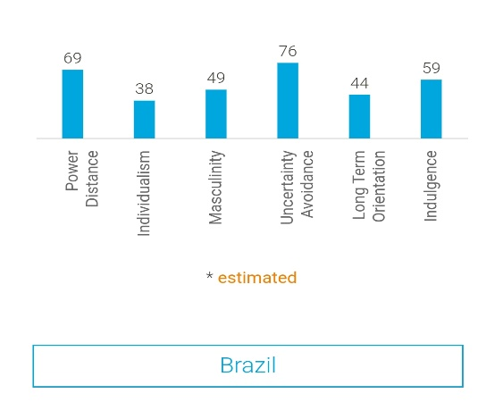
Figure 1 Six Dimension Value of Brazil (Country Comparison - Hofstede Insights, 2021)

- Power Distance: Having a score of 69 showcases that Brazilian people tend to have respect toward the hierarchy of society. Sense of power and status are very important among the Brazilian people (Moran et al., 2014).
- Individualism: Having a score of 38 showcases that the people of Brazil love to form integrated and cohesive groups and lives accordingly. In Brazil, people love to communicate in elaborate form and profusely (Hofstede,1995).
- Masculinity: High score on this index refers to that society is driven by a sense of power, success, and Competition. Having a score of 49 refers to Brazil has driven by both successes as well enjoying the quality of life (Christopher, 2015).
- Uncertainty Avoidance: Having a score of 79 showcases they have a higher sense of Uncertainty Avoidance. Here people need to have time for their relax and for enjoying their meal and chat with friends (Beugelsdijk And Welzel, 2018).
- Long term orientation: With a score of 44 people in Brazil are in between both pragmatism and normative. People here are respectful toward their previous norms and traditions. They also are encouraging toward adopting newer technologies (Christopher, 2015).
- Indulgence: Having a score of 59 is showcasing that people love to indulge themselves while having some quality time (Country Comparison - Hofstede Insights, 2021).

Country B (Guests cultural background)
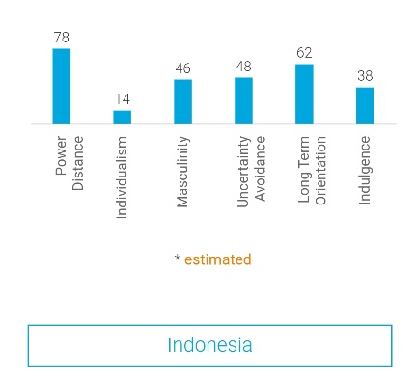
Figure 2 Six Dimension Value of Indonesia (Country Comparison - Hofstede Insights, 2021)
- Power Distance: The score of 78 they are more likely to follow a directive leadership and, they are followers of a social hierarchy where power is more concentrated (Tomalin and Stempleski, 2013).
- Individualism: Having a score of 14 showcases that they are a collectivistic society where people like to define themselves within a social framework (Anderson, 2012).
- Masculinity: The score of 46 shows they fall in the middle of both a masculine and feminine society where they love to sense the feeling of success and enjoy their free time and being careful toward others (Jackson, 2020).
- Uncertainty Avoidance: In Indonesia, people have a low preference for avoiding uncertainties. Whenever they are feeling low, they don't seem to express their emotions through anger or loud voices (Huang and Crotts, 2019).
- Long term orientation: Indonesian culture is quite pragmatic which means they do not stick with a particular tradition (Hofstede,1995).
- Indulgence: With the score of 38 it is showcasing that Indonesian culture is restraint in nature. Rather they are more control over their actions (Country Comparison - Hofstede Insights, 2021).

Country Analysis
Cultural diversity is present among all the regions and learning the differences among different cultures is necessary. Learning about the differences assist the minimising personal biases as well as certain stereotypes (Anderson, 2012).
A wide array of differences present between Brazil and Indonesia is stated in the following:

- Brazilian culture is louder. They are more likely to express their feelings in explicit form. (Anderson, 2012). Indonesian people remain quite calm. Even if they are feeling negative toward a particular situation, they don't like to express their feelings. The staff must remain talkative while serving the Brazilian guests and conservative while serving the Indonesian guest (Christopher, 2015).
- In Brazil, people love to enjoy their leisure time as much as possible by doing many activities such as dancing. As Indonesia is more a restrained culture, they like to pass their time in a calmer and more peaceful environment (Kim & Reuben, 1988).
- Brazilians are flaring in their clothing sense and Indonesians are more minimalistic in their clothing.
- Brazilians love informal greetings and conversations whereas Indonesians doesn’t waste much time in conversation with people they are not acquainted with (Samovar & Porter, 1995).

Hotel handbook

Etiquettes |  | Do’s and don’t
Handshake | Brazil | Do's  - Handshaking is preferred  - The staff should maintain steady eye contact while shaking hands.  - The staff are suggested to initiate the hand Shaking.  Don’t  - The staff are suggested not to offer a handshake to women until it is initiated from the other side.
Handshake | Indonesia | Do's  - Handshaking with small pumps  - Bowing Down head slightly while Shaking hand is also preferred.  Don’t  - The Hotel staff should not shake hands with women until she initiates it.
Language | Brazil | Do's  - Using English is appreciated.  - Brazilian accent must be appreciated by the Staff.  Don’t  - Staff should interrupt a Brazilian guest while they are speaking.
Language | Indonesia | Do's  - Bahasa Indonesia or Malay language is preferred (Samovar & Porter, 1995).  Don’t  - The staff should avoid speaking too fast while making conversation in English.
Clothing | Brazil | Do's  - Brazilian people like to wear Colourful clothes and the staff should dress accordingly (Christopher, 2015).  Don’t  - The staff should not wear dull coloured clothes especially black should be avoided.
Clothing | Indonesia | Do's  - The staff can wear casual and batik dresses to serve the Indonesian guest  Don’t  - Revealing clothes should be avoided.
Addressing | Brazil | Do's  - Men should be addressed by using the work ‘Senhor’, women should be addressed by ‘Senhora' and girls should be addressed by ‘Senorita’ (Kim & Reuben, 1988).  Don’t  - The Brazilian should not be addressed by their formal names only.
Addressing | Indonesia | Do's  - The Indonesian should be greeted first with the word ‘Selamat’ which means peace.  Don’t  - The staff should not maintain eye contact as this is taken as a sign of hostility
Food | Brazil | Do’s  - The knives should be kept in the right and fork in the left while serving them.  - Separate glass for various drinks must be kept.  Don’t  - The staff should not rush about anything while serving Brazilian guests.
Food | Indonesia | Do’s  - Serving proper hand washing items on their tables as they like to eat with their hands.  Don’t  - The staff should not talk about other things except the meal during dining time.

Conclusion
This assignment highlighted the key differences present in Brazilian culture and Indonesian culture. Both the countries have some major differences in terms of their thinking pattern, way of perceiving things. The staff member has been suggested some possible actions that will bring more satisfaction among the hotel guest by considering their cultural aspects.

References

Hofstede, G., & Bond, M. H. (1984). Hofstede's culture dimensions: An independent validation using Rokeach’s value survey. Journal of Cross-Cultural Psychology, Issue. 15, pp. 417-433.
Hofstede, G. (1995). The business of international business is culture. In T. Jackson (Ed.). Crosscultural Management. Oxford, England: Butterworth Heinemann.
Kim, Y. Y., & Reuben, B. D. (1988). Intercultural transformation: a systems theory. In Y. Y. Kim & W. B. Gudykunst (Eds.), Theories in Intercultural Communication. Newbury Park, CA: Sage.

Kincaid, D. L. (1988). The convergence theory and intercultural communication. In Y. Y. Kim & W. B. Gudykunst (Eds.), Theories in intercultural communication. Newbury Park: CA Sage.

Lewis, R. D (2006). When cultures collide. leading across cultures. Boston, MA: Nicholas Brealey
International.

Powers, T. F., & Riegel, C. D. (1993). A bright future for hospitality education: providing value in the 21st century. Hospitality Research Journal, Issue 17, pp. 295-308.

Samovar, L. A., & Porter, R. E. (1995). Communication between cultures. Belmont, CA: Wadsworth.

Spitzberg, B., & Cupach, W. (1984). Interpersonal communication competence. Beverly Hills, CA: Sage.
Beugelsdijk, S. And Welzel, C., (2018). Dimensions and dynamics of national culture: Synthesizing Hofstede with Inglehart. Journal of cross-cultural psychology, 49(10), pp.1469-1505.
Huang, S.S. and Crotts, J., (2019). Relationships between Hofstede's cultural dimensions and tourist satisfaction: A cross-country cross-sample examination. Tourism Management, 72, pp.232-241.
Jackson, T., (2020). The legacy of Geert Hofstede.

