MODULE CODE: BMSK5006
MODULE TITLE: KNOWLEDGE AND INFORMATION MANAGEMENT SKILLS FOR THE WORKPLACE

Lecturer Name: Mr Rexon Nting
Student Name: Suhel Ali
Student ID Number: 1604631



Table of Contents

Introduction 3
Relationship between data, information and knowledge 3
Relationship between individual knowledge and organisational knowledge 4
Application of analysis and modelling techniques to identify knowledge assets 5
Evaluation of actual and potential knowledge assets 6
Explanation on why is it important to create, store, apply and integrate knowledge? 8
Provide a Framework for Establishing Knowledge Management Culture 10
Explain the Contribution Knowledge Assets have on an Organization 10
Evaluate the Knowledge Requirement for the Organization 11
Evaluate Organization’s Framework for Enabling Knowledge Sharing 11
Recommend Improvement to the Current Framework 12
Conclusion 12
Reference 13

Introduction

As the assignment title suggests, we will discuss about knowledge and information management skills for workplace. In this programme we have learned a number of leadership and management skills that can help us progress in our careers. The topic of this assignment is under management skill. We all are aware of the fact that management skills play a key role to survive sustainably in an individual’s career. Information management and knowledge management are two different things and each of them plays an important role in the smooth functioning of a workplace. Every employee needs to possess basic knowledge as well as information management skills. The importance of both knowledge and information in an individual’s life is known by all. Amazon is the company that we take into consideration. Knowledge management includes different aspects to it which is discussed in details in the assignment below. Data, information and knowledge play an important role and the relationship between them is important to understand knowledge management well. It is also important to understand the creation of new knowledge and why it should be stored. This assignment here is a detailed research work on Knowledge Management.

Relationship between data, information and knowledge

Data, information as well as knowledge are the basic concepts that will help a person understand knowledge management well. The basic concept of data, information and knowledge is known to everyone however, we will focus on the relation between them. Data, information and knowledge have close meanings. In simple words data can be defined as a collection of facts and once the unprocessed data is processed it is called to be information. Data is a plural term of datum. Any data that is processed in a manner that is presentable in nature is termed as information (Bavik, 2018). A data is absolutely useless in its raw form; a set of data goes through a number of phases to be called information. The best examples of data is prices and names of the items bought, now these are two sets of data and until and unless they are organised and related together it does not make any sense to us, as just the prices or just the name of items bought will be of no help to an individual. Now knowledge can be gained by evaluation of information. The ability of an individual to use specific information or an experience in any situation is termed as knowledge.
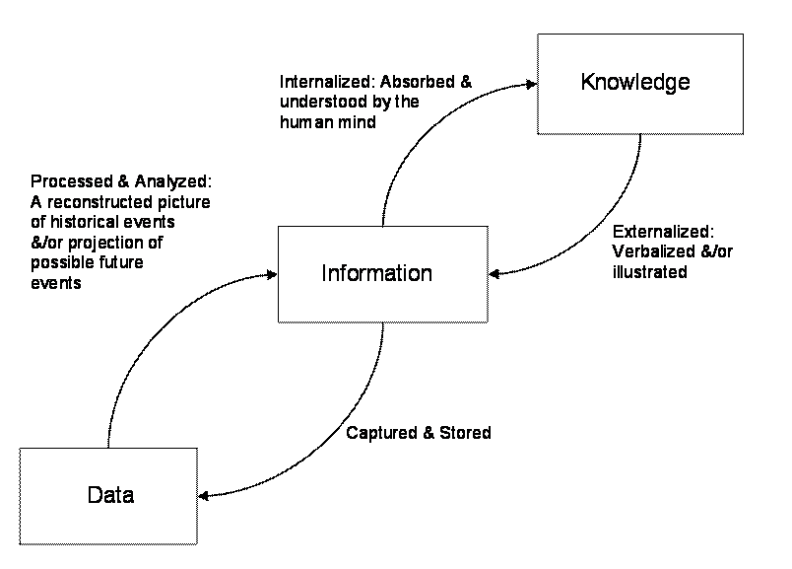
The figure above gives a clear idea of the relationship between knowledge, information as well as data. The easiest way to understand the relationship shared between information and knowledge is by locating the source of information. It is clear that all these three things are quite similar to each other and are often confused with one another. Hence, a clear difference between them helps us use them efficiently in the workplace of an organisation.
Amazon is an e-commerce company which provides the retailers an online platform to sell their products. Being an e-commerce site it is evident that they are responsible to maintain a huge database. This database includes different types of data which are name of items being sold, name of sellers, price of each items, etc. However, will all these individual data collections once being processed to produce a useful information. This information is then analysed thoroughly to gain knowledge about the type of data which can be used to take different important decisions related to the company. These decisions contribute effectively in the progress of the company.

Relationship between individual knowledge and organisational knowledge
Individual knowledge is referred to as the knowledge gained by an individual irrespective of the procedure involved in gaining the knowledge. On the other hand organisational knowledge is known as the knowledge of a group of people. We need to first understand the need of knowledge. Knowledge is mainly required to find a resolution to a critical situation that has aroused. Knowledge as mentioned earlier can be anything from experience based to context based to various skill sets. In a workplace the main requirement of knowledge is to utilise it in a decision making situation. Organisational knowledge is organisation specific and individual knowledge is specific to that individual. Knowledge is gained by interpreting information and it completely depends on the individual or a group of people on how they interpret the information.
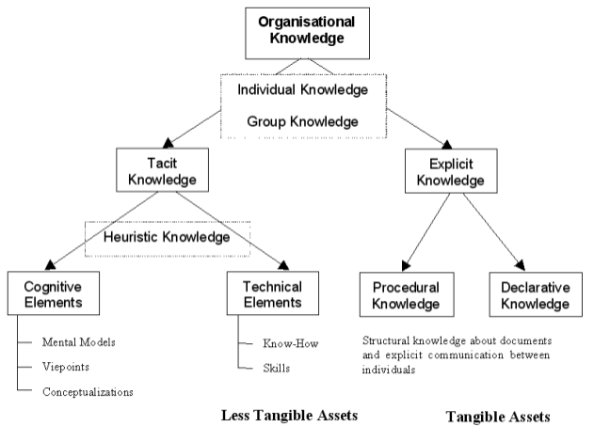 An individual knowledge can be used to create an organisational knowledge and vice versa. Let us take an example; A is new in a company where B and C work in the same position. The skill sets required to work in the specific position is partly known by B and partly known by C. As A is new in the company so B and C were assigned to train A. Now the training is the procedure where B and C together share their organisational knowledge to A. Now after a few days there was another new candidate called D. A was asked to train D. Here the same knowledge that was organisational in nature is now individual in nature and is imparted to D.
The above mentioned example helps us understand the relationship between individual knowledge and organisational knowledge. In Amazon there are different departments and each department is responsible for their specific work. Every department has teams and these teams comprises of team members. The knowledge acquired by these team members is called organisational knowledge.

Application of analysis and modelling techniques to identify knowledge assets

Knowledge when shared is more effective and makes it easier to understand. But are there specific methodologies to transfer knowledge? Let’s say that you were part of a great learning experience and wish to help other people by sharing your experience, but the question arises that how will you manage to do so? It sounds a bit challenging. The process of collection and collation of the required knowledge is called knowledge asset. Knowledge asset comprises of a set of guidelines which are set taking into consideration the business requirement and links it with different document that helps in selecting the right approach to the required investigation. The objective of this entire procedure is to share the knowledge with an individual or a group of people who are located at a different location. However, the most effective procedure to share knowledge is considered to be via face to face still there can be situational requirements that demands transfer of knowledge to people present at a distance. The following techniques need to be followed to identify knowledge assets.
- It is important to have a clear idea of the importance if the knowledge asset and who will be benefitted by that specific knowledge asset.
- There should be a procedure to examine the knowledge that the people possess and how can that knowledge be used in identifying the knowledge asset.
- Identifying the sources of the required knowledge asset.
- Analysing similar conditions that occurred in the past to take adequate lessons in order to prevent them from making any kind of mistake that were analysed as made in the past situation.
- Validation plays an important role and it is hence important to validate the requirement as well as the sources of knowledge assets.
- Not everybody has the same pace of learning and hence it is important to understand the person who will be benefitted by the knowledge to plan things according to his requirement.
- Finally using the knowledge for the business requirement.
When we take a real life example, Amazon is an online platform for retailers to showcase their products and it gives these retailers the opportunity to increase their sales. It is hence evident that Amazon needs more number of retailers to attract more customers. Hence, they first categorise the fields that the sellers they are looking for and then conduct an extensive survey to get potential information about the sellers they were looking for. After that they assign a knowledgeable person to investigate the list of sellers and finally set a list of trustable sellers who will attract new customers and will maintain their reputation in the market.

Evaluation of actual and potential knowledge assets

Actual knowledge assets are referred to the direct source of knowledge. For example, A is a trainer of a specific skill set, so if anybody has any question related to that skill set can expect A to answer their query. In this case A is an actual knowledge asset. Similarly, if there is a data which after processing may or may not provide you with the required knowledge can be termed as a potential knowledge asset. A knowledge asset that has the potential to produce a specific knowledge is a potential knowledge asset. It is a challenging job to run a company. There are different departments responsible for different types of work (Tiwana, 2000). And in a company it is quite difficult to forecast the type of situation that might occur. Hence, it is important to have the availability of both actual as well as potential knowledge assets in a company.

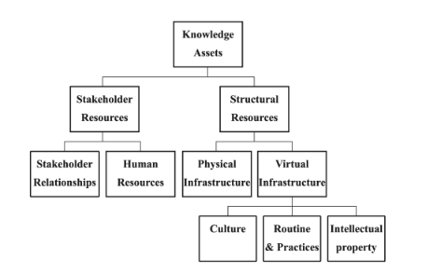

As seen in the above figure structural resources of knowledge assets are considered to be actual knowledge assets and stakeholders resources are the potential knowledge assets. We will first talk about the potential knowledge assets where we see there are two sub parts to it which are stakeholder relationships and human resources. Human resource department of an organisation plays an im[portant role in the progress of any company. Their main function includes the search of popential candidates and then to conduct an interview to identify the ability of the candidate and finalising if there are the best suited ones for the vacant position. Here HR use their potential knowledge that benefits the company in a long term basis (Nonaka, 2015). On the other hand there is actual knowledge assets which againg has two sub parts of physical infrastructure and virtual infrastructure. Physical infrastructure is considered to be a stronger knowledge asset than the virtual infrastructure. Physical infrastructure includes the structured procedure of collection of data and then analysing it to conclude the required information however in case of virtual infrastructure the procedure is mostly dependent of the practices that an individual is used to.
Similarly, in Amazon uncertainties are common and the company needs to prepare itself in such a way that they are capable of preventing any kind of uncertainty. Hence, keeping their options for both actual as well as potential knowledge open is the only way to prevent these uncertainties effect the company. They consider all the information from the stakeholders to conclude the positive or negative effect of their decision and plan things accordingly.

Explanation on why is it important to create, store, apply and integrate knowledge?

“Knowledge is power”, everyone knows the power of knowledge. Knowledge means facts or information or it can also refer to a specific skill set. When we say knowledge management, terminologically it means the strategical management of knowledge. There are various procedures involved in knowledge management which includes searching, collecting, examining, organising and lastly making the knowledge accessible for others. As mentioned earlier, skill sets can be termed as knowledge as well and in a workplace knowledge management can be used as a helpful tool in a workplace to complete an assignment efficiently. It can be used to find a candidate possessing some specific skills required to fill up a vacant position in an organisation. The main objective of knowledge management is to focus on knowledge, understanding and wisdom (Donate, 2015). It takes into consideration all types of knowledge which includes experienced-based knowledge or context-based knowledge. Technology plays an important role in knowledge management. Technology has made it easier in different aspects. There is some knowledge that needs to be explicit and demands to be transferred from one individual to another through effective interaction and technology helps to make a pathway for safe transfer of this knowledge.
Knowledge can be created and needs to be shared as well. Knowledge management has the prior objective of searching and locating the knowledge, assessing and encouraging the employees to create more useful knowledge.
The capability of an organisation to create new knowledge proves to be a huge advantage in terms of sustainability in today’s competitive market. Knowledge creation is not considered to be a part of knowledge management. Knowledge creation refers to constant sharing, processing and successful interpretation of various other types of knowledge that is already available. Sometimes creation of new knowledge is the result of a specific necessity. The phases that knowledge goes through from being possessed by an individual to learning it through experience increases the option of creation of new knowledge. To ensure successful creation of knowledge it is important to support ideas with innovation.
Sharing of knowledge is majorly related to creation of knowledge. Creation of knowledge includes experience in the specific field, cooperation among each other, constant communication and proper education related to the knowledge. Collection of relevant data and information plays an important role in creation of new knowledge as it gives the opportunity to improve the decision making skills.
Storage of knowledge plays an important role in any company. Storage of a newly created knowledge can benefit employees in the future situations. Technological advancement has changed the entire system of storage units. Before the invention of computers or the digital world everything was to be documented with relevant proofs and these documents were to be stored safely in any corner of the office building (Alavi, 2001). However, manual documentation was both time consuming and took a huge amount of space and was complex in nature. Computers on the other hand give you the option of storing all the important information, data or knowledge online. It is both less time consuming as well as safer in different aspects. With passwords it gets impossible for any unwanted person to access the information stored. But the question of requirement of storage of knowledge still remains unanswered.
For example, a company came across an uncertain situation which was handled tactfully for a manager in the company who had specific knowledge about the situation. Now, ten years down the line the company faces the same situation however the manager who handled it last time has retired by now. The main objective that can be drawn from this specific scenario is that if the knowledge was stored or shared then the company would have been capable of overcoming this situation. Storage of data should be structured in order to make it easily accessible for others.
Every organisation should create a knowledge map which includes information like documents related to the workflow as well as detailed documentation of the decision making procedure to identify the employees who possess excellent decision making skill. Knowledge workers on the other hand are the ones who are closely involved in the knowledge creation procedure. In every organisation there is the presence of knowledge workers (Rubenstein, 2001). Usually the highly experienced employees are considered to be knowledge workers. These knowledge workers contribute in creation of innovative knowledge. We have discussed the importance of creation of knowledge earlier.
Amazon being a leading e-commerce company has the necessity of creation of new knowledge on a regular basis. On the other hand they also need to store a huge amount data which can be used to analyse and conclude different knowledges that can be used further to improve the strategies which will ensure significant progress in the company’s economy.
Importance of intellectual property rights
Intellectual property rights play an important role in the knowledge management. Usually it is accepted all over the world cause of some important aspects which includes:
- These rights ensure attractive incentives for employees who are involved in the procedure of creation of knowledge.
- It ensures the appropriate recognition to any creators.
- Rewards are considered to be motivating and this right ensures rewards for inventors.
- As it encourages new inventions hence, it is evident that only original items will be available.
- Protection of intellectual property ensures significant growth both in economic and technological sector.
- As a result of which the company is benefitted.
It is important to copyright one’s work and this right does the same. Amazon too follows this policy and has seen a significant progress in their business since they have started to follow this policy.

Provide a Framework for Establishing Knowledge Management Culture

Knowledge management helps organizations and its personnel to enhance their knowledge that could be required to perform the specific job. By making a knowledge management culture, organization could safeguard their internal data and information from threats (Donate, and de Pablo, 2015). A knowledge management framework delivers the key idea of sharing experience with the team members or fresher, educating the new joiners so that they could able to perform. Every organization maintains own tactic and process to develop- and groom the new and existed people that desire to enhance their knowledge towards a particular matter. Therefore knowledge management culture leads organization to decide their goal such as making educate their workers through the knowledge development process (Omotayo, 2015). As the importance of maintaining knowledge management culture is countless such as organization could minimize risks, able to make cost effective plan for productivity, safeguards the data and information form vulnerabilities, an etc. For an example, the case of Amazon has been described through the report.
Amazon is known as the leading e-commerce brand or platform that satisfies their customers through range of product offerings. The company points their advanced knowledge management vulture or practices for the main reason of their success. By adopting the KM culture and practices the company able to make their personnel efficient. As the company always believe to expand the business analysis of the market demand is fairly required. Similarly the internal people of the company should also be aware of these practices. Hence they follow their KM strategy and framework to provide training the employees.

Explain the Contribution Knowledge Assets have on an Organization

Knowledge assets could be defined as the strategic way that helps a unified group to share their experience and information with their targeted people through certain media (Santoro, et al., 2018). The leading role of knowledge assets in knowledge management is to deliver the core understanding of knowledge sharing. This helps one group of people to retain the data and information from another group by maintaining a secured way (Grover, and Froese, 2016). The knowledge assets of Amazon could be rectified through their integrated online platform. That has been built for catering the customer one integrated online platform by which they could avail products and services. Amazon, on the other hand, also allows customers to chat with customer service executive so that the customer could resolve their queries as well. Therefore by allowing customers to provide feedback and comment, the company has extended their knowledge assets. These knowledge assets of Amazon led the company to improve their image across the market.

Evaluate the Knowledge Requirement for the Organization

Finding the acute requirement of knowledge, company could conceal their existing knowledge gaps. Similarly completing the knowledge requirement, organization could upgrade their performance across the market (Inkinen, 2016). This also leads them to reduce the mistakes and enhances the work efficiency of the workers. Though Amazon has found using the cloud computing platform but still they faces data related issues. The company should make proper plan to make their internal work force well verse regarding the cloud computing platforms. This could lead them to conduct a cloud computing training program. This should be focused on educating their internal staffs regarding networking, virtualization and usage of operating systems. So that workers could able to tackle the technical problems. On the other hand, delivering proper knowledge based training the company could educate their worker about their existing marketing process (Miller, 2018). Through which the new people could understand the job details. It has also been noticed several time that customers had ordered a product and received another one, though the company maintains a return policy but still customers do not receives their money back within the stipulated time. These situations are occurred due to lack of knowledge regarding the process. Hence the company should also maintain an in-house training process that could enhance the knowledge of their internal staffs.

Evaluate Organization’s Framework for Enabling Knowledge Sharing

Amazon should improve their existed knowledge management process so that they could improve their knowledge sharing intentions. The details of the framework for enabling the knowledge sharing process of the e-commerce company have been mentioned below:
- Modification of Presentation: As the company offers all the products in an integrated platform which is quite similar to other e-commerce brands. Therefore modifying the website through adding new web accessories and options could help the company to drag the attention of the customers (Kremer, et al., 2019).
- Customer Selection: the company should upgrade their internal team so that they could be capable to analyze the buying habit of the customers. This will help the employees to deliver suggestion to the customers for their purchasing stated by Bavik, et al., (2018).
- Feedback Options: Amazon is well known for its feedback option which helps the customers to share their shopping experiences. Therefore the company should also protect this section so that fake shoppers could not make any negative review. So they could provide this option only for those who is an existing customer or just bought products from Amazon.

Recommend Improvement to the Current Framework

As the company is disrupting the e-commerce business so they should upgrade their existing framework. This will help them to compete with their top rival e-commerce companies. The company should adopt customer analysis program by which the employees of Amazon could be able to suggest the customers for their shopping. The analysis should be based on the buying intention of the customers. Similarly protecting the feedback section the company could minimize vulnerabilities. There are customers who still face difficulties to purchase online. So the company should need to simplify the buying formalities. Therefore to modify their purchasing procedures company should provide adequate training toward their staffs. So these factors need to be categorized while planning the knowledge sharing framework. Through this process the employees of the Amazon will be capable enough to guide the customers that are dealing with issues while purchasing products from the company.

Conclusion

Module BMSK5006 has helped us understand the fields we need to work on in order to ensure success in our professional life. This specific assignment about knowledge management has given us the opportunity to understand the importance of knowledge management in the workplace. Knowledge plays an important role in every individual’s life. In an organisation as well it is hence important to manage the knowledge required to run the company well. Knowledge can be acquired by experience or trainings. Hence, it is important for any company to organise occasional trainings to ensure that their employees have updated skill sets to perform better. On the other hand technological advancement creates new applications that can improve the productivity of an employee. For companies it is easier to train their old employees instead of looking for new employees who possess that specific skill set. Employees and their performance decide the progress of a company. Hence, it is important to ensure that the employees are motivated. Rewards and recognitions are considered to be an excellent way to motivate the employees. The most important part of knowledge management is the storage of newly created knowledge. Creation of new knowledge involves collection of data and the processing it well to make it eligible for analysis, once it is analysed well the conclusion can be used to create new knowledge. There will never be a time when the importance of knowledge will decrease. Hence, the demand of knowledge management in the workplace will never see a downfall.

Reference

- Alavi, M. and Leidner, D.E., 2001. Knowledge management and knowledge management systems: Conceptual foundations and research issues. MIS quarterly, pp.107-136.
- Bavik, Y.L., Tang, P.M., Shao, R. and Lam, L.W., 2018. Ethical leadership and employee knowledge sharing: Exploring dual-mediation paths. The Leadership Quarterly, 29(2), pp.322-332.
- Davenport, T.H., De Long, D.W. and Beers, M.C., 1998. Successful knowledge management projects. Sloan management review, 39(2), pp.43-57.
- Donate, M.J. and de Pablo, J.D.S., 2015. The role of knowledge-oriented leadership in knowledge management practices and innovation. Journal of Business Research, 68(2), pp.360-370.
- Grover, R. and Froese, T.M., 2016. Knowledge management in construction using a SocioBIM platform: A case study of AYO smart home project. Procedia Engineering, 145, pp.1
- Hislop, D., Bosua, R. and Helms, R., 2018. Knowledge management in organizations: A critical introduction. Oxford University Press.
- Inkinen, H., 2016. Review of empirical research on knowledge management practices and firm performance. Journal of knowledge management, 20(2), pp.230-257.
- Kremer, H., Villamor, I. and Aguinis, H., 2019. Innovation leadership: Best-practice recommendations for promoting employee creativity, voice, and knowledge sharing. Business Horizons, 62(1), pp.65-74.
- Miller, K., 2018. Knowledge Management in Higher Education Online Learning Environments (Doctoral dissertation, University of Maryland University College).
- Nonaka, I. and Toyama, R., 2015. The knowledge-creating theory revisited: knowledge creation as a synthesizing process. In The essentials of knowledge management (pp. 95-110). Palgrave Macmillan, London.
- Omotayo, F.O., 2015. Knowledge Management as an important tool in Organisational Management: A Review of Literature. Library Philosophy and Practice, 1(2015), pp.1-23.
- Rubenstein-Montano, B., Liebowitz, J., Buchwalter, J., McCaw, D., Newman, B., Rebeck, K. and Team, T.K.M.M., 2001. A systems thinking framework for knowledge management. Decision support systems, 31(1), pp.5-16.
- Santoro, G., Vrontis, D., Thrassou, A. and Dezi, L., 2018. The Internet of Things: Building a knowledge management system for open innovation and knowledge management capacity. Technological Forecasting and Social Change, 136, pp.347-354.
- Tiwana, A., 2000. The knowledge management toolkit: practical techniques for building a knowledge management system. Prentice Hall PTR.
- Webb, S.P., 2017. Knowledge management: Linchpin of change. Routledge.

