

Police effectiveness on mitigating the potential impact of Adverse Childhood Experiences on children who have witnessed domestic abuse.

Elsie Thomas
2125195
BSc (Hons) Professional Policing Practice

Acknowledgements:

I would like to thank my sister for always being there, for helping me through the many tears and for always believing in me. I would like to thank my parents for always encouraging me to push through and for their support through a very stressful three years. I would also like to thank my partner for the unwavering support despite completing a degree himself.
I would also like to thank my work assessors for being a constant pillar of support when the last few years have proved particularly difficult.
I would like to thank all my university assessors for their feedback, their helpfulness and their motivation throughout the past 3 years.

Declaration
This work has not previously been accepted in substance for any degree and is not being concurrently submitted in candidature for any degree.
Signed: E.Thomas
Date: 06/10/2024

STATEMENT 1
This dissertation is being submitted in partial fulfilment of the requirements for the degree of BA.
Signed: E.Thomas
Date: 06/10/2024

STATEMENT 2
This dissertation is the result of my own independent work/investigation, except where otherwise stated.
Other sources are acknowledged by footnotes giving explicit references. A bibliography is appended.
Signed: E.Thomas
Date: 06/10/2024

STATEMENT 3
I hereby give consent for my dissertation, if accepted, to be available for photocopying and for interlibrary loan, and for the title and summary to be made available to outside organisations.
Signed: E.Thomas
Date: 06/10/2024

STATEMENT 4
I hereby give consent for my dissertation, if accepted, to be available on the university’s IT system to those who have consent to use the system.
Signed: E.Thomas
Date: 06/10/2024

Abstract:

This dissertation sets out to examine the effectiveness of the police service in helping to prevent Adverse Childhood Experiences developing in children who are exposed to domestic abuse within their home. Within this study, it will be explored how Adverse Childhood Experiences effect children and also how they can have an impact during adulthood if they are not successfully prevented. The role and processes of the police service will be examined when managing the risks posed to children in a domestic setting. Analysis will take place surrounding policies and procedures in place and whether these are being followed effectively. This research will give consideration to what is needed to improve the police services response in mitigating Adverse Childhood Experiences and provide recommendations of how this can successfully be achieved.

Contents:
Chapter one - Introduction . . . . . . . . . . . . . . . . . . .7
  - Background. . . . . . . . . . . . . . . . . . . . . . . . . . . 7
  - Research Rationale .. . . . . . . . . . . . . . . . . . . . . 7
  - Aims and Objectives. . . . . . . . . . . . . . . . . . . . . 8
  - Structure . . . . . . . . . . . . . . . . . . . . . . . . . . . . . . 8
  - Conclusion . . . . . . . . . . . . . . . . . . . . . . . . . . . . 8
Chapter two – Literature review . . . . . . . . . . . . . .9
2.1 Introduction. . . . . . . . . . . . . . . . . . . . . .. . . . . . 9
2.2 Arguments . . . . . . . . . . . . . . . . . . . . . . . . . . . . . 9
2.3 Misconceptions surrounding Adverse Childhood Experiences and police involvement . . 11
2.4 Misconceptions surrounding Adverse Childhood Experiences and police involvement. . . 12
2.5 Conclusion . . . . . . . . . . . . . . . . . . . . . . . . . . . . .15
Chapter three – Methodology. . . . . . . . . . . . . . . .. 15
3.1 Introduction. . . . . . . . . . . . . . . . . . . . . . . . . . . . 16
3.2 Research strategy. . . . . . . . . . . . . . . . . . . . . . . . .16
3.3 Data Collection . . . . . . . . . . . . . . . . . . . . . . . . . . 17
3.4 Ethical Practice. . . . . . . . . . . . . . . . . . . . . . . . . . 18
3.5 Conclusion. . . . . . . . . . . . . . . . . . . . . . . . . . . . . . . 19
Chapter four – Analysis of results. . . . . . . . . . . . .. . 19
4.1 Introduction. . . . . . . . . . . . . . . . . . . . . . . . . . . . . 19
4.2 Participant consent. . . . . . . . . . . . . . . . . . . . . . . .19
4.3 Participant demographic. . . . . . . . . . . . . . . . . ..20
4.4 Current policies in place and knowledge and understanding. . .22
4.5 Participant views and opinions. . . . . . . .. . . . . . 29
4.6 Conclusion. . . . . . . . . . . . . . . . . . . . . . . . . . . . .. . 30
Chapter five – Conclusion and recommendations . .30
5.1 Introduction. . . . . . . . . . . . . . . . . . . . . . .. . . . . 31
5.2 Summary of primary findings. . . .. . . . . . . . . . .31
5.3 Objectives. . . . . . . . . . . . . . . . . . . . . . . . . .. . . .31
5.3.1 Explore the effectiveness of policies in place to reduce the impact of experiencing ACES on children who have witnessed domestic abuse. . . 31
5.3.2 To explore the current policies in place that aim to mitigate the impact on witnessing domestic abuse. . . . . . . . . . . . . . . . . . . . . . . . . . . . . . . . . . . . . 32
5.3.3 Are these policies fit for purpose in today’s society?. . 33
5.4 Recommendations and conclusion. . . . . . . . . . 33
Six – Bibliography. . . . . . . . . . . . . . . . . . . . . . . . . . .34
Seven – Appendices. . . . . . . . . . . . . . . . . . . . . . . . .38
7.1 Appendix 1 – Copy of Questionnaire . . . . . . . .38
7.2 Appendix 2 - Ethics form. . . . . . . . . . . . . . . . . . 45
7.3 Appendix 3 – Questionnaire answers. .. . . . . .60
7.4 Appendix 4 - Responses to Question 3. . . . . . .65
7.5 Appendix 5 -Responses to Question 5. . . . . . .67
7.6 Appendix 6 - Responses to Question 6. . . . . . .68
7.7 Appendix 7 – Responses to Question 7. . . . . .69
7.8 Appendix 8 - Responses to Question 8. . . . . . 70
7.9 Appendix 9 - Responses to Question 9. . . . . . .71
7.10 Appendix 10 - Responses to Question 10. . . 72
1.0 Introduction
This dissertation topic sets out to measure police effectiveness on mitigating the effect of adverse childhood experiences on children who have experienced domestic abuse.

  - Background
Adverse Childhood Experiences (ACES) are defined as stressors “that children may suffer in early life. Such experiences include multiple types of abuse; neglect; violence between parents or caregivers; other kinds of serious household disfunction such as alcohol and substance abuse…” (The World Health Organisation 2020). More and more children are experiencing Adverse Childhood Experiences and current studies suggest that “an estimated 60% of children reported at least one ACE” (Waite. Ryan. 2020). This is concerning because Adverse Childhood Experiences can have not only a detrimental impact on children, but this can also cause significant issues in adulthood if not identified and addressed at the earliest available opportunity. For example, “often ACES can be barriers to healthy attachment relationships forming for children” (NHS Manchester University 2024). Adverse Childhood experiences need to be mitigated as allowing a child to continue through life without preventing these ACES can lead to negative impacts on their later life including “conditions like depression, asthma, cancer and diabetes in adulthood…risky behaviours like smoking and heavy drinking…education and employment potential…ACES…being passed from one generation to the next” (CDC, Vital Signs 2021).

  - Research Rationale
The current studies available surrounding Adverse Childhood Experiences focus on other professions such as social work and healthcare professionals. However, as outlined above, ACES stem from “neglect, violence between parents or caregivers…alcohol and substance abuse” (The World Health Organisation 2020). These are behaviours which are often witnessed by police first and foremost, sometimes before any other professionals, meaning that police are required to be able to both identify the risk of Adverse Childhood Experiences and know how to utilise the correct policies and procedures to ensure that the correct support is put in place for any children who are exposed to these behaviours. It is also important to recognise the bigger picture whereby behaviours such as alcohol and substance abuse can be linked to domestic abuse or be a result of ACES, also highlighting the risks associated with ACES being passed on through generations. The number of children experiencing Adverse Childhood Experiences is increasing despite awareness for ACES increasing. It is vital that professionals are able to both identify and respond to children being exposed to Adverse Experiences to prevent them from advancing and being passed onto future generations. Despite the police service often being the first professionals to become aware of children being at risk of developing ACES such as attendance at a Domestic Incident, there is limited research available to assess whether a police response is effective in mitigating these risks. Due to this, the research conducted within this dissertation sets out to explore police effectiveness on mitigating the potential impact of adverse childhood experiences on children who have witnessed domestic abuse.

  - Aims and Objectives
This will be accomplished by exploring the following objectives, to explore the effectiveness of policies in place to reduce the impact of experiencing ACES on children who have witnessed domestic abuse, to assess the effectiveness the current policies in place that aim to mitigate the impact on witnessing domestic abuse and, whether these policies fit for purpose in today’s society.

  - Structure
This poses the question whether the current policies and procedures in place are fit for purpose within today’s society where Adverse Childhood Experiences continue to be prevalent.

With the continued prevalence of Adverse Childhood Experiences within today’s society, questions arise surrounding whether the policies in place now are actually helping the adults of the future.

To address the above outlined objectives, the research will be separated into chapters to ensure each objective is met. Chapter two of the dissertation will analyse the current academic research available surrounding adverse childhood experiences and their effect on children within both their early years and later life. This chapter will also acknowledge police effectiveness in identifying and responding to Adverse Childhood Experiences in children who have witnessed Domestic Abuse within their household setting.

Within chapter three consideration will be given to the most suitable research technique and methodology to assist with collecting the primary research for this dissertation.

Chapter four will assess the collated data following the selected data method established within chapter three. From this data, responses will be analysed in order to establish and explore any themes identified from the data analysis.

Chapter five will conclude this dissertation and address the final objective of this research by summarising the findings as well as identifying any issues within this study. Following this, recommendations will be provided based on the academic observations recognised in line with this research.

  - Conclusion
As outlined within the research rationale above, this dissertation will aim to explore and analyse the proficiency of police in being able to identify and respond to Adverse Childhood Experiences on children who have been a witness to domestic abuse. This will be achieved by identifying what current policies are in place, the effectiveness of these policies and giving consideration to whether these are fit for purpose in today’s society.

- Literature Review

2.1 Introduction
This discussion will address three main objectives surrounding the topic of police effectiveness in mitigating the potential impact of Adverse Childhood Experiences on children who have witnessed Domestic Abuse. The first objective of this dissertation will explore the effectiveness of policies in place to reduce the impact of experiencing ACES on children who have witnessed domestic abuse. The second objective will explore the current policies in place that aim to mitigate the impact on witnessing domestic abuse. Encompassing what is out there at the moment. Discussion will take place surrounding Domestic Abuse Stalking and Harassment Risk Assessments, Child Concern Questions and Public Protection Notification Referrals and Police relationships with Social Services. Finally, the last objective will explore whether these policies are fit for purpose in today’s society.
2.2 Arguments
In society, it is widely recognised that, “childhood exposure to, abuse, neglect, domestic violence, and related household stressors are widespread and commonly occur across all populations” (Asmundson. Afifi. 2008). Unsurprisingly, exposure to domestic abuse poses a direct risk to children of developing Adverse Childhood Experiences (ACES). Domestic abuse is defined as an incident “or pattern of conduct where someone’s behaviour towards another is abusive, and where the people involved are aged 16 or over and are or have been personally connected…” (NCVO, 2022). One of the main causes of Adverse Childhood Experiences is, “exposure to risk in the home” (Waite. Ryan. 2020) meaning that a child witness of domestic abuse, is at heightened risk of developing Adverse Childhood Experiences. Children who develop, “one or more early-life adversities were at greater risk for substance abuse, mental illness, and perpetrating violence than those reporting no ACES”. (Asmundson. Afifi. 2019). Outlining that the detrimental effects that exposure to Domestic Abuse can have on children, is capable of effecting their behaviour adversely in their adulthood. Reinforcing this, (Ferguson. Featherstone. Morris. 2019) explores that “section 120 of the Adoption and Children Act 2002 identified ‘impairment suffered from seeing or hearing the ill-treatment of another’ as a form of significant harm”. Underlining that children do not have to be subject to physical abuse to be at risk of considerable harm. In addition to this, research reflects that “in a 2014 study on ACES, 47% of people experienced at least one ACE with 9% of the population having 4+ ACES” (Bellis Et Al, 2014). This suggests that Domestic Abuse and Child Adverse Experiences have been prevalent for generations, however, are only being widely recognised in more recent years. This research was conducted ten years ago and, despite considerable efforts to tackle domestic abuse, this is still equally prevalent in today’s society. For example, more recent research during the Covid-19 Pandemic displays a significant increase in the use of their domestic abuse helpline which, “reported a 700% increase in traffic to their support website and a 120% in calls received to their helpline in April 2020, compared to April 2019” (Brodie. Hawkins. Mckinlay. 2022). Supporting this, studies conclude that, “Mothers ACE’s are significantly associated with their children’s developmental risk. If replicated, findings suggest that addressing intergenerational trauma through focus on childhood adversity among young children’s caregivers may promote child development” (Sun. Patel. Rose-Jacobs. Frank. Black & Chilton. 2017). This also highlights that failures to properly mitigate Adverse Childhood Experiences can have an intergenerational impact on societies children of the future, even if they are not witnessing domestic abuse. Perhaps insinuating that prevention is better than cure. (Beedlove et al 2020) identifies “several factors that can buffer against these negative effects and contribute to beneficial outcomes…these factors are known as positive childhood experiences and protective factors”. Positive childhood experiences are commonly associated with early intervention which aims to help to prevent or minimise the impact that ACES have on children. Early intervention is implemented in numerous ways some of which include, “family and parenting programmes, assistance with health issues, including mental health, responses to emerging thematic concerns…and help for emerging problems relating to domestic abuse, drug or alcohol misuse” (Parliament UK, 2018). On the other hand, this could also imply that childhood adverse experiences were not previously identified and responded to, as they are in society today.

2.3 Misconceptions surrounding Adverse Childhood Experiences and police involvement.
Current policy states that police should take positive action in any domestic abuse incident that they attend. The (CPS. 2017) outline that, this is to “make the victim and any children safe. This may mean arresting a person suspected of an offence, where the power to arrest exists, or taking other positive steps to ensure safety”. However, this indicates that issues may arise when a power of arrest does not exist. This may occur if the victim does not disclose any criminal offences to attending officers. In this instance, (College Of Policing. 2024) recommend that, “where there are no apparent grounds for arrest, sometimes the victim just wants the perpetrator to leave the premises temporarily or the situation can be defused by removing the perpetrator from the location”. However, this does not necessarily safeguard children in the long term. In light of this, some research may “assess police contact as a potential adverse childhood experience by measuring its prevalence, nature and distribution” (Geller. 2021). Suggesting that police contact may in fact be a direct cause of children developing childhood adverse experiences. Similarly, it is underlined that “elevated ACE scores were linked with increased risk of juvenile justice system contact including arrest or incarceration” (Testa. Jackson. 2022) Suggesting, that police contact with children is negatively associated with adverse childhood experiences, and that police contact with children is likely to increase a child’s risk of winding up within the criminal justice system at some point in their lifetime. Critics express concerns that within a household where domestic abuse occurs, “children are perceived as innocent bystanders caught up in the crossfire rather than victims in their own right” (Devaney. 2008). Proposing that police involvement is not currently sufficient when managing risk posed to children who are subjected to domestic abuse within their home. However, it is not as widely recognised that police officers are “often the first professionals that may become aware of the DA that children are experiencing, and their presence may represent a ‘key moment’ within which to enhance their safety” (Millar. Devaney. Butler. 2018).

2.4 Exploring policies and procedures in place which aim to mitigate the effects of ACES on children who are exposed to domestic abuse.
Some more recent research recognises that “there is a greater emphasis now than in the past on reporting children’s presence at a domestic violence incident” (Millar. Saxton. Overlien. Elliffe. 2021). However, studies appear to focus on children being treated as a bystander rather than a victim, and police knowledge and training, rather than how police manage the risk posed to children. Amongst current studies, there appears to be little understanding of how police record children’s information, what information is recorded and, how this information is shared with partner agencies with the aim to best support children who are exposed to domestic abuse at home. There is little research emphasising the “process for recognising and referring a child exposed to domestic abuse” and a “child-protection referral to social care services” (Ashley. Armitage. Taylor. 2016). This is heavily linked to Social care and not linked specifically to the police service. Research suggests there is little outlining what police do when they respond to a domestic abuse incident where there are children within the household. It is collectively understood amongst authorities that, “relationships between professionals are a key factor for facilitating information sharing” (Thompson. 2016). A niche in research means that it is not understood that police are often the authority who submit Domestic Abuse Stalking and Harassment Risk Assessments (DASHRA) and Public Protection Notification (PPN) referrals when they attend any domestic abuse related incident. Therefore, more often than not, police are the organisation responsible for kickstarting the information sharing process, allowing a multi-agency approach to take shape and support the children involved. The Domestic Abuse Stalking and Harassment Risk Assessment was created in 2009 and the risk assessment, “should be completed for all cases of domestic abuse by frontline staff” and the form ensures that, “details of children resident at the address must be provided” (Richards. 2009). Thus meaning, that every domestic incident attended by police requires the completion of a risk assessment whereby the children’s details are obtained and recorded, including the children’s School and General Practitioner information. Raising a debate whether this data is being recorded by police in every case. There is currently inadequate research surrounding police efficiency in responding to the prevention of adverse childhood experiences when dealing with domestic abuse incidents. Government agencies have published information surrounding the duty of attending officers to complete, “a public protection notification document (PPN) which summarises the vulnerability of victims. This notice goes to the force Public Protection Unit (PPU) which uses the information to assess the risk” (HMIC, 2015). Further research surrounding this is limited as it stands. Suggesting modern research is required surrounding the information that police obtain and how they share this information with third party agencies to support the children who are witnessing domestic abuse in today’s society. Recognition is given that, when the public protection notification referral is shared with the Public Protection Unit, they are able to provide a risk assessment to decipher whether a Strategy Meeting is required. A strategy discussion takes place when there “are concerns that there is a serious risk of harm to the child” (Islands safeguarding children partnership) and “it is felt that there is a need for compulsory intervention, then there will need to be a plan made to carry out the enquiry and monitor its progress” (Islands safeguarding children partnership). Indicating that the responsibility often lies with police to submit the initial public protection referral and share this with the relevant third-party agencies. This also outlines that the agencies present at a Strategy Discussion should include, “a first line manager from Social Services, a detective sergeant from the police, other agencies as appropriate for example health, education, the referrer (if they are a professional)” (Islands safeguarding children partnership). Promoting that information sharing is taking place. Nevertheless, there is a notable gap in research accounting for how children who do not meet the threshold of serious harm, are supported following being witness to a domestic abuse incident. Similarly, a Multi-Agency Risk Assessment Conference (MARAC) takes place and information is shared about the “highest risk domestic abuse cases between representatives of local police, health, child protection, housing practitioners, Independent Domestic Violence Advisors (IDVAs), probation and other specialists from the statutory and voluntary sectors.” (Safe Lives, 2014). Once again suggesting that there in insufficient research surrounding the management of cases that fall below the high risk and serious harm threshold, despite research suggesting that prevention of adverse childhood experiences is better than cure. However, further study also reiterates that “IDVAS, police and health professionals commonly refer high risk victims to MARAC” Safe Lives, 2014 underlining that police can, and often are assessing risk and sharing children’s information with the necessary agencies. However, failings suggest that this is not necessarily always the case. Research outlines, “a number of significant gaps and failings in the nature of the police response in particular” (McPhee. Hester. Bates. Lilley-Walker. Patsios. 2022). Posing questions such as, whether police are following the correct policies and procedures when attending domestic abuse incidents. This may also raise concerns surrounding whether police are notifying who should be notified and whether Domestic abuse stalking and harassment assessments and Public Protection Notification referrals are being submitted, and whether lessons are being learned in order to mitigate the development of adverse childhood experiences. Alternatively, consideration may be given, that if police are following the correct policies and procedures, perhaps improvement is required. For example, perhaps police do not have sufficient time after calls to submit a detailed and thorough Domestic Abuse Stalking and Harassment Risk Assessment and public protection notification. Perhaps police are being diverted to other calls and forgetting crucial information from the domestic incident when they update this hours later. Studies suggest that this may be the case referring to this “as a ‘supply and demand’ issue, where the aim is to match the supply of police resource to the demand for service” (Davies. Bowers. 2019). Suggesting that there are issues with police officers meeting the increasing demand of calls. Perhaps signifying that there are time pressures meaning that the Domestic Abuse Stalking and Harassment Risk assessment and, Public Protection Notification referrals are not as thorough as they could be impacting the voice of a child being accurately captured and conveyed to the relevant agencies. On the other hand, officers may not be aware of Adverse Childhood Experiences and the impact that they have on children. Or perhaps policies and procedures need to be adjusted. Maybe the child concern section on the Public Protection Notification referral could be more detailed and thorough and police should be prompted to ask children more questions. Revision of the current questions may suggest that police are not prompted to ask the right questions. Perhaps clarity needs to be sought surrounding how attending officers are recording this, what attending officers are doing with the information they obtain, whether police ask if children reside at the address when there are no children present at the incident, or if there are any stepchildren. These questions remain prevalent and unanswered, due to there being little to no research surrounding police officers and their response to domestic abuse incidents where there are child witnesses or children residing in the home address.
2.5 Conclusion
Concluding this discussion, research suggests that further study is required. Front line Police Officers may be able to provide answers to these questions to better inform research. Detectives working within the public protection unit may be able to provide feedback on whether this information is being completed at the earliest opportunity and whether the information they receive in their referrals is adequate. This study will answer questions addressing whether the current policies and procedures in place are fit for purpose within today’s society. Research answers may in turn, aid improvements to current policies and procedures which help to prevent Adverse Childhood Experiences for children who are witness to Domestic Abuse. Not only may this research help ensure children’s safety now, but also mitigate adverse childhood experiences which can lead to criminal behaviour in later life.

3.0 Methodology

3.1 Introduction
This chapter will provide an insight into the research methods that have been undertaken for this dissertation. Discussion will take place surrounding the ethical assurance as well as outlining the justification for using the methods employed to conduct the research for this dissertation. Although there is some research surrounding domestic abuse, child adverse experiences and multi-agency working, there is insufficient research surrounding police effectiveness when managing the risk of adverse experiences posed to children who are exposed to domestic abuse. In order to gain new evidence or to inform any current learning, it is necessary to conduct research to compile primary data for this topic.

3.2 Research Strategy
Research is defined as, “the creation of new knowledge and/or the use of existing knowledge in a new and creative way so as to generate new concepts, methodologies and understanding.” (Western Sydney University. 2023). The use of mixed method methodology research is praised by (Pfeiffer Library Tiffin University. 2022) as it enables the implementation of “the strength of both qualitative and quantitative research methods”. As there is very limited information surrounding this current study, it is imperative for primary research to be embedded within this dissertation topic. The collection of both qualitative and quantitative data will likely provide more rounded research into police effectiveness than using one of these methods alone. Primary research is defined by (University of Southampton, 2024) as, “gathering data that has not been collected before. Methods to collect it can include interviews, surveys, observations, or any type of research that you can go out and collect yourself”. Collecting primary data for this research will mean that the study will be designed to meet the objectives of this dissertation and will ensure that this reflects accurate results. The Survey research method will be used to collect data for this dissertation as it allows the mixed method approach to be adapted so that both qualitative and quantitative data can be obtained. Findings indicate that “it was possible to interpret the quantitative data with more insight and to test hypothesis raised by qualitative findings” (Wenger, 1999). Suggesting that the survey research method will allow a detailed and precise response to be obtained by participating officers. Critics highlight that “interviews are time consuming, as the researcher needs to go through a long process, starting from establishing access to making contact with participants, conducting the interview followed by transcribing the data and making use of it” (Alsaawi. 2014), whereas the survey approach is likely to be less time consuming in comparison. Sampling for this study will take place within the organisation, amongst police officers. The survey can be disseminated out via email and on the workplaces shared information hub page. This sampling approach has been selected so that the research can be directed towards the target audience, which is police officers, particularly those who respond to domestic incidents and engage primarily with child witnesses of domestic abuse such as response officers and public protection unit officers to ensure that the data collected is both accurate and reliable. It is imperative that research is sampled correctly to ensure that the results collected are informed and honest answers which represent the profession that is being sampled.

3.3 Data Collection
Some studies praise the use of survey research as this “produces data based on real-world observations (Kelly. Clark. Brown. Sitzia. 2003). However, it is also criticised that the “data that are produced are likely to lack details or depth on the topic being investigated” (Kelly. Clark. Brown. Sitzia. 2003). The survey disseminated to conduct this research includes both multiple choice questions and comment sections. In order to prevent any relevant information being excluded from the survey response, comment sections were utilised within the questionnaire to allow participants to expand on their answer or to provide a reasoning for the answer provided where elaboration may be necessary. Although survey data is criticised for lacking depth, consideration has been given to the fact that data collection “relies heavily on the honesty of respondents” (Rogers. Richarme. 2015). Suggesting that respondents may be more likely to provide their honest opinion when completing an anonymous survey online than they are in a face-to-face interview. As this survey is being conducted internally, the survey method may assist in obtaining truthful responses from participants ensuring that the data collected for this survey will be honestly reflected in the results. The information collected for this survey will be via an online form (Survey Monkey) and the quantitative data will be portrayed in graphs allowing the data to be reviewed and analysed clearly. All qualitative data obtained from the research will be collected and discussed within the research results, where any themes that have been identified from the responses will be evaluated.

3.4 Ethical Practice
It is obligatory for Ethical Practice to be adhered to when conducting research as this is about “trust and integrity and doing the right thing even when no one is watching” (IOSH. 2024). It is currently outlined that when conducting ethical research, the researcher should “obtain informed consent from potential research participants, minimise the risk of harm to participants, protect their anonymity and confidentiality, avoid using deceptive practices, and give participants the right to withdraw” (Aerd dissertation. 2012). To mitigate any ethical issues in this study, participants will be informed prior to the commencement of the survey that in completing the questionnaire they are providing their informed consent to take part in this study. Participants will also be informed that they have the right to withdraw from the study at any time and my contact information provided so that this can be requested following completion of the survey. Responses obtained as part of this research survey are anonymous and are stored on a secure device which has only been accessible by the researcher throughout this study. Following completion of this study, all research data will be disposed of as “research Data must be securely archived at the end of the research, or securely destroyed using the most appropriate method” (UWE, Bristol. 2024). At the commencement of any new study, “ethical approval must be obtained before any research involving human participants, identifiable personal data and/or animals is undertaken” (City University of London. 2024). Ethical approval has been sought via the submission of an ethical approval form which has been authorised by the ethics committee prior to the research being conducted for this dissertation.

3.5 Conclusion
Concluding this chapter, the analysis above outlines that a mixed method methodology is the most appropriate research technique to support this dissertation study. The use of primary research will enable new information to be gained surrounding police effectiveness, whereas existing research around Adverse Childhood Experiences and other professions will allow an insightful comparison in order to critically analyse the results obtained.

4.0 analysis of results

4.1 Introduction
Within this chapter analysis and discussion will take place surrounding the survey results. This will include a systematic presentation of the findings within this research. In total, 24 people participated in the survey research. The purpose of this research is to examine Police effectiveness on mitigating the potential impact of adverse childhood experiences on children who have witnessed domestic abuse. There are three main objectives of this research which are as follows:
- Explore the effectiveness of policies in place to reduce the impact of experiencing ACES on children who have witnessed domestic abuse.

- To explore the current policies in place that aim to mitigate the impact on witnessing domestic abuse.

- Are these policies fit for purpose in today’s society?

4.2 Participant consent

Question 1) I confirm that I have read and considered the information provided surrounding this research. I wish to take part in this survey and understand how I can withdraw from this study if I wish to.
Question 1 asked participants whether they had read the information provided prior to taking the survey, whether they wish to consent to partaking in the research and that they are aware how they can withdraw from the study should they wish to.
100% of participants confirmed that they were happy with the information provided, consented to taking part in the research and, understood how to withdraw from the research.

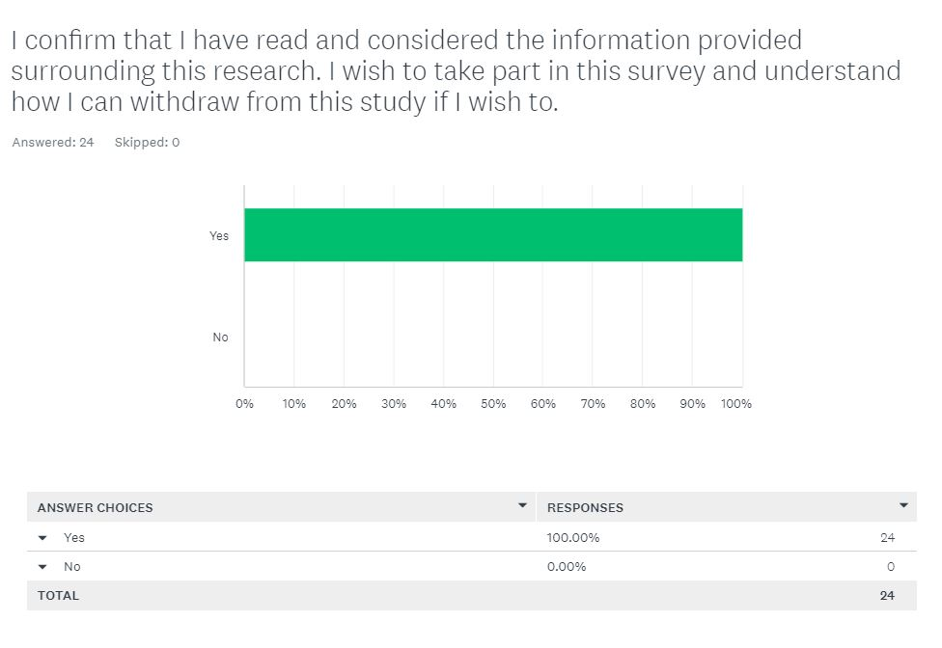

4.3 Participant demographic
Question 2) Does your role within the Police Service involve dealing with children who have witnessed Domestic Abuse?
Question 2 of the survey confirmed whether the participants were Police Officers who are exposed to child witnesses of domestic abuse. This is predominantly officers within Response Policing or Public Protection Unit (PPU) roles. 91.67% confirmed that they are required to engage with children who have witnessed Domestic Abuse within their role as a Police Officer. It could be argued that the 8.33% of Police Officers who responded to this survey, do not feel that they are exposed to Child witnesses of domestic abuse meaning that their answers are not relevant to this research study. However, the 8.33% correlates to 2 respondents and further answers provided by the respondents highlight that this may be a misunderstanding as to whether the child was believed to just be present at the incident or considered as a witness to the incident. This will be further elaborated when analysing additional questions answered by the participants within this survey.

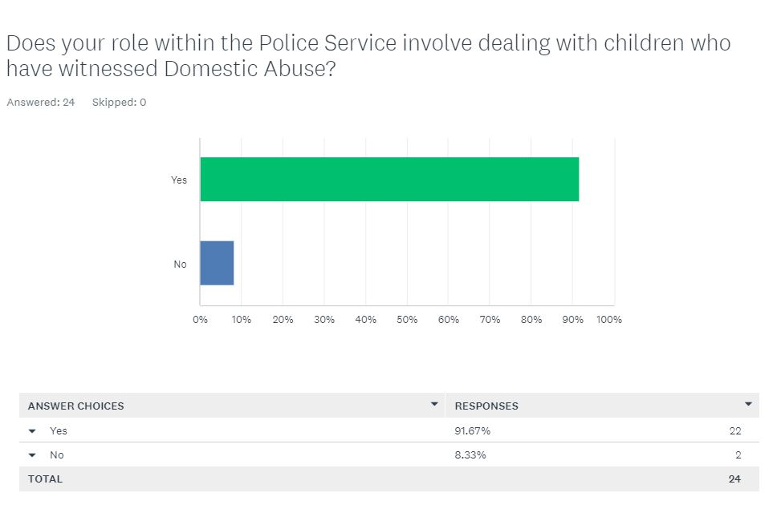

Question 3) Do you feel that your knowledge is clear on what Adverse Childhood Experiences (ACES) are and their impact on children? (Please give a summary of your understanding within the comment section below)
This question relates to the education of the Police Officers partaking within the survey. 79.17% of respondents state that they have an adequate knowledge of what Adverse Childhood Experiences are and their impact on children. Whereas 20.83% of respondents would state that they do not have sufficient knowledge of what Adverse Childhood Experiences are and their impact on children.
Within the summaries provided by participants it can be identified that there are varying levels of understanding among the participants. There are three main themes identifiable when analysing the responses provided by participants within the comment section of this question. This includes, people who portray a very limited knowledge of ACES, those with a reasonable understanding of ACES and, those with excellent knowledge of ACES. Those with very limited knowledge have provided responses such as, “had training on it but knowledge is not good enough to explain it”, “No, I have not had much training on this the last time I did was over 2 years ago. I feel I cannot deal with these calls adequately” and, “I know some ACES but not all, I’m unsure what effect they have on children”. Other respondents who display a reasonable knowledge surrounding ACES state that, “children who are exposed to violence in the household at young ages can be subject to ACES”, “behaviour can be normalised and the children can grow up to imitate that behaviour believing it is the correct way to act. This continues in cycles unless action can be taken to prevent” and, “Adverse childhood experiences are a range of circumstances/instances which cause childhood trauma. These can lead to mental health and other issues in adulthood including them ending up within the criminal justice system”. However, respondents who display an excellent knowledge of ACES provide detailed and informed answers such as, “experiences had by children in their early years, shape their behaviour and wellbeing later in their life. Unless a child feels safe, their ability to learn and develop significantly decreases. Being in an unsafe environment such as, a domestic abuse household where alcoholism is prevalent or where a parent is in prison, brings a constant level of uncertainty to a child’s life which will undoubtedly have a negative impact on their wellbeing”, “traumatic or stressful events experienced or witnessed by a child that can have a negative impact in the future. Examples of ACES could be physical, sexual, emotional abuse, mental illness etc” and, “ACES are traumatic experiences that children have whilst growing up that can impact them negatively throughout their life. It can affect them in different ways, such as having poor mental health. This can range from physical and emotional abuse to losing a parent at a young age”. The varied levels of understanding that can be analysed from the response summaries suggest that a substantial portion of respondents who answered “yes” on the poll, in fact do not have a reasonable knowledge of what adverse childhood experiences are or the effect that they have on children.
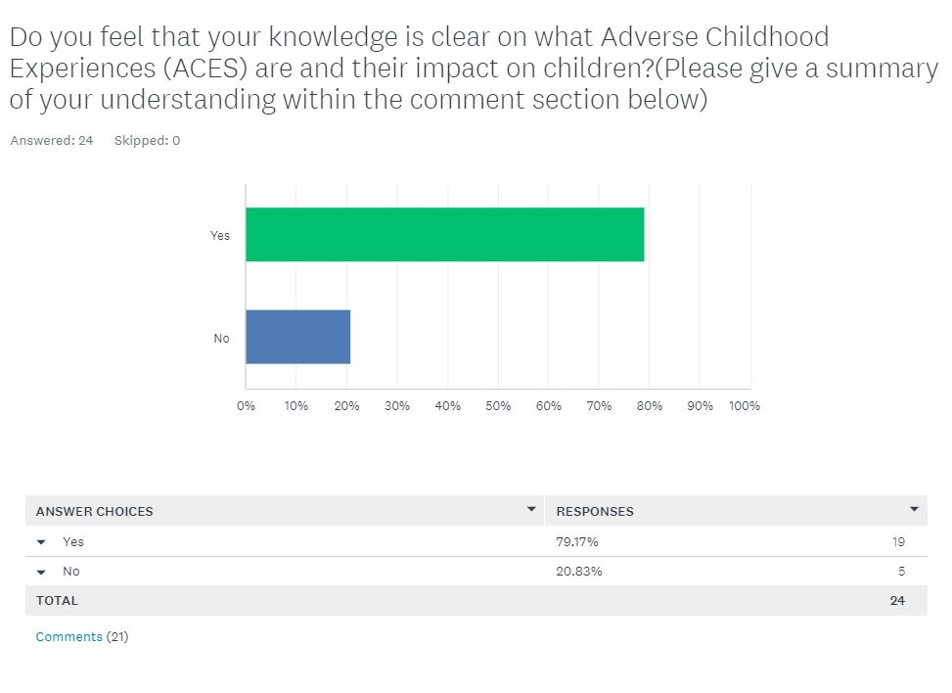

4.4 Current policies in place and knowledge and understanding
Question 4) Do you feel that you always submit a detailed and thorough PPN when managing a Domestic Incident where children may be exposed to Domestic Abuse?
This question relates to the respondents understanding and ability to fulfil their role. This is achieved by examining whether the respondents understand and adhere to the current policies and procedures in place which aim to reduce the impact of potential incidents on children who are experiencing domestic abuse. 70.83% of respondents feel that they always submit a thorough PPN when attending Domestic Incidents where children may be exposed. However, 29.17% of respondents do not feel that they do this.
A Public Protection Notice (PPN) is “an information sharing document that records safeguarding concerns about an adult or child. PPNs are shared with partner agencies to inform a multi-agency approach” (HMICFRS, 2023). This policy has been put in place in order to share any concerns about children with partner agencies so that they can identify and provide any necessary support. Research suggests that 70.93% of respondents would ensure that a comprehensive referral is submitted to third party agencies to ensure the relevant support is identified and implemented for the children. Whereas 29.17% of participants confirm that they may not always submit a detailed referral. Although the respondents may be submitting the Public Protection Notice suggesting compliance with the current policies set out, this may not be sufficient in terms of information and ensuring that the children’s views and opinions have been captured so that they can receive the correct support, therefore suggesting that the objective is not always successfully met.
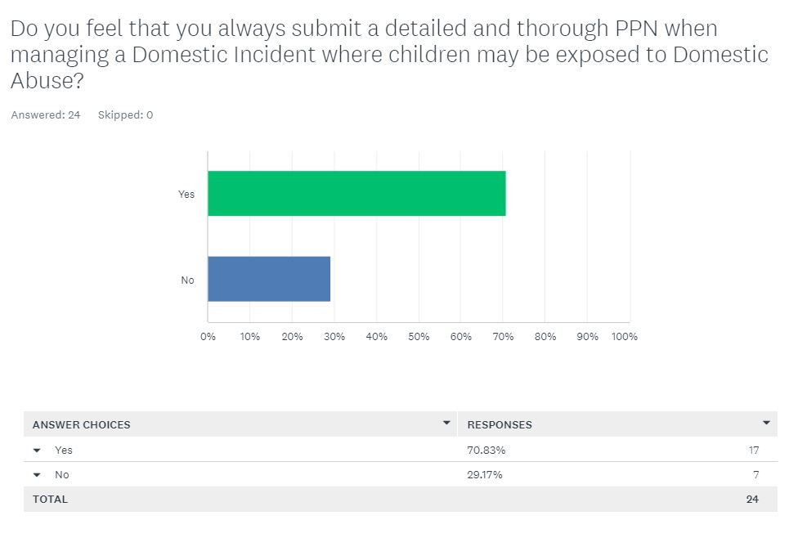

Question 5) When a child has been present at a Domestic Incident, do you speak to all/any of the children to obtain their account? (Please explain why within the comment section below).
This question aims to establish whether respondents would treat children at domestic incidents as a victim rather than a witness in line with current policy. This aims to mitigate the impact of Adverse Childhood Experiences by ensuring that all children who are exposed to domestic abuse are able to provide an account of what has happened. This allows officers to identify whether the children are exposed to any potential Adverse Childhood Experiences and identify whether the child feels safe, or what can be done for the child to feel safe and share this with social services via a PPN submission. 75% of respondents would claim that they would speak to children present at a Domestic Abuse incident. However, 25% of participants would not speak to the children.
There are four main themes identified from the participants comments: some participants would not speak to any children present, others would sometimes speak to children present dependant on circumstances, some would treat the child as a witness rather than a victim and, some would always speak to any children within the household.
Those who would not speak to any children present at the incident suggest, that “sometimes this is not appropriate due to their ages” or “sometimes the children are sleeping and therefore cannot be spoken to or they are too young”.
Participants who would speak to children dependant on circumstances would state that, “I will sometimes speak to the children if they are awake or if it is necessary within the circumstances as the child may not of been present therefore, I will not speak with them as speaking to Police can be daunting”, “depending on age” and, “if parents say the same thing I will always try to confirm with children if they are old enough. Can be awkward as parent will usually want to be there to see what the children say” and, “I try to speak to all of the children at a domestic incident however, sometimes this isn’t possible due to their age”.
Partakers who would treat the children as a witness rather than a victim believe that “their opinion is important and kids tend to tell it as it is”, “to obtain their account of what happened” and, “always speak to the child as part of my investigation”.
However, those who ensure that they would always speak to any children present recognise, “it is important to speak at some point to all children within the household. Priority should be taken to speak to any children who have actually witnessed the domestic incident, as this may be evidential. However, further information from other siblings who may have also been present, but not witnesses, will be important as this will help build a picture of what the household is like on a day to day basis and this will help supporting agencies provide the most appropriate support”. These respondents also highlight, “within PPU if there is an incident involving a child or that they have witnessed, they would be spoken to by police through a witness interview planning booklet, often with social services present. We generally try and speak to all children within the family too even if they have not witnessed that specific incident, as they could have an account of previous incidents”. These contributors will also identify that, “it is vital that all children who may be witness to domestic abuse are spoken to. Not only do children provide vital evidence and information but can show signs of emotional distress as a result of being in a household where Domestic Abuse is perpetrated”.
The varying themes identified within these responses suggests that there are perhaps limited respondents who understand why capturing the voice of the child is important. For example, some participants would only ensure that they speak to the child to gather evidence for prosecution and are not considering whether the child has been impacted by what has been witnessed or whether they may need support. Other participants would not wake the child if they were sleeping to ensure that they feel safe when they are at home and fail to recognise that this could be a regular occurrence. Other participants fail to speak to children due to their age and fail to recognise that the child may tell them that they do not feel safe when they are at home. 75% of respondents stating “yes” in response to this question suggest that this objective is being met however, the further responses provided highlight that only the minority recognise why this needs to be done and the importance of this. This may suggest that although a child’s voice is being considered, this is not always being obtained due to limited knowledge and understanding of the participants. This would indicate that the objective is not successfully met.
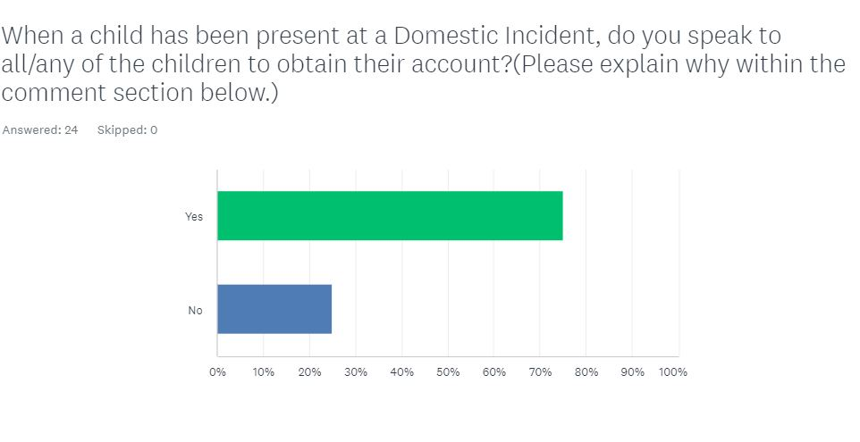

Question 6) Do you always obtain the details of all the children linked to the involved parties? (For example, those living with ex-partners/grandparents etc) Please provide reasons why within the comment section below.
This question sets out to further explore whether policies and procedures surrounding Operation Encompass are effectively being met to help mitigate the effects of ACES on children who have been exposed to domestic abuse. However, this question specifies that this is being done when children are not present at the address. Operation Encompass outlines that this is achieved “when the police attend incidents of domestic violence or abuse where children are directly or indirectly involved, they notify the designated safeguarding lead at the child’s school before the start of the next school day. The safeguarding lead then makes sure the child gets the immediate support that they need.” (Metropolitan Police, 2024).
75% of participants confirmed that they would obtain the details of all children including any children not at the address at the time of the incident. A number of respondents solidified this understanding within the comment section confirming that, “where a child has been exposed to domestic abuse and is likely to continue to do so, identifying family members who offer safety and security is essential to maintain the welfare and emotional well-being of the child(ren)”, “even if the child doesn’t live at the address they may have contact with the parties of domestic abuse which could put them at risk”, “Children who are not at the address or who usually reside with another party may still be exposed to the abuse and should be referred for support. Their schools should also be made aware so that they are able to keep an eye on the welfare of the child” and, “Op encompass means we have a statutory obligation to share all children involvement to their school. Social Services may have information the police do not so sharing this information can be important for any safeguarding issues”. These responses display a clear understanding of the current policies and procedures in place and the reasons why they need to be adhered to.
However, 25% of respondents confirm that they do not obtain the details of all children including any who are not at the address. It is notable that other responses within the comment section highlight a lack of understanding around the purpose and importance of Operation Encompass. Some respondents believe, “sometimes they are not relevant as they were not there or involved and asking them and speaking to them could cause them to be upset and worried” and, “I do try to but sometimes it slips my mind as it feels irrelevant to the specific incident”. Other respondents will simply confirm that they “will obtain the details of the children that are there” or that their “focus can often be on the most involved child”.
Research responses suggest that although some respondents have a clear knowledge and understanding of what Operation Encompass is and how to carry out this procedure, there are several respondents who do not appear to have any knowledge of Operation Encompass and are not following the correct policies and procedures which may perhaps lead to safeguarding errors.
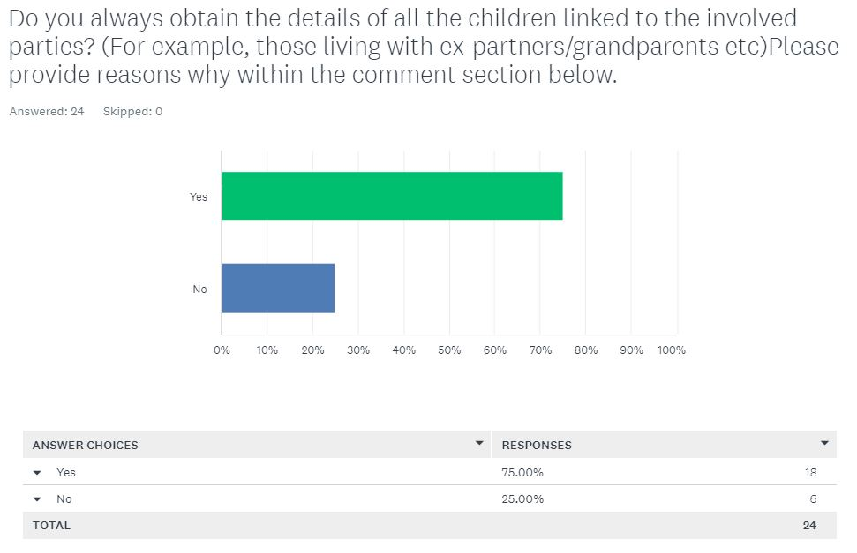

Question 7) Do you always obtain the children’s School and GP information? (Please provide comments within the comment section below)
This question sets out to establish whether police officers are successfully obtaining the up to date and correct information surrounding who children’s public protection notification needs to be shared with. Current studies criticise that, “highly vulnerable individuals frequently interact with health-care services but remain unknown to the police” (Kennedy, N. 2023). Suggesting that information sharing between Police, Health, Schools, and Social Services is essential to effectively mitigating the risk of ACES on children who have witnessed Domestic Abuse. 54.17% of respondents state that they always obtain a child’s GP and School information.
8.33% of participants will confirm that they do not always obtain the children’s School or GP details.
The other 37.50% of respondents have selected other.
The comments received from respondents suggest that this objective is not always met. Some respondents state that they “always obtain the child’s school but not always the GP”. Others state that they “do when they remember but sometimes forget it”. This suggests that not only is there limited understanding of operation compass among some respondents, but also a lack of understanding around who the Public Protection Notifices are shared with and how this helps to mitigate the effect of ACES on children who have been exposed to Domestic Abuse.
However, other respondents confirm that, “operation encompass ensures that schools attended by children who witness domestic abuse are supported within the education setting. GPs are not only a rich source of information relating to families but can offer additional services to children who may be effected by domestic abuse”. This response shows a heightened level of understanding surrounding why this information is obtained and shared by police and how this initiates support for children and young people.
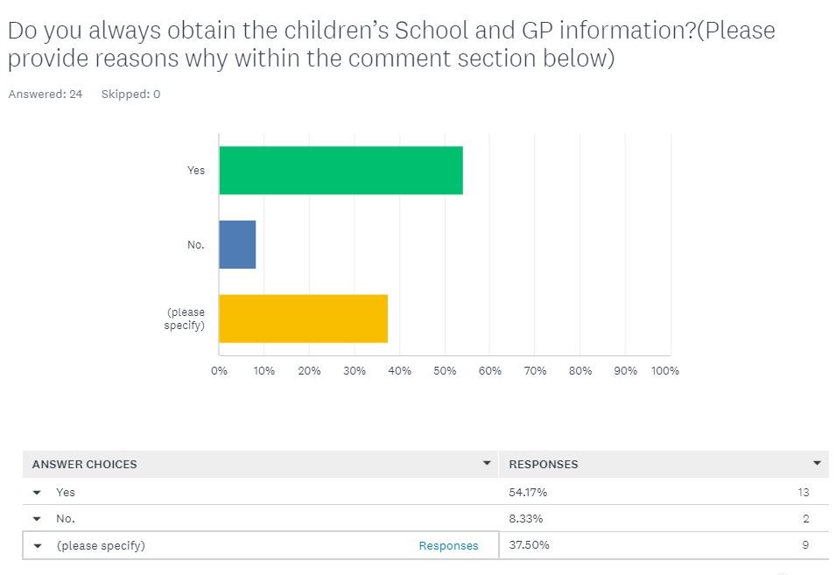

Question 8) Do you understand why the child concern section of a Public Protection Notification Referral (PPN) need to be completed? Please explain your understanding within the comment section below.
This question aims to identify the level of understanding respondents have regarding why the information on the child concern section of the referral is relevant and how this information may be useful.
75% of respondents feel that they understand why the child concern aspect of the referral needs to be completed. Comments which corroborate this answer include, “accurately identifying child concerns within the PPN allows children services to identify whether the child is in need, or at risk and offer the correct level of intervention and prevention to ensure the needs of the child are met”. This response outlines that this part of the referral not only allows agencies to identify when support is required but also when the child is at risk and intervention is required. This underlines that early intervention and prevention is key to mitigating the effects that ACES have on children who have been exposed to domestic abuse. Similarly, other respondents recognise that this question set “allows us to paint a bigger picture of the circumstances in which the children live in. It also allows us to appropriately risk assess the situation and make decisions which best safeguard those involved”. Underlining, that this information is also vital for officers to conduct an accurate risk assessment to not only assess the immediate safety of the child, but also to ensure that the referral is accurately completed to aid third party agencies in safeguarding the children effectively.
25% of respondents do not understand why the child concern section of the referral needs to be completed. More concerning responses outline a lack of understanding feeling that this is completed “for future calls”, that they are “not sure” and, “sometimes they don’t give a lot of information and I don’t see the relevancy if they don’t say anything”. These responses underline a lack of understanding of why policies and procedures are in place which correlates to them not always being followed.
These responses highlight that when there is sufficient knowledge and understanding surrounding policies and procedures, these are adhered to meaning the objective is met. However, when there is a failure to understand and recognise the importance of policies and procedures this can result in these not being met, especially to the expected standard which could in turn effect how well they assist with mitigating the effect of ACES on the involved children.
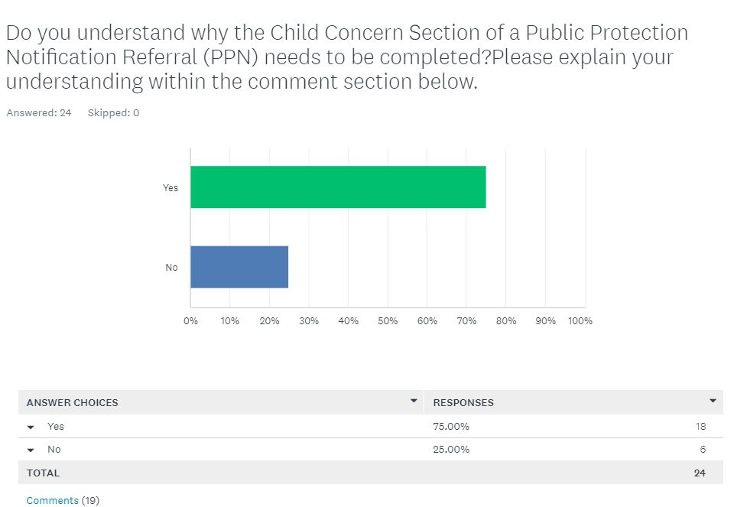

Question 9) Do you know who a child concern PPN is shared with and how this information is used? (If yes, please explain your understanding)
This question sets out to identify whether respondents understand the policies and procedures surrounding the submission of Public Protection Notice (PPN) referrals. This explores whether respondents recognise how their observations are used to help mitigate against potential ACES on children who have been exposed to domestic abuse.
66.67% of respondents would state that they know who a child concern PPN is shared with. Explanations supporting this knowledge are limited to responses such as, “social services and this information will then be used to assess what resources are needed and what action plan can be created for this child. Multiple PPNs on different occasions can help to build a picture of the child’s life”, “PPNs are shared with children’s services initially. Depending on the needs of the child, this can be shared further with other agencies, such as health, education, or 3rd sector agencies. The PPN is useful for other agencies to identify the risks and signpost the child to the most appropriate agency which is best placed to support the child” and, “A PPN is discussed in a strategy meeting, facilitated by social services where there is information shared between agencies that are involved with the family such as police, social services, health, education”. This suggests that a number of respondents who answered yes, do have a strong level of understanding of who a PPN is shared with and how this information is used.
However, a number of respondents show very limited knowledge and will state, “Social Services”, “limited knowledge” and, “social services and healthcare”. This suggests that a number of people who responded yes, are aware of some agencies the PPN is shared with but not all and have little to no knowledge of how this information is used to support children who are identified as at risk or in need of support or early intervention.
33.33% of other participants answered no. Answers which support this response include, “no, I send it to the email and I do not get updated after this”, “not sure who it is shared with” and “do not know who the information is shared with or how this would support the child”. These answers reflect that there are a number of participants who do not understand the policies and procedures in place and how this information can be vital to having a positive impact on children’s lives moving forward.
These research responses may suggest that a lack of knowledge and understanding surrounding how a PPN is used to assist children at risk, may directly impact the quality of PPN submissions. This in turn could effect the effectiveness of this policy in mitigating ACES on children who have witnessed domestic abuse. This could indicate that participants would benefit from regular training to solidify this.
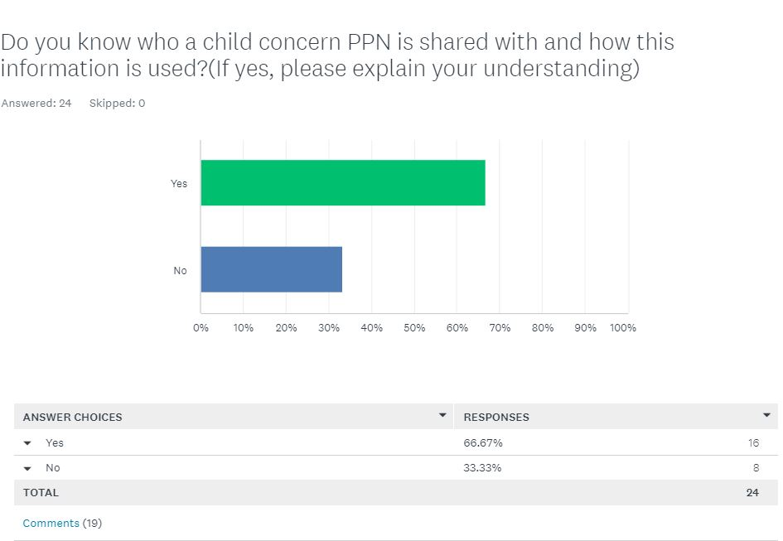

4.5 Participant views and opinions
Question 10) Do you feel that any of the below effect the quality of your PPN submissions? (Please select all that apply)
This question sets out to obtain the respondents views and opinions surrounding whether the current policies and procedures in place are fit for purpose in today’s society and if not, why not. These options were broken down into:
- None of the above
- I have insufficient time after calls to complete a detailed enough PPN
- I have limited knowledge and understanding of ACES and the effect these may have on children
- Other
16.67% of people felt that none of the above effected the quality of their PPN submissions.
66.67% of partakers felt that they had insufficient time after calls to complete a detailed enough PPN.
20.83% of respondents believe that the child concern section on the PPN is not thorough enough.
20.83% of participants express they have limited knowledge/understanding of ACES and the effect these may have on children.
12.50% stated they felt that other reasons impacted the quality of their PPN submissions.
Respondents who stated “other” were required to provide an explanation, these respondents stated that, they had “insufficient time sometimes, not all the time”, that “putting the amount of risk into words can be difficult” and, “timings can effect but it is dependent on the seriousness of the incident”.
Research responses suggest that large portion of respondents feel that they do not always have sufficient time after a domestic incident to submit a thorough and PPN, this is also reflected within the “other” responses. However, there are also several respondents who believe that the child concern section on the PPN would benefit from being more thorough in order to meet the desired objective. The research responses also indicate that numerous participants do not feel that they have sufficient knowledge and training around Adverse Childhood Experiences and that further learning is required for them to effectively fulfil their role.

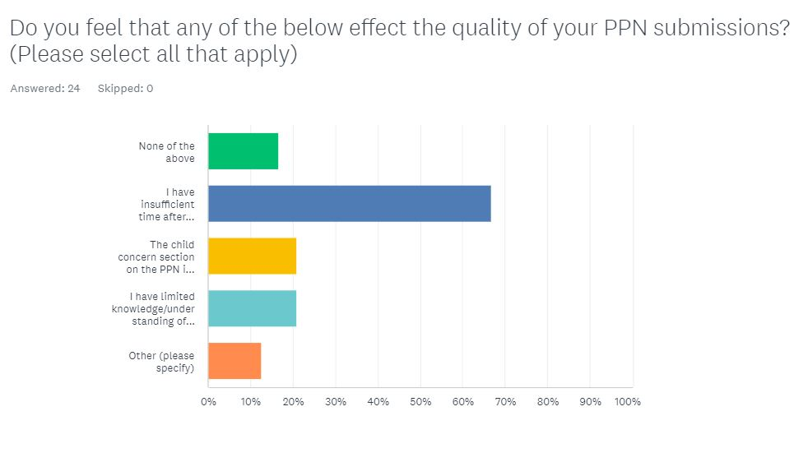

4.6 Conclusion
Concluding the results above, one of the main themes that can be identified from the research is a recurring theme that participants do not have a clear knowledge or understanding around policies and procedures. The research results suggest that perhaps the policies and procedures in place are adequate but further learning and training is required to ensure that these are fully understood by participants to ensure that they know how to implement these into their day to day duties and successfully achieve the desired outcomes.

5.0 Conclusion and Recommendations
5.1 Introduction:
This concluding chapter will provide an overview of the research findings in this study. During this overview, reflection will take place surrounding the objectives laid out within the introductory chapter. This is to establish whether the objectives of this dissertation have been successfully met. However, this will also establish whether the research findings support or oppose the research discussed within the literature review. Finally, this chapter will conclude with its recommendations.

The objectives of this research are as follows:
1. Exploring the effectiveness of policies in place to reduce the impact of experiencing ACES on children who have witnessed domestic abuse.
2. Exploring the current policies in place that aim to mitigate the impact on witnessing domestic abuse.
3. Identifying whether these policies fit for purpose in today’s society.

5.2 Summary of primary findings:
The aim of this dissertation is to study Police effectiveness on mitigating the potential impact of adverse childhood experiences on children who have witnessed domestic abuse. A questionnaire was sampled among 25 police officers within response policing and the public protection unit to establish participating officers’ knowledge and understanding of Adverse Childhood Experiences (ACES) and current policies and procedures in place which set out to achieve this. The findings of this research indicated that there is a limitation of knowledge around both Adverse Childhood Experiences and the current policies and procedures in place which aim to mitigate the effect on children.

5.3 Objectives:
5.3.1 Explore the effectiveness of policies in place to reduce the impact of experiencing ACES on children who have witnessed domestic abuse.
Participants understanding of current policies and procedures was analysed through questions put to them within the research survey. The research questions included those directed to the understanding of current policies and procedures in place and the impact that these may have on reducing a child’s development of Adverse Childhood Experiences. Several survey questions also required the participant to evidence their knowledge within a comment section. This question set identified that there is a quantity of participants who demonstrate a clear understanding of the policies and procedures in place, including Operation Encompass, Public Protection Notifications (PPN) and, multi-agency working. However, responses to this question also identified participants that have a limited knowledge of the current policies and procedures in place. Some participants also clarified that they had no knowledge surrounding the policies and procedures in place and would just submit a Public Protection Notification because they are required to do so at a Domestic Incident. In addition to this, further questions within the survey required participants to elaborate on how the information is shared. Participants with a heightened understanding explained that Operation Encompass requires officers to obtain children’s School and General Practitioner (GP) information so that the information is shared with them, and further relevant referrals and signposting can be implemented where required for the child. They would also outline that the Public Protection Notification is shared with children’s services initially, who will then evaluate the information within the referral and disseminate this to the most appropriate departments in order to implement the correct supports and safeguards for the children’s needs. However, other participants displayed significantly less knowledge advising that the Public Protection Notification is shared with Social Services. Whereas, some participants would confirm that they did not know what happens with a Public Protection Notification or why children’s General Practitioner or School information needs to be obtained by police at every Domestic Incident. Perhaps the highlighted lack of understanding amongst participants correlates to the effectiveness of policies and procedures in place to reduce the impact of experiencing Adverse Childhood Experiences on children who have witnessed Domestic Abuse.

5.3.2 To explore the current policies in place that aim to mitigate the impact on witnessing domestic abuse.
Upon arrival at any Domestic related call, attending officers should identify the presence of any children at the address. This includes children present at the incident but also those who may not be present at the time but who sometimes reside at the address or are a child of the victim or the perpetrator. Supporting this (CPS, 2022) announced guidance stating that “children effected by domestic abuse will be automatically treated as victims regardless of whether they were present during violent incidents”. This is also because children who are a child of the victim or perpetrator at the address may have already witnessed domestic incidents or may witness any that could arise in the future. Officers are then required to obtain the name, date of birth, School and General Practitioner information of each child. This is part of Operation Encompass, which aims to “improve early intervention and enable the most vulnerable children to be safeguarded from the harms of Domestic Abuse” (Operation Encompass, 2019). Officers then submit all the children’s information and the information surrounding the incident to Social Services who are able to then identify whether the child is at risk. This is done by submitting a PPN, “an information sharing document that records safeguarding concerns about an adult or child. PPNs are shared with partner agencies to inform a multi-agency response” (HMICFRS, 2023). They are then able to evaluate the correct level of intervention and prevention to meet the needs of the individual. Within the PPN, there is a child concern section which includes a child’s voice, prompting officers to speak to all children who are present at the address. A reflection on Public Protection Notices within Gwent area highlights, “that analysis also includes the impact of the situation on the child/children which is helpful to know before making contact” (Royal Society for Public Health, 2020). This not only assists officers with identifying whether any offences have occurred, but it helps understand the impact that the incident has had on the child so that this can be noted within the PPN to assist with identifying the correct support for the child. However, there are lessons to be learned “since the Domestic Abuse Act 2021, children that have been exposed to domestic abuse are now recognised as victims of domestic abuse in their own right, rather than just witnesses” (Barnardo’s 2024). However, analysing respondents’ answers to the questionnaire surrounding whether all children at the address are spoken to at domestic incidents, many responses suggest that officers are still treating children as witnesses rather than victims. Some responses suggesting, “if they are asleep or were not present, I will not speak to them”, “to obtain their account of what happened” and, “always speak to all children as part of my investigation”. This indicates that there are still lessons to be learned when managing the risks posed to children who are present at domestic incidents. However, this also highlights a misunderstanding around children and their exposure to Adverse Childhood Experiences which may mean that further learning is required surrounding this to support police being more effective in reducing the impact of ACES on children who witness domestic abuse.

5.3.3 Are these policies fit for purpose in today’s society?
More and more children are experiencing Adverse Childhood Experiences. The number of children effected by Adverse Childhood Experiences is increasing. “Forty-Four percent (4,085) of police-reported Domestic Violence incidents were reported to have at least one child witness” (Gjelsvik. Verhoek-Oftedahl. Pearlman. 2003). Adverse Childhood Experiences should be mitigated, as research suggests “all generations with one or more early-life adversities were at greater risk for substance abuse, mental illness, and perpetrating violence compared to those reporting no ACEs” (Gordon. Asmundson. Afifi. 2020). Respondents were asked questions surrounding the current policies and procedures within the survey. 66.67% of respondents felt that they had insufficient time after a domestic incident to submit a detailed and thorough PPN. 20.83% of participants in the questionnaire felt that the child concern section on the PPN is not thorough enough. 20.83% of respondents will confess that they have limited knowledge or understanding of ACES and the effect that these have on children. Research suggests that perhaps officers would benefit from additional time following a domestic incident to ensure that a high quality PPN can always be submitted. As outlined above, ACES are prevalent and have long lasting effects that should be addressed however, based on the responses of this research, it could be argued that due to the lack of knowledge from the participants, those who are tasked with protecting the vulnerable do not feel that they are trained efficiently when managing risks posed to children at domestic incidents. Suggesting that the policies in place are fit for purpose but are not effective in their objective as further learning may be required.

5.4 Recommendations and conclusion
Concluding this dissertation, it can be identified that there are several research participants with a clear and extensive understanding of Adverse Childhood Experiences and the police services current policies and procedures to work towards mitigating the effect of domestic abuse on children. However, it is also notable that there are a large portion of participants with limited knowledge surrounding these topics. This suggests that there are recommendations that can be detected as a result of this research. For example, the research suggests that further training may be required to ensure that officers have the knowledge and ability to be able to identify potential Adverse Childhood Experiences. In addition to this, further training may also be useful, so that the current policies and procedures are fully understood in order to be successfully applied and followed to effectively respond to children who are exposed to Adverse Childhood Experiences. This in turn would help children receive the correct help and support. In addition to this, police officers on response policing could be required to complete a substantial attachment on the Public Protection Unit, working with specialised officers in order to expand on their knowledge and skills from training. Similarly, police officers may benefit from attachments with Children’s Social Services to understand how the information that they share is used and disseminated in order to support children who are experiencing domestic abuse at home.

Bibliography:
Aerd dissertation, 2012. Principles of research ethics. [online] Available at: Principles of research ethics | Lærd Dissertation (laerd.com) (Accessed 12/05/2024).
Alsaawi, A (2014) A critical review of qualitative interviews. [online] Available at: A Critical Review of Qualitative Interviews by Ali Alsaawi :: SSRN (Accessed 17/06/2024)
Ashley, L. Armitage, G. Taylor, J. 2016. Recognising and referring children exposed to domestic abuse: a multiprofessional, proactive systems-based evaluation using a modified Failure Mode and Effects Analysis (FMEA). [online] Available at: Recognising and referring children exposed to domestic abuse: a multi-profe...: EBSCOhost (uwtsd.ac.uk) (Accessed 03/05/2024).
Asmundson, G. Afifi, T. (2019) Adverse Childhood Experiences : Using Evidence to Advance Research, Practice, Policy, and Prevention. [online] Available at: ProQuest Ebook Central - Reader (Accessed 03/04/2024)
Asmundson, G. J. G., & Afifi, T. O. (Eds.). (2020). Adverse childhood experiences : using evidence to advance research, practice, policy, and prevention. Elsevier/Academic Press. [Online] Available at: ProQuest Ebook Central - Reader (Accessed 03/04/2024)
Barnardo’s (2024). Children affected by Domestic Abuse. [Online] Available at: Effects of domestic abuse on children | Barnardo's (barnardos.org.uk) (Accessed 09/09/2024).
Beedlove, M. Choi, J. Zyromski, B. (2020) Mitigating the Effects of Adverse Childhood Experiences: How Restorative Practices in Schools Support Positive Childhood Experiences and Protective Factors [online] Available at: Mitigating the Effects of Adverse Childhood Experiences: How Restorative Practices in Schools Suppor (actionaces.org) (Accessed 07/10/2024)
Bellis Et Al, (2014). Adverse Childhood Experiences (ACES) and Attachment. [Online] Available at: Adverse Childhood Experiences (ACEs) and Attachment - Royal Manchester Children's Hospital (mft.nhs.uk) (Accessed 03/04/2024)

Brodie, Z, P. Hawkins, R, D. Mckinlay, J. (2022) “Abusers are Using COVID to Enhance Abuse”: Domestic Abuse Helpline Workers’ Perspectives on the Impact of COVID-19 Restrictions on those Living with Domestic Abuse. [online] Available at: “Abusers are Using COVID to Enhance Abuse”: Domestic Abuse Helpline Workers’ Perspectives on the Impact of COVID-19 Restrictions on those Living with Domestic Abuse - Zara P. Brodie, Roxanne D. Hawkins, Chloe MacLean, Jack McKinlay, 2023 (uwtsd.ac.uk) (Accessed 04/05/2024)
CDC, Vital Signs (2021). Adverse Childhood Experiences (ACES). [online] Available at: Adverse Childhood Experiences (ACEs) | VitalSigns | CDC (Accessed 30/09/2024).
City University of London (2024). Research ethics approval process. [online] Available at: Research ethics approval process • City, University of London (Accessed 12/05/2024).
College Of Policing. 2024. Arrest and other positive approaches. [online] Available at: Arrest and other positive approaches | College of Policing (Accessed 04/05/2024).
CPS, (2022) Children classed as domestic abuse victims under new guidance. [online] available at: Children classed as domestic abuse victims under new guidance | The Crown Prosecution Service (cps.gov.uk) (accessed 06/10/2024).
CPS. 2017. Domestic Abuse Referrals from the Police to CPS – Troubleshooting Guide. [online] Available at: Domestic Abuse Referrals from the Police to CPS – Troubleshooting Guide (Accessed 04/05/2024)
Davies, T. Bowers, K. (2019). Patterns in the supply and demand of urban policing at the street segment level. [online] Available at: Full article: Patterns in the supply and demand of urban policing at the street segment level (uwtsd.ac.uk) (Accessed 04/05/2024).
Devaney, J. 2008. Chronic child abuse and domestic violence: children and families with long-term and complex needs. [Online] Available at: Chronic child abuse and domestic violence: children and families with long-...: EBSCOhost (uwtsd.ac.uk) (Accessed 03/05/2024).
Ferguson, G. Featherstone, B. Morris, K. 2019. Framed to fit? Challenging the domestic abuse ‘story’ in child protection. [online] Available at: Framed to fit? Challenging the domestic abuse ‘story’ in child protection - ProQuest (Accessed 03/05/2024).
GELLER, A., PHD., 2021. Youth-Police Contact: Burdens and Inequities in an Adverse Childhood Experience, 2014-2017. American Journal of Public Health. [online] Available at: Youth-Police Contact: Burdens and Inequities in an Adverse Childhood Experience, 2014-2017 - ProQuest (Accessed 03/05/2024).
Gjelsvik, A. Verhoek-Oftedahl, W. Pearlman, D. (2003). Domestic violence incidents with children witnesses: findings from Rhode Island surveillance data. [Online] Available at: Domestic violence incidents with children witnesses: findings from Rhode Island surveillance data - ScienceDirect (Accessed 09/09/2024).
Gordon, J. Asmundson, G. Afifi, T. (2020) Adverse Childhood Experiences: Using evidence to advance research, practice, policy, and prevention. [Online] Available at: ProQuest Ebook Central - Reader (Accessed 10/09/2024)
HMIC, 2015. PEEL: Police effectiveness 2015 (vulnerability). [Online] Available at: police-effectiveness-vulnerability-2015-south-wales.pdf (justiceinspectorates.gov.uk) (Accessed 03/05/2024).
HMICFRS (2023). Public Protection Notice (PPN). [online] Available at: Public protection notice (PPN) - His Majesty’s Inspectorate of Constabulary and Fire & Rescue Services (justiceinspectorates.gov.uk) (Accessed 04/08/2024).
HMICFRS, (2023). Public Protection Notice (PPN). [Online] Available at: Public protection notice (PPN) - His Majesty’s Inspectorate of Constabulary and Fire & Rescue Services (justiceinspectorates.gov.uk) (Accessed 09/09/2024).
IOSH (2024). Ethical Practice. [online] Available at: Ethical Practice in Safety and Health | IOSH (Accessed 12/05/2024).
Islands safeguarding children partnership. Strategy discussion. [online] Available at: Strategy discussion - Child Protection Guidelines (iscp.gg) (Accessed 03/05/2024),
Kelly, K. Clark, B. Brown, V. Sitzia, J. (May 2003) [online] available at: Good practice in the conduct and reporting of survey research | International Journal for Quality in Health Care | Oxford Academic (oup.com) (Accessed 17/06/2024)
Kennedy, N. (2023). Insights from linking police domestic abuse data and health data in South Wales, UK: a linked routine data analysis using decision tree classification. [online] Available at: Insights from linking police domestic abuse data and health data in South Wales, UK: a linked routine data analysis using decision tree classification - ScienceDirect (Accessed 05/08/2024)
McPhee, D. Hester, M. Bates, L. Lilley-Walker, S. J. Patsios, D. (2022). Criminal justice responses to domestic violence and abuse in England: an analysis of case attrition and inequalities using police data. [online] Available at: Full article: Criminal justice responses to domestic violence and abuse in England: an analysis of case attrition and inequalities using police data (uwtsd.ac.uk) (Accessed 03/05/2024).
Metropolitan Police, (2024). Operation Encompass. [online] Available at: Operation Encompass | Metropolitan Police (Accessed 04/08/2024)
Millar, A. Devaney, J. Butler, M. 2018. Emotional intelligence: challenging the perceptions and efficacy of ‘soft skills’ in policing incidents of Domestic Abuse Involving Children. [Online] Available at: Emotional Intelligence: Challenging the Perceptions and Efficacy of 'Soft S...: EBSCOhost (uwtsd.ac.uk) (Accessed 03/05/2024).
Millar, A. Saxton, M. Overlien, C. Elliffe, R. 2021. Police Ofcers Do Not Need More Training; But Diferent Training. Policing Domestic Violence and Abuse Involving Children: A Rapid Review. [Online] Available at: Police Officers Do Not Need More Training; But Different Training. Policing...: EBSCOhost (uwtsd.ac.uk) (Accessed 03/05/2024).
NCVO (2022). Legal definition of Domestic Abuse. [online] Available at: Legal definition of domestic abuse | NCVO (Accessed 07/10/2024).
NHS Manchester University (2024). Adverse Childhood Experiences (ACES) and attachment. [online] Available at: Adverse Childhood Experiences (ACEs) and Attachment - Royal Manchester Children's Hospital (mft.nhs.uk) (Accessed 30/09/2024).
Operation Encompass, (2019). For every child. [Online] Available at: Home : Operation Encompass (Accessed 09/09/2024).
Parliament UK, (2018). The evidence behind early intervention. [online] Available at: Evidence-based early years intervention - Science and Technology Committee - House of Commons (parliament.uk) (Accessed 07/10/2024).
Pfeiffer Library Tiffin University, 2022. Research methodology. [Online] Available at: What are research methodologies? - Research Methodologies - Pfeiffer Library at Tiffin University (Accessed 12/05/2024)
Richards, L. 2009. Domestic Abuse, Stalking and Harassment and Honour Based Violence (DASH, 2009) Risk Identification and Assessment and Management Model. [Online] Available at: DASH-2009.pdf (reducingtherisk.org.uk) (Accessed 03/05/2024).
Rogers, F. Richarme, M (2015). [online] Available at: The Honesty of Onlien Survey Respondents: Lessons Learned and Prescriptive Remedies (researchgate.net) (Accessed 17/06/2024)
Royal Society for Public Health, (2020). Gwent Police roll out PPN workshops. [online] Available at: RSPH | Gwent Police roll out PPN workshops (Accessed 06/10/2024).
Safe Lives, 2014. Frequently asked questions Multi-Agency Risk Assessment Conferences (MARAC). [online] Available at: MARAC FAQs General FINAL.pdf (safelives.org.uk) (Accessed 03/05/2024)
Sun, J., Patel, F., Rose-Jacobs, R., Frank, D. A., Black, M. M., & Chilton, M. (2017). Mothers’ Adverse Childhood Experiences and Their Young Children’s Development. American Journal of Preventive Medicine. [Online] Available at: Mothers’ Adverse Childhood Experiences and Their Young Children’s Development - ScienceDirect (uwtsd.ac.uk) (Accessed 03/04/2024).

Testa, A. Jackson, D, B. 2022. Adverse Childhood Experiences and Perceived Unfair Police Treatment: Differences by Race and Ethnicity. [Online] Available at: Adverse Childhood Experiences and Perceived Unfair Police Treatment: Differences by Race and Ethnicity - ScienceDirect (uwtsd.ac.uk) (Accessed 03/05/2024).
The World Health Organisation (2020). Adverse Childhood Experiences International Questionnaire (ACE-IQ). [online] Available at: Adverse Childhood Experiences International Questionnaire (ACE-IQ) (who.int) (Accessed 30/09/2024)
Thompson, K. 2016. How is information shared in ‘everyday’ practice? [online] Available at: FIVE How is information shared in ‘everyday’ practice? from Strengthening child protection: Sharing information in multi-agency settings on JSTOR (uwtsd.ac.uk) (Accessed 03/05/2024).
University of Southampton, (2024). Primary research. [online] Available at: Home - Primary research - LibGuides@Southampton at University of Southampton Library (soton.ac.uk) (Accessed 12/05/2024)
UWE, Bristol. (2024). Disposal of Research Data. [online] Available at: Disposal of research data - Research data security | UWE Bristol (Accessed 07/10/2024).
Waite, R. Ryan, R, A. (2020) Adverse childhood experiences: what students and health professionals need to know. [online] Available at: Adverse Childhood Experiences : What Students and Health Professionals Need to Know (uwtsd.ac.uk) (Accessed 30/09/2024)
Waite, R. Ryan, R. (2020) Adverse Childhood Experiences: What Students and Health Professionals Need To Know. [online] Available at: Adverse Childhood Experiences : What Students and Health Professionals Need...: EBSCOhost (uwtsd.ac.uk) (Accessed 03/04/2024)
Wenger, C, G (1999) Advantages gained by combining qualitative and quantitative data in longitudinal study [online] Available at: Advantages Gained By Combining Qualitative and Quantitative Data in a Longitudinal Study - ScienceDirect (Accessed 17/06/2024).
Western Sydney University, (2023) Definition of Research. [Online] Available at: Definition of Research | Western Sydney University (Accessed 12/05/2024).

7. Appendices

7.1 Appendix 1 – Copy of Questionnaire

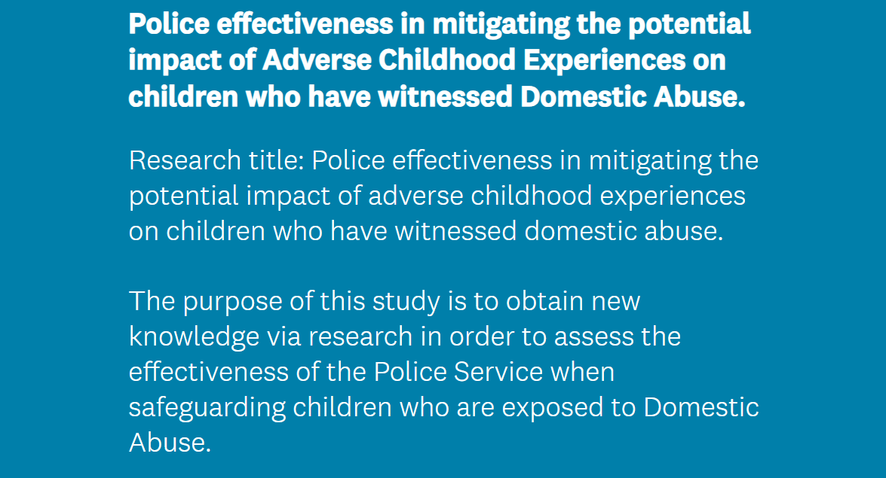
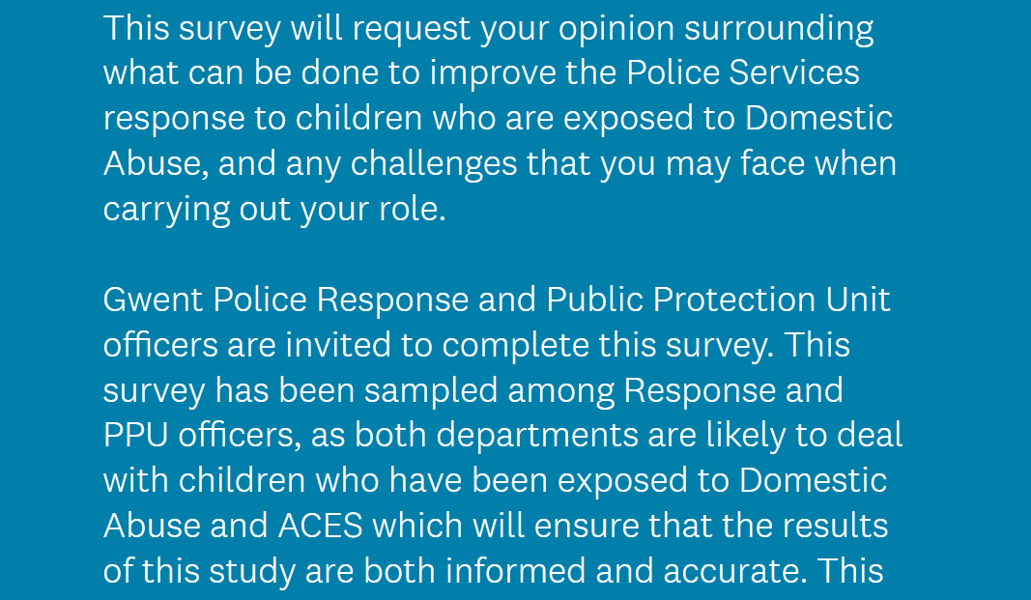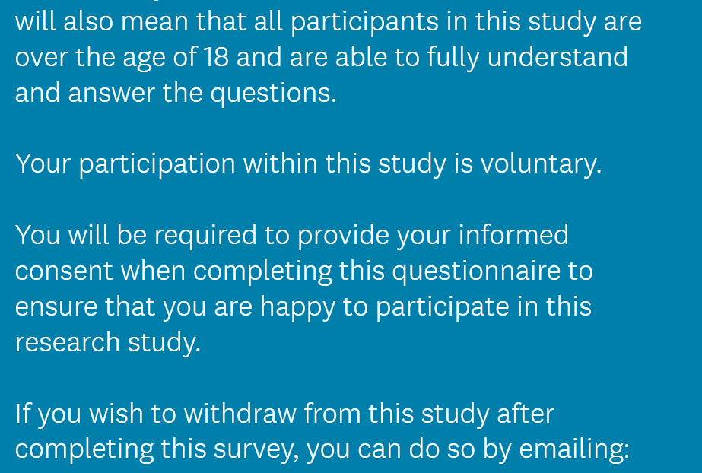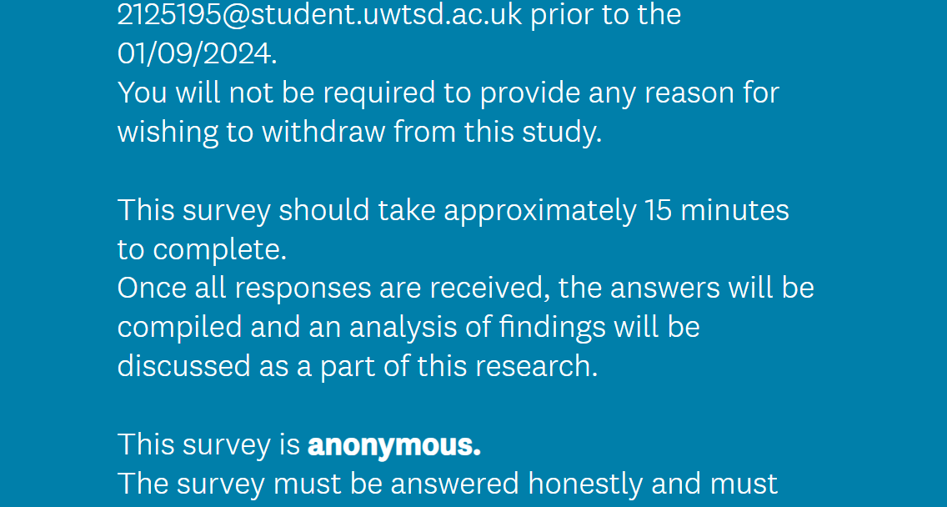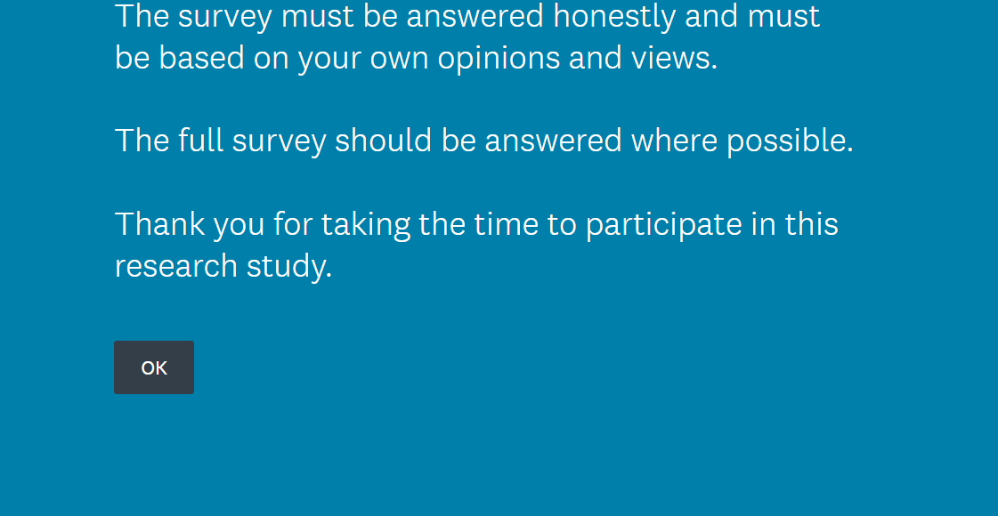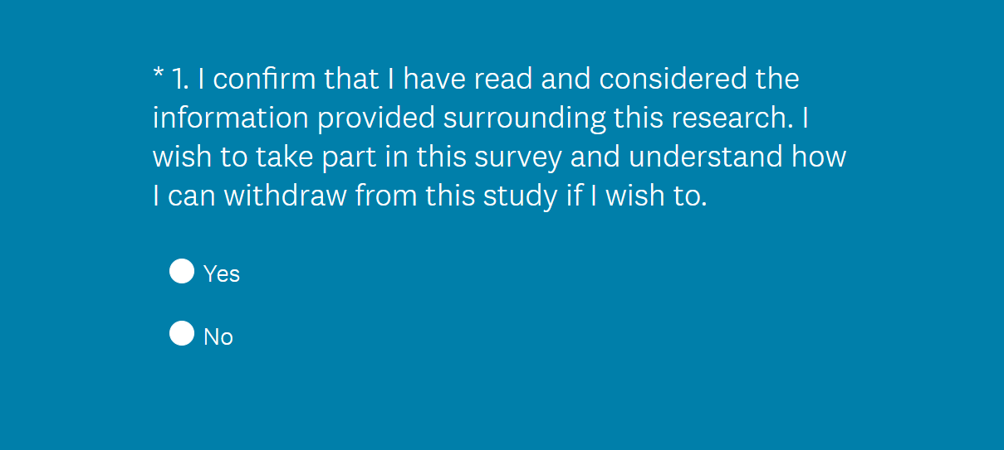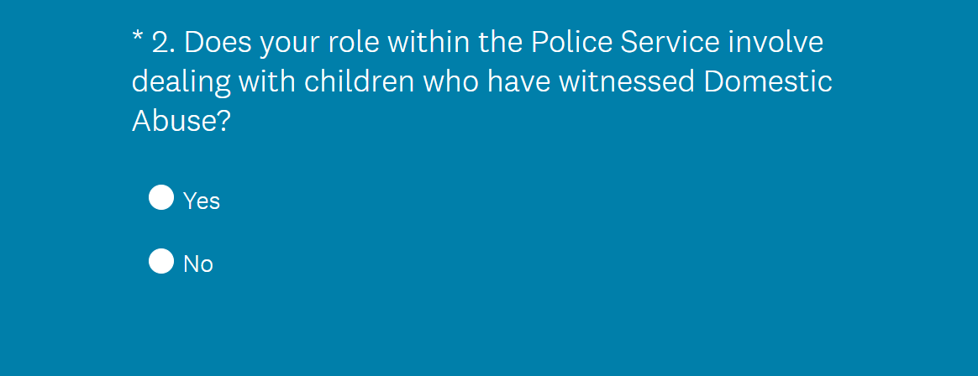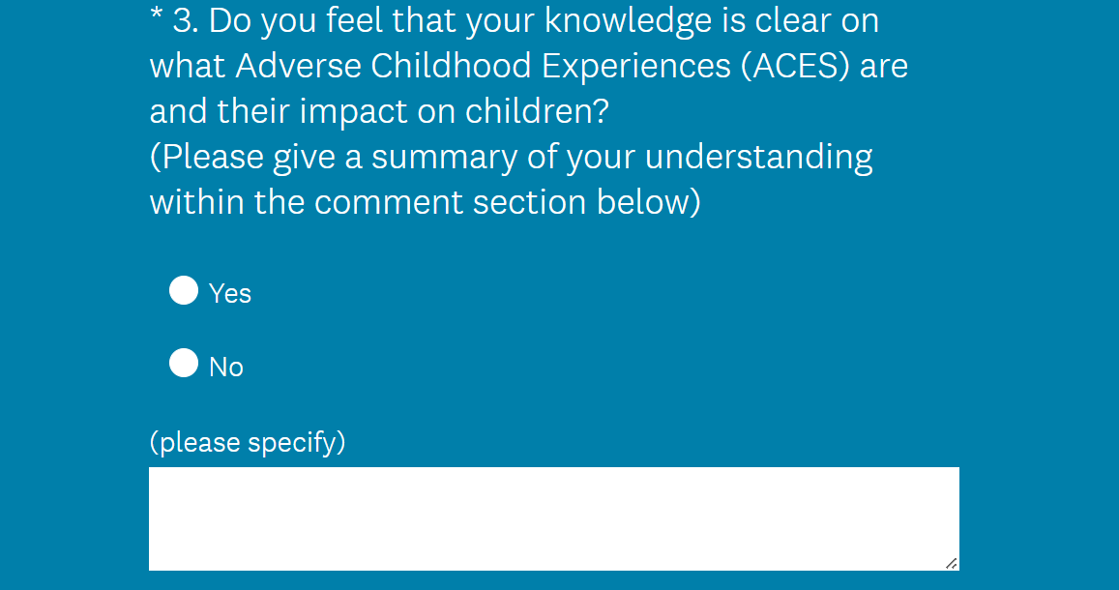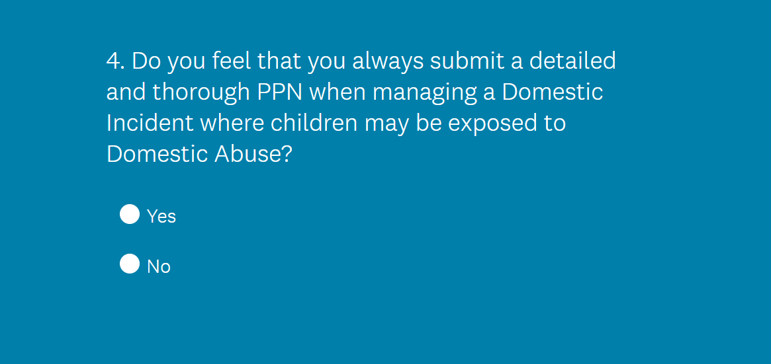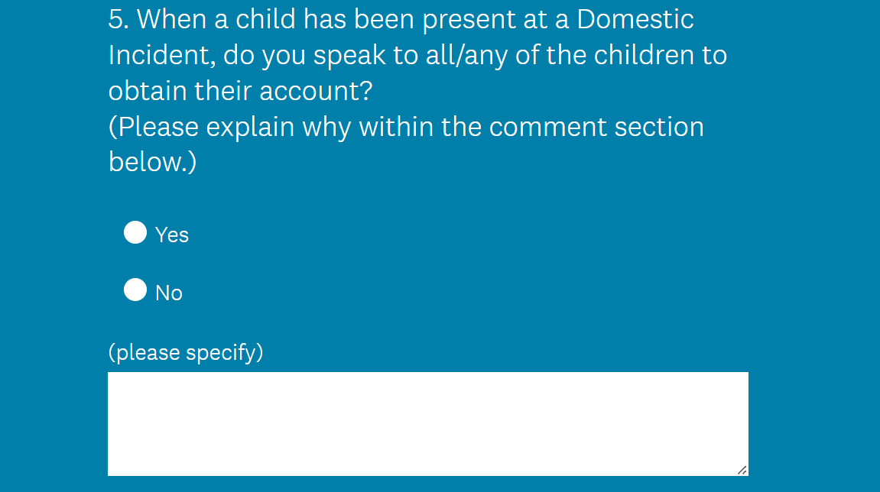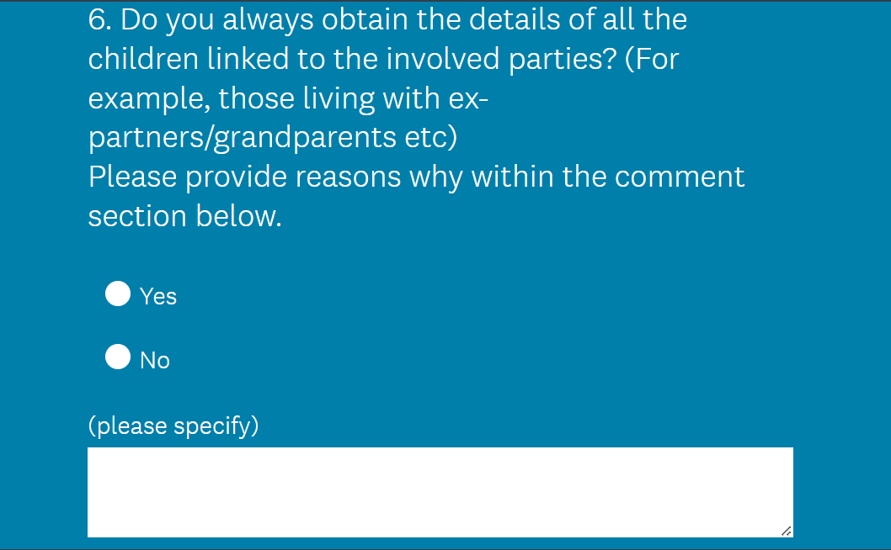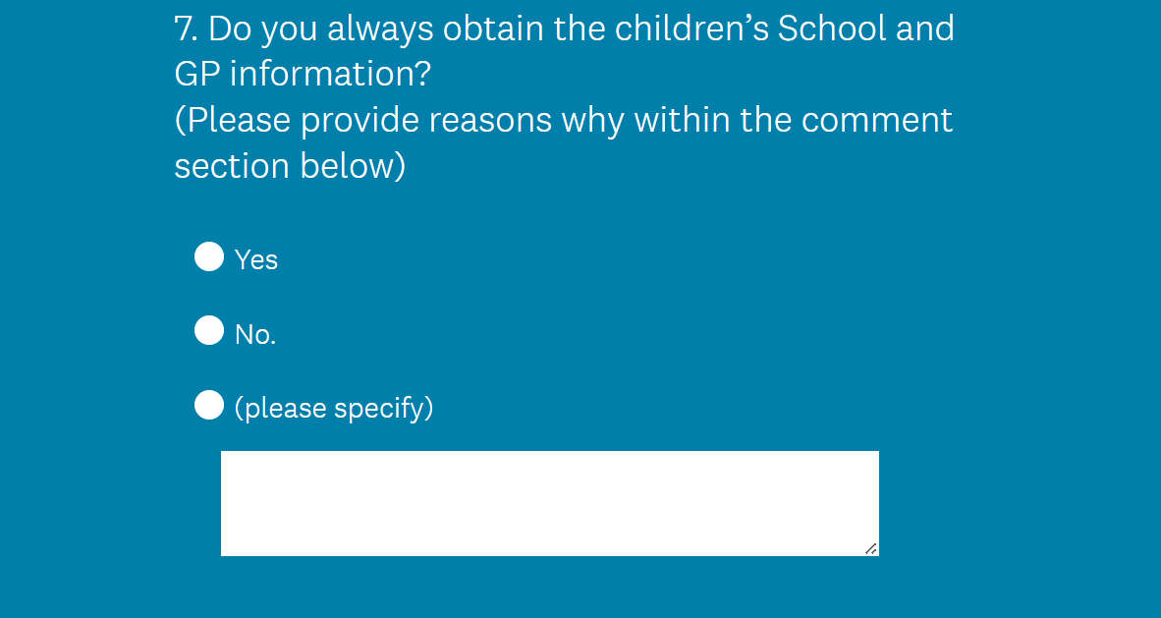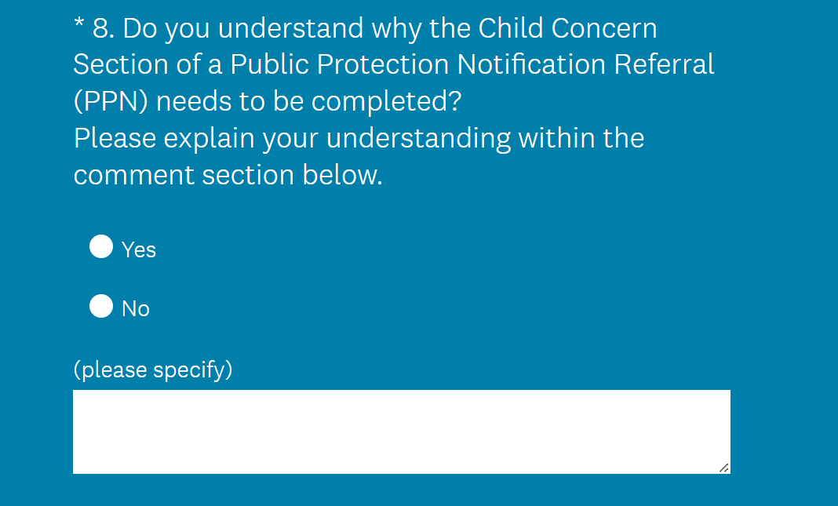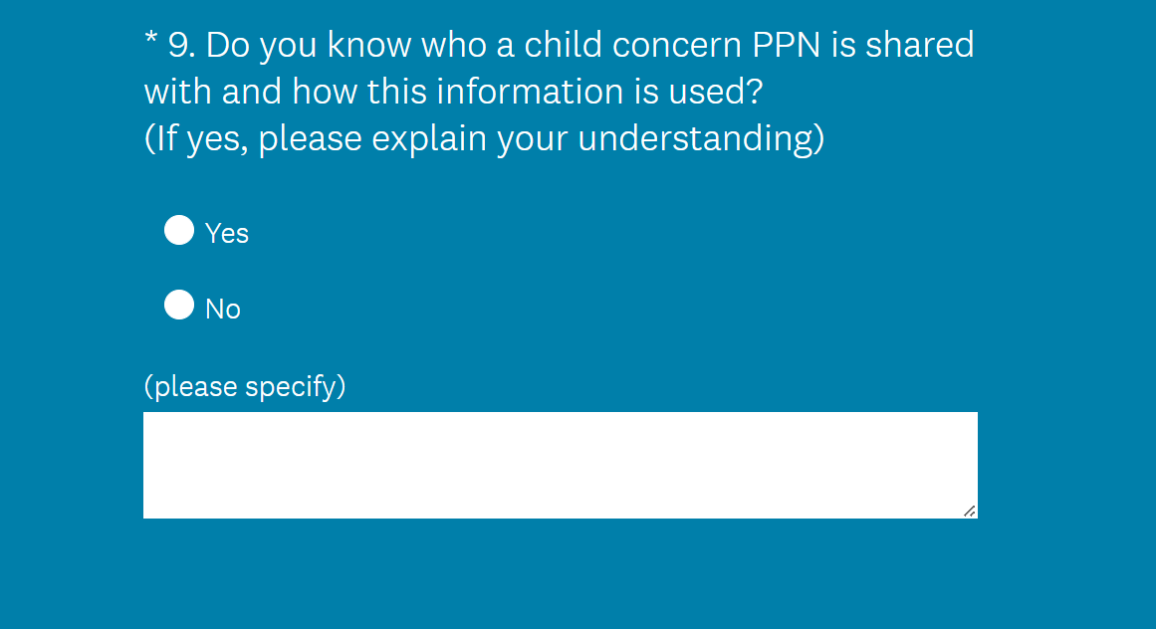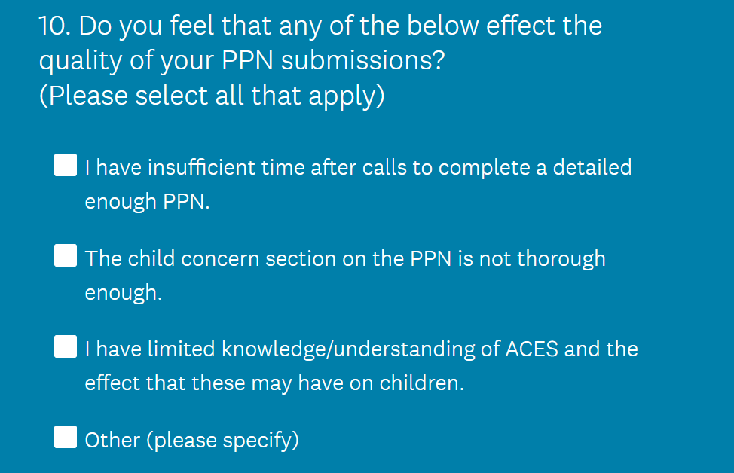

7.2 Appendix 2 - Ethics form
In order for research to result in benefit and minimise risk of harm, it must be conducted ethically. A researcher may not be covered by the University’s insurance if ethical approval has not been obtained prior to commencement.

The University follows the OECD Frascati manual definition of research activity: “creative work undertaken on a systematic basis in order to increase the stock of knowledge, including knowledge of man, culture and society, and the use of this stock of knowledge to devise new applications”. As such this covers activities undertaken by members of staff, postgraduate research students, and both taught postgraduate and undergraduate students working on dissertations/projects.

The individual undertaking the research activity is known as the “principal researcher”.

Ethical approval is not required for routine audits, performance reviews, quality assurance studies, testing within normal educational requirements, and literary or artistic criticism.

Please read the notes for guidance before completing ALL sections of the form.

This form must be completed and approved prior to undertaking any research activity. Please see Checklist for details of process for different categories of application.

SECTION A: About You (Principal Researcher)
1 | Full Name: |  | Elsie Thomas
2 | Tick all boxes that apply: |  | Member of staff: | ☐ | Honorary research fellow: | ☐
 | Undergraduate Student | ☒ | Taught Postgraduate Student | ☐ | Postgraduate Research Student | ☐

3 | Institute/Academic Discipline/Centre: | IMH
4 | Campus: | Swansea
5 | E-mail address: | 2125195@student.uwtsd.ac.uk
6 | Contact Telephone Number:
 | For students:
7 | Student Number: | 2125195
8 | Programme of Study: | BSc (Hons) Professional Policing Practice
9 | Director of Studies/Supervisor: | Michelle Hill.

SECTION B: Approval for Research Activity
1 | Has the research activity received approval in principle?  (please check the Guidance Notes as to the appropriate approval process for different levels of research by different categories of individual) |  | YES | ☒ | NO | ☐
 |  |  |  |  | Date
2 | If Yes, please indicate source of approval (and date where known): Approval in principle must be obtained from the relevant source prior to seeking ethical approval | Research Degrees Committee |  | ☐
2 |  | Institute Research Committee |  | ☐
2 |  | Other (write in) |  | ☒ | Michelle Hill

SECTION C: Internal and External Ethical Guidance Materials
 | Please list the core ethical guidance documents that have been referred to during the completion of this form (including any discipline-specific codes of research ethics, location-specific codes of research ethics, and also any specific ethical guidance relating to the proposed methodology). Please tick to confirm that your research proposal adheres to these codes and guidelines. You may add rows to this table if needed.
1 | UWTSD Research Ethics & Integrity Code of Practice | ☒
2 | UWTSD Research Data Management Policy | ☒
3 | [List any other relevant documents here] | ☐

SECTION D: External Collaborative Research Activity
If there are external collaborators then you should gain consent from the contact persons to share their personal data with the university. If there are no external collaborators then leave this section blank and continue to section E.
1 | Institution
2 | Contact person name
3 | Contact person e-mail address
4 | Is your research externally funded? |  | YES | ☐ | NO |  | ☐
5 | Are you in receipt of a KESS scholarship? |  | YES | ☐ | NO |  | ☐
6 | Are you specifically employed to undertake this research in either a paid or voluntary capacity? | Voluntary | YES | ☐ | NO | ☐
7 |  | Employed | YES | ☐ | NO | ☐
8 | Is the research being undertaken within an existing UWTSD Athrofa Professional Learning Partnership (APLP)? | If YES then the permission question below does not need to be answered. | YES | ☐ | NO |  | ☐
9 | Has permission to undertake the research has been provided by the partner organisation? | (If YES attach copy)  If NO the application cannot continue | YES | ☐ | NO |  | ☐

Where research activity is carried out in collaboration with an external organisation
10 | Does this organisation have its own ethics approval system? | YES | ☐ | NO | ☐
 | If Yes, please attach a copy of any final approval (or interim approval) from the organisation (this may be a copy of an email if appropriate).

SECTION E: Details of Research Activity
1 | Indicative title: | A childs voice: Police effectiveness in obtaining and responding to a child’s voice in order to prevent adverse childhood experiences.
2 | Proposed start date: |  | Proposed end date:
Introduction to the Research (maximum 300 words per section)
Ensure that you write for a Non-Specialist Audience when outlining your response to the points below:
- Purpose of Research Activity
- Proposed Research Question
- Aims of Research Activity
- Objectives of Research Activity
Demonstrate, briefly, how Existing Research has informed the proposed activity and explain
- What the research activity will add to the body of knowledge
- How it addresses an area of importance.
3 | Purpose of Research Activity  This proposal will advocate the importance of police effectiveness in capturing a child’s voice when dealing with children as both victims and witnesses. Children who are victims and witnesses to crime, are likely to be exposed to adverse childhood experiences (ACEs) which the police service should aim to minimise where possible. Research suggests that ACES can “include being a victim of abuse, neglect or exposure to risk in the home or community” (Waite, R. Ryan, R. 2020). Suggesting, that police are certain to have significant involvement in incidents where ACES are prevalent. Studies into ACES revealed that, “all generations with one or more early-life adversities were at greater risk for substance abuse, mental illness, and perpetrating violence than those reporting no ACES”. (Asmundson, G. Afifi, T. 2019). This research is worthy of consideration for an undergraduate dissertation as it is necessary, relevant and will not only outline what the police service already do, but it will highlight areas of improvement to enhance police effectiveness in identifying and adequately responding to the voice of a child victim or witness. Consideration will be given to the causes of ACEs and what can be done by police to help identify and act on these in order to mitigate them.
4 | Research Question  A childs voice: Police effectiveness in capturing and responding to a child’s voice, in order to prevent adverse childhood experiences.
5 | Aims of Research Activity  The aim of the research activity is to establish how effective police are in capturing a childs voice. Secondly, the research sets out to explore how effective police are in responding to a childs voice to ensure adverse childhood experiences are prevented. The analysis of this data will not only highlight what police already do, but it should highlight where improvements can be made. Although there is already research surrounding a child’s voice and adverse childhood experiences, there appears to be a gap in the research relating to the police service obtaining and responding to a child’s voice. Police are often the first point of contact for children who are exposed to crime as victims or witnesses suggesting that this research is both relevant and necessary and may support police in improving their service to children.  (this box should expand as you type)
6 | Objectives of Research Activity  This proposal will be directed to achieve three main objectives:  - Assess police effectiveness in obtaining a child’s voice when attending incidents with a child victim or witness.  - Evaluate police ability to recognise the causes of ACES when responding to incidents and how effectively these are addressed.  - Identify how police can improve effectiveness in capturing and responding to a child’s voice to minimise ACEs.  A survey will be disseminated to all response police officers and public protection unit officers within Gwent Police which will direct questions surrounding a child’s voice and how they set out to capture this. The data will be analysed to assess police effectiveness at obtaining a child’s voice when dealing with them as either a victim or a witness to crime.  The survey sampled will also direct questions to officers surrounding their management of the information they obtain from the child’s thoughts and feelings. voice. This will include questions around how they record this and how they represent this information and who they share this with. The data will be evaluated in to assess police effectiveness in responding to the voice of a child who has been a victim or a witness to crime.  The results of the survey will be used in comparison with existing literature reviews to identify how police can improve in obtaining and responding to a child’s voice to minimise a child’s exposure to ACEs.  (this box should expand as you type)
Proposed methods (maximum 600 words)
Provide a brief summary of all the methods that may be used in the research activity, making it clear what specific techniques may be used. If methods other than those listed in this section are deemed appropriate later, additional ethical approval for those methods will be needed. You do not need to justify the methods here, but should instead describe how you intend to collect the data necessary for you to complete your project.
7 | A survey will be disseminated to all response police officers and public protection unit officers which will direct questions surrounding a child’s voice and how they set out to obtain this. The data will be analysed to assess police effectiveness at capturing a child’s voice when dealing with them as either a victim or a witness.  The survey sampled amongst response and public protection unit officers will also direct questions to officers surrounding their response to a child’s voice. This will include questions around recording this and how they use this information. The data will be evaluated in to assess police effectiveness in responding to the voice of a child who has been a victim or a witness.  The results of the survey research, will be used in comparison with literature reviews to identify how police efficacy in capturing and responding to a child’s voice to minimise a child’s exposure to ACEs.  A survey will allow the distribution of questions to police officers within response and public protection roles within Gwent Police. A survey will questions to be directed to officers surrounding their role particularly focusing on a child’s voice, and knowledge of ACEs. Obtaining this information as a survey will reach more officers within a shorter time frame without compromising the quality of data. Using a survey to conduct this research will also be less time consuming.  This proposal will sample research amongst professionals who work within fields that have exposure to children who are victims and witnesses of crime. The research will be sampled amongst, front line response officers, and Public Protection Unit officers.  Sampling perspectives from experts who work in this field means that accurate data will be gathered from police professionals. These professionals will have frequent contact with children who have either been victims or witnesses of crime and will speak to them in the early stages of a police investigation. This will acquire accurate answers from officers to establish how they carry out their duties when dealing with incidents involving children, how they document this and how they share this with relevant agencies.  (this box should expand as you type)
Location of research activity
Identify all locations where research activity will take place.
8 | The questionnaire will be disseminated within Gwent Police organisation only, specifically to Gwent Police Public Protection Unit officers and Gwent Police Response officers meaning that research responses will be within the Gwent locality.
Research activity outside of the UK
If research activity will take place overseas, you are responsible for ensuring that local ethical considerations are complied with and that the relevant permissions are sought. Specify any local guidelines (e.g. from local professional associations/learned societies/universities) that exist and whether these involve any ethical stipulations beyond those usual in the UK (provide details of any licenses or permissions required). Also specify whether there are any specific ethical issues raised by the local context in which the research activity is taking place, for example, particular cultural and/or legal sensitivities or vulnerabilities of participants. If you live in the country where you will do the research then please state this.
9 | N/A.

10 | Use of documentation not in the public domain: Are any documents NOT publicly available? | NO | ☒
10 |  | YES | ☐
11 | If Yes, please provide details here of how you will gain access to specific documentation that is not in the public domain and that this is in accordance with the current data protection law of the country in question and that of England and Wales.  The research conducted will surround the data evaluated from responses to the questionnaire. Other data used will be from the university library or google scholar, which will be referenced within my work using the Harvard Referencing guidelines.

 | Does your research relate to one or more of the seven aims of the Well-being of Future Generations (Wales) Act 2015? | YES | NO
12 | A prosperous Wales | ☐ | ☒
13 | A resilient Wales | ☐ | ☒
14 | A healthier Wales | ☐ | ☒
15 | A more equal Wales | ☐ | ☒
16 | A Wales of cohesive communities | ☐ | ☒
17 | A Wales of vibrant culture and thriving Welsh language | ☐ | ☒
18 | A globally responsible Wales | ☐ | ☒
19 | If YES to any of the above, please give details:
 | (this box should expand as you type)

SECTION F: Scope of Research Activity
 | Will the research activity include: | YES | NO
1 | Use of a questionnaire or similar research instrument? | ☒ | ☐
2 | Use of interviews? | ☐ | ☒
3 | Use of focus groups? | ☐ | ☒
4 | Use of participant diaries? | ☐ | ☒
5 | Use of video or audio recording? | ☐ | ☒
6 | Use of computer-generated log files? | ☐ | ☒
7 | Participant observation with their knowledge? | ☐ | ☒
8 | Participant observation without their knowledge? | ☐ | ☒
9 | Access to personal or confidential information without the participants’ specific consent? | ☐ | ☒
10 | Administration of any questions, test stimuli, presentation that may be experienced as physically, mentally or emotionally harmful / offensive? | ☐ | ☒
11 | Performance of any acts which may cause embarrassment or affect self-esteem? | ☐ | ☒
12 | Investigation of participants involved in illegal activities? | ☐ | ☒
13 | Use of procedures that involve deception? | ☐ | ☒
14 | Administration of any substance, agent or placebo? | ☐ | ☒
15 | Working with live vertebrate animals? | ☐ | ☒
16 | Procedures that may have a negative impact on the environment? | ☐ | ☒
17 | Other primary data collection methods. Please indicate the type of data collection method(s) below. | ☒ | ☒
 | Details of any other primary data collection method:  (this box should expand as you type) | ☒ | ☒
If NO to every question, then the research activity is (ethically) low risk and may be exempt from some of the following sections (please refer to Guidance Notes).

If YES to any question, then no research activity should be undertaken until full ethical approval has been obtained.

SECTION G: Intended Participants
If there are no participants then do not complete this section, but go directly to section H.

 | Who are the intended participants: | YES | NO
1 | Students or staff at the University? | ☒ | ☐
2 | Adults (over the age of 18 and competent to give consent)? | ☒ | ☐
3 | Vulnerable adults? | ☐ | ☒
4 | Children and Young People under the age of 18? (Consent from Parent, Carer or Guardian will be required) | ☐ | ☐
5 | Prisoners? | ☐ | ☐
6 | Young offenders? | ☐ | ☐
7 | Those who could be considered to have a particularly dependent relationship with the investigator or a gatekeeper? | ☐ | ☐
8 | People engaged in illegal activities? | ☐ | ☐
9 | Others. Please indicate the participants below, and specifically any group who may be unable to give consent. | ☐ | ☐
 | Details of any other participant groups:  (this box should expand as you type) | ☐ | ☐

Participant numbers and source
Provide an estimate of the expected number of participants. How will you identify participants and how will they be recruited?
10 | How many participants are expected? | 50-80  (this box should expand as you type)
11 | Who will the participants be? | Police officers working within the Gwent Police organisation.
12 | How will you identify the participants? | Work colleagues.

 | Information for participants: | YES | NO | N/A
13 | Will you describe the main research procedures to participants in advance, so that they are informed about what to expect? | ☒ | ☐ | ☐
14 | Will you tell participants that their participation is voluntary? | ☒ | ☐ | ☐
15 | Will you obtain written consent for participation? | ☐ | ☐ | ☒
16 | Will you explain to participants that refusal to participate in the research will not affect their treatment or education (if relevant)? | ☐ | ☐ | ☒
17 | If the research is observational, will you ask participants for their consent to being observed? | ☐ | ☐ | ☒
18 | Will you tell participants that they may withdraw from the research at any time and for any reason? | ☐ | ☐ | ☒
19 | With questionnaires, will you give participants the option of omitting questions they do not want to answer? | ☒ | ☐ | ☐
20 | Will you tell participants that their data will be treated with full confidentiality and that, if published, it will not be identifiable as theirs? | ☒ | ☐ | ☐
21 | Will you debrief participants at the end of their participation, in a way appropriate to the type of research undertaken? | ☒ | ☐ | ☐
22 | If NO to any of above questions, please give an explanation
 | (this box should expand as you type)

 | Information for participants: | YES | NO | N/A
24 | Will participants be paid? | ☐ | ☐ | ☒
25 | Is specialist electrical or other equipment to be used with participants? | ☐ | ☐ | ☒
26 | Are there any financial or other interests to the investigator or University arising from this study? | ☐ | ☐ | ☒
27 | Will the research activity involve deliberately misleading participants in any way, or the partial or full concealment of the specific study aims? | ☐ | ☐ | ☒
28 | If YES to any question, please provide full details
 | (this box should expand as you type)

SECTION H: Anticipated Risks

Outline any anticipated risks that may adversely affect any of the participants, the researchers and/or the University, and the steps that will be taken to address them.

If you have completed a full risk assessment (for example as required by a laboratory, or external research collaborator) you may append that to this form.
1 | Full risk assessment completed and appended? |  | Yes | ☐
1 |  |  | No | ☒
2 | Risks to participants  For example: sector-specific health & safety, emotional distress, financial disclosure, physical harm, transfer of personal data, sensitive organisational information
 | Risk to participants | How you will mitigate the risk to participants:
3 | If research activity may include sensitive, embarrassing or upsetting topics (e.g. sexual activity, drug use) or issues likely to disclose information requiring further action (e.g. criminal activity), give details of the procedures to deal with these issues, including any support/advice (e.g. helpline numbers) to be offered to participants. Note that where applicable, consent procedures should make it clear that if something potentially or actually illegal is discovered in the course of a project, it may need to be disclosed to the proper authorities
4 | Risks to the investigator  For example: personal health & safety, physical harm, emotional distress, risk of accusation of harm/impropriety, conflict of interest
 | Risk to the investigator:  (this box should expand as you type) | How you will mitigate the risk to the investigator:
5 | University/institutional risks  For example: adverse publicity, financial loss, data protection
 | Risk to the University:  (this box should expand as you type) | How you will mitigate the risk to the University:  (this box should expand as you type)
6 | Environmental risks  For example: accidental spillage of pollutants, damage to local ecosystems
 | Risk to the environment:  (this box should expand as you type) | How you will mitigate the risk to environment:  (this box should expand as you type)

 | Disclosure and Barring Service
 | If the research activity involves children or vulnerable adults, a Disclosure and Barring Service (DBS) certificate must be obtained before any contact with such participants. | YES | NO | N/A
7 | Does your research require you to hold a current DBS Certificate? | ☐ | ☐ | ☒
8 | If YES, please give the certificate number. If the certificate number is not available please write “Pending”; in this case any ethical approval will be subject to providing the appropriate certificate number.

SECTION I: Feedback, Consent and Confidentiality

1 | Feedback  What de-briefing and feedback will be provided to participants, how will this be done and when?
 | There will be information attached to the questionnaire that will thank participants for completing the questionnaire and which will advise them that their answers will be used to collect data for a dissertation project analysing police effectiveness in obtaining and responding to a child’s voice, in order to prevent adverse childhood experiences.
2 | Informed consent  Describe the arrangements to inform potential participants, before providing consent, of what is involved in participating. Describe the arrangements for participants to provide full consent before data collection begins. If gaining consent in this way is inappropriate, explain how consent will be obtained and recorded in accordance with prevailing data protection legislation.
There will be information attached to the questionnaire advising that the questionnaire is voluntary. All participants will be over the age of 18 so consent will not be required.
The participant can stop completing the questionnaire at any point.

(this box should expand as you type)
3 | Confidentiality / Anonymity  Set out how anonymity of participants and confidentiality will be ensured in any outputs. If anonymity is not being offered, explain why this is the case.
The questionnaire will be anonymous and no confidential information of any participants will be held.

(this box should expand as you type)

SECTION J: Data Protection and Storage

 | Does the research activity involve personal data (as defined by the General Data Protection Regulation 2016 “GDPR” and the Data Protection Act 2018 “DPA”)? | YES | NO
1 | “Personal data” means any information relating to an identified or identifiable natural person (‘data subject’). An identifiable natural person is one who can be identified, directly or indirectly, in particular by reference to an identifier such as a name, an identification number, location data, an online identifier or to one or more factors specific to the physical, physiological, genetic, mental, economic, cultural or social identity of that natural person. Any video or audio recordings of participants is considered to be personal data. | ☐ | x
 | If YES, provide a description of the data and explain why this data needs to be collected:
2 | (this box should expand as you type)
 | Does it involve special category data (as defined by the GDPR)? | YES | NO
3 | “Special category data” means sensitive personal data consisting of information as to the data subjects’ –  (a) racial or ethnic origin,  (b) political opinions,  (c ) religious beliefs or other beliefs of a similar nature,  (d) membership of a trade union (within the meaning of the Trade Union and Labour Relations (Consolidation) Act 1992),  (e) physical or mental health or condition,  (f) sexual life,  (g) genetics,  (h) biometric data (as used for ID purposes), | ☐ | x
 | If YES, provide a description of the special category data and explain why this data needs to be collected:
4 | (this box should expand as you type)

 | Will data from the research activity (collected data, drafts of the thesis, or materials for publication) be stored in any of the following ways? | YES | NO
5 | Manual files (i.e. in paper form)? | ☐ | ☒
6 | University computers? | ☐ | ☒
7 | Private company computers? | ☐ | ☒
8 | Home or other personal computers? | ☒ | ☐
9 | Laptop computers/ CDs/ Portable disk-drives/ memory sticks? | ☐ | ☒
10 | “Cloud” storage or websites? | ☐ | ☒
11 | Other – specify: | ☐ | ☒
12 | For all stored data, explain the measures in place to ensure the security of the data collected, data confidentiality, including details of backup procedures, password protection, encryption, anonymisation and pseudonymisation:
 | (this box should expand as you type)

 | Data Protection
 | Will the research activity involve any of the following activities: | YES | NO
13 | Electronic transfer of data in any form? | ☐ | ☒
14 | Sharing of data with others at the University outside of the immediate research team? | ☐ | ☒
15 | Sharing of data with other organisations? | ☐ | ☒
16 | Export of data outside the UK or importing of data from outside the UK? | ☐ | ☒
17 | Use of personal addresses, postcodes, faxes, emails or telephone numbers? | ☐ | ☒
18 | Publication of data that might allow identification of individuals? | ☐ | ☒
19 | Use of data management system? | ☐ | ☒
20 | Data archiving? | ☐ | ☒
21 | If YES to any question, please provide full details, explaining how this will be conducted in accordance with the GDPR and Data Protection Act (2018) (and any international equivalents, where appropriate):
 | (this box should expand as you type)
22 | List all who will have access to the data generated by the research activity:
 | (this box should expand as you type)
23 | List who will have control of, and act as custodian(s) for, data generated by the research activity:
 | (this box should expand as you type)
24 | Give details of data storage arrangements, including security measures in place to protect the data, where data will be stored, how long for, and in what form. Will data be archived – if so how and if not why not.
 | (this box should expand as you type)
25 | Please indicate if your data will be stored in the UWTSD Research Data Repository (see https://researchdata.uwtsd.ac.uk/ ). If so please explain. (Most relevant to academic staff)
 | (this box should expand as you type)
26 | Confirm that you have read the UWTSD guidance on data management (see https://www.uwtsd.ac.uk/library/research-data-management/) | YES | ☐
27 | Confirm that you are aware that you need to keep all data until after your research has completed or the end of your funding | YES | ☐

SECTION K: Declaration
The information which I have provided is correct and complete to the best of my knowledge. I have attempted to identify any risks and issues related to the research activity and acknowledge my obligations and the rights of the participants.

In submitting this application I hereby confirm that I undertake to ensure that the above named research activity will meet the University’s Research Ethics and Integrity Code of Practice which is published on the website: https://www.uwtsd.ac.uk/research/research-ethics/
1 | Signature of applicant: | Elsie Thomas | Date: 04/02/2024

For STUDENT Submissions:
2 | Director of Studies/Supervisor: |  | Date:
3 | Signature: |  | Date:

For STAFF Submissions:
4 | Academic Director/ Assistant Dean: |  | Date:
5 | Signature: |  | Date:

Checklist: Please complete the checklist below to ensure that you have completed the form according to the guidelines and attached any required documentation:
☒ | I have read the guidance notes supplied before completing the form.
☒ | I have completed ALL RELEVANT sections of the form in full.
☒ | I confirm that the research activity has received approval in principle
☐ | I have attached a copy of final/interim approval from external organisation (where appropriate)
☐ | I have attached a full risk assessment (where appropriate) ONLY TICK IF YOU HAVE ATTACHED A FULL RISK ASSESSMENT
☒ | I understand that it is my responsibility to ensure that the above named research activity will meet the University’s Research Ethics and Integrity Code of Practice.
☒ | I understand that before commencing data collection all documents aimed at respondents (including information sheets, consent forms, questionnaires, interview schedules etc.) must be confirmed by the DoS/Supervisor, module tutor or Academic Director.

RESEARCH STUDENTS ONLY
Once complete, submit this form via the MyTSD Doctoral College Portal at (https://mytsd.uwtsd.ac.uk).

RESEARCH STAFF ONLY
All communications relating to this application during its processing must be in writing and emailed to pgresearch@uwtsd.ac.uk , with the title ‘Ethical Approval’ followed by your name.

STUDENTS ON UNDERGRADUATE OR TAUGHT MASTERS PROGRAMMES should submit this form (and receive the outcome) via systems explained to you by the supervisor/module leader.

7.3 Appendix 3 – Questionnaire answers

7.4 Appendix 4 - Responses to Question 3
Adverse childhood experiences are traumatic incidents which occur during childhood which have a knock-on effect on the child. This can include problems with relationships, eating, substance abuse and many others. With early intervention, the magnitude of the damage can be minimised or at least controlled.
Training undertaken as part of training day
Children who are exposed to violence in the household at a young age can be subject to aces
Had training on it but knowledge is not good enough to explain it
How childhood trauma can have a lasting impact on the child once they grow into an adult. Which may cause them to fall into criminality or become DV aggressors or victims themselves.
No I have not had much training on this and the last time I did was over 2 years ago. I feel I cannot deal with these calls adequately.
Traumatic or stressful events experienced or witnessed by a child that can have a negative impact in the future. Examples of ACEs could be physical, sexual, emotional abuse, mental illness etc.
I am aware of the importance of identifying adverse childhood experiences at an early stage to ensure that children's services can offer prevention and intervention at the earliest opportunity
behaviour can be normalised and the children can grow up to imitate that behaviour, believing it is the correct way to act. this continues in cycles unless positive action can be taken to prevent.
I do not know much about ACEs and feel like I need to know more about it
I know some aces but not all, I’m not sure what effect they have on children
I have had little training from a long time ago however, I am aware that ACES are childhood experiences that can have a long lasting effect on them.
Adverse childhood experiences are a range of circumstances/instances which cause childhood trauma. These can lead to mental health and other issues in adulthood including them ending up within the criminal justice system
ACES are traumatic experiences that children have whilst growing up that can impact them negatively throughout their life. It can affect them in different ways, such as having poor mental health. This can range from physical and emotional abuse to losing a parent at a young age.
The initial 6 month training period does cover this topic however i feel research would suggest that there should be training to keep officers up to date.
Experiences had by children in their early years, shape their behaviour and wellbeing later in their life. Unless a child feels safe, their ability to learn and develop is significantly decreases. Being in an unsafe environment such as, a domestic abuse household, a household where alcoholism is prevalent or where a parent is in prison, brings a constant level of uncertainty to a child's life which will undoubtedly have a negative impact on their wellbeing.
It is when children are exposed/witness domestic violence and then this effects them later in life
An experience or scenario which is traumatic, they are normally a regular occurrence resulting in the child being in a constant state or alertness which causes problems in their social and emotion
al development.
Traumatic events that occur in Childhood. Could lead to negative impact while still a child and when they become adults
I have a general understanding of what ACES are and that they can have a varying affect on children depending on her experiences. I do not feel I have had specific training within my role on PPU to understand this further and also to identify potential Children who are showing signs of these experiences.
Adverse experiences such as a violent childhood could lead to the child being a violent adult.
7.5 Appendix 5 – Responses to Question 5
I speak to the children to see how they are, not only in relation to the incident but also life in that home in general. I can assess from this conversation how they're treated, if they're fed and attending school etc.
Always speak to all children as part of my investigation
To obtain there account of what happened
I will if they are awake and are old enough generally. I won't wake the child unless it is a very serious incident.
If they are asleep or they were not present I do not speak to them
To welfare check the child and ensure appropriate safeguarding is put in place. The child may disclose further offences to police which need to be acted on.
It is vital that all children who may be witnesses to domestic abuse are spoken to. Not only do children provide vital evidence and information, but can show signs of emotional distress as a result of being in a household where domestic abuse is perpetrated
sometimes feel not appropriate, due to ages
Sometimes the children are sleeping and therefore cannot be spoken to or they are too young
Sometimes they are sleeping
I will sometimes speak to the children if they are awake or if it is necessary within the circumstances as the child may not of been present therefore, I will not speak with them as speaking to police can be daunting
Yes, children may have been exposed to domestic abuse which can lead to them having ACES. This should be recognised so that the relevant support can be put in place to safeguard the children.
I try to speak to all of the children at a domestic incident, however sometimes this isn't possible due to their age.
depending on age
Witnesses/require safeguarding
It is important to speak at some point to all children within the household. Priority should be taken to speak to any children who have actually witnessed the domestic incident, as this may be evidential. However, further information from other siblings who may have also been present, but not witnesses, will be important as this will help build a picture of what the household is like on a day to day basis and this will help supporting agencies provide the most appropriate support.
We are required to speak to all persons present and this includes children. Children can be vital witnesses in DV cases and being able to speak to children who are present can make it easier for officers to safeguard them.
their opinion is important and kids tend to tell it how it is.
If parents say the same thing will always attempt to confirm with children if they are old enough. Can be awkward as parent will usually want to be there to see what children say.
Within PPU if there is an incident involving a child or that they have witnessed. They would be spoken to Police through a WITNESS INTERVIEW PLANNING BOOKLET, often with Social Services present. We generally will try and speak to all child within the family too even on occasions if they have not witnessed that specific incident, as they could have an account of previous incidents.
To make sure they are ok and to gain their account.

7.6 Appendix 6 – Responses to Question 6
I try to do so but sometimes it slips my mind as it feels irrelevant to the specific incident.
Yes all parties spoken to
I will obtain the details of the children that are there.
Sometimes they are not relevant as they were not they or involved and asking them and speaking with them could cause them to be upset and worried
Even if the child doesn't live at the address they may have contact with the parties of domestic abuse which could put them at risk.
Where a child has been exposed to domestic abuse and is likely to continue to do so, identifying family members who offer safety and security is essential to maintain the welfare and emotional well-being of the child(ren)
to link via niche and submit ppn where needed
I try to obtain all the information
Only the children at home
As per policy it is required to obtain the details of the involved parties to ensure a good and thorough PPN can be submitted
Children who are not at the address or who usually reside with another partner may still be exposed to the abuse and should be referred for support. Their schools should also be made aware so that they are able to keep an eye on the welfare of the child.
I obtain the details of all children so that the right safeguards can be put in place for any children or anyone else that needs it.
The focus can often be on the most involved child.
No, I have only ever taken details of the children living at the address. However, this is certainly something that should be developed as it is important to safeguard all those that come in to contact with any perpetrators.
To ensure that relevant safeguarding is put in place for those children via PPN's
op encompass
Op Encompass means we have a statutory obligation to share all children involvement to their school. Social Services may have information the Police do not so sharing this information can be important for any safeguarding issues
Yes, as above all children noted that the parents, step parents have access will need to be noted and considered to be spoken to, through a WIPB booklet.
Only children at the address.

7.7 Appendix 7 – Responses to Question 7
Always obtain school but never GP
Yes
No as sometimes I have forgotten and sometimes the situation takes over
Yes - As part of Operation Encompass, I always ensure the school is included so the schools are away and can provide additional support in school.
Operation Encompass ensures that schools attended by children who witness domestic abuse are supported within the education setting. GPs are not only a rich source of information relating to families, but can offer additional services to children who may be affected by DA
I do when I can remember but sometimes I don’t always get it
I always do this on my electronic pocket notebook to again ensure a thorough PPN can be submitted and the relevant parties are then aware of the incidents to ensure everyone gets the support they need.
It is important for other agencies to be aware of any incidents so that any safeguards can be put in place.
As above.

7.8 Appendix 8 – Responses to Question 8
to express officer thoughts on the level of concern for the child
For future calls
So that they can get the best help from the agencies it is shared with
Not sure
The details will be sent to social services so they have knowledge of the incident and the impact on the child.
Sometimes they don’t give a lot of information and I don’t see the relevancy if they don’t say anything
To make social services aware of police views when attending calls involving children.
Accurately identifying child concerns within the PPN allows children's services to identify whether the child is in need, or at risk and offer the correct level of intervention and prevention to ensure the needs of the child are met
I don’t have much knowledge of the reason why PPNs are submitted other than for safeguarding
This can really help to identify any ACES and helps social services to really determine the risk of the child.
Unsure why the questions are asked when there is a domestic between the parents/family members.
It needs to be completed so that the correct support can be given to the children that are experiencing any traumatic experiences. It is also completed for other agencies to safeguard correctly.
This is part of the safeguarding process
Yes, this sections allows us to paint a bigger picture of the circumstances in which the children live in. It also allows us to appropriately risk assess the situation and make decisions which best safeguard those involved.
To assist the partner agencies who are sent the PPN so they can offer support and further safeguarding if required
for correct support
As part of a DASH it should always be done as above for Op Encompass
If I am in the process of taking a PPN with parents/children/school I will always obtain the key information such as their GP, school etc. However I would note that within our departments we are tasked by our supervisor to submit a PPN based off a 101 call that has been closed to us. We then are completing a PPN with only the information noted on the CAD log. So I can honestly say that in those situations I do not have this information to completed this section.
So social services can help and schools to be made aware.

7.9 Appendix 9 – Responses to Question 9
social services and this information will then be used to assess what resources are needed and what action plan can be created for this child. Multiple PPN's on different occasions can help to build a picture of the child's life
Social services
Not sure who it is shared with
Social services.
No as I send it to the email and I do not get updated after this
Social services, healthcare
PPNs are shared with the children's services initially. Depending on the needs of the child, this can be shared further with other agencies, such has health, education or 3rd sector agencies. The PPN is useful for other agencies to identify the risks and signpost the child to the most appropriate agency which is best placed to support the child
limited knowledge
I think it is shared with social services and schools but not sure who else
Not sure who it is shared with
I know that as police officers we send them off to adult/child social services email however, after that I do not know
Do not know who the information is shared with or how this would support the child.
Social services, Health board, Housing, Schools.
Child PPN's should always be shared with social service in order to future safeguard the children
A PPN is discussed at a Strategy Meeting, facilitated by social services where there is information shared between agencies that are involved with the family such as, Police, Social Services, Health, Education.
I am aware of it being sent to social services, schools and GP's but unsure if it gets sent to anyone else
I am aware we should always complete with children, I do not know however in great detail where this information goes other than to schools to make them aware. Do not really know what the school does with the information or social services

Yes, we submit our PPN and send it onto the Local authority (SS) where the child of concern resides. This information can and often in our PPU world will lead to a multi agency strategy where support is considered, whilst also considering a Section 47 investigation where Police and Social service conduct a joint visit/investigation into the concerns raised through the initial PPN/DTR.
Schools and social services to help the child to cope with what has happened

7.10 Appendix 10 – Responses to Question 10
Insufficient time sometimes, not all the time.
Putting the amount of risk into words can be difficult.
timings can effect but is dependent on seriousness of incident

