COVER

Employability Skills in the Workplace
Personal change and mindset for commerce in the 21st century.

BMSK4005 Lloyd Beharry
LEVEL4 Group3
1712412 Douglas Bousquet

CONTENTS:

INTRODUCTION

LIFE LINE REFERENCE reflections

COURSE EVALUATION SWOT / PESTEL / FUTURE AMBITIONS

IMPROVEMENT SKILLS – LEADERSHIP / MANAGEMENT
(PDP personal development plan)

EMPLOYABILITY SKILLS NEEDED / SOUGHT – GREATER UNDERSTANDING Joharri window review

TOPIC 5#: MANAGEMENT SKILLS AND ROLES WITHIN THE ONLINE PLATFORM

CONCLUSIVE ANALYSIS: REFELECTIVE WALK

INTRODUCTION
BE ONE WITH THE JOURNEY -APPLIED TO BUSINESS
This report will be a reflective review of the influence of re-education at the University of Wales Trinity Saint David, over my working experience. The course which covers aspects such as employability skills for the work place and uses academic theories and skillset knowledge required for the working environment are looked at with my view to expand a position of self-employment and future effective growth of a business platform online.
Aspects to be explored will include reflective review of lifeline experience, historical overview for the context of then and now. The effects of re-education while studying the courses at UWTSD, (University of Wales Trinity Saint David); Swot ,smart and Pestle analysis in relation to business platform choices and a personal development plan to establish areas of improvement and steps moving forward. To close, my ambitions outlined and concluding summary analysis.
While the task has asked to consider the skills required for effective employability in the workplace, I have adopted a position of employer seeking to find such required qualities and skills in potential working partners, staff to train (in full or part-time capacity). Such skills as time management, analytical thinking, proactive planning for operations and problem solving along with good communication abilities are now measurable following the course studied and will be highly desired and sought after requirements.

LIFE LINE REFERENCE - REFLECTIONS
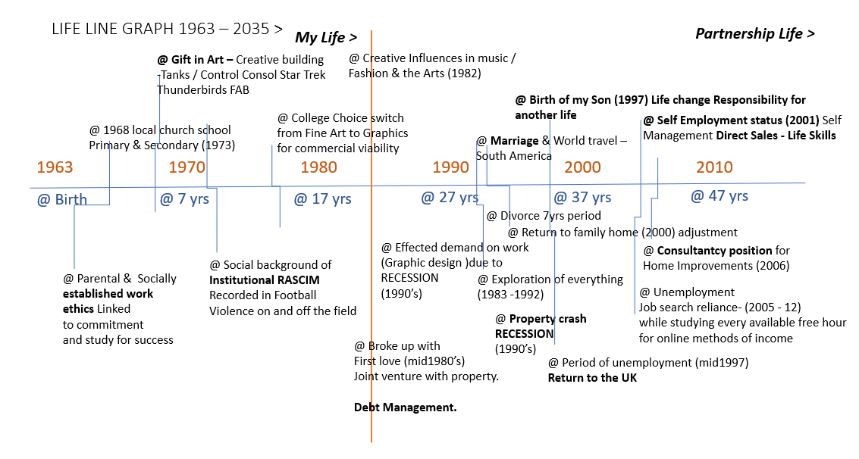
Lifeline chart a

My full time position as an Online Marketer establishing a web-based platform in support of local business promotions has allowed me to manually apply the theories explored through the university course work direct to a real life situation. By applying my natural talents and past working experiences I have validated some of the findings defined in the course.
YOU WOULD LIKE TO SET UP A BUSINESS / BE EMPLOYED FOR A POSITION
Description:
I am currently working to establish a start up business platform, supporting the needs of local business owners in their effective promotions of brand, product and services. The platform is web-based and encompasses additional aspects which are designed to enhance creative skill for young people in the integration of technologies with commerce. For skilled trainees, creative artist using digital means. As well as the new marketplace of integration of social media with business.
The Desire:
The desire to work on and develop with the Platform ‘Change and effect Ltd’ is born out of an increased awareness of purpose. Emphasising my abilities to do; and historical experience in fields such as Direct Selling (Local Business Discount cards), Marketing (Freemans Mail Order Catalogues), Packaging (Superdrug stores), Independent Specialist design firms ( Major Display, Perfect Publishing) and Design Consultancy Kitchens & Bathrooms for the ‘sheds’(Wickes, Homebase).
The creative strengths I possess have been the focus of my academic career being natural in feel and application. I feel a greater understanding through visual responsive learning.
The direction to move from the creative discipline of fine arts to a more commercial discipline of commercial art with Graphics and Media were based on ‘How to make money with something I loved to do? Art as a natural talent – expression to commercialism – skillset acquisition – Purpose in life.
Skills Assessment:
The skill to produce commercial art that paid for itself beyond being a unique creative talent were fashioned from learning and honing skills required in critical thinking for the processes of design brief solutions, research and design development as a problem solution for an end result. Interpersonal skills for interpretation, analysis, creativity and resolutions to tasks all came from the experience of the design processing with the development of the technological means being applied to complete for the end result.
Self determination:
To collaborate my desires, skills history and abilities into the factors which act as my guide and criteria for business success. A conscious move from the ‘ You should do things this way’ to ‘ Do you want to do things this way’ and ‘How can I best apply my abilities to achieving this with my unique experience. Attitude.
A Spiritual Guide:
spiritual nurturing and awareness to who I am and my defined purpose act in support of my desires aims and ambitions acting as a time reflector of the abilities to do; for what is genuinely purposeful, defining my worth and connecting with all important things in life for a positive and productive outcome.

COURSE EVALUATION - models and questionairs
In our first lesson: we reviewed the most likely important requirements for successful exchanges within a working group concerning behavioural expectations.
Codes of behaviour in a classroom or study environment following the expression of some student grievances concerning relocation of campus. In light of poor communication, the ability or in-ability to express concerns effectively were demonstrated.
Considering the individual as well as the collective.
Some of the considerations are listed below
Co-operation and mutual respect
Constructive contributions from all members
Agreed code of conduct – talking one at a time. Listening to all views. Debate – brainstorming.
Progression of ideas, conversations and expressions. Offering solutions not problems.
Overall a positive attitude to learning as well as towards others in the group of varying learning and confidence levels of ability in both verbal and non-verbal expression / communications.
We consider a personal development plan briefly touching on measurable tools to monitor our findings such as SWOT analysis and SMART acronym highlighting personal confidence and competencies in the reflective views of our professional career development.
Personal reflections and competency in working effectively. Development plan.
S.W.O.T.
Personal Strengths:
Considerate, great ability, committed, Supportive ambition, visual perceiver, grifted artistic skills, developed good use of the English language. Strong work ethic, time management, patience. Team and solo worker. Self-determination – drive for desires. Ambition.

Personal Weaknesses:
Complicating processes, unfocused, Supportive ambition- attainment through others, poor numeracy /arithmetic skills,

OPPORTUNITY:

TREATS:

EMPLOYABILITY SKILLS NEEDED / SOUGHT – GREATER UNDERSTANDING
READYNESS FOR EMPLOYMENT OR EMPLOYER ROLE

Wisdom thinking further than the present. Technology call advances in current use in the marketplace. Marketplace shift from boss 2 inspired leaders creative. Rapid and constant lead advantage. Bridge exit environment forcing change. When action taken leveridge advantage when action taken. The process of I'm thinking, exploration and elaboration.
Academic structuring coming quite late on as a rounding up of experiences finding together changes and developments . Practiced and applied recognised pattern theories and principles of operations in the business environment.
knowledge has come about not by being informed of a pattern of work but by a greater understanding of the requirements and rules applied to the majority of workforces. On how things work. How to produce and gather information and ultimately process it effectively to produce a greater outcome. Shut storytelling past experiences solve the problem.

WHO AM I LOOKING TO WORK WITH?
Those who I seek to work with will be unconventional in ideas, creative in expression and resolve and have a driving force / passion for what they get involved with. A reflection of my own values in a strong work ethic. Disciplined in Setting about a task, overcoming obstacles and maintaining high levels of application to complete the task required. Seek to learn, develop and improve on results. Again, strong work ethics in time management, listening and communication skills needed. Also an inter-dependant ability to work solo or as a team member for mutual outcomes and positive gains.
DETERMINATION – PATIENCE.
REFLECTIONS OF MYSELF.
WHAT I MAY NEED / AREAS TO IMPROVE:
UNDERSTANDING OTHERS – SETTING DEALS AND DEAL PROCEEDURES.
FLEXIBILITY IN ACCEPTING OTHERS – ABILITIES, AMBITION, PRINCIPLES,
LEARNING AS I GO FROM SUCCESSFUL OTHERS IN BUSINESS AREAS UNFARMILIAR TO ME CURRENTLY.

JOHARRI WINDOW ASSESSMENT / HONEY & MOMFORD / SMART

Using the commonly known assessment of SWOT, to analyse personal as well as business factors in a manner in which strategy can be adopted for a particular end result. Exploring strengths and weaknesses reflectively usually internal influences comma and opportunities and threats which pose externally influencing factors , to consider. The nature of the outside business environment.

Diversity of skill set , creativity Business strengths.
artists, musicians, image graphic artists and photographers, actors, writers, entrepreneurs.
Personal strengths good verbal communication skills , speech, presentations. Non verbal empathy, skills. Transferable skills. Experience in sales direct and as a consultant. Education in graphic design, print, packaging, publicity. Solo disciplines and team worker , time management and appreciation. Critical analysis, from design background, solution finding and conveying of messages. Life balance , 50 years plus. Emotional and character , drive ambition. Experience over financial. Giving back. Character, ginuwine, quality first, giving plus receiving Newmarket offering C&E unique mix of services, digital marketing. Lead advantage. Reciprocity.
Weakness
category numeracy mental arithmetic. Multitasking to effect. Generating wealth.
KPI, key performance indicators.
USP, urban digital marketing network with crossover into youth creative hearts, fashion and entrepreneurship. Yet to be established. Visibility. Profit margin , operating currently without external investment support. Brand recognition, organically developed through the ethos, customer loyalty, giving back to the next generation through mentoring. Be one with the journey.
Value growth potential equals global.
Self monitoring for quality service provisions.

Opportunities and threats using pistol model.
To assess the external opportunities which could effect personally and in business the platform C&E. How advantage could be made into opportunities.
Gathering grassroots support through local business ownership , charities, government support projects, national funding projects I Prince's Trust, angel investors , partnerships with entrepreneurs.
Factors outside your control but positive in results. On the negative reflection the threats, would be competing operations providing matching services. In the area of social media content management, regular advertising methods her digital advertising .
Educational in the service provided. Not fully understood as technologies rapidly upgrading and changing. 2 high tech to be fully applied understood.
Creativity mixed with tech require for innovative solutions both as unique selling point and as a threat if mixed mixture is not achieved and conveyed.
Joe Harry
Joe Harry window is a recognise study of influential effects communication through and with the team knowledge of individuals through quadrant categories. When applied to me, to the business com a greater understanding can be developed as well as trust. Reference Joseph luft and Harry Ingham. 1955.
Further action development equals greater use of the January window principles to establish trust and confidence between team members of the platform ciony. Both at a call founders level as well as a more regulated version for the support workers and outsources.
2 years working on the project development for C&E has established a credibility based on similar values and ambitions to support others in growth through expression of skills and talent as well as presenting new ways for wealth creation and generation. Primarily to local business operators , filling in the gap left by large business operators servicing providers seeking larger paying clients has more viable business proposition. The small business owner reading to be needing to be effective effectively promoted is one of our target market sectors for generation of revenue the business .
The collaboration with core individual in this process has to some degree attempted to be applied. The principles highlighted by the johari window and is only gradually being adopted. Partly due to personal intimacy trust establishment comma and partly due to the multi trading approach applied. To have an effective launch of the platform and its services.
I believe that more then simply applying my experience and skill set to establish the platform objectives that of supporting the community in talent expression, creativity and entrepreneurial spirit, growing trust and engagement overtime will increase my open free window area to include other aspects which are not solely applicable 2 mythology , skill set, application of a craft or management of operations.
Smart goals .
Day today jobs
specific
increase revenue to platform by targeted pictures of a single service provision equals page one search rankings placement for any business with an advertising budget.
Miserable
CRM management of emails times 2 Daily Times 10 weekly times 30 plus monthly. Target monthly and quarterly reviews pricing no fee until placed. Then 297 pounds per week maintenance unlimited visitors , unlimited buying customers.
Achievable
one person focus achievable. Yes Matt out process for others to replicate or provide to outsource multiply.
Relevant
the result is important to bring income to a self funding project. Allowing services to continue in the development of the platform in other areas.
Time bond you lie measured monthly and quarterly from may 2019 platform structure development from September 2016 2 to date. 297 pounds per week times 4 equals 1188 per month divide by 2 split 4 Co founders 594 H. For one client. You line from my list in smart goal setting, I can establish a game plan that will address my immediate objective , that of continuing participation of the platform by ensuring income is made when the platform continues to be viable and self reliance. At this time without external investment. Leadership skills through delegation as well as hands on application is a secondary position positive to the set tasks of the following month.
Refocus of prospect pool. Foot pain recipients of service provided.
Focus on one service for all potential client of a similar niche group.
Multiply by system ising the pitch and fulfillment of service offering.
Monitoring processing funnel, for communication, fulfillment and follow up to pitches to prospects in an attempt to increase ROI on service offerings.
Scheduled to allow for additional projects rolling alongside. Monthly and quarterly assessments asset as standard. Smart goals
establish a working funnel for the effective prospecting of business clients by providing a key service as an introduction to other potential offerings under platform umbrella of services. You line for film and can be via the core members or outsources and sales personnel.
Evaluation will be made weekly , monthly, quarterly from CRM stats and email responses recorded. Timeline
reviewed as with milestones.

MOTIVATION
Having left the position of work to start something yet to be established as proven on the grounds of personal satisfaction above financial security, I believe I am strongly motivated hi strong I have strong motivational drive. Combined with positive thinking and spiritual balance in direction of purpose my persistence is forging the channels to my success and the fruits of the seeds song to date. Day to day practices of reviewing my ambitions, targets and set goals have become my focus living and breathing consideration in life. My help , dreams and visions are encouraged with like minded individuals striving for their aspiration , hopes and dreams but being willing to help and support others along the way. Being one with the journey, of self expression for the positive growth in order to empower the whole in community throughout generations. Through change and effect. Motivational environment . Having
accountability and like minded ambition.
With an ethos of supporting others along the way in a creatively expressive environment, catches the reasoning for the last 2 years of committed development to the platform change and effects primarily on the business operations side

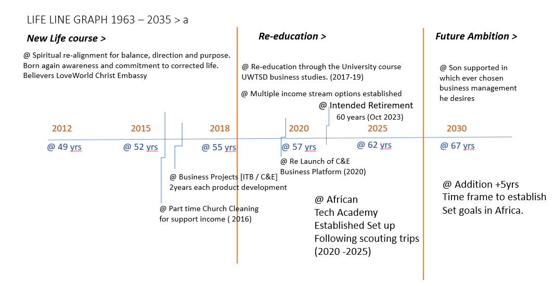
Continued lifeline chart b – Ambitions and future planning

