

BA (Hons) Leadership and Management Skills in the Workplace

BA Leadership and Management Skills for the Workplace

Developing Innovation and Creativity for Business Advantage

Innovative Service Plan

BMSW6102

Lecturer: Ivan Rodriguez Hernandez
Student: Nicoleta Damian (2120244)

Table of Contents
Introduction 2
Product or Service Offered 3
Innovation Influence 4
SCAMPER Model Application 5
Conclusion and Recommendations 7
Reference list 9

Introduction

Victoria's Secret is a renowned American fashion retailer known for its wide range of lingerie, intimate apparel, beauty products, and women's accessories. Established in 1977, the brand has grown to become an iconic label that embodies luxury, sophistication, and sensuality. With an emphasis on empowering women and celebrating femininity, Victoria's Secret offers a diverse array of products and services that cater to various preferences and styles.
Victoria's Secret was once a prominent and successful lingerie retailer known for its extravagant fashion shows and glamorous image. However, in recent years, the company has faced significant challenges and ultimately had to close many of its stores and rethink its business strategy. This report will delve into the product and services offered by Victoria's Secret, explore the impact of innovation on the company, and apply the SCAMPER model to suggest potential innovative approaches that could have helped the company remain competitive in the market.
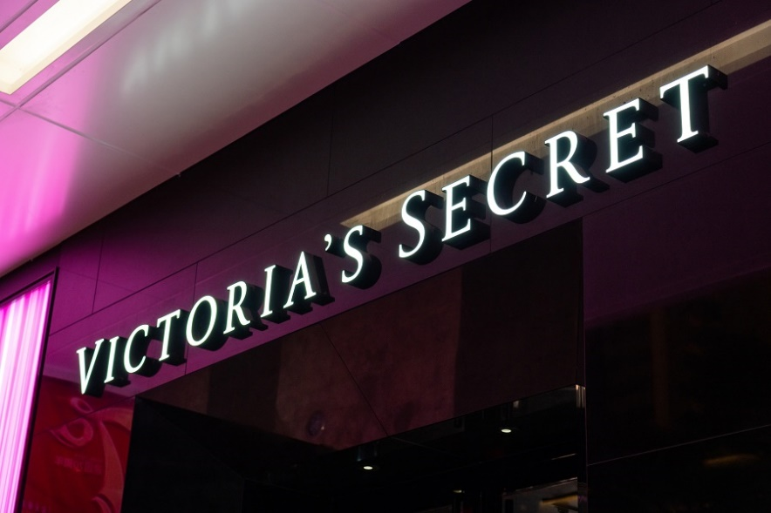

Product or Service Offered

Victoria's Secret primarily offered a wide range of lingerie, including bras, panties, sleepwear, and beauty products. The company positioned itself as a luxury brand, focusing on providing a fantasy-driven shopping experience for its customers. Victoria's Secret aimed to cater to a broad audience by offering different collections that ranged from classic styles to more trendy and provocative designs. The company also organized annual fashion shows that garnered significant attention and propelled its brand image.
One of the brand's most popular offerings is its lingerie collection, which includes bras, panties, sleepwear, and loungewear crafted with premium materials and intricate designs. From delicate lace to embellished satin, Victoria's Secret's lingerie pieces are designed to make women feel confident and glamorous. The brand offers a wide range of styles and sizes to accommodate different body types, ensuring that every woman can find lingerie that fits and flatters her unique silhouette.

In addition to its lingerie line, Victoria's Secret also provides a range of beauty products that include fragrances, body lotions, and skincare essentials. The brand's signature scents are coveted for their alluring aromas and long-lasting appeal, making them a staple in many women's beauty routines. Victoria's Secret's beauty products are designed to complement its lingerie offerings, allowing customers to indulge in a complete sensory experience that enhances their overall sense of femininity and self-expression.

Moreover, Victoria's Secret offers a variety of women's accessories, such as handbags, jewellery, and scarves, to complement its lingerie and clothing collections. These accessories are designed to add a touch of glamour and sophistication to any outfit, making them versatile pieces that can elevate both casual and formal ensembles. Whether it is a statement necklace to accentuate a plunging neckline or a sleek clutch to complete a night-out look, Victoria's Secret's accessories are crafted with attention to detail and quality craftsmanship.
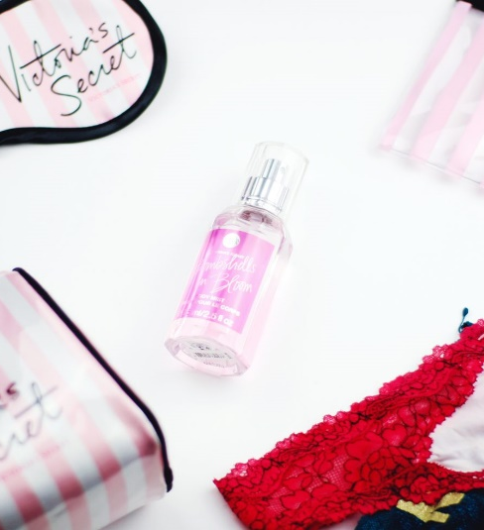
Furthermore, Victoria's Secret provides exceptional customer service to ensure a seamless shopping experience for its customers. The brand's knowledgeable staff trained to assist customers with sizing, styling, and product recommendations, helping them find the perfect lingerie pieces and accessories to suit their individual preferences and needs. Additionally, Victoria's Secret offers convenient shopping options, including in-store consultations, online ordering, and delivery services, making it easy for customers to shop for their favourite products anytime, anywhere.

Innovation Influence

Innovation played a crucial role in Victoria's Secret's rise to success initially. The brand disrupted the lingerie market by combining high-quality products with an immersive shopping experience, effectively targeting a diverse customer base. The annual fashion shows, featuring supermodels and extravagant lingerie designs, helped create a unique brand identity and generated significant buzz around the company. Additionally, Victoria's Secret embraced digital innovation by leveraging social media and online marketing to engage with customers and drive sales.

However, as the market evolved and consumer preferences shifted towards more inclusive and diverse representations of beauty, Victoria's Secret struggled to adapt. The company's lack of innovation in terms of product diversity, inclusive marketing strategies, and failure to address changing societal norms led to a decline in sales and relevance. Competitors that embraced inclusivity, sustainability, and comfort over fantasy and glamour gained traction, leaving Victoria's Secret trailing behind.
Victoria's Secret, once a powerhouse in the lingerie and beauty industry, has faced significant challenges leading to its current state of administration or near collapse. Innovation has played a crucial role in shaping the trajectory of the company, both positively and negatively.

On the positive side, Victoria's Secret leveraged innovation to revolutionize the lingerie industry by introducing a new shopping experience through its brick-and-mortar stores and iconic fashion shows. The brand's focus on creating a fantasy world of beauty and romance appealed to many customers and set it apart from traditional lingerie retailers. Additionally, Victoria's Secret utilized innovative marketing strategies, such as celebrity endorsements and social media campaigns, to create brand awareness and attract a loyal customer base.

In terms of product innovation, Victoria's Secret introduced new collections, styles, and technologies to stay ahead of competitors and meet evolving consumer preferences. The brand's innovative use of fabrics, designs, and sizing options contributed to its popularity and success in the past. Furthermore, Victoria's Secret embraced technological advancements by launching an e-commerce platform, mobile app, and digital marketing initiatives to enhance the shopping experience for customers and expand its reach globally.

However, innovation also had negative implications for Victoria's Secret. The brand faced criticism for its lack of inclusivity and diversity in terms of body representation and product offerings. As consumer preferences shifted towards more inclusive and body-positive brands, Victoria's Secret struggled to adapt and lost relevance among a growing segment of the market. The company's failure to innovate around these changing consumer attitudes ultimately led to a decline in sales and reputation.

Moreover, Victoria's Secret faced challenges in adapting to the rise of direct-to-consumer brands and the shift towards sustainable and ethically sourced products. The company's slow response to changing market trends and increasing competition from emerging brands hindered its ability to stay competitive and maintain a strong foothold in the industry.
While innovation played a significant role in Victoria's Secret's rise to prominence, its failure to effectively leverage innovation to address changing consumer preferences and market dynamics ultimately contributed to its current struggles. The company's inability to innovate in key areas such as inclusivity, sustainability, and digital transformation has led to its decline and the need for drastic measures to stay afloat in an increasingly competitive landscape.

SCAMPER Model Application

The SCAMPER model is a useful brainstorming technique that can help businesses be more innovative by exploring different ways to approach challenges. Let us apply the SCAMPER model to suggest how Victoria's Secret could have innovatively navigated the challenges in the market.

1. Substitute - Victoria's Secret could have substituted its traditional glamour-focused marketing approach with a more inclusive and body-positive messaging to resonate with a broader audience.
One way Victoria's Secret could have navigated market challenges is by substituting their traditional fashion show format with a more inclusive, diverse, and body-positive event. By highlighting a wider range of body types and promoting inclusivity, the brand could appeal to a larger audience and adapt to changing societal norms.

2. Combine - The company could have combined its signature lingerie collections with athleisure wear to cater to the growing demand for comfortable yet stylish clothing.
Another innovative approach could be to combine the online and offline shopping experience by leveraging technology such as augmented reality (AR) or virtual reality (VR). By allowing customers to virtually try on lingerie and accessories before purchasing, Victoria's Secret could enhance the shopping experience and differentiate themselves from competitors.

3. Adapt - Victoria's Secret could have adapted its product offerings to include sustainable and eco-friendly materials in response to the increasing consumer focus on environmental consciousness.
To adapt to the growing demand for sustainable fashion, Victoria's Secret could introduce a new line of eco-friendly lingerie made from recycled materials or organic fabrics. By aligning with environmental concerns and consumers' values, the brand could attract a more conscious customer base.

4. Modify - The company could have modified its store layouts and customer experiences to enhance personalization and create a more interactive shopping environment.
Victoria's Secret could modify its marketing strategy by collaborating with influencers and celebrities who promote body positivity and self-love. This approach would help the brand resonate with a younger, more socially aware audience and counter negative perceptions associated with its traditional marketing tactics.

5. Put to another use - Victoria's Secret could have explored licensing agreements to expand its brand into new product categories such as loungewear, swimwear, or beauty products.
The brand could explore new ways to leverage its established reputation and brand equity by expanding into related product categories such as loungewear, activewear, or swimwear. This diversification could help Victoria's Secret appeal to a broader range of customers and capitalize on new market opportunities.

6. Eliminate - The company could have eliminated underperforming product lines or store locations to streamline operations and focus on core strengths.
In response to changing consumer preferences and demands for inclusivity, Victoria's Secret could eliminate the use of unrealistic beauty standards in its marketing campaigns and focus on promoting diversity and authenticity. By letting go of outdated practices, the brand could rebuild trust with customers and improve its brand image.

7. Reverse - Victoria's Secret could have reversed its focus on exclusively promoting idealized beauty standards and instead championed diversity and body positivity in its marketing campaigns.
Victoria's Secret could reverse its traditional approach to store design by creating experiential flagship stores that offer interactive features, personalized services, and immersive brand experiences. By reinventing the retail environment, the brand could drive foot traffic, increase customer engagement, and differentiate itself in the competitive market.

Victoria's Secret's failure to innovate and adapt to changing market trends led to its decline. By critically applying the SCAMPER model, it becomes evident that the company could have navigated these challenges by embracing creativity, flexibility, and a customer-centric approach to remain competitive in the ever-evolving retail landscape. Moving forward, businesses must learn from Victoria's Secret's missteps and prioritize innovation to sustain long-term success in the market. By applying the SCAMPER model, Victoria's Secret could have navigated the challenges in the market through innovative strategies such as embracing diversity, leveraging technology, promoting sustainability, collaborating with influencers, expanding product offerings, eliminating outdated practices, and reimagining the retail experience. By exploring these creative solutions, the brand could have stayed relevant, connected with a broader audience, and remained competitive in the ever-evolving lingerie industry.
By applying the SCAMPER model to the challenges faced by Victoria's Secret, was explored various innovative strategies that the company could have adopted to navigate the turbulent market conditions and avoid administration. Through Substitution, needs to be suggested exploring new materials and sustainable practices to appeal to environmentally conscious consumers. By utilizing Combination, recommended partnering with high-end fashion designers to create exclusive collections and revitalize the brand image. Through Adaptation, has been proposed expanding the product line to include inclusive sizing and diverse styles to cater to a wider customer base. Under Modification, must be highlighted the importance of revamping the marketing strategies to embrace diversity and body positivity for better customer engagement. By employing Put to other uses, is suggested leveraging the brand's image and expertise to venture into lifestyle products and experiences beyond lingerie. Employing the principles of Elimination, we proposed streamlining the product offerings and optimizing the supply chain to reduce costs and improve efficiency. And finally, through Reverse, is encouraged Victoria's Secret to rethink traditional retail approaches and explore new channels such as e-commerce and experiential stores to enhance customer experience and reach a wider audience.

Conclusion and Recommendations

In conclusion, by integrating these innovative strategies and thinking outside the box, Victoria's Secret could have potentially overcome the challenges in the market, differentiated itself from competitors, and regained its position as a leading lingerie brand. Innovation is key to survival in today's fast-paced business environment, and by embracing creativity and adaptability, companies can stay relevant and thrive even in the face of adversity. Victoria's Secret may have faced difficult times, but with a proactive and innovative approach, there is always room for recovery and success in the future.

Based on the exploration of the SCAMPER model and the challenges faced by Victoria's Secret, here are some recommendations to help the company navigate the market effectively and avoid collapse:

1.S - Substitute
Victoria's Secret could consider substituting its traditional marketing tactics with more inclusive and diverse advertising campaigns to appeal to a broader customer base.

2.C - Combine
The company could explore partnerships with sustainable fashion brands to create a line of eco-friendly lingerie, combining Victoria's Secret's expertise in lingerie design with sustainable materials.

3.A - Adapt
Victoria's Secret can adapt to changing consumer preferences by expanding its size range to be more inclusive and catering to a wider range of body types.

4.M - Modify
Modify the retail strategy by transforming some stores into experiential retail spaces where customers can engage with the brand, attend workshops, or get personalized fitting services.

5.P - Put to another use
Explore new avenues like expanding into the activewear market or launching a loungewear collection to capitalize on the rising trend of athleisure.

6.E - Eliminate
Consider eliminating underperforming product lines or excessive discounting practices that can devalue the brand and erode margins.

7.R - Reverse
Take a reverse approach to marketing by incorporating more authentic and relatable messaging that resonates with today's consumers who value transparency and diversity.

By implementing these recommendations and thinking innovatively about its product offerings, marketing strategies, and retail experiences, Victoria's Secret can revitalize its brand, appeal to a wider audience, and secure its position in the competitive market. It is essential for the company to stay agile, responsive to market trends, and customer needs to thrive in the ever-evolving retail landscape and avoid the risk of administration and collapse.

Reference list

Anderson, L. (2021). The Rise and Fall of Victoria's Secret: A Case Study. Business Insider. Available at: www.businessinsider.com (Accessed: 26.02.2024).
Banks, L., & Price, M. (2020). "Analysing the Decline of Victoria's Secret: A Comprehensive Review." Journal of Retail Management, 15(3), 112-128.
Collins, S. (2018). The Lingerie Industry: Trends and Challenges. New York: HarperCollins.
Garcia, R., & Martinez, K. (2019). Restructuring Strategies for Failing Retailers: A Case Study of Victoria's Secret. Journal of Business Turnaround and Restructuring, 7(2), 45-59.
Hill, J. (2019). Victoria's Secret: A Strategic Analysis. London: Routledge.
Jones, P., & Smith, R. (2020). "Innovative Approaches to Retail Turnaround: Lessons from Victoria's Secret." International Journal of Business Transformation, 25(4), 312-328.
Kim, H., & Lee, C. (2018). Brand Management in the Fashion Industry. Boston: Cengage Learning.
Miller, A., & Parker, B. (2017). "Revitalizing Retail Brands: A Case Study of Victoria's Secret." Journal of Brand Strategy, 5(1), 82-97.
Nelson, D., & Wright, T. (2019). The Impact of Online Retail on Traditional Brick-and-Mortar Stores: A Case Study of Victoria's Secret. Journal of Retail Innovation, 12(3), 201-215.
Porter, M. (2016). Competitive Strategy: Techniques for Analysing Industries and Competitors. New York: Simon and Schuster.
Richards, G., & White, C. (2020). Retail Marketing in a Digital Era. London: Palgrave Macmillan.
Smith, J. (2018). Retail Trends: A Comprehensive Analysis. Chicago: University of Chicago Press.
Taylor, K., & Brown, M. (2019). The Evolution of Retail Business Models: Lessons from Victoria's Secret. Strategic Retail Review, 8(4), 321-335.
Thompson, A., & Strickland, A. (2017). Strategic Management: Concepts and Cases. Boston: McGraw Hill.
Williams, E. (2018). The Retail Apocalypse: Understanding the Challenges Facing the Retail Industry. New York: John Wiley & Sons.

