BMIH4002 Food & Beverage Operations

Student Name: Klaudia Modrzejewska
Student Id: 2243846
Modular Name: Antoinette Milne

Table of Contents
Introduction 3
PART 1: Restaurant Concept 3
PART 2: Menu Design 4
Conclusion 8
Reference list 9

Introduction
A restaurant can be firmly distinguished by considering the type of services it offers and the type of ambience maintained by the authority (Davis et al., 2018). As opined by Cousins (2020), a restaurant can be unique in many ways. It may serve such a kind and quality of food that cannot be found elsewhere. Similarly, the ambience or the atmosphere of a restaurant can make it different from others (Johnston, 2012). The report aims to develop a menu design for a restaurant premises so that food quality can act as a factor that differentiates the restaurant from others. For this study, Hotel Trinity has been chosen, which is a part of the Trinity Hotel Chain, located in the region of the UK.

PART 1: Restaurant Concept
The restaurant concept is considered to be the most important aspect that can aid in the process of differentiation. As per the views of Walker (2021), a restaurant concept is considered as the overall theme or idea which precisely defines the concept of the restaurant. Mainly, there are five factors which contribute to a restaurant concept including service style, menu design ambience, decor, and restaurant location (Motarjemi and Lelieveld, 2014). However, with respect to the chosen restaurant, the Trinity Hotel, may consider following fine dining and family-style restaurants. As in recent time, most people go out for family and fine dining, thus considering this service style might be beneficial for the restaurant. As per the views of Zutshi (2019), a family restaurant is referred to as an establishment that serves simple food at a very cheap rate, and welcomes children and adults as well. On the other hand, Erkmen and Hancer (2019), said that a fine dining restaurant refers to an establishment that offers sophisticated, expensive and unique facilities which are not offered in the average restaurants. In this case, the Trinity Hotel me consider these two service styles wherein, consumers visiting there will be offered quality services with a good ambience so that they can enjoy a special moment.
As per the recent data, gathered from the UK statistical department, found that, in 2020, around 16% of the participants belonging to the age group of 18 and 24 years, mostly visited the restaurant once in week (Statista, 2023). Whereas, only 4% of those 65 years and over go for a visit to the restaurant (Statista, 2023). Thus, considering the above data, it can be said that the potential target consumers of Trinity Hotels will be 18 and 24-year-old clients since this group visits the restaurant most. However, clients of all the groups will be treated and welcomed.
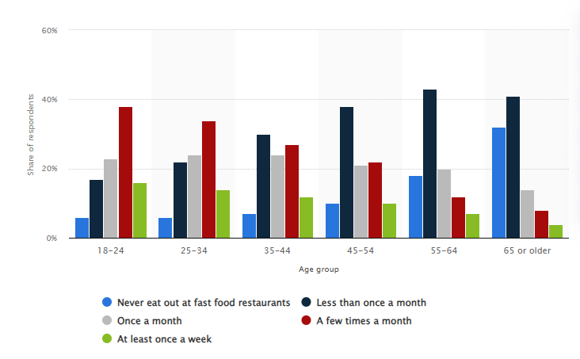
Figure 1: “How often do you eat out at quick service restaurants, e.g. burgers, pizza?”
(Source: Statista, 2023)
As Trinity Hotels is following both fine dining and family restaurant service styles so the restaurant authority will offer a mixed type of menus. That will be compatible with the choices of any age group and meet their desires as well. Starting from salads, soups, main courses, shakes and many types of drinks will be offered by the restaurant so that all-in-one service can be offered to the guests visiting there. Along with that, different desserts and exciting combo offers will be also availed by the authorities. Further, for kid’s special meals will be offered from the business end. Moreover, keeping in mind about the both vegan and non-vegan consumer’s separate cuisines will be offered by Trinity Hotels.

PART 2: Menu Design
Title: Crafting a Memorable Dining Experience Menu in Keeping with the Concept
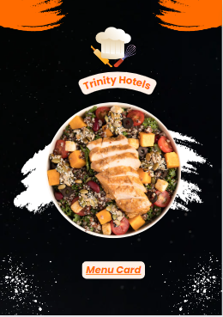
Figure 2: Cover page of the menu card
(Source: Created by the learner)
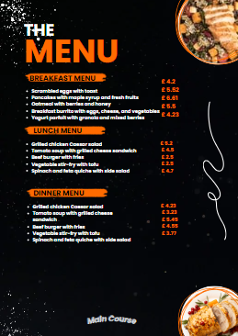
Figure 3: Main Course
(Source: Created by the learner)
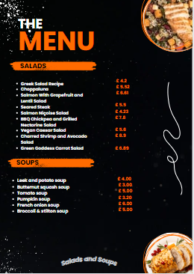
Figure 4: Salads and Soups
(Source: Created by the learner)
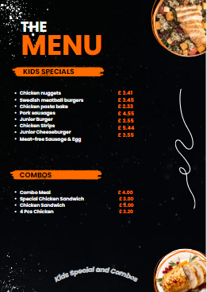
Figure 5: Kids Special and Combos
(Source: Created by the learner)
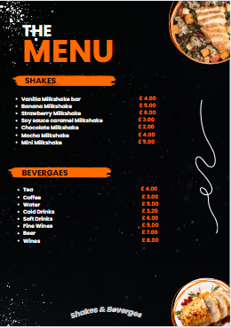
Figure 6: Shakes and Beverages
(Source: Created by the learner)
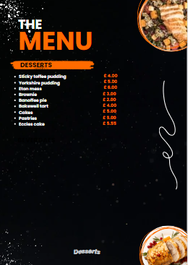
Figure 7: Desserts
(Source: Created by the learner)
The above menu design portrayed can be considered as a final menu card for Trinity Hotels. The business is going to operate across the location of the United Kingdom. The menu card suggested for the business has highlighted all the attractive menus that can attract consumers. Moreover, dishes that will be offered by the restaurant are also going to please consumers visiting there. It has been clearly obtained that keeping in mind the concept of a family restaurant, the main course including breakfast items, lunch items and dinner items are enlisted. Along with that, by considering both the vegan and non-vegan consumers the menu card has been designed. Keeping in mind the health-conscious people salads and soups have been portrayed in this menu card. Along with that, kids' special arrangements were also being made. Further, different combos have been arranged at an exciting price. Moreover, different shakes and beverages have also been introduced on the menu. Along with that dessert has been also listed on the menu card wherein different exciting dishes will be offered to the visiting customers.
By analysing the overall menu card developed for Trinity Hotels, it is really seen that all the food prices are quite affordable thereby, medium-income groups can afford them. Even retired people can visit and spend time there with family members and afford to buy food items and enjoy their dining. Thus, considering the pricing rate of the menu card, it can be said the restaurant authority is following an economic pricing strategy. As per the views of Rosenbloom et al. (2020), economic pricing strategy refers to a pricing strategy where products are sold at lower prices to attract large groups of consumers in terms of enhancing business profit. Therefore, it can be said that the restaurant authorities are selling products at cheap rates so that they can attract a large scope of consumers in terms of maximising their business profit and growing further.
Further, it is seen that some of the consumers may be allergic to some of the ingredients. Therefore, considering the health condition of the consumers all the ingredients used for preparing the dishes will be mentioned to the consumers before taking their orders (Holleman et al., 2021). That will protect clients from the harmful impact of allergic items.

Conclusion
From the above discussion, it has been obtained that the study has concluded about a menu card which will be followed by Trinity Hotels which will be operating across the location of the United Kingdom. Menu cards have been designed for the restaurant and have been highlighted in this study. Further, the pricing strategy which will be followed by the business has been highlighted along with the prices of different food items. Along with that, it is estimated that considering the allergenic condition of client’s food will be prepared and delivered to them.

Reference list
Cousins, J., 2020. Food and beverage service. 9th ed. London: Hodder Education Group.
Davis, B., Lockwood, A., Pantelidis, I.S. and Alcott, P., 2018. Food and beverage management. Routledge.
Erkmen, E. and Hancer, M., 2019. Building brand relationship for restaurants: An examination of other customers, brand image, trust, and restaurant attributes. International Journal of Contemporary Hospitality Management, 31(3), pp.1469-1487.
Holleman, B.C., van Os‐Medendorp, H., van den Bergh, H., van Dijk, L.M., Linders, Y.F., Blom, W.M., Verhoeckx, K.C., Michelsen‐Huisman, A., Houben, G.F., Knulst, A.C. and Lentz, L.R., 2021. Poor understanding of allergen labelling by allergic and non‐allergic consumers. Clinical & Experimental Allergy, 51(10), pp.1374-1382.
Johnston, R., 2012. Service operations management: improving service delivery. 4th ed. Harlow, England: Pearson.
Motarjemi, Y and Lelieveld, H., 2014. Food safety management: a practical guide for the food industry. Illustrated edition. Amsterdam: Academic Press.
Rosenbloom, D., Markard, J., Geels, F.W. and Fuenfschilling, L., 2020. Why carbon pricing is not sufficient to mitigate climate change—and how “sustainability transition policy” can help. Proceedings of the National Academy of Sciences, 117(16), pp.8664-8668.
Statista, 2023. How often do you eat out at quick service restaurants, e.g. burgers, pizza?. [Online]. Available at: <https://www.statista.com/statistics/1123873/frequency-of-visiting-fast-food-restaurants-in-the-united-kingdom-by-age-group/> [Accessed on 2nd November 2023].
Zutshi, A., 2019 ‘How to develop well-informed and assured teams to embed food safety compliance in the UK catering and hospitality industry’, Perspectives in Public Health, 139(6), pp. 294–295.

