


Component 2: Written Report

Student name: Shengyul Mutafcheva
Student I.D: 2324059
Module code : BMHP5015_LON
Lecturer name: Caroline Salami
Word count: 1938 (excluded the table and figures)

Submitted: 17 December 2025

Table of Contents
1. Introduction 3
2. Job description of the selected job 3
3. Skills and experiences required for the selected job 5
4. Development of personal skills and resources 8
4.1. Building my personal brand 8
4.2. Resources and skills required for this job role 8
5. Action Plan and Timeline 10
6. Communication of skills to potential employers 14
7. Conclusion 14
8.References 16

1. Introduction
This report focuses on a health and social care job that I am interested in pursuing in the future. I want to work as a wellbeing and disability advisor. The vacancy for this job is advertised on Indeed by a local training company.
I have chosen this role because it offers the chance to support the development of inclusive communities and workplaces by providing support and adjustments in accordance with the Equality Act 2010. My motivation is to make a positive difference for individuals with disabilities or long-term health conditions, helping them to overcome barriers and reach their full potential in academic or professional settings. This role is dynamic, diverse, and engaging, offering ongoing learning opportunities to help me develop professionally and personally.
Screenshots
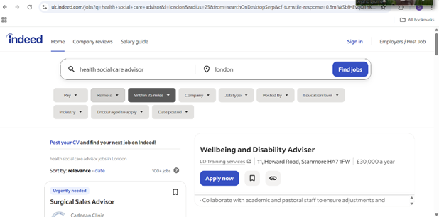

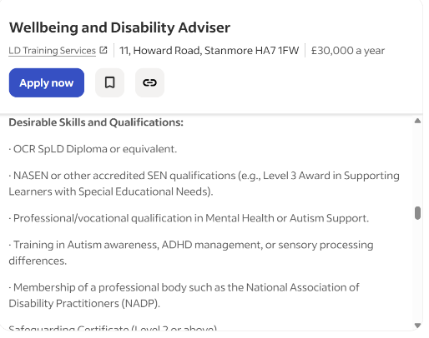
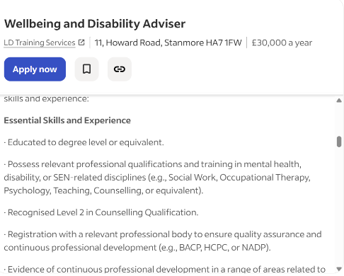

2. Job description of the selected job
A Wellbeing and Disability Advisor (WDA) offers expert guidance and support to individuals with disabilities or mental health issues in educational or organisational settings, ensuring equal access and opportunities. Their main responsibilities include managing individual casework, recommending reasonable adjustments, planning support strategies, advising on funding sources, liaising with professional and external services, contributing to policy development, and raising awareness through events and training. This role is essential for ensuring compliance with legislation such as the Equality Act 2010.
The theoretical foundation of disability is Critical Disability Theory (CDT). CDT challenges the traditional medical perspective of disability by framing it as a social, cultural, and political construct, aiming to dismantle ableism and foster societal change through the inclusion of disabled voices (Knox, 2024). According to CDT disability is socially constructed, dependent on societal barriers and norms rather than inherent impairment. The emphasis is on amplifying disabled voices to challenge negative narratives and assumptions. It advocates for a politically transformative approach that promotes inclusivity and emancipation of disabled individuals (Sustainability Directory, 2025).
According to the job description for the WDA role, the candidate is expected to support students with disabilities or additional needs, promoting well-being and inclusivity within the academic setting (Indeed, 2025). Key responsibilities include providing expert advice and guidance and developing accessible support services. The candidate should hold qualifications in relevant fields (e.g., HSC), have experience in supporting Special Educational Needs (SEN), and be familiar with current disability legislation. Essential skills for this role include excellent communication, problem-solving, and experience in crisis management and safeguarding. A flexible, self-motivated approach is also required to meet students' diverse needs.
The personal attributes needed for this role, as detailed in the person specification, are compassion, patience, and a student-centred approach (Indeed, 2025). The candidate should be able to adapt communication and support strategies to accommodate diverse learning, emotional, and sensory needs. They should also show cultural awareness, compassion, and respect for diversity. Other qualities include being tenacious, skilled, and able to stay calm in high-pressure situations.

3. Skills and experiences required for the selected job
Based on the job description, the skills needed for the WDA role include strong verbal and written communication, effective problem-solving, expertise in crisis management and safeguarding, as well as flexibility and self-motivation.
To identify my strengths and weaknesses, I utilise the SWOT analysis, a recognised personal strategy for assessing internal and external factors (Teoli et al., 2023). Figure 1 summarises my strengths and weaknesses, alongside the potential threats and opportunities.

Figure 1: SWOT analysis of my skills
Reflecting on my experiences and analysing my skills, I utilise Gibbs’ framework. It provides a systematic approach for evaluating an experience, drawing conclusions, and planning improvements (Soni, 2025). The framework consists of six stages: description, feelings, evaluation, analysis, conclusion, and action plan (Figure 2). The model helps to deconstruct events by addressing limitations and challenges as learning opportunities, thereby enhancing practical and professional competencies (Ocampo et al., 2025).

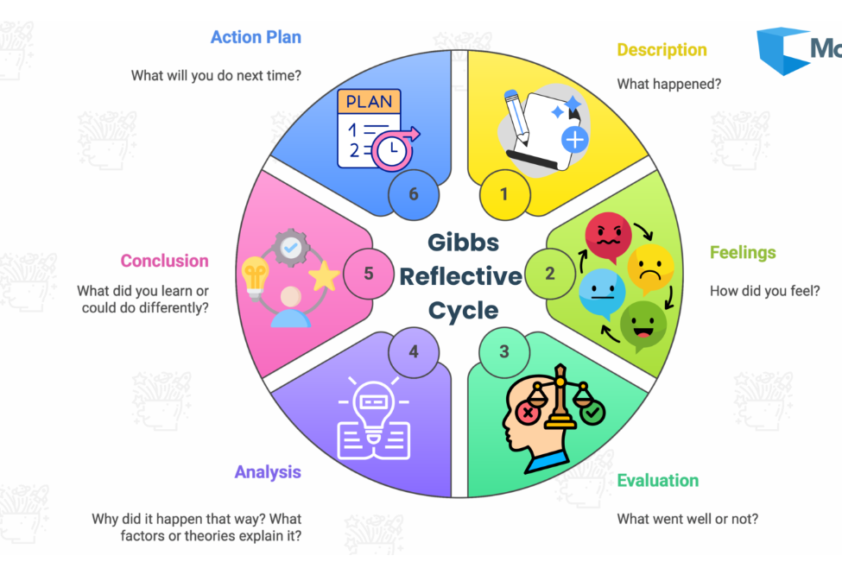
Figure 2: The Gibbs’ Reflective Cycle (1988, cited in Soni, 2025)
According to the SWOT analysis, my organisation, time management, and digital skills are among my strengths. A good real-life example of these skills is completing my undergraduate assignments. While working on my assignments, I feel confident and resilient because I usually organise my time, research effectively, and use digital tools (e.g., OneNote and Daily Task Planner) to manage my notes and to-do lists. To organise and manage my time and daily tasks, I use the Eisenhower Matrix (Figure 3), a task management tool that categorises tasks into four distinct classifications based on two main factors: urgency and importance (Litten, 2025). Apart from my academic experiences as a student, my previous roles as a teaching assistant and an administrative officer also helped me improve these skills.
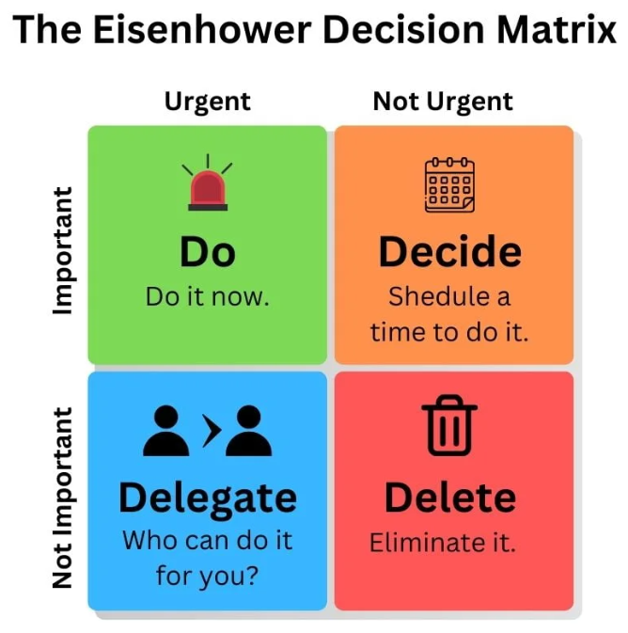
Figure 3: The Eisenhower Matrix (Krislok, 2025)
Other strengths include my oral communication, empathy, and reflective skills. I demonstrate these during my university course when engaging with my lecturers and fellow students. I feel enthusiastic and motivated, which enhances my engagement with the course material and improves my understanding of both my tutors and classmates. Applying empathy in communication helps me understand and share others' feelings through active listening, fostering trust, deeper connections, and conflict resolution. Empathy, supported by the Theory of Mind (ToM), enables interpretation, prediction, and explanation of others' behaviours, thereby facilitating complex social interactions (Ruhl, 2025). Strong theory-of-mind skills promote communication, social connections, education, and conflict resolution, making them essential for everyday social interactions.
As a mother caring for a child with autism, I have experience in both nurturing my own child and working with disabled children. To support my child effectively and efficiently, I completed online courses on autism. I also work closely with my child’s teaching staff regarding his Education, Health and Care (EHC) Plans.
Conversely, based on the SWOT results, the skills I need to improve include problem-solving, crisis management, written communication, leadership, and safeguarding.

4. Development of personal skills and resources

4.1. Building my personal brand
To build my personal brand, I need to define my professional identity, identify my target audience, craft my unique value proposition, develop my brand voice and image, and then communicate this through valuable content and strategic networking on LinkedIn to establish trust and authority (Colney, 2024). I can add value to my personal brand by focusing on my strengths, especially my communication and empathy skills, as well as my experiences working with autistic children.
My unique selling points (USP) are my enthusiasm and strong motivation to work with individuals with disabilities. I am intrinsically driven to support those students, finding joy and interest in guiding and assisting SEN learners. I will do the work solely for the pleasure and personal fulfilment it offers, aiming for exploration and mastery (Fishbach and Woolley, 2021). Additionally, my ambition and high emotional intelligence (EI) make me valuable for this role. I can identify, employ, understand, and regulate emotions and emotional data. Singh et al. (2022) emphasise the significance of EI in the workplace, highlighting that it “is a better predictor of success, quality of relationships, and happiness” (p. 2255).

4.2. Resources and skills required for this job role
For this role, I plan to enrol in online courses to strengthen my weaker areas, supplemented by reading relevant books. Additionally, to enhance my written communication and use the formal register, I will endeavour to apply these skills when communicating with my tutors and work managers. Having learned the steps of problem-solving (Figure 4), I also intend to practise these skills at home and at work, using the knowledge gained. Regarding leadership and crisis management, I can practise these skills with my autistic child by developing a crisis management strategy and employing techniques to de-escalate him during disruptive behavioural episodes, while ensuring safety in escalating situations. I will also undertake safeguarding training for disabled individuals covering physical and emotional abuse, neglect and exploitation (Level 1 for awareness, Level 2/3 for direct care and management), along with modules on national legislation, signs of harm, and reporting procedures (NHS England, 2024). These are often tailored for learning disabilities, autism, or physical disabilities and employ inclusive methods.
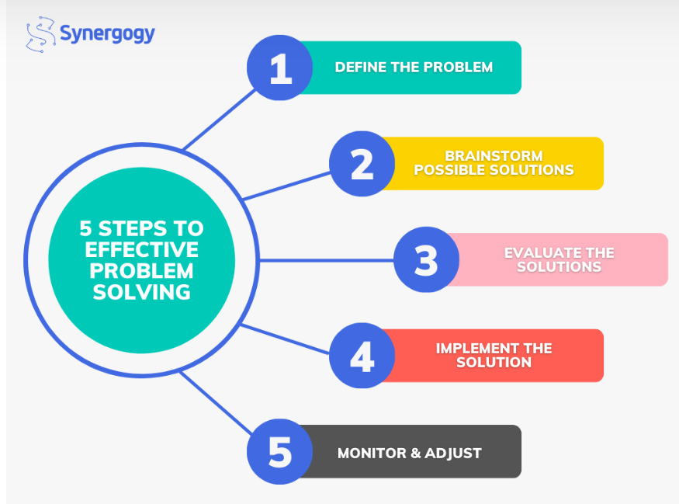
Figure 4: The problem-solving process (Maini, 2023)
I also need to undertake Special Educational Needs (SEN) training for disabled people, such as courses on Oliver McGowan Training for learning disability/autism (Dynamic Training, 2025) and ADHD (UK Open College, 2025) or a postgraduate diploma in SEN, as well as life skills training for adults with learning disabilities covering inclusion, communication, conduct, and law. Additionally, I will obtain a Level 2 Counselling qualification, including active listening, rapport building, person-centred theories, ethical limits, and self-awareness to develop communication and empathy skills (Online Learning College, 2025).
I plan to volunteer as a SEN teaching assistant at a college to gain more experience working with adolescents and supporting them in their academic endeavours.

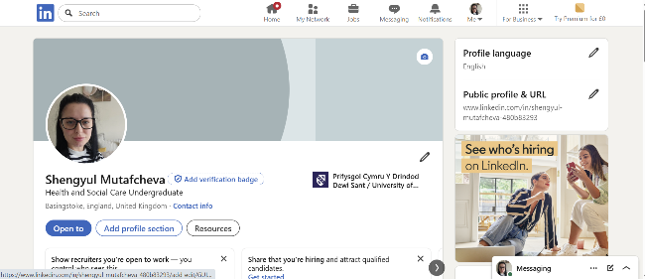
Screenshots
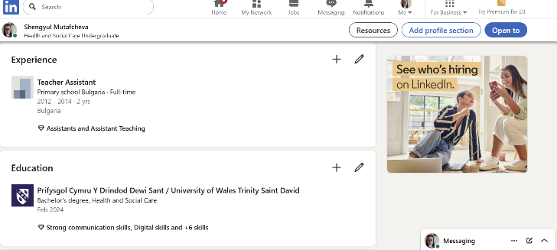

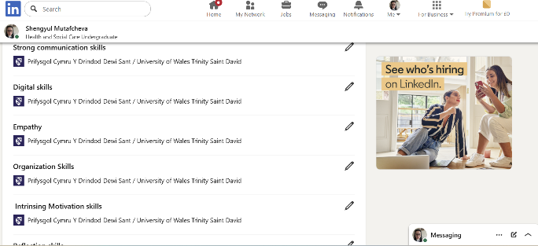

5. Action Plan and Timeline
I created an action plan for career development, including short- and long-term goals, skills I will improve, and specific actions with due dates. Developing an action plan will help me stay focused, motivated, and on track by outlining concrete, attainable career goals. This enables me to proactively learn new skills, monitor my development, take advantage of opportunities, and adjust to new circumstances, all of which contribute to my long-term success and happiness (Government People Group, 2023). The SMART goals (Specific, Measurable, Achievable, Relevant, Time-bound), included in the action plan, enhance motivation, focus, and accountability, transforming vague ambitions into structured, actionable steps. This makes it easier to monitor progress and align efforts with broader objectives, ultimately boosting the chances of success and reducing resource wastage (Day and Thornhill, 2025).

Long-term goals | Short-term goals | Skills that will be developed | Action to take | Resources and materials | Anticipated problems | Timeline
 | To obtain a BSc degree in HSC | Organisation skills  Digital skills  Academic skills  Research skills  Communication skills  Teamwork skills  Reflection skills  Time management skills | 1. Complete the modules, assessments and dissertation successfully.  2. Practice my soft and hard skills in the academic setting with tutors and classmates.  3. Ask for support when needed.  4. Participate in collaborative projects to improve teamwork skills. | Face-to-face lectures  Moodle resources  Library resources  Free online academic sources  SFE funding  Dissertation supervision | Struggling with my dissertation, which may increase my anxiety. (Getting support from the university wellbeing team, managing my time effectively and organising notes and sources for effective writing.)  Failing to complete assignments due to conflicts with my autistic child.  (Getting support from family and Autism specialists) | December 2026
To obtain a Postgraduate Diploma (PGDip) in Special Educational Needs (SEN) |  | Leadership skills  Safeguarding skills  Conflict management skills  Research skills  Problem-solving skills  Communication skills  Academic skills  Collaboration and teamwork skills | 1. Finish all modules and assessments successfully.  2. Engage actively in workshops and seminars.  3. Watch webinars and videos related to SEN.  4. Use my soft and hard skills in academic and professional environments with tutors and colleagues.  5. Ask for support when needed. | Face-to-face lectures  Course materials  Library resources  Free online sources  Videos  Course forum  SFE funding  Tutor guidance | Struggling to maintain university-work-life balance.  (Getting academic support from tutors, professional support from wellbeing professionals, and emotional support from family and friends)  Having an illness. (Maintaining a healthy lifestyle and diet.) | 2028-2029 academic year
 | To obtain a Certificate  (Level 2) in Counselling  (Free Courses in England, 2025) | Counselling skills  Empathy  Building rapport  Active listening skills  Communication skills  Organisation skills  Problem-solving skills  Reflection skills | 1. Finish the online modules and assessments successfully.  2. Actively participate in the virtual workshops and webinars.  3. Volunteer in schools for children with disabilities to gain experience in communicating and supporting SEN students. | Online resources  Webinars and videos  Course forum  Tutor guidance and support | May not be an accredited course.  Verifying accreditation bodies before commencing the course. | February-May 2027
 | To obtain a  ADHD awareness diploma  (New Skills Academy, 2025) |  | 1. Complete the online modules and assessments.  2. Participate actively in the virtual workshops and webinars.  3. Volunteer in our local community centre to help young people with ADHD. | Online resources  Webinars and videos  Tutor guidance and support | Might face technical problems accessing the course or materials. (Communicating the issue to the institution's IT professionals) | June 2027
 | To obtain a Certificate in Safeguarding Adults and Children  (SCIE, 2025) | Collaboration and teamwork skills  Verbal and non-verbal communication  Problem-solving | 1. Complete the online modules, practical exercises, and assessments successfully.  2. Actively participate in scenario-based discussions, virtual workshops and webinars. | Online resources  Webinars and videos  Tutor guidance and support | May find it challenging to understand policies and legislation related to safeguarding.  (Asking for academic support and discussing it with classmates in the course forum) | July 2027

Table 1: Action plan

6. Communication of skills to potential employers
To effectively showcase my skills and competencies to prospective employers, I will utilise a written curriculum vitae (CV), my LinkedIn profile, and a digital portfolio, tailoring each to suit the specific role and including tangible examples. I will update my CV, adjusting the content to emphasise the skills most relevant to this role (National Careers Service, 2025). I will incorporate both job-specific hard skills (e.g., digital skills) and transferable soft skills (e.g., communication, leadership), maintaining a balance. To demonstrate the impact of my competencies, I will also use numerical data and statistics. Additionally, I will include links to my LinkedIn profile and digital portfolio on my CV.
I will update my LinkedIn profile to showcase examples, highlight professional achievements (such as new employment, work anniversaries, and promotions), and gather endorsements. This will enable me to display my professional experience and accomplishments to other profile visitors. An updated profile creates opportunities to connect with new users and build relationships (LinkedIn Help, 2025).
I will also create a compelling portfolio that showcases my best work with high-quality samples highlighting my strengths (Indeed Editorial Team, 2025). I will ensure it is well-organised, visually appealing, and free of errors. I will upload it to my LinkedIn profile.

7. Conclusion
In this report, I focused on my career goal and the skills necessary for it. To secure the Wellbeing and Disability Advisor role, I need to enhance my problem-solving, crisis management, written communication, leadership, and safeguarding skills. My current profile does not yet align with the career I am eager and motivated to pursue, so I developed an action plan with SMART goals to meet the requirements in the job description and person specification. The plan details the qualifications I need to obtain through relevant training courses that will help me strengthen my weaker skills.
Through this process, I have learned how to use the SWOT analysis tool to evaluate my strengths, weaknesses, opportunities, and threats, which has helped me identify areas for improvement in my future career. I have also learned how to build my personal and professional brand to attract career opportunities. Additionally, I have learned how to design an action plan and set SMART goals. This journey has clarified my passion for working with SEN students and motivated me to pursue a career to help them progress in their academic studies.

8.References
Conley, D. (2024) How To Build A Personal Brand. Available at: https://www.personatalent.com/development/how-to-build-a-personal-brand/ (Accessed: 14 December 2025).
Day, B. and Thornhill, J. (2025) The Ultimate Guide To SMART Goals. Available at: https://www.forbes.com/uk/advisor/business/smart-goals/ (Accessed: 14 December 2025).
Dynamic Training (2025) Oliver McGowan Training | Tier 1 | Dynamic Training. Available at: https://www.dynamictraining.org.uk/training-courses/oliver-mcgowan-training-tier-1/ (Accessed 14 December 2025).
Fishbach, A. and Woolley, K. (2021) ‘The Structure of Intrinsic Motivation’, Annual Review of Organizational Psychology and Organizational Behavior, 9(1), pp.339–363. Available at: https://doi.org/10.1146/annurev-orgpsych-012420-091122.
Free Courses in England (2025) Free Online Counselling Skills Course with Certificate. Available at: https://freecoursesinengland.co.uk/counselling-skills/?gclid=Cj0KCQiAxonKBhC1ARIsAIHq_lvZeRV4w-RDbb5Wvau6Z-WVIr7Dh2XKBz_gvomIUO3IfJ-psrw9IFoaAgMZEALw_wcB&accid=5092&kw=counselling%20skills%20level%202&matchtype=e&network=g&campaignid=22322357892&device=c&devicemodel=&loc_physical_ms=1006779&loc_interest_ms=&placement=&creative=753439788149&adposition=&random=6398553527786049784&utm_feeditemid=&utm_device=c&utm_term=counselling%20skills%20level%202&utm_source=google_ads&utm_medium=paid&utm_campaign=searchads&utm_content=autos_cs_search_counselling&hsa_cam=22322357892&hsa_grp=175637551185&hsa_mt=e&hsa_src=g&hsa_ad=753439788149&hsa_acc=8772894239&hsa_net=adwords&hsa_kw=counselling%20skills%20level%202&hsa_tgt=kwd-468192367177&hsa_ver=3&gad_source=1&gad_campaignid=22322357892&gbraid=0AAAAABMKMvRpvKLzuCYppo61pofiGDhK8&gclid=Cj0KCQiAxonKBhC1ARIsAIHq_lvZeRV4w-RDbb5Wvau6Z-WVIr7Dh2XKBz_gvomIUO3IfJ-psrw9IFoaAgMZEALw_wcB (Accessed: 14 December 2025).
Government People Group (2023) Career Development Plan. Available at: https://www.gov.uk/government/publications/hr-career-frameworks/career-development-plan (Accessed: 14 December 2025).

Indeed (2025) Wellbeing and Disability Adviser. Available at: https://uk.indeed.com/viewjob?jk=d2660229c314562b&from=shareddesktop_copy (Accessed: 13 December 2025).
Indeed Editorial Team (2025) How to make a digital portfolio and tips for success. Available at: https://uk.indeed.com/career-advice/career-development/how-to-make-digital-portfolio (Accessed: 14 December 2025).
Knox, K.M. (2024) ‘Taking a Stand: What Every School Social Worker Should Know about Critical Disability Theory’, Children & Schools, 46(3). Available at: https://doi.org/10.1093/cs/cdae014.
Krislok, H. (2025) The Eisenhower Matrix: What It Is and How to Use It. Available at: https://productivitypatrol.com/eisenhower-matrix/ (Accessed: 13 December 2025).
‌LinkedIn Help (2025) How Do I Create a Good LinkedIn Profile? Available at: https://www.linkedin.com/help/linkedin/answer/a554351 (Accessed: 14 December 2025).
Litten, D. (2025) Master Your Time with the Eisenhower Matrix. Available at: https://www.projex.com/master-your-time-with-the-eisenhower-matrix/ (Accessed: 13 December 2025).
Maini, N. (2023) 5 Simple Steps to Effective Problem Solving. Available at: https://synergogy.com/5-simple-steps-to-effective-problem-solving/ (Accessed: 14 December 2025).
National Careers Service (2025) CV Sections | Careers Advice | National Careers Service. Available at: https://nationalcareers.service.gov.uk/careers-advice/cv-sections (Accessed: 14 December 2025).
New Skills Academy (2025) New Skills Academy. Available at: https://newskillsacademy.co.uk/?ref=130&utm_source=google&utm_medium=cpc&gad_source=1&gad_campaignid=22436391031&gbraid=0AAAAADnsRioMvFXSRd3C3EQZIby_68KJk&gclid=Cj0KCQiAxonKBhC1ARIsAIHq_luuyKP8OFdkN155s0XqfMJwBuzZNceoOEa5v2q5lfptIFnZcIRN8QQaAqDeEALw_wcB (Accessed 14 December 2025).
NHS England (2024) Safeguarding children, young people and adults at risk in the NHS. Available at: https://www.england.nhs.uk/long-read/safeguarding-children-young-people-and-adults-at-risk-in-the-nhs/ (Accessed: 14 December 2025).
Ocampo, F.A., McIntyre, B.G., Massey, D. and Saunders, R. (2025) ‘Nursing Student Reflections on a Research internship: a Reflective Discussion following the Gibbs’ Reflective Cycle’, Nurse Education Today, 145(1), p.106481. Available at: https://doi.org/10.1016/j.nedt.2024.106481.
Online Learning College (2025) TQUK Level 2 Certificate in Counselling Skills. Available at: https://www.online-learning-college.com/course/tquk-level-2-certificate-in-counselling-skills/?trueroas=8399357504&gad_source=1&gad_campaignid=8399357504&gbraid=0AAAAADhEDpZoheo2xekBRtzvDsrLIQI14&gclid=CjwKCAiA3fnJBhAgEiwAyqmY5Zy3lfqrRCsr2ndJIUUSc9RGyrX9h1We77KplDvx4QQPQS8cXOFlRxoCyS4QAvD_BwE (Accessed 14 December 2025).
Ruhl, C. (2025) Theory of Mind in Psychology: People Thinking. Available at: https://www.simplypsychology.org/theory-of-mind.html (Accessed: 13 December 2025).
Singh, A., Prabhakar, R. and Kiran, S.J. (2022) ‘Emotional Intelligence: A Literature Review Of Its Concept, Models, And Measures’, Journal of Positive School Psychology, 6(10), pp.2254-2275.
Social Care Institute for Excellence (2025) Safeguarding training course. Available at: https://www.scie.org.uk/training/safeguarding/ (Accessed: 14 December 2025).
Soni, A. (2025) Gibbs’ Reflective Cycle: Complete 2025 Guide with Examples, Applications and Critique. Available at: https://www.moralbox.com/gibbs-reflective-cycle-complete-2025-guide-with-examples-applications-and-critique/ (Accessed: 13 December 2025).
Sustainability Directory (2025) Critical Disability Theory. Available at: https://climate.sustainability-directory.com/term/critical-disability-theory/ (Accessed: 13 December 2025).
Teoli, D., An, J. and Sanvictores, T. (2023) SWOT analysis. National Library of Medicine. Available at: https://www.ncbi.nlm.nih.gov/books/NBK537302/ (Accessed: 13 December 2025).
UK Open College (2025) You searched for adhd- UK Open College, Distance Learning Specialists. Available at: https://ukopencollege.co.uk/?s=adhd (Accessed 14 December 2025).

