Cycle 1 Core Studies: The Learner: who am I teaching?

Charlotte Turner

ECAD4007.

Submission Deadline: 13/12/19.

Using Ella’s profile, identify how specific aspects of the child’s holistic development could be met within an educational setting. Underpin this with references to relevant theories, research and examples of excellent practice.

This assignment will identify certain aspects of a child’s holistic development, including: emotional, social, physical and cognitive. In particular, three of these developmental factors, emotional, social and cognitive will be discussed, in relation to meeting the needs of profiled pupil named Ella. Furthermore, a critical evaluation of theories and regulatory frameworks (Foundation Phase Curriculum), will be undertaken along with examples of excellent practice observed from a recent bridging experience. It is the responsibility of the educator, to comprehend child development and know that all children are diverse, and will reach developmental milestones at different stages of their lives. All educators have a duty to protect all children in their care and must provide a variety of strategies to support them with their development. From a recent bridging experience, it was evident within the school, that the teachers supported child development by using a strategy called EPIC, which basically involves pupils and teachers actively involved in the planning of class activities. (Please see Appendix 1). This strategy supports child development, as it allows children to have a poignant role and be responsible for their own learning, allowing them to communicate their feelings and opinions on what they want to learn. Children adhere to Donaldson’s Curriculum, in that that they are made to feel valued within the school, whilst enabling them to become ‘ambitious, capable learners.’ (Successful Futures, 2015).

When considering the profile of Ella, a four year old child who is in a Reception class, there are many aspects of child development that can be addressed. The first aspect to be discussed is Ella’s emotional development. ‘Emotional development refers to the ability to recognize, express, and manage feelings at different stages of life and to have empathy for the feelings of others.’ (Picture Perfect Playgrounds, 2019).
The Foundation Phase Curriculum states that all pupils must be: ‘encouraged to develop their self-esteem, their personal beliefs and moral values’. (Hwb.Gov.Wales, 2015).

It is evident that Ella does require emotional support, to allow her to express her feelings more openly. By the age of four years old, a child: ‘Can take turns and demonstrate appropriate self-control.’ (Dera.ioe.ac.uk, 2009). However, Ella’s profile implies that her emotional development is between the ages of 30-36 months, and being: ‘beginning to interact with peers’ (Dera.ioe.ac.uk, 2009). It is noted that Ella ‘is reluctant to share resources during play activities with others.’ Her emotional needs can be met in school, but firstly, the class teacher must discuss any concerns with Ella’s mother, as there may issues at home. If this is correct, concerns will need to be acted upon instantly and the school’s Wellbeing Coordinator will be able to provide support to her and her family. The next step to consider, is to ensure that the Additional Learning Needs Co-ordinator (ALNCO), assesses Ella, so that the right support is given, in order for her to develop effectively. All information from the ALNCO will be confidential. The ALNCO, teacher and other multi-agencies will observe Ella regularly and adhere to the Therapeutic approach called Thrive, which identifies emotional needs of a child. This approach adheres to the principle that: ‘Every child needs to feel valued, involved and appreciated’. (Parks, 2019).

It is evident that, Ella does have attachment issues towards her mother, as the profile states: ‘Ella is not always happy to separate from her mum each morning’. John Bowlby’s Attachment Theory, depicts the idea that when a child is born, they instantly form a bond with his/her parents, especially the mother. The theory elaborates that: ‘a child’s emotional bond to their familial caregiver was a biological response that ensured survival’. (Pound, 2005). In simplistic terms, this theory is conveying that children, like Ella, require a warm relationship with an individual person, usually their mother, to be to be emotionally secure. However, some may criticise Bowlby’s theory and state that in some instances: ‘Children have attachments to other people other than their mothers, but they do not show this attachment the same way’. (Lee, 2003).

In accordance with Lee, it is vital to understand that, not all children formulate an attachment with parents or carers and therefore it can be argued that Bowlby’s 1950’s theory is incorrect and outdated. These days the mother may not be seen as the principle attachment, but other people including: the father, grandparents, homosexual, lesbian or bisexual parents. However, in Ella’s case, she does demonstrate an attachment to her mother, but that does not mean that she has not witnessed emotional abuse.

On a recent bridging experience, it was observed that the school developed a check-in and check-out procedure, in the form of circle time, to allow children to communicate their feelings throughout the school day. ‘Circle time affords the opportunity for the teacher and class to communicate with each other about issues which promote self-esteem and positive behaviour.’ (Anon, 2019). To agree with Anon, 2019, this strategy is successful and will enable children like Ella, to build positive relationships with peers and teachers, whilst expressing her emotions freely, in a non-discriminatory environment. To encourage empathy, The Rainbow Fish by Marcus Pfister, was read to the children by the class teacher, to promote empathy and evaluate morality.

Another strategy to support Ella’s emotional development, is by keeping her industrious with numerous tasks, including: ensuring all coats are hung up on pegs, tidying up the toys, organising the books on the shelf and being a Helpu Heddiw. These tasks will provide a distraction when leaving her mother and will help build her confidence, self-esteem and make her feel part of the school community.

To ensure that Ella and her peers emotional development is protected in school, the children must be aware of their Rights. This means having all forty five Rights displayed on the walls of the school. This enables Ella to understand that her emotional wellbeing is vital and she knows that she has: ‘The Right to life. Governments must do all they can to ensure that children survive and develop to their full potential’- Article Six. (Downloads.unicef.org.uk, n.d.).

The next area of development to be discussed is social development. Squire, 2007 portrays that: ‘Social development involves children learning how to develop relationships and interactions with other people’. In other words, social development alludes to how children formulate friendships and connect with other people, in the environment they are in. For example, children creating positive relationships with teachers in school, to enable them to express and mature within their learning. On a recent bridging experience, to meet the social needs of all children, the teachers adhered to policies such as: The UN Convention of the Rights of the Child (1991), Disability and Discrimination Act (2005), Equality Act (2010), Sex Discrimination Act (1975), Restorative Practice policy, Pupil’s Voice, Race Relations Act (1965) and the UN Convention of the Rights of the Child (1991). In addition to this, teachers adhere to the Foundation Phase Curriculum (2015) and integral to this is the significance of childhood play.

Mildred Parton prevailed that play was associated with how children socially interact and that it allowed them to develop many skills like: sharing, cooperation and creating friendships. Parton, in a study of children aged two to five years old, identified six different kinds of play (Please see Appendix 4). Parton’s theory enables teachers to discover the different stages of play, as well as understanding whether children in the class are illustrating any signs of delay in social development or learning difficulties. Ella’s profile implies that: ‘she plays on her own a lot, and does not appear aware of her peers’. In Parton’s study, Ella is showing signs of ‘Solitary play: when children start to play on their own. Children do not seem to notice other children.’ (Picture Perfect Playgrounds, 2019). However, by the age of four years old: ‘children begin to be interested in other children…they are content to play by themselves alongside another child and this is called parallel play.’ (Moonie, 2005).

Ella’s social development can be supported within school by developing activities that follow the work of theorist Vygotsky. Vygotsky believed that play was paramount for children’s social development. Through collaboration, Ella and her peers will learn to play together and through a process called ‘scaffolding’, Ella will be supported by a more knowledgeable peer or teacher to further her social development. On a recent bridging experience, the teacher provided a stimulating outdoor environment, and paired children together to construct a train out of wooden blocks. Children were engaged in task and were developing language and social skills. As Vygotsky once elaborated in Barnes, 2011 book that: ‘social context was fundamental to language, conception formation and learning’. Some may agree with Vygotsky, and believe that children’s language can ultimately be developed through socialising with peers and other adults.

Another theorist who discusses the importance of children’s social development is Albert Bandura with his Bobo Doll experiment. Bandura’s Social Learning Theory, implicates that children learn social behaviours by mirroring adults’ overall conduct. Bee, 1992 verbalises that: ‘Bandura argues that…learning may occur merely as a result of watching someone else perform action. Learning of this type, called observational learning or modelling’. On a recent bridging experience, it was witnessed that all staff adhered to Bandura’s theory, by being positive role models around the children. Teachers spoke appropriately and politely to children and other staff and used social cues such as: ‘please’ and ‘thank you’. The school also addressed the importance of inclusive education and promoted all cultures and religions. This was shown by class displays of religious festivals, which included: Diwali, Eid, Hanukkah, Christmas and Chinese New Year and children learnt to develop respect for these different religions and cultures. Referring to Ella, it is paramount that within the school setting she feels welcome and part of the class and learns about the culture of her peers.

Yet when considering Bandura’s Bobo Doll theory, not every child will imitate positive behaviour and Learning-theories.org,2014 suggested that: ‘The Bobo doll experiment is too artificial and that if an adult was acting violently to a child, other children would not repeat the behaviour’.

The final area of development to be discussed is cognitive development. ‘Cognitive development describes the way in which individuals learn about and perceive themselves and their environment’. (Arrington, 2014). In other words, cognitive development addresses how children think, remember, problem-solve and create decisions. Jean Piaget constructed his work on children’s cognitive development and formulated four stages of development; ‘Sensorimotor: babies’ and toddlers’ knowledge…physical action and their senses, sight, sound, taste, touch and smell. Preoperational: Children aged two to six or seven years old, learn to manipulate the environment and to represent objects, words, which support play with ideas. Concrete Operational Stage: Seven to eleven years old, logical thought develops. Formal Operations Stage: Twelve and continues into adulthood….includes orderly thinking and mystery of logical thought.’ (Pound, 2005).

With Piaget’s theory in mind, Ella should be at the Preoperational stage of development, however, it is evident that she is below this stage and requires support. The Foundation Phase guidance for pupils’ indicates that, by the age of four years old, pupils have ‘increased memory skills’ (Dera.ioe.ac.uk, 2009). Whereas Ella’s profile implies that she is ‘is able to recall parts of a story’, she could improve her cognitive skills by becoming more independent and developing her growth mindset skills (Please see Appendix 2). The school can support Ella by, providing her with one-to-one support with literacy and numeracy activities. To help Ella achieve her Foundation Phase Outcomes, Ella should be rewarded with praise and achievement stickers. This in turn will help build confidence and self-esteem. To support Ella with her cognitive development, teachers could adhere to Lev Vygotsky’s Scaffolding approach. ‘Scaffolding is the process of giving support to learner at the appropriate time and at the appropriate level…to meet the needs of the individual. Scaffolding can be presented in many ways; including discussion- a good socially constructive approach’. (Pritchard, 2009). Scaffolding is a strategy that can be utilized in order to allow Ella to develop cognitively, with the support of a more knowledgeable person, an adult or even Ella’s peers.

Another way in which the school can assist Ella’s cognitive support is by adhering to the ‘Learning Zones’ strategy (Please see Appendix 2). This procedure was witnessed within the bridging school visited. The ‘Learning Zones’ is implemented within the growth mindset policy, in which children, like Ella can self-assess their own work, to illustrate what ‘zone’ they have achieved. The ‘zones’ consist of red: ‘danger zone’, orange: ‘stretched zone’ and green ‘comfort zone’. This will enable Ella to thrive within her work and comprehend what she has been learning, encouraging independence and self-learning. The teacher will need to support Ella with more challenging tasks.

To conclude, whilst considering the profile of Ella and identifying the different developmental areas, it is vital to firstly understand that not all children are the same, and will develop at different stages of their lives. Milestones for each developmental stage are put in place as simple guidelines and do not represent every child, as every child is different. However, with a child like Ella, it is evident that she does require further support and the school and teacher have a duty, as part of inclusive education to support her with her holistic development. It is essential to always remember that: ‘children are not things to be moulded, but are people to be unfolded’ (Jess Lair, n.d).

References

Anon, (2019). [online] Available at: https://www.unrwa.org/sites/default/files/introducing_circle_time.pdf [Accessed 22 Nov. 2019].

Arrington, E., 2014. Cognitive Development., p.47.

Barnes, J. (2011). Cross-Curricular Learning 3-14. 2nd ed. London: Sage, p.47.

Bee.H. (1992) The Developing Child, the 6th edition. New York: Harper Collins.,p.22

Dera.ioe.ac.uk. (2009). Foundation Phase Child Development Profile Guidance.. [online] Available at: https://dera.ioe.ac.uk/11289/13/090624foundationphaseguidanceen_Redacted.pdf [Accessed 11 Nov. 2019].

Downloads.unicef.org.uk. (n.d.). A Summary of the UN Convention on the Rights of the Child. [online] Available at: https://downloads.unicef.org.uk/wp-content/uploads/2019/10/UNCRC_summary-1_1.pdf?_ga=2.235748993.1670604915.1573503470-146530141.1573503470 [Accessed 11 Nov. 2019].

Hwb.gov.wales. (2015). Curriculum for Wales. [online] Available at: https://hwb.gov.wales/storage/d5d8e39c-b534-40cb-a3f5-7e2e126d8077/foundation-phase-framework.pdf [Accessed 11 Nov. 2019].

Lair, J. (n.d.). Jess Lair - Children are not things to be moulded... - The Ranch. [online] The Ranch. Available at: http://theranch.org/2008/02/23/jess-lair-children-are-not-things-to-be-molded/ [Accessed 28 Nov. 2019].

Learning-theories.org. (2014). learning_theories:social_cognitive_learning_theory [Learning Theories]. [online] Available at: https://www.learning-theories.org/doku.php?id=learning_theories:social_cognitive_learning_theory [Accessed 28 Nov. 2019].

Lee, E.J., 2003. The attachment system throughout the life course: Review and criticisms of attachment theory. Rochester, NY: Rochester Institute of Technology. http://www. personalityresearch. org/papers/lee. html (Accessed: 22nd November 2019).

Moonie, N. (2005). GCE As Level for Edexcel Health and Social Care. 1st ed. Oxon: Heinemann, p.17.

Parks, L. (2019). Home - The Thrive Approach. [online] The Thrive Approach. Available at: https://www.thriveapproach.com [Accessed 11 Nov. 2019].

Picture Perfect Playgrounds, I. (2019). Emotional Development. [online] Pgpedia.com. Available at: https://www.pgpedia.com/e/emotional-development [Accessed 21st Nov. 2019].

Pound, L., 2005. How Children Learn, London: Practical Pre-School Books,p.41,44, 37.

Pritchard, A. (2009). Ways of Learning. 2nd ed. Oxon: Routledge, p.25.

Squire, G. (2007). Children's Care, Learning and Development. Essex: Pearson Education., p.88.

Successful Futures. (2015). Looking at the Curriculum and Assessment Arrangements in Wales. [online] Available at: https://gov.wales/sites/default/files/publications/2018-03/succesful-futures-a-summary-of-professor-graham-donaldsons-report.pdf [Accessed 21 Nov. 2019].

Appendices

Appendix 1
Images taken by Charlotte Turner, in a local Swansea Primary School.
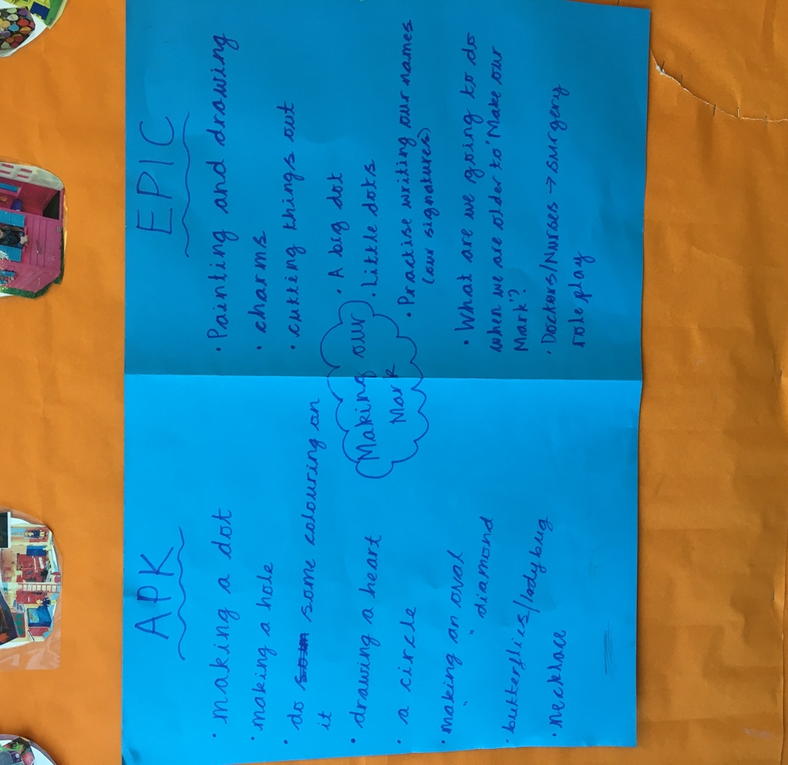
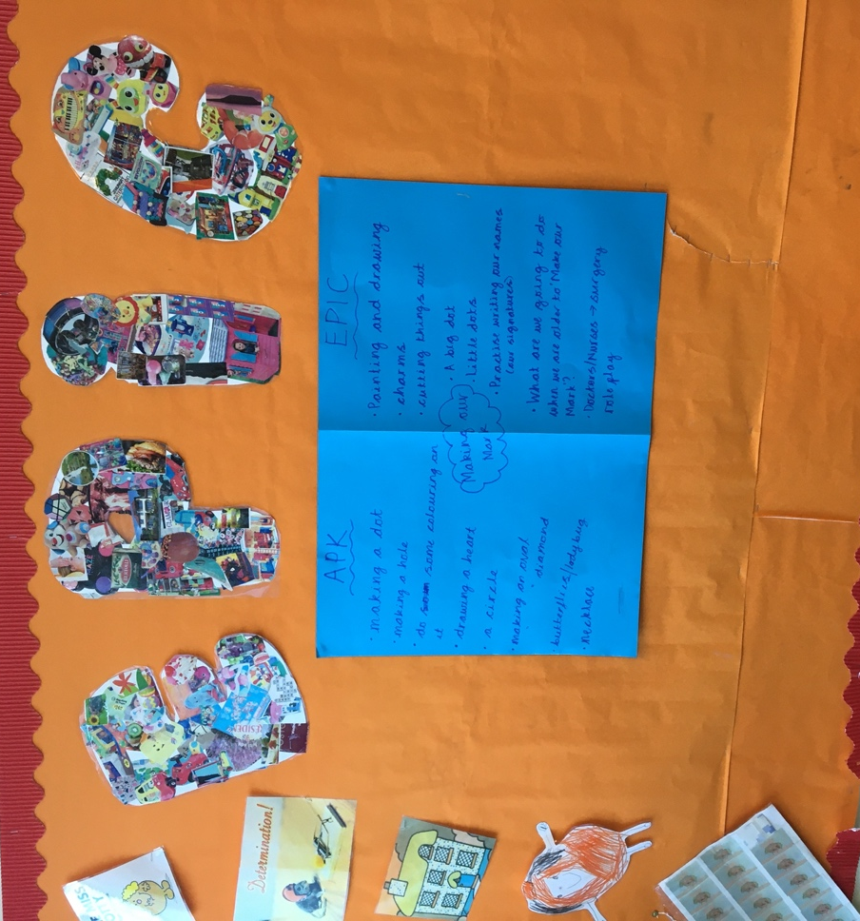
Appendix 2
Image taken by Charlotte Turner, in a local Swansea Primary School.

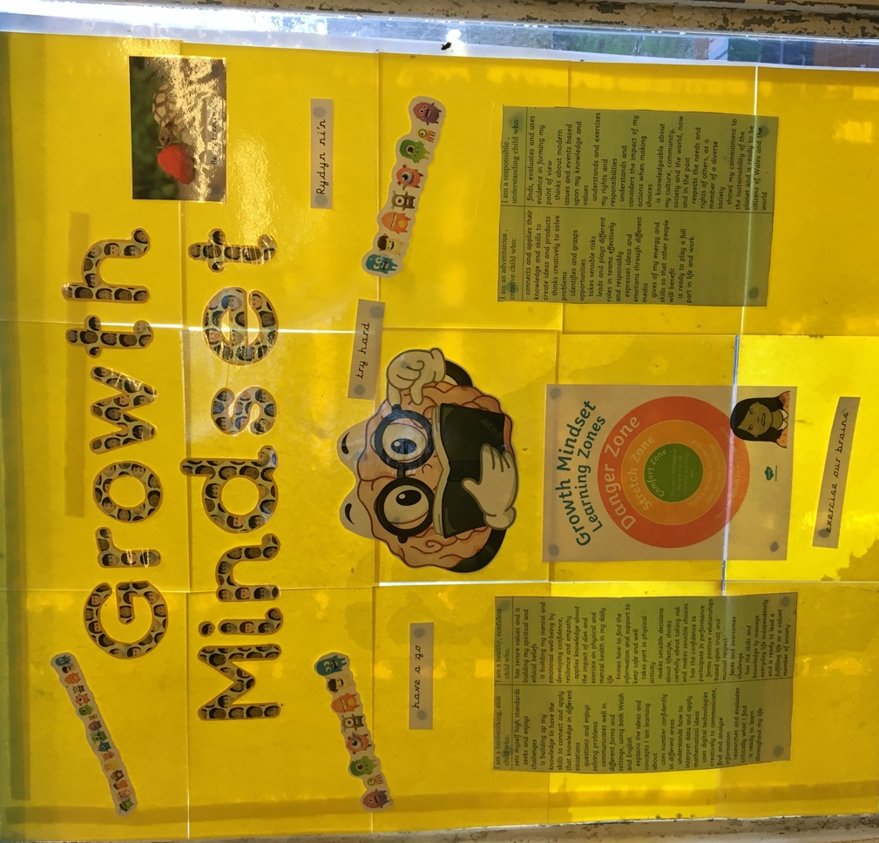

Appendix 3
Image taken by Charlotte Turner, in a local Swansea Primary School.

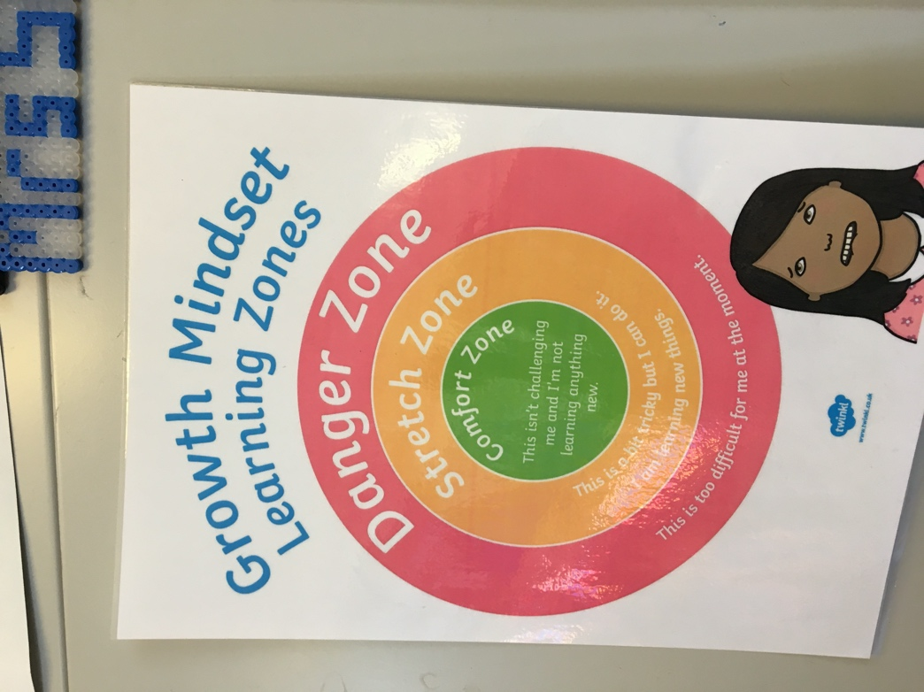

Appendix 4

Encourage Play (2017). Social Stages of Play. [image] Available at: https://www.encourageplay.com/blog/social-stages-of-play [Accessed 28 Nov. 2019].


