

Title of dissertation: A critical review of the use of Conducted Energy Devices (CED) by police forces in England and Wales.

Name of student: Luke Hier
Student number: 1910647
Degree title

Acknowledgements - students can write their acknowledgements here.

Declaration
This work has not previously been accepted in substance for any degree and is not being concurrently submitted in candidature for any degree.
Signed: L.Hier
Date: 31/05/2022

STATEMENT 1
This dissertation is being submitted in partial fulfilment of the requirements for the degree of BA.
Signed: L.Hier
Date: 31/05/2022

STATEMENT 2
This dissertation is the result of my own independent work/investigation, except where otherwise stated.
Other sources are acknowledged by footnotes giving explicit references. A bibliography is appended.
Signed: L.Hier
Date: 31/05/2022

STATEMENT 3
I hereby give consent for my dissertation, if accepted, to be available for photocopying and for interlibrary loan, and for the title and summary to be made available to outside organisations.
Signed: L.Hier
Date: 31/05/2022

STATEMENT 4
I hereby give consent for my dissertation, if accepted, to be available on the university’s IT system to those who have consent to use the system.
Signed: L.Hier
Date: 31/05/2022

Abstract
Within this research project, the aim was to identify if Tasers are fit for purpose and establish if they are the safest means of protecting both the public and the police. This topic was chosen due to the recent media coverage on a death of an individual following being tasered by an officer. The researched aimed to evaluate the primary uses of tasers and the context they are used. With increased media influence the research also aimed to explore both the public and polices opinions and perceptions on the use of tasers. During the research, limitations arouse with regards to up to date statistical data within the UK. Despite this, the study found that tasers are an effective use of force that assists officers in carry out their jobs effectively whilst also protecting them from possible injuries common with dealing with difficult situations and arrests. Also, tasers becoming a safer alternative to other uses of force with less officer being injured whilst on duty. The study also found that the use of tasers has widened considerably over the last decade and that slowly the public are becoming more accustomed to seeing them on officers on duty.

Contents List

Chapter 1 Introduction
1.0 Background …………….
1.1 Aims and Objectives…………..

Chapter 2 Literature Review
2. 0 Introduction …………
2.1 Public Perception
2.2 Police protection and perceptions
2.3 Medical implications and risks
2.4 Conclusion

Chapter 3 Methodology
3.0 Methodology

Chapter 4 Results and Analysis
4.0 Results and Analysis
4.1 Are Tasers fit for purpose; Are they safe for protecting the police and the public.
4.2 How is the weapon perceived?
4.3 What are the primary uses of a Taser; when should they be used?

Chapter 5 Conclusion and Recommendations
5.0 Main findings and Achievement of objectives
5.0.1 How is the weapon perceived by the police and public?
5.0.2 Are tasers for purpose- are they the safest way to protect both the police and public.
5.0.3 What are the primary uses of tasers and in what context are they used.
5.1 Limitations
5.2 Future Research
5.3 Conclusion

Bibliography

Appendices
Appendix A Blank Police Questionnaire
Appendix B Police Questionnaire Results
Appendix C Blank Public Questionnaire
Appendix D Public Questionnaire Results
Appendix E Interview 1 Transcripts:
Appendix F Interview 2 Transcripts:

Figures

Figure 1:
Figure 2:

Chapter One: Introduction

  - Background
Developments in technology have allowed police forces in England and Wales to close the gap between incapacitant sprays and firearms. The Conducted Energy Device (CED) is a piece of modern-day technology that forms part of a trained police officers work related equipment. Only devices manufactured by Taser International are authorised for use by police forces in Wales and England (Home Office, 2013). This is why the CED is commonly known and referred to as Taser. Throughout the research I will be referring to the CED as Taser.
In 2003 the taser was first introduced in the UK following an initial trial by firearms officers (McGuinness, 2016). It is classed as a less lethal weapon that aims to temporarily incapacitate a subject with an electrical current which interferes with the body’s neuromuscular system. As of September 2019, the National Police Chiefs’ Council (NPCC) state that the total number of Specially Trained Officers (STO) and Authorised Firearms Officers (AFO) who carry Taser was 30,548, out of a total officer workforce of 156,833 (2021). These figures are set to rise as the Home Office announced that police forces in England and Wales will receive £6.7 million to purchase 8,155 devices with the potential of arming 8000 more officers (Home Office, 2020).

  - Aims and Objectives
Aims - Within this research project the aim is to identify if tasers are fit for purpose and establish if they are the safest means of protecting both the public and the police. Furthermore, I will review the primary uses of Taser and ascertain in what context they are used. Finally, I will identify how the weapons is perceived by both, the public and the police to gain an understanding of how people view the weapon.

Objective 1: Are tasers fir for purpose- are they the safest way to protect both the police and public.
Objective 2: What are the primary uses of tasers and in what context are they used.
Objective 3: How is the weapon perceived by the police and public?

  - Rational
Having worked in the police force for only two years and undertook Taser training very recently, the topic and discussion around its use was very interesting and posed some interesting questions. In 2020 the home office announced that police forces in England and Wales would get more funding towards arming our officers with tasers. With this came a media frenzy with previous media stories on incident and deaths relating to tasers re-appearing online and in the media. There seems to be a relatively large grey area with regards to the medical impacts of a taser, with an individual’s medical history being a significant factor in the outcomes of a taser shock. With such a significant funding scheme going into Tasers, it is important to understand the purpose and use of tasers and how they are perceived. I will be carrying a taser on duty and having knowledge and understanding on its use will provide me with more confidence and consideration when using it.

  - Structure
Throughout this research the aims is to meet the studies objectives. To do this, the dissertation will be divided into five chapters.
Chapter one will outline the purpose and background of the study with a brief introduction to the topic of tasers. Chapter two will present current literature and review the data available on tasers within the UK to enable an critical review on taser usage. Chapter three will present the methods and methodology used to complete the data collection and identify the suitability and limitations of primary data collection. Chapter four will present the findings from the primary data collected and seek to withdraw key themes and findings. Following from this chapter five will discuss and answer the dissertations aims and with discussions on limitations and further research.

  - Conclusion
Chapter one has introduced the research topic with clear aims and objectives for the study. A brief background of tasers has been given along with a rational for the study and an overview of the dissertation structure. The next chapter will present the literature review, proving an in-depth analysis into current findings on tasers.

Chapter Two: Literature Review

2.1 Public perception
The publics’ confidence and opinions of the police are very temperamental and the fear of weapons can contribute and affect these considerably. It is said that the public’s fear of weaponry stems from a lack of knowledge on the matter. “A review of 56 published studies reported that the mere sight of weapons increases aggression in both angry and nonangry individuals” (Carlson et al, 1990). This is known as the ‘weapons effect’ and has been studied by phycologists for many years. It is feared that if police forces in England and Wales arm the vast majority of their officers with Taser, an increase in aggressive behaviour could arise as a direct result. A study conducted by NPCC in 2012 identified a number of reasons as to why a percentage of the public have a negative perception of Taser. The reasons include, negative or false media coverage, its use in other countries and the number of deaths that have occurred in association with the device. However, it is important to note that safety regulations are greater within England and Wales than in countries such as the United States of America (USA). The Independent Police Complaints Commission (IPCC) recognised that the public view tasers as a high-level use of force that should only be used when dealing with serious threats whereas the police view tasers as a piece of safety equipment that is of a lower risk than others. (IPCC 2014a, p. 25).

Studies conducted in the USA have identified that people who suffer with mental illness, those from minority groups and those who are under the influence of drugs or alcohol are more likely to have Taser used against them (Lin and Jones 2010, Gau et al. 2010, O’Brien et al. 2011). These categories of people are commonly referred to within the UK as vulnerable people. Therefore, it is understandable that public perception of the police and the device deteriorate when used against said categories of people, regardless of circumstances. The police conduct report 2015 reviewed the public’s opinion of the police force and found that concerns raised regarding the number of times the police used force was comparatively low. Only one in every 25 people said they were concerned about the frequency of the use of force with only a quarter stating they had some concerns (TNS, 2015). Similarly, another study found that “71% of the respondents considered it acceptable for officers to carry a Taser and four out of five participants claimed that they would be more likely to approach an officer for help if they were in possession of a Taser” (Polfed.org, 2016, p.469). Nevertheless, it also found that the public assume that the police only use type of force that are legal and within the requirements of the law however, when asked they had little knowledge of the laws and what types of force the police can legally use. It remains that the public continue to have some level of concern regarding the use of tasers but have a limited understanding on the laws, its use and why and when it is deployed.

2.2 Police protection and perceptions
According to College of Policing (CoP) “any use of the Taser must be proportionate, lawful, accountable and absolutely necessary” (2021, p.37).
Studies and reviews on the use of Tasers within the police force underlined the issues of ‘mission-creep’ which involves using certain types of force because it is readily available as opposed to using what is necessary (IPCC, 2014b). Research also stresses that the use of tasers has significantly increased “not only in terms of the number of police officers using it, but also in terms of its use in circumstances where it would not have been used in the past” (NPCC, 2015, p.211). In Rogers (2003) recent study he highlighted the need for better policing of firearms. He stated that there is need for more research on less-lethal weapons and that the government and UK police forces have committed to doing so. Officers are often called to very serious incidents in which they put themselves at risk or harm, because of this Tasers are predominantly used when officers seek to protect themselves and the public, to make an arrest or to gain control of a potentially dangerous situation (White & Ready, 2007).

Research conducted by NPCC (2019) using 38,355 separate uses of force, from 20 police forces, indicates the number of officers reporting injuries. Out of 5619 deployments of Taser, 225 resulted in officers getting injured accumulating to a 4% officer injury rate. When compared to Irritant spray 16% and baton 11% it is clear that Taser is a safer alternative for officers. From these finding it is evident that Tasers aid in reducing the risk officers face, this is said to be because it allows police to effectively contain a high-risk situation without resorting to lethal force or officer injury, a Taser device can be seen as a less lethal police response (Vilke & Chan,2007; White & Ready, 2007). McDonald et al (2009) researched the impact of introducing Tasers into the police department, specifically investigating the number of officer injury before and after the introduction of Tasers. Their study found that across 12 police departments there was a 25% reduction in the number of officers injured during arrest. Their study also highlighted that the main reasons for the reduction was the decline in the need to physically intervene and restrain an individual. Similarly, to this study Taylor and woods (2010) also researched and compared police departments with and without Taser devices over a four year period. Their findings highlight that departments without Taser had higher rates of officer and suspect injuries and more instances where medical attention was needed. These studies were conducted in the USA but due to the lack of comprehensive studies conducted in the UK it is useful to draw on findings that focus specifically on the comparison of police forces that use and do not use Taser, rather than officers who do and do not use it. With all police forces in the UK using Taser, it is difficult to complete a comparison. In contrast, a study conducted by Cambridge University with the help of City of London police reported that officers who were visibly armed with Taser used force 48% more often and were more likely to be assaulted, than those unarmed (2018). Although, a comprehensive study, important questions still remain unanswered such as the type of incident officers were deployed to. It is well documented that officers in possession of Taser attend calls which involve a higher risk to their personal safety and would therefore be more likely to use force or get assaulted.

In 2019, the Police Federation of England and Wales (PFEW) carried out a snapshot poll with regard to officers carrying Taser. The results from the poll identified that “89% of officers would want to routinely carry Taser after being given appropriate training, with nearly 97% saying their colleagues should be allowed to carry the devices” (Polfed, 2020). These results identify that officers feel the need for extra protection in situations where there baton or incapacitant spray may not be enough. However, it is clear that there is limited research on how officers perceive Tasers and their opinion on the device.

2.3 Medical implications and risks
The aim of this section is to underline some of the medical issues relating to taser deployment and issues regarding its safety. The literature review does not critically analyse the findings of the authors but provides an overview of current findings and literature related to the medical implications of Taser use.

A highly researched and debated topic within the area of Tasers is the medical implications. Taser is an electrical weapon which delivers short high-voltage, low current pulses through two barbs attached to fine wires. The purpose of the Taser is to temporarily incapacitate a person by causing painful muscular contractions (Kunz, Grove, & Fischer, 2012). The use and safety of Tasers are highly debatable the manufacturer of the devices state in the product information that use of TASER devices “causes physiologic and/or metabolic effects that may increase the risk of death or serious injury” (Taser International, 2013). The five-second charge generated by a Taser ECD is 50,000 volts and can be more hazardous when used on some individuals that are intoxicated, abuse drugs or have underlying health issues. The health implications and risks have been well documented, and are highly controversial. “Health concerns can be classified into three broad streams: sudden deaths, injuries and adverse effects, and the potential for the electrical energy of a discharge to cause disruption to cardiac functioning” (O'Brien & Thom, 2011, p.422). The difficulty with assessing the medical risks of Tasers is the ability to differentiate direct Taser complications from any other complex medical issues. The literature surrounding Taser deaths and injuries do not identify exactly what impact the Taser shot itself has on the human body.

The extent of injury after electric shock is determined by voltage, resistance, amperage, type of current, current pathway, and the duration of contact ( Jain S, Bandi V, 1999). In review of the possible injuries and health concerns following the deployment of a Taser the most common injury documented is the falls and injuries sustained after the shock is administered. Cooper‘s studies on electrical injuries found that high voltage direct current tends to cause a single muscle spasm, often throwing the victim from the source causing blunt trauma (1995). Indirect injury is often caused when a Taser is deployed and injuries occur after the shock has taken place. Often when a Taser is deployed the individual falls to the ground. The surface on which they fall can impact the severity of the injury. Additionally, the height the individual falls from can differ and therefore the severity of the injuries sustained as a result of the fall can also vary. As well as indirect injuries, minor injuries can occur such as injuries to the skin. “Injuries to the skin and underlying tissue and organs from probe penetration and from the passage of electrical current; joint injury; bony injury (including skull and traumatic brain injury) from falls; the physiological stress from the pain and muscle contractions could exacerbate pre-existing conditions (such as disorders of the heart, circulation and respiratory systems)” (NPCC, 2017).

Factors such as meatal health, drugs, alcohol and underlaying medical issues need to be considered before deploying a taser however there remains a gap in knowledge of the impact these factors have on an individual who has been tasered. How these factors can affect a person and their contribution to injury or death because of a taser remain largely unanswered (Bleetman, A, Steyn & Lee C., 2004a). A review by the IOPC on the use of Tasers between 2015 and 2020 examined 101 cases within England and Wales. Of those 101 cases 16 involved a death, they note that the deaths were not necessarily the result of Taser use. “However, four inquests have found that the use of Taser, in combination with other factors, contributed to or were relevant in a person’s death” (Independent Office for Police Conduct (IOPC), 2021). Other research into deaths linked with Taser such as the American Journal of Public Health suggest that “any injuries sustained during or after being exposed to the deployment of a Taser did not come from the weapon itself; other factors had the potential to affect the condition of the suspect”. While this is promising, other contributing factors would have to be considered when establishing why there are the amount of injuries and even deaths there are as a result of Taser deployment (Bleetman, A, Steyn & Lee C, 2004b). With such conflicting findings and no real evidence to suggest that Tasers cause death due to poor data sources and difficulty in completing medical examination, it is not possible to identify a Taser shock as the main cause of death. An in-depth analysis and study by Amnesty International through the use of media and police medical reports “identified a number of factors that were common to most of the Taser-related deaths it examined. These included pre-existing or underlying health problems such as heart conditions and mental illness, and being under the influence of drugs.” (Hancock L and Gant F, 2008).
A common misconception is that the deployment of a Taser has an impact on the cardiac functioning. Preliminary research on the effects of the TASER on human heart rhythm has confirmed earlier studies indicating the TASER does not cause ventricular fibrillation when used for short intervals on healthy adults. Furthermore, it should be noted that “although studies on this device are very incomplete, there is no credible proof that the TASER induces cardiac arrest when used by law enforcement officials in a prescribed manner. In fact, the voltage required to induce VF has been calculated to be 15 to 42 times the charge possible to be delivered from the TASER. It has been acknowledged that there have been no documented cases of VF directly caused by the device in more than 600,000 police uses” (Roberts, James R. MD. 2008, p.47).

2.4 Conclusion
Within the review of literature, information has been accumulated on the topics in which the research will be based. During the review it was noted that, although there are many academic studies on Taser and its uses internationally, studies within England and Wales are very limited or dated. Many recent studies have also observed the need for new data to help understand the current trend and use of tasers as most relevant research is currently based and reliant on a small number of data sets (Bolger 2015, Neuscheler and Freidlin 2015). Questions are also being asked about the corporate influence on research (Azadani et al. 2011).

In my research I aim to identify how the device is perceived by serving police officers who carry the device as well as those who do not. This will give better understanding of how safe, efficient and effective the device is, from those who use it and those who have seen it used. Furthermore, I aim to identify how the public perceive the device, as although, many officers carry them, there is limited up to date research. Finally, the recent death of ex Aston Villa footballer Dalian Atkinson who was subjected to Taser has made the public question the devices safety. Within my research, I aim to establish if his death has altered public opinion on whether or not the device should still be used.

Chapter Three- Methodology
When considering the research aims it was essential that the right methods were selected to collect and obtain useful and reliable information. A method that allowed for the opportunity to find out how the police and the public feel about the use of Tasers is key in answering the aims of the research. Having read a considerable amount of literature on research methods (Gill, 2008; Daley, 2013; Dencombe, 2010; McNiff and Whitehead, 2005; Drever, 2003) it was clear that to obtain a range of responses to fulfil the objectives of the study both, questionnaires and interviews would need to be used. The literature emphasises the importance of using a range of methods to ensure depth and triangulation (Daley, 2013; Dencombe, 2010; McNiff and Whitehead, 2005; Drever, 2003) and for this reason a variety of research methods will be used. Ensuring triangulation will allow the collection of reliable and comparable data.
The first research method will be a questionnaire/survey, which is an “investigation of the opinions or experiences of a group of people based on a series of questions” (Oxford Dictionary, 2018). According to Bell (2010) questions provided in the questionnaire are predetermined and mainly aimed at extracting specific data from a particular group of people regarding their opinions and behaviours. He also suggests that “the success of a research project depends on the population sampled and how representative it is of the target population”. When considering the sample used for this research the aim is to make reliable and accurate interpretations to a broader population, often referred to as “representation” (Bates, Brick & Baker, 2013).
For the purpose of this research, the aim is to explore both the public and the police perceptions and opinions on the use of Tasers. Firstly, a questionnaire will be administered to a sample of 25 police officers. All officers asked to complete the questionnaire will have been Taser trained and be currently working for a police force in England or Wales. Additionally, another 25 questionnaires will be given to the public. The members of the public selected to complete the questionnaire will be from various places within Wales. The public will be asked questions regarding their understanding of the use of Tasers and explore their knowledge, attitudes, perceptions, feelings and ideas regarding the use of the device. Two different questionnaires will be created to establish and compare the police and the public’s perception on the use of Tasers. The questionnaires will be different, as many questions given to the police will not apply to the public.
Prior to administering the questionnaire, a pilot/trail will be given to 5 people to ensure the questions are easy to understand and establish if there are any errors or need for additional questions to be added. This will be done for both the police and public questionnaire. An essential requirement that should be considered prior is consent. All participants will be asked to give their consent before completing the questionnaire. This will be done in the form of an information sheet as the first page of the questionnaire, which participants will have to read and agree their consent. Mahon (2013) states the need for this when conducting any ethical research.
Additional reasons for choosing questionnaires as a method is the element of time. Considering the time scale in which this study needs to be conducted a questionnaire allows for the collection of reliable, valid, and unbiased data from a representative sample in a timely manner and without resource constraints (Mutepfa & Tapera, 2018). The questionnaires will be distributed online, using a survey platform called Smartsurvey.co.uk.
When administering and using questionnaires as a method of research it is also important to acknowledge the limitations of using such methods. A common issue with online data collection is the response rate. Recent studies into the effectiveness of online data collection have raised concerns regarding the uptake in completing the questionnaires and the ability for people to ignore or delete requests to complete (Carbonaro & Bainbridge, 2000). Furthermore, the technical nature of online data collection can be a limitation, online surveys require the participant to have access to the internet and have a basic understanding of technology (Lefever et al, 2006). However, researchers have identified that, online data collection protects against the loss of data and simplifies the transfer of data into a database for analysis saving the researcher time and effort.
The second method that will be used is an interview to obtain more qualitative data on the topic of Tasers. The purpose of qualitative research is to explore and describe the ‘quality’ and ‘nature’ of how people behave, experience, and understand (Kvale, 2003). Interviews will be conducted as well as questionnaires as in comparison to questionnaires an interview is more useful in eliciting narrative data and allows for the investigation of the officer’s views in greater detail (Cohen et al (2007: 29). Furthermore, the interactive aspect an interview allows for the researcher to press for complete, clear answers and investigate topics that emerge from the pre-planned questions (Kallet, 2005a). Drever (2003) adds that interviews assist in “broadening the scope of understanding investigated phenomena, as it is a more naturalistic and less structured data collection tool”.
For the purpose of this research, a South Wales Police staff member will be interviewed. Their current role within the police is to train officers in a variety of aspects, one of those being Taser training. They were a police officer for 30 years and has since retired and re-joined as police staff in the training department. The interview will seek to gain their opinion and explore their experiences with Taser use. In order to draw comparison and look at different arguments, an interview with a member of a human rights group will also take place. The member has asked to remain anonymous, however, it can be confirmed that they work alongside police forces in England and Wales regarding use of force and stop search. For the purpose of this research, it is essential to critically analyse the data collected and by conducting two interviews; opinions and views of opposing arguments can be listened to and evaluated.
The interviews conducted will be done in a one-to-one environment, which is the most common form of interview (Kallet, 2005b). The interview will be semi structured which will allow for questions to be taken in different directions where appropriate and allow for more flexibility. The use of semi-structured interviews will also enable interaction and better discussions (McNiff, and Whitehead, 2005). Hitchcock & Hughes (1989) similarly state that semi structures interviews “allow depth to be achieved by providing the opportunity on the part of the interviewer to probe and expand the interviewee's responses”.
Throughout the interview, it is likely that answers given will need further investigating and semi-structured interviews will allow for this. Core questions will be planned, this is suggested by Berg, (2007) he recommends using a basic check list to help cover all the main elements and to keep some structure. When using interview as a method of data collection the person getting interviewed may want to take the discussion in different directions and having a core set of questions planned will allow the interview to say focused and ensure the discussion does not deviate too far from the research aims. The interview will be recorded and transcribes to depict key themes and opinions.
Having established the benefits and reasons for conducting a semi-structured interview, the limitations also need to be considered. Planning and conducting an interview can be time consuming and finding an appropriate time that both the researcher and interviewee can both attend can be challenging (Castellan, 2010). Furthermore, building a sense of trust and a safe environment can be difficult when interviewing. Ideally the interviewee needs to feel calm and at ease in order to give true and reliable responses (Oppong, 2013). On some occasions, having a semi structured interview plan can lead the conversation to deviate and discussions that are off topic can happen and provide information or data that does not relate to the research aims (Roshan, & Deeptee, 2009).

Chapter Four-Results and Findings
For the purpose of data analysis, both interviews have been transcribed in order to depict themes and answer the project objectives, (Appendix E and F). The analysis of the transcripts sought to address the research objectives and establish different viewpoints provided by the two interviewees. The survey was completed online using Smart survey, which collated and created statistical data to be interpreted and analysed. Using a platform such as Smart Survey had several advantages such as the simplicity of administering the questionnaire in a short period of time and the data collected were presented numerically and in percentages to allow for quick and easy interpretation of the results and findings (Appendix ?? and ??).

Throughout this section, the data analysis will attempt to answer the three objectives of the dissertation, which are:
- Are Tasers fit for purpose; Are they safe for protecting the police and the public.
- How is the weapon perceived?
- What are the primary uses of a Taser; when should they be used?

Are Tasers fit for purpose; Are they safe for protecting the police and the public.
With regards to the officers who took part in the questionnaire, all currently carry and are trained in the use of Taser. Of the 25 officers, 11 have discharged a Taser and 12 have not, the remaining two stated other as they have used a Taser as a stun drive and not fully deployed the device. Of the 13 who have used a Taser in one way or another, 9 of them said that its use was effective in dealing with a situation, 4 of them stated that its use was not effective.
Current research on Tasers highlights the impact carrying a Taser had on reducing the number assaults carried out on police officers, findings from the questionnaire correlate to these statements with the majority 52% agreeing and another 16% officers strongly agreeing that they thought carrying a Taser device lowers the risk of being assaulted, 12% however disagreed. With regards to the officer safety the data supports existing findings highlighted in the literature review by McDonald et al (2009). He found that there was a 25% reduction in the number of officers injured during arrest due to the reduction in the need for physical intervention.
Similarly, when asked if officers felt safer carrying a Taser there was a clear view with 96% of officers stating that they felt safer. Furthermore, research states that Tasers are used to deter offenders from assaulting police and of the officers who took part in the survey, 84% agreed that the presence of a Taser device reduces a subject’s aggression while in a confrontational situation.

The results of the public questionnaire on the use of Tasers found that 21 respondents (84%) identified that they felt safer when in the presence of an officer carrying a Taser, 3 respondents (12%) stated they did not feel safer in the presence of an officer carrying Taser and 1 respondent (4%) stated it did not make a difference.
The public were asked if they would be more likely to approach or speak to an officer in possession of a Taser device. This question had noticeable differing views with 15 respondents (60%) neither agreed nor disagreed that they would be more likely to approach an officer carrying a Taser device and other responses that can be seen in (appendix B) question 7. These findings do not correlate to the findings within the literature review, which stated that four out of five participants claimed that they would be more likely to approach an officer for help if they were in possession of a Taser (Polfed.org, 2016).
The public’s response to whether they found Tasers devices intimidating was very wide ranging. 32% felt that the presence of a Taser was intimidating but a majority 48% disagreed and 12% strongly disagreed. With the majority stating that they do not find the presence of a Taser intimidating the following question regarding the reassurance a Taser brings was high with 80% of respondents saying they felt reassured in the presence of a Taser. This data is again different to that identified in the literature review whereby Carlson et al, (1990) reported that the mere sight of weapons increases aggression in both angry and nonangry individuals”.

The interview with the current trainer for Tasers in South Wales Police has stated that from feedback and discussions with officers more and more are opting to carry a Taser for safety reasons. They explained that officers find by just carrying a Taser it becomes a deterrent in itself. The statement below is taken from the interview (Appendix E). They do however state that they do not think that Tasers should be a compulsory part of PPE.
“They turn up to incidents, people are looking and seeing they got Taser and on numerous occasions when we train them, I have lots of officers saying to me just because I was carrying that Taser the person basically complied with my requests”.
When asked about the safety and risk issues associated with Tasers, the trainer noted that the most common safety issues with regards to the public was the possibility of injury as a result of a Taser being deployed. They discussed possible injuries as a result of being Tasered, such as cardiac arrhythmia, injuries that occur after the impact such as head, body and muscular injuries from falling. They also discussed the risks to others, for example if a Taser was to miss the offender and make contact with others close by (Appendix E).

How is the weapon perceived?
How the police and public perceive the use of a Taser was explored within the questionnaire. The officers were asked if all front-line police officers in England and Wales should have the option to carry Taser devices. Majority of respondents either strongly agreed or agreed that all front line police officers in England and Wales should have the option to carry Taser devices but interestingly when asked if all officers should have a Taser without the option to opt out 28% disagreed. When asked if officers should NOT carry tasters all respondents either disagreed or strongly disagreed, this suggesting that all officers see a benefit and purpose to carrying Tasers.
The majority of responses in the police questionnaire, supports the findings within the literature review, for example, Polfed study found that 89% of officers would want to routinely carry Taser after being given appropriate training, with nearly 97% saying their colleagues should be allowed to carry the devices (Polfed, 2020). The public were also asked if they thought all front-line police officers in England and Wales should carry a Taser device, of the 25 asked 8 (32%) strongly agreed, 13 (52%) agreed and 4 (16%) neither agreed or disagreed.
During the interview, the Taser trainer stated that the think officers should all have the option to carry a Taser based on the statistics gathered within the South Wales police force. They explained that currently an officer is 20% less likely to be assaulted when doing your police role.
Within the literature review, it was found that The Independent Police Complaints Commission (IPCC) recognised that there is an obvious mismatch between the public perception that Taser is a high-level use of force that should only be considered when faced with the most serious threats of violence. Respondents were asked if a Taser should only be used when an officer is threatened with serious violence. The responses were varied as you can see from the results table below (Appendix ??).

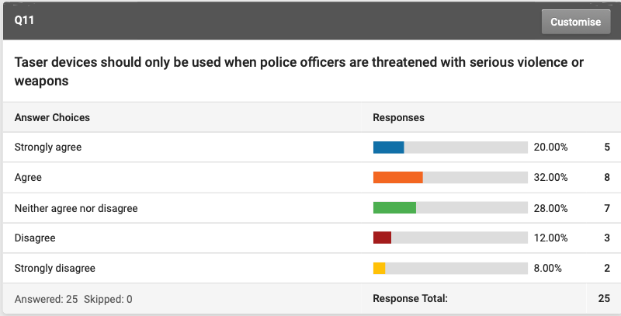

The public were then asked if they thought Taser devices should be used at an officer’s discretion; in any situation, they deem its use is necessary. 28% strongly agreed, 52% agreed and 20% disagreed. The opinions regarding the safety of Tasers were very varied with many differing views. The police were given the statement “Tasers are dangerous”. From the pie chart below (Figure 1), it is possible to state that the majority of officers strongly disagree with the statement. In contrast to this the public’s response gathered was again very wide ranging, the findings can be seen in (figure ??).

Police result.

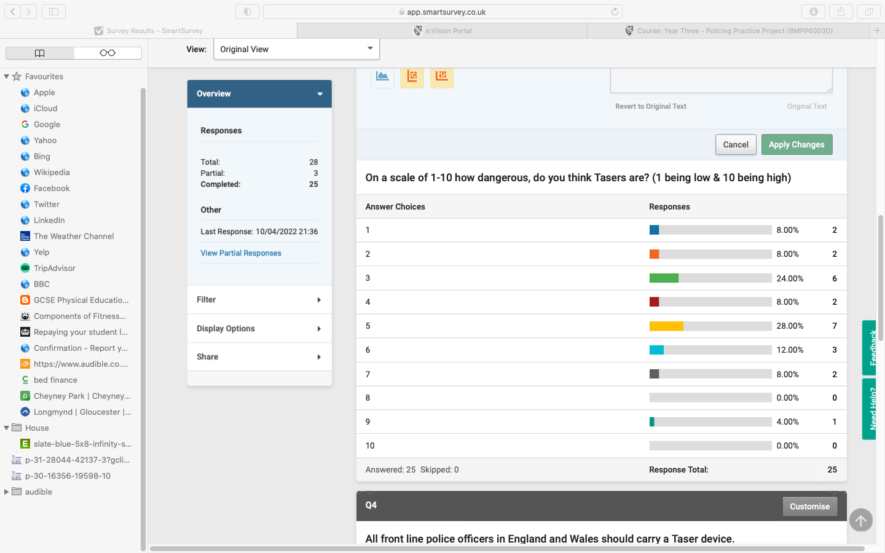
Public’s result.

– I often go out into the community and speak with people about use of force, stop search and policing in general. Tasers are often a topic spoken about, as people don’t know what they are or what they do, especially those who don’t come into contact with police regular. I think, um there is a lack of knowledge on Tasers in general.

What are the primary uses of a Taser; when should they be used?

When considering when Tasers should be used 42% of the public asked, thought that Taser devices should only be used when a police officer is threatened with serious violence. 28% neither agreed or disagreed with this statement. 20% either disagreeing or strongly disagreeing that Tasers should be used when threatened with serious violence. Furthermore, they were also asked is Taser devices should be used at an officers discretion, in any situation the deem its use is necessary, 80% either agreed or strongly agreed with this statement.
The police survey highlighted that officers agreed that Tasers should be used to lower the risk of being assaulted, 68% of officers agreed with this statement. Similarly, 84% of officers said that the presence of a Taser device reduces a subject’s aggression while in a confrontational situation. The officer interviewed commented on its use and the benefits;
“Tactical option around it is a distance tool it can offer them at least 25 feet away from a person or persons that they do perceive a threat from and can assist them with their personal safety then.”
Furthermore, with regards to when it should be used, they also stated that;
“I can’t actually say when they would use it because it would be down to that officer’s actual thought process and then being able to justify their action as and when they do use it. If we are talking about what type of incident, it is usually incidents involving weapons or highly aggressive persons.”
He continued by discussing the national decision model that is taught in Taser training but emphasises that situations are spontaneous and rapid that that implement this model every time can be difficult (Appendix e)

Chapter Five: Conclusion and Recommendations

5.0 Main findings and Achievement of objectives
5.0.1 How is the weapon perceived by the police and public?
Throughout the dissertation, it can be seen that the publics perceptions on the use of Tasers is varied and can be influenced by a number of factors. The research finding suggest that the public lack knowledge and understanding about the use of Tasers. Within the questionnaire responses by the public would imply a lack of opinion on the topic, this is demonstrated with many key questions answered with neither agree or disagree. Carlson et al similarly reported that the publics fear of weaponry stems from a lack of knowledge on the matter (1990). The publics opinion on the use of Tasers was very sporadic with a very varied opinions provided. A lack of knowledge can often lead to apprehension however, in contrast, this study found that the majority of the public were not fearful and do not find the Taser device intimidating.
We currently live in a generation in which media has a significant influence on the public’s perceptions. The public’s view on ‘how dangerous the deployment of a Taser is’, was also wide-ranging and this can often be a result of opinions formed through the media. The aim of the police is to achieve public confidence and to do this they need to manage how Tasers are portrayed in the media. Many incidences involving Tasers are caught on camera and can be interpreted differently by members of the public, therefore instilling either positive or negative opinions on its use, educating the public on its use and purpose can alter these opinions.
The public’s opinion is not as negative as initially though as a result of the literature review findings. Results found that in general the public agreed that the police should carry Tasers and that they trust them to use the device at their own discretion. Findings suggest that the public support the police decision to use a Tasers as long as its sufficiently justified or if the officer is threatened with serious violence or weapons. The appearance of an officer carrying a Tasers has become more common with majority of officers in Wales carrying one when on duty. As a result of this the public are becoming increasingly accustomed to the use/sight of Tasers with many reporting that they feel safer in the presence of an officer carrying a Taser.
The police perception on the use of Tasers is generally very positive with majority either carrying a Taser or agreeing that all officers should have the option to carry one. The most common reason for officers having a positive perspective on the use of Tasers is the safety element it brings. Most officers questioned reported that a Taser is used most commonly as a deterrent and as a threat to discourage any further trouble without having to physically intervene, which in turn reduces the chance of injury sustained when trying to physically restrain or arrest an individual.

5.0.2 Are Tasers for purpose- are they the safest way to protect both the police and public.
Finding suggest that both the public and the police agreed that a Taser should be drawn in any circumstance where the officers perceive the need for action and use of force to contain a situation. When considering if Tasers are fit for purpose it is important to consider other uses of force and when compared to the next use of force option, firearms they are far safer for the recipient and when compared to the baton they are safer for the officer and the recipient. It appears too that officers feel a lot safer when carrying Tasers and find they are less likely to be assaulted. Furthermore, this is supported by literature that also states an officer is 20% less likely to be assaulted doing their police role than not carrying a Taser. It has also been found that it allows officers to deal with incidents in a safer manor especially when other members of the public are in danger and the situation can be diffused quickly.
Tasers are a means of protecting the public in environments where an individual is or is likely to put others in danger as a Taser can defuse a situation quickly. Findings from the public found they felt safer in the presence of officers with the Taser.
The disadvantages of using a Taser is the injuries that can be sustained as a result. The most common injuries that incur because of a Taser deployment are indirect injuries such a blunt trauma that happen when the individual falls. Another aspect that questions the safety of Tasers is the missing research on the medical implication with regards to pre-existing or underlying health problems such as heart conditions and mental illness, and being under the influence of drugs. These are key aspects that significantly question the safety of the use of stares however when considering alternate use of force such as a firearms, stun guns and incapacitant spray officers find that Tasers bridge the gap.
5.0.3 What are the primary uses of Tasers and in what context are they used.

When considering the primary use of the Taser, injuring or temporarily incapacitating the offender is not one. The finding from this research has found that the leading purpose of a Taser is to protect the officer dealing with an incident or any other members of the public in danger because of an incident occurring. When trying to establish when a Taser should be deployed the nature of the threat and behaviour of the individual were the consistent responses and themes throughout the study. Current literature highlights the importance of officer safety and welfare and the need for officers to carry protective safety equipment to protect themselves. The use and the need for officers to carry Tasers assist in the protection of officers. The study found that most officers and members of the public think that all officers should have the option to carry a Taser.
From the result of the study and literature, it can be seen that Tasers are often used as a deterrent and often not actually deployed every time. This is because Tasers give the police more power over non-compliant people, they are subsequently being using as a de-escalation tool with just a threat of deployment being enough to deter an individual from committing a crime or assaulting and officer. On the other hand, when a Taser is deployed the main purpose is to temporarily incapacitate the individual to protect the police and the public or to defuse a possible serious incident quickly.

5.1 Limitations
This dissertation intended to critically review the use of Tasers by police in England and Wales. This research project did review literature and policy documents in both England and Wales however the primary research was only conducted in South Wales. Due to the time constraint of the course the sample was only representative of three police stations on South Wales therefore not allowing for a critical review of all officers.
Another limitation of the study was the lack of good data collected from the public questionnaire. The questionnaire consisted largely of closed questions, unfortunately these questions provided limited information on the reason behind some responses and opinions which made it harder to interpret the data collected. Furthermore, some question offered too many responses which in turn gave a big range of opinions and consequently did not assist in making any significant conclusions on some topics.
The interview conducted was very useful and provided information on current training and used of Tasers within South Wales. The person undertaking the interview maintained a very professional stance and limited their personal opinions on some questions making it difficult to really get their prospective on key questions. A lot of the information he gave was readily available online therefore not adding to the data as much as hoped.
Lastly when conducting research into current findings and research on the use of Tasers, articles and journals were predominantly based on polices forces in the United States of America making it difficult to compare statistics and data.
5.2 Future Research
This dissertation researched both the polices and public opinions and perceptions on the use of Tasers. To gain a more in-depth and true representation a more focused approach on just one would allow for a more detail understating and ability to collect more specific data and gain a detailed account of how for example the police perceive and use Tasers. Furthermore, future research on this topic could focus more on the use of equipment such as a Taser because it is available, rather than because it is necessary. A consistent finding was the use of a Taser as a deterrent and threat with clear warning against its use as a pain compliance tool.

5.3 Conclusion
To conclude the research has found that Tasers are an effective use of force that assists officers in carry out their jobs effectively whilst also protecting them from possible injuries common with dealing with difficult situations and arrests. Tasers are a safe way to control difficult situations quickly whilst also becoming a safer alternative to other used of force such as firearms, batons and sprays. It is clear from the findings that use of Tasers has widened considerably over the last decade and that slowly the public are becoming more accustomed to seeing them on officers on duty. Research has found that the Taser has significantly reduced the number of officers getting injured while on duty and that generally officers feel safer when carrying one. The Taser does also have some disadvantages with its use rising, questions on the terms of its use begin to arise with questions surrounding its safety and the potential dangers that can occur once it is deployed. The medical implications are still not widely research or studied enough to really discourage the use of Tasers.

Reference List/ Bibliography
Azadani, P., Tseng, Z.H., Ermakov, S., Marcus, G., and Lee, B., 2011. Funding source and author affiliation in TASER research are strongly associated with a conclusion of device safety. American heart journal, 162 (3), 533–537.
Bates, N., Brick, M. & Baker R. (2013). Summary Report of the AAPOR Task Force on Non-probability Sampling. Journal of Survey Statistics and Methodology. 1 (2), 90-143.
Bell, J. (2010), Doing Your Research Project: A guide for first time researchers in education, health and social science. Maidenhead: Open University Press. [e-book IOE library].
Berg, B. L. (2007). Qualitative research methods for the social sciences. London: Pearson.
Bleetman, A, Steyn & Lee C. (2004a). Introduction of the Taser into British policing. Implications for UK emergency departments: an overview of electronic weaponry. Emerg Med. 21 (1), 136-140.
Bleetman, A, Steyn & Lee C. (2004b). Introduction of the Taser into British policing. Implications for UK emergency departments: an overview of electronic weaponry. Emerg Med. 21 (1), 136-140.
Bolger. 2015. Just following orders: a meta-analysis of the correlates of American police officer use of force decisions. American journal of criminal justice, 40, 466–492.
Cambridge University. (2018). Carrying Tasers increases police use of force, study finds. Available: https://www.cam.ac.uk/research/news/carrying-tasers-increases-police-use-of-force-study-finds. Last accessed 11th January 2022.
Carbonaro, M. & Bainbridge, J. (2000). Design and development of a process for web-based surveyresearch. The Alberta Journal of Educational Research, 46, 4, 392–394.
Carlson, M., Marcus-Newhall, A., & Miller, N. (1990). Effects of situational aggression cues: A quantitative review. Journal of Personality and Social Psychology, 58, 622–633.
Castellan, C. (2010). Quantitative and qualitative research: a view for clarity. International Journal of Education, 2(2), 1-14.
Cohen, L., Manion, L., & Morison, K. (2007). Research Methods in Education. (6th ed.). London: Routledge.
College of Policing. (2021). Armed policing. Available: https://www.app.college.police.uk/app-content/armed-policing/conducted-energy-devices-taser/. Last accessed 23rd January 2022.
Cooper M. (1995). Emergent care of lightning and electrical injuries. Semin Neurol. 15 (3), 268-278.
Daly, C. (2013), Teachers as Inquirers (Adapted from an article for the Secondary English Magazine (Vol 10 No 1 Oct 2006).

Denscombe, M. (2010), The Good Research Guide for Small Scale Social Research Projects. Maidenhead: Open University Press [e-book IOE library].
Drever, E. (2003) ‘Different kinds of interviews’, in Using Semi-Structured Interviews in Small-scale Research: A teacher’s guide. Glasgow: Scottish Council for Research in Education, Chapter 2: 10−17.
Drever, E. (2003) ‘Different kinds of interviews’, in Using Semi-Structured Interviews in Small-scale Research: A teacher’s guide. Glasgow: Scottish Council for Research in Education, Chapter 2: 10−17.
Gau, J.M., Mosher, C., and Pratt, T., 2010. An inquiry into the impact of suspect race on police use of Tasers. Police quarterly, 13 (1), 27–48.
Gill, P., Stewart, K., Treasure E and Chadwick, B. (2008). Methods of data collection in qualitative research: interviews and focus groups. British Dental Journal. 204 (1), 291-295.
Hancock, L & Gant, F. (2008). Tasers A brief overview of the research literature. Crime and Misconduct Commission. 8 (1), 2-10.
Hitchcock, G & Hughes, D (1989). Research and the Teacher. London: Routledge. 83-84.
Home Office. (2013). Police use of Taser. Available: https://www.gov.uk/government/collections/use-of-taser-statistics. Last accessed 15th December 2021.
Home Office. (2020). Forces awarded extra funding for Taser. Available: https://www.gov.uk/government/news/forces-awarded-extra-funding-for-taser. Last accessed 23rd January 2022.
Home Office. (2021). Police use of force statistics, England and Wales: April 2020 to March 2021. Available: https://www.gov.uk/government/statistics/police-use-of-force-statistics-england-and-wales-april-2020-to-march-2021/police-use-of-force-statistics-england-and-wales-april-2020-to-march-2021. Last accessed 23rd January 2022.
IOPC. (2021). Review of IOPC cases involving the use of Taser 2015-2020. Available: https://www.policeconduct.gov.uk/sites/default/files/Documents/research-learning/IOPC_Taser_review_2021.pdf. Last accessed 21st January 2022.
IPCC review of Taser complaints and incidents. (2014a). 1st ed. [PDF] London: IPCC. Available at: https://www.ipcc.gov.uk/sites/default/files/Documents/guidelines_reports/Taser_report_final_ 2014.pdf. Last accessed 1st January 2022
IPCC. (2014b). IPCC review of Taser complaints and incidents 2004 – 2013. Available:https://www.policeconduct.gov.uk/sites/default/files/Documents/research-learning/use_of_force_review_of_taser_complaints_and_incidents.pdf. Last accessed 14th January 2022.
Jain S, & Bandi V. (1999). Electrical and lightning injuries. Critical Care Clinic. 15 (2), 319-331.
Kellet (2005a) “Interview techniques” in How to develop children as researchers. London: Paul Chapman, Chapter 6: 63−74.

Kellet. (2005b) “Interview techniques” in How to develop children as researchers. London: Paul Chapman, Chapter 6: 63−74.
Kvale, S. (2003). The psychoanalytic interview as inspiration for qualitative research. In P. M. Camic, J. E. Rhodes, & L. Yardley (Eds.), Qualitative research in psychology (pp. 275– 297). Washington, USA: American Psychological Association.
Kunz, S. N., Grove, N., & Fischer, F. (2012). Acute pathophysiological influences of conducted electrical weapons in humans: A review of current literature. Forensic Science International, 221(1–3), 1–4.
Lefever, S, Dal, M and Matthíasdóttir, A. (2006). Online data collection in academic research: advantages and limitations. British Journal of Educational Technology. 38 (4), 574-582.
Lin, Y. and Jones, J., 2010. Electronic control devices and use of force outcomes: incidence and severity of use of force, and frequency of injuries to arrestees and police officers. Policing: an international journal of police strategies & management, 33 (1): 152–178.
MacDonald, J., Kaminski, R. and Smith, M. (2009). The Effect of Less-Lethal Weapons on Injuries in Police Use-of-Force Events. American Journal of Public Health, 99(12), pp.2268- 2274.
Mahon PY. Internet Research and Ethics: Transformative Issues in Nursing Education Research. J Prof Nurs. 2014 Mar 1;30 (2):124–9.
McNiff, J & Whitehead, J. (2005). Action Research for Teachers: A practical guide. London: David Fulton.
Mutepfa, A and Tapera, R. (2018). Traditional Survey and Questionnaire Platforms. Available: https://www.researchgate.net/profile/Roy-Tapera/publication/323168303_Traditional_Survey_and_Questionnaire_Platforms/links/5a89bed4aca272017e62161c/Traditional-Survey-and-Questionnaire-Platforms.pdf. Last accessed 3rd March 2022.
McGuinness, T. (2016). Taser use in England and Wales. Available: https://researchbriefings.files.parliament.uk/documents/CBP-7701/CBP-7701.pdf. Last accessed 2nd December 2021.
National Police Chiefs’ Council press release (2015). ‘NPCC Less-Lethal Weapons Lead requests independent review of Taser safety advice.
Neuscheler, J. and Freidlin, A., 2015. Report on Electronic Control Weapons (ECWs) Submitted to the City of Berkeley. Stanford: Stanford Criminal Justice Center.
NPCC. (2012). Frequently Asked Questions about TASER. Available: https://www.npcc.police.uk/ThePoliceChiefsBlog/NPCCQuestionsandAnswersonTaser.aspx. Last accessed 23rd January 2022.
NPCC. (2017). Medical Management of People Subjected to Discharge from Conducted Energy Devices (“TASERs”). Available: https://library.college.police.uk/docs/WestMercia-police/Taser-advice-to-healthcare-professionals-v3.pdf? Last accessed 10th January 2022.
NPCC. (2019). Working Group on Less Lethal Weapons. Available: https://library.college.police.uk/docs/NPCC/Taser-Report-2020.pdf? Last accessed 10th January 2022.
NPCC. (2021). Conducted energy devices (Taser). Available: https://www.npcc.police.uk/NPCCBusinessAreas/OtherWorkAreas/Taser.aspx#:~:text=The%20total%20number%20of%20trained%20STO%20and%20AFO,will%20receive%20%C2%A36.7%20million%20to%20purchase%208%2C155%20de. Last accessed 23rd January 2022.
O’Brien, A., et al., 2011. Use of Tasers on people with mental illness: a New Zealand database study. International journal of law and psychiatry, 34 (1), 39–43.
O'Brien and Thom, K. (2014). Police use of TASER devices in mental health emergencies: A review. International Journal of Law and Psychiatry. 37 (4), 420-426.
Oppong, S. (2013). The problem of sampling in qualitative research. Asian Journal of Management Sciences and Education, 2(2), 202-210.
Oxford Dictionaries. (2022). Definition of survey in English by Oxford Dictionaries. Available: https://www.lexico.com/definition/survey. Last accessed 4th March 2022.
Polfed. (2020). Taser. Available: https://www.polfed.org/our-work/operational-policing/taser/#:~:text=Taser%20is%20an%20extremely%20effective%20means%20of%20dealing,communities%20as%20well%20as%20protecting%20officers%20from%20assault. Last accessed 5th January 2022.
Polfed.org. (2016). Taser. Available: https://www.polfed.org/taser. Last accessed 13th December 2021.
Roberts, James R. MD. (2008).The Medical Effects of Tasers. The Medical Effects of Tasers: Emergency Medicine News. 30 (2), 11-14.
Rogers, M. (2003). Police Force! An Examination of the Use of Force, Firearms and Less Lethal Weapons by British Police. The Police Journal, 76(3), pp.189-203.
Roshan, B. & Deeptee, P. (2009). Justifications for qualitative research in organisations: a step forward. The Journal of Online Education, 1, 1-7.

Taser International. (2013). TASER® handheld CEW warnings, instructions, and information: Law enforcement: Taser International. Available: http://www.taser.com/images/resources-and-legal/product-warnings/downloads/law-enforcementwarnings.pdf. Last accessed 18th Jan 2022.
Taylor, B., & Woods, D. J. (2010). Injuries to officers and suspects in police use-of-force cases: A quasi-experimental evaluation. Police Quarterly, 13(3), 260–289.
TNS. (2015). Police use of force. Available: https://www.policeconduct.gov.uk/sites/default/files/Documents/research-learning/BMRB_use_of_force_report.pdf. Last accessed 14th December 2021.
Vilke, G., & Chan, T. C. (2007). Less lethal technology: Medical issues. Policing: An International Journal of Police Strategies & Management, 30(3), 341–357.
White, M. D., & Ready, J. (2007). The Taser as a less lethal force alternative. Findings on use and effectiveness in a large metropolitan police agency. Police Quarterly, 10(2),170–191.

Appendices
Appendix A
POLICE QUESTIONNIARE BLANK
1. Are you currently a serving police officer?
- Yes
- No
- Other (please specify):

2. Do you carry a Taser Device?
- Yes
- No
- Other (please specify):

3. Do you as an officer, feel safer with or without Taser?
- With
- Without
- Other (please specify):

4. Have you ever discharged a Taser while in the line of duty?
- Yes
- No
- Other (please specify):

5. If so, was it effective?
- Yes
- No
- N/A

For the following questions, please indicate how strongly you agree/disagree with the statements presented.

6. All front line police officers in England and Wales should carry Taser devices.
- Strongly agree
- Agree
- Neither agree nor disagree
- Disagree
- Strongly disagree

7. All front line police officers in England and Wales should have the option to carry Taser devices.
- Strongly agree
- Agree
- Neither agree nor disagree
- Disagree
- Strongly disagree

8. Police officers in England and Wales should NOT carry Taser devices.
- Strongly agree
- Agree
- Neither agree nor disagree
- Disagree
- Strongly disagree

9. Carrying a Taser device lowers the risk of being assaulted.
- Strongly agree
- Agree
- Neither agree nor disagree
- Disagree
- Strongly disagree

10. Carrying a Taser device increases the risk of being assault.
- Strongly agree
- Agree
- Neither agree nor disagree
- Disagree
- Strongly disagree

11. The presence of a Taser device increases a subject’s aggression while in a confrontational situation.
- Strongly agree
- Agree
- Neither agree nor disagree
- Disagree
- Strongly disagree

12. The presence of a Taser device reduces a subject’s aggression while in a confrontational situation.
- Strongly agree
- Agree
- Neither agree nor disagree
- Disagree
- Strongly disagree

13. Taser devices are dangerous.
- Strongly agree
- Agree
- Neither agree nor disagree
- Disagree
- Strongly disagree

14. Members of the public are less likely to approach you if you are in possession of a Taser device.
- Strongly agree
- Agree
- Neither agree nor disagree
- Disagree
- Strongly disagree

Appendix B
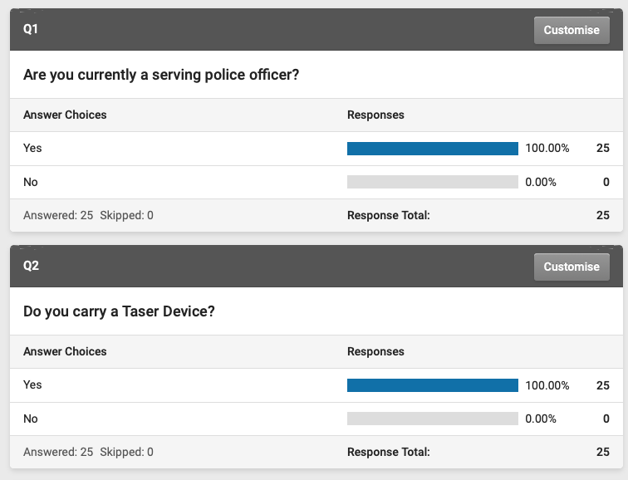
POLICE QUESTIONNIRE RESULTS

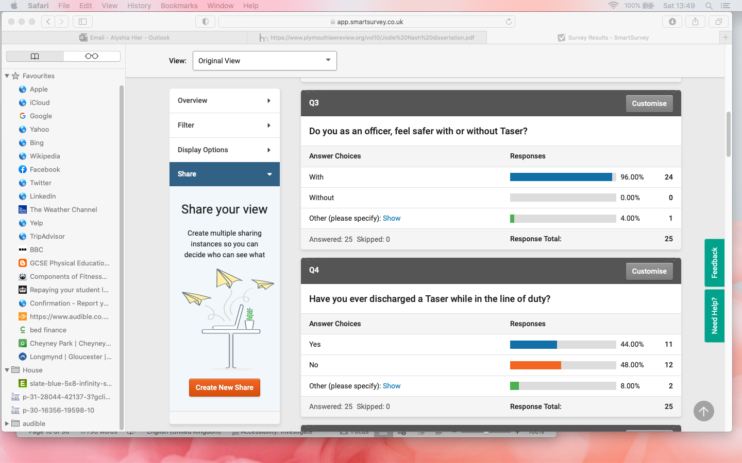

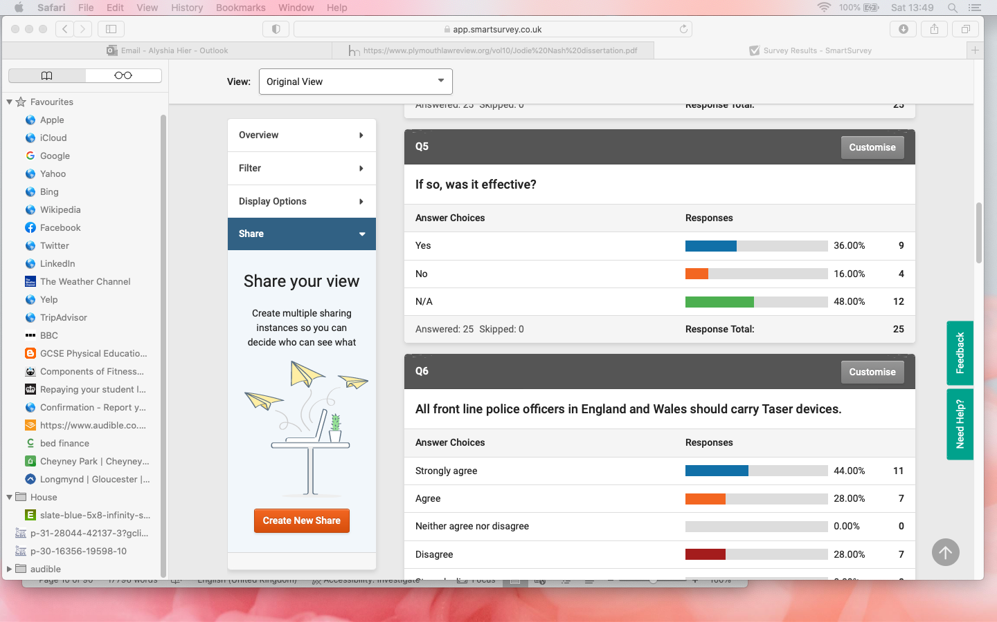

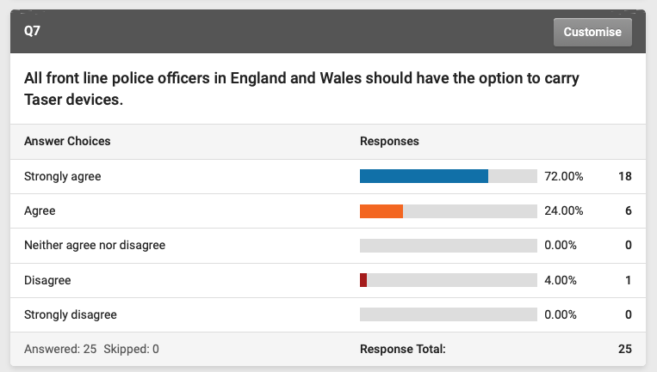
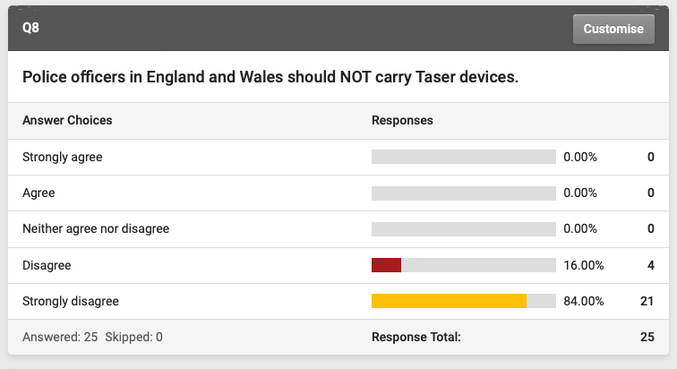
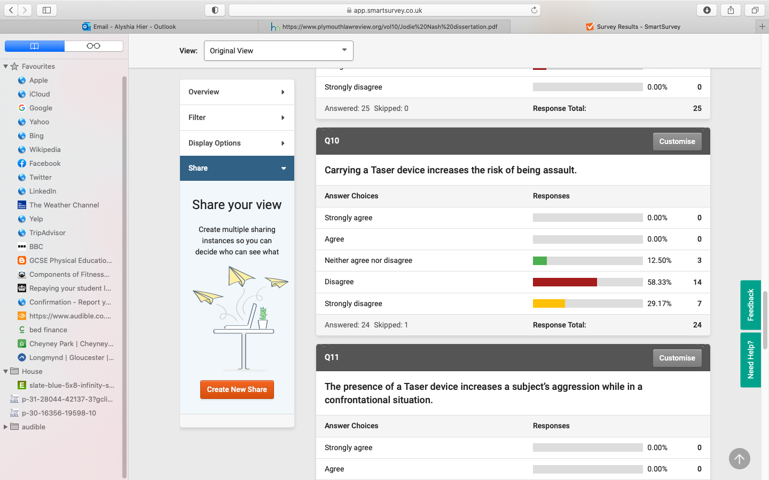
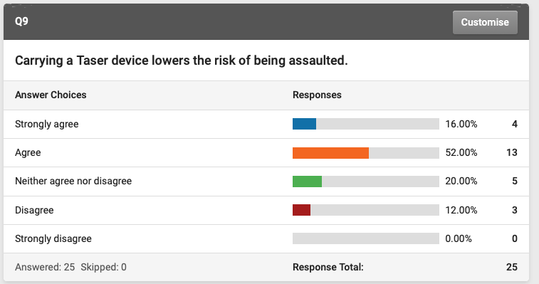
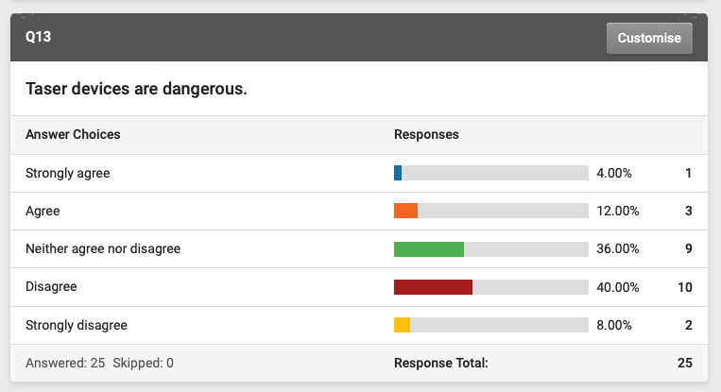
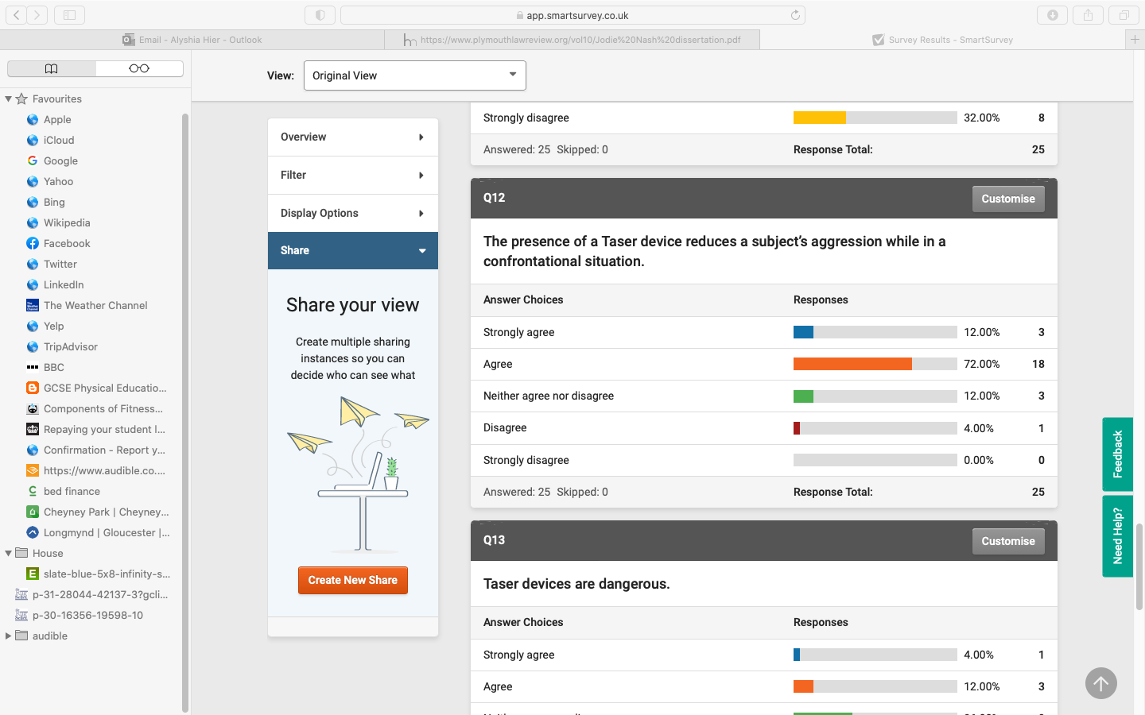
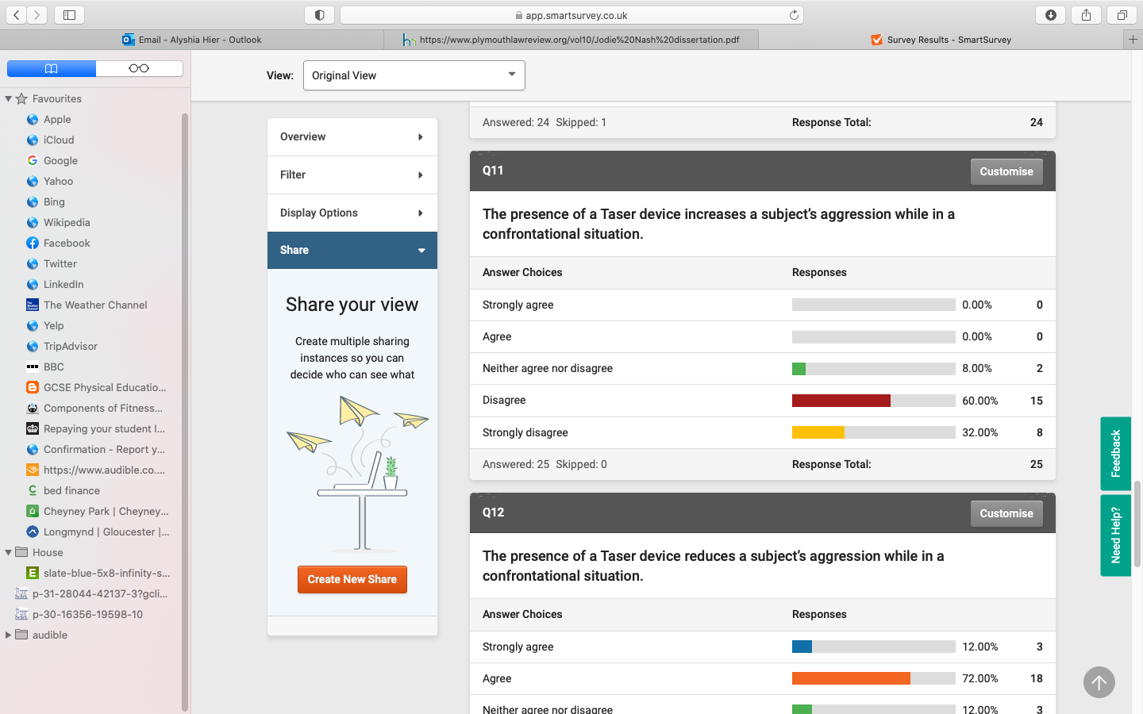
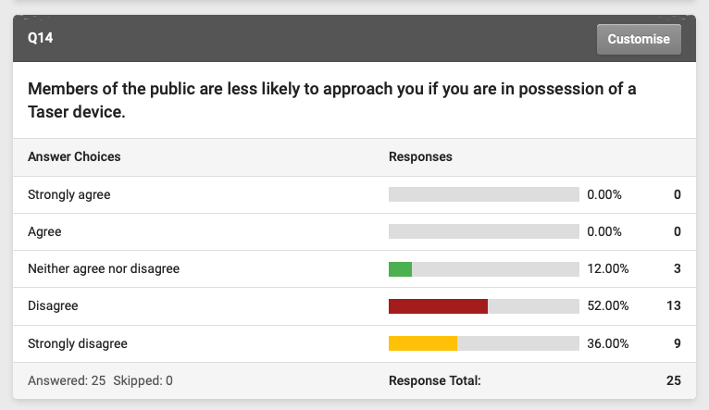

Appendix C
PUBLIC QUESTIONNAIRE BLANK
1. Do you know what a Taser device is?
- Yes
- No
- Other (Please Specify)

2. Do you feel safer when in the presence of an officer carrying a Taser device?
- Yes
- No
- Other (please specify):

3. On a scale of 1-10 how dangerous, do you think Tasers are? (1 being low & 10 being high)
- 1
- 2
- 3
- 4
- 5
- 6
- 7
- 8
- 9
- 10

For the following questions, please indicate how strongly you agree/disagree with the following statements.

4. All front line police officers in England and Wales should carry a Taser device.
- Strongly agree
- Agree
- Neither agree nor disagree
- Disagree
- Strongly disagree

5. All front line police officers in England and Wales should have the option to carry a Taser device.
- Strongly agree
- Agree
- Neither agree nor disagree
- Disagree
- Strongly disagree

6. Police officers in England and Wales should NOT carry Taser devices.
- Strongly agree
- Agree
- Neither agree nor disagree
- Disagree
- Strongly disagree

7. You would be more likely to approach or speak to an officer in possession of a Taser device.
- Strongly agree
- Agree
- Neither agree nor disagree
- Disagree
- Strongly disagree

8. You would be less likely to approach or speak with an officer in possession of a Taser device.
- Strongly agree
- Agree
- Neither agree nor disagree
- Disagree
- Strongly disagree

9. The presence of a Taser device is intimidating.
- Strongly agree
- Agree
- Neither agree nor disagree
- Disagree
- Strongly disagree

10. The presence of Taser is reassuring.
- Strongly agree
- Agree
- Neither agree nor disagree
- Disagree
- Strongly disagree

11. Taser devices should only be used when police officers are threatened with serious violence or weapons
- Strongly agree
- Agree
- Neither agree nor disagree
- Disagree
- Strongly disagree

12. Taser devices should be used at an officers discretion, in any situation they deem its use is necessary.
- Strongly agree
- Agree
- Neither agree nor disagree
- Disagree
- Strongly disagree

Appendix D
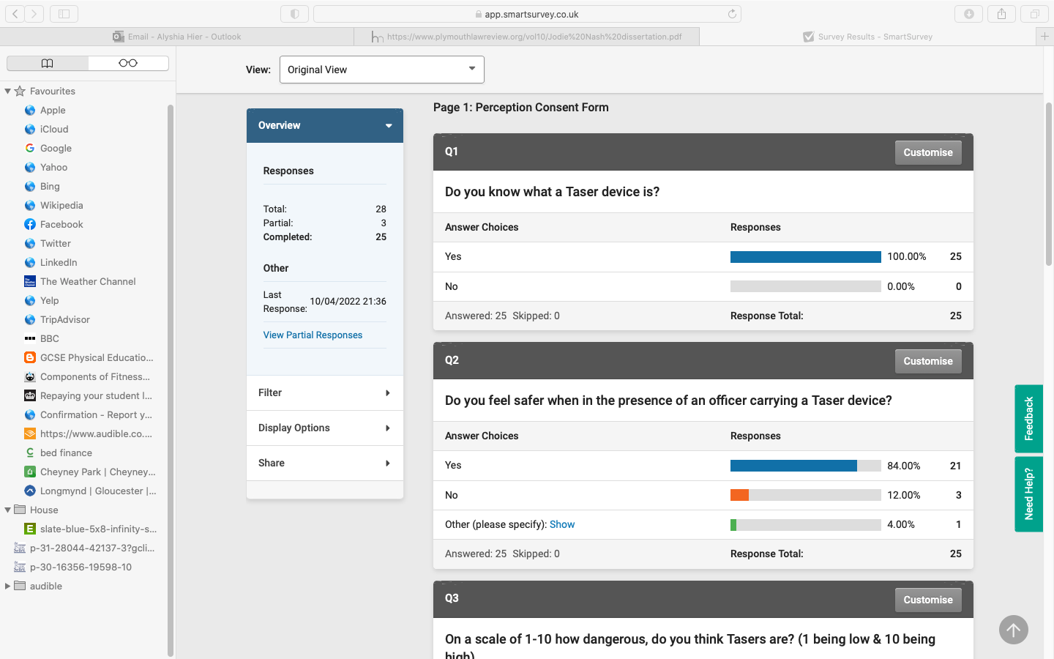
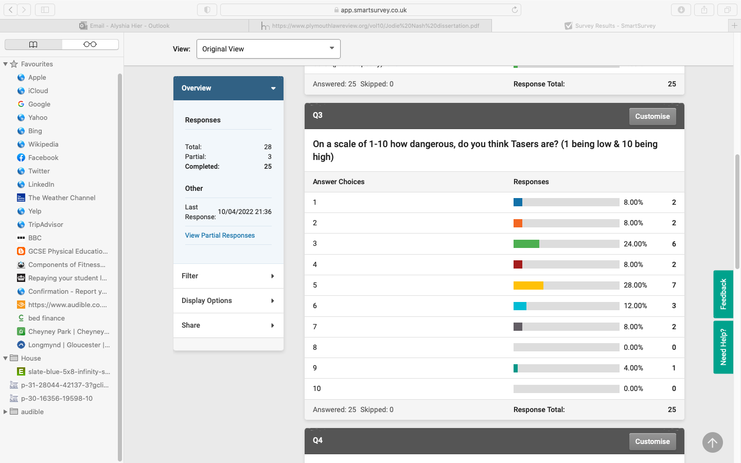
PUBLIC QUESTINNIRE RESULTS
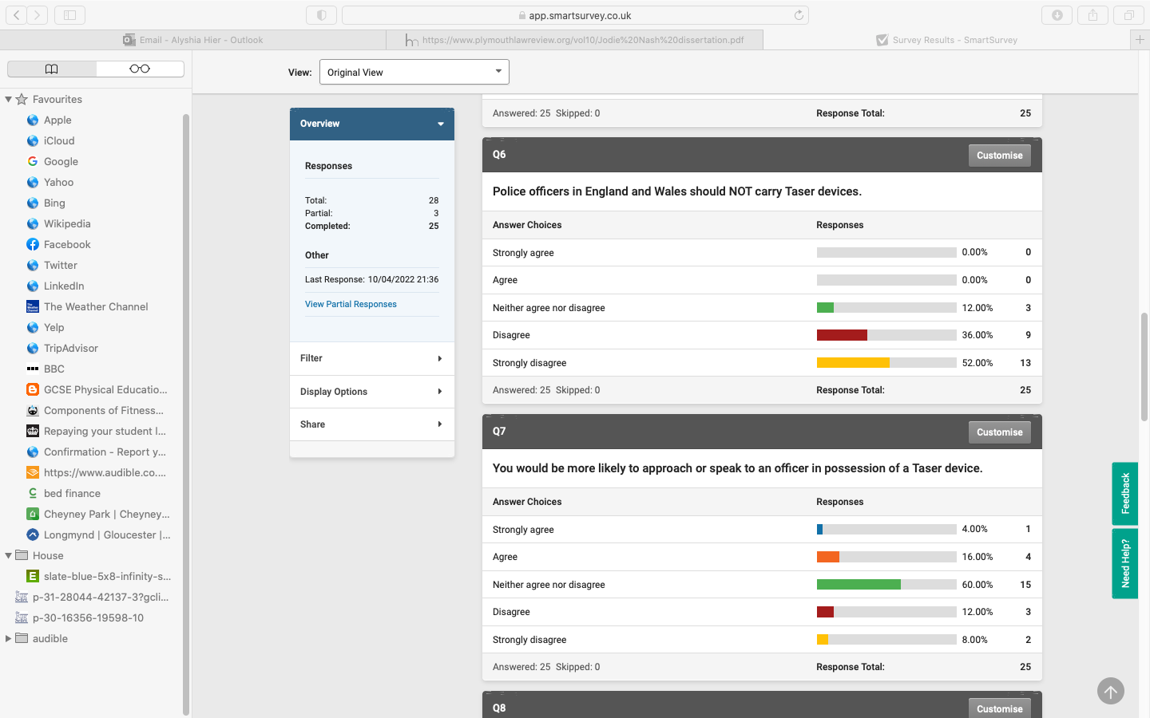
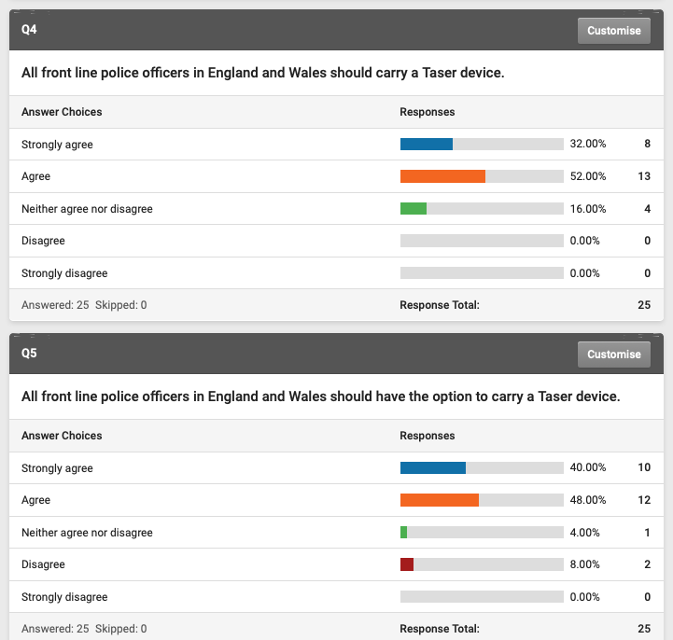
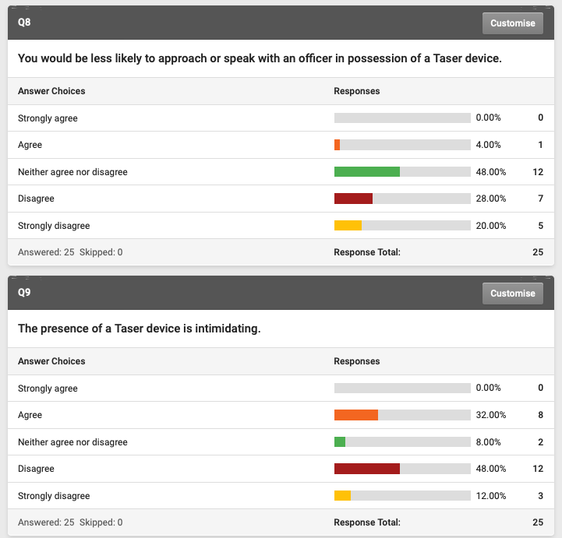

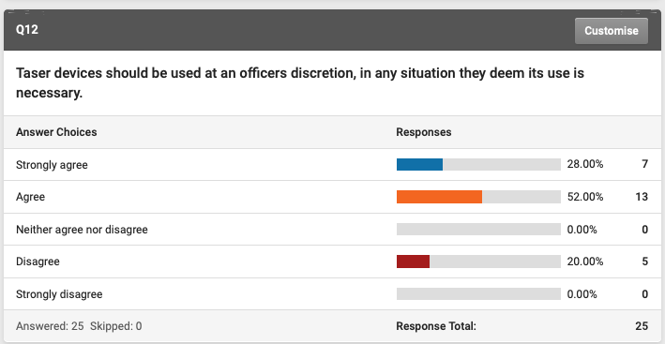
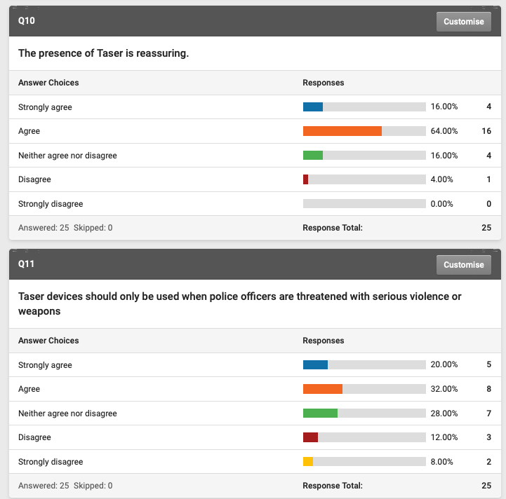
Appendix E
Interview Transcript (Police)
ME - What is the function of a Taser and what does the device aim to do?
Taser trainer – “The function of Taser is to give officers another personal protective option in dealing with persons they perceive are a threat to them so instead of using some of their other PPE, it’s an option that they can use. Tactical option around it is a distance tool it can offer them at least 25 feet away from a person or persons that they do perceive a threat from and can assist them with their personal safety then.”

Question - In what type of situations would an officer use Taser?
Taser trainer – “It depends on the officer’s perception again, if the officer perceives a threat to their safety, the safety of the person they are dealing with or any other members of the public then it would be down to that officer to justify their actions as a result of what they perceived. I can’t actually say when they would use it because it would be down to that officers actual thought process and then being able to justify their action as and when they do use it. If we are talking about what type of incident, it is usually incidents involving weapons or highly aggressive persons.”

Question - How effective are Tasers?
Taser trainer – “If you’re looking at statistics, if somebody was unclothed and the Taser was activated then its 90% accurate. If somebody is Tasered where they have clothes on. It can go down as low as 47% accurate. It all depends on the officer as well, whether they actually, when they discharge whether the Taser hit the subject or not, especially as the subject may be moving, struggling, threatening and so on so forth. So from an answer point a view it can be very accurate for those with no clothes on, but with clothing on it can be accurate but may not cause neuromuscular incapacitation because of the clothing that the person is wearing. So sometimes it depends on what type of clothes they got on would depend on whether the barbs would penetrate that clothing.”

Question - What are the risks of using Taser
Taser trainer – “There’s risk in relation to missing, so if the officer misses with Taser maybe there is somebody else in the background is it going to hit them. The other risks are to the person depending on where the barbs go. So if the barbs were to go in maybe areas of genitalia. Maybe the head then obviously there is a risk of further injury to that person and maybe hospitalisation for the barbs to be taken out. There’s a small risk to cardiac arrhythmia, which is basically the rhythm going out, sorry the heart rhythm going out of sync. People of small stature, i.e. smaller build people and younger people have more risk to cardiac arrhythmia than anyone else because the chest wall isn’t as formed and the chest wall then is closer to the heart so it can make the heart go out of sync. There is also an issue maybe if somebody’s got a vagus nerve stimulator or a pace maker or an internal defibrillator then that may cause an issue for that person but may not so it could depend on the situation.”

Question - What medical implications can occur as a result of being Tasered?
Taser trainer – “Yeah so medical implications so if somebody is Tasered then they get an intense amount of pain in the muscles that are contract. So all the muscles contract that the barbs hit contract 19 times a second and that can last for 5 seconds. In relation to that, a person can fall to the floor, they could crumple to the floor, the could fall like a tree, which then entails possible secondary injuries maybe from back, neck, head injuries. If they are at height that can also cause a bit more of a problem because a person falling from height is going to fall down to the floor but they may also just Constantiner up, just curl up in a ball. So again as I stated on the last sort of answer really it all depends where you hit them so they could have injuries from areas of the body that’s been hit like I said the head genitals um or they have pre-existing medical condition.”

Question - What should officers consider before using Taser?
Taser trainer – “There use of force options basically so ideally from a an officers training it will be officer presence to start off with, then tactical communications. If those don’t work or they perceive a threat or they have considered other options i.e. could be paver spray could be asp, could be i.e. our best tool which is out communication. All these should be considered, however sometimes they cant be considered and something happens basically straight off and the officer is put at risk straight away or somebody else is put at risk. The officer should ideally go through what we call the national decision making model, however some situations are so spontaneous and so rapid that the officer may not be able to sort of consider any other options and maybe there tactical options and there perception was to go for their Taser first.”

Question - What is the drive stun mode? And when would an officer use this technique?
Taser trainer – “The drive stun mode is use when the device is close to somebody. So for instance if I discharge the one barb, one went in and one didn’t, so I missed with the second barb. If I was to use the drive stun I would basically place the front of the Taser at least 9 inches away from the barb that hit them and what that would do is create a circuit from that one barb down to the Taser, so you could still get the neuromuscular incapacitation. That would hopefully, assist with controlling the subject, the issue you got with it sometimes is that it can leave marks because it can leave a burn mark and go through deep into the actual leg, which can in turn cause scaring. Even through it’s an option it’s one of the last resort options that we look at in training and obviously train the officers in the repercussions and its part of an IOPC enquiry as well so they class it as torture but as long as the officer can justify all their actions and evidence that it should be ok.”

Me - Is that an immediate IOPC referral then?
Taser trainer – “Yes, immediate referral yes.”

Me - Do you believe that all police officers in England and Wales should carry or have the option to carry a Taser device?
Why/why not?
Taser trainer – “ok, so I think that they should all have the option. I think from the statistics the we are getting back at the moment from a South Wales Police point of view. If you do carry a Taser your 20% less likely to be assaulted doing your police role than not carrying a Taser. I think society at the moment is changing and the dynamics of society is changing. It’s getting harder out there, officers are coming across more conflict day in day out. I think that from the feedback we are getting a lot of officers sat that just by carrying a Taser is a deterrent in its self. They turn up to incidents, people are looking and seeing they got Taser and on numerous occasions when we train them I have lots of officers saying to me just because I was carrying that Taser the person basically complied with my requests. So I think not just a use option but maybe just having it on them has helped. Statistically how do we compare that, I don’t know. Would the person of been challenging if the officers wasn’t carrying Taser or not but again from an injury potential as I said 20% less officers. So yeah I think everyone should have the option, I think it should be kept an option. I don’t think it should be part of PPE because obviously there’s quiet a stringent training course regarding it which they have to pass.”
Me – Just to confirm those statistics are from south wales police are they?
Taser trainer – “The 20% is from south wales police yes”

Me - Are there any alternatives to Tasers
Taser trainer – “Not as a stun gun no, so if you’re looking at a mechanical device that does what Taser does. There isn’t, there is stuff out there but as soon as the stuff comes on the market Taser or axon international basically buy them out. So axon would basically take over that company. There was a company that was doing Fazer F A Z E R and axon bought them out.”
Me – What were they? A similar stun gun company?
Taser trainer – “Yes a similar type of thing and they had a few good ideas but because axon are quite a lucrative multi million pound company then they are able to lied share of the market really.”

Me - What training is required to carry a Taser Device?
Taser trainer – “Ok, so initial training courses are 3 days. So it 24 hours contact time for that so officers come on quite a stringent training course which is pass or defer. So that means you either pass the course or you deferred to either come back on another course or come back on the set days for people that they may not come up to the standard. If they do pass that then they are fully qualified Taser carriers for the next year and then after that or just prior to their refresher which will be 364 days basically so they have to do a 1 day refresher then to refresh there knowledge and skills on an upskill course.”

Me - That’s great, thank you very much

Appendix F
Interview Transcripts (Human Rights Activist)
Question - Do you agree or disagree with the use of Taser by police officers in England and Wales?
Why?
Answer – I agree that they are needed in certain situations such as serious incidents involving weapons or dealing with really dangerous people, but I don’t believe they are needed on the scale that they are being used today. As a human rights activist, I acknowledge that police officers have rights also and that like everyone else they should have the right to be safe. But I don’t agree with the use of the drive stun mode. The aim of Taser is to achieve neuromuscular incapacitation and drive stun mode doesn’t do that. Article 3 of the human rights act is freedom from torture and inhuman or degrading treatment and the drive stun mode is a form of torture as all it does is create a large amount of pain to the recipient.

Question - Do you believe that all front line police officers in England and Wales should carry or have the option to carry a Taser device?
Why/why not?
Answer – Good question. No, I personally don’t think that all officers should routinely carry them, as there is no need. I think that all firearms officers should though, for the obvious reason of being Tasered is better than being shot and the risk of death or serious injury is much lower. As for response officers, I don’t think that every officer should have one nor do I think they should have the option to. I think that supervisors should put officers forward based on their operational experience and level of trust.

Question - Do you believe Tasers are safe?
Answer – Um, I often look at the statistics and they show that Tasers are relatively safe. When compared to the next use of force option, firearms they are far safer for the recipient and when compared to the baton they are safer for the officer and the recipient. They usually pose a higher risk to people to with pre-existing medical conditions or those under the influence, the influence of alcohol or drugs. I know a lot of people sustain injuries after the Taser hits them. They hit the ground, when they fall the hit the ground hard and um obviously the type of ground makes a difference so does the way you fall. I have seen images too, where the barb goes in an eye or tactical and they can be nasty injuries.

Question - Would you be more or less likely to approach an officer carrying a Taser device?
Answer – I myself do not routinely come into contact with the police outside of work and don’t necessarily see police officers regularly in my local area. I’m also not the type to just approach a police officer for a chat unless I know them and would only realistically approach one if I needed help, so I wouldn’t be concerned if they had a Taser or not. With that said, I speak with various people within the community about police use of force and stop search and I know a number of people who won’t approach an officer with a Taser or a gun.

Question - Do you believe that controversial Taser incidents that are covered by the media effect public perception? For example the death of ex Aston villa football player Dalian Atkinson?
Answer - Yes of course, I believe that the public lack knowledge and understanding on Tasers. When the media cover big stories like death of Dalian Atkinson, the public tend to take an interest and begin to acknowledge that there are in fact risks associated with Taser. Of course, the officer in question was found guilty of manslaughter after they discovered that he used the Taser for, um I think it was five or six times the recommended limit. For me Dalian’s death highlights how dangerous Tasers can be especially if used incorrectly or abused by the officer using it. The risk is often in the hands of the officer using it and this is why I don’t believe that all officers should carry them. I think it should only be a select few who are trusted and chosen.

Question - What is your perception of Taser?
Answer – Um, I agree that officers also need protecting and that they need something to help them protect themselves, which a Taser clearly does. I know that the spray and batten they carry sometimes just isn’t enough especially if they are working alone. I also realise that no weapon is going to be risk free for the officer or the recipient and that a balance needs to be established. Um, I wouldn’t, I wouldn’t say that I dislike Tasers, they’ve saved many more lives than they have ever taken.

Question - What do you think the public’s perception of Taser is?
Answer – I often go out into the community and speak with people about use of force, stop search and policing in general. Tasers are often a topic spoken about, as people don’t know what they are or what they do, especially those who don’t come into contact with police regular. I think, um there is a lack of knowledge on Tasers in general. People are unaware of the risks that are associated with Tasers and although the majority of the people I speak with are for police using Tasers, they often don’t know the risks. I think that information should be readily available on both the benefits, risks and circumstances of use. But I think the general perception is positive and that police should have them. I have found that in lower income areas there are far more people against police using them but they don’t tend to like the police either so.

