

Leading in Complexity
  - Recommendations for an executive development programme AT ICC
Julie Potter: 0851916 | Managing in Complex Environments | 20th August 2018

Glossary of Terms
“In a time of drastic change it is the learners who inherit the future. The learned find themselves equipped to live in a world that no longer exists.” (ERIC HOFFER)
AA – Absolute alignment
CAS – Complex adaptive system
DT – Design Thinking
ED – Executive development
EDP – Executive development programme
SS – Sophisticated simplicity
SSM – Soft systems methodology
VUCA – Volatile, uncertain, complex, ambiguous

Executive Summary
The following report outlines a definition for the terms ‘absolute alignment’ and ‘sophisticated simplicity’ in the context of leadership in a construction company, aspiring to deliver the mission to become the world leader in innovation and excellence for the sector. Consideration is given to complexity theory as a means of explaining how 21st century organisations should be viewed and the significance of the style of leadership required in these circumstances.
A search of the literature reveals a number of leadership skills considered essential in achieving absolute alignment and sophisticated simplicity in a complex environment, including networking, sensemaking, innovation and, emotional and social intelligence.
Recommendations for an executive development programme based on the design principles of adult learning are made.
Contents
Glossary of Terms 2
Executive Summary 4
Table of Figures 7
1. Introduction 8
1.1. The context of Leadership in the 21st Century 8
1.2. Characteristics of Complexity and Complex adaptive systems 10
1.3. Leadership in a Complex adaptive system 11
1.4. Implications for the Construction Sector 13
2. Literature Review 15
2.1. Absolute Alignment 15
2.2. Absolute Defined 16
2.3. Alignment Defined 16
2.3.1. Purpose 18
2.3.2. Capability 19
2.3.3. Coordination 20
2.4 Achieving Absolute Alignment 21
2.5. Sophisticated Simplicity 21
2.6. Sophisticated Defined 21
2.7. Simplicity Defined 22
2.7.1. Leadership Behaviours 23
2.7.2. Structure 24
2.7.3. Processes and Systems 26
2.8 Achieving Sophisticated Simplicity 27
2.9. Interdependencies of Sophisticated Simplicity and Absolute Alignment 27
2.10. A Framework for Executive Development 28
2.10.1. Learning Design Principles 29
2.10.2. Starting Conditions 30
2.11. Programme content and delivery methods 33
2.11.1. Networks and Boundary Spanning 34
2.11.2. Sensemaking 36
2.11.3. Emotional Intelligence and Social Intelligence 37
2.11.4. Innovation 39
2.12. Summary 43

Table of Figures
Figure 1: A representation of the interdependencies of SS & AA: 28
Figure 2: Design Considerations for an Executive Development Programme 33
Figure 3: Overview of Content and Delivery Methods 33
Figure 4: 4 Step Targeted Innovation Process 41
Figure 5: Stages of Design Thinking Process 42

1. Introduction
International Construction Company (ICC) is a privately owned, international enterprise passionate about becoming the first choice for all and harnessing innovation as a positive force for change. Their mission is to become the world leader in innovation and excellence in the construction sector.
The aim of this paper is to define the meaning of the ICC guiding principles of Absolute Alignment (AA) and Sophisticated Simplicity (SS). These concepts are defined in the context of leadership in a construction company aspiring to deliver the mission to become the world leader in innovation and excellence for the sector. In addition, the paper will outline an executive development framework that will support the delivery of these guiding principles leading to recommendations for action. The methodology adopted is qualitative and is limited to a critical review of secondary literature. Time, cost and word count restraints do not allow primary research to be undertaken.
To understand the concepts of AA and SS and how they can support the delivery of the ICC mission to become the world leader in innovation and excellence it is first important to understand the context in which they operate and the skills required of leaders in that context.

1.1. The context of Leadership in the 21st Century
It is commonly accepted the 21st-century economic environment is highly complex, characterised by rapidly evolving demands of globalisation, huge advances in technologies (affecting the quantity and quality of work), shifting customer expectations and new attitudes to work, driven by a multigenerational workforce (CIPD, 2017; Press & Goh, 2018; WEF, 2018). In order to deal with this, organisations such as ICC must learn quickly and adapt rapidly to changing conditions (Marion and Uhl-Bien, 2011; WEF, 2016). The term complexity refers to the “greater levels of uncertainty, ambiguity, interdependencies and interrelatedness that now characterise the environments in which organisations operate” (Clarke, 2013, p. 135). Rapid social, economic and technological shifts that are taking place as we enter the next decade are producing greater complexity, resulting in increasing dynamics of instability (Uhl-Bien, et al., 2007). Traditionally, complexity in business was seen as a negative aspect or difficulty to be overcome (Dyson, et al., 2007; Hammer, et al., 2012). However, advances in the field of complexity science present opportunities to make sense of and gain advantage from complexities existing in the external environment (Snowdon & Boone, 2007).
During the 20th century, organisations were viewed as ‘machine-like’ systems that could be directed towards more efficient and effective performance by applying principles successfully developed to improve machine performance (Stacey, 2004). As a result, a command and control style of leadership was adopted: the role of executives was to set the direction and managers assumed workers would behave predictably, without deviation from these organisational aims (Jackson, 2003). Today, both scholars and practising managers understand organisations do not behave like machines but are Complex Adaptive Systems (CAS), plagued with uncertainty (Clarke, 2013; Hammer, et al., 2012; Marion & Uhl-Bien, 2011; McDaniel, 2007; Snowdon & Boone, 2007).

1.2. Characteristics of Complexity and Complex adaptive systems
There is no agreed upon definition of either complexity or CAS and the scope of this report does not allow for a detailed discussion of the various possibilities. From a complexity science perspective and in the context of organisations, complexity can be said to have a number of recognisable characteristics. For the purpose of this report, the characteristics which will be applied are those described by Snowden & Boone (2007) as:
- Consisting of a large number of interacting elements.
- Nonlinear, minor changes can produce disproportionately major consequences.
- Dynamic, the whole is greater than the sum of its parts and solutions cannot be imposed: they arise from circumstances, often referred to as emergence.
- The system has a memory, the past is integrated with the present and elements evolve with one another and with the environment.
- Complex systems may appear to be ordered and predictable but hindsight does not lead to foresight because the external conditions and systems constantly change.
- The agents and the system constrain one another, especially over time; we cannot predict what will happen.
In its application to management, complexity theory recommends organisations should develop a level of complexity equal to that of the environment (Boisot & McKelvey, 2011; Cilliers, 2001; Stacey, 2004; Uhl-Bien, et al., 2007), referred to by Ashby (1960) as the law of requisite variety.
CAS are characterised by diverse agents that learn, interact with each other in non-linear ways, and therefore self-organise, have emergent properties and co-evolve with the environment (McDaniel, 2007). These interacting agents produce complex and adaptive behaviours (Kovacs & Corrie, 2017).

1.3. Leadership in a Complex adaptive system
In a CAS, leaders have to navigate a rising tide of rapidly emerging circumstances, in addition to dealing with the constant pressure to do more with less, shifting psychological contracts and flexing organisational boundaries (Goh, 2018; Center for Creative Leadership, 2018). When an organisation is viewed as a CAS, the role of management changes from one of command and control (Griffiths & Inman, 2016) to one of sensemaking, learning and improvisation (McDaniel, 2007). A type of leadership that can accommodate complexity and interdependence is required (Cameron & Green, 2017), along with the ability to cultivate an environment which allows innovative solutions to emerge from interactions between a variety of agents in the organisation (Griffiths & Inman, 2016; Marion & Uhl-Bien, 2011).
However, recent reports suggest there is a commonly held perception that organisations have shortages of quality leadership (APQC, 2014; Hagemann et al., 2016; Jacobson, 2014), with employees expressing dissatisfaction with the state of leadership (CIPD, 2015; Hagemann & Bawany, 2016), including decreasing levels of trust over the past two decades (Copeland, 2014). In fact, according to a recent report by Deloitte (2017), only about one-third of executives are considered to have excellent leadership skills and capabilities. The cost of this deficit is estimated by some to be in the millions of dollars (Schyns & J Schilling, 2013).
Today’s executives operate in a Volatile, Uncertain, Complex and Ambiguous (VUCA) world but do not necessarily regard themselves as equipped to deal with the levels of complexity they encounter (Kovacs & Corrie, 2017). This leadership deficit can be attributed to the lack of recognition that a different type of leadership is required to adapt to the complexities of a VUCA world, as the traditional command and control style of leadership is “unwieldy and increasingly uncompetitive” (Kerr, 2013, p. 56). Moreover, an absence of appropriate leadership development exists (APQC, 2014; Harvard Business Publishing, 2016; Passmore, 2014). Carefully shaped strategies that account for the changing context of business are required to close this leadership gap (Wilson, et al., 2011). Developing leaders should be done systemically, not just be seen as a curriculum composed of programmes. Leadership development activities must change the context within which leading takes place, not simply the mindset and behaviours of individual leaders (Passmore, 2014).

1.4. Implications for the Construction Sector
The construction industry consists of a diverse combination of localised needs: various crafts, services products and their professional providers. Different suppliers and other stakeholders are brought together around temporary projects in different stages of development (Kahkonen, 2015). As a result, it is axiomatic that construction projects are one of the most complex operations and as such, an understanding of complexity and how it might be managed is of significant importance (Wood & Gidado, 2008). The industry is also currently facing significant challenges, including increasing project complexity and scope requirements (but shorter deadlines), economic uncertainty and rising competition with a subsequent squeeze on profit margins (Antunes & Gonzalez, 2015).
The ability of leaders to remain flexible and adaptable in the face of this disruptive business environment will be essential to ICC maintaining competitive advantage (Goh, 2018). However, if a flexible approach to leadership is expected, this will have implications for leadership development in the industry, as this degree of flexibility does not currently exist (Walker, 2015).
In order for ICC to deliver its mission to become the world leader in innovation and excellence, the leadership of the organisation needs to adopt a complexity approach. Complexity requires leadership to “engage and involve their people, in order to rapidly anticipate, sense and respond to ever-increasing changes in the organisation environment” (Griffiths & Inman, 2016, p. 18). Leaders must develop capability in areas such as building and understanding networks (Clarke, 2013), sensemaking, (Ancona, 2012), innovation (Dodge, et al., 2017) and, emotional and social intelligence (Goleman, et al., 2002). With the right leadership development strategy in place to grow these capabilities, there is a far better chance ICC will achieve success in embedding the guiding principles on AA and SS and achieving its mission (Dinwoodie, et al., 2014).

2. Literature Review
The aim of the following literature review is to define the ICC guiding principles of absolute alignment (AA) and sophisticated simplicity (SS) within the context of leadership. Consideration will be given to how these principles support the delivery of the company vision to become the world leader in innovation and excellence in the construction sector. A framework for an executive development programme to support the implementation of these guiding principles will also be outlined, using a soft systems methodology (SSM) approach. This framework will form the basis for recommendations to action.
According to Checkland and Poulter (2010), the concept of worldview is the most important concept in understanding the complexity of human situations and the nature and form of SSM. Therefore, it should be noted that the principles of AA and SS and their necessity in delivering the vision of innovation and excellence is informed by a particular set of worldviews. As the author does not have access to the organisation, it will be necessary to use worldviews from evidence-based research to inform understanding of what AA and SS mean in the context of delivering innovation and excellence at ICC.

2.1. Absolute Alignment
Absolute alignment is one of the ICC guiding principles for supporting its mission to become the world leader in innovation and excellence in the sector. There is no recorded definition of the term absolute alignment (AA) in the literature but the term alignment is commonly referred to in management textbooks and journals.

2.2. Absolute Defined
The term absolute can be defined as “very great or to the largest degree” (Cambridge Dictionary, n.d.) or, as “not qualified or diminished in any way” (Oxford Dictionary, n.d.). Alignment is not easily accomplished in practice. There are limitations to the extent to which it can be achieved throughout an organisation (Armstrong & Taylor, 2017) for the reasons outlined below. Therefore, in the context of achieving organisational alignment towards the mission of ICC, we can assume that ‘absolute’ regards the intention to get the whole organisation aligned behind its purpose to the ‘largest degree’ possible.

2.3. Alignment Defined
Alignment refers to the act of attaining buy-in for the company vision from those who will have a role in making it a reality (Nautin, 2014; Straw, et al., 2013). McCauley (2014, p. 1), defines alignment as the “effective coordination and integration of the different aspects of the work so that it fits together in service of the shared direction.” Today, most executives are aware that their organisation needs to be aligned. In fact, the failure of an organisations vision can frequently have more to do with lack of alignment than with the strength of the vision or the efficiency of the execution (Straw, et al., 2013). Strategies, organisational capabilities, resources, and management information systems and processes should all be arranged to sustain the business purpose (Trevor & Varcoe, 2017).
However, what often happens in organisations is that employee and employer interests become contested terrain (Clutterbuck, 2012). This is described in agency theory as goal conflict, which assumes the pursuit of self-interest at the individual level will misalign with the goals at organisational level and appropriate incentives are required to bring about alignment (Eisenhardt, 1989). However, agency theory only presents a partial view of the world, which ignores the complexity of organisations assuming that people are predictable, and behaviours and outcomes can be controlled (Ibid). Complexity makes alignment much harder. To achieve alignment in large and geographically dispersed organisations, such as ICC, a greater amount of effort is required by leadership (Trevor & Varcoe, 2017).
There is congruence in the literature regarding the characteristics that define alignment:
- A clear, meaningful purpose (Boss, 2018; Clutterbuck, 2012; Schwartz, 2016; Trevor & Varcoe, 2017)
- People are capable and everyone is clear about their own and each other’s roles and responsibilities (Boss, 2018; McCauley, 2014; Trevor & Varcoe, 2017).
- Collaboration is encouraged cross-functionally, the work of any each team fits well with the work of any other (Boss, 2018; Llopis, 2014; McCauley, 2014; Trevor & Varcoe, 2017).
- There is a sense of coordination and synchronisation (McCauley, 2014; Nautin, 2014; Trevor & Varcoe, 2017).

2.3.1. Purpose
Alignment ensures that everyone in the organisation is ‘on the same page’, not just from a task perspective but also an emotional perspective (Straw, et al., 2013). This emotional buy-in is often linked to the purpose of an organisation and people will select into and out of organisations based partially on how aligned they feel with the organisation’s purpose (Clutterbuck, 2012). For individuals, feeling their work has purpose is considered a primary motivator (Pink, 2009) and experiencing a deep sense of purpose will result in the investment of more energy (Schwartz, 2016). Therefore, a clear purpose, which people can align with, will help attract and retain talent (Taylor, 2014). According to Kerr (2013, p. 144), “all great organisations are born from a compelling story. This central organising thought helps people understand what they stand for and why.” To fulfil the purpose to become the world leader in innovation and excellence for the sector, ICC must ensure leaders communicate the purpose with clarity, attaching meaning to it, from which individuals can extract concrete goals (Frankl, 2004). However, no matter how clear the purpose, it is reckless to commit to a business strategy without knowing whether you have the capability to achieve it.

2.3.2. Capability
Even the best strategy is useless unless supported by appropriate organisational capabilities (Trevor & Varcoe, 2017). Traditionally, businesses organised themselves with leaders and managers doing the thinking, and everyone else getting on and doing the job but, as digitisation replaces process-based roles, companies are in need of thinkers not just doers (WEF, 2018). For leadership, this means a different approach to leading than traditional command and control styles, as non-standard, creative, experimental work, in constantly changing environments does not naturally lend itself to management (Benn & Bolton, 2011; Chakhoyan, 2017).
Role clarity is also important here. Individuals should be aligned to the role they undertake (i.e. have the requisite capability to undertake the role) and roles aligned within the team (Boss, 2018). The requisite talent is also required to deliver the organisational goals now and in the future (Taylor, 2014). Roles, responsibilities and accountabilities need to integrate across teams, which makes collaboration a key enabler of alignment.
2.3.3. Collaboration
Poor collaboration is a major barrier to alignment (Boss, 2018). Effective leadership can break down silos across functions and departments and through the cross-fertilisation of ideas, the organisation will benefit from more collaboration, resulting in innovative problem solving across teams (Trevor & Varcoe, 2017). It is not possible to have clarity and alignment when leadership within a company “represent disjointed, disparate parts – rather than a convergence of intelligence and know-how that is in sync and strongly interconnected” (Trevor & Varcoe, 2017, p. 2). Leaders will need to work across organisational boundaries if they are to successfully achieve alignment.
Collaboration can occur when leaders create an environment that fosters conditions in which networks can evolve (Uhl-Bien, et al., 2007) and act as boundary spanners to connect otherwise disjointed groups (Schreiber, 2006). A high degree of social and emotional awareness is also required to sense tensions resulting from ambiguity and change (Stacey, 2004).

2.3.3. Coordination
Management systems are key to effective coordination across organisations. Management systems can be defined as all aspects of management infrastructure, operations, and tactics, from information systems to employee performance management (Trevor & Varcoe, 2017). To achieve alignment ICC will require management practices, systems and technologies aligned to fulfil the organisation’s purpose. Appropriate measures of success, both short and long-term will also need to be defined and communicated (Boss, 2018).

2.4 Achieving Absolute Alignment
AA can happen where individuals, with the right capabilities, can unite behind a meaningful purpose and when this purpose is supported by the right management systems. Dyson, for example, has an established reputation for creating innovative products. Their innovation strategy is reinforced by sub goals relating to hiring and retaining a highly creative workforce and ensuring the right systems and culture are in place for them to flourish (Clutterbuck, 2012).

2.5. Sophisticated Simplicity
Along with absolute alignment (AA), sophisticated simplicity (SS) is a guiding principle in the achievement of the ICC mission to become the world leader in innovation and excellence for the sector. As with AA, there is no commonly held definition of sophisticated simplicity (SS) but simple and simplicity are often referred to in management and complexity theory literature.

2.6. Sophisticated Defined
In the dictionary, the meaning of sophisticated is described as “intelligent or made in a complicated way and therefore able to do complicated tasks” (Cambridge Dictionary, n.d.) and “developed to a high degree of complexity” (Oxford Dictionary, n.d.), so when used in conjunction with the antonym of simplistic would appear to be an oxymoron. However, sophisticated can also mean, “Having, revealing, or involving a great deal of worldly experience and knowledge” (Oxford Dictionary, n.d.), which would appear to be a more apt definition in this context.

2.7. Simplicity Defined
The term ‘simplicity’ frequently appears within complexity theory literature (Marion & Uhl-Bien, 2011, Pablo, et al., 2017, Snowdon & Boone, 2007, Stacey, 2004). According to Kerr (2014, p. 2), “To be successful in this extremely complex and unstable business environment, executive leaders must do all that they can to simplify.” However, in their attempts to simplify the complexity of the external environment, organisations are prone to introducing internal complicatedness within their systems and processes (Backx, et al., 2017), making organisations themselves unintentionally complex (e Cunha & Rego, 2010). Ashkenas (2007, p. 102), noted that large organizations are by their very nature complex and this ‘‘complexity is the cumulative by-product of organizational changes, big and small, that over the years weave complications (often invisibly) into the way work is done’’. It is this type of unintended complexity that creates inefficiencies and apathy within organisations (e Cunha & Rego, 2010). To tackle these issues, organisations must take steps toward simplicity without introducing complicatedness (Backx, et al., 2017; Bersin, 2017; Kerr, 2014; e Cunha & Rego, 2010). Complicatedness hinders agility (Backx, et al., 2017) therefore, “If you want to be fast and agile, keep things simple” (Highsmith, 2009, p. 72).
Simplicity is not discussed as frequently in mainstream management literature as alignment, but management guru and analyst Josh Bersin (2017) has recently described it as the next big thing in HR and leadership.
The characteristics commonly thought to foster simplicity in a complex environment are:
- Leadership behaviours – Away from command and control towards sensemaking, learning and improvisation (Ashkenas, 2007; Backx, et al., 2017; Chakhoyan, 2017; McDaniel, 2007; Uhl-Bien, et al., 2007).
- Structure – Delayered, a network structure which breaks down silos and facilitates collaboration and innovation (Ashkenas, 2007; Backx, et al., 2017; Highsmith, 2009; Jacobson, 2014; Peters & Waterman, 1982; e Cunha & Rego, 2010).
- Processes and systems - A simple set of organisation-wide processes and employees empowered to use their judgement (Ashkenas, 2007; Backx, et al., 2017; Bekker, 2018; e Cunha & Rego, 2010).

2.7.1. Leadership Behaviours
Performance is driven by behaviour, including the behaviour of leaders. How they lead, whom they promote, what measures they value, how key decisions are made and how they communicate, are just some of the things that determine a leader’s impact on their operating environment (Backx, et al., 2017). Therefore, if leaders are committed to reducing complexity, they must identify how their own patterns of behaviour foster complicatedness and make a personal commitment to simplification (Ashkenas, 2007). Effective leadership in a CAS makes sensemaking, learning and improvisation central to managerial tasks rather than command, control and planning (McDaniel, 2007; Uhl-Bien, et al., 2007).
If organisations want to simplify in the face of complexity then leaders must learn to deal with ambiguity and tolerate conditions of uncertainty (Jacobson, 2014). This is where sensemaking comes in. According to Weick (1995, p. 57), “Sensemaking is a diagnostic process directed at constructing plausible interpretations of ambiguous cues that are sufficient to sustain action.” The significance of this will be discussed in more detail in section 2.12.2.
Leaders must behave in a way that is consistent with the nature of complex adaptive systems, rather than adopt the command and control behaviours that assume organisations are predictable and machine-like (McDaniel, 2007). It is these behaviours, which will in turn influence the organisational environment, including the structures, processes and systems in place (Backx, et al., 2017).

2.7.2. Structure
The overabundance of structure in many organisations gives people an excuse not to think, their contributions are devalued and they lose any sense of accountability and responsibility for results (Ashkenas, 2007; Backx, et al., 2017). To simplify Ashkenas (2007, p105) recommends:
• Reduce levels and layers
• Increase spans of control
• Consolidate similar functions
To achieve the above, companies such as Google and Facebook adopt network structures that are capable of flexing to challenges that must be met at the time (Jacobson, 2014). A network structure is characterised by open communication (both internal and external), fewer tiers, a wider span of control, and a bottom-up flow of decision-making and ideas (Farnham, 2015). The key resource in a network organisation is knowledge (Kew & Stredwick, 2015); temporary constellations or ‘swarms’ of people come together with the requisite knowledge to solve problems (Griffiths & Inman, 2016). Because of this, it is thought to be more flexible and agile than other structures, with improved collaboration and performance (Brash, et al., 2008). According to Child (2015, p. 309), the role of leadership within this type of network structure includes:
• Boundary spanners between levels and units.
• Initiators of networks.
• Co-ordinators and synthesisers of information flow.
• Conveyors of the vision downwards and advocates of decentralised initiatives upwards.
Boundary spanning and networks will be discussed further in section 2.12.1.

2.7.3. Processes and Systems
In attempting to reduce uncertainty amid complexity, organisations tend to react by introducing new processes and systems (Backx, et al., 2017). However, when you simplify process by taking out detail you force people to think for themselves and interact (Highsmith, 2009). This is a facet of ‘swarm intelligence’, which assumes the right set of simple rules applied within a group of highly interactive individuals generates innovation and creativity (e Cunha & Rego, 2010) (Marion & Uhl-Bien, 2011). According to Highsmith (2009) when intelligent people ‘swarm’ around a problem, they do not need a detailed set of principles describing everything. Instead, what is required to foster agility is a minimum set of “rules that have been shown to work well together” (Highsmith, 2009, p. 74).
Where documentation of policy and process are necessary they should be simple and organisation-wide (Ashkenas, 2007) and employees should be empowered to use their judgment rather than comply with an endless number of rules (Backx, et al., 2017). For example the expense policy at Netflix reads, Act in Netflix’s best interests (Markovitz, 2015). Such things as detailed job descriptions become obsolete and high levels of formalisation lose their importance, replaced by involvement-oriented mission statements, and a new, adaptive style of leadership (e Cunha & Rego, 2010).

2.8 Achieving Sophisticated Simplicity
SS can happen where the leadership of the organisation is committed to simplifying structure, processes and systems. Senior executive support is vital, they must role model the leadership behaviours required to adapt to complexity, fostering sensemaking, learning and improvisation as a means to simplify rather than the traditional command and control approach (McDaniel, 2007). A more networked structure, which encourages collaboration and emphasises the distributedness of swarm intelligence, along with the reduction of formalised processes is also required (e Cunha & Rego, 2010).

2.9. Interdependencies of Sophisticated Simplicity and Absolute Alignment
It is clear from the above definitions that AA and SS have interdependencies. Alignment will be difficult to achieve where there is complicatedness and simplicity is unfeasible unless everyone is aligned. For example, complicatedness can lead to a lack of collaboration among functions and departments (Brash, et al., 2008) and alignment cannot be achieved without collaboration (Pablo, et al., 2017). Both principles are dependent on the effectiveness of leadership and are required to deliver the organisations mission as depicted in Figure 1.
Figure 1: A representation of the interdependencies of SS & AA:
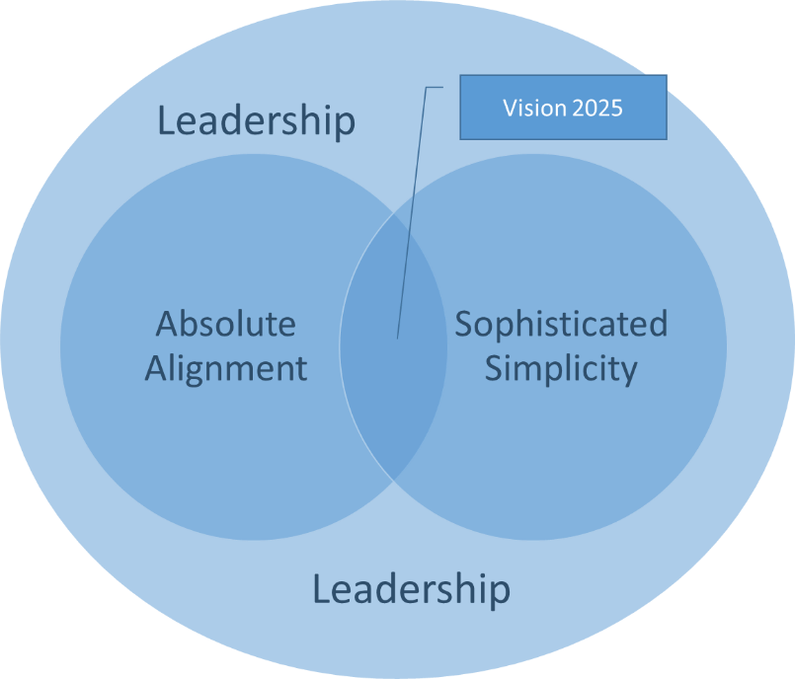

2.10. A Framework for Executive Development
The above analysis of the requirements for delivering the guiding principles of AA and SS has unearthed a plethora of essential leadership skills and behaviours including but not limited to:
- Skilfully communicating the purpose with clarity and meaning.
- Working across organisational boundaries.
- High capacity for empathy, emotional and social awareness and tolerance for high levels of anxiety and uncertainty.
- Sensemaking - thinking rationally and intuitively, articulating emerging themes, application of judgement in new and ambiguous situations.
- Improvisation - aptitude for spontaneity, imagination and reflection.
The following chapter outlines a framework to inform a development programme in which these skills and behaviours will be considered in the following development categories:
- Developing Network Perspective
- Developing Sensemaking capability
- Leading Innovation
- Developing emotional and social intelligence

2.10.1. Learning Design Principles
Traditionally, executive development (ED) has been routed in business schools but over the past 10 years has matured to meet the demand for immediate job relevance and sustainable impact. Modern ED must create impact by supplying knowledge, insights and learning just-in-time to an individual executive’s specific job-based circumstances, making it immediately relevant and inspiring sustainable behavioural change (van Wijk & Anderson, 2012). In addition to planned formal development more social and informal methods are appropriate (Gentry, et al., 2016), such as action learning, communities of practice, coaching and mentoring, and reflective learning (Beevers & Rea, 2016; Lockhart, et al., 2017; Smith & Sadler-Smith, 2006; Wuestewald, 2016). By making the learners own job challenges part of the learning journey it becomes more apparent what they must do to increase their impact and how they can do it (Thorsell, et al., 2012).

2.10.2. Starting Conditions
Learning and knowledge creation are themselves inherently complex activities involving the accommodation of a range of individual and contextual variables (Griffiths & Inman, 2017; Smith & Sadler-Smith, 2006; Stewart & Cureton, 2016). It is worth acknowledging that in designing any leadership intervention we are operating in the complex domain as defined by Snowden and Boone (2007), there is no one right answer and the consequences of the intervention cannot be known. Nevertheless, it is still important to understand the context or starting conditions in which the learning will take place to ensure security, depth and completeness of learning (Griffiths & Inman, 2017; Hattie & Yates, 2014). A useful way of analysing these is to use the CATWOE model (see Table 1) from SSM.
Table 1: Definitions of CATWOE
CATWOE Analysis
C | Customer | Those affected by the transformation as victims or beneficiaries
A | Actors | Those who will do the activities that make up the transforming activity
T | Transformation | A purposeful activity as a transforming process
W | Worldview | Different ways of viewing the problem situation
O | Owner | Parties who could stop the process
E | Environmental Constraints | Internal and external constraints which are taken as given in doing T
(Source: Adapted from Checkland & Poulter, 2010)
It is advised the process of analysis should start by defining the purposeful activity that will lead to the transformation and the worldviews that influence the process (Checkland & Poulter, 2010):
- Transformation: The leadership development programme is itself the purposeful activity, which will lead to the transformation. In this case, the delivery of the AA and SS principles.
- Worldview: It has already been acknowledged the author does not have access to the organisation and as a result, it has been necessary to use worldviews from evidence-based research to inform understanding of what AA and SS mean in the context of delivering innovation and excellence at ICC. It will also be necessary to use this approach in defining the starting conditions and framework for the EDP.
Major stakeholders whose views would normally be sought in this process would include the owners and top management, the learning and development team and the individuals who will participate (Smith & Sadler-Smith, 2006).
The above assumptions inform the other elements considered by the model:
- Customers: You could argue the direct beneficiaries are the delegates but the organisation as a whole will also be affected by the transformation. The paying customers are not the delegates but the budget holders and the business owners. The end client will also benefit from any positive outcomes of the development as research tells us the level of dedication a company has to leadership development has a bigger long-term impact on its business performance than anything else (Morgan, 2018).
- Actors: The actors are in this case those responsible for the design and delivery of the programme. This would typically be the L&D department or an outside agency.
- Ownership: It is important for the owners and senior leaders at ICC to recognise the value the EDP will deliver, therefore consideration must be given to how the programme will be evaluated at the outset (Beevers & Rea, 2016).
- Environment: The complexity of the external environment has been extensively discussed above, this along with the changing internal expectations and priorities, and business conditions will affect the design and delivery of the EDP.
Figure 2 summarises the design considerations that, along with the secondary research conducted into the skills and behaviours required to deliver AA and SS, will inform the content and delivery methods for the EDP.

Figure 2: Design Considerations for an Executive Development Programme
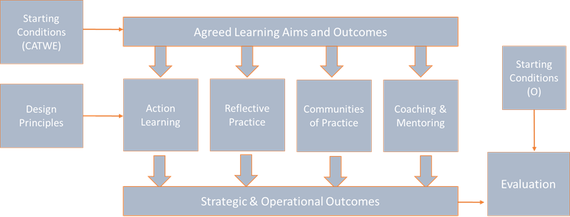

2.11. Programme content and delivery methods
A summary of the content and delivery methods is provided in figure 3.
Figure 3: Overview of Content and Delivery Methods
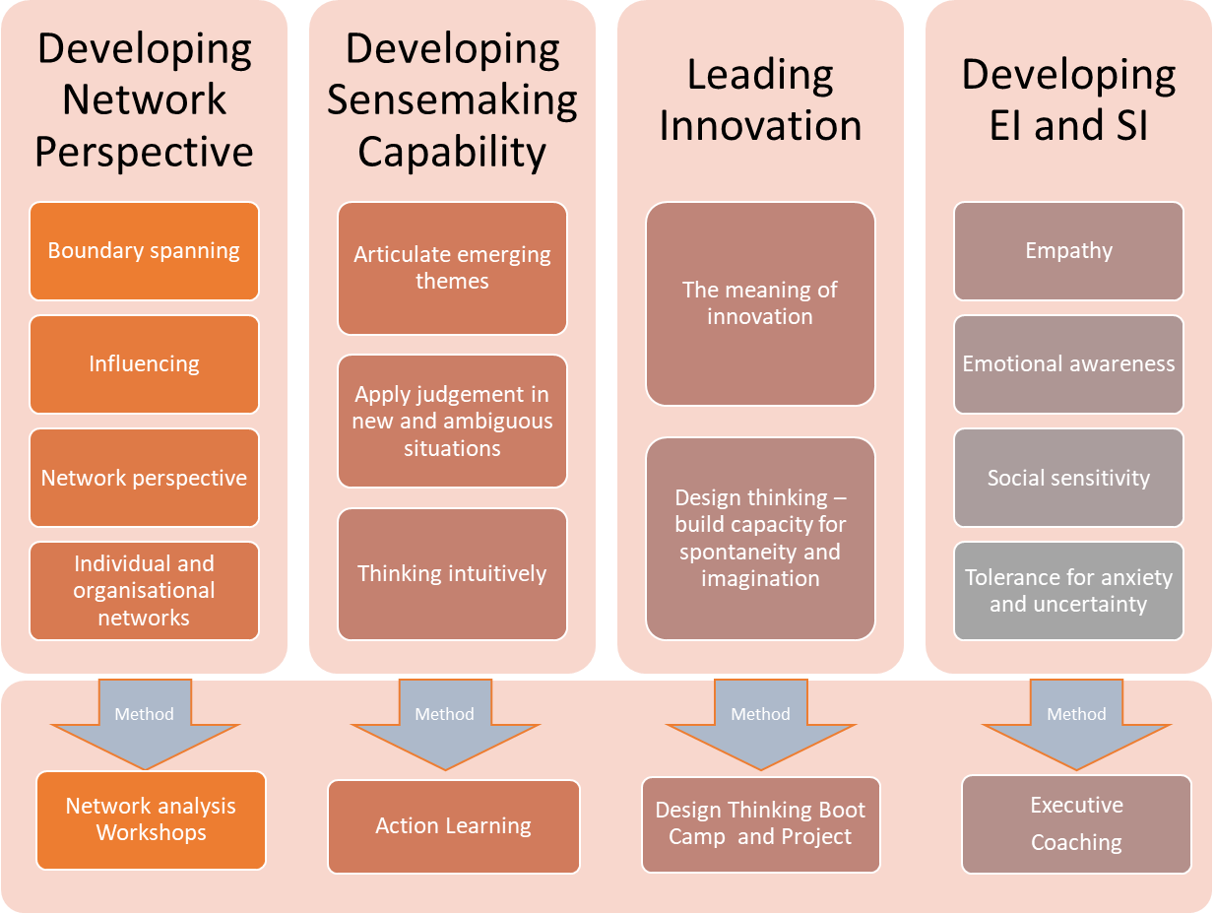

2.11.1. Networks and Boundary Spanning
“Complexity leadership requires leaders to develop their skills in effectively managing and developing networks” (Clarke, 2013, p. 141). However, a study by Ibarra & Hunter (2007, p. 101) found networking is “simultaneously one of the most self-evident and one of the most dreaded developmental challenges that aspiring leaders must address.’ As organisations strive for effective collaboration across boundaries, leaders must look beyond the organisational chart to the invisible informal networks supporting the organisation (Cross, et al., 2013; Cullen, et al., 2014). Research by MIT found that getting people to collaborate across boundaries was the biggest barrier to collaboration in organisations (Kane, et al., 2018). This is seen as a particular challenge within the deeply fragmented construction sector (Pablo, et al., 2017). Therefore, boundary-spanning skills are of particular interest to ICC.
Boundary spanners are individuals who are skilled at bridging interests and transferring information from disparate parts of the organisation (Cullen, et al., 2014; Williams, 2002). In reaching across boundaries, leaders learn to broaden their perspectives and generate more diverse and alternative ways of problem-solving, fostering cross-organisational innovation and transformation (Clarke, 2013; Ibarra & Hunter, 2007; Yip, et al., 2016).
Williams (2002) identified the following traits that characterise boundary spanners:
- Can communicate effectively without jargon and listen actively.
- Empathy and the ability to disagree and move on without harming the relationship.
- An easy and inviting personality that fosters honesty and openness.
- Politically sensitive
- Ability to manage interdependencies (complexity) – contributing factors: inter-organisational experience, transdisciplinary knowledge and cognitive ability.
- Have a large quantity of social capital
- Influencing and negotiating skills
- Is a trusted colleague
An effective way of identifying and developing boundary spanners within an organisation is first to conduct an Organisational Network Analysis (ONA) which provides insight into how social capital is distributed across the organisation (Brash, et al., 2008; Willburn & Cullen, 2014). An ONA will identify whether executives at ICC are isolated from the rest of the organisation and where there might be gaps in the boundaries they are spanning. This knowledge will help to accelerate the development of their own social capital. In addition to ONA a series of workshops, using action-learning techniques to explore the results of the analysis is recommended (Cross, et al., 2013).
The greater levels of collaboration inspired by boundary spanning leadership can facilitate the creation of shared meaning, where the leader engages in sensemaking with team members to promote shared understanding (Clarke, 2013). Effective sensemaking and innovation are dependent on having effective networks (Brash, et al., 2008; Clarke, 2013).

2.11.2. Sensemaking
Sensemaking is highly correlated with leadership effectiveness as it enables leaders to have a better grasp of what is going on in their environments and facilitates other leadership activities such as visioning, relating and inventing (Ancona, 2012). Put simply, sensemaking is “the making of sense” and “structuring the unknown” (Weick, 1995, p. 4); it is developing ideas with explanatory possibilities, rather than a body of knowledge (Weick, 1995). According to Ancona (2012, p4), sensemaking is “the activity that enables us to turn the ongoing complexity of the world into a situation that is comprehended explicitly in words and serves as a springboard into action.” It is especially critical when trying to understand organisations as the ability to understand a changing context is needed at every level (Kurtz & Snowdon, 2003). “Leaders need to engage in sensemaking to understand why their teams are not functioning, why their customers are leaving and why operations are falling short on safety and reliability” (Ancona, 2012, p. 5)
Sensemaking is not about finding the correct answer but about creating an emerging picture via cues (events, experiences, conversation etc.), enabling people to get some sense of a situation when faced with ambiguity and move to action (Ancona, 2012); Degn, 2013; Weick, 1995). In some cases, taking some action may be more important than finding the right answer, as in a rapidly changing environment, speed may top accuracy (Ancona, 2012). A number of studies have also recognised the positive contribution of leadership sensemaking within strategy development and change management (Balogun, et al., 2015; Degn, 2013; Dyson, et al., 2007; Werkman, 2010).
Development of sensemaking capability relies on leaders themselves being open to continuous learning, which includes self-evaluation and learning from others (Maphinda, 2017). Ancona (2013) recommends combining role models, action learning and feedback in developing sensemaking capability.
Sensemaking also requires that leaders have emotional intelligence (EI) and social intelligence (SI) (Ancona, 2012).

2.11.3. Emotional Intelligence and Social Intelligence
Since the publication of Goleman’s (1996) ‘Emotional Intelligence: Why it can matter more than IQ’, there has been increased interest in the role emotions play in our actions and, as such, performance at work. Due to the complexity of organisational change and the role emotions play in changes such as global expansion, job eliminations, leadership changes, and the stressors of day-to-day responsibilities, the EI and SI of leaders and how they interact with multiple stakeholders is something that organisations need to give attention to (Goleman, 1995; Nath, 2013). It is commonly acknowledged that employee motivation goes beyond the usual monetary reward systems traditionally offered (Njoroge & Yazdanifard, 2014, Pink, 2012). In motivating today’s employees, organisations must engage their minds and captivate their hearts, which can be achieved by incorporating social and emotional intelligence. These skills assist leaders in attending to individual employee needs enabling organisations to offer an environment that motivates and develops people (Njoroge & Yazdanifard, 2014).
Many practitioners and scholars believe that emotional intelligence can be improved upon through development and training programs (Goleman, et al., 2002; Mattingly & Kraiger, 2018; Nath, 2013; Neale, et al., 2009; Rajah, et al., 2011). Therefore, ICC should focus on creating gearing training and development programs targeted at improving levels of existing EI and SI. Mattingly and Kraiger (2018) suggest the need to individualise EI training and provide accurate feedback on participants' skills as EI is better trained using an active/experiential approach versus passive. One example of a development intervention as described by Goleman & Boyatzis (2008) included a 360° feedback. The case study leader used the feedback from the 360 to secure a mentor who coached her on how to express her viewpoint about contentious issues, modelling for her the art of giving feedback. Observing a role model of effective behaviour allows individuals to directly experience, internalise, and ultimately emulate what they observe and thus is an effective development mechanism (Goleman & Boyatzis, 2008).
Coaching is thought to be an effective intervention for developing EI and SI (Hughes, et al., 2009; Neale, et al., 2009). Coaching can help identify the interferences (negative thoughts and attitudes) that limit cognitive capacity and inhibit ability to manage emotions, preventing optimal performance (Neale et al., 2009). Removing these interferences will enhance learning (Goleman, 2008). A good starting point for the coaching might be a measure of current EQ using the Sparrow and Maddocks individual effectiveness tool (The British Psychological Society, n.d.).
High emotional intelligence is linked to a leader’s ability to build active networks (Cullen, et al., 2014) and to sensemaking capability (Ancona, 2012) which in turn are linked to effective innovation leadership.

2.11.4. Innovation
As a result of the relentless march of globalisation and increasing customer expectations, innovation has become a key driver of growth, performance and valuation (Brash, et al., 2008; Mickahail, 2015). Innovation is not just about product and service performance anymore, it also involves business models, company configuration, distribution and customer experience (Brash, et al., 2008; de Coutere & Horth, 2016).
In the face of challenging and unpredictable circumstances, leaders cannot rely on rational decision-making based on previous patterns, as ambiguity cannot be managed away (Horth & Buchner, 2014; Mitchell, 2017). Instead, they must try to make sense of the unfamiliar, which requires innovation leadership. This means bringing new thinking and different actions to how leaders lead (approach to leadership) and how they create a climate for innovative thinking (ibid).
There are a number of parts to the innovation process; clarify, ideate, develop and implement (see figure x) and a different style of leadership may be required at each stage (Kesting, et al., 2015). A number of studies have been conducted in the attempt to establish the impact of leadership approach on the innovation capability of organisations (see Kesting, et al., 2015 for a review and synthesis of the literature). Though no definitive style has been identified, it is agreed the leadership antithesis to developing an innovation culture is that of command and control, especially within the ideation stage (Dodge, et al., 2017; Kesting, et al., 2015).

Figure 4: 4 Step Targeted Innovation Process
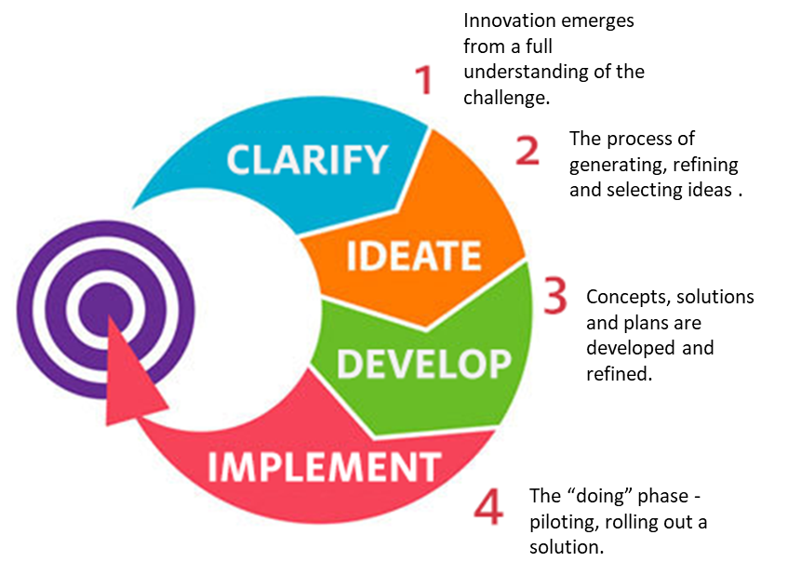
(Source: Centre for Creative Leadership, n.d.)
However, there is more to innovation than idea generation alone. Leaders must learn how to navigate ideas through a complex organisation. Championing ideas requires collaboration, (innovation does not happen in isolation) (Horth & Buchner, 2014), empathy with those you want to get on board, the ability to tell a compelling story (connecting the proposed innovation to results) (de Coutere & Horth, 2016) and seeing with new eyes (Liedtka, 2015). This requires skill in the areas of networking, sensemaking, and EI and SI previously discussed.
Design Thinking (DT) has emerged as a mechanism through which ideation can be encouraged (Liedtka, 2015; van Reine, 2017) and as a best practice through which organisations can influence corporate culture (Mickahail, 2015). DT can be defined as “an iterative process in which we seek to understand the user, challenge assumptions we might have, and redefine problems in an attempt to identify alternative strategies and solutions that might not be instantly apparent with our initial level of understanding” (Hasso Plattner Institute of Design Stanford, 2017). The process consists of a number of defined steps as outlined in figure 3.
Figure 5: Stages of Design Thinking Process
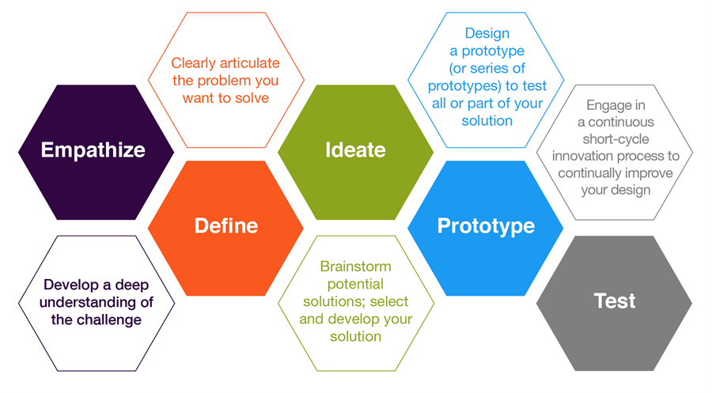
(Source: Hasso Plattner Institute of Design Stanford, 2017)
Some of the world’s leading brands, such as Apple, Google and General Electric, have adopted the DT approach and DT is being taught at leading universities around the world, including Stanford d.school, Harvard, and MIT (Interaction Design Foundation, 2018). Bootcamps are offered at these institutions and others as a means of experiencing and practising the process, offering the opportunity to learn how to apply DT to problems using practical methods.

2.12. Summary
The proposed framework incorporates the development of some of the skills thought to be fundamental in leading in complexity (Center for Creative Leadership, 2018). It can be seen from the above discussion these skills are interdependent and should form part of a holistic development programme. Delivery solutions will be investigated further in section x, including estimated costs for each.
6742

3. Conclusion
To understand the concepts of AA and SS and how they can support the delivery of the ICC mission to become the world leader in innovation and excellence, it is first important to understand the context in which they operate and the skills required of leaders in that context.
It is commonly accepted the 21st-century economic environment is highly complex, characterised by rapidly evolving demands of globalisation, huge advances in technologies, shifting customer expectations and new attitudes to work (CIPD, 2017; Press & Goh, 2018; WEF, 2018). Advances in the field of complexity science present organisations with opportunities to make sense and gain advantage from these complexities (Snowdon & Boone, 2007).
Organisations can no longer be viewed as ‘machine like’ systems that act predictably but as CAS, plagued with uncertainty (Clarke, 2013) and therefore type of leadership that can accommodate complexity and interdependence is required (Cameron & Green, 2017: Griffiths & Inman, 2016; Marion & Uhl-Bien, 2011).
However, research suggests that today’s executives do not necessarily regard themselves as equipped to deal with the levels of complexity they encounter (Kovacs & Corrie, 2017) and that effective leadership in these condition is in short supply (APQC, 2014; CIPD, 2017), with only about one-third of executives considered to have excellent leadership skills and capabilities (Deloitte, 2017). This leadership deficit can be attributed to the lack of recognition that a different type of leadership is required to adapt to the complexities of a VUCA world (Kerr, 2014) and a lack of appropriate leadership development(APQC, 2014).
ICC will require a carefully shaped leadership development strategy which takes account of the changing context of the business especially given the added complexity associated with the construction sector (Walker, 2015). In order for ICC to deliver its mission to become the world leader in innovation and excellence, the leadership of the organisation needs to adopt a complexity approach (Griffiths & Inman, 2016). Leaders must develop capability in areas such as building and understanding networks (Clarke, 2013), sensemaking, (Ancona, 2012), innovation (Dodge, et al., 2017) and, emotional and social intelligence (Goleman, et al., 2002). With the right leadership development strategy in place to grow these capabilities, there is a far better chance ICC will achieve success in embedding the guiding principles on AA and SS and achieving its mission (Dinwoodie, et al., 2014).
AA is defined as, Individuals with the right capabilities united behind a meaningful purpose,supported by the right management systems. AA requires leaders who can unite individuals behind a meaningful purpose and promote an innovation culture (Clutterbuck, 2012). SS is defined as, Simplifying structure, process and systems to allow for greater collaboration in a networked system. SS requires leaders who foster sensemaking, learning and improvisation as a means to simplify rather than the traditional command and control approach (McDaniel, 2007).
In defining the above terms and determining what is required from leaders to implement them, some essential leadership skills and behaviours have been unearthed, including but not limited to:
- Skilfully communicating the purpose with clarity and meaning.
- Working across organisational boundaries.
- High capacity for empathy, emotional and social awareness and tolerance for high levels of anxiety and uncertainty.
- Sensemaking - thinking rationally and intuitively, articulating emerging themes, application of judgement in new and ambiguous situations.
- Improvisation - aptitude for spontaneity, imagination and reflection.
These skills can be related to several development themes:
- Developing Network Perspective
- Developing Sensemaking capability
- Leading Innovation
- Developing emotional and social intelligence
It is these themes that are recommended as the focus for an executive development programme for the top 50 leaders at ICC.

4. Recommendations
Based on the above conclusions the following recommendations are made for an EDP aimed at delivering the capabilities to implement the guiding principles of AA and SS.
The chosen development methods (see figure 6) have been selected based on the concepts of constructivism and adult learning theory. Constructivism views learning as a highly individualised process in which learners are given the opportunity to explore, test out new ideas, share thinking with others and reflect on learning (Stewart & Cureton, 2016). Constructivism sits well with some of the key themes of adult learning in that learners are generally self-directing and have internal motivation for learning (Beevers & Rea, 2016).
Figure 6: Development Methods
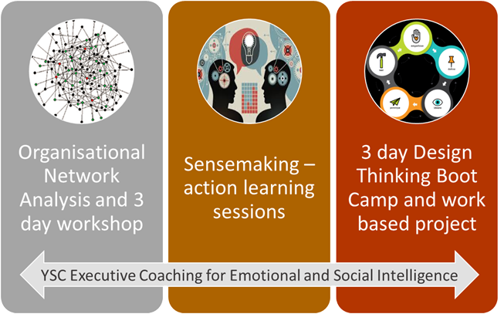
Learning will take place in a number of different
Costings are made based on an overall budget of £2 million over 3 years

References
Ancona, D., 2012. Sensemaking: Framing and Acting in the Unknown. In: The Handbook for Teaching Leadership. Thousand Oaks: Sage, pp. 3-18.
Antunes, R. & Gonzalez, V., 2015. A Production Model for Construction: A Theoretical Framework. Buildings, 5(1), pp. 209-228.
APQC, 2014. The Leadership Deficit: Survey Results Brief Synopsis, Houston: APQC.
Armstrong, M. & Taylor, S., 2017. Armstrong's Handbook of Human Resource Management Practice. 14 ed. London: Kogan Page.
Ashby, W. R., 1960. Design for a Brain. 2 ed. New York: Wiley.
Ashkenas, R., 2007. Simplicity-based management. Harvard Business Review, pp. 101-109.
Backx, J. et al., 2017. Mastering Complexity Through Simplicity: Four Steps to Creating Competitive Advantage. [Online]
Available at: http://img-stg.bcg.com/BCG-Mastering-Complexity-Through-Simplification-Feb-2017_tcm9-145559.pdf
[Accessed 20 June 2018].
Balogun, J., Bartunek, J. M. & Do, B., 2015. Senior Mangers' Sensemaking and Responses to Strategic Change. Organization Science, 26(4), pp. 960-979.
Beevers, K. & Rea, A., 2016. Learning and Development Practice in the Workplace. London: Chartered Institute of Personnel and Development.
Bekker, B., 2018. The key to sustainable high performance is “SIMPLICITY”. [Online]
Available at: https://www.linkedin.com/pulse/key-sustainable-high-performance-simplicity-brandon-bekker/
[Accessed 09 August 2018].
Benn, S. & Bolton, D., 2011. Key Concepts in Corporate Social Responsibility. London: Sage.
Bersin, J., 2017. Why Simplicity Is The Next Big Thing In HR And Business. Forbes, 13 June.
Boisot, M. & McKelvey, B., 2011. Complexity and Organisation-Environment Relations - Revisiting Ashby's Law of Requisite Variety. In: S. Maguire, P. Allen & B. McKelvey, eds. The Sage Handbook of Complexity and Management. London: Sage, pp. 279-295.
Boss, J., 2018. A Simple Flow For Thinking About Organizational Alignment. Forbes, 21 January.
Brash, J., Capozzi, M. M. & Davidson, J., 2008. Leadership and Innovation. McKinsey Quarterly, pp. 37-47.
Cambridge Dictionary, n.d. Meaning of “absolute” in the English Dictionary. [Online]
Available at: https://dictionary.cambridge.org/dictionary/english/absolute
[Accessed 09 August 2018].
Cameron, E. & Green, M., 2017. Essential Leadership. London: Kogan Page.
Center for Creative Leadership, 2018. How to Lead Effectively in a Disruptive World. [Online]
Available at: https://www.ccl.org/articles/leading-effectively-articles/lead-effectively-disruptive-world/
[Accessed 31 July 2018].
Chakhoyan, A., 2017. Is the era of management over?. [Online]
Available at: https://www.weforum.org/agenda/2017/12/is-management-era-over/
[Accessed 08 August 2018].
Checkland, P. & Poulter, J., 2010. Soft Systems Methodology. In: M. Reynolds & S. Holwell, eds. Systems Approaches to Managing Change: A Practical Guide. London: The Open University, pp. 191-242.
Child, J., 2015. Organization: Contemporary Principles and Practices. 2 ed. Chichester: John Wiley and Sons Ltd.
Cilliers, P., 2001. Boundaries, hierarchies and networks in complex systems. International Journal of Innovation Management, 5(2), pp. 135-147.
CIPD, 2015. Annual Survey: Learning and Development. [Online]
Available at: https://www.cipd.co.uk/Images/learning-development_2015_tcm18-11298.pdf
[Accessed 31 July 2018].
CIPD, 2017. From ‘inadequate to outstanding’: making the UK’s skills system world class. [Online]
Available at: https://www.cipd.co.uk/knowledge/work/skills/uk-skills-system-report
[Accessed 11 December 2017].
Clarke, N., 2013. Model of complexity leadership development. Human Resource Development International, 16(2), pp. 135-150.
Clutterbuck, D., 2012. The Talent Wave: Why Succession Planning Fails and What To Do About it. London: Kogan Page.
Copeland, M. K., 2014. THE EMERGING SIGNIFICANCE OF VALUES BASED LEADERSHIP: A LITERATURE REVIEW. International Journal of Leadership Studies, 8(2), pp. 105-135.
Cross, R., Ernst, C. & Passmore, B., 2013. A Bridge too Far? How Boundary Spanning Networks Drive Organizational Change and Effectiveness. Organizational Dynamics, 42(2), pp. 81-91.
Cullen, K. L., Palus, C. J. & Appaneal, C., 2014. Developing Network Perspective: Understanding the Basics of Social Networks and Their Role in Leadership, Greensboro: Centre for Creative Leadership.
de Coutere, B. & Horth, D. M., 2016. Innovation Leadership. Training Journal, pp. 12-15.
Degn, L., 2013. Sensegiving and strategic management in HEI's: The sensemaking and sensegiving processes of top-level managers. Higher Education, 69(6), pp. 901-913.
Deloitte, 2017. Global Human Capital Trends, s.l.: Deloitte University Press.
Dinwoodie, D. L., Quinn, L. & McGuire, J. B., 2014. Bridging the Strategy/Performance Gap: How Leadership Strategy Drives Business Results, Greensboro: Center for Creative Leadership.
Dodge, R. et al., 2017. The Role of Leadership in Innovation. Research-Technology Management, May-June, pp. 22-28.
Dwiartama, A. & Rosin, C., 2014. Exploring agency beyond humans: the compatibility of Actor-Network Theory (ANT) and resilience thinking. Ecology and Society, 19(3).
Dyson, R. G., Bryant, J. & O'Brien, F., 2007. The strategic development process. In: F. O'Brien & R. G. Dyson, eds. Support Strategy: Frameworks, Methods and Models. Chichester: John Wiley & Sons Ltd, pp. 3-24.
e Cunha, M. P. & Rego, A., 2010. Complexity, simplicity, simplexity. European Management Journal, 28(2), pp. 85-94.
Eisenhardt, K. M., 1989. Agency Theory: An Assessment and Review. Academy of Management Review, 14(1), pp. 57-74.
Farnham, D., 2015. Human Resource Management in Context. 4 ed. London: Kogan Page.
Frankl, V. E., 2004. Mans Search for Meaning. Reading: CPI Cox & Wyman.
Gentry, W. A., Eckert, R. H., Stawiski, S. A. & Zhao, S., 2016. The Challenges Leaders Face Around the World: More Similar than Different, Greensboro: Center for Creative Leadership.
Goh, T., 2018. What Future Ready Leaders Do Differently [Interview] (01 May 2018).
Goleman, D., 1995. Emotional Intelligence: Why it can matter more than IQ. London: Bloomsbury.
Goleman, D., Boyatzis, R. & McKee, A., 2002. The New Leaders; Transforming the art of leadership into the science of results. London: Sphere.
Griffiths, D. & Inman, M., 2016. Hgh Performance Workplaces: A practical approach to managing complexity and coping with change. South Wales Business Review, 6(4), pp. 18-20.
Griffiths, D. & Inman, M., 2017. Is it time to take learning design to task. Journal of Adult and Continuing, 23(2), pp. 226-249.
Hagemann, B. & Bawany, S., 2016. Enhancing Leadership and Executive Development. Leadership Excellence Essentials, 33(3), pp. 09-11.
Hagemann, B. e. a., 2016. Trends in Executive Development: A Benchmark Report, s.l.: Executive Development Associates.
Hammer, R. J., Edwards, J. S. & Tapinos, E., 2012. Examining the strategy development process through the lens of complex adaptive systems theory. Journal of the Operational Research Society, Volume 63, pp. 909-919.
Harvard Business Publishing, 2016. The State of Leadership Development, Boston: Harvard Business Publishing Corporate Learning.
Hasso Plattner Institute of Design Stanford, 2017. d School Crash Course in Design Thinking. [Online]
Available at: http://www.openculture.com/2017/08/take-a-90-minute-crash-course-in-design-thinking-from-stanfords-design-school.html
[Accessed 13 August 2018].
Hattie, J. & Yates, G., 2014. Visible learning and the science of how we learn. New York: Routledge.
Highsmith, J., 2009. Agile Project Management: Creating Innovative Products. Boston: Pearson Education.
Horth, D. & Buchner, D., 2014. Innovation Leadership, Greensboro: Center for Creative Leadership.
Hughes, M., Thompson, H. L. & Terrell, J. B., 2009. Handbook for developing emotional and social intelligence: Best practices, case studies, and strategies. New York: John Wiley and Sons.
Ibarra, H. & Hunter, M. L., 2007. How Leaders Create and Use Networks. Harvard Business Review, January.
Interaction Design Foundation, 2018. Design Thinking Programs. [Online]
Available at: https://www.interaction-design.org/courses/design-thinking-the-beginner-s-guide?ad-set=design-thinking-programs&gclid=Cj0KCQjwquTbBRCSARIsADzW88xGUlLYNsNfZrMhdubMAHfiP_ihFm9U6Oad_tnFsoiGkFMO3slDcO4aAtFeEALw_wcB
[Accessed 13 August 2018].
Jackson, M. C., 2003. Systems-thinking: Creative holism for managers. Chichester: Wiley.
Jacobson, R., 2014. A More Powerful Leadership Structure for Effecting Change. [Online]
Available at: https://chiefexecutive.net/a-more-powerful-leadership-structure-for-effecting-change/
[Accessed 07 20 2018].
Kahkonen, K., 2015. Role and nature of systemic innovations in construction and real estate sector. Construction Innovation, 15(2), pp. 130-133.
Kane, G. C. et al., 2018. Coming of Age Digitally, s.l.: MIT Sloan Management Review and Deloitte Insights.
Kerr, J., 2013. Legacy. London: Constable.
Kerr, J., 2014. The Executive Checklist. New York: Palgrave Macmillan.
Kesting, P., Ulhøi, J. P., Song, L. J. & Niu, H., 2015. The impact of leadership styles on innovation management - a review and a synthesis. Journal of Innovation Management, 3(4), pp. 22-41.
Kew, J. & Stredwick, J., 2015. Human Resource Management in Context. 3 ed. London: Chartered Institute of Personnel and Development.
Kovacs, L. C. & Corrie, S., 2017. Executive coaching in an era of complexity. Study 1. Does executive coaching work and if so how? A realistic evaluation. 12(2), pp. 74-89.
Kurtz, C. F. & Snowdon, D. J., 2003. The new dynamics of strategy: Sense-making in a complex and complicated world. IBM Systems Journal, 42(3), pp. 462-483.
Liedtka, J., 2015. Perspective: Linking Design Thinking with Innovation Outcomes through Cognitive Bias Reduction. Journal of Product Innovation Management, 32(6), pp. 925-938.
Llopis, G., 2014. Change Management Requires Leadership Clarity and Alignment. Forbes, 30 June.
Lockhart, J., McKee, D. & Donnelly, D., 2017. Leadership Development Within Executive Education: The Elephant in the Room. Utrecht, Academic Conferences and Publishing International Ltd.
Maphinda, H. K., 2017. Leadership and Sensemaking - a conceptual analysis. Unpublished, Stellenbosch: Stellenbosch University.
Marion, R. & Uhl-Bien, M., 2011. Implications of Complexity for the Study of Leadership. In: P. Allen, S. Maguire & B. McKelvey, eds. The Sage Handbook of Complexity and Management. London: Sage, pp. 385-399.
Markovitz, D., 2015. Building the Fit Organization: Six Core Principles for Making Your Company Stronger, Faster, and More Competitive. New York: McGraw-Hill Education.
Mattingly, V. & Kraiger, K., 2018. Can emotional intelligence be trained? A meta-analytical investigation. Human Resource Management Review.
McCauley, C., 2014. Making Leadership Happen, Greensboro: Center for Creative Leadership.
McDaniel, R. R., 2007. Management Strategies for Complex Adaptive Systems. Performance Improvement Quarterly, 20(2), pp. 21-42.
Mickahail, B., 2015. Corporate Implementation of Design Thinking for Innovation and Economic Growth. Journal of Strategic Innovation and Sustainability, 10(2), pp. 76-79.
Mitchell, M. T., 2017. 3 Crucial Behaviors for Successfully Leading Innovation, Greensboro: Center for Creative Leadership.
Morgan, B., 2018. How Leadership Development Impacts Customer Experience. Forbes, 3 April.
Nath, B., 2013. An examination of the relationship between emotional intelligence, leadership styles and leadership effectiveness.. s.l.:s.n.
Nautin, T., 2014. The Aligned Organization. The Lean Management Enterprise, pp. 137-142.
Neale, S., Spencer-Arnell, L. & Wilson, L., 2009. Emotional Intelligence Coaching. London: Kogan Page.
Njoroge, C. N. & Yazdanifard, R., 2014. The impact of social and emotional intelligence on employee motivation in a multigenerational workplace. Global Journal of Management And Business Research., 14(3), pp. 30-36.
Oxford Dictionary, n.d. Definition of 'absolute' in english. [Online]
Available at: https://en.oxforddictionaries.com/definition/absolute
[Accessed 09 August 2018].
Pablo, Z., London, K. & Wong, P., 2017. Adapting Novel Research Techniques to Analyse Collaboration in Offsite Manufacturing Housing Construction Innovations. In: P. W. Chan & C. J. Neilson, eds. Proceeding of the 33rdAnnual ARCOM Conference, 4-6 September 2017. Cambridge: Association of Researchers in Construction Management, pp. 124-133.
Passmore, W., 2014. Developing a Leadership Strategy: A Critical Ingredient for Organizational Success, Greensboro: Center for Creative Leadership.
Peters, T. J. & Waterman, R. H., 1982. In Search of Excellence. New York: Collins.
Pink, D., 2009. Drive. New York: Riverhead Books.
Press, J. & Goh, T., 2018. Leadership, Disrupted: How to Prepare Yourself to Lead in a Disruptive World, Greensboro: Center for Creative Leadership.
Rajah, R., Song, Z. & Arvey, R., 2011. Emotionality and leadership: Taking stock of the past decade of research. The Leadership Quarterly, Volume 22, pp. 1107-1119.
Schreiber, C., 2006. Human and organisational risk modelling: Critical personnel and leadership in network organisations. Unpublished Dissertations. Pittsburgh: Carnegie Mellon.
Schwartz, T., 2016. The Way We're Working Isn't Working. New York: Free Press.
Schyns, B. & J Schilling, 2013. How bad are the effects of bad leaders? A meta-analysis of destructive leadership and its outcomes. The Leadership Quarterly, 24(1), pp. 138-158.
Smith, P. J. & Sadler-Smith, E., 2006. Learning in Organizations: Complexities and Diversities. Abingdon: Routledge.
Snowdon, D. J. & Boone, M. J., 2007. A Leader's Framework for Decision Making. Harvard Business Review, November.
Stacey, R. D., 2004. Strategic Management and Organisational Dynamics: The Challenge of Complexity. 4 ed. Harlow: Pearson Education Limited.
Stewart, J. & Cureton, P., 2016. Designing Delivering and Evaluating Learning and Development. London: Chartered Institute of Personnel and Development.
Straw, J., Scullard, M., Kukkonnen, S. & Davis, B., 2013. The Work of Leaders. San Francisco: John Wiley and Sons Inc.
Taylor, S., 2014. Resourcing and Talent Management. 6 ed. London: CIPD.
The British Psychological Society, n.d. Psychological Testing Centre. [Online]
Available at: https://ptc.bps.org.uk/roles/public
[Accessed 14 November 2017].
Thorsell, J., Bridge, J. & Gardner, F., 2012. Executive Development: Evolutionary Revolution. Global Focus, 63(3), pp. 34-38.
Trevor, J. & Varcoe, B., 2017. How Aligned Is Your Organization?. Harvard Business Review, 07 February.
Uhl-Bien, M., Marion, R. & McKelvey, B., 2007. Complexity Leadership Theory: Shifting leadership from the industrial age to the knowledge era. The Leadership Quarterly, 18(4), pp. 298-318.
van Reine, P. P., 2017. The culture of design thinking for innovation. Journal of Innovation Management, 5(2), pp. 56-80.
van Wijk, G.-J. & Anderson, J., 2012. Customised Executive Learning. Global Focus, 6(1), pp. 12-16.
Walker, A., 2015. Project Management in Construction. 6 ed. Oxford: Wiley Blackwall.
WEF, 2016. The Future of Jobs, Geneva: World Economic Forum.
WEF, 2018. Towards a Reskilling Revolution: A Future of Jobs for All, Geneva: World Economic Forum.
Weick, K. E., 1995. Sensemaking in Organizations. Thousand Oaks: Sage.
Werkman, R., 2010. Reinventing Organization Development: How a sensemaking perspective can enrich OD theories and interventions. Journal of Change Management, 10(4), pp. 421-438.
Willburn, P. & Cullen, K., 2014. A Leader's Network: How to help your talent Invest in the right relationships at the right time, Greensboro: Centre for Creative Leadership.
Williams, P., 2002. The Competent Boundary Spanner. Public Administration, 80(1), pp. 103-124.
Wilson, M. S., Van Velsor, E., Chandrasekar, A. & Criswell, C., 2011. Grooming Top Leaders: Cultural Perspectives from China, India, Singapore, and the United States, Greensboro: Center for Creative Leadership.
Wood, H. L. & Gidado, K., 2008. An overview of complexity theory and its application to the construction industry. In: A. Dainty, ed. Procs 24th Annual ARCOM Conference, 1-3 September, 2008. s.l.:Association of Researchers in Construction Managemen, pp. 677-686.
Wuestewald, T., 2016. Adult Learning in Executive Development Programs. Adult Learning, 27(2), pp. 68-75.
Yip, J., Ernst, C. & Campbell, M., 2016. Boundary Spanning Leadership, Greensboro: Centre for Creative Leadership.

With reference to Actor Network Theory (ANT), agents can be defined as any entity (including humans, animals, materials, ideas and concepts) which participate in and shape the influence of a network related relationship (Dwiartama & Rosin, 2014).
Social capital is defined by the OECD as “networks together with shared norms, values and understandings that facilitate co-operation within or among groups” Invalid source specified.

