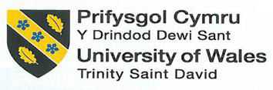

School of Hospitality and Tourism Management
BA International Hotel Management

BMIH5007 - Financial Management for the Hotel Industry
Student Name: Gabriel Neagu
Student ID: 2121349

Introduction
Financial management shall refer to planning, organisation, regulation and monitoring of funding so that organizational targets and goals could be achieved. There are different aspects included in this process including effective management of the sustainability of the business, ensuring profitability on a long-term basis and management of financial resources such as investment and money within the company (Grundy, Johnson and Scholes, 2022).
A multinational hotel group named Intercontinental Hotel Group based in Denham, Buckinghamshire, UK. The hotel management has many other substitute organizations and business corporation of hotel chains globally. The hotel has franchises in more than 100 different countries with 6000 hotel branches in different market segments. Most of the properties and hotel chains of IHG are operated by the third party and provide leverage to the local expertise. The main vision and primary aim of the IHG is to satisfy the guests with its quality services and diversity and is the prominent player in the hotel sector (Chang, McAleer and Wong, 2020).
An American multinational operating in the hospitality sector that is known with the name of Hyatt Hotels is currently operating luxury resorts and hotels at the global level. The company is operating under headquartered in Chicago, Illinois and it was founded and established in 1957. Hyatt Hotels manages thousands of hotels, resorts and homes across several countries (Marino-Romero et al., 2020). The Hyatt Hotels have taken a significant interest in the management of its finances, and are implementing several plans that will enhance their profitability and deliver long-term growth (Ivanov, 2019).

Total revenue

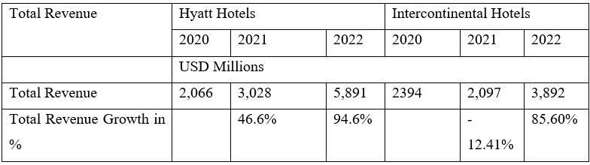

Source: Annual Report Hyatt and IHG
46.6% of the growth rate recorded for Hayyat from 2020 to 2021 suggest that the revenue of the industry increased and from 2021 to 2022, the annual growth revenue is recorded as 94.6% which also indicate a progressive growth of the business. On the contrary, the growth rate of revenue from 2020 to 2021 is recorded as -12.41 suggest a downfall in the total revenue profit but during the time period from 2021 to 2022 indicate an increase in the 85.60% annual revenue (Franco et al., 2020).
IHG also reported an approximate revenue of $2.39 billion USD in 2020. The period of COVID-9 impacted the hospitality sector as lead to a significant decline in the annual revenue during that period (Yagmur, Demirel and Kilic, 2023). The total revenue decrease from 2020 to 2021 with 12.41% decrease in the annual revenue but IHG rebounded the progress in the year of 2022 with total revenue of $3.89 billion USD indicating growth rate of 85.60%. The whole data of the annual revenue fluctuation indicates that during COVID-19, IHG faced many challenges and conflicting situations but strive a substantial revenue growth over time.
Different sources are associated with the revenue streams of Hyatt including the sale of beverages, foods, room revenue and other services related to the hotel (Egbide et al., 2022). Revenue is also generated by the company based on a loyalty program that is named as World of Hyatt which at the global level has associated over 20 million members. Presence in the vacation rental market is also expanding by Hyatt based on its partnership created with HomeAway and the acquisition of Oasis Collections (Susanto, 2022).
There is a diverse substitute portfolio of IHG as InterContinental, Holiday Inn, and Crowne Plaza with the company’s global offerings and diverse services to the customers contributing to the overall revenue of the growth performance. Moreover, IHG Reward Club also offers discounts and leverage offers to potential customers to bring loyalty and repetitive business (Polukhina et al., 2021).

Market Position
Marketing position can be evaluated using the EPS and dividend yield ratio
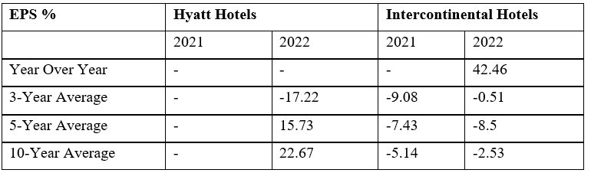
Source: Annual Report Hyatt and IHG
-17.22% of EPS fluctuate over the period of 3 years for Hyatt Hotel and it designates that the EPS average rate has negative value and over the period of 5 years, the value of EPS for the Hyatt Hotel is 15.73% shows a positive average growth rate and over the tome period of 190 years, the EPS growth rate of EPS for Hyatt Hotel is 22.67% which indicate an overall positive growth rate.
On the contrary, the EPS percentage fluctuates and varies from 2021 to 2022 at 42.26% as a significant increase in the EPS during these years of growth. But the average EPS over the 3-years period, EPS value is -9.08% representing a prominent decline over the three years. The EPS value of IHG over the time period of 5 years also has a negative value of -7.43% and -5.14% is the EPS value over the 10 years of the period indicating that the total growth rate of the IHG is negative and it is noteworthy that to EPS is not only depend on the financial growth of the business but also all different factors are mandatory to consider the performance and profitability of the company while calculating EPS for any business sectors like Hyatt and IHG hotel Companies (Dogru et al., 2023).
The buyback yield percentage for Hyatt Hotels in 2022 is 2.71%. This indicates the percentage of the company's shares repurchased by the company in relation to its market capitalization. The total yield percentage for Hyatt Hotels in 2022 is 2.71%. This includes both the dividend yield and the buyback yield.
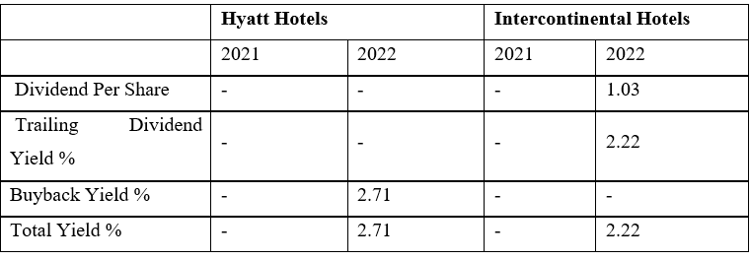
Source: Annual Report Hyatt and IHG

In 2022, the recorded dividend per share is $1.03 for IHG and it represent the amount of the dividend per share in the company market of shareholders. In 2022, the trailing dividend yield percentage is of 2.22% as a company dividend payment in terms of stock exchange price.
The IHG dividend information is not available in literature but the yield percentage of buyback of IHG is 2.71% in the year of 2022 to combine the dividend yield and buyback yield has the same value proportion for both IHG and Hyatt Company in the year of 2022.
Market Position of Hyatt Hotels: One of the world's largest hospitality companies, Hyatt Hotel Corporation has a strong presence in the luxury hotel sector. Across over 60 countries, it is identified that more than 1000 hotels are operated by the company, with an emphasis on luxury hotel brands like the Andaz, Grand Hyatt, and Park Hyatt (Akron et al., 2020).
With a total of $4.4 billion in revenue by 2021, Hyatt will be the world's 9th biggest hotel chain based on market share. It has 546 properties in the USA, of which there is a strong presence, followed by 267 office buildings in Asia Pacific. Hyatt also enjoys a significant presence within the EMEA region, having 209 hotels (Dewi and Sudiyatno, 2023).
Hyatt's dominant position in the market has been reinforced by the World of Hyatt loyalty program, with over 20 million members around the world. During the programme, members can avail themselves of special privileges such as access to rare experiences, free nights and accommodation upgrades (Ivanov and Webster, 2019).
Market Position of IHG: the brand diversity of IHG can be examined by the diverse portfolio of services of upscale, midscale, and extended luxury stay by including some of its chains of the hotel and restaurants of Crowne Plaza Hotels, Holiday Inn Express, and InterContinental Hotels (Egbide et al., 2022).
The hotel of IHG operates in more than 100 different countries with operational hotel branches and franchises of 6000 in different emerging market to cater various markets and approach potential clients globally. The total revenue growth of IHG in the year of 2022 is recorded as 2.39$ B with decrease in the revenue by 12.41% from 2021. Although the total revenue of $3.89 billion USD, showcasing an 85.60% growth rate.
Most of the properties of IHG are operated and managed by a third party and are franchised. The business strategy of IHG helps the company to expand in the global emerging market to leverage local expertise. There is a diverse substitute portfolio of IHG as InterContinental, Holiday Inn, and Crowne Plaza with the company’s global offerings and diverse services to the customers contributing to the overall revenue of the growth performance. Moreover, IHG Reward Club also offers discounts and leverage offers to potential customers to bring loyalty and repetitive business (Hamza et al., 2021).

Growth Protentional

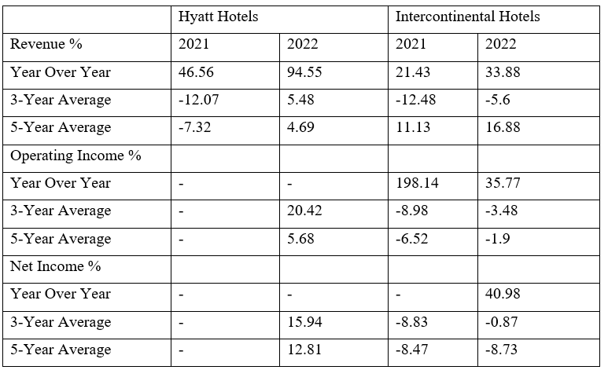

There is a strong revenue growth of Hyatt Hotel from 2021 to 2022 with the total growth rate of 46.5% and 94.55% respectively. On the contrary, revenue growth rates of IHG in 2021 were recorded as 21.43% and 33.88% in 2022 which represent that the company of Hyatt Hotel is more favorable in the generation of annual revenue growth as compared to IHG in both years of 2021 to 2022. EPS percentage fluctuates and varies from 2021 to 2022 at 42.26% as a significant increase in the EPS during these years of growth. But the average EPS over the 3-years period, EPS value is -12.07% for Hyatt Hotel representing a prominent decline over the three years. The EPS value of IHG over the time period of 5 years also has a negative value of -12.07 indicate that the total growth rate of the Hyatt Hotel is declining. 5-year revenue growth of Hyatt Hotel represent a negative value of EPS of -7.32% but IHG 5-years EPS and revenue growth is of 11.13%.
In 2022, the operating rate of IHG had an increase in the growth rate with the total revenue of 198.14% whereas, in the Hyatt Hotel, the annual revenue growth was not available but 3-year average data of the revenue growth also indicate that the IHG has faced a decline in 3-year average records with -8.98% of the revenue growth and IHG, 5 years revenue growth has indicated a significant decrease in the revenue growth with -6.25% of the IHG hotel. In 2022, the net income of IHG is 40.98% but unfortunately, the net income figures of the Hyatt is not recorded and available of these years. The net-income growth of 3-years of Hyatt Hotels was negative at -8.47% as representing a decline in the growth of the revenue. Whereas, the average net income growth of the Hyatt Hotel was -8.73% (Grundy, Johnson and Scholes, 2022)
Hyatt Hotel Corporation and IHG both have scope for further expansion in the hospitality industry, despite their differing market position and business structures (FABIYANI et al., 2021).

Financial Commitment to CSR

Financial Commitment to CSR
To show their dedication to sustainability, environmental preservation, and social responsibility, businesses are placing an increasing emphasis on corporate social responsibility (CSR). Hyatt Hotel Corporation and IHG have both made financial commitments to corporate social responsibility via several initiatives and programmes (Zhu, 2021).
Three key areas are addressed in the programme "Hyatt Thrive" by Hyatt Hotels Corporation, which is known for its Corporate Social Responsibility Programme: development of employee ecologies, community involvement and sustainability. These programmes were funded by the corporation in a significant way, with an emphasis on social engagement efforts like support for education and youth development as well as eco-friendly practices such as reducing waste and improving energy efficiency (Cerchione and Bansal, 2020).
Apart from its CSR program, which delivers grants and charitable contributions to several social and environmental issues, Hyatt Hotel Foundation has been set up. In particular, funding initiatives aiming at supporting the creation of lively communities, opportunities for learning and training as well as disaster relief are prioritized by the organization (Vivel-Búa, Lado-Sestayo and Otero-González, 2019).
There is a significant financial commitment in the management of the Intercontinental Hotel Group to initiate Corporate Social Responsibility as an integral part of IHG’s business to have various steps to promote and motivate sustainability, community engagement, and social responsibilities but I have no access to the financial figures of the hotel sectors without my prior knowledge of September 2021 and I can also provide an overview of IHG to promote and motivate CSR and some of the key elements of CSR initiatives:
IHG Green Engage: IHG has implemented and installed a management system of Proprietary environmental management system to called IHG Green Engage to help IHG to mitigate environmental factors and operate in more sustainable techniques. Different tools, guidance, and resources also have been associated with the IHG Green technology to monitor and enhance energy usage, waste management, carbon footprint, and water consumption to promote social care facilities and activities to enhance the hotel services to attract more potential customers.
Sustainable Development Goals (SDGs): To support and help in commanding the United Nation’s Sustainable Development Goals as to align the CSR initiatives with the focus on areas of responsible consumption and produce to climate action and partnership.
Water Stewardship: A comprehensive program of water stewardship to mitigate the water consumption in different substitute sectors of the business to focus on water conservation, recycling, and engagement of the local communities to maintain sustainable water management as serious practices in the continuous processing (Cain, Thomas and Alonso Jr, 2019).
Responsible Supply Chain: There is a responsible act of the sourcing and ethical business practices incurred in the company supply chain management and processing. The suppliers also motivate the company to encourage social, governance, and environmental standards and to actively participate in responsible procurement practices in the business sector or department (Panno, 2020).

Conclusion
There is revenue growth of IHG in 2022 as of 33.88% with the ability to recover from the drastic situation and uncertain circumstances as to asset-light strategy, loyalty program, and diverse brand portfolio to play a crucial role in market penetration and striving growth of the company to adapt and install CSR responsibilities to focus on the sustainability business practices to enhance the growth potential of the organization of IHG Company. There were many records related to the IHG’s operational and net income as an income of 2022 to represent the positive financial performances and increase the growth of the potential business through responsible CSR and other Green IHG activities to boost and enhance the performance in the rigorous and challenging competitive market of business

References
Akron, S., Demir, E., Díez-Esteban, J.M. and García-Gómez, C.D., 2020. Economic policy uncertainty and corporate investment: Evidence from the US hospitality industry. Tourism Management, 77, p.104019.
Cain, L.N., Thomas, J.H. and Alonso Jr, M., 2019. From sci-fi to sci-fact: the state of robotics and AI in the hospitality industry. Journal of Hospitality and Tourism Technology, 10(4), pp.624-650.
Cerchione, R. and Bansal, H., 2020. Measuring the impact of sustainability policy and practices in tourism and hospitality industry. Business Strategy and the Environment, 29(3), pp.1109-1126.
Chang, C.L., McAleer, M. and Wong, W.K., 2020. Risk and financial management of COVID-19 in business, economics and finance. Journal of Risk and Financial Management, 13(5), p.102.
Dogru, T., McGinley, S., Sharma, A., Isık, C. and Hanks, L., 2023. Employee turnover dynamics in the hospitality industry vs. the overall economy. Tourism Management, 99, p.104783.
Egbide, B.C., Agi-IIochi, M., Madugba, J., Taiwo, A. and Ayomide, I., 2022. Budgeting approaches and employee motivation in the hospitality industry. Problems and Perspectives in Management, 20(4), pp.602-613.
FABIYANI, N.N., SUDIRO, A., MOKO, W. and SOELTON, M., 2021. Conceptualizing the role of work engagement: a case study of the hotel sector in Surabaya during the COVID-19. The Journal of Asian Finance, Economics and Business, 8(5), pp.485-494.
Franco, S., Caroli, M.G., Cappa, F. and Del Chiappa, G., 2020. Are you good enough? CSR, quality management and corporate financial performance in the hospitality industry. International Journal of Hospitality Management, 88, p.102395.
Grundy, T., Johnson, G. and Scholes, K., 2022. Strategic Financial Management. Bachelor of Business Administration Programme Code: BBA Duration–3 Years Full Time, 2(1).
Hamza, P.A., Hamad, H.A., Qader, K.S., Gardi, B. and Anwar, G., 2021. Management of outsourcing and its relationship with hotels’ performance: An empirical analysis of selected hotels in Erbil. International Journal of Advanced Engineering Research and Science, 8(10).
Ivanov, S. and Webster, C., 2019. Economic fundamentals of the use of robots, artificial intelligence, and service automation in travel, tourism, and hospitality. In Robots, artificial intelligence, and service automation in travel, tourism and hospitality. Emerald Publishing limited.
Ivanov, S., 2019. Ultimate transformation: how will automation technologies disrupt the travel, tourism and hospitality industries?. Zeitschrift für Tourismuswissenschaft, 11(1), pp.25-43.
Panno, A., 2020. Performance measurement and management in small companies of the service sector; evidence from a sample of Italian hotels. Measuring business excellence, 24(2), pp.133-160.
Polukhina, A., Sheresheva, M., Efremova, M., Suranova, O., Agalakova, O. and Antonov-Ovseenko, A., 2021. The concept of sustainable rural tourism development in the face of COVID-19 crisis: Evidence from Russia. Journal of Risk and Financial Management, 14(1), p.38.
Vivel-Búa, M., Lado-Sestayo, R. and Otero-González, L., 2019. Influence of firm characteristics and the environment on hotel survival across MSMES segments during the 2007–2015 period. Tourism Management, 75, pp.477-490.

Appendix


