Blog Posts

Amy: “Panto Season Is Here!”

Seeing as we’re approaching the festive season, we want to know what your favourite pantomimes are! Cinderella is my personal favourite, but here are the top 5 pantomimes according to The Telegraph.
- Aladdin
Initially released as a film in 1992, Aladdin took to the stage in Amsterdam in 2014. Described as ‘a magic carpet ride to panto land’ by the Guardian’s theatre critic, Michael Billington, this incredible show is a great watch no matter what time of year!
- Jack and the Beanstalk
A little more vintage than Aladdin, the original Jack and the Beanstalk dates all the way back to 1807! The classic fairy-tale has been made into countless movies, but none of them will ever match the pantomime!
- Dick Whittington
Dick Wittington has done the rounds across just about every city in the UK, but that doesn’t stop us loving it! You can catch it in the famous London Palladium this Christmas, where a star-studded cast including Julian Clary, Elaine Page and Britain’s Got Talent winners Diversity all take to the stage.
- Peter Pan
Everybody loves Peter Pan and his pal Tinkerbell, and there’s no better place to see them than in this family-favourite pantomime. Not only is it one of the country’s most loved pantos, Peter Pan has also featured some of the biggest names in show-biz, from David Hasslehoff to the Chuckle Brothers.
- Cinderella
Described as ‘the UK’s most popular pantomime’, Cinderella is an all-time panto classic. A, quite literally, rags to riches story which is sure to have your whole family laughing, crying and having a ball this Christmas!

Rhodri: “Are you feeling festive or stressed this Christmas?”

‘Tis the season to be jolly’. It’s nativity season. The year is coming to an end, and now it’s time to think about CHRISTMAS. So, are you feeling festive or stressed this Christmas?

Christmas plays are always fun for children, but stressful for parents. Most parents will be thinking, how am I going to finishing making this costume in time? How many more days left? Can you please be quiet?

Your house is going to be like the London palladium. Your children practicing their acting skills, singing their hearts out, dancing from the moment they get up, until the moment they go to sleep. That’s what Christmas is all about! Just think how proud you’d feel when your child is on that stage playing a part in the school nativity play.

Christmas is also a time to celebrate for people who are not in the school nativity or playing a part in a pantomime. If you know someone who has learning difficulties and would love to freely express themselves on the stage, in front of a live audience, then The Rising Stars Theatre Company is for them. Let’s get everyone included this Christmas, and make the world a better place.

Cai: “3 Tips for Writing your Own Play”

In my opinion these tips are essential in writing your own play, and keeping to them will greatly increase the quality of your script.
- The most important part of writing a play will be creating an immersive story, you will have to keep the audience entertained if you want it to be successful. Which is why it is important to develop the story into the right format, keeping each act interesting and engaging.
- Another key element of writing a play is the dialogue, you must create dialogue which flows and comes off as natural. A good way to do this is to include plenty of interruptions between characters, which gives the play a more authentic feel.
- The last tip I have to offer is to tie in the dialogue with your planned stage directions as soon as you create them, having a picture of how each scene should be acted will make bringing it to life that much easier.

Jack: “4 Ways of Getting into The Performing Arts Industry”

1.Consider Educational routes, there are courses available within Wales where you can be educated upon what skills you need in the performing arts, this can help you gain an introduction into the industry.
2. Consider theatre groups, these will be outside of education, and will most likely require a audition of some sort, but this is a great way as they will assign you a role which will suit you, making sure you will be within your comfort zone.
3. Think about who you know and don’t be afraid to ask, if you know someone within the industry they may be able to get you a small part in the industry and from there you can build your way up within the industry.
4. Don’t only consider the stage, there are many roles backstage that you could take up, that could be just as rewarding.
Kate: - has an extended deadline for her blog posts.

Blog Supporting Paper

Please click on the link to visit the blog for The Rising Stars Theatre Company: https://uwtsdblogs.wordpress.com

A blog is:

“a website containing a writer's or group of writers' own experiences, observations, opinions, etc., and often having images and links to other websites.”
(Dictionary.com, 2017)

The Use as a Communication Tool

The main use of this blog was as a communication tool in order to raise awareness for the charity as the group and the charity believe that a lot more people should know about what they do. The blog was a good communication tool as it gives the group’s first hand personal views on the charity and relating themes to write on. The group have had good interaction on their blog based on the number of views, visitors and likes to the page. Figure 1 shows the level of interaction to date since the creation of the page.

Figure 1.

Other Communication Tools

As well as creating this blog, the group also created posters as a communication tool. The posters were put up in Argos, business offices, and secondary schools. We designed these posters to be eye catching yet very informative and therefore the group hopes that this will attract lots of attention towards the charity. The AIDA model can be used to demonstrate the group’s theory behind these communication tools.

“Ideally the message should get attention, hold interest, arouse desire, and obtain action, in practice, few messages take the consumer all the way from awareness to purchase, but the AIDA framework suggests the desirable qualities of a good message”
(Kotler & Armstrong, 2018, p. 433)

The group are hoping to raise awareness therefore these tools must be designed so people don’t miss it when walking past. The interest is important because the group need to increase the reader’s interest whilst displaying facts in an interesting manner. Although the charity is not selling a product or service the group needs to convey important information by showing the reader that they want to desire what the charity do or believe in. The last aspect is the action. Again, although the charity isn’t selling a product or service, the group and charity need individuals to integrate and communicate with the charity in order to raise awareness worldwide.

Blogging Platform

The group chose to create the blog on the site Wordpress as their blogging platform. They chose to use this platform as it is used by millions of people worldwide. Amy chose the site as she was reasonably comfortable with it. The group based the decision on the fact that they believe this will give their blog more exposure, and as you may have seen, the have received views from numerous countries such as New Zealand and Spain. Figure 2 shows the level of interaction worldwide the group has had with their blog. Wordpress has made it easy for users to create, personalise, and edit their own blog. Making it the clear decision for our group to create our blog on this platform with ease.

Figure 2.
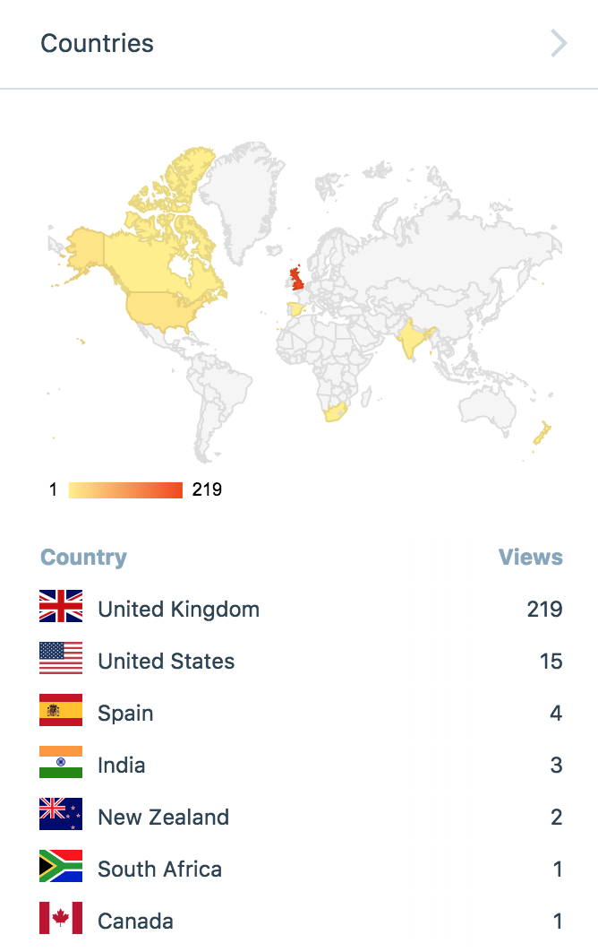

Our Plan

The group made a content plan to decipher which member was writing what blog post and to ensure blog posts weren’t repeated, each member was allocated with a blog of their choice. The plan illustrates that each member of the group had two blogs each, relating to the theme surrounding performing arts. Topics such as acting, dealing with learning difficulties and the performing arts industry in general, have all been discussed on our blog.
By having this content plan, it was easy to see if the group was on track and what posts were outstanding.

The Appearance

While creating this blog it was important that it looked appealing in order to draw people in to read it. If the appearance wasn’t colourful and eye catching, no reader would want to read all of the individual blog posts. In order to make the amount of text less overwhelming, having photos in the blog makes it look much more personal and professional, therefore this makes the blog less difficult to read.

Team Members

- Amy- Created the blog platform and researched particular topics to base her blogs on. She also aided Rhodri when necessary on the layout of the blog. In addition to that, she undertook the team leader role for this task as it was decided it contained her area of expertise and could help to ensure the piece was of highest possible quality.

- Rhodri- Was in charge of the theme of the blog, ensuring it looked professional and consistent throughout. This included the font of the text and background colours. Also, Rhodri researched for additional content that could be used to raise even more awareness for the charity, such as videos. Rhodri, along with Amy assured that everyone’s blogs were uploaded onto the site ready for submission.

- Jack- As social media manager, was responsible for controlling the group’s following on the blog, ensuring as many individuals could see the blog as possible to get the best interaction.

- Kate- As team leader it was Kate’s responsibility to keep the group in contact with The Rising Stars Theatre Company, and retrieved photos etc that make the blog more personal to The Rising Stars Theatre Company. Kate also assisted Rhodri when it came to picking the background and font.

- Cai- Was in charge of quality control, he ensured that all work was cohesive throughout and looked professional throughout.

Theory
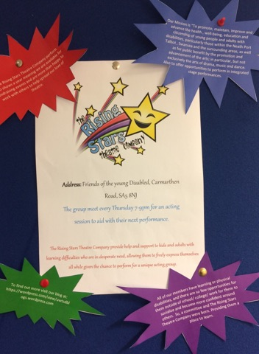
Marketing mix and the four p’s was first mentioned by (McCarthy & Parkinson, 2014) it explains there are the four p’s they have to consider to market a product successfully. The four p’s are Place, Product, Price, Promotion. The product the team created to advertise The Rising Stars Theatre Company is a blog on Wordpress which was created to spread awareness about what they do as a charity and to draw people in who have common interested in theatre. To promote the blog, the team created a poster about the Rising Stars Theatre Company and placed it in on a pin board in the university so that a wide walk of people has the opportunity to see it and then potentially go online and learn more.
It was also shared across the members Facebook accounts as that makes it available to an even wider audience.
By using a blog, and using the platform Wordpress which means that it can be created for free so no extra cost to the charity for this form of advertising and any type of advertisement is good for any organisation. Also, the readers don’t have to pay any money to view it meaning it can easily form a steady foot fall through the blog as people can click on it when curious as they don’t need to make any commitment.
The place of which the product is advertised has a huge impact on the amount of people who see it. By having it online there is no restriction as to who could come across it and decide to view it. By considering all these factors it has allowed for the team to get closer to meeting their main aim of spreading awareness.

Conclusion

To conclude, the blog posts helped the group develop their overall marketing campaign as it provided them with a platform where they could communicate with people in the local area. It has also aided them in reaching other parts of the world who could potentially start something similar to The Rising Star Theatre Company. Additionally, the content plan that the group made, helped them stay on track in terms of the blogs. Unfortunately, some members had taken longer to write their blogs than the group expected and other members had changed the topic they were writing about.

The group has managed to achieve 245 views from the creation of the blog in November, showing that they are reaching a target audience and therefore working towards their aims and objectives. In addition, the group feel that using Wordpress as their platform for blogging has really helped them in their success as they are reaching their target audience and fulfilling their potential in terms of their interaction on the site itself. Amy already had some pre-existing knowledge when it came to Wordpress, enabling the group to use the platform effectively and raise as much awareness as possible.

References

Dictionary.com, 2017. Blog. [Online]
Available at: http://www.dictionary.com/browse/blog
[Accessed 11 December 2017].

Kotler, P. & Armstrong, G., 2018. Principles of Marketing. 17th Edition ed. Harlow: Pearson Education Limited.

McCarthy, E. J. & Parkinson, S., 2014. Basic Marketing. new york: McGraw-Hill.

