Getting ideas from news stories 24 October 2020
While news media might not be incredibly heavy from an academic sources point of view, in the context of Covid conditions, where information, advice and crisis management can change daily, you can only do what you can. News media does use heavier reports, but often simplifies them for the general reader.
Some UK newspapers are the very best in the world …The Times, FT, The Guardian, The Telegraph etc, some are the very worst….The Sunday Sport, The Sun….sorry if these are your favourites, do read them but try to quote the quality press.
All media have travel, tourism, events, leisure sections, so consult them. They sometimes make the front pages, see the Simon Calder story covered elsewhere.
Here is a selection of my Saturday newspapers. From the selection you could make a judgement on my political/social leanings (waffly liberal), however I also take time to read other sources including right wing conservative ones e.g. The Telegraph, The Times, Institute of Economic Affairs (IEA) etc.
Unless you have been living a cave, you will know that we have a Covid crisis and that Leisure, Tourism, Events and Hospitality is having a tough time. The media has been covering this looking at it from the consumer, service provider and related product suppliers.
(When I taught tourism/leisure students in the past I had long discussions that the sector was primarily a service provider BUT there was a very profitable related PRODUCT industry linked to it. Swimming goggles sold at leisure centres, programmes at theatres, water bottles at gyms, conversion plugs at holiday destinations, sun cream at beach bars…. Therefore, service and product delivery be mutually supportive. Therefore, you do need to know about product marketing as well as service marketing)
- Daily Mirror 24 October 2020 https://www.mirror.co.uk/
Knowing where each source stands is important to recognise bias. The Mirror is a tabloid “red top” that is one of the few mass newspapers to support the Labour Party. Therefore, it will be full of sensation and is critical of the national government.
Apart from stories on people having sex 5 times a week in lockdown (I have a headache) there is quite a nice section on travel and tourism. Also, events are well covered.
Covid lockdown, Katie Price goes to the Maldives, despite being bankrupt, Marcus Rashford is well written up, the Covid reaction to staying at home cooking, gardening, home improvements, planning future holidays, fashion on a budget, cooking …….even pensioners organising The Olympics in their care homes are all in there.
Can your case company latch onto some of these trends?

Sports events-
Wales V France rugby tonight at 19.30
England v Barbarians tomorrow CANCELLED due to breaking Covid rules.
Lessons to be learnt by your case company? Business implications for both these examples?

The main pages on your sector features:
UK based Autumn holiday destinations
Also featured:
https://britishtravelawards.com/
Interesting that Page 46 of the Mirror is identical to the same coverage in the Daily Express and others. See promotional blog.
https://twitter.com/TravelEdNigel/status/1319670888279822337?ref_src=twsrc%5Etfw%7Ctwcamp%5Eembeddedtimeline%7Ctwterm%5Eprofile%3ABritTravAwrds&ref_url=https%3A%2F%2Fbritishtravelawards.com%2Fabouttheawards.php
Therefore, this is an ‘Advertorial’ (advert and editorial), a sponsored (i.e. paid for) story run in all tabloids, but it looks like a normal story. Check out who is involved in organising this event. Why it is important? What are the criteria for nominating and winning? Who won last year?
Nevertheless, interesting stories on:
*New flight routes to India (Virgin and Northwest carriers) Fares from £473! Shows carriers are still developing new products but check out how they make them Covid compliant, to recommend to your case company?
*Penalty free cancellation holidays from Kuoni. Good move worth recommending to your case company?

- South Wales Evening Post
Our local “rag”. Ok for local/regional stories. Has been known to make mistakes.
The South Wales Evening Post is a tabloid daily newspaper distributed in the South West region of Wales The paper has three daily editions - Swansea, Neath and Port Talbot and Carmarthenshire^{[2]} and is published by Media Wales, part of the Reach plc group.^{[2]} The current editor is Jonathan Roberts.^{[3]} As the name suggests, it had previously been an evening paper, but later moved to a morning daily.
The paper has a circulation of 13,257 as recorded by the ABC in January 2020, down from 40,149 in 2011.
Stories covered can be followed up to get more details. Check names and organisations and contact them directly.
Apart from general coverage of Covid, including Swansea City AFC disability fan group who remain loyal, the most important story for you and your sector is the announcement of major gigs to be hosted in Swansea in 2021. Showing that planning is taking place despite the lockdown.

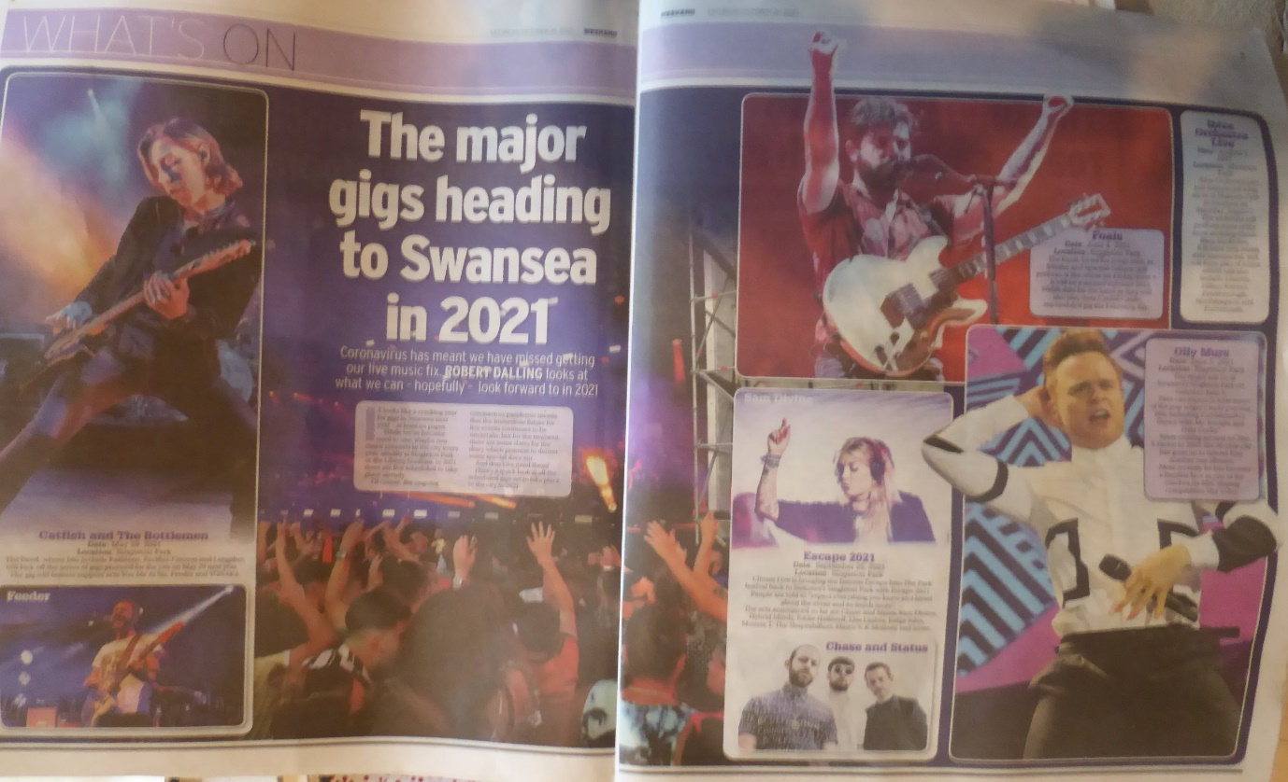

These gigs take many months to organise for major artists, at least 12 months. However, for smaller gigs, I wonder if flexible smaller operators and smaller venues can find a niche to exploit the public yearning for going out and music/arts events, once a gap appears in the Covid “firebreak”?
Look to Swansea’s long tradition of pub bands (Battle of the Bands competition), Volcano Theatre (I have been a fan for years but if you go do “expect the unexpected” do not go if you are very sensitive), the Liberty Stadium as a venue, Swansea City recreational department for Singleton Park events, venues like the Taliesin Theatre and the new(ish) independent cinema in Castle St. Check them out as local, Small and Medium Sized Enterprises (SMEs) which are often characterised as being more flexible and closer to their customers than the multiples.
What is happening to the Swansea Festival or Arts? Literature events often held in the University owned Dylan Thomas Centre http://www.dylanthomas.com/
Pontardawe Arts Centre? https://npttheatres.co.uk/pontardawe/ There used to be a respected Blues and Jazz Festival there.
Also, a story I will try to investigate. Fewer Covid case in towns by the seaside? Opportunity for them?
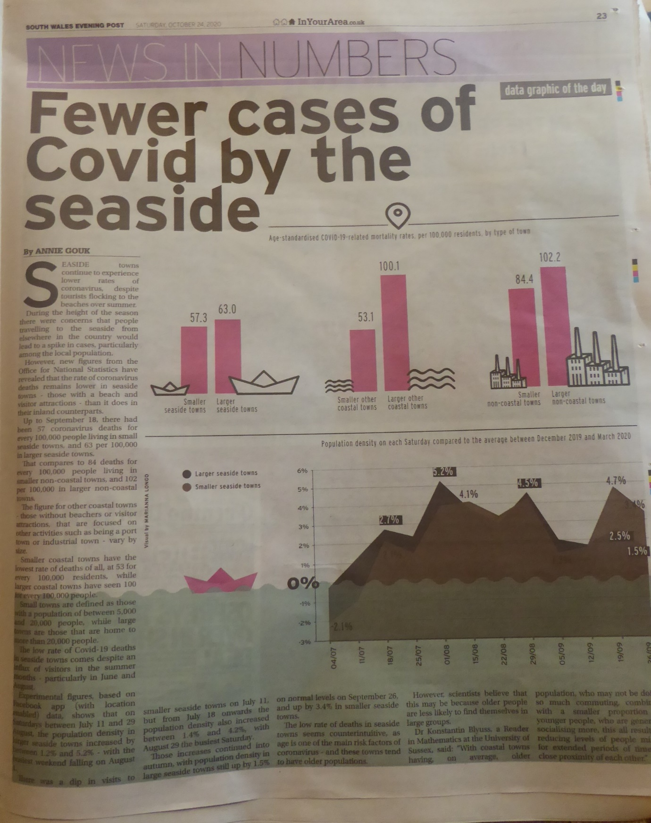
- The Guardian (The only liberal leaning quality newspaper).
https://www.theguardian.com/money/2020/oct/24/nationwide-reduces-flex-travel-insurance-cover-for-covid-cancellations
Similar coverage on Covid to other papers on gardening, cooking etc. Alternatives to travelling, going to events, exercising in the gym/leisure centre?
Can your case company be flexible to give home based services e.g. the restaurants that became takeaways or Michelin stared restaurants that delivered the ingredients for you to cook at home (often with a video instruction guide)….?
The main story that I spotted was my favourite destination The Canaries…now freed to be a “travel corridor” so that visitors do not have to self-isolate/quarantine when they return to UK. A great regional case study.
This sudden change of status has led to a shortage of flights, especially for the school half term. Jet2 can only fly from 30 October! Tui is running holidays that it had not got round to cancelling…..Ryanair is offering a value fare” of £690 to Lanzarote (What a surprise!).
https://www.theguardian.com/travel/2020/oct/22/canaray-islands-added-to-uk-travel-corridor-list
Virgin Holidays is still promising to refund cancelled holidays, though not quite yet, according to the Competition and Monopoly Authority (CMA) complaints investigation.
Studying Tourism, Hospitality, Events & Food (THEF) like any other discipline you need to get used to many acronyms. Anyone worked out MICE from my earlier emails? See below.
Another one from The Guardian today: RevAR?
Owner of the Holiday Inn group says that the fall in Revenue per Available Room (RevAR or RevPAR in the online version of the story, see link below) of 53.4% caused the InterContinental Hotels Group (IHG) hotels to close (199 to September). CEO reports some improvement and better conditions in China. However, does not see much improvement soon.
Reaction?
Opportunities for disinvestment for IHG. Sell off some hotels to smaller operators. Small hotels for consortia could be more flexible; opening and attracting visitors when localised opening happens, being nimbler and offering customised services. (So long as they have the resources to survive the worst time in lockdown zero incomes).
https://www.theguardian.com/business/2020/oct/23/holiday-inn-hotel-group-sees-revenue-fall-as-covid-19-keeps-people-at-home
Also, some interesting stay-at-home stories, Staycation ideas, for the winter, including surfing holidays…. plus selling related products, camping, surfing, outdoors clothing etc.
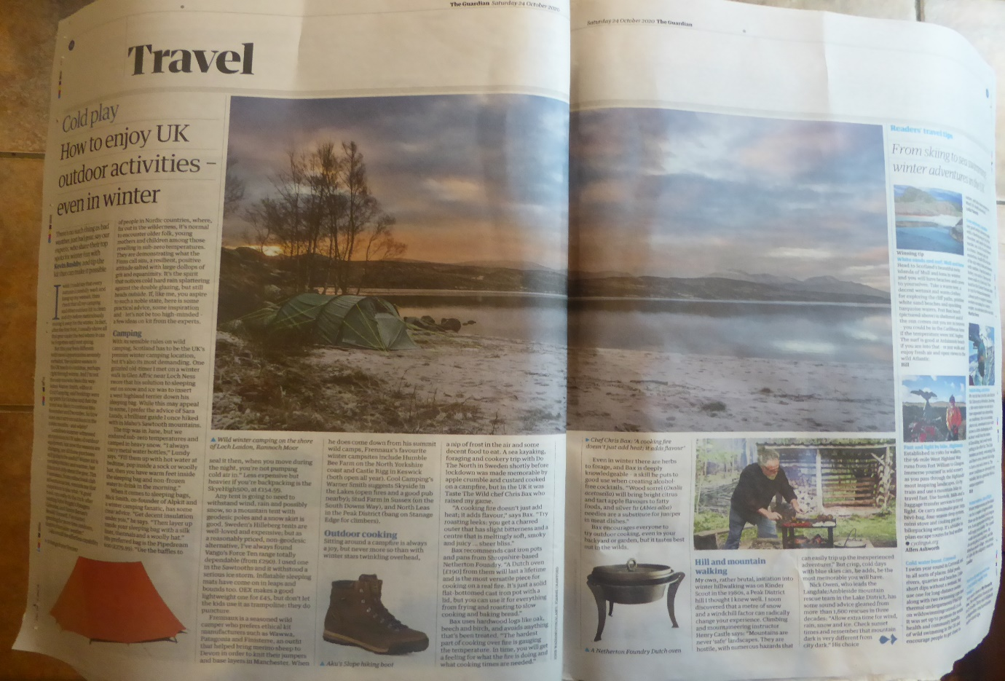
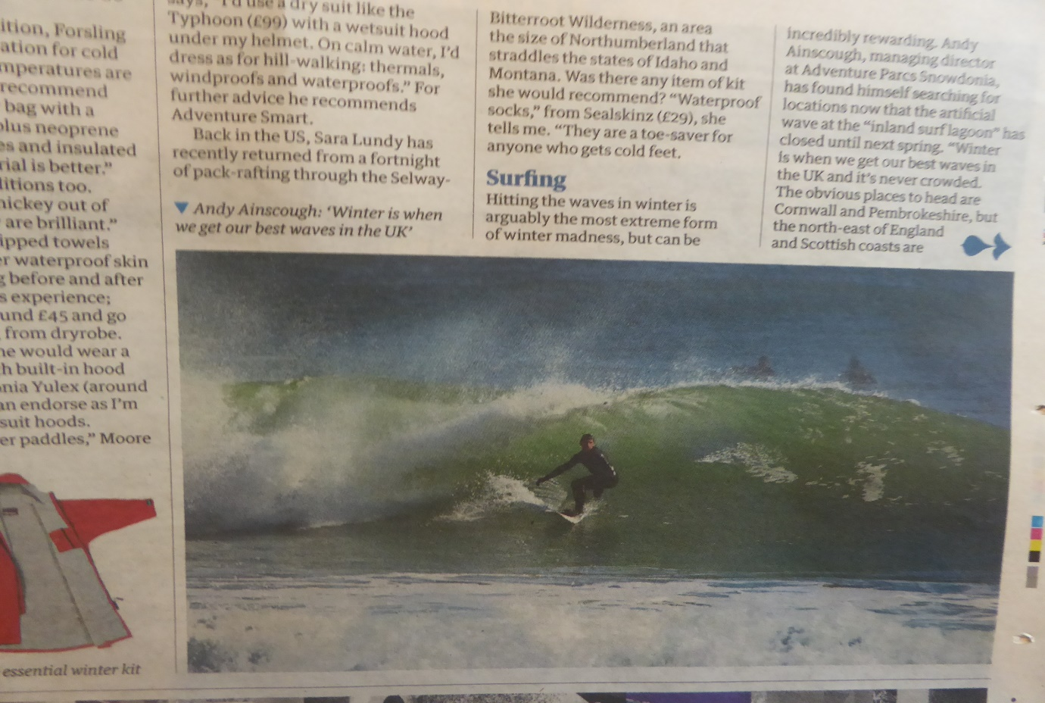
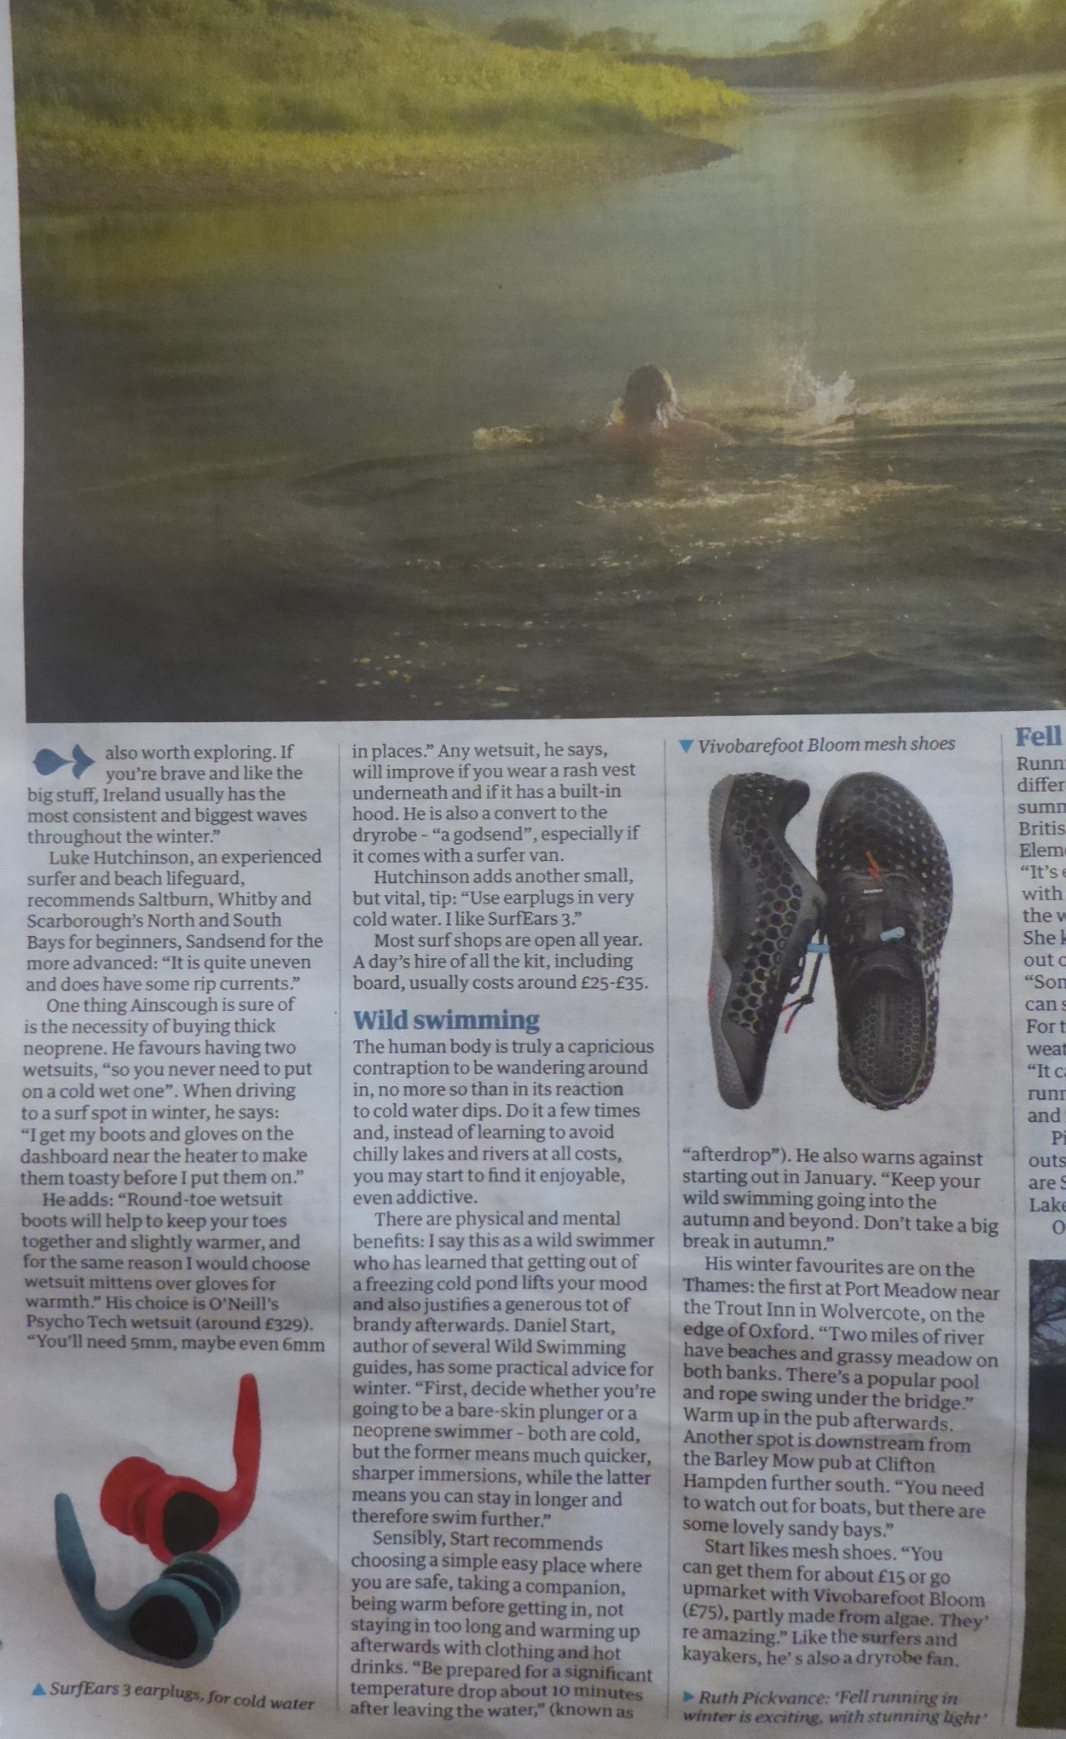

ANSWER to above:
Meetings, incentive travel, conventions and exhibitions (MICE) industry

Steve Griffiths (24 October 2020)

