Research Proposal

On

“Developing an AI-Powered Personalised Healthy Meal Marketplace for Zomato: A Business Development Proposal for Sustainable Growth in India's Urban Food-Tech Market”

Word count 2700 words excluding TOC, and References (2500 words +/- 10%)

Table of Contents
1. Title 4
2. Introduction, Background and Research Problem 4
2.1 Digital Food-Delivery Growth and Strategic Market Pressures 4
2.2 Behavioural Evidence and the Limits of Personalisation 4
2.3 Research Problem and Commercial Justification 5
3. Research Aim, Objectives and Questions 5
3.1 Research Aim 5
3.2 Research Objectives 5
3.3 Research Questions 6
4. Preliminary Literature Search and Research Gaps 6
4.1 Algorithmic Personalisation and Consumer Decision-Making 6
4.2 Digital Choice Architecture and Nutritional Transparency 7
4.3 Platform Ecosystems and Multi-Sided Commercial Value 7
4.4 Commercial Feasibility, Affordability and Consumer Trust 8
4.5 Research Gaps and Proposed Conceptual Contribution 8
Figure 1: Proposed Conceptual Framework for the Zomato Nourish360 AI-Enabled Personalised Healthy Meal Marketplace 9
5. Research Methodology Including Ethical Considerations 10
5.1 Research Philosophy and Analytical Design 10
5.2 Secondary Evidence Identification and Selection 10
5.3 Thematic Analysis and Commercial Evaluation 11
5.4 Research Quality and Methodological Limitations 11
5.5 Ethical Governance and Responsible AI 11
6. Research Risks and Mitigation Strategies 12
6.1 Secondary Evidence Reliability and Analytical Uncertainty 12
6.2 Algorithmic, Commercial and Ethical Exposure 12
6.3 Risk Mitigation and Research Feasibility 12
7. Research Timeline – Gantt Chart 13
Figure 2: Proposed Research Timeline – Gantt Chart for Zomato Nourish360 13
References 14

1. Title
Developing an AI-Powered Personalised Healthy Meal Marketplace for Zomato: A Business Development Proposal for Sustainable Growth in India's Urban Food-Tech Market

2. Introduction, Background and Research Problem

2.1 Digital Food-Delivery Growth and Strategic Market Pressures
There is a huge opportunity to innovate in the digital sector of the meal delivery market in India. Yet expansion is not the same as permanent profitability. “In the competitive climate of Zomato platform, customer convenience, restaurant engagement and delivery efficiency are the key drivers of commercial success. Zomato has over 27 million monthly users and works with more than 300,000 restaurants and 600,000 delivery partners. (Eternal Limited, 2026a) These results reveal a good coverage of the network but also a strategic problem: as the number of restaurants increase the complexity of the choice of the consumer may increase with no improvement of the quality of the decision.
Research has indicated consumer value, convenience, perceived utility and the experience of the platform effect the buying behavior for food-delivery (Tandon et al., 2021). However, the discovery in the ordinary restaurants cannot accurately explain the transformation of food options, pricing and the consumption conditions. More and more the competitive edge is to make the mass of options in the marketplace valuable ideas to an individual.

2.2 Behavioural Evidence and the Limits of Personalisation
Evidence suggests that improving food choices requires more than algorithmic accuracy. Lohmann et al. (2024) performed an experiment with 4,008 participants and showed that offering lower-carbon meals resulted in nutritional benefits and reduced average meal-related emissions by 12% (0.3 kg CO2e/order). El Majjodi et al., 2022 600 participants nutritional labeling decreased decision making obstacles tailored advise did not always lead to healthier choices. The disparity raises doubt on the idea that the higher personalization the better consumption. Similarly, Tandon et al. (2021), in a different study, found a relationship between consumption values and buy intentions of 355 customers. As it is an American study, it is not easy to generalize in price sensitive Indian urban market. So successful meal suggestion systems should be balanced with relevance, cost, nutrition transparency and consumer control.

2.3 Research Problem and Commercial Justification
The research mainly focuses on how Zomato can use the present platform capabilities to develop a commercial personalized healthy meal marketplace to combat the obstacles of high operational cost and ethical concerns. Nourish360 is a holistic platform that encompasses five integrated features including Foodprint, AI MealMatch, Smart Plate, Mood x Moment Engine and NourishPass. It can reduce friction in searches, boost relevancy of meals and aid increase return purchases However, these benefits remain hypothetical unless estimated against the expenses of implementation, truthfulness of restaurant data, algorithmic bias, and consumer readiness to accept personalized recommendations (El Majjodi et al., 2022; Lohmann et al., 2024). So the secondary research is to objectively assess if Nourish360 has defensible differentiation and scalable value creating, versus just layering technology complexity on top of an existing platform. The relevance of it is it connects the two, between behavioral evidence and financial viability and ethical advancement of the digital organization.

3. Research Aim, Objectives and Questions

3.1 Research Aim
This paper discusses the strategic and commercial potential of Zomato Nourish360, an AI-powered personalized healthy meal marketplace, to explore how intelligent meal matching can enhance consumer decision making, augment platform competitiveness and generate sustainable business value in India’s urban food delivery ecosystem. The study combines consumer value theory, digital choice architecture and platform ecosystems (Tandon et al., 2021; Hein et al., 2020).

3.2 Research Objectives
The research will pursue five interconnected objectives:
1. To evaluate India's urban healthy-meal market opportunities through consumer trends, competitive dynamics and published industry evidence.
2. To assess Zomato's technological resources, restaurant ecosystem and strategic readiness for AI-enabled meal personalisation.
3. To critically examine how affordability, nutritional transparency, convenience and algorithmic recommendations influence consumer trust and food-selection behaviour (El Majjodi et al., 2022).
4. To develop an integrated Nourish360 business model combining Foodprint, AI MealMatch, Smart Plate and contextual recommendation capabilities.
5. To assess commercial scalability, implementation costs, ethical risks and potential value creation using evidence-based feasibility criteria.

3.3 Research Questions
The investigation addresses five questions:
1. How do India's urban food-consumption patterns and competitive conditions influence Nourish360's market potential?
2. To what extent can Zomato's existing platform capabilities support differentiated meal recommendations?
3. How might personalised recommendations and nutritional transparency improve consumer decisions, considering evidence from a 600-participant experiment (El Majjodi et al., 2022)?
4. How can Nourish360 create measurable value for customers, restaurants and Zomato through ecosystem integration (Hein et al., 2020)?
5. What financial, technological and ethical constraints could restrict sustainable implementation and scalability?
The study will evaluate these questions using secondary evidence, distinguishing commercially plausible benefits from outcomes requiring empirical validation.

4. Preliminary Literature Search and Research Gaps

4.1 Algorithmic Personalisation and Consumer Decision-Making
Recommendation systems predict preferences and lessen the necessary to analyze information. Artificial Intelligence is a slow but steady evolution in our use of digital things. But commercial value doesn’t necessarily mean the advise is right. Tandon et al. (2021) surveyed 355 customers of US meal delivery services and applied structural equation modeling to identify strong links between platform visibility, consumption values and purchase intentions. They found that clients are the ones who experience the actual benefits of technology simplicity, not However, its relevance to the Indian urban market is limited by differences in geography, spending power, eating habits and internet usage.
El Majjodi et al. (2022) also assessed six suggestion interfaces with a sample of 600 individuals. They discovered that healthier choices were when using non-personalized instructions versus personalized recommendations when cooking. This puts into question the premise that preference-based algorithms will inevitably lead to healthier eating. So the success of the Nourish360 ideas has to be verified against the expected purchase likelihood, affordability and consumer happiness and nutrition adequacy.

4.2 Digital Choice Architecture and Nutritional Transparency
One proposed explanation for the effect of digital interfaces on client decision making is Choice Architecture explanation. Lohmann et al. (2024) performed a randomized experiment with 4,008 participants and discovered that switching to lower-carbon meals decreased average emissions per order by 12% (0.3 kg CO₂e per order). It also declined by 5.6 percentage points for high-carbon meals. Order Effects Even if a choice is available to consumers, the statistics suggest that the order in which recommendations are presented might influence visible results.
However the study was conducted in a simulated UK delivery context and this may limit the application of the study to Indian consumers who have a range of fiscal constraints and dietary options. Moreover, El Majjodi et al. (2022) showed that nutrition labeling can help to address the problem of identifying the relevant circumstances for recommendations. But easier choices don't necessarily lead to healthier eating habits later on.
So it’s about giving the Nourish360 Smart Plate reliable nutrition knowledge, clear comparisons, consumer choice and not algorithmic ranking.

4.3 Platform Ecosystems and Multi-Sided Commercial Value
Another concept of platform ecosystem is that competitive advantage derives from the interaction of platform owners, independent producers and consumers. Hein et al (2020) outline three basic characteristics of the ecosystems, ownership of the platform, strategies of value creation and autonomy of complementors. They say that Nourish360 works not just because of the suggestion algorithms but also because of restaurant cooperation, credible menu information and financial incentives that benefits both the parties.
Digital platforms are also sometimes defined as organizational structures that enable innovation and exchange among interdependent actors (Gawer, 2022). But ecological expansion can generate competing goals. Restaurants will push profitable items on the menu and customers will demand affordable nutritious meals and Zomato will have to take the hit of the price of customisation.
So we think the commercial value proposition of the marketplace needs to be balanced. More relevant advice could boost conversion of sales but costs of verification, restaurant onboarding fees and algorithm maintenance could eat into revenue. Existing literature does not adequately discuss the trade-offs of specialized healthy-food marketplaces on platforms.

4.4 Commercial Feasibility, Affordability and Consumer Trust
Commercial feasibility requires distinguishing technological capability from financially sustainable customer adoption. The consumption values affect the relationship between the platform’s visibility and purchasing intents (Tandon et al., 2021). Other traits don’t yield enhanced buying behavior on their own. Nourish360 should realize that the benefits of banking personalization should beyond the expected boundaries of information and privacy.
Even murkier is the relationship between influence and commercial success. Lohmann et al. (2024) found a significant increase in the offering of sustainable food yet the study did not find a sustainable customer retention or a profitable business strategy for the platform. Likewise, El Majjodi et al. [2022] focused on the interfaces of guidance, rather than on the costs of implementation at the restaurant level.
The bounds imply that adoption rate, match to order rate, repeat purchase rate and contribution margins should be considered as individual performance measurements. Without reliable evidence concerning restaurant data accuracy and consumer willingness to pay, commercial forecasts would remain speculative.

4.5 Research Gaps and Proposed Conceptual Contribution
The literature review revealed three lacunae in the literature relevant to the inquiry. First, although the consumer value analysis has been based on purchase intents, no connection has been made between the dietary fit and recommendation efficacy in the Indian urban food delivery context (Tandon et al., 2021). Second, empirical investigation shows short-term behavioral reactions, but not if healthier counsel may lead to a sustained commercial return (El Majjodi et al., 2022; Lohmann et al., 2024) Third, while collaborative value creation has been studied in the literature on platform ecosystems, there is little practical guidance on trade-offs between nutritional verification and restaurant incentives and algorithmic costs (Hein et al., 2020; Gawer, 2022).
Nourish360 closes these gaps with an integrated conceptual framework that fuses voluntary consumer profile, contextual meal matching, verifiable nutritional qualities and ecosystem engagement with potential economic incentives.
The proposed secondary research would involve a thorough examination of such connections utilizing available data, platform comparability and feasibility criteria. And most importantly it will distinguish the theoretically supported methods from the unproven commercial concepts. It therefore gives an evidence-based assessment of whether ethical AI personalization may be beneficial for customers, eateries and the platform simultaneously in the competitive food tech market in India.

Figure 1: Proposed Conceptual Framework for the Zomato Nourish360 AI-Enabled Personalised Healthy Meal Marketplace

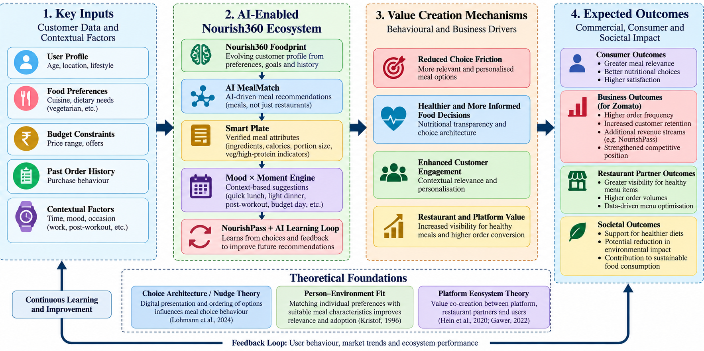

Source: Author-developed conceptual framework, informed by Hein et al. (2020), Gawer (2022), El Majjodi et al. (2022) and Lohmann et al. (2024).

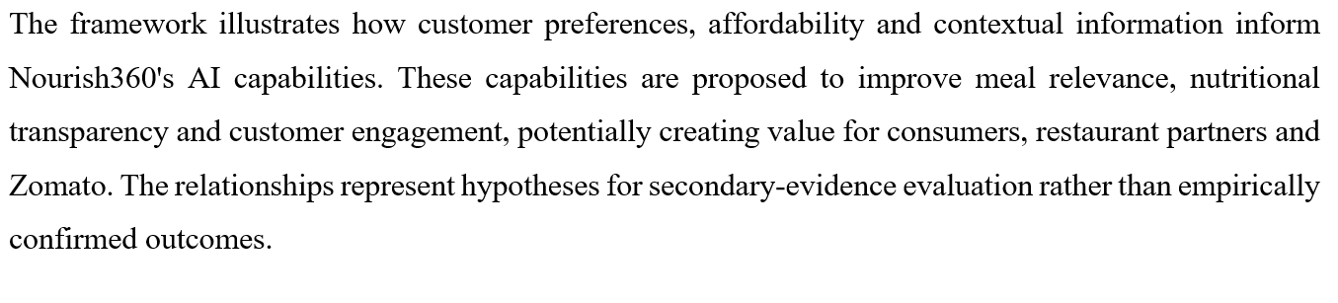

5. Research Methodology Including Ethical Considerations

5.1 Research Philosophy and Analytical Design
The study will be based on pragmatic research philosophy and will use the qualitative interpretation with quantitative assessment of the important business evidences. Pragmatism is the proper way to go because Nourish360's success is dependent on understanding consumer behavior and real business restrictions. The research will assess if the existing evidence is strong enough to support a commercially viable business approach, rather than empirically testing the performance of algorithms. The study adopts an exploratory secondary case-study design of Zomato’s capabilities in the urban food delivery ecosystem in India. The interactions between consumers and restaurants will be analyzed using the framework of Platform Ecosystem Theory, which recognizes that value creation cannot be assured solely by technical capabilities (Hein et al., 2020; Gawer, 2022).

5.2 Secondary Evidence Identification and Selection
Evidence will be obtained from published sources only, including journals indexed in Scopus, Google Scholar, Eternal business filings, government publications and recognized industry reports. Searches will include “AI food recommendation”, “healthy meal personalisation”, “Indian food delivery” and “platform commercial feasibility”. Preferably articles from 2016-2026, however foundational theoretical research can be included.
We want to pick 30-40 relevant documents to build a plausible proof base, not a statistically representative sample. Besides publication repute and commercial utility, methodological transparency and geographical relevance will be considered. It will be a claim of a systematic review. In line with Page et al (2021) transparent reporting of identification, screening and exclusion decisions will be given. Corporate evidence will be triangulated with independent publications to minimize promotional bias.

5.3 Thematic Analysis and Commercial Evaluation
The analysis will include thematic synthesis, comparative benchmarking and scenario-based financial assessment. The published data will be categorized under five pre-defined dimensions: customization effectiveness, nutritional transparency, affordability, ecosystem participation and implementation risk. If we find contradictory results, we will include them so that alternative hypotheses can be properly evaluated.
The comparative benchmarking will be against Zomato’s capabilities and publicly disclosed capabilities of other food-delivery systems. The commercial feasibility will be evaluated on the basis of contribution margin rationale, projections of client acceptability and implementation expenses.
Three illustrative adoption scenarios of 5%, 10% and 15% will be applied to an expressly defined eligible client group. The figures are mathematical assumptions, not a prediction of how many would embrace them.” A sensitivity study will be carried out to assess the effect of changes in conversion, repeat purchase and operating expenses on prospective profitability. This is in accordance with ecosystem research indicating that value generation is needed in addition to value capture (Hein et al., 2020).

5.4 Research Quality and Methodological Limitations
Enhanced research credibility will be achieved through triangulation of sources, stating inclusion criteria, and using consistent analysis methodologies. The published data will be quantitatively compared to estimates from researchers. The sensitivity of financial assumptions will be evaluated and scholarly conclusions that contradict them will be pointed out.
But the secondary data cannot establish the real-world acceptance of Nourish360, the correctness of its algorithms, or the direct consequences on customer behavior. Company disclosures may cherry pick positive outcomes and international studies may not be representative of Indian consumers. Therefore, the conclusions will be on conditional commercial feasibility and not proven market results (Page et al., 2021, Tandon et al., 2021).

5.5 Ethical Governance and Responsible AI
This study will not involve interviews, questionnaires, customer data, participant recruiting or identification. So the consent of the participants will not be sought. However, procedures for university ethics approval, intellectual property rights and suitable research techniques will still apply.
Published material will be appropriately referenced, stored and processed securely without access to private corporate databases. Any computer aided writing or analysis will be reported as appropriate and generated claims will be independently verified.
Nourish360’s conceptual assessment will investigate in depth issues around algorithmic discrimination, flawed nutritional classifications, and the potential for manipulation of customer decisions. Personalization does not always result in a better choice of nutritious foods (El Majjodi et al., 2022) which reinforces the necessity for transparency and user autonomy.
Thus, the final designs will focus on explainability, data minimization, nutritional verification and accountable platform governance rather than undue technical optimism.

6. Research Risks and Mitigation Strategies

6.1 Secondary Evidence Reliability and Analytical Uncertainty
The main methodological risk is the use of secondary evidence, which may be prone to reporting bias, conflicting market definitions and out-of-date commercial information. Corporate disclosures could overstate positive results, skewing the assessment of Nourish360’s viability. We use the transparent screen and source triangulation approach in Page et al. (2021) to avoid selection bias. A three-stage evidence assessment – high, moderate and low dependability – can differentiate independently confirmed facts from speculative business assumptions.

6.2 Algorithmic, Commercial and Ethical Exposure
Personalization also entails the risk of nutritional misinformation, algorithmic discrimination, and customer privacy. In a study of 600 participants, El Majjodi et al. (2022) discovered that personalized recommendations did not lead to healthier choices, contrary to the health benefits promised by Nourish360. In case of misalignment of restaurant information, platform incentives and consumer expectations, implementation risks are also produced inside the interconnected ecosystem [Hein et al., 2020]. We will take into account commercial uncertainties through hypothetical adoption scenarios of 5%, 10% and 15%, but we will not provide these assumptions as estimates.

6.3 Risk Mitigation and Research Feasibility
Mitigation will include source verification, sensitivity analysis and clear uncertainty recording. Nutritional benefit claims will need to be substantiated by respectable studies and privacy issues will be evaluated with the principles of data reduction. The probe requires no participant recruitment or personal customer records. This is because the research only uses secondary research. Conclusions will differentiate between the theoretical commercial potential and the experimentally proven results.

7. Research Timeline – Gantt Chart

Figure 2: Proposed Research Timeline – Gantt Chart for Zomato Nourish360

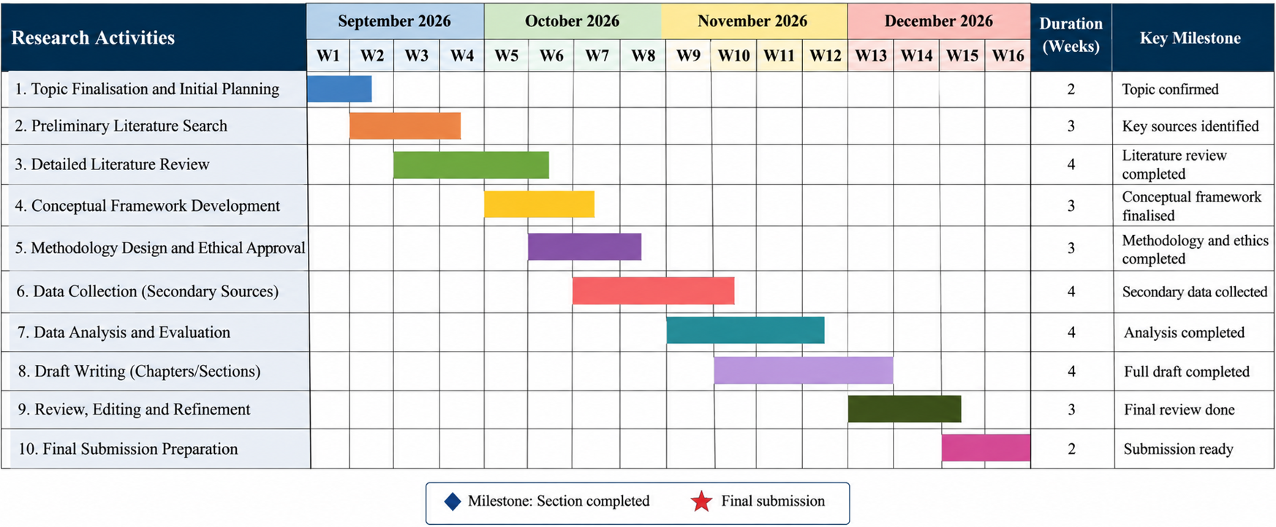

Source: Author's proposed research schedule (2026).

References
El Majjodi, A., Starke, A.D. and Trattner, C. (2022) ‘Nudging towards health? Examining the merits of nutrition labels and personalization in a recipe recommender system’, Proceedings of the 30th ACM Conference on User Modeling, Adaptation and Personalization, pp. 48–56. https://doi.org/10.1145/3503252.3531312
Eternal Limited (2026a) Zomato – Better food for more people. Available at: https://www.eternal.com/our-businesses/zomato/ (Accessed: 8 October 2026).
Eternal Limited (2026b) Q4FY26 shareholders’ letter and results. Available at: https://www.eternal.com/blog/q4fy26/ (Accessed: 8 October 2026).
Gawer, A. (2022) ‘Digital platforms and ecosystems: Remarks on the dominant organizational forms of the digital age’, Innovation: Organization & Management, 24(1), pp. 110–124. https://doi.org/10.1080/14479338.2021.1965888
Hein, A., Schreieck, M., Riasanow, T., Soto Setzke, D., Wiesche, M., Böhm, M. and Krcmar, H. (2020) ‘Digital platform ecosystems’, Electronic Markets, 30, pp. 87–98. https://doi.org/10.1007/s12525-019-00377-4
James, K.J. and Praveena, K. (2026) ‘AI-driven hyper-personalisation and consumer usage behaviour in food delivery applications’, Management Journal for Advanced Research, 6(3). https://doi.org/10.54741/MJAR/6.3.2026.319
Lohmann, P.M., Gsottbauer, E., Farrington, J., Human, S. and Reisch, L.A. (2024) ‘Choice architecture promotes sustainable choices in online food-delivery apps’, PNAS Nexus, 3(10), pgae422. https://doi.org/10.1093/pnasnexus/pgae422
Page, M.J., McKenzie, J.E., Bossuyt, P.M., Boutron, I., Hoffmann, T.C., Mulrow, C.D., Shamseer, L., Tetzlaff, J.M., Akl, E.A., Brennan, S.E. et al. (2021) ‘The PRISMA 2020 statement: An updated guideline for reporting systematic reviews’, BMJ, 372, n71. https://doi.org/10.1136/bmj.n71
Tandon, A., Kaur, P., Bhatt, Y., Mäntymäki, M. and Dhir, A. (2021) ‘Why do people purchase from food delivery apps? A consumer value perspective’, Journal of Retailing and Consumer Services, 63, 102667. https://doi.org/10.1016/j.jretconser.2021.102667

