BUSINESS MANAGEMENT

MARKETING FUNDAMENTALS
MIRCEA OCTAVIAN OLTEANU
2017632@student.uwtsd.ac.uk

Table of Contents

1. Introduction 3
2. Discussions 3
3. Conclusion 14
4. References 15

1. Introduction
Marketing forms a quintessential part of an organisation's endeavours in delivering products or services. As per the definition of the American Marketing Association, marketing is an activity perpetrated by the set of an institution that involves the processes of communicating, creating, delivering products or services to the end customers and exchanging offerings that ensures value for the partners, clients, customers, and society at large (ama, 2021). In this context, the present essay is tailored wherein the different processes in the marketing have been identified and discussed to explore how each of the facets of the marketing contributes towards the formulation of an effective and dynamic marketing process.

2. Discussions
The stages that encompass the marketing process of an organisation could be delineated as below.
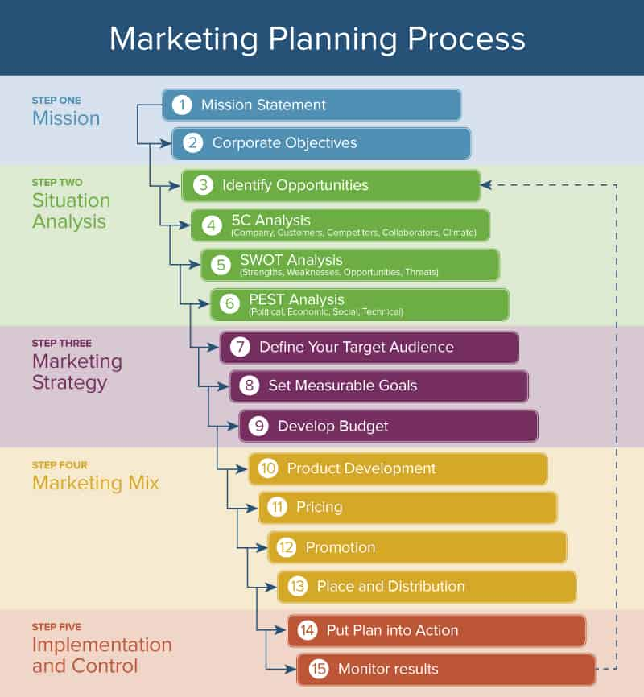
Figure 1: The different steps that are involved in the marketing process
(Source: smart sheet, 2021)
The marketing process starts with devising the marketing objectives that put forth the marketing goals which the organisation wants to achieve through its deliverance of the products or services to the prospective customers in the particular market. The marketing goals could be both non-financial goals like accentuating the brand loyalty and brand recognition or widening the customers reach and attracting their interests and financial goals that aim for procuring capital returns through reliable and convenient marketing strategies (Alabdulkader et al., 2017).
The next stage involves examining and evaluating the marketing environment that includes both the external and internal environment through market research. As per the observations of Jelassi and Martínez-López (2020), popularly termed as situational analysis or market audit refers to the marketing functioning wherein the marketer gathers information across the variegated aspects of the market to identify the threats and opportunities as well as the features and factors that characterises the market to inform marketing activities and strategies for an organisation. The examination and evaluation of the marketing environment are generally facilitated through the different marketing tools. For instance, PESTEL analysis enables the marketer in determining the macro-environmental factors that shape and influences the operational, functional, and strategic endeavours of the industry and thereby the companies operating in that industries either positively and negatively. The companies then accordingly formulate the marketing strategies that enable them to positively exploit the opportunities and be aware of the negative forces (Yüksel, 2012).
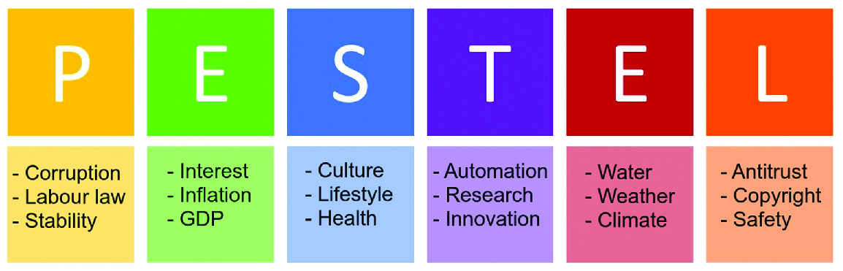
Figure 2: PESTEL framework and its respective components
(Source: Nurmi and Niemelä, 2018)
The acronym PESTEL stands for the Political, Economic, Social, Technological, Environmental, and Legal. For instance, after contextualising the PEST framework in the pharmaceutical industry of the UK to exhibit how it is done, the following findings have been derived:
- The Brexit has negatively impacted the pharmaceutical industry of the UK since 78% of research findings were facilitated by the European Union which got heavily disrupted after the Brexit transition along with loss of human labour and restrictions levied on the medical equipment (Kazzazi et al., 2017).
- The economic recession caused by the Covid-19 pandemic led to unprecedented challenges in the pharmaceutical industry of the UK by thwarting drug development, discouraging R&D investment, stoppage of the pharmaceutical supply chain, and restriction on biotech innovations (nridigital, 2021).
- The societal need for vaccines, drugs and medicines to fight the Covid-19 pandemic positively stimulated the pharmaceutical companies to upscale production and rolling diagnostic to retain the health of the global communities (abpi, 2021).
- Technological development like Artificial Intelligence-driven discovery of drugs empowered the pharmaceutical companies to digital transform functionally dynamics and reinforce and improve healthcare serviceability (Williamson, 2018).
All these findings empower the marketers to inform the other departments of the organisation about the pertinent contemporary trends and factors and thereby, collectively formulate the marketing strategies that optimise the marketing of the product or services in the best possible ways. This is further aided by another significant tool of situational analysis that is the SWOT analysis. The SWOT analysis refers to the process of recognising the strengths and weaknesses of the company as well the ascertaining the opportunities in the external environment that the company could utilise for greater growth and threats that the company might place during its operations (Gürel and Tat, 2017).
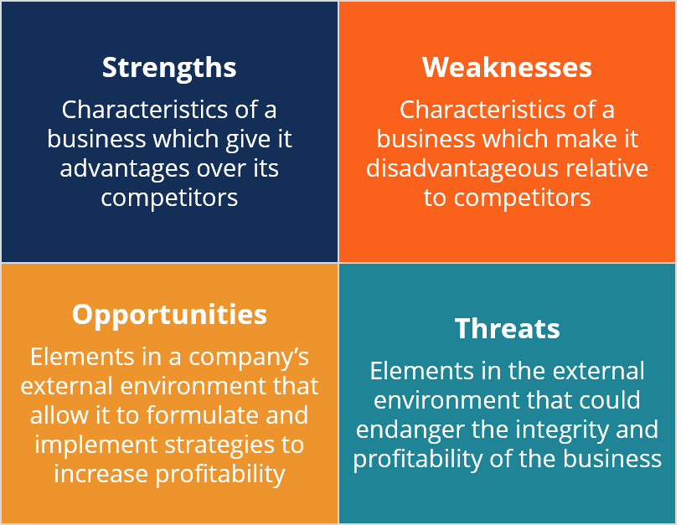
Figure 2: SWOT framework
(Source: corporatefinanceinstitute, 2021)
In addition to this, other significant frameworks are used for situational analysis like Porter’s Five Forces for determining the attractiveness of the industry in terms of profitability, and the 5Cs model that enables to analyse of the marketing environment in which the company operates and so on.
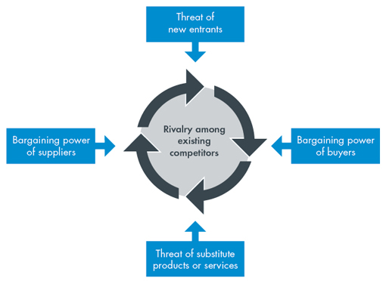
Figure 3: Porter’s Five Forces Framework
(Source: cgma, 2013)

Figure 4: 5Cs Framework
(Source: Created by the learner)
The next phase consists of formulating the budget and creating the STP for effectively marketing the product.
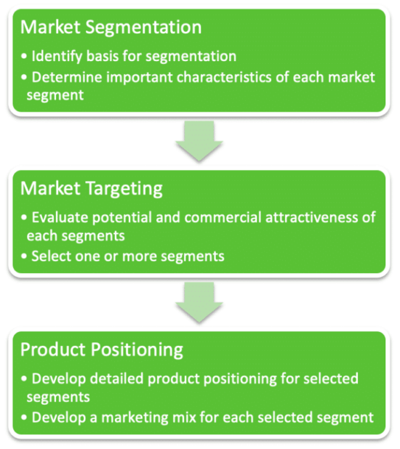
Figure 5: STP
(Source: Hanlon, 2021)
Segmentation, Targeting, and Positioning often abbreviated as the STP is the fundamental component of a marketing strategy that enables the company to ascertain which group of customers it wishes to serve. In the words of Dolnicar et al. (2018), Market segmentation refers to the categorisation of the homogenous groups that differently respond to the product or service offerings ensured by the company as well as to advertising, promotions, and other variables of the marketing mix. Therefore, segmentation that consists of consumers who shares a similar set of demands, needs, and interests could be divided into four variables. They are namely the Geographic, Demographic, Psychographic, and Behavioural segmentation.
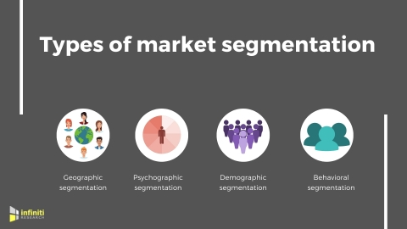
Figure 6: Types of market segmentation
(Source: BusinessWire, 2019)
Demographic segmentation includes:
- Age
- Gender
- Race
- Ethnicity
- Income
- Education
- Occupation
- Family life cycle
- Religion
The geographic segmentation includes
- Countries
- Region
- Rural, Suburban, Urban
- City Size
- Market density
- Neighborhoods
The psychographic segmentation includes
- Motives and Values
- Lifestyles
- Personality attributes
- Social Class
The behavioural segmentation includes
- Brand loyalty
- Volume Usage
- Decision roles like the influencer, initiator, buyer, decider, and user.
On the other hand, Targeting refers to the selection of the target groups on whom an organisation particularly counts on with its products and services after analysing the attractiveness of the market segment. Therefore, the target market constitutes the consumers that share the same characteristics. As per the observations of Camilleri (2018), the marketers decides the target market to which the company wants to serve and base this choosing of the target market on the parameters like the company resources, product life-cycle stages, product variability, and competitor’s marketing strategies. This implies that the selection of the target market calls for the marketer’s evaluation of the viability and profitability of the sub-segments of the entire market.
In addition to this, taking reference from the words of Akpoyomare et al. (2013), Positioning of the product or service in the market could be referred to the situation of the products with the right and most suitable attributes to impose and retain strong impressions and perceptions in the minds of the customers regarding the service or product offerings of the company. Furthermore, during the positioning of the products or services, the marketers take into consideration the strategies used by the competitors to devise the positioning strategy in such a way that empowers the organisation in gaining competitive precedence. This is because positioning involves the identification of the probable strategies that generate competitive advantage and gradually built the position of the organisation in its operating market.
The positioning of the brand is often depicted by using the perceptual map that provides a graphic overview regarding how the brand is differentiated, described, and branded in relation to its competitors. For instance, if a product is positioned in the market with high-quality and economic pricing then the positioning map would look like as illustrated below:
Figure 7: A positioning map of a company with the variables of high quality and low price
Competitor
Competitor
Competitors
Competitor
High Quality
Low Price

High Price
Low Quality

COMPANY
(Source: Created by the learner)
In order to show how the STP is integrated into a marketing strategy, an instance of a real organisation could be demonstrated. By considering the STP strategy of Kellogg’s, a renowned brand belonging to the food and beverage industry, it has been found that the geographic segmentation in the case of Kellogg's is done based on the countries as the brand operates globally. These include global regions of the USA, Canada, Asia, Latin America, Australia, and Europe (kelloggcompany, 2021). The demographic segmentation mainly is often based on age. Like some products are meant for the kids while some products offerings are meant for the adult segment (Kelloggs, 2021). Even the psychographic segmentation and demographic segmentation of gender are also evident in the product offerings of the company.
For instance, Kellogg's range of the Special K is offered with the benefits of low fats and fortified with essential vitamins, protein, and fibre for the women to help them to lead healthy lifestyles through proper weight management journey (Kelloggs, 2021). In addition to this, the target market of Kellogg’s mainly involves health-conscious consumers who would like to have a nutritious healthy breakfast along with healthy snacks and other food products. Moreover, the brand follows the competitive positioning strategy as it offers high-quality food products at affordable pricing (Rakshit, 2019).
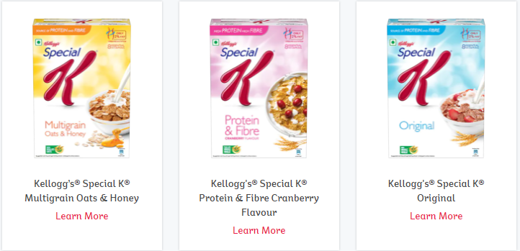
Figure 8: Kellogg’s product for adult women
(Source: Kelloggs, 2021)
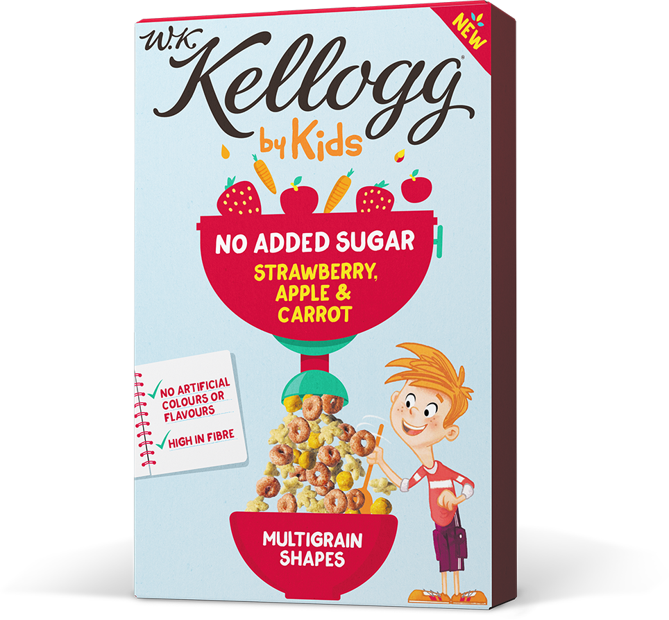
Figure 9: Kellogg’s product for children
(Source: Kelloggs, 2021)
The next stage requires the determination of the marketing mix elements. McCarthy's Marketing Mix elements would be as follows
Product | According to the statement of Grădinaru et al., (2016), the term 'product' can be defined as a collection of different attributes, which have the capability of exchanging or using for various purposes. The products can be observed as a mixture of tangible and intangible forms, either it would be a physical entity or service or a combination of both. For example, in the case of an automobile company, the primary product is their manufactured cars whereas, in the case of any hotel, the primary product is their offered facilities and services.
Price | Price can be defined as a formal ratio of the amount of the product and its monetary value to the company. It is the exact amount of money that should be paid by customers while acquiring a product or service. In order to market a product or service, companies often follow various pricing strategies, like an automobile company always focus on competitive pricing whereas a hotel can focus on either premium pricing or competitive pricing.
Place (or Distribution) | Grădinaru et al., (2016) mentioned that the distribution process includes several activities of marketing as well as carrying the products to the customers. It often helps in identifying or describing the extent of market coverage for any specific product or service. In the case of both automobile and hospitality firms, the distribution or place can be both online and offline.
Promotion | As per the definition of ANA or Association of National Advertisers, promotion can be defined as various tactics, used for encouraging short-term purchases., influencing trials of purchase, and so on. This is a major part applicable for increasing the company's market share and profit margin.
Table 1: 4P Marketing mix elements
(Source: Created by the learner)
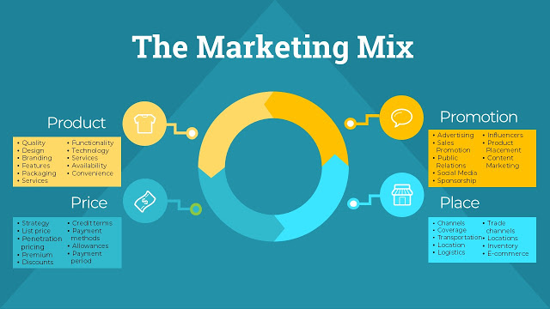
Figure 10: Marketing Mix 4P
(Source: Hopper, 2020)

3. Conclusion
After completion of the entire study, it can be concluded that every single aspect associated with marketing is significant and contributes to the development of a strong market position of any firm. The stages of marketing planning, the selection of target market, situation analysis, analysis of the current organisational position, and at last the development of marketing strategies all play a vital role for the organisations in the current competitive age. Hence, it can be assumed that firms who do not focus on their marketing tactics might face hurdles in case of their growth and development. Therefore, every firm should focus on the identification of the market needs, based on which they can develop strong marketing strategies for the future.

4. References
abpi.org.uk 2021. ABPI | What are pharmaceutical companies doing to tackle COVID-19? [Online] Available at: <https://www.abpi.org.uk/medicine-discovery/covid-19/what-are-pharmaceutical-companies-doing-to-tackle-the-disease/> [Accessed 2 July 2021].
Akpoyomare, O.B., Adeosun, L.P.K. and Ganiyu, R.A., 2013. Approaches for generating and evaluating product positioning strategy. International Journal of Business Administration, 4(1), pp.46-52.
Alabdulkader, A., Al Kahtani, S.H., Elhendy, A.M. and Al-Duwais, A.M., 2017. DO MARKETING OBJECTIVES AFFECT MARKETING EFFICIENCY? A CASE STUDY OF DATES MARKETING IN SAUDI ARABIA. Journal of Experimental Biology, 5, p.5.
ama.org 2021. What is Marketing? — The Definition of Marketing — AMA [Online] Available at: <https://www.ama.org/the-definition-of-marketing-what-is-marketing/> [Accessed 2 July 2021].
businesswire.com 2019. Choosing the Right Type of Market Segmentation to Suit Your Marketing Goals | Read Infiniti’s Latest Blog for More Insights, Businesswire.com. [Online] Available at: <https://www.businesswire.com/news/home/20191120005637/en/Choosing-the-Right-Type-of-Market-Segmentation-to-Suit-Your-Marketing-Goals-Read-Infiniti%E2%80%99s-Latest-Blog-for-More-Insights> [Accessed 2 July 2021].
Camilleri, M.A., 2018. Market segmentation, targeting and positioning. In Travel marketing, tourism economics and the airline product (pp. 69-83). Springer, Cham.
cgma.org 2013. Porter’s Five Forces of Competitive Position Analysis [Online] Available at: <https://www.cgma.org/resources/tools/essential-tools/porters-five-forces.html> [Online]
corporatefinanceinstitute.com 2021. SWOT Analysis - Learn How to Conduct a SWOT Analysis [Online] Available at: <https://corporatefinanceinstitute.com/resources/knowledge/strategy/swot-analysis/> [Accessed 2 July 2021].
Dolnicar, S., Grün, B. and Leisch, F., 2018. Market segmentation analysis: Understanding it, doing it, and making it useful (p. 324). Springer Nature.
Grădinaru, C., Toma, S.G. and Marinescu, P., 2016. Marketing mix in services. Ovidius” University Annals.
Gürel, E. and Tat, M., 2017. SWOT analysis: a theoretical review. Journal of International Social Research, 10(51).
Hanlon, M., 2021. STP marketing: The Segmentation, Targeting, Positioning model [Online] Available at: <https://www.smartinsights.com/digital-marketing-strategy/customer-segmentation-targeting/segmentation-targeting-and-positioning/> [Accessed 2 July 2021].
Hopper, D., 2020. [Online] Available at: <https://www.business2community.com/marketing/the-marketing-mix-is-it-still-relevant-today-02298017/> [Accessed 2 July 2021].
Jelassi, T. and Martínez-López, F.J., 2020. External Analysis: The Impact of the Internet on the Macro-environment and the Industry Structure of e-Business Companies. In Strategies for e-Business (pp. 49-95). Springer, Cham.
Kazzazi, F., Pollard, C., Tern, P., Ayuso-Garcia, A., Gillespie, J. and Thomsen, I., 2017. Evaluating the impact of Brexit on the pharmaceutical industry. Journal of pharmaceutical policy and practice, 10(1), pp.1-12.
kelloggcompany.com 2021. Kellogg Company News Room - Company Overview [Online] Available at: <https://newsroom.kelloggcompany.com/index.php?s=27521> [Accessed 2 July 2021].
kelloggs.co.uk 2021. [Online] Available at: <https://www.kelloggs.co.uk/en_GB/brands/wkk-by-kids.html> [Accessed 2 July 2021].
kelloggs.in 2021. [Online] Available at: <https://www.kelloggs.in/en_IN/who-we-are/news/new-special-k-multigrain-and-honey.html> [Accessed 2 July 2021].
kelloggs.in 2021. [Online] Available at: <https://www.kelloggs.in/en_IN/products.html> [Accessed 2 July 2021].
nridigital.com 2021. Covid-19: how will pharma cope with a looming recession? - Pharma Technology Focus | Issue 97 | August 2020 [Online] Available at: <https://pharma.nridigital.com/pharma_aug20/covid-19_pharma_recession> [Accessed 18 November 2020].
Nurmi, J. and Niemelä, M.S., 2018, November. PESTEL analysis of hacktivism campaign motivations. In Nordic Conference on Secure IT Systems (pp. 323-335). Springer, Cham.
Pourdehghan, A., 2015. The impact of marketing mix elements on brand loyalty: A case study of the mobile phone industry. Marketing and Branding Research, 2(1), pp.44-63.
Rakshit, A. 2019. New price points, smaller packs: How Kellogg plans to double India revenue, Business-standard.com. [Online] Available at: <https://www.business-standard.com/article/companies/new-price-points-smaller-packs-how-kellogg-plans-to-double-india-revenue-119072800383_1.html> [Accessed 2 July 2021].
smartsheet.com 2021. Here’s How the Marketing Process Works | Smartsheet [Online] Available at: <https://www.smartsheet.com/strategic-marketing-processes-and-planning> [Accessed 2 July 2021].
Williamson, J., 2018. ‘Digital’ drugs a key growth area for UK pharmaceutical sector - The Manufacturer [Online] Available at: <https://www.themanufacturer.com/articles/digital-drugs-key-growth-area-uk-pharmaceutical-sector/ > [Accessed 2 July 2021].
Yüksel, I., 2012. Developing a multi-criteria decision-making model for PESTEL analysis. International Journal of Business and Management, 7(24), p.52.

