

Module Code: International Meetings Management for the Hotel Industry
Module Code: BMIH6007

Assignment 1: Feasibility Plan for an International Meeting
Event Theme: Halloween in Winter
Student Name: Mashuda Begum
Student ID: 2119256
Lecturer Name: Kathryn Flynn

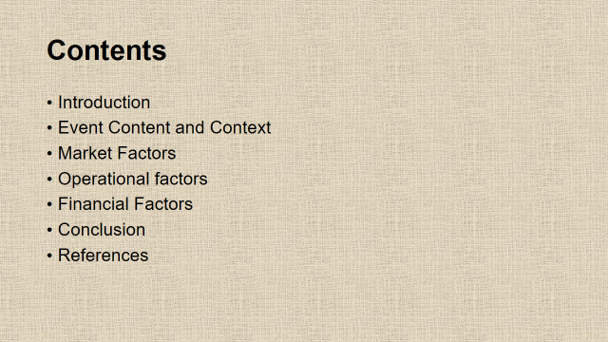
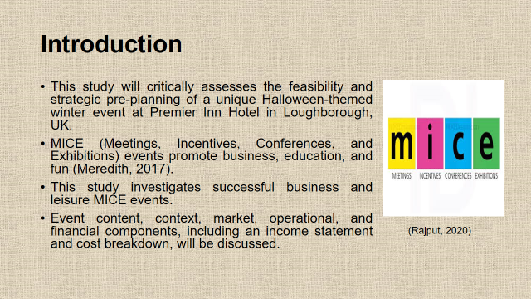
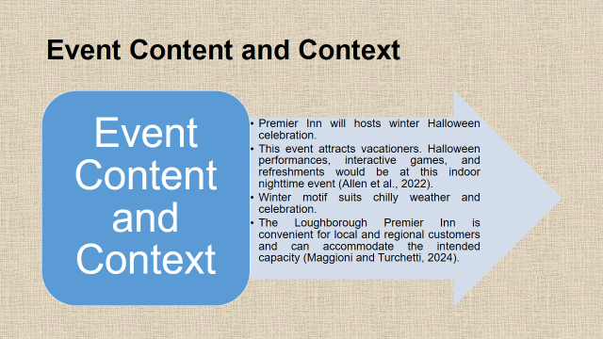
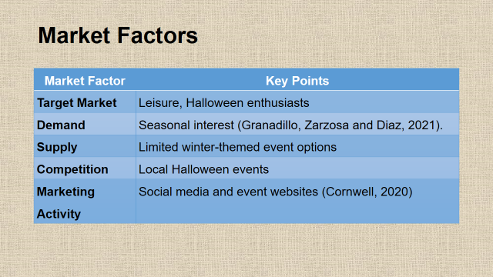
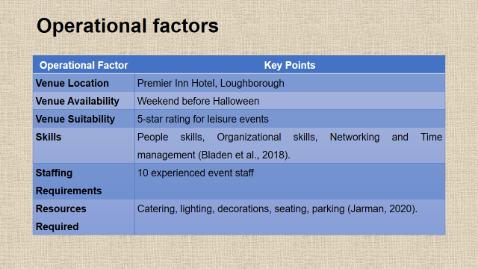
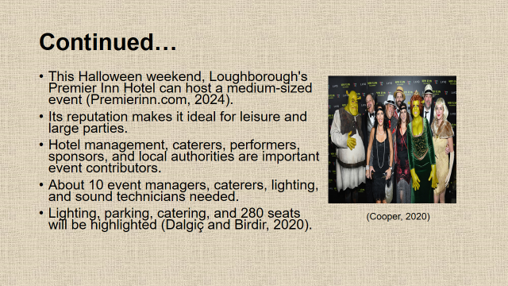
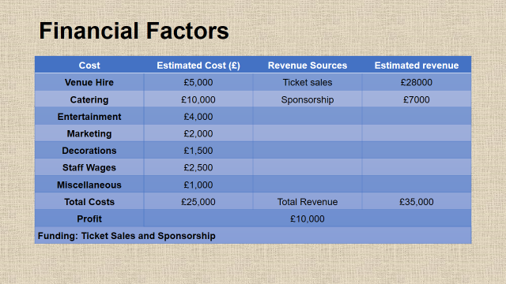
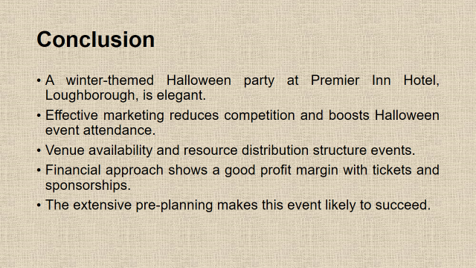

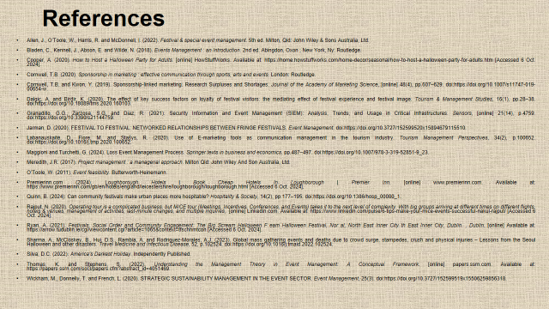

References:
- Allen, J., O’Toole, W., Harris, R. and McDonnell, I. (2022). Festival & special event management. 5th ed. Milton, Qld: John Wiley & Sons Australia, Ltd.
- Bladen, C., Kennell, J., Abson, E. and Wilde, N. (2018). Events Management : an Introduction. 2nd ed. Abingdon, Oxon ; New York, Ny: Routledge.
- Cooper, A. (2020). How to Host a Halloween Party for Adults. [online] HowStuffWorks. Available at: https://home.howstuffworks.com/home-decor/seasonal/how-to-host-a-halloween-party-for-adults.htm [Accessed 5 Oct. 2024].
- Cornwell, T.B. (2020). Sponsorship in marketing : effective communication through sports, arts and events. London: Routledge.
- Cornwell, T.B. and Kwon, Y. (2019). Sponsorship-linked marketing: Research Surpluses and Shortages. Journal of the Academy of Marketing Science, [online] 48(4), pp.607–629. doi:https://doi.org/10.1007/s11747-019-00654-w.
- Dalgiç, A. and Birdir, K. (2020). The effect of key success factors on loyalty of festival visitors: the mediating effect of festival experience and festival image. Tourism & Management Studies, 16(1), pp.28–38. doi:https://doi.org/10.18089/tms.2020.160103.
- Granadillo, G.G., Zarzosa, S.G. and Diaz, R. (2021). Security Information and Event Management (SIEM): Analysis, Trends, and Usage in Critical Infrastructures. Sensors, [online] 21(14), p.4759. doi:https://doi.org/10.3390/s21144759.
- Jarman, D. (2020). FESTIVAL TO FESTIVAL: NETWORKED RELATIONSHIPS BETWEEN FRINGE FESTIVALS. Event Management. doi:https://doi.org/10.3727/152599520x15894679115510.
- Labanauskaitė, D., Fiore, M. and Stašys, R. (2020). Use of E-marketing tools as communication management in the tourism industry. Tourism Management Perspectives, 34(2), p.100652. doi:https://doi.org/10.1016/j.tmp.2020.100652.
- Maggioni and Turchetti, G. (2024). Loss Event Management Process. Springer texts in business and economics, pp.487–497. doi:https://doi.org/10.1007/978-3-319-52851-9_23.
- Meredith, J.R. (2017). Project management : a managerial approach. Milton Qld: John Wiley And Son Australia, Ltd.
- O’Toole, W. (2011). Event feasibility. Butterworth-Heinemann.
- Premierinn.com (2024). Loughborough Hotels | Book Cheap Hotels In Loughborough | Premier Inn. [online] www.premierinn.com. Available at: https://www.premierinn.com/gb/en/hotels/england/leicestershire/loughborough/loughborough.html [Accessed 6 Oct. 2024].
- Quinn, B. (2024). Can community festivals make urban places more hospitable? Hospitality & Society, 14(2), pp.177–195. doi:https://doi.org/10.1386/hosp_00080_1.
- Rajput, N. (2020). Operating tour is a complicated business, but MICE tour (Meetings, Incentives, Conferences, and Events) takes it to the next level of complexity. With big groups arriving at different times on different flights, hotels & venues, management of activities, last-minute changes, and multiple inquiries,. [online] Linkedin.com. Available at: https://www.linkedin.com/pulse/6-tips-make-your-mice-events-successful-nakul-rajput/ [Accessed 6 Oct. 2024].
- Ryan, A. (2021). Festivals, Social Order and Community Engagement: The Big Scream Halloween F eam Halloween Festival, Nor al, North East Inner City th East Inner City, Dublin. , Dublin. [online] Available at: https://arrow.tudublin.ie/cgi/viewcontent.cgi?article=1065&context=tfschhmtcon [Accessed 6 Oct. 2024].
- Sharma, A., McCloskey, B., Hui, D.S., Rambia, A. and Rodriguez-Morales, A.J. (2023). Global mass gathering events and deaths due to crowd surge, stampedes, crush and physical injuries – Lessons from the Seoul Halloween and other disasters. Travel Medicine and Infectious Disease, 52, p.102524. doi:https://doi.org/10.1016/j.tmaid.2022.102524.
- Silva, D.C. (2022). America’s Darkest Holiday. Independently Published.
- Thomas, K. and Stephens, S. (2022). Understanding the Management Theory in Event Management: A Conceptual Framework. [online] papers.ssrn.com. Available at: https://papers.ssrn.com/sol3/papers.cfm?abstract_id=4051469.
- Wickham, M., Donnelly, T. and French, L. (2020). STRATEGIC SUSTAINABILITY MANAGEMENT IN THE EVENT SECTOR. Event Management, 25(3). doi:https://doi.org/10.3727/152599519x15506259856318

