
4/28/2021
Vanessa Emmanuella Liverpool (1917235)
lecturer: rexon nting
Managing Project in the Organisation
BMSW5104
Contents
Introduction 2
1.1 Company Background and Project Specification 2
2. The Importance and Practicality of Project Management 3
3. Key project Management tools and Techniques 3
3.1 Project Approach and Prince2 4
Agile 4
Waterfall 4
4. Stages of the Project 5
Initiation 5
Planning 6
4.1 Pestle Analysis 7
4.1 Work Breakdown Structure (WBS) 8
3. Project Scheduling Technique 11
3.1 Gantt Chart and Critical Path Method 11
4. Cost and Estimate Budget Plan 12
4.1 Payback Analysis 14
4.2 SWOT Analysis 15
5 Risk and Management Plan 15
5.1 Stakeholders Analysis 16
5.2 Communication Plan 17
6. Conclusion 17
REFERENCES 18

Introduction
According to the little book of the Project Management, Project Management (PM) is the application of knowledge, skills and techniques to execute projects effectively, it is a strategic competency for the organisations, enabling them to tie project results to business goals – and thus, better compete in their markets ( (ninefeetall, 2021).
This report will be analysing a wedding planning project. I was propelled to initiate this project as I was assigned these types of ventures before, a family member got married on the same day as Meghan and Harry from the Royal family, and so we also felt like royals as a family, the wedding was beautiful, spectacular, and I helped to plan it. I found it quite an interesting subject to discuss, moreover, it is always so fulfilling once the project is somewhat completed and the bridal party are delighted with such a service of excellence.

Company Background and Project Specification
Company background relates to a business plan, it depicts the originated ideas of its value and the idea of the plan in itself, this then, enables you to craft the idea into existence, with an accurate scope and conclusively frame it to possible employment (Andrew W. Gottschalk,1969).
Firstly, this project was introduced by the bride and groom, who are the main beneficiaries including the project manager. Originally, this wedding was planned for August 31st2020, for five hundred guests. Furthermore, due to Covid-19, the wedding has been postponed for August 31st2021 and will end on the same date, which is still subjected to change, as there are a numerous amount of uncertainty and rules which needs to be adhered too, such as, the amounts of guests had been dramatically reduced, as well as they may have to wear a face covering during the ceremony and the reception if any. As revealed by the Prime Minister, it is a likelihood, that by this summer holidays, things may well go back to a level of normality. With that being said, it may well be that guest may need to get vaccinated prior to any events going ahead. Equally these are all speculations, that the project manager would need to take into account in outlining the plans for this project. Notably, if this wedding does not go ahead while the planning is still being undertaken, the bridal party would be devastated, and the project manager will suffer significant loss in its business. Hence why the beneficiaries, have to work very closely, by following the government guidelines and protocols.
Meanwhile, this wedding, should it go ahead, will be taking place in Kent. In this project, the project manager, who will be in charge of planning, scheduling and controlling. I will elaborate on the process of the planning and its team, by using key management tools and techniques in conjunction with models and theories. In this report, I aim to give a comprehensive introduction of the development of the event.
I will scope out the personification of the project manager and whichever techniques and tools I have found fit to elaborate and ensure that the event is a success. As a result, devising a framework stipulating the large-scale of responsibility in the venture and the persons who will implement those. In addition, I will elaborate on the costs and benefits of the projects with any relevant financial requirement by creating a Gantt chart to support my scheduling techniques, which will enhance the precise time and dates of the planning. Consequently, assimilate, what risks are associated with the venture and how will they be identified and monitored or even prevented by creating a risk assessment plan. Subsequently, I will explain how the project will interact with all the applicable stakeholders and what they communication exigencies are and how the project director will bid to collaborate with them, by having a communication plan in place to ensure that each department has the right instruction and knowledge.
Ultimately, I will endeavour to create a SWOT analysis to determine the strength and weakness, within the project and its development. A self-assessment plan will be established and expound the applicable precept to forecast the IRR, critical chain, Pert and payback for this request of project.

2. The Importance and Practicality of Project Management
The importance and practicality of project management can be defined as the appropriate expectations which are set in any which way, that can be conveyed by a time frame and for the substantial amount. In other words, without the appropriate project management, the estimated expenses calculations and consignment agenda can appear to be enthusiastic, and or inadequate or incomplete (Gottschalk, 1969).
Firstly, the couple are now engaged and needed to start deciding on the scope of their wedding, and the most valuable aspects which are suitable to them. With that being said, once the clear look is envisioned and the details had begun to be laid out, the original cost of the project is twenty-thousand pounds. Equally, the bride and groom are significantly putting their greatest ideas together for a continuance collaboration. Similarly, choosing their venue deciding on caterers and many other stakeholders, schedule management, is a great asset obtain when planning such event as these techniques will support the monitoring and controlling of the event ensuing that everyone is informed with the correct dates and details and the expectations of the bridal party. The task ahead needs to be scheduled, while breaking work down into set deadlines.

3. Key project Management tools and Techniques
Similarly, to deliver my project more accurately and effectively by explaining the key stages needed to be accomplished, this is known as the Project Lifecycle (). The lifecycle focuses on the Scope or the project initiation, which depicts the idea into reality. if this stage is not performed in the right way, then it will be almost impossible to fulfil the project needs. In addition, it is vital to plan, launch, monitor then close the project. Subsequently, it is vital to introduce efficient project management tools and techniques while understanding their importance such as Agile, Prince2 and Waterfall.

3.1 Project Approach and Prince2
The project management methodologies are different, pertaining on how the project is managed or approached, in other words, some of these are much more suitable to other industries.
The focus in this report will be on the Prince2 method as it fits with the planning objectives. According to, Managing Successful Projects with PRINCE2 a project management method, used by organisations from wide range industry and sectors. This method, Stands for projects in controlled background. Similarly, there are a pros and cons to using Prince2 such as:
- For instance, the method promotes excessive levels of communication between all team members and stakeholders, equally gives all parties full control in the project.
- On the contrary, it is a very complex methodology and cannot be approved without appropriate training. For this day and age, it does not propose the level of flexibility given by Agile.

Agile
This PM is formulated on a flexible approach, it promotes brief expansion and combined challenging stages. Instead of the single expansion stages associated with the Waterfall approach. Similarly, there are also pros and cons to using Agile such as:
- Its enabling way of allowing companies to experiment and learn from their experiences until a definite solution is found. As well as there are regular opportunities to report on the progression of the project.
- On the opposite, it can be an issue to write a project on the get go, because of its final outcome is not fully known or understood. However, the frequent testing needed is labour intensive and it can be hard to manage if the ones using it are not fully engaged.

Waterfall
Additionally, this method consists of stages progression of activities with a vast amount of room for feedback. This approach fits in well with smaller projects where the requirements are understood. Just as the others, there are also pros and cons such as:
- Waterfall projects are the easiest to manage due to the firmness of the model, each stage has a specific deliverable and a review process, these stages are developed overall.
- On the other hand, its project prerequisite is recognised prior to the initiation of the project. However, this can lead to requirement creep as the stakeholders my demand additional information further down the line.
Built upon seven principles, themes and processes, PRINCE2 can be tailored to meet a specific requirement (PRINCE2, 2017). As a result, Prince2 projects should always explore previous events and learn from them. In addition, the venture should have a clear organisational structure and implicate the right personnel in the appropriate department. Furthermore, the project will be planned, supervised, and contained intermittently. The project aim is to focus on the tasks required while delivering effectively. Above all, Prince 2 must be made to measure to accommodate the projects size, importance, capability and environment. As a result, Prince 2 depicts the aspects of project management which consigns and correlates far and wide in the project. These elements help to keep a transcript of the project justification. Also, it helps to enhance the personnel roles individually and their responsibilities, while enhancing the quality and measuring requirements.
The key strengths of Prince2, these can be worn, in many ventures non-observant of the domain, production, capacity, complexity and risk. Therefore, has the ability to be suitable regardless of the requirement. Such as management stages, business justification. Similarly, Agile is a type of software development, which promotes a group of other software development methodologies, based upon interactive development. In contrast, Scrum is a subset of Agile, it processes framework for Agile development, by specific concepts and practices, separated into three groups, such as roles, artefacts, and times boxes. I have decided not to use either of these methods in my report as it does not give me enough flexibility with my planning. some of these are subjected to IT or even construction related projects.

4. Stages of the Project
Equally as defined earlier, PM is the application of knowledge, skills, tools, and techniques to project activities to meet the project requirement. Therefore, there are some reoccurring elements which it processes such as Initiating, planning, executing, monitoring and controlling and last but not least closing the project.

Initiation
Firstly, this the start of the wedding project where the bride and groom got engage and got in contact with the project management, where they elaborate on the project of a deeper level. In this stage, it is vital that all the important stakeholders discuss rather the project is feasible or not. Moreover, rather it should be undertaken. Upon agreement a project initiation document which outlines requirements of the project, as well as very important data.

Planning
According to balanced Scorecard Institute, a strategic plan is a document used to communicate with the organisation the organisation goals. The actions needed to achieve those goals and all the other critical elements developed during the planning exercise (Balanced Scorecard Institute, 2020).
This stage is vital into the success of the project, and it focuses on the actual map in which all stakeholders will follow. This stage commences with setting goals such as S.M.A.R.T
Figure 1 (by Vanessa Liverpool)
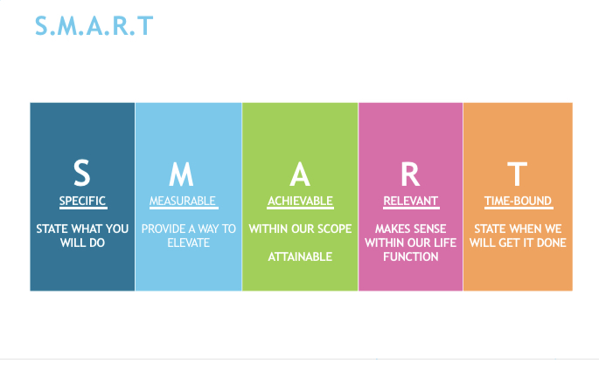
This method SMART, ensure that goals have been examined and provides a clear explanation in the way in which the goals of the wedding will be processed as it depicts in figure 1.
Therefore, once this stage is attainted, then the project is now a plan that is developed, by doing so cost, quality, resources and a realistic time frame would have been developed. Firstly, tailored for the wedding planning, this report will demonstrate planning the project by applying Prince2 by starting this project on the very first day it was communicated with the main stakeholders and the project manager. Once the engagement, the project manager working alongside the main beneficiaries, established a timeline and a budget as mentioned earlier. Which will be directed then, followed up in order to initiate the project by delegating to the appropriate personnel. Although the key stakeholders have had a face-to-face meeting with the project manager, however, due to Covid-19, there are a few adjustments which needs to be implemented, hence, to communicate the project plans effectively meetings will be held via zoom as we are still under restrictions and must follow the measures put in place by the Government. However, this platform can potentially create risks for the project. Equally, The Bride and Groom have given the project manager all vital information and their expectations of the project.
In addition, once the budget and timeline were concluded, the project manager begun to assign cost to each department, which are really a rough estimate, however the total of everything was added to the final wedding spending goal. Admittedly, a spreadsheet was created to make things easier for everyone. Eventually, the project manager made arrangements with vendors he regularly worked with and recommended to the main stakeholders. The project Manager will secure a meeting with all the vendors/stakeholders such as the photographer, video cast and much more via the same platform in order to discuss and to agree to the planning further. The bride and groom had already selected a few venues from the brochure provided prior to Covid-19, and the project manager will be in touch with the venues to ensure that the wedding can go ahead depending on the guest list, and budget. However, the budget which is twenty thousand pounds will be reduced by half at ten thousand pounds – which may be reduced further depending on the situation with capacity and guest numbers.
With that being said, the project manager, has placed adverts on indeed websites, for the positions in the chart figure 2. In addition, a few selections have already been made and the project manager have hired a wedding coordinator where they will communicate all of which the clients need on the day. As a result, they have already, concluded a few areas of the planning such as food tasting, where the customers explored a range of multi-cultured delicacies prior to Covid-19.

4.1 Pestle Analysis
This tool represents that the team is in the right direction in order to succeed. The PM focuses Pestel as an approach to assess the external circumstances. of the project, by categorising the opportunities and risks into socio- cultural, economic, political, and other legal factors. This analysis helps to identify the pros and cons of the project (CIPD,2020).
PESTEL Analysis figure 2 (by Vanessa Liverpool)
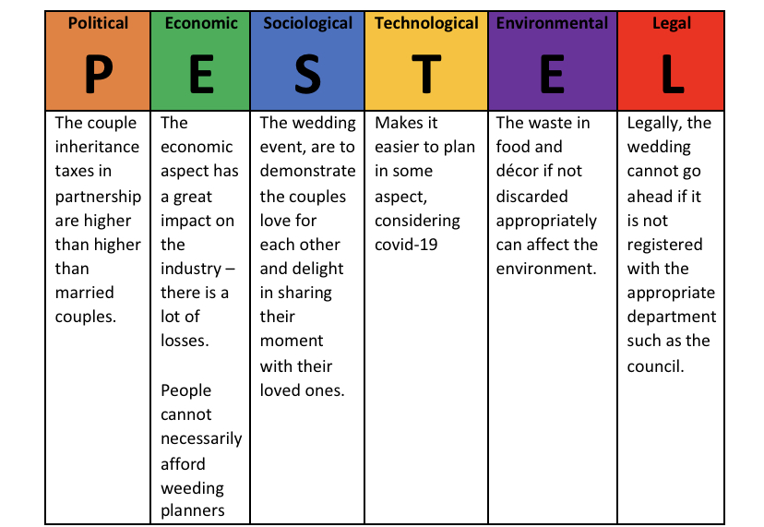
Equally, the fact that project managers reputation is being expensive, with covid not helping the situation, it is vital the PM reduce their prices in order to keep in business. As clients would maintain their budgets. Furthermore, the project manager must take in consideration of the competitive market.

4.1 Work Breakdown Structure (WBS)
This structure the (WBS) is known to be a hierarchical description of all work that must be done to fulfil the project in itself (Duke, 2021). Consequently, a breakdown structure (WBS) helps the project manager to foresee, the scope of the wedding devising using a diagram structure. The elite rank of the same contains consist of the development in every aspect of the wedding planning project. Significantly, if for any reason the elements are not part of the structure, then they will not be taken into consideration, and will be treated as an exclusion to the wedding.
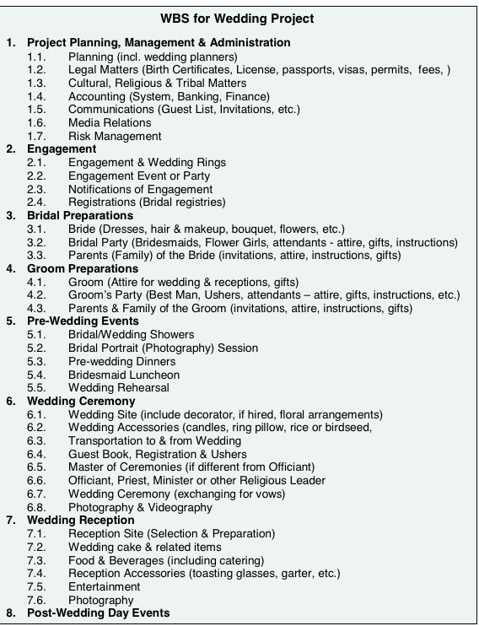
Figure 3: Wedding work Breakdown structure (by Vanessa Liverpool)
The work breakdown structure, has four valuable sections, such as:
- The project – In this case this is the wedding planning project aiming to deliver the most memorable day for the bride and groom, in accordance with their request.
- Major tasks – event coordinator, event planner, event manager, event assistant. All of these stakeholders have a specific task to follow and complete within a specific scope. Such as, HR (Hiring process), marketing (save the date, invites), operations (project is going according to plan), and the product (ceremony and reception, in some cases honeymoon)
- Subtasks it – Employees, sending out invites, sitting plan guest books and thank you, name tags, menus. All activities relating to the wedding such as tables gifts, coordination, communication. The suppliers – caterers, budget, videographer, photographer, venue.
- Activities to – Briefing, ensuring a rehearsal of activities.
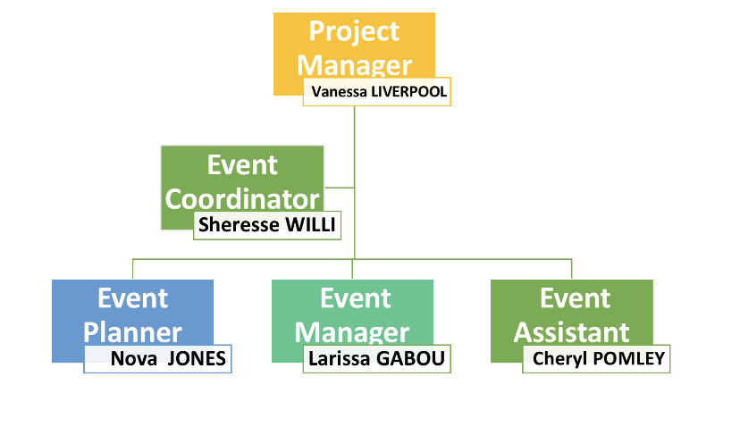
Figure 4 Organisation Structure (by Vanessa Liverpool)
As illustrated on the chart above, the wedding planning project is to be entrenched by the project manager which is the CEO. The role of the project manager is to be actively involved in the formation of the project, funding and allocation. The project Manager will delegate to the event coordinator which will follow suits and also delegate to the appropriate departments. The PM Job is in the construction and evolution of the project and its scope. The event coordinator task is to coordinate with the committee while maintaining clear channels of communication between the project manager (myself) and other team members. The event coordinator is also engaged in conversation relating to the budget, timetable, and overall timeline. In addition, the event planner, would need to develop criteria to understand the needs of others personnel task. With that being said, it is vital that the event planner re-creates her own planning in order to assimilate rather, more team members are needed on board the project. The event manager will be one in charge on the day of the event, because he will be briefed by the event planner, therefore he will be in charge of how the event will be developed on the day, whilst ensuring that everything is being delivered on the right timing, regardless of the delays of the bride and groom if any. The assistant will assist, the event manager, by ensuring that the guest is adhering to Covid-19 restrictions, by sanitising and washing of hands, social distancing, wearing a face covering even at the wedding reception. As a result, it is the planning project team to ensure that not only the wedding goes as well as possible, but that the guest and personnel are safe. The event assistant has an excellent customer service, she is very friendly and that is good for a hospitality project.

3. Project Scheduling Technique
According to the article, How Important Is Project Monitoring and How Do We Implement It Through Al? project monitoring reflects on the process of keeping track of all project-related metrics including team performance and tasks duration, by identifying potential problems and taking corrective actions necessary to ensure that the project is within scope, on budget and meets the specified deadlines (Wrike, Inc, 2021). A project Schedule has to be within a specific time frame, however, given the uncertainties around covid-19 the project scope has a high possibility of changing, as a result, this would be difficult to create and maintain a schedule that will last. Subsequently, using the right techniques these activities can be adjusted just in case the scope changes (Berkun, 2008).

3.1 Gantt Chart and Critical Path Method
Gantt Chart is defined as a bar chart which provides a visual view of tasks scheduled over a period of time. It is used to plan projects of all sizes, and it is a good way of demonstrating what task is scheduled to be completed on a specific day, as a result, it helps to have a visual notification on the start and finish date of the project (ProjectManager.com, Inc, 2021).
Consequently, the Gantt Chart will be the focus on scheduling in this report, it will help the project manager to analyse the wedding tasks and estimate the amount of time needed to fulfil each task in the project. Additionally, using this data, can help the project manager to develop a budget for the project with the minimum time as possible, during this process the project manager has the ability to track and review the planning project at any given time or stages of the project. The aim of scheduling in this report is to ensure that all activities are planned for the wedding on 31st of August 2021. However, considering the Global pandemic, these will be under constant review. Meanwhile, the critical path method is the longest sequence of tasks that must be completed to successfully conclude a project form start to finish (ProjectManager.com, Inc, 2021). With that being said, there are a few possible risks identified such as the florist and the and the music provider. Furthermore, the event planner who is in charge of these vendors may have to provide another florist due to details given by the Prime Minister instructing people not to leave their environment due to covid-19, having said that, this could cost the project manager extra which she did not anticipate. In addition, the music selection was not reviewed effectively due to the line of communication using the zoom platform, which I aim to elaborate upon in the risk management plan.
Wedding project (figure 5)
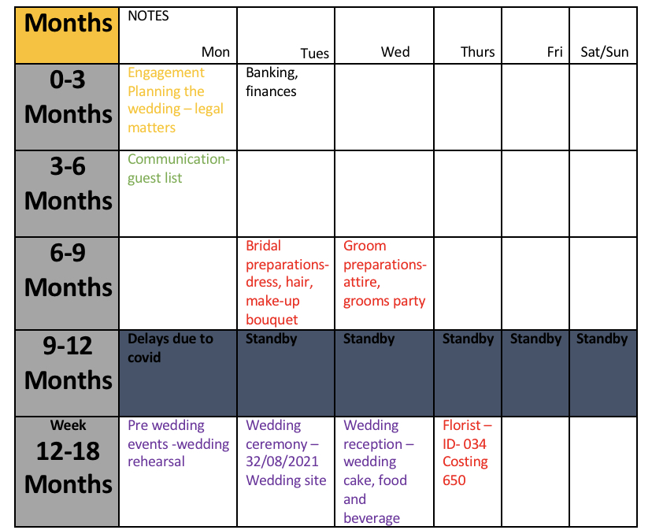
Start:31/05/2020 End 31/08/2021 (by Vanessa Liverpool)

4. Cost and Estimate Budget Plan
Cost and estimation in PM are the process of forecasting the financial ad other resources needed to complete a project within a define scope (Wrike, Inc, 2021).
Based upon the seasonal factor of the project and there is no specific for this event as it all relies upon the main stakeholders. However, this project is an impartial project, and there will be no minimal investment cost. The table in figure 6 depicts the investments made by the PM.
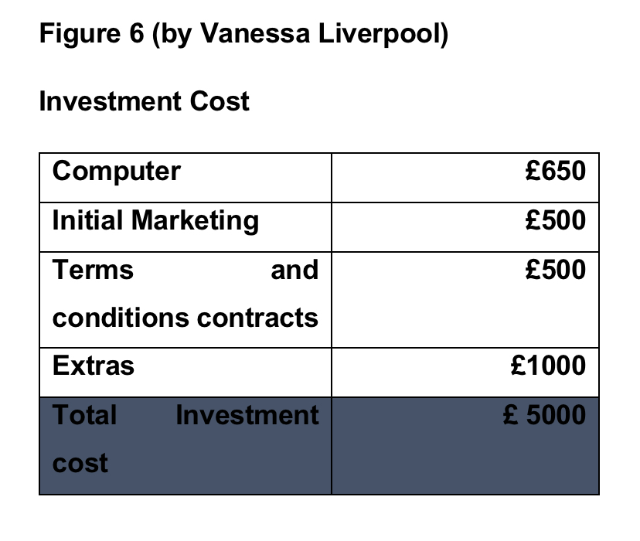
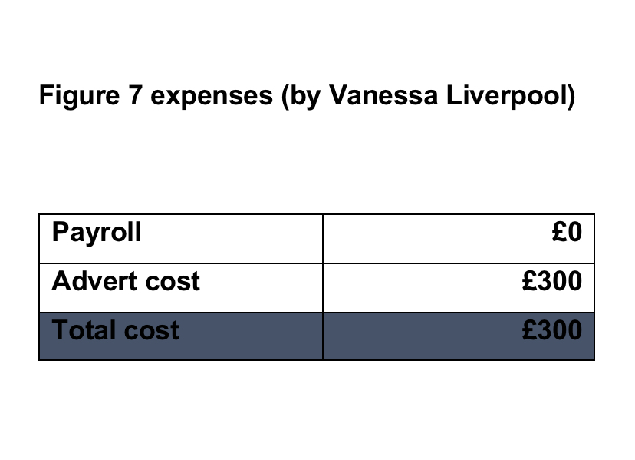
Alternatively, figure 7 depicts the expenses of the PM for the remainder of the year thereafter the investment cost occurred. While there is not a payroll system as it is as in and when a function or project turns up, however the PM will take what is left for herself once all staff are paid.

4.1 Payback Analysis
Payback period refers to the amount of time it takes to recover the cost of an investment or how long it takes for an investor to hit break even (Investopedia, 2021). With that being said it all pertains on how long it takes for the stakeholder to appoint the PM for their weeding planning, relating to the quantity of invitee and if the client is prepared to hire the PM partially or for the entire project. Figure 8 depicts the services the plans going ahead for the wedding and cost, which will depend upon the vendors.
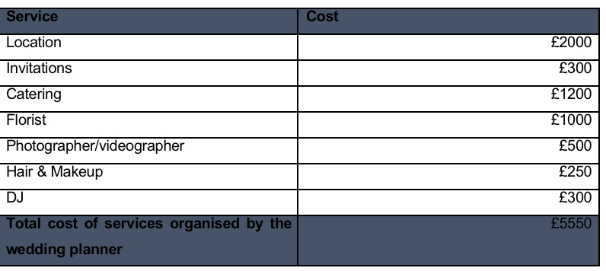
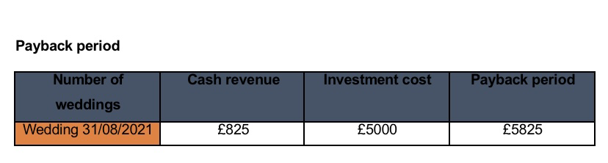
This payback period amount is strictly due three days after the wedding by the parents of the bride and groom.

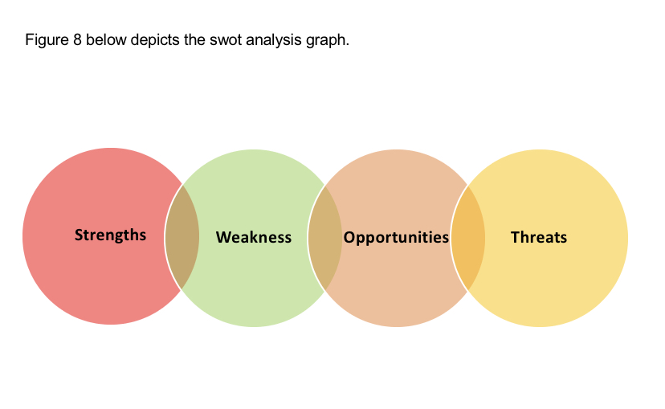
4.2 SWOT Analysis
The purpose of SWOT Analysis is to examine the internal of an institution and is useful for business strategies. The SWOT (Strengths, Weakness, Opportunity, Threats) (Lim,2021).
S - The project Manager will separate itself in comparison with other wedding planners and stands out. It has high quality staff members and is very knowledgeable with planning.
W – The company is fairly new on the market and for this type of business referral and experience is vital.
O – Thanks to covid-19 and its states of the lockdown, weddings are becoming very popular, and clients are willing to try new companies as quite a few other went into liquidation.
T – The competition out here is huge due to app and online wedding planner who have an awareness on how to use certain platforms.

5 Risk and Management Plan
As discussed in the Gantt chart, here as the PM I will develop a plan to avoid any kind of delays and costs. There are two factors that I am worried about, the florist and the DJ. There Is a high potential that one, the flowers that we chose might not be the bride choice due to the season of the year, two there might also be issues relating to delivery. As a result, I have made a plan B to communicate with another florist which guaranties delivery and the accurate products requested by the bride and groom. Although, this option can potentially keep me out of pocket, I have made arrangement with the future florist to continue working with her in the near future. In addition, the music is having issues finding the playlist mixed by the groom and also has had an accident with speaker from his last event, this can be repaired, however, I have contacted another local DJ who his willing to help at an extra cost.

5.1 Stakeholders Analysis
According to the article Stakeholder Analysis guidelines, stakeholders, analysis is the process of systematically gathering and analysing qualitative information to determine whose interests should be taken into account when developing and /or implementing a policy or program (Shmeer,2021). With that being said, the PM must identify all stakeholders in order to communicate with the appropriate persons effectively. Equally, the stakeholders in this wedding project are plentiful. Evidently, the bride and groom are the prevalent stakeholders. Nonetheless, the keys stakeholders are the parents, family members and the bridal party. Similarly, the guest, the vendors, such as the florist, venue, cake, decorators and the presiding officer. The other stakeholders are the project team members, while they actively take part in the in the project process, admittedly, they will also execute all the ventures activities effectively. Figure 9 shows the graph of the stakeholders.
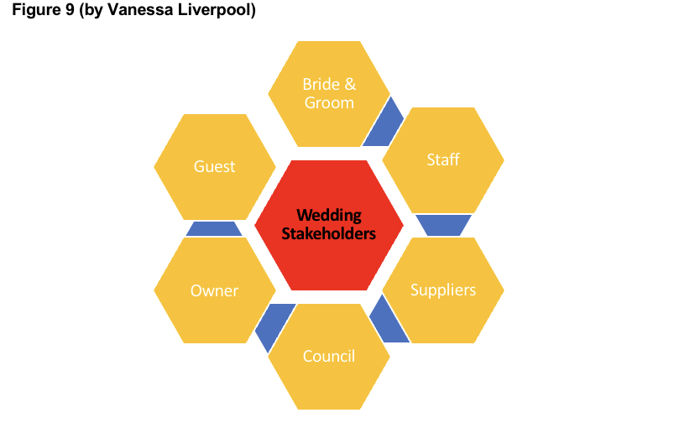

5.2 Communication Plan
The communication plan is designed by the PM of the wedding due on the 31/08/2020, which has been postponed due to the pandemic, which has caused tremendous delays in to face to face communication and the visualisation of the planning and making it as tangible as possible. However, using technology, the plans has been going ahead as it was a vital and only options in delivering the planning process. As a result, there had to be an effective way of doing so, therefore, a line of communication was calculated.
- Number of communication channels = n(n-1)
2
This depicts where n is applicable calculating the number of people implicated.
The overall number of subdivisions fragment of the development is five, as a result, 5 (5-1) / 2 = 10 applicable communication lines (Fichtner2006).

6. Conclusion
Finally, this report has critically identified the appropriate project management tools and techniques within the wedding project. It has acknowledged, the process of growth of the business and its strength and weaknesses. In addition, it has allowed the developer to minimize and identify risks while increasing the potential for success for the wedding planning and for future event.

REFERENCES

Ninefeettall, (2021). The little book of Project Management Accessed [28.04.2021]
Taylor, S. (2018). Prince 2 Certification Foundation and Practitioner Guidebook independent publisher 2018. [Accessed 28.04.2021]
Fechner, C. (2006). Project Management Professional. [Online] Available at : https://www.project-management.com/how-important-is-project-monitoring-and-how-do-we-implement-it-though-ai/ [Accessed 28.04.2021]
Lim, R. (2021). [Online] Available at : https://project-management.com/swot-analysis/ [Accessed 28.04.2021]
Investopedia, (2021). Payback Period. [Online] Available at : https://www.investopedia.com/terms/p/paybackperiod.asp [Accessed 27.04.2021]
ProjectManager.com, Inc. (2021) ProjectManager.com, Inc. [Online] Available at : https://www.projectmanager.com/critical-path-method
ProjectManager.com,Inc. (2021) ProjectManager.com, Inc.[Online] Available at : https://www.projectmanager.com/gantt-chart-method [Accessed 28.04.2021]
Wrike,Inc. (2021). Project management scheduling [Online] Available at : https://www.wrike.com/project-managment-guide/faq/what-is-scheduling-in-project-management/ [Accessed 28-04.2021]
Wrike, Inc. (2021). What is Cost Estimation in Project Management? [Online] Available at : https://www.wrike.com/project-management-guide/faq/what-is-cost-estimation-in-project-management/ [Accesess 28.04.2021]
Duke, (2021). What is work Breakdown Structure? [Online] Available at: https://www.workbreakdownstructure.com [Accessed 27.04.2021]
CIPD, (2021). PESTLE analysis [Online] Available at: https://www.cipd.co.uk/knowledge/strategy/organisational-development/pestle-analysis-factsheet#gref
Balancedscorecard, Org. (2021). Strategic Planning Basics [Online] Available at : https://balancedscorecard.org/strategic-planing-basic/

