Resonance
  - For electrical and Electronic principles
James T | 2322728 | Embedded Electronics | 28/04/2024

Contents
- Abstract – P2
- Introduction – P2-3
- Experimental Setup
  - Simulation Setup – P3-5
  - Practical Setup – P5-7
- Results – P8
- Discussion – P8-15
  - Capacitors – P9-10
  - Inductors – P10
  - Resistors – P10-11
  - Effects of Parasitics – P11-15
    - LTspice – P11-14
    - Proteus – P14-15
- Q factor
  - Simulated Q factor – P16
  - Practical Q factor – P16-17
- Conclusion – P17
- Bibliography -P19-20

Abstract
This report investigates the behaviour of a bandpass filter circuit, comparing simulations with practical implementations. The circuit, based on an LC configuration, is analyzed for resonance phenomena and frequency responses. The resonance frequency is calculated, and impedance properties at resonance are explored. Simulations conducted in proteus are compared with real-world experiments on a breadboard setup. Discrepancies between simulated and practical results are attributed to the presence of parasitic elements such as equivalent series resistance (ESR) in capacitors and inductors. The effects of these parasitic elements on circuit performance and quality factor are discussed, emphasising damping and resonance characteristics. LTspice simulations are employed as proof of concept of these discrepancies to illustrate the impact of varying ESR and EPC values on the circuit’s frequency response curve. Analysis of the Q factor further highlights differences between the simulated and practical circuits. The findings emphasize the significance of considering parasitic elements when doing circuit design.

Introduction
This lab report will cover the findings and differences of a band pass filter circuit that has been simulated against the in-practice circuit. [1]The circuit is a form of LC circuit, which is defined as an electrical circuit consisting of a capacitor (C) and inductor (L) connected. It can also be named a resonant circuit, tank circuit or tuned circuit. [2]When the inductive and capacitive reactance’s are equal in magnitude, cancelling each other out, resonance occurs.
For the reactance of a capacitor is, $X_{c}=\frac{1}{2πfC}$ , and for an inductor is $X_{L}= 2πfL$. Therefore setting $X_{C}=X_{L}$, the Resonant frequency equation can be determined as
$$f_{0}= \frac{ω_{0}}{2π}= \frac{1}{2π\sqrt{LC}}$$
For this specific circuit, as seen in figure 1 and 4, the resonance frequency is calculated using the equation mentioned:
$$\frac{1}{2π\sqrt{(1×{10}^{-3})(1×{10}^{-6})}}=5032.92121Hz$$
At resonance, extra points are taken to ensure the knee of the curve is accurate and smooth.
[3]At the resonant frequency, the impedance of the parallel LC goes to infinity. This can be proven by calculating the reactance (X) at the resonant frequency. Then using imaginary numbers to prove the impedance (Z) is at infinity:
$$Xc=\frac{1}{2π×5032.92×1×{10}^{-6}} X_{L}=2π×5032.92×1×{10}^{-3}$$
$$X_{C}=31.62Ω X_{L}=31.62Ω$$
$$Z=\frac{jX_{L}(-jX_{C})}{jX_{L}-jX_{C}}$$
$$Z=\frac{j31.62(-j31.62)}{j31.62-j31.62}$$
$$Z=\frac{999.8244}{0}=∞ since anything divided by zero is infinity/undefined$$
The impedance from the combination of parallel capacitor and inductor, at frequency f, in combination with the resistor R, forms a potential divider.
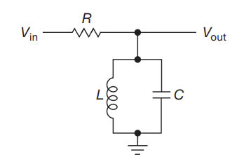
[4]Figure 1 – Parallel LC Tank Circuit
[3]Another variety of LC circuit is the series LC. In this circuit, at resonance, the reactance goes completely to zero assuming both the inductor and capacitor are ideal components, therefore having no resistive losses. Real-world components have losses however and therefore the minimum is non-zero, primarily dominated by the inductor.

Experiment setup

Simulation Setup
The circuit was made on proteus. The simulation is made up of an ideal 1uF capacitor, 1mH inductor and 1kΩ resistor, along with a signal generator on the input and an oscilloscope on the output.
The process of building the circuit is to find the components in the “pick parts” and add them to the “bin”. These will show up in the selector to build the circuit. 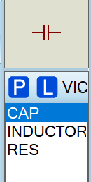
Figure 2 – Proteus Component selector
Then layout the components to get the rough layout of the circuit
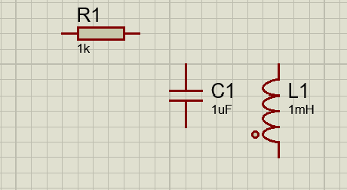
Figure 3 – Components laid out

Finally connect them up and add the signal generator and Oscilloscope 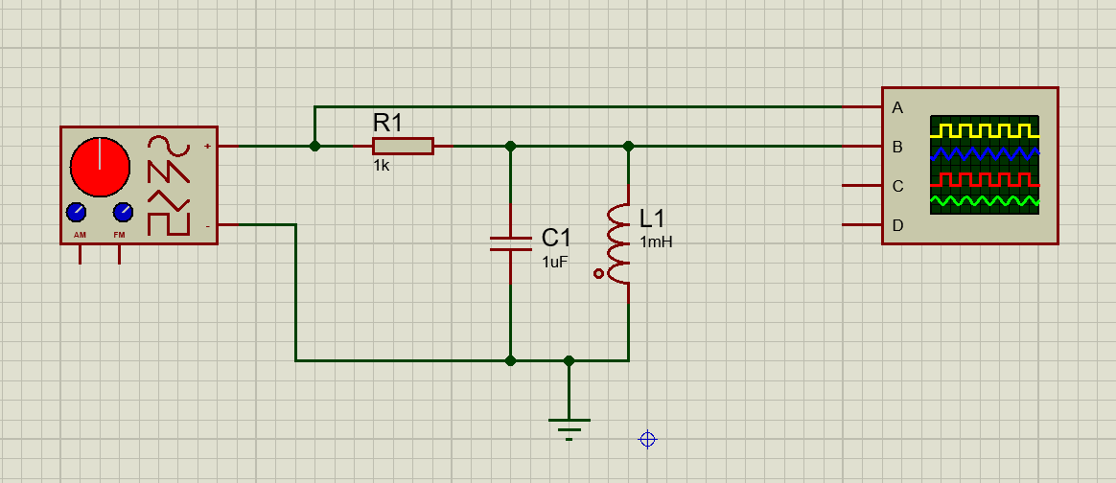
Figure 4 – Complete Circuit in Proteus
The signal generator is set to a frequency of 100Hz, with a peak-to-peak of 2V, as seen in figure 5.
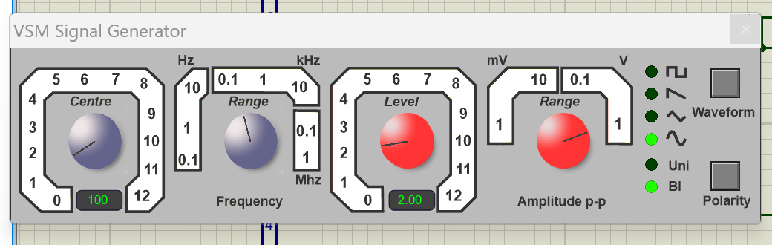
Figure 5 – Signal generator setup
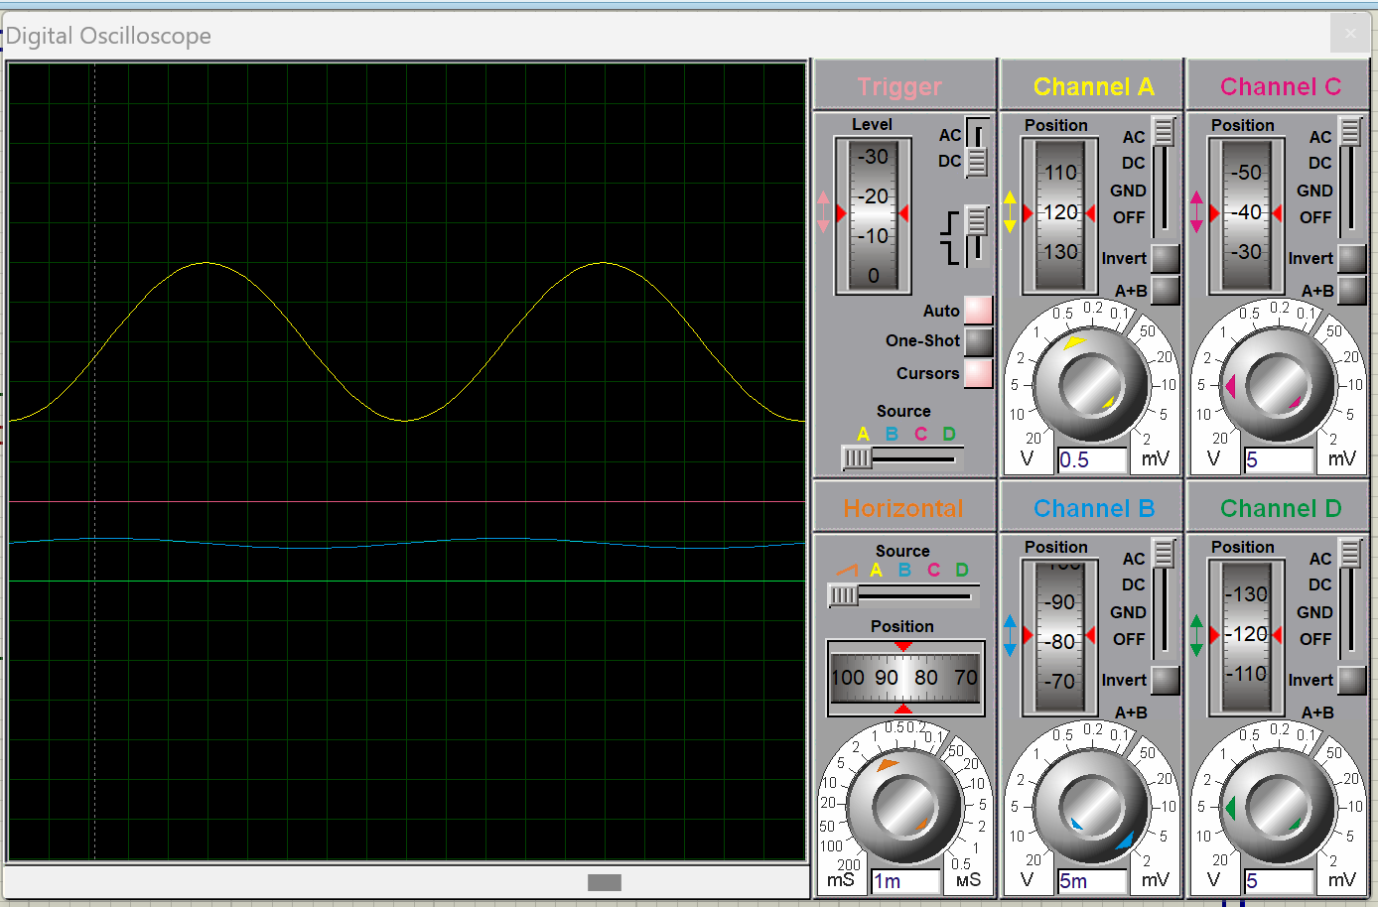
The Oscilloscope is set to 0.5mV on Channel A and 5µV on Channel B which gives the wavelength shown below in figure 6.
Figure 6 – Oscilloscope setup
The output voltage is measured across the resistor and inductor/capacitor at a range of frequencies from 100Hz to 20kHz. Using these results, the attenuation is calculated using
$$A=20×\log_{10}{\frac{V_{pk-pk}}{V_{in}}}$$

Practical setup
The practical setup is connected the same way as the simulated model, with the components placed on breadboard. The component values were kept the same – 1kΩ resistor, 1uF capacitor and 1mH inductor – however, the real-world exact values measured were a 979Ω resistor, 1.064µF capacitor and 0.994mH inductor.
The circuit was built by putting a leg of the capacitor and inductor in the same row, parallel to each other, with the ground on the back leg of the inductor/capacitor. A resistor was connected to the Vin column and connected to the first leg of the inductor/capacitor. The signal generator was connected to the red and black wire in figure 7. The oscilloscope channel 1 was connected to the inductor for the output, while channel 2 was connected to the red wire to display the 2V pk-pk input.
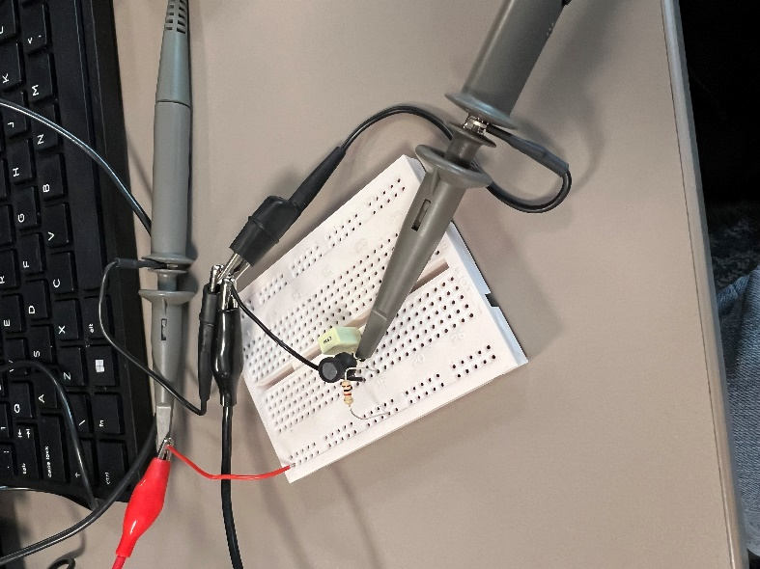
Figure 7 – Band pass filter circuit on breadboard
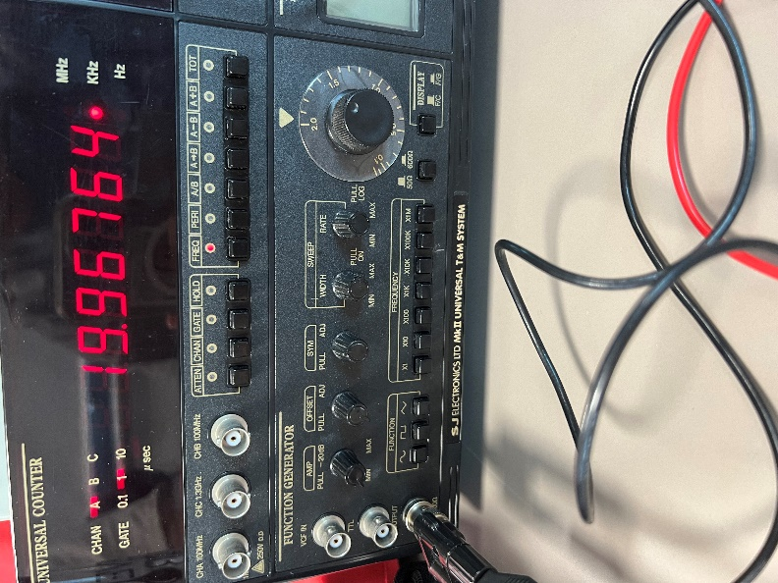
The signal generator is set to a sine wave, with the frequency range adjusted from 100Ω to 20kΩ. (figure 8)
Figure 8 – Wave generator Setup
The oscilloscope’s trigger level was set to keep the wave still, with the channel 1 vertical position adjusted to get the output wavelength to fit the oscilloscope’s screen and get an accurate measurement. (figure 9)
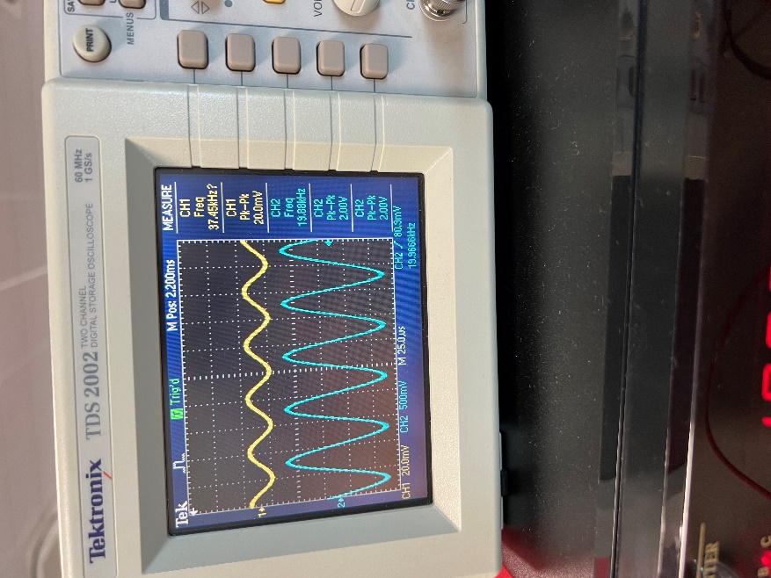
Figure 9 - Oscilloscope setup
The Overview of the setup can be seen in figure 10 below.
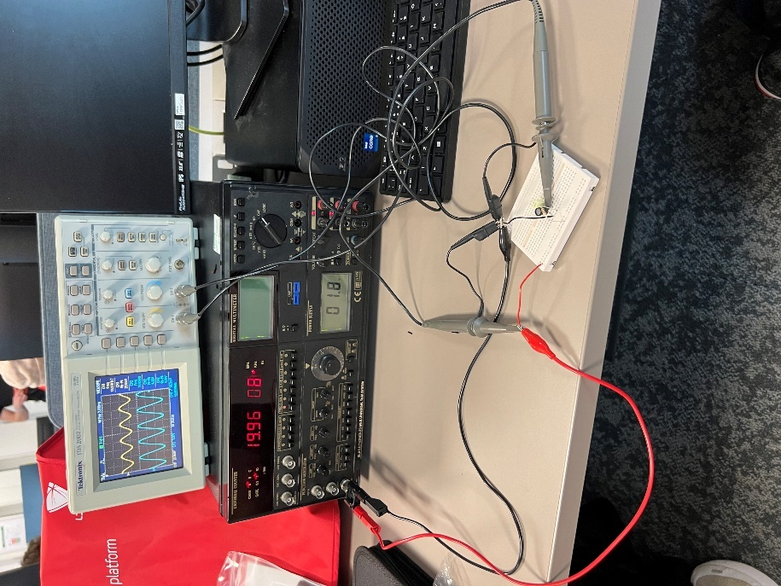
Figure 10 – Overview of the practical setup

Results
The simulated parallel LC circuit produced the results as seen in figure 11 below.
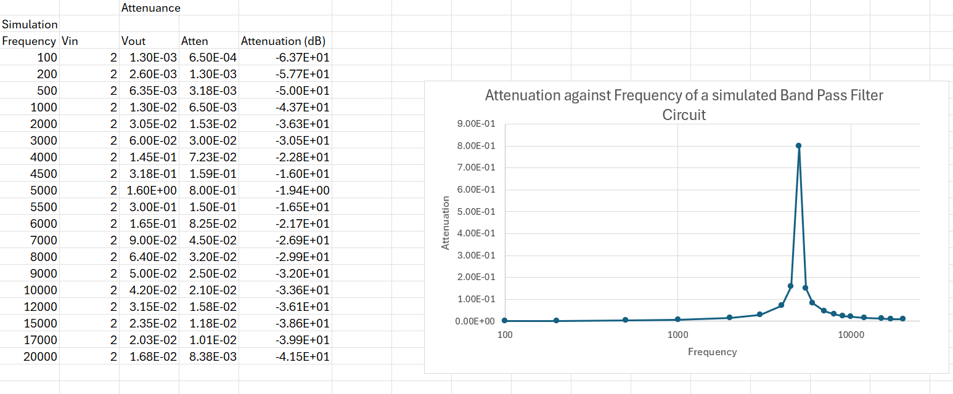
Figure 11 – Results for the simulated circuit
The tables shows the Vout pk-pk results and frequencies, along with the ratio and attenuation (dB) of Vout to Vin. The graph on the right is a graph of attenuation against frequency of the simulated parallel LC circuit.
The Practical Parallel LC Circuit produced the results below in figure 12.
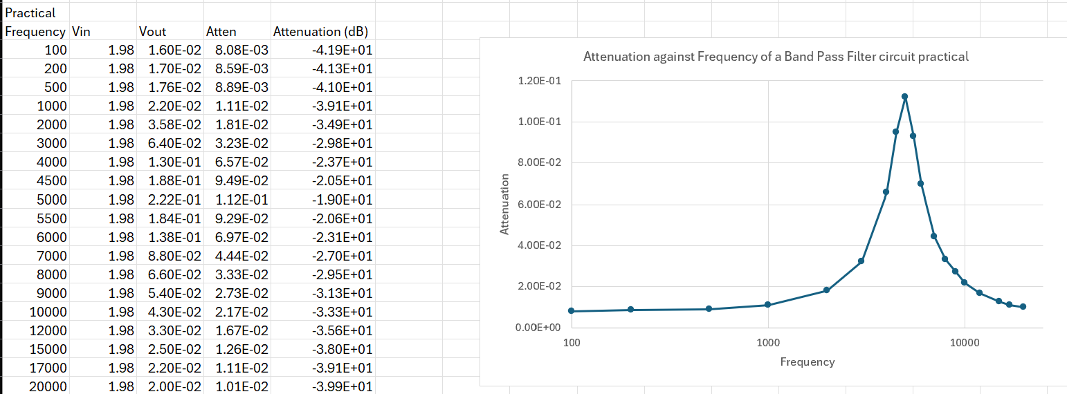
Figure 12 – Results for the Practical circuit
Similarly to the simulated results, the Vout pk-pk at the tested frequencies, as well as the ratio and attenuation (dB) of Vout to Vin is provided. The graph is attenuation against frequency for the practical results.

Discussion
Comparing the results shown above in figures 11 and 12 (as seen in figure 13), the peak of the practical is much smaller in comparison to the peak of the simulated graph. This is due to the proteus simulation using ideal components - [3]In practice, this is not the case. Losses in the inductor and capacitor reduce the peak. Capacitors have internal series resistance and inductance, while inductors have series resistance and parallel capacitance.
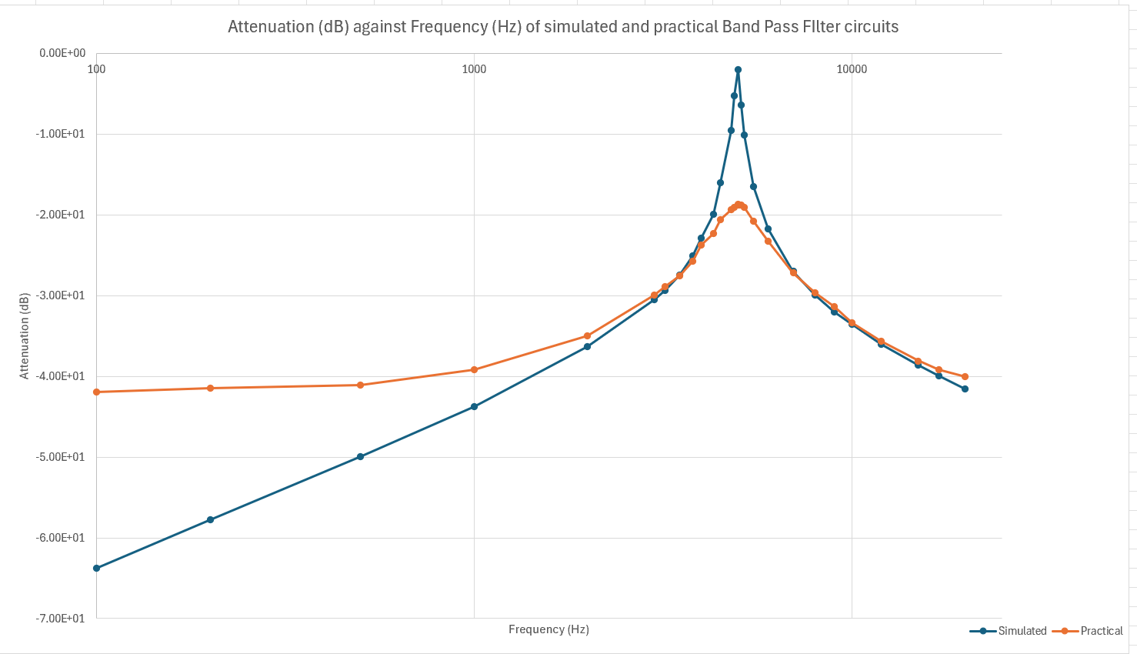
Figure 13 – Comparison between the simulated and real results

Capacitors
[5]Real capacitors exhibit the extra parasitic elements, primarily ESR (equivalent series resistance) and ESL (equivalent series inductance). [6]The ESR causes two things to happen:
- it has an influence on the AC response of the capacitor
- 2) because of thermal limitations, the ESR can impose limits on the amount of AC current that can flow through the capacitor.
The ESR of a capacitor is influenced by the construction and type of device, temperature, and test frequencies. The capacitor that was used has an ESR change with frequency of:
1kHz - $5.09189×{10}^{-5}$
10kHz – $7.63784×{10}^{-4}$
Which proves the ESR changing with frequency.
[7]The ESL contributes to the unwanted current flow, generating EMI (electromagnetic interference). These create issues in the higher frequency applications. [8]The Capacitor has a self-resonant frequency where the parasitic and inductance in the dielectric resonates with the capacitor. At frequencies higher than the self-resonance, they are no longer dependable as it becomes inductive, which increases its impedance.
Combining ESR, ESL, a parallel resistor and an ideal capacitor, it creates a real capacitor, as seen below in figure 14
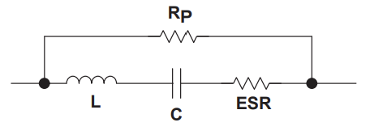
[8]Figure 14 – Real capacitor made up of ESR, ESL and Rp

Inductor
[9]Real inductors have three parasitic elements that influence their AC behaviour:
- ESR,
- EPC (equivalent parallel capacitance)
- EPR (equivalent parallel resistance).
Parasitic capacitance causes a self-resonance effect as well as contributing to EMI problems. [8]The ESR lowers the quality (Q) factor of the inductor. Since inductors are wound with wire, the size of this wire determines the ESR, [9]arising from the contact resistance on the input leads. [8]The parallel capacitor (EPC) at higher frequencies, degrades the inductors performances, essentially turning the inductor into a parallel resonant circuit. [9]The EPR is the coil resistance. [10]The equivalent resistive elements increase the inductor’s losses by limiting its impedance at the resonant point.
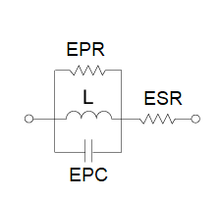
[9]Figure 15 – Real inductor made up of ESR, EPC and EPR

Resistor
[11]A real resistor has a very minute amount of parasitic capacitance and inductance, which can often be overlooked when designing circuits. [12]However, parasitic capacitance can have a significant effect on high frequency AC applications, causing unwanted effects. The impedance of a resistor with parallel capacitance will decrease as frequency is applied to it. The higher the frequency, the lower the impedance, therefore meaning the resistor is no longer observed as a constant element. This can delay the circuits response to high frequencies
[8]A real resistor has a parallel capacitance, series inductance of each lead, along with $C_{G}$ which is a capacitance formed by the resistor body and the ground plane. The parallel resistance is often within the range of 0.01 pF to 0.5pF.
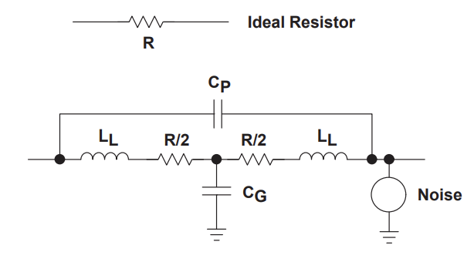
[8]Figure 16 – Resistor made up of ideal components

Effects of Parasitics

LTspice
To observe these changes, the circuit can be made in LTspice. The circuit on the left in figure 17 is the ideal circuit, matching the circuit made in proteus during the experiment. The circuit on the right is the same parallel LC circuit with some of the equivalent factors added for the resistor, capacitor, and inductor.
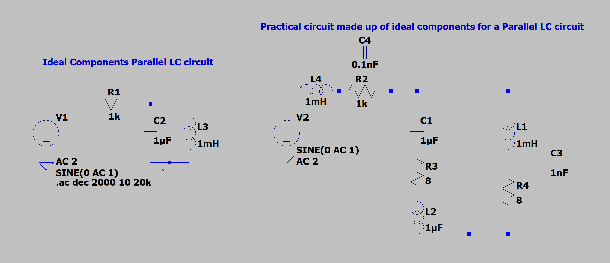
Figure 17 – LT spice Ideal and Practical circuit made up of Ideal components
Using the circuits with some roughly estimated values in the extra components, it can be seen in figure 18 that the green curve, which are the results from the circuit on the right, is like that of the results found from the experiment (seen in figure 13). The graph shows the Attenuence against frequency.
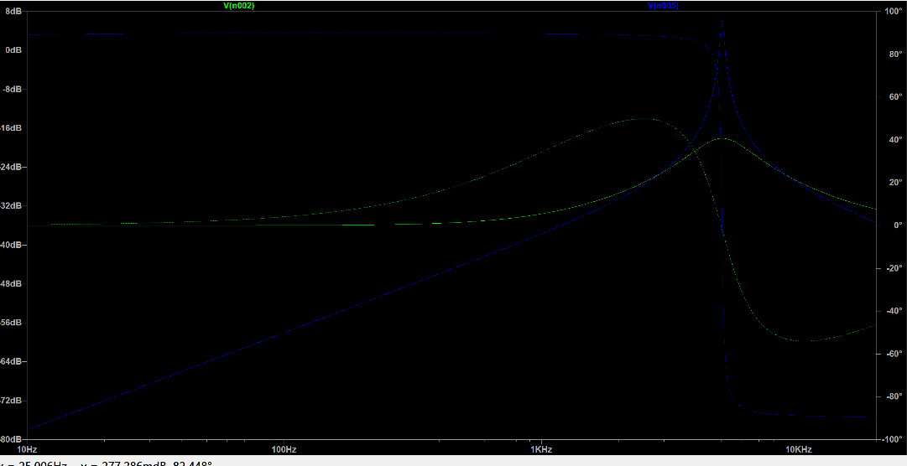
Figure 18 – Results from LTspice simulation
Changing the equivalent parallel capacitor value across the ideal 1k resistor from 0.1nF to 10nF, which can be seen in figure 19, causes the green curve to kick up more after the resonant frequency (as seen in figure 20). This is likely due to the change in impedance that the capacitor is causing since it is adding another path for current to flow through.
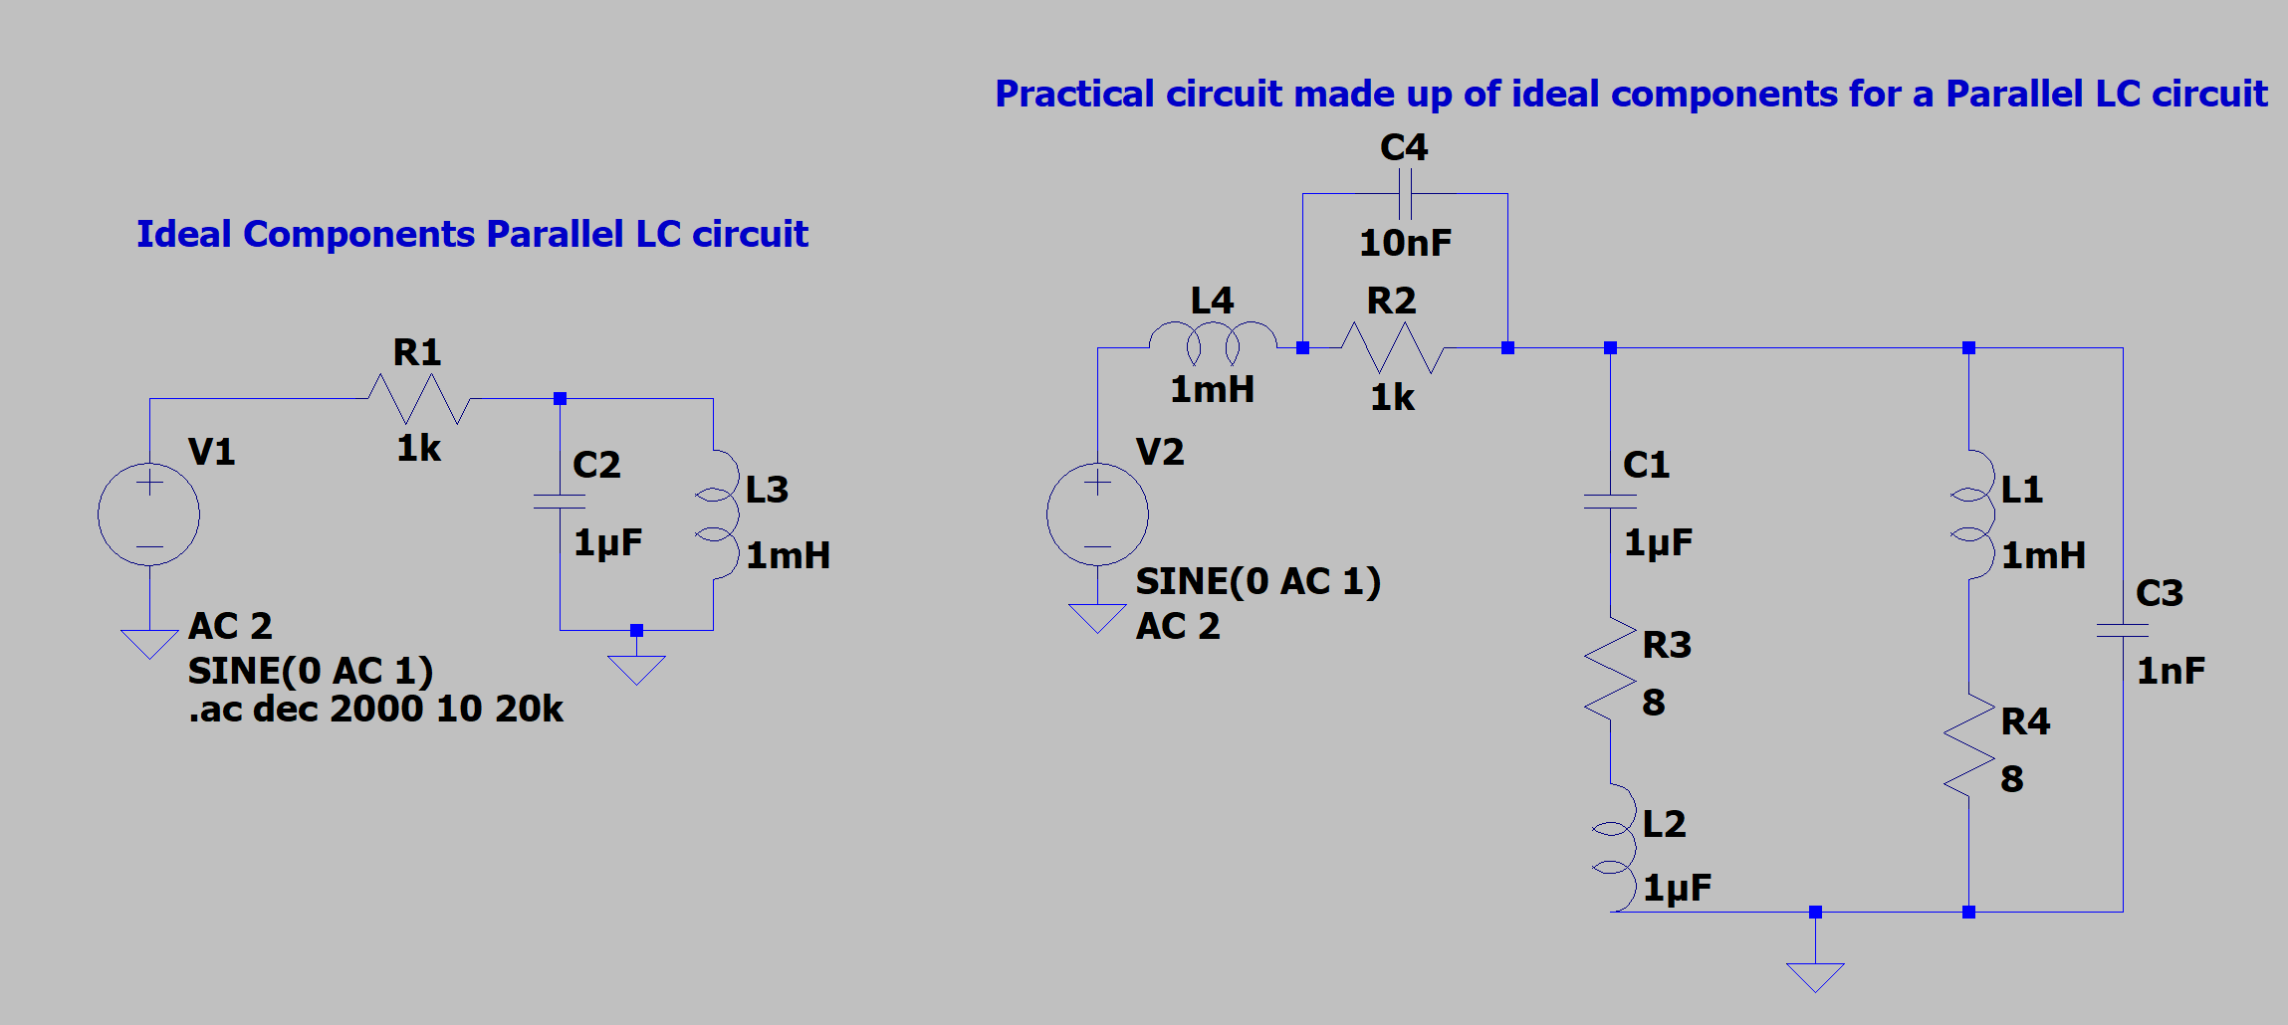
Figure 19 – circuit with EPC of the resistor in practical circuit increased
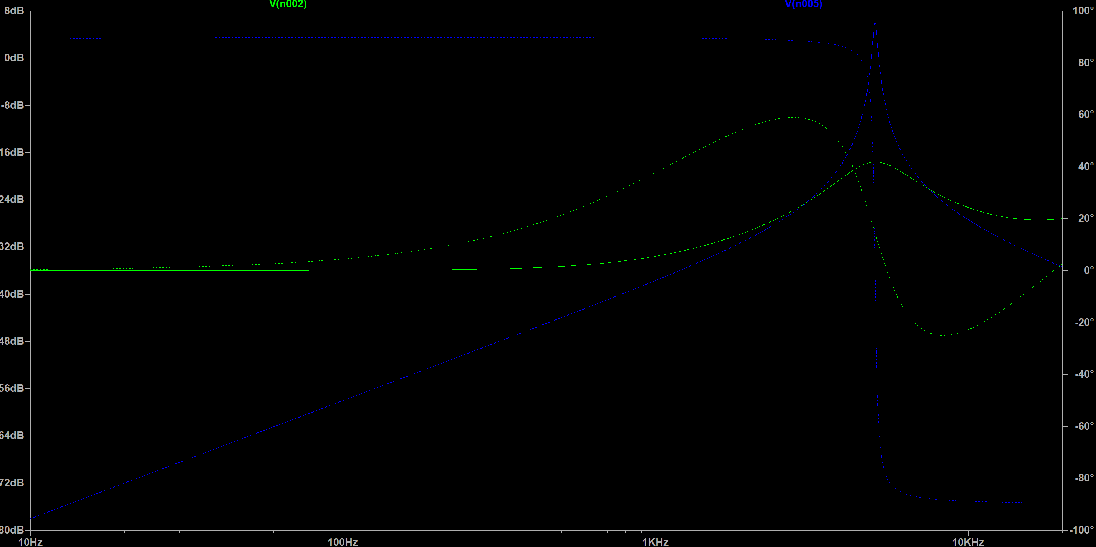
Figure 20 – Results of increasing the EPC of the resistor
Returning the EPC of the resistor to 0.1nF and lowering the ESR of the capacitor and inductor of the circuit, the graph in figure 22 has a higher resonant peak and its attenuance starts lower. Since the ESR of the parallel LC contributes to the damping of the peak, the less ESR, the less damping. [12]This means the circuit can resonate for longer periods since it doesn’t delay the circuits response to high frequencies, leading to a sharper peak, like that of the ideal circuits curve, where the ESR is zero.
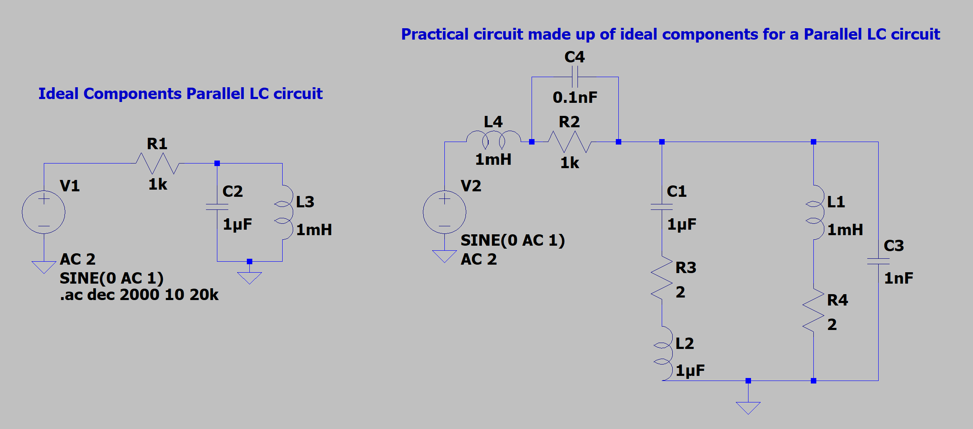
Figure 21 – ESR of parallel LC decreased
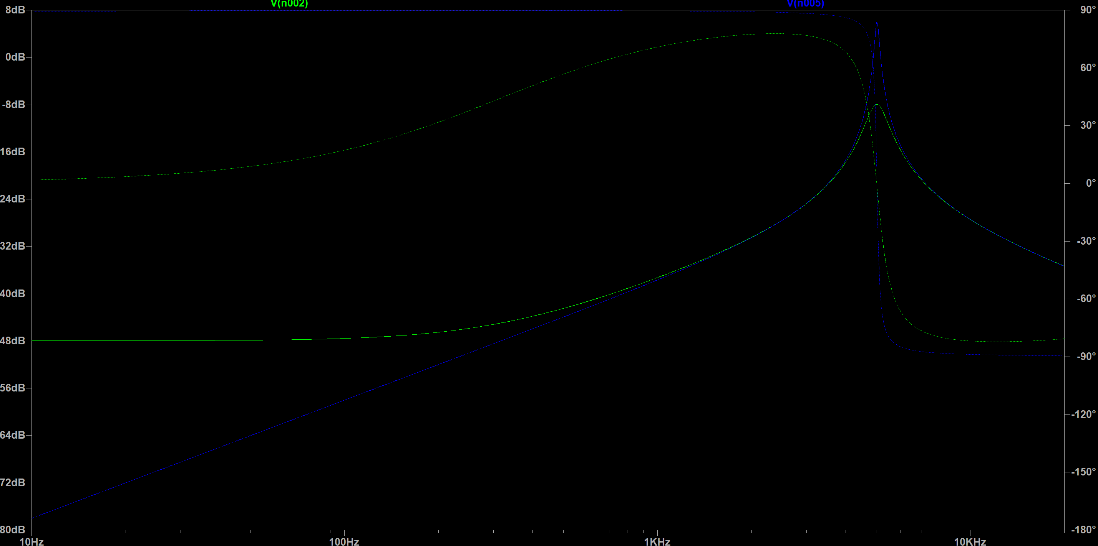
Figure 22 – Graph of parallel LC with ESR decreased against an ideal band pass filter circuit
To further study this point, the ESR was made negligible for the capacitor and inductor (shown in figure 23). Similarly to before, this causes the results to have negligible damping and so the resonance peak is sharper, meaning the Quality factor of the circuit is also greater. This also increases the efficiency of the circuit. The shape of the ideal circuit, and the filter with equivalent resistive factors made negligible, closely match each other.
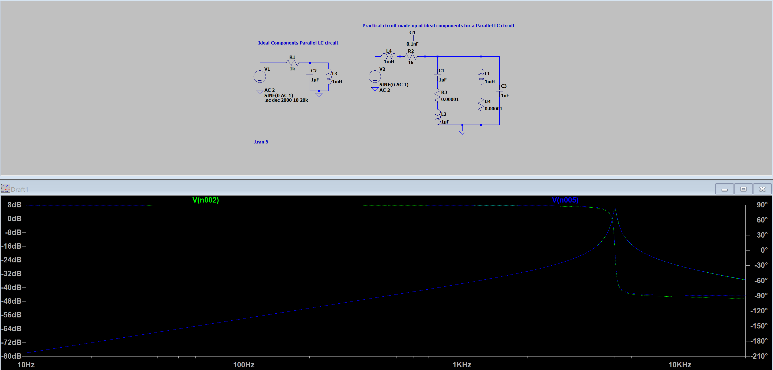
Figure 23 – ESR made negligible
This proves that the main factor causing the practical experiment results to have a lower resonance compared to the ideal band pass filter, is the ESR of the parallel LC.

Proteus
Since the measured ESR values of the capacitor were:
$$at 1kHz=5.09189×{10}^{-5}$$
$$at 10kHz=7.63784×{10}^{-4}$$
Making the circuit in proteus using the measured values of the actual components which are:
- Resistor = 979Ω, 84.5uH inductance
- Inductor = 0.994mH, 7.32Ω series resistance
- Capacitor = 1.064uF
And using the ESR values for the series resistor of the capacitor, it is possible to work out the attenuation at 1kHz and 10kHz.
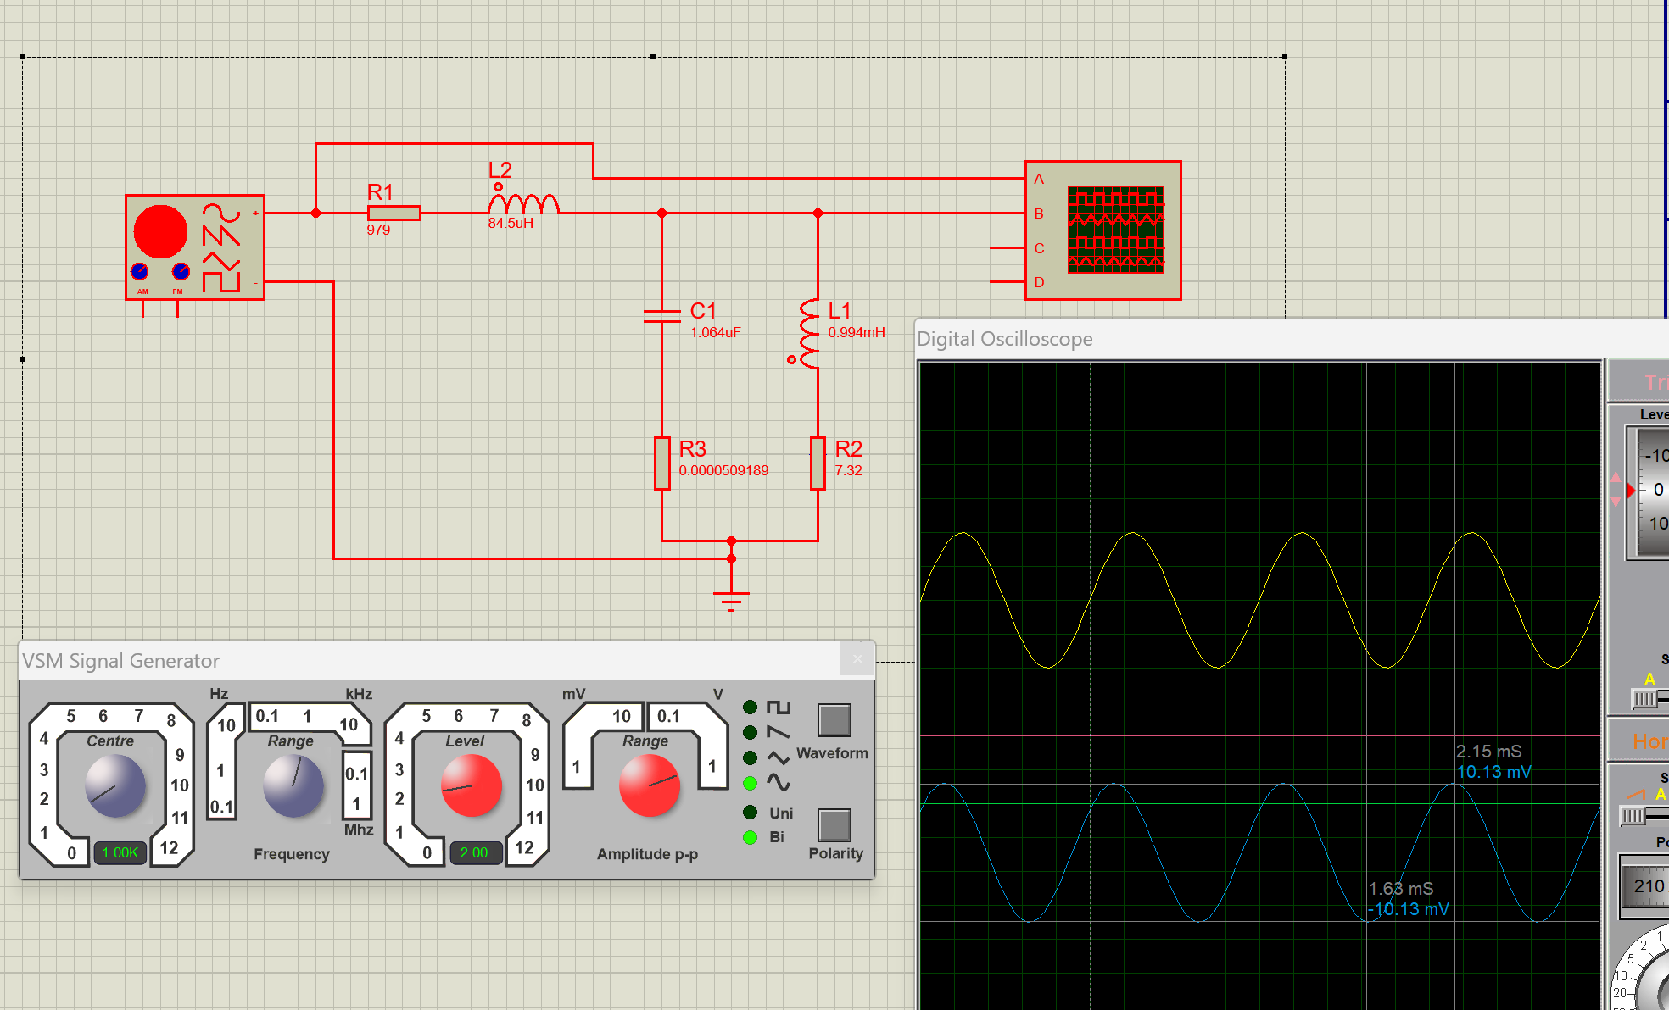
Figure 24 – Proteus simulation at 1kHz
At the 1kHz, with the ESR of the capacitor set to $5.09189×{10}^{-5}$, the amplitude is at 10.13mV (as seen in figure 24), making the pk-pk 20.26mV. Putting this into the attenuation formula
$$20×\log_{10}{\frac{20.26×{10}^{-3}}{2}}=-3.99×{10}^{1}$$
Comparing this value to the one table in figure 12, the value in the practical is $-3.92×{10}^{1}$.
Similarly, at 10kHz and ESR set to $7.63784×{10}^{-3}$, the amplitude is at 19.38mV (as seen in figure 25). This makes the pk-pk 38.76mV. Calculating the attenuation you get:
$$20×\log_{10}{\frac{38.76×{10}^{-3}}{2}}=-3.42×{10}^{1}$$
This in comparison to the practical result of $-3.34×{10}^{1}$ for attenuation (figure 12) is very close and therefore shows that accounting for ESR in simulation gives a more accurate and realistic result compared to the ideal components.
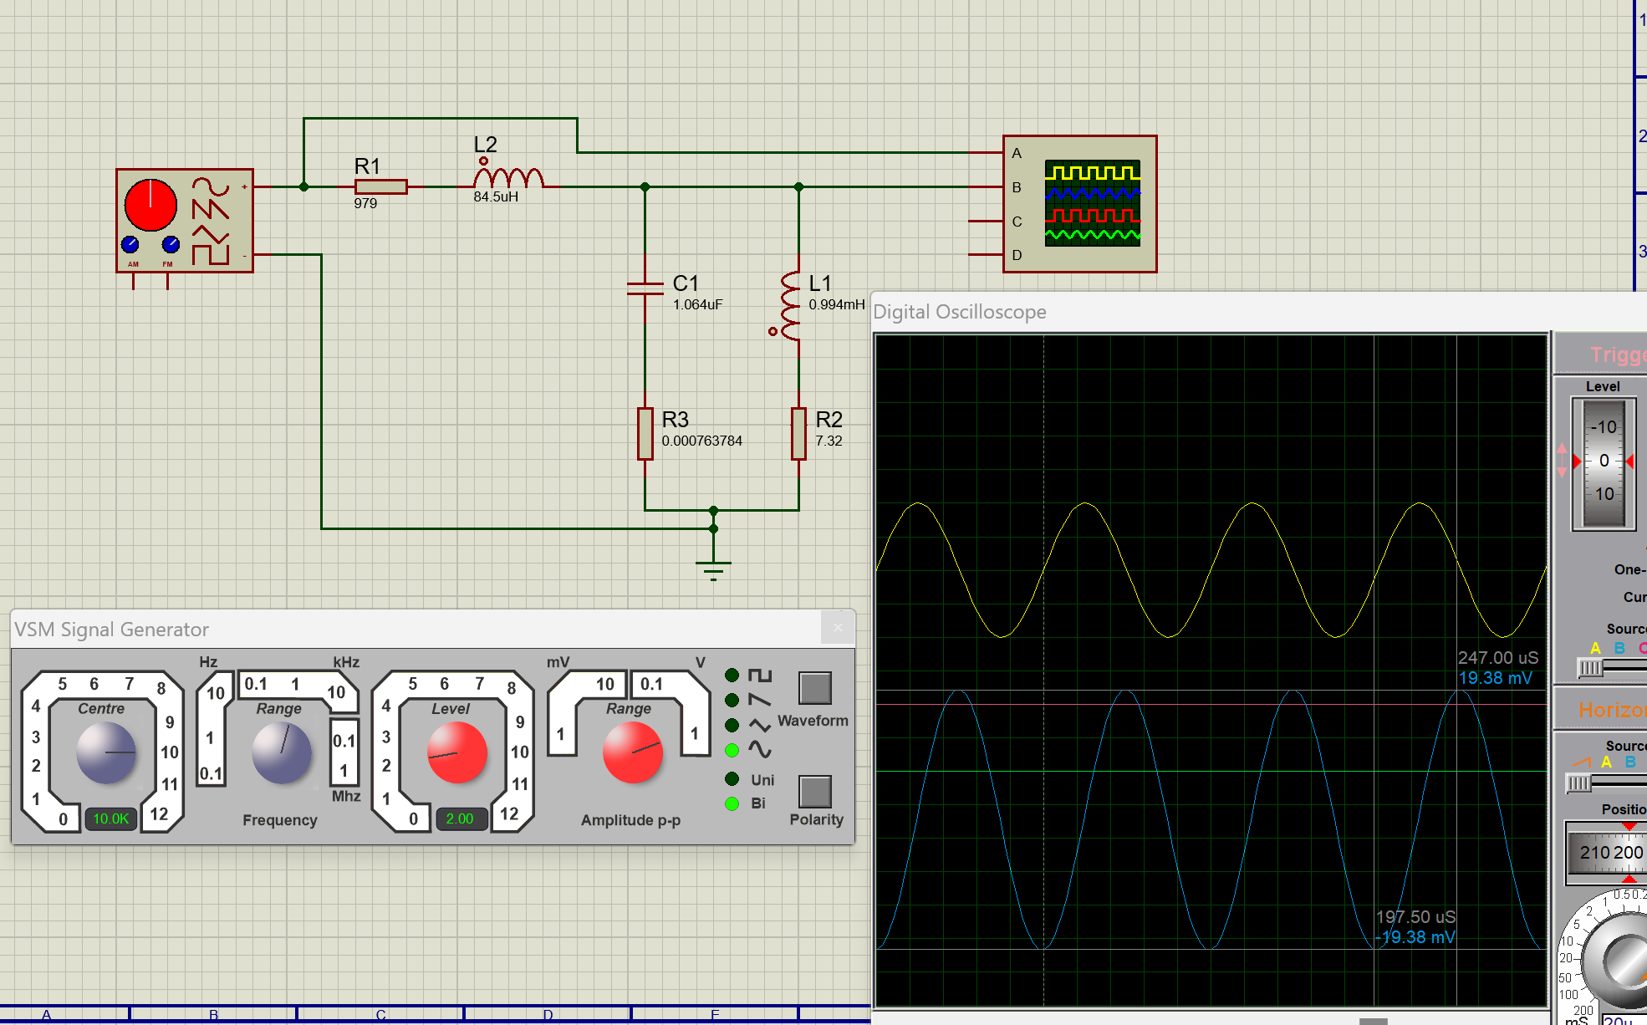
Figure 25 – Proteus simulation at 10kHz

Q Factor
[13]Q factor, or quality factor, is a metric that describes the underdamped condition of a resonator or oscillator. The Q factor is calculated by taking the resonant frequency and dividing it by the bandwidth.
$$Q=\frac{f_{r}}{BW}$$
Bandwidth of the response curve is measured between 70.7% amplitude points, which can be worked out by taking -3dB from the resonant frequency on the graph. That line is drawn on the graph by using “=Max(Attenuation points)-3” inc excel, since attenuation is measured in dB. After that, a frequency high and low line is drawn perpendicular to the 70.7% line. Bandwidth is then calculated by doing $f_{H}-f_{L}$. Using the resonant frequency of 5032.921Hz, calculated previously, the Q factor can be calculated for both the Simulated and Practical graphs.

Simulated Q factor
The Q factor of the simulated circuit can be seen in figure 26 below.
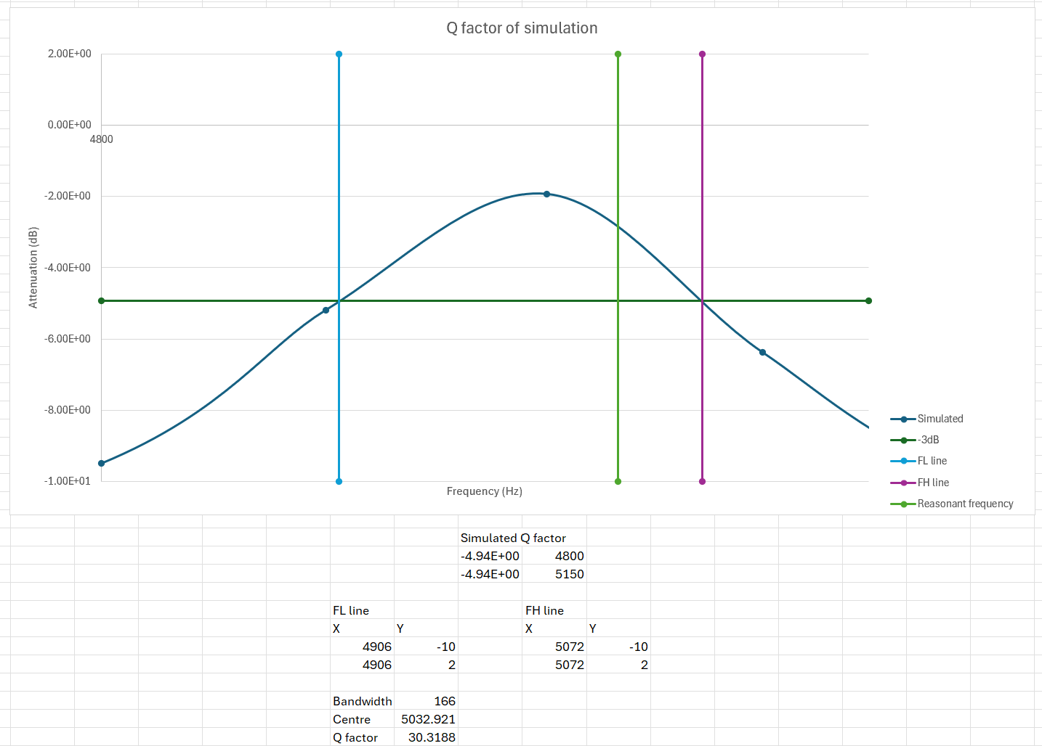
Figure 26 – Q factor of the simulated circuit
The Bandwidth was calculated as 166Hz, therefore using the Q factor equation, a Q factor of 30.319 can be seen. The resonant frequency line does not line up with the peak of the knee since there is no sample data for the resonant frequency. This is due to being unable to set the frequency from the signal generator on proteus to the exact resonance.

Practical Q factor
The Q factor of the practical circuit can be seen in figure 27. The Bandwidth was calculated to be 1315Hz, as the peak being much lower in the practical circuit, and therefore the high and low frequencies taken are at a higher bandwidth. This gives a Q factor of 3.827.
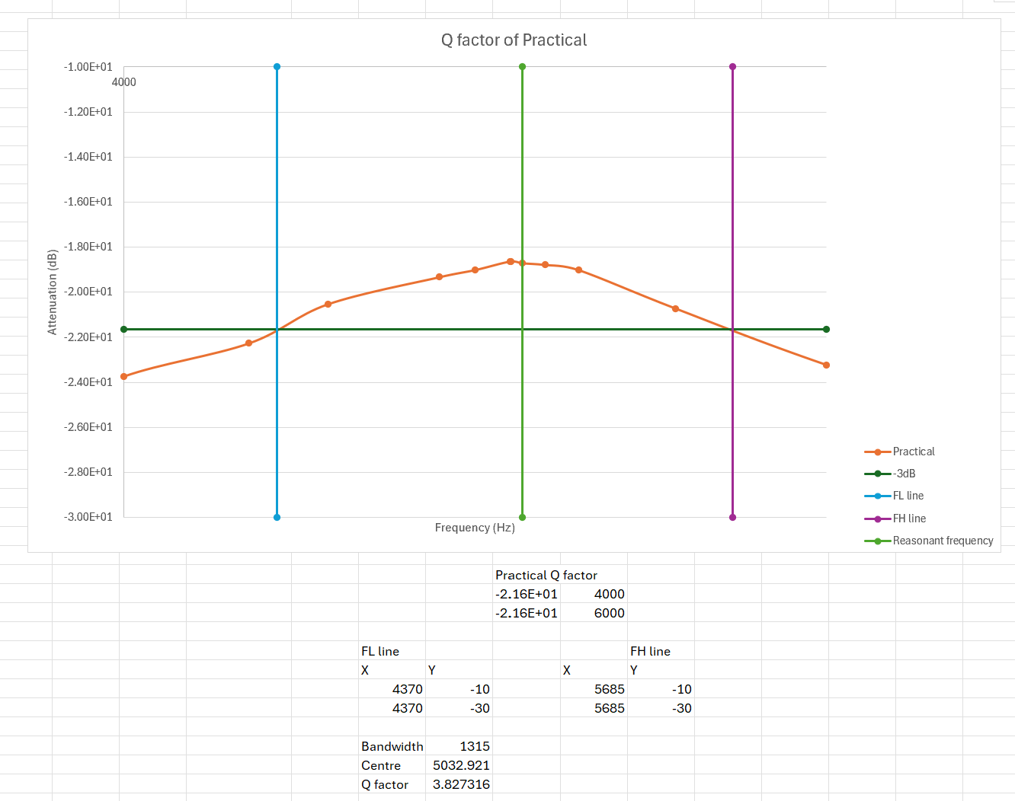
Figure 27 – Q factor of practical circuit
Comparing these Q factors, the Quality of the practical circuit is approximately 10 times worse than the simulated circuit, which is due to the reasons mentioned in the discussion.

Conclusion
To conclude, the practical circuit shows how much effect internal factors have on components, primarily being the components equivalent series resistance (ESR). These parasitics cause the dampening of the curve, which increases the bandwidth and decreases its quality factor. These factors can be mostly accounted for by adding extra ideal components to the simulated circuits, using the components equivalent circuits.

Bibliography

[1] | Electrical4U, “LC Circuit Analysis: Series And Parallel Circuits, Equations And Transfer Function,” Electrical4U, 4 July 2021. [Online]. Available: https://www.electrical4u.com/lc-circuit-analysis/?utm_content=cmp-true. [Accessed 28 April 2024].
[2] | R. Nave, “Resonance,” HyperPhysics, [Online]. Available: http://hyperphysics.phy-astr.gsu.edu/hbase/electric/serres.html. [Accessed 28 April 2024].
[3] | W. H. Paul Horowitz, “Resonant Circuits,” in The Art of Electronics Third edition, Cambridge University Press, 2015, pp. 52-54.
[4] | W. H. Paul Horowitz, “Resonant Circuits - A. Parallel and series LC Circuits,” in The Art of Electronics Third Edition, Cambridge University Press, p. 52.
[5] | W. H. Paul Horowitz, “Degradation of ultimate attenuation: non-ideal,” in The Art of Electronics Third Edition, Cambridge Univeristy Press, p. 392.
[6] | Digikey, “Simple Explanation of Capacitor ESR – Why Is It Important and How Is It Specified?,” Digikey, 15 September 2016. [Online]. Available: https://www.digikey.co.uk/en/articles/simple-explanation-of-capacitor-esr. [Accessed 1 May 2024].
[7] | S. Gupta, “Understanding ESR and ESL in Capacitors,” Circuit Digest, 17 June 2019. [Online]. Available: https://circuitdigest.com/tutorial/understanding-esr-and-esl-in-capacitors. [Accessed 1 May 2024].
[8] | Texas Intruments, “Understanding Basic Analog - Passive Devices,” Texas Instruments , July 1999. [Online]. Available: https://www.ti.com.cn/cn/lit/an/sloa027/sloa027.pdf. [Accessed 2 May 2024].
[9] | Cadence system analysis, “What Is the Parasitic Capacitance of an Inductor?,” Cadence, [Online]. Available: https://resources.system-analysis.cadence.com/blog/msa2021-what-is-the-parasitic-capacitance-of-an-inductor. [Accessed 1 May 2024].
[10] | J. Shepard, “AC challenges with inductors,” Power Electronics Tips, 2 September 2021. [Online]. Available: https://www.powerelectronictips.com/ac-challenges-with-inductors-faq/. [Accessed 2 May 2024].
[11] | J. Bishop, “How Resistors Work: Understanding the Fundamentals of Resistance,” circuitbread, 10 December 2018. [Online]. Available: https://www.circuitbread.com/tutorials/whats-a-resistor#:~:text=A%20perfect%20resistor%20has%20no%20capacitance%20and%20no,a%20very%20minute%20amount%20of%20capacitance%20and%20inductance.. [Accessed 1 May 2024].
[12] | EEPower, “Resistor Capacitance - Resistor Fundamentals,” EEPower, [Online]. Available: https://eepower.com/resistor-guide/resistor-fundamentals/resistor-capacitance/. [Accessed 1 May 2024].

