Data Handling and Business Intelligence

Table of Contents
1. Introduction 3
2. Data Cleaning and Preparation 3
3. Descriptive Statistics and Summary 4
4. Trend Analysis and Visualisation 7
5. Statistical Analysis using SPSS 10
6. Insights and Recommendations 14
References 15

1. Introduction
The report uses business intelligence methods to examine a food delivery dataset. This shows how well the company operates and delivers its services. The dataset contains delivery staff data together with environmental data and logistical information. This includes traffic patterns and weather conditions that affect delivery results. The study's main objective is to discover patterns and relationships which determine performance through the use of descriptive and inferential statistical methods. The data cleansing and transformation process, together with the visual representation work of the data analysis process (Martins et al. 2025). This is executed through Microsoft Excel, while SPSS handles advanced statistical tests. This includes hypothesis testing, correlation and regression analysis.
The research uses a data-driven method to study how delivery time, traffic conditions and weather patterns affect customer satisfaction. These researchers measure through delivery ratings. The study shows how business intelligence tools can help make better decisions for operational strategy development in the food delivery industry. The research demonstrates that data-driven insights improve operational responsiveness and enable organisations to make better strategic decisions about their business operations. The study proves that organisations need analytics to improve their operational performance while decreasing operational delays and maintaining their market advantage in quick product delivery environments.

2. Data Cleaning and Preparation
The data validation and data preparation process used Microsoft Excel to verify the dataset's precise details and matching information and its analytics-ready condition (Valencia-Arias et al. 2025). The dataset underwent a structured evaluation process to identify missing data and inconsistent data points. This affects crucial delivery time metrics, delivery person ratings and weather conditions and traffic density information. The research used multiple techniques to deal with missing values (NaN) based on their unique characteristics and occurrence patterns. The analytical process required complete data for numerical variables (‌Sharifnia et al. 2025). Thus, researchers eliminated rows with substantial missing data while they used mean imputation to fill minor data gaps. This allowed them to maintain dataset integrity without affecting the main pattern elements.
The research standardised categorical variables, which contained weather information. Road traffic density data through spelling correction, formatting error correction and removal of duplicate category labels. This has included various naming convention variations. The system converted date and time fields into standardised formats, which enabled precise time-based analysis and trend detection.
The researchers used conditional formatting and sorting methods to find outliers who showed extremely long delivery times. They later checked the outliers for validity before their removal because they wanted to maintain accurate results. The team established additional calculated fields (‌Shaw et al. 2025). This included delivery duration standardisation to enable their upcoming statistical examinations. The preprocessing steps are needed by businesses for their intelligence operations because bad data quality will lead to unreliable analytical results. This creates false insights that result in wrong decisions.

3. Descriptive Statistics and Summary
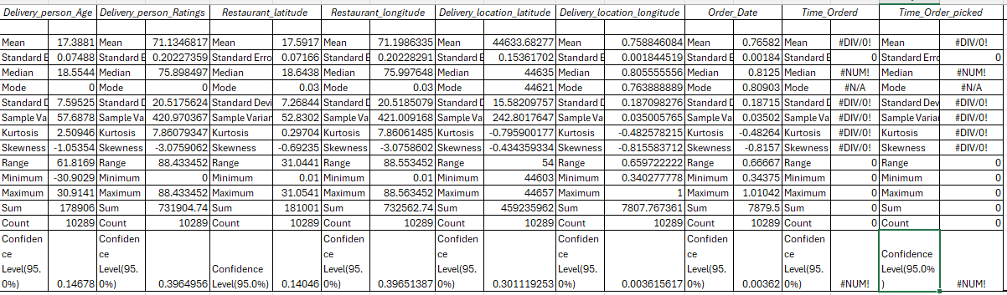
Figure 1: Descriptive statistics
(Source: MS Excel)
Extended descriptive statistics give researchers advanced knowledge about how primary dataset variables behave and disseminate their information through their distribution patterns (Long et al. 2025). The analysis is based on 10,289 valid observations, which ensure strong statistical credibility. The geographical variables of restaurant and delivery locations show moderate dispersion. The restaurant latitude measurement shows a mean value of 17.38 together with a standard deviation of 7.59. This demonstrates how the measurement spreads across different geographic areas. The longitude values exhibit greater distribution (SD ≈ 20.51). This indicates that they cover a larger area through their horizontal movement. The negative skewness in these variables indicates that observations are slightly concentrated toward higher values.
The order and pickup time variables show a standard deviation value of approximately 0.18. This value shows that most orders take place during the same time period. The negative skewness indicates that more orders were placed during the evening hours. This shows that customers ordered more during peak dining times. The variables show different kurtosis values. High kurtosis in longitude (≈ 7.86) indicates the presence of extreme values or outliers. This may affect delivery distance and time. Some variables exhibit negative kurtosis. This results in their data being distributed more evenly than normal distribution patterns.
The existence of #DIV/0! and #NUM! Errors in Time_Order_picked reveal that the data contains missing elements or data that has been incorrectly formatted. This demonstrates data quality problems. The dataset shows a moderate variable range, together with slight skewness and multiple outliers.
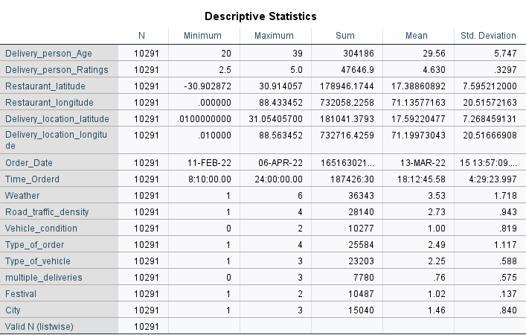
Figure 2: Descriptive statistics
(Source: IBM SPSS)
The dataset showcases its complete information through descriptive statistics. This summarises essential details about delivery operations and employee workflow patterns. The number of authentic data points in the dataset is 10,291, which indicates a significant sample size, thereby improving the reliability of the analysis and its applicability. The delivery team's age is 29.56 years with a standard deviation of 57.47. This indicates that most of the workers in this team are young, but they vary in age. The assessment of delivery performance indicates high quality in service delivery, as indicated by its ratings, which have a mean of 4.63 and a standard deviation of 0.33.
The restaurant and delivery coordinates exhibit spatial variables that display extensive spatial distribution, which demonstrates operational geographic diversity that creates variations in delivery times through distance differences. Orders typically reach their peak volume during the evening period, which begins at 18:12 according to statistical data, because this time matches the hours when food delivery services experience their highest demand. The patterns of important categorical variables show their existence through different data elements. Road traffic density (Mean = 2.73) demonstrates that most times the streets experience moderate to high traffic, which will reduce delivery speed. The weather conditions mean that 3.53 shows different environmental situations. This will create problems for consistent service delivery. The average delivery volume, Mean 0.76, shows that most deliveries consist of single orders, but there are instances of multiple deliveries
The dataset demonstrates actual operating challenges because various elements work together to produce delivery results.

4. Trend Analysis and Visualisation
Bar Graph
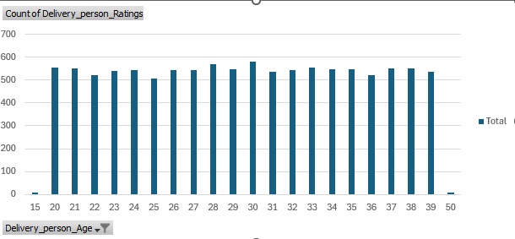
Figure 3: The trend shows the relationship between the delivery Pearson rating and the delivery person's age
(Source: MS Excel)
The Bar graph shows the relationship between the delivery person's age and ratings distribution through frequency counts. The 20-to-39 age group demonstrates consistent performance through their ratings. This range from 500 to 580. The age 30 peak at 579 indicates that more people represent this age, or they maintain consistent activity throughout the day. The data shows very low counts at ages 15 and 50, indicating outliers or limited data. The overall trend shows that age has no major effect on delivery ratings, which establishes a constant relationship between these two factors.
Line graph
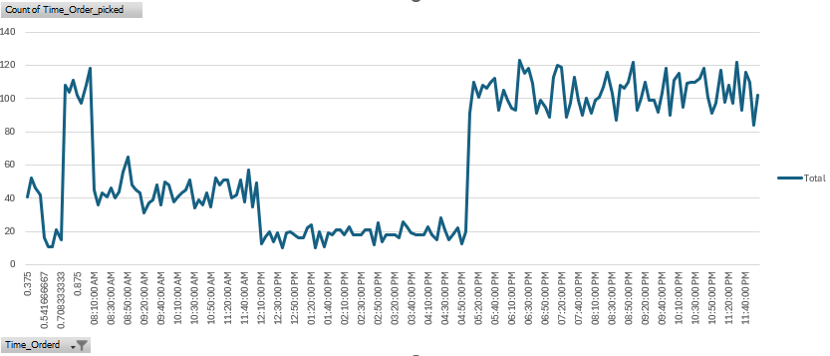
Figure 4: The trend shows the relationship between the count of time orders picked and the time ordered
(Source: MS Excel)
The Time_Order_picked line graph demonstrates that people demand services according to a particular schedule. This repeats throughout each day. The morning and early afternoon hours experience low activity levels. This remains constant across various time periods, except for the morning period when people show higher activity. From 5:00 PM onwards, there is a significant rise in the graph because this is the time when the demand is the highest. From 6:00 PM to 10:00 PM, this is the busiest time because all the activities were above 100. According to the research findings, the restaurants receive the largest number of customers during the evening hours because people want dinner.
Bar graph
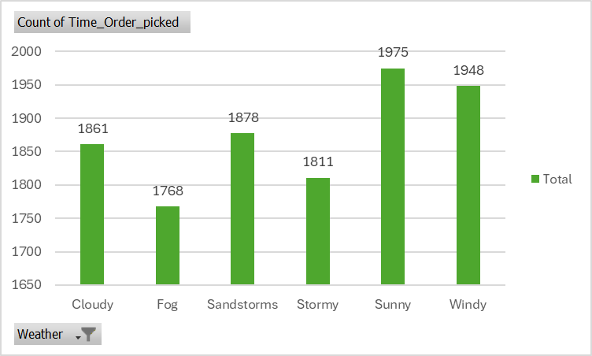
Figure 5: The trend shows the relationship between the count of time orders picked and the weather
(Source: MS Excel)
The bar graph shows how weather conditions affect the frequency of order pickups. The counts are relatively close across all categories, indicating a stable pattern regardless of weather. Sunny (1975) and Windy (1948) conditions produce higher pickup rates. This demonstrates that delivery activity increases during good weather. The Fog (1768) measurement shows the least amount of disruption to operations. The trend demonstrates that weather conditions affect delivery operations, but delivery services maintain their operations throughout all weather conditions because of their operational resilience.
Scattered plot
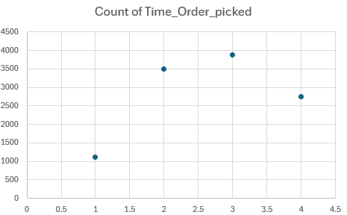
Figure 6: The trend shows the relationship between the Road Traffic density and the Time_Order_picked
(Source: MS Excel)
The scatter plot shows the relationship between road traffic density and order pickup frequency. The data indicates a clear variation across traffic levels. The pickup volume reaches its maximum value during low traffic conditions. This enables businesses to conduct their operations more quickly. The Jam conditions (3503) exhibit high activity levels, which indicate that the system experiences peak demand times while delays exist. The Medium traffic category (2751) and High traffic category (1110) display lower operational counts when compared to other traffic levels. The relationship indicates that order demand continues during traffic jams, but order processing and pickup efficiency increase during times of lower traffic volume.

5. Statistical Analysis using SPSS
Hypothesis Testing:

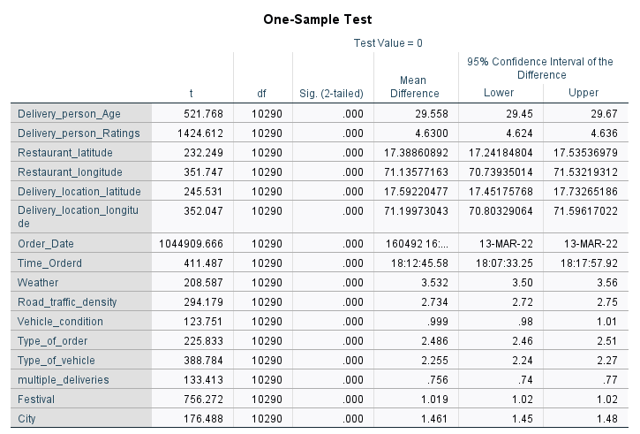
Figure 7: Simple T-Testing
(Source: IBM SPSS)
The researchers wanted to understand how weather conditions affect their Delivery_person_Ratings research. Delivery_person_Ratings achieved statistical significance through a one-sample t-test, which produced a mean value of 4.63 and a p-value of 0.000. The test results satisfy the p-value requirement because they showed a value below 0.05. The results show that the mean rating differs from the test value because the data shows high service performance throughout the entire dataset. The test results show that rating stability and reliability stay unchanged, while weather conditions create different results. Delivery personnel continue to deliver high ratings. This stays consistent because weather conditions stay constant throughout their work.
Correlation Analysis:
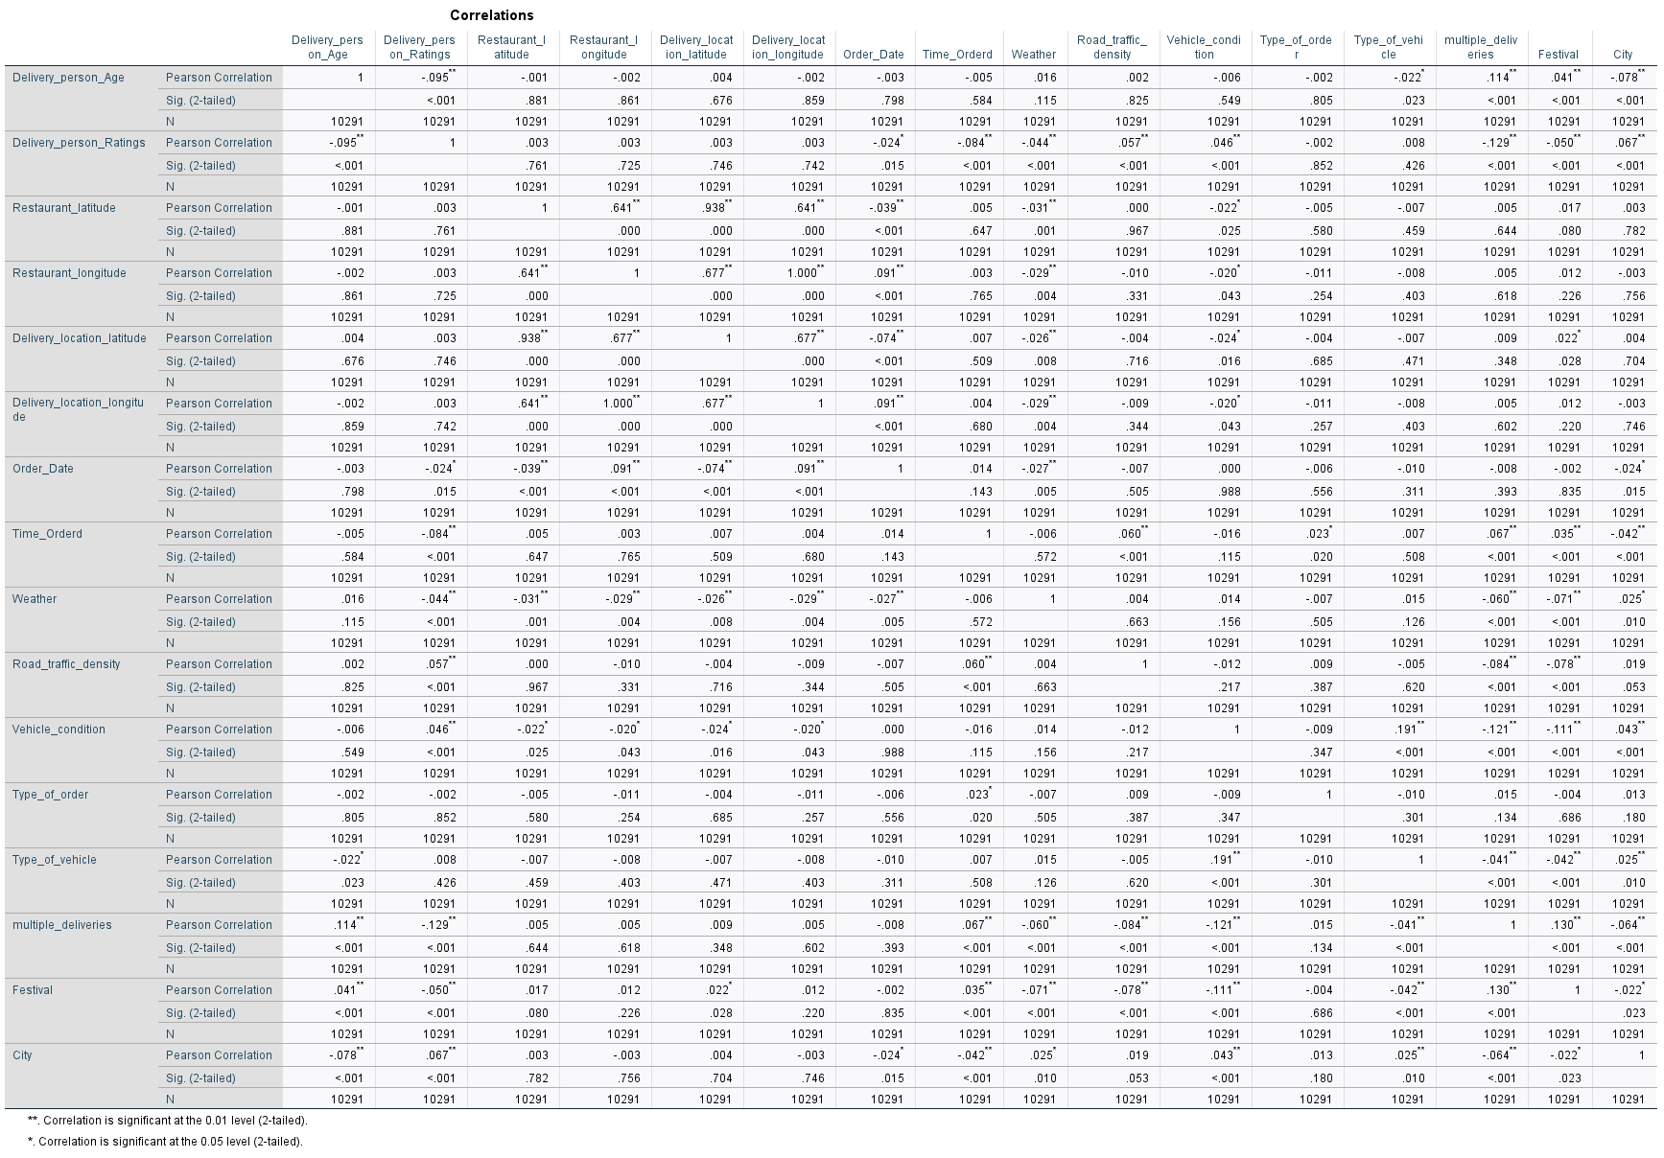
Figure 8: Correlation
(Source: IBM SPSS)
The correlation analysis reveals several significant relationships between variables. The relationship between Delivery_person_Age and Delivery_person_Ratings shows a negative correlation. This has a weak strength because ratings decrease only slightly with rising age (r = -0.095, p < 0.01). Road_traffic_density displays a weak positive correlation with ratings. This results in minimal effect on ratings (r = 0.057, p < 0.01). The study shows strong positive correlations between restaurant and delivery location coordinates. This reaches above 0.6 because the two points maintain geographical proximity. The study shows that multiple deliveries result in a negative impact on ratings because delivery staff must manage additional orders. The study found that delivery staff members faced difficulties when handling their work duties because their service quality decreased at a rate which reached (r = -0.129, p < 0.01). The study found that almost all relationships showed weak connections, which still had statistical significance.
Regression Analysis:
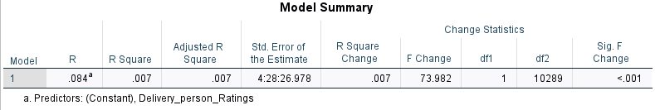
Figure 9: Model Summary
(Source: IBM SPSS)
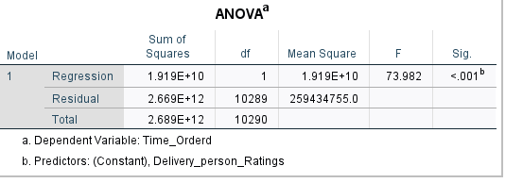
Figure 10: ANOVA
(Source: IBM SPSS)
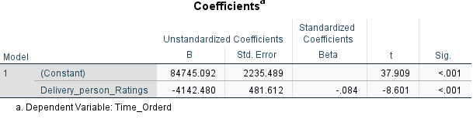
Figure 11: Coefficient
(Source: IBM SPSS)
The research study tests whether Delivery_person_Ratings can function as a delivery time predictor for Time_Orderd. The model demonstrates statistical significance through its F value of 73.982 and p-value. The value stays under 0.001, yet it cannot account for all aspects of the findings. The ratings coefficient shows a negative value, B = -4142.480, p < 0.001, which indicates that delivery times become slightly faster when customers give higher ratings. The effect size stays small. The statistical relationship between delivery ratings and delivery time shows significance, yet delivery ratings fail to provide accurate predictions about delivery time.

6. Insights and Recommendations
The analysis provides several important insights into delivery operations. Delivery performance shows stable patterns since delivery personnel achieve high average ratings with only slight differences from each other. The operational pressure on the system reaches its highest level during evening hours since this period experiences the highest demand for service. Delivery activities experience some impact from traffic density and weather conditions, but these factors only affect rating results in a limited manner. The need to manage multiple deliveries at once creates operational challenges that result in a decline in service quality.
The research results enable the development of multiple recommendations. Companies need to improve operational efficiency through delivery route optimisation and delivery staff expansion during peak evening hours. Organisations can choose vehicle types according to traffic patterns. This allows them to operate bikes in areas with heavy traffic jams. The company should restrict riders to handle only one delivery during peak periods to protect their service standards.
The analysis contains multiple limitations which affect its results. The relationship between certain variables remained weak because data problems emerged from missing and inconsistent values. This has decreased overall accuracy. Future studies need to add delivery distance information and current traffic conditions to achieve better results in prediction accuracy and operational decision-making.

References
Long, Y., Kroeger, S., Zaeh, M.F. and Brintrup, A. (2025). Leveraging synthetic data to tackle machine learning challenges in supply chains: challenges, methods, applications, and research opportunities. International Journal of Production Research, pp.1–22. doi:https://doi.org/10.1080/00207543.2024.2447927.
Martins, P., Cardoso, F., Váz, P., Silva, J. and Abbasi, M. (2025). Performance and Scalability of Data Cleaning and Preprocessing Tools: A Benchmark on Large Real-World Datasets. Data, [online] 10(5), p.68. doi:https://doi.org/10.3390/data10050068.
‌Sharifnia, A.M., Kpormegbey, D.E., Thapa, D.K. and Cleary, M. (2025). A Primer of Data Cleaning in Quantitative Research: Handling Missing Values and Outliers. PubMed. [online] doi:https://doi.org/10.1111/jan.16908.
‌Shaw, R.E., Farquharson, K.A., Bruford, M.W., Coates, D.J., Elliott, C.P., Mergeay, J., Ottewell, K.M., Segelbacher, G., Hoban, S., Hvilsom, C. and Pérez-Espona, S., (2025). Global meta-analysis shows action is needed to halt genetic diversity loss. Nature, 638(8051), pp.704-710. https://www.nature.com/articles/s41586-024-08458-x.pdf.
Valencia-Arias, A., Vásquez Coronado, M.H., Clavo Medina, M.L., Morales Garcia, M.J., Requejo Arias, A.R. and Saavedra Tirado, J.I. (2025). Research trends in the application of machine learning in sustainability practices based on a bibliometric analysis. Sustainable Futures, [online] 10, p.100987. doi:https://doi.org/10.1016/j.sftr.2025.100987.

