University of Wales Trinity Saint David
Wales Institute of Science and Art


Engineering Performance Characteristics
ACHA4003/4004/4012
George Hall
2404493
30/03/25

Contents
Table of Contents
Contents 2
1. Introduction 3
1.1 Introduction of the test 3
1.2 Aims of the test 3
2. Equipment and Methodology 3
2.1 Equipment 3
2.2 Methodology 3
3. Data 4
4. Graphical Results 6
4.1 Reasons for Graphs and Smoothed Data 6
4.2 SFC against Engine Speed 8
4.3 Torque against Engine Speed 8
4.4 Brake Power against Engine Speed 9
5. Conclusion 9
6. Evaluation and Improvements 9
6.1 Evaluation of the Test 9
6.2 Further Improvments 9
7. References 9

Introduction

Introduction of the test
A Honda VTEC engine will be put through a test on a dynamometer to measure and analyse the performance and characteristics of the engine. This test will be conducted in a controlled environment where ambient temperature and humidity can be measured. The engine will be tested at a range of RPMs to gather a full set of data which will be used for analysis of the engine’s performance.

Aims of the test
The aims of the tests are to calculate the corrected power output by the engine, the torque that the engine produces, the BMEP(Brake Mean Effective Pressure) in the cylinders that the engine produces, the SFC(Specific Fuel Consumption) of the engine and the overall thermal efficiency of the engine. Using the gathered results from the dynamometer test these values can be worked out using a range of formula. With the test results and worked out data comparisons and evaluations can be carried out and investigations into the relations between all the resultant data can be made to understand the performance of the engine and how engine speed(RPM) effects the engine.

Equipment and Methodology

Equipment
For this test an Eddy-current dynamometer W series will be used to test an inline 4 cylinder engine from a Honda Civic Coupe CRX. The engine has a bore of 75mm, a stroke of 90mm and a displacement of 1590cc which will be needed to work out the BMEP of the engine.
The dynamometer is driven by the engine, the energy from the engine is transformed into heat by the dynamometer, the test stand controller controls the observance of the speed and the desired torque(SCHENCK PEGASUS GmbH, 2001). As the engine tries to spin the outer casing of the dynamometer it is stopped by a strain gauge which sends the signal from the strain gauge of 0v-10v to the computer. The computer knows what the voltage means because the dynamometer is calibrated with the calibration arms, which give a length of 815.776mm for the centre of the dynamometer to the hook eye of the calibration arm. A mass is hung on one end so that the torque can be worked out round the centre axis of the dynamometer outer casing. From this the dynamometer report the found data back to the computer where the results are calculated and extrapolated by the computer. These results can then be use by the operator.

Methodology
The test process is first loaded onto the dynamometer control program this includes the startup process for the engine and then the engine speeds which the dynamometer needs to test for. In this test the engine speed ranges from 1000rpm to 5500rpm going up in increments of 50rpm which is controlled by the computer as the throttle is linked to it. With the load gathered from each engine speed explained above, the dynamometer also measures lambda and the fuel flow rate. The ambient temperature of the room, humidity and pressure in the air is also measured when the test is bring completed which were 27˚C, 47% and 1018.9 mbar. The data gathered is then put into an excel spreadsheet and the corrected power, torque, BMEP, SFC and overall thermal efficiency of the engine can then be worked out for each of the engine speeds. This data can then be put into graphs engine speed vs SFC, engine speed vs torque and engine speed vs corrected power. SFC, torque and corrected power values will be put through a smoothing software to give a better graph to look at and use to compare and analyse the data.

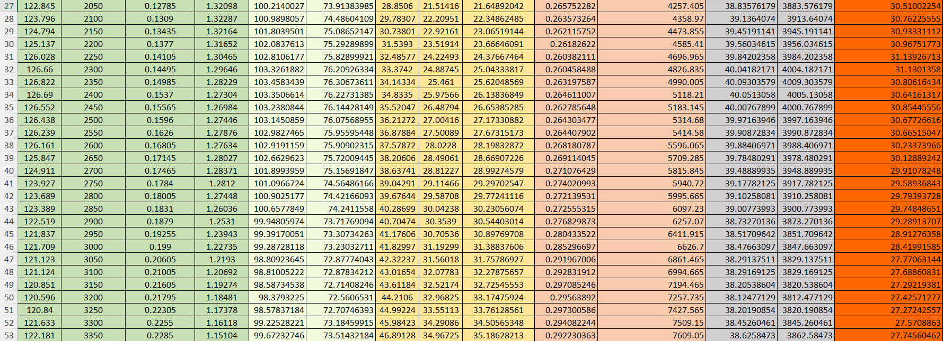
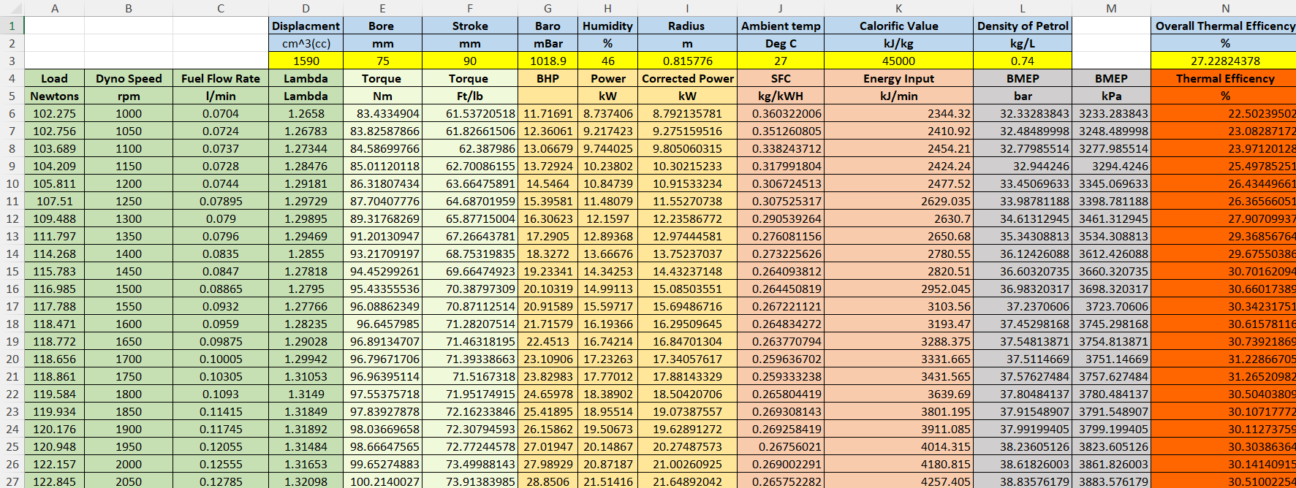
Data

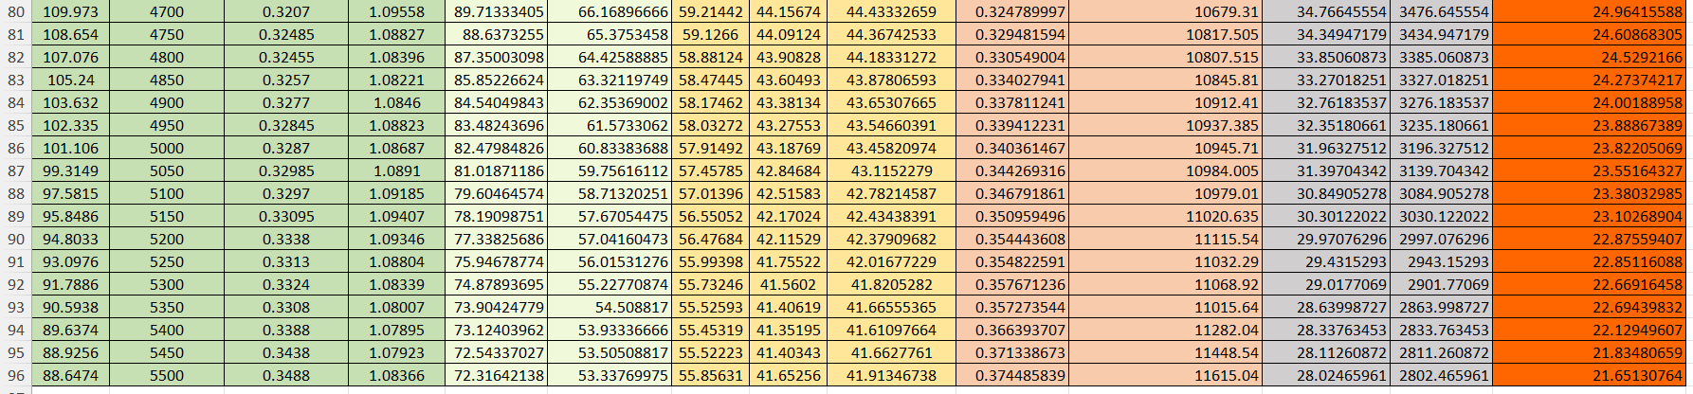
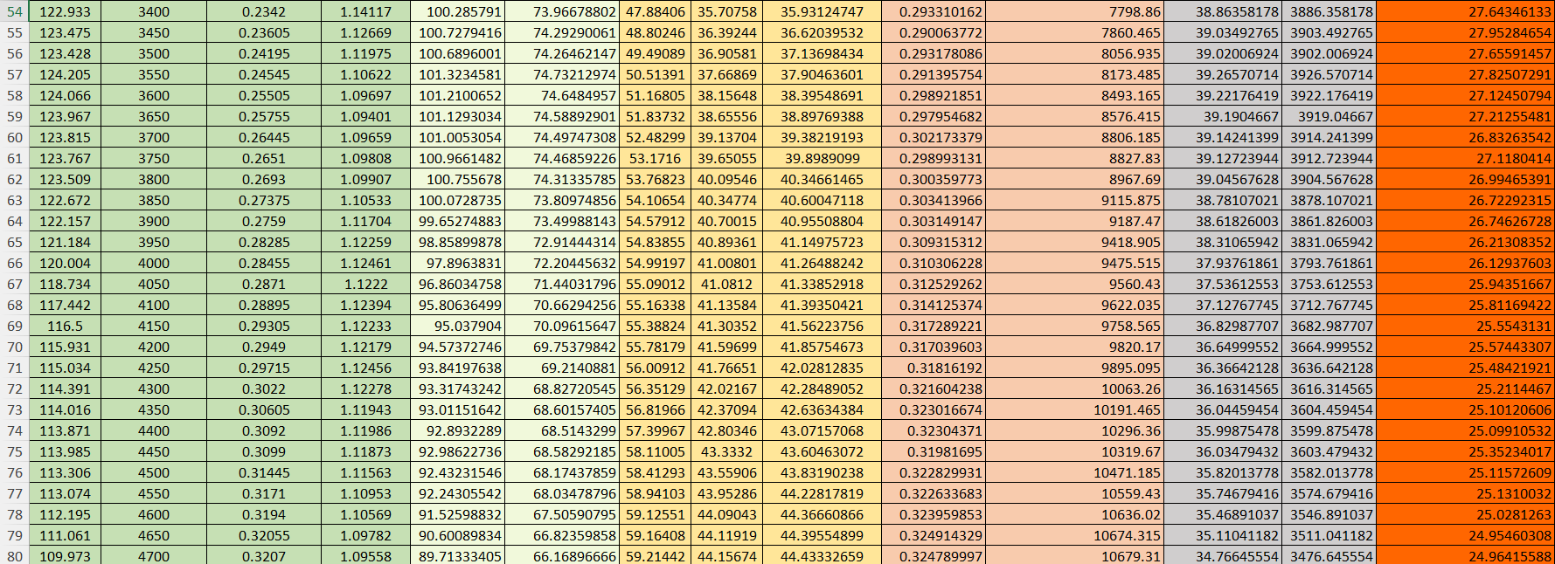
Below is the list of equations used to work out all the values for the table:
Torque:
$$Torque(Nm)=Load*0.815776$$
$$Torque\left(\frac{Ft}{Lb}\right)=Torque\left(Nm\right)*0.73756$$
The conversion to form Newton Meter to Foot-Pound is 0.73756 according to Szyk (2024).
Brake Horsepower(BHP):
$$BHP=\frac{Torque\left(\frac{Ft}{Lb}\right)*Engine Speed(rpm)}{5252}$$
Brake Power:
$$Power\left(kW\right)=\frac{Torque(Nm)*Engine Speed(rpm)}{9549}$$
Corrected Power:
$$Correted Power\left(kW\right)=Power\left(kW\right)*\frac{Atmospheric Pressure(bar)}{Baro(bar)}*√\frac{Ambient Temp(k)}{293(k)}$$

SFC:
$$SFC\left(\frac{kg}{kWH}\right)=\frac{Fuel Flow Rate\left(\frac{l}{min}\right)*0.75*60}{Corrected Power(kW)}$$

BMEP:
$$BMEP\left(bar\right)=\frac{2π*Torque(Nm)}{(Displacment\left(cc\right)÷1000)*0.0980665}$$
Thermal Efficiency:
$$Thermal Efficiency\left(\%\right)=\frac{Corrected Power\left(kW\right)*60}{Energy Input(\frac{kJ}{min})}*100$$

The overall thermal efficiency is the average of all the thermal efficiency at the different engine speed. Overall thermal efficiency should be in the range of 20-30%.

Graphical Results

4.1 Reasons for Graphs and Smoothed Data
To better understand the data, graphs can be used to visually show the relation between sets of data. Graphs mean that engineers can see trends with the data gathered from the tests, make comparisons between sets of data and see how one set of data affects others. For this test there are three useful graphs that can be created SFC vs Engine Speed, Torque vs Engine Speed, Brake Power vs Engine Speed. To create these graphs the data can be smoothed to give better results for comparing and looking at trends this was done in an online smoothing software found at mazurka’s website. Below is the data returned once it had been smoothed by a factor of 0.7.

4.2 SFC against Engine Speed

The graph starts SFC with decreasing from 1000rpm too around 1500rpm where it then proceeds to slowly increase SFC till it reaches the end of the test at 5500rpm. The SFC could starts off high at low engine speeds because the engine runs at relatively low temperatures at low engine speed and there for is less efficient and means more fuel ned to be consumed by the engine to keep the engine running this is caused because of a low load on the engine which increases SFC (Arnold, no date). Russo (2012) says that for petrol as load decreases SFC increase. Once the rpm gets past approximately 1500rpm the SFC starts to trend back up but at a slower rate this is because the mid-range engine speeds are the most fuel efficient. The lower the SFC the better as the engine is using less fuel and there for is more efficient (Suresh et al., 2021).

4.3 Torque against Engine Speed

The graphs starts with the torque of the engine lower than it increases till around 2500rpm and then it slowly decreases till it hits the end of the test at 5500rpm. At lower engine speed more torque is needed to get the car moving and get its power to the road (Arnold, no date).

4.4 Brake Power against Engine Speed

The graph shows how at low engine speed brake power is very low and trends constantly upwards till around 4500rpm when it starts to slowly flatten out as it has reached its peak power. After this it flattens and slowly trend down but not too much till it hits 5500rpm. At low rpms the engine creates torque to get the car moving and power needs to be low to keep it controllable. Then as the engine speed increases power increases with it. This means that the power created by the engine can go to the road and increase the speed of the car.

Conclusion
In conclusion from the data acquired form the test you can see that the peak of torque and low point of SFC are at the mid-range of engine speeds showing that the engine is most efficient from around 2000rpm – 4000rpm. These along with power also show how low engine speed and high engine speeds worse the performance of the engine. All this data proves how there is a range of engine speeds where efficiency is improved, and that the engine should be kept in those conditions for the best performance out.

Evaluation and Improvements

Evaluation of the Test
Due to the dynamometer being broken at the time of the test, the test was not completed by the group, but previously recorded data was used for the results off the test.

Further Improvements
Improvements for if this test was to be ran again would be to have a working dynamometer and be able to record fresh and up to date data and repeat it to get rid of any anomalies that may crop up. Using an average of multiple tests is a better way to gather data as it led to a better set of results for evaluations and to make comments about as they are going to be more realistic and reduce imperfections. Another improvement that could be done is to test the engine with the Morse test so that indicated power can be worked out properly leaving and having more data to compare. The test could also be improved by having the test done at multiple different ambient temperatures to see how the temperature effects the performance of the engine and see if there are any major changes at high and low temperatures which you would expect there to be.

References
Arnold, N. (no date) Technology explained, simply: Torque in cars | BMW.com. Available at: https://www.bmw.com/en/performance/torque-in-cars-explained.html (Accessed: 29 March 2025).
SCHENCK PEGASUS GmbH (2001) Technical Specification Eddy-Current Dynamometer W Series.
Suresh, M., Jawahar, C.P., Renish, R.R. and Malmquist, A. (2021) ‘Performance evaluation and emission characteristics of variable compression ratio diesel engine using Argemone Mexicana biodiesel’, Energy Sources, Part A: Recovery, Utilization and Environmental Effects, 43(12), pp. 1511–1523. Available at: https://doi.org/10.1080/15567036.2019.1648593.
Szyk, B. (2024) Nm to ft-lbs Converter. Available at: https://www.omnicalculator.com/conversion/nm-to-ft-lb#how-to-convert-newton-meters-to-foot-pounds (Accessed: 28 March 2025).

