Student Name: Emily Thomas
P Number 1901425
Programme of Study: Photography in the Arts
Module: M4X01560

Tasks in order I received them:
Task One: Semiotic Analysis (Ryan’s task) = 510
Task Two: Manifesto (Julia’s task) = 520
Task Three: Reflective writing (Jon’s task) = 529

Task one: Semiotic Analysis of an image (Ryan’s Task)

“Many of our beliefs are not chosen, we are born into them “ ( Giles Fraser, The Guardian, 2016), As individuals we are brought up into a world where certain things are right and wrong. As people we are thrown into a situation where what we are taught, is all we know until we branch out and learn individually. “we accept the reality of the world with which we are presented” (The Truman Show, 1998) as I would interpret as feeling safe in the things that are familiar making it difficult to see a further meaning behind something.

A big part of the Semiotic knowledge is to be able to find a deeper meaning behind something and knowing how it was created or why it was created. There can be more than one meaning behind a semiotic depending on the persons view of that image. Some can choose to look deeper into an image while others might glance at it seeing something completely different. A meaning in semiotics can be anything that could have another aspect to it. An example for semiotics is called Plato cave, where there’s an image of prisoners chained up to the brick wall, while the shadows are being casted over them on the wall, across the fire. The shadows made objects seem like that but once they move on, they realise that the reality they saw wasn’t the truth.
In June, 2006 there was an advert designed by Blattner Brunner for the toy company Lego. I choose to look at this campaign as I was instantly intrigued by the concept of it. The Lego ad is aimed at children as that is the majority of people who do purchase it. Looking at the ad it is visible that the Lego is meant to represent some sort of imagination to the viewers mind. By using the simplicity of shadows, they have made the once plain red blocks into something more being the airplane. To some people the red blocks are more than just two red blocks on top of each other which is what this ad is trying to say. I think a lot of us can remember building multiple creations with Lego and this advert shows the difference in reality and the truth as again we all know in reality it’s Lego but to someone else it’s a plane. Another aspect of the ad that caught my attention was the background as I initially thought the blue just represented masculinity though I soon realised that it was actually showing the plane in sky. How I look at it I see the plane flying above the bricks which is a great addition to the work. Although it is quite simple it does have a lovely meaning towards it and a sense of innocence as it offers a chance to go back to a younger age where the mind is constantly made up of imagination that runs wild. It also links nicely with how everyone can view something so simple so different.



(Lego by Blattner Brunner, 2006)

Bibliography
Giles Fraser, The guardian (2016) Available here:
https://www.theguardian.com/commentisfree/belief/2016/dec/01/many-of-our-beliefs-are-not-chosen-we-are-born-into-them ( viewed 2019)

The Truman show, (1998)

Plato Cave, The allegory of the cave https://faculty.washington.edu/smcohen/320/cave.htm

Lego image, Blattner Brunner (2006)- https://www.adsoftheworld.com/media/print/lego_plane (viewed December 2019)

Blattner Brunner (2006) advert research – available https://mymodernmet.com/creative-ads-lego-the-shadow/ (viewed December 2019)

Task 2: Manifesto (Julia’s task)
What I believe in?
8 statements:

- Mental health is nothing to be ashamed of.
- LGBTQ + representation in the media is necessary and important.
- Create meaningful messages through my work.
- To always be truthful within my work even though there’s a lot of false news and images.
- Photography is a way to express emotion.
- Young generations are the future and will change the world for good.
- Photography can be a way to make memories.
- Photography can be used as a form of communication.

Photography can be used as a form of communication:

I believe that photography focuses on so many situations and topics that it is able to start conversations by bringing attention to issues that are often not talked about or considered taboo. A campaign called “let’s talk”, (by mental health up), believe that photography can bring attention to mental health by “enabling conversations around mental health through the medium of photography.” (https://mentalhealth-uk.org/blog/lets-talk-using-photography-to-talk-about-mental-health/) by this they are able to use something so simple to bring awareness to something so important.

Daniel Regan is a photographer who focus on mental health and uses Photography as a way to communicate the issues he’s witnessed and also dealt with as a health visitor. “ I have always turned to photography to express the feelings of a fragmented identity, of my mind splitting apart and into something destructive, something unknown.” Photography to him is a way to speak about it without actually speaking about it, as I do feel that way with my own work, I understand. His work is unbelievably powerful and starts multiple conversations on mental health.
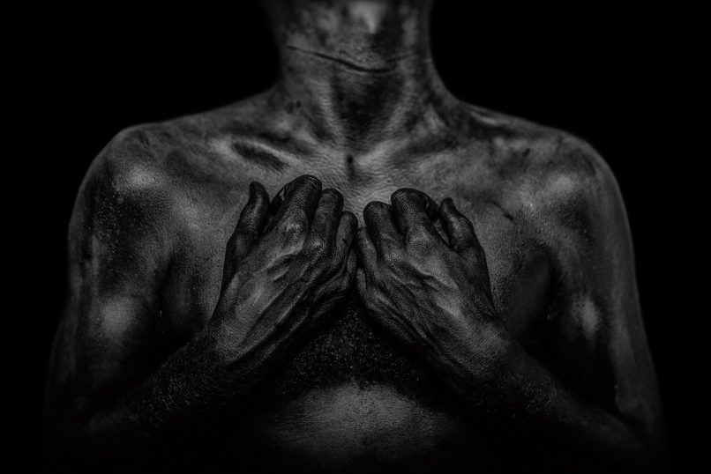

Fragmentary, Daniel Regan
Young generations are the future and will make change for good:

As a young person myself in this day and age I believe that we do want what’s best for our future, wanting change for the better. “ "We, young people, are the future of our community and the future of our country." (young parliament, 2018) a lot of young people from my perspective want change such as the amount of climate change protests or the general election. Students from all around the UK went protesting to state what they believe in and I believe these actions as well as how involved young people are will change the whole dynamic of the future.

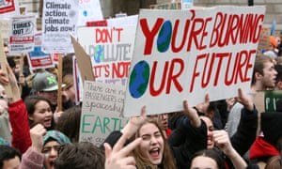
(the guardian, 2019)

To always be honest in my work even when there’s a lot of false news and images:
One thing that I will always stand by is being truthful and honest in my work as that to me is a very important factor for me to get to the best of my abilities. Especially due to the fact that in this day in age there is a lot of false or inaccurate articles and images that circulate our internet making it difficult to know what to believe in and what not to believe in. An example of this would be that in the 2019 general election Boris Johnson said that he wouldn’t sell the NHS or privatise it, though after he won, he’s began to privatise some bits of it. “The Tories claim the NHS is not up for sale – the truth is, it’s already been sold” (independent, Grace Blakely 2019) which shows that Johnson lied for more people to vote for the conservatives.


( 2019 express https://www.express.co.uk/news/uk/1130972/brexit-news-court-case-battle-bus-NHS-boris-johnson
It is important for us as a society and myself as an individual to always portray the truth in our work as it can make the world a better place. Also, by adding more truth into the world I think it’d make it a more trustworthy place especially in peoples work.

Bibliography
Lets talk, Mental health UK (viewed 2019) https://mentalhealth-uk.org/blog/lets-talk-using-photography-to-talk-about-mental-health/

Daniel Regan, Fragmentary (viewed 2019) http://danielregan.photography/fragmentary/

Young parliament (2018) https://www.youthparliament.wales/blog/2018/9/17/we-young-people-are-the-future-of-our-community-and-the-future-of-our-country (viewed 2019)

The guardian (2019) https://www.theguardian.com/environment/live/2019/apr/12/youth-climate-change-protests-across-britain-live

Grace Blakely, Independent (2019) https://www.independent.co.uk/voices/nhs-privatisation-sale-boris-johnson-conservatives-general-election-a9241881.html

Express (2019) https://www.express.co.uk/news/uk/1130972/brexit-news-court-case-battle-bus-NHS-boris-johnson

Task 3: Reflective writing ( Jon’s task)

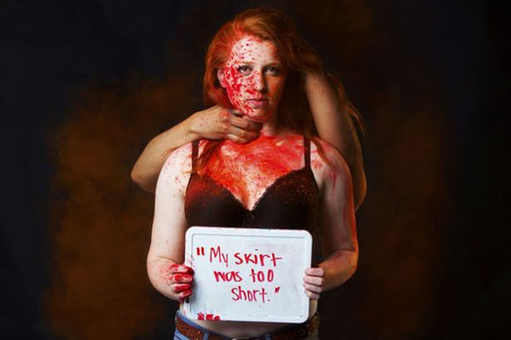

In the above there is a woman standing holding a sign saying, “My skirt was too short”, while she’s covered in red paint (that I assume represent blood) while somebody is behind her holding on to her neck, wrapping around the woman’s body. This is instantly powerful as without needing an explanation you automatically know something bad has happened to her. The sign that she’s holding shows that she might’ve been blamed for what has happened to her. This struck me more because as a woman these are the things I fear and am always aware of in my day to day life. I also know many other women and girls that are also fearful of this situation happening to them, as well as some men as this situation can happen to anyone. As women we are constantly told to be cautious of what we wear around people, but those people are never told that they’re in the wrong. The sign really struck a chord with me as I’ve read a lot of situations where the girls are told that what they wear are to blame for getting sexually harassed or assaulted. There was a story that a teacher in Australia was brought into the public eye when she said “All men have to fight their urges every day not to sexually assault or abuse [women]” (Maya Oppenheim, independent, 2019) which is a disgusting mindset as it is blaming the victim for getting sexually assaulted as men have urges to deal with is just wrong and makes them not want to open up about what happened to them. It’s as though she is saying that men are victims of having these urges and that if someone was to get sexually abused or assaulted, it would be your own fault for tempting the urges.
The artist behind the image is Yana Mazurkevich, wanted to start a conversation on rape culture, inspired by the Stanford University rape case where the victim had written a letter to the rapist that was readout in the court case. What makes this photo more gripping is that the words that are written on the board that the woman is holding in the picture is actually that woman’s words to her own experience which also make it quite sad on the fact that people go through this in today’s society. Within this series of photos while also trying to start a conversation she also creates an insight into victims and how they get blamed by their assault or how they are shamed.
I think this work is very inspirational and powerful especially as “ around 15% of those who experience sexual violence report to the police” (https://rapecrisis.org.uk/get-informed/about-sexual-violence/statistics-sexual-violence/) which I believe is to do with people being afraid to get shamed or blamed for what happens to them which definitely needs to change.
After going into more depth and researching the images, it is more affective and powerful as well as upsetting as so many people deal with this kind of thing on a regular basic. Overall, it made the image much harder to look at but in a good way as this is real and happens.

Bibliography
Maya Oppenheim, independent 2019 https://www.independent.co.uk/news/world/australasia/teacher-pupils-clothing-rape-women-swansea-high-school-new-south-wales-australia-a9174431.html

https://www.dailymail.co.uk/femail/article-3665594/Powerful-photo-series-reveals-reasons-women-BLAMED-sexual-assaults.html

