CertHE Skills for the workplace
Module: BMSK 4002
Title of report: Communication skills in the workplace
Number of Author: 1709301
Name of host: Trinity Saint David
Date of publication: 13th July 2018
2000-word report

- Executive Summary

This report is an investigation of the communication issues caused within the social services in the local council. It is important to identify the problems and suggest and discuss using development tools and theories to enhance communications skills and using verbal and non-verbal communications. Discussion of importance of effective team and management. Conclude what the main issues are and how to improve them using recommendations to the head of service Andrea Jones. it is important that cases of social work should be handled correctly and professionally, if errors made can affect the public causing consequences for the organisation. Employees complained of inadequate communication for process and standards. No two-way feedback from head of manager. Teams being formed frequently, unexplained absence. The object of this study is to explore staff’s perspective of un acceptable practice and workload of pending unresolved cases. A report was published with the concerns of the issue with Andrea making first approach to fill in manager positions, so that teams will lead clearly with a goal. It has perceived that the cause of these issues is that there is no ownership from the management team to sustain the department. No mechanism no authority.
Employers need employee engagement survey to establish ways to improve their business and work ethics and the need to make changes within the workplace they need to listen to concerns of staff and feedback. Feedback by managers enhances and builds trust and elevates negative assumptions. Feedback helps to see things from the perspectives of others; colleagues, clients, managers and employees.

Contents
2.0 Introduction……………………………………………………………………………page 4
3.0 Findings……………………………………………………………………………. page 5 – 9
- Conclusion………………………………………………………………………...page 10
- Recommendation………………………………………………………………page 11
- Appendix……………………………………………………………………………page 13 - 15
- Reference…………………………………………………………………………. page 16 - 17

2.0 Introduction

Communication is the exchange of thoughts, information and ideas that result in mutual understanding between two or more people. This report is about the Social Services in the local council, the service has been facing issues in managing and directing teams. The researcher will discuss how important it is to maintain and effective environment within the workplace through effective communication. Discuss learning models that can contribute to a better outcome of the situation. The researcher will conclude and recommend on the report.
A leader needs two-way communication via all communication channels when a message has been received it requires feedback so that all social workers receive the same information.
“Good feedback can build confidence and self esteem. Similarly, being willing to disclose to others will enable them to get to know us better and will encourage open two-way communication.” (Bassot, 2016, p102)
Andrea Jones the new head of social services will need to re-evaluate the seriousness of this issue and take appropriate action to ensure that all informal and formal discussions are liaised with all employees’, they all need to be involved and notified of changes of system and procedures in advance before the changes act within the workplace. It is important to be clear about what’s changing and why.
“How change is managed can also have a critical impact on the wellbeing at work is strongly linked to having a degree of control over the job and how it is done. Giving employees a voice in how change is managed can help maintain their sense of wellbeing. Badly managed change can cause long-lasting resentment and ill feeling that can lead to a breakdown of trust which damages employment relations and morale.” Univeristy of Cambridge (2018)

3.0 Findings

3.1 Issues
3.1.1 The researcher has found that there are many issues, reporting of two location, unfair outcome for families, teams have different standards and processes – inconsistency, sensitive cases of children are involved. Poor management – managers did not take accountability for others in the team because it’s not their job, a problem shared is a problem halved. Relationships between social workers were poor. No proper induction day and no rewards, incentives for staff. Shortage of staff. No feedback “It is clear that good feedback enhances growth and professional development, and is constructive and supportive whilst being challenging at the same time.” (Bassot, 2016, p94)
‘People who work in an effective team often feel that there is less pressure, as things are shared. They feel the working atmosphere is better because of the camaraderie and the sense of pulling together, even when things are tough. As a result, they gain more job satisfaction.’ Powley (2012)

3.1.2 Barriers to communication was that managers did not communicate effectively as previous manager was very ‘hands off’ he liked to stay in his office and communicate by email and too busy to reply to any questions. Here is a list of communication methods compulsory to use;
- Verbal
- Telephone
- Voicemail
- Email
- Online
- Letters
- Media
‘keepings a keen eye on all of your team may provide difficult, but by ensuring your staff feel comfortable to discuss any work/project issues and receive guidance, can boost teamwork, maintain morale and avoid decline in productivity.’ Haughton (2017)

3.1.3 Staff have been under-performing due to teams were constantly halted at the forming stage. “During stage one interpersonal interactions, are tentative, superficial, lacking confidence and uncertain. There is an absence of trust among members. Consequently, they look to the assigned leader for direction and guidance”. (Haynes, 2012 P.9) Managers need to be involved and help staff with performance. staff are reluctant to form with new staff as the they have not been able to over-come the barriers of introduction. “Conformity tends to be high and conflict low or non-existent. Member roles are unclear and undefined. Communication structure tends to be centralized with information among members being filtered through the assigned leader”. (Haynes, 2012 p.9)
Team leaders need to coach and mentor staff and help encourage staff to build confidence, develop further and overcome obstacles. An employee will go through trial and errors before they are able to be confident and adapt in the environment.
“Organizations embark on coaching programs for a variety of reasons. At the individual levels, coaching might be recommended to help employee through career transition, deal with a particular workplace challenge, or as a form of remedial action to improve performance.” (Ungemah, 2015 p.146)

3.1.4 The Researcher has identified 2 teams are situated in a different building due to convenience for staff members and client as the location is near client-based area. The teams are separate as this reduces congestion for travelling. The staff however feel that they are not regularly updated with new policies, procedures and are astonished with new terms and conditions.

3.1.5 New staff not given induction or full training. Teams are always on forming stage. New staff not giving adequate training. Induction day should be encouraged.

3.1.6 Shortage of staff causing pressure, poor performance, reduced team meetings. Teams not having permanent managers. work related stress can cause absence and emotional turmoil. ‘in the short-term, understaffing can be caused by sudden illness to members of your team or annual leave, while it may also be a more long-term issue caused by a substantial increase in customers, clients, and workloads or major employee redundancies.’ Haughton (2017)

3.2 Impact

3.2.1 Social service have an obligation to protect and safeguard, encourage the welfare of vulnerable infants, children and families. CSW (2018) Managers need to communicate with employees for update of employee’s individual cases. Social work is a sensitive, fragile environment when involving infants and children. Teams have different process and standards causing risk for families. Whereas one social worker feels a child is at risk, another social worker may overturn that decision because of different process and guidelines. Consequence of making inaccurate assessment may cause harm to the child/children.
‘Being a social worker is often challenging yet rewarding career. Social worker are responsible for helping individuals, families, and groups of people to cope with problems they’re facing to improve their patients’ lives.’ Fanning (2018)

3.2.2 Having induction day allows new employees to feel welcome and help overcome emotional barriers. Induction does not require to be formal, however induction needs to be planned in advance to ensure all colleague are treated with respect. Having a planned structure helps to retain employees.
Induction is an essential part of on boarding your new recruits and familiarising them with your organisation. Getting the induction process right can help you get new employees up to speed and productive as quickly as possible. As an employer, your staff are your most important asset. Induction gives you the chance to welcome new employees and build on their positive attitude and enthusiasm for their new job. It's an opportunity to familiarise new members of staff with your organisation and to introduce them to their immediate colleagues and other members of the wider workforce. It's also an ideal opportunity to familiarise new recruits with your organisation's policies on areas such as health and safety, equality and discrimination. Acas (2012)
Induction day covers many important parts of the employment,
- terms and conditions of employment
- rules and regulations
- employee benefits and incentives
- contact details
- office equipment being setup.
- Dress code.
- Health and safety
It is necessary for colleague introduction in order for team building, tackling problems, finding solutions, and delivering results. Teamwork is key to better consistency, team is a definition of people with a common goal, all staff have the same goal, success for the organisation in the appropriate way. It is important to have induction whatever the environment of the workplace.

3.3 Supporting models to enhance effective teamwork

3.3.1 Managers are required to take leadership, ownership of any unexpected situation to sustain the issue.
“The leader role is that of performing the management functions (planning, organizing, leading, and controlling) to effectively operate the managers’ unit to accomplish organizational objectives. Therefore, the leader role influences how the leader performs other roles.” (Lussier and Achua, 2016 p.11)

3.3.2 Communication Cycle
A communication cycle needs to be used to send and receive messages and feedback is required. In 1948 Claude Shannon, American mathematician and electronic engineer and Warren Weaver an American scientist. They developed The Mathematical theory of communication in 1949. Businesstopia (2018) (appendix 1)
“It is a transmission model consisting of five elements: an information source, which produces a message; a transmitter, which encodes the message into signals; a channel, to which signals are adapted for transmission; a receiver, which decodes (reconstructs) the message from the signal; a destination, where the message arrives. A sixth element, noise, is a dysfunctional factor: any interference with the message travelling along the channel (such as static on the telephone or radio) which may lead to the signal received being different from that sent”. Oxford reference (2018)
Shannon and Weaver believe that there should be two-way communication and feedback is relevant for transformation and improvement.

Why is Shannon and Weaver Recommended for Social Services?
This theory will help overcome the issue of managers being incompetent and not encouraging feedback or two-way communication. This cycle is a clear breakdown of communication effectively without message being misinterpreted. Staff and victims are being impacted due to content and uncertainty and this development tools need to be utilised for better outcome. The issues of different process and procedures should be made clear to all employees with this model.

David Berlo’s model of communication 1960, (see appendix 2) this model has no concept of feedback or two-way communication, both the sender and receiver have to be similar and have same level of understanding. This model is useful as they breakdown the process of communication.
“Managers generally are responsible for a team of people to whom they provide leadership and guidance. It is usual for them to be in direct contact with their team, but some managers are in charge of a virtual team. This is a work group whose members work in different locations, including at home, and are engaged in interdependent tasks; ie are truly teams and not just groups of independent workers. The virtual team manager has to exercise remote control through electronic means such as the internet and Skype, and telephone or video conferencing will be used for team meetings”. (Armstrong 2016 p34)
Is Berlo’s a suitable communication cycle?
Berlo’s model is effective as the message is transmitted, however equally insufficient as it does not have the transmission of feedback. Managers can integrate this model with Shannon Weaver to make it work. With social work communication needs to be efficient as there are timeframes for cases and without feedback employees can not progress further with investigations or achieve an outcome.

Wilber Schramm’s model of communication 1954. (Model images on appendix 3) A team needs to voice their opinions and feedback without fear to solve issues within the workplace. Any communication that is received and not responded is incomplete and ineffective. This cycle allows both sides to take turns to send and receive messages. Circular communication gives both parties opportunity to give their opinion. Feedback helps to know if the message intended has been interpreted accurately.
‘Schramm believed that an individual’s knowledge, experience and cultural background also play an important role in communication. Individuals from diverse cultures, religion or background tend to interpret the message in different ways.’ Juneja (2018)

Is Schramm’s model beneficial for Social Services?
Schramm model will be a great asset to the team as this tool allows feedback, opinion, so that there is a clear perception that the message has been clearly received and acknowledged, it is calm process as both sides take turn to voice their opinions. As there is vulnerable people and public involved in daily cases it is advisable to use models that can help break down the communication barriers and all aiming for a good case result.

3.3.3 Belbin Team roles
Dr Meredith Belbin (1981) created 9 team roles it is a method to identify behavioural contribution to the workplace. (see appendix 4) This model is used and is the path that most teams follow on their way to high performance. it is an international tool , Belbin team role is a motivated tool that can probe managers to use to identify and analyse strength and weaknesses of each team member and assigning each employee to the relevant role. Creating new team of mixture of different people with range of different behaviours will have a better, positive outcome. This will encourage balance within the team which enables to focus on success and achievements.
“Subsequent research has also demonstrated that teams consistently outperform individuals when dealing with high-risk complex issues where a wide range of complementary behaviours is required.” Belbin (2018)

Why is Belbin Theory useful for Induction day?
This tool will allow new managers to analyse newcomers to see what their behaviour is, this helps to forecast and plan in selecting teams so that each team have different behavioural roles. This will help team members to know each other and minimise conflict with the collaboration of stages of team development with the Tuckman Model. Employees should not need to feel spectacle or hesitant to approach colleagues with help with social work or cases if they know each other’s strength, weakness and interests.

3.3.4 Bruce Tuckman 1965
Bruce Tuckman (1965), is an exquisite tool for teambuilding, it is a very simple and straightforward illustration of how teams form and develop. Miller (2014), managers need to use this method (appendix 5) The model has 5 stages of forming-storming-norming-performing-adjourning. Each of these stages have important concepts, the forming stage helps managers help build relationships, storming is relevant to establish conflict within the team, norming stage the conflict has now been resolved by leader, and the goal for success is set, performing stage is when managers motivate team, building trust, adjourning stage is the success of the accomplishment of the project or task.
“Tuckman’s model is significant because it recognizes the fact that groups do not start off fully-formed and functioning. He suggests that teams grow through clearly defined stages, from their creation as groups of individuals, to cohesive, task-focused teams.” The happy manager (2018).

Why is Tuckman theory useful for Induction day?
Tuckman tool help with forming teams, storming stage will identify any conflict during team building, this will help managers to help resolve issues within the team with mutual accountability. This tool will help overcome barriers and minimise problems. Team bonding activities improve workplace projects that involve working together. This model can be used in conjunction with Belbin Team Role or integrated during the forming stage with different characteristics. Social workers should all have mutual agreement during investigating sensitive cases with all team members focusing on the better, positive outcome, they need to be on the same platform. Performing together for the best outcome.

4.0 Conclusion

The researcher has found that previous manager did not communicate with staff appropriately, despite occasional meetings face-to-face, the meeting was one way. Staff were given information however feedback, concerns and suggestions were not acknowledged. Staff have expressed their concerns to their team leaders who have tried and attempted to intervened and tried to approach manager with staff ideas and innovation which has been limited and un-noticed, this has frustrated employees tremendously and this causing conflict and one of many reasons of why high absence and resignation. The researcher has concluded that the social services required major amendments on their communication process, improvements on induction day. Managers need to communicate with all staff from hierarchy to descending, workload should not be left responsible to managers and deputy team managers. Regular feedback is required two way this can be through work email or daily staff meetings.

New manager should use technology, software that will allow all members of the organisation to receive the same briefs that should be read by all staffs across the company. Electronic devices need to be used where all staff need to log in every day to read briefs, notices, changes and check daily itinerary, schedules, breaks, location and as this is social work all staff should report on the system of their whereabouts for health and safety across the 2 buildings. When regulations change staff need to acknowledge that they are aware of this by ensuring that managers are aware that the mails/briefs have been read by all staff. This will give a forecast of absence staff or staff on annual leave are updated of the changes ASAP when they are schedule in the workplace in the future. Manager will need to use software to monitor that all staff have read upon the changes within the workplace, as well as acknowledging verbally that all staff understand the new policies and changings implementing and any concerns needs to be raised immediately to resolve conflict.

5.0 Recommendation

To improve the Social Services in the Local Council, here are a few recommendations for Andrea Jones the new head of service;
- Review social work cases more frequently so the public are not disadvantaged
- Managers need to communicate with all staffs effectively two way
- Create employee engagement survey
- Regular training for Managers and employees
- Team representative
- Rewards and incentive – chocolate, season tickets, day off, vouchers
- Organisation invest of software from external companies to communicate with staff with briefs, changes to T&C, policies, annual holidays
- Use Belbin model, Tuckman model, for developing new teams and adjusting existing teams
- One to one coaching, mentoring individually
- Face to face communication – building trust
- Induction day
- Monthly training
- Staff forum/ discussions of issues
- Health and safety – weather warnings

It is very important that all organisations have communication two way, this will enhance trust within the workplace. To help with communication Managers should utilise communication models;

- The Shannon-Weaver Mathematical Model 1949
- Berlo’s Model of communication
- Schramm’s Model of Communication 1954

To help with forming teams and help building relationships with colleague’s teamwork models are useful for managers;

- Belbin 9 team roles 1981
- Bruce Tuckman 1965

By completing Belbin team type questionnaire will give scoring of the questionnaire, which will evaluate individual’s behaviour role. For managers and teams to exceed their goal expectations/targets they need to understand the Belbin team role model to avoid being stuck in the forming, storming stage of the Tuckman model.

6.0 Appendices



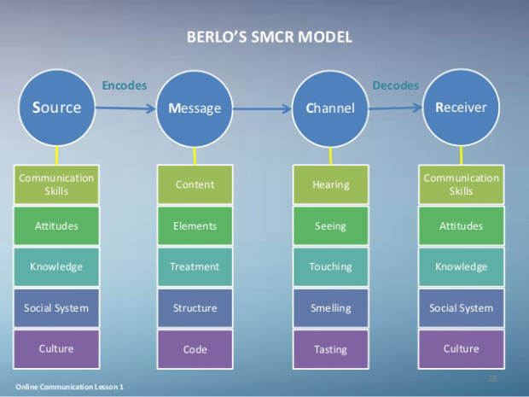

3.
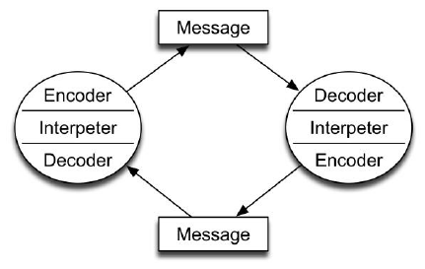

4.

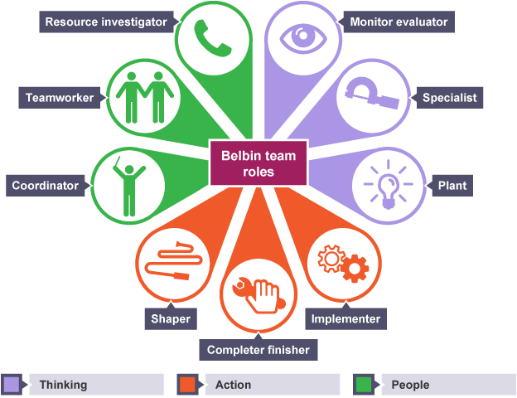

5.
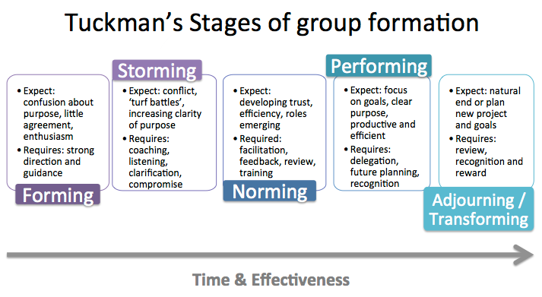
Effective team benefit from;
- Better outcomes
- Efficiency
- Mutual support
- Boost productivity
- Encourages innovation
- Improves moral
- Reduces conflict
- Allows flexibility
- Better ideas
All these can be achieved in great teamwork if the manager of the group has skills to manage and experience. A manager should have skills in;
- Motivation
- Encouragement
- Trust
- Communication
- Empathy
- Sympathy
- Offer incentive
- Bond
- Contribute
- Respect
- Be fair
- Commitment
- Awareness
- Responsibility
- Maturity
- Honest
- Listening

7.0 Reference list
Internet

Acas (2012) Induction: getting the first few days right.
Available at : www.acas.org.uk/index.aspx?articleid=3754
(Accessed: 16th August 2018)

Apex Leadership LTD (2018) Teamwork Theory.
Available at: http://the-happy-manager.com/articles/teamwork-theory/
(Accessed: 21st September 2018)

Belbin (2018) why use Belbin, In recruitment and career development
Available at: http://www.belbin.com/about/why-use-belbin/
(Accessed: 26th September 2018)

Bussinesstopia (2018) Communication, Shannon and weaver model of communication
Available at: http://www.businesstopia.net/comunication/shannon-and-weaver-model-communication
(Accessed: 26th September 2018)

CSWM (2018) Childrens social work matters, roles and career progression
Available at: https://www.childrenssocialworkmatters.org/csw-roles/
(Accessed 8th October 2018)

Fanning, J. (2018) MSW online programs.org blog
Available at: http://mswonlineprograms.org
(Accessed: 1st October 2018)

Haughton, J. (2017) CMI 5 ways to achieve top results from your short-staffed team
Available at: http://www.managers.org.uk
(Accessed: 1st October 2018)

Juneja, P. (2018) MSG Management study guide
Available at: https://www.managementstudyguide.com/schramm-model-of-communication.htm
(Accessed: 1st October 2018)

Oxford Reference (2018) Shannon and Weaver Model.
Available at :www.oxfordreference.com/view/10.1093/oi/authority.20110803100459436
(Accessed: 16th August 2018).

University Of Cambridge Organisational change guidance, Implementation of Change, Managing change effectively.
Available at: http://www.hr.admin.cam.ac.uk/policies-procedures/organisational-change-guidance/organisational-change-guidance-6
(Accessed: 26th September 2018)

E-books

Armstrong, M. (2016) Armstrong’s Handbook of management and leadership for HR. 4th ED. London: Kogan page LTD

Bassot, B. (2016) The reflective practice guide, An interdisciplinary approach to critical thinking. London, New York: Routledge LTD

Bassot, B. (2016) The reflective practice guide, An interdisciplinary approach to critical thinking. London, New York: Routledge LTD

Lussier, R.N and Achua, C.F. (2015) Leadership Theory, application & skills development. 6th ED. Boston: Cengage Learning

Haynes, N.M. (2012) Group Dynamics, Basic and Pragmaticsfor Practitioners. Lanham: University press of America

Ungemah, J. (2015) Misplaced talents A guide to better people decisions. USA: John Wiley & Sons

Article/ Journals

Harris, G. (2011) Five steps to achieve remarkable communication results, The Kevin Eikenberry group. P2
Available at : www.kevinEikenberry.com , www.ultimatecommunicatorworkshop.com

Powley, T. (2012) CMM TEAM WORK IN CARE HOME P44

Miller, T. (2014) TJ training journal engaging leadership p22
Available at: www.trainingjournal.com

