Academic Report – Portfolio

BA Leadership and Management

Ricardo Alexandre

2025546

BMWSW6101

Emergent Leadership Skills in the Workplace

Lecturer: Dr Sujeewa Herath

July 24, 2023

Table of Contents
Academic Report Part 1 2
Introduction 2
A. Effective Leadership Skills 3
1.1 Administrative Skills: 4
2.1 Interpersonal Skills: 4
3.1 Conceptual Skills: 5
B. Effective Leadership Styles 6
C. Tackling the Barriers to Leadership in the Workplace 9
D. Ethical Leadership 11
Conclusion 15
Reflective Report Part 2 16
I. Introduction 16
I. Conceptualising Leadership 17
II. Ethics Leadership Style Questionnaire 18
Reference: 20
Appendix A 23
Appendix B 24
Appendix C 25

TABLE OF FIGURE/TABLE

Figure 1. Source: Introduction to leadership: Concepts and practice (Northouse., 2019, p.1). 4
Figure 3. Source: In Practise Leadership Ethic (Crossan et. Al., 2017). 12

Table 1. Sources: Transactional versus Transformational Leaders (Den Hartog,1997). 9
Table 2. Comparing Barriers of leadership in some organisations (Appendix C). 10
Table 3. Source: Characteristics of leadership style concepts (Crossan et. Al., 2017, p.1). 13

Academic Report Part 1

Introduction
Effective leadership is crucial for the success of an organisation, impacting employee engagement, productivity, and overall performance. This report critically analyses various aspects of effective leadership in the workplace, including skills, styles, barriers and ethical behavior.
Leadership involves inspiring and influencing others, making informed decisions, and navigating challenges. Developing skills is important to meet evolving demands and create an environment where individuals thrive.
The report examines essential leadership skills like communication, decision-making, problem-solving and emotional intelligence. Evaluating personal abilities helps assess effectiveness within established leadership styles.
Different leadership styles, such as autocratic, democratic, transformational and servant leadership, have strengths and limitations in various scenarios. Strategies to overcome barriers like resistance to change, inadequate resources and ineffective communication are explored.
Ethical leadership, based on integrity, fairness, and transparency, considers stakeholders' needs and values. It fosters trust and accountability within the organisation.
In conclusion, effective leadership requires a combination of skills, styles and ethical principles. Evaluating personal abilities, assessing strategies and planning for change enhance effectiveness. Continuous development empowers leaders to adapt and drive teams towards shared goals in a dynamic workplace. Also, scenario as NHS.

A. Effective Leadership Skills
It is skills involve guiding, influencing and inspiring others to achieve common goals, navigate challenges, make informed decisions and foster positive relationships (Northouse, 2019). Three key categories:

- Administrative Skills:
Administrative skills involve effective planning, organisation, goal setting, resource allocation and monitoring progress.
- Interpersonal Skills:
Strong interpersonal skills enable leaders to effectively communicate, listen and empathise, fostering collaboration, conflict resolution and motivation.
- Conceptual Skills:
Strong conceptual skills enable leaders to identify patterns, trends and opportunities, set long-term objectives and develop innovative strategies.

Figure 1: Core Leadership Skills
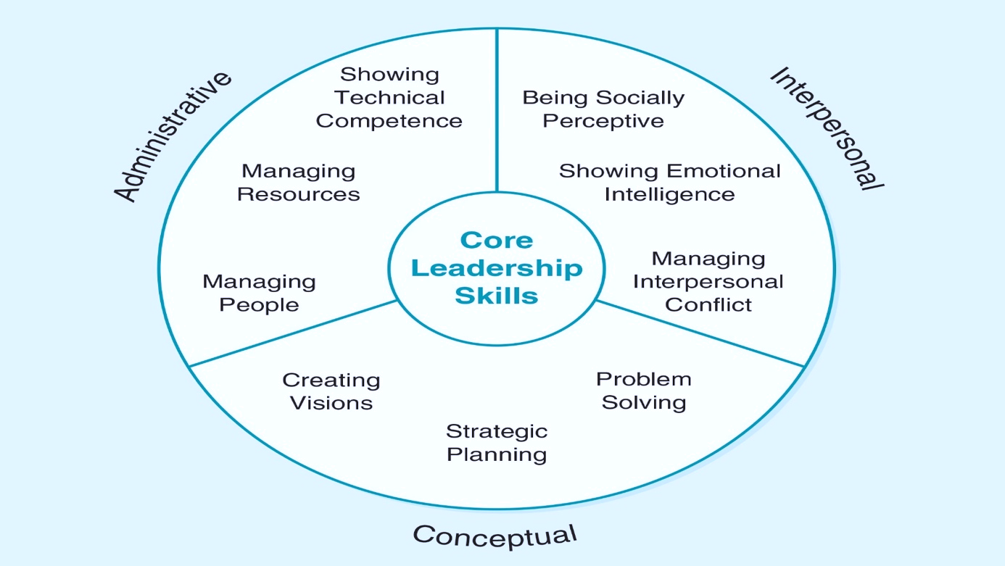
Figure 1. Source: Introduction to leadership: Concepts and practice (Northouse., 2019, p.1).

1.1 Administrative Skills:
- Planning and Organising:
Effective leadership requires administrative skills for resource management, coordination and efficient operations.
- Decision-Making:
Leaders need strong decision-making skills to consider different perspectives, weigh risks and benefits and choose the best course of action.
- Time Management:
Leaders must be able to prioritise tasks, meet deadlines, optimise productivity, delegate and allocate their time efficiently.

2.1 Interpersonal Skills:

Leaders need strong interpersonal skills for positive relationships, effective communication and collaboration.

- Communication:
Effective leaders possess skilled communicators who effectively express themselves, actively listen and convey information.
- Empathy: Empathy-driven leaders foster a supportive, inclusive work environment, demonstrating genuine concern for others and considering individual differences.

- Conflict Resolution: Leaders should possess strong conflict resolution skills to resolve disagreements and create a harmonious and productive work environment.

3.1 Conceptual Skills:
Enable leaders to think strategically, analyse complex situations and envision the future. Some key conceptual skills include:
- Critical Thinking:
Effective leaders can think critically to solve problems, make sound judgments and anticipate potential challenges.
- Strategic Planning:
Leaders with strong strategic planning skills can develop long-term visions, set goals and devise strategies to achieve them.
- Innovation:
Leaders with innovation skills can think creatively, challenge the status quo and foster a culture of innovation to drive positive change.
Continuously developing and refining leadership skills is crucial for effective problem-solving, team inspiration and organisational success.
Effective leadership requires communication, emotional intelligence, decision-making, adaptability and resilience to guide and inspire teams:

- Communication:
Effective communication boosts employee engagement, satisfaction, and performance (Eisenbeiss et al., 2008). Open, transparent communication is crucial for clarity, reduced anxiety and employee trust (Bordia et al., 2004).
- Emotional Intelligence:
It is positively impacting leadership effectiveness, enabling leaders to navigate social situations, build strong relationships and inspire teams (Goleman et al., 2002). Emotional intelligence is crucial in crisis situations, enabling leaders to demonstrate empathy and manage emotions effectively.
- Decision-Making:
It involves analysing information, evaluating options and fostering team ownership (Yukl, 2010). NHS requires healthcare professionals' involvement in decision-making for patient care.
- Adaptability:
In healthcare requires effective leadership, navigating uncertainty, innovation and embracing change (Huy, 2002). Adaptable leaders inspire and motivate teams to embrace change and find creative solutions.
- Resilience:
Resilience involves overcoming setbacks, maintaining focus, inspiring teams and improving organisational performance (Hochwarter et al., 2003).
The essay highlights the significance of interpersonal and conceptual skills in leadership in the NHS context. Interpersonal skills, like communication, empathy and conflict resolution, are crucial for building positive relationships, fostering collaboration and creating a supportive work environment. Conceptual skills, like critical thinking, strategic planning and innovation, enable leaders to analyse complex situations and envision the future. Continuously developing and refining leadership skills is essential for problem-solving, team inspiration and organisational success. The most suitable leadership style for the NHS is one that combines strong interpersonal and conceptual skills, enabling effective communication, empathy and constructive conflict resolution. (Smith, 2020).
Article advocates for healthcare leaders' visioning, innovation, collaboration and adaptability in the NHS context, focusing on effective communication, emotional intelligence, decision-making, adaptability and resilience.

B. Effective Leadership Styles

The Achievement-Oriented approach, proposed by John Adair (2007), focuses on setting challenging goals and providing individuals with the necessary support, resources and feedback to achieve those goals. Effective leaders often integrate principles from multiple theories, adapting team members and the organisation.

Four management theories analyse employee perception, management, motivation and organizational effectiveness, revealing contrasting perspectives on perception and motivation.

Theory X assumes employees dislike work and requires control and supervision for productivity. It relies on external control, rewards and punishments for motivation.
This theory may lead to a hierarchical, authoritarian culture, stifling creativity, engagement and is considered outdated in modern workplaces.

Theory Y assumes intrinsic motivation in employees, emphasising autonomy, empowerment and growth opportunities. It promotes a participative, collaborative culture, fostering engagement, creativity and innovation. Managers act as facilitators, allowing employees to contribute and tap into their full potential.

Theory Z, combines Japanese and American management practices, focusing on long-term employment, teamwork and supportive work environments. It promotes a strong organisational culture, long-term relationships and employee development, with implications for organisational success.

Theory A emphasises agility and adaptability in response to rapidly changing business environments. It values employee growth mindset, continuous learning opportunities and quick response to change. This theory promotes an innovative organisational culture, encouraging proactive, adaptable and open-mindedness, making it relevant in dynamic industries.

These four theories (A, X, Y and Z) provide insights into management approaches, focusing on employee inefficiency, supervision and micromanagement (Gannon & Boguszak, 2013).

Theory Y, introduced by Douglas McGregor (Cummings, et al., 2010), Theory Y emphasises employee self-motivation, responsibility and initiative. Managers promote empowering, autonomy and a positive work environment to boost motivation and productivity. Theory Z, introduced by William Ouchi (1981). Management practice blends Western and Japanese elements, promoting long-term employment, employee involvement and loyalty. Theory X and Y differ in employee motivation and management, with Theory Y emphasising empowerment, Theory Z focusing on relationships and Theory A highlighting agility. Organisations should consider strengths and limitations, adopting a tailored approach for their unique context and objectives.

Leadership styles, including autocratic, democratic, laissez-faire, transformational, situational, and contingency, significantly impact behaviour and performance (Aithal & Kumar, 2016.).

- Autocratic Leadership: It involves a leader with centralised authority, control over decision-making and a top-down approach. It's effective in situations requiring quick decision-making, clear direction and limited knowledge or experience (Lewin et al., 1939). However, excessive autocratic leadership may lead to decreased motivation, job satisfaction and creativity among employees (Van der Vegt & Bunderson, 2005).

- Democratic Leadership: It promotes shared decision-making, active involvement, collaboration, communication and a participative work environment, resulting in higher job satisfaction and performance (Bass & Riggio, 2006). Involving multidisciplinary teams and stakeholders in democratic leadership fosters diverse perspectives, ownership and commitment in decision-making.
- Laissez-Faire Leadership: It involves minimal interference and guidance, allowing individuals or teams to make decisions independently. It is effective in skilled, self-motivated teams with expertise and experience, but can lead to confusion, reduced productivity and decreased overall performance when there is a lack of structure or guidance. (Avolio et al., 1991).

Additional Leadership Styles:
Transactional versus Transformational Leaders
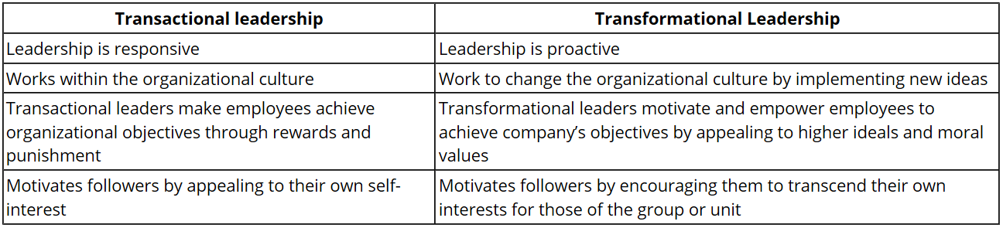
Table 1. Sources: Transactional versus Transformational Leaders (Den Hartog,1997).

Transformational leadership motivates followers to achieve exceptional performance, foster positive relationships and develop potential. (Table 1). It encourages innovation, learning and empowers subordinates in healthcare, driving change and improvement (Den Hartog,1997), (Eisenbeiss et al., 2008).

Situational/Contingency Leadership: Situational leadership adapts leadership behavior based on specific situations, assessing followers' needs and capabilities. Leaders can adopt directive or participative approaches, particularly in healthcare, to navigate complex challenges.
Leadership Style Appropriate for the NHS Context:
NHS requires democratic leadership for complex environments, promoting collaboration, shared decision-making, stakeholder involvement and improved job satisfaction. (Cummings et al., 2010). Democratic leadership in healthcare fosters collaboration, participatory decision-making and engagement, improving patient outcomes and addressing complexities in NHS contexts.

C. Tackling the Barriers to Leadership in the Workplace

Recently, research have shown an increased interest in comparing in class activity on these studies cases link with module session week 9 (Appendix C):

Table 2. Comparing Barriers of leadership in some organisations (Appendix C).
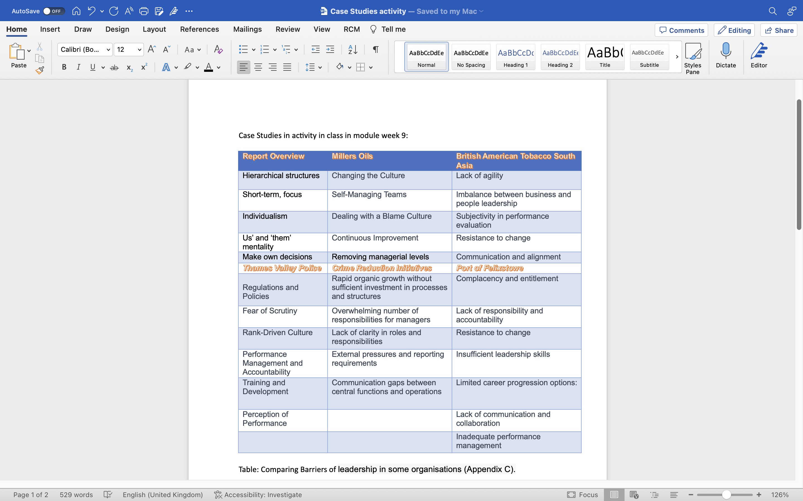
Uncertain times or crises are periods of disruption, volatility and ambiguity that challenge organizations and their leaders.
These situations involve unforeseen events or circumstances disrupting normal operations, requiring effective leadership to navigate complexities and uncertainties. The National Health Service (NHS) has experienced or is likely to encounter several crises due to the healthcare industry and external factors.
The COVID-19 pandemic has significantly impacted healthcare systems worldwide, presenting unprecedented challenges like patient influx, resource shortages and rapid decision-making. The NHS had to quickly adapt and mobilise resources to provide adequate care and protect healthcare workers' well-being. Kruk et al. (2022) emphasise the significance of strong leadership in healthcare crisis management, coordinating response efforts effectively.
Another potential crisis that the NHS might face is a financial crisis. The healthcare sector often operates within constrained budgets and economic downturns or funding cuts can significantly impact service delivery.
Financial crises can lead to resource shortages, reduced staffing levels and compromised patient care. In a study by McKee and Healy (2002), it was found that healthcare organizations facing financial crises require effective leadership to make difficult decisions, prioritise resources and maintain staff morale and motivation.
The article's recommendations on leadership priorities during uncertain times require critical evaluation to assess their relevance and effectiveness in addressing NHS challenges. Clear communication is crucial for accurate information, trust and stakeholder alignment.
Menon et al. (2017) emphasises the significance of communication in crisis management, decision-making and stakeholder satisfaction.
However, a point of critique regarding leadership priorities in uncertain times is the article's emphasis on top-down decision-making. While decisive leadership is crucial in crisis situations, an overly hierarchical approach may hinder innovation, collaboration and the involvement of frontline workers who have valuable insights and expertise. Research by Boin and McConnell (2007) suggests that crisis management requires a more participatory and inclusive leadership style that engages diverse perspectives and encourages collective problem-solving.
Another critical aspect that the article highlights is the importance of maintaining employee morale and well-being. It recognises the stress and pressure experienced by healthcare professionals during crises and recommends providing support and resources to ensure their well-being. Studies highlight crisis events' impact on healthcare workers' mental health and resilience (Greenberg et al., 2020).
Supportive leadership that acknowledges and addresses the well-being of staff can contribute to their motivation, job satisfaction and ability to deliver high-quality care.
Uncertain times and crises in healthcare, like the COVID-19 pandemic and financial crises, present significant challenges for leaders. Clear communication, employee well-being and a participatory leadership approach are crucial for effective leadership during these times. By understanding and addressing these challenges, leaders can navigate uncertainties and foster resilience within the NHS.

D. Ethical Leadership
Figure 2: In Practise Leadership Ethics

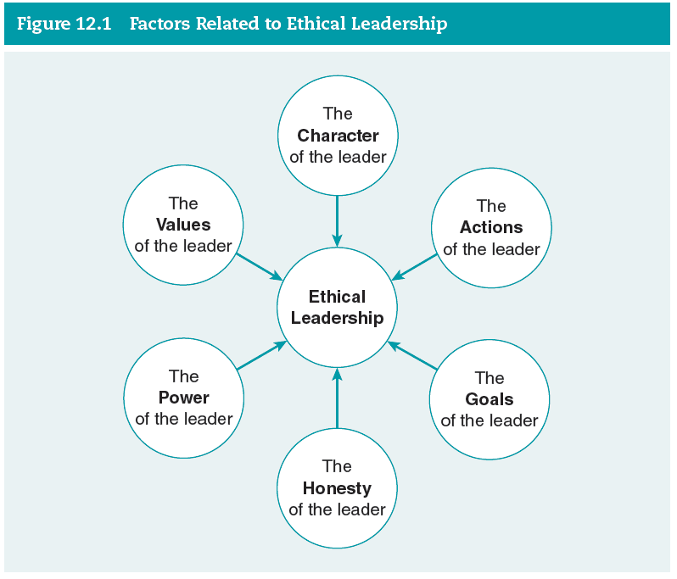

Figure 3. Source: In Practise Leadership Ethic (Crossan et. Al., 2017).

- The character of a leader is a pivotal factor in determining their effectiveness and influence. It comprises qualities, disposition and core values that shape their decision-making and behavior. Six essential dimensions of character are trustworthiness, respect, responsibility, fairness, caring and citizenship. These dimensions are fundamental to a leader's character and contribute to their ability to inspire trust, foster positive relationships and act ethically (Table 3).
- The actions of a leader achieve goals and objectives through principles like respect, service, fairness, establishing integrity and influence through aligning actions.
- These goals of a leader inspire and drive collective efforts by pursuing meaningful, worthy goals, fostering ownership and commitment among team members and establishing goals agreeable to all stakeholders.
- Honesty is a vital aspect of leadership and is synonymous with ethical behavior. Being truthful and transparent in communication and actions builds trust and credibility. Ethical leaders face the challenge of balancing honesty with appropriate discretion, considering the impact on others.
- The power of a leader lies in their ability to influence others. Ethical leaders wield their power in a fair and caring manner, actively preventing its misuse. They remain self-aware and vigilant, recognising the potential for abuse.
- Leadership values encompass ethical values, modal values and end values. Ethical values guide a leader's behavior, while modal values shape decision-making. End values represent the ultimate goals leaders strive to achieve (Crossan et. Al., 2017).
- By embodying ethical values, aligning moral values with ethical principles, and working towards meaningful end values, leaders foster a positive and ethical organisational culture. The values they uphold serve as a compass, guiding actions and influencing team behavior.

Table 2. Definitions for dimensions of leader character

Table 3. Source: Characteristics of leadership style concepts (Crossan et. Al., 2017, p.1).

Ethical leadership is crucial for organisational effectiveness, employee well-being, and societal impact. It involves leaders demonstrating moral principles, values, and behaviours in decision-making, interactions, and leadership. They prioritise integrity, fairness, transparency, and responsibility, setting an example and creating an ethical climate within their organisations. Ethical leaders serve as role models, influencing ethical behavior and fostering a culture of integrity, leading to increased trust, employee satisfaction, and organisational commitment. They also contribute to improved organisational performance, stakeholder relationships, and long-term sustainability.
The article emphasizes ethical priorities in leadership, particularly in the context of the National Health Service (NHS). It highlights the importance of ethical decision-making, integrity, trust, patient-centeredness, and accountability. Ethical leaders in healthcare prioritise patient well-being, uphold professional standards, and make decisions aligned with ethical principles. The article could further emphasise the importance of ethical leadership in fostering a culture of psychological safety, where individuals feel safe to speak up and engage in open dialogue (Elkomy et al., 2020).

This paper should explore potential ethical challenges faced by NHS leaders, such as resource allocation and maintaining professional integrity under external pressures. It would be beneficial to provide guidance on ethical approaches and explore psychological safety and specific ethical challenges. Charismatic leadership in the NHS is characterised by strong role models, clear goals, high expectations, and inspiration. It connects with followers by Cummings et al., (2010)., inspires trust, loyalty, and alignment with shared visions. Charismatic leaders effectively communicate beliefs, challenge team capabilities, and create an atmosphere of enthusiasm and passion. This transformative leadership inspires admiration and has a transformative impact on individuals and organisations.

Reflective Report Part 2

Introduction
In this reflective essay, I will explore my learning journey and insights gained through the study of effective leadership. To structure my points, The Gibbs Reflective Cycle (Adeani et al., 2020) will be used, which has six stages: description, feelings, evaluation, analysis, conclusion and action plan. This model guides me in reflecting on my increased knowledge of leadership styles, self-awareness and the impact it will have on my future workplace interactions.
Reflecting on my increased knowledge of task-oriented individuals, I recognise the importance of tasks in providing a sense of control and self-mastery. Aligning with some characteristics of task-oriented individuals, I can leverage this approach to enhance my productivity and sense of accomplishment. In future workplace interactions, I aim to create a supportive environment for task-oriented individuals by acknowledging their needs and providing clear goals and structure. I will continue to deepen my understanding of different work styles and explore strategies for effective collaboration, ultimately enhancing my ability to work with individuals possessing diverse orientations.
Increased Knowledge of Leadership Styles: Throughout my research and readings, I have gained a deeper understanding of various leadership styles and their implications in different contexts. I learned about autocratic, democratic and laissez-faire leadership styles, each with distinct characteristics and outcomes. The transformational leadership style, which emphasises inspiration and motivation, resonated with me the most. Its focus on creating a shared vision and empowering followers aligns with my personal beliefs about leadership (Leithwood & Jantzi, 2005).
Self-Awareness and Workplace Application: Studying leadership styles has increased my self-awareness as I reflected on my own leadership approach. I recognised the importance of emotional intelligence and effective communication in inspiring and motivating others. This awareness will undoubtedly benefit me in the workplace, as I can now consciously adapt my leadership style to different situations and individuals. By incorporating a transformational and democratic leadership approach, I aim to foster an inclusive and collaborative environment where team members feel valued and empowered (Drysdale, 2017).

Key Informative Literature: During my exploration of effective leadership, several pieces of literature have significantly informed my understanding. The works of Daniel Goleman (2002) on emotional intelligence, particularly his model highlighting of improve self-awareness, self-management, social awareness and relationship management. Have been instrumental in shaping my comprehension of effective leadership skills. Additionally, transformative study of leadership by Bass and Avolio (1991). He has provided valuable insights into the positive impact this leadership style can have on employee satisfaction, organisational performance, and patient care outcomes (Blake & Mouton, 1985).

Areas for Future Learning: Reflecting on my learning journey, I acknowledge the need to explore certain aspects of leadership further in the future. One area of interest is ethical leadership, as I believe delving deeper into ethical decision-making, integrity, and accountability will contribute to my growth as a leader. Additionally, gaining a better understanding of situational and contingency leadership approaches will expand my repertoire of leadership skills, allowing me to adapt effectively to diverse and challenging situations (Chima & Gutman, 2020).
Conclusion and Action Plan: This reflective essay has highlighted the significance of studying effective leadership and its practical application in the workplace. The examination of various leadership styles has enhanced my self-awareness and provided a framework to align my leadership approach with my values. Going forward, I am committed to furthering my understanding of ethical leadership and exploring situational and contingency leadership models. By doing so, I will equip myself with a comprehensive toolkit of leadership skills, enabling me to navigate complex workplace challenges and make a positive contribution to my team and organisation (Nanjundeswaraswamy & Swamy, 2014).

Conceptualising Leadership
- The questionnaire prompted me to explore my understanding of leadership, revealing that interactions with leaders significantly influenced my perception. Leadership goes beyond titles and positions, involving inspiring, influencing, fostering trust, collaboration and growth also taking responsibility for outcomes and impacts (Sethuraman & Suresh, 2014).
- As I progressed through the questionnaire, I carefully considered each item and used the provided scale to express my level of agreement or disagreement. Surprisingly, my highest score was for behavior emphasis, reflecting the significance I attribute to a leader's actions and behaviours in the process of leadership. I believe that leadership is not solely defined by inherent traits or abilities but is strongly influenced by how a leader acts and interacts with others (Appendix A).
- However, it is crucial to acknowledge that leadership encompasses various dimensions. While behavior emphasis received my highest score, I also recognise the importance of other aspects such as trait emphasis, relationship emphasis, and the dimensions outlined in the questionnaire. This realisation broadened my understanding of leadership and highlighted the multifaceted nature of the concept.
- Comparing scores and reflecting on their implications helped me understand my leadership approach. I identified strengths, preferences, and areas for growth, shaping my future leadership practice. I now focus on cultivating strong relationships, recognising individual differences, and fostering a shared vision among team members.
- In conclusion, the Conceptualising Leadership Questionnaire was a thought-provoking experience that deepened my understanding of how I define and perceive leadership. Through examining the implications of my scores and considering the various dimensions of leadership, I am now better equipped to navigate the challenges of leadership and positively impact the lives of those I lead.

Ethics Leadership Style Questionnaire

Ethical leadership styles vary based on individual preferences and beliefs. Here are some common ethical leadership styles:
- As a leader with a duty ethics perspective, I prioritise doing what is morally right and fulfilling my duties, even in difficult choices (Appendix B).
- Consequentialist Ethics: With a consequentialist perspective, I focus on the outcomes and consequences of my actions.
- Virtue Ethics: Emphasising personal character and virtues, I adopt a virtue ethics perspective.
- Relational Ethics: Ethical leadership emphasises building and nurturing relationships, trust and considering the impact of actions on others.
- Ethical Egoism: It prioritises self-interest and personal gain; I recognise that it may not be considered ethically desirable in leadership.
It is important to note that these styles can coexist to varying degrees within my leadership approach. Depending on the situation and my values, I may draw upon different ethical perspectives. I also understand the possibility of blending or integrating multiple ethical styles to create a unique leadership approach.
Understanding different ethical leadership styles enables me to make more informed decisions, navigate ethical dilemmas effectively and foster a positive ethical culture within my organization. By embracing a diverse range of ethical perspectives, I can lead with integrity, inspire trust, and promote ethical behaviour among my team members.

Reference:

- Adair, J.E., (2007). Leadership for innovation: How to organize team creativity and harvest ideas. Kogan Page Publishers.
- Adeani, I.S., Febriani, R.B. and Syafryadin, S., (2020). USING GIBBS’REFLECTIVE CYCLE IN MAKING REFLECTIONS OF LITERARY ANALYSIS. Indonesian EFL Journal, 6(2), pp.139-148.
- Aithal, P.S. and Kumar, P.M., (2016). Comparative analysis of theory X, theory Y, theory Z, and Theory A for managing people and performance. International Journal of Scientific Research and Modern Education (IJSRME), 1(1), pp.803-812.
- Avolio, B. J., Waldman, D. A., & Yammarino, F. J. (1991). Leading in the 1990s: The four I's of transformational leadership. Journal of European Industrial Training, 15(4), 9-16.
- Bass, B. M., & Riggio, R. E. (2006). Transformational leadership. Psychology Press.
- Beauchamp, T. L., & Childress, J. F. (2019). Principles of biomedical ethics. Oxford University Press.
- Blake, R. & Mouton, J. (1985). Managerial grid III: The key to leadership excellence. Houston: Gulf Publishing Co.
- Boin, A. and McConnell, A., (2007). Preparing for critical infrastructure breakdowns: the limits of crisis management and the need for resilience. Journal of contingencies and crisis management, 15(1), pp.50-59.
- Bordia, P., Hunt, E., Paulsen, N., Tourish, D., & DiFonzo, N. (2004). Uncertainty during organizational change: Is it all about control? European Journal of Work and Organizational Psychology, 13(3), 345-365.
- Brown, M. E., Treviño, L. K., & Harrison, D. A. (2005). Ethical leadership: A social learning perspective for construct development and testing. Organizational Behavior and Human Decision Processes, 97(2), 117-134.
- Ciulla, J.B., (2003). [Introduction to] The Ethics of Leadership. Wadsworth/Thomson Learning.
- Chima, A. and Gutman, R. (2020). What it takes to lead through an era of exponential change. Harvard Business Review. Available at: www.hbr.org.
- Crossan, M.M., Byrne, A., Seijts, G.H., Reno, M., Monzani, L. and Gandz, J., (2017). Toward a framework of leader character in organizations. Journal of Management Studies, 54(7), pp.986-1018.
- Cummings, G. G., MacGregor, T., Davey, M., Lee, H., Wong, C. A., Lo, E., & Muise, M. (2010). Leadership styles and outcome patterns for the nursing workforce and work environment: A systematic review. International Journal of Nursing Studies, 47(3), 363-385.
- Den Hartog, D.N., Van Muijen, J.J. and Koopman, P.L., (1997). Transactional versus transformational leadership: An analysis of the MLQ. Journal of occupational and organizational psychology, 70(1), pp.19-34.
- Drysdale, L. and Gurr, D., (2017). Leadership in uncertain times. International Studies in Educational Administration, 45(2), pp.131-159.
- Edmondson, A. C. (1999). Psychological safety and learning behavior in work teams. Administrative Science Quarterly, 44(2), 350-383.
- Eisenbeiss, S. A., Knippenberg, D. V., & Boerner, S. (2008). Transformational leadership and team innovation: Integrating team climate principles. Journal of Applied Psychology, 93(6), 1438-1446.
- Elkomy, S., Murad, Z. and Veleanu, V. (2020) ‘Does leadership matter for healthcare service quality? Evidence from NHS England’, International public management journal, ahead-of-print(ahead-of-print), pp. 1–28. Available at: https://doi.org/10.1080/10967494.2020.1828204.
- Gannon, D. and Boguszak, A., (2013). Douglas McGregor’s theory X and theory Y. CRIS-Bulletin of the Centre for Research and Interdisciplinary Study, 2, pp.85-93.
- Goleman, D., Boyatzis, R. E., & McKee, A. (2002). Primal leadership: Realizing the power of emotional intelligence. Harvard Business Press.
- Hochwarter, W. A., Kacmar, K. M., Perrewe, P. L., & Johnson, D. (2003). Perceptions of political structure, employee attitudes, and job performance. Journal of Leadership & Organizational Studies, 9(2), 28-38.
- Huy, Q. N. (2002). Emotional capability, emotional intelligence, and radical change. Academy of Management Review, 27(2), 243-264.
- Kotter, J., (1990). A force for change: How management differs from leadership. New York: FreePress.
- Kruk, M., Pawlak, M., Shirvan, M.E. and Shahnama, M., (2022). The emergence of boredom in an online language class: an ecological perspective. System, 107, p.102803.
- Lajoie, E.W. and Bridges, L., (2014). Innovation decisions: using the Gartner hype cycle. Library Leadership & Management, 28(4).
- Leithwood, K. and Jantzi, D., (2005). Transformational leadership. The essentials of school leadership, pp.31-43.
- Lewin, K., Lippitt, R., & White, R. K. (1939). Patterns of aggressive behavior in experimentally created social climates. Journal of Social Psychology, 10(2), 271-299.
- Liu, Y., Liao, H., Loi, R., & Lam, L. W. (2019). Linking ethical leadership to employee creativity: Knowledge sharing and psychological safety as mediators. Journal of Business Ethics, 156(4), 1095-1109.
- Maak, T., & Pless, N. M. (2006). Responsible leadership in a stakeholder society: A relational perspective. Journal of Business Ethics, 66(1), 99-115.
- Mayer, D. M., Kuenzi, M., & Greenbaum, R. L. (2010). Examining the link between ethical leadership and employee misconduct: The mediating role of ethical climate. Journal of Business Ethics, 95(1), 7-16.
- McKee, M. and Healy, J. eds., (2002). Hospitals in a changing Europe (Vol. 3). Buckingham: Open University Press.
- Menon, S., Edward, M. and George, B.P., (2017). Inter-stakeholder collaboration in event management: a case study of Kerala Travel Mart. International Journal of Leisure and Tourism Marketing, 5(4), pp.370-386.
- Mintzberg, H., (1973). Strategy-making in three modes. California management review, 16(2), pp.44-53.
- Nanjundeswaraswamy, T.S. and Swamy, D.R., (2014). Leadership styles. Advances in management, 7(2), p.57.
- Northouse, P.G., (2019). Introduction to leadership: Concepts and practice. Sage Publications. https://www.sagepub.com/sites/default/files/upm-binaries/59372_Chapter_6.pdf.
- Ouchi, W.G., (1981). Organizational paradigms: A commentary on Japanese management and Theory Z organizations. Organizational Dynamics, 9(4), pp.36-43.
- Sethuraman, K. and Suresh, J., (2014). Effective leadership styles. International Business Research, 7(9), p.165.
- Smith, J. (2020). Effective Leadership in Healthcare: Interpersonal and Conceptual Skills. Journal of Healthcare Management, 25(3), 45-58.
- Tannenbaum, R., and Schmidt, W.H., (1973). How to choose a leadership pattern. Harvard business review.
- Toor, S.U.R. and Ofori, G., (2008). Leadership versus management: How they are different, and why. Leadership and Management in Engineering, 8(2), pp.61-71.
- Van der Vegt, G. S., & Bunderson, J. S. (2005). Learning and performance in multidisciplinary teams: The importance of collective team identification. Academy of Management Journal, 48(3), 532-547.
- Vroom, V. H., & Yetton, P. W. (1973). Leadership and decision-making. Pittsburgh: University of Pittsburgh Press. http://dx.doi.org/10.4135/9781526441966.
- Yukl, G. A. (2010). Leadership in organizations (7th ed.). Pearson Education.

Appendix A

Conceptualising Leadership Questionnaire

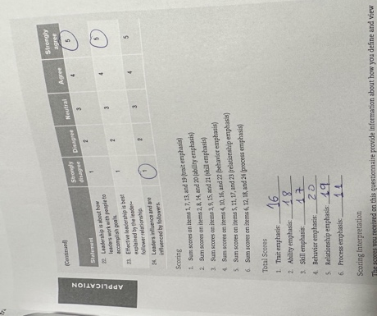

Appendix B
Ethical Leadership Questionnaire

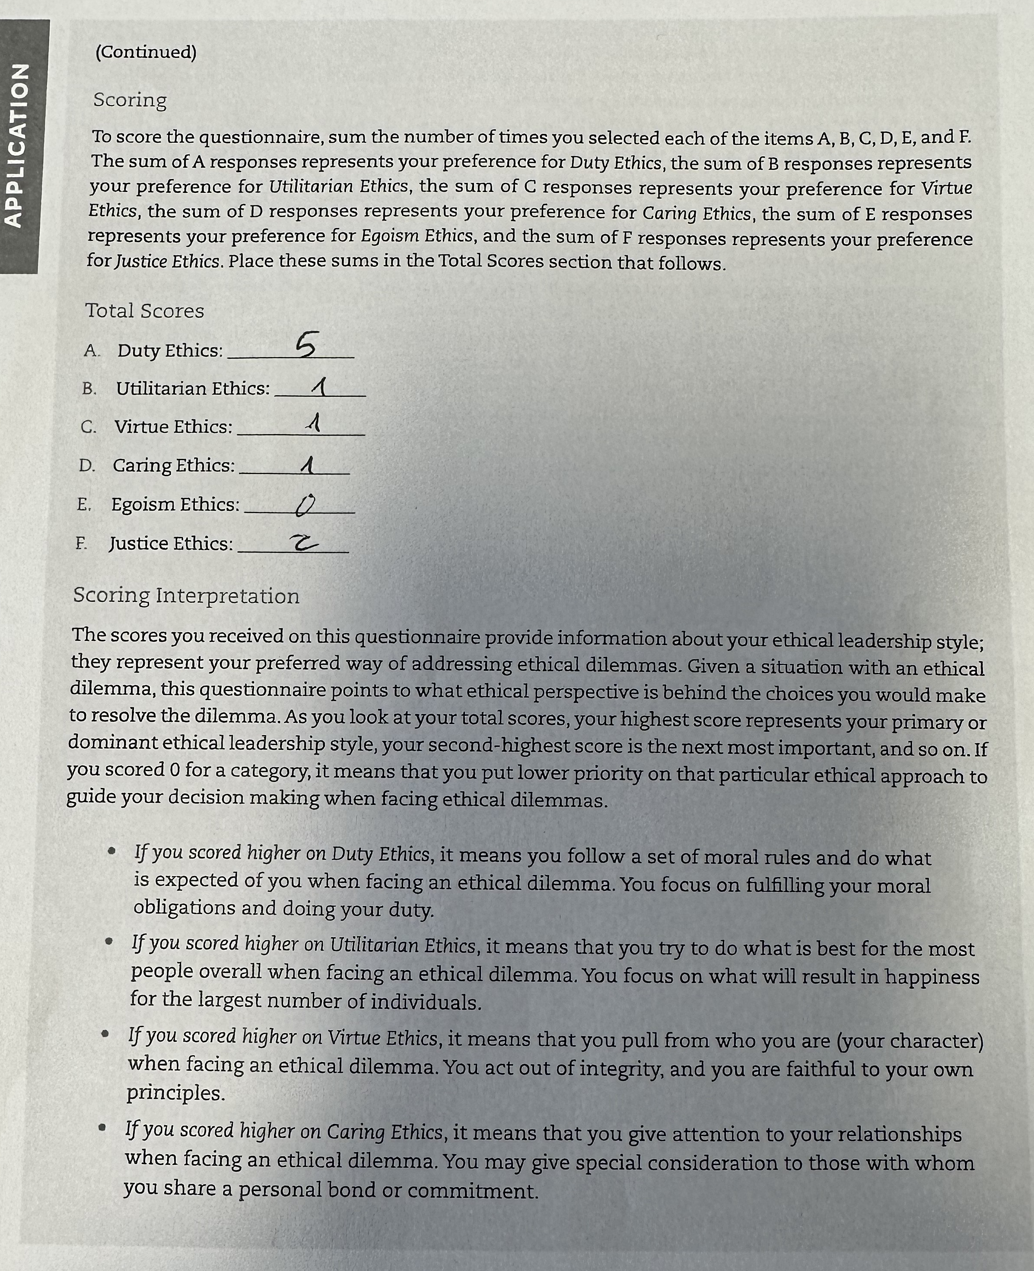

Appendix C

Comparing the barriers to leadership in the mentioned organisation, we can identify some common themes and strategies:
Hierarchical structures: Both CIPD and Millers Oils recognise hierarchical structures as a barrier to leadership. CIPD suggests fostering better communication and collaboration across hierarchies, while Millers Oils aims to create a more collaborative and empowered work environment through distributed leadership.
Short-term focus: CIPD emphasises the need to align performance management with long-term goals. This implies that short-term focus can hinder effective leadership. On the other hand, Thames Valley Police aims to foster independent decision-making at the front line while maintaining necessary regulations, suggesting a shift from short-term to more autonomous decision-making. Individualism vs. collective responsibility: CIPD highlights individualism as a barrier to leadership, suggesting the importance of creating a sense of collective responsibility towards the organisational vision. Similarly, HPUK emphasises the cultural change and motivation to install a sense of ownership and pride among employees.
Development programs and training: Several organisations, including CRI, HPUK, and CIPD, recognise the importance of leadership development programs and training. These programs aim to enhance leadership skills, address competencies like coaching and emotional intelligence, and provide managers with the necessary tools to lead effectively.
Reducing administrative burden: CRI and HPUK both address the issue of administrative burden on managers. CRI's restructuring aimed to create a structure that supports people and reduces administrative tasks, while HPUK encouraged front-line supervisors to prioritise managing people over operational tasks.
Alternative career tracks: Both CRI and HPUK introduced alternative career tracks, allowing employees to choose between managerial and technical roles. This approach provides opportunities for career growth and retention without requiring everyone to pursue managerial positions. Employee empowerment and accountability: CRI and HPUK focus on empowering employees and increasing individual accountability. CRI's strategies include clear communication, involvement of HR, and creating a supportive environment for leadership development. HPUK implemented performance visibility through the "Self-Service" tool, encouraging employees to take ownership of their work and improve their performance.
Overall, this organisation recognises the need for cultural change, leadership development, employee empowerment, and a shift from traditional hierarchical structures to overcome barriers to effective leadership. They emphasise communication, collaboration, accountability, and creating a supportive environment to foster leadership at all levels.

