Evie Divetta: 2100114 ECAD6008
Critically reflect on your progress in planning, preparing, and teaching lessons that incorporate specific pedagogical principles. (This evidence should be taken from you Professional Learning Passport –PLP.) Identify one of these pedagogical principles as an area for development and justify the next steps in your development.
Part 2 (3,041 words)

Pedagogy Standard Blended learning experiences

What did you do and why? | This week my task was to plan all of the numeracy lessons and P.E at the end of the week, whilst bearing in mind alternative ways of teaching that aren't solely focused upon the whiteboard. Therefore, i tried to create lessons where i stepped away from teaching AT the children from the whiteboard and used a variety of strategies to facilitate learning. This included doing practical activities on the floor using hula hoops to present Venn diagrams, using masking tape on the floor to create Carroll diagrams, implementing aspects of the digital competency framework by providing online games on the Ipads to consolidate understanding of Venn diagrams, and finally taking a P.E lesson whereby i had to take the children out of their normal learning environment into the sports hall. As well as providing fun activities for the children to see that learning does not need to be monotonous talking from the board, i used these experiences to encourage the children to lead their own learning. I took a step-back approach and allowed the children to provide feedback to each other, telling pupils why they were right or wrong, and to choose who got to partake in the activities after them. I wanted the children to have a sense of taking charge of their own learning by applying the skills i had gone over with them to encourage independence. Therefore, If a child placed something into the diagram they all had to say if it was right or wrong and why. During my focus task, if a child chose a shape they then had to choose who went next which provided a sense of control of their learning experience. If a child looked at me for support i would say who can help child A with this question, to activate deep thinking and reflection. Additionally, during my rotations, one group was the independent group who were expected to utilize the additional resources i laid out for them, including number boards, the times table boards and whiteboard to aid their independence. Again this was to evidence an example of non-teacher led activities, whereby the children were having to discuss on their tables and share feedback with one another.
What have you learned? | I have learned that children learn so much from being practically involved in learning. Using games and exploiting their familiarity of technology (Ipads) to promote learning was successful. Pairing the ipad with their topic was a great way to create incentive to complete the tasks. I can understand why being talked at from the whiteboard may lose effectiveness, and it is important to be mindful of the strategies you use to make your points and teach your learning objectives. I personally learn more from being hands on and doing things, so the more i can present these opportunities in my lessons i will. Taking the children out of the classroom into the sports hall during P.E evidenced to me how different environments support the creation of different skills as well as behaviors. If the weather were nicer i would have liked to have taken the children outside on the field or yard during P.E, or possibly to go outside with chalks and create the Carroll and Venn diagrams for a change of scenery to promote enthusiasm.
What next? | I intend to continue to find more opportunities throughout my placement to incorporate blended strategies to teaching. Due to classroom bubbles created out of Covid, a lot of areas such as the ''street'' where there are areas set up for different AOLES, is restricted to decrease cross over between classes. Being able to send the children to specific areas to engage with resources and materials would be a great asset, but now it is not utilized as much as it should be. I will continue to ask for my mentors input of websites and apps they are familiar with to use for specific tasks, to create a blended experience promoting the use of technology. I will also continue to strike a balance between leading the learning and allowing the children to teach each other. It is more beneficial for them to explain to a peer and consolidate their own understanding, when possible, rather than myself.
Assignment: Part 1

Pedagogy Standard | Assessment for learning
What did you do and why? | As part of our second bridging experience, I utilized 4 different techniques to evidence assessment for learning (AFL).  1. The first one I focused on was ‘quality and use of feedback’. I implemented a new strategy the children had not come across before which was to put 1 star and 1 wish in their books regarding the weeks numeracy lessons I had planned and delivered. The star represents something they enjoyed and now understand, whilst the wish is something they found challenging and would like to recap. I trialled this approach during the recap lesson on the 12.11.21 which was fitting as we were coming to the end of our data handling topic. The children were given time to reflect on this question and then I used lollipop sticks with all of their names on, to select a child at random to feedback to the class. When someone spoke, I encouraged the children to speak up if they had the same star or same wish as that person. I thought this was important as a lot of the children in my class lack confidence, and knowing another child found the same things difficult would be comforting. After a bit of a discussion of similarities and differences in peoples understanding, I walked around the room recapping the things they did not understand (aspects of the Carroll and Venn diagrams, or even bar charts from last week), whilst others carried on with their worksheets.  2. The second principle I focused on was ‘sharing criteria with others’. On the 15.11.21 during my literacy lesson, I created an opportunity for the class to come together and create their own success criteria for their big writes on the digestive system. After introducing the children to the digestive system via YouTube videos, verbal explanation, and a practical demonstration, I made a spider diagram on the board of what a successful explanation would look like. I encouraged the children to think back to the sentences we have learned about over prior weeks, what are common mistakes they find in their work, and what was included in the success criteria for their big write last week about bonfire safety. Using lollipop sticks to gauge feedback, I asked children to provide some examples. Once I was happy that they had made a good attempt at highlighting the successful features, I then placed my own success criteria on the board so that we could discuss all the features we need to include in our big writes next week to complete a successful explanation. The children’s main task was then to read through an exemplar explanation I had created (WAGOLL) and highlight in different colours all the successful features they could find to help aid them in their future work.  3. The third technique I trialled was peer assessment. Peer assessment was something totally new to my class but was totally successful. During literacy rotations on the 16-18.11.21, children were asked to complete reading comprehensions all about the digestive system which were accompanied by multiple questions. Once the children had completed the questions, I provided them with an answer sheet and they swapped books within their group to mark a peers work using purple pen. The children enjoyed having the responsibility to mark someone else’s work, and it highlighted to them the common mistakes that they were all making. If someone did make a mistake it is possible it was received better by a fellow friend than by me.  4. Lastly, during my lesson on the 19.11.21 I implemented a technique to promote deeper quality of talk and questioning. I created a dice which had 6 words on it (why, how, what, when, enjoy and challenge). My lesson utilized a jigsaw strategy to learning whereby each table had fact files on a specific organ, and the children had to absorb as much information as possible to become experts and relay facts to the entire class. After every group had presented their in-depth information, I threw the dice to random children in the room and whatever word was facing up was the question they had to answer. If they caught it and ‘why?’ was facing up, I would ask a why question regarding the digestive system. I sometimes asked other children to think of a question for the child with the dice. This was a great way of consolidating understanding in the children, as they had to be sure of the answer to ask the questions. If the dice landed on challenging or enjoyed, then the child had to talk about something they found difficult or enjoyed that week. This allowed me to gauge their understanding, and to see if there was something particularly challenging for all.
What have you learned? | - I have learned how effective a small activity can be in gauging understanding within the pupils. Also, that my class pick up new strategies very quickly. They had never been introduced to this within the class but understood it right away. This technique of feedback allowed me to go into further detail with the children about common things that they found challenging.  - I have learned that a success criterion is pivotal in ensuring that children know what is expected of them. Providing a success criterion allows children to have a focus and limits the likelihood of them getting fed up if I was to comment on additional things they need to do. At the beginning of the lesson, they can see what they need to do to complete a good piece of work so there are no surprises and they can prepare themselves to learn.  - I have become more aware that there are other ways to get children to see their mistakes other than you as a teacher just going over it with them. The children really benefited from marking each other’s work. The activity helped develop a new skill within the pupils, and it allowed them to see first-hand that the mistakes they make are also made by their peers, which may help boost some children’s confidence.  - Questions that are open ended make for much deeper conversation and allow you to gauge the children’s understanding. Just by using something fun like my foam dice, the children were reflecting and providing learning opportunities for each other without even really knowing.
What next? | 1&2- AFL is a critical component that is utilized every day that I teach a lesson, therefore I will continue to try new strategies and discuss with fellow students the technique’s they have come across during their placement.  3- I will do more work with self-assessing next week as pupils had chance to practice peer assessing this week, and they will be editing their big write next week. Pupils do have some experience of self-editing, but it is an underdeveloped skill within the class.  4- I will continue to ask questions continuously when I am, and when I am not teaching in the class to help consolidate learning and encourage deeper thinking. I will research other strategies that implement creative questioning to utilize in my future classes.

Pedagogy Standard | Real life authentic contexts
What did you do and why? | This week I was tasked with planning the literacy for the week. As a class we were preparing to create scientific explanations about the digestive system. During the introduction of this topic, I made very clear to the children the relevance of learning about the digestive system and encouraged them to think about why it is important that we learn about it. I explained how everyone has a digestive system and to understand our bodies biology is fundamental. To deepen the authentic connection between learning and real life, I performed a demonstration in front of the children. This required the use of bread, water, orange juice, a sandwich bag, a tea towel and a mixing bowl. I tore up the bread into the bag to represent our teeth breaking down the food. I then added water to represent saliva. Next, I added orange juice to represent stomach acid and began to squeeze the contents to replicate the massaging of the stomach to produce chyme. After this I took the contents out, put it into a tea towel which represented the small intestine and drained the liquid. The liquid was to represent the nutrients that the small intestine absorbs from the food into our bloodstream, and get passed to the liver. What is left is a dried and misshaped piece of bread that mimics the stool that passes to the large intestine and stores as waste. The children were able to visually refer to my demonstration when writing their drafts of their explanation. I believe my teaching strategy made it more real and authentic to them, especially as I continuously referred to how this process occurs within our bodies everyday.
What have you learned? | I have learned that learning can sometimes seem pointless to children if you do not provide explanations as to why we are learning about it. Making it clear the connections between what we learn in class and what occurs in real life helps consolidate learning, and allows children to draw upon experiences in the classroom. It also makes children more enthused by what you are saying, and by using demonstrations, resources and settings we can bring to life what we are teaching to create a real wow moment.
What next? | Whilst teaching all my lessons I always ask WHY questions. Why are we learning about it? I consider this fundamental when teaching because expressing the significance of the topic and it’s connection to the children makes them interested to learn more. As my time in ks2 comes to an end next week, I look forward to the opportunities to implement authentic contexts in play with foundation phase after Christmas.

Pedagogy Standard | Cross-curricular themes
What did you do and why? | I explained to the children that they will be doing a recount of a bible story and that this topic comes under humanities in the curriculum, therefore, we are again in our literacy, practising working cross-curricular like last week. However, this time we are looking at religion as opposed to science. The children were shown a power point on the board that contained a picture of a bible. They used talk partners to answer questions: what is this? What religion uses it? Who wrote it? We engaged in discussion to provide contextual background, and as the children had not had an R.E lesson this year yet, they needed this time to remind themselves of previous learning. Once the children had gained knowledge about Christianity and understood that the story, we will be looking at is from the bible, they were shown slides that presented the torah and the quaran. This began a compare and contrast discussion between religions to give the children background knowledge on other religious practices. The children were then told that they will be looking at the story ‘Jesus feeds the 5000’ and were shown a 3min YouTube clip. After the clip children were asked to discuss in their groups what they learned about the story? What is a miracle? Who were the disciples? And what was the message of the story? Lollipop sticks were used to obtain feedback from the groups. As a class then we focused on the WAGOLL. I went through on the board the success criteria for this big write and used examples within the WAGOLL that illustrated them. Writing in 3rd person, using ED and LY words (adjectives and adverbs) and using speech marks are the 4 S.C. I read through the first paragraph with the children so that they could familiarise themselves with the features, before continuing on their own. The children were given a S.C that they needed to colour in and then use those colours to identify the features within the WAGOLL.
What have you learned? | I have learned that it is easier than i thought to plan for cross curricular learning. Literacy skills can often be applied very easily within other AOLES. It is also always a nice lesson where multiple AOLES are brought together as the children always seem to enjoy using a variety of skills. Learners can see how subjects are not separate from each other, but complement each other and are all used together to support learning.
What next? | I will continue to create cross-curricular opportunities for pupils. I will also continue to point out the children when we are participating in a cross-curricular lesson, so that they can evidently see the links of the lesson. This will hopefully address that all AOLES are important and can be used in conjunction with one another to provide an optimal learning experience. During my next placement i will try to focus upon other AOLES that i have had not had the chance to teach during this placement, so that i have experience finding the connections across all subject areas. During this placement i have looked at cross curricular responsibilities between literacy and science, literacy and religious studies and numeracy and Welsh language.

ECAD6008 Assignment: Part 2

Assessment for learning (AFL) is used every day in the classroom which makes it an appealing aspect to develop further. Being informed of a child’s understanding during their learning journey is of particular importance to establish where they are in their learning now, where they are going, and what skills need to be worked upon to get there (William and Thompson, 2008). Using AFL strategies allows me to reflect upon the standard of my teaching and to put extra time into children who are struggling so they can all reach their full potential. AFL is something they were getting observed upon frequently in my placement school, so I know it is something that is continuously implemented and focused upon amongst the senior leadership team (SLT) staff, making it crucial to have sound knowledge about. Additionally, it is an aspect of my practise that my mentor commented was done well during my placement, therefore, I want to pursue this and learn even more about how to ensure its success within my lessons. This essay will address the 4 AFL strategies I utilized during my placement by discussing the literature that surrounds them, and how they can further be developed by acknowledging the pitfalls found in their implementation within the classroom.
The AFL strategies I used within my test week of the bridging had positive implications for the children, therefore, I wish to research how I can ensure I carry out the techniques effectively. Coe et al (2020) states that a great teacher has knowledge of students’ thinking, particularly the misconceptions some may have in relation to topics and addressing these is pivotal to learning. By implementing my question dice within my lessons to encourage quality of talk, I was able to address confusions in real time as well as allowing peers the opportunities to assist each other’s understanding (see appendix 1). In order to develop my quality of questioning, I will in future be aware of ‘evaluative listening’ (Davis, 1998 cited in Black and William, 2009). This is where you are focused on correcting the child and using helpful, supportive language such as ‘nearly’ or ‘almost’. However, i was more aware of putting the child on the spot and so asked if anyone else could help when I saw they were struggling to reach the answer, as opposed to pushing them to reach the answer themselves, in fear of embarrassing them with further attention from the class. Likewise, Black et al (2004) comments on the importance of giving enough time to children to recall the information. They highlight how providing short wait time only promotes questions that can be answered quickly. Upon reflection, maybe I was not allowing enough thinking time for children to generate confident and comprehensive answers. Additionally, Rowe (1972) cited in Sardareh et al (2014) discusses how often when a teacher asks questions to the class, they have an ideal answer in mind, and this can result in other answers not being given as much recognition which creates a barrier to explore learning further. The implication of all factors will be remembered as I go forward in my practise to improve my use of AFL. I have realised more so towards the end of my placement, the importance of not narrowing a child’s opportunity to express their ideas and allowing the conversation to progress in a snowball effect. I had considered this limitation of being too specific in my questioning, which is why the question dice I used in the classroom just had the words ‘what’, ‘why’, ‘how’ and ‘when’ so that they could be used to gain knowledge across a broad spectrum. However, in hindsight I probably did have an idea of where I wanted the conversation to go. Now that I have come across this material, I will ensure this is at the forefront on my mind when teaching to ensure questioning is pupil led.
Additionally, Coe et al (2020) discusses how a productive learning environment stems from positive student relationships. The AFL technique I implemented to promote quality of feedback, 1 star and 1 wish, promoted a sense of togetherness as I would ask the children to speak up if they found the same challenges as someone else. This was also to promote confidence within my pupils that they were not alone in what they found difficult (see appendix 2). Secondly, implementing the new strategy to the class of peer-assessment aided the promotion of healthy relationships between pupils where they felt they could look to each other for advice to support their learning journey. In my experience the children accepted feedback very well from each other, maybe more so than if it were from myself as a teacher, as that is more formal (see appendix 3). To develop the AFL principle of quality of feedback, in future I could implement a traffic light system. White and White (2018) found that this method allowed for quiet children to ask for help and encouraged collaborative teaching that promoted understanding. Children would be given green, yellow and red cards which represent their understanding of the work. During this method, children are encouraged to put their cards visibly on the desk so the teacher can gauge all lesson, not just at the end, as to how confident the children are with their work. They could have swapped the cards/counters at various points in my lessons so I knew who needed more help and they could have received it instantly. Benefits of this AFL is that it is low cost, easy to implement and a simple method for children to understand. However, it is recognised that this method of AFL becomes difficult the larger the class and children can often become embarrassed to ask for help. They also consider how whole class techniques such as this become void in effectiveness if the children are not prepared to admit when they do not understand and are not truthful. Using whole class AFL strategies such as thumbs up, showing smiley faces or this traffic light system may encourage children to follow the crowd as opposed to showing how they truly feel. They may be more likely to represent a green card because they don’t want to let on to peers that they struggled. Therefore, upon reflection, feedback strategies within their books such as 1 star and 1 wish that I implemented, or possibly trialling a traffic light stamp where the child colours in their books as opposed to on their tables, would be a more accurate representation. In my experience the children enjoyed this task and did not feel embarrassed or upset for having to set themselves a wish, as I discussed with the class beforehand that I did not expect them to feel confident and be amazing at everything right away. Furthermore, when I use AFL strategies to obtain quality of feedback, I will ensure they’re always purposeful in encouraging the children to teach and learn from each other. Vygotsky (1968) cited in Schunk (2012) highlights how learning is a social event, and children should be provided an opportunity to learn with and from one another. For example, if using whiteboards to hide and show answers, an AFL strategy known to some as ‘secret squirrel’ then children should collaborate in their groups to help anyone who may have been confused, which would evidence social construction. When I trialled my question dice and the 1 star and 1 wish, I encouraged the children to help one another to understand but I did not make explicit the benefits of helping one another and engaging in class discussions. In my future practise I will make clear the reasons why I asks pupils to share ideas and help their peers reach the answer, in the hopes it will encourage them to participate more.
Moreover, to develop my use of peer assessment as a method of AFL I will consider Gan (2011) cited in Hattie (2012), who highlights the usefulness of providing prompts to children when giving feedback on someone’s work e.g. ‘A reason this is good is because….’ or ‘something you may have been confused about is this … because…’. This way the feedback is structured in a kind manner if they are asked to provide justification for their marking. However, Falchikov and Goldfinch, (2000) cited in Hattie (2012) recognise that whilst peer feedback can lead to a reduction in confusion and create confidence in children’s abilities to recognize mistakes, it can also have negative effects such as lending possibility for shame and hopelessness for the children who have had questions wrong. Nevertheless, they comment on that the more positive relationships there are in the class, the less likely this will be, and promoting positivity and kindness is a fundamental principle I operate upon in my classrooms. Furthermore, when allowing children to peer assess in future, especially If giving additional comments, I will ensure to monitor the accuracy and usefulness of their feedback to promote socially constructed learning. Liu and Carless (2006) present the notion that although literature has found students to be reliable assessors, you are still giving them the responsibility to provide opinion on someone else’s work, which needs to be justified to be useful. My experience of peer-assessment was giving pupils the answer sheet, so they became familiar with looking at a peer's work and ticking the correct answers. Therefore, I did not need to think about this possible inaccuracy. Henceforth, in future classes where I get the opportunity to familiarise them with peer-assessment, I could carry this out differently and give children a success criterion instead of black and white answers. This would hopefully encourage them to decide for themselves whether they felt the criterion had been shown and consequently aid them to understand how to include criterion in their own work. Black et al (2004) recommends that a clear understanding of each success criteria is necessary to complete peer-assessment effectively, which supports the issues addressed by Didau (2015) cited in Crichton and Mcdaid (2016) that are commented on shortly.
According to Coe et al (2020) a great teacher structures lessons so as expectations and good examples of work are known to the children to promote success in their learning. They highlight how this does not mean simply copying out the learning objective and success criteria. Hattie (2012) additionally points out that both teacher and student need to know the purpose of what they are doing and work collaboratively to support effective learning Therefore, during my implementation of success criteria with my class, I developed the success criteria for a digestive system explanation with my whole class via use of a thought shower, so that the children were involved in the discussion of why such features bare importance. Additionally, the children were shown an exemplar of good work so that they knew what to aim for and were asked to highlight successful features (see appendix 4). An existing issue addressed by Didau (2015) cited in Crichton and Mcdaid (2016) is that of learning objectives and success criteria becoming part of a box ticking exercise as opposed to voicing their purposefulness. To be effective in the AFL journey, they believe children need to be provided an authentic context in which they understand the relevance and importance of each criterion to obtain the expectation of the teacher. However, Crichton and Mcdaid (2016) address a common issue in their study of teachers not spending enough time explaining why they were using their learning objectives and success criteria. They instead dove into what they perceived as being the most important part of the lesson, delivering it, as many believed going over such things takes up valuable time that could be spent teaching content. This issue was something I had to address and develop throughout my placement and is something I touched upon regularly in my reflections, as my mentors picked up on how I initially did not refer to ‘what, how and why’ questions. However, over the course of my placement this skill developed and i witnessed the benefits of this in my sessions, and so I will ensure I reflect upon this to develop effective AFL. In my experience, when children see the relevance of the lesson and are confident in how and why they must achieve good work, they appear more focussed. In my next placement, if they do not have them already, I could make why, what, how and when labels to put around the whiteboard so as I am reminded to refer to these to encourage an authentic context and justification for learning objectives and success criteria. Additionally, something of particular interest to my experience is the literature on the language that should be used within learning objective and consequential success criteria. Dymoke and Harrison (2008) cited in Crichton and Mcdaid (2016) believe these statements should use language that relates to cognition such as ‘understand how’ and ‘be aware of. However, during my placement my mentor touched upon that I should be using simple language in short sentences so that the steps to success and the skill being taught are clear. Therefore, due to this confliction, perhaps in my future practise to aid development i could use both types of information and see which best suits my learners and promotes optimal AFL. Upon reflection, it is a possibility my mentor favoured this way of criteria as I had a large amount of lower ability learners.
Lastly, during my week of trialling AFL for bridging my focus was not upon giving feedback to the children but creating opportunities for them to give feedback to myself or others. The feedback I did provide during my placement was mostly through verbal questioning sessions and correcting work with the child, therefore, I did not give written feedback. However, in future when I do, I will implement the beliefs of William (2011) and ensure to focus on what, how and why suggestions within my comments, not just telling the children where they went wrong. This will encourage them to think for themselves, which addresses a common downfall amongst teaching staff when evidencing this AFL. They additionally suggest that feedback should be given in simple and manageable terms as not to create a cognitive load and can be understood and materialise in pupils’ future work. This will inform the number and depth of comments I provide during my marking in the future. However, I am aware that schools have different marking policies and expectations so this will need to be considered. Nonetheless, there is debate highlighted by Francis (2011) as to whether verbal feedback is a better technique to facilitate learning as it is instant and does not require the children to read back in their books. Benefits include being able to judge immediately if they understand your feedback in the moment you provide it. It is also particularly beneficial to learners who struggle to read or children in early years where reading is a skill they are learning to develop. However, a limitation I recognise is the time it would take to provide every child with verbal feedback within the lesson, as well as the possibility of forgetting verbal feedback. Therefore, in my future practise I will use a mixture of verbal feedback as I walk around the room to correct understanding in real time and written feedback when marking books after the event so as they have support to refer to. Additionally, it may be an idea to use pupil voice and ask the children which form of feedback they think is most beneficial to them and allows them to progress.
To conclude and summarise, upon further analysis of existing literature there are numerous ways in which I intend to develop my use of AFL in future practise. Firstly, in terms of quality of talk, I am now more aware of the power of language used when questioning children as a means of gauging understanding. I will be mindful of the time I provide to my pupils to answer my questions, as well as using open ended questioning to allow for expansion on ideas and discussion. Secondly, I will definitely use the traffic light feedback system proposed in White and White (2018) as means to receive feedback, however, due to consideration of the implications of children providing feedback in front of peers, this will be trialled in workbooks so as it is more private. I think this will be a useful tool as I am marking to make note of the children who need additional support. After reflection upon the work by Vygotsky on the social element of learning, I will continue to ensure I create collaborative opportunities within my classroom. However, moving forward I will additionally discuss with the children the importance of sharing ideas and working together to support the understanding of peers. In my experience, when I have made explicit links to the relevance of topics to the children, it is then when they begin to engage more and the AFL becomes more effective. Thirdly, the way in which I conduct peer assessment will also develop, as I will next time consider the use of a success criteria to allow children more independence on judging if criterion has been addressed. This will hopefully manifest into better implementation in their own work. As I develop my use of peer-assessment I will also recall the work of Gan (2011) cited in Hattie (2012), who emphasises the benefit of using verbal prompts to guide children’s feedback on their peers’ work. Promoting positivity and uplifting my pupils is my focus, and I believe this is a safe way of encouraging useful and constructive feedback. Fourthly, in my opinion, of all the AFL strategies I believe success criteria is of the most importance as it begins the learning journey, and without knowing what you need to do you cannot perform successfully. In future, I will use both simplistic language and language that reflects cognitive skill as proposed by Dymoke and Harrison (2008) cited in Crichton and Mcdaid (2016) to evaluate which best suits my learners individually. Finally, I will use both verbal and written feedback when providing feedback to my pupils as there are strengths and limitations of both which I believe would accompany each other effectively.

(3041)

References:
Black, P., Harrison, C., Lee, C. and Marshall, B. (2004) ‘Working Inside the Black Box: Assessment for Learning in the Classroom’, Phi Delta Kappan, vol. 86, pp. 8-21 [Online]. Available at https://www.researchgate.net/publication/44835745_Working_Inside_the_Black_Box_Assessment_for_Learning_in_the_Classroom (Accessed 08 December 2021).
Black, P. and William, D. (2009) ‘Developing the theory of formative assessment’, Educational Assessment Evaluation and Accountability, vol. 21, pp. 5-31 [Online]. Available at https://link.springer.com/article/10.1007%2Fs11092-008-9068-5 (Accessed 08 December 2021).
Coe, C., Rauch, C.J., Kime, S. and Singleton, D. (2020) Great Teaching Toolkit: Evidence Review [Online]. Available at https://assets.website-files.com/5ee28729f7b4a5fa99bef2b3/5ee9f507021911ae35ac6c4d_EBE_GTT_EVIDENCE%20REVIEW_DIGITAL.pdf?utm_referrer=https%3A%2F%2Fwww.greatteaching.com%2F (Accessed 07 December 2021).
Crichton, H. and Mcdaid, A. (2016) ‘Learning intentions and success criteria: learners' and teachers' views’, Curriculum Journal, vol. 27, pp. 190-203 [Online]. Available at http://dx.doi.org/10.1080/09585176.2015.1103278 (Accessed 08 December 2021).
Francis, M. (2011) ‘But Will It Improve Their Writing? The use of Verbal, Peer and Written feedback as Formative Assessments’, Journal of classroom research in literacy, vol. 4, pp. 15-23 [Online]. Available at https://jcrl.library.utoronto.ca/index.php/jcrl/article/view/13021/pdf (Accessed 10 December 2021).
Hattie, J. (2012) Visible Learning for Teachers: Maximizing impact on learning [Online]. Available at https://hozir.org/pars_docs/refs/26/25322/25322.pdf (Accessed 07 December 2021).
Liu, M.F. and Carless, D. (2006) ‘Peer feedback: the learning element of peer assessment’, Teaching in higher education, vol. 11. pp. 279- 290 [Online]. Available at https://core.ac.uk/download/pdf/37890778.pdf (Accessed 09 December 2021).
Sardareh, SA., Saad, M.R.M., Othman, A.J. and M, R.C. (2014) ‘ESL Teachers' Questioning Technique in an Assessment for Learning Context: Promising or Problematic?’, International Education Studies, vol. 7, pp. 161-174 [Online]. Available at https://eric.ed.gov/?id=EJ1071010 (Accessed 09 December 2021).
Schunk, D. H. (2012) Learning Theories: An Educational Perspective. Boston: Pearson Education, Inc.
White, A.R. and White, P. (2018) Using traffic light cards in an English language classroom [Online]. Available at https://scholar.google.co.uk/scholar?cluster=16701934226821188895&hl=en&as_sdt=0,5 (Accessed 09 December 2021).
William, D. and Thompson, M. (2008) ‘Integrating Assessment with Learning: What Will It Take to Make It Work?’, in Dwyer, CA, (ed.) The Future of Assessment: Shaping Teaching and Learning, pp. 53-82. Routledge: New York, USA.
William, D. (2011) ‘What is assessment for learning?’, Studies in Educational Evaluation, vol. 37, pp. 3-14 [Online]. Available at https://www.sciencedirect.com/science/article/pii/S0191491X11000149 (Accessed 09 December 2021).

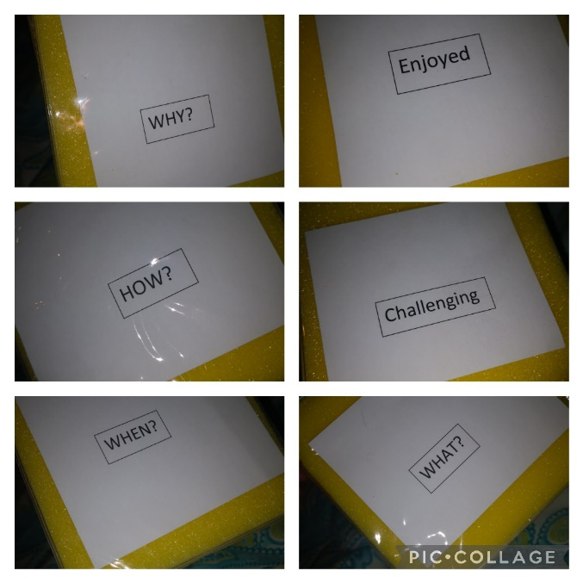
Appendices:
Appendix 1:

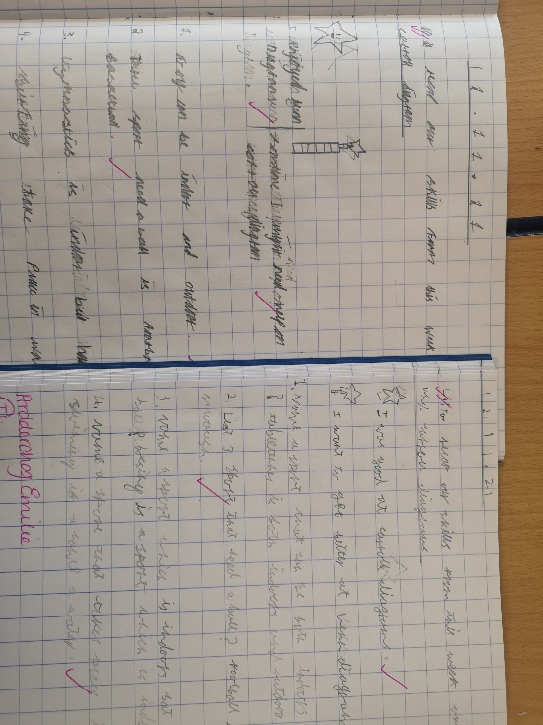
Appendix 2:

Appendix 3:
Lesson Plan PTE 1

Student-teacher | Evie Divetta | Class: | Year 4
AoLE or Subject | Literacy | Date: | 18.11.21
Lesson Focus: | To complete a reading comprehension on the digestive system. To peer assess provided answers.
Meaningful links to Curriculum | What matters statement: ‘I can find and use information from different materials that I read’ and ‘I can explain where and why I have made any changes or corrections’
Meaningful links to:  Cross Curricular Responsibilities | Literacy and science and technology.
Personal Targets (Linked to QTS and identifed in weekly review)
- AFL (Peer-assessment)
- Authentic contexts

Learning Objectives (focus on Learning- use accessible vocabulary):
The pupils will learn to: 1. Extract information from an explanation text.
2. To peer assess.

Success Criteria (clearly linked to each Learning Objective and related to the process and/or product of learning) | Assessment of Pupils’ Learning  Evidence  (What have the learners to say/write/do/produce – to demonstrate learning)
- HA- Use full sentences to answer questions about the explanation text.  - MA- Use a mixture of full sentences and multiple choice to answer questions about the explanation text.  - LA- Answer the multiple choice and matching statement questions about the digestive system.  - Swap books on the table and use the answer sheet to correct a peers work.  - Discuss any wrong answers and provide feedback. | - Fill out the questions provided to them by extracting appropriate information from the text.  - Provide feedback to their peers as to where and why they were incorrect.

Time | Activities/Methodology/Key Concepts  (Teacher’s Role – including key teaching points, differentiation strategies and key questions) | Pupil Tasks  (Pupils’ role –including differentiation, engagement in formative assessment and homework) | Resources  (Including Health and Safety requirement)
Opening phase (with links to prior learning) | Children will be told that to consolidate their understanding of the digestive system, they are going to be doing a reading comprehension activity. They will be asked why they think they are being asked to do this. If noone volunteers then i will choose someone to provide an explanation using lollipop sticks. They will be encouraged to understand that this will make them more familar with the text, as by looking for something they need to acknowledge all of the text around it. This increases the liklihood of information sticking in their brain. Also, they will be told how being able to skim and scan a text for specific information is a skill that will become handier as they get older. As they progress through school they will be asked to look at larger texts and being able to look for specific features will save them time. When they go to university or college and they may need to read lots and lots of books, articles etc.. being able to look for key things that you need is very important as you often have alot of reading to get through etc...
Teaching & Core Learning | Children will be given appropriate comprehensions and are told to find the answers to the questions in the text. They will also be told that they will get given answer sheets that will allow them to mark another friends work in purple pen, therefore, they are to do this task as independetly as possible. MA and LA answer sheets are to be glued into their books. | HA- Will be given full sentence questions and will need to answer in full sentences in their books.  MA- Will be given a mixture of full sentence questions that require a full sentence response, and multiple choice questions.  LA- Will have all multiple choice and matching the statement to the correct organ questions. They will also recieve a condensed texts to that given to the other 2 groups so as they do not have as much information to scan through. | -Reading comprehensions  - Literacy books  - Questions sheets  - Answer sheets  -Purple pens
Plenary | The peer reflection within this activity in going to act as the plenary for the children. Being given feedback on their answers, including the details they did not include should prompt them to include them in their writing next time. They will also take part in the the daily recaps with myself which will consist of me asking a question to a child, then that child asks someone else a question, whoever answers them then has to continue.

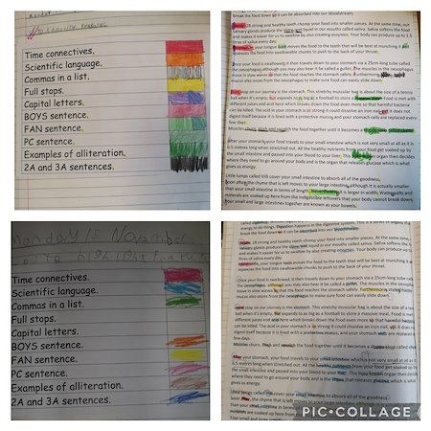
Appendix 4:

