“Collage, montage and assemblage have had a significant cultural impact on image-making” (Wigan p52 2006). Discuss.
Student Number: 1802227
BA: Illustration
Word Count: 2866 (2502 excluding quotes)
Tutor: Louise Burston

Within his book “Thinking Visually for Illustrators”, Mark Wigan claims that collage, montage and assemblage have all had “a significant cultural impact on image-making” (Wigan, 2006, p52). The intent of this essay is to analyse the trends and development of these techniques, to analyse how and why they have been utilised at different points of history. As with other non-digital mediums such as painting, drawing and sculpting, collage has been adopted by computer-based artists in the digital era, and, as Gallager states “The internet has revolutionised the medium; thanks to Google image search and sites like Flickr and Tumblr, collage artists now have an endless resource for images to alter, both digitally and by hand” (Gallager, 2011). The growth of these mediums often mirrors the society surrounding it; this is especially clear when comparing the brutality and “anti-art” stance of a movement such as Dadaism, versus the aesthetically pleasing, commercially friendly collage, montage, and assemblage of twenty-first century.
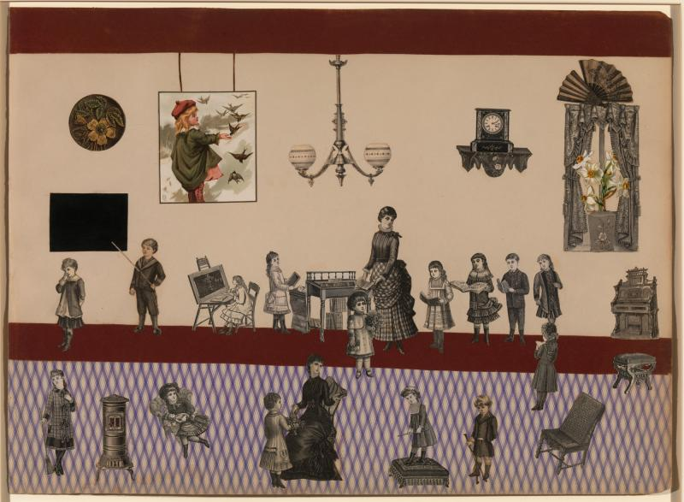
Victorian collages were popular amongst young, middle-class girls, who used collage to prepare themselves for domestic life and plan how their future homes might appear (Insider, 2013). In this sense, they show the complacency of these women, the acceptance of their inferior role in society, and of their restrictive possible futures. However, this argument may be subverted due to the known existence of Victorian scrapbooks and albums (such as the collections shown within the Met Museum’s “Playing with Pictures: The Art of Victorian Photocollage” (2010) exhibition). The whimsical nature of these scrapbooks differs greatly from the parlour collages, showing the wit and creativity of their female creators, and more importantly, more of their own personal tastes and wants – “the desire for fashion, for grace, natural beauty, romantic love, perhaps even for a foreign place” (Bermingham, 2011).
Figure 1: Unidentified, Untitled (Victorian Collage), 1880-1890
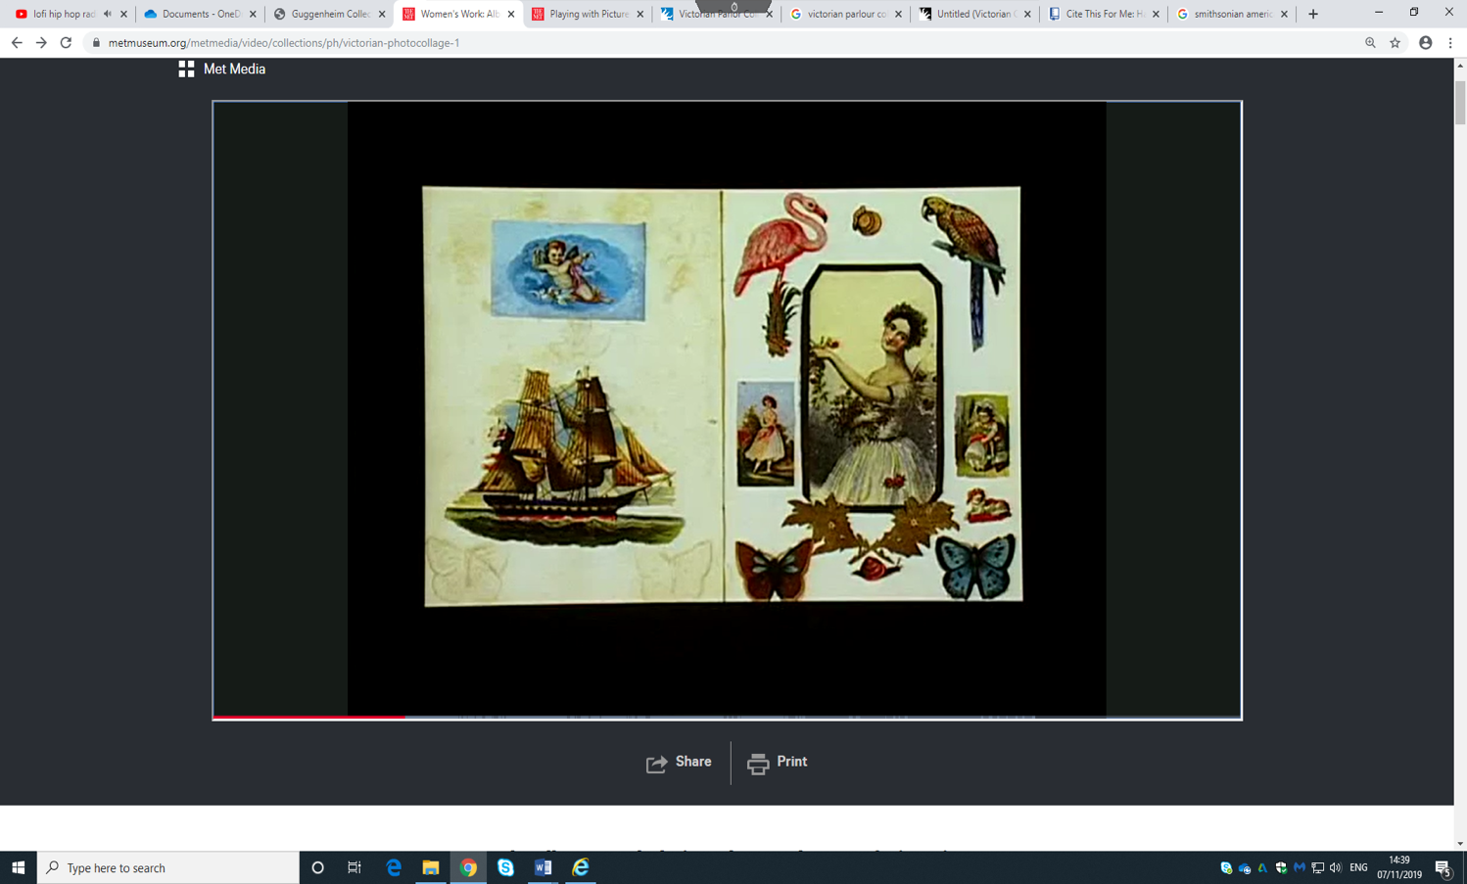
Figure 2: Unidentified, “The Scrapbook” (Victorian Scrapbook), 19th Century
It could be argued that Victorian Parlour Collages showed one side of the Victorian female experience -the need to find a husband, to create a family, and to care for a house- while the personal scrapbooks showed more of their “educated minds [and] accomplished hands” (TheMet.org, 2010), and were possibly their only outlet for expressing a desire for more agency and freedom. This isn’t to say that it is possible to fit women from the time into strict categories set by these two image-making trends, only to suggest the contrast between the intentions of both. However, it is obvious that neither medium fully broke away from conventional art styles and Victorian trends, as most of the images used were commercially published chromolithographs and engravings, and the aesthetic appeal of the created images was clearly always valued more than a strong message.
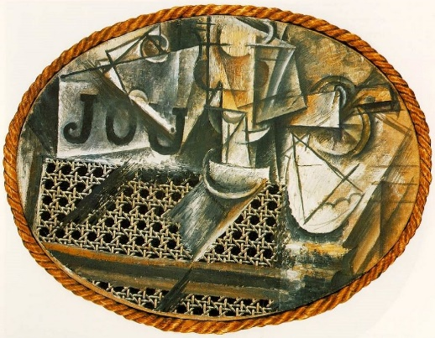
Figure 3: Pablo Picasso, “Still Life with Chair Caning”, 1912
The origin of collage as a medium in its own right isn’t fully clear, as Cubist artists Georges Braque and Pablo Picasso were both using the technique in their works during the same time. What is suspected to be one of the first collage creations was Figure 1: Picasso’s “Still Life with Chair Caning" (1912), in which he utilises an oil cloth and a piece of rope to add texture to the image. The intention of Cubism, and of collage within the movement, was to break down three-dimensional shapes into two-dimensions, highlighting the flatness of the canvas in a meta sense. With the addition of elements such as the oil cloth and rope, Picasso essentially disregarded the artistic harmony of the piece – the contrasting elements not only highlight falseness of the painted portion of the image, but also created a sense of truthfulness. In regards to “papier collé” Picasso stated; “the idea that different textures can enter into a composition to become reality in the painting that competes with reality in nature” (Brockelman, 2001).


While discussing the medium of collage, the Dada art movement could be claimed to be the most significant. The movement emerged during the early twentieth century, approximately 1916, due to outrage at the First World War, and at the state of a materialistic and nationalistic society in general (TheArtStory.org, 2012). The artists who were part of the movement used discomfort and confusion as a tool to critique the complacency of the public when faced with reality – they utilised the collage techniques also being used by Cubist artists (there was some crossover – for example, Kurt Schwitters was part of both art movements) to highlight the “beautiful absurdities” (Tzara, “Dada Soulève Tout”, 1921) of humanity.
Figure 4: Kurt Schwitters, “ABCD”, 1920

As shown in fig 4, Kurt Schwitter’s “ABCD” (1920) to the left, we can see a myriad of images, including a photograph of himself. The inclusion of a self-portrait indicates to us that what we see here is a more personal representation of the artist, and the large amount of letters and numbers indicate a rejection of the overwhelming nature of how information is simply heard and repeated over and over (symbolised here by how the image of stars in space is fed into his ear and out through his mouth. It wasn’t until the early twentieth century that artists began to use their canvases to represent their “state of mind” (Tzara from “The Dada painters and Poets” 1922, p250), versus the objective world. Of course, one cannot say that this shift began with Dadaism, as many experimental and more abstract and subjectivity-based art movements were developing during the time (such as Cubism, German Expressionism and Fauvism), however the ideals of Dadaism, provided an alternate method of representing oneself that undoubtedly impacted the other movements of the time, and the ones, such as Surrealism, that were born out of it.

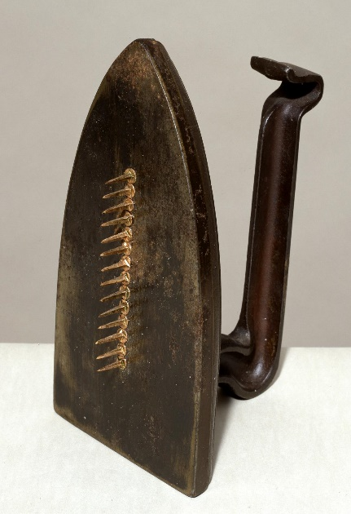
Alongside collage, the medium of assemblage also emerged in large part due to Picasso and Braque’s cubist experimentations - it utilised the same basic principles as collage, except in a three-dimensional space, creating sculptures as opposed to flat images. The technique was used by Surrealist artists such as Man Ray, Méret Oppenheim and Salvador Dalí (tate.org), as the added “realistic” element of the three-dimensionality helped create a stronger sense of unfamiliarity and unease. Fig 5 shows Man Ray’s “Cadeau” (1921), an unsettling combination of a flat iron and fourteen nails, rendering the former useless, in terms of its original purpose, but turning it into something new instead. Much of assemblage consisted of reimagining domestic household objects as something strange and unfamiliar, “[escaping] the rule of logic and the conventional identification of words and object” (tate.org). It became a more internal, subconscious based-technique, exploring Freudian ideas and, as stated by André Breton, “To aid the systematic derangement of all the senses….it is my opinion that we must not hesitate to bewilder sensation…” (Breton, “Surrealist Situation of the Object”, 1969, p263)
Figure 5: Man Ray, “Cadeau”, 1921 (replica 1971)

Another movement that owes its creation to the foundations of Dada is Pop Art, or at the very least, the collage and assemblage side of Pop Art. Its overall aesthetic and messages contrasts to Dadaism for a few reasons, the main one being the fact that it was created by (in part) and focused on the “unprecedented period of economic and political growth” (MOMA.org) of America after the end of the Second World War. The collages are bright and saturated, utilising imagery from popular media and products. Cartoons, celebrities, comics, food brands; everything that captured the consumerism of the culture at the time. Unlike Dadaism, the images were left to stand on their own, and weren’t distorted or manipulated to mock themselves (as Dada artworks did), however this isn’t to say that the artists were promoting an ideal view of America in their art – while more celebratory than purely critical, many of the works did utilise humour and sarcasm “to make a statement about current events, poke fun at fads, and challenge the status quo” (Invaluable.com, 2018), but they used a more accepted and less subversive style of art, meaning that it would reach a wider audience.

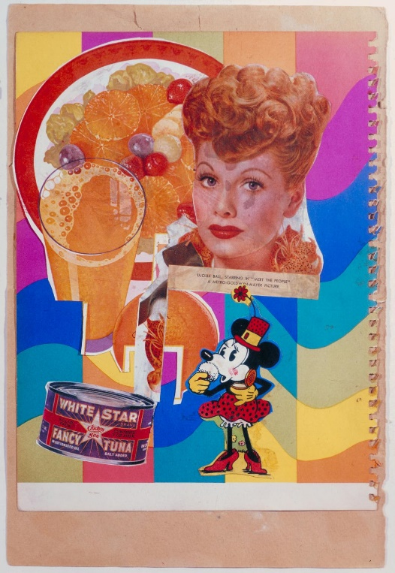
Figure 5: “Meet the People” (1948) is a Pop Art collage by Eduardo Palozzi. The artwork contains the images of a fruit salad, a glass of orange juice (which became an extremely popular drink in America following the war (Snelling, 2014), a can of brand tuna, cartoon character Minnie Mouse, and American actress Lucille Ball. All of these elements fit into the idea of an American experience, especially as the artist was Scottish, and viewing the country from an outsider’s perspective. Most of the images used were sourced from magazines given to Palozzi by American soldiers (Tate.org, 2004), adding to the authenticity of his view of American culture. Later on, inspired by Palozzi, British Pop Art as a whole began to focus more on American culture, and how “American influences, brands and entertainment were reaching Britain’s shores” (myartbroker, 2019)
Figure 6: Eduardo Palozzi, “Meet the People”, 1948

Fig 5 is one of the first known Pop Art artworks, and even early in the movement’s history we can see how it differs from Dadaism – while still critical of capitalism and mass consumerism, they don’t take the “anti-art” (Duchamp, 1913) stance, and the images used are shown in their entirety – body parts and facial features were rarely replaced by different images and anatomy was rarely played with. Overall, Pop Art, when compared to Dada, appears less subversive, and visually more similar to the previously discussed Victorian scrapbooks.
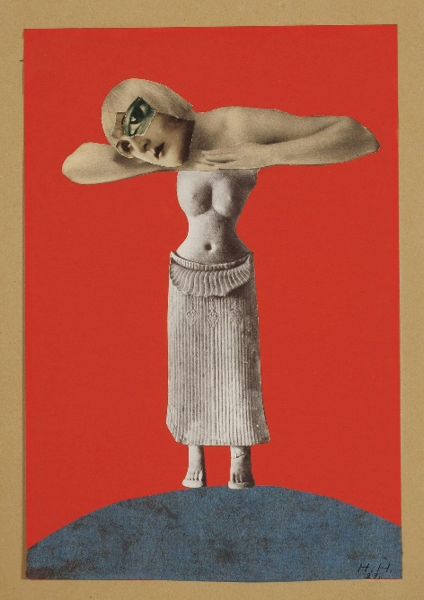
Figure 7: Hannah Hoch, “Untitled” 1930
Vaporwave is the name of a genre of music that emerged around 2011, that focused on slowing and manipulating music to create relaxing yet sometimes unnerving melodies (of course, the effect of the music on its listeners is entirely subjective). Most of the non-original music used is sourced from 80s songs and elevator music (Jurgens, 2016), reinterpreting and manipulating nostalgic elements using modern editing software. Focusing on the music’s accompanying visuals, there is a claim to be made that the Vaporwave aesthetic (usually referred to as “A E S T H E T I C” online) shares similarities to Dadaism, both visually, and in terms of the intentions behind their creations.
When comparing Figure 6 and Figure 7, we can see several similarities, the first of which being the use of statues. In figure 6, Hoch merged African statues with photographs of European individuals – “European and African, coloniser and colonised, documenter and documented, bourgeois modern and primordial tribal” (Jansen, 2016) to make a statement about the supremacist views of Nazi Germany and the similarities shared between different cultures. The statues did visually contrast, but were intended to serve as a metaphorical link between different ethnic groups. In Vaporwave images, Greco-Roman statues do not serve such a clear purpose. In a Reddit thread titled “What's the significance of the Greco-Roman statues in Vaporwave?”, user “T H E – E D I T O R” states:

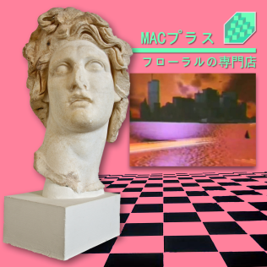
“These statues are remnants of past civilisations and have come to represent the stuff we found from the peak of those cultures… Moderns think in low art and high art, Vaporwave subverts that notion by juxtaposing statues that are universally accepted as high art with Windows 98 wallpapers and other [Vaporwave] tropes. Making them somehow equal in value.” (2018)
Figure 8: Cover art for Ramona Vektroid’s Vaporwave album “Floral Shoppe”, 2011

It could be argued that a celebration of cultures is also why Japanese text is so heavily featured in many Vaporwave visuals, despite not necessarily being a nostalgic element to Western audiences. However, as Lhooq argues, it may also be because “unreadable characters act as signifiers of a globalized and impenetrable future” (2013). Digital collage is used in Vaporwave aesthetics as a reference to 1980 - 1990 computer systems. As shown in figure 7, none of the elements belong together – they could have been combined almost photo-realistically with our modern technology, but many creators choose to retain the sense of falseness and imperfections, as that is more accurate to the limited visual capabilities of late twentieth century technology.

Both Vaporwave and Dadaism stem from the desire to critique society in some way, Dada in relation to the First World War and Nazi Germany (among other reasons such as gender equality and beauty standards), and Vaporwave in relation to economic crises, global capitalism, and as a way to deal with ongoing political unease. However, unlike Dadaism, most Vaporwave images are intended to be visually pleasing – the colours tend to be harmonious, the “glitched” and digital effects add a sense of interest, and most of all, they encourage a sense of nostalgia, even if it simultaneously critiques capitalism. It shares some similarities with Pop Art in that sense, it is both a celebratory and critical look at a certain culture and time period.


Moving on to contemporary collage and how it both differs from and resembles its Victorian and early-twentieth century movements, it is interesting to consider the work of artist Adam Hale, who has utilised technology, namely his own website and an Instagram account (instagram.com/the.daily.splice) to create an unending series of daily artworks for his audience. The images he creates look almost digitally edited yet are actually hand-cut and glued together, echoing the preciseness of the Victorian scrapbooks more than any other collages discussed in this essay. In an interview with Vice, he stated “a response to all the free publications I was receiving on my commute and wanted to create something permanent from something disposable” (Hale, 2015) – the message behind his collages stem more from the idea of reusing and reinterpreting the images that otherwise will be thrown away.
Figure 9: Adam Hale, “Binx” 2015

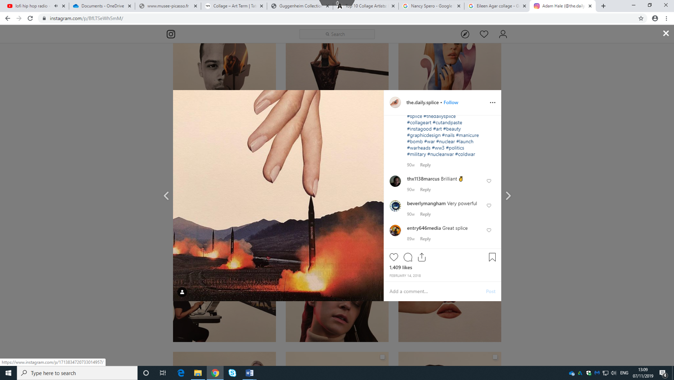
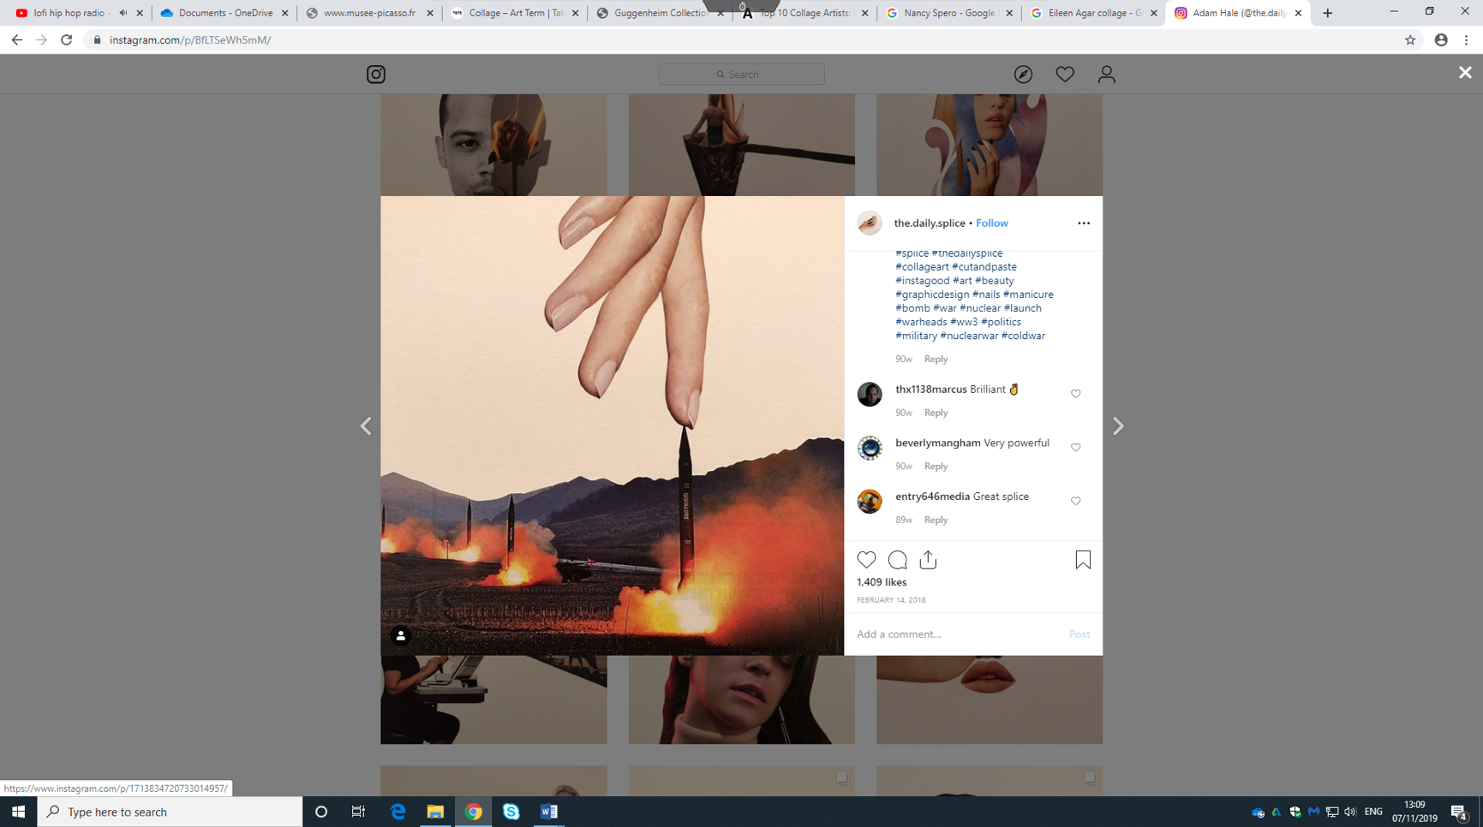
This isn’t to say that his works feature no social or political commentary, as shown in Figure 10, “X Press the Button” (2018), he uses the medium to turn advertisements for jewellery, makeup and clothes into a statement against war. The juxtaposition of appealing, fashion photography against a photograph of missiles is intended to be jarring, as are the ‘tags’ used for the post; “#nails #manicure #bomb #war #nuclear”. In the twenty-first century, collages have generally become more stylised and visually appealing, which in turn appeal to larger audience. Writer Sandra Iliescu criticises this approach; “historicist montages...harness [collage’s] aesthetic in the service of some straightforward, narrow message” (2008). Whether or not the validity of collage has changed within recent years, it is undeniable that artists’ approach to the technique has evolved, both in terms of how they visually cut and arrange the images, the images/materials that they use, and the message or intentions behind each piece.
Figure 10: Adam Hale, “X Push the Button” 2018

The development of technology has allowed the potential of collages to develop; new ways of combining images and materials are always emerging, which led to the creation of montages. It is speculated that the first montage was created by George Albert Smith during the first few years of the twentieth century (Sadoul, Templin, 1946), however it took many years for the technique of montage to be utilised in a similar way to collage, forgoing realism and focusing more on stylisation and juxtapositions.
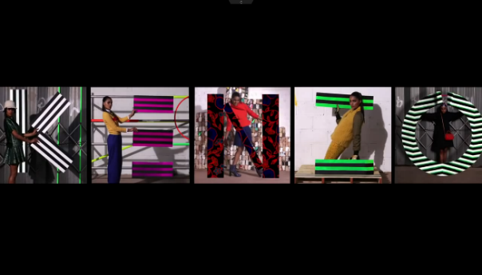
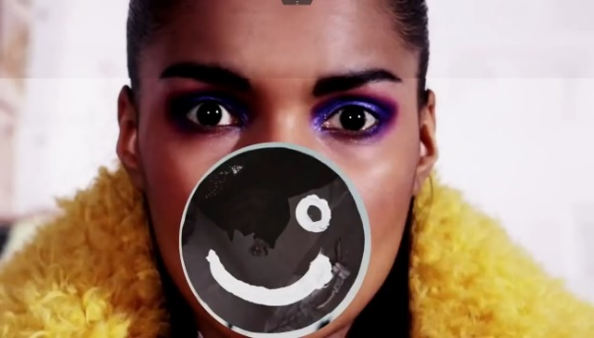
Figure 11: Quentin Jones, Kenzo Pre-Fall 2012 [Video]
Figure 10, Quentin Jones’ “Kenzo Pre-Fall 2012” (2012) video is formed from stop-motion, computer generated imagery, and hand drawn elements, all combined together to create flashy, juxtaposing imagery that takes advantage of the digital medium, but still retains the handmade, imperfect style of non-digital collage. Unlike many of the previously-discussed works, Jones’ creations often do not appear to have any obvious or intentional underlying meanings, as she stated in an interview with CreativeReview.co.uk, “my work is often light-hearted and fun because I work in fashion and beauty, and [I] don’t feel like it should be taken too seriously” (Jones, 2019).

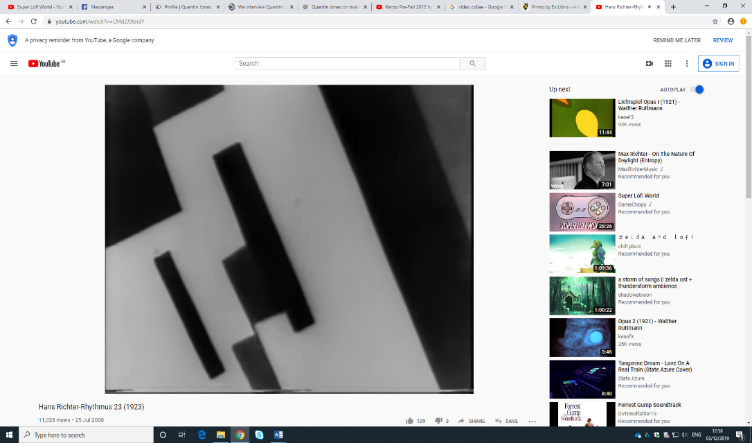
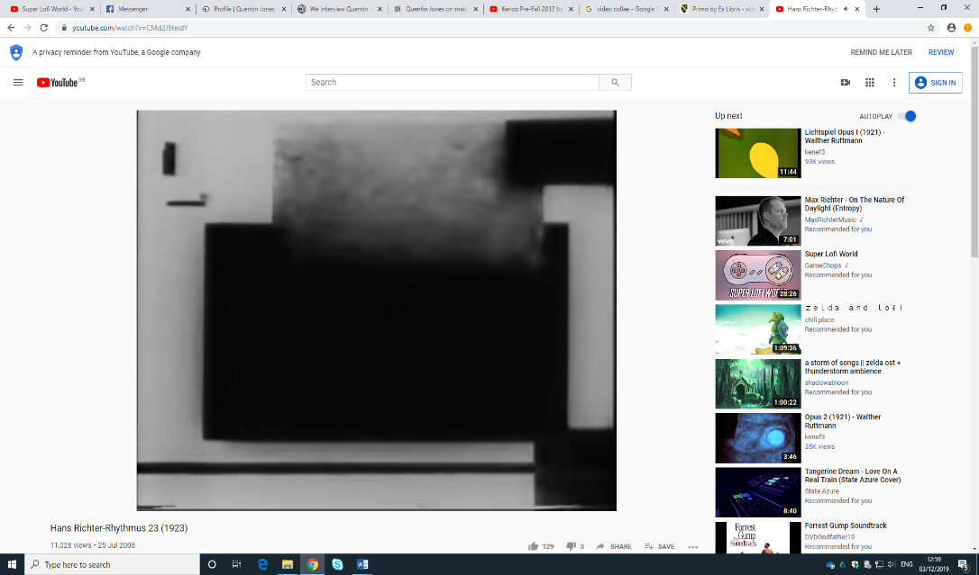
As she often works with advertisers, Jones takes a different approach to collage versus Dadaists or Pop Artists, most of which criticised consumerism or brands in some way. This isn’t to state that either of these artists are more “correct”, only that the intentions behind the creation of collages has shifted dramatically over time. Figure 11, part of a Dada film series, was more abstract, creating a “satisfying cinematic tension” (Elderfield, 2008). The Dada films, while there wasn’t a large amount made, cared more about creating a mood, rather than advertising, or conveying a literal message.
Figure 12: Hans Richter & Viking Eggeling, “Rhythmus” [video], 1923

In conclusion, both the visual style and intentions behind collage, assemblage and montage have developed drastically over the decades since it became popularised by movements such as Cubism and Dadaism. Juxtaposition, whether for a purpose or simply aesthetic interest, has always been a large draw of the medium; it is present in almost all of the works discussed in this essay. Despite the drastic changes during the technique’s lifespan, it is still interesting to note the similarities between the Victorian collages against the newer artworks, such as Adam Hale’s – it shows that no matter what images, mark making or materials are utilised, artists and viewers are drawn to new ways of creating images that respond to context. Collage creates a blunt type of surrealism in most cases – there is rarely an attempt to make images blend together seamlessly, as that goes against the main purpose of collage, montage, and assemblage.

Bibliography.

André Breton, (1969) “’Surrealist Situation of the Object’ in Manifestoes of Surrealism” Michigan: University of Michigan Press

Artsy. (2014). “The Birth of Collage and Mixed-Media”. [online] Available at: https://www.artsy.net/article/matthew-the-birth-of-collage-and-mixed-media

Bermingham, A. The Met (2011). “Women's Work: Albums and Their Makers - The Art of Victorian Photocollage”. [video] Available at: https://www.metmuseum.org/metmedia/video/collections/ph/victorian-photocollage-1

Brockelman, T. (2001). “The Frame and the Mirror”. Evanston, Ill.: Northwestern University Press, p.117. Available at: https://books.google.co.uk/books?id=H9fbTcN_WbQC&pg=PA117&lpg=PA117&dq=the+purpose+of+papier+coll%C3%A9+was+to+give+the+idea+that+different+textures+can+enter+into+a+composition+to+become+reality+in+the+painting+that+competes+with+reality+in+nature.&source=bl&ots=q88_0EtGol&sig=ACfU3U0s0WCUtuVrDd1XyTmP97tXVWI0Qg&hl=en&sa=X&ved=2ahUKEwjznO2Or4rmAhVUasAKHeQpBMsQ6AEwA3oECAcQAQ#v=onepage&q=the%20purpose%20of%20papier%20coll%C3%A9%20was%20to%20give%20the%20idea%20that%20different%20textures%20can%20enter%20into%20a%20composition%20to%20become%20reality%20in%20the%20painting%20that%20competes%20with%20reality%20in%20nature.&f=false

Dačić, A. (2015). “How Can we Define the Phenomenon of Meta Art? A Dance between Philosophy and Art History”. [online] Widewalls. Available at: https://www.widewalls.ch/meta-art-metamodernism

Elderfield, J (2008) “Dada in the Collection of the Museum of Modern Art” New York: Museum of Modern Art.

Gadgil, S. (2019). Quentin Jones on making playful visuals for fashion brands and mags. [online] Creative Review. Available at: https://www.creativereview.co.uk/quentin-jones-playful-films/

Gallager, J (2011) “Cutting Edges- Contemporary Collage” Berlin: Gestalten

Iliescu, S. (2008). “Research and Debate -- Beyond Cut-and-Paste: The Promise of Collage in Contemporary Design”. Places, 20(1). Available at: https://escholarship.org/uc/item/9hw638sm

Invaluable. (2018). “What is Pop Art? Techniques, Artists, and Examples that Shaped the Movement.” [online] Available at: https://www.invaluable.com/blog/what-is-pop-art/

Jansen, C. (2016). “Hannah Höch's Reimagining of Indigenous African Artefacts”. [online] AnOther. Available at: https://www.anothermag.com/art-photography/8931/hannah-hoch-reimagines-indigenous-african-artefacts

Jones, Q. (n.d). [online] Quentin Jones. Available at: https://www.quentinjones.info/profile

Jurgens, G. (2016). “Why Won’t Vaporwave Die?”. [online] Format.com. Available at: https://www.format.com/magazine/features/art/vaporwave

Kenzo (2012). “Kenzo Pre-Fall 2012 by Quentin Jones”. [video] Available at: https://www.youtube.com/watch?v=3MrEiZZkPnY&list=PLIOL8Gt9OIqEeVyIUU4eO7nRZ3DNH12wP&index=16&t=0s

Peralta, K. (2016), “Vaporwave is Dead. Long Live Vaporwave”. [online]. Available at: https://www.esquire.com/entertainment/music/a47793/what-happened-to-vaporwave [Accessed 24 October 2019].

Lhooq, M. (2013). “Is Vaporwave the Next Seapunk?” | Thump. [online] Available at: https://web.archive.org/web/20140426034616/http://thump.vice.com/words/is-vaporwave-the-next-seapunk

Metmuseum.org (2010). “Playing with Pictures: The Art of Victorian Photocollage”. [online] Available at: https://www.metmuseum.org/exhibitions/listings/2010/victorian-photocollage

Moma.org (n.d.). MoMA | “Pop Art”. [online] Available at: https://www.moma.org/learn/moma_learning/themes/pop-art/

Motherwell, R (1951) “The Dada Painters and Poets” San Francisco: Wittenborn Art Books Inc.
MyArtBroker (2019) “Britain Vs America – Pop Art” [online] MyArtBroker. Available at: https://www.myartbroker.com/blog/myartbroker-explores-pop-art-britain-vs-america/

Nationalgalleries.org. (2018). “Eduardo Paolozzi” | National Galleries of Scotland. [online] Available at: https://www.nationalgalleries.org/art-and-artists/artists/eduardo-paolozzi

Nick, S. (2014). “The History of Orange Juice”. [online] Live Better. Available at: https://www.medibank.com.au/livebetter/be-magazine/food/the-history-of-orange-juice/

PixelDash85 (2018) “What's the significance of the Greco-Roman statues in Vaporwave?” [online] Reddit. Available at: https://www.reddit.com/r/VaporwaveAesthetics/comments/a2l7ny/whats_the_significance_of_the_grecoroman_statues/

Sadoul, G. and Templin, Y. (1946). “Early Film Production in England: The Origin of Montage, Close-Ups, and Chase Sequence”. California: University of California Press, pp.249-259.

Skidmore, M. (2014). “We interview Quentin Jones about her new London show with Robert Storey”. [online] It's Nice That. Available at: https://www.itsnicethat.com/articles/quentin-jones-1

Smithsonian Insider. (2013). “Victorian Parlor Collage”. [online] Available at: https://insider.si.edu/2013/02/victorian-parlor-collage

Tate (2004). “Meet the People”. [online] Tate. Available at: https://www.tate.org.uk/art/artworks/paolozzi-meet-the-people-t01459

Tate. (2019). “Assemblage – Art Term”[online] Tate. Available at: https://www.tate.org.uk/art/art-terms/a/assemblage

Tate. (2019). “‘Cadeau’, Man Ray, 1921, editioned replica 1972” [online] Tate. Available at: https://www.tate.org.uk/art/artworks/man-ray-cadeau-t07883

Tate. (2019). “Cubism – Art Term” | [online] Tate. Available at: https://www.tate.org.uk/art/art-terms/c/cubism

Tate. (2019). “Fountain’, Marcel Duchamp, 1917, replica 1964” [online] Tate. Available at: https://www.tate.org.uk/art/artworks/duchamp-fountain-t07573

Tate. (2019). “Anti-art – Art Term” [online] Tate. Available at: https://www.tate.org.uk/art/art-terms/a/anti-art

The Art Story.org (2012). “Dada Movement Overview and Key Ideas”. [online] Available at: https://www.theartstory.org/movement/dada/
Wallach, L. (2012). “A Cut-Down History of Collage”. [online] Artspace. Available at: https://www.artspace.com/magazine/art_101/art_market/art_101_collage-5622

Wigan, M. (2015). “Thinking Visually for Illustrators”. London: Bloomsbury Publishing, p.52.

http://www.johncoulthart.com/feuilleton/2007/03/26/lamour-fou-surrealism-and-design/

List of Figures.

Figure 1: Unidentified, Untitled (Victorian Collage), 1880-1890. Available at: https://americanart.si.edu/artwork/untitled-victorian-collage-32752

Figure 2: Unidentified, “The Scrapbook” (Victorian Scrapbook), 19th Century. Available at: https://www.metmuseum.org/metmedia/video/collections/ph/victorian-photocollage-1

Figure 3: Pablo Picasso, “Still Life with Chair Caning”, 1912. Available at: https://www.artsy.net/article/matthew-the-birth-of-collage-and-mixed-media

Figure 4: Kurt Schwitters, “ABCD”, 1920. Available at: https://www.metmuseum.org/art/collection/search/265584

Figure 5: Man Ray, “Cadeau Audace”, 1921. Available at: https://www.tate.org.uk/art/artworks/man-ray-cadeau-t07883

Figure 6: Eduardo Palozzi, “Meet the People” 1948. Available at: https://www.tate.org.uk/art/artworks/paolozzi-meet-the-people-t01459

Figure 7: Hannah Hoch, “Untitled” 1930. Available at: https://arthistoryproject.com/artists/hannah-hoch/untitled-4/

Figure 8: Ramona Vaktroid, “Floral Shoppe” 2011. Available at: https://www.tinymixtapes.com/news/macintosh-pluss-floral-shoppe-coming-vinyl

Figure 9: Adam Hale, “Binx” 2015. Available at: https://www.instagram.com/p/5KQGCRPdYC/

Figure 10: Adam Hale, “X Push the Button” 2018. Available at: https://www.instagram.com/p/BfLTSeWh5mM/

Figure 11: Quentin Jones, “Kenzo Pre-Fall 2012” [Video], 2012. Available at: https://www.youtube.com/watch?v=3MrEiZZkPnY&list=PLIOL8Gt9OIqEeVyIUU4eO7nRZ3DNH12wP&index=16&t=0s

Figure 12: Hans Richter & Viking Eggeling, “Rhythmus” [Video], 1923. Available at: https://www.youtube.com/watch?v=CMd2J9teidY

