Community Engagement
Project Proposal

Introduction
Following a recent needs analysis undertaken in the Swansea area, it was proven that there are inadequate provisions for activities within this area for lone-parents to participate in with their children. It also demonstrated the high number of lone-parent households in Swansea, along with concerning lone-parent household poverty rates. Focusing primarily on lone-parent families, it became clear that this kind of provision is needed for many reasons, which include social mobility; to prevent isolation; and to have a positive effect on children’s futures by providing opportunities for them to develop closer relationship with their families’. It was surprising to learn that Swansea has been named as a UNESCO Learning City, with one of their criteria being the focus upon revitalising and promoting learning in all families and communities (UNESCO, 2019). However, the availability of diverse or inclusive ranges of family learning available is limited, almost non-existent. Therefore, I feel that Swansea is not wholly deserving of this status at present. This project will support the lone-parent family group in Swansea by introducing a consistent, affordable and reliable method of interacting, engaging and learning with their children.
Statement of Need
The population of lone-parent families in Swansea is higher than the overall average in Wales, as recorded by the Office of National Statistics in 2017 being 7.8% of the cities’ population, whereas the whole average percentage in Wales stands at 7.5%. As demonstrated in the needs analysis, based on the 245,000 estimated population of Swansea, this averages that there are an estimated 19,000 lone-parent families in the locality. Therefore, there are many lone-parent families residing in the city of Swansea, many of which live in relative poverty. Despite the improvements in acceptance of diversity and inclusion in the United Kingdom in recent years, there still seems to be a stigma and social exclusion issue for lone-parents in the general community. An article published by Wales Online, highlights the challenges of the single-parent stigma which remain prevalent in Wales (See Appendix 1).
Being a lone-parent can, but not in all cases, bring challenging times in terms of financial stresses. Additionally, for working lone-parents this factor may be coupled with the lack of time available to spend with their children, due to ensuring they earn enough alone, to provide for their family.
There is also the impact that separation can have upon a child. It is important to consider that children can really struggle with the realisation that hey do not have the support or company of two parents, more so if they had already been accustomed to this previously. It is widely reported that children who come from broken homes tend to suffer in many areas of their lives, continuing through to adulthood. See appendix 2. Therefore, this project will hope to change that negative cycle by ensuring children from broken homes feel secure, loved,and that their parents or carers take an interest in them in sessions.
Spending quality time with your child/children has many mental and emotional benefits, along with the ability to enable children and parents to take advantage of cultural and leisure activities that may usually only be affordable to those with a larger income. The ability to spend time with your children, enjoying what you are doing in a safe environment can build relationships, increase both the child and sometimes the adult’s self-esteem, and will build trust and memories for both child and parent.
Using my own reflections upon being in this situation, being the parent in a lone-parent family, there were multiple occasions throughout my daughter’s childhood when despite my working full-time, I still could not afford to take my child to participate in activities outside of the home in our spare time. Did this affect me? Yes. Did I feel helpless and isolated? Yes.
Whilst there are so many enjoyable activities parents can certainly do with children in the home environment, this lack of provision for other activities away from the home can lead to isolation, a feeling of inadequacy, and also the impending feeling of failing your child by being unable to socialise or participate in activities with children of a similar age, leading to the child then also facing the same feelings of failure. It is a tragic situation to find oneself in, and I have discovered through conversations with several other lone-parents in Swansea, that this is a problem for a considerable proportion of them.
Investigation was undertaken to locate any existing child and parent workshops in Swansea, which did not result in any positive results. Whilst in half -terms and school holidays, companies such as Hobbycraft and Three Mobile, run free crafts and digital literacy workshops, these are just for children, parents cannot be involved in any of these experiences. These workshops have limitations to spaces available, with most allowing a maximum of 8 children in each. The same applies to the infrequent local museum activities, which again are for just the children, and are sporadic in their scheduling. When you consider the population of single-parent households in Swansea as being 19,000, it then dawns on you that that these provisions are also open to all families in addition to the lone-parent group, which would amount to a much larger proportion of people. Upon consideration of these details, it rapidly becomes clear that 8 spaces in a free of charge workshop are very likely to be filled as soon as they become available, and are in no way adequate for the families of Swansea (See Appendix 3).
Time to Change Wales (2018) reported that loneliness for single parents is often overlooked or unnoticed and can lead to devastating mental health issues. Gingerbread, a charity who support single-parents, say that even reading an article by another single-parent, describing their own troubles or coping strategies, can make other single-parents feel like they are not alone, and more supported (Gingerbread, 2019).
The British Heart Foundation conducted a survey of 4,000 parents in 2017, which revealed that 10% of parents had not spent quality time with their children for over a year, or not at all. 28% of parents said that they had left the house at least once a week without seeing their children (British Heart Foundation, 2017).
I feel that the provision of a consistent, affordable parent and child activity scheme is one way to improve the lives and self-esteem of the lone-parent families in Swansea. Therefore, my project proposal will benefit both the adults and children who are members of the lone-parent family community, by allowing them to access quality time together, learning together and making memories in a safe and encouraging environment.
The positive affects of such a scheme may also contribute to the wider public community, in the sense that both adults and children will learn new skills and information which could be of benefit to employers, their peers, and also promote a sense of family in the community, understanding that families can consist of many variations of structure. This type of parent and child learning scheme will also encourage the formation of stronger bonds between parent and child and may lead to other friendships and networking between people in the group, as all will possess a similarity which each other can relate to.
It cannot go unnoticed however, that although there has been no evidence found of any previous attempt to organise a provision such as the one proposed in this report. The Swansea Council have attempted to assist parents in deprived areas with schemes such as Flying Start, which provides parenting classes, free childcare. Child play sessions and advice for parents and families. This scheme is only available to families with a child between 0-3 years and to families residing in areas stipulated by the Welsh Government. Therefore, this proposal will be unique and the first of its kind in the Swansea area.
The City of London Council acknowledge the importance and the benefits to the community of a family learning and activity scheme. The council, in conjunction with local communities, run various family courses throughout the year such as arts and crafts and cookery, using local market produce. The families often produce items in the classes, which are then sold at local markets. Further information regarding this scheme can be found by visiting the following City of London website address: https://www.cityoflondon.gov.uk/services/education-learning/adult-learning/adult-courses/Pages/families-and-parents.aspx. An excerpt from the website can be seen in
Appendix 4.

Proposed Project
My proposed solution to the need/s identified is a dedicated and professional lone-parent and child/children learning and activity scheme, which will provide workshops, lessons and trips. The scheme name is ‘The Little Bay Workshops’ and will provide learning and creativity experiences and lessons, which will vary from termly projects with desired outcomes, to hobby-based activities. These workshops will operate consistently and will be as dependable as a school/business/college with their delivery.
The workshops will be directed by myself, and several university peers from whom I can utilise their unique skills and talents. As the workshops operate over two sites, a site supervisor will be employed for each of these, to oversee the smooth operation of the scheme. In return they will receive pay, and excellent experience for their future careers. I will pioneer and facilitate the scheme initially, as I feel that my experiences as a single mother are invaluable to other lone parents, ensuring that I have a degree of understanding to their home lives and desire to improve themselves and also their family bonds and relationships. I have a high degree of skills in terms of workshop topics and can deliver a variety of sessions such as arts and crafts, cookery, drama, singing, entrepreneurial skills, languages and also GCSE tuition and exam preparation skills.
I will also draw upon the skills of members of the local community such as retired and working florists, bakers, and business owners. Ensuring that their businesses are promoted throughout our scheme and in publications in social media in return for their time.
Each session will be supervised and run by a minimum of 2 staff members, and all up-to-date DBS certificates will be on display in each session.
Prior to launching the Little Bay Workshops, it is imperative that I gain the opinions of the local communities in terms of the kind of classes and activities that would interest them. To do this, I will be distributing surveys with details of the proposed scheme, asking families to make suggestions for the workshop content. I will also include an example of some initial workshop topics, asking the families if these would be of interest to them or not. Although the scheme is aimed at lone-parent families, I feel that by gaining the opinions of all families on these ideas, will be vital in order for me to provide workshops which enable the lone-parent families to participate in areas that other non-lone-parent families would. By gaining an opinion from varied family demographics, I aim to gain a broad view of the cultural, academic and leisure interests of the communities in which the scheme will operate.
Once the class topics have been confirmed, myself and the two site supervisors will attend various workshops in order to gain knowledge of how to operate these in our scheme, gaining insight from the content and delivery.

Locations/Venues
The Little Bay Workshops will operate across two sites in Swansea to start. They will operate every weekday evening between 4-7pm (not bank holidays), and on Saturdays, with a view to expanding to Sundays depending on the overall success of the first term of the project. The terms will correlate with the seasons; Spring; Summer; Autumn and Winter.
Site 1 will be in the All Saints Church Hall, Mumbles, Swansea. This is a venue with toilets, kitchen, parking, disabled access, and within 400 metres of local transport. The site is also within walking distance of Mumbles, Bishopston, West Cross, Blackpill, Sketty, Brynmill, and can be reached easily by using the purpose-built bay path which stretches from Swansea city centre to this location.
Site 2 will be in the Cockett Community Hall, Cockett, Swansea. This is a venue with toilets, kitchen, disabled access, and within walking distance of several areas of Swansea. It is also easily accessible by public transport, the nearest bus top being within 200 metres walk.
The two initial locations are an attempt to cover wider areas of Swansea, rather than being placed in the town centre, both locations are slightly outside of the city centre, providing a peaceful space to conduct the scheme.
Location 1: All Saints Church Hall Mumbles (2 public transport stops within 5 minutes’ walk) 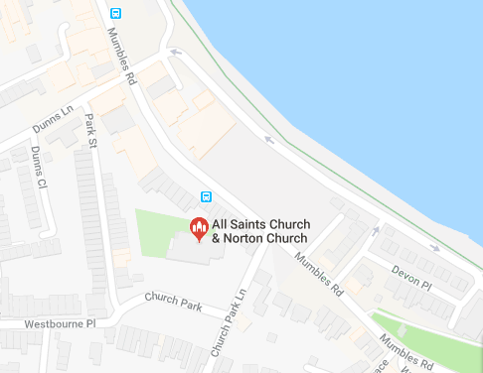

Location 2: St Peters/Cockett Community Hall (Opposite public transport and within walking distance to several areas of Swansea.
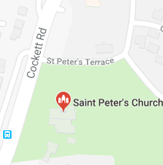
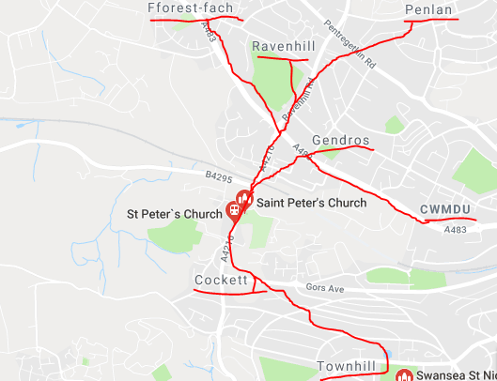

Timetable Example:

Little Bay Family Workshops

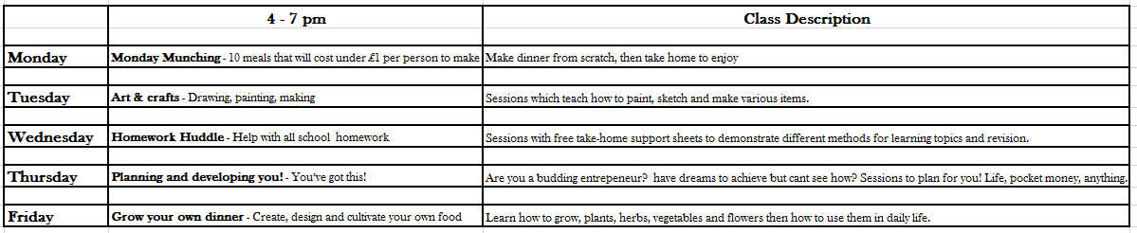

Staffing
Depending on uptake, each venue and session can accommodate up to 40 people. There will be a site supervisor on each site at all times, along with one other paid staff member, and 2 volunteer staff. This equates to staff to participant ratio 1:10 if at full capacity. This is the initial staffing plan, which may increase in terms of volunteers from local university degree programmes or even local community members who wish to commit some of their spare time to this project.
Recruitment for volunteers will include visits to University of wales Trinity St David, to discuss the project with staff and students, and to recruit any education, childcare, or teacher training students. We will also be opening this up for local volunteers who make have a skill/s they could promote in our sessions. Posters will be placed in local shops and churches, along with schools and universities.
For the paid roles, these will be advertised online on employment websites, at local universities, and posted in the job centre and local newspaper.
As the project director, I will attend each session as both a facilitator and coach. I feel it is imperative that I am fully immersed in the whole project in order to ensure that any changes that may be beneficial can be made, and also so that I can act as a leader for staff to come to for any assistance. My experiences as a single parent may also be beneficial to parents attending, as the attendees will be from a homogenous community, of which I also belong.

Funding and finances
Swansea Council offer funding under the Children and young people funding scheme, which is where I have applied for funding to operate privately for one year initially. The council may wish to consider adopting the scheme in the future, if the project is successful. The finer details of this possible transfer of project and business proposal will require careful consideration and planning at a future date.
The two venues have agreed a fee of £120 per week each to have full use between 3:30 – 7:30pm on weekdays and 9:30am – 4:00pm every Saturday. The venue therefore cost approximately £14,400 per year, based on a 48-week service. Wages to be paid, total approximately £28,000 per year. Leaving the remainder of funding attained for materials or any other kinds of scheme related costs.
I have completed and application through The Children and Young People Funding Grant, (See Appendix 5) and the project is eligible for a £70,000 grant, which includes the addition of free publicity from the council, which has been agreed in principle for all new Children and Young people funded schemes. The council have also offered to arrange an information feature and link to any funded schemes on their main Families section of the Swansea Council website.
In order to recuperate some profit to use towards the continuation of the scheme, the workshop sessions will be chargeable at a very minimal amount per week. Each family can attend a week-long trial of the sessions to see if this is something they feel they can enjoy and benefit from. The costs are then £5.00 for 1 adult and 1 child, £1 per further child as a weekly fee. Whilst there is a considerable rate of poverty in the Swansea lone-parent community, the fee of £5.00 for 6 days of sessions which will include one meal making evening, would be worth investing in for families as there are no other activities which they could participate in for even 1 day at this cost. This would hope to focus families on value in terms of life experiences and towards their own future happiness.

Advertising and Promotion
In addition to the agreed promotion by Swansea Council, in local government establishments, discussed in the Funding and Finance section of this report, The Little Bay Workshops will be promoted by posters in various shops throughout the city; in childcare establishments; job centres, bus stations; and schools. The adverts will clearly communicate the targeted group for attendance, the location, times and contact details to enrol. A Facebook page and email address is available to gain more details and to register for sessions.

Project aims & objectives
The aims of this project are to change the lives of lone-parent families, for the better and to provide them with somewhere to learn together and spend time developing their relationships both within their families, and also the wider lone-parent family community.
Ultimately, this project is to provide single-parent families with consistent family activities, which they can fully participate in with their children. However, the project also has indirect benefits such as encouraging the parents to use some of the things learned in the sessions to better the lives of their families. Workshops on offer include planning and life goals, these will aim to boost even the most disheartened of parents to taking small steps to achieving things they may have previously considered as out of reach, whether this may be future job prospects, taking other adult educational courses or just to be able to cook meals with fresh ingredients that do not cost the earth.
Whilst the project is educational and fun, it is a place which will respect diversity and try to adapt sessions so that all participants get the best possible experiences.
Increasing self-esteem in both the child and parent/adult is also an aim of these workshops. I want everyone who attends to leave feeling valued, and children spending quality time with parents is a known provider of security, confidence and trust.
Ultimately, this project is to provide single-parent families with consistent family activities, which they can fully participate in with their children.

Potential Barriers
- Volunteer pool – A concern for me is the reliability and subscription of volunteers. In order to prevent any issues concerning there not being enough staff at any one time, I will be over-allocating volunteer numbers to the sessions to ensure there will not be a short-fall. In the event that a specialist trainer does not attend a session for any reason, I will put together a full training manual for their planned session and will have observed their session prior to the agreement of their subscription to the The Little Bay Workshop.
- Geographical access issues – As this project is going to be trialled for 12 months, I had to decide on two sites which are situated in different areas of the city. I have ensured that both are accessible on foot from many areas, and also by public transport. However, there may be people who wish to participate who cannot reach the sessions. When the class subscibers are confirmed prior to the seasonal sessions beginning, I will send out a blanket emal asking if any attendees would be willing to offer lifts to other families. This will help, but ultimately, there may always be somebody who cannot get to the sessions. This will be considered if we continue to run the scheme after the first 12 months.
- Families who are not lone-parent families feeling as though they are excluded – This is something I feel will certainly cause some potential feedback and disappointment. This project is designed to address a need for a particular group, which is lone-parent families, but this does not mean that the very same application and scheme could not be created for general families. This will be something in which I will record any queries raised and direct to the local council should any queries arise, as I am aware that families with both parents are also living in relative poverty and would possibly welcome such an option. This would need be the subject of a separate project and analysis.
- Sessions times – It could be an issue for some parents to attend due to work commitments, and the timings are at present fluid, so if we feel the responses warrant a change to these, this will be applied to meet need.

Evaluation method
I am going to evaluate my project as being a success if parents and children attend. To measure the level of success and effectiveness for the participants, I will ask them all to complete a survey upon completion of each term, which I will use to reflect upon when considering and planning for future projects and sessions (See Appendix 6).

Conclusion
From the evidence identified in the needs analysis undertaken for the lone-parent family population in Swansea, there is a significant need for a family activity provision in the area. The further information discussed within this proposal, which has used first-hand input from lone-parents along with general investigative data, confirms that we need to address this need in the lone-parent family community.
This project proposal intends to provide solutions for stressors which are placed upon lone-parent families, and to increase the happiness, well-being and social mobility of all families involved.
There are going to be challenges, some of which have been identified in the proposal, but this project will be a working progress, and a solution will be found for any barriers as the project develops.
I have ensured that the aims and objectives of this proposal benefit the targeted group, and the success and long-term impact of this scheme will be measured.
To summarise the project proposal above, The Little Bay Workshops is a hopeful and positive project, which despite the overall planning, will more than likely require some amendments over time to ensure it operates to its full potential. The project provides several solutions for the needs of the lone-parent family communities of Swansea, and by creating and providing these opportunities at Little Bay Workshops, we hope to provide secure foundations for families’ relationships and self-esteem which will make positive effects to them in their future lives.

Appendices

Appendix 1:

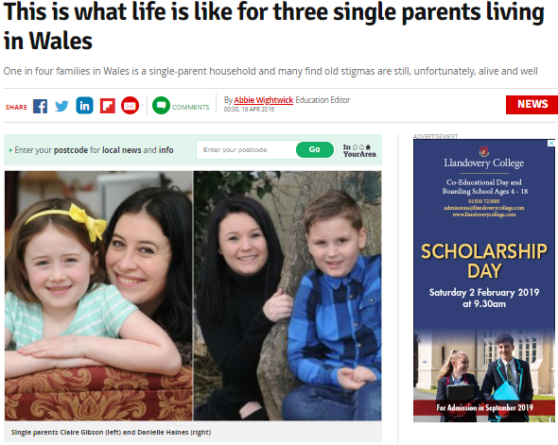Single parents now make up one in four families in Wales.
Much has changed in the two decades since former Welsh Secretary John Redwood suggested benefits to single mothers could be withheld until absent fathers had been approached to contribute, but there is still stigma and radical benefits changes are on the way.
In the three years to 2014, 43% of children in single parent families in Wales lived in relative poverty
And from April 2017, for the first time ever, parents with pre-school children will be made to job search or face sanctions from when their child turns three.
So what is it like bringing up a child as a single parent in 2016? We asked a father and two mothers
Claire Gibson, 35, from Canton, Cardiff, has a daughter, Amelia, eight.
She became a single parent when her marriage broke up and was unemployed for a short time after being made redundant.
“I became a single parent five years ago. I do feel there’s a stigma. Everyone thinks, especially when you are unemployed, that you are on benefits.
“People did imply things and people do assume you are lazy. People think that being a single mum on benefits you are lazy when in fact you are so busy.
“There is still stigma. There’s a general feeling that you have failed and are on the scrounge.

'I don't tell people, I'm a single parent'
“People judge me because I work part time. I get a very small bit of housing benefit but my intention is to go full time when my daughter is older.
“I do not tell people I’m a single parent. I keep it to myself.
"I get a general feeling that I had better not tell people.
“As a single parent, you have to do everything yourself. You have to think about child care issues and doing things around the house - the DIY, cleaning, paying the bills.
“Childcare is tricky. I have to work part time and my job is flexible.
Simon Lewis, 50, from Conwy, has been a single parent to his two children Tyron, 13, and Tia, 11, for 11 years since his relationship with their mother broke down.

It's not always the parent's fault'
“The big issue for me is that people know it’s not always the parent’s fault they become a single parent.“Child care is an issue. I think if a child doesn’t have a supportive life at home and always goes to and comes back from school unattended that can cause problems in the community and they may get into trouble.
“The thing that used to irritate me were little comments that the children were disadvantaged because they were not brought up by their mum. That upsets me. I don’t think there’s a difference.
“As a single father, you get polarised views. Some say, ‘isn’t it wonderful what he is doing?’ and others may think I’m doing it wrong. I am not sure if women get those views.

'I love being a parent'
Wales Online (2016) This is what life is like for three single parents living in Wales. https://www.walesonline.co.uk/news/wales-news/what-life-like-three-single-11198432(Accessed: 14 January 2019).

Appendix 2:

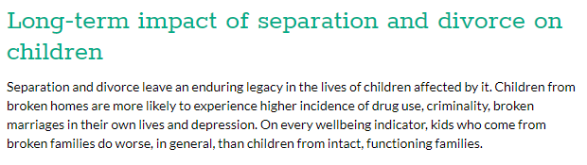
Kidspot(2017) Separation and children: How it affects your kids https://www.kidspot.com.au/health/ask-the-expert/ask-dr-justin/separation-and-children-how-it-affects-your-kids/news-story/5eb7f494653f75ed60095c07a2940ace (Accessed: 12 January 2019).
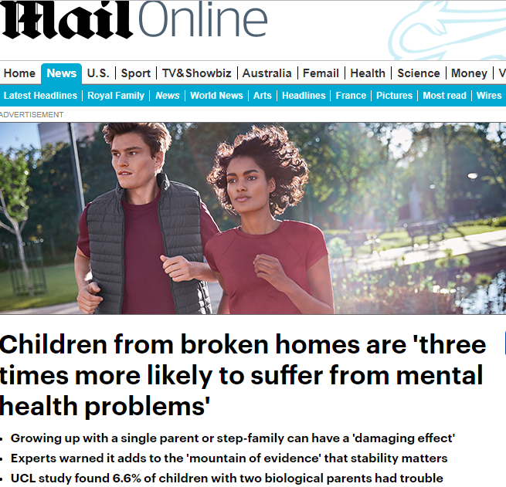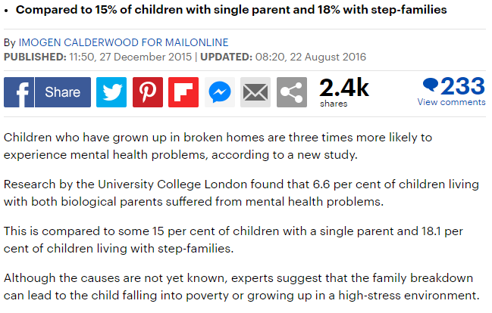
Daily Mail (2017)
Appendix 3:

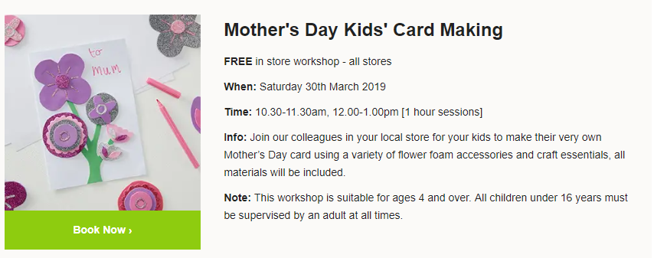
Hobbycraft (2018) Events and Workshops https://www.hobbycraft.co.uk/store-events (Accessed: 14 January 2019).

Appendix 4:

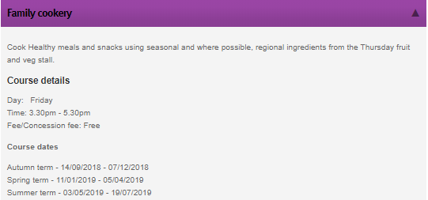
City of London (2019) Families and Parents. https://www.cityoflondon.gov.uk/services/education-learning/adult-learning/adult-courses/Pages/families-and-parents.aspx (Accessed: 15 January 2019).
Appendix 4:

Little Bay Family Workshops

Mumbles Timetable

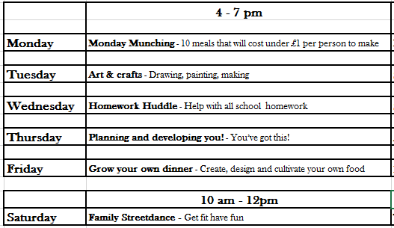


Appendix 5:

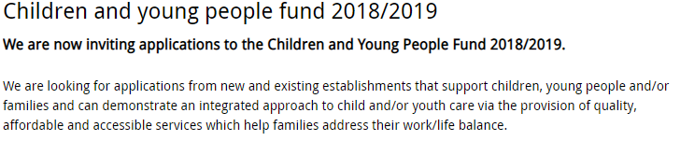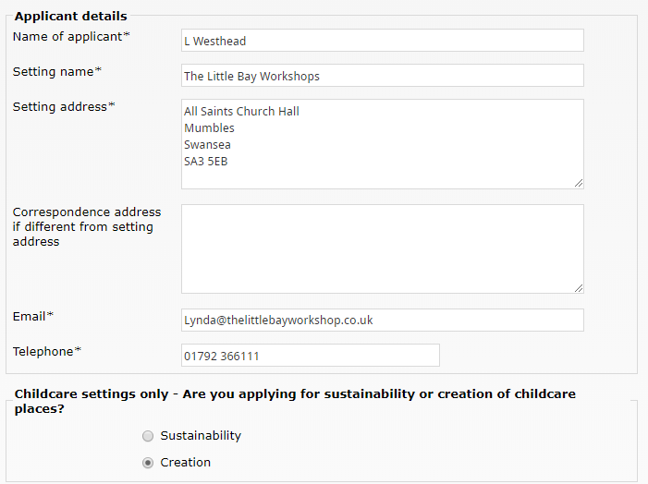
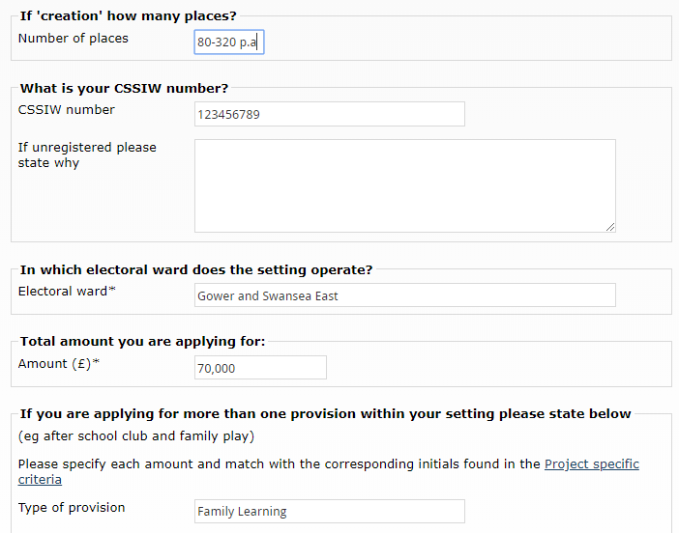

Appendix 6:

Little Bay Family Workshops
Survey

Thank you so very much for being part of our Little Bay community. We do hope that you enjoyed your time here and that we may see you again soon.
So that we know what we have done well, and what you think could make the workshops even more fantastic in the future, please could you soare a few moments to complete this anonymous survey? We would really appreciate it and thank you again for your company this season.
Lynda Westhead, Little Bay Project Mother

- Would you attend future Little Bay Workshop sessions? Yes/No

- Which sessions you’re your favourite and why? ........................................................................................................................................................................................................................................

- Which sessions were less enjoyable and why? ……………………………………………………………………………………………………………………………………………………………………………………………………………………

- Would you recommend Little Bay Workshops to other lone-parent families? Yes/No
Thank you so much!
Reference list

BBC (2017) Childline receives 4,000 calls from ‘lonely’ children https://www.bbc.co.uk/news/uk-39580234 (Accessed: 09 January 2019).
Calderwood, I. (2017) Children from ‘broken homes’ are three times more likely to suffer from mental health problems https://www.dailymail.co.uk/news/article-3375294/Children-broken-homes-three-times-likely-suffer-mental-health-problems.html (Accessed: 12 January 2019).
City of London (2018) Families and Parents https://www.cityoflondon.gov.uk/services/education-learning/adult-learning/adult-courses/Pages/families-and-parents.aspx (Accessed: 10 January 2019).
Full fact (2018) https://fullfact.org/economy/poverty-uk-guide-facts-and-figures/ (Accessed: 11 January 2019).
http://uil.unesco.org/lifelong-learning/learning-cities
Kidspot Health (2017) Separation and children: How it affects your kids https://www.kidspot.com.au/health/ask-the-expert/ask-dr-justin/separation-and-children-how-it-affects-your-kids/news-story/5eb7f494653f75ed60095c07a2940ace (Accessed: 12 January 2019).
Swansea Council (2017) Population https://www.swansea.gov.uk/population (Accessed: 11 January 2019).
Wightwick, A. (2016) This is what life is like for three single parents living in Wales https://www.walesonline.co.uk/news/wales-news/what-life-like-three-single-11198432 (Accessed: 10 January 2019).

