Name: Teresa Onyemah

Student Number: 1921783

Module Title: Effective Team Working and
Communication (BMSW4002_LON)

Assignment Title: Models and Skills in Communication

Lecturer: Dr. Gulnar Ali

CONTENTS
Contents………………………………………………………………………. 2
1 Introduction............................................................................................. 3
2 Models of Communication……………………….……………....…… 3
2.1 Shannon and Weaver Communication Model….….......………...3
2.2 Schramm Communication Model……….……………………….6
2.3 Berlo Communication Model……………………………………7
3 Communication Skills…………………………………….…………….8
3.1 Verbal Communication……………………………………….….8
3.2 Non-Verbal Communication…………………………….……….8
3.3 Listening……………………………………….…………. ….….9
3.3.1 Active Listening……………………………….…….….…9
3.3.2 Empathetic Listening…………………….…………….….9
4 Conclusion……………………………………………….…………….10
5 Reference List………………………………………………………….11
6 Appendix A…………………………………………………………….12
7 Appendix B…………………………………………………………….13

- INTRODUCTION
Communication is basically seen as the process of moving information from one individual to another for common understanding. Effective communication is an important tool in maintaining strong working relationships and achieving productivity at all levels in an organisation. Communication simply means the act of conveying or transmitting information from one person (sender) to another (receiver) which may be oral (use of voice), written (use of printed media such as books, emails, magazines or websites), or non-verbal (use of body language). This report seeks to look into different models of communication with examples and communication skills.

- MODELS OF COMMUNICATION
2.1 Shannon and Weaver Model of Communication
The Shannon and Weaver model is the "mother of all models" of communication amongst other models. According to Businesstopia (2018), the model was primarily created Claude Elwood Shannon in 1948 when he wrote an article titled “A Mathematical Theory of Communication”. This term according to experts clearly refers to a model integrated with the concepts of source, message, transmitter, signal, channel, noise, receiver, encoding, decoding, information destination, probability of error, information rate, channel capacity, etc. The model further argues that communication within the human system can be divided into 6 major areas, namely, sender, encoder, channel, noise, decoder, and receiver. A later advancement of the theory by Norbert Weiner added another concept known as feedback. This turned the model from linear to cyclical model of communication.

- Concepts in Shannon Weaver Model
Sender – Sender is the originator that makes the message, selects the preferred channel and sends the desired messages. A sender can send messages in multiple ways, which can be verbal or non-verbal depending on the situation and the receiver.
- Encoder (Transmitter) – Encoder is the transmitter or message converter. It converts messages into signals or binary figures. A person can also be called an encoder because he can convert ideas into spoken words, sign languages or written words to someone.

- Channel – A channel which is also known as the medium is used to send messages. It is the vehicle that gets information from the sender using a transmitter through to the decoder and receiver.

- Decoder – Decoder is a machine used to translate signals or binary figures into messages or the receiver who translates the message from received signals. It also means the reception point of the signals which is converted into messages that are understandable for the receiver.

- Receiver (Destination) –Receiver is the place where the message must reach. It is the person who gets the message as intended by the sender. The receiver gives corresponding feedback according to the received message.

- Noise – Noise interfere in the communication process by clogging a message while it is on the way to the receiver from a sender. Noise are disturbances like people, environment, etc. which does not allow the message get to the receiver in the right frame it was sent. There are two types of noise which are internal and external noise. As the name implies, internal happens within the sender or receiver as a result of mistake in encoding or decoding. The external type of noise comes from outside and mostly cannot be controlled by either the sender or the receiver despite have the power to impede messages. This is evident in the case of “Maria and Pedro”, where Pedro could not decode the message sent by Maria requesting him to get her a chicken on his way back. The message interruption emanated from the noisy construction site (external noise) and barred Pedro from decoding the exact content of the message, which is to purchase a chicken and not come to kitchen.

- Feedback - Feedback as a unique step in the model occurs when the receiver of the message responds accordingly to the sender in the expected manner. As documented, Norbert Weiner proposed the feedback step to defend the model in the face of criticism by experts on the linear nature of the approach. The response will let the sender understand that communication has truly taken place.

Case Study of the Shannon and Weaver Model of Communication in My Workplace
Example of how the Shannon-Weaver Model works in my workplace: A telephone conversation
Sender: Hannah (Please get me my study materials on the shelf).
Encoder: Telephone (Sender)
Channel: The telephone wires
Noise: Mumbling, Network malfunctioning.
Decoder: Telephone (Receiver)
Receiver: Judith
Feedback: She brings the study materials in the cabinet

She could not get the message passed by Hannah accurately as a result network malfunctioning. Maybe if she had repeated the message, Judith would have given a corresponding feedback. Repetition of messages would have bridged the gap.

2.2 Schramm’s Model of Communication (1954)
This model gives explanation of communication, which can be used to determine how communication between two people take place when ideas, or attitudes are being exchanged. Proposed by Wilbur Schramm, the model of communication is cyclical and contains all basic principles of communication which is based on the theory and view that communication is a two-way thing. With this, it means that there will at least be a sender and a receiver to make communication work and known as interpersonal communication. Research proves it that several models (theories) on communication are linear in nature but the Wilbur Schramm Communication Model is circular. This indicates that two parties are required to send and receive a message, and both the sender and the receiver must encode and decode the message to interpret the message accurately.

The above model of communication is evident when we look at the case of the Professor and the village people. The Professor needed help while his house was on fire on fire but unconsciously encoded his message in a way that the villagers will not understand. The villagers are not educated and could not decode the message because he used words such as ‘edifice’, ‘consumed’ and ‘conflagration’. They kept looking at him and could not help as a result of that. Schramm’s Model of Communication clearly indicates that encoding and decoding are very important. The inability of the receiver to decode will affect interpretation. If statement like ‘help, my house is on fire’ was used, the village people would have understood and offered to help.

Case Study of the Schramm’s Model of Communication in My Workplace
Teach and Student Conversation
Teresa to Michael – “Will you be needing more time to finish your allocated project?” Instead of Michael to respond, kept mute and the communication between them was not complete. The communication would have been complete if Michael had responded in the affirmative if he needed more time or otherwise if unwilling. Based on Schramm’s Model, when information get to the receiver, it is the responsibility of the receiver to give corresponding feedback to let the sender know that he or she is clear with the message or not.

2.3 Berlo’s Model of Communication (1960)
In 1960, David Berlo postulated Berlo’s Model of Communication (Sender-Message-Channel and Receiver), which was done from Shannon and Weaver’s Model of Communication of 1948. Berlo described impactful factors on individual components in the communication processes that makes it more efficient. This model also concentrates on encoding and decoding which happens before messages are sent by the sender and before the messages are received by the receiver. Berlo split the model into four (4) stages to describe the process of communication. These stages are sender, message, channel and receiver.
- COMMUNICATION SKILLS
These are abilities used when transferring and receiving different kinds of information which includes ideas, emotions or what is happening around us. It involves observing, listening, empathising and speaking. Communication can also be seen as the ability to convey information to another effectively. Good verbal and non-verbal communication skills help to facilitate information sharing between people inside an Organisation efficiently. The three essential communication skills are carefully explained below:

  - Verbal Communication
Verbal communication which include both spoken and written style of communication is used to share information with other people. However, people use this term to generally describe only spoken communication. The verbal sphere of communication is about the words that you carefully pick, and how they are received and interpreted. Verbal communication therefore warrants both a speaker or in any case the writer to transmit the message, and a listener which could also be a reader to make sense of the message as communicated.

  - Non-verbal Communication
While the usage of verbal communication on a regular basis is a general routine, non-verbal communication is mostly not intentionally used, but it avails us information about people and their situations. Non-verbal communication is the process of passing information through the use of body language. This is type of communication is germane as it gives worthwhile information regarding a situation which includes how a person feels, how someone receives information and the best way to approach a person or group of people (Indeed, 2019).
  - Listening
Listening is a term in which a person listens to the one who generates the sound to be listened. Listening is the capacity to accurately receive and interpret a message or information efficiently. It is key to good and effective communication as the ability to listen well gives room for clear understanding. This ability is so important that employers provide listening skills training for employees.

    - Active Listening
Active listening simply means, listening to what someone is saying bother verbal and non-verbal, and putting efforts to understand what is being said. The listener is attentive, nonjudgmental, non-interrupting, analyses what the speaker says for hidden messages, and extract meanings contained in the information. An active listener deeply focuses on non-verbal messages from the speaker so as to grasp the full meaning of what is being said.

    - Empathetic Listening
Empathetic listening is a listening skill that requires the inclusion of empathy in the listening process for clearer understanding of emotions. It is also the process of placing careful attention to the speaker with empathy via compassion, emotional identification and insight. The first basic principle is to "seek to understand, before being understood” while the second is to connect emotionally and cognitively simultaneously (Huitt, 2009).

4. CONCLUSION
In conclusion, communication is essential to the establishment and maintenance of quality relationships with individuals, groups and organisations. Even in the workplace, communication play vital roles in the running and development of the organisation if effective. Communication is important because relationships involves direct or indirect nature of communication. Consequently, to improve communications strength in the workplace, awareness on the importance of communication should be developed by administrators and ensure employees practice active listening. In all spheres, there should be a condition where plans, issues and opinions as regard work are discussed and handled in a proficient and professional manner.

REFERENCES
Businesstopia, 2018. Berlo’s SMCR Model of Communication. [Online]
Available at: https://www.businesstopia.net/communication/berlo-model-communication
[Accessed July 2020].
Businesstopia, 2018. Shannon and Weaver Model Of Communication. [Online]
Available at: https://www.businesstopia.net/communication/shannon-and-weaver-model-communication
[Accessed 18 July 2020].
Claude, S., 1948. A Mathematical Theory of Communication. The Bell System Technical Journal, 27(1), pp. 379-423.
Drew, C., 2020. Shannon Weaver Model of Communication: 7 Key Concepts. [Online]
Available at: https://helpfulprofessor.com/shannon-weaver-model/
[Accessed 7 July 2020].
Huitt, W., 2009. Empathetic Listening. [Online]
Available at: http://www.edpsycinteractive.org/topics/process/listen.html
[Accessed 11 August 2020].
Indeed, 2019. Nonverbal Communication Skills: Definition and Examples. [Online]
Available at: https://www.indeed.com/career-advice/career-development/nonverbal-communication-skills
[Accessed 29 July 2020].
Indeed, 2020. Communication Skills: Definitions and Examples. [Online]
Available at: https://www.indeed.com/career-advice/resumes-cover-letters/communication-skills
[Accessed 3 August 2020].
Wikipedia, 2020. Active Listening. [Online]
Available at: https://en.m.wikipedia.org/wiki/Active_listening
[Accessed 28 July 2020].
Wikipedia, 2020. Listening. [Online]
Available at: https://en.m.wikipedia.org/wiki/Listening
[Accessed 28 July 2020].

APPENDIX A

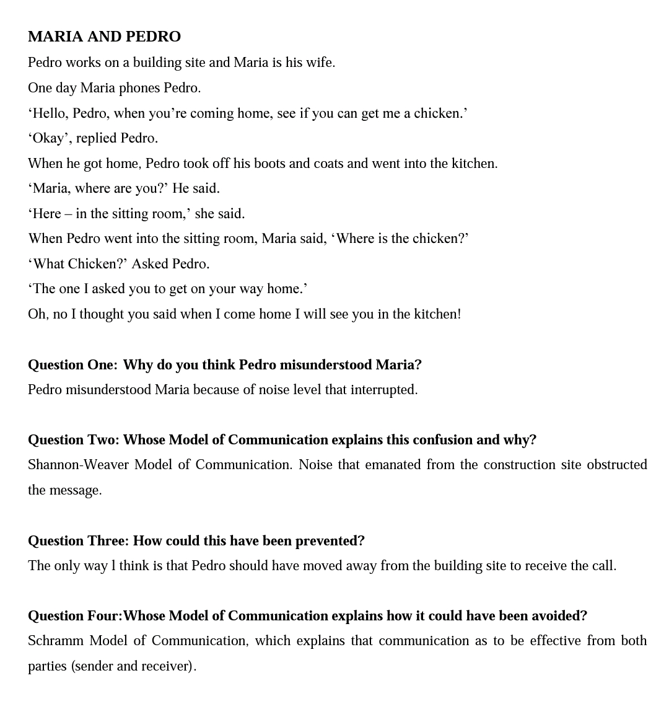

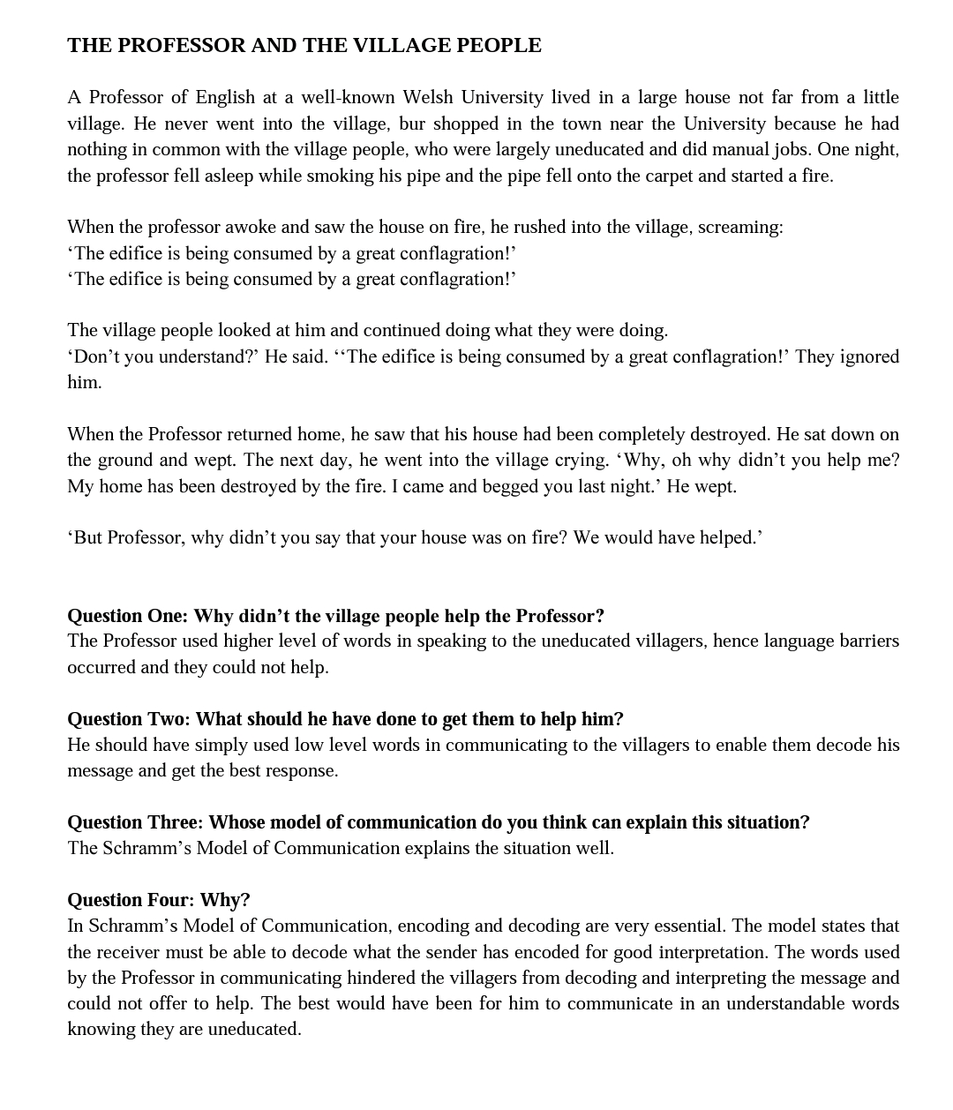
APPENDIX B

