Digital Skills and Research Methods
(BMSK4003 LON)
STUDENT: AZAD ALI 1705785
LECTURER: ANLY C MOHAN
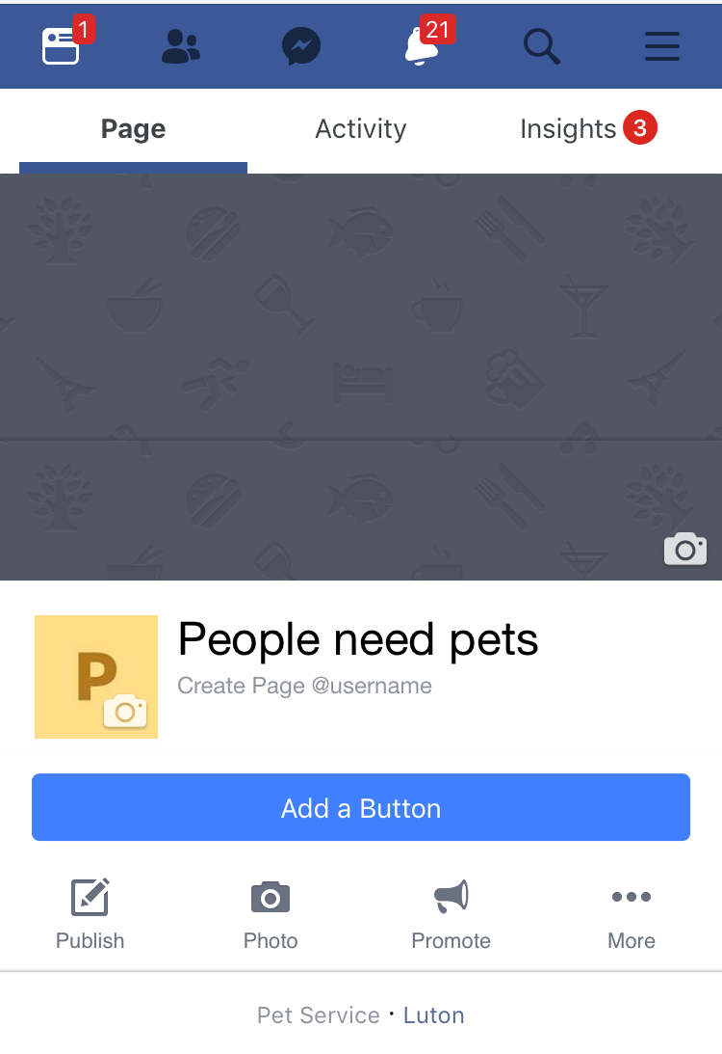

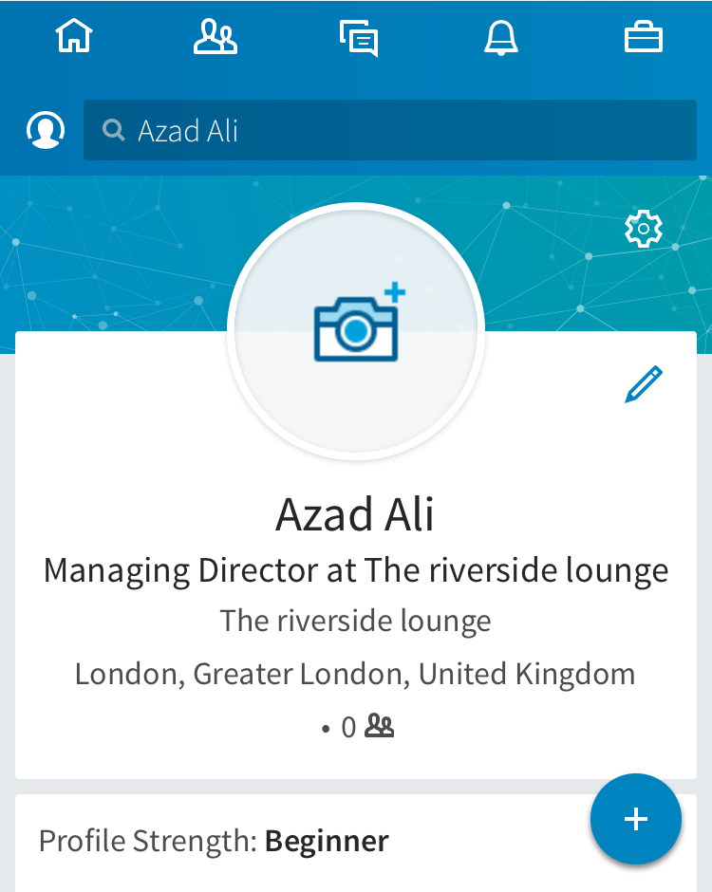

Contents
Introduction: 3
Evaluate effectiveness of the use of digital technologies within the workplace 4
Explore social media as a tool for marketing, information gathering, and communication within the workplace 8
Social media as a tool for marketing: 8
Social media to gather information: 9
Explore social media as a tool for communication within the workplace: 11
Creating professional online presence to illustrate and evidence this research 12
Conclusion: 14
References 15

Introduction:
Technological development has accelerated every phase of business activities increasing the productivity of every economic resource and functional is of the organization. The office automation, EDI system, and lean production system have added dynamic contribution in this respect (Pye, Bates and Heath, 1986). Social media is an emerging medium for marketing, information gathering and communication nowadays creating a bridge among the groups of the end user and the companies. The individual can show his professional image using social media in a considerable way that suits his professional expected image.

Evaluate effectiveness of the use of digital technologies within the workplace
The involvement of technology in the business activities and management of organization and information has accelerated efficiency and productivity in respective areas through automation and managing a huge volume of data. It is contributing to every single area of function and decision making process with its unique value of data management and automation. However, here is a brief discussion evaluating effectiveness of the use of modern technology in workplace-

Figure 1: use of modern technology in workplace
Source:
Office automation: it refers to the use of information technology to digitally create, collect, store, manipulate and office information needed for managing the office activities to achieve organizational goal. It enhances the speed of office work along with decreasing the personnel to manage data manually, that results in saving the operational cost of office and also reduces the time frame of tasks increasing efficiency through least chance of error (Pye, Bates and Heath, 1986). Office automation tools can be categorized into 8 sections according to the functions of the organization like-
Office automation areas | Tools
Marketing | Iterable for email marketing, Community Elf for blog management, to maintain consistency in social media DrumUp, HubSpot for lead generation
office management | Evernote to take note, Expensify for receipt and reimbursement, NexentaStor to store files, Ipswitch to share file, Seafile to create backup file, Kisi to access management, Ring to manage visitors,
contact management | Pardot for contacts form, Issuetrak for frequently asked question, Help Scout to support, Hatchback for customer relationship management,
sales management | Sendbloom to manage accounts, Shopify for online ordering, Float for budgeting,
project management | FunctionFox for project management,
human resource management | Workable for hiring, Planday for roistering
employee training | Certspring for onboarding
Office environment | Nest for temperature, Optimum Energy, Managed by Q
Table 1: categories of office automation tools
Source:
EDI: electronic data interchange is a concept of communicating certain information electronically. Walmart, Kmart and most of the supermarkets use EDI concept to maintain the lowest lost sale and manage the least inventory. EDI exchanges data with the central warehouse or the manufacturers about the transaction and inventory in the store that help them to replenish inventory in time to avoid the lost sale.
Database Management System: it refers to the system software used for creating and managing the databases. The organization uses database system according to their organizational needs and requirements. It provides the users and programmers with to create, retrieve, update and manage data (Ramakrishnan and Gehrke, 2011).
Vendor management inventory: it is an inventory system where the vendors take the total responsibility for maintaining inventory for the organization. The super-market like Walmart, Kmart, and Sainsbury’s use this system to replenish their inventory. The effective data interchange helps the vendor’s to manage the inventory of the retailers (Pye, Bates and Heath, 1986).
Lean manufacturing: a way of minimizing waste as much as possible sacrificing productivity in the organization. To eliminate waste to an extent the company needs to manage an automated system to communicate with the internal and external system of the organization related to production and operation. Nowadays, most of the giant companies like Toyota, BMW, Dell etc. are using lean manufactory to improve the performance of production and operation (Ramakrishnan and Gehrke, 2011).
Just in time inventory: it is a way of managing inventory decreasing the cost of managing inventory at the point of sale and increase efficiency with effective communication and transportation system to collect the inventory whenever and wherever they need.
Automated order processing: the automated order processing cycle improves the service of order placing and reporting status and order filling is now automated to improve the efficiency of the system and has successfully decreased the order processing time and efficiency with almost zero error (Ramakrishnan and Gehrke, 2011).

Explore social media as a tool for marketing, information gathering, and communication within the workplace
Social media has become the largest and closest network to reach the highest amount of prospects and interact with them directly. Nowadays, people of all ages are involved in social networking to be connected with their peers through sharing opinions and views. Thus, it has become one of the most influential platforms to reach the opinion leaders and conduct marketing, information gather and communication with the end consumers (Bondarouk and Olivas-Lujan, 2013).

Social media as a tool for marketing:
Social media is used in marketing performing as a medium of promotion. It has become a part of direct marketing through contacting with the consumers in a concentrated way that is called micro-marketing and perform one to one marketing. Almost all of the companies in this modern age are creating and managing customer relationship through social media (The impact of social media on customers’ image for mobiles, 2016). The marketing through social media has increased the responsiveness of the company towards the customer requirement as it has become a way of communicating the messages interactively. The company can get detailed information about customer requirements and update the customers about the continuous improvement of the products and services (Mas-Tur, Tur-Porcar and Llorca, 2016). Amazon, Samsung, Microsoft, Xiaomi etc. are using social media as a tool for marketing through conducting customer relationship through the social media. The company can collect the market information and even involve the customers in the upcoming product innovation through social media promotion. Samsung once had launched a campaign to design the box of the mobile phones by the mass subscriber of their page that helps them to find out the way to attract the consumers to the company directly involving them to the upcoming project. It has also helped to increase the competition in the market as the consumers are now available with huge information to assess the offering of the company. It also contributes to effective marketing by creating and communicating value to the customers and convinces them to take the service or the products of the company. Social media is a cost-effective way of communicating with the people as does not cost high maintenance cost through the pop-up advertisement costs higher (., 2017). The company can connect its value with its customers through this social environment.

Figure 2: effectiveness of social media in marketing
Source: (Trappel and McQuail, 2011)

Social media to gather information:
As it is discussed before that it is now the largest platform to reach the prospects and observe them through their reaction of business activities, it is one of the best way to collect information about the market demand, customer requirements as well as the competitive position of the company in the market. Samsung, Nokia, Amazon etc. are using social media to anticipate the demand of the products and predict the future demand or the change of buyer’s behaviour in future. The company can track the trend emerging that can create a significant change for the company to be the first mover in the market (Reis Pinheiro, 2011). Information related to market analysis; product specification and even the marketing process can be collected from social media. There is a disadvantage of collecting data from social media as the data integrity cannot be ensured through social media. The consumers often provide review or respond to news without having depth of experience in the particular area where information needed. As a result, the survey conducted through social media often misleads the company. The review and rating system to the social media has contributed to the process of gathering information about the current performance and future expected performance. The opinion leader in the social media groups and pages also helps the company to know about its position to the market, expectation of the customers and their loyalty to the company also. LinkedIn helps the companies to hire professional assessing the virtual CV provided by LinkedIn and assessing the posts, articles, activities and skills of the individual. it is becoming popular as it decreases the cost of recruitment process and choosing the right person for the company.

Figure 3: effectiveness of using social media to gather information
Source: (Reis Pinheiro, 2011)

Explore social media as a tool for communication within the workplace:
Social media like Facebook, Whatsapp, LinkedIn, Google+ are connecting people creating a complex web of communication (Poell, 2013). Every year the involvement of prospects in the social media has made it a platform to be connected with them. The social media is performing a great deal to create a communication within the workplace (Reis Pinheiro, 2011). Nowadays, companies are maintaining their human resource management using the social media as a part of communicating the information to the particular employee. To research and personal development, recruitment and hiring, employee recognition and engagement, employment branding, listening and monitoring, Social media perform a vital role through creating effective communication among the employees and managers of the company. For instance, the service providers in hospitality industry use social media like Whatsapp to communicate with the employees to update their work routine and other internal information to create a healthy employee-manager relationship as well as disciplined work schedule. It also helps to manage horizontal conflict among the employees or the vertical conflict within the organization through its effectiveness in communication (Isaacs, 2014). The social media communication improves the employee engagement and productivity creating a connection to the distant employees or the managers and helps to monitor and control them also. The global brands like Unilever, Nokia, and Samsung etc. use social media to communicate with even the regional employees and create a flat hierarchy of organizational culture (Isaacs, 2014).

Creating professional online presence to illustrate and evidence this research
The fresher and the employees can create their professional image through the social media like LinkedIn; Facebook etc. the consultants like Sandeep Maheshwari in India, recruitment agencies and social workers can create a corporate or professional image using their pages, groups or personal profile to communicate the professional competencies.

Figure 4: the way of building successful online presence and build a professional image
Source: (Isaacs, 2014)
To create a successful and professional image individual needs to work better through social media like Haley Gomez, a lecturer at Cardiff University to raise her profile through Twitter to reach her research to the mind of her prospects. Secondly, the individual need to create a better network communicating with people with diversified characteristics. Jonathon Hart-Smith, the managing director of CK Science uses his YouTube channel though uploading a video about his experience of recruiting and providing job-related advice that helps him to create a network with a number of subscribers. The LinkedIn profile plays a vital role to create a corporate and professional image. Nowadays, it has become a source of assessing a person’s skill, personal development by the professionals or the company who needs right people for their organization. Thus, a strong and updated LinkedIn profile helps to create a professional image. While roaming and sharing things in social media, an individual should consider the impact of the content on his or her social image as the people are going to assess the image of a person through his profile on social media. An individual should not be involved in nasty controversies and humiliate others to emphasize the personal view. It creates a negative image of the person towards the viewers.

Conclusion:
The social media has now become a platform to meet with a huge prospect, share views and opinions observe their behavior and even convince towards the message of the company. The technological development helps the managers to improve the productivity of the workforce through office automation, automated production, and operation process. Social media is now using as a strong marketing tool to create interactive communication with the set of prospect and draw their attention towards the company through sales promotion also.

References
., S. (2017). Social Media: The Future of Marketing. International Journal of Contemporary Research and Review.
Bondarouk, T. and Olivas-Lujan, M. (2013). Social media in human resources management. Bingley, U.K.: Emerald.
Isaacs, D. (2014). Social media and communication. Journal of Paediatrics and Child Health, 50(6), pp.421-422.
Mas-Tur, A., Tur-Porcar, A. and Llorca, A. (2016). Social Media Marketing For Adolescents. Psychology & Marketing, 33(12), pp.1119-1125.
Poell, T. (2013). Social media and the transformation of activist communication: exploring the social media ecology of the 2010 Toronto G20 protests. Information, Communication & Society, 17(6), pp.716-731.
Pye, R., Bates, J. and Heath, L. (1986). Profiting from office automation. London: Department of Trade and Industry.
Ramakrishnan, R. and Gehrke, J. (2011). Database management systems. Boston: McGraw-Hill.
Reis Pinheiro, C. (2011). Social network analysis in telecommunications. Hoboken, N.J.: Wiley.
The impact of social media on customers’ image for mobiles. (2016). Journal of Advances in Humanities and Social Sciences, 2(5).
Trappel, J. and McQuail, D. (2011). Media in Europe today. Bristol, UK: Intellect.

