
Nest Ferch Rhys and Gwenllian Ferch Gruffudd: Women and The Colonisation of Wales
Dissertation submitted in partial fulfilment of B.A. (Hons) in History and Anthropology. University of Wales Trinity Saint David.


Lucy Peebles
May 2020

Abstract
There is a vast amount of history surrounding medieval Britain, but despite this, there is still very little written about the women of Wales during its colonisation by the Anglo-Normans. This may be related to the idea that Wales was complacent, and women were unimportant when it came to matters of state. This text focuses on the lives of Gwenllian ferch Gruffudd and Nest ferch Rhys to dispute this idea, writing women back into history and uncovering not only how the colonisation impacted them but how they impacted it. Using our case studies, we analysed both witting and unwitting testimonies to draw out the important moments in the lives of these women, and the country around them. We found that women were active members in both the colonisation and the rebellions Wales mounted against it, sometimes due to being manipulated by the men on either side of the fighting, but also through their own decisions and actions. We also found that our ideas of rebellion needed to be expanded further than the ideas of physical and public outcry, showing us the colonisation of Wales in a different light – after all, the use of the Welsh language can be a form of rebellion in itself. This text can be used to further our understanding of women’s rights, responsibilities, and expectations during this period, but beyond this it enhances and is enhanced by the recent movement to write women back into history, something that Wales is trailing behind the rest of Europe in.
Acknowledgements
I would like to express my deepest gratitude to my parents, who despite not understanding many facets of my dissertation read each and every draft I sent to them, and for their unending support and always being there with encouraging words and words of praise whenever they could see the stress was bringing me down a little bit. I would also like to thank my baby sister Libby whose seemingly constant meltdowns during lockdown made locking myself in my room to do my dissertation seem like the best idea.
My friends deserve similar gratitude, for being on the receiving end of many rants about interesting titbits of information I found that would not fit into the realms of the essay. For being there at any time of night and day whenever I had a question whether it be for help rewording a sentence or on what font would be best to use. For allowing me to help myself through helping them and reminding me that we were all in the same boat. Without whose support I would not have enjoyed every moment of the past three years.
I would like to recognise the role of the university itself, allowing me the freedom to learn what I love in an institution that allowed me to remain individual and explore myself as a person alongside the academic exploration that was occurring.
And most importantly, I am indebted to my supervisor; Dr Harriett Webster who has gone above and beyond to help me in ways I will never be able to thank her for. But I will try, thank you for the fast and concise replies that pulled me out of my own worries and stress that had been bogging me down and helping me to realise that I could do this. Thank you for the meetings that stopped me from procrastinating and leaving this to the last second, and for the words “little and often” which have become a motto which ensured this got finished. Thank you for the advice and the encouragement to look at things from different angles and to use a wider variety of sources. Thank you for everything, Harriett.
Note:
Throughout the sources used for this text, several spellings of names and places have been used, in order to make reading as seamless as possible, we have used one singular spelling of all names and places. Llywelyn is always spelt Llywelyn, Gruffudd will always be spelt Gruffudd, etc.

Table of Contents
Abstract………………………………………………………………………………………………………………………………….. | 1
Acknowledgements………………………………………………………………………………………………………………… | 2
Note………………………………………………………………………………………………………………………………………… | 3
List of Maps…………………………………………………………………………………………………………………………….. | 5
List of Genealogical Tables……………………………………………………………………………………………………. | 6
Introduction……………………………………………………………………………………………………………………………. | 7
Chapter 1: Gwenllian ferch Gruffydd and Nest ferch Rhys: Upbringings and Colonisation…… | 12
Father’s Lives and Political Landscape…………………………………………………………………………. | 13
Rights………………………………………………………………………………………………………………………….. | 15
Education……………………………………………………………………………………………………………………. | 17
Conclusion………………………………………………………………………………………………………………….. | 20
Chapter 2: Gwenllian ferch Gruffudd and Nest ferch Rhys: Marriage and Colonisation………… | 21
Marriage as a Vehicle for Colonisation………………………………………………………………………. | 22
Marriage as a Defence against Colonisation………………………………………………………………. | 26
Conclusion………………………………………………………………………………………………………………….. | 28
Chapter 3: Gwenllian ferch Gruffydd and Nest ferch Rhys: Rebellions and Colonisation………. | 30
Conclusion………………………………………………………………………………………………………………….. | 36
Overall Conclusion……………………………………….……………………………………………………………………… | 38
Select Bibliography……………………………………………………………………………………………………………..….. | 41
Appendix 1 – Maps…………………………………………………………………………………………………………………. | 45
Appendix 2 – Genealogical Tables…………………………………………………………………………………………. | 51

List of Maps
Map of Medieval Wales  Roger Turvey (2002) The Welsh Princes: 1063-1283 | 45
Kingdoms of Medieval Wales  Kari Maund (2000) The Welsh Kings: The Medieval Rulers of Wales. | 46
The Gains and Losses of Llywelyn ap Gruffudd, 1255-77  Roger Turvey (2002) The Welsh Princes: 1063-1283 | 47
Map of Welsh Regions in 1093  Ginny Burges, (2017) Remarkable Women: The Life and Times of Gwenllian ferch Gruffydd | 48
Map showing Sepringham Priory and its distance from Wales.  Google Maps | 49
Map showing Boundaries, Kingdoms and Settlements in Norman Wales (After the death of Rhys ap Tewdwr).  Jon Gower (2012) The Story of Wales. | 50

Paternal Ancestry of Gruffudd ap Cynan  Kari L. Maund (1996) Gruffudd ap Cynan A collaborative Biography | 51
Maternal Ancestry of Gruffudd ap Cynan  Kari L. Maund (1996) Gruffudd ap Cynan A collaborative Biography | 52
Nest ferch Rhys’ Children.  Kari Maund, Princess Nest of Wales: Seductress of the English | 53
Genealogical tables

Introduction
Throughout history, women have often been seen as both prizes and threats to invaders. Therefore, it makes sense that they would be at the heart of foreign relations. Johns writes; “Abductions of queens was a way for rivals to establish a claim to political power” and Golding remarks that the Normans “won power in England” through marrying Emma of Normandy to Aethelred II of England. Returning focus to the noblewomen of Wales, it is observed that Gerald Windsor secured a marriage with Nest ferch Rhys with a clear intention of giving himself and his armies a “firmer foothold” in Wales. This was not something that the Normans had brought to Wales either since, in the Mabinogion tale of Branwen, Daughter of Llyr, she is married to the King of Ireland, Matholwch, which created a strong “relationship” between the Kingdom of Ireland and that of Wales. Despite this, women in Wales are often left out of the histories, which is something I and other historians are aiming to correct.
In order to achieve this, I intend to analyse the experiences of two Welsh noblewomen whose lives were at a pivotal moment in Welsh and Anglo-Norman history and can, therefore, give us a different insight into a widely discussed topic like the colonisation of Wales. I have divided the lives of the noblewomen into four distinct categories: childhood, marriage, rebellions and their deaths and legacies, as these four categories cover the majority of the aspects of their lives that the Anglo-Normans would have interfered in, giving us an insight into a woman’s plight and influence during the colonisation of Wales rather than the much discussed lives of men, of which there is a considerable amount of research into and writing on.
David Carpenter’s book ‘The Struggle for Mastery: Britain, 1066-1284’ is a great example and has a chapter called ‘Wales, Scotland and the Normans’ which touches on how Wales was easy to conquer due to the divisions amongst the people and yet incredibly difficult to conquer in its entirety since its geography made it hard for outsiders to traverse. It focuses more on the politics within Wales than the Anglo-Normans with reference to the fathers of our chosen noblewomen. David Bates’ ‘The Normans and Empire’ focuses more on empire than colonialism, but since imperialism was the driving force of most colonialism it is important for us to study both aspects. It helps build an understanding of the wider discourse around this subject before delving into the different ways the ideas of empire can be perpetuated; language and imagery being examples. Brendan Smith’s ‘Colonisation and Conquest in Medieval Ireland: the English in Louth 1170-1330’ discusses the settlement of the Anglo-Normans in Ireland which allows us to see the Anglo-Norman forms of colonisation on a larger scale outside of Wales. The downside of all of these studies, however, is that there is very little reference to women at all throughout them. That is where Brian Golding’s ‘Conquest and colonisation’ comes in, it mentions women throughout, though none of them are Welsh, it does allow us to see how women were used as a vehicle of the conquest through marriage alliances, as an example.
There is very little research or writing on the roles of women during this time, or the challenges that they rose to, or their downfalls, since the majority of texts focus on the heroic actions of the ruling men during this period. Messer notes that “in comparison with studies that have been undertaken on gender and women’s history across Europe, surveys on women in medieval Wales are long overdue”, and it is time we caught up – it is time the women of medieval Wales are recognised as being more than just an extension of the men in their lives. They were more than damsels in distress in a scary male-dominated world as they are represented by historians of the past. Much of the writing on women and colonialism in the medieval period, especially in Wales is in the subtext or included purely in reference to marriage; Emma of Normandy is only mentioned through the power her husband gained from marrying her. It makes it hard to highlight individual books that are useful in this regard. Many of the works I have access to that focus on women’s roles in colonisation and how it affected them focus for on the larger scale colonisation of Africa and the Americas, which can be used to draw parallels between the process of colonisation, but they are several hundred years apart which makes it more difficult.
Beyond this, it is next to impossible to draw conclusions about a period in history while ignoring or forgetting the lives of half of the population. There are clear limitations to writing a piece of work based on the lives of women in medieval Wales: Van Houts observes that “for various reasons the contributions of women, in particular, is explicitly recorded very infrequently”. She adds that it is possible to piece together the lives of medieval women but only through “reading between the lines” of texts written about men. This text was integral in the writing of this essay, as it prompted me to include different types of research, Van Houts recognises that once we introduce women into our studies it becomes integral to open our minds to oral tales as well as the recorded literary work. Davies wrote about the role of storytellers in medieval Wales, of how they would travel from court to court telling stories and carrying the culture with them. Not many of the texts based on their stories survive, but the majority of the ones that do remain in the Mabinogion and as such they carry a part of the culture within them. I would never have considered using this text in my work, since I did not believe it carried weight within an academic historical text, since it is classed as mythology, but Davies also notes that there are “two cultures, oral and literate” prevalent in medieval culture. I believe it is important to include both, especially since the storyteller would have had a position of authority within a court, granted a seat next to the ruler and would, therefore, no doubt have an impact on and a fully formed understanding of the culture.
This essay will cover the lifespans of these two women, starting with Nest ferch Rhys’ birth in approximately 1085 and extending into the lives of their children and grandchildren. It is a large period of time, but the fall of Rhys ap Tewdwr (Nest’s father) has been credited as the beginning of the end the Britons, and by the time their grandchildren were living it appears as though all hope for Wales being independent had collapsed. Therefore, the lives of these two women can hopefully show us the beginning, middle and end of the colonisation of Wales in a way that has not fully been explored before.
In order to do this, I have outlined three smaller research questions and how I am to answer them in individual chapters focusing on the roles of these women during this period of their lives: The first will be focused on their childhood, their parental influences, and any Anglo-Norman interference, as well as how they were raised since they had such varied upbringings despite both starting out as part of the Welsh nobility. All their fathers were kings whose kingdoms were under threat from their Anglo-Norman neighbours, and who dealt with it in varying ways, some vying for peace and some waging total war. It will be interesting to uncover exactly how this affected their adulthood and legacies.
Chapter two will focus on their married lives; who did they marry and why? It seems, on the surface, that both women’s married life was influenced by the Anglo-Norman neighbours in one way or another. Whether it was through a husband being chosen for them (Nest ferch Rhys) or choosing their husband to spite the burgeoning peace between their family and the Anglo-Normans (Gwenllian ferch Gruffydd). These entirely different situations speak volumes on the Anglo-Norman invasion and the Welsh attitudes towards the invaders which makes them vitally important in understanding the political climate within Wales at this point in time.
The third chapter will look at the women as rebels, and whether they opposed the Anglo-Norman control in their own way or did not as the case may be. At first glance, it appears as though only Gwenllian ferch Gruffydd was part of any rebellion since she led an army against the Anglo-Norman invaders and lost her life for something she believed in. However, rebellion exists in many forms – and could Nest naming her daughters Welsh names and teaching them parts of Welsh culture or housing her rebel brother at the beginning of his rebellion be a form of rebellion in itself? I hope, in this chapter to fully unpack the little rebellions made by the noblewomen, as well as the bigger, more obvious ones.
Gwenllian ferch Gruffydd and Nest ferch Rhys: Upbringings and Colonisation
In this chapter, I aim to discover the ways in which the Anglo-Normans influenced childhood in Wales, especially that of females. Studies of children and adolescents during the medieval life cycle are “of increasing prominence in medieval studies”. Historians appear to be moving towards understanding that formative years are important when trying to understand the lives people in any time period. However, they appear to be largely focused on “young manhood”. There are examples of studies on the lives of women highlighting and bringing attention to their childhoods, ‘Daughters of Chivalry’ by Kelcey Wilson-Lee is an example. It draws parallels between the childhoods of Edward I of England’s daughters and their actions as adults. It is especially important in this case since it can be used to highlight the interference of the Anglo-Normans into the lives of these noblewomen, and possibly cast a light on the influence they would have had on the other women of Wales during their childhood.This chapter will discuss three core aspects of childhood, using them as indicators of how women’s lives were impacted by the Anglo-Norman invasion. We will begin by exploring aspects of their father’s lives and the political landscape in which they were raised. After this we will focus on rights; debating whether Anglo-Norman culture afforded women more rights than that of Wales. Specifically, land and inheritance and its correlation with marriage. Finally, we will segue into education and the distinct differences between the two cultures; for example, noble children raised in England were more likely to be educated in church establishments while those in Wales were most likely educated at home.
In the most basic sense, it is easy to see the interference of the Anglo-Norman invaders in the childhoods and early years of these noblewomen purely in where they grew up. Gwenllian ferch Gruffudd was raised in Wales, in the traditional Welsh way; at her “father’s plate” as Welsh custom dictated. While this phrase probably was not intended to be taken literally it does create a warm image of family meals enjoyed together. Maund hypothesises that a noble child in Wales would spend their time following their father on his travels, living in his various houses, interacting with his court and watching him greet visitors, host feasts and administer justice when necessary. Nest would have experienced this type of childhood during her earliest years before she was sent to England where all this would have changed as the Norman’s raised her how they deemed appropriate. We are drawing on the life of Gwenllian ferch Llywelyn in this chapter because it allows for a wider view into the subject and also provides a stark contrast. Gwenllian ferch Llywelyn never experienced childhood in Wales, instead she was taken from her father within a year of her birth upon his death in 1282, and raised in England, I believe it would be safe to assume she was deposited in Sepringham house very soon after. She took the Vow and became a nun in 1289 at age seven, and it makes sense that she would have been educated in the ways of the church years before joining the order.
Fathers lives and political landscape
The fathers of all three of these noblewomen were integral figures in the political landscape of Wales. All three were regarded as kings in their own right, ruling expansive kingdoms within Wales. Gruffudd ap Cynan, Gwenllian ferch Gruffudd’s father, became King of Anglesey in 1099, and though there is not a wealth of sources that show how he increased his territory it is understood that he expanded to what is known as Gwynedd. Evans notes that he expanded his territory to such proportions that the King of England (Henry I) mounted “one of the most powerful invasions” made into Wales up until this point, but that there was very little fighting and a staggering agreement was made that allowed Gruffudd ap Cynan to keep his power comfortably. Since Gwenllian ferch Gruffudd was born in 1100, she was born at a tumultuous time where Gruffudd was finding his feet as ruler and she would have grown up right in the middle of his struggles to expand his territory and the very real threat of the Normans invading and taking away what she believed was rightfully theirs. This type of political uncertainty could very well have birthed her dedication to rebellion against the Normans in her later life. Seeing the way they rallied against her father to take something that was his birth right and possibly being raised in fear of losing everything as other women in her position had in the past could have created some deep seated hatred of the Anglo-Normans and everything they represented.
Rhys ap Tewdwr, Nest ferch Rhys’ father, ruled Deheubarth, a kingdom in the south west of Wales,largely unchallenged by his Norman neighbours from 1079, until his death until 1093. Other than a ‘pilgrimage’ made by William I to Saint David’s Cathedral in 1081, the only other interaction Rhys is known to have with the Normans is the one that resulted in his death. His death is not entirely in the hands of the Anglo-Normans since he was believed to have been “betrayed by his own troops” after traveling to Breckonshire to defend the people there from the Normans. Nest would have been present in her father’s court, possible aware of the situations that were unfolding, but unlike Gwenllian ferch Gruffudd, her experiences with the Anglo-Norman’s as a child were probably of a slightly calmer nature, due to the relative peace. This too is probably reflected in her later stance with the Anglo-Normans.
Gwenllian ferch Llywelyn was a unique case, spending very little time in the home of her father, and therefore being left with a scarce experience of the political climate her father would have been embroiled in. Llywelyn ap Gruffudd achieved a feat that most of the Kings of Wales had dreamed of; he united the Kingdoms of Gwynedd, Powys and Deheubarth, in the course of his reign as Prince of Wales. However, while Gwenllian ferch Llywelyn would not have experienced the turmoil within Llywelyn’s home, that does not mean she was free of it. She was after all, cast off into a religious house that was the opposite side of the country from where she should have lived with her family.As well as spending her life in exile, she was “made a nun against her will” by her Anglo-Norman captors. Despite being on the other side of the country, it is clear that she was not free of the politics of her father. Her father was a very powerful man, and her claim to his land and title in the eyes of the Anglo-Normans, ensured they moved her across country and turned her into a nun. Her bodily autonomy and future children were taken from her at an extremely young age because they feared a rebellion, she or her children could start should they wish. She did not know her father though, and there is no way to know how much of her history she was taught in Sepringham, which could explain why she did not form any rebellions in her later life.
Rights
Maund notes that in medieval England women were afforded slightly “wider privileges” than those in Wales; for example, Welsh women were, according to some sources treated as life-long minors who could not inherit or own any land. However, those in Anglo-Norman England, could inherit some forms of land, and through laws passed this privilege passed onto women in Wales) at least as far as we can tell. Another example of this is that Nest was recognised as a princess by the Normans and afforded the rights and power of a princess – which was something she never would have received in Wales since women did not receive titles such as this. Richards contributes to this argument with her statement that women were granted the same rights in Wales as those in England, in that they could inherit and be given lands in their marriage contracts in the thirteenth century something she accredited to Edward I’s ‘Statute of Wales’ which was created in 1284. But Nerys Patterson disputes this view, writing instead that once a girl reached twelve she was recognised as a woman and from then on “even if she does not get a man, she should control her property” and that this was recognised in both medieval Wales and Ireland as the norm before the Anglo-Norman interference. Though we cannot speak in certainties, it appears as though, when the Normans came to Deheubarth, Nest’s brother Gruffudd was whisked away to Ireland where he, as the heir of the throne, could be protected and raised right – but Nest was left behind. This can indicate that the family believed she would not be considered a threat to the Normans since she did not have a claim to the throne, nor the land.
In medieval Wales, the distinction between the rights and worth of a male and female did not occur at conception, or even birth but was created and perpetuated by the Church during a Baptism ritual. Ferraro writes that children in medieval Europe were raised to fulfil different roles. However, medieval Wales operated slightly differently, there is evidence to suggest that in medieval Wales children were raised the same regardless of gender until the age of 12, which is at the fathers plate. The most striking difference in customs and law happen at age twelve; it is at this age when girls are married and at fourteen is when boys leave the house to work in whichever capacity suits their status. But even this, at the very base, is the same ideal; the children leave their home to service a lord and bring respect to their birth families. This tradition of keeping the children at home is inherently different to how children in Anglo-Norman England were raised. Royal children in Anglo-Norman England were fostered by other noble families or in houses dedicated to raising the Royal children since their parents were often travelling. Children in Anglo-Norman England were also sent to religious houses where they were raised ‘right’. Gwenllian ferch Llywelyn was raised in Sepringham house, from a very young age, a stark difference from what would have awaited her had she been raised in Wales. Rearing children in such different ways is bound to result in differences, for example, the education offered is bound to be different, and a child raised at home is bound to see or come to understand things that those raised miles way might never experience – both things I wish to address in the rest of this chapter.
Education
Noble children in medieval England were often educated in monasteries or nunneries but there were only three religious houses that provided education in Wales; Usk, Llanlugan and Llanllyr. It would be short sighted to assume then, that many of the noble children were educated at these institutions and that they had great influence on the culture. Also, since Welsh children were raised at home it stands to reason that they got their education at home too. The evidence depicting education in medieval Wales is scarce, and there is nothing that I could find on the education of women in the law books or even the stories in the Mabinogion or other writing forms. The law books very rarely even mention children outside of who should have custody of them should a marriage break down. This, however, does not mean that we do not know anything. Kari Maund, when discussing women in the Mabinogion notes that “we are told nothing about their education, only about their appearance, social skills, nobility of birth and virginity”. However we can make inferences; we know that Branwen (in Branwen Daughter of Llyr) wrote a letter home, so we can infer that she was taught to read and write, at the very least. The education of boys is rarely mentioned, but if the Mabinogion were tales told to entertain Kings it makes sense that including the education received was not a priority. We learn little other than that boys were raised to be “proper”, thanks to Pwyll, Prince of Dyfed, and that riding horses was important in their education thanks to Math Son of Mathonwy. We can also infer from Math’s story that boys were taught to handle weapons from a young age since it specifies that he did not only due to a deal made with a deity. Though there is not much mention of education in manuscripts, we do get a glimpse into Gruffudd ap Cynan’s education and its focus on his lineage and entitlement as well as ensuring he had good manners. Orme suggests that education in Wales was often left to the discretion of the individual families; boys were likely taught Welsh poetry and law at home, and daughters were taught to read and write only as much as their family deemed necessary. Our ideas of education are very likely worlds apart from the medieval ideas of education, in fact, education during this period, across most of the continent, centred around the Church. It is not until the thirteenth century, in either England or Wales that the majority of noble males and females were taught to read, write and sing in Latin, though they were only taught enough that they could live an ecclesiastic life to the fullest extent.
If this is the case, and education was the choice of the parent, then there is no way to ascertain the literacy of our three noblewomen, other than to make more inferences. Gwenllian ferch Gruffudd who was raised solely in Wales, may have been educated to a certain extent but it is not likely that she was as literate as her English counterparts. Gwenllian ferch Llywelyn, who spent her entire life in a religious house, well known for being institutions of education. The Gilbertine order dedicated all resources to educating nuns, rather than helping laywomen and since Gwenllian ferch Llywelyn was made a nun at a young age it stands to reason her education would have been impeccable (at least by medieval standards). This order prevailed at Sepringham and was one of the very few orders which had both men and women in one place, believing that women would benefit from having literate men supervising them and their education. Nest who was raised under English nobility expectations may have been educated away from home, at a religious house, gaining all the benefits befitting a woman of her status. It appears as though the Anglo-Normans brought their ideas of education and literacy and encouraged Wales to follow, there was more focus on ecclesiastic learning after their interference than being taught at home as it had previously been in Wales. This shift in the way children were educated and the importance of the church can also be seen through the seven monasteries that were built by the Anglo-Normans in the years after the colonisation of Wales.
Conclusion
In this chapter, I aimed to uncover the ways in which the Anglo-Normans interfered into childhood in Wales, especially in the case of females. There were many ways in which the Anglo-Normans interfered, changing culture as they colonised the kingdoms, placing their laws and expectations on the populace. However, I am unsure of how much of this would have made a difference in the lives of the lower classes. Changes in land ownership rights, education and the removal of women who posed a threat to Anglo-Norman control would not necessarily have had any effect on the ordinary person. Therefore, in conclusion, the upbringings of Gwenllian ferch Gruffydd, Nest ferch Rhys, and Gwenllian ferch Llywelyn are not indicative of the Anglo-Norman colonisation of Wales when it comes to all levels of society, but these case studies are crucial in bringing a gendered approach to the upper-class struggles.
Gwenllian ferch Gruffudd and Nest ferch Rhys: Marriage and Colonisation
A significant portion of women’s power in the medieval period came from marriage: invaders used marriage to gain a foothold in kingdoms they were conquering, and marriage in the upper levels of medieval Welsh society was centred largely around “dowries, inheritance, land, status, influence and the creation and nourishment of networks”. Though we do not know how such marriages were negotiated, the marriage of Branwen ferch Llyr in the Mabinogion was negotiated entirely by her brother, the King of Wales, and Matholwch the King of Ireland seemingly without any input or consent from Branwen herself, in order to tie the families and kingdoms together.
In this chapter, I intend to analyse the different marriages of important women during the period of the colonisation of Wales, centring largely around Gwenllian ferch Gruffudd and Nest ferch Rhys who had fundamentally different marriages; one marrying a Welsh man and creating an alliance between two large and influential Welsh kingdoms (Deheubarth and Gwynedd) and the other marrying a nobleman, giving him a foothold into the Kingdom of Deheubarth. However, it would be impossible to draw any solid conclusions on marriage as an institution from only two marriages, so we will be drawing on a few others where necessary.
In order to answer this question, I have created two categories of marriages we are going to consider: marriage as a vehicle for colonisation and marriage as a defence against colonisation. It is rather simplistic, and even while creating the categories I realised that they are simply different sides of the same coin – they are after all both types of marriages based on gaining or consolidating power – whether that is with a neighbouring Kingdom within a country or an invading force, completely ignoring the idea of love or emotional connection being a reason of marriage. However, they are slightly different in that one focuses on solidifying a claim to a land that you have an inherited right to, versus legitimising a claim to a land that you had no previous right to. Despite being simple, they do allow us to see exactly how the Anglo-Norman’s influenced marriage, if only by their presence.
Marriage as a Vehicle for Colonisation
Marriage as a vehicle for colonisation is something the Norman’s were known for. One of the most famous marriages they facilitated in order to strengthen connections between Normandy and the Anglo-Saxon land they wished to claim was the marriage of Emma of Normandy to Aethelred II of England in 1002. England and Normandy had always had an uneasy relationship, but in 991 it reached a peak when Aethelred accused Duke Richard II of Normandy of harbouring his enemies, the Vikings, peace was brokered and Aethelred II was married to Emma of Normandy. This marriage gave the “Conqueror” justification to assert his “claim to the throne of England”. When Emma arrived in the Anglo-Saxon courts she was able to bring some of the Norman ideals and aspects of her culture with her, slowly introducing the ideas into the court where it could be spread. Though Aethelred died in 1016, Emma had had enough time to dig her heels into the country, and when the Vikings invaded she married the new king, Canute, allowing her to continue to introduce her culture and pave the way for when the Normans did invade. It was not until a while later that the consequences of choosing a Norman bride began to show: after Canute died, his son Harold took the throne, but when he died things got slightly more complicated. Edward the Confessor was chosen to be his successor, and he had been raised in Normandy, in a Norman court and came to England with a “Norman retinue”, and William the Conqueror took advantage of this and was named Edward’s heir – the Conquering of England was technically legitimate through this action and some would argue that it meant that the noble people in England were more open to the idea of having a Norman ruler since they had been exposed to the culture for so long.
Nest ferch Rhys’ story is very similar to that of Edward mentioned above. While she never would have inherited her father’s kingdom in Wales, to the Normans she was invaluable. She was raised in a Norman court, with Norman culture being forced upon her, her education and upbringing were changed dramatically – she would be an unwitting ally in the colonisation of Wales. She probably would have grown up moving with a Norman retinue (admittedly not a large one) and moving to Wales could possibly mimic the entrance of Edward into England. Nest carried connections to the royal bloodline of Deheubarth, and because of this she could not be allowed to marry a Welsh man, or even an Anglo-Norman man full of self-interest, like Arnulf de Belleme (the Earl of Pembroke) since it would give oxygen to the flames of rebellion that still flickered throughout Wales. Gerald of Windsor, however, had proved his loyalty to the crown time and time again, leading campaigns against those who opposed Anglo-Norman rule in Pembroke of which he was the Constable in place of Arnulf de Belleme. When Arnulf and his brother Robert rebelled against the Crown in order to try and claim more lands, Gerald defected from them and continued to submit to King Henry I. It was because of this loyalty that he was gifted the land of Pembroke and was offered Nest’s hand in marriage. It could also have had something to do with Nest being Henry I’s mistress, because of which, and despite her royal blood she was not fit to be the wife of a high ranking noble since she was no longer a virgin this is an idea that was present in both England and Wales, and can be found the laws and customs of both countries – so it is not an idea the Normans brought with them to Wales. Gerald was loyal enough that he would not take advantage of her blood, but low ranking enough to take the gift that was offered. Nest’s affair with Henry I is also worth more of a mention, Freda Davies, recounts their tale as one of love and devotion followed by an unfortunate separation. While this may not be completely accurate, we have no way of telling how they felt about each other, but when Nest was kidnapped and “ravished”, or viciously raped at least twice, depending on the source, Henry took action. Henry exiled Owain ap Cadwgan, the man who did it, and took his land from him, he was later killed in a battle with Henry’s men. This seems like an extreme action for the Anglo-Norman King of England to take, and in my opinion, shows that he at least cared for her and the child they created together a little. But despite the way he may or may not have felt about her, they could never be married because he needed to marry someone who could stabilise the political upheavals in his territories and add legitimacy to his claim, and that of his children, to the English throne. Matilda was the daughter of an Anglo-Saxon princess and was related to Edward the Confessor which gave him that legitimacy he so desperately needed. Her relation to her Scottish family, also brokered an alliance between the two countries and ensured that Henry could “concentrate his military resources on Normandy and Wales”. These were both things that Nest, who, at the time was the only person of her family residing in England or Wales and represented the end of an era of Welsh strength, could never offer.
Although Gwenllian ferch Llywelyn never married in a traditional sense, the Anglo-Normans did intervene, and took that option from her, probably for the very same reasons they interfered in the marriage of Nest. She was the daughter of Llywelyn ap Gruffudd who was one of the only men to unite the major kingdoms of Wales under a common ruler: none of his or his brothers children were allowed to marry, or even allowed freedom. The boys (Llywelyn and Owain) were incarcerated in Bristol Castle for their whole lives, and the girls sent to several Gilbertine houses close to Sepringham. Gwenllian became a nun at the young age of seven, tying her to the Church and ensuring she would never have children, and if she did they would be seen as illegitimate and would have no hope of inheriting claim to any land. Gwenllian perhaps posed more of a threat to the English throne than her cousins did. Her mother was Eleanor de Montfort, Edward the I’s aunt which gave her a legitimacy in both the eyes of the Welsh and the Anglo-Normans. It is interesting they chose to treat Nest ferch Rhys and Gwenllian ferch Llywelyn so differently, but this only highlights how much things had changed in the two hundred years that had passed in between their births. Edward I put a stranglehold on Wales, through his ring of steel “a multitude of hugely expensive stone castles all across the land to keep the Welsh principalities under control”, he seized the land, stole treasures, destroyed churches and abbeys and mercilessly quelled any possibility of revolt after crushing the “embryonic Welsh state” Llywelyn had been cultivating. The ruling King of England would no longer accept peace with Wales, he would no longer allow for it to be ruled by its own people who swore fealty to him, he wanted the land as his own, and he colonised it and ruled over the remains. This merciless approach to Wales no doubt seeped into his treatment of the heirs of Wales’ last true prince.

Marriage as a defence Against Colonisation
Marriage in the upper levels of Welsh culture had always revolved around ideas of land and status and creating and nourishing networks between families and kingdoms. There are countless examples of this throughout Welsh literature and its history. In the third branch of the Mabinogion Rhiannon agrees to a marriage to Manawydan in order to better relationships between him and her son, knowing the marriage could help broker peace. Branwen of Llyr’s role in her marriage was described as being a “peaceweaver” – the weight of making peace between Wales and Ireland fell almost entirely onto her shoulders as she married Matholwch. This connection between Ireland and Wales through marriage is one that is prevalent in almost every Welsh royal family. When Rhys ap Tewdwr ascended the throne of Deheubarth in 1081, his position may have been tenuous, there were other contenders for the throne. In order to counteract any possible uprisings he married Gwladus ferch Rhiwallon (who would later become Nest ferch Rhys’ mother), solidifying his place. Similarly to Gruffudd ap Cynan, Gruffudd ap Rhys ap Tewdwr (Nest ferch Rhys’ brother) was raised in Ireland, it is difficult to know who he stayed with while there since there is limited mention of Gwladus’ heritage anywhere but it is safe to assume that they had familial ties there and therefore felt safe to flee after Rhys ap Tewdwr was killed.
Another example of a marriage as a defence against colonisation is when Gwenllian ferch Gruffudd married Gruffudd ap Rhys ap Tewdwr. Gwenllian ferch Gruffudd’s marriage is disputed – some sources argue she was married to Gruffudd ap Rhys by her father who recognised the ally, others arguing she eloped in the night. While we do not know a lot about Gwenllian ferch Gruffudd’s life, we can follow the major events through the lives of the men she was associated with. For example, I could find no reference to their wedding, but in medieval Wales a marriage may not have carried the same weight as it did in later centuries, so it is possible that it was not recorded for that reason. A couple could be married by word alone,: “’I take you as my wife’ – created a valid marriage immediately”, and in the story of Branwen daughter of Llyr, her wedding consisted of a meal with her family and her betrothed before they slipped away to consummate the marriage. Though the exact date of Gwenllian ferch Gruffudd and Gruffudd ap Rhys ap Tewdwr’s wedding is unknown I would argue it happened not long after he visited and sought refuge from her father in 1115. Though we know remarkably little about this marriage it is still a controversial and divisive topic within academia.
We know that Gruffudd ap Rhys ap Tewdwr “sought and obtained” protection from Gruffudd ap Cynan from the Anglo-Normans who he had been terrorising, we also know, that Gruffudd ap Cynan was tasked by Henry I to take him dead or alive. Not long after, Gruffudd ap Rhys ap Tewdwr escaped, and continued his campaign against the Norman lords in South Wales. There is not a wealth of information of what happened after this, and in the primary texts I can only find mentions of Gwenllian ferch Gruffudd in family trees or at the time of her death but I believe she was with Gruffudd when he escaped. It is possible that Gwenllian ferch Gruffudd’s marriage followed traditional Welsh laws, in that her father would have brokered the agreement and consented on her behalf, which would have been more common at the time, and “it was, after all, natural to seek partners for one’s children among neighbouring families.” However, I do not believe this is the way it happened: the Welsh law books, specifically have laws for women who choose to marry men their families do not agree with, which indicates it may have happened more than we assume looking back, of course, it was still frowned upon and they risked facing ostracism – especially if the man was seen to be below their rank. Gruffudd ap Cynan had cultivated a comfortable relationship with the Normans and it was his desire to keep it this way, perhaps he planned to do this through marrying Gwenllian to a powerful Norman Lord.
Gwenllian is best known for her rebellion against the Anglo-Norman colonisers. It makes sense, then, that she would have had a visceral reaction to being offered to who she considered an enemy. Perhaps enough to marry a man who stood for the same thing as she did – as evidenced by her father arresting him on the Anglo-Norman’s behalf. Perhaps she convinced her father to let him go, perhaps she snuck him out herself – we will never know exactly what happened but it seems pretty clear that her father probably did not agree at first. Not only could marrying Gwenllian to a troublesome Welsh rebel have created fiction with the Anglo-Normans, but he was also below her rank, his family had fallen spectacularly to the Anglo-Normans, at this point I do not think he had any land of his own, and his followers were often referred to as “young imbeciles”. Whatever the case may be, the Anglo-Norman’s were prevalent in the marriage of Gwenllian ferch Gruffudd, either in unknowingly encouraging their union, or possibly in being her betrothed.
Conclusion
In conclusion, while marriage as an institution stayed the same during the colonisation of Wales, the Anglo-Normans used it as a way to increase their power in, and claim to, Wales. We can see how they carefully used marriage to introduce their ideas and culture to the land they were colonising, making the country more receptive to them. It is impossible to deny that they used Nest ferch Rhys from the moment they captured her, reshaping her into a respectable Anglo-Norman noblewoman, marrying her to a respected nobleman and placing her back into her homeland – all with the goal of subduing Welsh rebels, and turning her descendants to their cause. Their interference with Gwenllian ferch Llywelyn was slightly less clear and had nothing to do with marriage at all other than denying her the chance to marry – nullifying the chance of her having children and helping them gain power in that respect. Gwenllian ferch Gruffudd showed a different way the Anglo-Norman’s influenced marriage in Wales, they did not physically interfere and in fact it is entirely possible that she chose her husband to spite them and their campaign into Wales.
Of course, once again, we must note that the majority of the population of Wales would not have been deemed important enough for the Anglo-Normans to interfere in their marriages, it was only those who owned land, and lead kingdoms that would qualify. In that regard then, the marriages of Gwenllian ferch Gruffudd and Nest ferch Rhys are not representatives of the experiences of much of the country, but they do represent what noblewomen at the time would have been met with. Which of course, makes sense, since the Anglo-Normans would not have advanced far into Wales if they had focused on marrying the common folk; those without land, money or influence.Another thing we, like other historians, have overlooked entirely is the presence of love, whether this is due to an unknown bias on our part, believing the popular misconception that love is a recent western invention or simply because it does not fit within the boundaries of the question we aimed to answer – it is something we need to consider when discussing marriage. Perhaps Gwenllian ferch Gruffudd married Gruffudd ap Rhys ap Tewdwr because they fell in love as soon as they met, perhaps it had nothing to do with the Anglo-Normans at all, perhaps Nest never loved Henry I but instead had fallen for Gerald of Windsor and had pursued him herself.
Gwenllian ferch Gruffydd and Nest ferch Rhys: Rebellions and Colonisation
“When we think of fighting oppression, we tend to have a very narrow view of it. The first thing that comes to mind is a massive public rebellion or protest. In slave history we hail Nat Turner and Toussaint L’ Ouverture as great rebels because of their armed resistance. However, we never mention the slaves who rebelled on the plantations by breaking tools, slowing down production or who stole from the master as an expression of protest”
The rebellion of women, especially in the middle ages, falls more into the second category. As outlined by Cherry. Rebelling in a public and physical way would have ostracised them from the society they lived in, and while some, like Gwenllian ferch Gruffudd and Petronilla de Grandmesnil, broke the mould and rebelled in major ways, the majority of women would have attempted to rebel in smaller ways – if they felt the need and had the courage to rebel at all. Women showing any kind of physical strength was frowned upon, since they were breaking the gender “definitions” that were woven into the society.
This chapter will focus on the rebellions of Gwenllian ferch Gruffudd and Nest ferch Rhys, which allow us to see rebellions in different forms. Gwenllian ferch Gruffudd was combative, and she is well known throughout Wales for her violent rebellion. Nest ferch Rhys on the other hand, rebelled in smaller ways, is less known for her rebellions and unless you are really looking for them, they are easy to miss. In order to gain a broader understanding of the rebellions we are also going to touch on the rebellions of Nest ferch Osbern, who although she was not rebelling against the Anglo-Normans was rebelling against her position in society and the men in her life, and Petronilla de Grandmesnil who had a similar rebellion to Gwenllian, at least on paper.
Women in Wales would have, I assume, wanted to rebel for the same reasons the men did – their country was being attacked, and their culture was being threatened. While the people with money, land, and titles stood to lose more in this regard, they shared something with the poorer members of society. The more important things, the things that tied them together, the language and customs they lived their lives by were under attack. Therefore, while contemporary sources focus more on the upper levels of society, of the nobles and the Kings, I want to keep in mind that they were not the only ones with cause or means to rebel, even if it was only small rebellions.
Gwenllian ferch Gruffudd is the only Welsh woman we know who entered the “martial arena”, and she fought for most of her life. Warner refers to her as a ‘Robin Hood’ figure, scathingly commenting on her living in the woods and causing “endless trouble by bringing reprisals on to the innocent” through her guerrilla style warfare tactics. She did all of her fighting with her husband at her side, but in 1137, when a big battle was looming, he visited her father in order to ask for reinforcements, he got held up, and Gwenllian ferch Gruffudd was forced to ride into battle without him. The battle of Cydweli was bloody, Gwenllian ferch Gruffudd herself had her head chopped off, and her son Morgan was killed while her other son Maelgwyn was captured. Gwenllian ferch Gruffudd’s rebellion stretched on way beyond her death, she became a martyr for the cause. Perhaps she relit the fire, for her sons, by 1153, had seized Ystrad Tywi, much of Dyfed and Ceredigion from the Normans. Gwenllian ferch Gruffudd’s violent protest against the Anglo-Normans tells us that women were not simply passive members of society, they were influenced by and influenced events in equal measure, it is a great example of why history’s focus on the princes during this age is short sighted and the holes in the narrative they are creating.
Another example of women not being passive and making a stand is Petronilla de Grandmesnil who rode into battle against the Norman King: though she was the Countess of Leicester, she was not compliant with the Norman leaders. The countess “established a reputation as a strong-willed political figure”, when her husband rebelled against the king and they both escaped to the court of Louis VII. When they came back in 1173, she rode at the head of the mercenary army, alongside her husband, clad in armour, armed with a shield and a lance. Her rebellion, like Gwenllian ferch Gruffudd’s, was not a victorious tale: she was removed from her horse and captured by Simon de Wahill during the battle and escorted to prison alongside her husband. It is suggested that she was a bad influence on her husband, and that it was at her behest that the rebellion was started. If she did influence her husband’s opinions, she was rebelling in another way completely, women were expected to be “meek and obedient” in marriage.
If we prescribe to traditional ideas of masculinity and femininity, then the rebellions of Gwenllian ferch Gruffudd and Petronilla de Grandmesnil better fit the ideals of manhood. The story of Gwenllian ferch Gruffudd’s many rebellions, has significant similarities to that of Owain Glyndwr and Llywelyn ap Gruffudd. Owain Glyndwr was referred to as the son of prophecy, the man who would reclaim Welsh independence and only wanted to defend his country against invaders. Though Gwenllian is less well known, their motivations are the same. Owain Glyndwr is known as a “genius at guerrilla warfare”, so, not only were Gwenllian and his motivations the same but so were their methods. With Llywelyn ap Gruffudd, his final battle and death share similarities with those of Gwenllian ferch Gruffudd; he was separated from his army, left vulnerable and alone while scouting to see if the village he was camping nearby was full of enemies or allies. Gwenllian ferch Gruffudd’s husband left her to look for allies, and she was left alone in a situation she perhaps had not been in before. Gwenllian ferch Gruffudd died in battle, and Llywelyn ap Gruffudd was stabbed carelessly by an Anglo-Norman who did not even know who he was. But their deaths tell us about how Wales was perceived by the Anglo-Normans; in England royals and high ranking nobles would be taken prisoner after battles and ransomed for money, they could expect to be “treated well”, but if they were deemed to be “barbarians” they would be killed on the battlefield without respect. Which is exactly what happened to Gwenllian ferch Gruffudd and Llywelyn ap Gruffudd.
Like Gwenllian ferch Gruffudd, Llywelyn ap Gruffudd and Owain Glyndwr have had long reaching legacies, every year on the 11 December there is a memorial service held for Llywelyn ap Gruffudd in Cilmeri with more and more support in recent years. Owain Glyndwr, has been remembered by Fidel Castro as “one of the greatest freedom fighters of all time”, and politicians in Wales were so worried of the power his name and rebellion held that they boycotted all chance at a celebration or memorial of his 600 year anniversary in 2009.
Nest ferch Rhys may never have been afforded the option to be rebellious outside of the bounds of her femininty, to disobey her husband in any way. When they were wed, they she was at a severe disadvantage, not only because she was a woman but because she was alone. When Branwen ferch Llyr’s husband started treating her poorly in the Mabinogion, she wrote a letter to her brother and he waged war to stop it. But Nest ferch Rhys’ family were decimated, her brother in Ireland and there was no one to protect her. This does not mean that she did not take part in smaller rebellions within the home, her children and grandchildren, for example, were given Welsh names, and Nest ferch Rhys’ grandson Gerald of Wales remained proud of his Welsh ancestry. Nest ferch Rhys may have slipped out of the spotlight towards the end of her life but she birthed a dynasty and her children achieved great things: they owned swathes of land and her daughters had influential marriages. However, they did not carry seeds of rebellion against the Normans, they held their lands with the Normans and Robert and Maurice even helped colonise Ireland alongside and at the orders of the Normans.
Nest ferch Rhys’ biggest rebellion against the Normans (and possibly her husband) was allowing her bother to stay with her. Gruffudd ap Rhys ap Tewdwr was a known rebel in his life, it would have made sense for her to turn her back on him. But she did not and he lived with her for a while, but she didn’t join his rebellion after he left – whether she allowed him to stay out of family sentiment or because she secretly agreed with his cause, we’ll never know. But the fact that she allowed him to stay at all, says a lot. We discussed previously, how Owain ap Cadwgan kidnapped Nest ferch Rhys, from her home, held her against her will before she was retrieved by her husband. However, Olwen Davies theorises that she was complicit in the whole affair, stating that there is no record of her putting up a fight at all. This idea could carry some truth, her husband worked with the man who was responsible for her father’s death, and Owain was a Welsh man. This plot ruined Gerald of Windsor’s reputation, after all, if he could not even protect his own wife from the rebels, how could he possibly protect the Norman lands? Perhaps this was Nest ferch Rhys’ plan, to destabilise him? We will never know exactly what happened with Owain ap Cadwgan and Nest ferch Rhys, but it interesting to theorise.
Nest ferch Rhys’ rebellions are interesting, it is easy to imagine a large proportion of the population of women in Wales taking small, seemingly insignificant, rebellions against the colonisers. But I think these rebellions were every bit as important as the larger ones, perhaps they were not large battles where land was regained or lost, or where dynasties or kingdoms rose and flourished, but they shaped the country, nonetheless. If Nest had kept her Welsh heritage away from her children, had not encouraged them to be proud of it, and if every other woman in Wales had had the same thought, the Anglo-Normans would not have even needed to invade – the colonisation would have been completed by the Welsh themselves. This was how they broke tools in the field, how they stood up to their oppressors, the only way they knew how.
Nest ferch Osbern, rebelled against her son, she seemingly had no problem with the Normans, which makes her stand out from the other’s we have mentioned, but she went to extreme lengths to punish her son. Nest ferch Osbern had an affair, and when her son found out he “gave him a severe beating, mutilated him and packed him off in great disgrace.” Nest ferch Osbern went to Henry I, claiming that her son, Mahel, was actually illegitimate, “confirming it by an oath which she swore in person before the whole court”, Mahel was later deemed illegitimate and had any lands he was due to inherit stripped from him. Nest ferch Osbern reminds us that Welsh women were not only being oppressed by their colonisers but by their countrymen too. Sexism and misogyny were rife in both countries, from what we know of the time, it is almost certain that her husband was having an affair with little to no consequences. Her rebellion may not have been against the Anglo-Normans but it was also one that may have been emulated throughout Wales, perhaps in different ways.
Conclusion
We can understand much of the colonisation of Wales by the Anglo-Normans through the rebellions of Nest ferch Rhys and Gwenllian ferch Gruffudd. Also, unlike the other chapters, then can allow us glimpses into how all women were feeling, not just those of the upper classes. Anyone could have rebelled against the pressure to anglicise by naming their children Welsh names (like Nest ferch Rhys did). Nest ferch Osbern, despite being Welsh, is often referred to as Agnes, which is the result of the Anglo-Norman’s interference in her life. Could this mean that Nest ferch Rhys fought to keep her birth name to be referred to, and remembered by, the name her parents gave her? Was this a rebellion on her part? The Noble class in Wales, by the end of the Thirteenth Century spoke French, did this mean there was a pressure from the top for people to adapt to this new language? If so, then refusing to do this and keeping the Welsh language alive would also be a form of rebellion. Did they, like the forgotten rebels of slave history, break their tools, make things harder for their overlords in a way that would not necessarily be memorable?
There are a lot of gaps in medieval Welsh history, and as we have discussed in the introduction of this dissertation, women usually slip through them. Were there other women, like Gwenllian ferch Gruffudd, deemed unimportant and not remembered who rode in to battle? Were there other Robin Hood or Maid Marian figures in the woods of Wales? There is no way to know one way or the other, but the tales of Gwenllian ferch Gruffudd and Nest ferch Rhys do allow us to see into the world of women, allows us to see that unrest and a deep distrust of the Normans was prevalent in medieval Wales, and not just among the men.

Overall Conclusion
In conclusion, this dissertation draws out the role of women, allowing us to consider another angle to the colonisation of Wales, and a period which is often referred to as the age of Princes, something that is reflected in a large proportion of historiography. The lives of girls and women are often ignored in the law books and popular culture like the Mabinogion where most of the attention is dedicated to the Princes. A study like this highlights this inequality while also shedding a little light on what their lives could have been like. Writing women back into history is invaluable, personally, I study history to understand more about myself, my country and the world around us in the present day. It is incredibly hard to do this when the narrative centres almost entirely around men. From my work alone, we can see that women were integral in both the colonisation of Wales and its rebellion.
That being said, I can understand why other historians have overlooked women’s acts of rebellion and submission; it is easy to write women off as unimportant, given our own biases towards the women of the past and our perceptions of rebellion. We do not see the small acts of rebellion as being as important as the big battles or wars, and the majority of women’s rebellions during this time are small and easy to miss. However, if we are ever to truly understand the facets of the Anglo-Norman colonisation of Wales, we must include women in our writings. If we prescribe to traditional ideas of masculinity and femininity, the story of women during the colonisation of Wales will allow us to see how everyday life changed, how the domestic sphere was influenced. We know this is not always the case, since Gwenllian ferch Gruffudd, breaks this mould in a spectacular fashion. But it does hold a grain of truth, Nest ferch Rhys was manipulated by the Anglo-Normans to perpetuate the colonisation through her marriage and children, but she rebelled in that form too. Her children carried the names of her Ancestors, and it is easy to imagine her teaching them however much of the language she managed to remember from her childhood. Focusing on the big battles fought mainly by men, while interesting, leads to the idea that the past is a mass of single massacres with nothing in between, by bringing women back into the picture and stepping away from the battles we allow ourselves to see a clearer picture of a time that is more like ours than we care to admit.
This dissertation encouraged me to think about the value of using both witting and unwitting testimonies. Using both allows our arguments more validity, believability and flexibility. Joseph Campbell wrote that “Myth is much more important and true than history. History is just journalism and you know how reliable that is”. It is a reminder that many historical sources were written for a purpose, were written for people to remember, there is a bias prevalent in them. This is not to say that literary sources are more reliable, but they were usually written for a different purpose, the Mabinogion, for example, was written purely out of fear that the stories would be lost to the colonisation, and the tales themselves were created to entertain people; which tells us more about the culture of the time, perhaps, than texts written in Monasteries which focus more on lineages and battles and the deaths of those deemed important.
This text uses two key case studies, the lives of Gwenllian ferch Gruffudd and Nest ferch Rhys. These case studies were chosen because they share key similarities; for example, they were both daughters of influential kings in Wales, who ruled over vast kingdoms. They were born within twenty years of each other, so the political landscape into which they were born was similar too; their families and lives were threatened by the Anglo-Norman invasion. They both married and birthed dynasties, they both rebelled against the colonisation, but it is their differences that were most important to this text; one was born, raised and lived in Wales, fighting loudly for Welsh independence and against the Anglo-Normans, the other was born in Wales, but was taken early in her life, and rebelled in a slightly quieter way. Their differences allow us to gain a deeper understanding of not only the complexities of women during this period, but the intricacies in the colonisation and rebellion itself.
Both men and women played a role in the colonisation of Wales, and the rebellions against it. It is easy to see how the Anglo-Normans used both men and women to further their cause, through marriages and alliances the independence of Wales was taken inch by inch. Throughout this text alone, we see cases of women being married to Anglo-Norman nobles in order to ensure their family’s territory, and kingdoms, would remain in Anglo-Norman hands. But we also see men being manipulated into turning on fellow Welshmen and their country, with ideas of money, land and titles, as well as the threat of the Anglo-Normans’ significantly bigger army. The difference between how they were manipulated lies in their position of society, men were treated as leaders, offered the carrot (more lands, more power) and the stick (losing the lands and power they already held) while women were not given a choice, and their ‘manipulation’ revolved entirely around marriage and procreation.
While the lives of Gwenllian ferch Gruffudd and Nest ferch Rhys are not perfect to understand how the colonisation of Wales affected women of all classes they do allow us to see another side of colonisation. It is easy to see the Welsh as complacent and passive towards their colonisers, especially the South. But these accounts, to me, discount this theory, the women of Wales were not complacent. Even if their rebellions were often more on the smaller side – they were rebelling. They were active participants in the colonisation and the rebellions against it, fighting and pushing against their oppressors. And the legacy of these rebellions is still going on. There are people who remember Gwenllian ferch Gruffudd and her sacrifice, even today. The fight for the language and identity is still being fought at every corner, and the fight for independence has renewed once again.
Select Bibliography
Primary Sources.
Annales Cambriae, in A collection of Documents, ed. by Rhidian Griffiths. Aberystwyth: National Library of Wales, 1986.
Brut Y Tywysogion, trans. By John Williams. London: Longman, Green, Longman and Roberts, 1860.
Gerald of Wales, The Autobiography of Gerald of Wales, trans. By H.E.Butler. Suffolk: The Boydell Press, 1937.
Gerald of Wales, The Journey through Wales and the description of Wales, trans. By. Lewis Thorpe. Suffolk: The Chaucer Press, 1978.
Hywel DDa, The Law, trans. By Dafydd Jenkins. Llandysul: Gomer Publishing, 1986.
Jones, Tegwyn, ‘Carchar Braw’ in A collection of Documents, ed. by Rhidian Griffiths. Aberystwyth: National Library of Wales, 1986.
The History of Gruffydd ap Cynan, trans. By Arthur Jones. Manchester: Manchester University Press, 1910.
The Mabinogion, trans. By Jeffrey Gantz London: Penguin Books Ltd, 1976.
The Mabinogion, trans. By Sioned Davies. Oxford: Oxford University Press, 2007.
The Mabinogion, trans. By. T.P. Ellis and J. Lloyd. Oxford: Clarendon Press, 1860.
Walter of Guisborough, in A collection of Documents, ed. by Rhidian Griffiths. Aberystwyth: National Library of Wales, 1986.
Secondary sources.
Bates, David, The Normans and Empire. Oxford: Oxford University Press, 2013.
Breverton, Terry, Owain Glyndwr. Gloucestershire: Amberly Publishing, 2012.
Burges, Ginny. Remarkable Women: The Life and Times of Gwenllian ferch Gruffydd, (Warrior Princess of Wales), 2017, https://rhapsodyinwords.com/2017/04/30/remarkable-women- the-life-and-times-of-gwenllian-ferch-gruffydd-warrior-princess-of-Wales/.
Campbell, Joseph Quotes, N.D. Available at: https://www.goodreads.com/author/quotes/20105.Joseph_Campbell.
Carpenter, David, The Struggle for Mastery: Britain, 1066-1284. New York: Oxford University Press, 2003.
Carr, Anthony D. The Gentry of North Wales in the Later Middle Ages. Cardiff: University of Wales Press, 2017.
Charles-Edwards, T.M. ‘Nau Kynywedi Teithiauc’ in The Welsh Law of Women, ed. by Dafydd Jenkins and Morfydd E. Owen. Cardiff: University of Wales Press, 1980. pp. 24-40.
Cherry, Myisha, ‘The Different Faces of Rebellion’, Huffpost, 22nd September 2013. Available at: https://www.huffpost.com/entry/the-different-faces-of re_b_3632966?guccounter=1&guce_referrer=aHR0cHM6Ly93d3cuZ29vZ2xlLmNvbS8&guce_ referrer_sig=AQAAACROsG0op_5UmbtCdg6svm0DMrtX-ZNp5QvBLPQEpgn- SwgqF4waP4fD1roslOuAQDgecmS0soxKYg2LhoZYHvRX7xe3hC648YX04etJStrLZnPiiJWxEzpjq 2Oz1K0Kyjk5ndo48na9Td5iOPzyOezaRukwqksx-HW0fsWLAfd3.
Crouch, David, ‘Grandmesnil, Petronilla de, Countess of Leicester’, Oxford Dictionary of National Biography. 2008. Available at: https://doi-org.ezproxy.uwtsd.ac.uk/10.1093/ref:odnb/47224.
Davies, Freda, ‘The Power of Beauty’, Pembrokeshire Life, April 2003.
Davies, John, A History of Wales. London: Penguin Books Limited, 2007.
Davies, Olwen, ‘Princes Nest: The Helen of Wales’, Country Quest, November 2007.
Davies, R.R. The Age of Conquest: Wales 1063-1415. Oxford: Oxford University Press, 2000.
Davies, Sioned, ‘Storytelling in Medieval Wales’, Oral Tradition, 7(2) (1992), pp 231-257. Available at: <https://mospace.umsystem.edu/xmlui/bitstream/handle/10355/64600/OralTradition7-2- Davies.pdf?sequence=1&isAllowed=y>.
Evans, Gwynfor, Land of my Fathers. Ceredigion: Y Lolfa Cyf, 1992.
Evans, Simon D. A Mediaeval Prince of Wales: Life of Gruffudd Ap Cynan (Historia Gruffud vap Kenan. Somerset: Llanerch Enterprises, 1990.
Felin Fach, What Happened at Cilmeri, 11th December 1282? 2019. Available at: https://www.felinfach.com/blogs/blog/cilmeri-holy-ground.
Ferraro, Joanne M. ‘Childhood in Medieval and Early Modern Times’, in The Routledge History of Childhood in the Western World. ed. by Paula S. Fass. Oxfordshire: Routledge LTD, 2012.
Golding, Brian, Conquest and Colonisation. Hampshire: PALGRAVE, 2001.
Gower, Jon, The Story of Wales. London: BBC Books, 2012.
Huneyccutt, Lois L. Matilda of Scotland: A Study in Medieval Queenship. Woodbridge: The Boydell Press, 2003.
Johns, Susan M. Gender Nation and Conquest in the High Middle Ages: Nest of Deheubarth. Manchester: Manchester University Press, 2013.
Jones, Heather Rose, A Simple Guide to Constructing 13th Century Welsh Names. Available at: https://heraldry.sca.org/names/Welsh13.html.
Karras, Ruth Mazo Sexuality in Medieval Europe: Doing Unto Others. Abingdon: Routledge & CRC Press, 2012.
Kay Morgan, ‘Gendered Postcolonial Discourse in the Mabinogi’, Proceedings of the Harvard Celtic Colloquium, 24/25 (2004/2005). Available at: https://www.jstor.org/stable/40285191?read- now=1&refreqid=excelsior%3A69b1f8165b30e5bf25c78e199b07c7af&seq=4#page_scan_ta b_contents.
Knighton, Andrew, What Happened to Prissoners of War in Medieval England, 2016. Available at: https://www.warhistoryonline.com/medieval/happened-prisoners-war-medieval- england.html.
Lewis Anna, ‘The Untold Story of Wales’ Joan of Arc – the sword-wielding heroine you’ve probably never heard of’, Wales Online, 1st May 2019. Available at: https://www.Walesonline.co.uk/news/Wales-news/gwenllian-ferch-gruffydd-Wales-boudica- 16147944.
Maund, Kari, Princess Nest of Wales: Seductress of the English. Gloucestershire: Tempus Publishing Limited, 2007.
Maund, Kari, The Welsh Kings: The Medieval Rulers of Wales. Gloucestershire: Tempus Publishing, 2000.
McAll, Christopher, ‘The Normal Paradigms of a Woman’s Life in the Irish and Welsh’, in Jenkins, Dafydd and Owen, Morfydd E. (ed.) The Welsh Law of Women. Cardiff: University of Wales Press, 1980.
Messer, Danna R. The Uxorial lifecycle and female agency in Wales in the twelfth and thirteenth centuries. Bangor: Bangor University, 2014.
Naked History, Gwenllian ferch Gruffudd. 2016. Available at: http://www.historynaked.com/gwenllian-ferch-gruffydd/.
Orme, Nicholas, Medieval Children, New Haven: Yale University Press, 2003.
Orme, Nicholas, ‘Education in Medieval Wales’, The Welsh History Review, 27(4) (2015), 607-644. Available at: <http://www.monasticWales.org/browsedb.php?term=monastries+built+by+normans&func =quicksearch&x=0&y=0>.
Patterson, Nerys, ‘Women as Vassal: Gender symmetry in Medieval Wales’, Proceedings of the Harvard Celtic Colloquium, 8(1) (1988) pp.31-45.
Phillips, Kim M. ‘The Medieval Maiden: Young Womanhood in Late Medieval England’ (unpublished doctoral thesis, University of York, 1997) Available at: http://etheses.whiterose.ac.uk/2439/1/DX203902.pdf.
Prichard, Thomas Jeffrey Llewelyn, The Heroines of Welsh History: Comprising Memoirs and Biographical Notices of the Celebrated Women of Wales. Bristol: Canynge’s House, 1854.
Pryce, David. Gwen – Welsh Warrior Princess: Episode 1 – The Reluctant Bride. Colorado: David Pryce, 2015.
Richards, Gwenyth, Welsh Noblewomen in the Thirteenth Century. New York: Edwin Meller Press, 1940.
Sheen, Michael, Annual Raymond Williams Memorial Lecture 2017 / Michael Sheen, online video recording, Youtube, 18th November, 2017, <https://www.youtube.com/watch?v=bbVdA7zS8dE&fbclid=IwAR1feHXTNzwQYcSOn2xswjZ qd6WGjUQfr1LrqoOsQ8upgBO0GsuooprApEU>.
Shimpock, Kathy E. ‘The ‘Unlikely Female’ Characters of the Mabinogi’. unpublished doctoral thesis, University of Wales, Trinity Saint David, 2017.
Smith, Beverly J. Llywelyn ap Gruffudd: Prince of Wales. Cardiff: University of Wales Press, 1998.
Smith, Brendan, Colonisation and Conquest in Medieval Ireland: The English in Louth 1170- 1330. Cambridge: Cambridge University Press, 1999.
Thornton, David E. ‘The Genealogy of Gruffudd Ap Cynan’, in Gruffudd ap Cynan: A Collaborative Biography, ed. by K.L. Maund. Woodbridge: The Boydell Press, 1996. pp.79- 108.
Turvey, Roger, The Welsh Princes: 1063-1282. London: Pearson Education, 2002.
University of Cambridge, Aethelred the Unready, King of the English: 1,000 years of bad press. Available at: https://www.cam.ac.uk/research/features/aethelred-the-unready-king-of-the- english-1000-years-of-bad-press.
University of Notre Dame, ‘The Helen of Wales’: Nest Ferch Rhys ap Tewdwr, a Shaper of History (Part 2), 2018 https://sites.nd.edu/manuscript-studies/2018/09/07/the-helen-of-Wales- nest-ferch-rhys-ap-tewdwr-a-shaper-of-history-part-2/#_ftn30 .
Van Houts, Elisabeth. Memory and Gender in Medieval Europe 900-1200. Hampshire: Macmillan Press, 1999.
Walpole, S. ‘Some Decisive Marriages of English History’, The New Review, 9(53), (1893) 384-392.
Warner, Phillip, British Battlefields. Cited in Terry Breverton, Owain Glyndwr. Gloucestershire: Amberly Publishing, 2012.
Warner, Phillip, Famous Welsh Battles. Glasgow: William Collins Sons & CO. Ltd, 1977.
Webster, Harriet, et al, City Witness. Available at: http://www.medievalswansea.ac.uk/en/game/.
Wilson-Lee, Kelcey, Daughters of Chivalry: The Forgotten Children of Edward I. London: Picador, 2019.
Winward, ‘Some Aspects of the Women in The Four Branches’, p.84. cited by Kathy E. Shimpock, in ‘The ‘Unlikely Female’ Characters of the Mabinogi’. unpublished doctoral thesis, University of Wales, Trinity Saint David, 2017.
Woodbury, Sarah (2012) Marriage in the Medieval Era. Available at: https://www.sarahwoodbury.com/marriage-customs-in-Wales/.
Further Reading
Bradford, Helen, ‘Women, Gender and Colonialism: Rethinking the History of the British Cape Colony and its Frontier Zones, c. 1806-70’, Journal of African History, 37(3) (1996). Available at: DOI: https://doi.org/10.1017/S0021853700035519.
Mikaere, Ani, ‘Colonisation and the Imposition of Patriarchy: A Ngati Raukawa Women’s Perspective’, in Pihama, Leonie et al (ed.) A collection of Writings 1999-2019 Volume II. Aotearoa: Te Kotahui Research institute, 2019.
Sheldon, Kathleen, ‘Women and Colonialism’, Oxford Bibliographies, (2018). Available at: DOI: 10.1093/OBO/9780199846733-0067.
Snyder, Terri L. ‘Women, Race and the Law in Early America’, American History, (2015). Available at: DOI: 10.1093/acrefore/9780199329175.013.12.

Appendix 1 - Maps
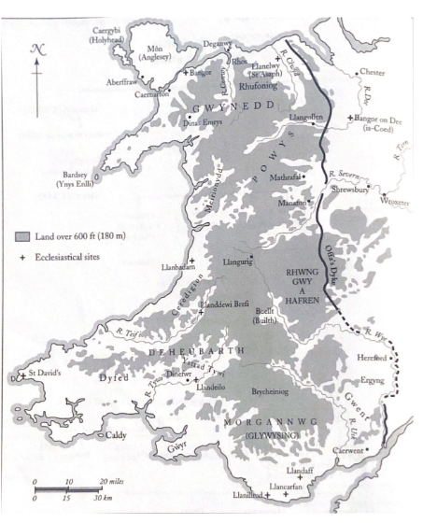
1 Map of Medieval Wales

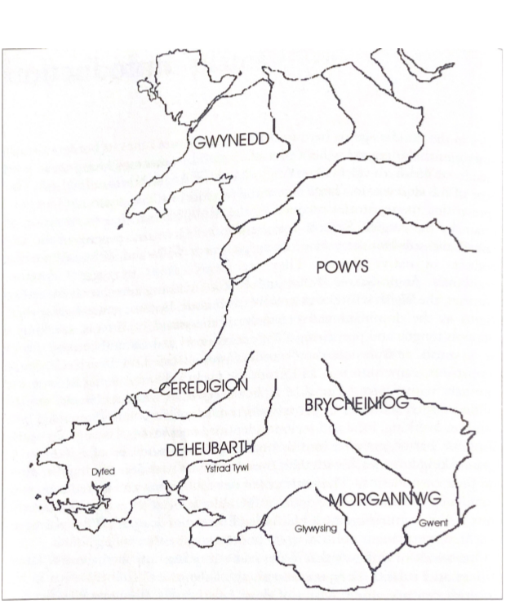
2 Kingdoms of Medieval Wales

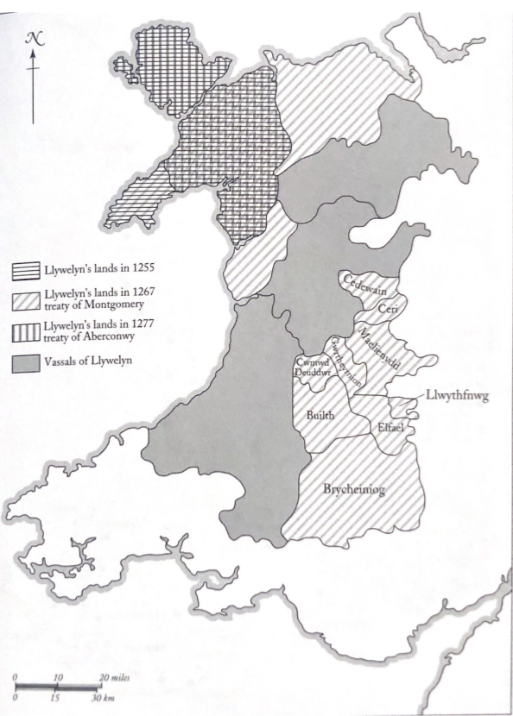
3 The Gains and losses of Llywelyn ap Gruffudd, 1255-77

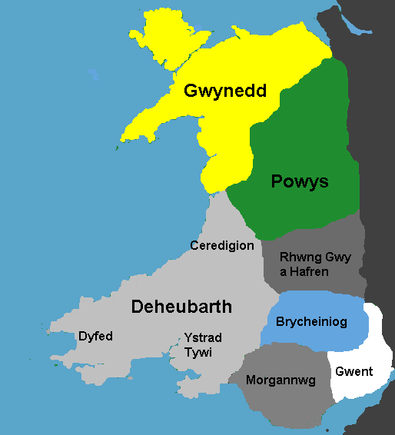
4 Map of Welsh Regions in 1093

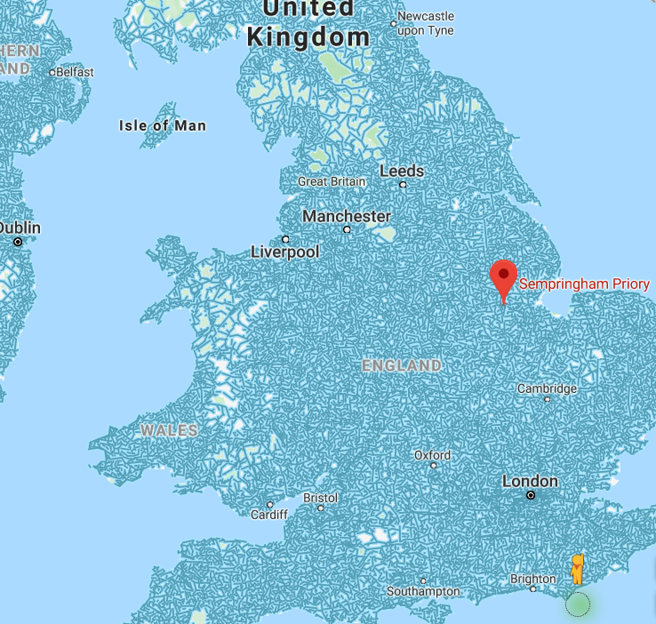
5 Map showing Sepringham Priory and its distance from Wales

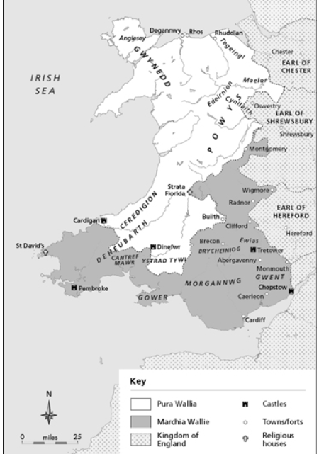
6 Map showing boundaries, kingdoms and settlements in Norman Wales (After the death of Rhys ap Tewdwr)
Appendix 2 – Genealogical Tables
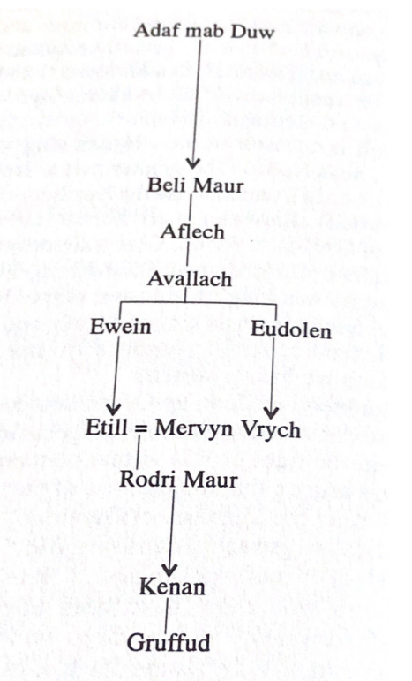
1 Paternal Ancestry of Gruffudd ap Cynan

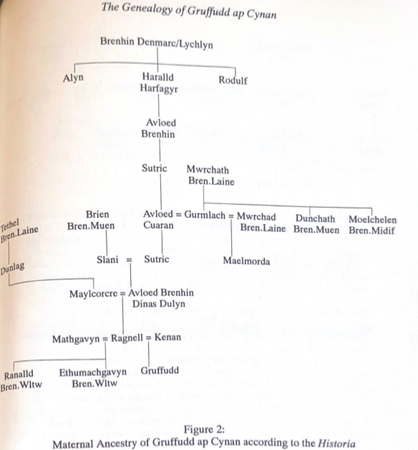

2 Maternal Ancestry of Gruffudd ap Cynan
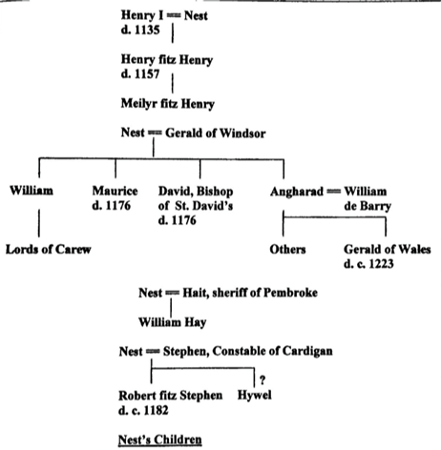
3 Nest Ferch Rhys' Children

Susan M. Johns, Gender, Nation and Conquest in the High Middle Ages: Nest of Deheubarth. (Manchester: Manchester University Press, 2013) p.36.
Brian Golding, Conquest and Colonisation. Revised ed. (Hampshire: PALGRAVE, 2001) p.10.
Gerald of Wales, The Journey through Wales and the description of Wales, trans. By. Lewis Thorpe (Suffolk: The Chaucer Press, 1978) p.149.
The Mabinogion, trans. By. T.P. Ellis and J. Lloyd (Oxford: Clarendon Press, 1929) pp.46-47.
Kari Maund, Princess Nest of Wales: Seductress of the English. (Gloucestershire: Tempus Publishing Limited, 2007) p.185.
David Carpenter, The Struggle for Mastery: Britain, 1066-1284 (New York: Oxford University Press, 2003).
David Bates, The Normans and Empire (Oxford: Oxford University Press, 2013).
Brendan Smith, Colonisation and Conquest in Medieval Ireland: The English in Louth 1170-1330 (Cambridge: Cambridge University Press, 1999).
Brian Golding, Conquest and colonisation (Hampshire: PALGRAVE, 2001).
Danna R. Messer, The Uxorial lifecycle and female agency in Wales in the twelfth and thirteenth centuries. (Bangor: Bangor University, 2014).
Thomas Jeffrey Llewelyn Prichard, The Heroines of Welsh History: Comprisisng Memoirs and Biographical Notices of the Celebrated Women of Wales (Briston: Canynge’s House, 1854) p.46. Writes Nest as though she is a helpless victim with no control over anything in her life as though things happen to her rather than someone who participates in the world.
Further reading, there are several articled and books that are listed here: Kathleen Sheldon ‘Women and Colonialism’, Oxford Bibliographies, (2018). Available at: DOI: 10.1093/OBO/9780199846733-0067. Helen, Bradford, ‘Women, Gender and Colonialism: Rethinking the History of the British Cape Colony and its Frontier Zones, c. 1806-70’, Journal of African History, 37(3) (1996). Available at: DOI: https://doi.org/10.1017/S0021853700035519. Terri L. Snyder, ‘Women, Race and the Law in Early America’, American History, (2015). Available at: DOI: 10.1093/acrefore/9780199329175.013.12. Ani Mikaere, ‘Colonisation and the Imposition of Patriarchy: A Ngati Raukawa Women’s Perspective’, in Pihama, Leonie et al (ed.) A collection of Writings 1999-2019 Volume II. (Aotearoa: Te Kotahui Research institute, 2019).
Elisabeth van Houts, Memory and Gender in Medieval Europe 900-1200 (Hampshire: Macmillan Press, 1999) p. 2.
Ibid.
Sioned Davies, ‘Storytelling in Medieval Wales’, Oral Tradition, 7(2) (1992), 231-257 (p.232-234).
Davies, Storytelling. p.233.
Ibid.
Brut Y Tywysogion, trans. By John Williams (London: Longman, Green, Longman and Roberts, 1860) p.53. Britons, i.e the Welsh, Irish and Scottish Celts.
Kim M. Phillips, ‘The Medieval Maiden: Young Womanhood in Late Medieval England’ (unpublished doctoral thesis, University of York, 1997) Available at: http://etheses.whiterose.ac.uk/2439/1/DX203902.pdf [Accessed: 11th March 2020] p.ii.
Ibid.
Kelcey Wilson-Lee, Daughters of Chivalry: The Forgotten Children of Edward I (London: Picador, 2019). This text also has the benefit of being set in the same period, allows us to see the same steps of the colonisation of Wales from the opposite perspective. Interestingly, Edward I’s youngest daughter would have been born around the same time Gwenllian ferch Gruffudd was.
Christopher McAll, ‘The Normal Paradigms of a Woman’s Life in the Irish and Welsh Texts’ in The Welsh Law of Women, ed. by Dafydd Jenkins and Morfydd E. Owen (Cardiff: University of Wales Press, 1980), pp. 7-23, (p.8).
Kari Maund, Princess Nest of Wales. p.48.
Tegwyn Jones, ‘Carchar Braw’ in A collection of Documents, ed. by Rhidian Griffiths (Aberystwyth: National Library of Wales, 1986) p.3.
Annales Cambriae, in A collection of Documents, ed. by Rhidian Griffiths (Aberystwyth: National Library of Wales, 1986) p.5.
Gwyneth Richards, Welsh Noblewomen p. 195.
Kari Maund, The Welsh Kings: The Medieval Rulers of Wales, (Gloucestershire: Tempus Publishing, 2000) p.85.
See pages 45 and 46.
Gwynfor Evans, Land of my Fathers (Ceredigion: Y Lolfa Cyf, 1992) p.174.
Ginny Burges, Remarkable Women: The Life and Times of Gwenllian ferch Gruffydd, (Warrior Princess of Wales), 2017, < https://rhapsodyinwords.com/2017/04/30/remarkable-women-the-life-and-times-of- gwenllian-ferch-gruffydd-warrior-princess-of-Wales/> [Accessed 13th September 2019].
See pages 46 and 48.
Kari Maund, Princess Nest of Wales. p. 35.
Gerald of Wales, The Journey through Wales and the description of Wales. p. 148.
Kari Maund, Princess Nest of Wales. p.46. This interaction wasn’t one of war, even if it was threatening in nature, and though there isn’t definitive proof, it is widely accepted that Rhys submitted to William during this meeting, since from then on he paid William £40 a year as a sort of tax.
Gerald of Wales, Journey through Wales and the Description of Wales. p.148. This is disputed by David Moore who argues in The Welsh Wars of Independence that he was on a peaceful mission – which is substantiated by the idea that William I and Rhys ap Tewdwr were at peace at this time. There was no cause for an unnecessary battle on either side.
See page 47.
J. Beverley Smith, Llywelyn ap Gruffudd: Prince of Wales (Cardiff: University of Wales Press, 1998) p.90. At least according to the poet Llygad Gwr.
See page 49.
J. Beverley Smith, Llywelyn ap Gruffudd. p.580.
Kari Maund, Princess Nest of Wales. p.8.
Ibid.
Kari Maund, Princess Nest of Wales. p.49. Maund writes that “Their [Nest and Gwladus] status was defined and referred to in relation to Rhys – The King’s daughter, the King’s wife” - Norman’s afforded their own titles to the women in Wales, but Welsh culture did not recognise this.
Gwenyth Richards, Welsh Noblewomen. p.153.
Nerys Patterson, ‘Women as Vassal: Gender Symmetry in Medieval Wales’, Proceedings of the Harvard Celtic Colloquium, 8(1) (1988) 31-45 (pg36).
Kari Maund, Princess Nest of Wales. P. 63.
Nerys Patterson, ‘Women as Vassal’ p.35.
Joanne M. Ferraro, ‘Childhood in Medieval and Early Modern Times’, in The Routledge History of Childhood in the Western World. ed. by Paula S. Fass (Oxfordshire: Routledge LTD, 2012) pp.63-65.
Nerys Patterson, ‘Women as Vassal’ p.36.
Nicholas Orme, Medieval Children (New Haven: Yale University Press, 2003) pp.56-57. The word fostered mainly meant ‘to feed’ or ‘to bring up’ in medieval times.
Gwenyth Richards, Welsh Noblewomen. pp.94-95.
Nicholas Orme, ‘Education in Medieval Wales’, The Welsh History Review, 27(4) (2015), 607-644 (p. 618).
Hywel DDa, The Law, trans. By Dafydd Jenkins (Llandysul: Gomer Publishing, 1986).
Kari Maund, Princess Nest of Wales. P.51.
The Mabinogion, trans. By Jeffrey Gantz (London: Penguin Books Ltd, 1976) pp.66-83.
The Mabinogion, Jeffrey Gantz p.65.
The Mabinogion, Jeffery Gantz. p. 109.
Ibid.
D. Simon Evans, A mediaeval Prince of Wales: Life of Gruffudd Ap Cynan (Historia Gruffud vab Kenan (Somerset: Llanerch Enterprises, 1990) p. 58.
Nicholas Orme, ‘Education in Medieval Wales’. pp. 626, 643.
Kari Maund, Princess Nest of Wales. p.52.
Nicholas Orme, ‘Education in Medieval Wales’. p.626.
Gwyneth Richards, Welsh Noblewomen pp.194-195.
Ibid.
Nicholas Orme, ‘Education in Medieval Wales’. p. 612.
Monastic Wales, Monastic Wales. Available at: <http://www.monasticWales.org/browsedb.php?term=monastries+built+by+normans&func=quicksea rch&x=0&y=0> [Accessed: 4th May 2020].
Anthony D. Carr, The Gentry of North Wales in the Later Middle Ages (Cardiff: University of Wales Press, 2017) p. 141.
Anthony D. Carr, The Gentry of North Wales. p.163.
The Mabinogion, trans. By Sioned Davies (Oxford: Oxford University Press, 2007) p.23.
Gruffudd ap Cynan is a great example of the power and connections that could be gained in a marriage, he was the grandchild of a King of Gwynedd, but it was his ties to his Scandinavian heritage (on his mother’s side, see page 52) that ensured he had the army needed to conquer the land. The History of Gruffudd ap Cynan, trans, by Arthur Jones (Manchester: Manchester University Press, 1910) p.47.
Brian Golding, Conquest and Colonisation. P.10.
Ibid.
S. Walpole, ‘Some Decisive Marriages of English History’, The New Review, 9(53), (1893), 384-392 (P.385) It is unclear who they mean when they say “conqueror”, but I believe they are speaking of William the Conqueror who Conquered Anglo-Saxon England in 1066.
S. Walpole, ‘Some Decisive Marriages’. p.387.
University of Cambridge, Aethelred the Unready, King of the English: 1,000 years of bad press. Available at: https://www.cam.ac.uk/research/features/aethelred-the-unready-king-of-the-english-1000-years-of- bad-press [Accessed: 26th March 2020].
S. Walpole, ‘Some Decisive Marriages’. p.387.
Ibid.
S. Walpole, ‘Some Decisive Marriages’. pp.387-388.
Kari Maund, Princess Nest. p.49.
Kari Maund, Princess Nest. p.130.
Kari Maund, Princess Nest. p.127.
Ibid.
Kathy E. Shimpock, ‘The ‘Unlikely Female’ Characters of the Mabinogi’ (unpublished doctoral thesis, University of Wales, Trinity Saint David, 2017) pp.11-12.
Kari Maund, Princess Nest. p.130.
Freda Davies, ‘The Power of Beauty’, Pembrokeshire Life, April 2003, pp.6-7.
The History of Gruffudd ap Cynan, trans, by Arthur Jones p.177.
Freda Davies, ‘The Power of Beauty’.
University of Notre Dame, ‘The Helen of Wales’: Nest Ferch Rhys ap Tewdwr, a Shaper of History (Part 2), 2018 <https://sites.nd.edu/manuscript-studies/2018/09/07/the-helen-of-Wales-nest-ferch-rhys-ap- tewdwr-a-shaper-of-history-part-2/#_ftn30 > [Accessed: 1st April 2019].
The History of Gruffudd ap Cynan, trans, by Arthur Jones p.177.
Kari Maund, Princess Nest of Wales p.147.
Lois L. Huneyccutt, Matilda of Scotland: A Study in Medieval Queenship, (Woodbridge: The Boydell Press, 2003) pp.27-28.
Ibid.
Gwenyth Richards, Welsh Noblewomen. pp.191-192.
Ibid.
Michael Sheen, Annual Raymond Williams Memorial Lecture 2017 / Michael Sheen, online video recording, Youtube, 18th November, 2017, < https://www.youtube.com/watch?v=bbVdA7zS8dE&fbclid=IwAR1feHXTNzwQYcSOn2xswjZq d6WGjUQfr1LrqoOsQ8upgBO0GsuooprApEU> [Accessed: 18th November 2017].
Antony D. Carr, The Gentry of North Wales. p.141.
Kathy E. Shimpock, ‘The ‘Unlikely Female’ Characters’ p.33.
Kathy E. Shimpock, ‘The ‘Unlikely Female’ Characters’ p.35.
Kari Maund, Princess Nest of Wales. p. 47.
Kari Maund, The Welsh Kings. p. 91.
Ruth Mazo Karras, Sexuality in Medieval Europe: Doing Unto Others, (Abingdon: Routledge & CRC Press, 2012) p.71.
The Mabinogion, trans. By Sioned Davies. P.23.
The History of Gruffydd ap Cynan, Arthur Jones. p.88.
Ibid.
Ibid.
Kathy E. Shimpock, ‘The ‘Unlikely Female’ Characters’, p.26.
Antony D. Carr, The Gentry of North Wales, p.163.
T.M. Charles-Edwards, ‘Nau Kynywedi Teithiauc’ in The Welsh Law of Women, ed. by Dafydd Jenkins and Morfydd E. Owen (Cardiff: University of Wales Press, 1980), pp. 24-40, (p.36).
Kathy E. Shimpock, ‘The ‘Unlikely Female’ characters’, p.26.
The History of Gruffydd ap Cynan, Arthur Jones. p.88. He was willing to capture someone who had sought refuge with him - something that went against medieval Noble customs.
David Pryce, a fiction author who focuses on Welsh history, hypothesises that her father was preparing to marry her off to a powerful Anglo-Norman Lord, which although there’s no solid evidence to support this claim, it falls in line with my own interpretation of the evidence that does exist.
The History of Gruffydd ap Cynan, Arthur Jones. p.88.
R.R. Davies, The Age of Conquest: Wales 1063-1415 (Oxford: Oxford University Press, 2000) pp.42-43.
Sarah Woodbury, Marriage in the Medieval Era, 2012, < https://www.sarahwoodbury.com/marriage-customs-in-Wales/> [Accessed: 8th April 2020].
Myisha Cherry, ‘The Different Faces of Rebellion’, Huffpost, 22 September 2013, <https://www.huffpost.com/entry/the-different-faces-of- re_b_3632966?guccounter=1&guce_referrer=aHR0cHM6Ly93d3cuZ29vZ2xlLmNvbS8&guce_referrer_ sig=AQAAACROsG0op_5UmbtCdg6svm0DMrtX-ZNp5QvBLPQEpgn- SwgqF4waP4fD1roslOuAQDgecmS0soxKYg2LhoZYHvRX7xe3hC648YX04etJStrLZnPiiJWxEzpjq2Oz1K0Ky jk5ndo48na9Td5iOPzyOezaRukwqksx-HW0fsWLAfd3> [Accessed: 25th April 2020].
The Mabinogion, trans. By Sioned Davies. pp. 16-17. When the women tell everyone that Rhiannon was strong enough to fight off six women on her own in the Mabinogion, she is ostracised from the castle, sent to sit outside the castle walls and carry people on her back, punishing her and making a statement to other women that physical strength is a bad quality.
Petronilla de Grandmesnil was the Countess of Leicester who mounted an attack against the Norman King at her husband’s side. Her story of rebellion is remarkably similar to that of Gwenllian ferch Gruffudd and allows us to see that women did rebel in physical ways like men.
Winward, ‘Some Aspects of the Women in The Four Branches’, p.84. cited by Kathy E. Shimpock, in ‘The ‘Unlikely Female’ Characters of the Mabinogi’ (unpublished doctoral thesis, University of Wales, Trinity Saint David, 2017) p.29.
Philip Warner, Famous Welsh Battles (Glasgow: William Collins Sons & CO. Ltd, 1977) pp.78-79.
Gerald of Wales, The Journey through Wales and the description of Wales. pp.88-89.
Kari Maund, The Welsh Kings. p.97.
Phillip Warner, Famous Welsh Battles. p.79. Warner’s take on Gwenllian is a little harsh, to me, she was only a girl trying to get back at the people who had colonised her lands and were benefitting from the suffering of her people. She probably was not a saint – but were the people she was fighting, innocent? Wales Online, in a recent article, refer to her as a Hero due to her ‘Maid Marion’ type actions during this time Anna Lewis, ‘The Untold Story of Wales’ Joan of Arc – the sword-wielding heroine you’ve probably never heard of’, Wales Online, 1st May 2019. < https://www.Walesonline.co.uk/news/Wales-news/gwenllian-ferch-gruffydd-Wales-boudica- 16147944> [Accessed: 26th April 2020].
It may be important to note that this marriage may have been her first act of rebellion, as mentioned in the previous chapter, she very well may have disobeyed her father’s orders, and his plans to procure a Norman husband for her, in order to marry a Welsh man.
Perhaps due to Gruffudd ap Cynan’s dislike of him and their union.
Gerald of Wales, The Journey through Wales and the description of Wales. p. 137.
The act of beheading Gwenllian may have been meant as an act of respect in a way, women were often burned at the stake, while men captured during battle were beheaded, by beheading her, in her death she was elevated to the status of the men she fought against and beside. Naked History, Gwenllian ferch Gruffudd. 2016 < http://www.historynaked.com/gwenllian- ferch-gruffydd/> [Accessed 10th March 2020].
Gerald of Wales, The Journey through Wales and the description of Wales. p.137.
Phillip Warner, Famous Welsh Battles. p.79. For centuries after, Welsh men going to battle used “Justice for Gwenllian” as their battle cry.
John Davies, A History of Wales, (London: Penguin Books Limited, 2007) p.121. See Page 50 for a map (Ystrad Twyi, Ceredigion, and Dyfed can all be found in the Kingdom of Deheubarth.
David Crouch, ‘Grandmesnil, Petronilla de, Countess of Leicester’, Oxford Dictionary of National Biography, (2008) < https://doi-org.ezproxy.uwtsd.ac.uk/10.1093/ref:odnb/47224> .
Ibid.
Ibid.
Ibid.
Kathy E. Shimpock, ‘The ‘Unlikely Female’ Characters’. P.18. In the Mabinogion, Rhiannon shows similar rebellions, and in fact her husband defers to her judgement twice throughout the first branch.
Terry Breverton, Owain Glyndwr (Gloucestershire: Amberley Publishing, 2012) p.ii.
Phillip Warner, British Battlefields, cited in, Terry Breverton, Owain Glyndwr (Gloucestershire: Amberley Publishing, 2012) p.i.
Walter o Guisborough in A collection of documents, ed. by Rhidian Griffiths (Aberystwyth: National Library of Wales, 1986) p.7.
Walter o Guisborough, in A collection of documents. p.8.
Andrew Knighton, What Happened to Prisoners of War In Medieval England, 2016, < https://www.warhistoryonline.com/medieval/happened-prisoners-war-medieval-england.html> [Accessed: 2nd May 2020].
Felin Fach, What Happened at Cilmeri, 11th December 1282? 2019 < https://www.felinfach.com/blogs/blog/cilmeri-holy-ground> [Accessed:29th April 2020].
Terry Breverton, Owain Glyndwr. p.i.
Ibid.
The Mabinogion, trans. By Sioned Davies. p.27-29.
Kari Maund, Princess Nest of Wales. p.153. Three of her children were given Welsh names; Angharad, Gwladus and Hywel. Nest’s eldest son, Henry (Son of Henry I) gave his son the Welsh name Meilyr. (See also, page 53).
Ibid.
Gerald of Wales, The Autobiography of Gerald of Wales, trans. By H. E. Butler (Sufflok: The Boydell Press, 1937) p.83.
Ibid.
Kari Maund, Princess Nest of Wales. p.141.
Olwen Davies, ‘Princess Nest: The Helen of Wales’, Country Quest, November 2007, p.33.
Kari Maund, Princess Nest of Wales. pp.90, 127. Nest was captured by Arnulf de Belleme, who Gerald worked for, it perhaps makes sense then for Arnulf to have been involved in the battle that killed Rhys ap Tewdwr.
Kari Maund, Princess Nest of Wales. p.138.
I cannot fully accept that Nest was complicit in the kidnapping purely because of the children. They were taken too, and then she convinced him to let them all go. But if she had gone willingly, surely, she would have kept them close? What if her plot had been discovered? Would Gerald have hurt them? Would anyone else?
Gerald of Wales, Journey through Wales and description of Wales. p.89.
Ibid.
Heather Rose Jones, A Simple Guide to Constructing 13th Century Welsh Names <https://heraldry.sca.org/names/Welsh13.html> [Accessed 27th April 2020]. This website uses information taken from the Merionet Lay Subsidy Roll of 1292-3 – giving us an indication of just how popular Welsh names still were.
Gerald of Wales, Journey through Wales and description of Wales. p.88.
Harriet Webster, et al. City Witness <http://www.medievalswansea.ac.uk/en/game/> [Accessed:27th April 2020].
Susan M. Johns, Gender, Nation and Conquest p.36.
Joseph Campbell, Quotes, N.D. < https://www.goodreads.com/author/quotes/20105.Joseph_Campbell> [Accessed: 1st May 2020].
Morgan Kay, ‘Gendered Postcolonial Discourse in the Mabinogi’, Proceedings of the Harvard Celtic Colloquium, 24/25 (2004/2005), pp.216-228 (216) < https://www.jstor.org/stable/40285191?read- now=1&refreqid=excelsior%3A69b1f8165b30e5bf25c78e199b07c7af&seq=4#page_scan_tab_content s> [Accessed: 23rd April 2020]. This text notes that several of the themes of the Mabinogion may have been influenced by the colonisation and so the stories became more about loss, sadness, and devastation, in a way that perhaps they had not been before.
Nest ferch Rhys is an example, but so is Nest ferch Osbern.
See Gruffudd ap Cynan turning on Gruffudd ap Rhys ap Tewdwr, and also Owain ap Cadwgan being stripped of his land by Henry I after kidnapping Nest.

