  Component Three | Student  No: 2243324  Module  Title: Operating Hotel Facilities  Module  Code: BMIH4006  Lecturer: Daniel Payne

Introduction
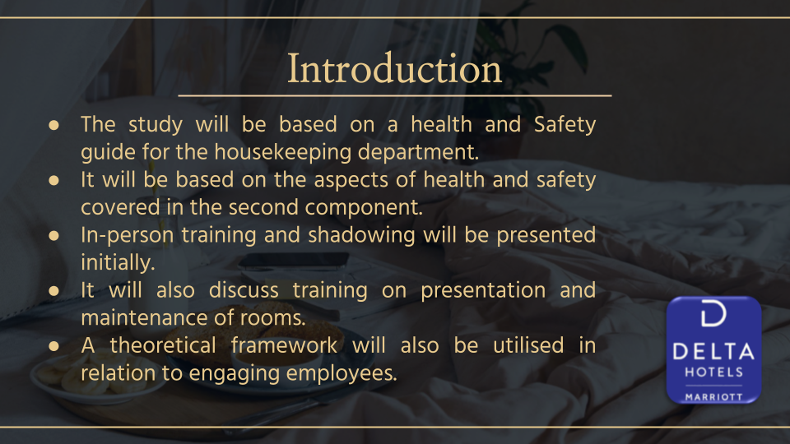
The following presentation will be based on a health and safety guide for housekeeping employees. The health and safety guide will be on the aspects developed in component two. The first discussion will cover training and development for cleanliness, in-person training and shadowing as well. Further, it will also present training for maintaining rooms and presenting it to guests. It will also evaluate the utilisation of a theoretical framework to engage employees in training. Other training related to health and safety are training through online materials and infection control.

Learning and Development for Cleanliness
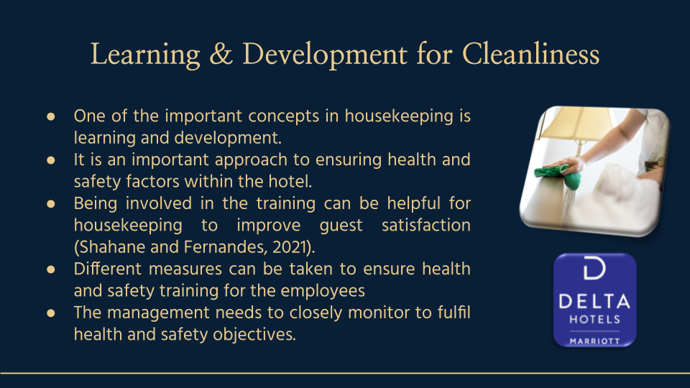
Learning and development is an important concept in the housekeeping department within hotel groups like Delta Hotels. Training is essential for the staff members to develop knowledge and skills in ensuring health and safety through cleanliness. Ensuring effective cleanliness training is essential as it helps them to enhance their professional attributes. It further helps in providing better services to maximise the experience of the guests (Shahane and Fernandes, 2021). There are different ways of providing training to the housekeeping employees. However, the management of the business needs to ensure that employees gain proper insights into fulfilling the objectives of cleanliness to maintain health and safety within the hotel and satisfy guests.
In-person training and shadowing
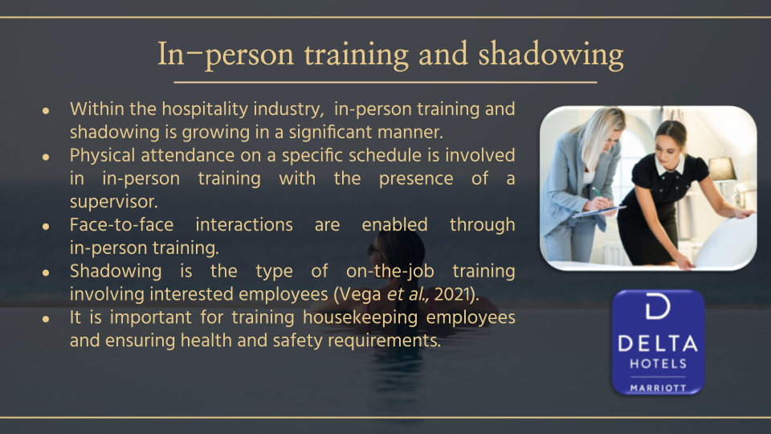
The concept of in-person training and shadowing is highly advanced within the hospitality sector. In-person training involves physical attendance on a specific schedule in the presence of a supervisor. It provides more hands-on experience for the employees through face-to-face interactions. Further, it also helps in greater understanding and clarification than the training through other modes. Shadowing is also a type of on-the-job training which enables the keen staff to follow and observe closely the performance of other employees (Vega et al., 2021). It is an essential factor of training employees in the position of housekeeping to ensure cleanliness which results in better management of health and safety in the hospitality business.

Training and development for the maintenance and presentation of rooms
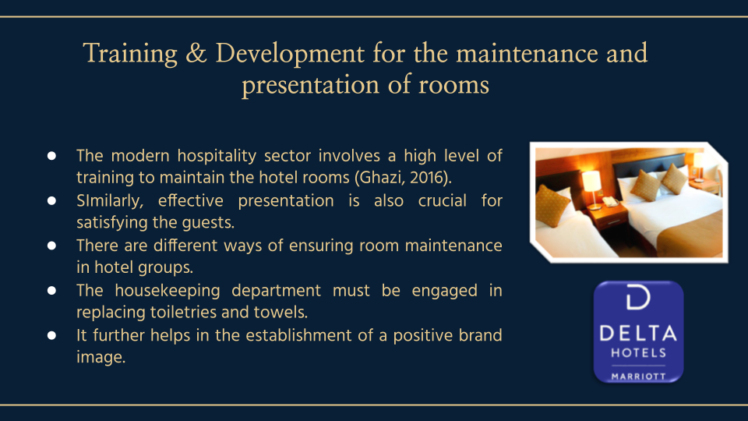
It is essential for the employees to be trained within the business environment for the maintenance and presentation of guest rooms (Ghazi, 2016). It is the best way for the housekeeping department to provide better satisfaction to the guests as well as prevent accidents. The employees will learn about different ways of maintaining the guest room. They will learn about frequent engagement in mopping which helps to prevent slips and falls within the hotel environment. The employees need to be engaged in changing towels and toiletries which is crucial for ensuring guests' safety from illness. Hence, providing training enhances better output which is significant for the establishment of a positive image of Delta Hotel.

Zinger Model of employee engagement Implementation for training
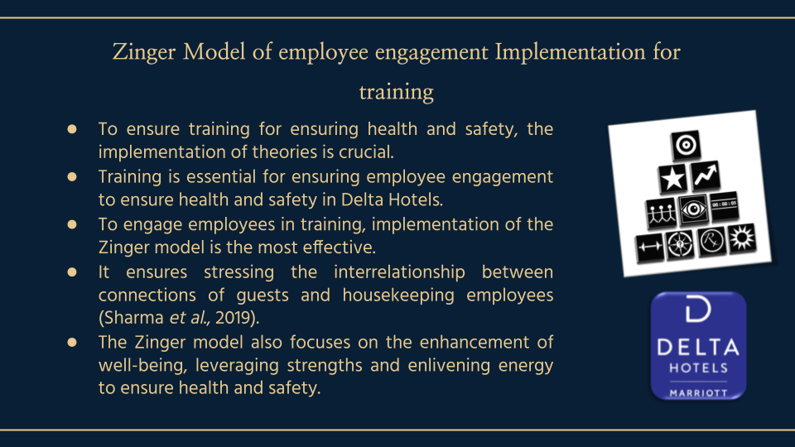
Theories play an important role in terms of providing better training to the employees to gain diverse skills to ensure health and Safety in the hotel environment. An important element of training employees is to ensure they are engaged in maintaining cleanliness for health and safety. The Zinger model of employee engagement is an important model for engaging employees in the training process. The model helps to stress the interrelationship between the connections of the employees with one another, the guests and even the organisation (Sharma et al., 2019). The model is highly focused on enhancing well-being, leveraging strengths and enlivening energy which is vital for ensuring health and safety in the hotels.

Zinger Model of employee engagement Implementation for training (Cont’d)
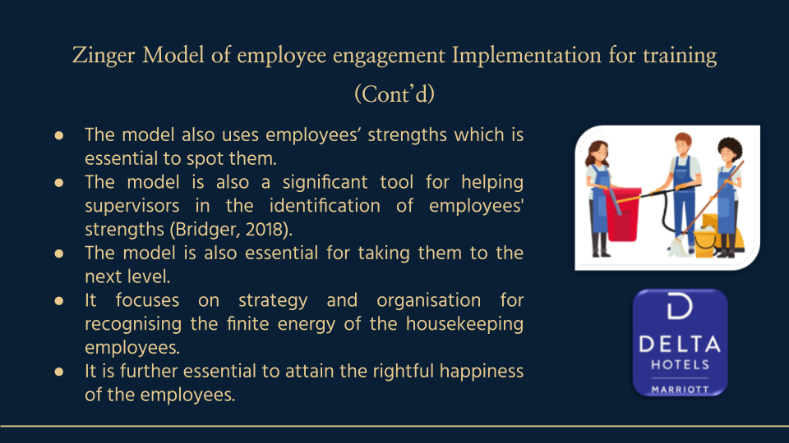
According to Zinger’s employee engagement model, using the strengths of the employees is vital for spotting them. It can be only provided to the employees through training and development. Further, the model is focused on employees’ emotional aspects. The model is a great tool for helping the supervisors of the housekeeping department to identify the strengths of the employees (Bridger, 2018). It further helps them to take them to the next level within the hospitality industry. The model is significant for training employees as it focuses on organisation and strategy to identify the finite energy of the employees to attain the objective of rightful happiness.

The use of video materials for training the housekeeping team for cleanliness
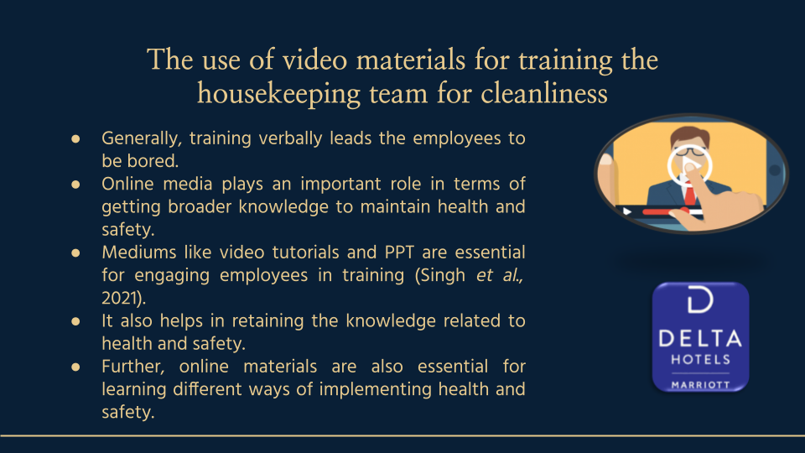
Often, training the employees verbally is boring to certain employees within the workplace. Training through online mediums is an essential factor for the employees to gain wider insights into maintaining cleanliness and safety within hotels. Online materials like PPTs and tutorials help them stay engaged during training. Further, training through video processes is much more effective than verbal training. It further makes knowledge retention on health and safety easy. Furthermore, online materials can be helpful for employees to learn about different modes of implementing cleanliness to ensure the health and safety of the guests.

Maintenance of protocols related to health and safety in hotel
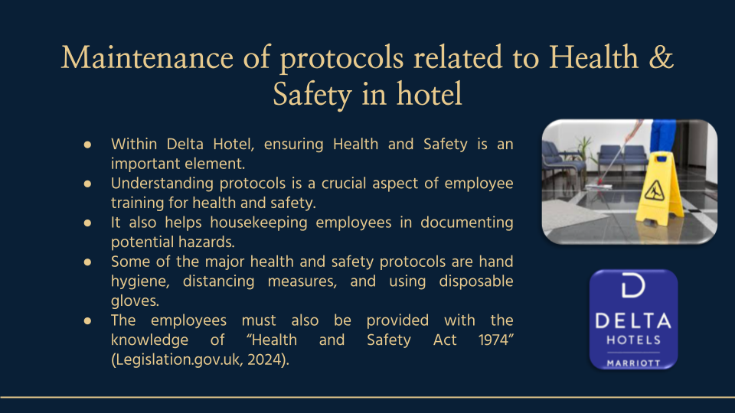
Ensuring the health and safety of the guests is an essential factor for a business like Delta Hotels to satisfy guests. Learning about health and safety protocols is an important part of training employees within the business. Providing training for maintaining protocols is crucial as it leads the staff to document potential hazards. Some of the major protocols that need to be taught in training are distancing measures, hand hygiene, use of disposable gloves and so on. A result of gaining such knowledge, it ensures the employees to implement cleanliness and well-being within the hotel. Further, the employees also need to be trained about Acts like “Health and Safety at Work Act 1974”. It gives out a legal structure of encouraging, stimulating and promoting health and safety standards in hotels (Legislation.gov.uk, 2024).

Training for the control of infection
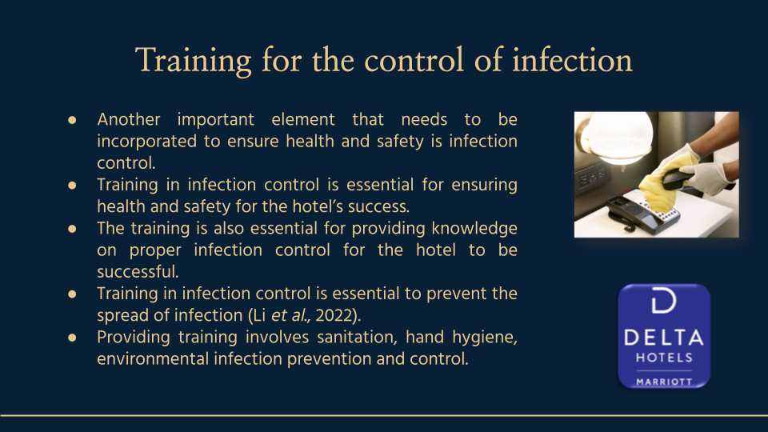
Infection control is another significant factor that should be maintained within the hotel facilities. To ensure proper health and safety concerns, it is crucial for the supervisor to provide training to the housekeeping employees of Delta Hotels. Providing training about the right infection control measures is essential for the success of the hotel (Li et al., 2022). Further, successful training for the employees regarding infection control helps to prevent infections from being spread among the guests. Infection control measures in the hotels involve hand hygiene, sanitation, environmental infection prevention and control.

Conclusion
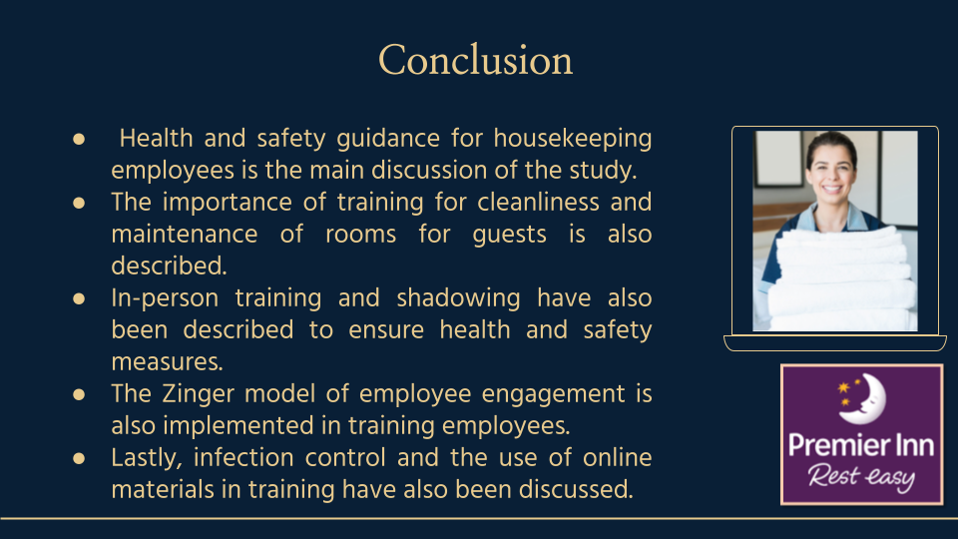
The above discussion has been based on health and safety guidance for housekeeping employees in Delta Hotels. It has described the importance of training and development for cleanliness and maintenance of rooms for guests. It has also analysed the necessity of in-person training and shadowing for housekeeping employees to ensure health and safety within the hotels. Further, the Zinger model of employee engagement is used in training the employees. Lastly, another essential discussion to ensure health and safety in Delta Hotels presented are infection control, use of online materials and so on.
References
Bridger, E., (2018) Employee engagement: a practical introduction. 2nd ed. HR Fundamentals. London: CIPD and Kogan Page.
Ghazi, K.M., (2016). Hotel maintenance management practices. Journal of Hotel and Business Management, 5(1), p.1000136.
Legislation.gov.uk. (2024). Health and Safety at Work etc. Act 1974. [online] Available at: https://www.legislation.gov.uk/ukpga/1974/37/contents [Accessed 7 Feb. 2024].
Li, X., Chen, H., Lu, L., Chen, L.-L., Brian Pui-Chun Chan, Wong, S.-C., Vincent Chi-Chung Cheng, Yuen, K.-Y., Chan, K.-H. and Kelvin Kai-Wang To., (2022). High compliance to infection control measures prevented guest-to-staff transmission in COVID-19 quarantine hotels. Journal of Infection, [online] 84(3), pp.418–467. doi:https://doi.org/10.1016/j.jinf.2021.10.016.
Shahane, R. and Fernandes, M. (2021). To Study the Training Program Implemented by the Housekeeping Department for Onboarding Staff in a Post Pandemic World and its Impact on Employee Motivation. [online] Ssrn.com. Available at: https://papers.ssrn.com/sol3/papers.cfm?abstract_id=4033098 [Accessed 7 Feb. 2024].
Sharma, N., Chaudhary, N. and Singh, V., (2019). Management Techniques For Employee Engagement In Contemporary Organizations. Hershey, Pennsylvania: IGI Global.
Singh, V., Narula, H., Sakshi Supehia, Sharma, M., Gupta, P.K., Sharma, A. and Rao, S., (2021). Impact of Video Modules-Based Training on Knowledge, Attitude, and Practices of Cleaning and Disinfection Among Housekeeping Staff at a Tertiary Care Center During the COVID-19 Pandemic. Cureus. [online] doi:https://doi.org/10.7759/cureus.19125.
Vega, R.M., Peláez, E. and Raj, B., (2021). Shadowing as peer experiential learning for faculty instructional development strategy: A case study on a computer science course. International Journal of Educational Research Open, [online] 2, pp.100091–100091. doi:https://doi.org/10.1016/j.ijedro.2021.100091.

