

ADAA7000 Coexistent Perspectives Module

Name: Judith Huntly
Student number: 0052081
Word Count: 3,548

- Please keep all drafts of your essay. You may be asked to produce these as evidence of your writing process.

- Please ensure you follow the AI guidance on the assessment brief and note when and how you are able to use AI.

- Please also note the guidance regarding plagerism on your assessment brief also refers to referencing the source of your material and that includes the use of AI.

For this assessment,
I confirm that I have not used Generative AI to support me in structuring my submission, including creating a draft argument structure, identifying parts and headings.
I confirm that I have not used Generative AI to create text for my submission.
I confirm that I have not used Generative AI for creative materials, such as images.

Student Signature: __J Huntly_

Abstract
This essay examines the life and work of artist, ceramicist, writer and collector Edmund De Waal. He is renowned for his minimalist porcelain installations and bestselling literature blending ceramic artistry with narrative art history. He creates poetic large-scale installations using handmade porcelain vessels arranged in steel and glass cabinets, exploring themes of diaspora, memory and the visual poetry of collecting. The essay examines the theories of Heidegger’s existential and phenomenological themes within his work alongside the theories of cultural critic Walter Benjamin, particularly regarding memory, collecting and the “aura” of objects. Ultimately the essay argues that De Waals work intertwines his personal pilgrimage through his writing, making and whilst exploring emotional and visceral connections to family history exile and displacement.
Research Question: #5
How does Edmund De Wall reshape ideas of authorship and materiality in his praxis?
Research argument:
This essay argues that De Wall’s work intertwines personal pilgrimage, diaspora and memory with his handmade ceramic vessels.

Introduction – (500 words)
Edmund de Waal (b. 1964) is a world-renowned British artist, master potter, and award-winning author celebrated for his minimalist porcelain installations and narratives on memory and exile. His work typically features groups of handmade white porcelain vessels housed in vitrines, bridging ceramic tradition with sculpture.
De Waal explores memory, trauma and loss transforming handmade vessels into emotional containers evoking themes of diaspora, displacement and quiet contemplation. His work is evocative of his traditionalist approach of ‘hand’ and ‘touch’ embracing imperfection with his incorporation of Japanese philosophy into his work which celebrates transience, flaws and the history of the objects.
DeWaal is known for his large-scale site-specific installations in museums and historic sites, his work focuses on the interaction between the porcelain vessels he creates and the spaces they occupy. His exhibitions whilst minimalist in nature are imbued with hidden complexity that contain entire worlds within the confines of the space. The poetic titles to his exhibitions add to, and illuminate his work. The arrangements and groupings fluctuating in size and shape like words and sentences displayed as the idea of language itself, contained within the shelf, transforming porcelain into visual poetry.
If you look closely his work is a metaphor for the passage of time, a meditation on history, memory and loss, the act of giving a work a name is the start of letting go – sending the work out into the world.
“I’ve always loved the idea of the mutability of things. . . . Nothing is forever. . . . There’s an inherent instability about how objects work in space”.
—Edmund de Waal
He works across mediums intertwining his sculptural practice with his writing and art history research. His work is intimate and reflective with a conversational tone asking questions and bridging the gap between his artistic creations and the historical storytelling in his writing. He artfully connects people through his work by reviving and telling stories that matter. De Waal’s work has an ethereal quality reflecting his family history and their exile and displacement during the Holocaust. His work is deeply connected to literature, collecting and collections his ceramics and writing expand on his innate passion for storytelling with objects as the central narrative.
Edmund de Waal's practice with both with his ceramic vessels and his writing engages with themes of memory, space, and materiality, which are often examined through the lens of phenomenology, a philosophical approach rooted in Heideggerian thought. De Waal explores how his porcelain installations create atmospheres that are comparable to philosophical inquiry, asking what it means to belong in a particular place and time.
Main body
De Waal’s practice is an exploration through the Practice as Research (PaR) paradigm which uses phenomenology to examine the embodied narrative within his ceramic vessels. The philosophical study of consciousness and the lived experience which focuses on subjectivity and meaning and the unique way he develops his work, how he encounters and interprets the world through emotions and lived experiences.
His phenomenological approach centres on the human experience of objects through sight, touch and spatial interaction. His installations of porcelain vessels are often housed in minimalist vitrines (glass case) that create a quiet dialogue between the material and the surrounding architecture with the audience acting as a resistance to forgetting.
De Waal focuses on the tactile nature of clay and porcelain focusing on the sensory interaction between the handmade vessel, the hand and the eye. His work creates spaces of silence in an oversaturated world encouraging the audience to slow down and reflect on the objects and their histories.
Heidegger’s phenomenological approach in his 1950 essay “The Thing” (Das Ding) he emphasizes that the "thingness" in the example of the jug is revealed when it is used as a vessel rather than when it is analysed as a static object. In his phenomenological exploration of the jug, Heidegger refers the reader to the idea of a vessel’s quality of containment: “The emptiness, the void, is what does the vessel’s holding…[the potter] shapes the void. For it, in it, and out of it, he forms the clay into the form”. Heidegger distinguishes between a mere object which are represented or manipulated by a subject (human)—and a "thing" (Ding), which has its own presence and essence. Using the jug example, the jug is not merely a vessel made by a potter but a thing that holds and pours, gathering a world of meaning – the jug is a gift (das Geschenk), the outpouring is a giving (Schenken) of the gift – “the jug’s jug character consists in the poured gift of the pouring out”. The pour is the solemn offering from the god’s - the authentic gift of offering and sacrifice. Similar to Heidegger’s exploration of the “thing” (the jug) assembling a world, De Waal creates collections of porcelain that invite contemplation and create a sense of place.
De Waal notes that the viewer or holder (of the object) completes the object, inviting a subjective, intimate experience. His work is often about memory and how objects can carry personal or collective histories.

In his book “The Hare with the Amber Eye’s” he investigates the “echoes and traces” of history and personal memory which relates to understanding one’s situatedness in the world. The book is a biography, a retelling of his family ancestry, the ascent and decline of a Jewish dynasty and how the objects (natsuke) have survived through three Jewish owners and the three rooms in which the collection was kept for over a hundred and forty years. The first is the study in Paris in the 1870s of the art-critic Charles Ephrussi. The second is the dressing-room of his great-grandmother Emmy von Ephrussi in the vast Palais Ephrussi on the Ringstrasse in Vienna. The third is that of her son Ignace, his great-uncle Iggie, in Tokyo in the 1970s, an apartment looking out across central Tokyo.
The Netsuke are small, intricately carved Japanese miniature sculptures traditionally made from wood or ivory, they served as a functional toggle for men’s kimono during the Edo period (1603 – 1868). Men’s Kimono’s lacked pockets so personal items like purses or medicine containers were hung from the sash (obi) and secured by a netsuke (toggle). The carvings often featured animals, mythical creatures, historical figures, fruit or daily scenes. As clothing style shifted towards western fashion the netsuke evolved from practical items into collector’s items.
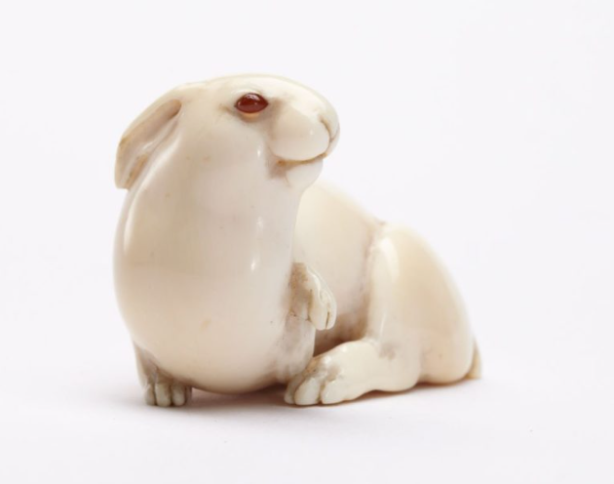 | 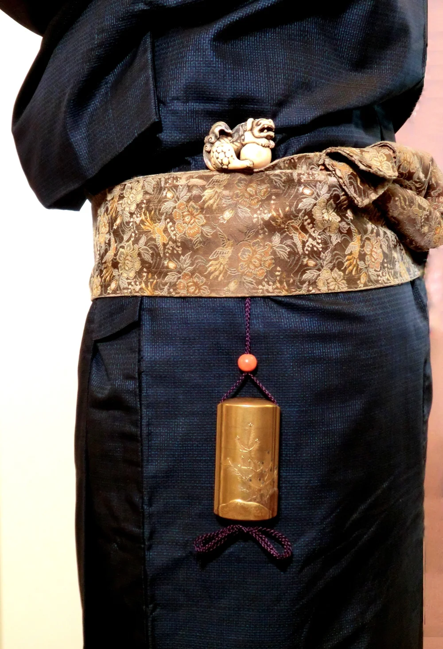

Listening to the retelling of (his great uncle) Iggie’s stories about the Netsuke collection he like the way “the repetition wears things smooth, like river stone”. (P8). De Waal is the fifth generation of the family to inherit this collection, in the book he states that “I am a potter: I make pots” - It has been central to his life, how things are made and how they are handled and what happens to them. He reflects on his time in Japan where he studied pottery and visited his great uncle in Tokyo, for De Waal the book is his journey to the places in which the collection lived, his secret history of touch. He talks about how they feel in his hand, how he turns them round in his fingers, the feel and weight of the material. If it’s wood, chestnut or elm or lighter – then ivory. He talks about the details, the patina on the wooden ones, the faint shine on the spine of the brindled wolf and tumbling acrobats. The ivory ones come in many shades of cream but not white. Some show signs of wear, the haunch of the faun resting on leaves has lost its markings. The cicada has a fault line; he wonders who dropped it. When and where?
He talks about the signatures – that moment of ownership before they are finished – and let go – into the world. The pleasure in finding where the signatures have been placed, the sole of a sandal, the end of a branch. You work your fingers around the smoothness and stoniness of the ivory, they are always asymmetric like his favourite Japanese tea-bowls, you cannot understand the whole from the part.
The collection which are at the heart of De Waal’s memoir has been placed on permanent loan to the Jewish Museum in Vienna. There are 264 netsuke in the collection, including the ivory “hare with amber eyes” which is the title of his book.
Despite being a collector and author, he states that his job is to make things. “How objects get handled, used and handed on is not just a mildly interesting question for me. It is my question” (De Waal 2010 p 19 ). De Waal talks very eloquently and passionately about his craft he describes how he can ‘read’ a pot he remembers the weight and balance, how it’s surface works with its volume, how the edge creates tension or loses it. He can feel the warmth of the vessel, if it has been made with diligence or at speed. He observes how it works with objects nearby and how it displaces a small part of the world around it. He talks about his objects as visceral objects contemplating his emotional response to the tactile and visual appeal or to the utility of the object. If he picks up the small white cup with a chip near the handle, how will it impact his life? The cup is a simple object, more ivory than white, - too small for coffee he thinks. Could the object become part of his life of handled things a favoured, favourite thing, or will it fall away into a personal story, an intertwining of things with memories. He could put it away or he could pass it on, how objects are handed on can be an expression of love or a huge responsibility that will complicate your life. What will be remembered, what will be forgotten? Where is he in the chain of forgetting, the rubbing away of previous ownership, where will this story take him before it gets too thin and smooth and disappears.
De Waal remembers if an object invited his touch with the whole hand or just fingers or asked you to stay away. Some things are meant to be looked at from a distance “it is not that handling something is better than not handling it” (De Waal 2010 p20). He describes the strange moment the breath of hesitancy before touching or not touching. As a potter he recalls how strange it is when people who have his pots talk about them as if they are alive, he is not sure if he can cope with the afterlife of what he has made but some objects do retain the pulse of their making.
De Waal is a maker, he makes things from porcelain, he arranges them, on shelves or within vitrines, in galleries, museums and houses. The groupings resemble poetry that has a title or phrase that helps them on their way in the world. In his book “an Archive” he discusses Walter Benjamin a German Jew that was forced into exile following the rise of the Nazi regime. Benjamin was a writer philosopher and collector who cared for the life of ‘things’. Benjamin believed in mapping the world through objects, he collected, postcards, books, children's toy’s, postage stamps and books. De Waal felt a kinship with Benjamin particularly with his writings and collecting. De Waal writes “Walter Benjamin knew about silences” (De Waal P. 100 2025) and that memory is a place you can disappear. He writes about visiting his apartment and his work that reflects his kind of enquiry a “memory work” and there being a series of vitrines, in which his (De Waal) work can pause, his vessels and fragments of vessels. He calls this work “Portbou” the place where Benjamin took his life whilst escaping over the mountains from occupied France into Spain.
In his homage to Benjamin, De Waal made three installation and writings exploring memory, exile and the aura of objects. His 2016 exhibition in Berlin entitled “Irrkunst” he explored the concept of the “art of straying” he focuses on Benjamin’s childhood exploring the meaning of overlooked objects. He used white porcelain to reflect ideas of memory and childhood and black porcelain to represent themes of exile, departure and loss. “I’ve made porcelain vessels that have been broken. Shards matter; they record a moment of disjuncture and loss. You look at the edge and feel the sharpness (De Waal P. 99 2025). De Waal often incorporates a temporary library of Benjamin’s text into his exhibitions, linking the ceramic pieces to archival history. His work often resonates with Benjamin’s theme, treating his own installations as pages or letters to engage with.
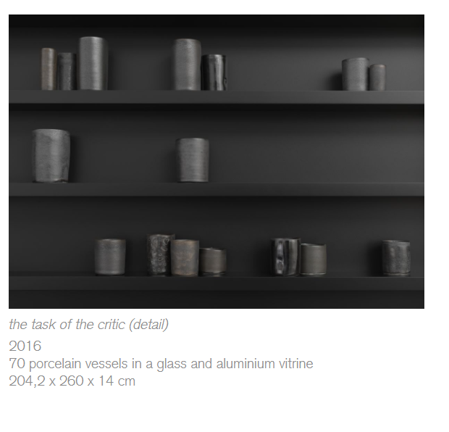
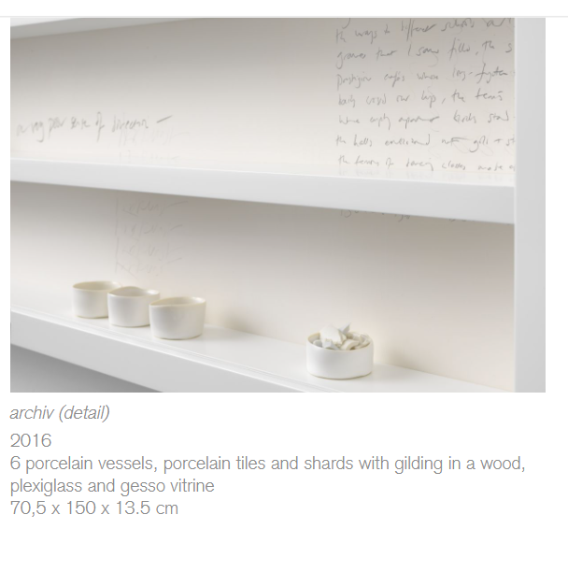
In his 2018 Exhibition “White Island” situated on the Island of Ibiza where Walter Benjamin fled (1932 –33) from Nazi Germany. De Waal explores the pull and push between the object and its shadow linking the brightness of the Mediterranean island to the darkening political reality Benjamin was escaping. The exhibition features porcelain vessels enclosed within vitrines (glass cases) paired with gold and white materials, the installation acts as a poetic reflection on the theme of solitude incorporating fragments of poetry, including works by the Russian poet Osip Mandelstam, emphasising the intense heat and light of the Mediterranean contrasting with the tragedy of loss . The work represents a continuation of De Waal’s focus on porcelain, the “white clay” and the play of shadows.
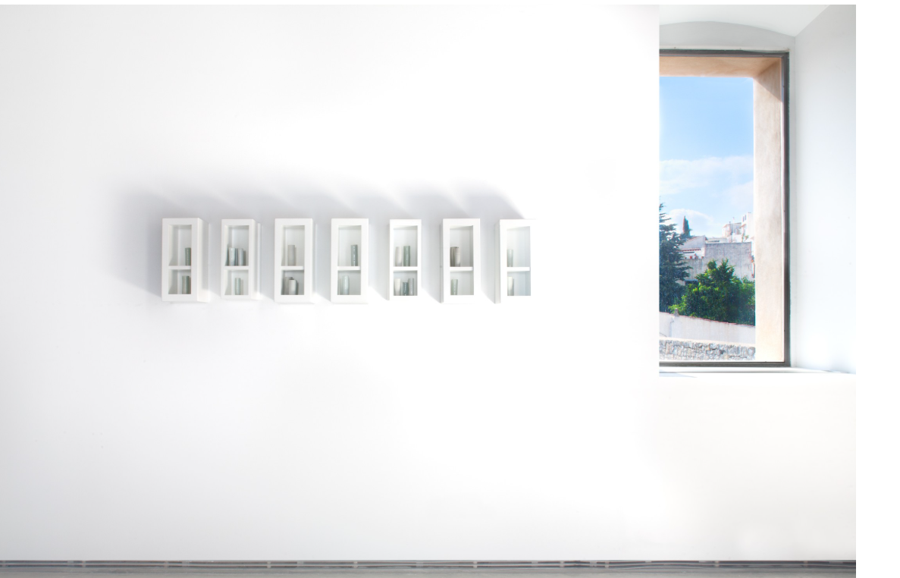
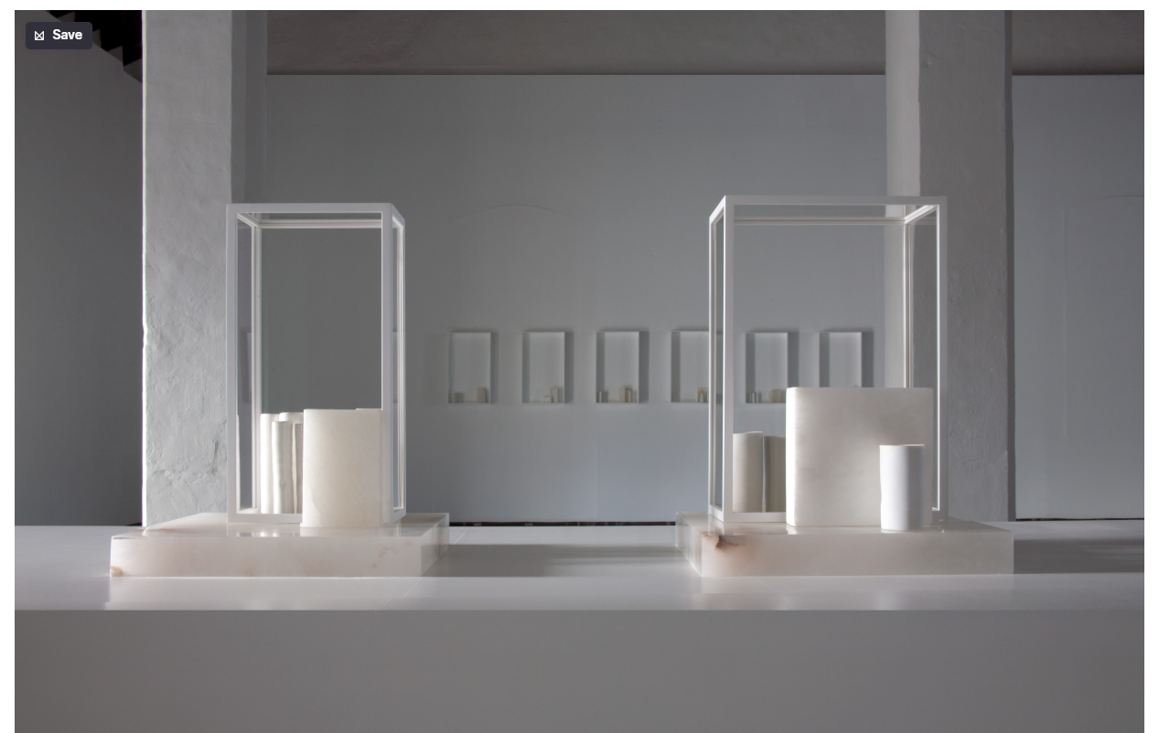
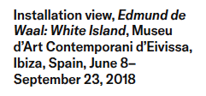
The Library of Exile was originally unveiled in 2019 at the Venice Biennale, the project was to celebrate the resilience of writers that have experienced displacement and to explore the idea of language as a form of migration. It was a large-scale monument consisting of porcelain panel’s inscribed with the names of lost libraries of the world from ancient Nineveh and Alexandria to more recently destroyed in Aleppo and Mosul. Inside the pavilion are four large scale vitrines titled Psalm I – IV containing porcelain vessels, marble and steel. The arrangement was inspired by the composition of the Talmud where text, translation and commentary share a single page. Visitors were encouraged to sit and read and leave personal reflections in a book of exile or write their names on ex libris - labels inside the volumes. The library housed over 2000 books written by exiled authors from antiquity to present day, including works by Ovid, Dante, Marina Tsvetaeva and Judith Kerr. Almost all books are translations highlighting how ideas move across borders. The library functioned as a traveling pavilion before reaching it’s permanent home. It started in Ateneo Veneto in Venice (2019) as part of the Psalm project during the Biennale. It then moved to Japanisches Palais Dresden (2019 – 2020) and displayed alongside the Dresden porcelain collection. The final location was the British Museum in London (2020 – 2021). When the exhibition came to an end the physical porcelain panels were gifted to the Warburg Institute in London and incorporated into its permanent structure. The 2000 books were donated to the University of Mosul Library in Iraq to help rebuild its collection after it was destroyed by ISIS
De Waal on discussing his praxis, he does not think about other people when he is making his objects. It is just him and the thing he is making; he focuses on tuning in to something that he finds engaging or complicated. There is a myriad of reasons for making things, their afterlife, the idea of how other people will perceive the object is of no consequence at the moment of his making it. It is only after; he considers all the complexities of being a maker involves. Heidegger argues that we aren’t isolated minds looking at a separate world of objects but we are “Dasein”- being-in-the-world already “thrown” into a world of tasks, tools and social meanings. You don’t “encounter” clay as a scientific substance but as a substance to create meaning with. Your “being” is inextricably linked to the context of the studio. Heidegger explains that no tool exists in isolation in the hammer theory discussed in Being and Time (1927) he explains how we experience existence by distinguishing between engaging with tools in daily life (“ready-to-hand) and observing them as separate objects (“present-to-hand). When working at the potter wheel the tools seamlessly serve a purpose and are barely noticed, they become invisible, the focus is on the work and not the tool (ready-to-hand). When it fails, is broken or missing, it stands out, an object to be scrutinised, analysed and repaired (present-at-hand). There is a shift from the practical engagement to the theoretical, scientific or mechanical observation. Heidegger argued that conventional philosophy focuses on the “present-at-hand" viewing the world as a collection of objects to be understood. When working in our primary authentic mode of being it is the “ready-at-hand" and working through practical involvement that is our authentic mode of being.
The elements De Waal likes about making and writing is that he can reference a title or submerge quotations in what he makes. It is his way of tipping his hat to someone, a moment, a book or a phrase of music. It is his way of saying it matters to him, a form of internalised confession.
During the silence and solitude of lockdown De Waal was inspired by two Song dynasty bowls he had in his studio, one was patched with iron and the other repaired with gold using the Japanese art of Kintsugi. He felt he needed to return to what he knew, the bowl, the open dish, the lidded jar. He designed the vessels to be touched and held, responding to the lack of physical interaction during the pandemic. The exhibition “Some Winter Pots” features a variety of wheel-thrown forms that are broken and patched on the rims with folded lead and gold, some are mended with gold lacquer, some hold shards of porcelain. The collection features black vessels that show the "flux of glaze” and white dishes fired without glaze to preserve every fingerprint and mark. Rather than hiding imperfections De Waal highlight cracks and breaks, viewing them as a way to mark loss rather than erase it.
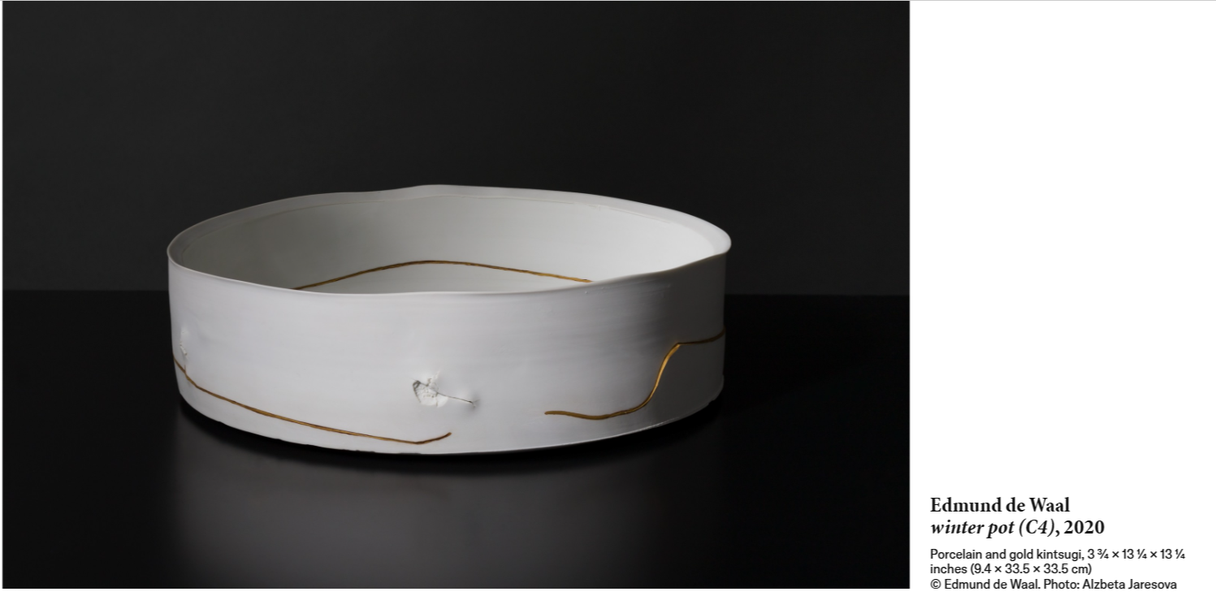
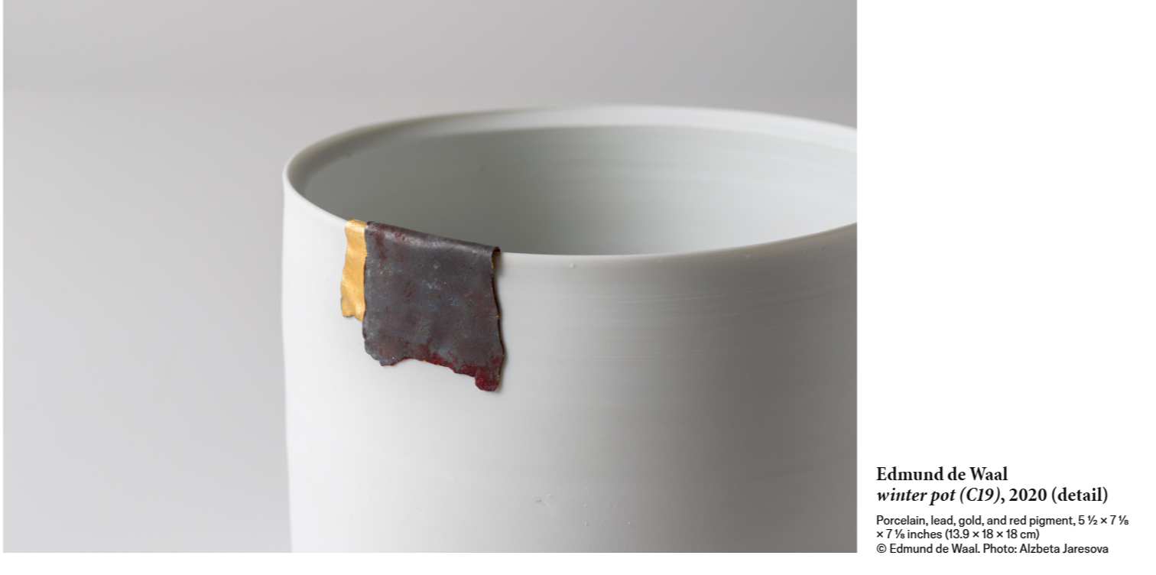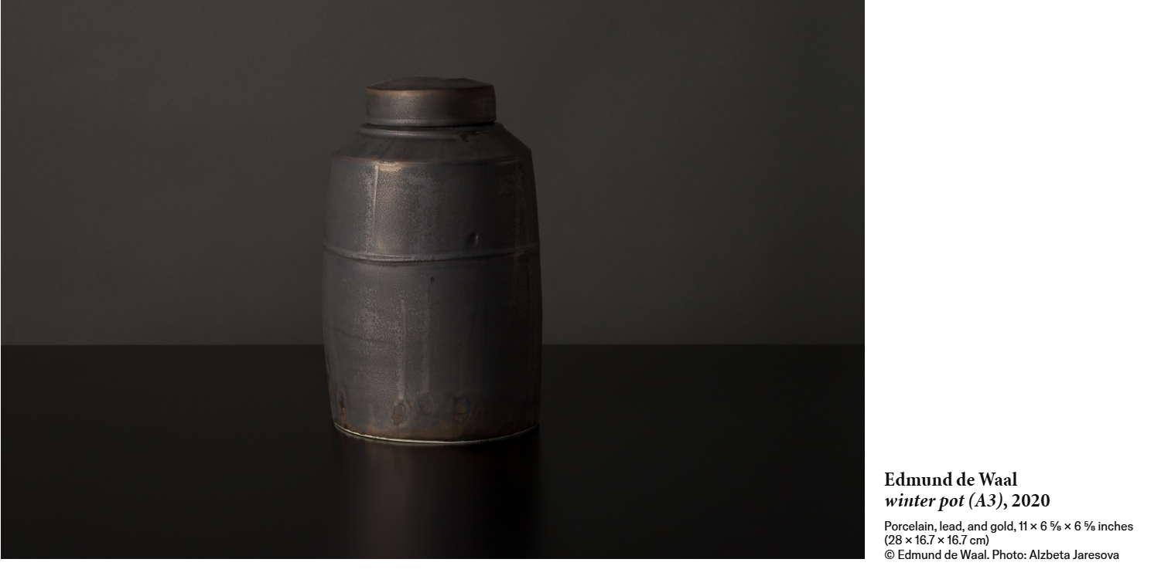
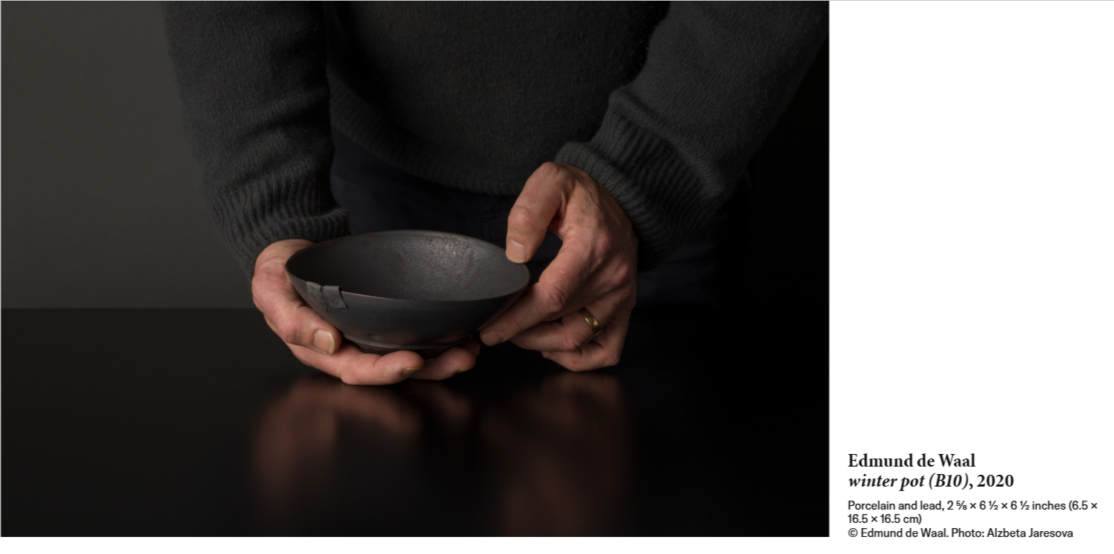
Conclusion (500 words)
De Waal lives and works in London, operating a studio focused on bridging the gap between functional pottery and artistic installation. His studio is purposefully divided into a "clay end" and a "word end," reflecting the interdependence of his making and writing practices. He approaches authorship as an extension of his ceramic art, focusing on the materiality of text, memory, and the "poetry of objects" his work aims to find a space of safety for objects to be held, acting as "fragments shored against the ruins" of history. De Waal frequently addresses the themes of loss, the survival of objects, and the relationship between literature and craft.
While De Waal does not explicitly present himself as a Heideggerian philosopher, his artistic practice and writing often intersect with these existential and phenomenological themes. His work is not just about the object itself, but about the experience of looking at, touching and being with the object in a particular place.
His artistic and literary work is deeply informed by the theories of cultural critic Walter Benjamin, particularly regarding memory, collecting and the “aura” of objects. Both thinkers focus on the “messiness” of human relationships, the fallibility of archives and the ways objects move between owners to create new meanings.
De Waal often quotes Benjamin on the “transmissibility” of collections, viewing objects as witnesses to history, inheritance and displacement. De Waal concludes that the task is to honour the “objectness” and history of things, while accepting that the narrative of these objects is always in flux, carrying both profound loss and the potential for new meaning.

Reference List
E. de Waal, (2025). An Archive. Ivorypress
E. de Waal, (2011) The Hare with Amber Eyes. Chatto & Windus
E. de Waal, ‘Irrkunst’, in Edmund de Waal: Irrkunst, exh. cat., Berlin: Galerie Max Hetzler / Holzwarth Publications, 2016, p. 5
T Greenfield (2002) Research Methods for Postgraduates. Arnold
H Collins. (2010) Creative Research - The Theory and Practice of Research for the Creative Industries. AVA Publishing
Heidegger, M., “The Thing” in Martin Heidegger, Poetry, Language, Thought (ed. Hofstaedter). New York, Harper and Row, 1975
https://www.google.com/search?q=heidigger+phenomenological+exploration+of+the+jug&rlz=1C1VDKB_en-GBGB1178GB1179&oq=heidigger+phenomenological+exploration+of+the+jug&gs_lcrp=EgZjaHJvbWUyBggAEEUYOTIJCAEQIRgKGKABMgcIAhAhGI8C0gEKMjYzODNqMGoxNagCCLACAfEF6nrRP4CU0Fw&sourceid=chrome&ie=UTF-8#fpstate=ive&vld=cid:5d322de6,vid:BuV8rbS4UsI,st:0
https://www.lrb.co.uk/podcasts-and-videos/podcasts/close-readings/conversations-in-philosophy-the-thing-by-martin-heidegger
https://www.edmunddewaal.com/writing/books/the-hare-with-amber-eyes/about
https://www.beyng.com/pages/en/BremenLectures/TheThing.html
https://www.lrb.co.uk/podcasts-and-videos/podcasts/close-readings/conversations-in-philosophy-the-thing-by-martin-heidegger

https://www.beyng.com/pages/en/BremenLectures/TheThing.html (The Thing [11–12])
https://www.ashmolean.org/netsuke
https://www.christies.com/en/stories/netsuke-collecting-guide-5-things-to-know-f79af69a9883460d8d1caacbc4b06714
https://www.britishmuseum.org/exhibitions/edmund-de-waal-library-exile#:~:text=Created%20as%20a%20'space%20to,commentary%20on%20a%20single%20page.
https://warburg.sas.ac.uk/news-events/news/warburg-institute-receive-major-gift-edmund-de-waal#:~:text=In%20addition%20to%20his%20gift,March%202020%20%E2%80%93%20January%202021).
https://gagosian.com/quarterly/2018/06/08/edmund-de-waal-white-island/
https://gagosian.com/exhibitions/2020/edmund-de-waal-some-winter-pots/
https://oro.open.ac.uk/26421/1/harmanHE_review.pdf

