LCHS4007
Digital Skills and Research Methods
Title - Improving Staff Communication at Riverdale Nursing Home Using Microsoft PowerPoint
Tutor name: Kwame Assa-Agyei
Student name: Cathy salumu
ID Number: 2441715
Table of Contents
Introduction 3
What the Task Involves 4
Why PowerPoint Is Suitable (Microsoft 365 tool) 4
How It Improves Efficiency and Communication 5
Advantages and Limitations 6
Conclusion 8
References 9

Introduction
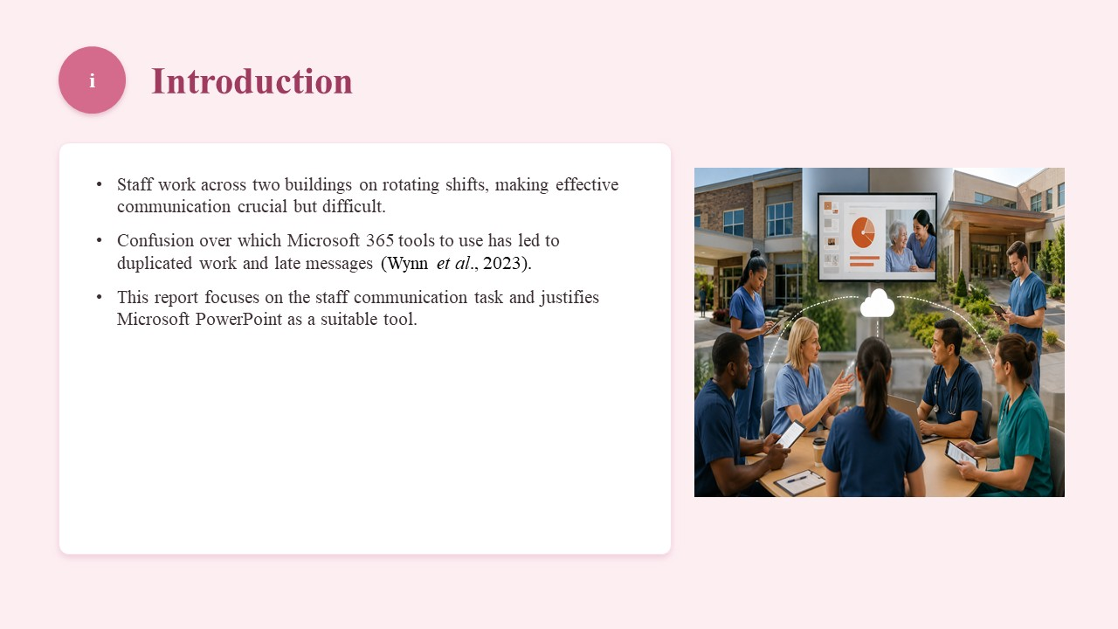
The employees at Riverdale Nursing Home operate in two buildings on rotating shifts, which complicates effective communication, although it is crucial. The lack of clarity on which Microsoft 365 tools to use has resulted in duplicating work and sending messages late (Wynn et al., 2023). The present report dwells on the workplace task of staff communication and justifies why Microsoft PowerPoint is an appropriate tool.

What the Task Involves
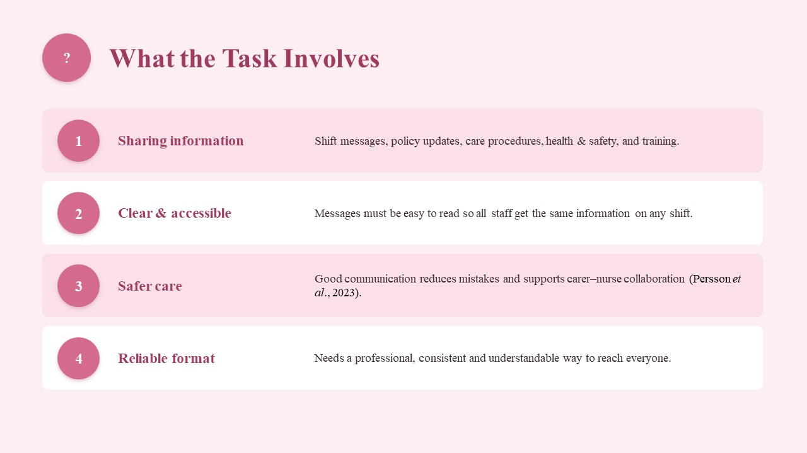
Staff communication consists of sharing significant information like shift messages, policy messages, care procedures, health and safety messages and training. The messages should also be easy to understand and read since the staff do not work all the time and at the same building, meaning that all the staff should get the same information irrespective of what shift they are on (Persson et al., 2023). Communication also helps to reduce mistakes during care delivery, collaboration between carers and nurses and administrative reports to the relevant people. The work then requires a reliable way of presenting information in a professional, consistent and understandable way to all the employees.

Why PowerPoint Is Suitable (Microsoft 365 tool)
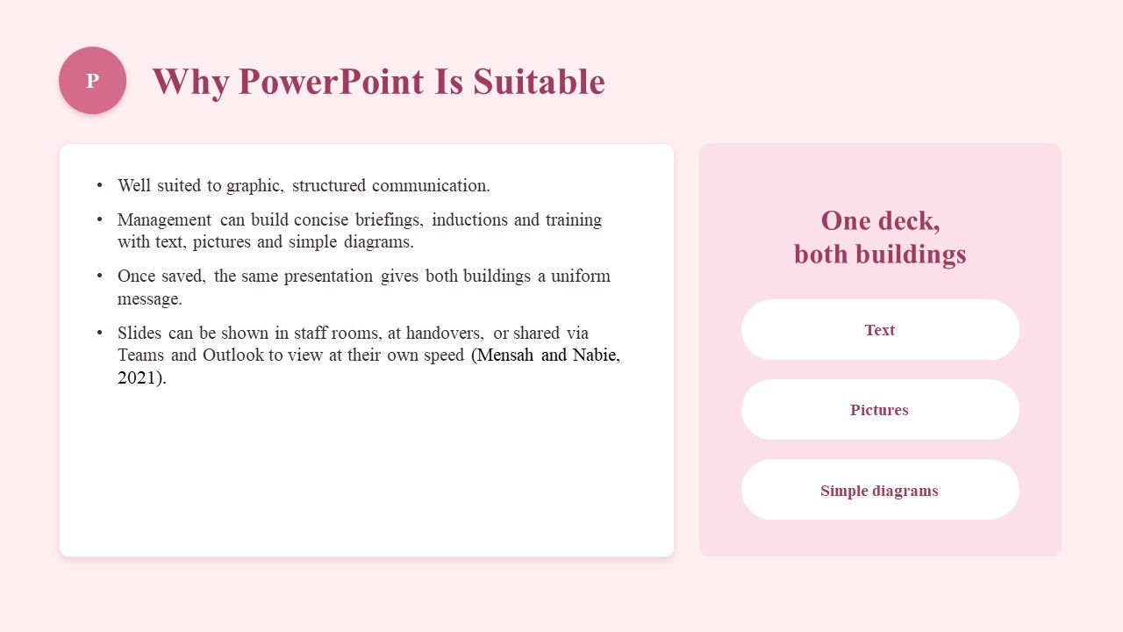
PowerPoint would be very suitable for communication that will be graphic and structured. The management can prepare an effective and concise briefing in the form of a slide presentation, induction and training presentation, which can be inclusive of text, pictures and simple diagrams (Mensah and Nabie, 2021). After saving, a presentation may be implemented in both buildings, whereby the team members would have the same uniform message. To project the slides in the staff rooms, during handover meetings or even in Microsoft Teams and Outlook so that the staff can view at their own speed.

How It Improves Efficiency and Communication
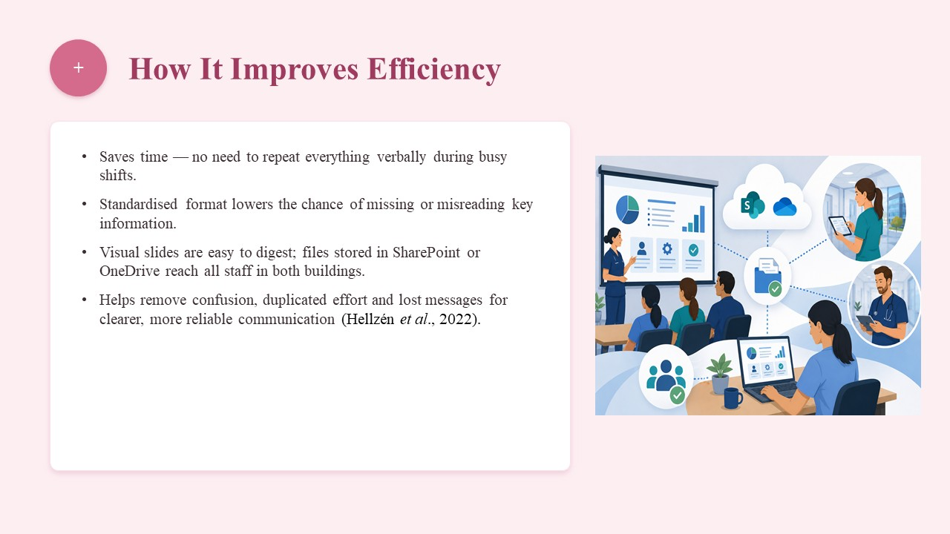
PowerPoint will also save time since one will not have to go through all the things verbally when there is a busy shift on. Information is presented in a standardised format, thereby minimising the likelihood of overlooking important information or misinterpreting information (Hellzén et al., 2022). Information can be easily digested by the staff in visual slides, and files can be stored in SharePoint or OneDrive, which means that the information will be accessible to all staff members of both buildings. This may assist in removing confusion, duplication of effort and lost messages that the management would prefer to avoid and instead have more concise and reliable communication throughout the entire organisation.

Advantages and Limitations
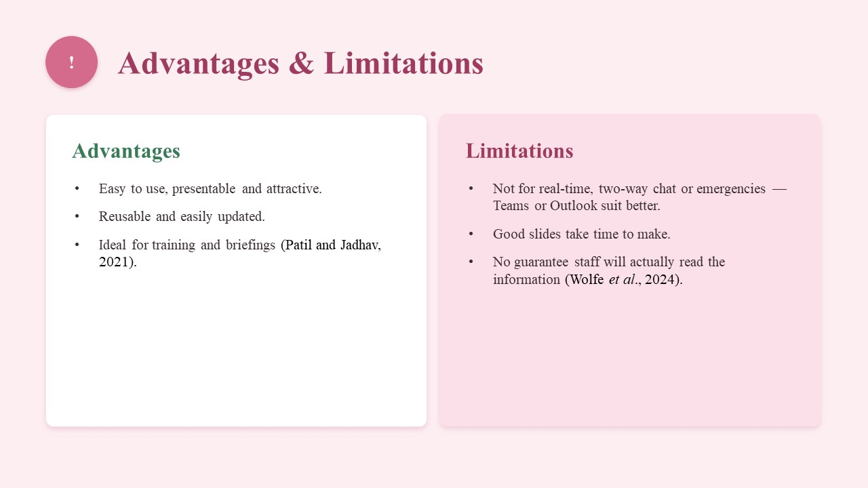
Advantages: PPT is easy to use, presentable and attractive. The presentation is reusable, can be easily updated and should be used in training and briefings (Patil and Jadhav, 2021).
Limitations: It is incapable of applying to real-time, two-way chat or emergencies, and in those instances Teams or Outlook will be more suitable. Better slides are made over time, and being in possession of PowerPoint does not guarantee that the personnel will read the information or not (Wolfe et al., 2024).

Conclusion
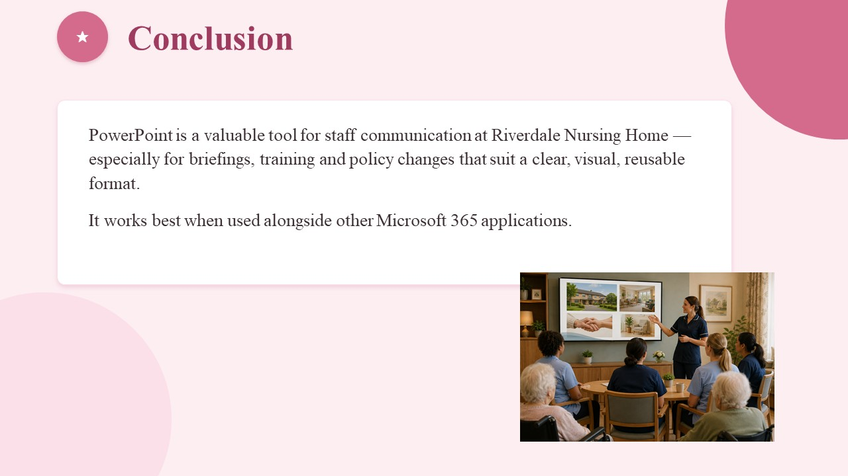
Microsoft PowerPoint would come in handy in staff communication in the Riverdale Nursing Homes, particularly for briefings, training and policy changes that would be more appropriately presented in a clear and visual, reusable format. Even though it is best utilised in conjunction with other applications.

References
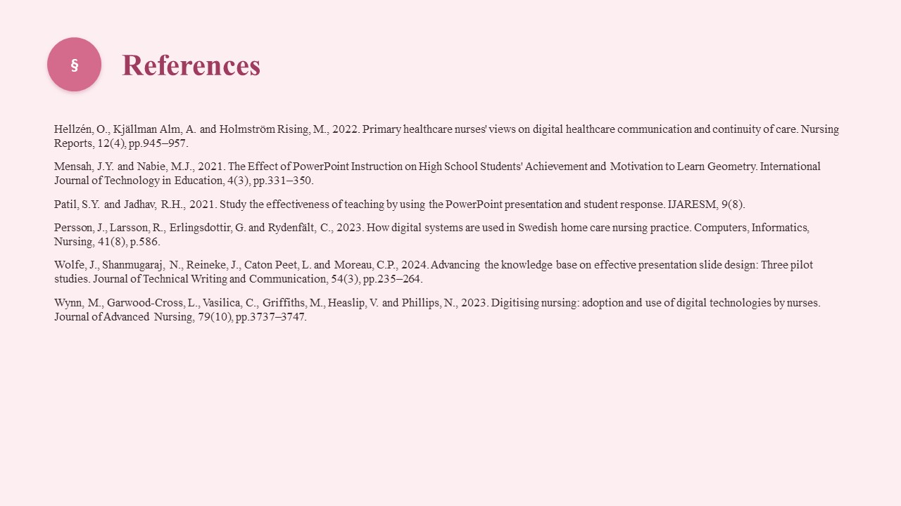
Hellzén, O., Kjällman Alm, A. and Holmström Rising, M., 2022. Primary healthcare nurses’ views on digital healthcare communication and continuity of care: a deductive and inductive content analysis. Nursing Reports, 12(4), pp.945-957. https://www.mdpi.com/2039-4403/12/4/91
Mensah, J.Y. and Nabie, M.J., 2021. The Effect of PowerPoint Instruction on High School Students' Achievement and Motivation to Learn Geometry. International Journal of Technology in Education, 4(3), pp.331-350. https://eric.ed.gov/?id=EJ1311518
Patil, S.Y. and Jadhav, R.H., 2021. Study the effectiveness of teaching by using the PowerPoint presentation and student response. International Journal of All Research Education and Scientific Methods (IJARESM), 9(8). https://www.researchgate.net/profile/Ramkishan-Jadhav/publication/353945823_Study_the_effectiveness_of_teaching_by_using_the_PowerPoint_presentation_and_student_response/links/611b69ef169a1a010307e3c2/Study-the-effectiveness-of-teaching-by-using-the-PowerPoint-presentation-and-student-response.pdf
Persson, J., Larsson, R., Erlingsdottir, G. and Rydenfält, C., 2023. How digital systems are used in Swedish home care nursing practice: a qualitative interview study to identify challenges and opportunities. Computers, Informatics, Nursing, 41(8), p.586. https://pmc.ncbi.nlm.nih.gov/articles/PMC10437456/
Wolfe, J., Shanmugaraj, N., Reineke, J., Caton Peet, L. and Moreau, C.P., 2024. Advancing the knowledge base on effective presentation slide design: Three pilot studies. Journal of Technical Writing and Communication, 54(3), pp.235-264. DOI: abs/10.1177/00472816231169433
Wynn, M., Garwood‐Cross, L., Vasilica, C., Griffiths, M., Heaslip, V. and Phillips, N., 2023. Digitising nursing: A theoretical and holistic exploration to understand the adoption and use of digital technologies by nurses. Journal of Advanced Nursing, 79(10), pp.3737-3747. DOI: abs/10.1111/jan.15810

