DATA HANDLING & BUSINESS INTELLIGENCE
STUDENT NAME : Anton Rumenov Mihaylov
STUDENT ID: 2030908

Table of Contents
Part 1 3
Part 2 5

Part 1
For pre-processing, analysis, and visualisation of data, Excel is a strong and flexible tool. It is a common choice for analysis of data and visualisation and is used by many companies for reporting and data analysis. Calculations, the creation of reports and graphics, and data management and manipulation are all done using it. Additionally, pivot tables and sophisticated formulas are created using it. Excel is the right tool for pre-processing information since it enables the organisation and structuring of the data in a way that makes it simple to analyse. An illustration of how Excel can be utilized for data pre-processing, analysis, and visualisation comes from the Superstore data collection. This dataset includes sales and profit information for a hypothetical retail company for the four years between 2009 and 2012. The set of data includes overall annual sales and profits as well as sales and profit breakdowns for each month of the year.
The data collection includes sales and earnings for several goods and services across a number of years. Date, product, customer, sales, and profit are among the columns that make up the table-format data set. This data collection may be employed to pre-process and analyse revenues and earnings over time to learn more about how a specific company or market is performing. Preparing the Department stores data set for analysis is the initial phase in pre-processing it. This entails eliminating any superfluous or redundant data, classifying the data into appropriate groups, and generating any required statistical results. By categorising the data in Excel and utilising the IF function to determine the sums for each category, this can be accomplished quickly. As a result, the data will be presented in an ordered manner, making it simpler to see trends and patterns.
After pre-processing and organising the data, it is time to conduct an analysis. There are several tools available in Excel for data analysis. The PivotTable function, has the ability to quickly provide data summaries, including the total earnings and revenues for each item or client. This might help you spot significant patterns and trends in your data. Additionally, Excel offers graphing and charting tools that can be used to visualise data and make it simpler to spot significant trends and patterns. To help convey the findings of the investigation, reports and presentations may be made using Excel. Visually attractive presentations and briefings that may be used to share the analysis' findings with others can be made using Excel's charts and graphs. Additionally, Excel has functions and formulae that can be utilised to build more intricate reports and presentations.
Using Excel tools like classifying, filtration, and data validation, the training dataset can be pre-processed. This makes it possible to organise the information in a manner that facilitates analysis. Additionally, pivot tables can be used to aggregate and summarise the data, which can be utilised to spot trends and patterns. After pre-processing, Excel can be used to analyse the data. Excel offers a variety of tools for data analysis, including graphs and charts which is used to represent the information. Additionally, you can identify trends and trends in the data by using Excel's built-in features, like bar charts and statistical tools.

Figure 1: Sales of Supermarket on Yearly basis
(Source: Created by Author)
The Superstore data set provided includes the sales figures for each year from 2009 to 2012. From this data it is possible to calculate the decline in sales or profits over the years. In 2009, the total sales figure was 8745982.663. In 2010, the total sales figure was 8754382.873. This shows an increase of 0.98%, or 87900, in sales. In 2011, the total sales figure was 8767765.497. This shows an increase of 0.15%, or 123873, in sales. Finally, in 2012, the total sales figure was 8767765.497. This shows no change in sales from the previous year. Overall, this data shows a slight increase in sales from 2009 to 2010, followed by a slight increase from 2010 to 2011, and then no change from 2011 to 2012. This indicates that there has been an incline in sales or profits over the years, as sales have remained relatively flat since 2011. When looking at the year-to-year variance in sales, there appears to be a slight decline in sales from 2009-2010, with a slight increase in sales from 2010-2011, followed by a decrease in sales from 2011-2012. The overall decline in sales for this four-year period is approximately 0.25%. When examining the sales growth rate for this four-year period, the average rate of growth is just 0.06%. This indicates that the sales growth rate has been relatively flat over this period. In conclusion, the Superstore data set shows a decline in sales over the four-year period from 2009-2012. The average rate of growth has been small, indicating that there has not been significant growth in sales over this period.

Figure 2: Day wise sales of Supermarket Store
(Source: Created by Author)
Excel is employed to analyse the calendar reduction in sales and profits. The data may be grouped by month and the year, and the percentage reduction in profits and sales for each year can be determined by establishing a pivot table. According to this data, the fall in sales and earnings was not constant over the course of the four years, with some months seeing a more noticeable decline than others. The decrease in revenue and profits throughout the four-year period can be seen in Excel. It is easy to determine whether there was a reduction in sales and earnings over the course of the four years by constructing a chart. Additionally, grouping the information by day and year and visualising the drop in sales and earnings on a period basis are both achievable with a pivot table.

Part 2
Gender
 |  | Frequency | Percent | Valid Percent | Cumulative Percent
Valid | Male | 91 | 45.5 | 45.5 | 45.5
Valid | Female | 109 | 54.5 | 54.5 | 100.0
Valid | Total | 200 | 100.0 | 100.0

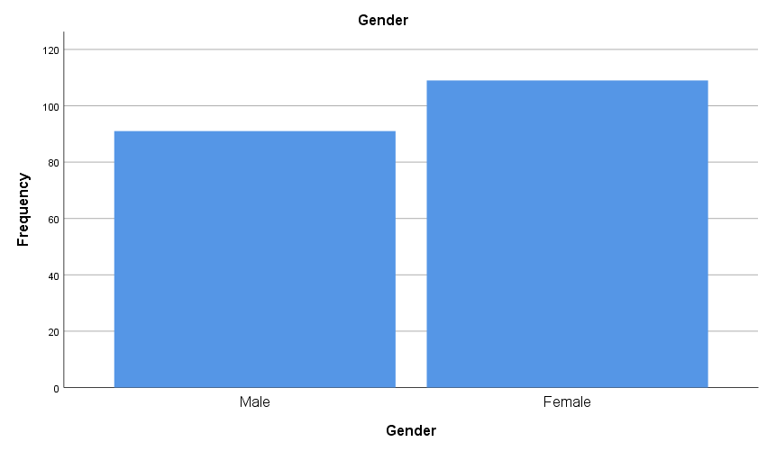

Icecream
 |  | Frequency | Percent | Valid Percent | Cumulative Percent
Valid | Vanilla | 95 | 47.5 | 47.5 | 47.5
Valid | Chocolate | 47 | 23.5 | 23.5 | 71.0
Valid | Strawberry | 58 | 29.0 | 29.0 | 100.0
Valid | Total | 200 | 100.0 | 100.0

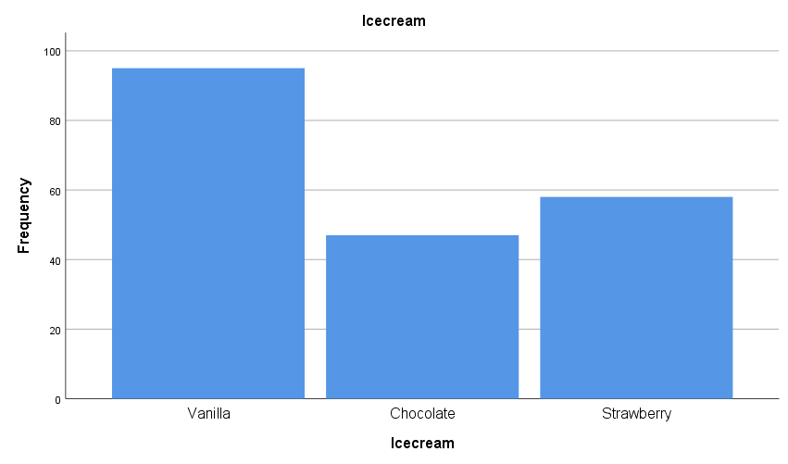
2.4
Cluster Membership
Case Number | ID | Cluster | Distance
1 | 70 | 1 | .000
2 | 121 | 2 | .000
3 | 86 | 3 | .000
4 | 141 | 3 | .000
5 | 172 | 2 | .000
6 | 113 | 2 | .000
7 | 50 | 2 | .000
8 | 11 | 2 | .000
9 | 84 | 2 | .000
10 | 48 | 2 | .000
11 | 75 | 2 | .000
12 | 60 | 2 | .000
13 | 95 | 3 | .000
14 | 104 | 3 | .000
15 | 38 | 1 | .000
16 | 115 | 1 | .000
17 | 76 | 3 | .000
18 | 195 | 2 | .000
19 | 114 | 3 | .000
20 | 85 | 2 | .000
21 | 167 | 2 | .000
22 | 143 | 2 | .000
23 | 41 | 2 | .000
24 | 20 | 3 | .000
25 | 12 | 2 | .000
26 | 53 | 2 | .000
27 | 154 | 3 | .000
28 | 178 | 2 | .000
29 | 196 | 3 | .000
30 | 29 | 1 | .000
31 | 126 | 2 | .000
32 | 103 | 3 | .000
33 | 192 | 3 | .000
34 | 150 | 2 | .000
35 | 199 | 3 | .000
36 | 144 | 3 | .000
37 | 200 | 2 | .000
38 | 80 | 3 | .000
39 | 16 | 1 | .000
40 | 153 | 2 | .000
41 | 176 | 2 | .000
42 | 177 | 2 | .000
43 | 168 | 2 | .000
44 | 40 | 1 | .000
45 | 62 | 3 | .000
46 | 169 | 1 | .000
47 | 49 | 3 | .000
48 | 136 | 2 | .000
49 | 189 | 2 | .000
50 | 7 | 2 | .000
51 | 27 | 2 | .000
52 | 128 | 3 | .000
53 | 21 | 2 | .000
54 | 183 | 2 | .000
55 | 132 | 2 | .000
56 | 15 | 3 | .000
57 | 67 | 1 | .000
58 | 22 | 2 | .000
59 | 185 | 2 | .000
60 | 9 | 2 | .000
61 | 181 | 2 | .000
62 | 170 | 3 | .000
63 | 134 | 1 | .000
64 | 108 | 2 | .000
65 | 197 | 3 | .000
66 | 140 | 2 | .000
67 | 171 | 2 | .000
68 | 107 | 1 | .000
69 | 81 | 1 | .000
70 | 18 | 2 | .000
71 | 155 | 2 | .000
72 | 97 | 3 | .000
73 | 68 | 2 | .000
74 | 157 | 2 | .000
75 | 56 | 2 | .000
76 | 5 | 1 | .000
77 | 159 | 3 | .000
78 | 123 | 3 | .000
79 | 164 | 2 | .000
80 | 14 | 3 | .000
81 | 127 | 3 | .000
82 | 165 | 1 | .000
83 | 174 | 2 | .000
84 | 3 | 1 | .000
85 | 58 | 2 | .000
86 | 146 | 3 | .000
87 | 102 | 3 | .000
88 | 117 | 3 | .000
89 | 133 | 2 | .000
90 | 94 | 3 | .000
91 | 24 | 2 | .000
92 | 149 | 1 | .000
93 | 82 | 3 | .000
94 | 8 | 1 | .000
95 | 129 | 1 | .000
96 | 173 | 1 | .000
97 | 57 | 2 | .000
98 | 100 | 3 | .000
99 | 1 | 1 | .000
100 | 194 | 3 | .000
101 | 88 | 3 | .000
102 | 99 | 3 | .000
103 | 47 | 1 | .000
104 | 120 | 3 | .000
105 | 166 | 2 | .000
106 | 65 | 2 | .000
107 | 101 | 3 | .000
108 | 89 | 1 | .000
109 | 54 | 1 | .000
110 | 180 | 3 | .000
111 | 162 | 2 | .000
112 | 4 | 1 | .000
113 | 131 | 3 | .000
114 | 125 | 1 | .000
115 | 34 | 3 | .000
116 | 106 | 2 | .000
117 | 130 | 3 | .000
118 | 93 | 3 | .000
119 | 163 | 1 | .000
120 | 37 | 1 | .000
121 | 35 | 1 | .000
122 | 87 | 2 | .000
123 | 73 | 2 | .000
124 | 151 | 2 | .000
125 | 44 | 1 | .000
126 | 152 | 3 | .000
127 | 105 | 2 | .000
128 | 28 | 2 | .000
129 | 91 | 3 | .000
130 | 45 | 1 | .000
131 | 116 | 2 | .000
132 | 33 | 1 | .000
133 | 66 | 2 | .000
134 | 72 | 2 | .000
135 | 77 | 1 | .000
136 | 61 | 3 | .000
137 | 190 | 2 | .000
138 | 42 | 2 | .000
139 | 2 | 2 | .000
140 | 55 | 2 | .000
141 | 19 | 1 | .000
142 | 90 | 3 | .000
143 | 142 | 2 | .000
144 | 17 | 2 | .000
145 | 122 | 2 | .000
146 | 191 | 3 | .000
147 | 83 | 2 | .000
148 | 182 | 2 | .000
149 | 6 | 1 | .000
150 | 46 | 1 | .000
151 | 43 | 1 | .000
152 | 96 | 3 | .000
153 | 138 | 2 | .000
154 | 10 | 2 | .000
155 | 71 | 2 | .000
156 | 139 | 2 | .000
157 | 110 | 2 | .000
158 | 148 | 2 | .000
159 | 109 | 2 | .000
160 | 39 | 3 | .000
161 | 147 | 1 | .000
162 | 74 | 2 | .000
163 | 198 | 3 | .000
164 | 161 | 1 | .000
165 | 112 | 2 | .000
166 | 69 | 1 | .000
167 | 156 | 2 | .000
168 | 111 | 1 | .000
169 | 186 | 2 | .000
170 | 98 | 1 | .000
171 | 119 | 1 | .000
172 | 13 | 2 | .000
173 | 51 | 3 | .000
174 | 26 | 3 | .000
175 | 36 | 1 | .000
176 | 135 | 1 | .000
177 | 59 | 2 | .000
178 | 78 | 2 | .000
179 | 64 | 3 | .000
180 | 63 | 1 | .000
181 | 79 | 2 | .000
182 | 193 | 2 | .000
183 | 92 | 3 | .000
184 | 160 | 2 | .000
185 | 32 | 3 | .000
186 | 23 | 1 | .000
187 | 158 | 2 | .000
188 | 25 | 2 | .000
189 | 188 | 3 | .000
190 | 52 | 1 | .000
191 | 124 | 1 | .000
192 | 175 | 3 | .000
193 | 184 | 2 | .000
194 | 30 | 3 | .000
195 | 179 | 2 | .000
196 | 31 | 2 | .000
197 | 145 | 2 | .000
198 | 187 | 2 | .000
199 | 118 | 2 | .000
200 | 137 | 3 | .000

2.5
Data Mining: In order to find patterns and relationships that are not immediately obvious, data mining is the process of obtaining, cleaning, converting, and analysing data from organised and unstructured sources. To extract pertinent patterns, topics, and words from big datasets, it makes use of cutting-edge machine learning and algorithms approaches. Mining techniques may be employed to find new opportunities, examine client behaviour, and make smarter decisions by revealing hidden links between data elements. Data mining is used by healthcare organisations to find fraud in complaints and other health records. Data mining is another tool used by banks and other financial institutions to stop money laundering and credit card fraud.
Text Mining: The practise of extracting useful data from text sources, such as websites, emails, papers, articles, and other sources available, is known as text mining. It extracts important phrases, themes, and attitudes from the text using the natural language processing approaches. Text analytics can be employed to identify trends, comprehend client opinions and input, and find new opportunities. Social media businesses utilise text mining to look for certain subjects in user posts. They are able to recognise trends, learn about customer opinions, and comprehend attitudes regarding goods and services thanks to this. Semantic search is another way that text mining is used to assist consumers find more pertinent information from a set of texts.
2.6
Advantages of Using SPSS | Disadvantages of Using SPSS
Simple to Use: SPSS is intuitive and simple to learn. It is simpler to comprehend and operate because of its very straightforward graphical user interface (GUI). Additionally, it contains a help menu that offers beneficial instructions on how to utilise the application.  SPSS includes a wide range of quantitative analysis techniques. Comprehensive Statistical Analysis Abilities It is applicable to many different statistical analysis methods, including ANOVA, regression analysis, correlation analysis, and descriptive statistics. It is therefore perfect for scientists that need to study their data.  Flexible Output Choices: SPSS offers a number of export options that let users export their findings to a variety of file types, including Microsoft, CSV, and HTML. It is simple to visualise and analyse the outcomes as a result.  The ability to create high-quality visualizations and charts is made possible by SPSS's superior graphical capabilities. As a result, it is simpler to interpret the findings and communicate them to others. | Cost: SPSS can be rather pricey and is not available for free. Additionally, a unique licence is needed for every machine. For tiny enterprises or lone researchers, this makes it expensive.  SPSS does not have extensive programming capabilities. It is not appropriate for complex programming jobs, despite having some basic programming capabilities.  Limited Machine Learning Features and functionality: SPSS is not suited for tasks requiring machine learning. The machine learning capabilities are not as advanced as those of other programmes like Python or R.  Limited Data Storage: SPSS has a limit on the volume of data it can save, despite the fact that it can do so. For academics who need to keep a lot of data, this could be an issue.

Advantages of Using Excel | Disadvantages of Using Excel
Excel is simple to use, and even those with little prior knowledge may pick it up fast. This makes it an excellent tool for both individuals and businesses.  Versatility: When it came to organising and analysing data, Excel provides a high level of flexibility. It enables users to design charts, unique algorithms, and even macros that may automate specific operations.  Excel offers strong visualisation capabilities, such charts and graphs, that make it simpler to understand data. This makes it simpler to spot trends and connections between various data sets.  Reporting: Microsoft Excel makes it simple to prepare reports or provide others access to data. Additionally, it enables customers to modify their analyses, which makes it the best option for companies who frequently need to produce reports. | Excel's complexity means that users may have to spend time and effort learning how to operate it efficiently. This may be particularly true when making intricate charts, macros, or algorithms.  Vulnerability: Excel might make mistakes that result in inaccurate data or calculations. When working with sensitive information or financial data, this might be very risky.  Limited Storage: Excel has a limited amount of storage, therefore the amount of data users may put in a single spreadsheet may be constrained.  Data stored in Excel may be subject to malicious attacks because the programme is not secure. In order to safeguard the confidential data saved in Excel, it is crucial to adopt the appropriate security steps.

