
report on team working & communication within the workplace
Word count: 2749 including references

June 25, 2021
uwtsd
Shah Uddin 2019661

Table of Contents
Executive Summary 2
Terms of References 2
Procedure 3
Introduction 3
Findings 4
Task 1 4
Using Teamwork Theory of Belbin to Improve Teamwork 4
Using Teamwork Theory of Tuckman to Improve Teamwork 6
Task Two 8
Theoretical Models of Communication: Importance of Two-Way Communication 8
Importance of Effective Virtual Communication & Team Work 11
Importance of Effective Communication 12
Conclusion 13
Recommendation 13
References 14
Appendices 18
Acknowledgements 18

Executive Summary
The main purpose of the report is to assess different theoretical models of communication and major theories in light of a given case scenario of the organization named ABC Technologies. The terms of reference and procedures have been followed by the introduction of the report. In the findings section, the elaboration of the teamwork theories of Belbin and Tuckman are depicted. It is then followed by different theoretical models of communication and the importance of two-way communication.

Terms of References
The report has been requested by my lecturer Melanie Squire for the assessment of the module effective team working and communication requested for 26th June 2021.

Procedure
Information has been collected from books, online sources and peer reviewed journals. The effective ways to gather information from different sources have been maintained by ensuring the authenticity and viability of the information. Information regarding the theories that have been presented in the report was collected from different sources for having a clear idea regarding its advantages and associated goals. Before finalising the information that was supposed to be included in the final report, several modifications were made of the draft.

Introduction
The report is focused on the analysis of the case study and relates different teamwork theories and communication models in relation to the case scenario. The given organisation in the case study has been suffering from several issues when they started working from home during the pandemic situation and most of the issues were associated with the lack of communication and ineffective leadership skills. The teamwork theory of Belbin husband elaborated with its importance that can be implemented in the given organisation for facilitating India communication. At the same time, the teamwork theory of Tuckman has been discussed and several aspects of the theory have been related to the given case scenario so that the existing communication problem could be mitigated. The report also focuses on different theoretical models of communication and their importance in two way communication. Communication and teamwork have also been discussed in this paper. Finally recommendations have been made regarding ensuring effective communication by implementing different theoretical models of communication.

Findings

Task 1

Using Teamwork Theory of Belbin to Improve Teamwork
Belbin and his research team conducted rigorous research to unveil the underlying reasons regarding the success of teamwork. From his research a team's success and failure is not dependent on intellect, Instead, it is dependent on behaviour. Belbin's theory is so popular and effective that more than 40% of organizations in the United Kingdom use the Belbin Team Role model (Fisher et al., 2002). From the case study, ABC Technologies, suffers from weak team interaction and operation, they might consider implementing Belbin's teamwork theory in the workplace. The primary purpose of this theory is to enhance the personal effectiveness and self-awareness of the team members while fostering positive relationships in the workplace. According to the theory of Belbin, the nine-team roles can be divided into three major categories, including thought focused team roles, people-focused team roles and action-focused team roles (Aritzeta et al., 2007). ABC Technologies lack all three aspects in their workplace.
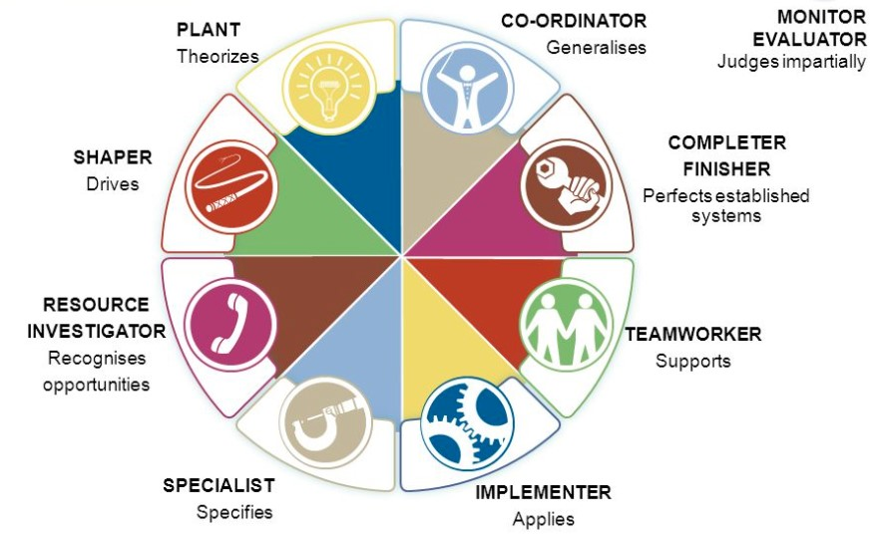
The primary purpose of this category of team role is being creative, generating ideas for solving complex issues, accessing all available options and charging correctly and finally evaluating the option having a particular skill. Plant, Monitor-Evaluator and Specialists are the three attributes of the thought focused team roles. ABC Technologies can quickly come up with ideas to ensure maximum communication and the engagement of team members by assessing a wide range of options (Fisher et al., 2000).

According to Belbin's theory, the people-focused team roles would make sure that all the employees are working together, maintaining diplomatic relationships. At the same time, they are focused on their goals (Lessem & Baruch, 2000). Different strategies suggested by the thought focused team could be used in enhancing the operation of people focused team in ABC Technologies.
Figure 1: Teamwork Theory of Belbin
Finally, the action-focused team role in Belbin's teamwork theory would encourage team members to overcome the challenges, be efficient and reliable, ensure quality work and proper operation of thought-focused teams and a people-focused team. Shaper, complete-finisher and implementer would make sure of that (Batenburg et al., 2013).

Using Teamwork Theory of Tuckman to Improve Teamwork
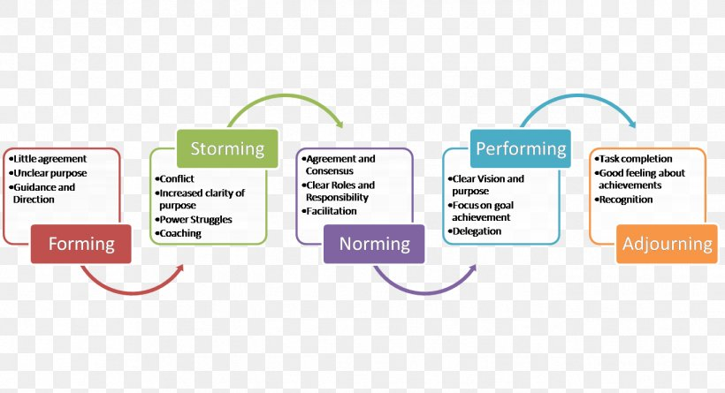
Tuckman's teamwork theory is associated with five interconnected stages, and each stage is essential for the formulation of an effective team and the team's development. Considering the case scenario of ABC Technologies, the stages of Tuckman's theory could be implemented.
Figure 2: Teamwork Theory of Tuckman

The first stage of this theory is called forming. In this stage, high dependence and faith in the leader can be seen for direction and guidance. This particular aspect is missing in ABC Technologies as they lack leadership and leadership attributes. So to resolve the issues in the team, they have to strengthen their leadership skills so that the leader can guide the team properly (Cassidy, 2007). The next aspect of Tuckman's teamwork theory is called storming. It is all about making a decision as a team after a brainstorming session and sharing personal opinions and values with the reader. This significant aspect is missing in ABC Technologies since improper communication persists among the team members. So to increase interaction as a team for making any decision, the leaders should come up with proper strategies to improve the communication skills among the team members. Most importantly, it is highly essential for ensuring positive conflict in the workplace. Positive conflict is by its very nature productive. It generates new ideas, addresses ongoing issues, allows individuals and teams to develop new abilities, and increases motivation (Tekleab et al., 2009).
The third aspect of the theory is called norming. It is all about being committed and focused on individual roles and responsibilities, which the leader facilitates. Since the leadership skills of ABC Technologies are highly lacking, this particular stage could not be obtained according to Tuckman's teamwork theory (Miller, 2008). The fourth stage is called performing. It is all about maintaining collaborative relationships among team members and achieving the target within the given timeframe while increasing strategic awareness (Bonebright, 2010).
The final stage of the theory is called adjourning, which is focused on whether the closure of any particular project is successful. But this stage can only be obtained upon the success of the usage of the previous four stages. So ABC Technologies has to ensure their maximum effort to achieve the four stages by enhancing leadership and communication skills.

Task Two

Theoretical Models of Communication: Importance of Two-Way Communication
The Shannon and Weaver Model is one of the essential theoretical communication models that focuses on human communication in several ways. According to this theory, six components are associated with human communication, and all these stages are interconnected with each other and have equal importance.
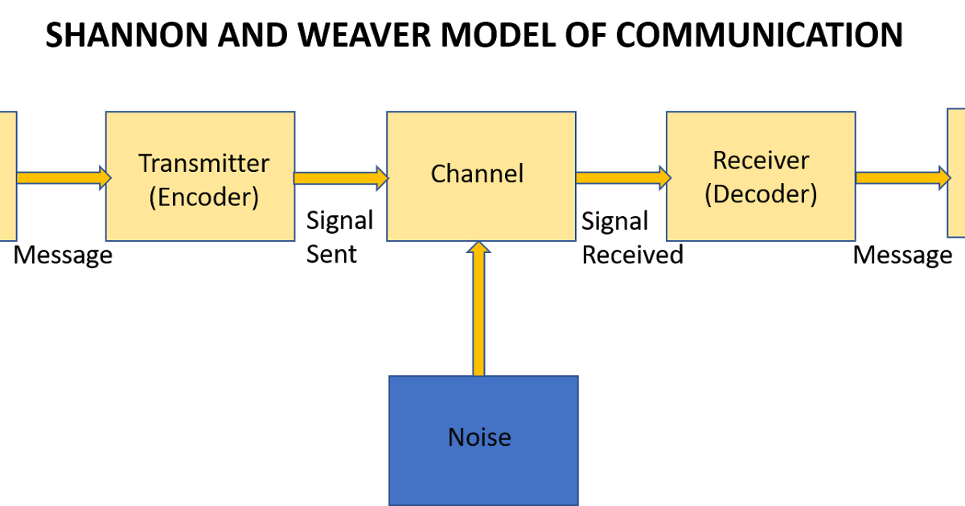
Figure 3: The Shannon and Weaver Model
Communication is a process where two parties interact with each other. One of them is called the sender, and the other one is the receiver. The Shannon weaver model of communication is designed for developing effective communication between these two parties. The model focuses on different other concepts, including transmitter, information source, noise, encode, decode, and information destination. The case scenario shows ineffective communication in ABC Technologies can be facilitated and resolved by implementing the Shannon Weaver model of communication (Al-Fedaghi, 2012). Two-way communication in workplaces ensures better relations with employees that were missing from ABC Technologies.
Another essential theoretical communication model is called Berlo's Model of Communication. This theoretical model has four major components in this theoretical communication model: source, message, channel, and receiver. The source is the first part of the communication that is delivering any particular message for opinion.
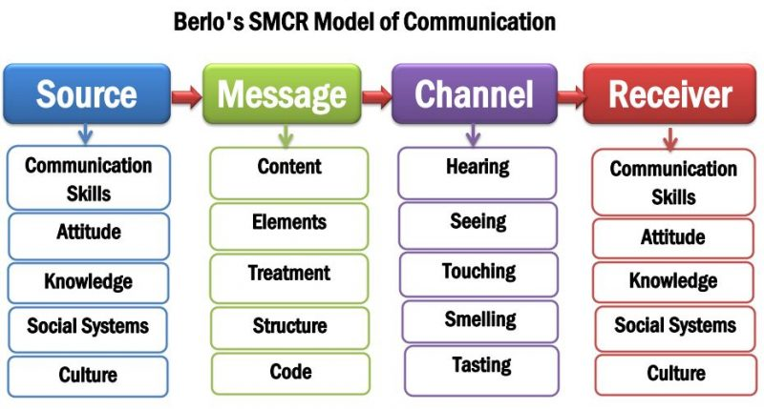
Figure 4: Berlo's Model of Communication
Several attributes are associated with the source. The source and the receiver both should have equal qualities in terms of delivering and receiving any information. After assessing the case scenario of ABC Technologies, it can be seen that all these attributes are missing among the employees regarding communication. Because of this reason, they are unable to provide suggestions regarding any particular tasks in the project, which is one of the essential aspects of two-way communication in the workplace (Saud et al., 2014).
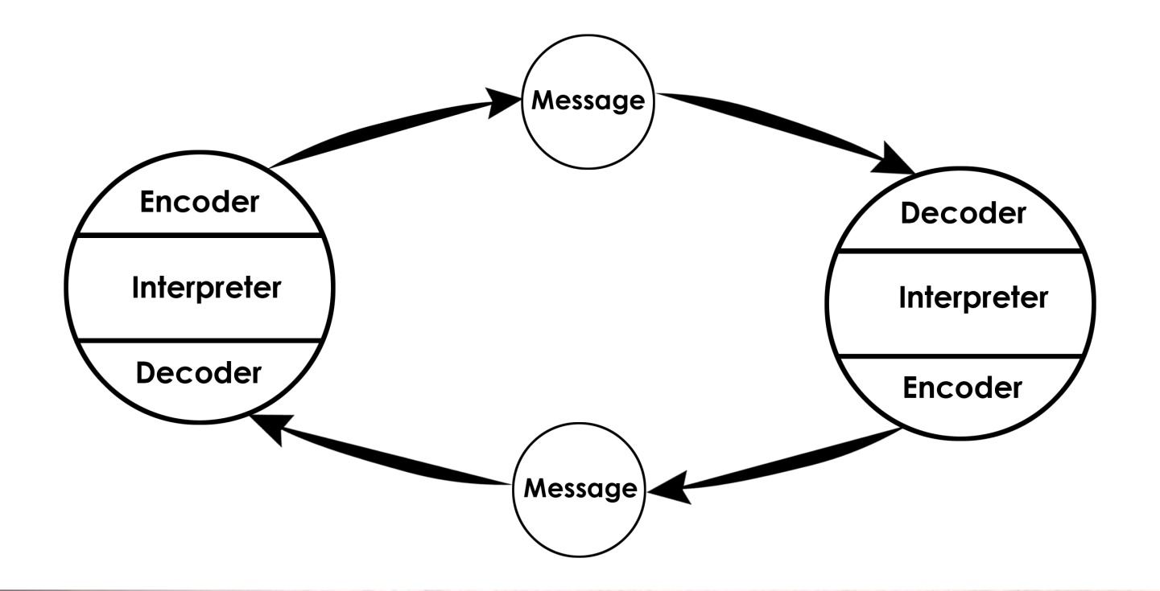
Figure 5: Schramm’s Communication model
To support this according to the Schramm model, is the procedure that occurs between a sender; that is also called as transmitter and a receiver: there should be a signal, as well as a channel via which the signal may be transferred. It's also possible for the sender and recipient to be the same person. The Schramm Communication Model happens to be circular, whereas numerous other communication theoretical models are seen linear. This indicates that a communication must be sent and received by at not less than two people. Therefor ABC Technologies can implement this communication model in their workplace at circular communication models to give opportunity to all regarding sharing their opinion and point of views. So the communication model would be beneficial due the brainstorming sessions of the organization.

Importance of Effective Virtual Communication & Team Work
Virtual communication is considered a new normal in the pandemic situation. Once virtual communication was thought to be disturbing and ineffective in terms of proper operation among employees, as it enhances workplace efficiency and communication. Consistent communication is one of the essential aspects of virtual communication, contributing to increasing the efficiency and productivity of the employees. Group chat, instant messaging and video conferencing are effective ways for solving pressing concerns in a workplace. It also allows the team members to arrive at any consequences regarding any issue as soon as possible. Boosting productivity is also associated with saving time that is ensured by virtual communication. Employees do not have to travel organized to any particular meeting to print countless documents or agendas. It is not only saving time and boosting productivity but also reducing extra operational costs associated with meetings (Reddy & Gupta, 2020). Saving information and sharing information over the communication medium is more accessible and convenient with the advancement of modern technology (Zimmermann et al., 2008).
Virtual communication is highly associated with the team working. Everyone in the group should be cooperative and supportive; otherwise, the essence of virtual communication could not be obtained. Moreover, the organizational goals and objectives can be achieved quickly and before the deadline if teamwork is ensured.

Importance of Effective Communication
Communication is among the critical aspects that engage employees in the workplace. ABC Technologies did not have proper communication and strategies associated with communication and because of this reason the engagement of the employees could not be ensured. This even led to conflict between multiple groups and team members. The engagement of employees is confirmed by communication which is essential for present in several other aspects of the team's performance (Radovic Markovic & Salamzadeh, 2018). The given case scenario shows that ABC Technologies had ongoing conflicts among multiple groups and team members that raised employee turnover. Effective communication also resolves dilemmas among team members regarding any particular task or project. The exact opposite consequence was observed in the given case scenario where team members' clear roles and responsibilities could not be adequately defined as effective communication was lacking in the team.

Conclusion
The major issue that was detected in the report was associated with the lack of communication. The report pointed out major theories associated with team work including the theory of Belbin and the theory of Tuckman. The theory of Belbin is essential for enhancing personal effectiveness and fostering positive relationships in the workplace. On the other hand, the theory of Tuckman allows the organisation to point out different ways to encounter major issues and brainstorm ideas to overcome the issues. The report also showed major theoretical models including Schramm's Communication Model, Berlo's Communication Model and the Shannon-Weaver Model. The report also stated different strategies for enhancing communication including the frequent arrangement of training and development sessions, choosing an appropriate communication method and the implementation of different theoretical models in the workplace.

Recommendation
Several strategies and actions can be taken for ensuring effective communication in the workplace to achieve the organisational goals and objectives within the given timeframe.
- First of all, training sessions should be arranged for the employees to help them overcome effective communication and the importance of communication.
- The progress of the development session should be recorded for further evaluation of the participants and their performance in the workplace.
- The training sessions would also be effective for conducting virtual communication in the pandemic situation and make the best use of it (Blum et al., 2005).
- Improving leadership skills and attributes is also a significant way to enhance effective communication in the workplace because a leader could guide the team members and employees properly and encourage them to maintain communication and coordination.
- Appropriate communication media that would be better suited for every employee should be identified after an effective brainstorming session.

References
Al-Fedaghi, S. (2012). A Conceptual Foundation for the Shannon-Weaver Model of Communication. International Journal of Soft Computing, 7(1), 12–19
Aritzeta, A., Swailes, S., & Senior, B. (2007). Belbin’s Team Role Model: Development, Validity and Applications for Team Building. Journal of Management Studies, 44(1), 96–118
Batenburg, R., van Walbeek, W., & in der Maur, W. (2013). Belbin role diversity and team performance: is there a relationship? Journal of Management Development, 32(8), 901–913
Blum, R. H., Raemer, D. B., Carroll, J. S., Dufresne, R. L., & Cooper, J. B. (2005). A Method for Measuring the Effectiveness of Simulation-Based Team Training for Improving Communication Skills. Anesthesia & Analgesia, 100(5), 1375–1380
Bonebright, D. A. (2010). 40 years of storming: a historical review of Tuckman’s model of small group development. Human Resource Development International, 13(1), 111–120
Cassidy, K. (2007). Tuckman Revisited: Proposing a New Model of Group Development for Practitioners. Journal of Experiential Education, 29(3), 413–417
Fisher, S. G., Hunter, T. A., & Macrosson, W. D. K. (2000). The distribution of Belbin team roles among UK managers. Personnel Review, 29(2), 124–140
Fisher, S. G., Hunter, T. A., & Macrosson, W. D. K. (2002). Belbin’s team role theory: for non‐managers also? Journal of Managerial Psychology, 17(1), 14–20
Radovic Markovic, M., & Salamzadeh, A. (2018). The Importance of Communication in Business Management
Lessem, R., & Baruch, Y. (2000). Testing the SMT and Belbin inventories in top management teams. Leadership & Organization Development Journal, 21(2), 75–84
Reddy, Bv., & Gupta, A. (2020). Importance of effective communication during COVID-19 infodemic. Journal of Family Medicine and Primary Care, 9(8), 3793
Miller, B. (2008). Influence of a Collaborative Norming Process on Teacher Perceptions of Middle Level Team Structure and Development. Electronic Theses and Dissertations.
Saud, S., Jufri, A., Rahman, M. A., & Salam, S. (2014). Learning Devices Development on Descriptive Writing for Foreign Language Based on Berlo’s SMCR Communication Model of Secondary School Student. Journal of Language Teaching and Research, 5(5).
Tekleab, A. G., Quigley, N. R., & Tesluk, P. E. (2009). A Longitudinal Study of Team Conflict, Conflict Management, Cohesion, and Team Effectiveness. Group & Organization Management, 34(2), 170–205
Zimmermann, P., Wit, A., & Gill, R. (2008). The Relative Importance of Leadership Behaviours in Virtual and Face-to-Face Communication Settings. Leadership, 4(3), 321–337.

Appendices
Some of the major questions associated with the theory of Belbin are as follows:
- What are the team roles of Belbin?
- What were the factors taken into account in terms of originating the concept?
- What does ‘Allowable Weakness’ stand for in the theory of Belbin?
- According to the theory of Belbin, is it possible to change the roles of the team members?
- What is the validity and reliability of the theory of Belbin at workplaces?

Acknowledgements
Special thanks to my lecturer Melanie who made me understand the module in great detail with all her contribution during classes. And also to all my fellow students who helped one another.

