BMBM5006
DIGITAL INTELLIGENCE AND ANALYTICS

ASSESSMENT TWO

An Analysis of swansea office Supplies

Angharad Medi Lewis
1905542



Submission date: 31 March 2022

Executive Summary

The purpose of this report is to identify the low or negative areas of profitability within Swansea Office Supplies, a small office supplies distributor, with growing concerns about their performance.

The Senior Applications and Data Analyst for the company uses Microsoft Excel, a traditional software, and Weka, a less commonly known, specialised, open-source, data mining tool to carry out the analysis.

The analysis from interpreting the data from the company’s sales information establishes what improvements should be made for the future.

This report highlights the strengths and weaknesses of Excel and Weka to determine whether the softwares are suitable for the company and describes how they can be used in harmony to recognise trends within data sets to provide results.

Recommendations to the company on discontinuing some products and keeping track of postage costs and discounts are generated from the analysis and acknowledges the areas that need attention.

Table of Contents

Executive Summary 1
Introduction 3
Main Findings 4
Microsoft Excel 4
WEKA 16
Conclusion 22
Recommendations 23
References 24

Introduction

Big Data refers to large, complex data sets, that grows exponentially with time, with sources coming from financial transactions, social networks, mobile phones and security cameras. The benefits of Big Data include better decision making and operational efficiency, improved customer service, profit and security (Deloitte, 2012).

Characterised by the key elements, Volume, Velocity, Variety and Veracity, Big Data is a combination of structured, semi-structured and unstructured data that can be mined for information with tools such as machine learning, data mining and Big Data analytics (Petersson and Breul, 2017).

Data mining is an automatic or semiautomatic process of discovering patterns and knowledge from large sets of data, discovering trends and specific relationships within data using algorithms (Witten, I., Frank, E. and Hall, M., 2011).

As the trend of data analytics grows and technological advancements continue, several data mining tools are available for businesses to gain valuable insights and predict customer behaviours. A company’s choice of data mining software will entirely depend on its preferences or needs (Kolb, 2012; Pat Research, 2020).

While Big Data and analytics have the potential to innovate businesses, George and Lin (2017) maintain that analytics is only a tool, whose value lies in how it is implemented (George and Lin, 2017).

This report analyses Swansea Office Supplies’ sales data using two data mining tools, Microsoft Excel and Weka, to identify the performance issues to conclude to make recommendations.

Main Findings

Microsoft Excel

Excel is a software created by Microsoft that allows users to store, calculate and analyse data in spreadsheets using formulas and functions that are then used to sort the data into sequences, graphs or tables (Johnson, Business Insider 2020).

Excel’s interface and basic functions are easy to navigate, with only a small amount of training required.
Advantages of using Excel include its accessibility on most devices and its efficiency, reliability, and ability to save data (Bucki, L. 2020; Walkenbach, J. et al 2013).

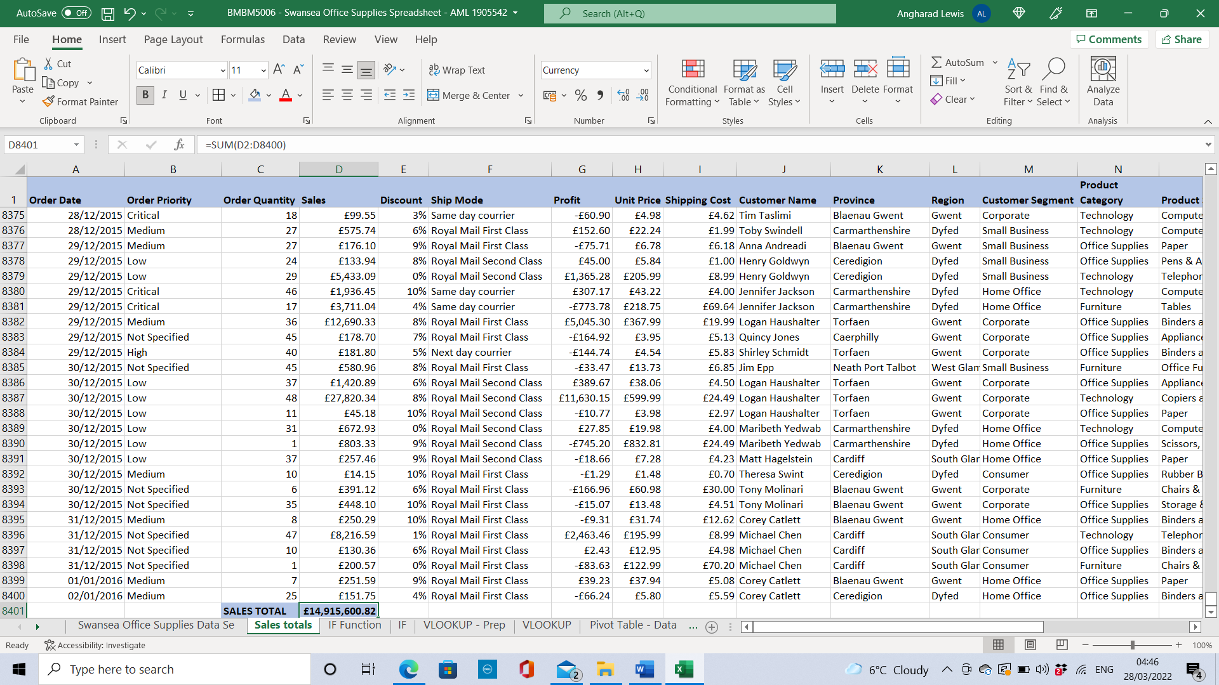
Figure 1: Sales totals

Excel’s functions allow users to calculate with ease. Using the sum (Alt+=) function automatically calculates the totals. The freeze panes function allows the user to continuously see the column titles whilst scrolling down the spreadsheet.

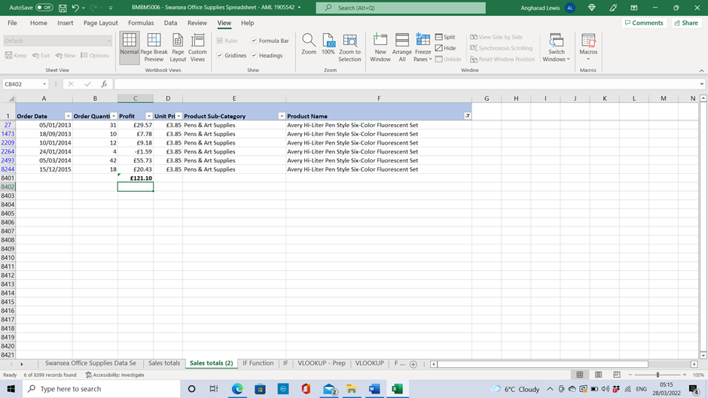
Figure 2: Simple calculation

A simple analysis of sales can be carried out by searching for an item in the product name column when filtering the data in the order of Order date, Order Quantity, Profit, Unit price, Product Sub-Category, Product name.

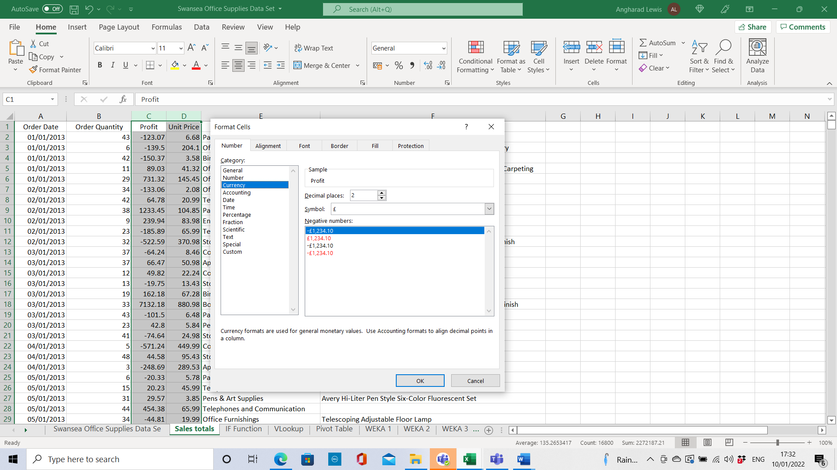
Figure 3: Format Cells

Pre-processing and Cell formatting are important stages of data mining. Data must be inputted correctly to get accurate results.
Cell formatting is a simple function used to tidy up large datasets by correcting mistakes to make them more understandable for Excel.

Within the dataset, currency-related columns were incorrectly categorised as ‘General’ and were changed to ‘Currency’. Cell formatting was carried out to change the number function.

The dataset was provided in the Comma Separated Value (CSV) format. When attempting to save the file, a warning message appears to inform of the potential risks of losing some features when saving the document as a csv file in Excel.

A disadvantage of using Excel is that it cannot always be trusted. It can be susceptible to glitches and corruption of files, as scientists found during the Covid pandemic when large amounts of data went missing. They found that breaking the spreadsheet into smaller ones offered a temporary fix (The Daily Telegraph, 2020).

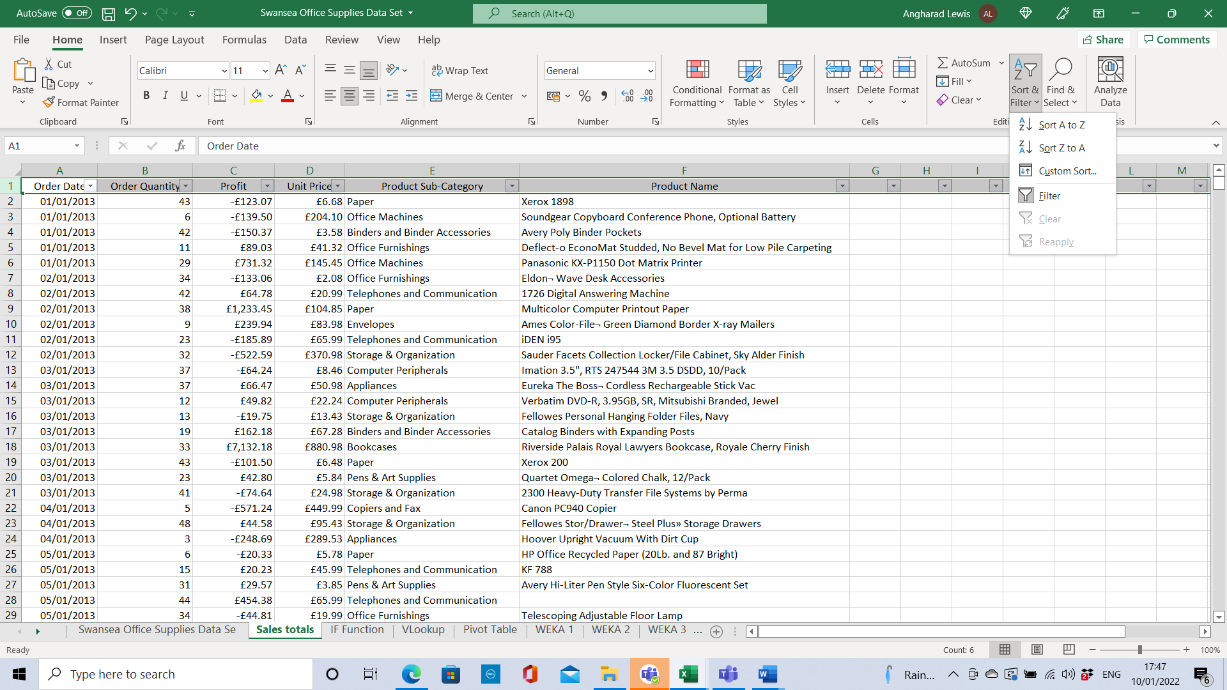
Figure 4: Filter and Sort

Excel’s filter and sort function allow users to view specific data for analysis, filtering out all unnecessary data.

Filtering the data provides the annual profit figures and determines which products were most successful.
2015 made a considerable profit of £776,467.52 compared to a £381,455.99 profit in 2014.

The product categories that made the most profit between 2013-2016 were Telephones and Communication (£316.951.62), Office machines (£307,712.93) and Binders and Binder accessories (£307,413.39). The biggest losses for the company are tables (-£99,062.50), bookcases (-£33,582.13), scissors, rulers and trimmers (-£7,799.25) and rubber bands (-£102.67).

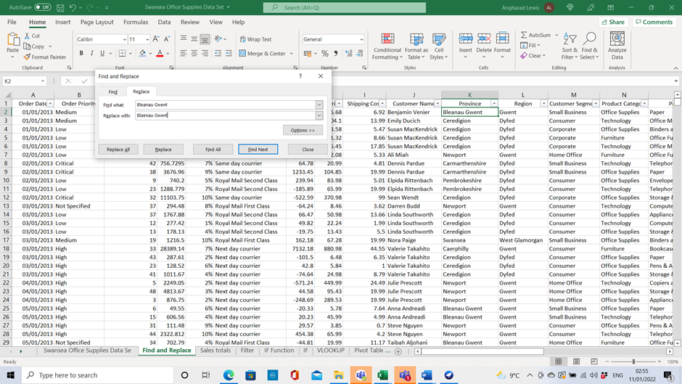
Figure 5: Find and Replace

When analysing data, it is important to check and change any spelling mistakes. Blaenau Gwent was found to be incorrectly spelt. By using the Find and Replace function, changing the same spelling mistake several times is done swiftly by selecting ‘Replace all’, automatically correcting 1087 spelling mistakes.

Excel includes several features that can be used to analyse data. Functions IF, LOOKUP, PIVOT TABLES, CHARTS and Graphs are used to determine the results.

Absolute Cell referencing is a cell reference within a spreadsheet that allows the formula to remain the same even if other factors are changed.

Conditional formatting is a way of visualising data. Turning the data into different colours is a quick and easy way of visualising data.

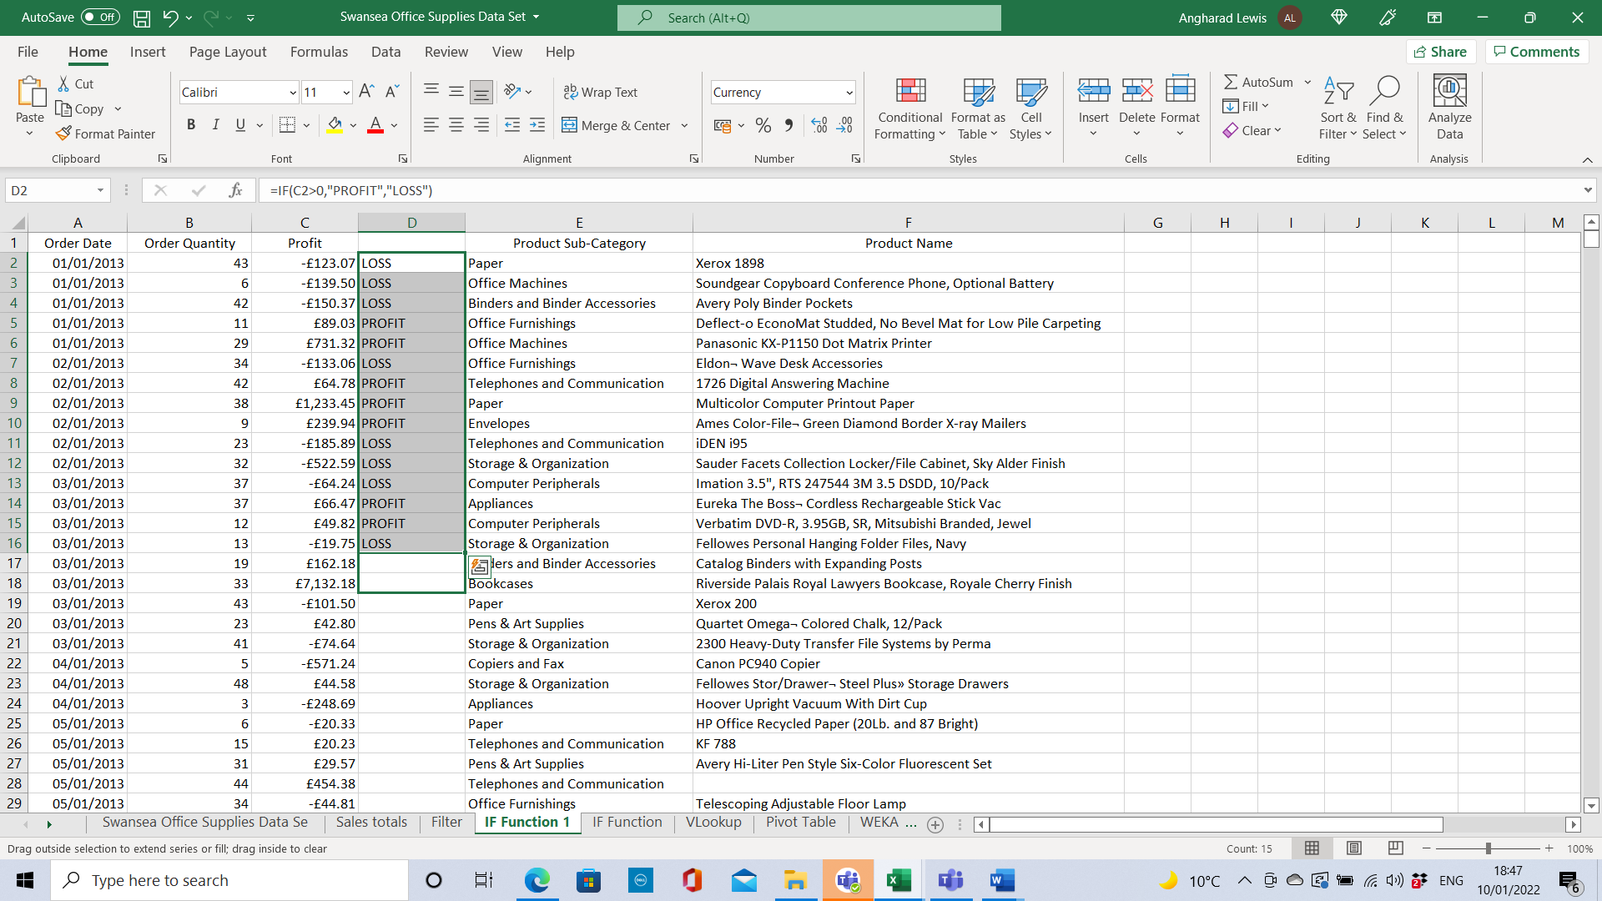
Figure 6: IF Function 1.0

The IF function can determine whether a sale made a profit or loss.

For inexperienced Excel users, training may be required before using the IF Function. For small businesses, it may cost time and money to provide training. The company may also have the added costs for business subscriptions for Microsoft 365 (Microsoft, 2022).

Extracting the order date, quantity, product name and sub-category data columns and inserting them into a new spreadsheet provides the profit and loss results.
The IF formula used for this report is =IF(C2>0,"PROFIT","LOSS").
The results are classed as a profit if the figure is higher than 0.

Dragging the first cell of the column down will determine the IF formula for all remaining cells.

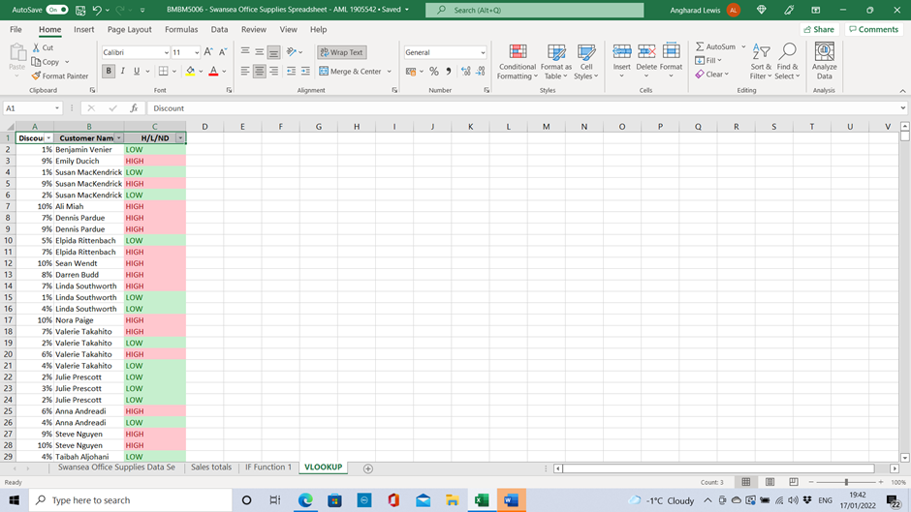
Figure 7: IF Function 1.1.

Using nested IF functions allowed three possible outcomes Low, High or No Discount.
Using =IF(A2<=0%,"NO DISCOUNT", IF(A2>=6%,"HIGH",IF(A2<=6%,"LOW"))) as the formula.
The results identify the customers who receive the biggest discounts.

The VLOOKUP Function uses a table to search for a value and provides an answer corresponding to the value.
The discount given and customer names were considered and by using the IF function, it visually determined if any discounts given were high or low.

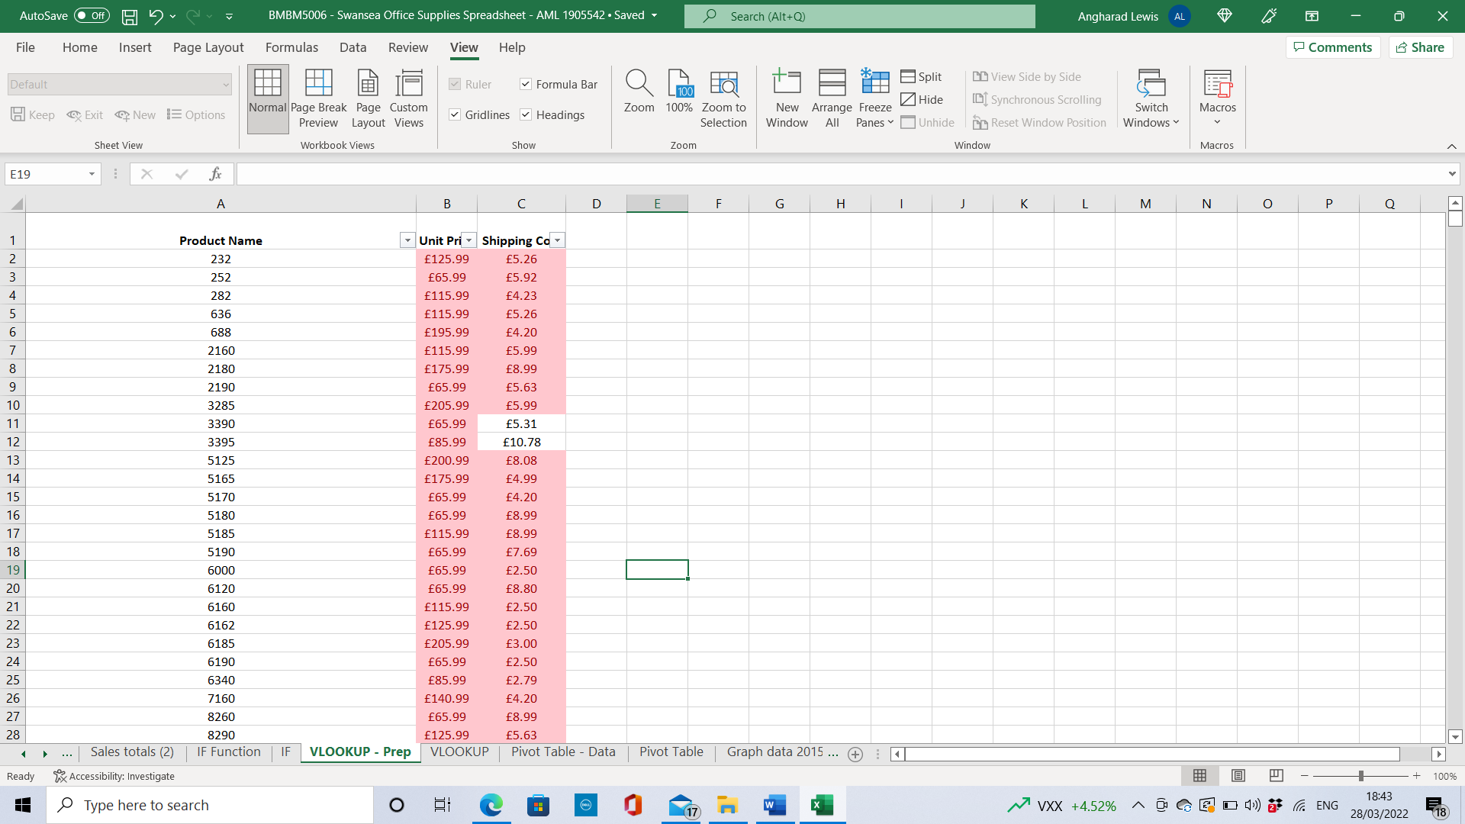
Figure 8: VLOOKUP Prep.

VLOOKUP can be used to look at shipping costs. The results show a loss on some products due to high shipping costs and the high postage prices for sending boxes via Royal Mail, which may be due to increases in postage prices.

The VLOOKUP function was applied to compare the shipping costs and unit prices of individual items as a way of identifying where the company needs to increase prices.

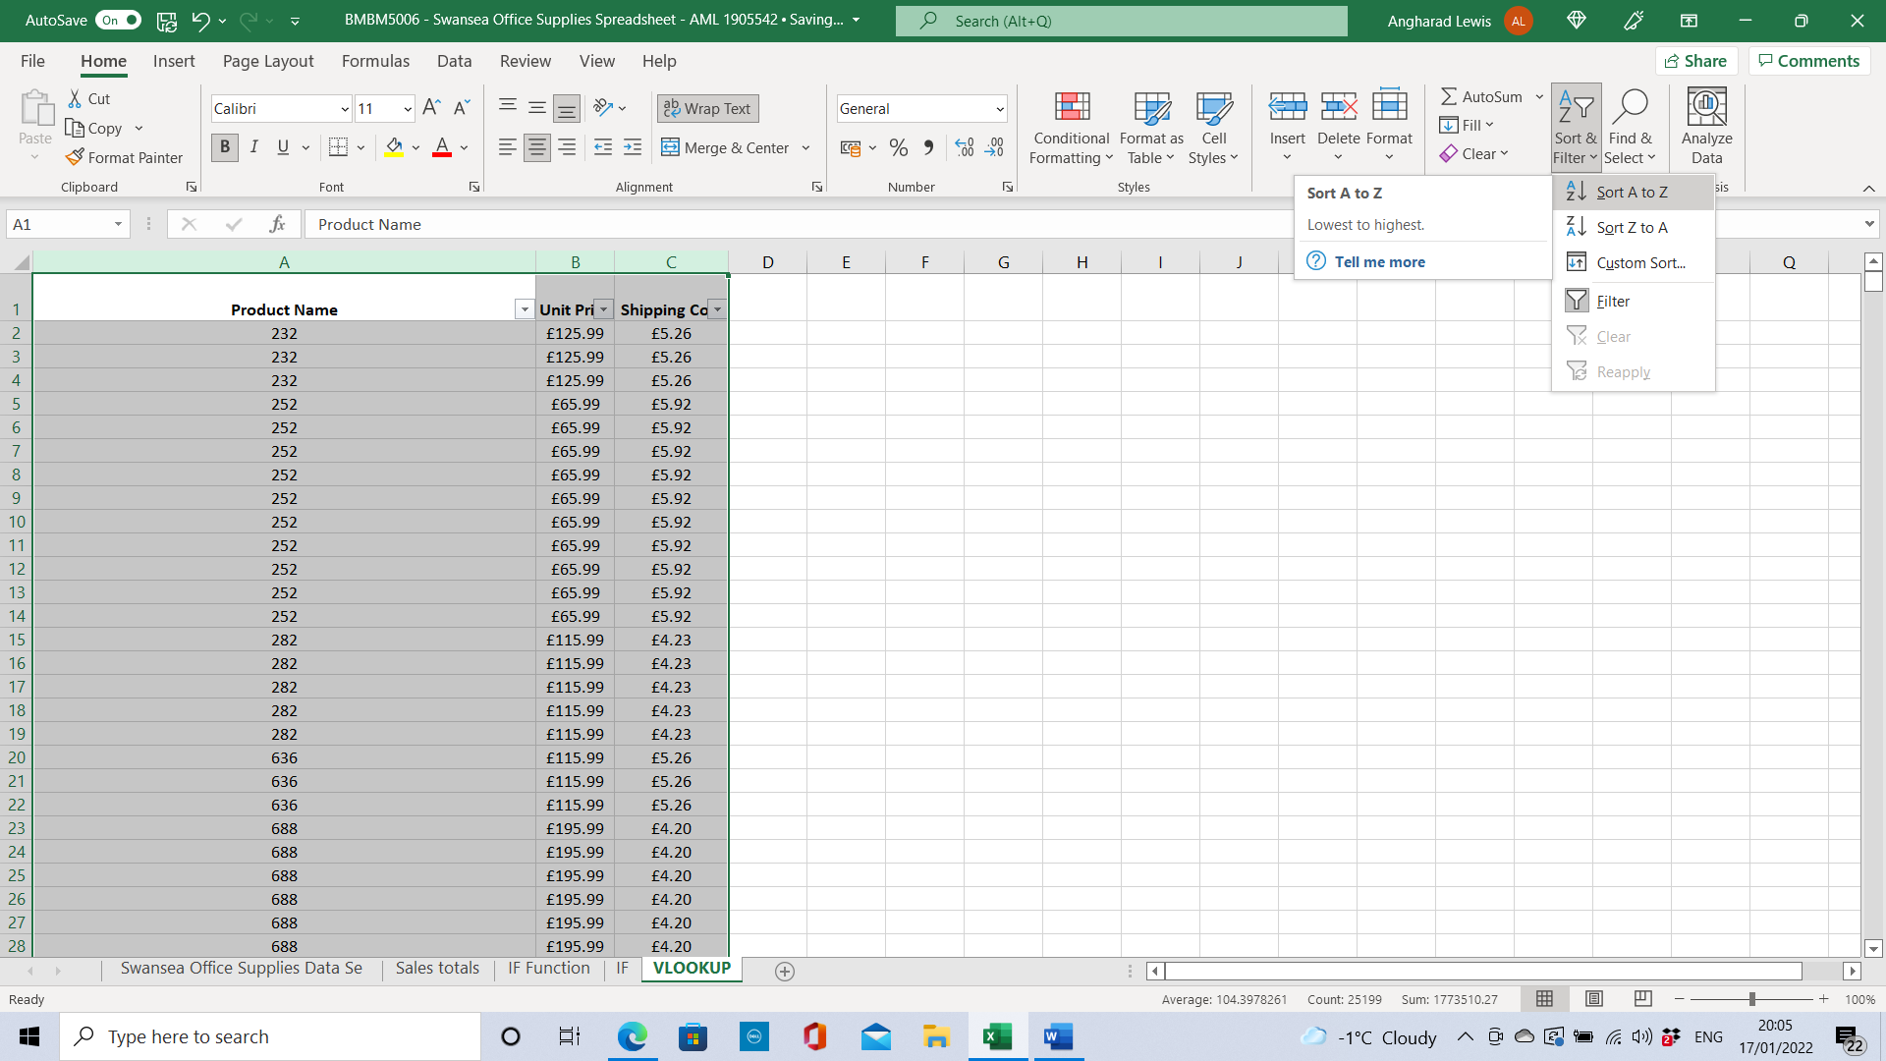
Figure 9: VLOOKUP

Sorting by product name, alphabetical order and sort and filter enable the user to remove duplicate entries.

Highlighting the data and selecting Conditional Formatting, Highlight Cell Rules, Duplicate values, Data tab and the Remove duplicates function found and removed 7073 duplicate values.

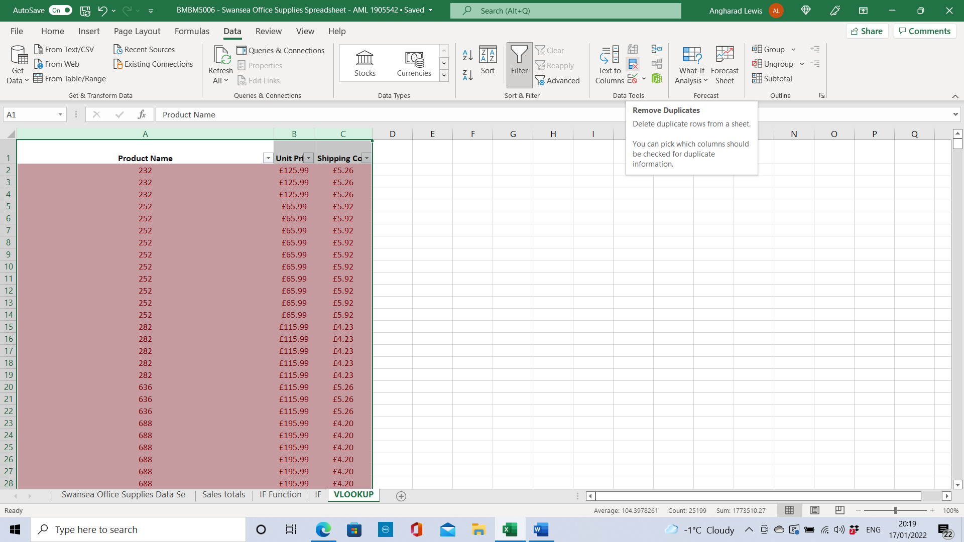
Figure 10: Duplicates removal

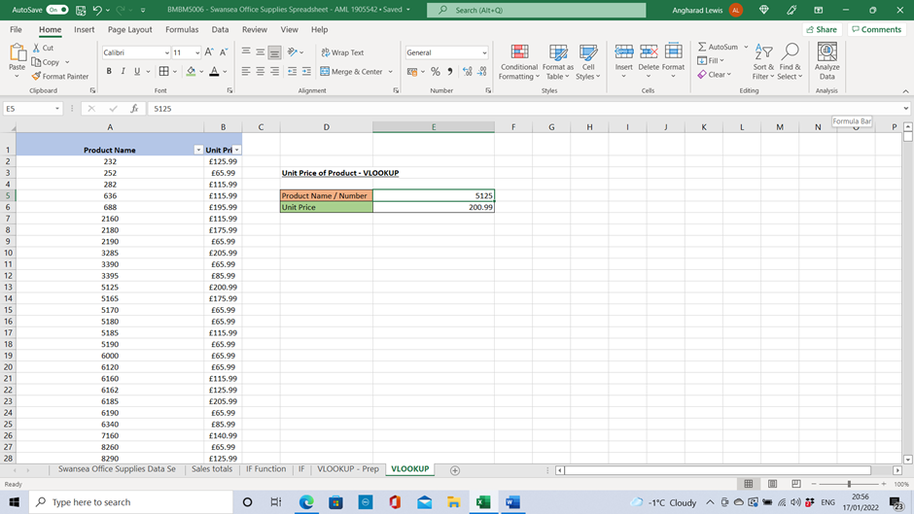
Figure 11: Unit price

VLOOKUP can be used to retrieve a product’s unit price. Using the VLOOKUP formula and entering the formula =VLOOKUP(E5,A2:B1327,2,FALSE) when inputting the product name or number of the product in column E5 gives the user a unit price for the product without having to find the information from a larger dataset.

For a more detailed search, the shipping costs can also be included to compare the shipping costs with the Unit price of the product. The VLOOKUP function with multiple criteria was not used in this instance.

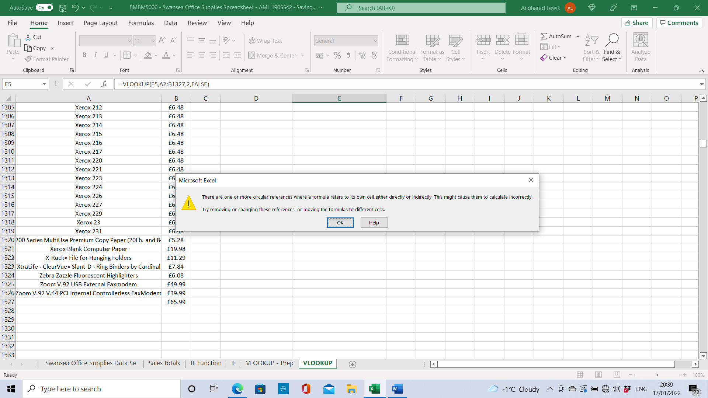
Figure 12: Error message from the first attempt.

Data could be managed better by inputting the product names or numbers, not a mixture of both.

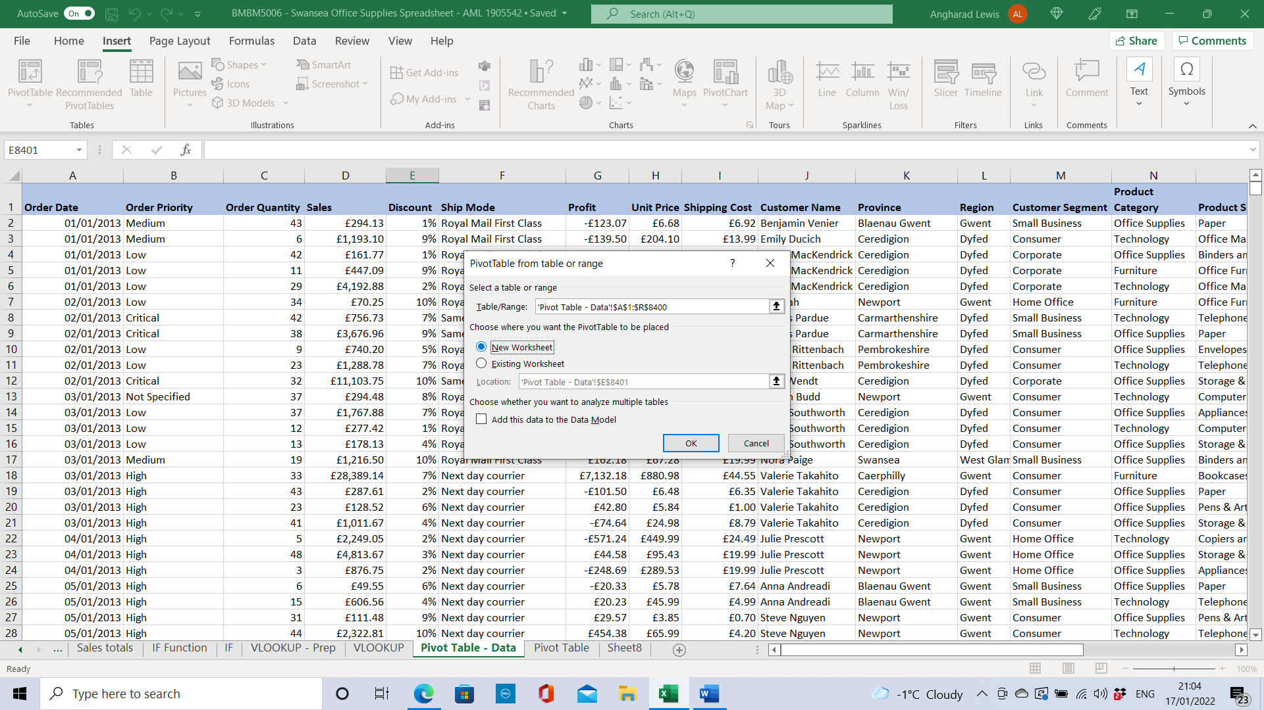
Figure 13: Pivot Table 1.0

A pivot table is a useful tool for searching for specific data. It reduces the size of the datasets for a more detailed analysis and enables the user to see patterns and trends (Microsoft, u.d.).

Creating a pivot table to break down the results by dates, product prices and shipping costs highlights any high shipping costs.

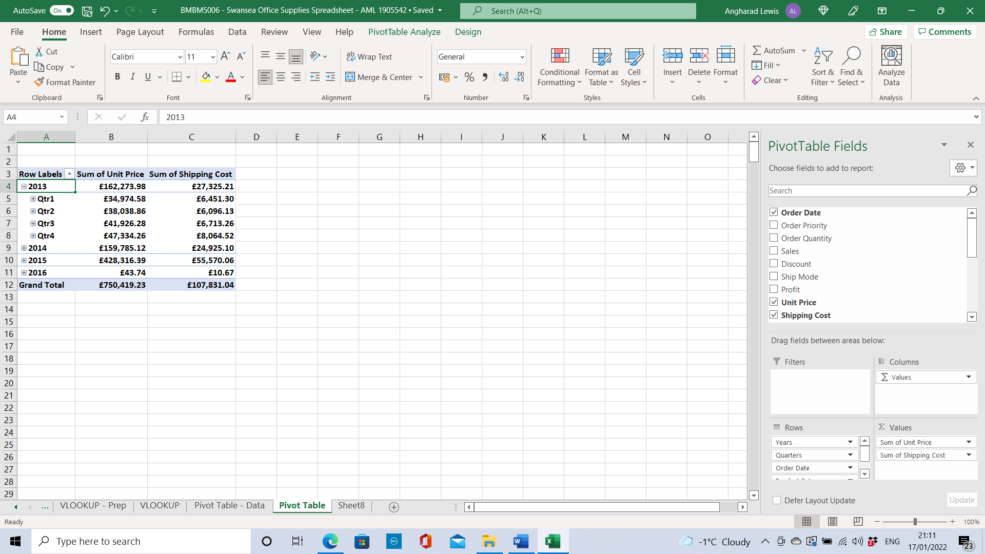
Figure 14: Pivot Table 1.1.

Other uses for pivot tables include viewing the performance of product sales by breaking it down by year, quarters, and products to give a total of sales per item.

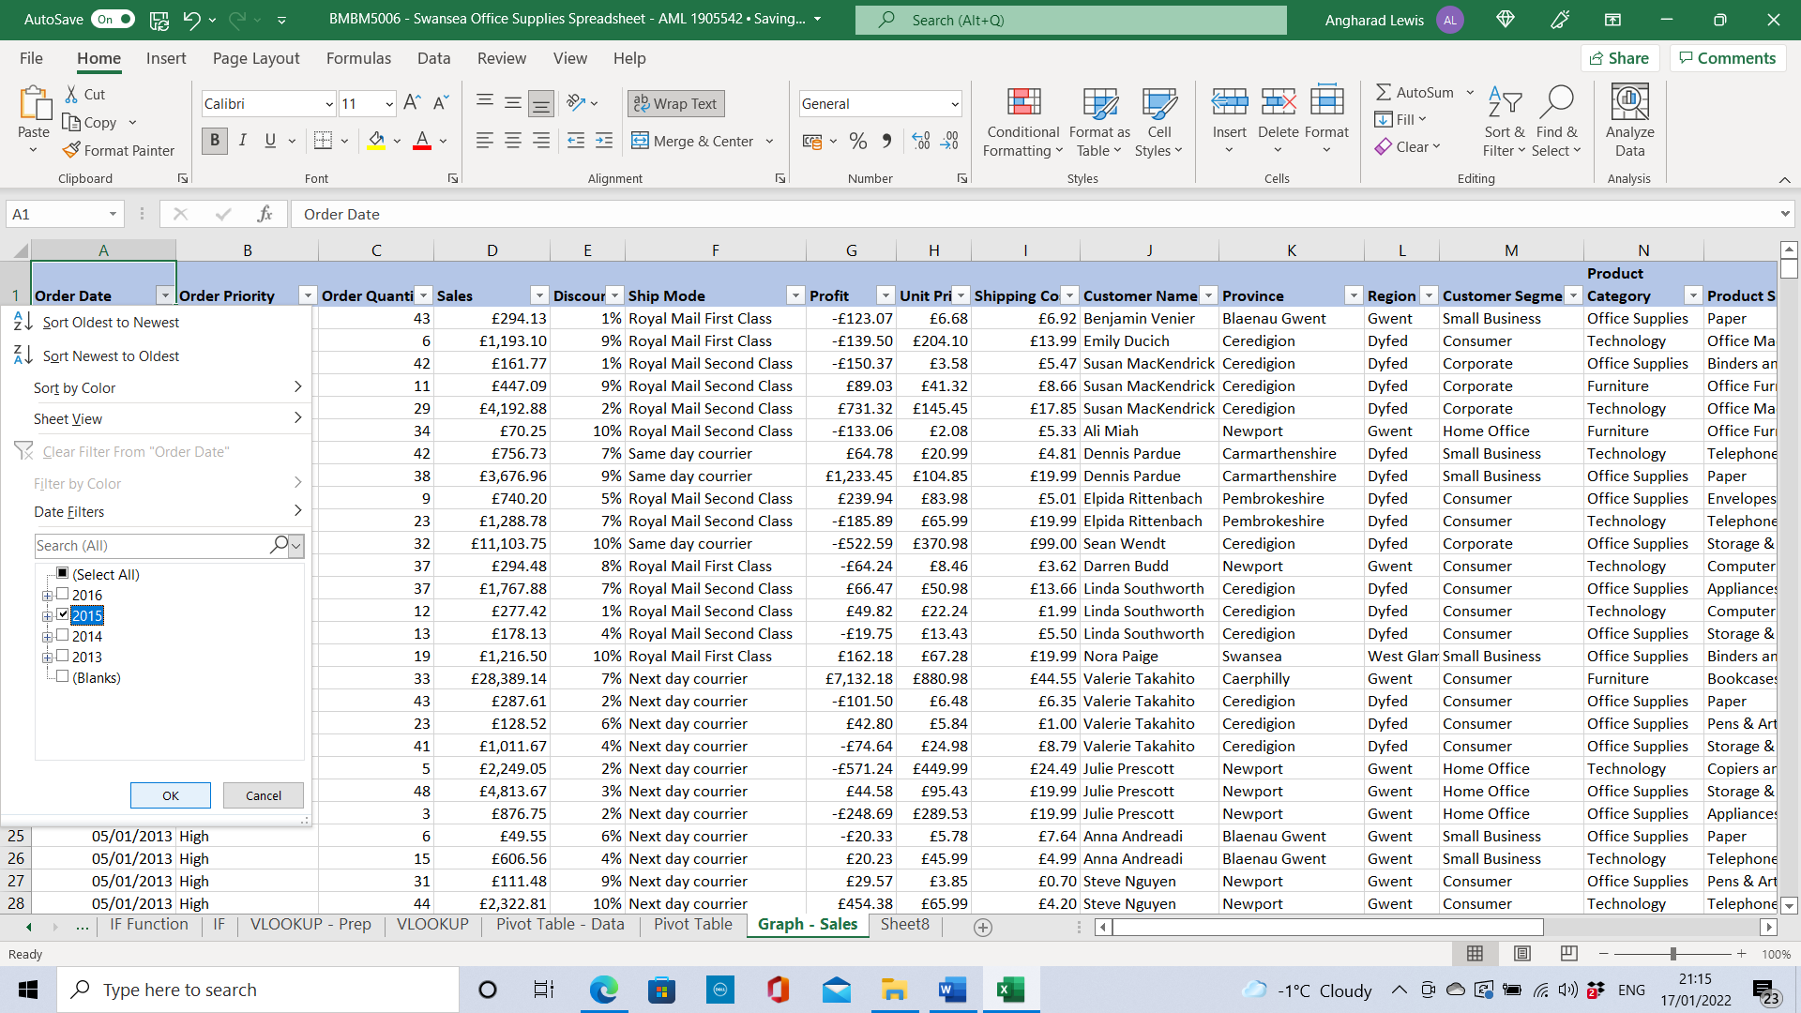
Figure 15: Visualising data

Charts and graphs are a great way of visualising results, making them easier to understand.
Creating a graph to show how well products are selling in each product sub-category can help to identify trends at certain periods. A filter was used to reduce the dates to April 2015 sales.

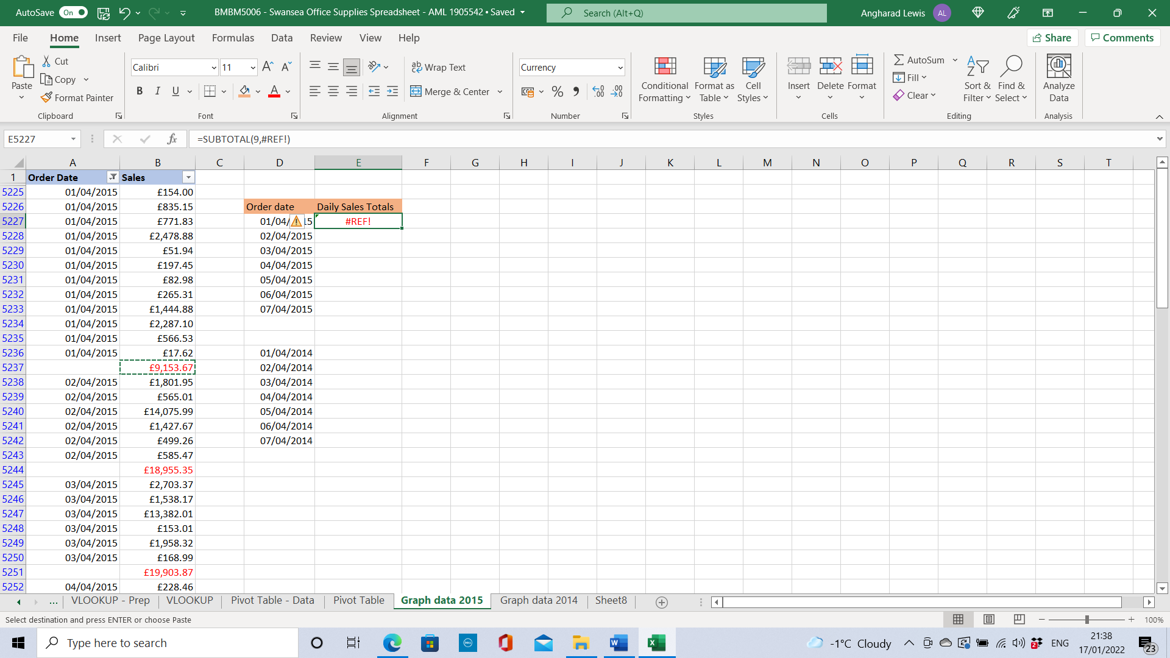
Figure 16: Error 1.2

Excel does not like copy and paste. An error message (#REF!) appears when attempting to copy the daily totals from the adjacent table. This was overcome by manually inputting the totals.

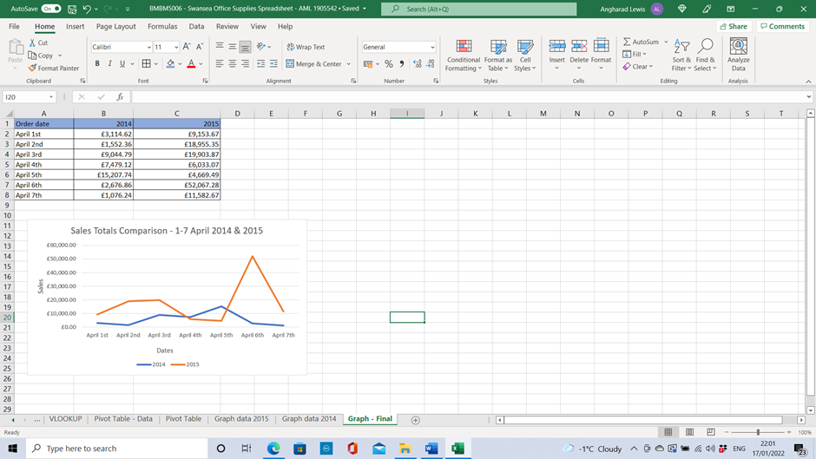
Figure 17: Graph

Graphs are a great way to look at trends and compare results. Daily sales totals for each day were calculated using AutoSum and a line chart was produced to compare the sales figures between the same weeks in April 2014 and 2015.
Excel allows the user to change the label of the Axis on graphs.

WEKA

Weka is free, open-source software, written in Java and produced at the University of Waikato. A collection of machine learning algorithms for data mining tasks, that runs on most platforms, it is one of the best tools for data analysis and predictive modelling. Free online courses are also provided online for continuous learning (WekaMOOC, 2013: Witten, I., and Frank, E., and Hall, M., 2011).

Weka gives an algorithm, not the actual answer. It includes features regression, classification, clustering, association rule mining, and attribute selection. The algorithm generated in Weka can be used in Excel to obtain the function. (Frank et al., 2016).

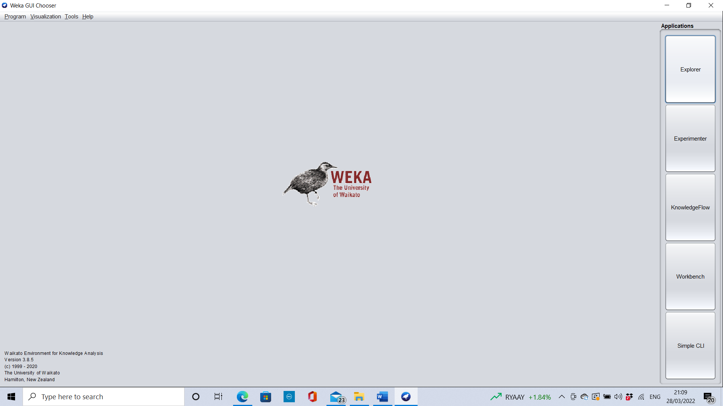
Figure 18: Interface

Weka’s basic looking GUI user interface includes several applications. The Explorer application is used for this analysis.

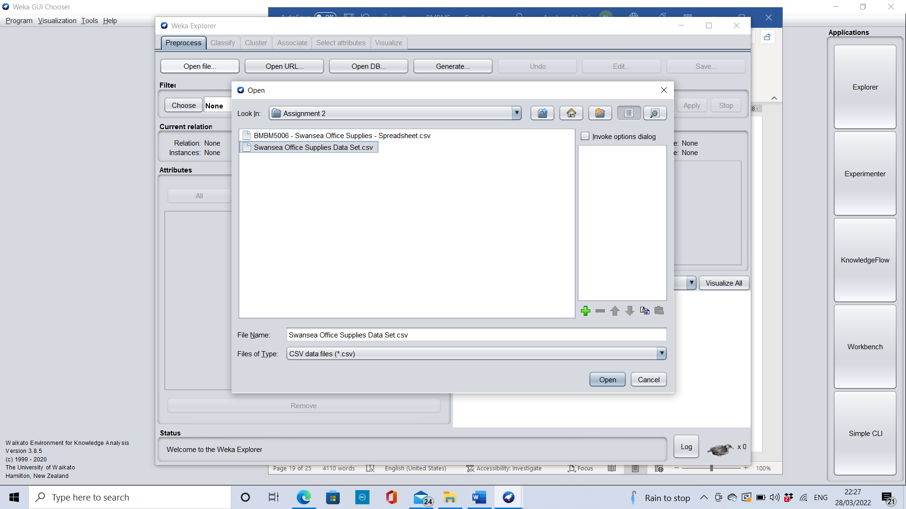
Figure 19: .CSV File

Data files used for Weka must be preprocessed and converted into a csv file before using the software. Weka converts the data into an ARFF format, a language that it can understand.
The dataset from Swansea Office Supplies was exported into a csv file and then transferred into an ARFF file in the tools tab.

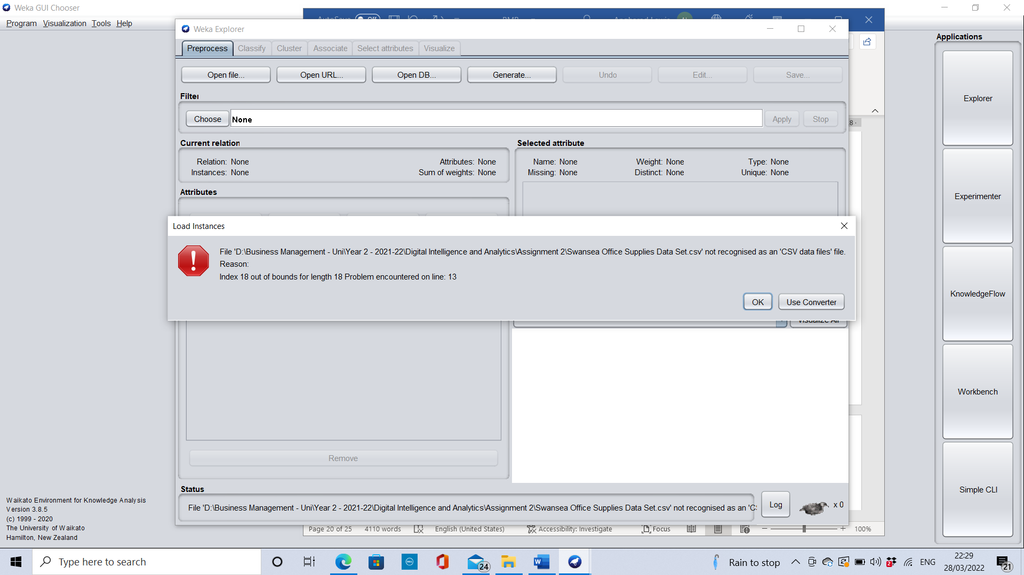
Figure 20: An error message - appeared when the dataset was not converted to an ARFF file.

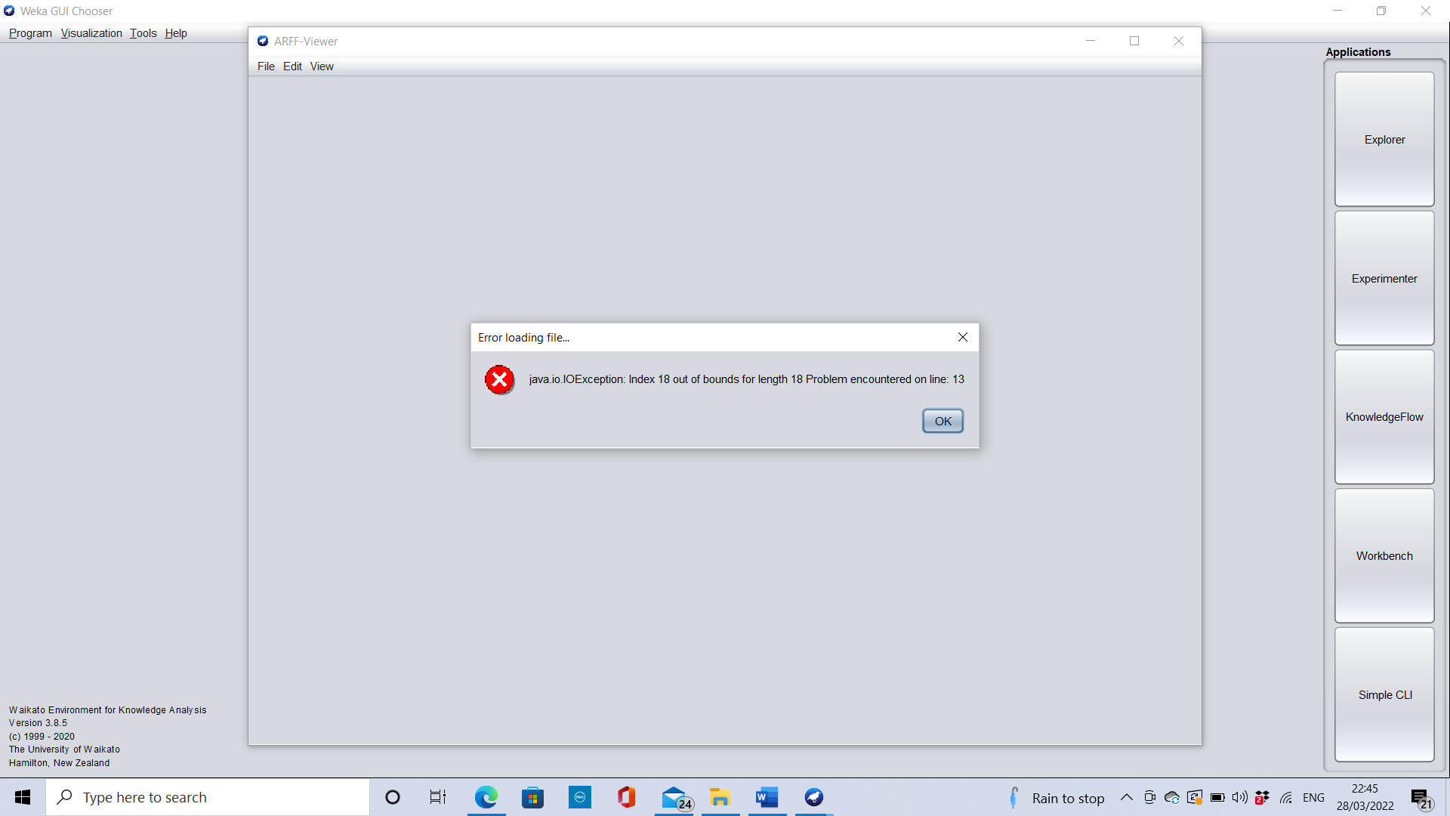
Figure 21: Error message - appeared until all unrecognisable characters were removed.

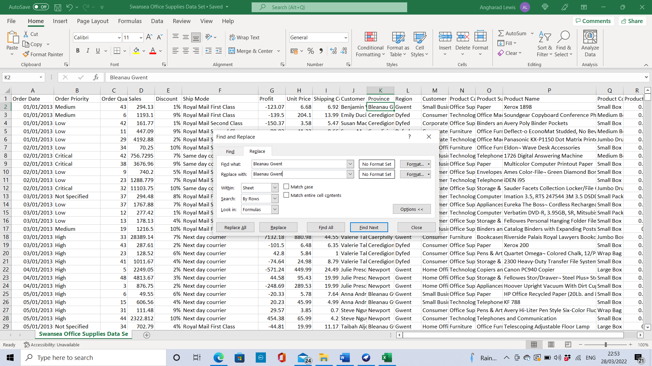
Figure 22: Find and replace - used to change the errors, before converting the file into an ARFF file in the ARFF viewer.

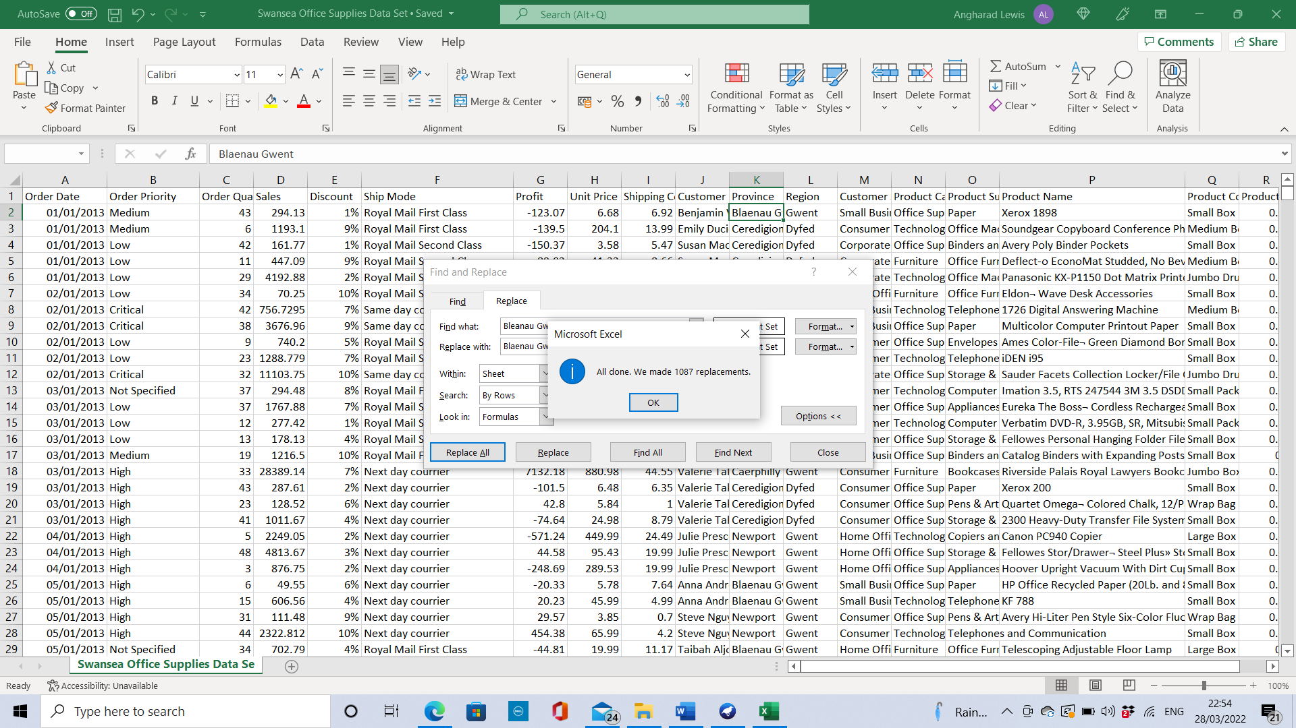
Figure 24: Find and replace corrections

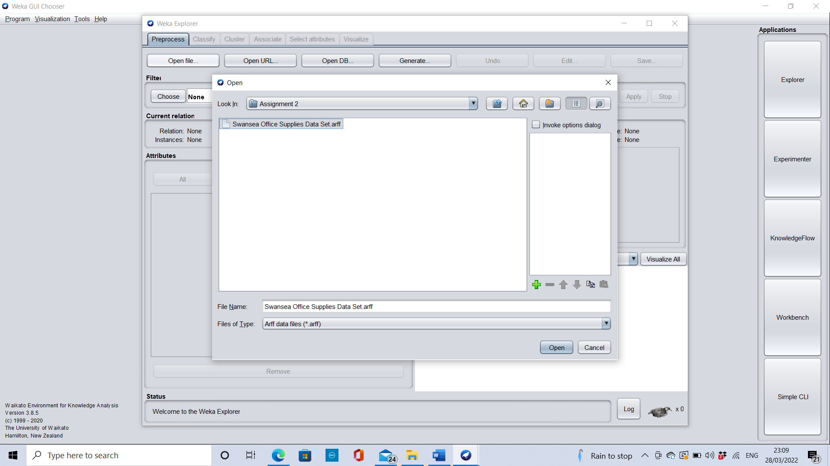
Figure 25: Uploading the ARFF file.
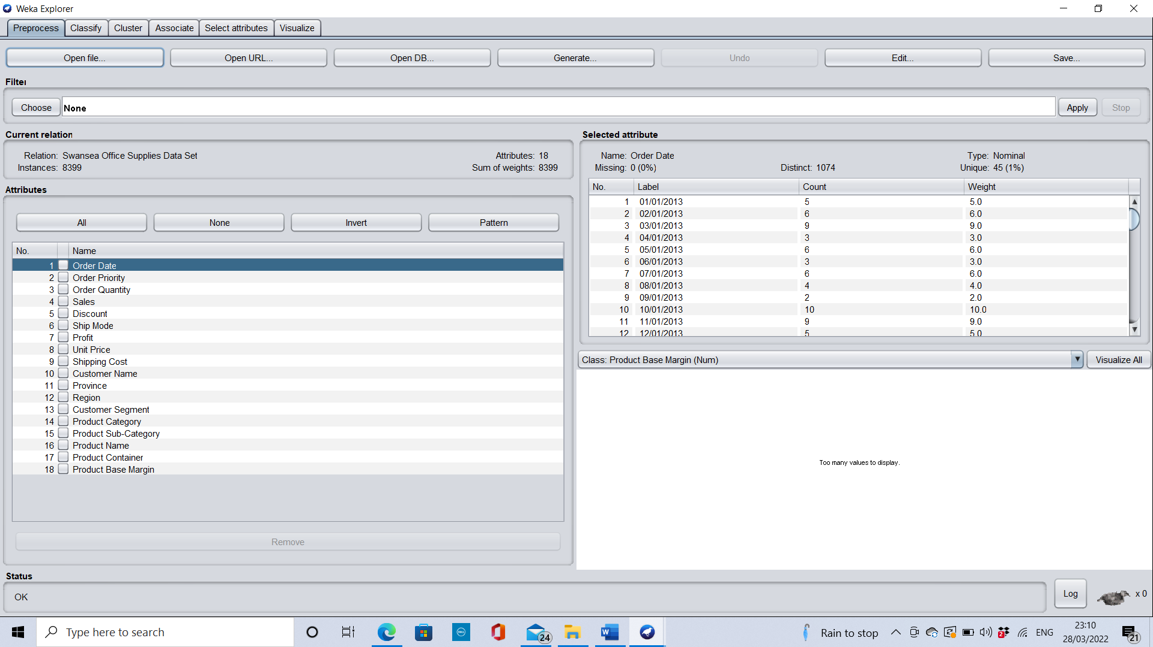
Figure 26: Preprocessing the information.

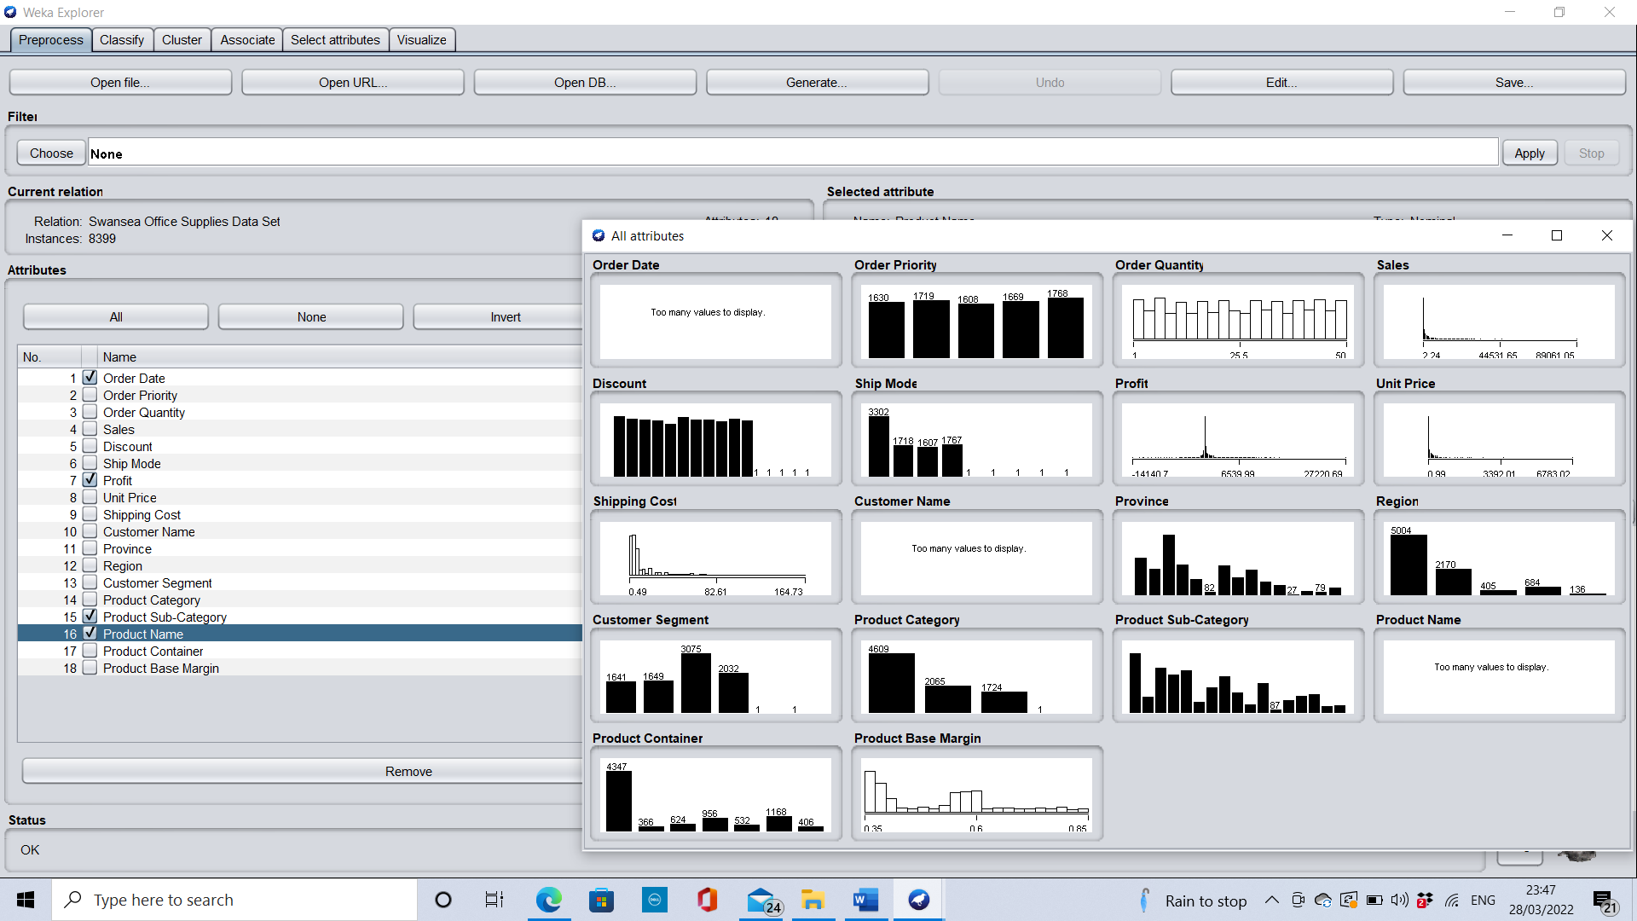
Figure 27: Preprocess

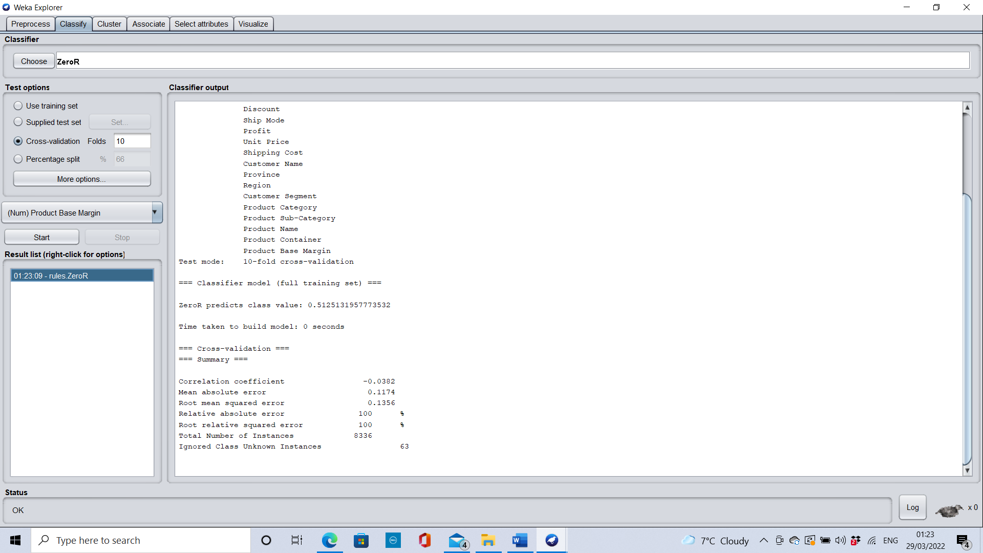
Figure 28: Classify

Loading the dataset to Weka will run the classification algorithms. The ZeroR algorithm is used in the above example.
Changing the classifier from “ZeroR” to “trees” and selecting “J48” produces an algorithm that generates a decision tree, which can be used to understand underlying patterns (Kaluza, 2013).

Clustering finds answers to specific questions. Groups of data can be formed to see if any patterns can be found.

Although Weka does have some benefits, several limitations were identified.
Weka can only handle clean, small datasets and is unable to work without working alongside another programme. It requires a package such as Excel to provide the data in the first instance.
It is quite sensitive to spelling mistakes, certain characters and currencies and is unable to save any data, whilst Excel has a save function.

Conclusion

The purpose of this report is to compare Microsoft Excel and Weka, to identify areas with low profitability within Swansea Office Supplies’ sales data.

The findings confirm that the company is not performing as it should due to large sales profit losses. Tables, Bookcases, Scissors, rulers and trimmers and rubber bands made a combined total loss of £140,546.55.

Shipping costs are an issue. Some products currently make a loss due to high shipping costs.

The company must monitor the customer discounts and explain why different percentages of discounts are given to customers.

Excel and Weka have several benefits for the company, both packages can in fact work side by side to provide the answers.

Users should be able to use Excel at a high level and WEKA at a basic level to be able to work efficiently with large datasets.

Weka benefits from its accessibility, cost, practicality, and its provision of online courses. Excel’s advantages include its saving abilities, data capacity and useful functions.

Graphs and charts in Excel allow users to label the Axis, a feature that Weka does not have.

Both packages can be delicate and prefer clean, raw data to work with, however, when used together, they can produce predictions and will benefit the company in the long term.

Recommendations

Based on the findings in this report, it is recommended that Swansea Office Supplies discontinue selling tables, bookcases, scissors, rulers, trimmers and rubber bands, to allow the company to concentrate on their most successful products such as Telephones and Communications and Office machines, binders and binder accessories.

Monitor shipping costs and consider changing delivery company. Discontinue shipping overseas or adjust the prices accordingly.

Cut back on the number of discounts awarded or possibly cap the discount rate.

Improve and increase staff training to increase staff competencies in Excel and Weka. The company will need to factor in the costs involved with training.

Comparisons were only made between Excel and Weka, however, alternative packages are available. The company should consider data mining packages that takes larger datasets.

References

Bucki, L. (2020) Excel Portable Genius. Indianapolis: Wiley.

Deloitte (2012). Big data: The three-minute guide. Available at:
https://www2.deloitte.com/global/en/pages/deloitte-analytics/solutions/three-minute-guide-to-big-data.html

Frank, E. et al. (2016). The WEKA Workbench Online Appendix for ‘Data Mining: Practical Machine Learning Tools and Techniques’. Available at: https://www.cs.waikato.ac.nz/ml/weka/Witten_et_al_2016_appendix.pdf (Accessed on: 29 March 2022).

George, G. and Lin, Y., (2017). Analytics, innovation, and organizational adaptation. Innovation: Organization & Management, 19(1), pp. 16-22. https://doi.org/10.1080/14479338.2016.125042

Johnson, D. (2020) Business Insider How to use Excel: A beginner’s guide to Microsoft’s spreadsheet program. Available at: https://www.businessinsider.com/how-to-use-excel

Kaluza, B. (2013) Instant Weka How-to. Birmingham: Packt Publishing Ltd.

Kolb, J.M., (2012) Business Intelligence in Plain Language. Chicago: Applied Data Labs Inc.

Microsoft (n.d.). Create a PivotTable to analyze worksheet data. Available at: https://support.microsoft.com/en-us/office/create-a-pivottable-to-analyze-worksheet-data-a9a84538-bfe9-40a9-a8e9-f99134456576

Microsoft (2022) Microsoft 365 for business. Available at: https://www.microsoft.com/en-gb/microsoft-365/business

Pat Research (2020) Top 25 Data Mining Software. Available at: https://www.predictiveanalyticstoday.com/top-data-mining-software/

Petersson, G. J. and Breul, J. D. (2017) Cyber Society, Big Data, and Evaluation. First edition. Abingdon: Routledge

The Daily Telegraph (2020) ‘Poor scientists blame their tools, as Excel takes the rap; Microsoft’s database software is back in the spotlight after the loss of 16,000 Covid case records, finds Laurence Dodds in San Francisco’, p. 8. Available at: https://www.proquest.com/docview/2448774262/abstract/DE967F993D304FA8PQ/1?accountid=130472

Walkenbach, J., et al (2013). Microsoft Office 2013 Library: The comprehensive tutorial resource. Indiana: John Wiley & Sons.

WekaMOOC (2013) Data mining with Weka [video]. Available at: https://www.youtube.com/watch?v=LcHw2ph6bss&list=PLm4W7_iX_v4NqPUjceOGd-OKNVO4c_cPD&index=1 (Accessed 29 March 2022).

Witten, I., Frank, E. and Hall, M. (2011) Data Mining: Practical Machine Learning Tools and Techniques. 3rd edn. Morgan Kaufmann, Burlington (USA). Available at: https://www.perlego.com/book/1837791/data-mining-practical-machine-learning-tools-and-techniques-pdf (Accessed: 27 September 2021).

