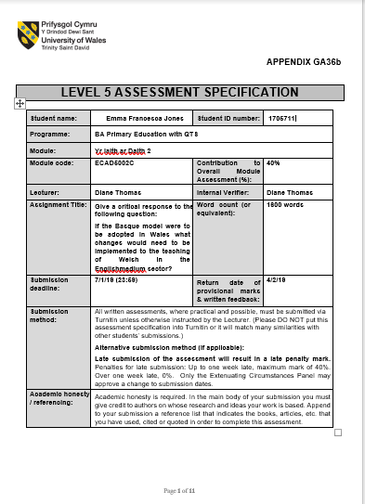
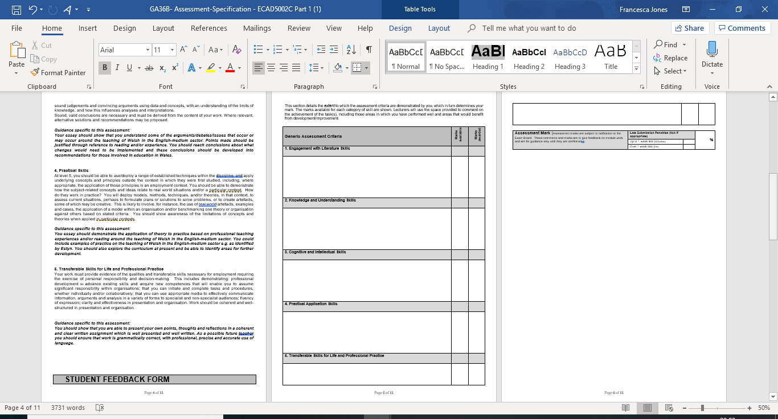
Assignment Title: Give a critical response to the following question: If the Basque Model were to be adopted in Wales what changes would need to be implemented to the teaching of Welsh in the English-medium Sector.
The purpose of this piece of writing it to discuss the changes that would need to me made within our education system for the teaching of Welsh as a second language within English medium schools following the representation of the Basque Model. The Basque model is most commonly known for its practice in Spain and France, however more so in the Spanish communities where the purpose of the model is identifying the three main models incorporated to it, to show how the implementation of using the Basque Language in to Spanish-medium schools can improve children’s skills of becoming bilingual within the two languages. Within Spain, the Basque model works to classify schools into three different grouping of their use of the language. The classifications depend on the level of the second language used throughout teaching compared to the main language, for example an A-model school would be where Spanish is used for all instruction, the B-model school would give opportunities for the children to use Spanish with the implementation of the Basque language being encouraged, and finally the schools categorised as the D- model will teach through the process of the Basque language and have Spanish taught as a compulsory subject. Many schools are working towards becoming categorised as the D-model to promote the use of the language within the children. As schools in Wales are working towards becoming more positive in developing the use of the Welsh language there are still many barriers that could be affecting this development, however, by implementing the strategies used throughout the Basque Model as well as taking advice from research found through the review of the Curriculum, Successful Futures and other education authorities such as the Welsh Government and Estyn, we could work to produce a bilingual school community throughout the country. As Professor Donaldson suggested in his review of Successful Futures, when discussing evidence for proposals that, ‘there is a firm commitment to the Welsh language and bilingualism’ (2015, page 15). This proposed that through the upcoming and new curriculum which is set to begin over the next year or too that the culture of Wales and the Welsh language will be considered through all aspects of the teaching to children and young people.
Referring to evidence from the Basque Model, where the Spanish use a CLIL approach to implement the use of a dual-language teaching and learning experience for the children. Used most commonly through the D-model, the approach works as an umbrella focusing on giving opportunities for children to learn through bilingual education, using language across the curriculum and work to increase the learner’s motivation. In Wales, we start using the Welsh Language from a young age with children, and even through there isn’t a huge variety of the language used, as schools are currently progressing through improving their use of Welsh every day, practices have been up in place to encourage a stronger purpose for in within our schools. An important factor that is currently helping the development of the Welsh Language within our schools is the implementation of the Curriculum Cymreig where we are basing our learning and skills on the history and culture of Wales, allowing the children to have a sense of feeling of where they come from and the importance of our language and historical features of their ever growing county. If we were to follow the procedures of the Basque Model and influence the use of Welsh within our schools today the children would benefit from not only developing their bilingual skills but also work to towards an outcome of Successful Futures in becoming ethically, informed citizens of their country. One problem that can cause the relapse of the Welsh Language Development in comparison to that of the Basque Model is the confidence of a teacher in their own personal use of the language. Today through teacher training courses there is the opportunity for trainees to develop their Welsh skills in suits to that of their capabilities and improve their own skills reaching targets of the Qualified Teaching Standards. Although, this is there to support the learning of trainees to develop the children’s initial skills, it also depends on individual’s confidence in using the language. Referring to the Basque Model, there are opportunities given to all citizens to develop their own skills through organised courses run mostly by the town council and local authorities, if this was the case within Wales, there would be a higher number of people using and speaking the language and promoting its use in everyday life. Already in Wales we have goals to reach through the promotion of Welsh language where we see that we reach one million speakers by 2050. This means that through education we are using the Welsh language to create our new population of Welsh speakers to reach our targeted goal. As Alun Davies, Welsh minister for Wales said in 2017, ‘Education is central to our vision, but we must ensure our young people come out of the education system ready and proud to use the language in all contexts’, this is why improving our schools bilingualism through the influences of the Basque Model we can assist the children in becoming confident to use their language in all contexts both inside and outside of the English-medium classroom. If in Wales, we had the same opportunities through the community as in Spain offering all citizens the opportunities to attend and develop their skills through courses suitable and affordable to them the children would be influenced outside of school to use the language as parents and people they see everyday would also be able to promote their use. As stated in the 2011 census from Estyn we see that in households where one parent may speak the Welsh language 45 percent of children between the ages of three and four could speak Welsh, it almost doubled in percentage in a household where both parents may use the Welsh language. This shows on reflection that children can be bilingual from a young age and it gives us the foundations to work with as these children enter the education sector. However, not all children experience the use of Welsh at home and even though there are opportunities in Wales being offered through college courses, they often come with a cost that many people aren’t willing to pay as it sets back costs for their living needs. Whereas many adults may attend adult learning within Wales these sessions also focus more on the mathematical and literacy outcomes for their learning compared to any other subject-knowledge areas. Too adopt the Basque Model into Wales, the most beneficial strategy would be to focus on developing the skills of such need within the Welsh language to retraining staff and outside agencies through the development of their own Welsh language knowledge and combining the learning of children to that with adults. In welsh-medium schools we currently have in place organised meetings in which parents are invited into the schools and talked through how they can assist their children’s learning and also offered support to expand their own knowledge of using the language. If this was put into place within English medium schools then the children are being offered opportunities to use the Welsh language, they are experiencing each day beyond the point of school life. Even through most Welsh in our current school’s policies is that of incidental Welsh used to instruct, command and praise learners they are a starting point for the language development and can only be expanded on. Also with the lack of confidence with some teacher’s own Welsh language, the children may not receive a full welsh lesson by their class teacher and they are normally filled in my the PPA cover that the children will see once a week. This reflects on how the children may see their teacher doesn’t teach them Welsh and it may not be taught to their understanding.
The Basque Model would work in Wales with a lot of support from the government and education authorities in offering the support and guidance that the initial teachers and support staff within schools who are they to help the development of the children. With action plans in place through Successful Futures, Cymraeg 2050, One Language for All and many other governments plans the focus and dedication to develop and achieve a bilingual school and children are making purpose to be achievable through the next 30 plus years where we aim to have one million welsh speakers of the everyday language. If we were to achieve the outline of a Basque model within our schools, it gives the children of our future the skills they will need to be involved through the development of their societies and jobs for their country over the years. Achieving a Basque Model within our schools will also be beneficial to the economic and historical development of Wales in promoting the History and culture of where the language began, how it has developed through the years and brought us to where we are in the current day and age. By creating more bilingual speakers and Welsh speakers we can hope that through the Cymraeg 2050 plan that we will regain the number of Welsh speakers we once had in 1911 which was recorded at 977,000.

Reference List
Donaldson, G. (2015) Successful Futures: Independent Review of Curriculum and Assessment Arrangements in Wales. Cardiff: Welsh Government
Hopwood, M et al. (2018) An overview of the assessment of language proficiency in a sample on bilingual jurisdictions. UWTSD: Qualifications Wales
Welsh Government. (2013b) One Language for All- Review of Welsh Second Language at Key Stages 3 and 4. Cardiff: Welsh Government
Welsh Government. (2017) Cymraeg 2050 A Million Welsh Speakers. Cardiff: Welsh Government
Welsh Government (2017) Welsh in education Action plan 2017 – 21. Cardiff: Welsh Government

