Emergent Leadership Skills for the Workplace: Report and Reflection

Student Name: Sana Arif

Student Number: 2116663

Lecture Name: Samuel Ofori

Module Code: BMSW6101

Date: January 2024

Contents
Emergent Leadership Skills for the Workplace: Report 3
Introduction 3
A Critical Explanation of the Theories 5
Situational or Contingency Leadership 13
Conclusion 16
Emergent Leadership Skills for the Workplace: Reflection 18
Introduction 18
What? 18
So What? 20
Now What? 21
References 26

List of Figures
Figure 1: Theory X, Y and Z 6
Figure 2: Theory X and Y 7
Figure 3: Theory X, Y and Z differences 9

Task 1 Introduction
The notion of leadership is critical to management studies and business administration (Solinger et al., 2020). Though leadership and management are employed synonymously, they have different characteristics. The definitions for leadership and management according to Rost are “an influence relationship between leaders and followers who intend real changes that reflect their mutual purposes and an authority relationship between at least one manager and one subordinate who coordinate their activities to produce and sell particular goods and/or services” (Rost, 1993 p. 102 & 1 Management is mainly focused on planning, organizing and controlling tasks as well as resources to accomplish goals, while leadership is centred around inspiring and impacting the team to achieve common objectives (Chima and Gutman, 2020). One of the major components of management is leadership which encompasses creating an environment whereby each individual can grow and succeed. Kotterman (2006) states that a manager needs to be a leader which implies that they need to have leadership qualities. Leaders design and execute plans that produce and sustain a competitive advantage. All management functions, planning, organising, staffing, directing, and controlling, are essential to management; leadership is considered as a part of the directing function of management. Along with listening and building relationships and collaboration, leaders tend to inspire, motivate, and influence followers too.
Examples of leadership theories are conceptual frameworks known as leadership theories which intend to understand, to forecast, and to explain the behaviour of leaders, and the effects that such behaviour has in an organisational or social environment (Mahajan, 2011). These theories are a framework for looking at both the traits of a good leader and the different leadership philosophies which can be applied depending on the situation, personal characteristics and organisational culture. The domain is filled with different viewpoints, ranging from the heralded Great Man theory - which claimed that leaders are not made but born (Spector, 2015); to the more recent situational, behavioural, and transformational leadership and trait (Bass and Bernard, 1985; Yang and Wei, 2017). The trait theory focuses on the inherent qualities and characteristics of a good leader, for instance, intelligence, charisma, and decisiveness (Day et al., 2021). On the contrary, behavioural theory encompasses the behaviours and actions of leaders, with the assumption that leadership can be learnt and developed through specific behaviours and practices (Aithal and Aithal, 2019; Bennis, 1959). Situational theory postulates that leadership effectiveness is contingent upon the situation it is exercised in. As example, a leader may require adapting their style in accordance with the capacities and the level of development of the team members (Hersey & Blanchard, 1969). Finally, transformational theory states that leaders can inspire and motivate their followers to extraordinary performances through vision, charisma, and ethical values (Bass, 1994).
This report will focus on three main leadership theories: X, Y and Z. These theories will be analysed within the context of a UK small business, paying special attention to the current socioeconomic situation. The report also addresses the relevance of cultural and personal differences when these theoretical approaches are applied to leadership. Additionally, it will also talk about contingency or situational leadership, and its significance to current problems faced by UK businesses, for instance, Covid, Brexit, and cyber-attacks. At the end of this report, the reader will have a clear understanding of these theories and their applicability to a real-life business situation.

A Critical Explanation of the Theories
The X, Y and Z theories of leadership are among the most popular and far-reaching theoretical frameworks for understanding leadership (Mallette, 2005). McGregor drew inspiration from Maslow's hierarchy of needs and reasoned that the needs are no longer motivational once they are fulfilled. The company easily fulfills needs of employees via financial rewards and benefits. When these needs are fulfilled, the motivation is gone.
The X theory, which is also known as the traditional or autocratic theory, was created by Douglas McGregor in the 1960s. The X theory of leadership is grounded on the three main presuppositions. The first assumption is that people are naturally lazy and they would rather not work if they can get away with it so it is important to keep them on a leash so that they are productive (McGregor, 1960). The second assumption is that people require direction and control to execute their tasks properly which shows the importance of leadership in directing and guiding employees so that they can accomplish organizational goals. The third assumption is that people are generally more security conscious than they are responsible and thus prefer to have job security rather than being entrusted with responsibilities (Kopelman, Prottas and Falk, 2010). This theory was popular in the early years of industrialization, when workers were seen as mere cogs in the organizational machine and is suitable in traditional bureaucratic organizations, such as government agencies, where there is clearly defined hierarchy and division of labor (Zendage, 2018). This theory prevents the satisfaction of higher needs due to the fact that it does not take into account these needs in the context of the work place. The diagram below explains this:
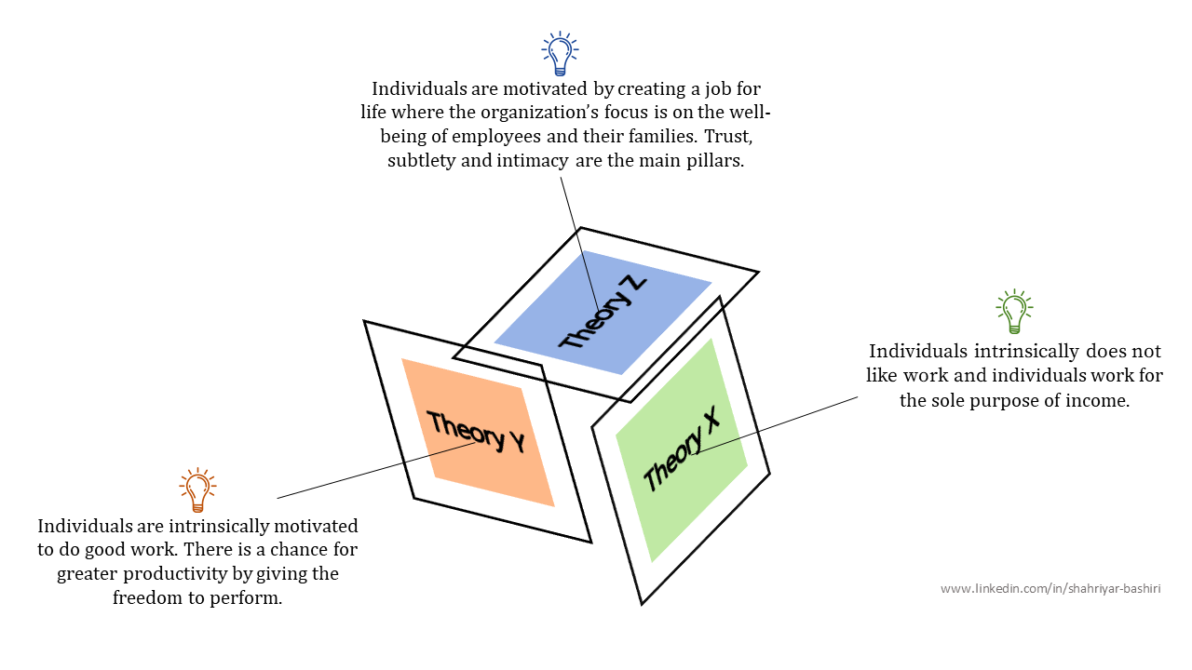
Figure 1: Theory X, Y and Z
On the contrary, the Y theory argues that people are intrinsically self-motivated and have a natural desire to be responsible and to grow (Neuliep, 1996). This theory emerged as a counter to the X theory, with proponents arguing that workers can be trusted and motivated to achieve higher levels of productivity and job satisfaction. In accordance with the theory Y, people enjoy their work and find satisfaction and fulfilment in it, and due to this, they are self-motivated and perform well. This self-motivation originates in the need for personal growth and development, rather than in the desire for external rewards or punishment (Burton, 2004). It further assumes that they are capable of taking on responsibilities and making decisions independently, being highly productive and showing initiative thus the importance of giving employees autonomy and providing opportunities for growth and development in organizations (McGregor, 1960). This theory is more relevant in knowledge-based organizations where people are regarded as valuable assets and are stimulated to contribute and take initiatives. The figure below shows theory X and Y;
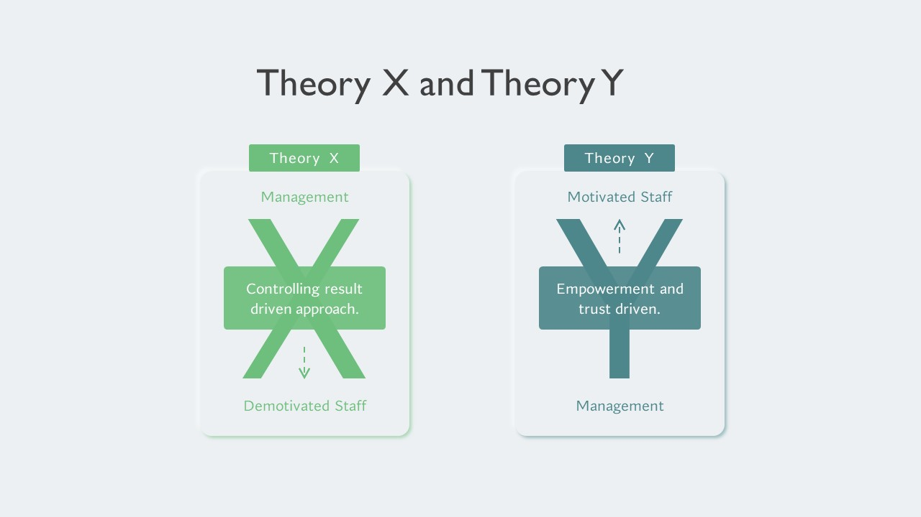
Figure 2: Theory X and Y
The Z theory, also referred to as the participative or democratic theory, was put forward by William Ouchi in the 1980s and combines features of both the X and Y theory (Ouchi, 1981). It stresses the need for interdependence and cooperation between leaders and led in the attainment of organizational objectives. The Z theory appreciates the importance of workers' motivation and participation, but it also recognizes the need for leadership’s control and direction (England, 1983). It stresses the role of collaboration, communication, and consensus in decision-making. Nevertheless, it also emphasizes the importance of formal authority structures, individual contributions, and recognition, which is consistent with individualistic values. This theory emphasizes the importance of common cultural values in organizational success and indicates the necessity for a balance between individual autonomy and collective collaboration in leadership.
Though the X, Y, and Z theories of leadership have specific differences in the assumptions and approaches, they have some common features. Firstly, all three theories acknowledge the role of leadership in ensuring success of the organization and achieving the goals. All these theories underscore the relevance of direction, control, motivation, and decision-making in a leader's role.Also, all these theories agree that employee motivation is key to achieving organizational goals. Combinedly, the X theory holds that employees can only be productive if they are closely supervised; however, both Y and Z theories emphasize on the role of motivation, whereby the Y theory touts self-motivation, while the Z theory underscores cultural values as a source of motivation. Moreover, all the three theories postulate an equilibrium of staff autonomy and leadership control. Individual autonomy is the central component of the Y theory whereas the need for cooperation and involvement is at the heart of the Z theory despite the presence of formal authority structures (Ouchi, 1981). Finally all of the three theories are in tandem on the need for organizational culture in the design of leadership styles and behaviours of the workers. X theory claims a bureaucratic and hierarchical culture while Y theory opts for a more participative and democratic culture. In this regard, the Z theory makes allowance for stylistic equilibrium between individualistic and collective cultural values (Sullivan, 1983).
According to the X theory, individuals are not intendedly unmotivated hence require a close supervision and control from the leaders to perform the tasks effectively (Zendage, 2018). This is quite different from the Y and Z theories that all people are self-interest and take buns. The Y theory emphasizes the importance of individual autonomy and initiative, in contrast, the Z theory is hinged on collective approach and participation. The other main divergence between these theories is the way in which they see the employees’ capacities and what they are capable of doing. The X theory holds that people are inherently lazy and require guidance and control in order to perform well while the Y and Z theories view staff as capable and motivated individuals who can be actively involved in organizational success (Kopelman, Prottas and Falk, 2010). The table below shows these differences;
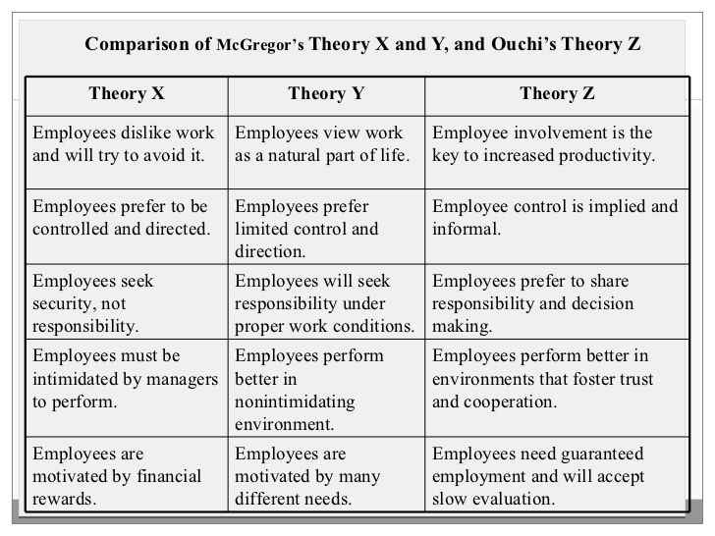
Figure 3: Theory X, Y and Z differences
Besides this, the X theory of management is based on traditional bureaucratic culture, with strict hierarchies and rigid structures (Khan, 1985). Nevertheless, the Y and Z models which follow better the organizational trends of modernity and contemporariness taking into account the use of flexible decisions and employees’ involvement. Also, the X theory is often matched with a command and control leadership type while the Y and Z theory coincide with a more democratic and participative style of leadership (Kopelman, Prottas and Falk, 2010). Finally, the X, Y, and Z theories also differ in their applicability to various organizational contexts. Although the X theory is more applicable in the traditional bureaucratic organisations, the Y and Z theories are more appropriate in the modern knowledge-based organisations that emphasise on employee autonomy and participation (McGregor, 1960).
In a small business context, the benefits and drawbacks of the three leadership styles (X, Y, and Z) can be illustrated by taking the example of a UK-based small marketing agency. As per the X theory, the agency’s owner considers employees as being unmotivated and incapable of making decisions independently (Zendage, 2018). Therefore, the manager assumes a strong top-down approach, very closely supervising and controlling all facets of their subordinates' work. This, however, might be reassuring to the owner at the expense of the employees and the organization. Micromanagement often results in less trust and autonomy for employees which in turn can dampen their creativity and innovation (Aithal and Kumar, 2016b). This can also lead to a decreased morale of employees which in turn will lead to low productivity and low satisfaction at work. The hierarchical structure formed by the top-down approach might result in lack of communications and collaboration among the team members and thus hinder the agency's success.
On the contrary, the Y theory may be more advantageous in a small business venture. This method implies that the owner entrusts their employees' skills and gives them freedom and chances for development and involvement. This can result in higher employee motivation and job satisfaction which in turn will create better productivity and creativity. The employees' potential should be recognized by the owner and that way the owner can also gain from the innovative ideas and solutions from the team. Nevertheless, while the Y theory also has its downsides (Aithal & Kumar,2016a), in a small business, giving too much autonomy to employees may result into low coordination and lack of direction with employees implementing different strategies and solutions. This can lead to confusion and may hinder the achievement of common goals.
Finally, the Z theory is possibly the most appropriate approach for a small business. Through creating a participative and collaborative culture owner can promote the feeling of teamwork and unity among the employees (Sullivan, 1983). This may result in stronger relationships, better communication, and collective decision-making which can in turn lead to more efficient strategies and solutions. Although the Z theory of leadership has many strengths e.g. the focus on participation and cooperation, it also has several shortcomings and criticisms. A prominent disadvantage is that it may not apply in all business situations. For instance, in the industries with high competitiveness and speed, an authoritarian and hierarchical leadership style is needed to guarantee efficiency and quick decision-making (Islam and Kalumuthu, 2020). The Z theory could also be responsible for nurturing a decision-making culture that utilizes consensus, which can impede progress if not properly managed. Another limitation of the Z theory is that it places a lot of emphasis on the cultural values and norms of the organization, thus ignoring the differences of individuals in the organization. Despite the acknowledgement of the balance between individualistic and collectivistic cultural values in the theory, it does not offer a complete framework for handling diversity and inclusion in the workplace.
This is most likely to push out the small group of individuals who are considered of little importance in the organization (Sullivan, 1983).
As for the culture and individual differences of leadership, the most effective theoretical perspective is the Z theory. The reason for this is that the Z theory highly respects how cultural values and norms shape employee behavior and motivation (Islam & Kalumuthu, 2020). One aspect of culture that significantly affects leadership is the generational gap. The emergence of the new generation in the workforce which involves Gen Z and Millennials requires that the leaders should understand and relate with their values and needs in order to lead well. According to Sullivan (1983), the Z theory having as its core elements teamwork, communication and involvement is the most recommended for managing this generational shift. This is in line with the standards of the new generations. It encourages open communication and participatory decision-making which creates a platform for accommodation of different views and opinions (Aithal and Kumar, 2016b).
Additionally, the Z theory handles gender and equality concerns adequately in leadership. This approach is characterized by an integrative and participatory nature which calls for more even distribution of power and decision-making rights both among male and female leaders. It creates a culture that embraces inclusivity and diversity, which has been proven to lead to better organizational performance and innovation (Mroczkowski, 2005). For instance, firms with more females at the top have been found to have better financial results, and stronger employee engagement (Yang and Wei, 2017).
Besides this, Z-theory is applicable to political, religious and family concerns at the workplace.
Leaders can build a culture of collaboration and communication which will create a safe and inclusive environment for diverse beliefs and values. It can, thus, result in increased employee satisfaction and productivity, since people are more likely to perform well in a workplace where their personal beliefs and values are respected.
The other theoretical alternatives (X and Y) also cannot be totally dismissed when one looks at the significance of culture and personal differences in leadership. Every method has its pros and cons; they are more or less relevant in different contexts and organizational cultures. For example the X theory may not be suitable for a diverse and inclusive workplace, however it will be effective in industries that necessitate a hierarchical structure, such as the military or emergency services (Bass, 2015). Also, the Y theory can be more effective in creative and innovative industries which highly cherish employee autonomy and individual contributions. Alternatively, situations may be found where these theories may be applied in parallel in order to effectively address the differences in leadership owing to cultural and personal traits (Hattangadi, 2015). For instance in the small business environment, the leader may change their style of leadership depending on the situation and the context.
What is equally crucial to reveal is that no single theory can be used to explain the complex and changing cultural and personal variety of the leadership. continuous learning, adaptation and integrating different methods is a must for leaders who aspire to successfully deal with a diverse team.
In general, the Z theory is the most effective is in the leadership understanding the culture and individual difference. By using collaboration, communication and cultural values it forms an inclusive workplace that results in better organizational performance and employee satisfaction.

Situational or Contingency Leadership
Contingency approaches to leadership acknowledge that there is no single best way to lead and that effective leadership depends on a variety of factors, including the organization's structure, culture, objectives, and the external environment. Three key contingency approaches to leadership are the path-goal theory, the Least Preferred Coworker (LPC) approach, and the transformational theory (da Cruz, Nunes, and Pinheiro, 2011). These approaches account for the situational and cultural variables that affect leadership and show the need for leaders to adjust their style appropriately (Leister, Borden and Fiedler, 1977; Bass, 1985).
The path-goal theory posits that effective leadership is contingent upon a leader influencing and guiding their subordinates to reach their goals by providing them with the necessary support and resources (Bass, 1985). This approach acknowledges that different situations demand different leadership styles, like directive, supportive, participative, or achievement-oriented; therefore, the leader should adapt their approach according to the situation. On the contrary, the LPC approach deals with the leader’s least preferred colleague and how he/she rates this person on the scale of friendly to unfriendly. From this standpoint, the individuals with the highest LPC scores, who typically describe their least preferred coworker in positive terms, are more relationship-oriented and favor participative leadership styles. On the contrary, those with a low LPC score who label their least preferred coworker in negative terms are more task-oriented and tend to prefer directive leadership style (Leister, Borden and Fiedler, 1977).
Finally, the transformational theory states that leaders are transformational when they inspire, motivate and challenge their followers to accomplish great things through ideas, charisma and ethics (Bass, 1985). This theory states that leaders have to adjust their styles to the current context and challenges, and that transformational leaders can create positive change and innovation within their organizations.
The British business environment has been through a lot of challenges such as political and economic uncertainty, environmental and technological disruptions in recent times. One prominent issue which has greatly affected UK businesses is Brexit. The Brexit of the UK out of the EU in 2016 has led to a number of difficulties for businesses including increased trade barriers, tariffs and potential labor shortage (Overton and Reland, 2022). This has led to increased uncertainty with businesses having to deal with complex regulations and market changes which have long-term implications to their operations and profitability. Also, the Covid-19 pandemic has further caused huge disruptions to UK businesses, leaving many of them struggling to accommodate office remote work and closure of non-essential businesses (Parsoya and Perwej, 2020). Through this we arrive to the economic insecurity, to the decrease in consumer confidence, and to the changes in consumer behavior that have affected businesses belonging to the sectors of retail and hospitality, manufacturing, and transport.
All in all, companies’ issues including inflation and zero-hour contracts have also been the problems for UK businesses, especially SMEs. Inflation rates may lead to increases in the production cost and consumers' spending, working on a zero-hour contract will influence job insanity and worker motivation. Such problems highlight the urgency of having an effective leadership to deal with finance and human resource related problems.
One such case which shows how the existing problems affect a UK small business is the case of the UK retailer, Primarks. In 2020, Primark's annual profits plummeted more than two-thirds due to the Covid-19 pandemic (Lokanan, 2021). Operating as a non-essential retailer, Primark had to close its stores during lockdowns which led to a significant fall in sales and profits. While the company also went through additional hurdles due to Brexit leading to an increase in shipping and customs costs affecting their business operations (Lokanan, 2021). Despite these challenges, it has demonstrated strong leadership in addressing these problems and continuing to be one of the UK's largest retailers. One effective approach implemented by the company was to focus on their cost-effective and low-priced business model. It enabled the company to manage the effects of Brexit and the pandemic by keeping their prices affordable and retaining their customer base. In parallel, it launched digital platforms which allowed the company to keep trading during lockdowns and engage with their audience via the internet (Lokanan, 2021). This highlights the importance of adapting to changing market conditions and utilizing technology to overcome challenges.
Nevertheless, one area where Primark's leadership may have failed is in their handling of worker rights concerns. The pandemic led Primark to cancel orders from their suppliers in the developing countries, which raised concerns about worker exploitation and job losses in 2022 (Rozario, 2022). Therefore, ethics and responsible leadership is crucial in the midst of challenges and disruptions because everyone in the business must be well taken care of.

Conclusion
In conclusion, the current UK business world is dynamic and unpredictable, and this makes strategic leadership a necessity for success. The X, Y, and Z theories of leadership as well as the contingency approaches (path-goal theory, LPC approach, and transformational theory) emphasize the role of such factors as situational, cultural, and personal variables in determining leadership effectiveness. These theories also emphasize the need to balance employee autonomy and control, as well as the role of organizational culture, in enhancing employee motivation and meeting organizational objectives. Besides, the current social-economic situation in the UK such as Brexit, Covid-19, and climate change demands adaptive and transformational leadership. The example of Primark demonstrates how good leadership steers businesses through and out of these problems. In this case, the Z theory is the dominant leadership style which highlights collaboration, communication, and the balance of individual and collective cultural values. This approach provides for effective leadership when dealing with variable and dynamic business environments, that typical leadership styles might not be effective enough. Theory Z offers a general model which contributes to the comprehension of cultural and personal variations in leadership and hence is a relevant technique for the businesses in UK to tackle the complexity and competition in the present business environment.

Emergent Leadership Skills for the Workplace: Reflection

Task 2 Introduction
The focus of my reflective report is to critically analyse my learning experiences and understanding of leadership aspects and behaviors from the BMSW6101 module. This write up will also look at how these principles can be practically used in the workplace and my other areas of personal growth and leadership development. I have opted to use the Rolfe 3-stage model of reflective practice as the basis for this report. This model consists of three stages: What, so what, and now what? The what stage consists of conveying the factual details of the experience; the so what stage deals with critically analysing the experience and identifying personal feelings and thoughts; and the now what stage is centred on identifying practical changes and improvements that can be made in light of the experience (Brown et al., 2015). By using this model, I will be able to structure my reflection in a systematic and organised way, giving me the opportunity to gain a deeper understanding of my learning experience and its implications for my future leadership practice. In the following parts, I will describe the main topics and theories of the module and spot the key readings that have directed my learning. I shall then critically reflect upon my learning experience, explore my strengths and weaknesses, and consider how this module has influenced my perception of leadership. Finally, I will present my action plan for implementation at work and end with a summary of my most important reflection points.

What?
In this module, we looked at different issues in leadership: leadership traits and behaviours, including the nature and function of leadership, different leadership styles, qualities, and characteristics of good leaders, and the influence of leadership on organisations and individuals. We also explored different theories of leadership, including the trait theory, behavioural theory, contingency theory, transformational and transactional leadership, and the path-goal theory.
Also, we participated in some practical work and discussions, such as analyzing leadership cases, affirming our personal leadership traits and acts, and attending group assignments.
One of the main topics talked about in classes is the nature of leadership, which opened my eyes to the fact that leadership is a complex and multidimensional concept that is influenced by many factors, like personal traits, behaviors, the situational context, and organizational culture. We also looked at the key elements of leadership among which are integrity, emotional intelligence, charisma and the ability to inspire and influence others. Moreover, we discuss varied leadership styles and their application in various circumstances. First, we compared task-oriented and relationship-oriented styles of leadership and how they enable effective team performance or team members' relationships.
During the course of this module, I have read a lot of the materials we have covered, and one of them is Chapter 7 of Yukl's (2013) "Leadership in Organizations". Another reading is Chapter 16 of Robbins, Coulter, and Randel's (2021) "Organisational Behaviour in the Workplace" which also I read. Initially, my response toward new leadership concepts and theories was a mixture of curiosity and excitement. I have always wanted to get hands on with different styles and approaches of leadership and this module gave me such an opportunity in a well-structured and formal manner. It was interesting to notice that my classmates reacted differently to the different leadership styles and theories thus providing us a broader point of view and bringing about meaningful debates. Among the theories, the path-goal theory was outstanding to me as I could relate to it as a leader. I found it challenging to apply some of the theories to real-world scenarios, but this also helped me to critically analyse and better understand the complexities of leadership.

So What?
During this module, the enthusiasm and curiosity to understand various theories and concepts of leadership were ignited in me because it is a field that has always fascinated me. I found the information on the differences between management and leadership beneficial because it helped me appreciate the role and responsibility of a leader in an organization. I also found the discourse on situational or contingency leadership to be interesting, as it emphasised the need to adjust one’s leadership style depending on the situation.
One of the theories that appealed to me most was the path-goal theory by House (1971), which focuses on the leader's role in motivating and directing the team towards a common goal. This concept resonated with me as it dawned upon me the need to align personal and organisational goals to achieve maximum performance and job satisfaction. However, I thought Theory X, Y, and Z leadership (McGregor, 1960; Ouchi, 1981) was hard to implement as it required a drastic change in mindset and understanding the factors that affect employees' behaviour and satisfaction in the workplace.
One of the assignments required that I critically explain the concepts of Theory X, Y, and Z leadership and provide real-life examples of their application in a small business setup, as well as conduct an in-depth analysis of situational or contingency leadership and its significance to the current and recent issues in the UK business context. Firstly, the assignment had the prospect of being intimidating as it involved a comprehensive grasp of the theories and their practical manifestation. Nevertheless, as I ventured further into the study and structuring of my thoughts and ideas, my confidence and eagerness to complete the task increased. Writing Parts 1 (a) and (b) gave me the opportunity to go into details and critically analyse the given topics; this enabled me to get a deeper understanding and knowledge of leadership. It also presented me with a chance to test the theories and concepts on actual situations and problems, thereby making them more practical for me.
After analysing my previous work experience, I have come to appreciate that my inadequate knowledge and application of leadership theories and concepts may have been partly responsible for some of the challenges I encountered as a leader. For example, I could have taken a more task-oriented approach instead of a relationship-oriented approach in situations where a relationship-oriented approach could have yielded better results. Moreover, I have also reflected on my responses to the class questionnaires and noted areas of growth and development, for example, improving my communication skills and emotional intelligence.

Now What?
Consequently, I have developed a greater understanding and appreciation for the role and effects of leadership in organizations. I have also gained pertinent theoretical knowledge and practical skills that I can apply in my future work environment, for example, being self-aware of my own values, traits, and behaviours as a leader and the importance of adaptability and flexibility in different contexts.
One part of this training I will be taking with me to my workplace is the influence of character or emotional intelligence (EI) on leadership effectiveness. EI is the ability to recognise, comprehend, manage, and use one’s and others’ emotions to direct one’s thinking and behaviour (Charkhalashvili and Kapanadze, 2023). As a leader, EI at a high level becomes crucial since it helps to foster positive relationships, make better decisions, manage conflicts, and manage stress efficiently. In my future workplace, I will consciously work on improving my EI by engaging in self-reflection and seeking feedback from my team members to ensure I am leading with empathy, awareness, and self-regulation.
The other point I will take away is to be cognizant of different leadership styles and their appropriate situations. At my former place of work, I mostly adopted a task-oriented leadership style, since I was of the view that accomplishing goals and deadlines was of utmost importance for the success of the organization. Nevertheless, this module has taught me that maintaining a strong relationship and keeping a cohesive team is as significant as having a one-size-fits-all approach, since it may not work in all cases (Solinger, Jansen, and Cornelissen, 2020). Henceforth, I may strive to be more flexible in my leadership style depending on the individual and situation for the purpose of ensuring balance between task accomplishment and team satisfaction.
One area of leadership that I would like to explore further is leading a team with diverse members and fostering equality, diversity, and inclusion at work. With workplaces becoming more diverse and globalised, leaders should therefore possess the ability to appreciate and integrate diversity as well as create a supportive and inclusive environment where each employee is highly valued and respected (Scott, 2022). More and more attention is paid to diversity and inclusion in the workplace. Leaders must develop the relevant skills and knowledge to create a workplace culture of belonging and provide equal opportunities for all employees.
I am certain that knowledge of diversity and inclusion in the workplace will not only empower my leadership skills but also help to achieve a more just and amiable working environment. It will help me appreciate the challenges and barriers that various groups in the work setting may experience and formulate mechanisms for supporting their performance and well-being. Similarly, conflict management and cooperation promotion in a diverse team will also be important skills for my leadership roles (Scott, 2022).
With time and experience, I will apply the different leadership facets to my own practice. Leveraging on the knowledge and abilities acquired from this module, I endeavour to manifest the different virtues of good leaders, which include integrity, empathy, and flexibility. In addition, I will also continue to develop myself in regards to my abilities and skills, including communication, emotional intelligence, and problem solving, in order to lead and empower my team effectively. Additionally, I will actively work on enhancing my leadership behaviours, which include role modelling, providing guidance and support, and promoting a good working environment. Moreover, I will acknowledge and appreciate the significance of creating profound connections with my teammates, further utilising my impact to instill and nurture them to work as a team towards a common goal.
As well, it is my intention to continue improving my team leadership skills and learn about promoting diversity and inclusion through joining online courses or attending seminars and workshops. I will also search for resources like books, research papers, articles that deal with this aspect of leadership and add them into my self-directed learning. I also intend to participate in conversations and discussions with people who come from diverse backgrounds so as to broadly enrich my understanding through their stories and utterances.
I will be looking for a chance to gain practical leadership skills working with a multicultural team as well. The other sides of diversity and inclusion may present as teamwork projects, or volunteering with organisations that promote these values. This way I will not only develop theoretical knowledge but I will also gain valuable practical experience and skills that will help me to grow as a leader. Additional sources of learning may be networking with people from different disciplines, joining LinkedIn groups or communities that address diversity and inclusion, and still seeking feedback and mentorship from experienced people about this subject. I wish to keep on creating and growing as a leader who will make our workplace diversified and inclusive.
Conclusion
This reflective report in a nutshell has allowed for an analysis of my learning experiences and knowledge about the leadership qualities and behaviours in the module. In my reflections, I have used the Rolfe 3-stage reflective model to systematically structure them which gave me a deeper level of understanding of my learning experience and its implications to the leadership practice. The module provides me with a great amount of theoretical knowledge and practical skills such as knowing the essence of the leadership and its purpose, exploring various theories of leadership and developing self-awareness of my leadership features and actions. My learnt knowledge about emotional intelligence and adaptability in leadership will be carried forward and I will expand my knowledge and skills in leading a multicultural team and promoting employee equality, diversity, and inclusion. I intend to achieve such competency through continuous learning and by purposefully reflecting on my leadership practices.

References
Aithal, P. S., & Kumar, P. M. (2016a). Comparative analysis of theory X, theory Y, theory Z, and Theory A for managing people and performance. International Journal of Scientific Research and Modern Education (IJSRME), 1(1), 803-812.
Aithal, P.S. and Aithal, S. (2019) “A New Attitude-Behaviour (AB) Theory for Organizational Leadership,” International Journal of Management, Technology, and Social Sciences, pp. 83–97. doi:10.47992/ijmts.2581.6012.0063.
Aithal, P.S. and Kumar, P.M.S. (2016) “Organizational Behaviour in 21st Century ‘Theory A’ for Managing People for Performance,” SSRN Electronic Journal [Preprint]. doi:10.2139/ssrn.2816887.
Aithal, P.S. and Kumar, P.M.S. (2016b) “Organizational Behaviour in 21st Century ‘Theory A’ for Managing People for Performance,” SSRN Electronic Journal [Preprint]. doi:10.2139/ssrn.2816887.
Bass, B. M. (2015). Theory X and Y. Wiley Encyclopedia of Management, 1-1.
Bass, B. M., & Avolio, B. J. (Eds.). (1994). Improving organizational effectiveness through transformational leadership. sage.
Bass, B. M., & Bass Bernard, M. (1985). Leadership and performance beyond expectations.
Bennis, W.G. (1959) “Leadership Theory and Administrative Behavior: The Problem of Authority,” Administrative Science Quarterly, 4(3), p. 259. doi:10.2307/2390911.
Burton, R. M., Obel, B., Burton, R. M., & Obel, B. (2004). Leadership and management style. Strategic Organizational Diagnosis and Design: The Dynamics of Fit, 87-126.
Carson, C.M. (2005) “A historical view of Douglas McGregor’s Theory Y,” Management Decision, 43(3), pp. 450–460. doi:10.1108/00251740510589814.
Charkhalashvili, T. and Kapanadze, T. (2023) “Emotional Intelligence and Leadership,” Business and Legislation [Preprint]. doi:10.52340/bal/2023.16.02.09.
Chima, A. and Gutman, R. (2020). What it takes to lead through an era of exponential change. Harvard Business Review.
da Cruz, M. R. P., Nunes, A. J. S., and Pinheiro, P. G. (2011). Fiedler's Contingency Theory: Practical Application of the Least Preferred Coworker (LPC) Scale. IUP Journal of Organizational Behavior, 10(4).
Day, D.V., Riggio, R.E., Tan, S.J. and Conger, J.A. (2021) “Advancing the science of 21st-century leadership development: Theory, research, and practice,” The Leadership Quarterly, 32(5), p. 101557. doi:10.1016/j.leaqua.2021.101557.
England, G.W. (1983) “Japanese and American Management: Theory Z and Beyond,” Journal of International Business Studies, 14(2), pp. 131–142. doi:10.1057/palgrave.jibs.8490522.
Hattangadi, V. (2015). Theory x & theory y. International Journal of Recent Research Aspects, 2(4), 20-21.
House, R.J. (1971) “A Path Goal Theory of Leader Effectiveness,” Administrative Science Quarterly, 16(3), p. 321. doi:10.2307/2391905.
Islam, L.C.M.E. and Kalumuthu, Prof.Dr.K.R. (2020) “Assumptions of Theory Z: A Tool for Managing People at Work,” The Asian Journal of Professional & Business Studies, 1(1). doi:10.61688/ajpbs.v1i1.10.
Khan, A. (1985) “Damages for Police Wrongs,” The Police Journal: Theory, Practice and Principles, 58(4), pp. 323–328. doi:10.1177/0032258x8505800408.
Kopelman, R.E., Prottas, D.J. and Falk, D.W. (2010) “Construct validation of a Theory X/Y behavior scale,” Leadership & Organization Development Journal, 31(2), pp. 120–135. doi:10.1108/01437731011024385.
Kopelman, R.E., Prottas, D.J. and Falk, D.W. (2010) “Construct validation of a Theory X/Y behavior scale,” Leadership & Organization Development Journal, 31(2), pp. 120–135. doi:10.1108/01437731011024385.
Kotterman, J. (2006). Leadership versus management: what's the difference? The Journal for Quality and Participation, 29(2), 13.
Leister, A., Borden, D. and Fiedler, F.E. (1977) “Validation of Contingency Model Leadership Training: Leader Match,” Academy of Management Journal, 20(3), pp. 464–470. doi:10.5465/255420.
Lokanan, M. E. (2021). Analyzing Primark’s Financial Performance Using Financial Ratios and Models. SAGE Publications: SAGE Business Cases Originals.
Mahajan, S. (2011) “Study on Leadership Styles and Theories,” Indian Journal of Applied Research, 4(3), pp. 281–282. doi:10.15373/2249555x/mar2014/86.
Mallette, L. A. (2005, March). Theory Pi-engineering leadership not your theory X, Y or Z leaders. In 2005 IEEE Aerospace Conference (pp. 4389-4397). IEEE.
McCauley, C.D. and Palus, C.J. (2020) “Developing the theory and practice of leadership development: A relational view,” The Leadership Quarterly, p. 101456. doi:10.1016/j.leaqua.2020.101456.
McGregor, D. (1960). Theory X and theory Y. Organization theory, 358(374), 5.
Mroczkowski, T. (2005) “Theory Z: Myths, Realities and Atlernatives,” Relations industrielles, 38(2), pp. 297–318. doi:10.7202/029354ar.
Neuliep, J. W. (1996). The influence of Theory X and Y management style on the perception of ethical behavior in organizations. Journal of Social Behavior and Personality, 11(2), 301.
Overton, S. and Reland, J. (2022) “Analysing the impacts of Brexit,” Futurum Careers [Preprint]. doi:10.33424/futurum252.
Parsoya, S. and Perwej, A. (2020) “The Impacts of COVID-19 Pandemic on Business and Economies: Global Perspectives,” Journal of International Business and Economy, 22(1), pp. 109–126. doi:10.51240/jibe.2021.1.5.
Rost, J. (1993). Leadership for the twenty-first century. Bloomsbury Publishing USA.
Rozario, K. (2022) Primark’s Online Trial Runs Into Problems On First Day—That’s A Good Sign, Forbes. Available at: https://www.forbes.com/sites/kevinrozario/2022/11/14/primarks-online-trial-runs-into-problems-on-first-day-thats-a-good-sign/?sh=5e8a46a134bc.
Scott, T. (ed.) (2022) “Embracing inclusivity in the workplace by challenging discrimination,” Emergency Nurse, 30(4), pp. 5–5. doi:10.7748/en.30.4.5.s1.
Solinger, O.N., Jansen, P.G.W. and Cornelissen, J.P. (2020) “The Emergence of Moral Leadership,” Academy of Management Review, 45(3), pp. 504–527. doi:10.5465/amr.2016.0263.
Spector, B.A. (2015) “Carlyle, Freud, and the Great Man Theory more fully considered,” Leadership, 12(2), pp. 250–260. doi:10.1177/1742715015571392.
Sullivan, J.J. (1983) “A Critique of Theory Z,” Academy of Management Review, 8(1), pp. 132–142. doi:10.5465/amr.1983.4287722.
Tailab, M.M.K. (2020) “Using Importance-Performance Matrix Analysis to Evaluate the Financial Performance of American Banks During the Financial Crisis,” SAGE Open, 10(1), p. 215824402090207. doi:10.1177/2158244020902079.
Yang, qi and Wei, hua (2017) “The impact of ethical leadership on organizational citizenship behavior,” Leadership & Organization Development Journal, 39(1), pp. 100–113. doi:10.1108/lodj-12-2016-0313.
Zendage, H. (2018) “DOUGLAS MCGREGOR THEORY X AND Y,” Scholarly Research Journal for Humanity Science & English Language, 6(26). doi:10.21922/srjhsel.v6i26.11912.

