
BMIH5001: Entrepreneurship
Student Name: Baby Lima
Student ID: 2133582
Teacher Name : Chris Wilkin
Date : 05.02.24

Table of Contents
Part 1: Report 3
Introduction 3
Key Partnerships 3
Value Propositions 4
Customer Segments 4
Key Resources 5
Customer Relationships 5
Channels 5
Cost Structure 6
Revenue Streams 7
Conclusion 7
Part 2: Reflective 8
References 10
Appendix-I: Business Model Canvas 11
Appendix-II: Mind Map 13

Part 1: Report

Introduction
This new restaurant distinguishes itself from the rest with its innovative and meticulous approach to cooking amidst the diverse food options in the city. It's in the middle of Romford Town Centre, where you can smell lots of different foods and hear the busy sounds of city life. In the middle of all the different kinds of food in the city, this new restaurant stands out as a leader in innovation and careful cooking (Nelson, 2013). In this place, where there are many different kinds of food, people who love food want more than just good taste. They are looking for stories about being able to continue for a long time, being affordable, and making sure customers are always happy. This essay uses the Business Model Canvas to create a plan for the visionary establishment. By getting ready and thinking carefully, the burger shop shows how it not only makes delicious food but also cares about where the ingredients come from and treats customers well. It promises to go above and beyond to make customers happy.

Key Partnerships
The new burger restaurant is special because it shows teamwork and caring for the environment. It's located in busy Romford Town Centre. The store wants to work closely with local suppliers who have a focus on making high-quality and genuine products. We make sure to pick the best ingredients like buns, cheeses, and meats for our food. We work closely with our suppliers to get good prices and make sure everything is fresh and high quality. Also, three partners who love great food are leading this cooking project. These partners bring a sense of teamwork and responsibility to the business (Roddick, 2013). They are all committed to sharing profits fairly. When they work together using their different skills and knowledge, they become a great team. They want to achieve their own business goals and create a culture of honesty and responsibility. The burger shop wants to change the way people eat by working together and sticking to the same beliefs. It helps the environment, keeps costs low, and makes customers happy. This shows how working together can make the culinary industry better and more sustainable as it becomes a part of busy streets. It not only sells delicious burgers but also reminds us of its importance.

Value Propositions
The burger restaurant's primary attractiveness lies in its cleanliness, affordability, and tasty menu. The store promises to always make sure food is prepared very cleanly and safely, which is important to customers who care a lot about food safety and cleanliness. We make sure our food is clean and safe at every step, so our customers can trust and enjoy it. Also, the shop is different because it offers high quality items at a good price compared to other stores. By creating partnerships with local suppliers, it makes it easier to get high-quality ingredients at a good price (Shepherd, 2008). As a result, the store can sell things for less money without making them taste or look worse. Basically, it allows everyone to have great food experiences, making fancy dining available to more people. However, the way they make the burgers at the shop is very different and unique. It makes the regular burger better with special things like mushroom buns and lots of meat. It's all about new and creative cooking. In the busy food scene in Romford Town Centre, these creative changes not only make the taste better but also appeal to modern food lovers with sophisticated tastes, raising the bar for great burgers.

Customer Segments
The new burger restaurant is for everyone in Romford Town Centre. The store offers food that's good for everyone, like students who need a fast snack, workers who want a tasty lunch, and people who want to eat out without a hassle. These people all want to eat delicious food that is affordable and meets high standards for quality and cleanliness. Research shows that Honest Burgers, Five Guys, and McDonald's are in the same area, and they all serve similar types of food. They are competing with each other for the same customers (Glackin, 2012). The burger shop is known for always caring about the environment and making sure to use sustainable practices. Even though their burgers are really good, these competing companies don't focus much on being environmentally friendly or getting ingredients in a sustainable way. The burger shop wants to make sure their burgers are good for the environment, taste good, and are affordable, so they can fill a gap in the market. It needs to bring in customers who care a part around the nourishment they eat, not fair how it tastes, but also how it influences the environment and in the event that it's made ethically. By doing this, it needs to ended up well-known within the active feasting scene of Romford Town Centre and construct a gather of faithful clients.

Key Resources
The burger shop idea can as it were come to fulfilment with the help of people, funds, and materials. The key to making a pleasant eating range is to have a store with all the devices you would, like advanced kitchen stuff and comfy furniture. In any case, the company's genuine control comes from the gather of labourers who are great at making nourishment and making a difference client. These workers are exceptionally imperative for giving clients an awesome feasting involvement and keeping the shop's tall guidelines (Rae, 2008). We have set aside £20,000 to cover the costs of beginning and running the trade smoothly. The infusion of capital is just like the backbone of the wander. It gives the money required to get critical equipment, discover great areas, and do successful promoting. The burger shop is in a great spot to reach its objective of serving top notch and maintainable nourishment to savvy Romford Town Centre customers.

Customer Relationships
The burger shop focuses on building good relationships with its customers by giving them special attention and helping them in a personalized way. Whether customers talk to staff in person at the store or contact them through online platforms, their questions, feedback, and concerns are quickly taken care of with great attention (Spinelli, 2008). The store wants to make sure it has a good connection with its customers by talking to them and solving problems quickly. The store wants to build trust and loyalty by making customers happy. This is because happy customers are likely to come back and tell their friends about the store. The store wants to make regular customers who will tell others about its brand. This will make the store more successful in Romford Town Centre, where many other restaurants compete. The store plans to do this by always giving great service and showing it cares about making customers happy.

Channels
The burger restaurant wants to connect with its customers using different ways like social media, ads, and events. An active online presence on social media, email, and advertising websites supports traditional marketing like meeting people in person. This means that when different online drives are connected together, it makes it easier for people with different preferences to see and access them (Scarborough, 2011). Also, the store uses the best location to put up signs and decorations in busy places to catch the eye of shoppers. By using both traditional and digital ways, the shop makes sure that its brand is strong and memorable for its customers. Not only does this plan help the shop reach more people, but it also encourages customers to engage in a meaningful way. The store tries to make friends and loyal customers, whether in person or online. By meeting clients in person or online, the shop wants to create meaningful relationships that lead to lasting success and growth in the competitive hospitality industry.

Cost Structure
Cost Category | Allocation (£) | Description
Research and Development | £10,000 | Fine-tuning menu offerings and operational processes
Marketing | £3,000 | Promotional activities for raising awareness and attracting customers
Salaries | £3,000 | Fair compensation for employees' contributions
Miscellaneous Expenses | £4,000 | Reserved for unforeseen expenses
The table gives a nitty gritty outline of how the burger shop employments its funds. The starting venture of £20,000 is part into distinctive categories to create beyond any doubt assets are utilized well. Most of the £10,000 is used for investigate and improvement to create beyond any doubt the menu alternatives and how the shop runs are truly great (Ireland, 2018). We have £3,000 to spend on advancing our commerce and drawing in modern customers. To form beyond any doubt that representatives who offer assistance the shop do well get paid reasonably, an additional £3,000 has been spared for compensations. At long last, the burger shop will have £4,000 spared for unforeseen costs whereas it opens and runs.

Revenue Streams
The burger shop makes most of its cash by offering its uncommon burgers and other top notch things on the menu. The store is attempting out better approaches to form cash, like charging for delivery and catering administrations. This makes a difference them make cash completely different ways. The store offers more administrations to clients to create them cheerful and makes more cash by doing this (Williams, 2021). The store makes its costs by considering how much it costs to run the commerce, but moreover makes beyond any doubt the costs are still competitive. This makes sure the company can keep making money and keeps prices low for customers. The store finds the right balance to make as much money as possible without making things too expensive or bad quality. It does this by setting prices based on how good its products are. The shop wants to make it easy for customers to shop. They offer different ways to pay to make it convenient for everyone. Customers like that they can choose how they want to pay, either with their phone or with a debit/credit card. The burger shop is making more money, because they use a strategy that makes all customers happy and keeps them coming back.

Conclusion
The new sustainable burger shop is looking to shake up the traditional fast food landscape in Romford Town Centre by providing low-cost, eco-conscious, and tasty burgers. The shop wants to make sure that people have a memorable dining experience (Nelson, 2013). They do this by working with other businesses, coming up with new ideas, and making sure customers are happy. The shop expects to do well in the busy hospitality industry in Romford Town Centre by planning carefully and working hard. They want to be known for their great food and be successful for a long time.

Part 2: Reflective
I dive into the complicated layers of my motivations and characteristics as I set out on the brilliantly travel of assessing the comes almost of my have entrepreneurial and authoritative test. This paper business the Gibbs cleverly cycle to evaluate the in-class overview scores on a very basic level. The in common GET2 Test Endeavour Rating of 61 percent and individual scores for Require for Achievement (57 percent), Require for Autonomy (67 percent), Innovative Slant (50 percent), Calculated Risk-Taking (67 percent), and Locus of Control (75 percent) paint the picture of my desires as a trade individual and executive. This examination focuses to interpret the complexities of my capable identity, revealing my qualities, deficiencies, and improvement openings (Ireland, 2018). The in-class studies revealed an affluent weaved craftsmanship of information around my entrepreneurial and authoritative slants. The most part GET2 Test Wander Rating of 61 percent may well be a comprehensive pointer of my entrepreneurial potential and outlines my status to investigate the commerce landscape's complexities. Development assessment of individual scores uncovered an equip of elevating drivers and enthusiastic penchants. My Necessity for Achievement score, remaining at 57%, diagrams an ace attempting to discover development be that as it may prompts thought into the lanes for laying out and wrapping up forceful destinations. In separate, a Require for Independence score of 67% illustrates a strong slant for flexibility and self-determination. This will be in line with the characteristics of viable commerce visionaries who prosper on freedom and the adaptability to choose their claim way (Williams, 2021). Inventive Fondness, measured at half, welcomes interested and prompts examination into methodologies for creating movement and innovativeness in initiating endeavours. A multifaceted entrepreneurial travel is set up by the division between the need for flexibility and innovative ideation. With a calculated risk-taking score of 67%, I drop into the category of people who are willing to require risks and recognize helplessness in exchange for openings. I am a trade individual who is comfortable meandering into the cloud and searching for improvement outside of the commonplace since of my status to require calculated threats (Nelson, 2013). With a commanding 75% score, locus of control rises as a characterizing characteristic. This tall score outlines a firm conviction in my capacity to affect comes about through exercises, highlighting flexibility and quality. A critical feeling of control without a doubt with powerlessness turns into a reference point planning me through the erratic districts of innovative interface. When I see at my scores, my sentiments are a kaleidoscope of endorsement, intrigued, and a thirst for reflection. My certainty in my capacities as a trade visionary is fortified by the fulfilment of tolerating scores over ordinary in Require for Autonomy and Calculated Risk-Taking. A travel into the advancement of creative considering is at the same time begun by the intrigued begun by the ordinary score on Creative Affinity (Roddick, 2013). My above-average Require for Freedom score is consistent with the characteristics of viable commerce individuals, concurring to McClelland's Speculation of Needs. It encapsulates the self-directed nature required for entrepreneurial endeavours, a pine for to shape my capable way and normal drive for opportunity. Utilizing the Risk-Reward Framework, I can see how my calculated risk-taking and reward-seeking behaviours are balanced. This adjust positions me as a commerce visionary arranged to examine vulnerabilities with a shrewd eye on conceivable prizes. The tall Locus of Control score proposes a strong insides locus of control, proposing an essential certainty in my capacity to influence comes around (Shepherd, 2008). This property lines up with the versatility and flexibility basic for result inside the able initiating scene. The brilliantly trip into my initiating and administrative inspirations uncovers a nuanced representation. A complex picture of qualities and openings for improvement is made by the puzzling web of scores, which expand from Require for Autonomy to Locus of Control. I can utilize this examination as a compass to create strides my risk-taking liking, increase my creativity, and utilize my independence more reasonably. By dependably assessing and refining my spearheading and definitive inspirations, I'm arranged to set out on a way of advancement, quality, and critical commitments inside the one of a kind space of exchange.

References
Barringer, B. R. & Ireland, R.D. (2018) Entrepreneurship: Successfully Launching New Ventures, 4th Ed., Prentice Hall: New Jersey
Williams, S. (2021) FT Guide to Business Start Up: The most comprehensive guide for entrepreneurs, 32nd Ed., Financial Times Press: Harlow. Recommended
Nelson, O. (2013) Enterprise development in SMEs and entrepreneurial firm’s dynamic processes. IGI Global.
Rickman, C., & Roddick, D. (2013) The Small Business Start-Up Workbook: A step-by-step guide to starting the business you’ve dreamed of. London, How to Books
Blackwell, E. (2011), How to Prepare a Business Plan: Planning for Successful Start-up and Expansion, (5th Ed) Sunday Times Business Enterprise Series, Kogan Page
Hisrich, R.D., Peters, M.P. & Shepherd, D.A. (2008) Entrepreneurship, 7th Ed.,McGraw Hill: NY
Mariotti, S. and Glackin, C. (2012) Entrepreneurship: Starting and Operating a Small Business (3rd Ed), London: Prentice-Hall.
Rae, D. (2008) Entrepreneurship: from opportunity to action, 2nd Ed., Basingstoke: Palgrave Macmillan
Timmons, J. & Spinelli, S. (2008) New Venture Creation: Entrepreneurship for the 21st Century, McGraw Hill: Boston
Zimmerer, T.W. & Scarborough, N.M. (2011) Essentials of Entrepreneurship, 6th Ed., Prentice Hall: New Jersey

Appendix-I: Business Model Canvas

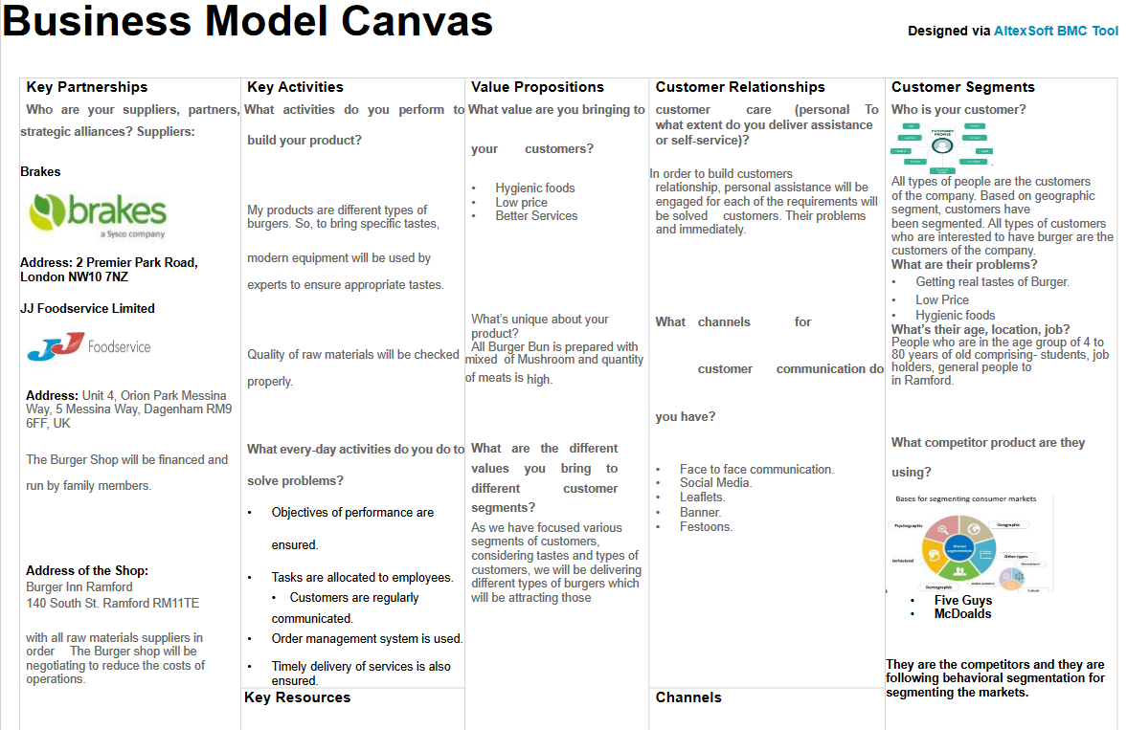
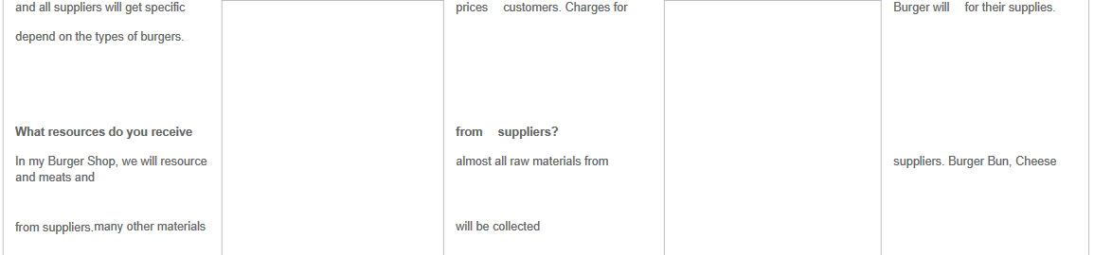
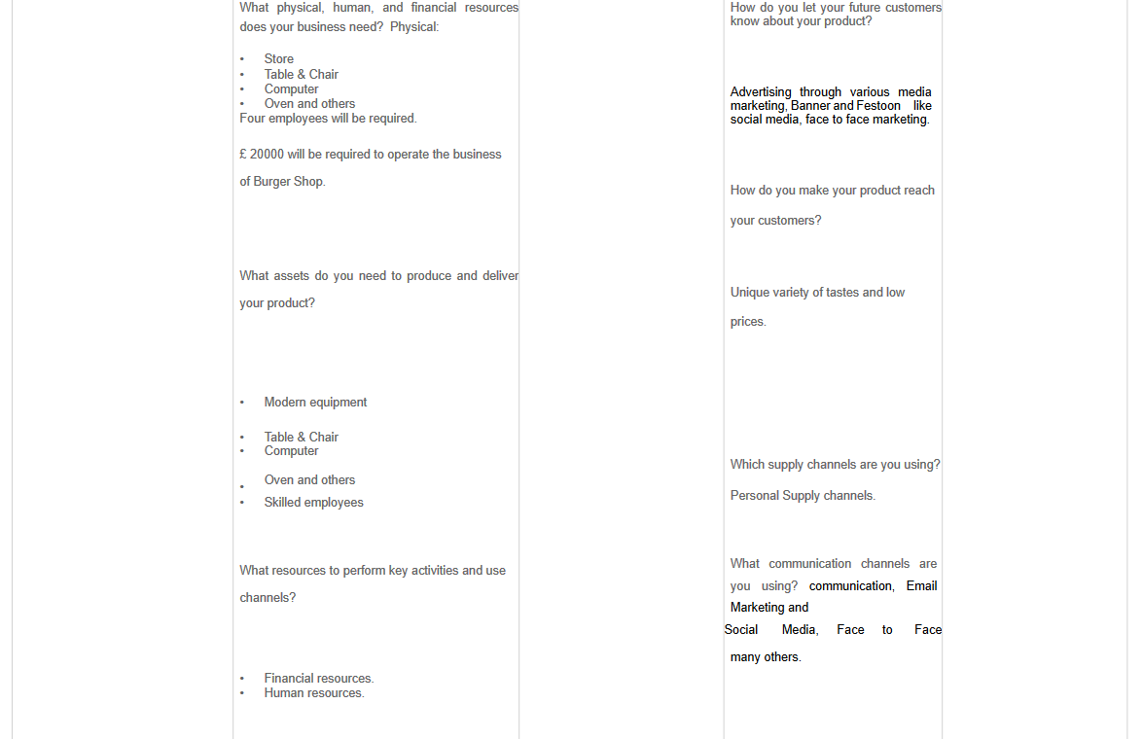
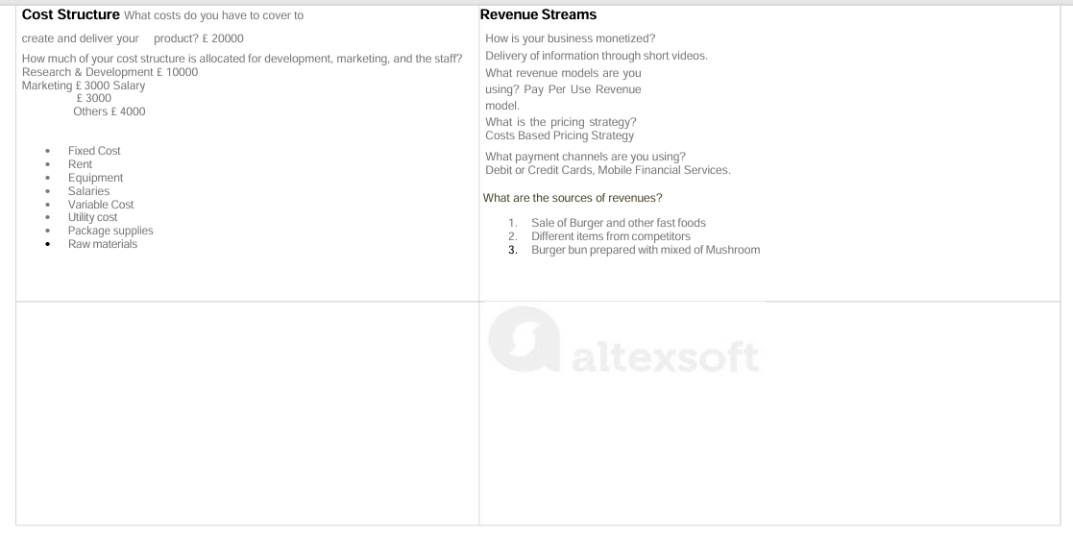

Appendix-II: Mind Map



